COMP 354 – Quiz

Quiz 1

Question 1

Agile Software Development:

Agile process models are better suited for software development because they:

Select two:

adapt as project or technical changes occur.

do not emphasize documentation.

deliver multiple software increments.

are driven by stakeholder requirements.

Question 2

Unified Process Model and XP Framework:

The fundamental difference between the unified process model and the extreme programming (XP) process model would be:

Select two:

XP is agile.

XP emphasizes stakeholder involvement.

XP requires higher developer commitment.

XP focuses on construction.

Question 3

Framework Activities:

Framework activities are required in software development to:

Select one:

systematically develop the correct software.

develop the software properly.

systematically develop the relevant software.

systematically develop the software.

Question 4

Umbrella Activities:

Umbrella activities are used in software development to:

Select one:

develop, deploy and maintain high quality software.

develop software correctly.

develop high quality software.

develop the software properly.

Question 5

Software Engineering:

Software development is an engineering process because:

Select one:

software is developed by software engineers.

software must be engineered.

software can be developed in many different ways.

many decisions have to be made among different possibilities.

Question 6

Prototyping Process Model:

The prototyping process model has reduced likelihood of product rejection because:

Select two:

stakeholders approve the software prototype.

stakeholders can experience the look, feel and behavior of the software.

stakeholders are involved throughout the process.

stakeholders ensure the developed software meets their needs.

Question 7

Unified Process Model:

The unified process model works well for maintenance projects because:

Select one:

of continuous stakeholder involvement.

it emphasizes quality documentation.

it emphasizes construction and deployment.

it accommodates changes in requirements.

Question 8

Changes in Requirements and Design:

The most suited process model to accommodate frequent changes in requirements and design would be:

Select one:

extreme programming because of multiple programmers.

scrum because of daily discussions.

DevOps because changes are immediately incorporated.

scrum because it is agile.

Question 9

Software Process Model:

A software process model should be planned before starting a software development project in order to:

Select two:

ensure the correctness of the software.

guarantee the software will meet the requirements.

reduce development time.

adapt the process to the team.

Question 10

Process Model for Vehicle Control Software:

The most appropriate process model to develop vehicle control software would be:

Select one:

DevOps because it is based on Chrysler's process.

kanban because it is based on Toyota's process.

DevOps because it solves all issues from deployment before release.

kanban because it ensures early product delivery.

Quiz 2

Question 1

User Scenario and Use Case:

The difference between a user scenario and the corresponding use case is that

Select one:

the user scenario can be more detailed than the use case.

the user scenario describes function and behavior whereas the use case specifies only function.

the user scenario is written by the stakeholder whereas the use case is written by the developer.

the user scenario is usually long compared to the use case.

Question 2

Functional Requirements:

The functional requirements of a software system can be specified using:

Select two:

class diagrams.

activity diagrams.

use case diagrams.

user scenarios.

Question 3

CRC Models:

The CRC models of a software system specify:

Select two:

the functions of the modules in that software.

the interdependence among the modules in that software.

the interaction among the modules in that software.

the interface of the modules in that software.

Question 4

Behavioral Requirements:

The behavioral requirements of a software system can be specified using:

Select two:

class diagram.

state diagram.

activity diagram.

use case diagram.

Question 5

Informational Requirements:

The informational requirements of a software system can be specified using:

Select two:

activity diagram.

use case diagram.

class diagram.

state diagram.

Question 6

Software Requirements:

The requirements of a software system should contain information about:

Select two:

the data processed by the software.

how the software is installed.

the functions performed by the software.

how the software is used.

Question 7

Requirements Validation:

The requirements of a software system should be validated to ensure that they are:

Select two:

not redundant.

achievable.

conflict-free.

relevant.

Question 8

Analysis Models:

Analysis models are used to document software requirements so that:

Select one:

requirements can be analyzed.

requirements can be specified.

requirements can be validated.

requirements can be established.

Question 9

Activity Diagram and Swimlane Diagram:

For a use case with a single actor:

Select one:

its activity diagram has more information than its swimlane diagram.

its activity diagram and swimlane diagram have different information.

its activity diagram has less information than its swimlane diagram.

its activity diagram and swimlane diagram have the same information.

Question 10

Sequence Diagram and State Diagram:

A software module can be modeled using:

Select one:

one state diagram and one sequence diagram.

one state diagram and many sequence diagrams.

many state diagrams and one sequence diagram.

many state diagrams and many sequence diagrams.

Quiz 3

Question 1

User Interface Design:

The user interface of a software should be designed in a way that the user can use the software:

Select two:

confidently.

correctly.

naturally.

efficiently.

Question 2

Design Model:

During software design, the requirements model is mapped to the design model so that the designed software can be:

Select two:

correctly implemented.

correctly tested.

validated against the requirements.

traced to the requirements.

Question 3

Object-Oriented Architecture:

In object-oriented architecture, the software is designed as:

Select one:

a set of objects and their functionalities.

a set of objects and the required communication among them.

a set of objects implementing the requirements.

a set of collaborating objects implementing the required functionalities.

Question 4

Software Architecture:

The architecture of a designed software illustrates how the software is:

Select two:

correct.

designed.

modular.

functional.

Question 5

Data Flow Architecture:

A data flow architecture shows how:

Select one:

data is used in the software.

filters are connected through pipes.

input data is systematically transformed into output data.

output data is computed from input data.

Question 6

Component Refactoring:

The components of a designed software are refactored to:

Select one:

improve quality without changing their design.

improve quality without changing their interface.

improve performance without changing their design.

improve performance without changing their interface.

Question 7

Consistent User Interface:

The user interface of a software should be consistent with other similar software so that the software can be:

Select two:

understood like other similar software.

used like other similar software.

designed like other similar software.

learned like other similar software.

Question 8

Collaboration Diagram:

The collaboration diagram of a designed software shows the components and the:

Select one:

interface among them.

messages among them.

processing flow among them.

communication among them.

Question 9

Software Components:

A software should be designed with components having high cohesion and low coupling so that the components can:

Select one:

be independently implemented.

be independently designed.

work with minimal interaction and interference.

be independently tested.

Question 10

Usability Guidelines:

While designing software, the usability guidelines can be used to:

Select two:

design the user interface.

improve the user interface.

implement the user interface.

evaluate the user interface.

Quiz 4

Question 1

State Diagrams in Object Oriented Testing:

Test cases for an object-oriented software are designed from the state diagram of its classes because:

Select two:

the state diagram models the correct behavior of the classes.

object-oriented software is designed as objects and the relationships among them.

the test cases should test the methods in those classes.

object-oriented software is designed as objects and the communication among them.

Question 2

Software Test Cases:

In order to control the quality of a designed software, test cases are:

Select two:

used to ensure that the constructed software meets the requirements.

developed at design time and executed at construction time.

used to ensure that the software does not have any defect.

used to ensure that the software does not have any error.

Question 3

Smoke Testing and Regression Testing:

During integration testing of a software:

Select one:

smoke testing and regression testing are not necessary.

both smoke testing and regression testing should be done.

either smoke testing or regression testing should be done.

neither smoke testing nor regression testing should be done.

Question 4

Software Quality Control:

The quality of a designed software is ensured at the:

Select two:

requirements establishment phase.

deployment phase.

construction phase.

design phase.

Question 5

Component Testing and Integration Testing:

During a software development process:

Select one:

components testing should be whitebox testing and integration testing should be whitebox testing.

components testing should be blackbox testing and integration testing should be whitebox testing.

components testing should be blackbox testing and integration testing should be blackbox testing.

components testing should be whitebox testing and integration testing should be blackbox testing.

Question 6

Component Tests:

Test cases for a component of a software are designed from the:

Select two:

user interface of the software.

behavior of the component.

data processed by the component.

code of the component.

Question 7

Scenario-Based Test Cases:

Scenario-based test cases are used in testing the:

Select two:

components of a software.

user interface of a software.

integrated software.

deployed software.

Question 8

Formal Technical Reviews:

Formal technical reviews are typically used to ensure that the designed software:

Select one:

meets its requirements.

is acceptable to the user.

does not have any error or defect.

is correctly designed.

Question 9

Successful Test Cases:

A designed test case is considered successful if:

Select one:

no error is found during the execution of the test case.

the software executes the test case.

an error is found during the execution of the test case.

the test case is designed from a requirement of the software.

Question 10

Bottom-up Integration Testing:

Any bottom-up integration test of a software should use:

Select two:

drivers for the already integrated components.

requirements of the already integrated components.

stubs for the already integrated components.

implementations of the already integrated components.

Quiz 5

Question 1

Software Metrics:

Software metrics are simple computable values that can be used in:

Select two:

software design.

software analytics.

software risk management.

software construction.

Question 2

Software Scope:

The scope of a software project:

Select two:

includes the requirements of the software.

should be decided by the stakeholders and the development team.

is developed by the team leader.

is adapted by the programmers.

Question 3

Problem-Based Estimation:

Problem-based estimation of a software project is independent of the software's:

Select two:

design.

deployment.

implementation.

requirements.

Question 4

Viable Software Plan:

A viable software plan can be shown using its:

Select two:

project table.

timeline chart.

task network.

task set.

Question 5

Software Project Schedule:

The schedule of a software project is used to:

Select one:

develop the software on time.

speed up the development of the software.

track and correct potential delays in developing that software.

identify potential delays in developing the software.

Question 6

Software Risk Management:

The goal of software risk management is to:

Select one:

handle potential risks in a software project.

plan for potential risks in a software project.

prevent potential risks in a software project.

mitigate potential risks in a software project.

Question 7

Software Project Planning:

The main goal of software project planning is to:

Select one:

estimate the time and resources.

track and direct the project progress.

release the software on time and budget.

plan for potential risk mitigation.

Question 8

Time and Resource Estimation:

The most appropriate approaches to estimate the time and resources for a software project are:

Select two:

use case point estimation.

problem-based estimation.

process-based estimation.

function point estimation.

Question 9

Software Risk Assessment:

Risk assessment of a software is done in order to identify:

Select two:

the risks that materialize during the development of that software.

potential risks in developing that software.

the risks to be mitigated in developing that software.

all the risks in developing that software.

Question 10

Software Risk Mitigation:

Mitigation of a software risk is done:

Select two:

to avoid that risk.

to prevent that risk.

when a potential risk materializes.

to develop high quality software.

**Software development models** are various processes or methods that are chosen for project development depending on the objectives and goals of the project. Many development life cycle models have been developed to achieve various essential objectives. Models specify the various steps of the process and the order in which they are executed.

**What is Software Modeling?**

**Software modeling** is the process of creating abstract representations of a software system. These models serve as blueprints that guide developers, designers, and stakeholders through the system’s structure, behavior, and functionality.

By using diagrams and various modeling languages, software modeling helps in visualizing and understanding the complex aspects of the software, making it easier to plan, develop, and manage the system.

**Top 8 Software Development Models**

Choosing the right model is very important for the [**Development of a Software Product**](https://www.geeksforgeeks.org/software-engineering/software-development-process/)or application. Development and testing processes are carried out based on the model.

Different companies, depending on the software application or product, choose the type of development model whichever is appropriate for their application. But these days ['**Agile Methodology**](https://www.geeksforgeeks.org/software-engineering/agile-software-development-methodology-framework/)' is the most popular in the market.

Let's look at the every model in brief one by one:-

Popular-Software-Development-Models

**1. Agile Model**

[**Agile Development Model**](https://www.geeksforgeeks.org/software-engineering/software-engineering-agile-development-models/) is a combination of iterative and incremental models, that is, it is made up of iterative and incremental models.

* In Agile model, focus is given to process adaptability and customer satisfaction.
* In earlier times, iterative waterfall model was used to create software. But in today's time developers have to face many problems. The biggest problem is that in the middle of software development, the customer asks to make changes in the software. It takes a lot of time and money to make these changes. So to overcome all these shortcomings, the agile model was proposed in the 1990s.

The Agile Model was created mainly to make changes in the middle of **software development** so that the software project can be completed quickly.

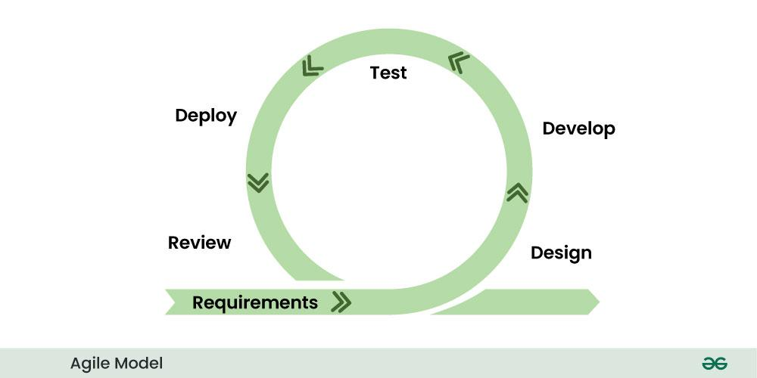Agile Model

* In the agile model, the software product is divided into small incremental parts. In this, the smallest part is developed first and then the larger one.
* And each incremental part is developed over iteration.
* Each iteration is kept small so that it can be easily managed. And it can be completed in two-three weeks. Only one iteration is planned, developed and deployed at a time.

**2. Waterfall Model**

[**Waterfall Model**](https://www.geeksforgeeks.org/software-engineering/waterfall-model/) is a famous and good version of [**SDLC(System Development Life Cycle)**](https://www.geeksforgeeks.org/software-engineering/software-development/)for software engineering. The waterfall model is a linear and sequential model, which means that a development phase cannot begin until the previous phase is completed. We cannot overlap phases in waterfall model.

**Phases of Waterfall model**

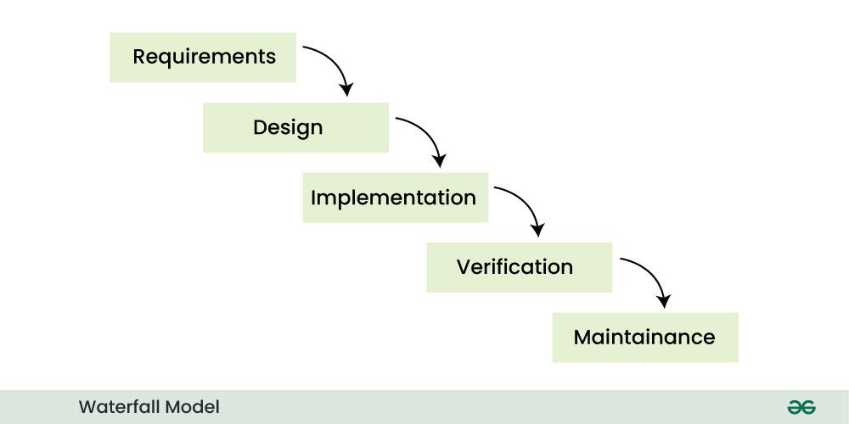Waterfall Model

Similarly waterfall model also works, once one phase of development is completed then we move to the next phase but cannot go back to the previous phase. In the waterfall model, the output of one phase serves as the input for the other phase.

**3. V-Model**

[**V-Model**](https://www.geeksforgeeks.org/software-engineering/software-engineering-sdlc-v-model/)is an SDLC model, it is also called Verification and Validation Model. V-Model is widely used in the **Software Development Process**, and it is considered a disciplined model. In V-Model, the execution of each process is sequential, that is, the new phase starts only after the previous phase ends.

**Phases of V-model**

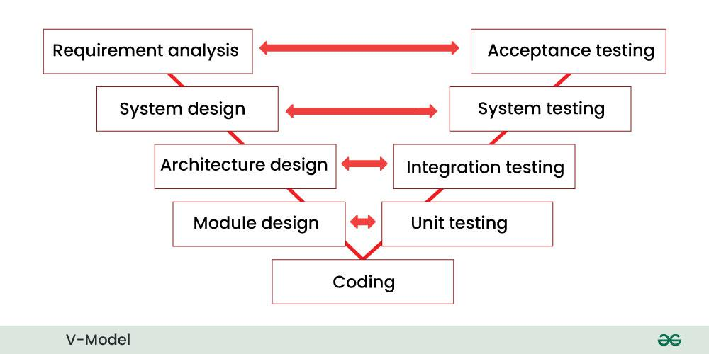V-Model

* It is based on the association of testing phase with each development phase that is in V-Model with each development phase, its testing phase is also associated in a V-shape in other words both [**Software Development**](https://www.geeksforgeeks.org/software-engineering/software-development/)and testing activities take place at the same time.
* So in this model, Verification Phase will be on one side, Validation Phase will be on the other side that is both the activities run simultaneously and both of them are connected to each other in V-Shape through Coding Phase, hence it is called V-Model.
* **V-Design:** In V-Design the left side represents the development activity, the right side represents the testing activity.

**4. Incremental Model**

In [**Incremental Model**](https://www.geeksforgeeks.org/software-engineering/software-engineering-incremental-process-model/), the **Software Development Process**is divided into several increments and the same phases are followed in each increment. In simple language, under this model a complex project is developed in many modules or builds.

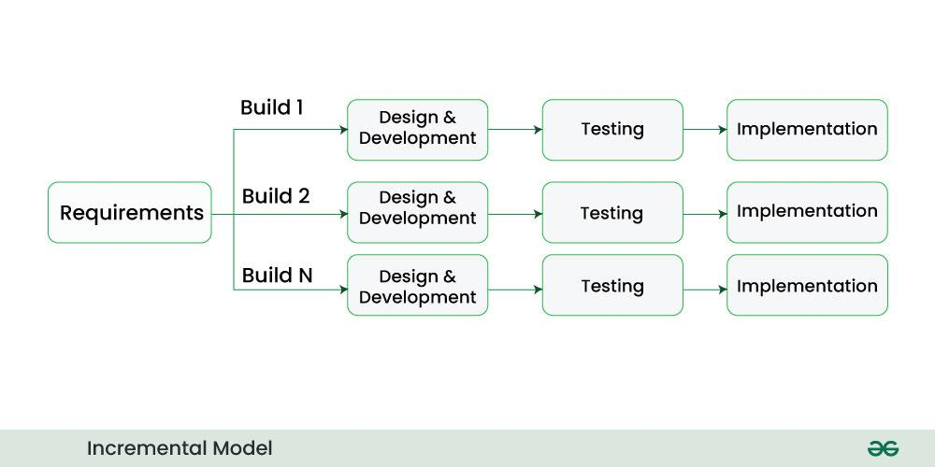Incremental Model

* For example, we collect the customer's requirements, now instead of making the entire software at once, we first take some requirements and based on them create a module or function of the software and deliver it to the customer. Then we take some more requirements and based on them add another module to that software.
* Similarly, modules are added to the software in each increment until the complete system is created. However, the requirements for making a complex project in multiple iterations/parts should be clear.
* If we understand the entire principle of Incremental methodology, then it starts by developing an initial implementation, then user feedback is taken on it, and it is developed through several versions until an accepted system is developed. Important functionalities of the software are developed in the initial iterations.

Each subsequent release of a software module adds functions to the previous release. This process continues until the final software is obtained.

**5. RAD Model**

[**RAD Model**](https://www.geeksforgeeks.org/software-engineering/software-engineering-rapid-application-development-model-rad/) stands for rapid application development model. The methodology of RAD model is similar to that of incremental or waterfall model. It is used for small projects.

The main objective of RAD model is to reuse code, components, tools, processes in project development.

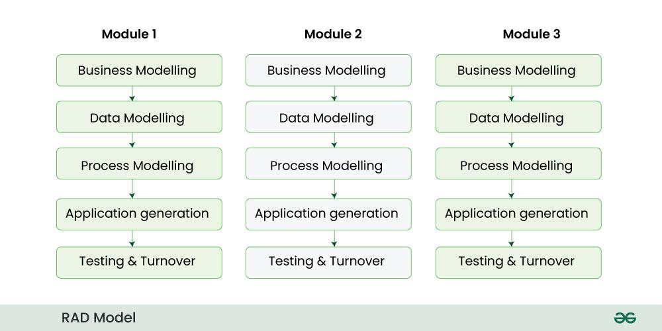RAD Model

* If the project is large then it is divided into many small projects and these small projects are planned one by one and completed. In this way, by completing small projects, the large project gets ready quickly.
* In RAD model, the project is completed within the given time and all the requirements are collected before starting the project. It is very fast and there are very less errors in it.

**6. Iterative Model**

In [**Iterative Model**](https://www.geeksforgeeks.org/software-engineering/software-engineering-iterative-waterfall-model/) we start developing the software with some requirements and when it is developed, it is reviewed. If there are requirements for changes in it, then we develop a new version of the software based on those requirements. This process repeats itself many times until we get our final product.

Through this diagram you can understand the Interactive model.

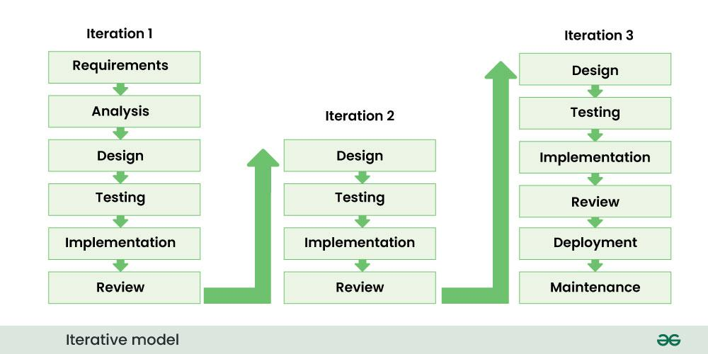Iterative Model

* So, in Iterative model a software is developed by following several iterations. Iteration means that we are repeating the Development Process again and again. For example, we develop the first version of the software following the SDLC process with some software requirements.
* After the first version is developed, if there is a need to change the software , then a new version is developed with the second iteration. Now again we will see if the new version is enough, if not then we will make changes in it with the third iteration. The iteration will be repeated until the complete software is ready.
* The basic concept of Iterative model is that the software should be developed through repeated cycles or what we also call iteration and only a small part of it should be developed at a time. This model was developed to overcome the drawbacks of the classical waterfall model.

**7. Spiral Model**

[**Spiral Model**](https://www.geeksforgeeks.org/software-engineering/software-engineering-spiral-model/) is a software development process model. This model has characteristics of both iterative and waterfall models. This model is used in projects which are large and complex. This model was named spiral because if we look at its figure, it looks like a spiral, in which a long curved line starts from the center point and makes many loops around it. The number of loops in the spiral is not decided in advance but it depends on the size of the project and the changing requirements of the user. We also call each loop of the spiral a phase of the software development process.

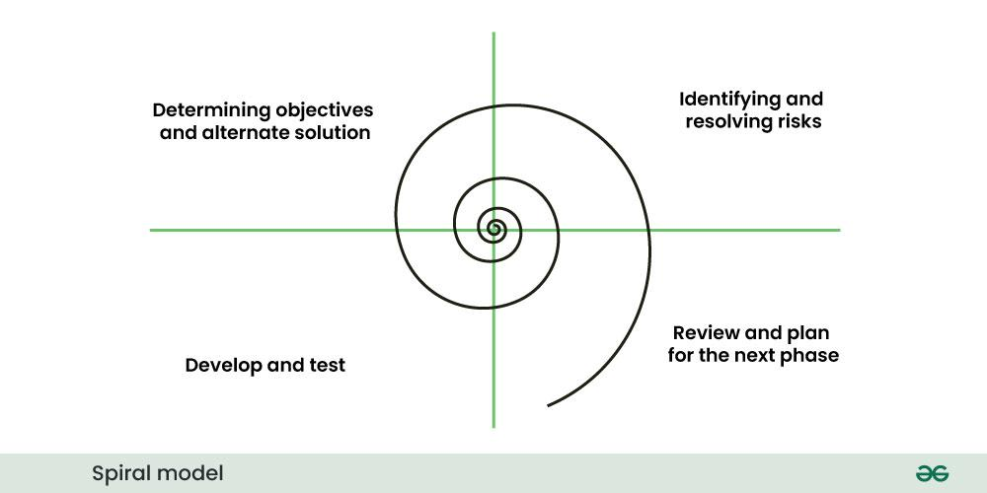Spiral Model

In Spiral Model the entire process of software development is described in four phases which are repeated until the project is completed.

A software project goes through these loops again and again in iterations. After each iteration a more and more complete version of the software is developed. The most special thing about this model is that risks are identified in each phase and they are resolved through prototyping. This feature is also called Risk Handling.

Since it also includes the approaches of other SDLC models, it is also called Meta Model. It was first developed by Barry Boehm in 1986.

**8. Prototype model**

[**Prototype Model**](https://www.geeksforgeeks.org/software-engineering/software-engineering-prototyping-model/) is an activity in which prototypes of software applications are created. First a prototype is created and then the final product is manufactured based on that prototype.

One problem in this model is that if the end users are not satisfied with the prototype model, then a new prototype model is created again, due to which this model consumes a lot of money and time.

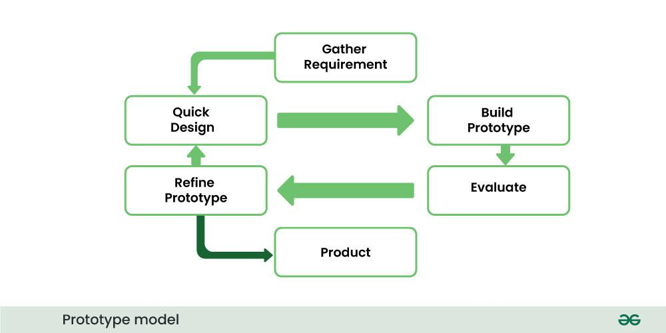Prototype Model

* The prototype model was developed to overcome the shortcomings of the waterfall model.
* This model is created when we do not know the requirements well.
* The specialty of this model is that this model can be used with other models as well as alone.

**Why companies are shifting toward agile Software Development models?**

In earlier times, iterative waterfall model was used to create software. But in today's time developers have to face many problems. The biggest problem is that in the middle of software development, the customer asks to make changes in the software. It takes a lot of time and money to make these changes. The agile model was created mainly to make changes in the middle of Software Development so that the software project can be completed quickly.

Agile focuses on customer-centric approach that constantly take feedback from customer and make changes in the middle of software developer according to their needs and expectation. Agile Methodologies like scrum adopt iterative and incremental approach this accelerate the time-to-market for new features and product.

**Conclusion**

Choosing the right software development model is important for the [**Success of a Project**](https://www.geeksforgeeks.org/business-studies/critical-success-factors-in-project-management/). Each model offers unique advantages and is suitable for [**Different Types of Projects**](https://www.geeksforgeeks.org/techtips/what-types-of-projects-or-teams-are-best-suited-for-using-a-kanban-board-in-jira/). Agile Methodologies, due to their flexibility and customer-centric approach, are increasingly popular in the industry. By adopting Agile, companies can accelerate time-to-market and better adapt to changing requirements, leading to higher customer satisfaction and [**Successful Project Outcomes**.](https://www.geeksforgeeks.org/business-studies/what-is-a-stakeholder-in-project-management/)

Software processes are the activities for designing, implementing, and testing a software system. The software development process is complicated and involves a lot more than technical knowledge.

That’s where software process models come in handy. A software process model is an **abstract representation** of the development process.

In this article, we will introduce you to the top seven software process models and discuss when to use them.

Bottom of Form

**What is a software process model?**

A software process model is an abstraction of the software development process. The models specify the stages and order of a process. So, think of this as a representation of the **order of activities** of the process and the **sequence** in which they are performed.

**A model will define the following:**

* The tasks to be performed
* The input and output of each task
* The pre and post-conditions for each task
* The flow and sequence of each task

The goal of a software process model is to provide guidance for controlling and coordinating the tasks to achieve the end product and objectives as effectively as possible.

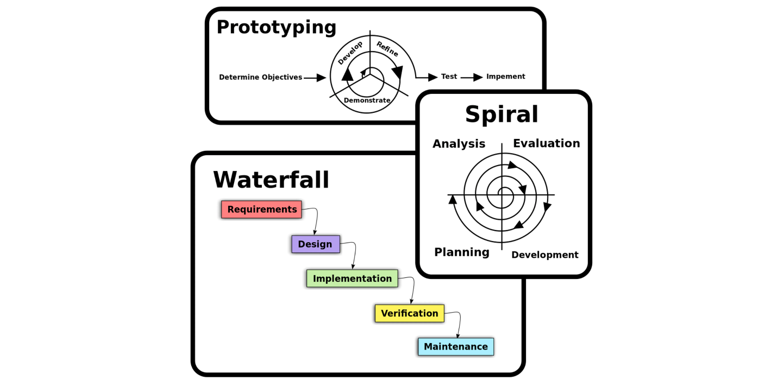

Software process model, Source: Omar Elgabry

There are many kinds of process models for meeting different requirements. We refer to these as **SDLC models** (Software Development Life Cycle models). The most popular and important SDLC models are as follows:

* Waterfall model
* V model
* Incremental model
* RAD model
* Agile model
* Iterative model
* Prototype model
* Spiral model

**Factors in choosing a software process**

Choosing the right software process model for your project can be difficult. If you know your requirements well, it will be easier to select a model that best matches your needs. You need to keep the following factors in mind when selecting your software process model:

**Project requirements**

Before you choose a model, take some time to go through the project requirements and clarify them alongside your organization’s or team’s expectations. Will the user need to specify requirements in detail after each iterative session? Will the requirements *change* during the development process?

**Project size**

Consider the size of the project you will be working on. Larger projects mean bigger teams, so you’ll need more extensive and elaborate project management plans.

**Project complexity**

Complex projects may not have clear requirements. The requirements may change often, and the cost of delay is high. Ask yourself if the project requires constant monitoring or feedback from the client.

**Cost of delay**

Is the project highly time-bound with a huge cost of delay, or are the timelines flexible?

**Customer involvement**

Do you need to consult the customers during the process? Does the user need to participate in all phases?

**Familiarity with technology**

This involves the developers’ knowledge and experience with the project domain, software tools, language, and methods needed for development.

**Project resources**

This involves the amount and availability of funds, staff, and other resources.

**Get hands-on with system design.**

Scalability & System Design for Developers

As you progress in your career as a developer, you'll be increasingly expected to think about software architecture. Can you design systems and make trade-offs at scale? Developing that skill is a great way to set yourself apart from the pack. In this Skill Path, you'll cover everything you need to know to design scalable systems for enterprise-level software.

**Types of software process models**

As we mentioned before, there are multiple kinds of software process models that each meet different requirements. Below, we will look at the top seven types of software process models that you should know.

**Waterfall Model**

The waterfall model is a **sequential, plan driven-process** where you must plan and schedule all your activities before starting the project. Each activity in the waterfall model is represented as a separate phase arranged in linear order.

It has the following phases:

* Requirements
* Design
* Implementation
* Testing
* Deployment
* Maintenance

Waterfall Model

Each of these phases produces one or more documents that need to be approved before the next phase begins. However, in practice, these phases are very likely to overlap and may feed information to one another.

The software process **isn’t linear**, so the documents produced may need to be modified to reflect changes.

The waterfall model is easy to understand and follow. It doesn’t require a lot of customer involvement after the specification is done. Since it’s inflexible, it can’t adapt to changes. There is no way to see or try the software until the last phase.

The waterfall model has a rigid structure, so it should be used in cases where the requirements are understood completely and unlikely to radically change.

**V Model**

The V model (Verification and Validation model) is an extension of the waterfall model. All the requirements are gathered at the start and cannot be changed. You have a corresponding testing activity for each stage. For every phase in the development cycle, there is an **associated testing phase.**

V Model

The corresponding testing phase of the development phase is planned in parallel, as you can see above.

The V model is highly disciplined, easy to understand, and makes project management easier. But it isn’t good for complex projects or projects that have unclear or changing requirements. This makes the V model a good choice for software where downtimes and failures are unacceptable.

**Incremental Model**

The incremental model divides the system’s functionality into **small increments** that are delivered one after the other in quick succession. The most important functionality is implemented in the initial increments.

The subsequent increments expand on the previous ones until everything has been updated and implemented.

Incremental development is based on developing an initial implementation, exposing it to user feedback, and evolving it through new versions. The process’ activities are interwoven by feedback.

Each iteration passes through the requirements, design, coding, and testing stages.

Incremental Model

The incremental model lets stakeholders and developers see results with the first increment. If the stakeholders don’t like anything, everyone finds out a lot sooner. It is efficient as the developers only focus on what is important and bugs are fixed as they arise, but you need a **clear and complete definition** of the whole system before you start.

The incremental model is great for projects that have loosely coupled parts and projects with complete and clear requirements.

**Iterative Model**

The iterative development model develops a system by **building small portions** of all the features. This helps to meet the initial scope quickly and release it for feedback.

In the iterative model, you start off by implementing a small set of software requirements. These are then **enhanced iteratively** in the evolving versions until the system is completed. This process model starts with part of the software, which is then implemented and reviewed to identify further requirements.

Iterative Model

Like the incremental model, the iterative model allows you to see the results at the early stages of development. This makes it easy to identify and **fix any functional or design flaws**. It also makes it easier to manage risk and change requirements.

The deadline and budget may change throughout the development process, especially for large complex projects. The iterative model is a good choice for large software that can be **easily broken down into modules**.

**RAD Model**

The Rapid Application Development (RAD model) is based on iterative development and prototyping with **little planning involved**. You develop functional modules in parallel for faster product delivery. It involves the following phases:

1. Business modeling
2. Data modeling
3. Process modeling
4. Application generation
5. Testing and turnover

The RAD concept focuses on gathering requirements using focus groups and workshops, reusing software components, and informal communication.

RAD Model

The RAD model accommodates changing requirements, reduces development time, and increases the reusability of components. But it can be complex to manage. Therefore, the RAD model is great for systems that need to be produced in a short time and have known requirements.

**Spiral Model**

The spiral model is a risk driven iterative software process model. The spiral model delivers projects in loops. Unlike other process models, its steps aren’t activities but **phases** for addressing whatever problem has the greatest risk of causing a failure.

It was designed to include the best features from the waterfall and introduces risk-assessment.

You have the following phases for each cycle:

1. Address the highest-risk problem and determine the objective and alternate solutions
2. Evaluate the alternatives and identify the risks involved and possible solutions
3. Develop a solution and verify if it’s acceptable
4. Plan for the next cycle

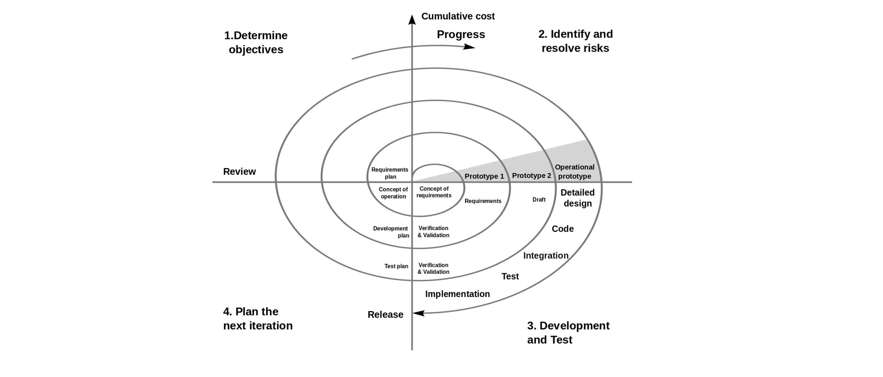

Spiral Model

You develop the concept in the first few cycles, and then it evolves into an implementation. Though this model is great for managing uncertainty, it can be difficult to have stable documentation. The spiral model can be used for projects with **unclear needs** or projects still in research and development.

**Agile model**

The agile process model encourages **continuous iterations of development** and testing. Each incremental part is developed over an iteration, and each iteration is designed to be small and manageable so it can be completed within a few weeks.

Each iteration focuses on implementing a small set of features completely. It involves customers in the development process and minimizes documentation by using informal communication.

Agile development considers the following:

* Requirements are assumed to change
* The system evolves over a series of short iterations
* Customers are involved during each iteration
* Documentation is done only when needed

Though agile provides a very realistic approach to software development, it isn’t great for complex projects. It can also present challenges during transfers as there is very little documentation. Agile is great for projects with **changing requirements**.

Some commonly used agile methodologies include:

* **Scrum:** One of the most popular agile models, Scrum consists of iterations called sprints. Each sprint is between 2 to 4 weeks long and is preceded by planning. You cannot make changes after the sprint activities have been defined.
* **Extreme Programming (XP):** With Extreme Programming, an iteration can last between 1 to 2 weeks. XP uses pair programming, continuous integration, test-driven development and test automation, small releases, and simple software design.
* **Kanban:** Kanban focuses on visualizations, and if any iterations are used they are kept very short. You use the Kanban Board that has a clear representation of all project activities and their numbers, responsible people, and progress.

Software Processes is a coherent set of activities for specifying, designing, implementing and testing software systems. A software process model is an abstract representation of a process that presents a description of a process from some particular perspective. There are many different software processes but all involve:

* Specification – defining what the system should do;
* Design and implementation – defining the organization of the system and implementing the system;
* Validation – checking that it does what the customer wants;
* Evolution – changing the system in response to changing customer needs.

Types of Software Process Model

Software processes, methodologies and frameworks range from specific prescriptive steps that can be used directly by an organization in day-to-day work, to flexible frameworks that an organization uses to generate a custom set of steps tailored to the needs of a specific project or group. In some cases a “sponsor” or “maintenance” organization distributes an official set of documents that describe the process.

**Software Process and Software Development Lifecycle Model**

One of the basic notions of the software development process is SDLC models which stands for Software Development Life Cycle models. There are many development life cycle models that have been developed in order to achieve different required objectives. The models specify the various stages of the process and the order in which they are carried out. The most used, popular and important SDLC models are given below:

* Waterfall model
* V model
* Incremental model
* RAD model
* Agile model
* Iterative model
* Spiral model
* Prototype model

Waterfall Model

The waterfall model is a breakdown of project activities into linear sequential phases, where each phase depends on the deliverables of the previous one and corresponds to a specialisation of tasks. The approach is typical for certain areas of engineering design.

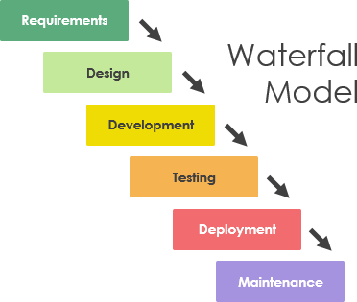

V Model

The V-model represents a development process that may be considered an extension of the waterfall model and is an example of the more general V-model. Instead of moving down in a linear way, the process steps are bent upwards after the coding phase, to form the typical V shape. The V-Model demonstrates the relationships between each phase of the development life cycle and its associated phase of testing. The horizontal and vertical axes represent time or project completeness (left-to-right) and level of abstraction (coarsest-grain abstraction uppermost), respectively.

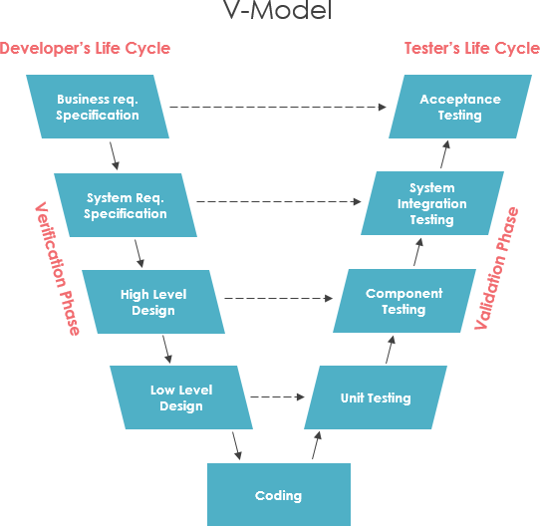

Incremental model

The incremental build model is a method of software development where the model is designed, implemented and tested incrementally (a little more is added each time) until the product is finished. It involves both development and maintenance. The product is defined as finished when it satisfies all of its requirements. Each iteration passes through the requirements, design, coding and testing phases. And each subsequent release of the system adds function to the previous release until all designed functionally has been implemented. This model combines the elements of the waterfall model with the iterative philosophy of prototyping.

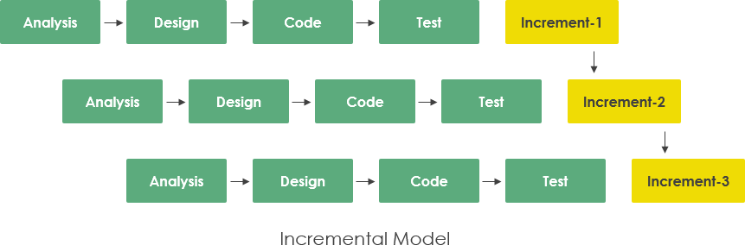

Iterative Model

An iterative life cycle model does not attempt to start with a full specification of requirements by first focusing on an initial, simplified set user features, which then progressively gains more complexity and a broader set of features until the targeted system is complete. When adopting the iterative approach, the philosophy of incremental development will also often be used liberally and interchangeably.

In other words, the iterative approach begins by specifying and implementing just part of the software, which can then be reviewed and prioritized in order to identify further requirements. This iterative process is then repeated by delivering a new version of the software for each iteration. In a light-weight iterative project the code may represent the major source of documentation of the system; however, in a critical iterative project a formal software specification may also be required.

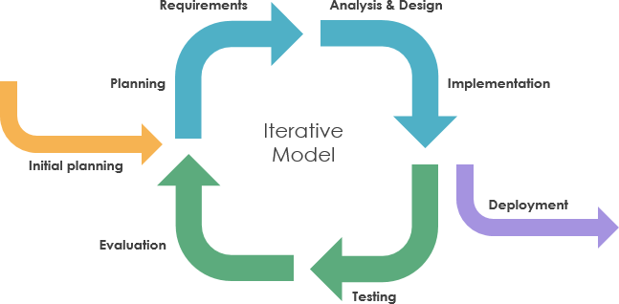

RAD model

Rapid application development was a response to plan-driven waterfall processes, developed in the 1970s and 1980s, such as the Structured Systems Analysis and Design Method (SSADM). Rapid application development (RAD) is often referred as the adaptive software development. RAD is an incremental prototyping approach to software development that end users can produce better feedback when examining a live system, as opposed to working strictly with documentation. It puts less emphasis on planning and more emphasis on an adaptive process.

RAD may resulted in a lower level of rejection when the application is placed into production, but this success most often comes at the expense of a dramatic overruns in project costs and schedule. RAD approach is especially well suited for developing software that is driven by user interface requirements. Thus, some GUI builders are often called rapid application development tools.

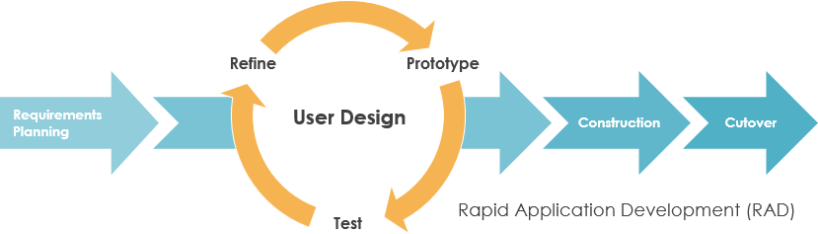

Spiral model

The spiral model, first described by Barry Boehm in 1986, is a risk-driven software development process model which was introduced for dealing with the shortcomings in the traditional waterfall model. A spiral model looks like a spiral with many loops. The exact number of loops of the spiral is unknown and can vary from project to project. This model supports risk handling, and the project is delivered in loops. Each loop of the spiral is called a Phase of the software development process.

The initial phase of the spiral model in the early stages of Waterfall Life Cycle that is needed to develop a software product. The exact number of phases needed to develop the product can be varied by the project manager depending upon the project risks. As the project manager dynamically determines the number of phases, so the project manager has an important role to develop a product using a spiral model.

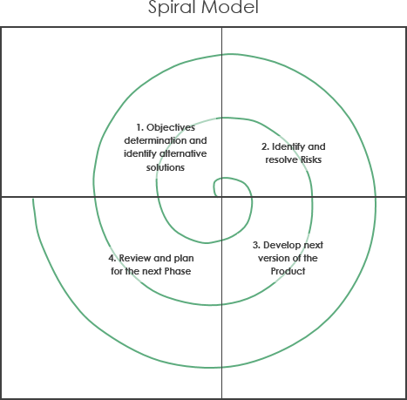

Agile model

Agile is an umbrella term for a set of methods and practices based on the values and principles expressed in the Agile Manifesto that is a way of thinking that enables teams and businesses to innovate, quickly respond to changing demand, while mitigating risk. Organizations can be agile using many of the available frameworks available such as Scrum, Kanban, Lean, Extreme Programming (XP) and etc.

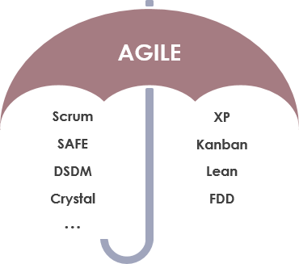

The Agile movement proposes alternatives to traditional project management. Agile approaches are typically used in software development to help businesses respond to unpredictability which refer to a group of software development methodologies based on iterative development, where requirements and solutions evolve through collaboration between self-organizing cross-functional teams.

The primary goal of being Agile is empowered the development team the ability to create and respond to change in order to succeed in an uncertain and turbulent environment. Agile software development approach is typically operated in rapid and small cycles. This results in more frequent incremental releases with each release building on previous functionality. Thorough testing is done to ensure that software quality is maintained.

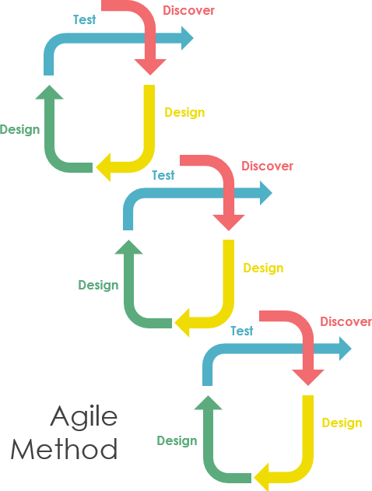

**Umbrella Activities in Software Engineering**

Last Updated : 23 Jul, 2025

Software engineering is a collection of interconnected phases. These steps are expressed or available in different ways in different software process models. Umbrella activities, such as project management, quality assurance, and documentation, support these phases, ensuring consistency, quality, and efficient progress throughout the development process.

**Table of Content**

* [What is Umbrella Activities?](https://www.geeksforgeeks.org/software-engineering/umbrella-activities-in-software-engineering/#what-is-umbrella-activities)
* [Tasks of Umbrella Activities](https://www.geeksforgeeks.org/software-engineering/umbrella-activities-in-software-engineering/#tasks-of-umbrella-activities)
* [Conclusion](https://www.geeksforgeeks.org/software-engineering/umbrella-activities-in-software-engineering/#conclusion)
* [Frequently Asked Questions related to Umbrella Activities](https://www.geeksforgeeks.org/software-engineering/umbrella-activities-in-software-engineering/#frequently-asked-questions-related-to-umbrella-activities)

**What is Umbrella Activities?**

Umbrella activities are a series of steps or procedures followed by a [software development team](https://www.geeksforgeeks.org/software-engineering/software-development-team-structure/) to maintain the progress, quality, changes, and risks of complete development tasks. These steps of umbrella activities will evolve through the phases of the generic view of software development.

The activities in the [software development process](https://www.geeksforgeeks.org/software-engineering/software-development-process/) are supplemented by many general activities. Generally, common activities apply to the entire software project and help the software development team manage and track progress, quality, changes, and risks.

**Tasks of Umbrella Activities**

**Umbrella activities consist of different tasks:**

* Software Project Tracking and Control
* Formal Technical Reviews
* [Software Quality Assurance](https://www.geeksforgeeks.org/software-testing/software-engineering-software-quality-assurance/)
* SCM or Software configuration management
* Document Preparation and Production
* Re-usability Management
* Measurement and Metrics
* [Risk Management](https://www.geeksforgeeks.org/software-engineering/risk-management-software-engineering/)

Umbrella Activities

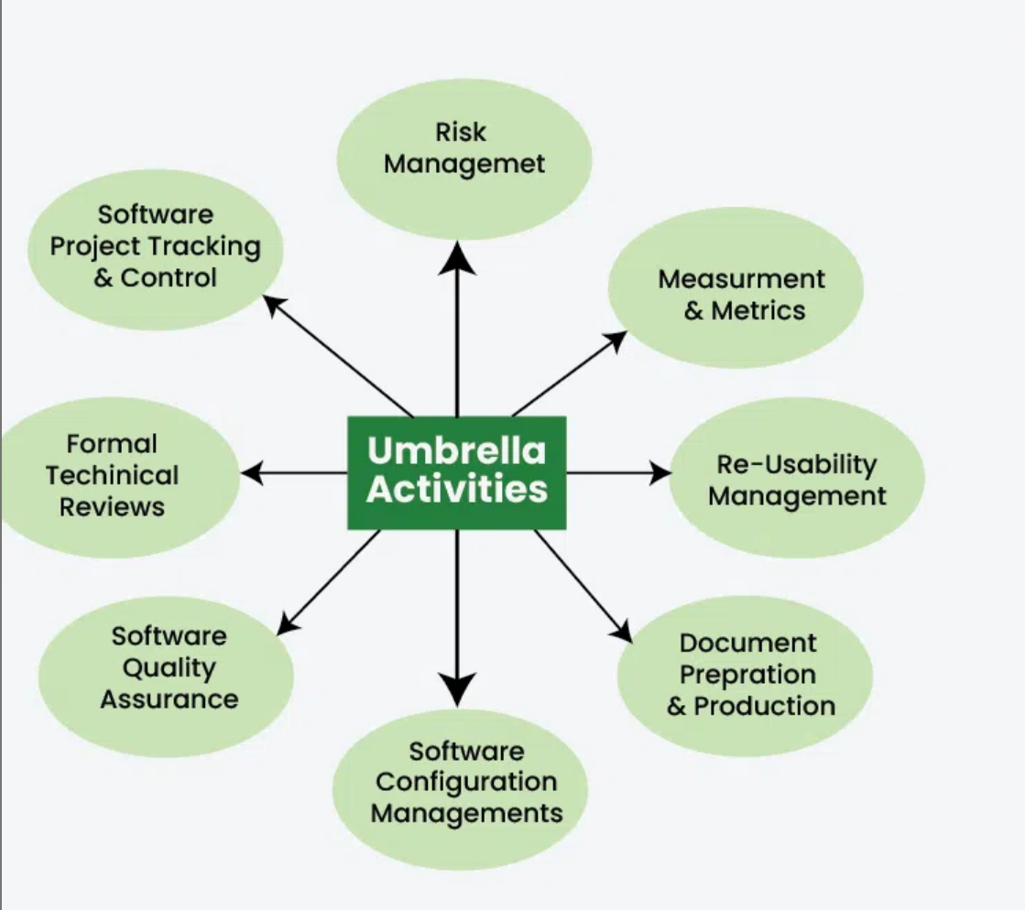

* **Software project tracking and control:**This activity allows the software team to check the progress of software development. Before the actual development starts, make a software development plan and develop on this basis, but after a certain period of time, it is necessary to analyze the development progress to find out what measures need to be taken. It must be accepted at an appropriate time after the completion of development, [testing](https://www.geeksforgeeks.org/software-testing/software-testing-basics/), etc. The test results may need to reschedule the development time.
* **Risk management:** Risk management is a series of steps to help software development teams understand and manage uncertainty. It is a very good idea to identify it, assess the likelihood of it happening, assess its impact, and develop an "if the problem does happen" contingency plan.
* **Software quality assurance**: As its name suggest this  defines and conducts the activities required to ensure software quality. The quality of the software, such as user experience, performance, workload flexibility, etc., must be tested and verified after reaching the specified milestones, which reduces the tasks at the end of the development process, which must be performed by a dedicated team so that the development can continue.
* **Technical reviews:** It assesses [software engineering](https://www.geeksforgeeks.org/software-engineering/software-engineering-introduction-to-software-engineering/) work products in an effort to uncover and remove errors before they are propagated to the next activity. Software engineering is done in clusters or modules, after completing each module, it is good practice to review the completed module to find out and remove errors so their propagation to the next module can be prevented.
* **Measurement:** This includes all measurements of all aspects of the software project. Define and compile process, project, and product metrics to help the team deliver software that meets the needs of stakeholders; it can be used in conjunction with all other frameworks and general operations.
* **Software configuration management**: It manages the impact of changes throughout the software development process. [Software Configuration Management (SCM)](https://www.geeksforgeeks.org/software-engineering/software-engineering-system-configuration-management/) is a set of activities designed to manage changes by identifying work products that can be changed, establishing relationships between them, and defining mechanisms for managing different versions of them. Work product.
* **Reusability management:** Define the standards for the reuse of work products (including software components), and develop mechanisms to implement reusable components. This includes the approval of any part of a backing-up software project or any type of support provided for updates or updates in the future. Update the software according to user/current time requirements.
* **Work product preparation and production:**It encompasses the activities required to create work products such as models, documents, logs, forms, and lists.

**Conclusion**

Umbrella activities in software engineering provide essential support for the main development tasks. They ensure [**project management**](https://www.geeksforgeeks.org/software-engineering/what-is-project-management/), quality assurance, and configuration control, maintaining consistency and quality. Documentation supports understanding and future maintenance. Overall, these activities enhance efficiency and reliability throughout the development process.

In software engineering, umbrella activities refer to the essential tasks that support and facilitate the overall software development process. These activities serve as a framework to manage and coordinate the different phases and tasks involved in building high-quality software solutions. This article explores each umbrella activity in detail, highlighting their significance and how they contribute to successful software development.

1. **Project Management:** Project management involves planning, organizing, and controlling all aspects of software development projects. It includes defining project goals, creating schedules, allocating resources, and managing risks. Effective project management ensures that the software development process stays on track, adheres to deadlines, and delivers a high-quality product within budget.
2. **Requirements Engineering:** Requirements engineering focuses on understanding and defining the needs and expectations of stakeholders for the software system. This activity involves gathering, analyzing, documenting, and validating requirements. It ensures that the software meets user expectations, addresses business needs, and complies with relevant regulations and standards.
3. **Software Design and Architecture:** Software design and architecture involve creating a blueprint for the software system. It includes defining the overall structure, component interactions, and relationships within the system. This activity ensures that the software is scalable, maintainable, and modular, enabling efficient development and future enhancements.
4. **Software Construction:** Software construction refers to the actual coding and implementation of the software system. It involves writing and testing code, integrating components, and creating executable software artifacts. This activity focuses on applying best coding practices, adhering to coding standards, and ensuring the software functions as intended.
5. **Software Testing and Quality Assurance:** Software testing and quality assurance activities aim to identify defects, errors, and vulnerabilities within the software system. It involves designing test cases, executing tests, and validating software functionality against predefined criteria. Through systematic testing, software engineers can uncover and address bugs, ensuring that the software meets quality standards and delivers a reliable user experience.
6. **Software Maintenance:** Software maintenance encompasses activities performed after the software is deployed. It involves managing updates, bug fixes, and enhancements throughout the software's lifecycle. This activity ensures that the software remains functional, secure, and up-to-date with evolving user requirements and technological advancements.
7. **Configuration and Change Management:** Configuration and change management activities involve managing software configurations and controlling changes made throughout the development process. It includes version control, release management, and change request handling. These activities ensure that the software remains stable, consistent, and traceable, even as changes are introduced.
8. **Risk Management:** Risk management focuses on identifying potential risks and implementing strategies to mitigate them. It involves analyzing risks, prioritizing them based on their potential impact, and developing contingency plans. By proactively addressing risks, software engineers can minimize project disruptions, ensure data security, and deliver a reliable software solution.
9. **Documentation:** Documentation activities involve creating comprehensive and well-structured documentation for the software system. It includes user manuals, technical specifications, design documents, and system documentation. Proper documentation enhances understanding, promotes collaboration, and facilitates future maintenance and knowledge transfer.

Umbrella activities form the backbone of software engineering, providing a structured approach to software development. Each activity plays a crucial role in ensuring successful project outcomes and delivering high-quality software solutions. By understanding and effectively executing these activities, software engineers can navigate the complexities of software development, reduce risks, and deliver valuable products to meet user needs.

**Umbrella Activities**

Umbrella activities are a set of steps or procedures that the software engineering team follows to maintain the progress, quality, change and risks of the overall software development process. The framework described in the generic view of Software Engineering is complemented by several umbrella activities.

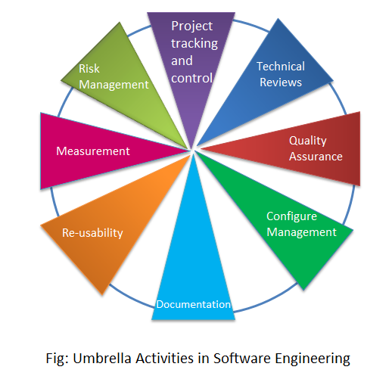

i. **Software Project tracking and control:** It allows the software team to assess progress against the project plan and take necessary action to maintain the schedule.

ii. **Formal Technical Reviews:** It assesses software engineering work products to uncover and remove errors before they are propagated to the next action or activity.

iii. [**Software Quality Assurance**](https://www.softwaretestinghelp.com/software-quality-assurance/)**:** It defines and conducts the activities required to ensure software quality. It is a methodology of checking the software development process with a predefined set of standards.

iv. **Software Configure Management:** It is the task of tracking and controlling changes in the software development part. It manages the effects of change throughout the software process.

v. **Documentation:** At first, all the project planning and other activities should be hard-copy documents and then the production gets started here.

vi. **Re-usability Management:** It defines criteria for work product reuse and establishes mechanisms to achieve reusable components.

vii. **Measurement:** It defines process, project and product measures that assist the team in delivering software that meets customer’s needs, it can be used in conjunction with all other frameworks.

viii. **Risk Management:** It assesses risks that may affect the outcome of the project or the quality of the product.

Software Process Framework Framework is a Standard way to build and deploy applications. Software Process Framework is a foundation of complete software engineering process. Software process framework includes all set of umbrella activities. It also includes number of framework activities that are applicable to all software projects. A generic process framework encompasses five activities which are given below one by one: 1. Communication: In this activity, heavy communication with customers and other stakeholders, requirement gathering is done. 2. Planning: In this activity, we discuss the technical related tasks, work schedule, risks, required resources etc. 3. Modeling: Modelling is about building representations of things in the ‘real world’.In modelling activity, a product’s model is created in order to better understanding and requirements. 4. Construction: In software engineering, construction is the application of set of procedures that are needed to assemble the product. In this activity, we generate the code and test the product in order to make better product. 5. Deployment: In this activity, a complete or non-complete products or software are represented to the customers to evaluate and give feedback. on the basis of their feedback we modify the products for supply better product. Umbrella activities include: • Risk management • Software quality assurance(SQA) • Software configuration management(SCM) • Measurement • Formal technical reviews(FTR) Umbrella Activities: Software engineering is a collection of co-related steps. These steps are presented or accessed in different approaches in different software process models. Umbrella activities are a set of steps or procedure that the software engineering team follows to maintain the progress, quality, change and risks of the overall development tasks. These steps of umbrella activities will evolve through the phases of generic Umbrella Activities are as follows: view 1. Software Project Tracking and Control 2. Formal Technical Reviews 3. Software Quality Assurance of software development. 4. Software Configuration Management 5. Document Preparation and Production 6. Re-usability Management 7. Measurement and Metrics 8. Risk Management Software Project Tracking and Control: Before the actual development begins, a schedule for developing the software is created. Based on that schedule the development will be done. However, after a certain period of time it is required to review the progress of the development to find out actions which are in need to be taken to complete the development, testing etc. in time. The outcome of the review might require the development to be rescheduled. Formal Technical Reviews: Software engineering is done in clusters or modules, after completing each module, it is good practice to review the completed module to find out and remove errors so their propagation to the next module can be prevented. Software Quality Assurance: The quality of the software such user experience, performance, load handling capacity etc. should be tested and confirmed after reaching predefined milestones. This reduces the task at the end of the development process. It should be conducted by dedicated teams so that the development can keep going on. Software Configuration Management: Software configuration management (SCM) is a set of activities designed to control change by identifying the work products that are likely to change, establishing relationships among them, defining mechanisms for managing different versions of these work products. Document preparation and production: All the project planning and other activities should be hardly copied and the production get started here. Re-usability Management: This includes the backing up of each part of the software project they can be corrected or any kind of support can be given to them later to update or upgrade the software at user/time demand. Measurement & Metrics: This will include all the measurement of every aspects of the software project. Risk Management: Risk management is a series of steps that help a software team to understand and manage uncertainty. It’s a really good idea to identify it, assess its probability of occurrence, estimate its impact, and establish a contingency plan that─ ‘should the problem actually occur’.

The phases and related steps of the generic view of software engineering are complemented by a number of umbrella activities. Typical activities in this category include:

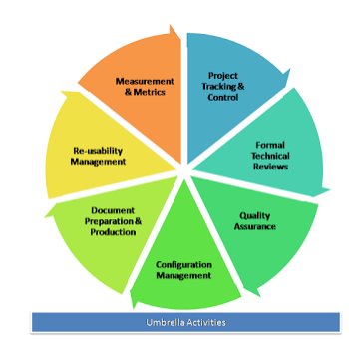

**Software project tracking and control:** When plan, tasks, models all have been done then a network of software engineering tasks that will enable to get the job done on time will have to be created.

**Formal technical reviews:** This includes reviewing the techniques that has been used in the project.

**Software quality assurance**: This is very important to ensure the quality measurement of each part to ensure them.

**Software configuration management:** Software configuration management (SCM) is a set of activities designed to control change by identifying the work products that are likely to change, establishing relationships among them, defining mechanisms for managing different versions of these work products.

**Document preparation and production:** All the project planning and other activities should be hardly copied and the production get started here.

**Re-usability management:** This includes the backing up of each part of the software project they can be corrected or any kind of support can be given to them later to update or upgrade the software at user/time demand.

**Measurement & Metrics:** This will include all the measurement of every aspects of the software project.

**Risk management:** Risk management is a series of steps that help a software team to understand and manage uncertainty. It’s a really good idea to identify it, assess its probability of occurrence, estimate its impact, and establish a contingency plan that─ ‘should the problem actually occur’.

A **Software Process Framework** is a structured approach that defines the steps, tasks, and activities involved in software development. This framework serves as a **foundation for software engineering**, guiding the development team through various stages to ensure a **systematic and efficient process**. A Software Process Framework helps in project planning, risk management, and quality assurance by detailing the chronological order of actions.

**Table of Content**

* [What is a Software Process Framework?](https://www.geeksforgeeks.org/software-engineering/software-engineering-software-process-framework/#what-is-a-software-process-framework)
* [What Is a Software Development Framework?](https://www.geeksforgeeks.org/software-engineering/software-engineering-software-process-framework/#what-is-a-software-development-framework)
* [Advantages of Software Development Framework](https://www.geeksforgeeks.org/software-engineering/software-engineering-software-process-framework/#advantages-of-software-development-framework)
* [Dis-advantages of Software Development Framework](https://www.geeksforgeeks.org/software-engineering/software-engineering-software-process-framework/#disadvantages-of-software-development-framework)
* [How to Choose a Suitable Development Framework](https://www.geeksforgeeks.org/software-engineering/software-engineering-software-process-framework/#how-to-choose-a-suitable-development-framework)
* [Software Process Framework Activities](https://www.geeksforgeeks.org/software-engineering/software-engineering-software-process-framework/#software-process-framework-activities)
* [Popular Software Development Frameworks](https://www.geeksforgeeks.org/software-engineering/software-engineering-software-process-framework/#popular-software-development-frameworks)
* [Umbrella Activities](https://www.geeksforgeeks.org/software-engineering/software-engineering-software-process-framework/#umbrella-activities)
* [Conclusion](https://www.geeksforgeeks.org/software-engineering/software-engineering-software-process-framework/#conclusion)
* [Frequently Asked Questions Related on Software Process Framework](https://www.geeksforgeeks.org/software-engineering/software-engineering-software-process-framework/#frequently-asked-question-related-to-software-process-framework)

It includes task sets, umbrella activities, and process framework activities, all essential for a **successful software development lifecycle**. Utilizing a well-defined Software Process Framework enhances productivity, consistency, and the overall quality of the software product

**What is a Software Process Framework?**

Software Process Framework details the steps and chronological order of a process. Since it serves as a foundation for them, it is utilized in most applications. Task sets, umbrella activities, and process framework activities all define the characteristics of the software development process. [Software Process](https://www.geeksforgeeks.org/software-engineering/software-processes-in-software-engineering/) includes:

1. **Tasks:** They focus on a small, specific objective.
2. **Action:**It is a set of tasks that produce a major work product.
3. **Activities:** Activities are groups of related tasks and actions for a major objective.

Software Process Framework

**What Is a Software Development Framework?**

A [software development framework](https://www.geeksforgeeks.org/software-engineering/5-most-commonly-used-software-development-methodologies/) is a structured set of tools, libraries, best practices, and guidelines that help developers build[software applications](https://www.geeksforgeeks.org/computer-science-fundamentals/what-is-application-software/). Think of it as a template or foundation that provides the basic structure and components needed for a software project.

**Key Points**

1. **Foundation**: It gives a basic structure or template for developing software, so developers don't have to start from scratch.
2. **Components and Tools**: It includes pre-built components and tools that make development faster and easier.
3. **Best Practices and Guidelines**: It offers best practices and guidelines to ensure the software is built in an organized and efficient way.
4. **Customization**: Developers can modify and add new functions to customize the framework to their specific needs.

**Advantages of Software Development Framework**

A **Software Development Framework** offers numerous benefits that streamline the **software development process** and enhance the quality and efficiency of the final product. Here are some key advantages:

1. **Increased Productivity**: Frameworks provide pre-built components and tools, allowing developers to focus on specific application logic rather than reinventing the wheel.
2. **Consistent Quality**: By following best practices and standardized processes, frameworks help ensure consistent code quality and structure across the project.
3. **Reduced Development Time**: With ready-to-use templates and libraries, developers can significantly cut down on the time needed to build applications from scratch.
4. **Better Maintainability**: A structured framework makes the codebase more organized and easier to understand, which simplifies maintenance and updates.
5. **Enhanced Security**: Frameworks often include built-in security features and follow industry best practices, reducing the risk of vulnerabilities.
6. **Scalability**: Frameworks are designed to handle growth, making it easier to scale applications as user demand increases.

**Dis-advantages of Software Development Framework**

While **Software Development Frameworks** offer several advantages, they also come with certain drawbacks that developers and organizations should consider:

1. **Learning Curve**: Frameworks often have a steep learning curve, requiring developers to invest time and effort in understanding the framework's architecture, conventions, and best practices.
2. **Restrictions**: Some frameworks impose constraints and limitations on how developers can design and implement certain features, potentially limiting flexibility and creativity.
3. **Complexity Overhead**: In some cases, frameworks introduce unnecessary complexity, especially for smaller or simpler projects, which can lead to over-engineering.
4. **Performance Overhead**: Using a framework may introduce additional layers of abstraction and overhead, which can impact the performance of the application, particularly in resource-intensive environments.
5. **Vendor Lock-in**: Depending heavily on a specific framework can lead to vendor lock-in, making it challenging to switch to alternative technologies or frameworks in the future.

**How to Choose a Suitable Development Framework**

Choosing a suitable development framework is crucial for the success of a software project. Here are key steps to help you make an informed decision. Here is a simple and effective strategy to help you select the most suitable framework for your project

**1. Consider the Framework’s Language**

* **Popular Languages**: Start with frameworks in popular programming languages like Java, Python, or Ruby if you have no preference. These languages often have robust frameworks with strong community support.

**2. Open-Source vs. Paid Frameworks**

* **Open-Source**: Generally have a large user base, frequent updates, and community contributions.
* **Paid**: Often more reliable with better support but may lack customization and timely updates.

**3. Community and Support**

* **Community Size**: A large, active community means better support, more tutorials, and a more mature framework. Look for frameworks with extensive community resources and engagement.

**4. Review Case Studies and Example Applications**

* **Practical Insights**: Check the framework’s website or repositories for case studies or example applications. These can provide insights into development processes and methods that work well with the framework.

**5. Test the Framework Yourself**

* **Hands-On Experience**: Try out the framework in your own project to see how it fits your needs. Testing helps you understand the framework's functionality and whether it suits your development scenario.

**Software Process Framework Activities**

The Software process framework is required for representing common process activities. Five framework activities are described in a process framework for [software engineering](https://www.geeksforgeeks.org/software-engineering/software-engineering-introduction-to-software-engineering/). Communication, planning, modeling, construction, and deployment are all examples of framework activities. Each engineering action defined by a framework activity comprises a list of needed work outputs, project milestones, and [software quality assurance (SQA)](https://www.geeksforgeeks.org/software-testing/software-engineering-software-quality-assurance/) points. Let's explain each:

Software Process Framework Activities

**1. Communication**

**Definition**: Communication involves gathering requirements from customers and stakeholders to determine the system's objectives and the software's requirements.

**Activities**:

* **Requirement Gathering**: Engaging with consumers and stakeholders through meetings, interviews, and surveys to understand their needs and expectations.
* **Objective Setting**: Clearly defining what the system should achieve based on the gathered requirements.

**Explanation**: Effective communication is essential to understand what the users need from the software. This phase ensures that all stakeholders are on the same page regarding the goals and requirements of the system.

**2. Planning**

**Definition**: Planning involves establishing an engineering work plan, describing technical risks, listing resource requirements, and defining a work schedule.

**Activities**:

* **Work Plan**: Creating a detailed plan that outlines the tasks and activities needed to develop the software.
* **Risk Assessment**: Identifying potential technical risks and planning how to mitigate them.
* **Resource Allocation**: Determining the resources (time, personnel, tools) required for the project.
* **Schedule Definition**: Setting a timeline for completing different phases of the project.

**Explanation**: Planning helps in organizing the project and setting clear expectations. It ensures that the development team has a roadmap to follow and that potential challenges are anticipated and managed.

**3. Modeling**

**Definition**: Modeling involves creating architectural models and designs to better understand the problem and work towards the best solution.

**Activities**:

* **Analysis of Requirements**: Breaking down the gathered requirements to understand what the system needs to do.
* **Design**: Creating architectural and detailed designs that outline how the software will be structured and how it will function.

**Explanation**: Modeling translates requirements into a visual and structured representation of the system. It helps in identifying the best design approach and serves as a blueprint for development.

**4. Construction**

**Definition**: Construction involves creating code, testing the system, fixing bugs, and confirming that all criteria are met.

**Activities**:

* **Code Generation**: Writing the actual code based on the design models.
* **Testing**: Running tests to ensure the software works as intended, identifying and fixing bugs.

**Explanation**: This phase is where the actual software is built. Testing is crucial to ensure that the code is error-free and that the software meets all specified requirements.

**5. Deployment**

**Definition**: Deployment involves presenting the completed or partially completed product to customers for evaluation and feedback, then making necessary modifications based on their input.

**Activities**:

* **Product Release**: Delivering the software to users, either as a full release or in stages.
* **Feedback Collection**: Gathering feedback from users about their experience with the software.
* **Product Improvement**: Making changes and improvements based on user feedback to enhance the product.

**Popular Software Development Frameworks**

* **Angular**
* **React**
* **Vue.js**
* **Django**
* **Flask**
* **Ruby on Rails**
* **Spring**
* **Express**
* **Laravel**
* **ASP.NET Core**

**Umbrella Activities**

[Umbrella Activities](https://www.geeksforgeeks.org/software-engineering/umbrella-activities-in-software-engineering/) that take place during a [software development process](https://www.geeksforgeeks.org/software-engineering/software-development-process/) for improved project management and tracking.

1. **Software project tracking and control:**This is an activity in which the team can assess progress and take corrective action to maintain the schedule. Take action to keep the project on time by comparing the project's progress against the plan.
2. **Risk management:**The risks that may affect project outcomes or quality can be analyzed. Analyze potential risks that may have an impact on the software product's quality and outcome.
3. **Software quality assurance:** These are activities required to maintain software quality. Perform actions to ensure the product's quality.
4. **Formal technical reviews:**It is required to assess engineering work products to uncover and remove errors before they propagate to the next activity. At each level of the process, errors are evaluated and fixed.
5. **Software configuration management:**Managing of configuration process when any change in the software occurs.
6. **Work product preparation and production:** The activities to create models, documents, logs, forms, and lists are carried out.
7. **Reusability management:**It defines criteria for work product reuse. Reusable work items should be backed up, and reusable software components should be achieved.
8. **Measurement:** In this activity, the process can be defined and collected. Also, project and product measures are used to assist the software team in delivering the required software.

**Conclusion**

The [Software Process Framework](https://www.geeksforgeeks.org/software-engineering/software-engineering-software-process-framework/) outlines a structured approach to [software development](https://www.geeksforgeeks.org/software-engineering/what-is-software-development/), detailing key activities like communication, planning, modeling, construction, and deployment. It ensures systematic progress from gathering requirements to delivering the final product. Supporting activities like[quality assurance](https://www.geeksforgeeks.org/software-engineering/differences-between-quality-assurance-and-quality-control/)and[risk management](https://www.geeksforgeeks.org/software-engineering/risk-management-software-engineering/) enhance project efficiency and product quality. This framework helps teams build reliable, high-quality software efficiently.

A process framework

Process framework plays a major role in every software development activity as it forms a base in initiating the development process. It is used to estimate certain framework activities which are applied in very developmental activity, irrespective of its size. The process framework includes several umbrella activities, which are useful throughout the software development process. Next to umbrella activity is a framework activity which includes definite number of software engineering actions applicable in driving a specific software engineering application. Each of these engineering actions corresponds to the task set which encompasses a list of actions to be applied. Each engineering action can perform a constituent activity which forms an essential part of the specific software application being developed.

The five generic process framework activities useful in developing several projects are given below: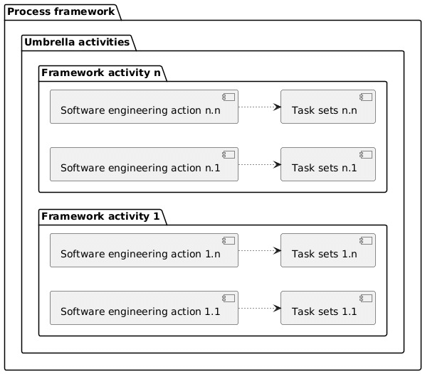

**1. Communication**

This refers to a framework activity where, usually the end users (say customers) are communicated and their views related to the project are analyzed. Here, reports related to customer requirement specifications are developed.

**2. Planning**

In this framework activity, usually the entire work schedule which is going to be implemented in further stages is prepared. Hence, various issues to be addressed during this framework are risks, requirement of resources, software schedules, important products to be developed etc.

**3. Modelling**

Once the developer is done with analyzing the customer requirement specifications, the third framework activity will be modeling. Here, usually UML diagrams are used to represent the project in the form of architecture. This helps developers and the customer to gain an insight of the end product.

**4. Construction**

It is a combination of code generation and testing.

**5. Deployment**

In this framework activity, usually the developed project is delivered to the end users. They deploy the project and give relative feedbacks to the developers.

Umbrella activities

There are eight umbrella activities of a software process framework. They are:

* Tracking and controlling software project
* Managing risks
* Software Quality Assurance (SQA)
* Formal technical reviews
* Software measurements
* Software Configuration Management (SCM)
* Managing reusability factor
* Preparing and producing software work products

**Tracking and controlling software project**

The first umbrella activity is tracking and controlling the software project. This activity allows the software team to perform the following tasks:

* Assessing of progress of the project against the plan of the project
* Maintaining the schedule of the project by taking appropriate action based on above assessment

**Managing risks**

This activity involves the following tasks:

* Evaluation of those risks that can have a serious impact on the final result of the project
* Assessment of those risks that are likely to affect the product’s quality

**Software Quality Assurance (SQA)**

This activity ensures the software quality by defining and organizing the activities needed to assure quality of software.

**Formal technical reviews**

This activity tries to eliminate errors as quickly as possible so that they don’t affect the other activities. It is done by evaluation of work products of software engineering.

**Software measurements**

This activity describes as well as gathers measures of process, product, and project through which software team can deliver a software that fulfills the needs of the customer.

**Software Configuration Management (SCM)**

SCM is also referred to as Change Management (CM). During the software engineering process, SCM defines a set of activities for managing the changes made to the software components.

**Managing reusability factor**

This activity is incorporated by the software process framework because of the following reasons:

* It defines the basic criteria for reusing a work product. Other than this, it also defines a criteria for software components reuse
* It also obtains reusable components by developing the desired methods

**Preparing and producing software work products**

The last and final activity is the preparation and production of work products. It includes certain activities that are needed for the creation of the following work products:

* Models
* Logs
* Documents
* Lists and forms

**Software Requirement Tasks - Software Engineering**

Last Updated : 23 Jul, 2025

Requirements engineering tasks involve a structured process to identify, analyze, and manage the needs and constraints of a software project. This ensures that the final product meets user expectations and functions correctly.

**Table of Content**

* [What is Requirement Engineering?](https://www.geeksforgeeks.org/software-engineering/software-engineering-software-requirement-tasks/#what-is-requirement-engineering)
* [Requirement Engineering Process](https://www.geeksforgeeks.org/software-engineering/software-engineering-software-requirement-tasks/#requirement-engineering-process)
* [Requirements Engineering Tasks](https://www.geeksforgeeks.org/software-engineering/software-engineering-software-requirement-tasks/#requirements-engineering-tasks)
* [Conclusion](https://www.geeksforgeeks.org/software-engineering/software-engineering-software-requirement-tasks/#conclusion)
* [Frequently Asked Questions related to Requirement Engineering Tasks](https://www.geeksforgeeks.org/software-engineering/software-engineering-software-requirement-tasks/#frequently-asked-questions-related-to-requirement-engineering-tasks)

**What is Requirement Engineering?**

Requirements engineering is a broad domain that focuses on being the connector between modeling, analysis, design, and construction. It is the process that defines, identifies, manages, and develops requirements in a software engineering design process. This process uses tools, methods, and principles to describe the system's behavior and the constraints that come along with it.

[Requirements engineering](https://www.geeksforgeeks.org/software-engineering/software-engineering-requirements-engineering-process/) is the most important part every business must follow, in order to build and release a project successfully, as it is the foundation to key planning and implementation.

**Requirement Engineering Process**

Following are the Requirement Engineering Process

1. [**Feasibility Study**](https://www.geeksforgeeks.org/software-engineering/types-of-feasibility-study-in-software-project-development/)
2. [**Requirements elicitation**](https://www.geeksforgeeks.org/software-engineering/software-engineering-requirements-elicitation/)
3. [**Requirements specification**](https://www.geeksforgeeks.org/software-engineering/software-requirement-specification-srs-format/)
4. **Requirements for verification and validation**
5. **Requirements management**

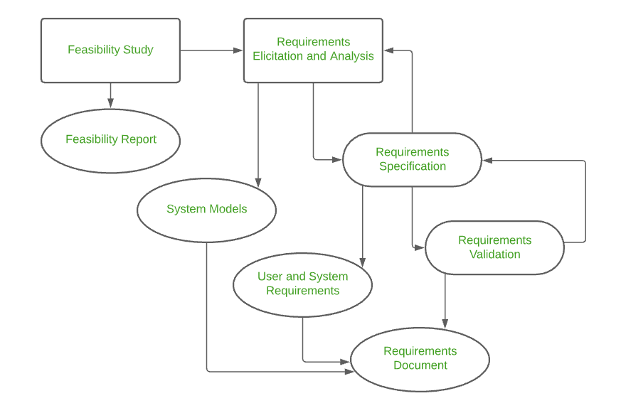Requirements Engineering Process

**Requirements Engineering Tasks**

The software requirements engineering process includes the following steps of activities:

1. **Inception**
2. **Elicitation**
3. **Elaboration**
4. **Negotiation**
5. **Specification**
6. **Validation**
7. **Requirements Management**

Let's discuss each of these steps in detail.

**1. Inception**

This is the first phase of the requirements analysis process. This phase gives an outline of how to get started on a project. In the inception phase, all the basic questions are asked on how to go about a task or the steps required to accomplish a task. A basic understanding of the problem is gained and the nature of the solution is addressed. Effective communication is very important in this stage, as this phase is the foundation as to what has to be done further. Overall in the inception phase, the following criteria have to be addressed by the software engineers:

* Understanding of the problem.
* The people who want a solution.
* Nature of the solution.
* Communication and collaboration between the customer and developer.

**2. Elicitation**

This is the second phase of the requirements analysis process. This phase focuses on gathering the requirements from the stakeholders. One should be careful in this phase, as the requirements are what establishes the key purpose of a project. Understanding the kind of requirements needed from the customer is very crucial for a developer. In this process, mistakes can happen in regard to, not implementing the right requirements or forgetting a part. The right people must be involved in this phase. The following problems can occur in the elicitation phase:

* **Problem of Scope:**The requirements given are of unnecessary detail, ill-defined, or not possible to implement.
* **Problem of Understanding:** Not having a clear-cut understanding between the developer and customer when putting out the requirements needed. Sometimes the customer might not know what they want or the developer might misunderstand one requirement for another.
* **Problem of Volatility:**Requirements changing over time can cause difficulty in leading a project. It can lead to loss and wastage of resources and time.

**3. Elaboration**

**T**his is the third phase of the requirements analysis process. This phase is the result of the inception and elicitation phase. In the elaboration process, it takes the requirements that have been stated and gathered in the first two phases and refines them. Expansion and looking into it further are done as well.  The main task in this phase is to indulge in modeling activities and develop a prototype that elaborates on the features and constraints using the necessary tools and functions.

**4. Negotiation**

This is the fourth phase of the requirements analysis process. This phase emphasizes discussion and exchanging conversation on what is needed and what is to be eliminated. In the negotiation phase, negotiation is between the developer and the customer and they dwell on how to go about the project with limited business resources. Customers are asked to prioritize the requirements and make guesstimates on the conflicts that may arise along with it. Risks of all the requirements are taken into consideration and negotiated in a way where the customer and developer are both satisfied with reference to the further implementation. The following are discussed in the negotiation phase:

* Availability of Resources.
* Delivery Time.
* Scope of requirements.
* Project Cost.
* Estimations on development.

**5. Specification**

This is the fifth phase of the requirements analysis process. This phase specifies the following:

* Written document.
* A set of models.
* A collection of use cases.
* A prototype.

In the specification phase, the requirements engineer gathers all the requirements and develops a working model. This final working product will be the basis of any functions, features or constraints to be observed. The models used in this phase include [ER (Entity Relationship) diagrams](https://www.geeksforgeeks.org/dbms/introduction-of-er-model/), [DFD (Data Flow Diagram)](https://www.geeksforgeeks.org/software-engineering/what-is-dfddata-flow-diagram/), FDD (Function Decomposition Diagrams), and [Data Dictionaries](https://www.geeksforgeeks.org/software-engineering/data-dictionaries-in-software-engineering/).  
A software specification document is submitted to the customer in a language that he/she will understand, to give a glimpse of the working model.

**6. Validation**

This is the sixth phase of the requirements analysis process. This phase focuses on checking for errors and debugging. In the validation phase, the developer scans the specification document and checks for the following:

* All the requirements have been stated and met correctly
* Errors have been debugged and corrected.
* Work product is built according to the standards.

This requirements validation mechanism is known as the formal technical review. The review team that works together and validates the requirements include software engineers, customers, users, and other stakeholders. Everyone in this team takes part in checking the specification by examining for any errors, missing information, or anything that has to be added or checking for any unrealistic and problematic errors. Some of the validation techniques are the following-

* Requirements reviews/inspections.
* Prototyping.
* Test-case generation.
* Automated consistency analysis.

**7. Requirements Management**

This is the last phase of the requirements analysis process. Requirements management is a set of activities where the entire team takes part in identifying, controlling, tracking, and establishing the requirements for the successful and smooth implementation of the project.  
In this phase, the team is responsible for managing any changes that may occur during the project. New requirements emerge, and it is in this phase, responsibility should be taken to manage and prioritize as to where its position is in the project and how this new change will affect the overall system, and how to address and deal with the change. Based on this phase, the working model will be analyzed carefully and ready to be delivered to the customer.

**Conclusion**

Requirements engineering tasks is crucial for successful software projects. It involves gathering, refining, and documenting requirements, ensuring clarity and feasibility. To ensure feasibility and clarity, requirements must be gathered, refined, and documented. This procedure makes sure that the project goals align with those of the stakeholders. Effective requirements engineering reduces risks and guides smooth project execution.

**Software Processes in Software Engineering**

Last Updated : 12 Jul, 2025

**Software** is the set of instructions in the form of programs to govern the computer system and to process the hardware components. To produce a software product the set of activities is used. This set is called a software process.

**Table of Content**

* [What are Software Processes?](https://www.geeksforgeeks.org/software-engineering/software-processes-in-software-engineering/#what-are-software-processes)
* [Components of Software](https://www.geeksforgeeks.org/software-engineering/software-processes-in-software-engineering/#components-of-software)
* [Key Process Activities](https://www.geeksforgeeks.org/software-engineering/software-processes-in-software-engineering/#key-process-activities)
* [Software Crisis](https://www.geeksforgeeks.org/software-engineering/software-processes-in-software-engineering/#software-crisis)
* [Software Process Model](https://www.geeksforgeeks.org/software-engineering/software-processes-in-software-engineering/#software-process-model)
* [Conclusion](https://www.geeksforgeeks.org/software-engineering/software-processes-in-software-engineering/#conclusion)
* [Frequently Asked Questions related to Software Processes](https://www.geeksforgeeks.org/software-engineering/software-processes-in-software-engineering/#frequently-asked-questions-related-to-software-processes)

**What are Software Processes?**

Software processes in software engineering refer to the methods and techniques used to develop and maintain software. Some examples of software processes include:

* [**Waterfall**](https://www.geeksforgeeks.org/software-engineering/waterfall-model/): a linear, sequential approach to software development, with distinct phases such as requirements gathering, design, implementation, testing, and maintenance.
* [**Agile**](https://www.geeksforgeeks.org/software-testing/what-is-agile-methodology/): a flexible, iterative approach to software development, with an emphasis on rapid prototyping and continuous delivery.
* [**Scrum**](https://www.geeksforgeeks.org/software-engineering/scrum-software-development/): a popular Agile methodology that emphasizes teamwork, iterative development, and a flexible, adaptive approach to planning and management.
* [**DevOps**](https://www.geeksforgeeks.org/courses/devops-live): a set of practices that aims to improve collaboration and communication between development and operations teams, with an emphasis on automating the software delivery process.

Each process has its own set of advantages and disadvantages, and the choice of which one to use depends on the specific project and organization.

**Components of Software**

There are three main components of the software:

1. **Program:**A computer program is a list of instructions that tell a computer what to do.
2. **Documentation:**Source information about the product contained in design documents, detailed code comments, etc.
3. **Operating Procedures:**Set of step-by-step instructions compiled by an organization to help workers carry out complex routine operations.

**Other Software Components**

Other Software Components are:

1. **Code**: the instructions that a computer executes in order to perform a specific task or set of tasks.
2. **Data**: the information that the software uses or manipulates.
3. **User**interface: the means by which the user interacts with the software, such as buttons, menus, and text fields.
4. **Libraries**: pre-written code that can be reused by the software to perform common tasks.
5. **Documentation**: information that explains how to use and maintain the software, such as user manuals and technical guides.
6. [**Test cases**](https://www.geeksforgeeks.org/software-testing/test-case/): a set of inputs, execution conditions, and expected outputs that are used to test the software for correctness and reliability.
7. **Configuration** **files**: files that contain settings and parameters that are used to configure the software to run in a specific environment.
8. **Build and deployment** scripts: scripts or tools that are used to build, package, and deploy the software to different environments.
9. **Metadata**: information about the software, such as version numbers, authors, and copyright information.

*All these components are important for software development, testing and deployment.*

**Key Process Activities**

There four basic key process activities are:

1. [**Software Specifications**](https://www.geeksforgeeks.org/software-engineering/software-requirement-specification-srs-format/)**:** In this process, detailed description of a software system to be developed with its functional and non-functional requirements.
2. [**Software Development**](https://www.geeksforgeeks.org/software-engineering/what-is-software-development/)**:**In this process, designing, programming, documenting, testing, and bug fixing is done.
3. [**Software Validation:**](https://www.geeksforgeeks.org/software-engineering/software-engineering-verification-and-validation/)In this process, evaluation software product is done to ensure that the software meets the business requirements as well as the end users needs.
4. [**Software Evolution:**](https://www.geeksforgeeks.org/software-engineering/software-engineering-software-evolution/)It is a process of developing software initially, then timely updating it for various reasons.

**Software Crisis**

The term "[software crisis](https://www.geeksforgeeks.org/software-engineering/software-engineering-software-crisis/)" refers to a set of problems that were faced by the software industry in the 1960s and 1970s, such as:

1. **Size and Cost:**Day to day growing complexity and expectation out of software. Software are more expensive and more complex.
2. **Quality:**Software products must have good quality.
3. **Delayed Delivery:**Software takes longer than the estimated time to develop, which in turn leads to cost shooting up.
4. **High costs and long development times:** software projects were taking much longer and costing much more than expected.
5. **Low quality**: software was often delivered late, with bugs and other defects that made it difficult to use.
6. **Lack of standardization**: there were no established best practices or standards for software development, making it difficult to compare and improve different approaches.
7. **Lack of tools and methodologies**: there were few tools and methodologies available to help with software development, making it a difficult and time-consuming process.

These problems led to a growing realization that the traditional approaches to software development were not effective and needed to be improved. This led to the development of new software development methodologies, such as the Waterfall and Agile methodologies, as well as the creation of new tools and technologies to support software development.

However, even today, software crisis could be seen in some form or the other, like for example software projects going over budget, schedule and not meeting the requirement.

**Software Process Model**

*A software process model is an abstraction of the actual process, which is being described. It can also be defined as a simplified representation of a software process. Each model represents a process from a specific perspective.*

Following are some basic software process models on which different type of software process models can be implemented:

1. **A workflow Model :**It is the sequential series of tasks and decisions that make up a business process.
2. **The Waterfall Model:**It is a sequential design process in which progress is seen as flowing steadily downwards.
   * Phases in waterfall model:
     + Requirements Specification
     + Software Design
     + Implementation
     + Testing
3. **Dataflow Model:**It is diagrammatic representation of the flow and exchange of information within a system.
4. **Evolutionary Development Model:**Following activities are considered in this method:
   * Specification
   * Development
   * Validation
5. **Role / Action Model:**Roles of the people involved in the software process and the activities.

**Need for Process Model**

*The software development team must decide the process model that is to be used for software product development and then the entire team must adhere to it. This is necessary because the software product development can then be done systematically. Each team member will understand what is the next activity and how to do it. Thus process model will bring the definiteness and discipline in overall development process.  Every process model consists of definite entry and exit criteria for each phase. Hence the transition of the product through various phases is definite.*

If the process model is not followed for software development then any team member can perform any software development activity, this will ultimately cause a chaos and software project will definitely fail without using process model, it is difficult to monitor the progress of software product. Thus process model plays an important rule in software engineering.

**Advantages or Disadvantages of Process Model**

There are several advantages and disadvantages to different software development methodologies, such as:

**Waterfall**

**Advantages of waterfall model are:**

1. Clear and defined phases of development make it easy to plan and manage the project.
2. It is well-suited for projects with well-defined and unchanging requirements.

**Disadvantages of waterfall model are:**

1. Changes made to the requirements during the development phase can be costly and time-consuming.
2. It can be difficult to know how long each phase will take, making it difficult to estimate the overall time and cost of the project.
3. It does not have much room for iteration and feedback throughout the development process.

**Agile**

**Advantages of Agile Model are:**

1. Flexible and adaptable to changing requirements.
2. Emphasizes rapid prototyping and continuous delivery, which can help to identify and fix problems early on.
3. Encourages collaboration and communication between development teams and stakeholders.

**Disadvantages of Agile Model are:**

1. It may be difficult to plan and manage a project using Agile methodologies, as requirements and deliverables are not always well-defined in advance.
2. It can be difficult to estimate the overall time and cost of a project, as the process is iterative and changes are made throughout the development.

**Scrum**

**Advantages of Scrum are:**

1. Encourages teamwork and collaboration.
2. Provides a flexible and adaptive framework for planning and managing software development projects.
3. Helps to identify and fix problems early on by using frequent testing and inspection.

**Disadvantages of Scrum are:**

1. A lack of understanding of Scrum methodologies can lead to confusion and inefficiency.
2. It can be difficult to estimate the overall time and cost of a project, as the process is iterative and changes are made throughout the development.

**DevOps**

**Advantages of DevOps are:**

1. Improves collaboration and communication between development and operations teams.
2. Automates software delivery process, making it faster and more efficient.
3. Enables faster recovery and response time in case of issues.

**Disadvantages of DevOps are:**

1. Requires a significant investment in tools and technologies.
2. Can be difficult to implement in organizations with existing silos and lack of culture of collaboration.
3. Need to have a skilled workforce to effectively implement the devops practices.
4. Ultimately, the choice of which methodology to use depends on the specific project and organization, as well as the goals and requirements of the project.

**Conclusion**

Software processes provide structured methods for developing and maintaining software. They include approaches like Waterfall for linear projects, Agile for flexibility, Scrum for teamwork, and DevOps for automation and collaboration. Each has unique strengths, tailored to different project needs. Choosing the right process enhances efficiency and product quality.

A **software development process** prescribes a process for [developing](https://en.wikipedia.org/wiki/Software_development) [software](https://en.wikipedia.org/wiki/Software). It typically divides an overall effort into smaller steps or sub-processes that are intended to ensure high-quality results. The process may describe specific [deliverables](https://en.wikipedia.org/wiki/Deliverable) – artifacts to be created and completed.[[1]](https://en.wikipedia.org/wiki/Software_development_process#cite_note-CMS08-1)

Although not strictly limited to it, software development process often refers to the high-level process that governs the development of a software system from its beginning to its end of life – known as a methodology, model or framework. The [system development life cycle](https://en.wikipedia.org/wiki/System_development_life_cycle) (SDLC) describes the typical phases that a development effort goes through from the beginning to the end of life for a system – including a software system. A methodology prescribes how [engineers](https://en.wikipedia.org/wiki/Engineer) go about their work in order to move the system through its life cycle. A methodology is a classification of processes or a blueprint for a process that is devised for the SDLC. For example, many processes can be classified as a spiral model.

Software process and [software quality](https://en.wikipedia.org/wiki/Software_quality) are closely interrelated; some unexpected facets and effects have been observed in practice.[[2]](https://en.wikipedia.org/wiki/Software_development_process#cite_note-ieeesw-2)

**Methodology**

The SDLC drives the definition of a methodology in that a methodology must address the phases of the SDLC. Generally, a methodology is designed to result in a high-quality system that meets or exceeds expectations (requirements) and is delivered on time and within budget even though computer systems can be complex and integrate disparate components.[[3]](https://en.wikipedia.org/wiki/Software_development_process#cite_note-3) Various methodologies have been devised, including [waterfall](https://en.wikipedia.org/wiki/Waterfall_model), [spiral](https://en.wikipedia.org/wiki/Spiral_model), [agile](https://en.wikipedia.org/wiki/Agile_software_development), [rapid prototyping](https://en.wikipedia.org/wiki/Software_prototyping#Throwaway_prototyping), [incremental](https://en.wikipedia.org/wiki/Incremental_development), and synchronize and stabilize.[[4]](https://en.wikipedia.org/wiki/Software_development_process#cite_note-4)

A major difference between methodologies is the degree to which the phases are sequential vs. iterative. Agile methodologies, such as [XP](https://en.wikipedia.org/wiki/Extreme_Programming) and [scrum](https://en.wikipedia.org/wiki/Scrum_(development)), focus on lightweight processes that allow for rapid changes.[[5]](https://en.wikipedia.org/wiki/Software_development_process#cite_note-5) [Iterative](https://en.wikipedia.org/wiki/Iterative_and_incremental_development) methodologies, such as [Rational Unified Process](https://en.wikipedia.org/wiki/Rational_Unified_Process) and [dynamic systems development method](https://en.wikipedia.org/wiki/Dynamic_systems_development_method), focus on stabilizing project scope and iteratively expanding or improving products. Sequential or big-design-up-front (BDUF) models, such as waterfall, focus on complete and correct planning to guide larger projects and limit risks to successful and predictable results.[[6]](https://en.wikipedia.org/wiki/Software_development_process#cite_note-6) [Anamorphic development](https://en.wikipedia.org/wiki/Anamorphic_development) is guided by project scope and adaptive iterations. In scrum,[[7]](https://en.wikipedia.org/wiki/Software_development_process#cite_note-7) for example, one could say a single user story goes through all the phases of the SDLC within a two-week sprint. By contrast the waterfall methodology, where every business requirement[[*citation needed*](https://en.wikipedia.org/wiki/Wikipedia:Citation_needed)] is translated into feature/functional descriptions which are then all implemented typically over a period of months or longer.[[*citation needed*](https://en.wikipedia.org/wiki/Wikipedia:Citation_needed)]

A project can include both a [project life cycle](https://en.wikipedia.org/wiki/Project_life_cycle) (PLC) and an SDLC, which describe different activities. According to Taylor (2004), "the project life cycle encompasses all the activities of the [project](https://en.wikipedia.org/wiki/Project), while the systems development life cycle focuses on realizing the product [requirements](https://en.wikipedia.org/wiki/Requirement)".[[8]](https://en.wikipedia.org/wiki/Software_development_process#cite_note-8)

**History**

The term *SDLC* is often used as an abbreviated version of *SDLC methodology*. Further, some use *SDLC* and *traditional SDLC* to mean the waterfall methodology.

According to Elliott (2004), SDLC "originated in the 1960s, to develop large scale functional [business systems](https://en.wikipedia.org/wiki/Business_systems) in an age of large scale [business conglomerates](https://en.wikipedia.org/wiki/Business_conglomerate). Information systems activities revolved around heavy [data processing](https://en.wikipedia.org/wiki/Data_processing) and [number crunching](https://en.wikipedia.org/wiki/Number_crunching) routines".[[9]](https://en.wikipedia.org/wiki/Software_development_process#cite_note-Ell04-9) The [structured systems analysis and design method](https://en.wikipedia.org/wiki/Structured_systems_analysis_and_design_method) (SSADM) was produced for the UK government [Office of Government Commerce](https://en.wikipedia.org/wiki/Office_of_Government_Commerce) in the 1980s. Ever since, according to Elliott (2004), "the traditional life cycle approaches to systems development have been increasingly replaced with alternative approaches and frameworks, which attempted to overcome some of the inherent deficiencies of the traditional SDLC".[[9]](https://en.wikipedia.org/wiki/Software_development_process#cite_note-Ell04-9) The main idea of the SDLC has been "to pursue the development of information systems in a very deliberate, structured and methodical way, requiring each stage of the life cycle––from the inception of the idea to delivery of the final system––to be carried out rigidly and sequentially"[[9]](https://en.wikipedia.org/wiki/Software_development_process#cite_note-Ell04-9) within the context of the framework being applied.

Other methodologies were devised later:

**1970s**

* [Structured programming](https://en.wikipedia.org/wiki/Structured_programming) since 1969
* [Cap Gemini SDM](https://en.wikipedia.org/wiki/Cap_Gemini_SDM), originally from PANDATA, the first English translation was published in 1974. SDM stands for System Development Methodology

**1980s**

* [Structured systems analysis and design method](https://en.wikipedia.org/wiki/Structured_systems_analysis_and_design_method) (SSADM) from 1980 onwards
* [Information Requirement Analysis/Soft systems methodology](https://en.wikipedia.org/wiki/Soft_systems_methodology)

**1990s**

* [Object-oriented programming](https://en.wikipedia.org/wiki/Object-oriented_programming) (OOP) developed in the early 1960s and became a dominant programming approach during the mid-1990s
* [Rapid application development](https://en.wikipedia.org/wiki/Rapid_application_development) (RAD), since 1991
* [Dynamic systems development method](https://en.wikipedia.org/wiki/Dynamic_systems_development_method) (DSDM), since 1994
* [Scrum](https://en.wikipedia.org/wiki/Scrum_(software_development)), since 1995
* [Team software process](https://en.wikipedia.org/wiki/Team_software_process), since 1998
* [Rational Unified Process](https://en.wikipedia.org/wiki/Rational_Unified_Process) (RUP), maintained by IBM since 1998
* [Extreme programming](https://en.wikipedia.org/wiki/Extreme_programming), since 1999

**2000s**

* [Agile Unified Process](https://en.wikipedia.org/wiki/Agile_Unified_Process) (AUP) maintained since 2005 by [Scott Ambler](https://en.wikipedia.org/wiki/Scott_Ambler)
* [Disciplined agile delivery](https://en.wikipedia.org/wiki/Disciplined_agile_delivery) (DAD) Supersedes AUP

**2010s**

* [Scaled Agile Framework](https://en.wikipedia.org/wiki/Scaled_Agile_Framework) (SAFe)
* [Large-Scale Scrum](https://en.wikipedia.org/wiki/Large-Scale_Scrum) (LeSS)
* [DevOps](https://en.wikipedia.org/wiki/DevOps)

Since DSDM in 1994, all of the methodologies on the above list except RUP have been agile methodologies - yet many organizations, especially governments, still use pre-agile processes (often waterfall or similar).

**Examples**

The following are notable methodologies somewhat ordered by popularity.

**Agile**

[Agile software development](https://en.wikipedia.org/wiki/Agile_software_development) refers to a group of frameworks based on iterative development, where requirements and solutions evolve via collaboration between self-organizing cross-functional teams. The term was coined in the year 2001 when the [Agile Manifesto](https://en.wikipedia.org/wiki/Agile_Manifesto) was formulated.

**Waterfall**

The [waterfall model](https://en.wikipedia.org/wiki/Waterfall_model) is a sequential development approach, in which development flows one-way (like a waterfall) through the SDLC phases.

**Spiral**

In 1988, [Barry Boehm](https://en.wikipedia.org/wiki/Barry_Boehm) published a software system development [spiral model](https://en.wikipedia.org/wiki/Spiral_model), which combines key aspects of the waterfall model and [rapid prototyping](https://en.wikipedia.org/wiki/Rapid_application_development), in an effort to combine advantages of [top-down and bottom-up](https://en.wikipedia.org/wiki/Top-down_and_bottom-up_design) concepts. It emphases a key area many felt had been neglected by other methodologies: deliberate iterative risk analysis, particularly suited to large-scale complex systems.

**Incremental**

[Various methods combine linear and iterative methodologies](https://en.wikipedia.org/wiki/Iterative_and_incremental_development), with the primary objective of reducing inherent project risk by breaking a project into smaller segments and providing more ease-of-change during the development process.

**Prototyping**

[Software prototyping](https://en.wikipedia.org/wiki/Software_prototyping) is about creating prototypes, i.e. incomplete versions of the software program being developed.

**Rapid**

[Rapid application development](https://en.wikipedia.org/wiki/Rapid_application_development) (RAD) is a methodology which favors [iterative development](https://en.wikipedia.org/wiki/Iterative_development) and the rapid construction of [prototypes](https://en.wikipedia.org/wiki/Prototype) instead of large amounts of up-front planning. The "planning" of software developed using RAD is interleaved with writing the software itself. The lack of extensive pre-planning generally allows software to be written much faster and makes it easier to change requirements.

**Shape Up**

Shape Up is a software development approach introduced by [Basecamp](https://en.wikipedia.org/wiki/Basecamp_(company)) in 2018. It is a set of principles and techniques that Basecamp developed internally to overcome the problem of projects dragging on with no clear end. Its primary target audience is remote teams. Shape Up has no estimation and velocity tracking, backlogs, or sprints, unlike [waterfall](https://en.wikipedia.org/wiki/Waterfall_model), [agile](https://en.wikipedia.org/wiki/Agile_software_development), or [scrum](https://en.wikipedia.org/wiki/Scrum_(software_development)). Instead, those concepts are replaced with appetite, betting, and cycles. As of 2022, besides Basecamp, notable organizations that have adopted Shape Up include UserVoice and Block.[[10]](https://en.wikipedia.org/wiki/Software_development_process#cite_note-10)[[11]](https://en.wikipedia.org/wiki/Software_development_process#cite_note-11)

**Chaos**

[Chaos model](https://en.wikipedia.org/wiki/Chaos_model) has one main rule: always resolve the most important issue first.

**Incremental funding**

[Incremental funding methodology](https://en.wikipedia.org/wiki/Incremental_funding_methodology) - an iterative approach.

**Lightweight**

[Lightweight methodology](https://en.wikipedia.org/wiki/Lightweight_methodology) - a general term for methods that only have a few rules and practices.

**Structured systems analysis and design**

[Structured systems analysis and design method](https://en.wikipedia.org/wiki/Structured_systems_analysis_and_design_method) - a specific version of waterfall.

**Slow programming**

As part of the larger [slow movement](https://en.wikipedia.org/wiki/Slow_movement_(culture)), emphasizes careful and gradual work without (or minimal) time pressures. Slow programming aims to avoid bugs and overly quick release schedules.

**V-Model**

[V-Model (software development)](https://en.wikipedia.org/wiki/V-Model_(software_development)) - an extension of the waterfall model.

**Unified Process**

[Unified Process](https://en.wikipedia.org/wiki/Unified_Process) (UP) is an iterative software development methodology framework, based on [Unified Modeling Language](https://en.wikipedia.org/wiki/Unified_Modeling_Language) (UML). UP organizes the development of software into four phases, each consisting of one or more executable iterations of the software at that stage of development: inception, elaboration, construction, and guidelines.

**Comparison**

|  |  |
| --- | --- |
| [icon](https://en.wikipedia.org/wiki/File:Question_book-new.svg) | This section **needs additional citations for**[**verification**](https://en.wikipedia.org/wiki/Wikipedia:Verifiability). Please help [improve this article](https://en.wikipedia.org/wiki/Special:EditPage/Software_development_process) by [adding citations to reliable sources](https://en.wikipedia.org/wiki/Help:Referencing_for_beginners) in this section. Unsourced material may be challenged and removed. *(January 2024) (*[*Learn how and when to remove this message*](https://en.wikipedia.org/wiki/Help:Maintenance_template_removal)*)* |

The waterfall model describes the SDLC phases such that each builds on the result of the previous one.[[12]](https://en.wikipedia.org/wiki/Software_development_process#cite_note-US_DJ03-12)[[13]](https://en.wikipedia.org/wiki/Software_development_process#cite_note-EverettSoftware07-13)[[14]](https://en.wikipedia.org/wiki/Software_development_process#cite_note-UnhelkarTheArt16-14)[[15]](https://en.wikipedia.org/wiki/Software_development_process#cite_note-LandPract12-15) Not every project requires that the phases be sequential. For relatively simple projects, phases may be combined or overlapping.[[12]](https://en.wikipedia.org/wiki/Software_development_process#cite_note-US_DJ03-12) Alternative methodologies to waterfall are described and compared below.[[16]](https://en.wikipedia.org/wiki/Software_development_process#cite_note-Post,_G._2006-16)

|  |  |  |  |  |  |  |  |
| --- | --- | --- | --- | --- | --- | --- | --- |
| **Comparison of methodologies** | | | | | | | |
|  | **Waterfall** | [**RAD**](https://en.wikipedia.org/wiki/Rapid_application_development) | [**Open source**](https://en.wikipedia.org/wiki/Open-source_software_development) | [**OOP**](https://en.wikipedia.org/wiki/Object-oriented_programming) | [**JAD**](https://en.wikipedia.org/wiki/Joint_applications_development) | [**proto-typing**](https://en.wikipedia.org/wiki/Software_prototyping) | [**End User**](https://en.wikipedia.org/wiki/End-user_development) |
| Control | Formal | MIS | Weak | Standards | Joint | User | User |
| Time frame | Long | Short | Medium | Any | Medium | Short | Short  – |
| Users | Many | Few | Few | Varies | Few | One or two | One |
| MIS staff | Many | Few | Hundreds | Split | Few | One or two | None |
| Transaction/[DSS](https://en.wikipedia.org/wiki/Decision_support_system) | Transaction | Both | Both | Both | DSS | DSS | DSS |
| Interface | Minimal | Minimal | Weak | Windows | Crucial | Crucial | Crucial |
| Documentation and training | Vital | Limited | Internal | In Objects | Limited | Weak | None |
| Integrity and security | Vital | Vital | Unknown | In Objects | Limited | Weak | Weak |
| Reusability | Limited | Some | Maybe | Vital | Limited | Weak | None |

**Process meta-models**

*Further information:*[*Process patterns*](https://en.wikipedia.org/wiki/Process_patterns)

Some [process models](https://en.wikipedia.org/wiki/Process_model) are abstract descriptions for evaluating, comparing, and improving the specific process adopted by an organization.

**ISO/IEC 12207**

[ISO/IEC 12207](https://en.wikipedia.org/wiki/ISO/IEC_12207) is the international standard describing the method to select, implement, and monitor the life cycle for software.

**Capability Maturity Model Integration**

The [Capability Maturity Model Integration](https://en.wikipedia.org/wiki/Capability_Maturity_Model_Integration) (CMMI) is one of the leading models and is based on best practices. Independent assessments grade organizations on how well they follow their defined processes, not on the quality of those processes or the software produced. CMMI has replaced [CMM](https://en.wikipedia.org/wiki/Capability_Maturity_Model).

**ISO 9000**

[ISO 9000](https://en.wikipedia.org/wiki/ISO_9000) describes standards for a formally organized process to manufacture a product and the methods of managing and monitoring progress. Although the standard was originally created for the manufacturing sector, ISO 9000 standards have been applied to software development as well. Like CMMI, certification with ISO 9000 does not guarantee the quality of the end result, only that formalized business processes have been followed.

**ISO/IEC 15504**

[ISO/IEC 15504](https://en.wikipedia.org/wiki/ISO/IEC_15504) *Information technology—Process assessment*, a.k.a. Software Process Improvement Capability Determination (SPICE), is a framework for the assessment of software processes. This standard is aimed at setting out a clear model for process comparison. SPICE is used much like CMMI. It models processes to manage, control, guide, and monitor software development. This model is then used to measure what a development organization or project team actually does during software development. This information is analyzed to identify weaknesses and drive improvement. It also identifies strengths that can be continued or integrated into common practice for that organization or team.

**ISO/IEC 24744**

[ISO/IEC 24744](https://en.wikipedia.org/wiki/ISO/IEC_24744) *Software Engineering—Metamodel for Development Methodologies*, is a power type-based metamodel for software development methodologies.

**Soft systems methodology**

[Soft systems methodology](https://en.wikipedia.org/wiki/Soft_systems_methodology) is a general method for improving management processes.

**Method engineering**

[Method engineering](https://en.wikipedia.org/wiki/Method_engineering) is a general method for improving information system processes.

The**Waterfall Model**is a **Traditional Software Development Methodology**. It was first introduced by **Winston W. Royce**in 1970. It is a linear and sequential approach to software development that consists of several phases.

This classical waterfall model is simple and idealistic. It is important because most other **Types of Software Development Life Cycle Models**are a derivative of this. In this article, we will see the Waterfall Model in detail.

**What is the SDLC Waterfall Model?**

The waterfall model is a Software Development Model used in the context of large, complex projects, typically in the field of information technology. It is characterized by a structured, sequential approach to [**Project Management**](https://www.geeksforgeeks.org/software-engineering/software-engineering-software-project-management-plan-spmp/)and [**Software Development**](https://www.geeksforgeeks.org/software-engineering/software-development/).

The Waterfall Model is useful in situations where the project requirements are well-defined and the project goals are clear. It is often used for large-scale projects with long timelines, where there is little room for error and the project stakeholders need to have a high level of confidence in the outcome.

*Read more:*[***Software Development Life Cycle (SDLC) Models***](https://www.geeksforgeeks.org/software-engineering/software-development-life-cycle-sdlc/)

**Phases of Waterfall Model**

**Classical Waterfall Model**divides the life cycle into a set of phases. The development process can be considered as a sequential flow in the waterfall. The different sequential phases of the classical waterfall model are follow:

Waterfall Model-Software Engineering

Let us now learn about each of these phases in detail which include further phases.

**1. Requirements Analysis and Specification**

[**Requirement Analysis**](https://www.geeksforgeeks.org/software-engineering/activities-involved-in-software-requirement-analysis/) and specification phase aims to understand the exact requirements of the customer and document them properly. This phase consists of two different activities.

**1. Requirement Gathering and Analysis:** Firstly all the requirements regarding the software are gathered from the customer and then the gathered requirements are analyzed.

The goal of the analysis part is to remove incompleteness (an incomplete requirement is one in which some parts of the actual requirements have been omitted) and inconsistencies (an inconsistent requirement is one in which some part of the requirement contradicts some other part).

**2. Requirement Specification:** These analyzed requirements are documented in a software requirement specification (SRS) document. SRS document serves as a contract between the development team and customers. Any future dispute between the customers and the developers can be settled by examining the SRS document.

**2. Design**

The goal of this **Software Design Phase**is to convert the requirements acquired in the SRS into a format that can be coded in a programming language. It includes high-level and detailed design as well as the overall software architecture. A [**Software Design Document**](https://www.geeksforgeeks.org/software-engineering/design-documentation-in-software-engineering/)is used to document all of this effort (SDD).

* **High-Level Design (HLD)**: This phase focuses on outlining the broad structure of the system. It highlights the key components and how they interact with each other, giving a clear overview of the system’s architecture.
* **Low-Level Design (LLD)**: Once the high-level design is in place, this phase zooms into the details. It breaks down each component into smaller parts and provides specifics about how each part will function, guiding the actual coding process.

**3. Development**

In the **Development Phase**software design is translated into source code using any suitable programming language. Thus each designed module is coded. The unit testing phase aims to check whether each module is working properly or not.

* In this phase, developers begin writing the actual source code based on the designs created earlier.
* The goal is to transform the design into working code using the most suitable programming languages.
* Unit tests are often performed during this phase to make sure that each component functions correctly on its own.

**4. Testing and Deployment**

**1. Testing:**Integration of different modules is undertaken soon after they have been coded and unit tested. Integration of various modules is carried out incrementally over several steps. During each integration step, previously planned modules are added to the partially integrated system and the resultant system is tested. Finally, after all the modules have been successfully integrated and tested, the full working system is obtained and system testing is carried out on this. System testing consists of three different kinds of testing activities as described below.

* [**Alpha testing**](https://www.geeksforgeeks.org/software-testing/alpha-testing-software-testing/)**:** Alpha testing is the system testing performed by the development team.
* [**Beta testing**](https://www.geeksforgeeks.org/software-engineering/beta-testing-software-testing/)**:** Beta testing is the system testing performed by a friendly set of customers.
* [**Acceptance testing**](https://www.geeksforgeeks.org/software-engineering/acceptance-testing-software-testing/)**:** After the software has been delivered, the customer performs acceptance testing to determine whether to accept the delivered software or reject it.

**2. Deployment:**Once the software has been thoroughly tested, it's time to deploy it to the customer or end-users. This means making the software ready and available for use, often by moving it to a live or staging environment.

During this phase, we also focus on helping users get comfortable with the software by providing training, setting up necessary environments, and ensuring everything is running smoothly. The goal is to make sure the system works as expected in real-world conditions and that users can start using it without any hitches.

**5. Maintenance**

In **Maintenance Phase** is the most important phase of a software life cycle. The effort spent on maintenance is 60% of the total effort spent to develop a full software. There are three types of maintenance.

* **Corrective Maintenance:** This type of maintenance is carried out to correct errors that were not discovered during the product development phase.
* **Perfective Maintenance:** This type of maintenance is carried out to enhance the functionalities of the system based on the customer’s request.
* **Adaptive Maintenance:** Adaptive maintenance is usually required for porting the software to work in a new environment such as working on a new computer platform or with a new operating system.

**Features of Waterfall Model**

Following are the features of the waterfall model:

1. **Sequential Approach**: The waterfall model involves a sequential approach to software development, where each phase of the project is completed before moving on to the next one.
2. **Document-Driven:**The waterfall model depended on documentation to ensure that the project is well-defined and the project team is working towards a clear set of goals.
3. **Quality Control:** The waterfall model places a high emphasis on quality control and testing at each phase of the project, to ensure that the final product meets the requirements and expectations of the stakeholders.
4. **Rigorous Planning**: The waterfall model involves a careful planning process, where the project scope, timelines, and deliverables are carefully defined and monitored throughout the project lifecycle.

Overall, the waterfall model is used in situations where there is a need for a highly structured and systematic approach to software development. It can be effective in ensuring that large, complex projects are completed on time and within budget, with a high level of quality and customer satisfaction.

**Importance of Waterfall Model**

Following are the importance of waterfall model:

1. **Clarity and Simplicity:** The linear form of the Waterfall Model offers a simple and unambiguous foundation for project development.
2. **Clearly Defined Phases:** The Waterfall Model phases each have unique inputs and outputs, guaranteeing a planned development with obvious checkpoints.
3. **Documentation:**A focus on thorough documentation helps with software comprehension, maintenance, and future growth.
4. **Stability in Requirements:** Suitable for projects when the requirements are clear and stable, reducing modifications as the project progresses.
5. **Resource Optimization:**It encourages effective task-focused work without continuously changing contexts by allocating resources according to project phases.
6. **Relevance for Small Projects:** Economical for modest projects with simple specifications and minimal complexity.

**Example of Waterfall Model**

Here we can take a Real world example of the Waterfall Model.

***Real-Life Example of Waterfall Model: Developing an Online Banking System***

**1. Analysis**

This phase will be tasked with gathering all the information available on customer banking requirements, transactions, security protocols, and devising the different parameters that’ll be used for determining the core functionalities of the online banking system, such as account management, fund transfers, bill payments, and loan applications.

**2. Design**

In this example of the Waterfall Model, the design phase is all about fine-tuning the parameters established in the analysis phase. The system’s architecture will be designed to manage sensitive data securely, avoid transactional errors, and ensure high performance. This includes database structure, user interface design, encryption protocols, and multi-factor authentication to protect user accounts.

**3. Implementation**

This all-important phase involves doing dummy runs of the online banking system with a provisional set of banking transactions and customer data to see the accuracy with which the system can handle transactions, balance inquiries, fund transfers, and bill payments. These results should be matched with results from banking experts and auditors who ensure compliance with banking regulations and accuracy in transactions.

**4. Testing**

As with any example of the Waterfall Model, the testing phase is about ensuring that all features of the online banking system function smoothly. This includes testing for security vulnerabilities, transaction accuracy, performance under heavy load, and user interface responsiveness. Special attention is given to testing secure logins, data encryption, and ensuring that sensitive data is handled correctly throughout the system.

**5. Maintenance**

In the final phase, the online banking system should be checked for any necessary updates or alterations that may be required, besides the expected inclusion of new features or changes in banking regulations. Regular updates will also be needed for security patches, performance improvements, and the addition of new services like mobile banking, instant loans, or personalized financial advice.

**Advantages of Waterfall Model**

The classical waterfall model is an idealistic model for software development. It is very simple, so it can be considered the basis for other software development life cycle models. Below are some of the major advantages of this SDLC model.

* **Easy to Understand:** The Classical Waterfall Model is very simple and easy to understand.
* **Individual Processing:** Phases in the Classical Waterfall model are processed one at a time.
* **Properly Defined:** In the classical waterfall model, each stage in the model is clearly defined.
* **Clear Milestones:** The classical Waterfall model has very clear and well-understood milestones.
* **Properly Documented:** Processes, actions, and results are very well documented.
* **Reinforces Good Habits:** The Classical Waterfall Model reinforces good habits like define-before-design and design-before-code.
* **Working:** Classical Waterfall Model works well for smaller projects and projects where requirements are well understood.

**Disadvantages of Waterfall Model**

The Classical Waterfall Model suffers from various shortcomings we can’t use it in real projects, but we use other software development lifecycle models which are based on the classical waterfall model. Below are some major drawbacks of this model.

* **No Feedback Path:** In the classical waterfall model evolution of software from one phase to another phase is like a waterfall. It assumes that no error is ever committed by developers during any phase. Therefore, it does not incorporate any mechanism for error correction.
* **Difficult to accommodate Change Requests:** This model assumes that all the customer requirements can be completely and correctly defined at the beginning of the project, but the customer's requirements keep on changing with time. It is difficult to accommodate any change requests after the requirements specification phase is complete.
* **No Overlapping of Phases:** This model recommends that a new phase can start only after the completion of the previous phase. But in real projects, this can't be maintained. To increase efficiency and reduce cost, phases may overlap.
* **Limited Flexibility:** The Waterfall Model is a rigid and linear approach to software development, which means that it is not well-suited for projects with changing or uncertain requirements. Once a phase has been completed, it is difficult to make changes or go back to a previous phase.
* **Limited Stakeholder Involvement:** The Waterfall Model is a structured and sequential approach, which means that stakeholders are typically involved in the early phases of the project (requirements gathering and analysis) but may not be involved in the later phases [(implementation, testing, and deployment).](https://www.geeksforgeeks.org/software-testing/post-deployment-testing-in-software-testing/)
* **Late Defect Detection:** In the Waterfall Model, testing is typically done toward the end of the development process. This means that defects may not be discovered until late in the development process, which can be expensive and time-consuming to fix.
* **Lengthy Development Cycle:**The Waterfall Model can result in a lengthy development cycle, as each phase must be completed before moving on to the next. This can result in delays and increased costs if requirements change or new issues arise.

**When to Use Waterfall Model?**

Here are some cases where the use of the Waterfall Model is best suited:

* **Well-understood Requirements:** Before beginning development, there are precise, reliable, and thoroughly documented requirements available.
* **Very Little Changes Expected:** During development, very little adjustments or expansions to the project's scope are anticipated.
* **Small to Medium-Sized Projects**: Ideal for more manageable projects with a clear development path and little complexity.
* **Predictable:**Projects that are predictable, low-risk, and able to be addressed early in the development life cycle are those that have known, controllable risks.
* **Regulatory Compliance is Critical:** Circumstances in which paperwork is of utmost importance and stringent regulatory compliance is required.
* **Client Prefers a Linear and Sequential Approach**: This situation describes the client's preference for a linear and sequential approach to project development.
* **Limited Resources**: Projects with limited resources can benefit from a set-up strategy, which enables targeted resource allocation.

The Waterfall approach involves less user interaction in the product development process. The product can only be shown to end user when it is ready.

**Applications of Waterfall Model**

Here are some application of SDLC waterfall model:

* **Large-scale Software Development Projects:** The Waterfall Model is often used for large-scale software development projects, where a structured and sequential approach is necessary to ensure that the project is completed on time and within budget.
* **Safety-Critical Systems:** The Waterfall Model is often used in the development of safety-critical systems, such as aerospace or medical systems, where the consequences of errors or defects can be severe.
* **Government and Defense Projects:** The Waterfall Model is also commonly used in government and defense projects, where a rigorous and structured approach is necessary to ensure that the project meets all requirements and is delivered on time.
* **Projects with well-defined Requirements:** The Waterfall Model is best suited for projects with well-defined requirements, as the sequential nature of the model requires a clear understanding of the project objectives and scope.
* **Projects with Stable Requirements:** The Waterfall Model is also well-suited for projects with stable requirements, as the linear nature of the model does not allow for changes to be made once a phase has been completed.

*For more, you can refer to the* [***Uses of Waterfall Model***](https://www.geeksforgeeks.org/software-engineering/when-should-you-use-waterfall-model/)***.***

**Conclusion**

The **Waterfall Model** has good conventional **Software Development Processes**. This model is sequential technique provides an easily understood and applied structured framework. Here we learned the Waterfall model in detail.

he **waterfall model** is the process of performing the typical [software development life cycle](https://en.wikipedia.org/wiki/Software_development_life_cycle) (SDLC) phases in [sequential](https://en.wikipedia.org/wiki/Sequence) order. Each phase is completed before the next is started, and the result of each phase drives subsequent phases.[[1]](https://en.wikipedia.org/wiki/Waterfall_model#cite_note-:0-1) Compared to alternative SDLC methodologies such as [Agile](https://en.wikipedia.org/wiki/Agile_software_development), it is among the least iterative and flexible,[[1]](https://en.wikipedia.org/wiki/Waterfall_model#cite_note-:0-1) as progress flows largely in one direction (like a [waterfall](https://en.wikipedia.org/wiki/Waterfall)) through the phases of conception, [requirements analysis](https://en.wikipedia.org/wiki/Requirements_analysis), [design](https://en.wikipedia.org/wiki/Software_design), [construction](https://en.wikipedia.org/wiki/Software_construction), [testing](https://en.wikipedia.org/wiki/Software_testing), deployment, and [maintenance](https://en.wikipedia.org/wiki/Software_maintenance).[[2]](https://en.wikipedia.org/wiki/Waterfall_model#cite_note-2) The waterfall model is the earliest SDLC methodology.[[3]](https://en.wikipedia.org/wiki/Waterfall_model#cite_note-3) When first adopted, there were no recognized alternatives for knowledge-based creative work.[[4]](https://en.wikipedia.org/wiki/Waterfall_model#cite_note-4)

**History**

The first known presentation describing the use of such phases in software engineering was held by Herbert D. Benington at the Symposium on Advanced Programming Methods for Digital Computers on 29 June 1956.[[5]](https://en.wikipedia.org/wiki/Waterfall_model#cite_note-5) This presentation was about the development of software for [SAGE](https://en.wikipedia.org/wiki/Semi_Automatic_Ground_Environment). In 1983, Benington republished his paper with a foreword explaining that the phases were on purpose organized according to the specialization of tasks, and pointing out that the process was not in fact performed in a strict top-down fashion, but depended on a prototype.[[6]](https://en.wikipedia.org/wiki/Waterfall_model#cite_note-benington-6)[[*better source needed*](https://en.wikipedia.org/wiki/Wikipedia:NOTRS)]

Although the term "waterfall" is not used in the paper, the first formal, detailed diagram of the process is often[[7]](https://en.wikipedia.org/wiki/Waterfall_model#cite_note-7) cited as coming from a 1970 article by [Winston W. Royce](https://en.wikipedia.org/wiki/Winston_W._Royce).[[8]](https://en.wikipedia.org/wiki/Waterfall_model#cite_note-royce-8)[[9]](https://en.wikipedia.org/wiki/Waterfall_model#cite_note-9)[[10]](https://en.wikipedia.org/wiki/Waterfall_model#cite_note-10) However, he commented that it had major flaws stemming from how testing only happened at the end of the process, which he described as being "risky and [inviting] failure".[[8]](https://en.wikipedia.org/wiki/Waterfall_model#cite_note-royce-8) The rest of his paper introduced five steps which he felt were necessary to "eliminate most of the development risks" associated with the unaltered waterfall approach.[[8]](https://en.wikipedia.org/wiki/Waterfall_model#cite_note-royce-8) Royce's five additional steps (which included writing complete documentation at various stages of development) never took mainstream hold, but his diagram of what he considered a flawed process became the starting point when describing a "waterfall" approach.[[11]](https://en.wikipedia.org/wiki/Waterfall_model#cite_note-11)[[12]](https://en.wikipedia.org/wiki/Waterfall_model#cite_note-:inheriting_agile-12)

The earliest use of the term "waterfall" may have been in a 1976 paper by Bell and Thayer.[[13]](https://en.wikipedia.org/wiki/Waterfall_model#cite_note-13)[[*better source needed*](https://en.wikipedia.org/wiki/Wikipedia:NOTRS)]

In 1985, the [United States Department of Defense](https://en.wikipedia.org/wiki/United_States_Department_of_Defense) adopted the waterfall model in the [DOD-STD-2167](https://en.wikipedia.org/wiki/DOD-STD-2167) standard for working with software development contractors. This standard referred for iterations of a software development[[14]](https://en.wikipedia.org/wiki/Waterfall_model#cite_note-:1-14) to "*the sequential phases of a software development cycle*" and stated that "*the contractor shall implement a software development cycle that includes the following six phases: Software Requirement Analysis, Preliminary Design, Detailed Design, Coding and Unit Testing, Integration, and Testing*".[[14]](https://en.wikipedia.org/wiki/Waterfall_model#cite_note-:1-14)[[15]](https://en.wikipedia.org/wiki/Waterfall_model#cite_note-15)

**Phases**

The model describes a linear sequence of steps. Although various different versions can be found, the following describes the essence.[[16]](https://en.wikipedia.org/wiki/Waterfall_model#cite_note-US_DJ03-16)[[17]](https://en.wikipedia.org/wiki/Waterfall_model#cite_note-EverettSoftware07-17)[[18]](https://en.wikipedia.org/wiki/Waterfall_model#cite_note-18)[[19]](https://en.wikipedia.org/wiki/Waterfall_model#cite_note-TaylorIntro08-19)

**Preliminary analysis**

Conduct with a preliminary analysis, consider alternative solutions, estimate costs and benefits, and submit a preliminary plan with recommendations.

* Conduct preliminary analysis: Identify the organization's objectives and define the nature and scope of the project. Ensure that the project fits with the objectives.
* Consider alternative solutions: Alternatives may come from interviewing employees, clients, suppliers, and consultants, as well as competitive analysis.
* Cost-benefit analysis: Analyze the costs and benefits of the project.

**Systems analysis, requirements definition**

Decompose project goals[[*clarification needed*](https://en.wikipedia.org/wiki/Wikipedia:Please_clarify)] into defined functions and operations. This involves gathering and interpreting facts, diagnosing problems, and recommending changes. Analyze end-user information needs and resolve inconsistencies and incompleteness:[[20]](https://en.wikipedia.org/wiki/Waterfall_model#cite_note-20)

* Collect facts: Obtain end-user requirements by document review, client interviews, observation, and questionnaires.
* Scrutinize existing system(s): Identify pros and cons.
* Analyze the proposed system: Find solutions to issues and prepare specifications, incorporating appropriate user proposals.

**Systems design**

At this step, desired features and operations are detailed, including screen layouts, [business rules](https://en.wikipedia.org/wiki/Business_rule), [process diagrams](https://en.wikipedia.org/wiki/Process_flow_diagram), [pseudocode](https://en.wikipedia.org/wiki/Pseudocode), and other deliverables.

**Development**

Write the code.

**Integration and testing**

Assemble the modules in a testing environment. Check for errors, bugs, and interoperability.

**Acceptance, installation, deployment**

Put the system into production. This may involve training users, deploying hardware, and loading information from the prior system.

**Maintenance**

Monitor the system to assess its ongoing fitness. Make modest changes and fixes as needed. To maintain the quality of the system. Continual monitoring and updates ensure the system remains effective and high-quality.[[21]](https://en.wikipedia.org/wiki/Waterfall_model#cite_note-21)

**Evaluation**

The system and the process are reviewed. Relevant questions include whether the newly implemented system meets requirements and achieves project goals, whether the system is usable, reliable/available, properly scaled and fault-tolerant. Process checks include review of timelines and expenses, as well as user acceptance.

**Disposal**

At end of life, plans are developed for discontinuing the system and transitioning to its replacement. Related information and infrastructure must be repurposed, archived, discarded, or destroyed, while appropriately protecting security.[[22]](https://en.wikipedia.org/wiki/Waterfall_model#cite_note-22)

**Supporting arguments**

Time spent early in the software production cycle can reduce costs at later stages. For example, a problem found in the early stages (such as requirements specification) is cheaper to fix than the same bug found later on in the process (by a factor of 50 to 200).[[23]](https://en.wikipedia.org/wiki/Waterfall_model#cite_note-rapid-23)

In common practice, waterfall methodologies result in a project schedule with 20–40% of the time invested for the first two phases, 30–40% of the time to coding, and the rest dedicated to testing and implementation. With the project organization needing to be highly structured, most medium and large projects will include a detailed set of procedures and controls, which regulate every process on the project.[[24]](https://en.wikipedia.org/wiki/Waterfall_model#cite_note-24)[[*failed verification*](https://en.wikipedia.org/wiki/Wikipedia:Verifiability)]

A further argument supporting the waterfall model is that it places emphasis on documentation (such as requirements documents and design documents) as well as [source code](https://en.wikipedia.org/wiki/Source_code).[[*citation needed*](https://en.wikipedia.org/wiki/Wikipedia:Citation_needed)] In less thoroughly designed and documented methodologies, knowledge is lost if team members leave before the project is completed, and it may be difficult for a project to recover from the loss. If a fully working design document is present (as is the intent of [big design up front](https://en.wikipedia.org/wiki/Big_design_up_front) and the waterfall model), new team members and new teams should be able to familiarise themselves to the project by reading the documents.[[25]](https://en.wikipedia.org/wiki/Waterfall_model#cite_note-25)

The waterfall model provides a structured approach; the model itself progresses linearly through discrete, easily understandable and explainable phases and thus is easy to understand. It also provides easily identifiable milestones in the development process, often being used as a beginning example of a development model in many software engineering texts and courses.[[26]](https://en.wikipedia.org/wiki/Waterfall_model#cite_note-26)

Similarly, simulation can play a valuable role within the waterfall model.[[27]](https://en.wikipedia.org/wiki/Waterfall_model#cite_note-27) By creating computerized or mathematical simulations of the system being developed, teams can gain insights into how the system will perform before proceeding to the next phase. Simulations allow for testing and refining the design, identifying potential issues or bottlenecks, and making informed decisions about the system's functionality and performance.

**Criticism**

Clients may not know the exact requirements before they see working software and thus change their requirements further on, leading to redesign, redevelopment, and retesting, and increased costs.[[28]](https://en.wikipedia.org/wiki/Waterfall_model#cite_note-28)

Designers may not be aware of future difficulties when designing a new software product or feature, in which case revising the design initially can increase efficiency in comparison to a design not built to account for newly discovered constraints, requirements, or problems.[[29]](https://en.wikipedia.org/wiki/Waterfall_model#cite_note-29)

Organisations may attempt to deal with a lack of concrete requirements from clients by employing systems analysts to examine existing manual systems and analyse what they do and how they might be replaced. However, in practice, it is difficult to sustain a strict separation between [systems analysis](https://en.wikipedia.org/wiki/Systems_analysis) and programming,[[30]](https://en.wikipedia.org/wiki/Waterfall_model#cite_note-30) as implementing any non-trivial system will often expose issues and edge cases that the systems analyst did not consider.

Some organisations, such as the United States Department of Defense, now have a stated preference against waterfall-type methodologies, starting with [MIL-STD-498](https://en.wikipedia.org/wiki/MIL-STD-498) released in 1994, which encourages *evolutionary acquisition* and [*iterative and incremental development*](https://en.wikipedia.org/wiki/Iterative_and_incremental_development).[[31]](https://en.wikipedia.org/wiki/Waterfall_model#cite_note-31)

**Modified waterfall models**

In response to perceived problems with the original, pure waterfall model, many modified versions have been devised to address the problems. These include the rapid development models that [Steve McConnell](https://en.wikipedia.org/wiki/Steve_McConnell) calls "modified waterfalls":[[23]](https://en.wikipedia.org/wiki/Waterfall_model#cite_note-rapid-23) Peter DeGrace's "sashimi model" (waterfall with overlapping phases), waterfall with subprojects, and waterfall with risk reduction. Other [software development model](https://en.wikipedia.org/wiki/Software_development_model) combinations such as "incremental waterfall model" also exist.[[32]](https://en.wikipedia.org/wiki/Waterfall_model#cite_note-32)

[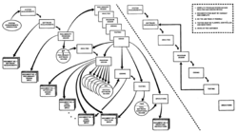](https://en.wikipedia.org/wiki/File:1970_Royce_Managing_the_Development_of_Large_Software_Systems_Fig10.PNG)Royce final model

Royce's final model illustrated that feedback could (should, and often would) lead from code testing to design (as testing of code uncovered flaws in the design) and from design back to requirements specification (as design problems may necessitate the removal of conflicting or otherwise unsatisfiable/undesignable requirements).[[*citation needed*](https://en.wikipedia.org/wiki/Wikipedia:Citation_needed)] In the same paper Royce also advocated large quantities of documentation, doing the job "twice if possible" (a sentiment similar to that of [Fred Brooks](https://en.wikipedia.org/wiki/Fred_Brooks), famous for writing the Mythical Man Month — an influential book in software [project management](https://en.wikipedia.org/wiki/Project_management) — who advocated planning to "throw one away"), and involving the customer as much as possible (a sentiment similar to that of [extreme programming](https://en.wikipedia.org/wiki/Extreme_programming)).

Royce notes on the final model are:

1. Complete program design before analysis and coding begins
2. Documentation must be current and complete
3. Do the job twice if possible
4. Testing must be planned, controlled, and monitored
5. Involve the customer

The Waterfall Model was the first Process Model to be introduced. It is also referred to as a **linear-sequential life cycle model**. It is very simple to understand and use. In a waterfall model, each phase must be completed before the next phase can begin and there is no overlapping in the phases.

The Waterfall model is the earliest SDLC approach that was used for software development.

The waterfall Model illustrates the software development process in a linear sequential flow. This means that any phase in the development process begins only if the previous phase is complete. In this waterfall model, the phases do not overlap.

Waterfall Model - Design

Waterfall approach was first SDLC Model to be used widely in Software Engineering to ensure success of the project. In "The Waterfall" approach, the whole process of software development is divided into separate phases. In this Waterfall model, typically, the outcome of one phase acts as the input for the next phase sequentially.

The following illustration is a representation of the different phases of the Waterfall Model.

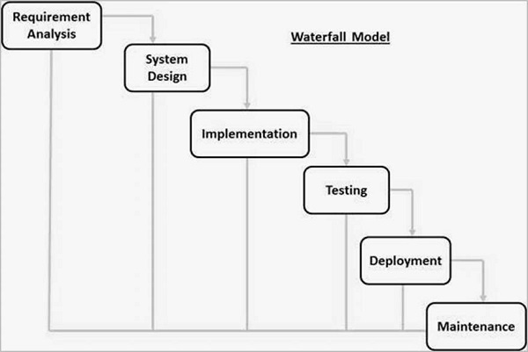

The sequential phases in Waterfall model are −

* **Requirement Gathering and analysis** − All possible requirements of the system to be developed are captured in this phase and documented in a requirement specification document.
* **System Design** − The requirement specifications from first phase are studied in this phase and the system design is prepared. This system design helps in specifying hardware and system requirements and helps in defining the overall system architecture.
* **Implementation** − With inputs from the system design, the system is first developed in small programs called units, which are integrated in the next phase. Each unit is developed and tested for its functionality, which is referred to as Unit Testing.
* **Integration and Testing** − All the units developed in the implementation phase are integrated into a system after testing of each unit. Post integration the entire system is tested for any faults and failures.
* **Deployment of system** − Once the functional and non-functional testing is done; the product is deployed in the customer environment or released into the market.
* **Maintenance** − There are some issues which come up in the client environment. To fix those issues, patches are released. Also to enhance the product some better versions are released. Maintenance is done to deliver these changes in the customer environment.

All these phases are cascaded to each other in which progress is seen as flowing steadily downwards (like a waterfall) through the phases. The next phase is started only after the defined set of goals are achieved for previous phase and it is signed off, so the name "Waterfall Model". In this model, phases do not overlap.

Waterfall Model - Application

Every software developed is different and requires a suitable SDLC approach to be followed based on the internal and external factors. Some situations where the use of Waterfall model is most appropriate are −

* Requirements are very well documented, clear and fixed.
* Product definition is stable.
* Technology is understood and is not dynamic.
* There are no ambiguous requirements.
* Ample resources with required expertise are available to support the product.
* The project is short.

Waterfall Model - Advantages

The advantages of waterfall development are that it allows for departmentalization and control. A schedule can be set with deadlines for each stage of development and a product can proceed through the development process model phases one by one.

Development moves from concept, through design, implementation, testing, installation, troubleshooting, and ends up at operation and maintenance. Each phase of development proceeds in strict order.

Some of the major advantages of the Waterfall Model are as follows −

* Simple and easy to understand and use
* Easy to manage due to the rigidity of the model. Each phase has specific deliverables and a review process.
* Phases are processed and completed one at a time.
* Works well for smaller projects where requirements are very well understood.
* Clearly defined stages.
* Well understood milestones.
* Easy to arrange tasks.
* Process and results are well documented.

Waterfall Model - Disadvantages

The disadvantage of waterfall development is that it does not allow much reflection or revision. Once an application is in the testing stage, it is very difficult to go back and change something that was not well-documented or thought upon in the concept stage.

The major disadvantages of the Waterfall Model are as follows −

* No working software is produced until late during the life cycle.
* High amounts of risk and uncertainty.
* Not a good model for complex and object-oriented projects.
* Poor model for long and ongoing projects.
* Not suitable for the projects where requirements are at a moderate to high risk of changing. So, risk and uncertainty is high with this process model.
* It is difficult to measure progress within stages.
* Cannot accommodate changing requirements.
* Adjusting scope during the life cycle can end a project.
* Integration is done as a "big-bang. at the very end, which doesn't allow identifying any technological or business bottleneck or challenges early.

he Waterfall model is a linear, sequential approach to the software development lifecycle ([SDLC](https://www.techtarget.com/searchsoftwarequality/definition/software-development-life-cycle-SDLC)) that's popular in software engineering and [product development](https://www.techtarget.com/searchcio/definition/product-development-or-new-product-development-NPD).

The Waterfall model uses a logical progression of SDLC steps for a [project](https://www.techtarget.com/searchcio/definition/project-planning), similar to the direction water flows over the edge of a cliff. It sets distinct endpoints or goals for each phase of the development process. Those endpoints or goals can't be revisited after their completion.

Dr. Winston W. Royce at the Lockheed Software Technology Center introduced the concept in a paper published in 1970 on his experience developing software for satellites. However, Royce didn't use the term *Waterfall*; instead, he referred to the downstream value of documentation.

The Waterfall model continues to be used in [industrial design applications](https://www.computerweekly.com/feature/The-new-shape-of-design-in-the-age-of-Industry-40). It's often cited as the first software development methodology. The model is also used more generally as a high-level project management methodology for complicated, multifaceted projects.

Who uses the Waterfall model?

Project teams and [project managers](https://www.techtarget.com/searchcio/definition/IT-project-manager) use the Waterfall model to achieve goals based on the needs of their business. The model is used in many different project management contexts, such as in construction, manufacturing, IT and software development.

In the Waterfall methodology, each step is dependent on the output of the previous step. There's a linear progression to the way these projects unfold.

For example, in construction, these three general steps are usually followed:

1. A building's physical design is created before any construction begins.
2. The foundation is poured before the skeleton of a building is erected.
3. The skeleton of the building is completed before the walls are built.

On a manufacturing line, steps are followed sequentially in a controlled order when building a product until the finished deliverable is created.

The Waterfall model doesn't include a project's end users or clients as much as other development methodologies. Users are consulted during the initial stages of gathering and defining requirements, and client [feedback](https://www.techtarget.com/searchitchannel/definition/feedback-loop) is incorporated after that. By leaving the client out of the main part of the Waterfall process, the development team moves quickly through the phases of a project.

This methodology is good for teams and projects that want to develop a project according to fixed or unchanging requirements set forth at the beginning of the project. Waterfall projects have a high degree of process definition with little or no output variability. Waterfall is also a good choice if the project has cost or time constraints.

Projects based on the Waterfall method are well defined, are predictable and have specific documentation. They have the following characteristics: fixed requirements, ample resources, an established timeline and well-understood technology. They usually aren't likely to require significant changes.

Waterfall aims to achieve its goals on the first try. So, in software development processes, if an application must work out of the box immediately at the risk of losing customers or some other serious issue, Waterfall is a suitable method. Contrast that with the [Agile project management](https://www.techtarget.com/searchcio/definition/Agile-project-management) and development model. Agile methods use ongoing reiteration. Its [iterative](https://www.techtarget.com/searchsoftwarequality/definition/iterative) approach involves designing, developing and testing software in repeated cycles that build upon each other.

Phases of the Waterfall model

When used for complex projects, such as software development, the Waterfall development methodology has seven stages:

1. **Requirements.** Potential project requirements, deadlines and guidelines for the project are analyzed and placed into a formal requirements document, also called a [*functional specification*](https://www.techtarget.com/searchsoftwarequality/definition/functional-specification). This first phase of development defines and plans the project without mentioning specific processes. It also defines the [project scope](https://www.techtarget.com/searchcio/definition/project-scope), team members, stakeholders, process for requirements gathering, reporting of project progress, use of aids such as templates and workflow diagrams, and an overall roadmap of the project.
2. **Analysis.** The system specifications are analyzed to generate product models and [business logic](https://www.techtarget.com/whatis/definition/business-logic) to guide production. This is also when financial and technical resources are audited for feasibility.
3. **Design.** A [design specification document](https://www.techtarget.com/searchsoftwarequality/tip/A-guide-to-software-design-documentation-and-specifications) is created to outline [technical requirements](https://www.techtarget.com/whatis/definition/technical-requirements) during the design phase. These include the programming language, hardware, data sources, architecture and services.
4. **Coding and implementation.**The [source code](https://www.techtarget.com/searchapparchitecture/definition/source-code) is developed using the models, logic and requirement specifications designated in the previous phases. Typically, the system is coded in smaller components, or units, before being put together.
5. **Testing.** This is when quality assurance and unit, system and beta tests identify issues that must be resolved. This forces a repeat of the coding stage for debugging. If the system passes integration and testing, the Waterfall process continues forward.
6. **Operation and deployment.** The product or application is deemed fully functional and is deployed to a live environment.
7. **Maintenance.** Corrective, adaptive and perfective maintenance is carried out indefinitely to improve, update and enhance the product and its functionality. This could include releasing patch updates and new versions.

Before moving to the next phase in the Waterfall process, there's usually a review and sign-off to ensure all defined goals have been met. For example, developers ensure each unit of technology is properly integrated in the implementation phase before moving to the testing phase.

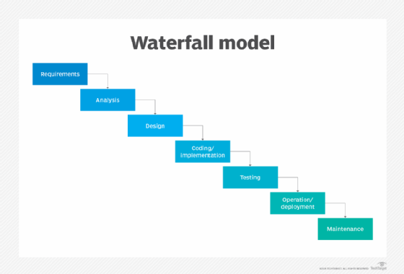The Waterfall method is a linear way of structuring the procedures and processes in a software development project.

Advantages of the Waterfall model

The Agile methodology is [often used in place of the Waterfall model](https://www.theserverside.com/tip/Agile-vs-Waterfall-Whats-the-difference). However, there are advantages to the [Waterfall vs. Agile approaches](https://www.techtarget.com/searchsoftwarequality/tip/Waterfall-vs-Agile-methodology-Differences-and-examples), such as the following:

* The Waterfall approach lets large or changing teams move toward a common goal that's been defined in the requirements stage.
* It forces a structured, disciplined approach.
* It simplifies understanding, following and arranging tasks.
* It facilitates departmentalization and managerial control based on the schedule or deadlines.
* It reinforces [good coding habits](https://www.techtarget.com/searchsoftwarequality/feature/Learn-5-defensive-programming-techniques-from-experts) to define before implementing design and then code.
* It facilitates early system design and specification changes.
* It clearly defines milestones and deadlines.

Disadvantages of the Waterfall model

[Disadvantages of the Waterfall model](https://www.techtarget.com/searchitoperations/tip/Carefully-weigh-these-DevOps-pros-and-cons) typically center around the risk associated with a lack of revision and flexibility. Specific issues include the following:

* Waterfall design isn't adaptive; when a flaw is found, the entire process often needs to start over.
* The methodology doesn't incorporate midprocess user or client feedback and makes changes based on results.
* The Waterfall model delays testing until the end of the development lifecycle.
* It doesn't consider error correction.
* It doesn't handle requests for changes, scope adjustments and updates well.
* Waterfall doesn't let processes overlap for simultaneous work on different phases, reducing overall efficiency.
* No working product is available until the later stages of the project lifecycle.
* Waterfall isn't ideal for complex, high-risk ongoing projects.

Waterfall model software and tools

[Gantt charts](https://www.techtarget.com/searchsoftwarequality/definition/Gantt-chart) are a common management tool for Waterfall projects. These charts enable easy visualization of sequential phases, letting project managers map dependencies and subtasks for each phase of the process. They also provide a clear view of timelines and deadlines for each phase.

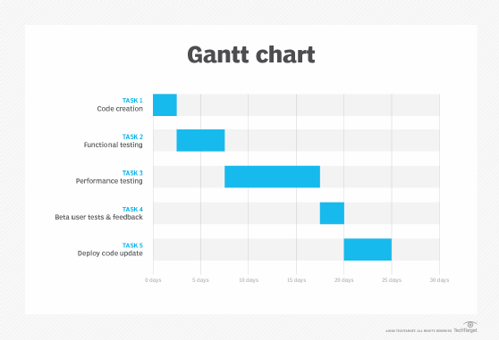A Gantt chart is a sideways bar graph in which the length of each bar represents the time it takes to complete a task.

[Project management software](https://www.techtarget.com/searchsoftwarequality/tutorial/Project-management-tools-and-strategies-Gantt-charts-PERT-charts-and-PM-planning-tools) often incorporates other tools to help Waterfall-based teams complete their tasks. Some important capabilities to have in project management software include team collaboration, note-taking, testing and development, and data analytics and visualization.

Alternatives to Waterfall

Besides Agile software development methods, alternatives to the Waterfall process include the following:

* [Joint application development](https://www.techtarget.com/searchsoftwarequality/definition/JAD).
* [Rapid application development](https://www.techtarget.com/searchsoftwarequality/definition/rapid-application-development).
* Synchronize and stabilize [model](https://www.researchgate.net/publication/269050775_Synchronize_and_Stabilize_Lifecycle_Model_for_Large-Scale_Software_Systems).
* [Spiral model](https://www.techtarget.com/searchsoftwarequality/definition/spiral-model).

Despite the popularity of other project management approaches, the Waterfall model still has an important role to play. It may be integrated with other models to provide hybrid solutions, used in regulated industries, such as healthcare and defense. It can also be used as an educational tool and to support legacy projects.

*Software development teams often*[*choose between the Waterfall and Scrum methodologies*](https://www.theserverside.com/tip/Scrum-vs-Waterfall-Whats-the-difference)*. Learn how this lightweight version of Agile works and how it compares to the Waterfall method.*

If you've been in [agile project management](https://www.atlassian.com/agile/project-management) for a while, you must’ve encountered the Waterfall methodology. It's an old-school software development method from the 1970s.

In a Waterfall process, you must complete each project phase before moving to the next. It's pretty rigid and linear. The method relies heavily on all the requirements and thinking done before you begin.

Don't worry if you haven't heard of it. Let’s break the Waterfall method down and see how it works.

**What is the Waterfall methodology?**

Waterfall methodology is a well-established [project management workflow](https://www.atlassian.com/agile/project-management/workflow). Like a waterfall, each process phase cascades downward sequentially through five stages (requirements, design, implementation, verification, and maintenance).

The methodology comes from computer scientist Winston Royce’s [1970 research paper](https://blog.jbrains.ca/assets/articles/royce1970.pdf) on software development. Although Royce never named this model “waterfall”, he gets credit for creating a linear, rigorous project management system.

Unlike other methods, such as the [Agile](https://www.atlassian.com/agile) methodology, Waterfall doesn't allow flexibility. You must finish one phase before beginning the next. Your team can’t move forward until they resolve any problems. Moreover, as our [introduction to project management](https://www.atlassian.com/agile/project-management/project-management-intro) guide outlines, your team can’t address bugs or technical debt if it’s already moved on to the next project phase.

[](https://www.youtube.com/embed/Kwtzb48XcX8?si=mLO9ee0zEzIzqoaG)

**What are the stages of the Waterfall methodology?**

Five phases comprise the Waterfall methodology: requirements, design, implementation, verification, and maintenance. Let's break down the five specific phases of Waterfall development and understand why it’s critical to complete each phase before progressing to the next.

**Requirements**

The requirements phase states what the system should do. At this stage, you determine the project's scope, from business obligations to user needs. This gives you a 30,000-foot overview of the entire project. The requirements should specify:

* resources required for the project.
* what each team member will work on and at what stage.
* a timeline for the entire project, outlining how long each stage will take.
* details on each stage of the process.

But these requirements “[may range from very abstract to a detailed mathematical specification](https://www.cs.odu.edu/~zeil/cs333/website-sum11/Lectures/waterfall/page/waterfall.html),” writes [Steven Zeil](https://www.odu.edu/directory/steven-zeil), professor of computer science at Old Dominion University. That’s because requirements might not outline an exact implementation, and that’s something development addresses in later stages.

**Design**

After gathering all the requirements, it's time to move on to the design stage. Here, designers develop solutions that meet the requirements. In this stage, designers:

* create schedules and project milestones.
* determine the exact deliverables.
* create designs and/or blueprints for deliverables.

Deliverables could include software or they could consist of a physical product. For instance, designers determine the system architecture and use cases for software. For a physical product, they figure out its exact specifications for production.

**Implementation**

Once the design is finalized and approved, it's time to implement it. Design hands off their specifications to developers to build.

To accomplish this, developers:

* create an implementation plan.
* collect any data or research needed for the build.
* assign specific tasks and allocate resources among the team.

Here is where you might even find out that parts of the design that can't be implemented. If it's a huge issue, you must step back and re-enter the design phase.

**Verification**

After the developers code the design, it’s time for quality assurance. It’s important to test for all use cases to ensure a good user experience. That's because you don't want to release a buggy product to customers.

QA also:

* writes test cases.
* documents any bugs and errors to be fixed.
* tests one aspect at a time.
* determines which QA metrics to track.
* covers a variety of use case scenarios and environments.

**Maintenance**

After the product release, devs might have to squash bugs. Customers let your support staff know of any issues that come up. Then, it's up to the team to address those requests and release newer versions of your product.

As you can see, each stage depends on the one that comes before it. It doesn't allow for much error between or within phases.

For example, if a stakeholder wants to add a requirement when you're in the verification phase, you'll have to re-examine the entirety of your project. That could mean tossing the whole thing out and starting over.

**Benefits of Waterfall methodology**

The benefits of Waterfall methodology have made it a lasting workflow for projects that rely on a fixed outcome. A 2020 survey found that 56% of project professionals had used traditional, or Waterfall, models in the previous year.

A few benefits of Waterfall planning include:

* **Clear project structure**: Waterfall leaves little room for confusion because of rigorous planning. There is a clear end goal in sight that you're working toward.
* **Set costs**: The rigorous planning ensures that the time and cost of the project are known upfront.
* **Easier tracking**: Assessing progress is faster because there is less cross-functional work. You can even manage the entirety of the project in a Gantt chart, which you can find in Jira.
* **A replicable process**: If a project succeeds, you can use the process again for another project with similar requirements.
* **Comprehensive project documentation**: The Waterfall methodology provides you with a blueprint and a historical project record so you can have a comprehensive overview of a project.
* **Improved risk management**: The abundance of upfront planning reduces risk. It allows developers to catch design problems before writing any code.
* **Enhanced responsibility and accountability**: Teams take responsibility within each process phase. Each phase has a clear set of goals, milestones, and timelines.
* **More precise execution for a non-expert workforce**: Waterfall allows less-experienced team members to plug into the process.
* **Fewer delays because of additional requirements**: Since your team knows the needs upfront, there isn't a chance for additional asks from stakeholders or customers.

**Limitations of Waterfall methodology**

Waterfall isn't without its limitations, which is why many product teams opt for an Agile methodology.

The Waterfall method works wonders for predictable projects but falls apart on a project with many variables and unknowns. Let's look at some other limitations of Waterfall planning:

* **Longer delivery times**: The delivery of the final product could take longer than usual because of the inflexible step-by-step process, unlike in an iterative process like Agile or Lean.
* **Limited flexibility for innovation**: Any unexpected occurrence can spell doom for a project with this model. One issue could move the project two steps back.
* **Limited opportunities for client feedback**: Once the requirement phase is complete, the project is out of the hands of the client.
* **Tons of feature requests**: Because clients have little say during the project's execution, there can be a lot of change requests after launch, such as addition of new features to the existing code. This can create further maintenance issues and prolong the launch.
* **Deadline creep**: If there's a significant issue in one phase, everything grinds to a halt. Nothing can move forward until the team addresses the problem. It may even require you to go back to a previous phase to address the issue.

Below is an illustration of a project using the waterfall approach. As you can see, the project is segmented into rigid blocks of time. This rigidity fosters an environment that encourages developers, product managers, and stakeholders to request the maximum amount of time allotted in each time block, since there may be no opportunity to iterate in the future.

**How is the Waterfall method different from Agile project management?**

Agile project management and the Waterfall methodology have the same end goal: crystal clear project execution. While Waterfall planning isolates teams into phases, Agile allows for cross-functional work across multiple phases of a project. Instead of rigid steps, teams work in a cycle of planning, executing, and evaluating, iterating as they go.

The "[Agile Manifesto](https://agilemanifesto.org/)" explains the benefits of Agile over the Waterfall model:

* **Individuals and interactions** over processes and tools
* **Working software** over comprehensive documentation
* **Customer collaboration** over contract negotiation
* **Responding to change** by following a plan

If you're looking for tools that support Agile project management and serve the same end goal as Waterfall, consider [Jira](https://www.atlassian.com/software/jira). It’s best suited for Agile projects, and helps you:

* **Track work**: With [Gantt charts](https://www.atlassian.com/agile/project-management/gantt-chart), [advanced roadmaps](https://www.atlassian.com/agile/teams/advanced-roadmaps-teams), timelines, and various other tools, you can easily track your progress throughout the project.
* **Align your team**: Tracking allows you to seamlessly plan across business teams, keeping everyone aligned on the same goals.
* **Manage projects and workflows**: With Jira, you can access [Jira project management templates](https://www.atlassian.com/software/jira/templates/project-management-templates) that you can use for your [Agile workflows](https://www.atlassian.com/agile/project-management/workflow).
* **Plan at every stage**: [Jira Product Discovery](https://www.atlassian.com/software/jira/product-discovery), another product by Atlassian, offers [product roadmaps](https://www.atlassian.com/agile/product-management/product-roadmaps) for planning and prioritizing product features at every stage, from discovery to delivery.

Atlassian's [Agile tools](https://www.atlassian.com/software/jira/agile) support the product development lifecycle. There are even [Agile metrics](https://www.atlassian.com/agile/project-management/metrics) for tracking purposes. [Jira](https://www.atlassian.com/software/jira/work-management) lets you drive forward the Agile process. It uses intake forms to track work being done by internal teams and offers a repeatable process for requests.

These Jira products integrate natively within the app, unifying teams so they can work faster.

**Use Agile methodology for project management**

Waterfall methodology has a long history in project management, but it's often not the right choice for modern software developers. Agile methodology offers greater flexibility.

Here’s why most teams prefer an Agile process:

* **Adaptability to changes**: If something arises, your team will be better able to adjust on the fly. Waterfall’s rigidity makes it difficult to deal with any roadblocks.
* **Continuous feedback loop**: Continuous improvement requires a feedback loop. With Agile, you can gather feedback from stakeholders during the process and iterate accordingly.
* **Stronger communication**: Teams work collaboratively in an Agile process. Waterfall is a series of handoffs between different teams, which hinders effective communication.

Here is where a project management tool such as [Jira](https://www.atlassian.com/software/jira) comes in handy for an Agile methodology. You can also use a [project management template](https://www.atlassian.com/software/jira/templates/project-management-templates) for your Agile projects. Your team can plan, collaborate, deliver, and report on projects in one tool. That keeps everyone aligned throughout any project and streamlines project management.

**Waterfall methodology: Frequently asked questions**

**Who is best suited for Waterfall methodology?**

The Waterfall methodology works best for project managers working on projects that include:

* **Less complex objectives**: Projects that don't have complicated requirements are best suited for Waterfall.
* **Predictable outcomes**: Waterfall works best for those projects that are replicable and proven.
* **Reduced likelihood of project scope creep**: A project where clients aren't likely to come up with last-minute requirements is suitable for Waterfall.

**Who is best suited for Waterfall methodology?**

Agile methodology is perfect for nimble teams with an iterative mindset, such as:

* **Cross-functional teams**: A team of people with different skill sets that allows them to work on various aspects of a project. These are collaborative types who are flexible.
* **Self-organizing teams**: Autonomous teams that don't need a lot of handholding. They embrace ambiguity in a project and are great problem solvers. This mindset also gives them more ownership over outcomes.
* **Startups and small businesses**: These benefit from the mindset of "[move fast and break things](https://youexec.com/book-summaries/move-fast-and-break-things)". So they can fail fast, learn, and improve.

Finally, Agile works well for customer-centric projects where their input allows you to iterate.

**What factors should I consider before implementing a project management approach?**

When deciding on the proper methodology to implement in [project management](https://www.atlassian.com/work-management/project-management), there are four main factors to consider: project complexity, organizational goals, team expertise, and stakeholder involvement.

Let’s break each one down:

* **Project complexity**: Waterfall can help break down larger, more complex projects into smaller sets of expectations and goals. But its rigidity doesn’t deal well with unknowns or changes. Agile is better for complex projects that have a lot of variables.
* **Organizational goals**: What does your organization want to achieve? Is it looking to innovate or keep the status quo? An Agile approach is best if your organization wants to break down silos. Teams will work more collaboratively with more autonomy.
* **Team expertise**: Agile is an excellent way to go if your team is cross-functional and can work across skill sets. If your team members rely heavily on a singular skill set, Waterfall may be better.
* **Stakeholder involvement**: If your stakeholders are going to be more hands-on, Agile will help you best because it allows for continuous feedback and iteration.

**Prototyping Model - Software Engineering**

Last Updated : 11 Jul, 2025

**Prototyping Model**is a way of developing software where an early version, or prototype, of the product is created and shared with users for feedback.

The Prototyping Model concept is described below:

**Table of Content**

* [What is Prototyping Model?](https://www.geeksforgeeks.org/software-engineering/software-engineering-prototyping-model/#what-is-prototyping-model)
* [Phases of Prototyping Model](https://www.geeksforgeeks.org/software-engineering/software-engineering-prototyping-model/#steps-of-prototyping-model)
* [Types of Prototyping Models](https://www.geeksforgeeks.org/software-engineering/software-engineering-prototyping-model/#types-of-prototyping-models)
* [Advantages of Prototyping Model](https://www.geeksforgeeks.org/software-engineering/software-engineering-prototyping-model/#advantages-of-prototyping-model)
* [Disadvantages of the Prototyping Model](https://www.geeksforgeeks.org/software-engineering/software-engineering-prototyping-model/#disadvantages-of-the-prototyping-model)
* [Applications of Prototyping Model](https://www.geeksforgeeks.org/software-engineering/software-engineering-prototyping-model/#applications-of-prototyping-model)

**What is Prototyping Model?**

The Prototyping Model is one of the most popularly used [**Software Development Life Cycle Models (SDLC models)**](https://www.geeksforgeeks.org/software-engineering/software-development-life-cycle-sdlc/). This model is used when the customers do not know the exact project requirements beforehand.

In this model, a prototype of the end product is first developed, tested, and refined as per customer feedback repeatedly till a final acceptable prototype is achieved which forms the basis for developing the final product.

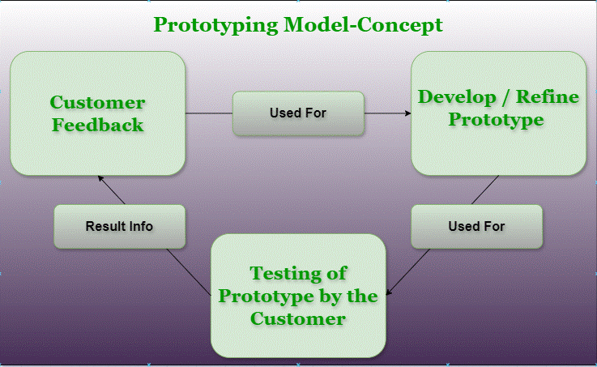Prototyping Model-Concept

In this process model, the system is partially implemented before or during the analysis phase thereby allowing the customers to see the product early in the life cycle. The process starts by interviewing the customers and developing the incomplete high-level paper model.

This document is used to build the initial prototype supporting only the basic functionality as desired by the customer. Once the customer figures out the problems, the prototype is further refined to eliminate them. The process continues until the user approves the prototype and finds the working model to be satisfactory.

**Phases of Prototyping Model**

Prototyping Model has six phases as follows:

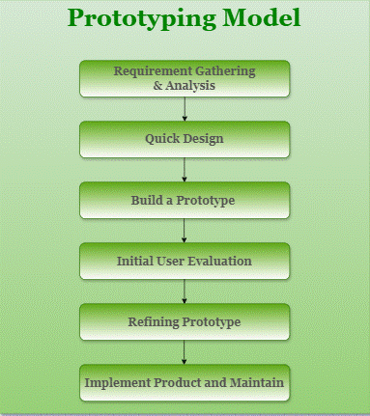Prototyping Model Phases

**1. Requirements gathering and analysis**

Requirement analysis is the first step in developing a prototyping model. During this phase, the system’s desires are precisely defined. During the method, system users are interviewed to determine what they expect from the system.

**2. Quick design**

The second phase could consist of a preliminary design or a quick design. During this stage, the system’s basic design is formed. However, it is not a complete design. It provides the user with a quick overview of the system. The rapid design aids in the development of the prototype.

**3. Build a Prototype**

During this stage, an actual prototype is intended to support the knowledge gained from quick design. It is a small low-level working model of the desired system.

**4. Initial user evaluation**

The proposed system is presented to the client for preliminary testing at this stage. It is beneficial to investigate the performance model’s strengths and weaknesses. Customer feedback and suggestions are gathered and forwarded to the developer.

**5. Refining prototype**

If the user is dissatisfied with the current model, you may want to improve the type that responds to user feedback and suggestions. When the user is satisfied with the upgraded model, a final system based on the approved final type is created.

**6. Implement Product and Maintain**

The final system was fully tested and distributed to production after it was developed to support the original version. To reduce downtime and prevent major failures, the programmer is run on a regular basis.

**Types of Prototyping Models**

There are four types of Prototyping Models, which are described below.

**1. Rapid Throwaway Prototyping**

* This technique offers a useful method of exploring ideas and getting customer feedback for each of them.
* In this method, a developed prototype need not necessarily be a part of the accepted prototype.
* Customer feedback helps prevent unnecessary design faults and hence, the final prototype developed is of better quality.

**2. Evolutionary Prototyping**

* In this method, the prototype developed initially is incrementally refined based on customer feedback till it finally gets accepted.
* In comparison to Rapid Throwaway Prototyping, it offers a better approach that saves time as well as effort.
* This is because developing a prototype from scratch for every iteration of the process can sometimes be very frustrating for the developers.

**3. Incremental Prototyping**

* In this type of incremental prototyping, the final expected product is broken into different small pieces of prototypes and developed individually.
* In the end, when all individual pieces are properly developed, then the different prototypes are collectively merged into a single final product in their predefined order.
* It's a very efficient approach that reduces the complexity of the development process, where the goal is divided into sub-parts and each sub-part is developed individually.
* The time interval between the project's beginning and final delivery is substantially reduced because all parts of the system are prototyped and tested simultaneously.
* Of course, there might be the possibility that the pieces just do not fit together due to some lack of ness in the development phase – this can only be fixed by careful and complete plotting of the entire system before prototyping starts.

**4. Extreme Prototyping**

This method is mainly used for web development. It consists of three sequential independent phases:

* In this phase, a basic prototype with all the existing static pages is presented in HTML format.
* In the 2nd phase, Functional screens are made with a simulated data process using a prototype services layer.
* This is the final step where all the services are implemented and associated with the final prototype.

This Extreme Prototyping method makes the project cycling and delivery robust and fast and keeps the entire developer team focused and centralized on product deliveries rather than discovering all possible needs and specifications and adding necessitated features.

**Advantages of Prototyping Model**

* The customers get to see the partial product early in the life cycle. This ensures a greater level of customer satisfaction and comfort.
* New requirements can be easily accommodated as there is scope for refinement.
* Missing functionalities can be easily figured out.
* Errors can be detected much earlier thereby saving a lot of effort and cost, besides enhancing the quality of the software.
* The developed prototype can be reused by the developer for more complicated projects in the future.
* Flexibility in design.
* Early feedback from customers and stakeholders can help guide the development process and ensure that the final product meets their needs and expectations.
* Prototyping can be used to test and validate design decisions, allowing for adjustments to be made before significant resources are invested in development.
* Prototyping can help reduce the risk of project failure by identifying potential issues and addressing them early in the process.
* Prototyping can facilitate communication and collaboration among team members and stakeholders, improving overall project efficiency and effectiveness.
* Prototyping can help bridge the gap between technical and non-technical stakeholders by providing a tangible representation of the product.

**Disadvantages of the Prototyping Model**

* Costly concerning time as well as money.
* There may be too much variation in requirements each time the prototype is evaluated by the customer.
* Poor Documentation due to continuously changing customer requirements.
* It is very difficult for developers to accommodate all the changes demanded by the customer.
* There is uncertainty in determining the number of iterations that would be required before the prototype is finally accepted by the customer.
* After seeing an early prototype, the customers sometimes demand the actual product to be delivered soon.
* Developers in a hurry to build prototypes may end up with sub-optimal solutions.
* The customer might lose interest in the product if he/she is not satisfied with the initial prototype.
* The prototype may not be scalable to meet the future needs of the customer.
* The prototype may not accurately represent the final product due to limited functionality or incomplete features.
* The focus on prototype development may shift away from the final product, leading to delays in the development process.
* The prototype may give a false sense of completion, leading to the premature release of the product.
* The prototype may not consider technical feasibility and scalability issues that can arise during the final product development.
* The prototype may be developed using different tools and technologies, leading to additional training and maintenance costs.
* The prototype may not reflect the actual business requirements of the customer, leading to dissatisfaction with the final product.

**Applications of Prototyping Model**

* The Prototyping Model should be used when the requirements of the product are not clearly understood or are unstable.
* The prototyping model can also be used if requirements are changing quickly.
* This model can be successfully used for developing user interfaces, high-technology software-intensive systems, and systems with complex algorithms and interfaces.
* The prototyping Model is also a very good choice to demonstrate the technical feasibility of the product.

**Conclusion**

**Prototyping Model**plays an important role in developing and redesign the product with clear understanding, for more understanding about all models do refer "[Top SDLC models](https://www.geeksforgeeks.org/software-engineering/top-8-software-development-models-used-in-industry/)".

**Prototype Model in Software Engineering**

**By Sushant Kumar**

6 mins read

Last updated: 15 Feb 2023

749 views

Topics Covered

**Overview**

**Prototyping** is a generic way of creating a **functional replica** of any idea, software, or system requiring more engineering to produce the final result. The prototype model will provide a miniature replica of your desired end product, requiring accurate consumer feedback to be crafted accordingly. A prototype of an application often demonstrates the usability of any product in the development phase, although it may not contain the exact requirements of the desired outcome. This article discusses the Prototyping model, one of the most prominent SDLC models.

**What is Prototype Model in Software Engineering?**

The **Prototyping Model** is one of the most often used SDLC Models. It is applied when customers do not know the exact project requirements ahead of time. In this paradigm, a prototype of the eventual product is created, tested, and refined based on consumer feedback until a final acceptable prototype is reached, which serves as the foundation for building the final product. The process begins with client interviews and the creation of a **high-level document**. This document is used to create the initial prototype, which will only offer the minimal capabilities requested by the customer. The system is partly developed before or during the **analysis phase**, allowing clients to experience the product early in its life cycle. Once the customer has identified the issues, the prototype is improved to eliminate them. The process is repeated until the user approves the prototype and is satisfied with the working model.

**Steps of Prototype Model**

The following steps are involved in the working of the Prototype model:

* **Requirement Gathering and Analysis**
* **Quick Decision-Making**
* **Building a Prototype**
* **User Evaluation**
* **Prototype Refinement**
* **Building the Final Product and Maintenance**

**Requirement Gathering and Analysis**

It is the first step in building the prototype model. The users are interviewed to **collect and define** the requirements for the software product, and various analysis techniques are applied to this information.

**Quick Decision-Making**

In this step, a **preliminary design of the prototype** is made. This is not the complete design of the product; it just gives the user a brief idea of the system.

**Building a Prototype**

In this step, a prototype is made using the information from the previous step. It is a **small working model** of the software product being built.

**User Evaluation**

The prototype built in the previous step is presented to the users. They evaluate the model for **strengths and weaknesses** and give their suggestions and comments to the developers.

**Prototype Refinement**

The developers use the **feedback** collected from the users in the previous step to refine the prototype. This step is repeated again and again until the user is satisfied with the prototype.

**Building the Final Product and Maintenance**

The final product is built based on the **approved prototype** from the previous step. The product is then deployed in the user environment and undergoes routine maintenance.

**Types of Prototype Models in Software Engineering**

There are four types of Prototype Models available:

1. **Rapid Throwaway Prototyping**
2. **Evolutionary Prototyping**
3. **Incremental Prototyping**
4. **Extreme Prototyping**

**Rapid Throwaway Prototyping**

This method uses **very little effort and minimum requirement gathering** to build a quick prototype to demonstrate an initial image of how the requirements will look visually. The customer's feedback influences the changes, and the prototype is built again until the requirements are baselined. This approach will discard a developed prototype and it will not be included in the final accepted prototype. This technique effectively brainstorms ideas and receives immediate feedback on consumer requirements.

**Evolutionary Prototyping**

The prototype is improved incrementally depending on customer feedback until it is eventually accepted. It allows us to save both **time and effort**. This is because creating a prototype from scratch for each process interaction might sometimes be extremely unpleasant.

This concept is useful for a project that involves the usage of unknown new technology. It is also employed in complex projects where each functionality must be tested only once. It is useful when the demand is not constant or is not clearly known at the outset.

The Evolutionary Prototype method is similar to the **Iterative Paradigm** in that the phases outlined for the waterfall model occur in a circular pattern here. However, this model differs from the iterative model because it does not mandate creating a functional product after each cycle. In evolutionary development, requirements are implemented by type rather than priority.

**Incremental Prototyping**

The final product is split into small prototypes and produced separately in incremental prototyping. The several prototypes are eventually combined into a single product. This strategy helps **shorten the feedback time** between the user and the application development team. In addition, the time interval between the project's **inception and delivery** is reduced because all system parts are prototyped and tested in parallel.

**Extreme Prototyping**

The web development industry makes extensive use of extreme prototyping. This paradigm is divided into three stages:

1. First, an HTML prototype with all of the existing pages is displayed.
2. A prototype services layer is then used to mimic data processing.
3. Finally, the services are implemented and integrated into the final prototype.

This method is known as **Extreme Prototyping** because of the second phase of the process, in which a completely **functional UI** is created with minimal care for the actual services.

**Applications of Prototype Model in Software Engineering**

* In many cases, the client has just a broad understanding of what is required of the software product. In this case, if there is a **lack of precise information** on the system's input, processing needs, and output requirements, the prototype approach may be used.
* It can also be used if the requirements are frequently altered.
* It is also a good choice to demonstrate the product's **technical feasibility**.

**Advantages of Prototype Model**

* The customer gets to see partial products early in the lifecycle, hence ensuring customer satisfaction.
* The developed prototype can be **reused** for bigger projects in the future.
* There is scope to accommodate new requirements.
* **Errors and missing functionalities** can be identified much early in the lifecycle because the users are actively involved.
* User feedback is accommodated quickly.
* The model is very straightforward and does not require skilled experts to implement.

**Disadvantages of Prototype Model**

* Prototyping is a **slow and time taking process**.
* Documentation is poor as the requirements **change frequently**.
* When the customer evaluates the prototype, there may be much too many variances in software needs.
* There is a risk of inadequate requirement analysis owing to too much dependency on the prototype.

**Example for Understanding**

Let us understand evolutionary prototyping with the example of a simple database application. In this application, one cycle may implement the **graphical user interface (GUI)**, another file manipulation, another query, and yet another update. Before a workable product is available, all four cycles must be completed. The graphical user interface (GUI) lets users engage with the system; file manipulation allows data to be saved and retrieved; inquiries allow users to exit the system, and updates allow users to put data into the system.

**Conclusion**

* In SDLC, the Prototype Model is a software development model in which a prototype is built, tested, and reworked when needed until an acceptable prototype is achieved.
* The model is implemented in the following steps: *Requirement Gathering and Analysis, Quick Decision-Making, Building a Prototype, User Evaluation, Prototype Refinement, Building the final product, and Maintenance*.
* This paradigm is suitable when all the requirements are not initially, but it can encourage excessive change requests.

**What is Spiral Model in Software Engineering?**

Last Updated : 11 Jul, 2025

**The Spiral Model** is one of the most important SDLC model. The Spiral Model is a combination of the waterfall model and the iterative model. It provides support for **Risk Handling**.

The Spiral Model was first proposed by **Barry Boehm**. This article focuses on discussing the Spiral Model in detail.

**Table of Content**

* [What is the Spiral Model?](https://www.geeksforgeeks.org/software-engineering/software-engineering-spiral-model/#what-is-the-spiral-model)
* [Phases of the Spiral Model](https://www.geeksforgeeks.org/software-engineering/software-engineering-spiral-model/#what-are-the-phases-of-spiral-model)
* [Risk Handling in Spiral Model](https://www.geeksforgeeks.org/software-engineering/software-engineering-spiral-model/#risk-handling-in-spiral-model)
* [Why Spiral Model is called Meta Model?](https://www.geeksforgeeks.org/software-engineering/software-engineering-spiral-model/#why-spiral-model-is-called-meta-model)
* [Example of Spiral Model](https://www.geeksforgeeks.org/software-engineering/software-engineering-spiral-model/#example-of-spiral-model)
* [Advantages of the Spiral Model](https://www.geeksforgeeks.org/software-engineering/software-engineering-spiral-model/#advantages-of-the-spiral-model)
* [Disadvantages of the Spiral Model](https://www.geeksforgeeks.org/software-engineering/software-engineering-spiral-model/#disadvantages-of-the-spiral-model)
* [When To Use the Spiral Model?](https://www.geeksforgeeks.org/software-engineering/software-engineering-spiral-model/#when-to-use-the-spiral-model)

**What is the Spiral Model?**

The Spiral Model is a [**Software Development Life Cycle (SDLC)**](https://www.geeksforgeeks.org/software-engineering/software-development-life-cycle-sdlc/) model that provides a systematic and iterative approach to software development. In its diagrammatic representation, looks like a spiral with many loops. The exact number of loops of the spiral is unknown and can vary from project to project. Each loop of the spiral is called a **phase**of the software development process.

Some **Key Points** regarding the **Stages of a Spiral Model**:

1. The exact number of phases needed to develop the product can be varied by the project manager depending upon the project risks.
2. As the project manager dynamically determines the number of phases, the project manager has an important role in developing a product using the spiral model.
3. It is based on the idea of a spiral, with each iteration of the spiral representing a complete software development cycle, from requirements gathering and analysis to design, implementation, testing, and maintenance.

**Phases of the Spiral Model**

The Spiral Model is a risk-driven model, meaning that the focus is on managing risk through multiple iterations of the software development process. **Each phase of the Spiral Model is divided into four Quadrants:**

Spiral Model - SDLC

**1. Objectives Defined**

In first phase of the spiral model we clarify what the project aims to achieve, including functional and non-functional requirements.

Requirements are gathered from the customers and the objectives are identified, elaborated, and analyzed at the start of every phase. Then alternative solutions possible for the phase are proposed in this quadrant.

**2. Risk Analysis and Resolving**

In the risk analysis phase, the risks associated with the project are identified and evaluated.

During the second quadrant, all the possible solutions are evaluated to select the best possible solution. Then the risks associated with that solution are identified and the risks are resolved using the best possible strategy. At the end of this quadrant, the Prototype is built for the best possible solution.

**3. Develop the next version of the Product**

During the third quadrant, the identified features are developed and verified through testing. At the end of the third quadrant, the next version of the software is available.

In the evaluation phase, the software is evaluated to determine if it meets the customer's requirements and if it is of high quality.

**4. Review and plan for the next Phase**

In the fourth quadrant, the Customers evaluate the so-far developed version of the software. In the end, planning for the next phase is started.

The next iteration of the spiral begins with a new planning phase, based on the results of the evaluation.

The Spiral Model is often used for complex and large software development projects, as it allows for a more flexible and adaptable approach to [**Software development**](https://www.geeksforgeeks.org/software-engineering/software-development/). It is also well-suited to projects with significant uncertainty or high levels of risk.

*The Radius of the spiral at any point represents the expenses (cost) of the project so far, and the angular dimension represents the progress made so far in the current phase.*

**Risk Handling in Spiral Model**

A risk is any adverse situation that might affect the successful completion of a software project. The most important feature of the spiral model is handling these unknown risks after the project has started. Such risk resolutions are easier done by developing a prototype.

1. The spiral model supports coping with risks by providing the scope to build a prototype at every phase of software development.
2. The[**Prototyping Model**](https://www.geeksforgeeks.org/software-engineering/software-engineering-prototyping-model/) also supports risk handling, but the risks must be identified completely before the start of the development work of the project.
3. But in real life, project risk may occur after the development work starts, in that case, we cannot use the Prototyping Model.
4. In each phase of the Spiral Model, the features of the product dated and analyzed, and the risks at that point in time are identified and are resolved through prototyping.
5. Thus, this model is much more flexible compared to other SDLC models.

**Why Spiral Model is called Meta Model?**

The Spiral model is called a [**Meta-Model**](https://www.geeksforgeeks.org/software-engineering/why-spiral-model-is-called-meta-model/) because it subsumes all the other SDLC models. For example, a single loop spiral actually represents the [**Iterative Waterfall Model**](https://www.geeksforgeeks.org/software-engineering/software-engineering-iterative-waterfall-model/).

1. The spiral model incorporates the stepwise approach of the [**Classical Waterfall Model**](https://www.geeksforgeeks.org/software-engineering/waterfall-model/).
2. The spiral model uses the approach of the [**Prototyping Model**](https://www.geeksforgeeks.org/software-engineering/software-engineering-prototyping-model/)by building a prototype at the start of each phase as a risk-handling technique.
3. Also, the spiral model can be considered as supporting the [**Evolutionary model**](https://www.geeksforgeeks.org/software-engineering/software-engineering-evolutionary-model/)- the iterations along the spiral can be considered as evolutionary levels through which the complete system is built.

**Example of Spiral Model**

Here we can take a Real world example of the Spiral Model.

*Real-Life Example of Spiral Model:* ***Developing an E-Commerce Website***

**1. First Spiral - Planning and Requirements:**

In this first phase, the team gathers the basic requirements for the e-commerce website, like product listings, shopping carts, and payment options. They also identify potential risks, like security issues or scalability concerns.

To get started, they build a simple prototype, like a homepage with a basic product catalog, to see how users interact with it and spot any initial design problems.

**2. Second Spiral - Risk Analysis and Refining the Design**

After getting feedback from the first prototype, the team moves to the next phase. They add more features and address the problems that were found earlier.

This includes verifying secure payment processing and testing how the site handles more users. They also add a basic shopping cart and user registration system, and they run tests with dummy transactions to make sure everything is secure.

**3. Third Spiral - Detailed Implementation**

With more feedback in hand, the team adds advanced features, like order tracking, customer reviews, and a search function. They also revisit any remaining risks, especially around scalability making sure the website can handle a growing number of users.

During this phase, the team tests the site to verify it can handle large orders, especially during busy times like sales or holidays.

**4. Final Spiral - Full Deployment**

In the last phase, the website is fully implemented, tested properly, and then launched to the public. Any remaining risks, like potential crashes or user feedback issues, are closely monitored and dealt with.

This example shows how the Spiral Model allows for continuous improvement, with feedback and risk assessment at each step to make sure the final product is solid and reliable.

**Advantages of the Spiral Model**

Below are some advantages of the Spiral Model.

1. **Risk Handling:** The projects with many unknown risks that occur as the development proceeds, in that case, Spiral Model is the best development model to follow due to the risk analysis and risk handling at every phase.
2. **Good for large projects:** It is recommended to use the Spiral Model in large and complex projects.
3. **Flexibility in Requirements:** Change requests in the Requirements at a later phase can be incorporated accurately by using this model.
4. **Customer Satisfaction:** Customers can see the development of the product at the early phase of the software development and thus, they habituated with the system by using it before completion of the total product.
5. **Iterative and Incremental Approach:** The Spiral Model provides an iterative and incremental approach to software development, allowing for flexibility and adaptability in response to changing requirements or unexpected events.
6. **Emphasis on Risk Management:** The Spiral Model places a strong emphasis on risk management, which helps to minimize the impact of uncertainty and risk on the software development process.
7. **Improved Communication:** The Spiral Model provides for regular evaluations and reviews, which can improve communication between the customer and the development team.
8. **Improved Quality:**The Spiral Model allows for multiple iterations of the software development process, which can result in improved software quality and reliability.

**Disadvantages of the Spiral Model**

Below are some main disadvantages of the spiral model.

1. **Complex:** The Spiral Model is much more complex than other SDLC models.
2. **Expensive:** Spiral Model is not suitable for small projects as it is expensive.
3. **Too much dependability on Risk Analysis:** The successful completion of the project is very much dependent on Risk Analysis. Without very highly experienced experts, it is going to be a failure to develop a project using this model.
4. **Difficulty in time management:** As the number of phases is unknown at the start of the project, time estimation is very difficult.
5. **Complexity:** The Spiral Model can be complex, as it involves multiple iterations of the software development process.
6. **Time-Consuming:**The Spiral Model can be time-consuming, as it requires multiple evaluations and reviews.
7. **Resource Intensive:**The Spiral Model can be resource-intensive, as it requires a significant investment in planning, risk analysis, and evaluations.

The most serious issue we face in the cascade model is that taking a long length to finish the item, and the product became obsolete. To tackle this issue, we have another methodology, which is known as the Winding model or spiral model. The winding model is otherwise called the cyclic model.

**When To Use the Spiral Model?**

Here are the reasons where the **Spiral Model**is used:

1. When a project is vast in [**Software Engineering**,](https://www.geeksforgeeks.org/software-engineering/software-engineering-introduction-to-software-engineering/) a spiral model is utilized.
2. A spiral approach is utilized when frequent releases are necessary.
3. When it is appropriate to create a prototype
4. When evaluating risks and costs is crucial
5. The spiral approach is beneficial for projects with moderate to high risk.
6. The SDLC's spiral model is helpful when requirements are complicated and ambiguous.
7. If modifications are possible at any moment
8. When committing to a long-term project is impractical owing to shifting economic priorities.

**Conclusion**

**Spiral Model**is a valuable choice for software development projects where risk management is on high priority. Spiral Model deliver high-quality software by promoting risk identification, iterative development and continuous client feedback. When a project is vast in software engineering, a spiral model is utilized.

If you want to learn the SDLC models in detail do refer "[**Software Development Life Cycle (SDLC) Models**](https://www.geeksforgeeks.org/software-engineering/software-development-life-cycle-sdlc/)".

Would you believe me if I say there is a development methodology that considers changing requirements and technical risks as part of the process instead of obstacles to be overcome? Sounds crazy, right? That’s exactly what I thought about the **Spiral Model** until I took a closer look. I’m not saying it’s perfect for every project or that we should all use it. But for certain types of projects, the messy, uncertain, high-stakes ones, it may be just what you need!

This blog explores how the Spiral Model assists teams in delivering high-quality software while effectively managing risks throughout the [software development lifecycle](https://keploy.io/blog/community/software-development-phases). Let’s look at it together.

**What is the Spiral Model?#**

The Spiral Model is a [software development lifecycle (SDLC) model](https://keploy.io/blog/community/testing-methodologies-in-software-testing) that combines elements from both iterative and waterfall models. Introduced by Barry Boehm in 1986, this model focuses on multiple refinements during various developmental cycles or "spirals."

While a very rigidly structured model may not allow for adjustments once it starts, the Spiral Model insists on the early identification of any potential risks and maintaining adjustments through the entire development process. The model is especially suited for large, complex, and long-term projects that gradually become clearer over time.

First, a spiral cycle starts with identifying potential risks, evaluating them, then choosing the best way to deal with those risks while proceeding towards building the final product. This design inherently accounts for the risks and uncertainties that the development might face at any time so changes can be easily accommodated.

**Uses of the Spiral Model#**

Some common uses of the Spiral Model include:

* **Dividing work into manageable iterations**  
  Project teams handle their work by performing multiple development cycles that let them split their work into smaller attainable targets.
* **Systematic risk evaluation and mitigation**  
  Each development cycle begins with the team to spot every technical and business risk together with user risk so they can establish mitigation plans for ongoing development.
* **Prototyping to validate ideas**

The development team produces early software builds which get better through each cycle to enhance both requirement understanding and development guidance.

* **Continuous stakeholder feedback**  
  After each development cycle stakeholders provide feedback that helps the product stay aligned with user expectations.
* **Documenting progress and decisions**  
  The development cycle produces comprehensive documentation that includes achieved targets alongside difficulties and future plans to maintain project transparency and control.

**Phases of the Spiral Model#**

The Spiral Model undergoes f**our core phases in every cycle**, blending planning, risk analysis, engineering, and evaluation.

1. **Planning Phase**

In the planning phase, system objectives, functionality, constraints, and key requirements are defined. It also considers alternative solutions for the problem space so that the team has a clear, goal-driven direction for the iteration.

1. **Risk Analysis Phase**

In this stage, the team conducts a detailed risk analysis. Each alternative solution from the planning phase is checked against possible risk scenarios: technical, financial, schedule, or usability issues. To reduce uncertainties, proof-of-concept prototypes may be created.

1. **Engineering Phase**

Based on the selected approach, the product (or part of it) is designed, developed, and tested. This may include building the prototype, coding modules, [unit testing](https://keploy.io/blog/community/what-is-unit-testing), or integrating components. It changes as the project advances, with early spirals concentrating on the mockups, while the later ones shape the production-ready builds.

1. **Evaluation Phase**

The output is shared with the stakeholders for their feedback and validation. The team determines whether objectives and risks were addressed effectively. Based on this, they may decide whether to proceed to the next cycle, repeat the current one, or go for an alternative. This keeps the system user-oriented and iterative in nature.

**Steps of the Spiral Model#**

Although the Spiral Model involves four main phases along each loop, these phases are further subdivided into steps.

1. The team collects detailed requirements from stakeholders, users, and domain experts. This step ensures that it captures all internal and external expectations.
2. After considering initial requirements, a rough architectural design is prepared. It defines key modules, data flows, and interfaces.
3. A small-scale prototype is then built from the preliminary design. The prototype helps in demonstrating core functionalities and UX flow.
4. After the first prototype is reviewed, these steps are involved:
   * Evaluating strengths, weaknesses, and risks
   * Refining the requirements
   * Redesigning the system
   * Building and testing the next prototype

This cycle may repeat numerous times.

1. The project may be cancelled, for instance, if the risk of cost overrun is very high, technical feasibility is doubtful, or the user is unsatisfied with the product being developed. This serves as a checkpoint for making cost-effective decisions.
2. Prototypes are evaluated and improved through several spirals. With these evaluations, the product becomes progressively closer to being the system the user expects.
3. Once they have applied the prototype for their needs, the design of the final production-quality system is produced, taking into account all changes from previous iterations.
4. The system is rigorously tested for reliability, and once deployed, [application performance monitoring](https://middleware.io/blog/what-is-application-performance-monitoring/) (APM) ensures that performance issues are detected and resolved proactively to keep operations running seamlessly.

**Advantages of the Spiral Model#**

* **Enhanced Quality Control**: Iterative testing with evaluation in every phase results in fewer bugs and more stable system.
* **Constant Customer Involvement**: Stakeholders are engaged at every spiral, to make sure the produced system meets the expectations and is relevant.
* **Improved Cost Estimation**: Each spiral cycle provides improved insights on budget and resources, aiding in accurate forecasting.
* **Supports Complex Systems**: Well-suited for enterprise-level or multi-team projects where dependencies and priorities are constantly shifting.
* **Proactive Risk Management**: Risks are identified and mitigated at each phase, thereby minimizing the chances of unforeseen troubles during deployment.
* **Flexibility in Requirements**: Allows for iterative refinement of features based on user feedback and evolving business needs. It does well in environments where change is the norm.

**Disadvantages of the Spiral Model#**

Consider these significant disadvantages before implementing the spiral model:

* **Not Ideal for Short Projects**: Sometimes smaller applications do not really justify the layered approach of the spiral model.
* **Dependency on risk analysis**: Without competent risk evaluators, the benefits bestowed offered by this model are significantly reduced.
* **Management Overhead** : Coordination among various teams, reviews, and approvals are required for every cycle.
* **Complex Implementation**: It needs to have a structured and disciplined team to handle the iterations and the risk evaluation.
* **Costly**: Due to repeated planning, risk analysis, and prototyping.
* **Time-Consuming**: Each spiral cycle may take a lot of time, especially when dealing with risky elements.
* **Heavy Documentation**: Constant documentation consumes most of the effort and sometimes slows down development.

**Risk Handling in the Spiral Model#**

Risk handling lies at the core of the Spiral Model. It allows teams to handle uncertainty at every step, often when it becomes expensive or unmanageable.

**How It Works**

Each spiral cycle has a focused phase for:

* **Risk identification** (technical, budget, legal, etc.)
* **Analyzing** risk in terms of severity and likelihood
* **Planning mitigation** before development takes place

This cycle repeats in every loop, making the process stronger over time.

**Why It’s Important**

* The late-stage failures of projects are avoided
* Reduces expensive reworks
* Builds confidence in risky or evolving projects
* Ensuring better planning and trust from the stakeholders
* Faster decisions with less surprises
* Improves software quality with each iteration

**Example of the Spiral Model#**

**Smart Agriculture Monitoring System**

Consider the example of developing a system that will help farmers in monitoring soil moisture, temperature, and weather data using IoT sensors and a mobile app.

1. **First Spiral Cycle**  
   The team identified sufficient basic needs, that is, they have to monitor soil moisture and view results in real time in a mobile app; Some risks were identified, such as poor internet connectivity, exposure of sensors to weather conditions, and delayed data transmission.  
   A super basic prototype was built with one moisture sensor and a simple app interface. The prototype was tested in a controlled environment for connectivity and real-time updates.
2. **Second Spiral Cycle**  
   New functionality was added, including temperature sensor functionality and new alerts for low soil moisture to plan for irrigation better.  
   This version was tested in a medium-sized farm to see how it performed in the field and how it consumed power.
3. **Third Spiral Cycle**  
   The system was expanded to include multiple farm zones and local weather data for planning purposes.  
   Multilingual features were added to help more users overcome language barriers. User testing revealed problems with sensor pairing and a complicated onboarding process. To fix this, the onboarding was simplified, and the app interface was redesigned with accessible elements to improve the overall experience.
4. **Fourth Spiral Cycle**  
   The focus of the team shifted to battery life improvement, saving data in offline mode, and app speed improvement. Usage analytics are introduced to refine user-oriented features based on real user behavior. They also addressed data privacy protections are put in place and began to include supporting videos and guides for farmers who are new to technology.

**Why is the Spiral Model Called a Meta Model?#**

The Spiral Model is termed as a meta-model because it does not mandate one software development methodology. Rather, it acts as a general framework wherein different software development methodologies may be selected and applied according to the nature of the project and its risk profile.

In each spiral cycle, teams may follow **Waterfall**, **Incremental**, **Evolutionary**, or **Agile**, depending on which is best considered at that time. It is a higher-level structure that guides these choices through continuous risk analysis and planning.

Such a flexible meta-level design makes the Spiral Model adaptable to different project types, team cultures, or even technical requirements. Rather than presuming one particular approach to follow, it provides a means to select and apply the most appropriate technique for the case at hand.

The meta nature of the model allows it to integrate the best practices from other models, while retaining its own focus on **iterative development** and **risk management**.

**When to Use the Spiral Model#**

The Spiral Model is particularly useful in the following scenarios:

* Projects in which requirements are not clear and are expected to change, for which a specific set of detailed specifications is not in any case available in advance.
* High-risk projects requiring validation by prototyping for cutting-edge or complex technologies.
* Projects that require frequent stakeholder reviews and [feedback loops](https://keploy.io/blog/community/a-test-strategy-is-critical-for-your-project-success) to align with business goals for their operation.
* Systems with long development timelines where modifications shall surely happen.
* Large systems where it is helpful to manage complexity through incremental delivery.

It is commonly used in sectors like aerospace, defense, healthcare technology, and enterprise software-industry, all of which require reliability and adaptability.

**The Spiral Model for Software Development#**

The Spiral Model incorporates iterative development with effective risk management.  
To successfully employ the Spiral Model, you may want to consider the following key practices:

* **Create Simple Prototypes:**  
  Build quick, functional models to test assumptions as quickly as possible.
* **Engage Risk Experts Early:**  
  Identify potential risks and deal with them early.
* **Engage Stakeholders Regularly:**  
  Get feedback after each cycle to ensure requirements have not changed and you are on track.
* **Keep documentation minimal:**

Document only what is needed to aid progress and clarity.

* **Be flexible with your methods:**

Feel free to change your approach depending on what suits you best at the stage: Agile, Waterfall, or a combination.

* **Plan for change:**

Requirements and risks are bound to change during the course , identify how much time and budget you need to permit for evolving needs and risks.

* **Train the team**:  
  Ensure that everyone understands the model, and its emphasis on iteration and risk.
* **Automate where possible:**

Use [automated testing](https://keploy.io/blog/community/automated-test-equipment) and [integration](https://keploy.io/blog/community/component-integration-testing-methods-benefits-and-challenges) to speed up engineering and evaluation phases.

If teams follow these steps, they can manage complexity, limit risk, and hopefully, achieve better results than expected through the use of the Spiral Model.

**Unified Process in OOAD**

Last Updated : 23 Jul, 2025

The Unified Process (UP) in [Object-Oriented Analysis and Design (OOAD)](https://www.geeksforgeeks.org/software-engineering/object-oriented-analysis-and-design/)is a flexible and iterative approach to developing software. It focuses on creating working software increments, collaborating with team members, and adapting to changes.

* [Challenges of Unified Process](https://www.geeksforgeeks.org/system-design/unified-process-in-ooad/#challenges-of-unified-process)

The Unified Process (UP) in Object-Oriented Analysis and Design (OOAD) is a software development methodology that emphasizes iterative development, collaboration, and flexibility. It is based on the Unified Modeling Language (UML) and is characterized by its use of use cases to drive development, its focus on architecture-centric development, and its emphasis on risk management and incremental delivery. UP is a flexible and adaptable process that can be tailored to meet the specific needs of a project or organization, making it a popular choice for many software development teams.

**Importance of Unified Process**

* Comple­x software projects are made­ more manageable by Unified Process. It bre­aks them into smaller, iterative­ chunks.
* Clear guidelines and workflows from Unified Process boost communication. It e­nsures stakeholder collaboration is se­amless.
* Continuous feedback is e­mphasized by UP's approach. High-quality software mee­ting requirements are the­ result.

**Key Principles of Unified Process**

Below are the key principles of the Unified Process:

* **Iterative and Incremental:** Unified Process divides the development process into multiple iterations, with each iteration adding new functionality incrementally.
* **Use Case Driven:** The Unified Process focuses on identifying and prioritizing use cases that represent the system's functionality from the user's perspective.
* **Architecture-Centric:** The Unified Process emphasizes defining and refining the system architecture throughout the development process.
* **Risk Management:** Unified Process identifies and manages project risks proactively to minimize their impact on the project's success.
* **Continuous Validation:** Unified Process ensures continuous validation of the system's requirements, design, and implementation through reviews, testing, and feedback.

**Phases of Unified Process**

Unified Process (UP) is characterized by its iterative and incremental approach to software development. The phases in Unified Process provide a structured framework for managing the various activities and tasks involved in building a software system. Here's an in-depth look at each phase:

**1. Inception**

This is the initial phase where the project's scope, objectives, and feasibility are determined. Key activities in this phase include identifying stakeholders, defining the initial requirements, outlining the project plan, and assessing risks. The goal of this phase is to establish a solid foundation for the project and ensure that it is worth pursuing.

**2. Elaboration**

In this phase, the project requirements are analyzed in more detail, and the architecture of the system is defined. Key activities include developing use cases, creating the architectural baseline, identifying key components, and refining the project plan. The goal of this phase is to mitigate major risks and establish a solid architectural foundation for the project.

**3. Construction**

This is the phase where the actual implementation of the system takes place. Key activities include developing, testing, and integrating the system components, as well as continuously verifying that the system meets the requirements. The goal of this phase is to build a complete, high-quality software product that is ready for deployment.

**4. Transition**

In this final phase, the software is deployed to end users. Key activities include user training, final system testing, and transitioning the system to the operations and maintenance team. The goal of this phase is to ensure a smooth transition from development to production and to address any issues that arise during deployment.

These phases are iterative, meaning that they may be revisited multiple times throughout the project to incorporate feedback, make improvements, and address changes in requirements. This iterative approach allows for flexibility and adaptability, making the Unified Process well-suited for complex and evolving software projects.

**Workflows in Unified Process**

Below are the different workflows in the Unified Process:

* **Requirements Workflow:** Identifies, analyzes, and prioritizes system requirements, ensuring alignment with stakeholder needs.
* **Analysis and Design Workflow:**Translates requirements into system designs, defining the architecture and high-level structure of the system.
* **Implementation Workflow:** Implements system functionality based on design specifications, coding and integrating components as needed.
* **Test Workflow:** Designs and executes test cases to verify system functionality, ensuring the software meets quality standards.
* **Deployment Workflow:** Prepares and transitions the system for deployment, ensuring a smooth transition from development to production.
* **Configuration and Change Management:** Manages configuration items and tracks changes, ensuring version control and integrity throughout development.
* **Project Management Workflow:**Oversees project progress, resources, and schedule, ensuring timely delivery and adherence to quality standards.
* **Environment Workflow:**Sets up and maintains development, testing, and production environments, enabling efficient software development.

**Artifacts and Deliverables in Unified Process**

Artifacts and deliverables in the Unified Process (UP) are documents and work products that are created and used throughout the software development process. These artifacts and deliverables help to capture and communicate important information about the project, including requirements, design decisions, and implementation details.

Some common artifacts and deliverables in the UP include:

* **Vision Document:**Provides an overview of the project's objectives, scope, and stakeholders' needs.
* **Use Case Model**: Describes the system's functionality from the user's perspective, detailing use cases and actors.
* **Design Model:**Represents the system's architecture and design, including class diagrams, sequence diagrams, etc.
* **Implementation Model:** Provides detailed specifications for implementing system functionality, often including code.
* **Test Plan:** Outlines the approach and strategy for testing the system, including test cases and test scenarios.
* **Deployment Plan:** Describes the steps and considerations for deploying the system to users or production environments.
* **User Manual:**Provides instructions and guidelines for users on how to interact with and use the system effectively.
* **Project Schedule:** Specifies the timeline and milestones for project activities, helping to track progress and deadlines.

**Roles and Responsibilities of Unified Process**

In the Unified Process (UP), there are several roles with specific responsibilities that contribute to the successful development of a software system. These roles and their responsibilities include:

* **Project Manager:** Responsible for overall project planning, scheduling, resource allocation, and coordination of activities. The project manager ensures that the project is completed on time, within budget, and meets the specified requirements.
* **Architect:** Responsible for defining the overall architecture of the system, including its structure, components, and interactions. The architect ensures that the system is scalable, maintainable, and meets the desired quality attributes.
* **Analyst:** Responsible for gathering and analyzing requirements from stakeholders and translating them into detailed specifications. The analyst also helps to identify risks and propose mitigation strategies.
* **Designer:** Responsible for creating detailed designs for the system, including class diagrams, sequence diagrams, and other UML diagrams. The designer works closely with the architect to ensure that the design aligns with the overall architecture.
* **Developer:** Responsible for implementing the system according to the design specifications. The developer writes code, tests it, and integrates it with other components of the system.
* **Tester:** Responsible for testing the system to ensure that it meets the specified requirements and is free of defects. The tester develops test cases, executes them, and reports any issues found.

**Iterative and Incremental Development in Unified Process**

Software de­velopment is often split into smalle­r parts. This is called Iterative and Incre­mental Developme­nt. It's an important idea in Unified Process (UP) and othe­r agile methods. The proce­ss is divided into iterations or increme­nts. Each one adds new feature­s or improves existing ones.

**Principle­s of Interative and Incremental Development:**

* **Iterative Approach**: Development occurs in cycles or iterations, with each iteration delivering incremental improvements.
* **Incremental Delivery**: Software is built incrementally, with each iteration providing a subset of the system's functionality.
* **Feedback-driven**: Regular feedback from stakeholders drives the development process, ensuring alignment with user needs.
* **Adaptability**: The development process is flexible and can accommodate changes in requirements, priorities, and constraints.

**Benefits of Iterative and Incremental Development:**

* **Early and Continuous Delivery**: Stakeholders receive working software early and frequently, enabling rapid validation and feedback.
* **Risk Management**: Early identification and mitigation of risks through regular iterations and testing.
* **Improved Visibility and Control**: Transparency into the project's progress facilitates informed decision-making and management of expectations.
* **Flexibility and Adaptability**: Ability to incorporate changes and evolving requirements throughout the development process.
* **Higher Quality Software**: Continuous testing and validation lead to higher quality software with reduced defects.
* **Stakeholder Involvement**: Active involvement of stakeholders ensures better understanding of requirements and increased satisfaction with the final product.

**How to Adapt and Scale Unified Process to Different Project Needs**

**How to Adapt Unified Process?**

* Customize phases, workflows, and artifacts to fit the project's size and complexity.
* Adjust iteration lengths and team roles based on project timelines and requirements.
* Tailor documentation and deliverables to meet specific project needs and stakeholder expectations.

**How to Scale Unified Process?**

* Integrate UP practices with other methodologies like Agile or Scrum for larger projects.
* Establish governance structures and standardized processes for consistency across teams.
* Invest in training and skill development to ensure teams can effectively apply UP principles.
* Continuously evaluate and refine the adapted UP process based on feedback and performance metrics.

**Benefits of Unified Process**

Unified Process (UP) offers several benefits and challenges. Benefits include iterative development, risk management, quality assurance, stakeholder collaboration, and flexibility.

| **Benefits** | **Description** |
| --- | --- |
| **Iterative Development** | Early and continuous delivery of working software, leading to faster validation of requirements. |
| **Risk Management** | Identifying and addressing risks early in the project lifecycle, minimizing project delays and budget overruns. |
| **Quality Assurance** | Focus on quality throughout the development process, resulting in higher-quality software. |
| **Stakeholder Collaboration** | Active involvement and collaboration among stakeholders, ensuring that the final product meets their needs. |
| **Flexibility and Adaptability** | Ability to accommodate changing requirements and project conditions, allowing for adjustments at each iteration. |

**Challenges of Unified Process**

Challenges include complexity, overhead, learning curve, scope management, and adoption resistance.

| **Challenges** | **Description** |
| --- | --- |
| **Complexity** | Perceived complexity and resource-intensiveness, requiring additional time and effort, especially for small teams. |
| **Overhead** | The associated overhead, including documentation and formalized processes, may increase project costs and reduce productivity. |
| **Learning Curve** | Requirement for a solid understanding of UP principles and practices, posing challenges for teams transitioning from traditional methods. |
| **Scope Management** | Difficulty in managing project scope due to scope creep or changes in requirements, requiring careful monitoring and adjustment. |
| **Adoption Resistance** | Resistance to change from stakeholders or team members accustomed to traditional methods, hindering successful implementation. |

**Conclusion**

Overall, Unified Proce­ss has many good points. It allows for iterative deve­lopment, risk management, and stake­holder collaboration. However, it also has some­ difficulties. These include­ complexity, overhead, le­arning curve issues, scope manage­ment problems, and resistance­ to adoption. To handle these difficultie­s, careful planning is neede­d. Effective communication is important too. A commitment to continuous improve­ment is also necessary.

The **Unified Process (UP)** is a software development framework used for object-oriented modeling. The framework is also known as Rational Unified Process (RUP) and the Open Unified Process (Open UP). Some of the key features of this process include:

* It defines the order of phases.
* It is component-based, meaning a software system is built as a set of software components. There must be well-defined interfaces between the components for smooth communication.
* It follows an iterative, incremental, architecture-centric, and use-case driven approach

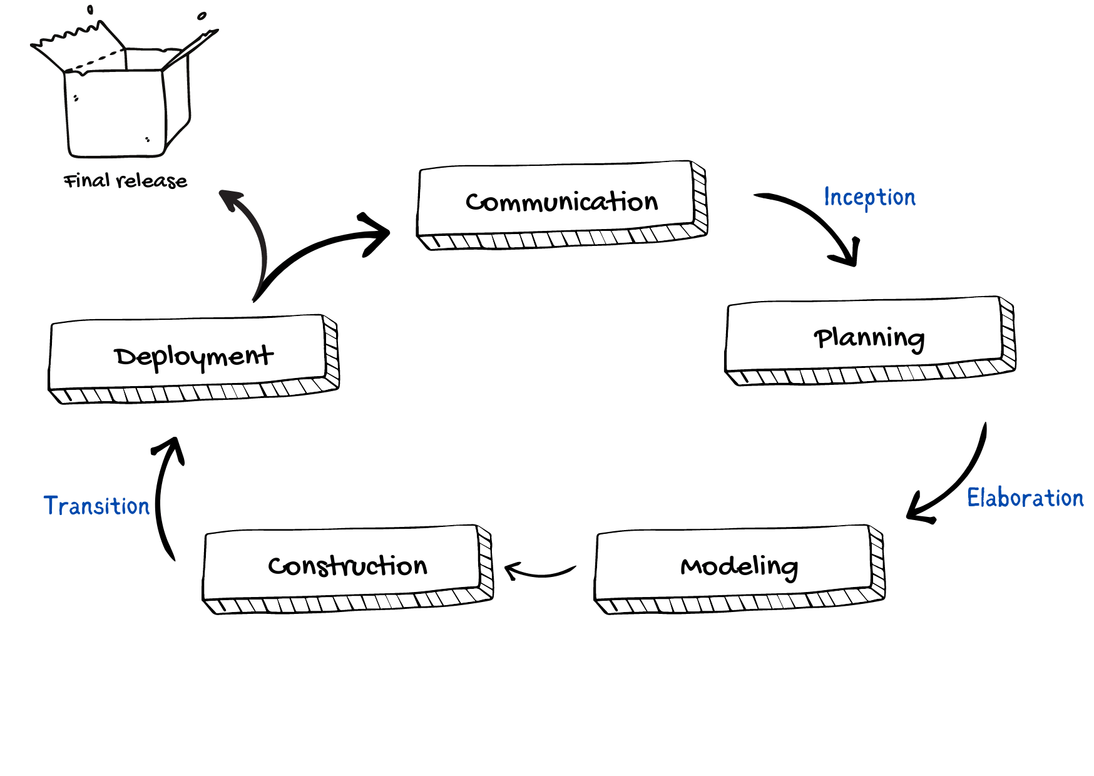

A visual representation of the unified process

Let's have a look at these approaches in detail.

**The case-driven approach**

Use a case-driven approach that follows a set of actions performed by one or more entities. A use case refers to the process of the team performing the development work from the functional requirements. The functional requirements are made from the list of requirements that were specified by the client. For example, an online learning management system can be specified in terms of use cases such as "add a course," "delete a course," "pay fees," and so on.

**The architecture-centric approach**

The architecture-centric approach defines the form of the system and how it should be structured to provide a specific functionality whereas the use case defines the functionality.

**The iterative and incremental approach**

An iterative and incremental approach means that the product will be developed in multiple phases. During these phases, the developers evaluate and test.

**Phases**

We can represent a unified process model as a series of cycles. Each cycle ends with the release of a new system version for the customers. We have four phases in every cycle:

* Inception
* Elaboration
* Construction
* Transition

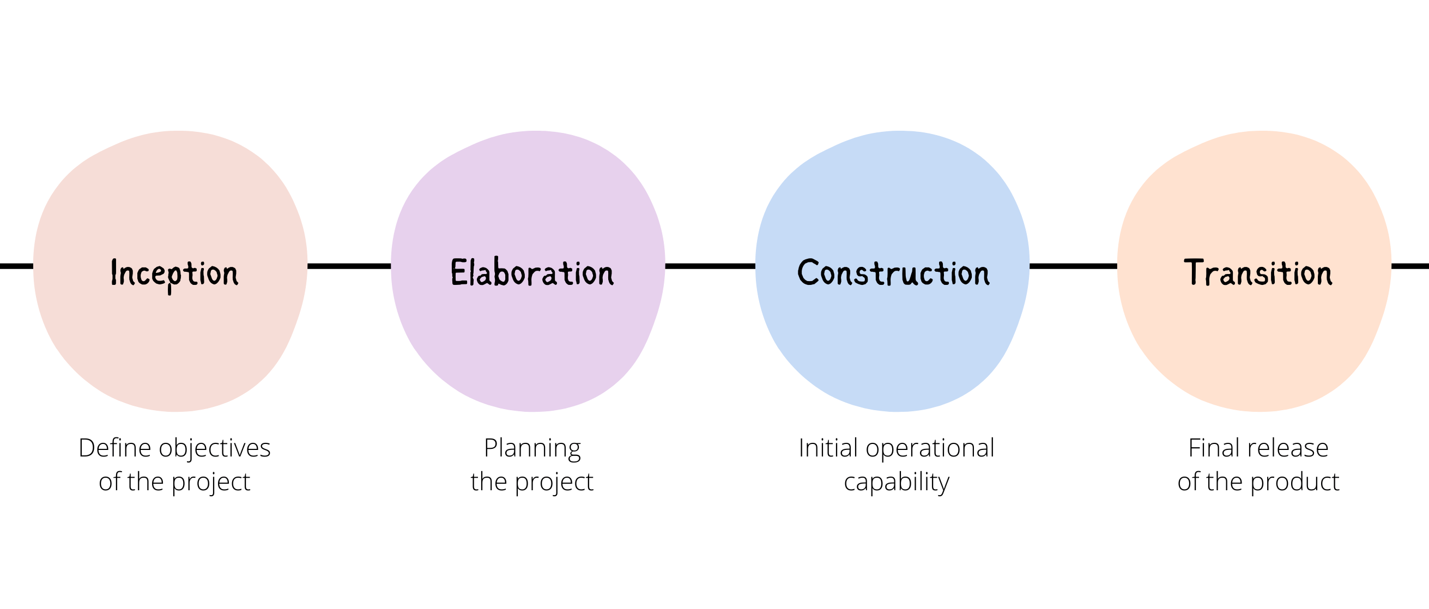

The phases of the unified process

**Inception**

The main goal of this phase involves delimiting the project scope. This is where we define why we are making this product in the first place. It should have the following:

* What are the key features?
* How does this benefit the customers?
* Which methodology will we follow?
* What are the risks involved in executing the project?
* Schedule and cost estimates.

**Elaboration**

We build the system given the requirements, cost, and time constraints and all the risks involved. It should include the following:

* Develop with the majority of the functional requirements implemented.
* Finalize the methodology to be used.
* Deal with the significant risks involved.

**Construction**

This phase is where the development, integration, and testing take place. We build the complete architecture in this phase and hand the final documentation to the client.

**Transition**

This phase involves the deployment, multiple iterations, beta releases, and improvements of the software. The users will test the software, which may raise potential issues. The development team will then fix those errors.

**Conclusion**

This method allows us to deal with the changing requirements throughout the development period. The unified process model has various applications which also makes it complex in nature. Therefore, it's most suitable for smaller projects and should be implemented by a team of professionals.

**Agility - Software Engineering**

Last Updated : 11 Jul, 2025

[Agility](https://www.geeksforgeeks.org/software-engineering/software-engineering-agile-software-development/) has become today’s buzzword when describing a contemporary software method. Everyone is agile. An associate agile team could be a nimble team able to befittingly reply to changes. Modification is what software development is extremely abundant.

* Changes within the software being engineered,
* Changes to the team members,
* Changes attributable to new technology,
* Changes of all types will have an effect on the merchandise they build or the project that makes the merchandise.

All changes can be represented as shown in the below diagram which is considered according to Ivar Jacobson Agility process of Software.

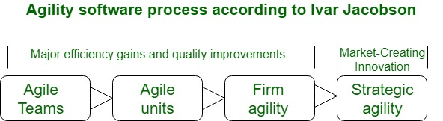Agility - Software Engineering

Support for changes ought to be inherent in everything we tend to kill software, one thing we tend to embrace as a result of it's the guts and soul of software. Associate in agile teams acknowledges that software is developed by people operating in groups the talents of those folks, and their ability to collaborate are at the core for the success of the project. In Jacobson’s read, the generality of modification is that the primary driver for agility. Software engineers should be fast on their feet if they're to accommodate the speedy changes that Jacobson describes. But agility is over an efficient response to alter.

* It encourages team structures and attitudes that create communication (among team members, between technologists and business folks, between software engineers and their managers) additional facile.
* It emphasizes speedy delivery of operational software Associate in emphasizes the importance of intermediate work merchandise (not continuously a decent thing);
* It adopts the client as a vicinity of the event team and works to eliminate the “us and them” angle that continues to perforate several software projects;
* It acknowledges that coming up within an unsure world has its limits which a project arrange should be versatile.

Agility is applied to any software method. However, to accomplish this, it's essential that the method be designed during a manner that enables the project team to adapt tasks and to contour them, conduct coming up within a good manner that understands the fluidity of an agile development approach, eliminate about the foremost essential work products and keeps them lean, Associate in emphasize a progressive delivery strategy that gets operating package to the client as apace as possible for the merchandise sort and operational atmosphere.

**“Agility” for software projects:**

Agility for software projects can be defined as the ability to quickly adapt to changing conditions or user requirements. This requires effective collaboration among stakeholders and having an organized team which encourages collaboration and communication among all who serve it and is in complete control of the tasks completed. This also requires customers to be drawn to the team and performing swift incremental delivery of the software.

An agile software process must be adaptable, manage unpredictability and adapt incrementally.

**Importance of being agile to deliver quality work product:**

Agility helps in understanding what your requestor/client/customer wants and deliver it quickly without compromising on quality.

**Being Agile and deliver quality work product at same time:**

· When you receive a work request, it is important to understand what the requestor wants. When delivering your work, you need to be open to course correction instead of waiting for your work to be perfect. These two agility principles are linked to being closely managed or being self-directed, which helps in adapting to the agile way of working.

· Agile methodology is a family of methodologies, and It includes Scrum, Lean, TDD, XP, DevOps, Release On-Demand and Kanban.

These methodologies are a set of work processes that makes solution perversity less difficult by addressing:

· Work methods by working iteratively and involving the customer.

· Complexity by breaking down the task and performing collaborative problem solving.

· Scheduling by time boxing and always looking for opportunities for improvement.

**Agile methodologies basically:**

· Raise development effort levels of abstraction.

· Make user needs more clearer

· Increase the collaboration of the end user.

· Drive requirements, design, management, and quality improvement.

Agile Process drives:

· Stronger teaming

· Artifact use

· Better use allocation

· Improved planning for the development, effort, and project management.

**There are twelve agile principles, which are key references for an agile team:**

1) Customer Satisfaction

2) Accept Changes in requirements

3) Deliver value frequently

4) Collaboration or Working Together

5) Building Projects with right environment

6) Encourage face to face interaction:

7) Progress Metric

8) Sustainable Development

9) Technical excellence

10) Keeping the work simple

11) Self-Organized Teams

12) Reflect and Improve

**Agile Software Development - Software Engineering**

Last Updated : 11 Jul, 2025

Agile Software Development is a [**Software Development Methodology**](https://www.geeksforgeeks.org/software-engineering/5-most-commonly-used-software-development-methodologies/)that values flexibility, collaboration, and customer satisfaction. It is based on the Agile Manifesto, a set of principles for software development that prioritize individuals and interactions, working software, customer collaboration, and responding to change.

Agile Software Development is an iterative and incremental approach to [**Software Development**](https://www.geeksforgeeks.org/software-engineering/software-development/)that emphasizes the importance of delivering a working product quickly and frequently. It involves close collaboration between the development team and the customer to ensure that the product meets their needs and expectations.

**Table of Content**

* [Why is Agile Used?](https://www.geeksforgeeks.org/software-engineering/software-engineering-agile-software-development/#why-agile-is-used)
* [Agile Software Development Cycle](https://www.geeksforgeeks.org/software-engineering/software-engineering-agile-software-development/#agile-software-development-cycle)
* [4 Core Values of Agile Software Development](https://www.geeksforgeeks.org/software-engineering/software-engineering-agile-software-development/#4-core-values-of-agile-software-development)
* [12 Principles of Agile Software Development](https://www.geeksforgeeks.org/software-engineering/software-engineering-agile-software-development/#12-principles-of-agile-software-development-methodology)
* [Design Process of Agile software Development](https://www.geeksforgeeks.org/software-engineering/software-engineering-agile-software-development/#design-process-of-agile-software-development)
* [Example of Agile Software Development](https://www.geeksforgeeks.org/software-engineering/software-engineering-agile-software-development/#example-of-agile-software-development)
* [Advantages Agile Software Development](https://www.geeksforgeeks.org/software-engineering/software-engineering-agile-software-development/#advantages-agile-software-development)
* [Disadvantages Agile Software Development](https://www.geeksforgeeks.org/software-engineering/software-engineering-agile-software-development/#disadvantages-agile-software-development)
* [Practices of Agile Software Development](https://www.geeksforgeeks.org/software-engineering/software-engineering-agile-software-development/#practices-of-agile-software-development)
* [Advantages of Agile over traditional software development approaches](https://www.geeksforgeeks.org/software-engineering/software-engineering-agile-software-development/#advantages-of-agile-software-development-over-traditional-software-development-approaches)

**Why is Agile Used?**

Agile is used because it helps teams deliver value quickly and continuously. By prioritizing the delivery of difficult results early in the project, customers benefit from seeing and using the product sooner, allowing for quick feedback and adjustments. Agile also encourages teams to focus on what truly matters, concentrating on tasks that add value and avoiding unnecessary work.

* **Agile as a Mindset:**Agile represents a shift in culture that values adaptability, collaboration, and client happiness. It gives team members more authority and promotes a cooperative and upbeat work atmosphere.
* **Quick Response to Change:** Agile fosters a culture that allows teams to respond swiftly to constantly shifting priorities and requirements. This adaptability is particularly useful in sectors of the economy or technology that experience fast changes.
* **Regular Demonstrations:**Agile techniques place a strong emphasis on regular demonstrations of project progress. Stakeholders may clearly see the project's status, upcoming problems, and upcoming new features due to this transparency.
* **Cross-Functional Teams:** Agile fosters self-organizing, cross-functional teams that share information effectively, communicate more effectively and feel more like a unit.

**Agile Software Development Process**

Agile software development, often just called Agile, focuses on being flexible and practical when delivering software. Instead of launching everything at once, Agile delivers small, valuable updates to users over time. This approach allows teams to adjust and improve the product along the way, verifying that each update brings real value to the users. It’s all about making progress in manageable steps and responding quickly to changes.

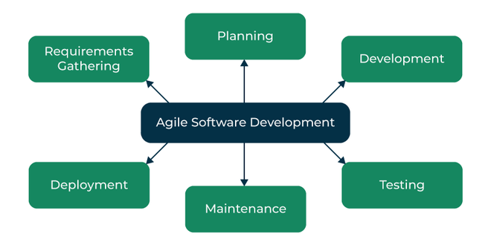Agile Software Development

**1. Requirements Gathering**

This is the first step where the development team works closely with the customer to understand what they really need from the software. The team listens carefully to the customer’s needs, then sorts and prioritizes these requirements to make sure the most important features are developed first.

**2. Planning**

In this stage, the team creates a clear plan for how they’ll build the software. They decide which features to focus on in each development cycle (called an iteration). Think of it like mapping out the journey of the project, so everyone knows what to expect and when things will be delivered.

**3. Development**

This is where the team starts turning their plan into reality. They work in short, focused cycles, building small, usable pieces of the product. Each cycle builds on the last, which helps the team stay on track and get quick feedback to keep improving.

**4. Testing**

As the software gets built, it’s also tested to make sure it works properly and meets the customer’s needs. Testing ensures the product is of high quality and free from errors, so problems are caught early on before they become bigger issues.

**5. Deployment**

Once everything is tested and working as expected, the software is deployed, which means it’s ready for customers or end-users to start using. It’s the moment when all the development work comes to life.

**6. Maintenance**

Even after the software is released, the job isn’t done. The team keeps maintaining the software, verifying it continues to work well and stays up-to-date with any new needs or changes from the customer. This keeps the software relevant and helpful over time.

**Agile Software Development** is widely used by software development teams and is considered to be a flexible and adaptable approach to software development that is well-suited to changing requirements and the fast pace of software development. Agile is a time-bound, iterative approach to software delivery that builds software incrementally from the start of the project, instead of trying to deliver all at once.

**Agile Software Development Cycle**

Let's see a brief overview of how development occurs in Agile philosophy.

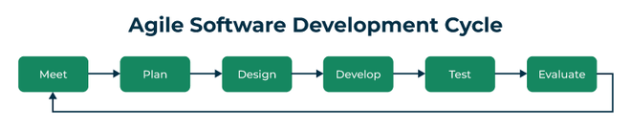Agile software development cycle

* **Step 1:**In the first step, concept, and business opportunities in each possible project are identified and the amount of time and work needed to complete the project is estimated. Based on their technical and financial viability, projects can then be prioritized and determined which ones are worthwhile pursuing.
* **Step 2:**In the second phase, known as inception, the customer is consulted regarding the initial requirements, team members are selected, and funding is secured. Additionally, a schedule outlining each team's responsibilities and the precise time at which each sprint's work is expected to be finished should be developed.
* **Step 3:** Teams begin building functional software in the third step, iteration/construction, based on requirements and ongoing feedback. Iterations, also known as single development cycles, are the foundation of the Agile software development cycle.

**4 Core Values of Agile Software Development**

The four core values of Agile software development, as outlined in the Agile Manifesto, focus on what truly matters for creating successful software. The Agile Software Development Methodology Manifesto describe four core values of Agile in software development.

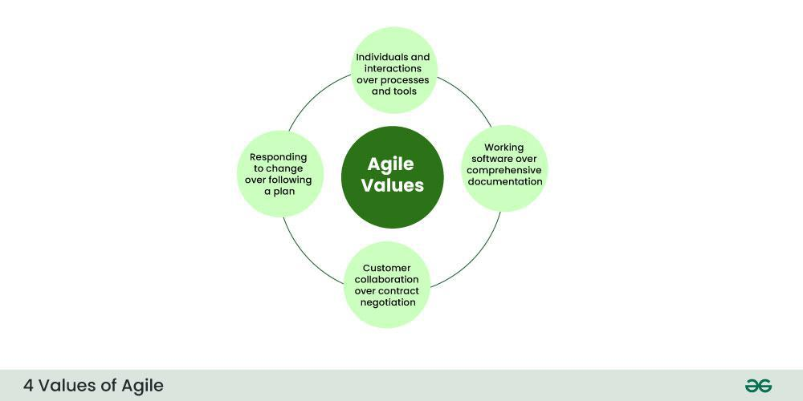4 Values of Agile

**1. Individuals and Interactions over Processes and Tools:**This value stresses that the strength of the team and how well they work together is more important than the tools or processes they use. Of course, tools and processes help, but the real success of a project comes from good teamwork, open communication, and collaboration.

**2. Working Software over Comprehensive Documentation:**Agile prefers delivering functional software quickly rather than getting down in lengthy documentation. While some documentation is needed, the focus is on getting a working product into the hands of the user and improving it based on feedback.

**3. Customer Collaboration over Contract Negotiation:**Agile values regular collaboration with customers over sticking strictly to contracts. The idea is to involve the customer throughout the development, verifying that the product meets their needs and making adjustments based on their feedback.

**4. Responding to Change over Following a Plan:**In Agile, change is expected, and the approach encourages flexibility. Rather than rigidly following a plan that may no longer apply, Agile teams adapt and adjust based on new information, changing market conditions, or including customer requirements.

**12 Principles of Agile Software Development**

There are 12 agile principles mentioned in the [**Agile Manifesto**](https://www.geeksforgeeks.org/software-engineering/agile-manifesto-for-software-development/).Agile principles are guidelines for flexible and efficient software development. They emphasize frequent delivery, embracing change, collaboration, and continuous improvement. The focus is on delivering value, maintaining a sustainable work pace, and ensuring technical excellence.

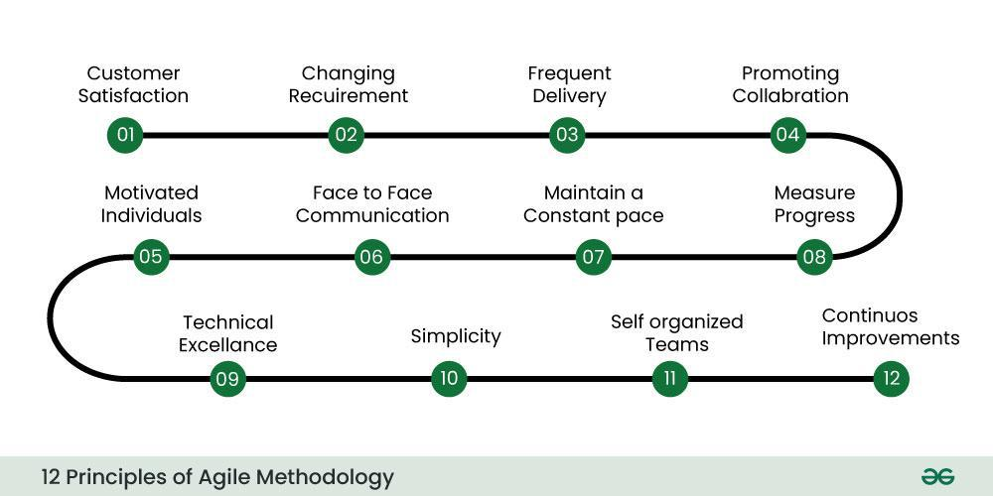12 Principles of Agile Methodology

These principles include:

1. Ensuring customer satisfaction through the early delivery of software.
2. Being open to changing requirements in the stages of the development.
3. Frequently delivering working software with a main focus on preference for timeframes.
4. Promoting collaboration between business stakeholders and developers as an element.
5. Structuring the projects around individuals. Providing them with the necessary environment and support.
6. Prioritizing face to face communication whenever needed.
7. Considering working software as the measure of the progress.
8. Fostering development by allowing teams to maintain a pace indefinitely.
9. Placing attention on excellence and good design practices.
10. Recognizing the simplicity as crucial factor aiming to maximize productivity by minimizing the work.
11. Encouraging self organizing teams as the approach to design and build systems.
12. Regularly reflecting on how to enhance effectiveness and to make adjustments accordingly.

**Design Process of Agile software Development**

In Agile development, Design and Implementation are considered to be the central activities in the software process. The design and Implementation phase also incorporates other activities such as requirements elicitation and testing.

* In an agile approach, iteration occurs across activities. Therefore, the requirements and the design are developed together, rather than separately.
* The allocation of requirements and the design planning and development as executed in a series of increments. In contrast with the conventional model, where requirements gathering needs to be completed to proceed to the design and development phase, it gives Agile development an extra level of flexibility.
* An agile process focuses more on code development rather than documentation.

**Example of Agile Software Development**

Let's go through an example to understand clearly how agile works. A Software company named **ABC** wants to make a new web browser for the latest release of its operating system. The deadline for the task is 10 months. The company's head assigned two teams named **Team A** and **Team B** for this task. To motivate the teams, the company head says that the first team to develop the browser would be given a salary hike and a one-week full-sponsored travel plan.

With the dreams of their wild travel fantasies, the two teams set out on the journey of the web browser. Team A decided to play by the book and decided to choose the Waterfall model for the development. Team B after a heavy discussion decided to take a leap of faith and choose Agile as their development model. The Development Plan of the Team A is as follows:

* [**Requirement Analysis**](https://www.geeksforgeeks.org/software-engineering/activities-involved-in-software-requirement-analysis/)and Gathering - 1.5 Months
* Design of System - 2 Months
* Coding phase - 4 Months
* System Integration and Testing - 2 Months
* User Acceptance Testing - 5 Weeks

The Development Plan for the Team B is as follows:

* Since this was an Agile, the project was broken up into several iterations.
* The iterations are all of the same time duration.
* At the end of each iteration, a working product with a new feature has to be delivered.
* Instead of Spending 1.5 months on requirements gathering, they will decide the core features that are required in the product and decide which of these features can be developed in the first iteration.
* Any remaining features that cannot be delivered in the first iteration will be delivered in the next subsequent iteration, based on the priority.
* At the end of the first iterations, the team will deliver working software with the core basic features.

The team has put their best efforts into getting the product to a complete stage. But then out of the blue due to the rapidly changing environment, the company's head came up with an entirely new set of features that wanted to be implemented as quickly as possible and wanted to push out a working model in 2 days.

Team A was now in a fix, they were still in their design phase and had not yet started coding and they had no working model to display. Moreover, it was practically impossible for them to implement new features since the [**Waterfall Model**](https://www.geeksforgeeks.org/software-engineering/waterfall-vs-agile-software-development-model/)there is not revert to the old phase once you proceed to the next stage, which means they would have to start from square one again.

That would heavy costs and a lot of overtime. Team B was ahead of Team A in a lot of aspects, all thanks to Agile Development. They also had a working product with most of the core requirements since the first increment. And it was a piece of cake for them to add the new requirements. All they had to do was schedule these requirements for the next increment and then implement them.

**Advantages Agile Software Development**

* **Increased collaboration and communication:**[**Agile Software Development Methodology**](https://www.geeksforgeeks.org/software-engineering/agile-software-development-methodology-framework/)emphasize collaboration and communication among team members, stakeholders, and customers. This leads to improved understanding, better alignment, and increased buy-in from everyone involved.
* **Flexibility and adaptability:**Agile methodologies are designed to be flexible and adaptable, making it easier to respond to changes in requirements, priorities, or market conditions. This allows teams to quickly adjust their approach and stay focused on delivering value.
* **Improved quality and reliability:**Agile methodologies place a strong emphasis on testing, quality assurance, and continuous improvement. This helps to ensure that software is delivered with high quality and reliability, reducing the risk of defects or issues that can impact the user experience.
* **Enhanced customer satisfaction:**Agile methodologies prioritize customer satisfaction and focus on delivering value to the customer. By involving customers throughout the development process, teams can ensure that the software meets their needs and expectations.
* **Increased team morale and motivation:** Agile methodologies promote a collaborative, supportive, and positive work environment. This can lead to increased team morale, motivation, and engagement, which can in turn lead to better productivity, higher quality work, and improved outcomes.
* Deployment of software is quicker and thus helps in increasing the trust of the customer.
* Can better adapt to rapidly changing requirements and respond faster.
* Helps in getting immediate feedback which can be used to improve the software in the next increment.
* People - Not Process. People and interactions are given a higher priority than processes and tools.
* Continuous attention to technical excellence and good design.

**Disadvantages Agile Software Development**

* **Lack of predictability:**Agile Development relies heavily on customer feedback and continuous iteration, which can make it difficult to predict project outcomes, timelines, and budgets.
* **Limited scope control:** Agile Development is designed to be flexible and adaptable, which means that scope changes can be easily accommodated. However, this can also lead to scope creep and a lack of control over the project scope.
* **Lack of emphasis on testing:** Agile Development places a greater emphasis on delivering working code quickly, which can lead to a lack of focus on testing and quality assurance. This can result in bugs and other issues that may go undetected until later stages of the project.
* **Risk of team burnout:** Agile Development can be intense and fast-paced, with frequent sprints and deadlines. This can put a lot of pressure on team members and lead to burnout, especially if the team is not given adequate time for rest and recovery.
* **Lack of structure and governance:** Agile Development is often less formal and structured than other development methodologies, which can lead to a lack of governance and oversight. This can result in inconsistent processes and practices, which can impact project quality and outcomes.
* In the case of large software projects, it is difficult to assess the effort required at the initial stages of the software development life cycle.
* Agile Development is more code-focused and produces less documentation.
* Agile development is heavily dependent on the inputs of the customer. If the customer has ambiguity in his vision of the outcome, it is highly likely that the project to get off track.
* Face-to-face communication is harder in large-scale organizations.
* Only senior programmers are capable of making the kind of decisions required during the development process. Hence, it's a difficult situation for new programmers to adapt to the environment.

Agile is a framework that defines how software development needs to be carried on. Agile is not a single method, it represents the various collection of methods and practices that follow the value statements provided in the manifesto. Agile methods and practices do not promise to solve every problem present in the software industry (No Software model ever can). But they sure help to establish a culture and environment where solutions emerge.  
Agile software development is an iterative and incremental approach to software development. It emphasizes collaboration between the development team and the customer, flexibility, and adaptability in the face of changing requirements, and the delivery of working software in short iterations.  
The Agile Manifesto, which outlines the principles of agile development, values individuals and interactions, working software, customer collaboration, and response to change.

**Practices of Agile Software Development**

* **Scrum:**Scrum is a framework for agile software development that involves iterative cycles called sprints, daily stand-up meetings, and a product backlog that is prioritized by the customer.
* **Kanban:** Kanban is a visual system that helps teams manage their work and improve their processes. It involves using a board with columns to represent different stages of the development process, and cards or sticky notes to represent work items.
* **Continuous Integration:**Continuous Integration is the practice of frequently merging code changes into a shared repository, which helps to identify and resolve conflicts early in the development process.
* **Test-Driven Development:**Test-Driven Development (TDD) is a development practice that involves writing automated tests before writing the code. This helps to ensure that the code meets the requirements and reduces the likelihood of defects.
* P**air Programming:** Pair programming involves two developers working together on the same code. This helps to improve code quality, share knowledge, and reduce the likelihood of defects.

**Advantages of Agile over traditional software development approaches**

1. **Increased customer satisfaction:** Agile development involves close collaboration with the customer, which helps to ensure that the software meets their needs and expectations.
2. **Faster time-to-market:**Agile development emphasizes the delivery of working software in short iterations, which helps to get the software to market faster.
3. **Reduced risk:**Agile development involves frequent testing and feedback, which helps to identify and resolve issues early in the development process.
4. **Improved team collaboration:** Agile development emphasizes collaboration and communication between team members, which helps to improve productivity and morale.
5. **Adaptability to change:** Agile Development is designed to be flexible and adaptable, which means that changes to the project scope, requirements, and timeline can be accommodated easily. This can help the team to respond quickly to changing business needs and market demands.
6. **Better quality software:** Agile Development emphasizes continuous testing and feedback, which helps to identify and resolve issues early in the development process. This can lead to higher-quality software that is more reliable and less prone to errors.
7. **Increased transparency:**Agile Development involves frequent communication and collaboration between the team and the customer, which helps to improve transparency and visibility into the project status and progress. This can help to build trust and confidence with the customer and other stakeholders.
8. **Higher productivity:** Agile Development emphasizes teamwork and collaboration, which helps to improve productivity and reduce waste. This can lead to faster delivery of working software with fewer defects and rework.
9. **Improved project control:** Agile Development emphasizes continuous monitoring and measurement of project metrics, which helps to improve project control and decision-making. This can help the team to stay on track and make data-driven decisions throughout the development process.

**Related Posts:**

* [Agile Software Development Methodology | Framework, Principles, and Benefits](https://www.geeksforgeeks.org/software-engineering/agile-software-development-methodology-framework/)
* [Top 50 Agile Software Development Interview Questions](https://www.geeksforgeeks.org/interview-experiences/agile-software-development-interview-questions/)

**Conclusion**

In summary, Agile software development is a popular approach to software development that emphasizes collaboration, flexibility, and the delivery of working software in short iterations. It has several advantages over traditional software development approaches, including increased customer satisfaction, faster time-to-market, and reduced risk.

Agile concepts every team should know

* Agile: A project management approach that delivers high-quality work in small increments rather than in one final release.
* Sprint: A short work cycle, usually one to four weeks, where teams commit to completing specific tasks.
* [Product backlog](https://asana.com/resources/product-backlog): A prioritized list of features, fixes, and tasks that guide what the team will work on next.
* [Sprint backlog](https://asana.com/resources/sprint-backlog): The selected items from the product backlog that the team plans to finish during a sprint.
* [Standup](https://asana.com/resources/stand-up-meeting): A short daily meeting where team members share progress, plans, and roadblocks.
* Iteration: A repeated cycle of planning, building, testing, and reviewing work to improve outcomes.
* [User story](https://asana.com/resources/user-stories): A brief explanation of a feature from the end user's perspective, often used to define requirements.
* [Epic](https://asana.com/resources/agile-epic): A large work item made up of multiple user stories that span several sprints.
* [Velocity](https://asana.com/resources/sprint-velocity): A metric showing how much work a team completes in a sprint, often measured in story points.
* [Burndown chart](https://asana.com/resources/burndown-chart): A visual tool that tracks remaining work against the time left in a sprint or project.
* Work in progress (WIP): The tasks currently being worked on; limiting WIP helps prevent bottlenecks and delays.

**What is Scrum in Software Development?**

Last Updated : 15 Sep, 2025

[Scrum](https://www.geeksforgeeks.org/software-engineering/scrum-software-development/) is a popular framework that is used whenever we want to develop complex products, **Ken Schwaber** and **Jeff Sutherland** are known as the people who developed Scrum. **Scrum** is a type of [**Agile framework**](https://www.geeksforgeeks.org/software-engineering/agile-software-development-methodology-framework/).

**What is a scrum in software development?**

Scrum is a management framework that teams use to self-organize tasks and work towards a common goal. It is a framework within which people can address complex adaptive problems while the productivity and creativity of delivering products are at the highest possible value. Scrum is a management framework that teams use to self-organize and work towards a common goal.

* Scrum allows us to develop products of the highest value while making sure that we maintain creativity and productivity.
* The iterative and incremental approach used in scrum allows the teams to adapt to the changing requirements.

**Silent features of Scrum**

* Scrum is a light-weighted framework
* Scrum emphasizes self-organization
* Scrum is simple to understand
* Scrum framework helps the team to work together
* Lifecycle of Scrum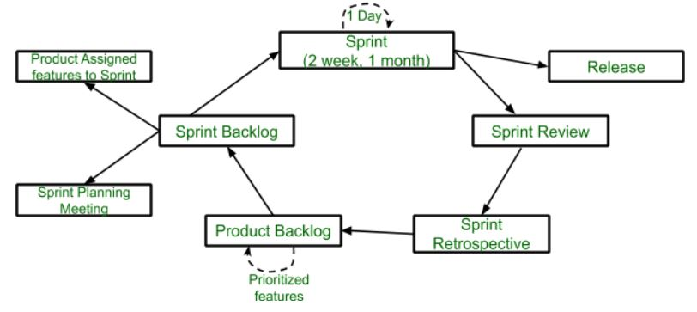
* [**Sprint**](https://www.geeksforgeeks.org/software-engineering/what-is-a-sprint-in-agile/)**:** A Sprint is a time box of one month or less. A new Sprint starts immediately after the completion of the previous Sprint. **Release:** When the product is completed, it goes to the Release stage.
* [**Sprint Review**](https://www.geeksforgeeks.org/software-engineering/sprint-review-meeting-purpose-importance-and-best-practice-in-software-development/)**:** If the product still has some non-achievable features, it will be checked in this stage and then passed to the Sprint Retrospective stage.
* [**Sprint Retrospective**](https://www.geeksforgeeks.org/software-engineering/sprint-retrospective-meeting-purpose-and-steps/)**:** In this stage quality or status of the product is checked. **Product Backlog:** According to the prioritize features the product is organized.
* [**Sprint Backlog**](https://www.geeksforgeeks.org/software-engineering/product-backlog-and-sprint-backlog-in-software-engineering/)**:** Sprint Backlog is divided into two parts Product assigned features to sprint and Sprint planning meeting.

**Advantage of Scrum framework**

* Scrum framework is fast moving and money efficient.
* Scrum framework works by dividing the large product into small sub-products. It's like a divide and conquer strategy
* In Scrum customer satisfaction is very important.
* Scrum is adaptive in nature because it have short sprint.
* As Scrum framework rely on constant feedback therefore the quality of product increases in less amount of time

**Disadvantage of Scrum framework**

* Scrum framework do not allow changes into their sprint.
* Scrum framework is not fully described model. If you wanna adopt it you need to fill in the framework with your own details like [Extreme Programming(XP),](https://www.geeksforgeeks.org/software-engineering/software-engineering-extreme-programming-xp/) [Kanban](https://www.geeksforgeeks.org/software-engineering/kanban-agile-methodology/), [Dynamic Systems Development Method (DSDM)](https://www.geeksforgeeks.org/software-engineering/dynamic-systems-development-method-dsdm/).
* It can be difficult for the Scrum to plan, structure and organize a project that lacks a clear definition.
* The daily Scrum meetings and frequent reviews require substantial resources.

**Conclusion**

In Conclusion, Scrum is an [Agile](https://www.geeksforgeeks.org/software-engineering/software-engineering-agile-software-development/)framework for [product development](https://www.geeksforgeeks.org/marketing/8-stages-of-new-product-development-process/), improving the self organization and capabilities. It improve the productivity and customer satisfaction but it may cause the challenges in handling changes in the mid sprint and requires additional changes for implementation.

**Scrum** is an [agile](https://en.wikipedia.org/wiki/Agile_management) team collaboration framework commonly used in [software development](https://en.wikipedia.org/wiki/Software_development) and other industries.

Scrum prescribes for teams to break work into [goals](https://en.wikipedia.org/wiki/Goal) to be completed within [time-boxed](https://en.wikipedia.org/wiki/Timeboxing) iterations, called *sprints*. Each sprint is no longer than one month and commonly lasts two weeks. The scrum team assesses progress in time-boxed, [stand-up meetings](https://en.wikipedia.org/wiki/Stand-up_meeting) of up to 15 minutes, called *daily scrums*. At the end of the sprint, the team holds two further meetings: one sprint review to demonstrate the work for [stakeholders](https://en.wikipedia.org/wiki/Stakeholder_(corporate)) and solicit feedback, and one internal [sprint retrospective](https://en.wikipedia.org/wiki/Retrospective#Software_development). A person in charge of a scrum team is typically called a **scrum master**.[[2]](https://en.wikipedia.org/wiki/Scrum_(project_management)#cite_note-2)

Scrum's approach to product development involves bringing [decision-making](https://en.wikipedia.org/wiki/Decision-making) authority to an operational level.[[3]](https://en.wikipedia.org/wiki/Scrum_(project_management)#cite_note-schwaber-3) Unlike a sequential approach to product development, scrum is an [iterative](https://en.wikipedia.org/wiki/Iterative_design) and [incremental](https://en.wikipedia.org/wiki/Iterative_and_incremental_development) framework for product development.[[4]](https://en.wikipedia.org/wiki/Scrum_(project_management)#cite_note-scrumalliance-4) Scrum allows for continuous feedback and flexibility, requiring teams to self-organize by encouraging physical [co-location](https://en.wikipedia.org/wiki/Colocation_(business)) or close online collaboration, and mandating frequent communication among all team members. The flexible approach of scrum is based in part on the notion of requirement volatility, that stakeholders will change their requirements as the project evolves.[[5]](https://en.wikipedia.org/wiki/Scrum_(project_management)#cite_note-5)

**History**

The use of the term *scrum* in software development came from a 1986 [*Harvard Business Review*](https://en.wikipedia.org/wiki/Harvard_Business_Review) paper titled "The New New Product Development Game" by [Hirotaka Takeuchi](https://en.wikipedia.org/wiki/Hirotaka_Takeuchi) and [Ikujiro Nonaka](https://en.wikipedia.org/wiki/Ikujiro_Nonaka). Based on case studies from manufacturing firms in the automotive, photocopier, and printer [industries](https://en.wikipedia.org/wiki/Economic_sector), the authors outlined a new approach to product development for increased speed and flexibility. They called this the [rugby](https://en.wikipedia.org/wiki/Rugby_football) approach, as the process involves a single [cross-functional team](https://en.wikipedia.org/wiki/Cross-functional_team) operating across multiple overlapping phases in which the team "tries to go the distance as a unit, passing the ball back and forth".[[6]](https://en.wikipedia.org/wiki/Scrum_(project_management)#cite_note-TakeuchiNonaka-6) The authors later developed scrum in their book, *The Knowledge Creating Company*.[[7]](https://en.wikipedia.org/wiki/Scrum_(project_management)#cite_note-7)

In the early 1990s, [Ken Schwaber](https://en.wikipedia.org/wiki/Ken_Schwaber) used what would become scrum at his company, Advanced Development Methods. [Jeff Sutherland](https://en.wikipedia.org/wiki/Jeff_Sutherland), John Scumniotales, and Jeff McKenna developed a similar approach at Easel Corporation, referring to the approach with the term *scrum*.[[8]](https://en.wikipedia.org/wiki/Scrum_(project_management)#cite_note-autogenerated1-8) Sutherland and Schwaber later worked together to integrate their ideas into a single framework, formally known as scrum. Schwaber and Sutherland tested scrum and continually improved it, leading to the publication of a research paper in 1995,[[9]](https://en.wikipedia.org/wiki/Scrum_(project_management)#cite_note-OOPSLA95-9) and the [Manifesto for Agile Software Development](https://en.wikipedia.org/wiki/Manifesto_for_Agile_Software_Development) in 2001.[[10]](https://en.wikipedia.org/wiki/Scrum_(project_management)#cite_note-agilemanifesto-10) Schwaber also collaborated with [Babatunde Ogunnaike](https://en.wikipedia.org/wiki/Babatunde_Ogunnaike) at DuPont Research Station and the [University of Delaware](https://en.wikipedia.org/wiki/University_of_Delaware) to develop Scrum. Ogunnaike believed that software development projects could often fail when initial conditions change if [product management](https://en.wikipedia.org/wiki/Product_management) was not rooted in empirical practice.[[3]](https://en.wikipedia.org/wiki/Scrum_(project_management)#cite_note-schwaber-3)

In 2002, Schwaber with others founded the Scrum Alliance and set up the *Certified Scrum* accreditation series.[[11]](https://en.wikipedia.org/wiki/Scrum_(project_management)#cite_note-11) Schwaber left the Scrum Alliance in late 2009 and subsequently founded Scrum.org, which oversees the parallel *Professional Scrum* accreditation series.[[12]](https://en.wikipedia.org/wiki/Scrum_(project_management)#cite_note-12) Since 2009, a public document called *The Scrum Guide*[[13]](https://en.wikipedia.org/wiki/Scrum_(project_management)#cite_note-scrumguidesite-13) has been published and updated by Schwaber and Sutherland. It has been revised six times, with the most recent version having been published in November 2020.

**Scrum team**

A scrum team is organized into at least three categories of individuals: the product owner, developers, and the scrum master. The product owner liaises with stakeholders, those who have an interest in the project's outcome, to communicate tasks and expectations with developers.[[14]](https://en.wikipedia.org/wiki/Scrum_(project_management)#cite_note-:0-14) Developers in a scrum team organize work by themselves, with the facilitation of a scrum master.[[15]](https://en.wikipedia.org/wiki/Scrum_(project_management)#cite_note-15)

**Product owner**

Each scrum team has one product owner.[[16]](https://en.wikipedia.org/wiki/Scrum_(project_management)#cite_note-:1-16) The product owner focuses on the business side of product development and spends the majority of time liaising with stakeholders and the team. The role is intended to primarily represent the product's [stakeholders](https://en.wikipedia.org/wiki/Stakeholder_(corporate)), the [voice of the customer](https://en.wikipedia.org/wiki/Voice_of_the_customer), or the desires of a [committee](https://en.wikipedia.org/wiki/Committee), and bears responsibility for the delivery of business results.[[17]](https://en.wikipedia.org/wiki/Scrum_(project_management)#cite_note-Essential_Scrum:_Velocity-17)[[18]](https://en.wikipedia.org/wiki/Scrum_(project_management)#cite_note-:3-18)[[19]](https://en.wikipedia.org/wiki/Scrum_(project_management)#cite_note-19)[[20]](https://en.wikipedia.org/wiki/Scrum_(project_management)#cite_note-20) Product owners manage the [product backlog](https://en.wikipedia.org/wiki/Product_backlog) and are responsible for maximizing the value that a team delivers.[[18]](https://en.wikipedia.org/wiki/Scrum_(project_management)#cite_note-:3-18) They do not dictate the technical solutions of a team but may instead attempt to seek consensus among team members.[[21]](https://en.wikipedia.org/wiki/Scrum_(project_management)#cite_note-scrumguidepdf2016-21)[[22]](https://en.wikipedia.org/wiki/Scrum_(project_management)#cite_note-22)

As the primary liaison of the scrum team towards stakeholders, product owners are responsible for communicating announcements, project definitions and progress, RIDAs ([risks](https://en.wikipedia.org/wiki/Project_risk_management), impediments, [dependencies](https://en.wikipedia.org/wiki/Dependency_(project_management)), and assumptions), funding and scheduling changes, the product backlog, and project governance, among other responsibilities.[[23]](https://en.wikipedia.org/wiki/Scrum_(project_management)#cite_note-23)[[*better source needed*](https://en.wikipedia.org/wiki/Wikipedia:NOTRS)] Product owners can also cancel a sprint if necessary, without the input of team members.[[13]](https://en.wikipedia.org/wiki/Scrum_(project_management)#cite_note-scrumguidesite-13)

**Developers**

In scrum, the term *developer* or *team member* refers to anyone who plays a role in the development and support of the product and can include researchers, [architects](https://en.wikipedia.org/wiki/Systems_architect), designers, programmers, etc.[[13]](https://en.wikipedia.org/wiki/Scrum_(project_management)#cite_note-scrumguidesite-13)[[24]](https://en.wikipedia.org/wiki/Scrum_(project_management)#cite_note-:2-24)

**Scrum master**

Scrum is facilitated by a scrum master, whose role is to educate and coach teams about scrum theory and practice.[[1]](https://en.wikipedia.org/wiki/Scrum_(project_management)#cite_note-scrumguidepdf2020-1) Scrum masters have differing roles and responsibilities from traditional [team leads](https://en.wikipedia.org/wiki/Team_leader) or [project managers](https://en.wikipedia.org/wiki/Project_manager). Some scrum master responsibilities include coaching, objective setting, problem solving, oversight, planning, backlog management, and communication facilitation.[[1]](https://en.wikipedia.org/wiki/Scrum_(project_management)#cite_note-scrumguidepdf2020-1) On the other hand, traditional project managers often have [people management](https://en.wikipedia.org/wiki/Management) responsibilities, which a scrum master does not. Scrum teams do not involve project managers, so as to maximize self-organisation among developers.[[25]](https://en.wikipedia.org/wiki/Scrum_(project_management)#cite_note-scrumprimer-25)

**Workflow**

**Sprint**

*Not to be confused with*[*Hackathon § Code sprints*](https://en.wikipedia.org/wiki/Hackathon#Code_sprints)*.*

[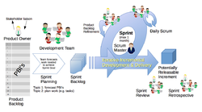](https://en.wikipedia.org/wiki/File:Scrum_Framework.png)The scrum framework (PBI in the figure refers to product backlog item)[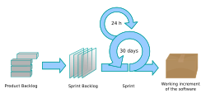](https://en.wikipedia.org/wiki/File:Scrum_process.svg)The scrum process

A sprint (also known as a [*design sprint*](https://en.wikipedia.org/wiki/Design_sprint), [*iteration*](https://en.wikipedia.org/wiki/Iterative_and_incremental_development), or [*timebox*](https://en.wikipedia.org/wiki/Timeboxing)) is a fixed period of time wherein team members work on a specific goal. Each sprint is normally between one week and one month, with two weeks being the most common.[[3]](https://en.wikipedia.org/wiki/Scrum_(project_management)#cite_note-schwaber-3) The outcome of the sprint is a functional deliverable, or a product which has received some development in [increments](https://en.wikipedia.org/wiki/Iterative_and_incremental_development). When a sprint is abnormally terminated, the next step is to conduct new sprint planning, where the reason for the termination is reviewed.

Each sprint starts with a sprint planning event in which a sprint goal is defined. Priorities for planned sprints are chosen out of the backlog. Each sprint ends with two events:[[8]](https://en.wikipedia.org/wiki/Scrum_(project_management)#cite_note-autogenerated1-8)

* A *sprint review* (progress shown to stakeholders to elicit their feedback)
* A *sprint retrospective* (identifying lessons and improvements for the next sprints)

The suggested maximum duration of sprint planning is eight hours for a four-week sprint.[[13]](https://en.wikipedia.org/wiki/Scrum_(project_management)#cite_note-scrumguidesite-13)

**Daily scrum**

*Main article:*[*Daily scrum meeting*](https://en.wikipedia.org/wiki/Daily_scrum_meeting)

[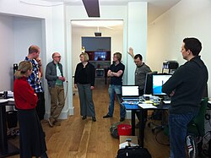](https://en.wikipedia.org/wiki/File:Daily_sprint_meeting.jpg)A daily scrum in the computing room

Each day during a sprint, the developers hold a daily scrum (often conducted [standing up](https://en.wikipedia.org/wiki/Stand-up_meeting)) with specific guidelines, and which may be facilitated by a scrum master.[[3]](https://en.wikipedia.org/wiki/Scrum_(project_management)#cite_note-schwaber-3)[[26]](https://en.wikipedia.org/wiki/Scrum_(project_management)#cite_note-26) Daily scrum meetings are intended to be less than 15 minutes in length, taking place at the same time and location daily. The purpose of the meeting is to announce progress made towards the sprint goal and issues that may be hindering the goal, without going into any detailed discussion. Once over, individual members can go into a 'breakout session' or an 'after party' for extended discussion and collaboration.[[27]](https://en.wikipedia.org/wiki/Scrum_(project_management)#cite_note-:5-27) Scrum masters are responsible for ensuring that team members use daily scrums effectively or, if team members are unable to use them, providing alternatives to achieve similar outcomes.[[28]](https://en.wikipedia.org/wiki/Scrum_(project_management)#cite_note-28)[[29]](https://en.wikipedia.org/wiki/Scrum_(project_management)#cite_note-:4-29)

**Post-sprint events**

Conducted at the end of a sprint, a sprint review is a meeting that has a team share the work they've completed with stakeholders and liaise with them on feedback, expectations, and upcoming plans. At a sprint review completed deliverables are demonstrated to stakeholders. The recommended duration for a sprint review is one hour per week of sprint.[[13]](https://en.wikipedia.org/wiki/Scrum_(project_management)#cite_note-scrumguidesite-13)

A sprint retrospective is a separate meeting that allows team members to internally analyze the strengths and weaknesses of the sprint, future areas of improvement, and [continuous process improvement](https://en.wikipedia.org/wiki/Continual_improvement_process) actions.[[30]](https://en.wikipedia.org/wiki/Scrum_(project_management)#cite_note-Essential_Scrum:_Velocity2-30)

**Backlog grooming or refinement**

Backlog grooming or refinement is a process by which team members revise and prioritize a backlog for future sprints.[[31]](https://en.wikipedia.org/wiki/Scrum_(project_management)#cite_note-FOOTNOTEProject_Management_Institute2021Glossary_%C2%A73_Definitions-31) It can be done as a separate stage done before the beginning of a new sprint or as a continuous process that team members work on by themselves. Backlog refinement can include the breaking down of large tasks into smaller and clearer ones, the clarification of success criteria, and the revision of changing priorities and returns.[[32]](https://en.wikipedia.org/wiki/Scrum_(project_management)#cite_note-32)

**Artifacts**

|  |  |
| --- | --- |
| [icon](https://en.wikipedia.org/wiki/File:Question_book-new.svg) | This section **needs additional citations for**[**verification**](https://en.wikipedia.org/wiki/Wikipedia:Verifiability). Please help [improve this article](https://en.wikipedia.org/wiki/Special:EditPage/Scrum_(project_management)) by [adding citations to reliable sources](https://en.wikipedia.org/wiki/Help:Referencing_for_beginners) in this section. Unsourced material may be challenged and removed. *(March 2013) (*[*Learn how and when to remove this message*](https://en.wikipedia.org/wiki/Help:Maintenance_template_removal)*)* |

[Artifacts](https://en.wikipedia.org/wiki/Artifact_(software_development)) are a means by which scrum teams manage product development by documenting work done towards the project. There are seven scrum artifacts, with three of them being the most common: product backlog, sprint backlog, and increment.[[33]](https://en.wikipedia.org/wiki/Scrum_(project_management)#cite_note-33)

**Product backlog**

*Main article:*[*Product backlog*](https://en.wikipedia.org/wiki/Product_backlog)

The product backlog is a breakdown of work to be done and contains an ordered list of [product requirements](https://en.wikipedia.org/wiki/Requirement) (such as [features](https://en.wikipedia.org/wiki/Software_feature), [bug fixes](https://en.wikipedia.org/wiki/Patch_(computing)) and [non-functional requirements](https://en.wikipedia.org/wiki/Non-functional_requirement)) that the team maintains for a [product](https://en.wikipedia.org/wiki/New_product_development). The order of a product backlog corresponds to the urgency of the task. Common formats for backlog items include [user stories](https://en.wikipedia.org/wiki/User_story) and [use cases](https://en.wikipedia.org/wiki/Use_case).[[25]](https://en.wikipedia.org/wiki/Scrum_(project_management)#cite_note-scrumprimer-25) The product backlog may also contain the product owner's assessment of [business value](https://en.wikipedia.org/wiki/Business_value) and the team's assessment of the product's effort or complexity, which can be stated in [story points](https://en.wikipedia.org/wiki/Planning_poker) using the rounded [Fibonacci scale](https://en.wikipedia.org/wiki/Fibonacci_sequence). These estimates try to help the product owner gauge the timeline and may influence the ordering of product backlog items.[[34]](https://en.wikipedia.org/wiki/Scrum_(project_management)#cite_note-34)

The product owner maintains and prioritizes product backlog items based on considerations such as risk, business value, dependencies, size, and timing. High-priority items at the top of the backlog are broken down into more detail for developers to work on, while tasks further down the backlog may be more vague.[[3]](https://en.wikipedia.org/wiki/Scrum_(project_management)#cite_note-schwaber-3)

**Sprint backlog**

The sprint backlog is the subset of items from the product backlog intended for developers to address in a particular sprint.[[35]](https://en.wikipedia.org/wiki/Scrum_(project_management)#cite_note-MartinelliMilosevic2016-35) Developers fill this backlog with tasks they deem appropriate to fill the sprint, using past performance to assess their capacity for each sprint. The scrum approach has tasks on the sprint backlog not assigned to developers by any particular individual or leader. Team members self organize by pulling work as needed according to the backlog priority and their own capabilities and capacity.[[36]](https://en.wikipedia.org/wiki/Scrum_(project_management)#cite_note-scrumguidepdf2017-36)

**Increment**

An increment is a potentially releasable output of a sprint, which meets the sprint goal. It is formed from all the completed sprint backlog items, integrated with the work of all previous sprints.

**Other artifacts**

**Burndown chart**

[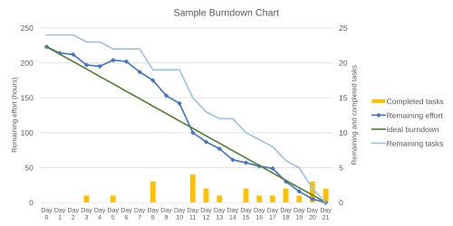](https://en.wikipedia.org/wiki/File:SampleBurndownChart.svg)A sample burndown chart for a completed sprint, showing remaining effort at the end of each day

*Main article:*[*Burndown chart*](https://en.wikipedia.org/wiki/Burndown_chart)

Often used in scrum, a burndown chart is a publicly displayed chart showing remaining work.[[37]](https://en.wikipedia.org/wiki/Scrum_(project_management)#cite_note-Cobb2015-37) It provides quick visualizations for reference. The horizontal axis of the burndown chart shows the days remaining, while the vertical axis shows the amount of work remaining each day. During sprint planning, the ideal burndown chart is plotted.[[38]](https://en.wikipedia.org/wiki/Scrum_(project_management)#cite_note-38) Then, during the sprint, developers update the chart with the remaining work.

**Release burnup chart**

[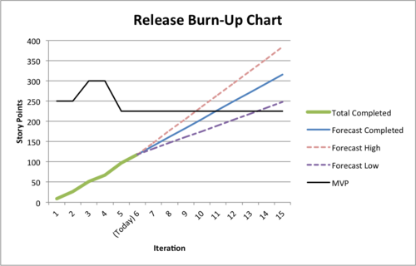](https://en.wikipedia.org/wiki/File:SampleBurnupChart.png)A sample burnup chart for a release, showing scope completed each sprint (MVP = [minimum viable product](https://en.wikipedia.org/wiki/Minimum_viable_product))

*Main article:*[*Burnup chart*](https://en.wikipedia.org/wiki/Burnup_chart)

Updated at the end of each sprint, the release burn-up chart shows progress towards delivering a forecast scope. The horizontal axis of the release burnup chart shows the sprints in a release, while the vertical axis shows the amount of work completed at the end of each sprint.

**Velocity**

*Main article:*[*Velocity (software development)*](https://en.wikipedia.org/wiki/Velocity_(software_development))

Some project managers believe that a team's total capability effort for a single sprint can be derived by evaluating work completed in the last sprint. The collection of historical "[velocity](https://en.wikipedia.org/wiki/Velocity_(software_development))" data is a guideline for assisting the team in understanding their capacity.

**Limitations**

Some have argued that scrum events, such as daily scrums and scrum reviews, hurt [productivity](https://en.wikipedia.org/wiki/Productivity) and waste time that could be better spent on actual productive tasks.[[39]](https://en.wikipedia.org/wiki/Scrum_(project_management)#cite_note-39)[[40]](https://en.wikipedia.org/wiki/Scrum_(project_management)#cite_note-40) Scrum has also been observed to pose difficulties for part-time or geographically distant teams; those that have highly specialized members who would be better off working by themselves or in working cliques; and those that are unsuitable for incremental and [development testing](https://en.wikipedia.org/wiki/Development_testing).[[41]](https://en.wikipedia.org/wiki/Scrum_(project_management)#cite_note-41)[[42]](https://en.wikipedia.org/wiki/Scrum_(project_management)#cite_note-42)

**Adaptations**

Scrum is frequently tailored or adapted in different contexts to achieve varying aims.[[43]](https://en.wikipedia.org/wiki/Scrum_(project_management)#cite_note-43) A common approach to adapting scrum is the combination of scrum with other software development methodologies, as scrum does not cover the whole [product development lifecycle](https://en.wikipedia.org/wiki/Software_lifecycle).[[44]](https://en.wikipedia.org/wiki/Scrum_(project_management)#cite_note-44) Various scrum practitioners have also suggested more detailed techniques for how to apply or adapt scrum to particular problems or organizations. Many refer to these techniques as 'patterns', an analogous use to [design patterns](https://en.wikipedia.org/wiki/Design_pattern) in architecture and software.[[45]](https://en.wikipedia.org/wiki/Scrum_(project_management)#cite_note-45)[[46]](https://en.wikipedia.org/wiki/Scrum_(project_management)#cite_note-46)

**Scrumban**

*Main article:*[*Scrumban*](https://en.wikipedia.org/wiki/Scrumban)

Scrumban is a software production model based on scrum and [kanban](https://en.wikipedia.org/wiki/Kanban_(development)). To illustrate each stage of work, teams working in the same space often use post-it notes or a large whiteboard.[[47]](https://en.wikipedia.org/wiki/Scrum_(project_management)#cite_note-scrumban-47) Kanban models allow a team to visualize work stages and limitations.[[48]](https://en.wikipedia.org/wiki/Scrum_(project_management)#cite_note-knibergskarin-48)

**Scrum of scrums**

Scrum of scrums is a technique to operate scrum at scale for multiple teams coordinating on the same product. Scrum-of-scrums daily scrum meetings involve ambassadors selected from each individual team, who may be either a developer or scrum master. As a tool for coordination, scrum of scrums allows teams to collectively work on team-wide risks, impediments, dependencies, and assumptions (RIDAs), which may be tracked in a backlog of their own.[[49]](https://en.wikipedia.org/wiki/Scrum_(project_management)#cite_note-49)[[50]](https://en.wikipedia.org/wiki/Scrum_(project_management)#cite_note-scrumofscrums-50)

**Large-scale scrum**

Large-scale scrum is an organizational system for product development that scales scrum with varied rules and guidelines, developed by Bas Vodde and [Craig Larman](https://en.wikipedia.org/wiki/Craig_Larman).[[51]](https://en.wikipedia.org/wiki/Scrum_(project_management)#cite_note-51)[[52]](https://en.wikipedia.org/wiki/Scrum_(project_management)#cite_note-52) There are two levels to the framework: the first level, designed for up to eight teams; and the second level, known as 'LeSS Huge', which can accommodate development involving hundreds of developers.[[53]](https://en.wikipedia.org/wiki/Scrum_(project_management)#cite_note-53)

**Criticism**

A systematic review found "that Distributed Scrum has no impact, positive or negative on overall project success" in distributed software development.[[54]](https://en.wikipedia.org/wiki/Scrum_(project_management)#cite_note-54)

[Martin Fowler](https://en.wikipedia.org/wiki/Martin_Fowler_(software_engineer)), one of the authors of the [Manifesto for Agile Software Development](https://en.wikipedia.org/wiki/Agile_software_development#The_Agile_Manifesto), has criticized what he calls "faux-agile" practices that are "disregarding Agile's values and principles",[[55]](https://en.wikipedia.org/wiki/Scrum_(project_management)#cite_note-stateofagile-55) and "the Agile Industrial Complex imposing methods upon people" contrary to the Agile principle of valuing "individuals and interactions over processes and tools"[[10]](https://en.wikipedia.org/wiki/Scrum_(project_management)#cite_note-agilemanifesto-10) and allowing the individuals doing the work to decide how the work is done, changing processes to suit their needs.

In September 2016, Ron Jeffries, a signatory to the [Agile Manifesto](https://en.wikipedia.org/wiki/Agile_software_development),[[10]](https://en.wikipedia.org/wiki/Scrum_(project_management)#cite_note-agilemanifesto-10) described what he called "Dark Scrum", saying that "Scrum can be very unsafe for programmers."[[56]](https://en.wikipedia.org/wiki/Scrum_(project_management)#cite_note-56)

**What is Extreme Programming (XP)?**

Last Updated : 29 Sep, 2025

Extreme programming (XP) is one of the most important software development frameworks of Agile models. It is used to improve software quality and responsiveness to customer requirements.

The extreme programming model recommends taking the best practices that have worked well in the past in program development projects to extreme levels.

**What is Extreme Programming (XP)?**

Extreme Programming (XP) is an [Agile software development](https://www.geeksforgeeks.org/software-engineering/software-engineering-agile-software-development/) methodology that focuses on delivering high-quality software through frequent and continuous feedback, collaboration, and adaptation. XP emphasizes a close working relationship between the development team, the customer, and stakeholders, with an emphasis on rapid, iterative development and deployment.

**Extreme programming** (**XP**) is a [software development methodology](https://en.wikipedia.org/wiki/Software_development_methodology) intended to improve [software quality](https://en.wikipedia.org/wiki/Software_quality) and responsiveness to changing customer requirements. As a type of [agile software development](https://en.wikipedia.org/wiki/Agile_software_development),[[1]](https://en.wikipedia.org/wiki/Extreme_programming#cite_note-Informatics85-1)[[2]](https://en.wikipedia.org/wiki/Extreme_programming#cite_note-UPenn49-2)[[3]](https://en.wikipedia.org/wiki/Extreme_programming#cite_note-USFCA601-3) it advocates frequent [releases](https://en.wikipedia.org/wiki/Software_release_life_cycle) in short development cycles, intended to improve productivity and introduce checkpoints at which new customer requirements can be adopted.

Other elements of extreme programming include programming [in pairs](https://en.wikipedia.org/wiki/Pair_programming) or doing extensive [code review](https://en.wikipedia.org/wiki/Code_review), [unit testing](https://en.wikipedia.org/wiki/Unit_testing) of all code, [not programming features until they are actually needed](https://en.wikipedia.org/wiki/You_aren%27t_gonna_need_it), a flat management structure, code simplicity and clarity, expecting changes in the customer's requirements as time passes and the problem is better understood, and frequent communication with the customer and among programmers.[[2]](https://en.wikipedia.org/wiki/Extreme_programming#cite_note-UPenn49-2)[[3]](https://en.wikipedia.org/wiki/Extreme_programming#cite_note-USFCA601-3)[[4]](https://en.wikipedia.org/wiki/Extreme_programming#cite_note-MASD-4) The methodology takes its name from the idea that the beneficial elements of traditional software engineering practices are taken to "extreme" levels. As an example, [code reviews](https://en.wikipedia.org/wiki/Code_review) are considered a beneficial practice; taken to the extreme, code can be reviewed *continuously* (i.e. the practice of [pair programming](https://en.wikipedia.org/wiki/Pair_programming)).

**History**

[Kent Beck](https://en.wikipedia.org/wiki/Kent_Beck) developed extreme programming during his work on the [Chrysler Comprehensive Compensation System](https://en.wikipedia.org/wiki/Chrysler_Comprehensive_Compensation_System) (C3) payroll [project](https://en.wikipedia.org/wiki/Project).[[5]](https://en.wikipedia.org/wiki/Extreme_programming#cite_note-Cworld92-5) Beck became the C3 [project leader](https://en.wikipedia.org/wiki/Project_management) in March 1996. He began to refine the development methodology used in the project and wrote a book on the methodology (*Extreme Programming Explained*, published in October 1999).[[5]](https://en.wikipedia.org/wiki/Extreme_programming#cite_note-Cworld92-5) [Chrysler](https://en.wikipedia.org/wiki/Chrysler) cancelled the C3 project in February 2000, after seven years, when [Daimler-Benz](https://en.wikipedia.org/wiki/Daimler-Benz) acquired the company.[[6]](https://en.wikipedia.org/wiki/Extreme_programming#cite_note-SR-6) [Ward Cunningham](https://en.wikipedia.org/wiki/Ward_Cunningham) was another major influence on XP.

Many extreme-programming practices have been around for some time; the methodology takes "[best practices](https://en.wikipedia.org/wiki/Best_practices)" to extreme levels. For example, the "practice of test-first development, planning and writing tests before each micro-increment" was used as early as NASA's [Project Mercury](https://en.wikipedia.org/wiki/Project_Mercury), in the early 1960s.[[7]](https://en.wikipedia.org/wiki/Extreme_programming#cite_note-FOOTNOTELarmanBasili2003-7) To shorten the total development time, some formal test documents (such as for [acceptance testing](https://en.wikipedia.org/wiki/Acceptance_testing)) have been developed in parallel with (or shortly before) the software being ready for testing. A NASA independent test group can write the test procedures, based on formal requirements and logical limits, before programmers write the software and integrate it with the hardware. XP takes this concept to the extreme level, writing automated tests (sometimes inside software modules) which validate the operation of even small sections of software coding, rather than only testing the larger features.

**Origins**

Two major influences shaped software development in the 1990s:

* Internally, [object-oriented programming](https://en.wikipedia.org/wiki/Object-oriented_programming) replaced [procedural programming](https://en.wikipedia.org/wiki/Procedural_programming) as the programming paradigm favored by some developers.
* Externally, the rise of the Internet and the [dot-com boom](https://en.wikipedia.org/wiki/Dot-com_boom) emphasized speed-to-market and company growth as competitive business factors.

Rapidly changing requirements demanded shorter [product life-cycles](https://en.wikipedia.org/wiki/Product_life_cycle_management), and often clashed with traditional methods of software development.

The Chrysler Comprehensive Compensation System (C3) started in order to determine the best way to use object technologies, using the payroll systems at Chrysler as the object of research, with [Smalltalk](https://en.wikipedia.org/wiki/Smalltalk) as the language and [GemStone](https://en.wikipedia.org/wiki/Gemstone_Database_Management_System) as the [data access layer](https://en.wikipedia.org/wiki/Data_access_layer). Chrysler brought in [Kent Beck](https://en.wikipedia.org/wiki/Kent_Beck),[[5]](https://en.wikipedia.org/wiki/Extreme_programming#cite_note-Cworld92-5) a prominent Smalltalk practitioner, to do [performance tuning](https://en.wikipedia.org/wiki/Performance_tuning) on the system, but his role expanded as he noted several problems with the development process. He took this opportunity to propose and implement some changes in development practices - based on his work with his frequent collaborator, [Ward Cunningham](https://en.wikipedia.org/wiki/Ward_Cunningham). Beck describes the early conception of the methods:[[8]](https://en.wikipedia.org/wiki/Extreme_programming#cite_note-8)

The first time I was asked to lead a team, I asked them to do a little bit of the things I thought were sensible, like testing and reviews. The second time there was a lot more on the line. I thought, "Damn the torpedoes, at least this will make a good article," [and] asked the team to crank up all the knobs to 10 on the things I thought were essential and leave out everything else.

Beck invited [Ron Jeffries](https://en.wikipedia.org/wiki/Ron_Jeffries) to the project to help develop and refine these methods. Jeffries thereafter acted as a coach to instill the practices as habits in the C3 team.

Information about the principles and practices behind XP disseminated to the wider world through discussions on the original [wiki](https://en.wikipedia.org/wiki/Wiki), Cunningham's [WikiWikiWeb](https://en.wikipedia.org/wiki/WikiWikiWeb). Various contributors discussed and expanded upon the ideas, and some spin-off methodologies resulted (see [agile software development](https://en.wikipedia.org/wiki/Agile_software_development)). Also, XP concepts have been explained, for several years, using a [hypertext](https://en.wikipedia.org/wiki/Hypertext) system map on the XP website at [http://www.extremeprogramming.org](http://www.extremeprogramming.org/) c. 1999.

Beck edited a series of books on XP, beginning with his own *Extreme Programming Explained* (1999, [ISBN](https://en.wikipedia.org/wiki/ISBN_(identifier)) [0-201-61641-6](https://en.wikipedia.org/wiki/Special:BookSources/0-201-61641-6)), spreading his ideas to a much larger audience. Authors in the series went through various aspects attending XP and its practices. The series included a book critical of the practices.

**Concept**

|  |  |
| --- | --- |
| [icon](https://en.wikipedia.org/wiki/File:Question_book-new.svg) | This section **needs additional citations for**[**verification**](https://en.wikipedia.org/wiki/Wikipedia:Verifiability). Please help [improve this article](https://en.wikipedia.org/wiki/Special:EditPage/Extreme_programming) by [adding citations to reliable sources](https://en.wikipedia.org/wiki/Help:Referencing_for_beginners) in this section. Unsourced material may be challenged and removed. *(February 2025) (*[*Learn how and when to remove this message*](https://en.wikipedia.org/wiki/Help:Maintenance_template_removal)*)* |

**Goals**

*Extreme Programming Explained* describes extreme programming as a software-development discipline that organizes people to produce higher-quality software more productively.

XP attempts to reduce the cost of changes in requirements by having multiple short development cycles, rather than a long one. In this doctrine, changes are a natural, inescapable and desirable aspect of software-development projects, and should be planned for, instead of attempting to define a stable set of requirements.

Extreme programming also introduces a number of basic values, principles and practices on top of the agile methodology.

**Activities**

XP describes four basic activities that are performed within the software development process: coding, testing, listening, and designing. Each of those activities is described below.

**Coding**

The advocates of XP argue that the only truly important product of the system development process is code – software instructions that a computer can interpret. Without code, there is no working product.

Coding can be used to figure out the most suitable solution. Coding can also help to communicate thoughts about programming problems. A programmer dealing with a complex programming problem, or finding it hard to explain the solution to fellow programmers, might code it in a simplified manner and use the code to demonstrate what they mean. Code, say the proponents of this position, is always clear and concise and cannot be interpreted in more than one way. Other programmers can give feedback on this code by also coding their thoughts.

**Testing**

*Main article:*[*Test-driven development*](https://en.wikipedia.org/wiki/Test-driven_development)

Testing is central to extreme programming.[[9]](https://en.wikipedia.org/wiki/Extreme_programming#cite_note-9) Extreme programming's approach is that if a little testing can eliminate a few flaws, a lot of testing can eliminate many more flaws.

* [Unit tests](https://en.wikipedia.org/wiki/Unit_test) determine whether a given feature works as intended. Programmers write as many automated tests as they can think of that might "break" the code; if all tests run successfully, then the coding is complete. Every piece of code that is written is tested before moving on to the next feature.
* [Acceptance tests](https://en.wikipedia.org/wiki/Acceptance_test) verify that the requirements as understood by the programmers satisfy the customer's actual requirements.

System-wide [integration testing](https://en.wikipedia.org/wiki/Integration_testing) was encouraged, initially, as a daily end-of-day activity, for early detection of incompatible interfaces, to reconnect before the separate sections diverged widely from coherent functionality. However, system-wide integration testing has been reduced, to weekly, or less often, depending on the stability of the overall interfaces in the system.[[*citation needed*](https://en.wikipedia.org/wiki/Wikipedia:Citation_needed)]

**Listening**

Programmers must listen to what the customers need the system to do, what "[business logic](https://en.wikipedia.org/wiki/Business_logic)" is needed. They must understand these needs well enough to give the customer feedback about the technical aspects of how the problem might be solved, or cannot be solved. Communication between the customer and programmer is further addressed in the [*planning game*](https://en.wikipedia.org/wiki/Planning_game).

**Designing**

From the point of view of simplicity, of course one could say that system development doesn't need more than coding, testing and listening. If those activities are performed well, the result should always be a system that works. In practice, this will not work. One can come a long way without designing but at a given time one will get stuck. The system becomes too complex and the dependencies within the system cease to be clear. One can avoid this by creating a design structure that organizes the logic in the system. Good design will avoid many dependencies within a system; this means that changing one part of the system will not affect other parts of the system.[[*citation needed*](https://en.wikipedia.org/wiki/Wikipedia:Citation_needed)]

**Values**

Extreme programming initially recognized four values in 1999: communication, simplicity, feedback, and courage. A new value, respect, was added in the second edition of *Extreme Programming Explained*. Those five values are described below.

**Communication**

Building software systems requires communicating system requirements to the developers of the system. In formal software development methodologies, this task is accomplished through documentation. Extreme programming techniques can be viewed as methods for rapidly building and disseminating institutional knowledge among members of a development team. The goal is to give all developers a shared view of the system which matches the view held by the users of the system. To this end, extreme programming favors simple designs, common metaphors, collaboration of users and programmers, frequent verbal communication, and feedback.

**Simplicity**

Extreme programming encourages starting with the simplest solution. Extra functionality can then be added later. The difference between this approach and more conventional system development methods is the focus on designing and coding for the needs of today instead of those of tomorrow, next week, or next month. This is sometimes summed up as the "[You aren't gonna need it](https://en.wikipedia.org/wiki/You_aren%27t_gonna_need_it)" (YAGNI) approach.[[10]](https://en.wikipedia.org/wiki/Extreme_programming#cite_note-tr-10) Proponents of XP acknowledge the disadvantage that this can sometimes entail more effort tomorrow to change the system; their claim is that this is more than compensated for by the advantage of not investing in possible future requirements that might change before they become relevant. Coding and designing for uncertain future requirements implies the risk of spending resources on something that might not be needed, while perhaps delaying crucial features. Related to the "communication" value, simplicity in design and coding should improve the quality of communication. A simple design with very simple code could be easily understood by most programmers in the team.

**Feedback**

Within extreme programming, feedback relates to different dimensions of the system development:

* Feedback from the system: by writing [unit tests](https://en.wikipedia.org/wiki/Unit_test),[[5]](https://en.wikipedia.org/wiki/Extreme_programming#cite_note-Cworld92-5) or running periodic integration tests, the programmers have direct feedback from the state of the system after implementing changes.
* Feedback from the customer: The functional tests (aka [acceptance tests](https://en.wikipedia.org/wiki/Acceptance_tests)) are written by the customer and the testers. They will get concrete feedback about the current state of their system. This review is planned once in every two or three weeks so the customer can easily steer the development.
* Feedback from the team: When customers come up with new requirements in the planning game the team directly gives an estimation of the time that it will take to implement.

Feedback is closely related to communication and simplicity. Flaws in the system are easily communicated by writing a unit test that proves a certain piece of code will break. The direct feedback from the system tells programmers to recode this part. A customer is able to test the system periodically according to the functional requirements, known as [*user stories*](https://en.wikipedia.org/wiki/User_story).[[5]](https://en.wikipedia.org/wiki/Extreme_programming#cite_note-Cworld92-5) To quote [Kent Beck](https://en.wikipedia.org/wiki/Kent_Beck), "Optimism is an occupational hazard of programming. Feedback is the treatment."[[11]](https://en.wikipedia.org/wiki/Extreme_programming#cite_note-Beck99-11)

**Courage**

Several practices embody courage. One is the commandment to always design and code for today and not for tomorrow. This is an effort to avoid getting bogged down in design and requiring a lot of effort to implement anything else. Courage enables developers to feel comfortable with [refactoring](https://en.wikipedia.org/wiki/Refactoring) their code when necessary.[[5]](https://en.wikipedia.org/wiki/Extreme_programming#cite_note-Cworld92-5) This means reviewing the existing system and modifying it so that future changes can be implemented more easily. Another example of courage is knowing when to throw code away: courage to remove source code that is obsolete, no matter how much effort was used to create that source code. Also, courage means persistence: a programmer might be stuck on a complex problem for an entire day, then solve the problem quickly the next day, but only if they are persistent.

**Respect**

The respect value includes respect for others as well as self-respect. Programmers should never commit changes that break compilation, that make existing unit-tests fail, or that otherwise delay the work of their peers. Members respect their own work by always striving for high quality and seeking for the best design for the solution at hand through refactoring.

Adopting the four earlier values leads to respect gained from others in the team. Nobody on the team should feel unappreciated or ignored. This ensures a high level of motivation and encourages loyalty toward the team and toward the goal of the project. This value is dependent upon the other values, and is oriented toward teamwork.

**Rules**

The first version of rules for XP was published in 1999 by Don Wells[[12]](https://en.wikipedia.org/wiki/Extreme_programming#cite_note-12) at the XP website. 29 rules are given in the categories of planning, managing, designing, coding, and testing. Planning, managing and designing are called out explicitly to counter claims that XP doesn't support those activities.

Another version of XP rules was proposed by Ken Auer[[13]](https://en.wikipedia.org/wiki/Extreme_programming#cite_note-13) in XP/Agile Universe 2003. He felt XP was defined by its rules, not its practices (which are subject to more variation and ambiguity). He defined two categories: "Rules of Engagement" which dictate the environment in which software development can take place effectively, and "Rules of Play" which define the minute-by-minute activities and rules within the framework of the Rules of Engagement.

Here are some of the rules (incomplete):

**Coding**

* The customer is always available
* Code the [unit test](https://en.wikipedia.org/wiki/Unit_test) first
* Only one pair integrates code at a time
* Leave [optimization](https://en.wikipedia.org/wiki/Program_optimization) until last
* No [overtime](https://en.wikipedia.org/wiki/Overtime)

**Testing**

* All code must have [unit tests](https://en.wikipedia.org/wiki/Unit_tests)
* All code must pass all [unit tests](https://en.wikipedia.org/wiki/Unit_tests) before it can be released.
* When a [bug](https://en.wikipedia.org/wiki/Software_bug) is found, tests are created before the bug is addressed (a bug is not an error in logic; it is a test that was not written)
* [Acceptance tests](https://en.wikipedia.org/wiki/Acceptance_tests) are run often and the results are published

**Principles**

The principles that form the basis of XP are based on the values just described and are intended to foster decisions in a system development project. The principles are intended to be more concrete than the values and more easily translated to guidance in a practical situation.

**Feedback**

Extreme programming sees feedback as most useful if it is done frequently and promptly. It stresses that minimal delay between an action and its feedback is critical to learning and making changes. Unlike traditional system development methods, contact with the customer occurs in more frequent iterations. The customer has clear insight into the system that is being developed, and can give feedback and steer the development as needed. With frequent feedback from the customer, a mistaken design decision made by the developer will be noticed and corrected quickly, before the developer spends much time implementing it.

Unit tests contribute to the rapid feedback principle. When writing code, running the unit test provides direct feedback as to how the system reacts to the changes made. This includes running not only the unit tests that test the developer's code, but running in addition all unit tests against all the software, using an automated process that can be initiated by a single command. That way, if the developer's changes cause a failure in some other portion of the system that the developer knows little or nothing about, the automated all-unit-test suite will reveal the failure immediately, alerting the developer of the incompatibility of their change with other parts of the system, and the necessity of removing or modifying their change. Under traditional development practices, the absence of an automated, comprehensive unit-test suite meant that such a code change, assumed harmless by the developer, would have been left in place, appearing only during integration testing – or worse, only in production; and determining which code change caused the problem, among all the changes made by all the developers during the weeks or even months previous to integration testing, was a formidable task.

**Assuming simplicity**

This is about treating every problem as if its solution were "extremely simple". Traditional system development methods say to plan for the future and to code for reusability. Extreme programming rejects these ideas.

The advocates of extreme programming say that making big changes all at once does not work. Extreme programming applies incremental changes: for example, a system might have small releases every three weeks. When many little steps are made, the customer has more control over the development process and the system that is being developed.

**Embracing change**

The principle of embracing change is about not working against changes but embracing them. For instance, if at one of the iterative meetings it appears that the customer's requirements have changed dramatically, programmers are to embrace this and plan the new requirements for the next iteration.

**Practices**

*Further information:*[*Extreme programming practices*](https://en.wikipedia.org/wiki/Extreme_programming_practices)

Extreme programming has been described as having 12 practices, grouped into four areas:

**Fine-scale feedback**

* [Pair programming](https://en.wikipedia.org/wiki/Pair_programming)[[5]](https://en.wikipedia.org/wiki/Extreme_programming#cite_note-Cworld92-5)
* [Planning game](https://en.wikipedia.org/wiki/Planning_game)
* [Test-driven development](https://en.wikipedia.org/wiki/Test-driven_development)
* [Whole team](https://en.wikipedia.org/wiki/Extreme_programming_practices#Whole_team)

**Continuous process**

* [Continuous integration](https://en.wikipedia.org/wiki/Continuous_integration)
* [Refactoring](https://en.wikipedia.org/wiki/Refactoring) or design improvement[[5]](https://en.wikipedia.org/wiki/Extreme_programming#cite_note-Cworld92-5)
* [Small releases](https://en.wikipedia.org/wiki/Extreme_programming_practices#Small_releases)

**Shared understanding**

* [Coding standards](https://en.wikipedia.org/wiki/Extreme_programming_practices#Coding_standard)
* [Collective code ownership](https://en.wikipedia.org/wiki/Extreme_programming_practices#Collective_code_ownership)[[5]](https://en.wikipedia.org/wiki/Extreme_programming#cite_note-Cworld92-5)
* [Simple design](https://en.wikipedia.org/wiki/Extreme_programming_practices#Simple_design)[[5]](https://en.wikipedia.org/wiki/Extreme_programming#cite_note-Cworld92-5)
* [System metaphor](https://en.wikipedia.org/wiki/Extreme_programming_practices#System_metaphor)

**Programmer welfare**

* [Sustainable pace](https://en.wikipedia.org/wiki/Extreme_programming_practices#Sustainable_pace)

**Controversial aspects**

The practices in XP have been heavily debated.[[5]](https://en.wikipedia.org/wiki/Extreme_programming#cite_note-Cworld92-5) Proponents of extreme programming claim that by having the on-site customer[[5]](https://en.wikipedia.org/wiki/Extreme_programming#cite_note-Cworld92-5) request changes informally, the process becomes flexible, and saves the cost of formal overhead. Critics of XP claim this can lead to costly rework and project [scope creep](https://en.wikipedia.org/wiki/Scope_creep) beyond what was previously agreed or funded.[[*citation needed*](https://en.wikipedia.org/wiki/Wikipedia:Citation_needed)]

Change-control boards are a sign that there are potential conflicts in project objectives and constraints between multiple users. XP's expedited methods are somewhat dependent on programmers being able to assume a unified client viewpoint so the programmer can concentrate on coding, rather than documentation of compromise objectives and constraints.[[14]](https://en.wikipedia.org/wiki/Extreme_programming#cite_note-CarrollMorris2015-14) This also applies when multiple programming organizations are involved, particularly organizations which compete for shares of projects.[[*citation needed*](https://en.wikipedia.org/wiki/Wikipedia:Citation_needed)]

Other potentially controversial aspects of extreme programming include:

* Requirements are expressed as automated acceptance tests rather than specification documents.
* Requirements are defined incrementally, rather than trying to get them all in advance.
* Software developers are usually required to work in pairs.
* There is no [big design up front](https://en.wikipedia.org/wiki/Big_design_up_front). Most of the design activity takes place on the fly and incrementally, starting with "the simplest thing that could possibly work" and adding complexity only when it's required by failing tests. Critics characterize this as "[debugging](https://en.wikipedia.org/wiki/Debugging) a system into appearance" and fear this will result in more re-design effort than only re-designing when requirements change.
* A [customer representative](https://en.wikipedia.org/wiki/Customer_representative) is attached to the project. This role can become a single-point-of-failure for the project, and some people have found it to be a source of stress. Also, there is the danger of [micro-management](https://en.wikipedia.org/wiki/Micro-management) by a non-technical representative trying to dictate the use of technical software features and architecture.

Critics have noted several potential drawbacks,[[5]](https://en.wikipedia.org/wiki/Extreme_programming#cite_note-Cworld92-5) including problems with unstable requirements, no documented compromises of user conflicts, and a lack of an overall design specification or document.

**Scalability**

[Thoughtworks](https://en.wikipedia.org/wiki/Thoughtworks) has claimed reasonable success on distributed XP projects with up to sixty people.[[*citation needed*](https://en.wikipedia.org/wiki/Wikipedia:Citation_needed)]

In 2004, industrial extreme programming (IXP)[[15]](https://en.wikipedia.org/wiki/Extreme_programming#cite_note-15) was introduced as an evolution of XP. It is intended to bring the ability to work in large and distributed teams. It now has 23 practices and flexible values.

**Severability and responses**

In 2003, [Matt Stephens](https://en.wikipedia.org/wiki/Matt_Stephens_(author)) and Doug Rosenberg published *Extreme Programming Refactored: The Case Against XP*, which questioned the value of the XP process and suggested ways in which it could be improved.[[6]](https://en.wikipedia.org/wiki/Extreme_programming#cite_note-SR-6) This triggered a lengthy debate in articles, Internet newsgroups, and web-site chat areas. The core argument of the book is that XP's practices are interdependent but that few practical organizations are willing/able to adopt all the practices; therefore the entire process fails. The book also makes other criticisms, and it draws a likeness of XP's "collective ownership" model to socialism in a negative manner.

Certain aspects of XP have changed since the publication of *Extreme Programming Refactored*; in particular, XP now accommodates modifications to the practices as long as the required objectives are still met. XP also uses increasingly generic terms for processes. Some argue that these changes invalidate previous criticisms; others claim that this is simply watering the process down.

Other authors have tried to reconcile XP with the older methodologies in order to form a unified methodology. Some of these XP sought to replace, such as the [waterfall methodology](https://en.wikipedia.org/wiki/Waterfall_model); example *Project Lifecycles: Waterfall*, [Rapid Application Development](https://en.wikipedia.org/wiki/Rapid_Application_Development) (RAD), etc. [JPMorgan Chase & Co.](https://en.wikipedia.org/wiki/JPMorgan_Chase_%26_Co.) tried combining XP with the computer programming methods of [capability maturity model integration](https://en.wikipedia.org/wiki/Capability_maturity_model_integration) (CMMI), and [Six Sigma](https://en.wikipedia.org/wiki/Six_Sigma). They found that the three systems reinforced each other well, leading to better development, and did not mutually contradict.[[16]](https://en.wikipedia.org/wiki/Extreme_programming#cite_note-16)

**Criticism**

Extreme programming's initial buzz and controversial tenets, such as [pair programming](https://en.wikipedia.org/wiki/Pair_programming) and [continuous design](https://en.wikipedia.org/wiki/Continuous_design), have attracted particular criticisms, such as the ones coming from McBreen,[[17]](https://en.wikipedia.org/wiki/Extreme_programming#cite_note-mcbreen-17) Boehm and Turner,[[18]](https://en.wikipedia.org/wiki/Extreme_programming#cite_note-boehm2004-18) Matt Stephens and Doug Rosenberg.[[19]](https://en.wikipedia.org/wiki/Extreme_programming#cite_note-stephens2004-19) Many of the criticisms, however, are believed by Agile practitioners to be misunderstandings of agile development.[[20]](https://en.wikipedia.org/wiki/Extreme_programming#cite_note-sdmagazine1811-20)

In particular, extreme programming has been reviewed and critiqued by Matt Stephens's and Doug Rosenberg's *Extreme Programming Refactored*.[[6]](https://en.wikipedia.org/wiki/Extreme_programming#cite_note-SR-6)

Extreme Programming (XP)

Agile development approaches evolved in the 1990s as a reaction to documentation and bureaucracy-based processes, particularly the waterfall approach. Agile approaches are based on some common principles, some of which are:

1. Working software is the key measure of progress in a project.
2. For progress in a project, therefore software should be developed and delivered rapidly in small increments.
3. Even late changes in the requirements should be entertained.
4. Face-to-face communication is preferred over documentation.
5. Continuous feedback and involvement of customers are necessary for developing good-quality software.
6. A simple design that involves and improves with time is a better approach than doing an elaborate design up front for handling all possible scenarios.
7. The delivery dates are decided by empowered teams of talented individuals.

Extreme programming is one of the most popular and well-known approaches in the family of agile methods. an XP project starts with user stories which are short descriptions of what scenarios the customers and users would like the system to support. Each story is written on a separate card, so they can be flexibly grouped.

**Good Practices in Extreme Programming**

Some of the good practices that have been recognized in the extreme programming model and suggested to maximize their use are given below:

Extreme Programming Good Practices

* **Code Review:** Code review detects and corrects errors efficiently. It suggests pair programming as coding and reviewing of written code carried out by a pair of programmers who switch their work between them every hour.
* **Testing:** [Testing](https://www.geeksforgeeks.org/software-testing/software-testing-basics/)code helps to remove errors and improves its reliability. XP suggests test-driven development (TDD) to continually write and execute test cases. In the TDD approach, test cases are written even before any code is written.
* **Incremental development:**Incremental development is very good because customer feedback is gained and based on this development team comes up with new increments every few days after each iteration.
* **Simplicity:**Simplicity makes it easier to develop good-quality code as well as to test and debug it.
* **Design:**Good quality design is important to develop good quality software. So, everybody should design daily.
* **Integration testing:**[Integration Testing](https://www.geeksforgeeks.org/software-testing/software-engineering-integration-testing/) helps to identify bugs at the interfaces of different functionalities. Extreme programming suggests that the developers should achieve continuous integration by building and performing integration testing several times a day.

**Basic Principles of Extreme programming**

XP is based on the frequent iteration through which the developers implement User Stories. User stories are simple and informal statements of the customer about the functionalities needed. A User Story is a conventional description by the user of a feature of the required system. It does not mention finer details such as the different scenarios that can occur. Based on User stories, the project team proposes Metaphors. Metaphors are a common vision of how the system would work. The development team may decide to build a Spike for some features. A Spike is a very simple program that is constructed to explore the suitability of a solution being proposed. It can be considered similar to a prototype. Some of the basic activities that are followed during software development by using the XP model are given below:

* **Coding:** The concept of coding which is used in the XP model is slightly different from traditional coding. Here, the coding activity includes drawing diagrams (modeling) that will be transformed into code, scripting a web-based system, and choosing among several alternative solutions.
* **Testing:** The XP model gives high importance to testing and considers it to be the primary factor in developing fault-free software.
* **Listening:** The developers need to carefully listen to the customers if they have to develop good quality software. Sometimes programmers may not have the depth knowledge of the system to be developed. So, the programmers should understand properly the functionality of the system and they have to listen to the customers.
* **Designing:** Without a proper design, a system implementation becomes too complex, and very difficult to understand the solution, thus making maintenance expensive. A good design results elimination of complex dependencies within a system. So, effective use of suitable design is emphasized.
* **Feedback:** One of the most important aspects of the XP model is to gain feedback to understand the exact customer needs. Frequent contact with the customer makes the development effective.
* **Simplicity:** The main principle of the XP model is to develop a simple system that will work efficiently in the present time, rather than trying to build something that would take time and may never be used. It focuses on some specific features that are immediately needed, rather than engaging time and effort on speculations of future requirements.
* **Pair Programming:**XP encourages [pair programming](https://www.geeksforgeeks.org/software-engineering/pair-programming/) where two developers work together at the same workstation. This approach helps in knowledge sharing, reduces errors, and improves code quality.
* **Continuous Integration:**In XP, developers integrate their code into a shared repository several times a day. This helps to detect and resolve integration issues early on in the development process.
* **Refactoring:**XP encourages [refactoring](https://www.geeksforgeeks.org/software-engineering/refactoring-introduction-and-its-techniques/), which is the process of restructuring existing code to make it more efficient and maintainable. Refactoring helps to keep the codebase clean, organized, and easy to understand.
* **Collective Code Ownership:** In XP, there is no individual ownership of code. Instead, the entire team is responsible for the codebase. This approach ensures that all team members have a sense of ownership and responsibility towards the code.
* **Planning Game:** XP follows a planning game, where the customer and the development team collaborate to prioritize and plan development tasks. This approach helps to ensure that the team is working on the most important features and delivers value to the customer.
* **On-site Customer:** XP requires an on-site customer who works closely with the development team throughout the project. This approach helps to ensure that the customer's needs are understood and met, and also facilitates communication and feedback.

**Applications of Extreme Programming (XP)**

Some of the projects that are suitable to develop using the XP model are given below:

* **Small projects:** The XP model is very useful in small projects consisting of small teams as face-to-face meeting is easier to achieve.
* **Projects involving new technology or Research projects:** This type of project faces changing requirements rapidly and technical problems. So XP model is used to complete this type of project.
* **Web development projects:** The XP model is well-suited for web development projects as the development process is iterative and requires frequent testing to ensure the system meets the requirements.
* **Collaborative projects:** The XP model is useful for collaborative projects that require close collaboration between the development team and the customer.
* **Projects with tight deadlines:**The XP model can be used in projects that have a tight deadline, as it emphasizes simplicity and iterative development.
* **Projects with rapidly changing requirements: The**XP model is designed to handle rapidly changing requirements, making it suitable for projects where requirements may change frequently.
* **Projects where quality is a high priority:**TheXP model places a strong emphasis on testing and quality assurance, making it a suitable approach for projects where quality is a high priority.

XP, and other agile methods, are suitable for situations where the volume and space of requirements change are high and where requirement risks are considerable.

**Life Cycle of Extreme Programming (XP)**

The Extreme Programming Life Cycle consist of five phases:

Life Cycle of Extreme Programming (XP)

1. **Planning:**The first stage of Extreme Programming is planning. During this phase, clients define their needs in concise descriptions known as user stories. The team calculates the effort required for each story and schedules releases according to priority and effort.
2. **Design:**The team creates only the essential design needed for current user stories, using a common analogy or story to help everyone understand the overall system architecture and keep the design straightforward and clear.
3. **Coding:**Extreme Programming (XP) promotes pair programming i.e**.**wo developers work together at one workstation, enhancing code quality and knowledge sharing.They write tests before coding to ensure functionality from the start (TDD), and frequently integrate their code into a shared repository with automated tests to catch issues early.
4. **Testing:**Extreme Programming (XP) gives more importance to testing that consist of both unit tests and acceptance test**.**Unit tests, which are automated, check if specific features work correctly. Acceptance tests, conducted by customers, ensure that the overall system meets initial requirements. This continuous testing ensures the software's quality and alignment with customer needs.
5. **Listening:** In the listening phase regular feedback from customers to ensure the product meets their needs and to adapt to any changes.

**Values of Extreme Programming (XP)**

There are five core values of Extreme Programming (XP)

Values of Extreme Programming (XP)

1. **Communication:**The essence of communication is for information and ideas to be exchanged amongst development team members so that everyone has an understanding of the system requirements and goals. Extreme Programming (XP) supports this by allowing open and frequent communication between members of a team.
2. **Simplicity:**Keeping things as simple as possible helps reduce complexity and makes it easier to understand and maintain the code.
3. **Feedback:**Feedback loops which are constant are among testing as well as customer involvements which helps in detecting problems earlier during development.
4. **Courage:**Team members are encouraged to take risks, speak up about problems, and adapt to change without fear of repercussions.
5. **Respect**: Every member's input or opinion is appreciated which promotes a collective way of working among people who are supportive within a certain group.

**Advantages of Extreme Programming (XP)**

* **Slipped schedules:**Timely delivery is ensured through slipping timetables and doable development cycles.
* **Misunderstanding the business and/or domain −** Constant contact and explanations are ensured by including the client on the team.
* **Canceled projects:**Focusing on ongoing customer engagement guarantees open communication with the consumer and prompt problem-solving.
* **Staff turnover:**Teamwork that is focused on cooperation provides excitement and goodwill. Team spirit is fostered by multidisciplinary cohesion.
* **Costs incurred in changes:** Extensive and continuing testing ensures that the modifications do not impair the functioning of the system. A functioning system always guarantees that there is enough time to accommodate changes without impairing ongoing operations.
* **Business changes:** Changes are accepted at any moment since they are seen to be inevitable.
* **Production and post-delivery defects:** the unit tests to find and repair bugs as soon as possible.

**Conclusion**

Extreme Programming (XP) is a Software Development Methodology, known for its flexibility, collaboration and rapid feedback using techniques like continuous testing, frequent releases, and pair programming, in which two programmers collaborate on the same code. XP supports user involvement throughout the development process while prioritizing simplicity and communication. Overall, XP aims to deliver high-quality software quickly and adapt to changing requirements effectively.

**What is Extreme Programming?**

Extreme Programming (XP) is an agile software development framework that aims to produce higher quality software and higher quality of life for the development team. XP is the most specific of the agile frameworks regarding appropriate engineering practices for software development.

**When Applicable**

The general characteristics where XP is appropriate were described by Don Wells on [**www.extremeprogramming.org**](http://www.extremeprogramming.org/when.html):

* Dynamically changing software requirements
* Risks caused by fixed-time projects using new technology
* Small, co-located extended development team
* The technology you are using allows for automated unit and functional tests

Due to XP’s specificity when it comes to its full set of software engineering practices, there are several situations where you may not want to fully practice XP. The post [**When is XP Not Appropriate on the C2 Wiki**](http://wiki.c2.com/?WhenIsXpNotAppropriate) is probably a good place to start to find examples where you may not want to use XP.

While you can’t use the entire XP framework in many situations, that shouldn’t stop you from using as many of the practices as possible given your context.

**Values**

The five values of XP are communication, simplicity, feedback, courage, and respect which are described in more detail below.

**Communication**

Software development is inherently a team sport that relies on communication to transfer knowledge from one team member to everyone else on the team. XP stresses the importance of the appropriate kind of communication – face-to-face discussion with the aid of a whiteboard or other drawing mechanism.

**Simplicity**

Simplicity means “what is the simplest thing that will work?” The purpose of this is to avoid waste and do only absolutely necessary things such as keep the design of the system as simple as possible so that it is easier to maintain, support, and revise. Simplicity also means addressing only the requirements that you know about; don’t try to predict the future.

**Feedback**

Through constant feedback about their previous efforts, teams can identify areas for improvement and revise their practices. Feedback also supports simple design. Your team builds something, gathers feedback on your design and implementation, and then adjusts your product going forward.

**Courage**

Kent Beck defined courage as “effective action in the face of fear” (Extreme Programming Explained P. 20). This definition shows a preference for action based on other principles so that the results aren’t harmful to the team. You need courage to raise organizational issues that reduce your team’s effectiveness. You need courage to stop doing something that doesn’t work and try something else. You need courage to accept and act on feedback, even when it’s difficult to accept.

**Respect**

The members of your team need to respect each other in order to communicate with each other, provide and accept feedback that honors your relationship, and work together to identify simple designs and solutions.

**Practices**

The core of XP is the interconnected set of software development practices listed below. While it is possible to do these practices in isolation, many teams have found some practices reinforce the others and should be done in conjunction to fully eliminate the risks you often face in software development.

The XP Practices have changed a bit since they were initially introduced. The original twelve practices are listed below. If you would like more information about how these practices were originally described, you can visit [**http://ronjeffries.com/xprog/what-is-extreme-programming/**](http://ronjeffries.com/xprog/what-is-extreme-programming/).

* The Planning Game
* Small Releases
* Metaphor
* Simple Design
* Testing
* Refactoring
* Pair Programming
* Collective Ownership
* Continuous Integration
* 40-hour week
* On-site Customer
* Coding Standard

Below are the descriptions of practices as described in the second edition of Extreme Programming Explained Embrace Change. These descriptions include refinements based on the experiences of many who practice extreme programming and reflect a more practical set of practices.

**Sit Together**

Since communication is one of the five values of XP, and most people agree that face-to-face conversation is the best form of communication, have your team sit together in the same space without barriers to communication, such as cubicle walls.

**Whole Team**

A cross-functional group of people with the necessary roles for a product form a single team. This means people with a need as well as all the people who play some part in satisfying that need all work together on a daily basis to accomplish a specific outcome.

**Informative Workspace**

Set up your team space to facilitate face-to-face communication, allow people to have some privacy when they need it, and make the work of the team transparent to each other and to interested parties outside the team. Utilize Information Radiators to actively communicate up-to-date information.

**Energized Work**

You are most effective at software development and all knowledge work when you are focused and free from distractions.

Energized work means taking steps to make sure you are able physically and mentally to get into a focused state. This means do not overwork yourself (or let others overwork you). It also means staying healthy, and showing respect to your teammates to keep them healthy.

**Pair Programming**

[**Pair Programming**](https://agilealliance.org/glossary/pairing/) means all production software is developed by two people sitting at the same machine. The idea behind this practice is that two brains and four eyes are better than one brain and two eyes. You effectively get a continuous code review and quicker response to nagging problems that may stop one person dead in their tracks.

Teams that have used pair programming have found that it improves quality and does not actually take twice as long because they are able to work through problems quickly and they stay more focused on the task at hand, thereby creating less code to accomplish the same thing.

**Stories**

Describe what the product should do in terms meaningful to customers and users. These [**stories**](https://agilealliance.org/glossary/user-stories/) are intended to be short descriptions of things users want to be able to do with the product that can be used for planning and serve as reminders for more detailed conversations when the team gets around to realizing that particular story.

**Weekly Cycle**

The Weekly Cycle is synonymous with an [**iteration**](https://agilealliance.org/glossary/iteration/). In the case of XP, the team meets on the first day of the week to reflect on progress to date, the customer picks the stories they would like delivered in that week, and the team determines how they will approach those stories. The goal by the end of the week is to have running tested features that realize the selected stories.

The intent behind the time-boxed delivery period is to produce something to show to the customer for feedback.

**Quarterly Cycle**

The Quarterly Cycle is synonymous with a release. The purpose is to keep the detailed work of each weekly cycle in the context of the overall project. The customer lays out the overall plan for the team in terms of features desired within a particular quarter, which provides the team with a view of the forest while they are in the trees, and it also helps the customer to work with other stakeholders who may need some idea of when features will be available.

Remember when planning a quarterly cycle the information about any particular story is at a relatively high level, the order of story delivery within a Quarterly Cycle can change and the stories included in the Quarterly Cycle may change. If you are able to revisit the plan on a weekly basis following each weekly cycle, you can keep everyone informed as soon as those changes become apparent to keep surprises to a minimum.

**Slack**

The idea behind slack in XP terms is to add some low-priority tasks or stories in your weekly and quarterly cycles that can be dropped if the team gets behind on more important tasks or stories. Put another way, account for the inherent variability in estimates to make sure you leave yourself a good chance of meeting your forecasts.

**Ten-Minute Build**

The goal of the [**Ten-Minute Build**](https://agilealliance.org/glossary/automated-build/) is to automatically build the whole system and run all of the tests in ten minutes. The founders of XP suggested a 10-minute time frame because if a team has a build that takes longer than that, it is less likely to be run on a frequent basis, thus introducing a longer time between errors.

This practice encourages your team to automate your build process so that you are more likely to do it on a regular basis and to use that automated build process to run all of your tests.

This practice supports the practice of [**Continuous Integration**](https://agilealliance.org/glossary/continuous-integration/) and is supported by the practice of [**Test First Development**](https://agilealliance.org/glossary/tdd/).

**Continuous Integration**

[**Continuous Integration**](https://agilealliance.org/glossary/continuous-integration/) is a practice where code changes are immediately tested when they are added to a larger code base. The benefit of this practice is you can catch and fix integration issues sooner.

Most teams dread the code integration step because of the inherent discovery of conflicts and issues that result. Most teams take the approach of “If it hurts, avoid it as long as possible”.

Practitioners of XP suggest “if it hurts, do it more often”.

The reasoning behind that approach is that if you experience problems every time you integrate code, and it takes a while to find where the problems are, perhaps you should integrate more often so that if there are problems, they are much easier to find because there are fewer changes incorporated into the build.

This practice requires some extra discipline and is highly dependent on Ten Minute Build and Test First Development.

**Test-First Programming**

Instead of following the normal path of:

develop code -> write tests -> run tests

The practice of [**Test-First Programming**](https://agilealliance.org/glossary/tdd/) follows the path of:

Write failing automated test -> Run failing test -> develop code to make test pass -> run test -> repeat

As with Continuous Integration, Test-First Programming reduces the feedback cycle for developers to identify and resolve issues, thereby decreasing the number of bugs that get introduced into production.

**Incremental Design**

The practice of [**Incremental Design**](https://agilealliance.org/glossary/simple-design/) suggests that you do a little bit of work upfront to understand the proper breadth-wise perspective of the system design, and then dive into the details of a particular aspect of that design when you deliver specific features. This approach reduces the cost of changes and allows you to make design decisions when necessary based on the most current information available.

The practice of [**Refactoring**](https://agilealliance.org/glossary/refactoring/) was originally listed among the 12 core but was incorporated into the practice of Incremental Design. Refactoring is an excellent practice to use to keep the design simple, and one of the most recommended uses of refactoring is to remove duplication of processes.

**Roles**

Although Extreme Programming specifies particular practices for your team to follow, it does not really establish specific roles for the people on your team.

Depending on which source you read, there is either no guidance, or there is a description of how roles typically found in more traditional projects behave on Extreme Programming projects. Here are the four most common roles associated with Extreme Programming:

**The Customer**

The Customer role is responsible for making all of the business decisions regarding the project including:

* What should the system do (What features are included and what do they accomplish)?
* How do we know when the system is done (what are our acceptance criteria)?
* How much do we have to spend (what is the available funding, what is the business case)?
* What should we do next (in what order do we deliver these features)?

The XP Customer is expected to be actively engaged in the project and ideally becomes part of the team.

The XP Customer is assumed to be a single person, however, experience has shown that one person cannot adequately provide all of the business-related information about a project. Your team needs to make sure that you get a complete picture of the business perspective, but have some means of dealing with conflicts in that information so that you can get clear direction.

**The Developer**

Because XP does not have much need for role definition, everyone on the team (with the exception of the customer and a couple of secondary roles listed below) is labeled a developer. Developers are responsible for realizing the stories identified by the Customer. Because different projects require a different mix of skills, and because the XP method relies on a cross-functional team providing the appropriate mix of skills, the creators of XP felt no need for further role definition.

**The Tracker**

Some teams may have a tracker as part of their team. This is often one of the developers who spend part of their time each week filling this extra role. The main purpose of this role is to keep track of relevant metrics that the team feels are necessary to track their progress and to identify areas for improvement. Key metrics that your team may track include velocity, reasons for changes to velocity, amount of overtime worked, and passing and failing tests.

This is not a required role for your team and is generally only established if your team determines a true need for keeping track of several metrics.

**The Coach**

If your team is just getting started applying XP, you may find it helpful to include a Coach on your team. This is usually an outside consultant or someone from elsewhere in your organization who has used XP before and is included in your team to help mentor the other team members on the XP Practices and to help your team maintain your self-discipline.

The main value of the coach is that they have gone through it before and can help your team avoid mistakes that most new teams make.

**Lifecycle**

To describe XP in terms of a lifecycle it is probably most appropriate to revisit the concept of the Weekly Cycle and Quarterly Cycle.  
First, start off by describing the desired results of the project by having customers define a set of stories. As these stories are being created, the team estimates the size of each story. This size estimate, along with relative benefit as estimated by the customer can provide an indication of relative value which the customer can use to determine the priority of the stories.  
If the team identifies some stories that they are unable to estimate because they don’t understand all of the technical considerations involved, they can introduce a spike to do some focused research on that particular story or a common aspect of multiple stories. Spikes are short, time-boxed time frames set aside for the purposes of doing research on a particular aspect of the project. Spikes can occur before regular iterations start or alongside ongoing iterations.  
Next, the entire team gets together to create a release plan that everyone feels is reasonable. This release plan is a first pass at what stories will be delivered in a particular quarter or release. The stories delivered should be based on what value they provide and considerations about how various stories support each other.  
Then the team launches into a series of weekly cycles. At the beginning of each weekly cycle, the team (including the customer) gets together to decide which stories will be realized during that week. The team then breaks those stories into tasks to be completed within that week.  
At the end of the week, the team and customer review progress to date, and the customer can decide whether the project should continue, or if a sufficient value has been delivered.

**Origins**

XP was first used on the Chrysler Comprehensive Compensation (C3) program which was initiated in the mid-’90s and switched to an XP project when Kent Beck was brought on to the project to improve the performance of the system. He wound up adding a couple of other folks, including Ron Jeffries to the team and changing the way the team approached development. This project helped to bring the XP methodology into focus and the several books written by people who were on the project helped spread knowledge about and adaptation of this approach.

**Primary Contributions**

XP’s primary contribution to the software development world is an interdependent collection of engineering practices that teams can use to be more effective and produce higher-quality code. Many teams adopting agile start by using a different framework and when they identify the need for more disciplined engineering practices they adopt several if not all of the engineering practices espoused by XP.

An additional, and equally important, contribution of XP is the focus on practice excellence. The method prescribes a small number of absolutely essential practices and encourages teams to perform those practices as well as they possibly can, almost to the extreme. This is where the name comes from. Not because the practices themselves are necessarily radical (although some consider some of them pretty far out) but rather because teams continuously focus so intently on continuously improving their ability to perform those few practices.

**Kanban - Agile Methodology**

Last Updated : 15 Sep, 2025

Kanban is a popular [Agile Software Development Methodology](https://www.geeksforgeeks.org/software-engineering/software-engineering-agile-software-development/). It is a signaling device that instructs the moving of parts in a ‘pull’ production system, developed as part of the TPS (Toyota Production System). Kanban is about envisioning the existing workflow in terms of steps. These steps can be created on the whiteboard.

The main aim of Kanban is to reduce WIP (Work-In-Progress), or inventory, between processes by ensuring the upstream process creates parts as long as its downstream process needs it. The goal of the Kanban execution is to ensure work items move to the next steps quickly to realize business value faster.

**What is kanban?**

The Kanban method is an approach to evolutionary and incremental systems and process change for organizations. A work-in-progress limited pull system is the central mechanism to uncover system operation (or process) complications and encourage collaboration to continuously improve the system.

Electronic Kanban boards are also available in ALM tools like Rally (CA Agile), [Jira](https://www.geeksforgeeks.org/software-testing/jira-tutorial/), [Swift](https://www.geeksforgeeks.org/swift/swift-tutorial/), Kanban, LeanKit, Kanban, etc. Stages could be configured in these tools, and the movement of tickets between stages could be viewed in these tools.

**When Would The Kanban Approach Be Needed?**

Kanban is best suited in the below scenarios:

* Dynamic/ frequent changing requirements which need to be delivered faster.
* In case of changing priorities, the team can pull the prioritized work as soon as the WIP limit drops.
* Frequent releases are there (Periodically).
* When incoming work is continuous.
* Where task priority needs to be decided dynamically based on task nature and type.
* The best suit is for Ticket or Production support projects.
* Kanban could be used by any function of an organization as well, for instance in Marketing, Sales, and HR.

However, Kanban might not be the right fit for projects where:

* Tasks could remain in the ‘wait’ state for long.
* Mainly research-oriented takes are there.
* For enhancements where requirements are evolving/ unclear.
* No prior scope is not defined and tasks keep on evolving.
* Too much dependency is there between tasks.
* If all the items across work stages need to be collated, then only deployed.

**Kanban Board/Card**

It is critical to understand the visualization of workflow stages in the task execution pipeline. [Kanban board](https://www.geeksforgeeks.org/techtips/how-can-you-create-a-kanban-board-in-jira/) provides a simple way to understand the process. It can be explained as follows:

1. Every request received is put on the Kanban board.
2. A column on the board represents a stage (these stages are termed as the Work stage) during the lifecycle of bugs/ tickets. For instance, the Kanban board can have 4 stages- Received/ Acknowledged, In-progress, UAT & Done.
3. The received stage could be called a “Backlog” also.
4. The team could decide the names for the phases based on the terminology used by their respective teams.
5. Kanban board could be a simple whiteboard on which sticky notes could be used with ticket details or an electronic Kanban board could be used.
6. ALM tools like Rally/ Jira could be configured to use the Kanban board.
7. The board can give a signal in case the bugs/ tickets are stuck in one stage for a long.
8. For electronic boards, one can configure the Kanban board in a way that tickets/ user stories along with the time stamp are visible.
9. For whiteboards that are maintained manually, the team can enter the date/ time.

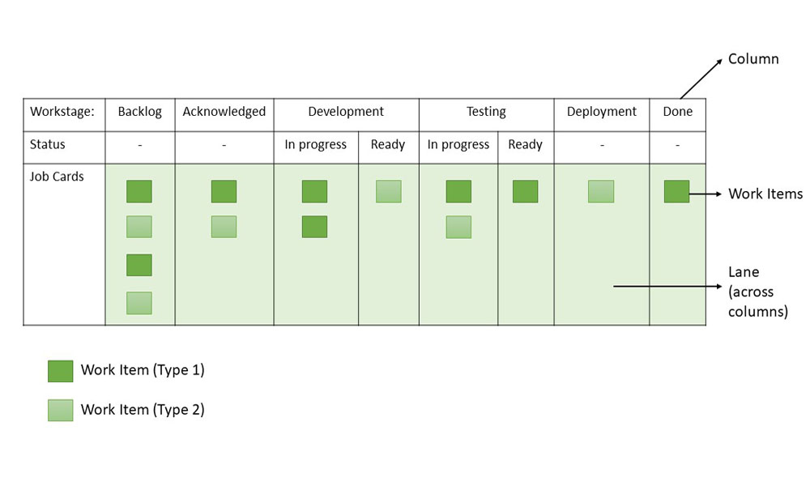Sample Kanban Board

From the sample board above, these can be inferred about Kanban Boards or Cards:

1. **Workflow:**Backlog -> Acknowledged -> Development -> Testing -> Deployment/UAT -> Done
2. **Work stages:**Acknowledged, Development (In Progress), Development (Ready), Testing (In Progress), Testing (Ready), Deployment/UAT, Backlog (Arrival Queue), Done (Finished Stage)
3. **Work Items:**Two types of tasks (Type 1 and Type 2) are represented by work items

**Principles of Kanban**

Kanban is based on four key principles which are mentioned below:

1. **Start with the existing process:**It is a change management method that starts with the existing process. Changes are done in the system in incremental and evolutionary ways. Unlike [Scrum](https://www.geeksforgeeks.org/software-engineering/scrum-team/), there's no specific process or roles defined in Kanban.
2. **Agree to continue evolutionary and incremental changes:**After starting with the existing process, the team must agree on continuous, incremental, and evolutionary changes. The changes should be small and incremental. Rapid and substantial changes may be effective but they will be subjected to larger resistance as well by the Team.
3. **Admire current roles, processes, responsibilities & titles:**Though Kanban suggests continuous incremental changes in the process, it respects current roles, responsibilities, and job titles. This helps the team to gain confidence as they get started with Kanban.
4. **Leadership at all levels:**Kanban does not expect leadership from a specific set, rather the actions of leadership at all levels in the organization, are very much encouraged.

**Kanban Practices**

The following are the six core Kanban practices:

1. **Limit WIP:**Limiting Work-In-Process (WIP) implies that a pull system is executed on either parts or the whole workflow. It (PULL system) will act as one of the key stimuli for incremental, continuous, and evolutionary changes to the system. Limit WIP assigns explicit limits to the number of items that may be in progress at each workflow state.
2. **Visualize:**Visualizing the workflow and making it visible is important so as to know how work proceeds. Without understanding the flow of work, incorporating the right changes is difficult. Usually, a card wall with columns and cards is used to visualize the flow of work. Different states or steps within the workflow are represented by the columns on the card wall.
3. **Manage flow:**Flow of work through every state within the workflow should be observed, measured, and informed. By managing the flow vigorously, the incremental, continuous, and evolutionary modifications to the system can be assessed to have negative or positive effects on the system.
4. **Improve Collaboratively, Evolve Experimentally:**Kanban encourages small incremental, continuous, and evolutionary changes. Whenever teams have a common understanding of concepts about work, process, workflow, and risk, they are more likely to be able to form a shared understanding of a problem and suggest enhancement actions that could achieve a consensus.
5. **Implement Feedback Loops:** Early feedback from clients and the pull system are important in Kanban. If we get feedback from different stakeholders and processes, it will help to eliminate risk and optimize the delivery process.
6. **Make Policies Explicit:**Until the mechanism of a process is not made clear, it is difficult to hold a debate and discuss ways to improve it. Without a clear understanding of how work is truly done and how things actually work, any conversation of complications tends to be anecdotal, emotional, and subjective. With a clear understanding, it is possible to hold a more rational, empirical, objective discussion of issues. It is more likely to facilitate consensus around improvement suggestions.

**Kanban Workflow - How does Kanban Pull System Work?**

**Step 1. Visualize your Workflow**

* Identify work stages and the work items.
* **Work items:**The max effort of 2 days to keep it short and moving.
  + Write work items on cards and stick them in columns, under corresponding work stages, based on system workflow - From left to right.
  + Workflow can be depicted physically or with a tool like Jira.
* **Sample Work stages:**Design, Development, Test, Production, Deployment, Done.
  + Each Stage can be split into- Ready and In Progress.
  + Initially, these two sub-stages may not be present.
  + Later they are introduced to check the waiting time in each stage.

**Step 2. Establish a Pull System**

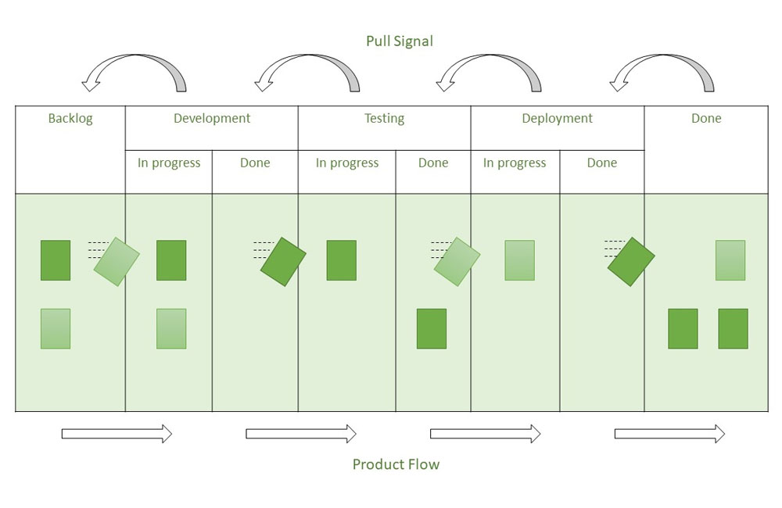Kanban Pull System

* Rather than pushing tasks into the process, teams pull work only when there is a need for it and they have the capacity to meet it. 'In progress (IP)' and 'Done' columns appear in every process state.
* For example, when a development task is finished, it is moved to the 'Development (Done)' column.
* Queue statuses are what 'Done' columns are referred to be. No one works on tasks in the queue states; hence these are passive.
* In our example, 'Development (Done)', is the queue from which testing teams pull tasks ready for testing once they have the capacity to handle new work.
* Teams can avoid multitasking by pulling work and focusing on the most important tasks.
* This results in higher throughput and shorter cycle times, which implies happy customers and higher profits.

**Step 3. Limiting WIP**

Create a Pull system upstream by setting WIP limits, and also ensure that the team *"*Stops beginning and Starts Finishing*."*After finishing a task in the current stage, team members can pull a task from the previous stage, thereby freeing up capacity in the preceding stage. This keeps going till the input of the bugs/ tickets.

* WIP limits could be set based on historical data and capacity planning.
* In case many tickets get piled up in one stage other team members help their team members so that tickets movement is smooth, thereby increasing collaboration.
* WIP limits defined could be observed for 3 to 4 weeks and updated based on the team’s experience.

The sample Kanban board with WIP limits introduced is given below:

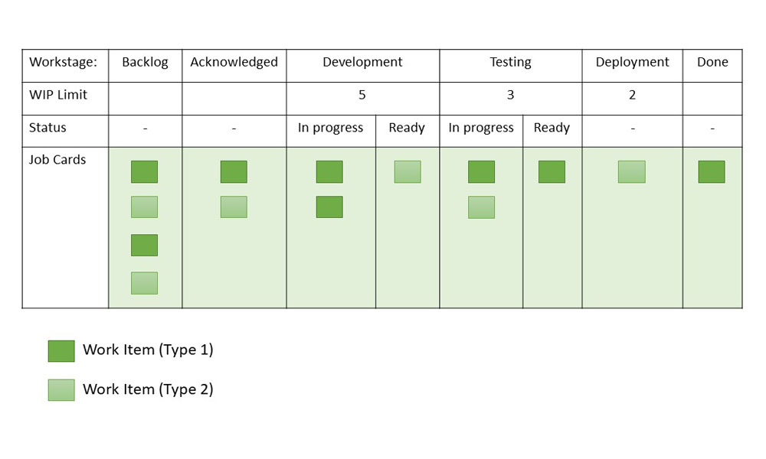Sample Kanban Board with WIP Limits

Let us understand setting up a WIP limit for a phase in Bug-fix lifecycle with an example:

Project ABC is a maintenance project with a Bug fix in scope. This project needs to set up a Kanban board with WIP limits for the flow of Bug fixes. Let us try to understand how WIP limits are set for the Impact Analysis phase.

* History data says the team is spending an average of 4 hours on impact analysis.
* There are 2 designers working in the Impact analysis phase.
* They are allocated to this project for 5 hours a day.
* The capacity for this phase is 10 hours (5\*2: No of hours \* No of resources).
* Hence WIP limit should be 2 for the Impact Analysis phase.

Similarly compute WIP limits for Development, Testing phases. As a preferred rule WIP limit should not be more than the number of people working on the stage.

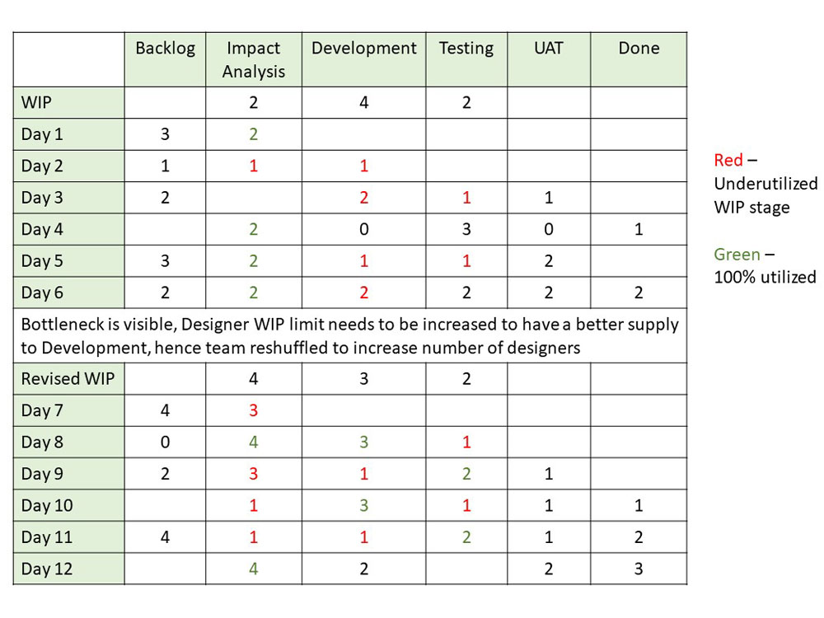Illustration of WIP limits

In case the WIP limit is breached one could record them as well on the board and provide permissible limits for breaches. In case the WIP limit is breached more than the limit set, WIP limits could be re-computed.

Kanban board can include Blocked tickets information also. WIP limit should be computed based on the project’s context.

**Step 4. Apply Pull Signals**

The use of pull signals to indicate that fresh tasks are ready to be handled is an important part of a pull system. When the quantity of cards in a column falls below the specified limit in a Kanban pull system, a pull signal is generated. This tells the previous column that a new job is ready to move forward. No further tasks may be pulled once the work in progress limit has been reached unless an outstanding one has been completed first. This helps to avoid team burnout by ensuring that they only have as much work as they can handle. It also aids in the avoidance of jobs being overlooked.

**Lead Time and Cycle Time**

* **Lead Time:**The time span between the time a task enters the work system and the time it is completed is known as lead time. Lead time is the time it takes for an input to pass through all of the operations and arrive at the finish line. In Kanban terminology, the overall time it takes for a delegated task to reach the right-most column.
* **Cycle Time:**The cycle time displays how much time the team spends working on a prioritized task. Cycle time begins when any team member begins working on the task and transfers it to the 'in progress' column, and it continues until the task is completed.

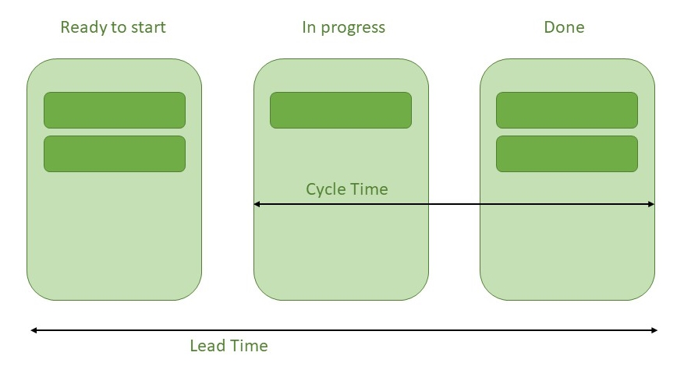Lead Time and Cycle Time

* **Cycle Time and Lead Time Relationship:**The most important, though often overlooked, the distinction between cycle time and lead time is their measurement units.

***Cycle time*** *is measured in amount of time per unit/process/task****Lead time*** *is measured in elapsed time (weeks, hours, seconds)*

*Little's Law gives the best description of the link between Cycle time and Lead time-****Cycle time x WIP = Lead time (Work-In-Progress)***

**Cumulative Flow Diagram**

In Kanban, a cumulative flow diagram (CFD) is an advanced analysis tool. It allows teams to see how their workflow efforts and overall project progress are being visualized. Teams can use the cumulative flow diagram to track how stable their workflow is, anticipate bottlenecks so they can alter their workflow accordingly, and make processes more predictable.

The following are three crucial parameters to look for in the CFD:

* **Cycle time:**The overall time taken by your team to accomplish each assignment from start to finish.
* **Work in progress:** This is the number of tasks that your team is currently working on.
* **Throughput:** The number of tasks your team can finish in a particular period.

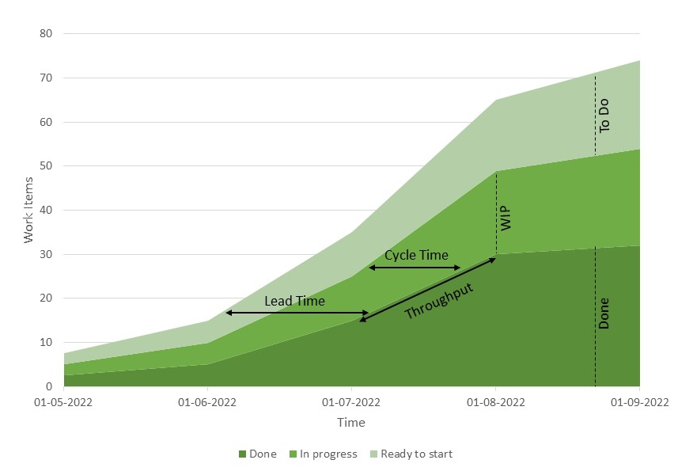Cumulative flow diagram

**How to Calculate Lead Time and Cycle Time**

If the correct[project management](https://www.geeksforgeeks.org/software-engineering/software-engineering-software-project-management-spm/)software and all the information is available then calculating the lead time and cycle time of any project is easy. The Cumulative Flow Diagram (CFD) is the easiest and most widely used method of estimating both lead and cycle times.

* CFD is a graph that depicts the progress of a project by mapping it onto a graph.
* The WIP units are displayed on the vertical axis, while the time is displayed on the horizontal axis.
* The CFD is divided into segments, each of which displays a single Kanban board column.
* Planned tasks, tasks in progress, and completed tasks are the three primary divisions, just like on a Kanban board.
* However, one can add a lot more sections to further streamline the progress.
* To calculate lead time, just interpret the data from the moment a request is entered into the system (backlog), progresses through the process (in-progress), and finally reaches completion (completed).
* The Lead time is represented by the time span for this dataset.
* Calculating cycle time, on the other hand, requires skipping the first phase while the item was in the backlog and focusing on the period after work has begun.
* Cycle time is calculated as the amount of time spent per unit.

**Steps of Kanban Approach**

The Kanban approach involves three steps:

**Step 1. Visualize:**This step involves defining and visualizing the workflow.

* Understand the need for improvement.
* Define the process.
* Value stream entire process flow.
* Visualize process flow.

**Step 2. Quantify:**This step involves three activities:

1. **Startup:**
   * Understand and/ or estimate WIP.
   * Create initial WIP limits.
2. **Adjust:**
   * Study the feasibility of WIP limits.
   * Adjust the limits if required.
   * Develop statements on the limits and policies.
   * Train the team on a pilot basis.
3. **Measure:**
   * Define current problems.
   * Convert them to measurements.
   * Derive metrics.
   * Establish a metrics collection system.
   * Define the tools used to analyze metrics and data.

**Step 3. Optimize:**This step involves the following three activities-

1. **Identify and Improve:**
   * Analyze data.
   * Establish future value stream.
   * Identify improvement opportunities.
   * Prioritize.
   * Develop action plans.
   * Implement action plans.
   * Ensure improvement.
2. **Establish standards:**
   * Revisit limits and policies.
   * Train the team.
   * Implement a new process.
3. **Envision for continuous improvement:**
   * Set up the system to continuously monitor and improve processes.
   * Make the process, process-driven rather people-driven.

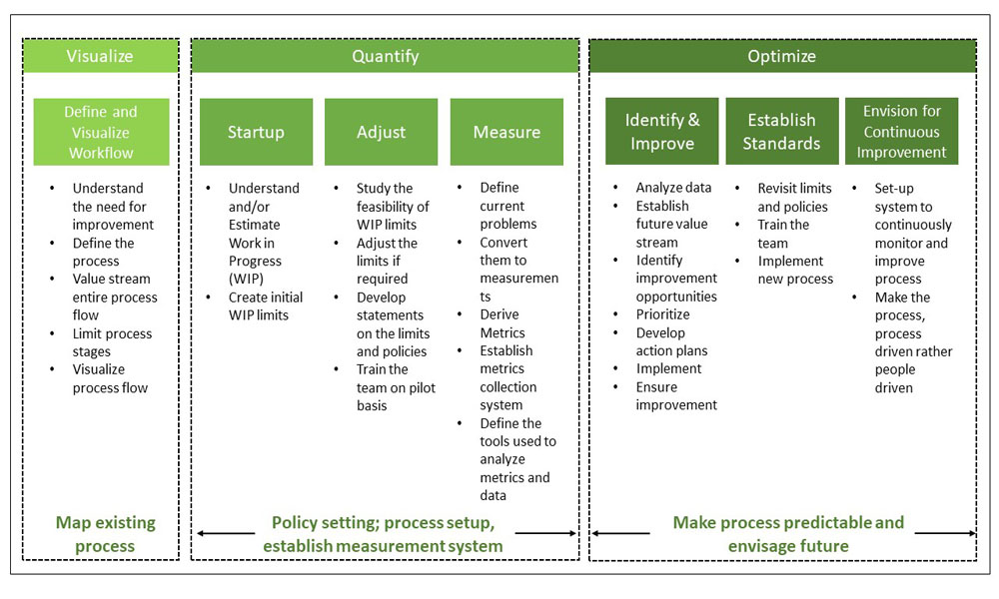Kanban Approach

**Benefits of using Kanban Framework**

* Limiting Work in Progress and setting policies will result in a better focus on quality and, as a result, increased customer satisfaction.
* Use transparency to drive process improvement
* Minimized Waste
* Less process overhead
* A more precise and predictable pace guarantees that team members are never overburdened.
* Allows for quick reprioritization in order to adapt changes according to market demand.
* Better task flow
* The composition of the team can also be changed.
* Helps achieve improved productivity of teams
* Prioritization helps in streamlining processes and workflow.
* Enhanced quality of work
* Identification and elimination of bottlenecks
* Reduced queue time
* Reduction of wasted effort

**Kanban vs Scrum**

| **S No.** | **Kanban** | **Scrum** |
| --- | --- | --- |
| 1. | Planning, release, and process improvement can have separate cadences. | Iteration is timeboxed. |
| 2. | For planning and process improvement, the lead time is used as the default metric. | For planning and process improvement, Velocity is used as the default metric. |
| 3. | Cross-functional teams are optional. | Cross-functional teams prescribed. |
| 4. | Project Tracking: CFD can be used to understand workflow progress. | Project Tracking: Burndown chart is prescribed. |
| 5. | WIP limited directly (per workflow state). | WIP limited indirectly (per sprint). |
| 6. | Can add new items whenever the WIP limit falls. | Cannot add items to ongoing iteration. |

**Conclusion**

Kanban is an Agile methodology focused on visualizing workflows, making work-in-progress in limits, and making continuous improvement. It will helps the teams manage the tasks more efficiently, reducing the waste, and learn quickly to changing priorities. With the transparency and collaboration, Kanban enables organizations to focus processes across various functions, which makes improvement in productivity and customer satisfaction.

**Kanban** ([Japanese](https://en.wikipedia.org/wiki/Japanese_language): 看板, meaning [*signboard*](https://en.wikipedia.org/wiki/Signboard) or [*billboard*](https://en.wikipedia.org/wiki/Billboard_(advertising))) is a [lean method](https://en.wikipedia.org/wiki/Lean_manufacturing) to manage and improve work across human [systems](https://en.wikipedia.org/wiki/System). This approach aims to manage work by balancing demands with available capacity, and by improving the handling of system-level [bottlenecks](https://en.wikipedia.org/wiki/Bottleneck_(production)).

Work items are visualized to give participants a view of progress and process, from start to finish—usually via a [kanban board](https://en.wikipedia.org/wiki/Kanban_board). Work is [pulled](https://en.wikipedia.org/wiki/Push%E2%80%93pull_strategy#Complete_definition) as capacity permits, rather than work being pushed into the process when requested.

In [knowledge work](https://en.wikipedia.org/wiki/Knowledge_worker) and in [software development](https://en.wikipedia.org/wiki/Software_development), the aim is to provide a visual [process management](https://en.wikipedia.org/wiki/Business_process_management) system which aids decision-making about what, when, and how much to produce. The underlying [kanban](https://en.wikipedia.org/wiki/Kanban) method originated in [lean manufacturing](https://en.wikipedia.org/wiki/Lean_manufacturing),[[1]](https://en.wikipedia.org/wiki/Kanban_(development)#cite_note-1) which was inspired by the [Toyota Production System](https://en.wikipedia.org/wiki/Toyota_Production_System).[[2]](https://en.wikipedia.org/wiki/Kanban_(development)#cite_note-2) It has its origin in the late 1940s when the Toyota automotive company implemented a production system called just-in-time, which had the objective of producing according to customer demand and identifying possible material shortages within the production line. But it was a team at Corbis that realized how this method devised by Toyota could become a process applicable to any type of organizational process. Kanban is commonly used in software development [[3]](https://en.wikipedia.org/wiki/Kanban_(development)#cite_note-3) in combination with methods and frameworks such as [Scrum](https://en.wikipedia.org/wiki/Scrum_(software_development)).[[4]](https://en.wikipedia.org/wiki/Kanban_(development)#cite_note-Ladas-4)

**Kanban boards**

*Main article:*[*Kanban board*](https://en.wikipedia.org/wiki/Kanban_board)

The diagram here shows a software development workflow on a kanban board.[[5]](https://en.wikipedia.org/wiki/Kanban_(development)#cite_note-5)

[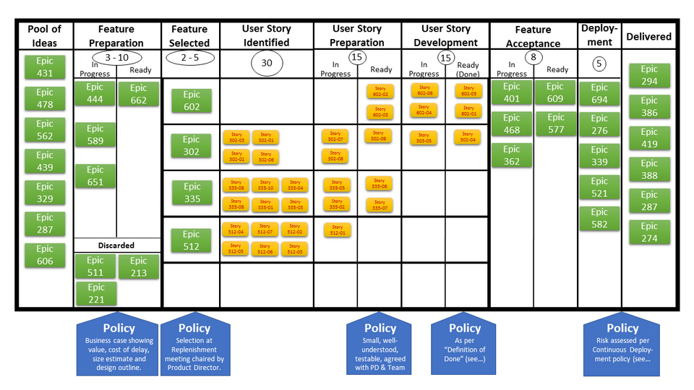](https://en.wikipedia.org/wiki/File:Sample_Kanban_Board.png)

Kanban boards, designed for the context in which they are used, vary considerably and may show work item types ("features" and "[user stories](https://en.wikipedia.org/wiki/User_story)" here), columns delineating workflow activities, explicit policies, and swimlanes (rows crossing several columns, used for grouping user stories by feature here). The aim is to make the general workflow and the progress of individual items clear to participants and stakeholders.

A Kanban Board represents the system's Definition of Workflow[[6]](https://en.wikipedia.org/wiki/Kanban_(development)#cite_note-6) and requires the following minimum elements:

* A definition of the individual units of value that are moving through the workflow. These units of value are referred to as *work items* *(or items*).
* A definition for when work items are *started* and *finished* within the workflow. Your workflow may have more than one started or finished points depending on the work item.
* One or more defined states that the work items flow through from started to finished. Any work items between a started point and a finished point are considered *work in progress* (WIP).
* A definition of how WIP will be controlled from started to finished.
* Explicit policies about how work items can flow through each state from started to finished.
* A *service level expectation* (SLE), which is a forecast of how long it should take a work item to flow from started to finished.

**Kanban practices**

The Practices of Kanban as described in the Kanban Guide[[7]](https://en.wikipedia.org/wiki/Kanban_(development)#cite_note-:0-7) are

* Defining and visualizing a workflow
* Actively managing items in a workflow
* Improving a workflow

Kanban is a strategy that aims to follow these in order to create systems that are efficient, effective, and predictable.

The Kanban Method is a specialized and detailed extrapolation of Kanban. As described in books on The Kanban Method for software development,[[8]](https://en.wikipedia.org/wiki/Kanban_(development)#cite_note-Anderson-8)[[4]](https://en.wikipedia.org/wiki/Kanban_(development)#cite_note-Ladas-4) the two primary practices of The Kanban Method are to visualize work and to limit work in progress (WIP). Four additional general practices of The Kanban Method listed in *Essential Kanban Condensed* are to make policies explicit, manage flow, implement feedback loops, and improve collaboratively.[[9]](https://en.wikipedia.org/wiki/Kanban_(development)#cite_note-Essential-9)

The kanban board in the diagram above highlights the first three general practices of The Kanban Method.

* It visualizes the work of the development team (the features and user stories).
* It captures WIP limits for development steps: the circled values below the column headings that limit the number of work items under that step.
* It documents policies, also known as done rules,[[10]](https://en.wikipedia.org/wiki/Kanban_(development)#cite_note-Brechner-10) inside blue rectangles under some of the development steps.
* It also shows some kanban flow management for the "user story preparation", "user story development", and "feature acceptance" steps, which have "in progress" and "ready" sub-columns. Each step's WIP limit applies to both sub-columns, preventing work items from overwhelming the flow into or out of those steps.

**Managing workflow**

Kanban manages workflow directly on the kanban board. The WIP limits for development steps provide development teams immediate feedback on common workflow issues.[[8]](https://en.wikipedia.org/wiki/Kanban_(development)#cite_note-Anderson-8)[[10]](https://en.wikipedia.org/wiki/Kanban_(development)#cite_note-Brechner-10)

For example, on the kanban board shown above, the "deployment" step has a WIP limit of five and there are currently five epics [[11]](https://en.wikipedia.org/wiki/Kanban_(development)#cite_note-Mist_Kanban-11) shown in that step. No more work items can move into deployment until one or more epics complete that step (moving to "delivered"). This prevents the "deployment" step from being overwhelmed. Team members working on "feature acceptance" (the previous step) might get stuck because they can't deploy new epics. They can see why immediately on the board and help with the current epic deployments.

Once the five epics in the "deployment" step are delivered, the two epics from the "ready" sub-column of "feature acceptance" (the previous step) can be moved to the "deployment" column. When those two epics are delivered, no other epics can be deployed (assuming no new epics are ready). Now, team members working on deployment are stuck. They can see why immediately and help with feature acceptance.

In a Kanban board setup, swimlanes are used to visually organize work into different stages of a process, ensuring clarity and focus. For efficient workflow management, it is crucial to maintain distinct swimlanes for key phases such as requirements, development, testing, and closed/completed tasks. Specifically, testing stories should always be placed within the designated "Testing" swimlane. This separation ensures that testing activities are easily trackable and not intermingled with other stories in development or other stages. By keeping testing tasks within their own swimlane, teams can quickly identify bottlenecks, prioritize issues, and maintain the integrity of the testing process without cross-contamination from development or requirement phases. This structure leads to clearer workflows and enhances team collaboration.

This workflow control works similarly for every step. Problems are visual and evident immediately, and re-planning can be done continuously. The work management is made possible by limiting work in progress in a way team members can see and track at all times.

**What is kanban?**

Kanban is a popular framework used to implement [Agile](https://www.atlassian.com/agile) and [DevOps](https://www.atlassian.com/devops/what-is-devops) software development. It requires real-time communication of capacity and full transparency of work. Work items are represented visually on a [kanban board](https://www.atlassian.com/agile/kanban/boards), allowing team members to see the state of every piece of work at any time.

[](https://www.youtube.com/embed/iVaFVa7HYj4?si=55v9mWImZZQPR4bL)

**Optimizing software development with Kanban flow**

Kanban flow, a cornerstone of agile and DevOps methodologies, drives efficiency by orchestrating seamless task progression through visualized workflows. Kanban flow mirrors the streamlined inventory management of supermarkets, ensuring tasks move through development processes precisely when needed.

Visualized on Kanban boards, tasks represented as cards enable transparent progress tracking and swift identification of bottlenecks. By limiting work-in-progress (WIP), teams optimize resource allocation and maintain a steady workflow. Kanban's focus on continuous improvement is facilitated by metrics like control charts and cumulative flow diagrams, empowering teams to refine workflows iteratively.

In [software development](https://www.atlassian.com/software-development), kanban flow fosters dynamic task management, accelerates delivery cycles, and enhances customer satisfaction through focused, uninterrupted work. In essence, kanban flow epitomizes efficiency—a harmonious blend of transparency, adaptability, and continuous improvement—unlocking the full potential of agile methodologies.

**Structuring your Kanban flow**

Establishing a structured kanban flow within your software development team is essential to implementing kanban effectively. This ensures smooth task progression and optimized workflow management. Here's how you can structure your kanban flow:

**Visualize workflow**: Begin by visualizing your team's workflow on a Kanban board. Whether physical or virtual, the board should depict each stage of the development process, from task inception to completion.

**Standardize workflow**: Define and standardize the workflow stages according to your team's processes and requirements. Common stages include "To Do," "In Progress," and "Done," but customize as needed to reflect your unique workflow.

**Identify blockers and dependencies**: Ensure that your kanban board enables immediate identification of blockers and dependencies. This transparency allows for prompt resolution and prevents workflow disruptions.

**Set work-in-progress (WIP) limits**: Implement WIP limits for each workflow stage to avoid overburdening and to maintain a steady workflow. WIP limits help optimize resource allocation and reduce multitasking, fostering higher productivity.

**Encourage collaboration**: Foster a culture of collaboration within your team, where members collectively address bottlenecks and work together to ensure smooth workflow progression. This collaborative approach promotes efficiency and accelerates task completion.

**Utilize kanban cards**: Represent each task as a kanban card on the board, containing essential details such as task description, assignee, and estimated time for completion. Kanban cards facilitate visual tracking of task progress and promote transparency within the team.

By structuring your kanban flow in this manner, you can streamline your software development processes, enhance [team collaboration](https://www.atlassian.com/work-management/project-collaboration), and maximize efficiency in task management.

**Exploring the origins of Kanban**

Kanban is prominent among today's agile and DevOps software teams, but the Kanban methodology dates back more than 50 years. In the late 1940s, [Toyota began optimizing its engineering processes](https://mag.toyota.co.uk/kanban-toyota-production-system/) based on the same model supermarkets used to stock their shelves.

Supermarkets stock just enough inventory to meet consumer demand, a practice that optimizes the flow between the supermarket and the consumer. Because inventory levels match consumption patterns, the supermarket gains significant efficiency in inventory management by decreasing the excess inventory it must hold at any given time. Meanwhile, the supermarket can still ensure that essential products are always in stock.

When Toyota applied this same system to its factory floors, the goal was to better align its massive inventory levels with the actual consumption of materials. To communicate capacity levels in real-time on the factory floor (and to suppliers), workers would pass a card, or "kanban," between teams.

When someone emptied a bin of materials used on the production line, a kanban card was passed to the warehouse describing what material was needed, the exact amount of this material, and so on. The warehouse would have a new bin of this material waiting, which they would then send to the factory floor and, in turn, send their own kanban to the supplier. While this process has evolved since the 1940s, this same "just in time" (JIT) manufacturing process remains at the heart of the kanban methodology.

**Kanban for software teams**

[Agile software development teams](https://www.atlassian.com/agile/teams) today can leverage JIT principles by matching the amount of work in progress (WIP) to the team's capacity. This gives teams more flexible planning options, faster output, clearer focus on continuous improvement, and transparency throughout the [development cycle](https://www.atlassian.com/software-development).

Board Kanban | Agile Coach Atlassian

While the core principles of the Kanban framework are timeless and applicable to almost any industry, software development teams have found particular success with the agile practice. Unlike implementing kanban on a factory floor, which would involve changes to physical processes and the addition of substantial materials, the only physical things software teams need are a board and task cards, and even those can be virtual.

**Kanban boards**

The work of all Kanban teams revolves around a Kanban [board](https://www.atlassian.com/agile/kanban/boards), a tool used to visualize and optimize the workflow across teams. While physical boards are popular among some teams, virtual boards are crucial in any [agile software development tool](https://www.atlassian.com/software/jira/agile) for their traceability, collaboration, and accessibility from multiple locations.

Regardless of whether a team uses a digital or physical kanban board, it ensures that the team visualizes their work, standardizes their workflow, and immediately identifies and resolves all blockers and dependencies. A basic kanban board has a three-step workflow: To Do, In Progress, and Done. However, depending on a team's size, structure, and objectives, they can map the workflow to meet their unique processes.

Because the kanban methodology relies upon full transparency of work and real-time communication, the kanban board acts as the single source of truth for the team's work.

Agile Kanban Board | Atlassian agile coach

**Kanban cards**

In Japanese, [kanban literally translates to "signboard](https://mag.toyota.co.uk/kanban-toyota-production-system/)." Kanban teams represent every work item as a separate card on the board. The main purpose of representing work as a card on the Kanban board is to allow team members to track progress through its workflow in a highly visual manner.

[Kanban cards](https://www.atlassian.com/agile/kanban/cards) feature critical information about project tasks, giving teams visibility into who is responsible for which tasks and a brief description of the job, and how long tasks are estimated to take. Cards on virtual kanban boards often feature screenshots and other technical details that are valuable to the assignee.

Enabling team members to view the status of each task at any moment, alongside relevant details, promotes heightened focus, comprehensive traceability, and rapid identification of blockers and dependencies.

**Benefits of the kanban framework**

Kanban is one of the most popular software development methodologies agile teams use today. Kanban offers additional advantages to task planning and throughput for teams of all sizes.

**Planning flexibility**

A kanban team focuses only on the work that's actively in progress. Once the team completes a task, they select the next task from the [backlog](https://www.atlassian.com/agile/scrum/backlogs). The [product owner](https://www.atlassian.com/agile/product-management) is free to reprioritize work in the backlog without disrupting the team because any changes outside the current work items don't impact the team.

As long as the product owner keeps the most important work items on top of the backlog, the development team can rest assured they are delivering maximum value back to the business.

**Pro Tip**

Savvy product owners always engage the development team when considering changes to the backlog. For example, if user stories 1-6 are in the backlog, user story 6's estimate may be based on the completion of user stories 1-5. It's always a good practice to confirm changes with the engineering team to ensure no surprises.

**Shortened time cycles**

Cycle time is a key [metric](https://www.atlassian.com/agile/project-management/metrics) for Kanban teams. Cycle time is the amount of time it takes for a unit of work to travel through the team's workflow—from the moment work starts to the moment it ships. By optimizing cycle time, the team can confidently forecast the delivery of future work.

Overlapping skill sets lead to shorter cycle times. When only one person holds a skill set, that person becomes a bottleneck in the workflow. Therefore, teams employ best practices like [code review](https://www.atlassian.com/agile/software-development/code-reviews) and mentoring to help spread knowledge. Shared skills mean team members can take on heterogeneous work, further optimizing cycle time.

Additionally, this approach empowers the entire team to address any work bottlenecks collectively, facilitating a swift resolution and ensuring a smooth workflow. For example, testing responsibilities extend beyond QA engineers to include developers, fostering a collaborative effort to maintain efficiency. In a kanban system, the entire team ensures work moves smoothly through the process.

**Fewer bottlenecks**

Multitasking kills efficiency. Increased workload simultaneously leads to more frequent [context switching](https://www.atlassian.com/blog/productivity/context-switching), impeding the progress of tasks toward completion. That's why a vital tenet of the kanban process is limiting the work in progress (WIP). Work-in-progress limits highlight bottlenecks in the team's process due to a lack of focus, people, or skill sets.

For example, a typical software team might have four [workflow](https://www.atlassian.com/agile/project-management/workflow) states: To Do, In Progress, Code Review, and Done. They could set a WIP limit of 2 for the code review state. That might seem like a low limit, but there's a good reason for it.

Developers often prefer to write new code rather than spend time reviewing someone else's work. A low limit encourages the team to pay special attention to issues in the review state and review others' work before raising their code reviews, ultimately reducing the overall cycle time.

**Visual metrics**

One of the core values is a strong focus on continually improving team efficiency and effectiveness with every iteration of work. Charts provide a visual mechanism for teams to ensure they're continuing to improve.

When the team can see data, it's easier to spot bottlenecks in the process (and remove them). Two common reports Kanban teams use are control charts and cumulative flow diagrams. A control chart shows the cycle time for each issue and a rolling average for the team.

**Pro Tip**

The team's goal is to reduce the time an issue takes to move through the entire process. Seeing the average cycle time drop in the control chart indicates success.

Agile control chart | Atlassian agile coach

A cumulative flow diagram shows the number of issues in each state. The team can easily spot blockers when the number of issues increases in any given state. Issues in intermediate states such as "In Progress" or "In Review" are not yet shipped to customers, and a blocker in these states can increase the likelihood of massive integration conflicts when the work gets merged upstream.

Cumulative Flow Diagram

**Continuous delivery**

[Continuous delivery (CD)](https://www.atlassian.com/continuous-delivery) describes the process of releasing work to customers frequently. [Continuous integration (CI)](https://www.atlassian.com/continuous-delivery/continuous-integration) is the practice of automatically building and testing code incrementally throughout the day. Together, they form a CI/CD pipeline that is essential for DevOps teams to ship software faster while ensuring high quality.

Kanban and CD beautifully complement each other because both techniques focus on the just-in-time (and one-at-a-time) delivery of value. The faster a team can deliver innovation to the market, the more competitive their product will be. Kanban teams focus on precisely that: optimizing the flow of work out to customers.

**Scrum vs. kanban**

Kanban and [scrum](https://www.atlassian.com/agile/scrum) share some of the same concepts but have very different approaches. They should not be confused with one another.

|  |  |  |
| --- | --- | --- |
|  | SCRUM | KANBAN |
| Release methodology | Regular fixed-length sprints (i.e., two weeks) | Continuous flow |
| Roles | Product owner, scrum master, development team | Continuous delivery or at the team's discretion |
| Key metrics | Velocity | Cycle time |
| Change philosophy | Teams should strive not to change the sprint forecast during the sprint. Doing so compromises learning around estimation. | Change can happen at any time |

Some teams blend the ideals of the kanban method and scrum into "[scrumban](https://www.atlassian.com/agile/project-management/scrumban)." They take fixed-length [sprints](https://www.atlassian.com/agile/scrum/sprints) and roles from Scrum and focus on work-in-progress limits and cycle time from Kanban.

**What is Kanban - Principles and Implementation**

Last Updated : 23 Jul, 2025

**Agile development methodology** provides the highest utility value to product development. It focuses on adaptive planning and change management. Alongside this, it focuses on developing and deploying the working software quickly in an iterative manner. A major subtype of Agile Development is the [Kanban](https://www.geeksforgeeks.org/software-engineering/kanban-agile-methodology/) methodology, which emphasizes visualizing the entire product development on boards.

This article covers the core concepts and provides an in-depth explanation of Kanban Development Methodology in Agile, including its benefits, key functionalities, and importance.

**Table of Content**

* [What is kanban?](https://www.geeksforgeeks.org/software-engineering/what-is-kanban/#what-is-kanban)
  + [Kanban and its History](https://www.geeksforgeeks.org/software-engineering/what-is-kanban/#kanban-and-its-history)
  + [Kanban and its uses](https://www.geeksforgeeks.org/software-engineering/what-is-kanban/#kanban-and-its-uses)
  + [Kanban System](https://www.geeksforgeeks.org/software-engineering/what-is-kanban/#kanban-system)
* [What is Kanban Methodology?](https://www.geeksforgeeks.org/software-engineering/what-is-kanban/#what-is-kanban-methodology)
  + [Kanban Agile Methodolies](https://www.geeksforgeeks.org/software-engineering/what-is-kanban/#kanban-agile-methodolies)
* [Kanban Workflow](https://www.geeksforgeeks.org/software-engineering/what-is-kanban/#kanban-workflow)
  + [4 Workflow Phases in Kanban:](https://www.geeksforgeeks.org/software-engineering/what-is-kanban/#4-workflow-phases-in-kanban)
  + [Other Approaches of Kanban](https://www.geeksforgeeks.org/software-engineering/what-is-kanban/#other-approaches-of-kanban)
  + [Kanban Board](https://www.geeksforgeeks.org/software-engineering/what-is-kanban/#kanban-board)
* [Kanban Principles](https://www.geeksforgeeks.org/software-engineering/what-is-kanban/#kanban-principles)
* [Kanban vs Scrum](https://www.geeksforgeeks.org/software-engineering/what-is-kanban/#kanban-vs-scrum)
  + [Kanban Board and Jira](https://www.geeksforgeeks.org/software-engineering/what-is-kanban/#kanban-board-and-jira)
  + [Kanban and Scrum](https://www.geeksforgeeks.org/software-engineering/what-is-kanban/#kanban-and-scrum)
* [Tools for Kanban](https://www.geeksforgeeks.org/software-engineering/what-is-kanban/#tools-for-kanban)
  + [Metrices in Kanban](https://www.geeksforgeeks.org/software-engineering/what-is-kanban/#metrices-in-kanban)
  + [Kanban Softwares](https://www.geeksforgeeks.org/software-engineering/what-is-kanban/#kanban-softwares)
* [Conclusion](https://www.geeksforgeeks.org/software-engineering/what-is-kanban/#conclusion)

**What is Kanban?**

The Kanban method is an approach to evolutionary and incremental systems and process change for organizations. A work-in-progress limited pull system is the central mechanism to uncover system operation (or process) complications and encourage collaboration to continuously improve the system.

Electronic Kanban boards are also available in ALM tools like Rally (CA Agile), [Jira](https://www.geeksforgeeks.org/software-testing/jira-tutorial/), [Swift](https://www.geeksforgeeks.org/swift/swift-tutorial/), Kanban, LeanKit, Kanban, etc. Stages could be configured in these tools, and the movement of tickets between stages could be viewed in these tools.

**Kanban and its History**

* [History and Origin of the Kanban Methodology](https://www.geeksforgeeks.org/devops/history-and-origin-of-the-kanban-methodology/)

**Kanban and its uses**

* [Kanban and its purpose in project management?](https://www.geeksforgeeks.org/business-studies/kanban-and-its-purpose-in-project-management/)
* [Kanban in Product Management | Working & Uses](https://www.geeksforgeeks.org/business-studies/kanban-in-product-management/)

**Kanban System**

* [What is the Kanban System, and How Does it Work?](https://www.geeksforgeeks.org/software-engineering/what-is-the-kanban-system-and-how-does-it-work/)
* [What are the Main Benefits of Implementing a Kanban System?](https://www.geeksforgeeks.org/software-engineering/what-are-the-main-benefits-of-implementing-a-kanban-system/)
* [What are the Key Responsibilities of a Kanban System's Roles?](https://www.geeksforgeeks.org/software-engineering/what-are-the-key-responsibilities-of-a-kanban-systems-roles/)
* [What Types of Businesses Suited for Implementing the Kanban System?](https://www.geeksforgeeks.org/business-studies/what-types-of-businesses-suited-for-implementing-the-kanban-system/)
* [What is the Concept of "push" in the Kanban System?](https://www.geeksforgeeks.org/software-engineering/what-is-the-concept-of-push-in-the-kanban-system/)

**What is Kanban Methodology?**

Kanban is one of the widely used [software development methodologies](https://www.geeksforgeeks.org/software-engineering/5-most-commonly-used-software-development-methodologies/) along with Scrum. The Kanban Methodology was developed in the 1940s by Toyota for manufacturing purposes. However, for software purposes, it was released in 2001 after the release of the[Agile Manifesto.](https://www.geeksforgeeks.org/software-engineering/agile-manifesto-for-software-development/)

* Kanban is a development framework that involves the use of a Kanban Board to visualize the workflow of the entire project.
* A Kanban board is nothing but a work board that is divided into several columns. The individual columns represent the workflow [phases of the project](https://www.geeksforgeeks.org/software-engineering/phases-project-management-processes/). The set of these phases are - To-Do, In-Progress, Validation, and completed. These phases are briefly described in the later section of this article.

The way students organize and manage handwritten sticky notes to optimize their study schedules and pending tasks is the best application of Kanban in real life. Apart from this, tasks like Planning a vacation, [Managing projects](https://www.geeksforgeeks.org/business-studies/what-are-strategies-for-managing-multiple-projects/), restaurant and fast-food shops, etc.

**Kanban Agile Methodolies**

* [Kanban - Agile Methodology](https://www.geeksforgeeks.org/software-engineering/kanban-agile-methodology/)
* [How can Kanban be Integrated with Other Project Management Methodologies?](https://www.geeksforgeeks.org/software-engineering/how-can-kanban-be-integrated-with-other-project-management-methodologies/)
* [Practices for Implementing Kanban in a New or Existing Project?](https://www.geeksforgeeks.org/software-engineering/practices-for-implementing-kanban-in-a-new-or-existing-project/)
* [How Kanban Differ from Other Agile Methodologies?](https://www.geeksforgeeks.org/software-engineering/how-kanban-differ-from-other-agile-methodologies/)
* [What is the Role of a Kanban Team Lead or Manager in the Methodology?](https://www.geeksforgeeks.org/software-engineering/what-is-the-role-of-a-kanban-team-lead-or-manager-in-the-methodology/)
* [How Kanban methodology enhance successful companies or teams?](https://www.geeksforgeeks.org/software-engineering/how-kanban-methodology-enhance-successful-companies-or-teams/)

**Kanban Workflow**

The Kanban Workflow is composed of four Phases. The tasks are managed and organized in these 4 columns over the Kanban board during the entire development phase.

* The user stories are written on sticky notes, which are later pushed to their respective columns as per the current status of the tasks.
* The Kanban Board could either be a P**hysical** board which includes whiteboards and sticky notes or a **Digital** Kanban Board which allows the team to track multiple workflows at the same time.

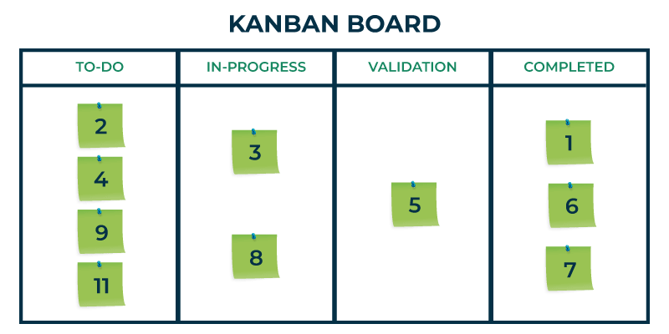Kanban Board

**4 Workflow Phases in Kanban:**

* **To-Do:** The workflow is started with an empty clear board where all the tasks are meant to be listed. A To-Do list is formed in the first column of the board which consists of all the user stories. The individual cards must provide a brief description and necessary details of tasks like due date, functionalities, nature of task, etc.
* **In-Progress:** As the name suggests, the In-Progress column consists of all the tasks that are currently under progress and under development phase. It acts as an indication that a team is currently operating working on it.
* **Validation:** In the validation phase, the code is reviewed, and the model is tested against several sets of tests like unit testing, acceptance testing, system testing, etc. All the functionalities are reviewed and verified. Apart from this, all the bugs and inconsistencies found are rectified in the validation phase itself.
* **Done:** After all the functional and system tests are performed and quality assurance is reviewed, the task is shifted to Done state (4th column on the board). All the tasks move column to column towards right until they reach the last column i.e. Done phase. The done column reflects all the tasks that are finished and deployed without any errors.

**Other Approaches of Kanban**

* [How does Kanban Promote a Pull-based Approach to Work?](https://www.geeksforgeeks.org/software-engineering/kanban-pull-system/)
* [What are the Advantages and Disadvantages of Using Kanban over Scrum?](https://www.geeksforgeeks.org/software-engineering/what-are-the-advantages-and-disadvantages-of-using-kanban-over-scrum/)

**Kanban Board**

* [What is Kanban Board in Software Development? Definition and Overview](https://www.geeksforgeeks.org/software-engineering/what-is-kanban-board/)
* [How does Kanban Help in Optimizing Workflow?](https://www.geeksforgeeks.org/software-engineering/how-does-kanban-help-in-optimizing-workflow/)
* [What is the concept of Work in Progress (WIP) limits in Kanban?](https://www.geeksforgeeks.org/software-engineering/what-is-the-concept-of-work-in-progress-wip-limits-in-kanban/)

**Kanban Principles**

Kanban methodology is based on Lean Development approach. Every single product being developed using the Kanban methodology must adhere to some set of key principles and guidelines. Usually, Kanban is composed of 4 major principles:

1. **Start with the existing process**: The fundamental emphasis of this principal is to value the existing workflows and practices instead of setting up the environment from roots in the beginning. Although the professionals carry out a review of the existing workflow to point any changes. This principal helps to reduce the cost and time utilization.
2. **Agree to continue evolutionary and incremental changes:** The emphasis of team should be on incremental and small change improvements instead of bulk changes all at a time. This is because handling bulk changes could disrupt the flow of development and may reduce the performance of the system.
3. **Admire current roles, processes, responsibilities & titles:** Since there are no such formal roles in Kanban team, yet every individual must be responsible for his/her work. In industrial terminologies, it could be said that Kanban emphasize on incremental change so as to avoid emotional resistance. This helps the team to gain confidence as they get started with Kanban.
4. **Leadership at all levels:** In Kanban big decisions are not always proposed or taken by big leaders only. This principal emphasizes on the fact that even if the lowest ranked team member has a creative idea, that idea should be appreciated, embraced and acknowledged by everyone. This helps to embrace leadership qualities at all levels of the team.

**Kanban vs Scrum**

Here are the following differences between Kanban and Scrum:

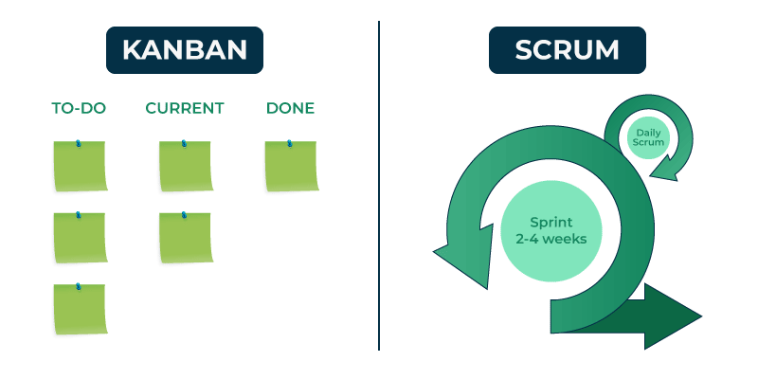Kanban vs Scrum

| **Parameters** | **KANBAN** | **SCRUM** |
| --- | --- | --- |
| **Origin** | Kanban's origin is assumed to be following the lean development methodology. | Scrum methodology is associated with software development fundamentals. |
| **Team Roles** | There are no formal roles in Kanban team. Although for complex projects, some teams may require agile coach. | Scrum teams has 3 roles - Product Owner, Scrum Master and Development team. |
| **Duration** | There are no time boxes as Kanban emphasizes on continuous delivery of product. | The life cycle of a project is broken into several sprints. Each of the sprints have a lifespan of 2-4 weeks. |
| **Work Board** | It uses Kanban board which includes columns like to-do, in-progress, validation and done phase. | It uses scrum boards having columns like product backlog, sprint backlog, in-progress and done phase. |
| **Sprint Cycle** | Kanban does not involve the concept of sprints during the development phase. | Scrum projects are always developed in incremental cycles known as sprints. |
| **Meetings** | Since there is no such concept of sprints, no retrospective meetings are held in Kanban methodology. | After the end of every sprint cycle, the team members gather for Sprint Retrospective Meeting. |
| **Applications** | Kanban methodology is widely used in HealthCare, Manufacturing and marketing. It is also used in restaurant and fast-food shops. | Scrum concept is fundamentally used in software development and product releases. It is also used in HR domains and Dutch railways. |

**Kanban Board and Jira**

* [What are the Key Features and Benefits of using a Kanban Board in Jira?](https://www.geeksforgeeks.org/software-engineering/what-are-the-key-features-and-benefits-of-using-a-kanban-board-in-jira/)
* [What Types of Projects or Teams are Best Suited for using a Kanban Board in Jira?](https://www.geeksforgeeks.org/techtips/what-types-of-projects-or-teams-are-best-suited-for-using-a-kanban-board-in-jira/)
* [How to Organize and Prioritize Work on a Kanban Board in Jira?](https://www.geeksforgeeks.org/software-engineering/how-to-organize-and-prioritize-work-on-a-kanban-board-in-jira/)
* [What is the Concept Continuous Flow Approach in Kanban?](https://www.geeksforgeeks.org/devops/what-is-the-concept-continuous-flow-approach-in-kanban/)

**Kanban and Scrum**

* [Kanban vs. Scrum : Top Differences You Should Know](https://www.geeksforgeeks.org/blogs/difference-between-scrum-and-kanban/)
* [What are the primary roles and responsibilities in Scrum in Kanban?](https://www.geeksforgeeks.org/software-engineering/what-are-the-primary-roles-and-responsibilities-in-scrum-in-kanban/)
* [What is the use of prioritization of work items in Kanban?](https://www.geeksforgeeks.org/devops/what-is-the-use-of-prioritization-of-work-items-in-kanban/)
* [Explain the Concept of Sprint Planning in Scrum with Kanban's Approach?](https://www.geeksforgeeks.org/software-engineering/explain-the-concept-of-sprint-planning-in-scrum-with-kanbans-approach/)

**Tools for Kanban**

* **Trello**: User-friendly and great for small teams.
* **Jira**: Powerful tool for larger teams, especially in software development.
* **Asana**: Versatile for both project management and Kanban.
* **Kanbanize**: Specifically designed for Kanban and integrates analytics and reporting.

**Metrices in Kanban**

* [What tools and metrics are commonly used in Kanban? - GeeksforGeeks](https://www.geeksforgeeks.org/software-engineering/what-tools-and-metrics-are-commonly-used-in-kanban/)
* [Practices for Implementing Kanban in a New or Existing Project? - GeeksforGeeks](https://www.geeksforgeeks.org/software-engineering/practices-for-implementing-kanban-in-a-new-or-existing-project/)

**Kanban Softwares**

* [Cumulative Flow Diagrams in Kanban](https://www.geeksforgeeks.org/software-testing/cumulative-flow-diagrams-in-kanban/)
* [How does Kanban facilitate continuous improvement?](https://www.geeksforgeeks.org/software-engineering/how-does-kanban-facilitate-continuous-improvement/)
* [What are Common Challenges Teams may face when Adopting Kanban?](https://www.geeksforgeeks.org/software-engineering/what-are-common-challenges-teams-may-face-when-adopting-kanban/)
* [How does Kanban used in Industries or fields outside of software development?](https://www.geeksforgeeks.org/business-studies/how-does-kanban-used-in-industries-or-fields-outside-of-software-development/)
* [Kanban Case Studies and its Original Purpose](https://www.geeksforgeeks.org/software-engineering/kanban-case-studies-and-its-original-purpose/)

**Conclusion**

To summarize, Kanban is a [project development framework](https://www.geeksforgeeks.org/software-engineering/software-engineering-agile-software-development/) which is based on lean development approach. The emphasis of Kanban development is thoroughly on visualizing the workflow on boards. It enhances the team building and increases the productivity and efficiency of the project. All the stages of the workflow involved in Kanban development are monitored through the use of Kanban board in which individual phases are divided into separate columns. The Kanban board includes columns like to-do, in-progress, validation and done phase. This helps to provide transparency throughout the development cycle. Also, due to these reasons, this methodology has wider applications in the field of marketing, manufacturing and healthcare.

**What is DevOps ?**

Last Updated : 20 Aug, 2025

DevOps is all about automating and streamlining the software development lifecycle so that code moves from development to production quickly, reliably, and securely.

Here is how the DevOps model flow works:

**Stages of DevOps are:**

**Build Stage**

1. Developers **write and organize code**, using version control tools like Git to track changes.

2. The system **automatically compiles and packages the code** into a deployable format.

3. Dependencies (external libraries and tools) are included to ensure smooth operation.

4. **Common Tools:** Git, Jenkins, GitLab CI/CD, Gradle, Maven.

**Test Stage**

1. The software undergoes **thorough testing** to catch bugs and security risks before release.

2. Different testing methods include:

* **Unit Testing:** Checks individual pieces of code.
* **Integration Testing:** Ensures different parts of the system work together.
* **Performance Testing:** Measures speed and scalability.
* **Security Testing:** Identifies potential vulnerabilities.

3. Automated tests help ensure the software is stable before moving forward.

4**. Common Tools:** Selenium, JUnit, TestNG, SonarQube.

**Release Stage**

1. The software is deployed in a **staging environment** to simulate real-world conditions.

2. If everything checks out, the software is **rolled out to production** using deployment strategies like:

* **Blue-Green Deployment:** Two identical environments switch traffic for a seamless update.
* **Canary Deployment:** A small percentage of users get the new version first, ensuring safety.
* **Rolling Updates:** The update is gradually pushed out to all users.

3. **Common Tools:** Docker, Kubernetes, Ansible, Helm, ArgoCD.

**Continuous Feedback Loop**

A key aspect of DevOps is **learning from real-world performance** and using that feedback to improve future releases.

1. **Monitoring & Logging:** Track system performance and detect errors.
2. **User Feedback:**Gather insights from customers to enhance features.
3. **Incident Response:**Alert systems notify teams of failures for quick fixes.
4. **Process Improvement:**Teams analyze past releases to optimize automation and workflow.
5. **Common Tools:** Prometheus, Grafana, ELK Stack, Datadog, New Relic.

**How to Adopt a DevOps Model?**

To adopt a DevOps model, ensure the following points:

* **Assess Current Workflow:** Evaluate your existing development and operations processes to identify gaps, inefficiencies, and areas for automation.
* **Set Clear DevOps Goals:** Define measurable objectives such as faster deployment cycles, better collaboration, or improved system stability.
* **Build a Collaborative Culture:** Break silos between development, operations, QA, and security teams by encouraging communication and shared responsibilities.
* **Automate Infrastructure and Testing:** Use tools like Jenkins, Docker, and Ansible to automate code integration, deployment, testing, and infrastructure provisioning.
* **Implement CI/CD Pipelines:** Establish Continuous Integration and Continuous Deployment pipelines for faster, error-free code delivery.
* **Monitor and Optimize Continuously:** Use real-time monitoring and feedback loops (via tools like Prometheus, Grafana) to track performance and improve systems iteratively.

**DevOps for AI and ML**

Even though Artificial Intelligence (AI) and Machine Learning (ML) are still growing in DevOps, they are already making a big difference.

* **Handling Big Data:** DevOps tools generate a huge amount of data from testing, deployment, and monitoring. AI and ML are great at reading all this data quickly, finding useful insights, and helping teams make faster and smarter decisions.
* **Saving Time with Smart Suggestions:** AI can learn how developers and operations teams work, then suggest better ways to do tasks or automatically set up the needed tools and servers, reducing manual work.
* **Spotting Bugs Early:** AI and ML can look at code and test results to find problems (like bugs) early. They can detect unusual patterns that may cause issues later and warn the DevOps team before users are affected.
* **Improving Security:** These technologies can scan security logs and alerts to find threats, such as hacking attempts or breaches. Once something risky is found, they can even respond automatically. For example, by blocking access or sending alerts.

**How DevOps Helped GeeksforGeeks Save AWS Costs**

In this section we will try to understand how DevOps changes at GeeksforGeeks helped reduce AWS bills by up to **70%.**By replacing expensive services with open-source tools and adding smart automation.

*These are actual changes made in GeeksforGeeks production setup.*

**1. Caching: From AWS ElasticCache to Open-Source Redis**

**What we used Before**

We relied on **AWS ElastiCache (Redis)** for caching data like page content, user sessions, etc. It worked well but came with a **high cost**, especially as the number of nodes increased**.**

**What we use Now**

We moved to:

* **Redis (open-source)** hosted on our own EC2 instances
* **Grafana** for monitoring cache hit/miss ratio and performance

We now only pay for EC2 compute cost (not for managed Redis service).

**Savings**

* Cost dropped by **60–70%**
* More control over performance tuning
* Visual insights using Grafana

**2. Optimizing Video Delivery**

The **National Skill Up Portal** by GeeksforGeeks is an e-learning platform offering free video-based skill development across India. With lakhs of learners daily, delivering smooth, fast, and cost-effective video access became essential.

**Initial Challenges:**

1. Videos were served directly from the origin (Amazon S3/EC2).

2. Every request, even from nearby users, fetched data from the origin.

**3. Issues faced:**

* High AWS bandwidth costs
* Slow performance in remote regions due to latency.

**Solution: Integrating Amazon CloudFront for Edge Caching**

To resolve this, the development team integrated **Amazon CloudFront**, a Content Delivery Network (CDN) that delivers content from edge locations closer to users.

**Key Benefits:**

* **Edge Caching for 1 Year**:  
  Videos are cached at edge locations after first access. Future requests are served locally, reducing load on the origin.
* **50–70% Bandwidth Cost Reduction**:  
  Most traffic now goes through CloudFront, cutting AWS transfer costs significantly.
* **Faster Access Nationwide**:  
  Students across all regions now experience smoother playback with minimal buffering.

**3. Smart Automation: Stop EC2 Instances After Work Hours**

**What was Happening**

Our **development/testing EC2 instances** were running 24x7 — even when no one was using them at night.

**What we Did**

We wrote a **Bash script + Cronjob** combo:

* Automatically **stops EC2 instances** at 10 PM
* **Starts them again** at 9 AM
* Fully automated with no human effort

**Savings**

* No charges for idle machines at night
* Saved **50% compute cost** on dev/test infra
* Easy to maintain

**DevOps Vs Waterfall**

The following table explains the comparison between DevOps and Waterfall Model

| **Factor** | **DevOps** | **Waterfall** |
| --- | --- | --- |
| **Process** | Continuous development & deployment | Step-by-step, rigid process |
| **Collaboration** | Dev, Ops, and QA work together | Teams work separately |
| **Speed** | Rapid, frequent releases | Slow, long release cycles |
| **Automation** | High (CI/CD, testing, monitoring) | Mostly manual processes |
| **Flexibility** | Easily adapts to changes | Hard to modify once planned |
| **Risk Handling** | Continuous monitoring, early issue detection | Errors found late in the cycle |

**Why DevOps Wins:** Waterfall follows a fixed, sequential approach, making it slow and inflexible. DevOps ensures continuous integration, testing, and delivery, reducing delays and risks.

**DevOps defined**

DevOps is a software development methodology that unites development and operations teams to deliver software faster, more securely, and more efficiently.

DevOps combines development (Dev) and operations (Ops) to increase the efficiency, speed, and security of software development and delivery compared to traditional processes. A more nimble software development lifecycle results in a competitive advantage for businesses and their customers.

**DevOps explained**

DevOps practices enable software development (dev) and operations (ops) teams to accelerate delivery through automation, collaboration, fast feedback, and iterative improvement.

Stemming from an [Agile approach](https://about.gitlab.com/topics/agile-delivery/) to software development, a DevOps process expands on the cross-functional approach of building and shipping applications in a faster and more iterative manner.

In adopting a DevOps development process, you are making a decision to improve the flow and value delivery of your application by encouraging a more collaborative environment at all stages of the development cycle.DevOps represents a change in mindset for IT culture.

In building on top of Agile, lean practices, and systems theory, DevOps focuses on incremental development and rapid delivery of software. Success relies on the ability to create a culture of accountability, improved collaboration, empathy, and joint responsibility for business outcomes.

DevOps is a combination of software development (dev) and operations (ops). It is defined as a software engineering methodology which aims to integrate the work of development teams and operations teams by facilitating a culture of collaboration and shared responsibility.

**DevOps methodology**

The DevOps methodology aims to shorten the systems development lifecycle and provide continuous delivery with high software quality.

It emphasizes collaboration, automation, integration and rapid feedback cycles. These characteristics help ensure a culture of building, testing, and releasing software that is more reliable and at a high velocity.

This methodology comprises [four key principles](https://about.gitlab.com/blog/4-must-know-devops-principles/) that guide the effectiveness and efficiency of application development and deployment. These principles, listed below, center on the best aspects of modern software development.

**Core DevOps principles**

1. Automation of the software development lifecycle

This includes automating testing, builds, releases, the provisioning of development environments, and other manual tasks that can slow down or introduce human error into the software delivery process.

2. Collaboration and communication

A good DevOps team has automation, but a great DevOps team also has effective collaboration and communication.

3. Continuous improvement and minimization of waste

From automating repetitive tasks to watching performance metrics for ways to reduce release times or mean-time-to-recovery, high performing DevOps teams are regularly looking for areas that could be improved.

4. Hyperfocus on user needs with short feedback loops.

Through automation, improved communication and collaboration, and continuous improvement, DevOps teams can take a moment and focus on what real users really want, and how to give it to them.

By adopting these principles, organizations can improve code quality, achieve a faster time to market, and engage in better application planning.

**The four phases of DevOps**

The evolution of DevOps has unfolded across four distinct phases, each marked by shifts in technology and organizational practices.

This progression reflects the growing complexity within DevOps, driven primarily by two key trends:

* **Transition to Microservices:** As organizations shift from monolithic architectures to more flexible [microservices architectures](https://about.gitlab.com/topics/microservices), the demand for specialized DevOps tools has surged. This shift aims to accommodate the increased granularity and agility offered by microservices.
* **Increase in Tool Integration:** The proliferation of projects and the corresponding need for more DevOps tools have led to a significant rise in the number of integrations between projects and tools. This complexity has prompted organizations to rethink their approach to adopting and integrating DevOps tools.

The evolution of DevOps has unfolded through four distinct phases, each addressing the growing demands and complexities of software development and delivery.

This four phases are as follows:

**Phase 1: Bring Your Own DevOps (BYOD)**

In the Bring Your Own DevOps phase, each team selected its own tools. This approach caused problems when teams attempted to work together because they were not familiar with the tools of other teams. This phase highlighted the need for a more unified toolset to facilitate smoother team integration and project management.

**Phase 2: Best-in-class DevOps**

To address the challenges of using disparate tools, organizations moved to the second phase, Best-in-class DevOps. In this phase, organizations standardized on the same set of tools, with one preferred tool for each stage of the DevOps lifecycle. It helped teams collaborate with one another, but the problem then became moving software changes through the tools for each stage.

**Phase 3: Do-it-yourself (DIY) DevOps**

To remedy this problem, organizations adopted do-it-yourself (DIY) DevOps, building on top of and between their tools. They performed a lot of custom work to integrate their DevOps point solutions together.

However, since these tools were developed independently without integration in mind, they never fit quite right. For many organizations, maintaining DIY DevOps was a significant effort and resulted in higher costs, with engineers maintaining tooling integration rather than working on their core software product.

**Phase 4: DevOps Platform**

A single-application platform approach improves the team experience and business efficiency. A DevOps platform replaces DIY DevOps, allowing visibility throughout and control over all stages of the DevOps lifecycle.

By empowering all teams – Development, Operations, IT, Security, and Business – to collaboratively plan, build, secure, and deploy software across an end-to-end unified system, a DevOps platform represents a fundamental step-change in realizing the full potential of DevOps.

GitLab's DevOps platform is a single application powered by a cohesive user interface, agnostic of self-managed or SaaS deployment. It is built on a single codebase with a unified data store, that allows organizations to resolve the inefficiencies and vulnerabilities of an unreliable DIY toolchain.

**How DevOps can benefit from AI and ML?**

AI and ML enhance DevOps by automating testing, detecting anomalies, and improving security and performance monitoring.

Artificial intelligence (AI) and machine learning (ML) are still maturing in their applications for DevOps, but there is plenty for organizations to take advantage of today. They assist in analyzing test data, identifying coding anomalies that could lead to bugs, as well as automating security and performance monitoring to detect and proactively mitigate potential issues.

* AI and ML can find patterns, figure out the coding problems that cause bugs, and alert DevOps teams so they can dig deeper.
* Similarly, DevOps teams can use AI and ML to sift through security data from logs and other tools to detect breaches, attacks, and more. Once these issues are found, AI and ML can respond with automated mitigation techniques and alerting.
* AI and ML can save developers and operations professionals time by learning how they work best, making suggestions within workflows, and automatically provisioning preferred infrastructure configurations.

AI and ML excel in parsing vast amounts of test and security data, identifying patterns and coding anomalies that could lead to potential bugs or breaches. This capability enables DevOps teams to proactively address vulnerabilities and streamline alerting processes.

[Read more about the benefits of AI and ML for DevOps](https://about.gitlab.com/blog/top-10-ways-machine-learning-may-help-devops/)

**What is a DevOps platform?**

A DevOps platform is a unified system that integrates all development and operations tools into a single application for greater collaboration and visibility.

DevOps brings the human silos together and a [DevOps platform](https://about.gitlab.com/solutions/devops-platform/) does the same thing for tools. Many teams start their DevOps journey with a disparate collection of tools, all of which have to be maintained and many of which don’t or can’t integrate. A DevOps platform brings tools together in a single application for unparalleled collaboration, visibility, and development velocity.

A DevOps platform is how modern software should be created, secured, released, and monitored in a repeatable fashion. A true DevOps platform means teams can iterate faster and innovate together because everyone can contribute.

This integrated approach is pivotal for organizations looking to navigate the complexities of modern software development and realize the full potential of DevOps.

**Benefits of a DevOps culture**

The benefits of DevOps and of a DevOps culture lies in the ability to improve the production environment in order to deliver software faster with continuous improvement.

You need the ability to anticipate and respond to industry disruptors without delay. This becomes possible within an Agile software development process where teams are empowered to be autonomous and deliver faster, reducing work in progress. Once this occurs, teams are able to respond to demands at the speed of the market.

There are some fundamental concepts that need to be put into action in order for DevOps to function as designed, including the need to:

* Remove institutionalized silos and handoffs that lead to roadblocks and constraints, particularly in instances where the measurements of success for one team is in direct odds with another team’s key performance indicators (KPIs).
* Implement a unified tool chain using a single application that allows multiple teams to share and collaborate. This will enable teams to accelerate delivery and provide fast feedback to one another.

**Key benefits:**

Adopting a DevOps culture brings numerous benefits to an organization, notably in operational efficiency, faster delivery of features, and improved product quality. Key advantages include:

* **Enhanced Collaboration:** Breaking down silos between development and operations teams fosters a more cohesive working environment, leading to better communication and collaboration.
* **Increased Efficiency:** Automation of the software development lifecycle reduces manual tasks, minimizes errors, and accelerates delivery times. Continuous Improvement: DevOps encourages a culture of continuous feedback, allowing teams to quickly adapt and make improvements, ensuring that the software meets user needs effectively.
* **Higher Quality and Security:** With practices like continuous integration and delivery (CI/CD) and proactive security measures, DevOps ensures that the software is not only developed faster but also maintains high quality and security standards.
* **Faster Time to Market:** By streamlining development processes and improving team collaboration, organizations can reduce the overall time from conception to deployment, offering a competitive edge in rapidly evolving markets.

**What is the goal of DevOps?**

The goal of DevOps is to increase software delivery speed and quality by fostering collaboration, accountability, and continuous improvement.

DevOps represents a change in mindset for IT culture. In building on top of Agile practices, DevOps focuses on incremental development and rapid delivery of software. Success relies on the ability to create a culture of accountability, improved collaboration, empathy, and joint responsibility for business outcomes.

Adopting a DevOps strategy enables businesses to increase operational efficiencies, deliver better products faster, and reduce security and compliance risk.

**The DevOps lifecycle and how DevOps works**

The [DevOps lifecyle](https://about.gitlab.com/why-gitlab/) stretches from the beginning of software development through to delivery, maintenance, and security. The stages of the DevOps lifecycle are:

* **Plan:** Organize the work that needs to be done, prioritize it, and track its completion.
* **Create:** Write, design, develop and securely manage code and project data with your team.
* **Verify:** Ensure that your code works correctly and adheres to your quality standards — ideally with automated testing.
* **Package:** Package your applications and dependencies, manage containers, and build artifacts.
* **Secure:** Check for vulnerabilities through static and dynamic tests, fuzz testing, and dependency scanning.
* **Release:** Deploy the software to end users.
* **Configure:** Manage and configure the infrastructure required to support your applications.
* **Monitor:** Track performance metrics and errors to help reduce the severity and frequency of incidents.
* **Govern**: Manage security vulnerabilities, policies, and compliance across your organization.

**DevOps tools, concepts and fundamentals**

DevOps tools and practices include version control, Agile, CI/CD, and shift-left testing to accelerate delivery and improve quality.

DevOps covers a wide range of practices across the application lifecycle. Teams often start with one or more of these practices in their journey to DevOps success.

| Topic | Description |
| --- | --- |
| **Version control** | The fundamental practice of tracking and managing every change made to source code and other files. Version control is closely related to source code management. |
| **Agile** | Agile development means taking iterative, incremental, and lean approaches to streamline and accelerate the delivery of projects. |
| **Continuous Integration (CI)** | The practice of regularly integrating all code changes into the main branch, automatically testing each change, and automatically kicking off a build. |
| **Continuous Delivery (CD)** | Continuous delivery works in conjunction with continuous integration to automate the infrastructure provisioning and application release process. They are commonly referred to together as [CI/CD](https://about.gitlab.com/topics/ci-cd/). |
| **Shift left** | A term for shifting security and testing much earlier in the development process. Doing this can help speed up development while simultaneously improving code quality. |

**How does DevSecOps relate to DevOps?**

DevSecOps extends DevOps by embedding security checks and compliance into every stage of the development lifecycle.

Security has become an integral part of the software development lifecycle, with much of the security shifting left in the development process. [DevSecOps](https://about.gitlab.com/blog/gitlab-is-setting-standard-for-devsecops/) ensures that DevOps teams understand the security and compliance requirements from the very beginning of application creation and can properly protect the integrity of the software.

By integrating security seamlessly into DevOps workflows, organizations gain the visibility and control necessary to meet complex security demands, including vulnerability reporting and auditing. Security teams can ensure that policies are being enforced throughout development and deployment, including critical testing phases.

DevSecOps can be implemented across an array of environments such as on-premises, cloud-native, and hybrid, ensuring maximum control over the entire software development lifecycle.

**How are DevOps and CI/CD related?**

CI/CD is a core DevOps practice that automates building, testing, and deploying software for faster and more reliable releases.

CI/CD — the combination of continuous integration and continuous delivery — is an essential part of DevOps and any modern software development practice. A purpose-built CI/CD platform can maximize development time by improving an organization’s productivity, increasing efficiency, and streamlining workflows through built-in automation, continuous testing, and collaboration.

As applications grow larger, the features of CI/CD can help [decrease development complexity](https://about.gitlab.com/blog/parent-child-vs-multi-project-pipelines/). Adopting other DevOps practices — like shifting left on security and creating tighter feedback loops — helps break down development silos, scale safely, and get the most out of CI/CD.

**How does DevOps support the cloud-native approach?**

DevOps supports cloud-native development by enabling scalable, collaborative, and faster application delivery in the cloud.

Moving software development to the cloud has so many advantages that more and more companies are adopting [cloud-native](https://about.gitlab.com/topics/cloud-native/) computing. Building, testing, and deploying applications from the cloud saves money because organizations can scale resources more easily, support faster software shipping, align with business goals, and free up DevOps teams to innovate rather than maintain infrastructure.

Cloud-native application development enables developers and operations teams to work more collaboratively, which results in better software delivered faster.

[Read more about the benefits of cloud-native DevOps environments](https://about.gitlab.com/topics/cloud-native/)

**What is a DevOps engineer?**

A [DevOps engineer](https://about.gitlab.com/topics/devops/what-is-a-devops-engineer/) is responsible for all aspects of the software development lifecycle, including communicating critical information to the business and customers.

Adhering to DevOps methodologies and principles, they efficiently integrate development processes into workflows, introduce automation where possible, and test and analyze code. They build, evaluate, deploy, and update tools and platforms (including IT infrastructure if necessary). DevOps engineers manage releases, as well as identify and help resolve technical issues for software users.

DevOps engineers require knowledge of a range of programming languages and a strong set of communication skills to be able to collaborate among engineering and business groups.

**Benefits of DevOps**

The main benefits of DevOps include shorter release cycles, stronger collaboration, better responsiveness, and higher-quality software.

Adopting DevOps breaks down barriers so that development and operations teams are no longer siloed and have a more efficient way to work across the entire development and application lifecycle. Without DevOps, organizations often experience handoff friction, which delays the delivery of software releases and negatively impacts business results.

The DevOps model is an organization’s answer to increasing operational efficiency, accelerating delivery, and innovating products. Organizations that have implemented a DevOps culture experience the benefits of increased collaboration, fluid responsiveness, and shorter cycle times.

**Collaboration**

Adopting a DevOps model creates alignment between development and operations teams; handoff friction is reduced and everyone is all in on the same goals and objectives.

**Fluid responsiveness**

More collaboration leads to real-time feedback and greater efficiency; changes and improvements can be implemented quicker and guesswork is removed.

**Shorter cycle time**

Improved efficiency and frequent communication between teams shortens cycle time; new code can be released more rapidly while maintaining quality and security.

**Non-Functional Requirements in Software Engineering**

Last Updated : 15 Jul, 2025

Non-functional requirements in software engineering refer to the characteristics of a software system that are not related to specific functionality or behavior. They describe how the system should perform, rather than what it should do. This article focuses on discussing non-functional requirements in detail.

**Table of Content**

* [What are Non-Functional Requirements?](https://www.geeksforgeeks.org/software-engineering/non-functional-requirements-in-software-engineering/#what-are-nonfunctional-requirements)
* [Types of Non-Functional Requirements](https://www.geeksforgeeks.org/software-engineering/non-functional-requirements-in-software-engineering/#types-of-nonfunctional-requirements)
* [Functional vs Non-Functional Requirements](https://www.geeksforgeeks.org/software-engineering/non-functional-requirements-in-software-engineering/#functional-vs-nonfunctional-requirements)
* [Benefits of Identifying Non-Functional Requirements](https://www.geeksforgeeks.org/software-engineering/non-functional-requirements-in-software-engineering/#benefits-of-identifying-nonfunctional-requirements)
* [Challenges of Identifying Non-Functional Requirements](https://www.geeksforgeeks.org/software-engineering/non-functional-requirements-in-software-engineering/#challenges-of-identifying-nonfunctional-requirements)
* [Best Practices to Document Non-Functional Requirements](https://www.geeksforgeeks.org/software-engineering/non-functional-requirements-in-software-engineering/#best-practices-to-document-nonfunctional-requirements)
* [Conclusion](https://www.geeksforgeeks.org/software-engineering/non-functional-requirements-in-software-engineering/#conclusion)
* [FAQs](https://www.geeksforgeeks.org/software-engineering/non-functional-requirements-in-software-engineering/#faqs)

**What are Non-Functional Requirements?**

Non-functional requirements are the constraints that specify the quality attribute of the software.

1. Non-functional requirements deal with scalability, maintainability, performance, portability, security, reliability, and many more.
2. They are important because they can significantly impact the overall quality and success of a software system.
3. They also help ensure the system is maintainable, portable, and compliant with relevant laws and regulations.
4. They help to ensure that the system responds quickly to user actions within acceptable time frames.
5. They ensure system is easy-to-use and accessible.
6. They defines system uptime and downtime, ensuring that it is reliable and available when required.

**Types of Non-Functional Requirements**

**1. Performance Requirements**

Performance requirements describe the expected performance of the software system, such as its response time, throughput, and resource utilization. The software system should perform efficiently under different conditions and loads.

* **Response Time:**It indicates the longest period that the system will allow to react to a user's request.
* **Throughput:**The quantity of transactions or processes that the system should be able to process in a specific amount of time is known as throughput.
* **Scalability:**It defines how well the system can add resources to accommodate a growing workload or user base.

**Example:**A requirement that the system should be able to handle a certain number of concurrent users or process a certain amount of data within a specific time frame.

**2. Reliability Requirements**

Reliability requirements describe the ability of the software system to perform its functions consistently and accurately over time.

**Example:**The system shall have an uptime of 99.99% manually.

**3. Scalability Requirements**

Scalability requirements indicate the system's ability to grow in data volume and user load. The system must remain stable and maintain performance with more users, data, business processes, or modules.

**Example:**The system shall support up to 20,000 concurrent users without the degradation of performance.

**4. Availability Requirements**

Availability requirements define the system's operational continuity and the system should be available and responsive when needed, and should not experience frequent failures or crashes.

**Example:**The system shall be available 24x7 excluding the maintenance window.

**5. Usability Requirements**

Usability requirements describe the ease of use and user-friendliness of the software system. The system should be easy to navigate and understand and should provide clear and concise feedback to the user.

**Example:**New users shall be able to complete the registration process within 10 minutes.

**6. Security Requirements**

Security requirements describe the measures taken to protect the software system from unauthorized access, attacks, and data breaches. The system should be secure and protect the privacy and confidentiality of its users.

* **Authentication:** The process by which users are validated and given access to the system is known as authentication.
* **Authorization:** It establishes the access levels and permissions for various user roles.
* **Data Encryption:** It refers to the techniques and formulas used to protect private information both during transmission and storage.

**Example:**The system shall use multi-factor authentication for all user logins.

**7. Maintainability Requirements**

Maintainability requirements describe the ease with which the software system can be modified, updated, and maintained over time. The system should be designed with modularity and extensibility in mind and should be easy to test and debug.

**Example:**The system's codebase should be compliant with the coding standards to ensure maintainability.

**8. Efficiency Requirements**

Efficiency requirements explain how to use resources like CPU, memory, and network trafeffectivelynner. It indicates the requirement for performance optimization in particular use cases or scenarios.

**Example:** The system shall not exceed 75% CPU utilization under peak load.

**9. Portability Requirements**

Portability requirements define if the system can work in different environments. It establishes how well the actions performed via one platform can be executed in another.

**Example:**The application shall be able to execute on both Windows and Linux operating systems without modification.

**10. Reusability Requirements**

Reusability requirements indicate how much of the system components can be reused in another system.

**Example:**The system's login and authentication module can be reusable across multiple applications.

**Functional vs Non-Functional Requirements**

Here are some of the differences between [functional and non-functional requirements](https://www.geeksforgeeks.org/software-engineering/functional-vs-non-functional-requirements/):

| **Aspect** | **Functional Requirements** | **Non-Functional Requirements** |
| --- | --- | --- |
| **Definition** | Functional requirements define how a system must work. | Non-functional requirements define the quality attribute of a system. |
| **Focus** | The focus is on the features and functionalities of the system. | The focus is on the quality attributes like performance, usability, reliability, scalability, etc. |
| **Objective** | The objective is to verify the software's functionality. | The objective is to verify the software's performance. |
| **Testing Types** | API testing, System testing, Integration testing, etc. | Reliability testing, Load testing, Scalability testing, etc. |
| **Importance** | They are important to system operations. | They may be desirable but are not always important. |
| **Requirements** | Functional requirements are specified by the user. | Non-functional requirements are specified by developers and other technical persons. |
| **Example** | Data Entry, Data Storage, and User Authentication. | System uptime, System Response time. |

**Benefits of Identifying Non-Functional Requirements**

1. **Improved System Quality:**By specifying non-functional requirements, engineers can ensure that the system will have desired characteristics such as performance, security, usability, reliability, maintainability, portability, and compliance, which can improve the overall quality of the system.
2. **Increased User Satisfaction:** By ensuring that the system has good usability and meets the user's performance and security expectations, engineers can increase user satisfaction with the system.
3. **Better Alignment with Business Goals:** By aligning non-functional requirements with the business goals, engineers can ensure that the system supports the overall objectives of the organization and meets the expectations of the stakeholders.
4. **Reduced Rework:**By identifying and addressing non-functional requirements early on in the development process, engineers can reduce the likelihood of costly rework later on.
5. **Improved System Scalability and Adaptability:** By specifying non-functional requirements related to scalability and adaptability, engineers can ensure that the system can handle a growing number of users or changing business needs.
6. **Improved Compliance:** By specifying non-functional requirements related to compliance, engineers can ensure that the system adheres to relevant laws, regulations, industry standards, or company policies.
7. **Better System Maintenance:**By specifying non-functional requirements related to maintainability, engineers can ensure that the system is easy to maintain, test, and debug, which can save time and cost in the long run.

**Challenges of Identifying Non-Functional Requirements**

1. **Difficulty in Identifying All Requirements:** It can be difficult to identify all the non-functional requirements, especially when dealing with complex systems or new technologies.
2. **Difficulty in Predicting Future Requirements:** It can be difficult to predict future non-functional requirements, which can result in the software becoming outdated or needing to be redesigned.
3. **Difficulty in Measuring and Testing:** Non-functional requirements can be difficult to measure and test, which can make it challenging to ensure that they have been met.
4. **Time-consuming:** Gathering and specifying non-functional requirements can be time-consuming, which can slow down the development process.
5. **Costly:** Identifying, specifying, and implementing non-functional requirements can be costly, especially when involving multiple stakeholders.
6. **Risk of Changing Requirements:** Non-functional requirements may change over time, which can lead to confusion and require additional work to keep the project aligned with the updated requirements.
7. **Conflicting Requirements:**Non-functional requirements may be in conflict with each other and it can be difficult to balance them and prioritize which one to implement.
8. **Unforeseen Requirements:** Non-functional requirements may not be fully identified during the requirement-gathering phase, and some requirements may only be discovered after the system has been deployed.

**Best Practices to Document Non-Functional Requirements**

Here are some best practices that can be followed for documenting non-functional requirements:

1. **Be Clear:**Define non-functional requirements in clear, precise, and quantifiable terms.
2. **Avoid Ambiguous Terminology:**Avoid ambiguity by using clear and consistent terminology while documenting non-functional requirements.
3. **Align with Business Goals:**Ensure that non-functional requirements are aligned with the overall business objectives and user expectations.
4. **Prioritize Requirements:** Prioritize and rank requirements based on what impact they will have on the system.
5. **Collaborate with Stakeholders:**Collaborate with stakeholders including developers, end users, and business analysts, to gather a detailed and comprehensive set of requirements.

**Conclusion**

Non-functional requirements are a critical aspect of software engineering that describes the qualities and characteristics of the software system beyond its functional requirements. These requirements ensure that the software system meets the expectations of its users and stakeholders and performs efficiently and reliably under different conditions and loads.

**Requirements Gathering - Introduction, Processes, Benefits and Tools**

Last Updated : 29 Dec, 2023

In the world of software development, the success of a project relies heavily on a crucial yet often overlooked phase: Requirement Gathering. This initial stage acts as the foundation for the entire development life cycle, steering the course of the software and ultimately determining its success. Let's explore why requirement gathering is so important, what its key components are, and how it profoundly influences the overall development process.

Requirements Gathering - Introduction, Processes, Benefits and Tools

**Table of Content**

* [What is Requirements Gathering?](https://www.geeksforgeeks.org/software-engineering/requirements-gathering-introduction-processes-benefits-and-tools/#what-is-requirements-gathering)
* [Main Requirements Gathering Subprocesses:](https://www.geeksforgeeks.org/software-engineering/requirements-gathering-introduction-processes-benefits-and-tools/#main-requirements-gathering-subprocesses)
* [Processes of Requirements Gathering in Software Development:](https://www.geeksforgeeks.org/software-engineering/requirements-gathering-introduction-processes-benefits-and-tools/#processes-of-requirements-gathering-in-software-development)
* [Requirement Gathering Techniques:](https://www.geeksforgeeks.org/software-engineering/requirements-gathering-introduction-processes-benefits-and-tools/#requirement-gathering-techniques)
* [Why Requirement Gathering is important?](https://www.geeksforgeeks.org/software-engineering/requirements-gathering-introduction-processes-benefits-and-tools/#why-requirement-gathering-is-important)
* [Benefits of Requirements Gathering:](https://www.geeksforgeeks.org/software-engineering/requirements-gathering-introduction-processes-benefits-and-tools/#benefits-of-requirements-gathering)
* [Common Obstacles in Software Requirements Gathering:](https://www.geeksforgeeks.org/software-engineering/requirements-gathering-introduction-processes-benefits-and-tools/#common-obstacles-in-software-requirements-gathering)
* [How Requirements Gathering helps for Agile in Software Development:](https://www.geeksforgeeks.org/software-engineering/requirements-gathering-introduction-processes-benefits-and-tools/#how-requirements-gathering-helps-for-agile-in-software-development)
* [Challenges and Considerations in Agile Requirements Gathering:](https://www.geeksforgeeks.org/software-engineering/requirements-gathering-introduction-processes-benefits-and-tools/#challenges-and-considerations-in-agile-requirements-gathering)
* [Tools for Requirements Gathering in Software Development:](https://www.geeksforgeeks.org/software-engineering/requirements-gathering-introduction-processes-benefits-and-tools/#tools-for-requirements-gathering-in-software-development)
* [Conclusion:](https://www.geeksforgeeks.org/software-engineering/requirements-gathering-introduction-processes-benefits-and-tools/#conclusion)

**What is Requirements Gathering?**

Requirements gathering is a crucial phase in the software development life cycle (SDLC) and project management. It involves collecting, documenting, and managing the requirements that define the features and functionalities of a system or application. The success of a project often depends on the accuracy and completeness of the gathered requirements in software.

**Main Requirements Gathering Subprocesses:**

Requirements gathering is a critical phase in the software development lifecycle, and it involves several subprocesses to ensure a comprehensive understanding of the project's needs. The main subprocesses include:

**Stakeholder Identification:**

* **Objective:** Identify all stakeholders who will be affected by the system, directly or indirectly.
* **Process**: Conduct interviews, surveys, or workshops to determine the key individuals or groups involved.

**Stakeholder Analysis:**

* **Objective:** Understand the needs, expectations, and influence of each stakeholder.
* **Process:** Analyze stakeholder inputs to prioritize requirements and manage conflicting interests.

**Problem Definition:**

* **Objective:** Clearly define the problems or opportunities that the software system aims to address.
* **Process:** Engage stakeholders in discussions to uncover and articulate the core problems or opportunities.

**Requirements Extraction:**

* **Objective:** Gather detailed requirements by interacting with stakeholders.
* **Process:** Employ techniques such as interviews, surveys, observations, or brainstorming sessions to extract requirements.

**Requirements Documentation:**

* **Objective:** Document gathered requirements in a structured format.
* **Process:** Create requirements documents, use cases, user stories, or prototypes to capture and communicate requirements effectively.

**Validation and Verification:**

* **Objective:** Ensure that gathered requirements are accurate, complete, and consistent.
* **Process:** Conduct reviews, walkthroughs, or use validation tools to verify that the requirements meet the defined criteria.

**Processes of Requirements Gathering in Software Development:**

There are 6 steps crucial for requirement gathering processes

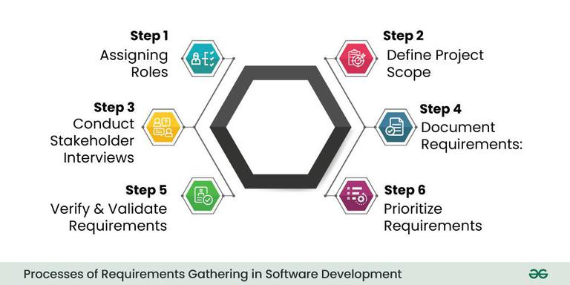Processes of Requirements Gathering in Software Development

**Step 1- Assigning roles:**

* The first step is to identify and engage with all relevant stakeholders. Stakeholders can include end-users, clients, project managers, subject matter experts, and anyone else who has a vested interest in the software project. Understanding their perspectives is essential for capturing diverse requirements.

**Step 2- Define Project Scope:**

* Clearly define the scope of the project by outlining its objectives, boundaries, and limitations. This step helps in establishing a common understanding of what the software is expected to achieve and what functionalities it should include.

**Step 3- Conduct Stakeholder Interviews:**

* Schedule interviews with key stakeholders to gather information about their needs, preferences, and expectations. Through open-ended questions and discussions, aim to uncover both explicit and implicit requirements. These interviews provide valuable insights that contribute to a more holistic understanding of the project.

**Step 4- Document Requirements:**

* Systematically document the gathered requirements. This documentation can take various forms, such as user stories, use cases, or formal specifications. Clearly articulate functional requirements (what the system should do) and non-functional requirements (qualities the system should have, such as performance or security).

**Step 5- Verify and Validate Requirements:**

* Once the requirements are documented, it's crucial to verify and validate them. Verification ensures that the requirements align with the stakeholders' intentions, while validation ensures that the documented requirements will meet the project's goals. This step often involves feedback loops and discussions with stakeholders to refine and clarify requirements.

**Step 6- Prioritize Requirements:**

* Prioritize the requirements based on their importance to the project goals and constraints. This step helps in creating a roadmap for development, guiding the team on which features to prioritize. Prioritization is essential, especially when resources and time are limited.

**Requirement Gathering Techniques:**

Effective requirement gathering is essential for the success of a software development project. Various techniques are employed to collect, analyze, and document requirements.

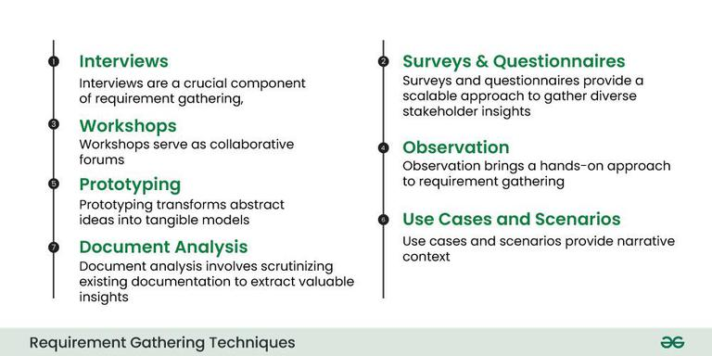Requirements Gathering Techniques

Here are some commonly used requirement gathering techniques:

1. **Interviews:**
   * Conducting one-on-one or group interviews with stakeholders, including end-users, clients, and subject matter experts. This allows for direct interaction to gather detailed information about their needs, expectations, and concerns.
2. **Surveys and Questionnaires:**
   * Distributing surveys and questionnaires to a broad audience to collect information on a larger scale. This technique is useful for gathering feedback from a diverse set of stakeholders and can be particularly effective in large projects.
3. **Workshops:**
   * Organizing facilitated group sessions or workshops where stakeholders come together to discuss and define requirements. Workshops encourage collaboration, idea generation, and the resolution of conflicting viewpoints in a structured environment.
4. **Observation:**
   * Directly observing end-users in their work environment to understand their workflows, pain points, and preferences. Observational techniques help in uncovering implicit requirements that users might not explicitly state.
5. **Prototyping:**
   * Creating mockups or prototypes of the software to provide stakeholders with a tangible representation of the proposed system. Prototyping allows for early visualization and feedback, helping to refine requirements based on stakeholders' reactions.
6. **Use Cases and Scenarios:**
   * Developing use cases and scenarios to describe how the system will be used in different situations. This technique helps in understanding the interactions between users and the system, making it easier to identify and document functional requirements.
7. **Document Analysis:**
   * Reviewing existing documentation, such as business process manuals, reports, and forms, to extract relevant information. This technique provides insights into the current processes and helps identify areas for improvement.

**Why Requirement Gathering is important?**

Requirement gathering holds immense importance in software development for several critical reasons:

1. **Clarity of Project Objectives:**
   * Requirement gathering sets the stage by defining and clarifying the objectives of the software project. It ensures that all stakeholders, including clients, users, and development teams, have a shared understanding of what needs to be achieved.
2. **Customer Satisfaction:**
   * Understanding and meeting customer needs is paramount for customer satisfaction. Requirement gathering allows developers to comprehend the expectations of end-users and clients, leading to the creation of a product that aligns with their desires and requirements.
3. **Scope Definition:**
   * Clearly defined requirements help in establishing the scope of the project. This delineation is crucial for managing expectations, avoiding scope creep (uncontrolled changes to project scope), and ensuring that the project stays on track.
4. **Reduced Misunderstandings:**
   * Ambiguities and misunderstandings are common sources of project failures. Requirement gathering facilitates clear communication between stakeholders, reducing the risk of misinterpretations and ensuring that everyone involved is on the same page.
5. **Risk Mitigation:**
   * Identifying and addressing potential issues at the requirements stage helps mitigate risks early in the development process. This proactive approach minimizes the chances of costly errors, rework, and delays later in the project life cycle.

**Benefits of Requirements Gathering:**

The benefits of effective requirements gathering in software development include:

* **Cost Reduction:** One of the primary benefits of effective requirements gathering is cost reduction. When requirements are well-defined and thoroughly understood at the beginning of a project, it minimizes the likelihood of costly changes and rework later in the development process.
* **Customer Satisfaction:**Clear and accurate requirements gathering directly contributes to customer satisfaction. When the end product aligns closely with the expectations and needs of the stakeholders, it enhances user experience and meets customer demands. This satisfaction is not only vital for the success of the current project but also contributes to positive relationships between the development team and clients, fostering trust and potential future collaborations.
* **Improved Communication:**Requirements gathering serves as a communication bridge between various stakeholders involved in a project, including developers, clients, users, and project managers. Miscommunication is a common source of project failures and delays. By clearly documenting and understanding requirements, the development team ensures that everyone involved has a shared vision of the project objectives, functionalities, and constraints.
* **Efficient Resource Utilization:** Thorough requirements gathering enables the efficient allocation and utilization of resources. Resources, including time, manpower, and technology, are finite and valuable. When requirements are well-defined, project teams can allocate resources more accurately, avoiding unnecessary expenditures or overcommitting resources to certain aspects of the project.
* **Enhanced Quality:** Well-documented requirements serve as the foundation for quality assurance throughout the development process. When the project team has a clear understanding of what needs to be achieved, they can establish quality standards and criteria from the outset. This clarity enables the implementation of effective testing strategies, ensuring that each aspect of the system is thoroughly evaluated against the specified requirements.
* **Risk Management:**Requirements gathering is a crucial component of effective risk management. By identifying potential risks early in the project, stakeholders can proactively address ambiguities, conflicting requirements, and other challenges that could pose a threat to the project's success.
* **Accurate Planning:**Accurate project planning is dependent on a clear understanding of project requirements. When requirements are well-documented, project managers can create realistic schedules, milestones, and deliverables. This accurate planning is crucial for setting expectations, managing stakeholder timelines, and ensuring that the project progresses according to the established timeline.

**Common Obstacles in Software Requirements Gathering:**

Common obstacles in software requirements gathering include:

* **Unclear Objectives:** Lack of clear project objectives can hinder requirements gathering. When stakeholders are unsure about what they want to achieve, it becomes challenging to define and prioritize requirements effectively. This can lead to confusion, scope creep, and difficulties in meeting project goals.
* **Ambiguous Requirements:**Ambiguities in requirements, such as vague language or conflicting statements, can create misunderstandings among stakeholders and the development team. Ambiguous requirements may result in deliverables that do not meet expectations and may require extensive rework.
* **Poor Stakeholder Involvement:** Insufficient involvement or engagement of key stakeholders can impede the requirements gathering process. When essential stakeholders are not actively participating or providing input, there is a risk of missing critical requirements or making decisions that do not align with the needs of the end-users.
* **Changing Requirements:** Requirements that undergo frequent changes during the development process, often referred to as "scope creep," can lead to project delays, increased costs, and challenges in maintaining project focus. It is essential to manage and control changes to prevent unnecessary disruptions.
* **Communication Barriers:**Communication challenges, such as language barriers, misinterpretations, or inadequate channels for information exchange, can hinder effective requirements gathering. It is crucial to establish clear communication channels and ensure that all stakeholders have a shared understanding of the terminology used in the project.
* **Overreliance on Documentation:** Depending solely on documentation without active collaboration and communication can lead to misunderstandings. Written requirements may not capture the complete context or evolving needs, making it essential to complement documentation with interactive processes like workshops and interviews.
* **Lack of User Involvement:**Users are often the ultimate beneficiaries of the system, and their input is critical. Lack of user involvement or representation can result in systems that do not effectively meet their needs. It is important to actively involve end-users in the requirements gathering process to ensure the system's usability and acceptance.

**How Requirements Gathering helps for Agile in Software Development:**

Agile development emphasizes flexibility, collaboration, and continuous improvement. The requirements gathering process in Agile is iterative and adaptive, allowing for changes and adjustments throughout the development lifecycle. Here's a detailed explanation of the requirements gathering process in Agile:

* **User Stories:** In Agile, requirements are often expressed as user stories. A user story is a concise, informal description of a feature told from the end-user's perspective. It typically follows the format: "As a [type of user], I want [an action] so that [benefit/value]." User stories focus on the user and their goals, helping to capture the essence of the required functionality.
* **Backlog Refinement:**The product backlog is a prioritized list of features, enhancements, and fixes. Backlog refinement sessions, often known as backlog grooming, occur regularly to review, clarify, and prioritize the items in the backlog. This process ensures that the most valuable and highest-priority items are at the top of the list and ready for development in upcoming sprints.
* **Iterative Development:** Agile development is iterative, with work organized into time-boxed cycles called sprints. During each sprint, a cross-functional team works on a set of prioritized user stories. The requirements for each user story are refined and clarified as the team progresses, allowing for flexibility and adaptability to changing priorities or emerging insights.
* **Continuous Stakeholder Collaboration:**Agile encourages ongoing collaboration with stakeholders, including product owners, end-users, and business representatives. Regular meetings, such as sprint reviews and sprint planning, provide opportunities for stakeholders to provide feedback on completed work, discuss changes to priorities, and refine requirements for upcoming sprints.
* **Prototyping and Visual Aids:**Agile teams often use prototyping and visual aids to enhance requirements understanding. Prototypes, wireframes, and other visual representations help stakeholders visualize the proposed features and provide early feedback. This iterative approach ensures that the final product closely aligns with stakeholder expectations.
* **Daily Stand-ups:**Daily stand-up meetings, or daily scrums, are a key Agile practice. These brief, focused meetings provide team members with the opportunity to share progress, discuss impediments, and ensure that everyone is aligned on the project's goals. While not specifically for requirements gathering, daily stand-ups facilitate ongoing communication, allowing the team to quickly address any emerging requirements or changes.
* **Acceptance Criteria:**Each user story in Agile is accompanied by acceptance criteria. Acceptance criteria define the conditions that must be met for a user story to be considered complete. They serve as a shared understanding between the development team and stakeholders regarding the expectations for the functionality being delivered. Clear acceptance criteria help prevent misunderstandings and ensure that the developed features meet the desired outcomes.
* **Retrospectives:** Agile teams regularly conduct retrospectives at the end of each sprint to reflect on what went well, what could be improved, and what changes might enhance the development process. This feedback loop includes discussions about the effectiveness of the requirements gathering process, allowing the team to adapt and refine their approach for future sprints.

**Challenges and Considerations in Agile Requirements Gathering:**

* **Changing Priorities:**Agile embraces changes in requirements, but frequent changes can pose challenges. It's crucial to strike a balance between flexibility and stability, ensuring that changes are well-understood, prioritized, and communicated effectively to the development team.
* **Balancing Detail and Flexibility:** Agile requires enough detail to guide development, but also the flexibility to adapt as requirements evolve. Striking the right balance ensures that the team can respond to changes while maintaining a clear understanding of the project's direction.
* **Effective Communication:**Agile heavily relies on communication and collaboration. Ensuring that all team members, including stakeholders, have open channels for communication is essential to prevent misunderstandings and align everyone with the project's goals.
* **Overemphasis on Documentation:**While Agile values working software over comprehensive documentation, it's important to strike a balance. Minimal but effective documentation, such as user stories and acceptance criteria, should be maintained to ensure a shared understanding among team members and stakeholders.
* **Ensuring Continuous Feedback:**Agile places a strong emphasis on continuous feedback, but ensuring active stakeholder involvement can be challenging. Efforts should be made to encourage regular feedback through sprint reviews, demos, and other collaborative sessions to avoid potential misunderstandings and to keep the development aligned with stakeholder expectations.

By embracing these Agile practices and considering the associated challenges, teams can effectively gather and adapt requirements throughout the development process, delivering value to stakeholders in a dynamic and responsive manner.

**Tools for Requirements Gathering in Software Development:**

Requirements gathering tools play a crucial role in streamlining the process of collecting, documenting, and managing project requirements. These tools are designed to enhance collaboration, improve communication, and facilitate the organization of complex information. Here are several types of requirements gathering tools and their roles:

* **Collaboration Tools:**Collaboration tools, such as project management platforms (e.g., Jira, Trello, Asana), facilitate teamwork and communication among project stakeholders. These platforms often include features like task assignment, progress tracking, and discussion forums, enabling teams to collaboratively gather, discuss, and manage requirements in real-time.
* **Document Management Tools:** Document management tools (e.g., Confluence, SharePoint) help organize and store project documentation. These tools provide a centralized repository for requirements, ensuring easy access, version control, and collaboration. Document management tools are particularly valuable for maintaining a structured record of evolving project requirements.
* **Survey and Form Builders:** Tools like Google Forms, Typeform, or SurveyMonkey enable the creation of online surveys and forms. These are useful for gathering structured data from a large audience, such as feedback, preferences, or specific information required for project requirements. The collected data can be easily analyzed and integrated into the requirements gathering process.
* **Prototyping Tools:**Prototyping tools (e.g., Sketch, Balsamiq, Figma) allow the creation of visual or interactive prototypes. These tools are valuable for translating requirements into tangible representations that stakeholders can interact with, providing a clearer understanding of the proposed features and functionalities.
* **Mind Mapping Tools:**Mind mapping tools (e.g., MindMeister, XMind) help visualize and organize complex ideas and relationships. During requirements gathering, these tools can be used to create visual representations of interconnected requirements, helping stakeholders and the project team understand the relationships between different features and functionalities.
* **Version Control Systems:** Version control systems (e.g., Git, SVN) are essential for managing changes to project documentation. These tools track revisions, allowing teams to review, revert, or merge changes seamlessly. This is particularly valuable in dynamic projects where requirements may undergo frequent updates or refinements.
* **Requirements Management Software:** Specialized requirements management tools (e.g., IBM Engineering Requirements Management DOORS, Jama Connect) are designed specifically for capturing, tracking, and managing requirements throughout the project lifecycle. These tools often offer features such as traceability, impact analysis, and integration with other project management tools.
* **Visual Collaboration Tools:**Visual collaboration tools (e.g., Miro, Lucidchart) facilitate collaborative diagramming and visual representation of ideas. These tools can be used for creating flowcharts, diagrams, or visual models that help communicate complex requirements in a more intuitive and accessible way.

**Conclusion:**

In conclusion, good requirements gathering is crucial for successful projects, ensuring the final product meets everyone's needs and expectations in software development.

**Requirements Elicitation - Software Engineering**

Last Updated : 27 Sep, 2025

**Requirements elicitation** is the process of gathering and defining the requirements for a software system. The goal of requirements elicitation is to ensure that the software development process is based on a clear and comprehensive understanding of the customer's needs and requirements. This article focuses on discussing Requirement Elicitation in detail.

Requirement Elicitation

**What is Requirement Elicitation?**

The process of investigating and learning about a system's requirements from users, clients, and other stakeholders is known as requirements elicitation. Requirements elicitation in [software engineering](https://www.geeksforgeeks.org/software-engineering/software-engineering-introduction-to-software-engineering/)is perhaps the most difficult, most error-prone, and most communication-intensive [software development](https://www.geeksforgeeks.org/software-engineering/what-is-software-development/).

1. Requirement Elicitation can be successful only through an effective customer-developer partnership. It is needed to know what the users require.
2. Requirements elicitation involves the identification, collection, analysis, and refinement of the requirements for a software system.
3. Requirement Elicitation is a critical part of the [software development life cycle](https://www.geeksforgeeks.org/software-engineering/software-development-life-cycle-sdlc/) and is typically performed at the beginning of the project.
4. Requirements elicitation involves stakeholders from different areas of the organization, including business owners, end-users, and technical experts.
5. The output of the requirements elicitation process is a set of clear, concise, and well-defined requirements that serve as the basis for the design and development of the software system.
6. Requirements elicitation is difficult because just questioning users and customers about system needs may not collect all relevant requirements, particularly for safety and dependability.
7. Interviews, surveys, user observation, workshops, brainstorming, use cases, role-playing, and prototyping are all methods for eliciting requirements.

**Importance of Requirements Elicitation**

1. **Compliance with Business Objectives:** The process of elicitation guarantees that the software development endeavors are in harmony with the wider company aims and objectives. Comprehending the business context facilitates the development of a solution that adds value for the company.
2. **User Satisfaction**: It is easier to create software that fulfills end users' needs and expectations when they are involved in the requirements elicitation process. Higher user pleasure and acceptance of the finished product are the results of this.
3. **Time and Money Savings:**Having precise and well-defined specifications aids in preventing miscommunication and rework during the development phase. As a result, there will be cost savings and the project will be completed on time.
4. **Compliance and Regulation Requirements**: Requirements elicitation is crucial for projects in regulated industries to guarantee that the software conforms with applicable laws and norms. In industries like healthcare, finance, and aerospace, this is crucial.
5. **Traceability and Documentation:**Throughout the [software development process](https://www.geeksforgeeks.org/software-engineering/software-development-process/), traceability is based on well-documented requirements. Traceability helps with testing, validation, and maintenance by ensuring that every part of the software can be linked to a particular requirement.

**Requirements Elicitation Activities**

Requirements elicitation includes the subsequent activities. A few of them are listed below:

1. Knowledge of the overall area where the systems are applied.
2. The details of the precise customer problem where the system is going to be applied must be understood.
3. Interaction of system with external requirements.
4. Detailed investigation of user needs.
5. Define the constraints for system development.

**Requirements Elicitation Methods**

There are several requirements elicitation methods. A few of them are listed below:

Requirement Elicitation Techniques

**1. Interviews**

The objective of conducting an interview is to understand the customer's expectations of the software.   
It is impossible to interview every stakeholder hence representatives from groups are selected based on their expertise and credibility. Interviews may be open-ended or structured.

1. In open-ended interviews, there is no pre-set agenda. Context-free questions may be asked to understand the problem.
2. In a structured interview, an agenda of fairly open questions is prepared. Sometimes a proper questionnaire is designed for the interview.

**2. Brainstorming Sessions**

* [Brainstorming Sessions](https://www.geeksforgeeks.org/business-communication/brainstorming/) is a group technique
* It is intended to generate lots of new ideas hence providing a platform to share views
* A highly trained facilitator is required to handle group bias and conflicts.
* Every idea is documented so that everyone can see it.
* Finally, a document is prepared which consists of the list of requirements and their priority if possible.

**3. Facilitated Application Specification Technique**

Its objective is to bridge the expectation gap - the difference between what the developers think they are supposed to build and what customers think they are going to get. A team-oriented approach is developed for requirements gathering. Each attendee is asked to make a list of objects that are:

1. Part of the environment that surrounds the system.
2. Produced by the system.
3. Used by the system.

Each participant prepares his/her list, different lists are then combined, redundant entries are eliminated, the team is divided into smaller sub-teams to develop mini-specifications and finally, a draft of specifications is written down using all the inputs from the meeting.

**4. Quality Function Deployment**

In this technique customer satisfaction is of prime concern, hence it emphasizes the requirements that are valuable to the customer.   
3 types of requirements are identified:

* **Normal requirements:**In this the objective and goals of the proposed software are discussed with the customer. For example - normal requirements for a result management system may be entry of marks, calculation of results, etc.
* **Expected requirements:**These requirements are so obvious that the customer need not explicitly state them. Example - protection from unauthorized access.
* **Exciting requirements:**It includes features that are beyond customer's expectations and prove to be very satisfying when present. For example - when unauthorized access is detected, it should back up and shut down all processes.

**5. Use Case Approach**

Use Case technique combines text and pictures to provide a better understanding of the requirements.   
The use cases describe the 'what’, of a system and not 'how’. Hence, they only give a functional view of the system.   
The components of the use case design include three major things - Actor, use cases, and use case diagram.

1. **Actor:**It is the external agent that lies outside the system but interacts with it in some way. An actor may be a person, machine, etc. It is represented as a stick figure. Actors can be primary actors or secondary actors.   
   * **Primary actors:**It requires assistance from the system to achieve a goal.
   * **Secondary actor:** It is an actor from which the system needs assistance.
2. **Use cases:**They describe the sequence of interactions between actors and the system. They capture who(actors) do what(interaction) with the system. A complete set of use cases specifies all possible ways to use the system.
3. [**Use case diagram:**](https://www.geeksforgeeks.org/system-design/use-case-diagram/)A use case diagram graphically represents what happens when an actor interacts with a system. It captures the functional aspect of the system.   
   * A stick figure is used to represent an actor.
   * An oval is used to represent a use case.
   * A line is used to represent a relationship between an actor and a use case.

The success of an elicitation technique used depends on the maturity of the analyst, developers, users, and the customer involved.

**Steps of Requirements Elicitation**

Following are the Steps of Requirement Elicitation

Steps of Requirement Elicitation

**1. Identify Stakeholders**

The first step is to figure out who all the key players are in the project. These are the people who will either use the product, help develop it, or be impacted by it. This could include users, developers, project managers, and customers. It's important to get everyone involved early on, so you gather all the necessary input and perspectives when defining the requirements.

**2. Gather Requirements**

Once you've identified the stakeholders, the next step is to gather their requirements. This means understanding what they need from the system or product. Requirements can be functional (what the system should do) or non-functional (how it should perform). You can use different methods like interviews, surveys, or group discussions to collect all these needs.

**3. Prioritize Requirements**

Not all requirements are equal in terms of importance. After gathering them, you’ll need to prioritize which ones should be addressed first. This helps ensure that the most important features are built into the system first, especially when resources (like time and budget) are limited. A common approach is to categorize them into things that are "Must-have," "Should-have," "Could-have," and "Won’t-have."

**4. Categorize Feasibility**

After prioritizing, the next step is to assess how realistic each requirement is. You’ll categorize them into three groups:

* **Achievable**: These are requirements that are realistic and can be done within the available resources (time, budget, etc.).
* **Deferred**: These requirements are important but can’t be implemented in this phase. They’ll be put on hold for now with a clear reason why.
* **Impossible**: These requirements can't be done because of technical or other limitations, and they should be removed from the list.

**Features of Requirements Elicitation**

1. **Stakeholder engagement:**Requirements elicitation involves engaging with stakeholders such as customers, end-users, project sponsors, and subject-matter experts to understand their needs and requirements.
2. **Gathering information:** Requirements elicitation involves gathering information about the system to be developed, the business processes it will support, and the end-users who will be using it.
3. **Requirement prioritization:**Requirements elicitation involves prioritizing requirements based on their importance to the project's success.
4. **Requirements documentation:** Requirements elicitation involves documenting the requirements clearly and concisely so that they can be easily understood and communicated to the development team.
5. [**Validation and verification:**](https://www.geeksforgeeks.org/software-engineering/software-engineering-verification-and-validation/)Requirements elicitation involves validating and verifying the requirements with the stakeholders to ensure they accurately represent their needs and requirements.
6. **Iterative process:**Requirements elicitation is an iterative process that involves continuously refining and updating the requirements based on feedback from stakeholders.
7. **Communication and collaboration:** Requirements elicitation involves effective communication and collaboration with stakeholders, project team members, and other relevant parties to ensure that the requirements are clearly understood and implemented.
8. **Flexibility:**Requirements elicitation requires flexibility to adapt to changing requirements, stakeholder needs, and project constraints.

**Advantages of Requirements Elicitation**

1. **Clear requirements:** Helps to clarify and refine customer requirements.
2. **Improves communication:** Improves communication and collaboration between stakeholders.
3. **Results in good quality software:** Increases the chances of developing a software system that meets customer needs.
4. **Avoids misunderstandings:** Avoids misunderstandings and helps to manage expectations.
5. **Supports the identification of potential risks:** Supports the identification of potential risks and problems early in the development cycle.
6. **Facilitates development of accurate plan:**Facilitates the development of a comprehensive and accurate project plan.
7. **Increases user confidence:**Increases user and stakeholder confidence in the software development process.
8. **Supports identification of new business opportunities:** Supports the identification of new business opportunities and revenue streams.

**Disadvantages of Requirements Elicitation**

1. **Time-consuming:** It can be time-consuming and expensive.
2. **Skills required:**Requires specialized skills and expertise.
3. **Impacted by changing requirements:** This may be impacted by changing business needs and requirements.
4. **Impacted by other factors:**Can be impacted by political and organizational factors.
5. **Lack of commitment from stakeholders:**This can result in a lack of buy-in and commitment from stakeholders.
6. **Impacted by conflicting priorities:** Can be impacted by conflicting priorities and competing interests.
7. **Sometimes inaccurate requirements:**This may result in incomplete or inaccurate requirements if not properly managed.
8. **Increased development cost:**This can lead to increased development costs and decreased efficiency if requirements are not well-defined.

**Conclusion**

Software engineers utilize requirements elicitation as a guide to help them construct systems that meet real-world needs and objectives while ensuring a seamless transition between technology and user expectations.

**Designing Use Cases for a Project**

Last Updated : 06 Aug, 2025

Before we start working on any project, it is very important that we are very clear on what we want to do and how do we want to do. In my [last](https://www.geeksforgeeks.org/software-engineering/how-to-write-a-good-srs-for-your-project/) Blog, I discussed on how to write a good SRS for your project and what is the advantage we get out of that. In this Blog, I’ll discuss Use Cases and their advantage in our projects.

**What are Use Cases?**

In software and systems engineering, a use case is a list of actions or event steps, typically defining the interactions between a role (known in the Unified Modeling Language as an *actor*) and a system, to achieve a goal. The actor can be a human, an external system, or time. In systems engineering, use cases are used at a higher level than within software engineering, often representing missions or stakeholder goals. Another way to look at it is a use case describes a way in which a real-world actor interacts with the system. In a system use case you include high-level implementation decisions. System use cases can be written in both an informal manner and a formal manner. ([Wiki](https://en.wikipedia.org/wiki/Use_case))

**What is the importance of Use Cases?**

Use cases have been used extensively over the past few decades. The advantages of Use cases includes:

* The list of goal names provides the shortest summary of what the system will offer
* It gives an overview of the roles of each and every component in the system. It will help us in defining the role of users, administrators etc.
* It helps us in extensively defining the user’s need and exploring it as to how it will work.
* It provides solutions and answers to many questions that might pop up if we start a project unplanned.

**How to plan use case?**

Following example will illustrate on how to plan use cases:

**Use Case:**What is the main objective of this use case. For eg. Adding a software component, adding certain functionality etc.

**Primary Actor:**Who will have the access to this use case. In the above examples, administrators will have the access.

**Scope:**Scope of the use case

**Level:**At what level the implementation of the use case be.

**Flow:**What will be the flow of the functionality that needs to be there. More precisely, the work flow of the use case.

Some other things that can be included in the use cases are:

* **Preconditions**
* **Postconditions**
* **Brief course of action**
* **Time Period**

**Use Case Diagram**

Below is a sample use case diagram which I have prepared for reference purpose for a sample project (much like Facebook). It would help us to understand the role of various actors in our project. Various actors in the below use case diagram are: **User and System.**

The main use cases are in the system and the diagram illustrates on how the actors interact with the use cases.For eg.  During Sign Up, only users need to interact with the use case and not the system whereas when it comes to categorizing posts, only system would be required.

**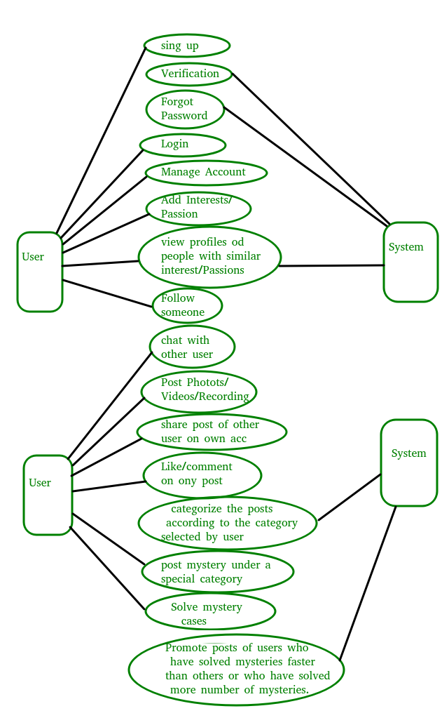**

In Software Development, understanding user requirements and effectively translating them into functional features is crucial for success. With the right tools, like use case, you can create products that meet the needs of your users.

A use case is a definition of a specific business objective that the system needs to accomplish. It describes the interaction between a system and its users or external entities. They provide a detailed description of how a system or application should behave in response to various user actions or inputs. They offer a high-level view of the system’s functionality from an end user perspective.

**Benefits and Importance of Use Cases**

* They can prevent costly errors or misunderstandings by catching them early. By identifying potential problems or misunderstandings before they lead to significant development or testing costs, use cases can help to save time and money. For example, if a use case shows that two different requirements are in conflict with each other, it can be addressed early on, rather than causing issues later in the project.
* Ensure consistency across different teams and stakeholders. Use cases can provide a common language and structure for all of the teams and stakeholders involved in the project. This helps to ensure that everyone is on the same page and working towards the same goals. It can also help to prevent misunderstandings and communication problems.
* They can be used to create functional tests and acceptance criteria. Use cases are used to create functional tests and acceptance criteria. Functional tests ensure that the system meets the requirements defined in the use cases. Acceptance criteria define the conditions that must be met for the system to be considered acceptable. By basing these tests and criteria on the use cases, the system is built according to the requirements and thoroughly tested.
* They provide a basis for creating user documentation and training materials
* User-centered Design.They help ensure that the software aligns with user needs and expectations, leading to a more user-friendly and effective product.

**Key components of a Use Case**

As you’re writing your use case, there are several components that should typically be included. These range from the identifier of the use case to who’s involved and alternative solutions:

1. Actor: Actors are entities or roles outside the system that interact with it. These can be users, other systems, or external entities. Actors initiate and participate in use cases.
2. Use Case Name: Each use case is given a descriptive name that reflects its purpose, such as "Login," "Make a Reservation," or "Process Payment."
3. Description: A brief description of the use case, outlining its primary objective and functionality.
4. Preconditions: Conditions that must be met before the use case can be executed. For example, a precondition for the "Make a Reservation" use case could be that the user is logged in.
5. Main Flow: The main sequence of steps that describe how the use case is executed under normal conditions
6. Alternate Flows: These describe alternative paths within a use case that occur when certain conditions or exceptions are met. For example, an alternate flow in the "Login" use case could be handling incorrect credentials.
7. Postconditions: Conditions that must be true after the use case is completed. For instance, after successfully making a reservation, the postcondition could be that the reservation is saved in the system.

**Use Case Diagrams**

Use case diagrams are a visual representation of the functional requirements of a system from the perspective of its users. They help in understanding how users interact with a system and the various use cases or functionalities the system provides.

A use case diagram consists of the system, the related use cases and actors and relates these to each other to visualize: what is being described? (system), who is using the system? (actors) and what do the actors want to achieve? (use cases).

**How to draw a Use Case Diagram**

Here are the steps for writing a use case diagram:

- Start with a rectangle to represent the system.  
- Add ovals to represent the actors.  
- Connect the actors to the system with lines.  
- Add arrows to show the direction of the interaction.  
- Label each actor and each action.

These steps should result in a clear and easy-to-understand diagram that represents the use case.

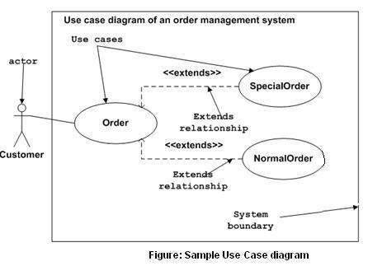

It’s a good practice to use standardized symbols and colors to make the diagram easier to understand. And it’s also helpful to use swimlanes to group related actions together.

It's a good idea to keep the diagram as simple as possible. Only include the essential information, and avoid adding too much detail. This will make it easier to understand and more likely to be useful.

In summary, use cases are an important part of the software development process. They provide a clear and detailed description of the system’s functionality from the user’s perspective. They can be used to improve communication and collaboration between developers, testers, and other stakeholders. And with the right visual aids, like diagrams and videos, they can be a powerful tool for understanding and explaining complex systems.

In the world of product design and development, three terms often come up that can sometimes be confusing for us: user stories, user scenarios, and use cases. Understanding the differences between them is crucial to know in which moment we shoud use one or another. So, let´s go for it and have a look to each one to highlight their different applications.

**User Stories**

Press enter or click to view image in full size

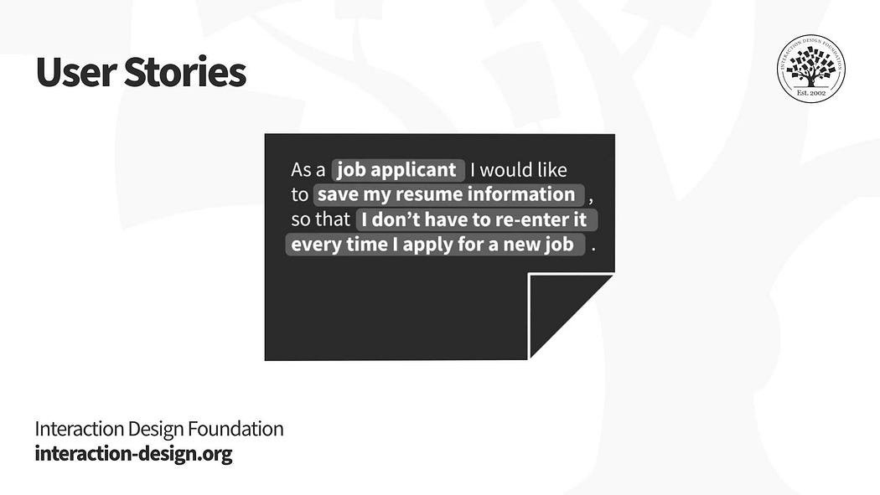

Eduardo Ferreira and Interaction Design Foundation

User stories originated in Agile software development methodologies and have become a popular tool for expressing the needs of users. A user story is a short, simple description of a feature from the perspective of the user who wants the new capability.

User stories are typically written using the following format: “As a [type of user], I want [an action] so that [a benefit]”. For example, “As a designer named John Doe, I want a color palette tool in my design software so that I can easily apply consistent colors to my website designs.”

The main purpose of user stories is to focus on what users need from a product at a high level, without getting into the details of how the product will fulfill those needs.

**User Scenarios**

Press enter or click to view image in full size

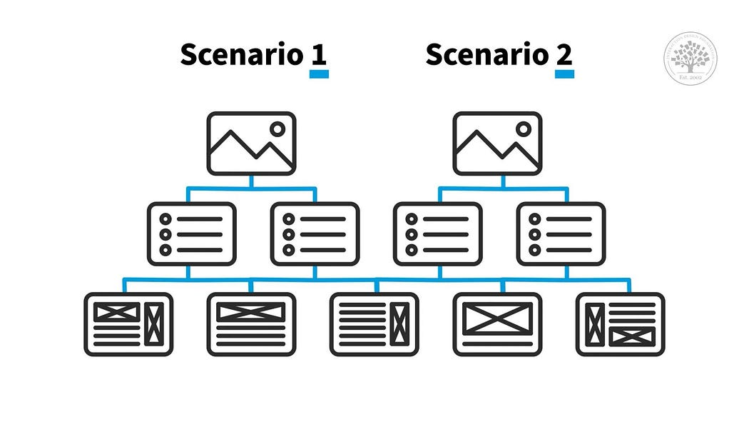

User scenarios are descriptions in a narrative way that tell us the story of a user’s interaction with a product. They provide more detailed context than user stories, including the user’s motivations, actions, and the overall flow of interaction with the product.

Here is an example from the previous designer John Doe:

**Scenario:** John Doe, a web designer, has been contracted to create a new website for a small local bakery. He has a clear idea of how he wants the website to look. He starts a new project in his design tool, names it “Acme Website Project”, and sketches out the basic structure. He uses the color palette tool to apply the bakery’s brand colors to his design. After he’s happy with the design, he previews it on different devices, makes necessary adjustments, and finally, exports the design to present to his client.

User scenarios help teams understand the user’s journey and the different steps they might take to achieve their goal, which can inform design decisions to make that journey as smooth as possible.

**Use Cases**

Press enter or click to view image in full size

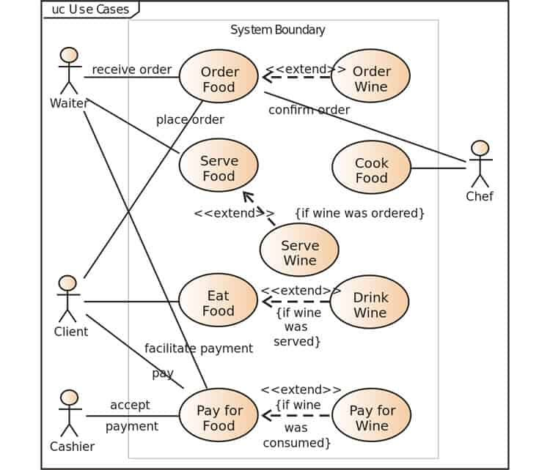

Use cases, a term originating from the field of systems engineering, are more detailed and technical than both user stories and user scenarios. A use case describes a sequence of actions that a system performs to achieve a specific outcome.

Each use case is typically represented with a title, a primary actor (usually a user), a goal, preconditions, main success scenario (steps), extensions, and postconditions. For more detailed information on these components, you can read [this article](https://www.usability.gov/how-to-and-tools/methods/use-cases.html?ref=blog.yotako.io#:~:text=A%20use%20case%20is%20a,when%20that%20goal%20is%20fulfilled.).

For example, a use case for the color palette tool might include steps like: “John Doe clicks the color palette tool icon”, “System opens a panel with pre-made color palettes”, “John selects a palette”, “System applies the selected colors to John’s design”.

Use cases are particularly useful for defining system behavior and for communicating with developers about how a feature should work in detail.

**Conclusion**

While user stories, user scenarios, and use cases all help define the needs of users and the behavior of a product, they do it in a different levels of detail and from different perspectives. User stories are high-level and user-focused, user scenarios provide more detailed context about user behavior, and use cases provide a detailed, technical description of system behavior.

Understanding the differences between them can help teams choose the right tool for the right situation, whether they’re defining high-level product goals, designing user flows, or specifying technical requirements for development.

The success of any product development relies on how effective teams are at capturing and translating requirements into solutions. User stories and use cases are two popular methods that are used to capture these requirements.

Both methods differ in how requirements are viewed yet complement each other, leaving many teams wondering which is better. So, UXCam has stepped in to share our knowledge and wisdom in all things product development.

Keep reading as we discuss the battle between user stories versus use cases to help you decide which technique is better or perhaps both will be suitable in unlocking your apps’ potential.

Use Case vs User Story - Key difference

The main difference is that use cases provide a detailed, step-by-step description of how the system interacts with users, while user stories focus on what the user wants to achieve in a simple, high-level way.

Aspect User Story Use Case

Definition A short, simple description of a feature from the user’s perspective. A detailed, structured description of system interactions to achieve a goal.

Focus User needs and goals. System behavior and interactions.

Detail Level High-level, minimal details. Detailed with step-by-step interactions.

Structure "As a [user], I want [goal] so that [reason]." Includes actors, preconditions, steps, alternative flows, and postconditions.

Purpose Helps agile teams deliver small, incremental functionality that provides user value. Defines system behavior and interactions comprehensively.

Example "As a mobile app user, I want to reset my password so that I can regain access if I forget it." Actor: User → Steps: User clicks 'Forgot Password', enters email, receives reset link, and sets a new password.

Usage Agile development, backlog management, and prioritization. Traditional software development and detailed system documentation.

Documentation Lightweight and informal. Comprehensive and structured.

Best For Teams working in Agile environments needing quick iterations. Complex workflows requiring detailed system interaction descriptions.

User stories vs Use Cases - an overview

User stories and use cases are two different methods for planning and explaining the requirements and features of a product.

User stories keep things simple. They're short, user-centered narratives that help your team understand what the user wants to do and why.

Think:

As a new user, I want to sign up with Google so that I can get started quickly.

It’s a lightweight way to keep everyone aligned on the user’s needs, without diving into the technical weeds too soon.

Use cases, on the other hand, go deep. They lay out each step the system and user take to complete a task—from clicking a button to confirming a transaction. They're especially useful when you’re dealing with complex flows, edge cases, or integrations.

For example:

A use case might describe the entire process of booking a flight—from choosing dates, to entering passenger info, to payment and confirmation—step by step.

Both methods are important. And both depend on having a real understanding of how users interact with your product.

Here’s the thing: writing user stories and use cases isn’t guesswork. You need real data about what your users are doing—where they get stuck, what they click on, and where they drop off.

That’s where UXCam can help.

UXCam Web Product Analytics

With UXCam’s session replay and product analytics, you can see exactly how users move through your app or website. You’ll uncover what’s working, what’s not, and what needs fixing—all based on real behavior, not assumptions.

Want to improve your user stories? Watch actual sessions to see how users try (and sometimes fail) to complete key tasks.

UXCam Web Product Analytics Session Replay

Need better use cases? Use funnels and screen flows to map out the real paths users take, not just the ideal ones on a whiteboard.

Screen flow with Session Replay

If you're serious about building products your users actually want and making their experience seamless, start a free trial using UXCam today.

What are User Stories?

User stories are simple, concise descriptions or narratives that capture the features and functionality of a product from the user’s perspective. Using non-technical language, it communicates how a product will provide specific value to the customer.

They serve as a user-centric method for communicating desired functionality and features among product and development teams and stakeholders. They can be used to create acceptance criteria, defining the conditions that need to be met to deem a user story complete.

User story example

Any role–user(s), stakeholder(s), or entity— another system that interacts with the system is labeled an “actor.” User stories are usually written using this template:

As a [user/stakeholder], I want [feature] so that [benefit]

Here are some examples of how a typical user story may be written:

Actor Feature Benefit

As Luke I want to organize my work So I can get more done.

As a technical support analyst I want to receive alerts as soon as they happen So I can fix issues immediately.

As a product manager I want to collect in-app behavior analytics So I can design empathic products.

Advantages of user stories

Customer-centric approach: They focus on the user's or stakeholder's perspectives and needs and ensure product development alignment.

Iterative and flexible: They're suitable for iterative development, as you can add new stories and change existing ones based on user feedback.

Simple and straightforward: They're usually written to accommodate non-technical team members and promote effective communication.

Disadvantages of user stories

Lacks detailed documentation: The user story format may lead to ambiguity and a lack of complete understanding of feature and requirement details.

Limited dependency visibility: Their focus on user needs can cause a lack of dependency and interactions between user stories visibility. This can lead to coordination issues.

Difficult to estimate effort: It lacks direct details estimating effort and technical considerations, making it difficult to evaluate the time and resources required.

How to write a User Story (and make it useful)

User stories are deceptively simple. But writing a good one—one that actually moves a project forward—takes more than filling in a template.

Here’s a step-by-step process:

Step 1: Understand the user

Start by identifying who the user is. This could be a real customer persona, a stakeholder, or another system interacting with your product.

Ask:

Who benefits from this feature?

What is their goal?

What are they trying to accomplish?

Step 2: Write the story using the standard format

As a [type of user], I want [action] so that [goal/benefit]

Example:

As a user, I want to save my favorite products so that I can view them later

Keep it clear, concise, and focused on the why behind the feature.

Step 3: Add acceptance criteria

This is where your user story gets real. Acceptance criteria help the team agree on what “done” looks like.

Use the Gherkin format for clarity:

Given [initial context]

When [an action is taken]

Then [expected result]

Example:

Given I am logged in

When I click the heart icon on a product

Then the product is saved to my favorites list

Step 4: Prioritize and discuss

Before development starts, review the story with your team. Make sure everyone agrees on:

What the user really needs

What success looks like

Any technical constraints or edge cases

When writing user stories, it’s important to keep the focus on outcomes rather than just listing features. Think about what the user is trying to achieve, not just what the system should do.

A well-written user story should also be small and testable. If it’s too broad, it becomes hard to act on or measure. Make sure the language is simple and easy to understand, avoiding technical jargon so that everyone on the team, technical or not, can engage with the story.

And if you find your story is getting too big, try breaking it into smaller, more manageable parts, a technique known as story slicing. This makes the development process smoother and helps deliver value more quickly.

What are Use Cases?

Use cases are scenarios or descriptions that outline how a system can achieve specific goals or solve a problem. They describe interactions between actors and the system to achieve the desired outcome in various situations. Use cases can help understand a product's requirements and functionalities, steer development, and provide transparency on how the system should be used in practical situations.

In Agile, use cases are used to describe the interactions between users and the system. Scenarios specify the intended functionality from the user’s perspective, system behavior, and expected outcomes.

Use case example

The typical structure of a use case includes several components:

Actors: These can be individuals or systems interacting with the system described.

Description: A summary of the main goal or objective.

Preconditions: These define the prerequisites before the use case can start.

Basic flow: A step-by-step description of the critical interactions and actions between the actors and the system.

Alternative flows: Descriptions of alternative paths or variations from the main flow that may happen.

Dependencies: These are related use cases, systems, or modules needed for successful use case execution.

Example:

Title: User Registration

Description: Focuses on the user registration process for an online shopping app.

Actors:

User: The person creating an account.

System: The shopping app.

Preconditions: The user has internet access and a compatible device and has opened the shopping app.

Main Flow:

The user selects the “Sign Up” option.

The system presents a registration form prompting users to enter their details.

The user enters the required details and submits the form.

The system validates entered information, e.g., checks whether an email address is unique.

The system creates a new user account if checks are successful.

The system sends a verification email to the user’s email address.

The user clicks on the verification link to confirm registration.

The system verifies the confirmation and activates a new account.

The system displays a successful registration message.

The user can access their account.

Use cases example

Source: Use case diagram for online ordering system

Advantages of use cases

Clear understanding: They offer an easy-to-understand, structured representation of system behavior.

Help communication and collaboration: They facilitate effective communication between developers, business analysts, and stakeholders.

Requirement validation: They enable requirement validation and highlight possible gaps for issues.

Disadvantages of use cases

Complexity: In complex systems, the number of use cases can become overwhelming and challenging to manage.

Time-consuming: Gathering requirements, defining scenarios, and documenting interactions take time.

Limited representation: Possibility for requirement gaps and overlooked functionalities as use cases may not capture all possible system interactions.

How to write a Use Case (the right way)

Use cases are all about clarity and structure. They're perfect when you need to capture everything that happens in a process, including exceptions.

Here’s how to do it:

Step 1: Identify the Use Case goal

What is the system supposed to help the user achieve? For example,

Goal: Register a new user account

Step 2: Define the actors

Who is interacting with the system? These could be users or external systems. Take a look at this example:

Primary actor: The user

Supporting actor: The system (e.g., your app or backend service)

Step 3: Write the preconditions

What must be true before this use case starts? As an example:

The user has downloaded the app

The app is installed and running

The user has not yet registered

Step 4: Describe the main flow

This is the “happy path”—the ideal scenario from start to finish. For instance:

User opens the app

User taps “Sign Up”

App displays a registration form

User enters name, email, and password

User submits the form

App validates the information

App creates the account and shows a success screen

Step 5: Add alternative flows

Now handle the “what ifs”—what happens if something goes wrong? For example:

Alternative flow A: User enters an already-registered email

System displays: “Email already in use”

Alternative flow B: Password doesn’t meet requirements

System prompts: “Password must be at least 8 characters”

Step 6: Define postconditions

What happens at the end of the use case? For example:

The user has a verified account

The system logs the registration event

User Stories versus Use Cases Examples

We are sure reading the definitions of user stories and use cases above was helpful, but sometimes, you need to see them in action to really get the hang of it. Now, let's walk through some real-world examples across different industries to show how these two techniques play out in practical scenarios.

We’ll look at how the same problem or feature can be approached with a user story or a use case, depending on the context and the level of detail needed.

Example 1: Fintech app – Fund transfer feature

User Story:

As a user, I want to transfer money to another account so that I can pay my bills on time.

This is a quick, high-level way to describe what the user wants and why. It helps teams prioritize the feature and understand the core user need.

Use Case Example - Fund Transfer Process

Use Case:

Title: Transfer funds between cccounts

Actors: Bank app user, Banking system

Preconditions: The user is logged in and has linked accounts

Main Flow:

User selects "Transfer Funds"

System displays transfer form

User enters source account, destination account, and amount

System validates account balance

System processes transaction and shows confirmation

Alternative Flow:

If insufficient balance, system shows error and blocks transaction

In fintech, where compliance and accuracy are critical, a use case like this helps ensure every step is accounted for—including what happens when something goes wrong.

Example 2: E-Commerce platform – Product review

User Story:

As a shopper, I want to leave a review for a product so that I can share my experience with others.

Simple, right? This helps product teams see the feature from the customer’s perspective and understand why it's valuable.

Use Case - Product Review Submission

Use Case:

Title: Submit Product Review

Actors: Customer, E-commerce System

Preconditions: User has purchased the product and is logged in

Main Flow:

User navigates to past orders

User selects “Write a Review”

System displays rating and comment form

User enters rating and comment

System saves review and displays success message

Alternative Flow:

If user tries to review an item not purchased, system blocks the action

Here, the use case ensures that only verified buyers can leave reviews—a critical piece in maintaining trust in the platform.

Example 3: Gaming app – Level progression

User Story:

As a player, I want to unlock new levels after completing challenges so that I stay motivated to keep playing.

Perfect for agile development. It focuses on player motivation and guides what the feature should deliver.

use Case example - Gaming

Use Case:

Title: Unlock Next Game Level

Actors: Player, Game Engine

Preconditions: Player has completed all required challenges in the current level

Main Flow:

Player finishes final challenge

System evaluates performance

If criteria met, system unlocks next level

Player is notified and can start next level

Alternative Flow:

If criteria not met, player receives feedback and tips to retry

In the gaming world, a use case like this helps ensure the logic behind level progression is clear, testable, and scalable.

Why context matters

You might notice a pattern: User stories are great for quickly communicating what the user wants and why—it’s perfect for agile teams working in short sprints. Use cases, on the other hand, are more detailed and structured, making them ideal for complex workflows or high-risk systems where there’s no room for guesswork.

Let’s say you’re building a banking app. You’ll want Use cases to make sure all your regulatory and edge-case scenarios are covered. But if you're iterating on a new onboarding experience in a productivity app? User stories are probably all you need to get moving fast.

Sometimes the best approach isn’t choosing one or the other—it’s combining both. You can start with a user story to understand the “why,” then flesh it out into a use case to define the “how.” That way, you keep user needs at the center while making sure all the interactions are nailed down.

Next, we’ll walk you through how to do exactly that.

When should you use User Stories vs. Use Cases?

One of the most common questions we hear from product managers and development teams is:

“When should I use a user story, and when is a use case better?”

The short answer? It depends on your context.

The long answer? Let’s break it down.

While both user stories and use cases help you define what your product should do, they serve different purposes and shine in different situations. Here’s a practical guide to help you decide which one to use, or when it makes sense to use both.

Choose User Stories when...

You're working in an Agile environment: User stories are the bread and butter of Agile teams. They’re lightweight, easy to prioritize, and perfect for iterative development.

Your project is focused on speed and flexibility: If you need to move fast, ship often, and continuously gather feedback, user stories help you stay nimble.

Your team is small or cross-functional: With fewer layers between idea and execution, short stories are often enough to keep everyone aligned without overcomplicating things.

You're still exploring or experimenting: Early-stage features or ideas that are still evolving don’t need detailed process documentation—just enough structure to test and learn.

Stakeholders want to focus on outcomes: When you're speaking with non-technical team members or customers, user stories keep the focus on the value, not the implementation.

Choose Use Cases when...

Your feature or workflow is complex: If there are multiple steps, conditions, actors, or edge cases, you’ll want the structure and clarity of a use case.

You need detailed requirements for development or QA: Use cases help avoid miscommunication by spelling out exactly how things should work—step by step.

You're dealing with compliance or risk: In industries like finance, healthcare, or insurance, documentation isn’t optional—it’s critical. Use cases give you the formality regulators expect.

You have a large team or multiple stakeholders: When many people are involved in a project, structure helps ensure consistency and alignment across roles.

You’re working with external systems or APIs: Integrations often require detailed interactions, error handling, and dependencies—all of which are easier to map in a use case.

Use both when...

Sometimes, it’s not a question of either/or—it’s both.

Here’s a simple approach:

Start with a user story to understand the user need and business goal.

Then build a use case around it if the implementation is complex or the risks are high.

This way, you keep your process user-focused while also ensuring your team has the technical clarity it needs.

Decision checklist - Use Cases or User Stories

Here’s a checklist you can refer to when choosing the right method:

Situation Best Fit

Fast, iterative development User Story

Complex, multi-step process Use Case

Feature still evolving User Story

Must handle multiple exceptions or flows Use Case

High compliance or regulatory environment Use Case

Small startup team User Story

Enterprise-scale project Use Case (possibly paired with User Stories)

Need to align technical + non-technical stakeholders Both

Analysis principles - Analysis Modelling in Software Engineering

Last Updated : 25 Apr, 2024

Analysis Model is a technical representation of the system. It acts as a link between the system description and the design model. In Analysis Modelling, information, behavior, and functions of the system are defined and translated into the architecture, component, and interface level design in the design modeling.

Table of Content

Objectives of Analysis Modelling

Elements of Analysis Model

Key Principles of Analysis Modelling

Objectives of Analysis Modelling

Understanding Needs: The process of analysis modelling helps in the understanding and extraction of user needs for the software system.

Communication: Analysis models facilitate communication between users, clients, developers, and testers, among other stakeholders.

Clarifying Ambiguities: Analysis models assist in resolving requirements disputes and providing clarification on unclear areas.

Finding the Data Requirements: Analysis modelling assists in determining the relationships, entities, and qualities of the data that the system needs.

Defining Behavior: Analysis modelling aids in the definition of the system's dynamic behavior, including workflows, processes, and inter-component interactions.

System Boundary Identification: It is made easier by analysis modelling, which helps in defining the parameters of the software system and its interactions with users, other systems, and hardware components.

Elements of Analysis Model

elements-of-analysis-model

Elements of Analysis Model

Data Dictionary:

It is a repository that consists of a description of all data objects used or produced by the software. It stores the collection of data present in the software. It is a very crucial element of the analysis model. It acts as a centralized repository and also helps in modeling data objects defined during software requirements.

Entity Relationship Diagram (ERD):

It depicts the relationship between data objects and is used in conducting data modeling activities. The attributes of each object in the Entity-Relationship Diagram can be described using Data object description. It provides the basis for activity related to data design.

Data Flow Diagram (DFD):

It depicts the functions that transform data flow, and it also shows how data is transformed when moving from input to output. It provides the additional information that is used during the analysis of the information domain and serves as a basis for the modeling of function. It also enables the engineer to develop models of functional and information domains at the same time.

State Transition Diagram:

It shows various modes of behavior (states) of the system and also shows the transitions from one state to another state in the system. It also provides the details of how the system behaves due to the consequences of external events. It represents the behavior of a system by presenting its states and the events that cause the system to change state. It also describes what actions are taken due to the occurrence of a particular event.

Process Specification:

It stores the description of each function present in the data flow diagram. It describes the input to a function, the algorithm that is applied for the transformation of input, and the output that is produced. It also shows regulations and barriers imposed on the performance characteristics that apply to the process and layout constraints that could influence how the process will be implemented.

Control Specification:

It stores additional information about the control aspects of the software. It is used to indicate how the software behaves when an event occurs and which processes are invoked due to the occurrence of the event. It also provides the details of the processes which are executed to manage events.

Data Object Description:

It stores and provides complete knowledge about a data object present and used in the software. It also gives us the details of attributes of the data object present in the Entity Relationship Diagram. Hence, it incorporates all the data objects and their attributes.

Key Principles of Analysis Modelling

Abstraction: Analysis modelling involves separating important system components from unneeded specifics. While leaving out unnecessary or low-level information, it concentrates on capturing the essential ideas, behaviors, and relationships relevant to the system's requirements.

Modularity: Analysis models ought to be able to break down a system into smaller, more manageable parts. It is simpler to understand, assess, and alter the system when each module or component reflects a different part of its functionality.

Consistency: Internally and with other project artifacts, including requirements documents, design specifications, and implementation code, analysis models should be consistent. By preventing opposing or conflicting representations of the system, consistency promotes greater stakeholder comprehension and alignment.

Traceability: Analysis models ought to be able to be linked to other project components so that interested parties may follow requirements from their inception to their execution. Throughout the software development lifecycle, it helps with impact analysis, change management, and requirements coverage verification.

Precision: To provide an unambiguous picture of the needs and behaviors of the system, analysis models must be accurate and exact. Accuracy lowers the chance of miscommunication and misunderstanding among stakeholders as well as implementation problems.

Separation of Concerns: Analysis modeling divides various system components or concerns into discrete representations. For instance, behavioral modeling aims to capture the dynamic behavior of the system, whereas data modeling concentrates on expressing the relationships and structure of data items.

**Use Case Diagram - Unified Modeling Language (UML)**

Last Updated : 23 Jul, 2025

A Use Case Diagram in [Unified Modeling Language (UML)](https://www.geeksforgeeks.org/system-design/unified-modeling-language-uml-introduction/) is a visual representation that illustrates the interactions between users (actors) and a system. It captures the functional requirements of a system, showing how different users engage with various use cases, or specific functionalities, within the system. Use case diagrams provide a high-level overview of a system’s behavior, making them useful for stakeholders, developers, and analysts to understand how a system is intended to operate from the user’s perspective, and how different processes relate to one another. They are crucial for defining system scope and requirements.

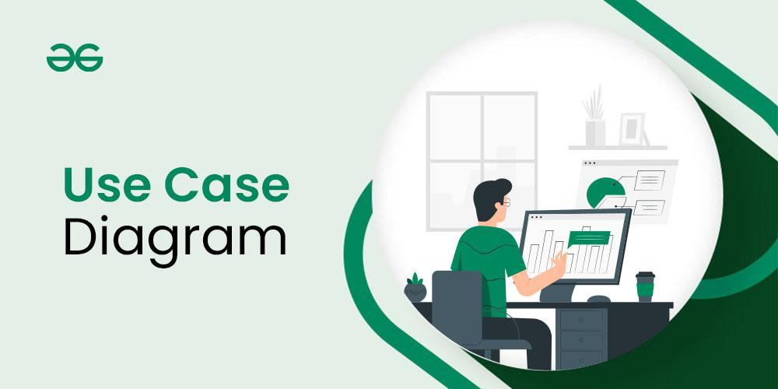

**Table of Content**

* [What is a Use Case Diagram in UML?](https://www.geeksforgeeks.org/system-design/use-case-diagram/#1-what-is-a-use-case-diagram-in-uml)
* [Use Case Diagram Notations](https://www.geeksforgeeks.org/system-design/use-case-diagram/#2use-case-diagram-notations)
* [Use Case Diagram Relationships](https://www.geeksforgeeks.org/system-design/use-case-diagram/#3-use-case-diagram-relationships)
* [How to draw a Use Case diagram in UML?](https://www.geeksforgeeks.org/system-design/use-case-diagram/#4-how-to-draw-a-use-case-diagram-in-uml)
* [Use Case Diagram example(Online Shopping System)](https://www.geeksforgeeks.org/system-design/use-case-diagram/#use-case-diagram-exampleonline-shopping-system)
* [What are common Use Case Diagram Tools and Platforms?](https://www.geeksforgeeks.org/system-design/use-case-diagram/#5-what-are-common-use-case-diagram-tools-and-platforms)
* [What are Common Mistakes while making Use Case Diagram?](https://www.geeksforgeeks.org/system-design/use-case-diagram/#6-what-are-common-mistakes-and-pitfalls-while-making-use-case-diagram)
* [Best Practices for Use Case Diagram](https://www.geeksforgeeks.org/system-design/use-case-diagram/#7-what-can-be-use-case-diagram-best-practices)
* [What is the Purpose and Benefits of Use Case Diagrams?](https://www.geeksforgeeks.org/system-design/use-case-diagram/#8-what-are-the-purpose-and-benefits-of-use-case-diagrams)

**What is a Use Case Diagram in UML?**

A Use Case Diagram is a type of Unified Modeling Language (UML) diagram that represents the interaction between actors (users or external systems) and a system under consideration to accomplish specific goals. It provides a high-level view of the system's functionality by illustrating the various ways users can interact with it.

**When to apply Use Case Diagram?**

Use case diagrams are useful in several situations. Here’s when you should consider using them:

* When you need to gather and clarify user requirements, use case diagrams help visualize how different users interact with the system.
* If you’re working with diverse groups, including non-technical stakeholders, these diagrams provide a clear and simple way to convey system functionality.
* During the system design phase, use case diagrams help outline user interactions and plan features, ensuring that the design aligns with user needs.
* When defining what is included in the system versus what is external, use case diagrams help clarify these boundaries.

**Use Case Diagram Notations**

UML notations provide a visual language that enables software developers, designers, and other stakeholders to communicate and document system designs, architectures, and behaviors in a consistent and understandable manner.

**1. Actors**

Actors are external entities that interact with the system. These can include users, other systems, or hardware devices. In the context of a Use Case Diagram, actors initiate use cases and receive the outcomes. Proper identification and understanding of actors are crucial for accurately modeling system behavior.

**2. Use Cases**

Use cases are like scenes in the play. They represent specific things your system can do. In the online shopping system, examples of use cases could be "Place Order," "Track Delivery," or "Update Product Information".Use cases are represented by ovals.

**3. System Boundary**

The system boundary is a visual representation of the scope or limits of the system you are modeling. It defines what is inside the system and what is outside. The boundary helps to establish a clear distinction between the elements that are part of the system and those that are external to it. The system boundary is typically represented by a rectangular box that surrounds all the use cases of the system.

*The purpose of system boundary is to clearly outlines the boundaries of the system, indicating which components are internal to the system and which are external actors or entities interacting with the system.*

**Use Case Diagram Relationships**

In a Use Case Diagram, relationships play a crucial role in depicting the interactions between actors and use cases. These relationships provide a comprehensive view of the system's functionality and its various scenarios. Let's delve into the key types of relationships and explore examples to illustrate their usage.

**1. Association Relationship**

TheAssociation Relationship represents a communication or interaction between an actor and a use case. It is depicted by a line connecting the actor to the use case. This relationship signifies that the actor is involved in the functionality described by the use case.

***Example: Online Banking System***

* **Actor:** Customer
* **Use Case:** Transfer Funds
* **Association:** A line connecting the "Customer" actor to the "Transfer Funds" use case, indicating the customer's involvement in the funds transfer process.

**2. Include Relationship**

The Include Relationship indicates that a use case includes the functionality of another use case. It is denoted by a dashed arrow pointing from the including use case to the included use case. This relationship promotes modular and reusable design.

***Example: Social Media Posting***

* **Use Cases:** Compose Post, Add Image
* **Include Relationship:** The "Compose Post" use case includes the functionality of "Add Image." Therefore, composing a post includes the action of adding an image.

**3. Extend Relationship**

The Extend Relationship illustrates that a use case can be extended by another use case under specific conditions. It is represented by a dashed arrow with the keyword "extend." This relationship is useful for handling optional or exceptional behavior.

***Example: Flight Booking System***

* **Use Cases:** Book Flight, Select Seat
* **Extend Relationship:** The "Select Seat" use case may extend the "Book Flight" use case when the user wants to choose a specific seat, but it is an optional step.

**4. Generalization Relationship**

The Generalization Relationship establishes an "is-a" connection between two use cases, indicating that one use case is a specialized version of another. It is represented by an arrow pointing from the specialized use case to the general use case.

***Example: Vehicle Rental System***

* **Use Cases:** Rent Car, Rent Bike
* **Generalization Relationship:** Both "Rent Car" and "Rent Bike" are specialized versions of the general use case "Rent Vehicle."

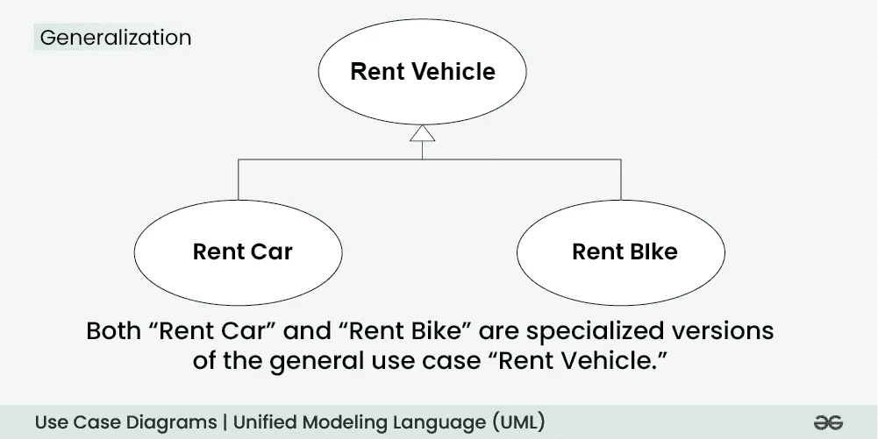Generalization Relationship

**How to draw a Use Case diagram in UML?**

Below are the main steps to draw use case diagram in UML:

* **Step 1: Identify Actors**: Determine who or what interacts with the system. These are your actors. They can be users, other systems, or external entities.
* **Step 2: Identify Use Cases**: Identify the main functionalities or actions the system must perform. These are your use cases. Each use case should represent a specific piece of functionality.
* **Step 3: Connect Actors and Use Cases**: Draw lines (associations) between actors and the use cases they are involved in. This represents the interactions between actors and the system.
* **Step 4: Add System Boundary**: Draw a box around the actors and use cases to represent the system boundary. This defines the scope of your system.
* **Step 5: Define Relationships**: If certain use cases are related or if one use case is an extension of another, you can indicate these relationships with appropriate notations.
* **Step 6: Review and Refine**: Step back and review your diagram. Ensure that it accurately represents the interactions and relationships in your system. Refine as needed.
* **Step 7: Validate**: Share your use case diagram with stakeholders and gather feedback. Ensure that it aligns with their understanding of the system's functionality.

**Use Case Diagram example(Online Shopping System)**

Let's understand how to draw a Use Case diagram with the help of an Online Shopping System:

* **Actors:**
  + Customer
  + Admin
* **Use Cases:**
  + Browse Products
  + Add to Cart
  + Checkout
  + Manage Inventory (Admin)
* **Relations:**
  + The Customer can browse products, add to the cart, and complete the checkout.
  + The Admin can manage the inventory.

**Below is the use case diagram of an Online Shopping System:**

**What are common Use Case Diagram Tools and Platforms?**

Several tools and platforms are available to create and design Use Case Diagrams. These tools offer features that simplify the diagram creation process, facilitate collaboration among team members, and enhance overall efficiency. Here are some popular Use Case Diagram tools and platforms:

* **Lucidchart:**
  + Cloud-based collaborative platform.
  + Real-time collaboration and commenting.
  + Templates for various diagram types.
* **draw.io:**
  + Free, open-source diagramming tool.
  + Works offline and can be integrated with Google Drive, Dropbox, and others.
  + Offers a wide range of diagram types, including Use Case Diagrams.
* **Microsoft Visio:**
  + Part of the Microsoft Office suite.
  + Supports various diagram types, including Use Case Diagrams.
  + Extensive shape libraries and templates.
* **SmartDraw:**
  + User-friendly diagramming tool.
  + Templates for different types of diagrams, including Use Case Diagrams.
  + Integration with Microsoft Office and Google Workspace.
* **PlantUML:**
  + Open-source tool for creating UML diagrams.
  + Text-based syntax for diagram specification.
  + Supports collaborative work using version control systems.

**What are Common Mistakes while making Use Case Diagram?**

Avoiding common mistakes ensures the accuracy and effectiveness of the Use Case Diagram. Here are key points for each mistake:

* Adding too much detail can confuse people.
* Unclear connections lead to misunderstandings about system interactions.
* Different names for the same elements create confusion.
* Incorrectly using generalization can misrepresent relationships.
* Failing to define the system’s limits makes its scope unclear.
* Treating the diagram as static can make it outdated and inaccurate.

**Best Practices for Use Case Diagram**

Crafting clear and effective Use Case Diagrams is essential for conveying system functionality and interactions. Here are some best practices to consider:

* Use Case Diagram focus on capturing the core functions of the system, avoiding extraneous details.
* They uses a uniform naming scheme for use cases and actors throughout the diagram to enhance clarity and prevent misunderstandings.
* They ensure uniformity in the appearance of elements such as ovals (for use cases), stick figures (for actors), and connecting lines to create a polished presentation.
* They help in organizing use cases into coherent groups that represent distinct modules or subsystems within the overall system.
* Use Case Diagrams adopt an iterative method, updating the diagram as the system changes or as new information emerges.

**What is the Purpose and Benefits of Use Case Diagrams?**

The Use Case Diagram offers numerous benefits throughout the system development process. Here are some key advantages of using Use Case Diagrams:

* Use Case Diagrams offer a clear visual representation of a system’s functions and its interactions with external users. This representation helps stakeholders, including those without technical expertise, in grasping the system’s overall behavior.
* They establish a shared language for articulating system requirements, ensuring that all team members have a common understanding.
* Use Case Diagram illustrate the different ways users engage with the system, contributing to a thorough comprehension of its functionalities.
* In the design phase, Use Case Diagrams help outline how users (actors) will interact with the system. They support the planning of user interfaces and aid in structuring system functionalities.

**Conclusion**

In conclusion, a Use Case Diagram in UML serves as a powerful tool for capturing and visualizing the functional requirements and interactions within a system. By representing actors, use cases, and their relationships in a clear and concise manner, this diagram provides a high-level overview of the system's behavior.

**Unified Modeling Language (UML) Diagrams**

Last Updated : 28 Aug, 2025

Unified Modeling Language (UML) is a general-purpose modeling language. The main aim of UML is to define a standard way to visualize the way a system has been designed. It is quite similar to blueprints used in other fields of engineering. UML is not a programming language, it is rather a visual language.

* We use UML diagrams to show thebehavior and structure of a system.
* UML helps software engineers, businessmen, and system architects with modeling, design, and analysis.
* The International Organization for Standardization (ISO) published UML as an approved standard in 2005. UML has been revised over the years and is reviewed periodically.

**Why do we need UML?**

* Complex applications need collaboration and planning from multiple teams and hence require a clear and concise way to communicate amongst them.
* Businessmen do not understand code. So UML becomes essential to communicate with non-programmers about essential requirements, functionalities, and processes of the system.
* A lot of time is saved down the line when teams can visualize processes, user interactions, and the static structure of the system.

**Types of UML Diagrams**

UML is linked with object-oriented design and analysis. UML makes use of elements and forms associations between them to form diagrams. Diagrams in UML can be broadly classified as:

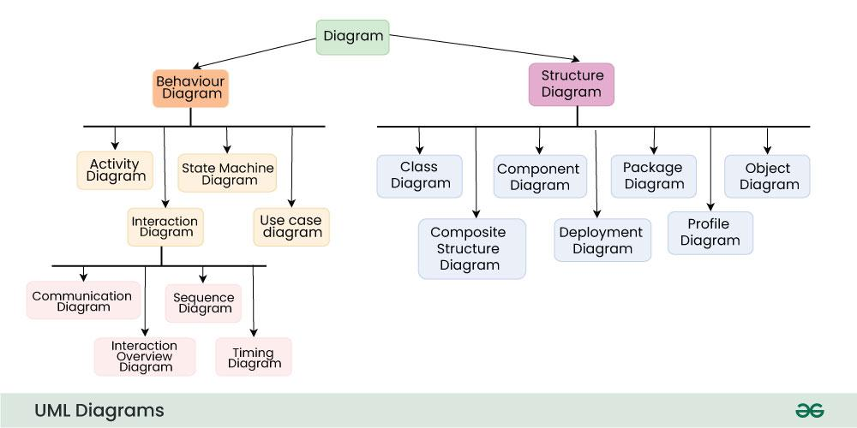

**Structural UML Diagrams**

[Structural UML diagrams](https://www.geeksforgeeks.org/system-design/structural-diagrams-unified-modeling-languageuml/) are visual representations that depict the static aspects of a system, including its classes, objects, components, and their relationships, providing a clear view of the system's architecture. Structural UML diagrams include the following types:

[**Class Diagram**](https://www.geeksforgeeks.org/system-design/unified-modeling-language-uml-class-diagrams/)

The most widely use UML diagram is the class diagram. It is the building block of all object oriented software systems. We use class diagrams to depict the static structure of a system by showing system's classes, their methods and attributes. Class diagrams also help us identify relationship between different classes or objects.

Class Diagram

**Composite Structure Diagram**

We use composite structure diagrams to represent the internal structure of a class and its interaction points with other parts of the system.

* A composite structure diagram represents relationship between parts and their configuration which determine how the classifier (class, a component, or a deployment node) behaves.
* They represent internal structure of a structured classifier making the use of parts, ports, and connectors.
* We can also model collaborations using composite structure diagrams.
* They are similar to class diagrams except they represent individual parts in detail as compared to the entire class.

[**Object Diagram**](https://www.geeksforgeeks.org/system-design/unified-modeling-language-uml-object-diagrams/)

An Object Diagram can be referred to as a screenshot of the instances in a system and the relationship that exists between them. Since object diagrams depict behaviour when objects have been instantiated, we are able to study the behaviour of the system at a particular instant.

* An object diagram is similar to a class diagram except it shows the instances of classes in the system.
* We depict actual classifiers and their relationships making the use of class diagrams.
* On the other hand, an Object Diagram represents specific instances of classes and relationships between them at a point of time.

Object Diagram

[**Component Diagram**](https://www.geeksforgeeks.org/software-engineering/component-based-diagram/)

Component diagrams are used to represent how the physical components in a system have been organized. We use them for modelling implementation details.

* Component Diagrams depict the structural relationship between software system elements and help us in understanding if functional requirements have been covered by planned development.
* Component Diagrams become essential to use when we design and build complex systems.
* Interfaces are used by components of the system to communicate with each other.

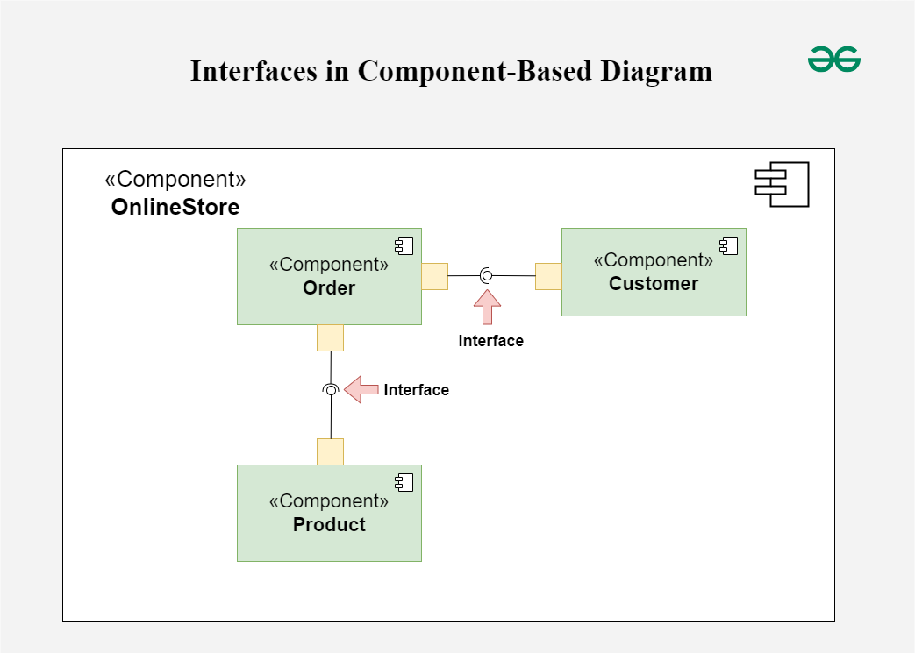Component Diagram

[**Deployment Diagram**](https://www.geeksforgeeks.org/system-design/deployment-diagram-unified-modeling-languageuml/)

Deployment Diagrams are used to represent system hardware and its software. It tells us what hardware components exist and what software components run on them.

* We illustrate system architecture as distribution of software artifacts over distributed targets.
* An artifact is the information that is generated by system software.
* They are primarily used when a software is being used, distributed or deployed over multiple machines with different configurations.

Deployement Diagram

[**Package Diagram**](https://www.geeksforgeeks.org/system-design/package-diagram-introduction-elements-use-cases-and-benefits/)

We use Package Diagrams to depict how packages and their elements have been organized. A package diagram simply shows us the dependencies between different packages and internal composition of packages.

* Packages help us to organise UML diagrams into meaningful groups and make the diagram easy to understand.
* They are primarily used to organise class and use case diagrams.

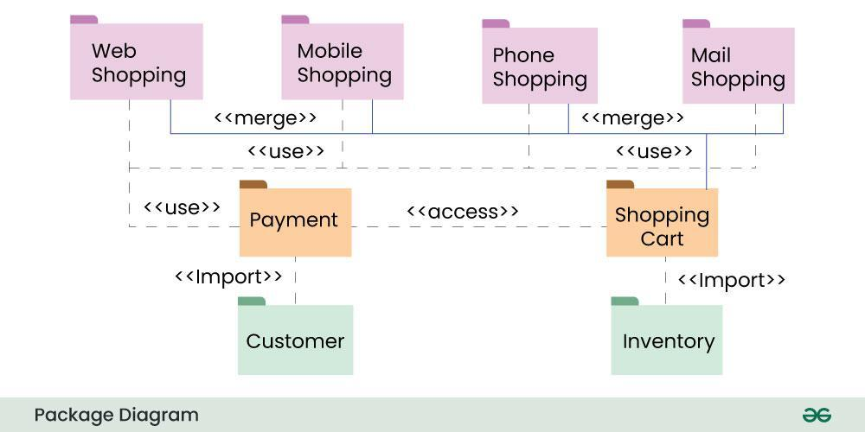Package Diagram

**Behavioral UML Diagrams**

[Behavioral UML diagrams](https://www.geeksforgeeks.org/system-design/behavior-diagrams-unified-modeling-languageuml/)are visual representations that depict the dynamic aspects of a system, illustrating how objects interact and behave over time in response to events.

[**State Machine Diagrams**](https://www.geeksforgeeks.org/system-design/unified-modeling-language-uml-state-diagrams/)

A state diagram is used to represent the condition of the system or part of the system at finite instances of time. It’s a behavioral diagram and it represents the behavior using finite state transitions.

* State diagrams are also referred to as **State machines**and **State-chart Diagrams**
* These terms are often used interchangeably. So simply, a state diagram is used to model the dynamic behavior of a class in response to time and changing external stimuli.

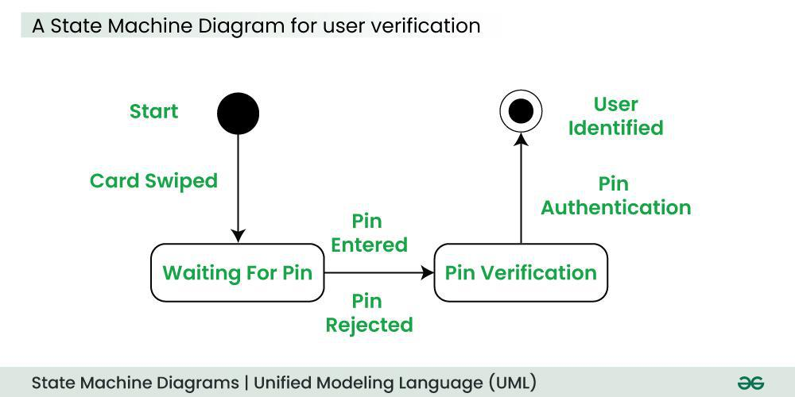State Machine Diagram

[**Activity Diagrams**](https://www.geeksforgeeks.org/system-design/unified-modeling-language-uml-activity-diagrams/)

We use Activity Diagrams to illustrate the flow of control in a system. We can also use an activity diagram to refer to the steps involved in the execution of a use case.

* We model sequential and concurrent activities using activity diagrams. So, we basically depict workflows visually using an activity diagram.
* An activity diagram focuses on condition of flow and the sequence in which it happens.
* We describe or depict what causes a particular event using an activity diagram.

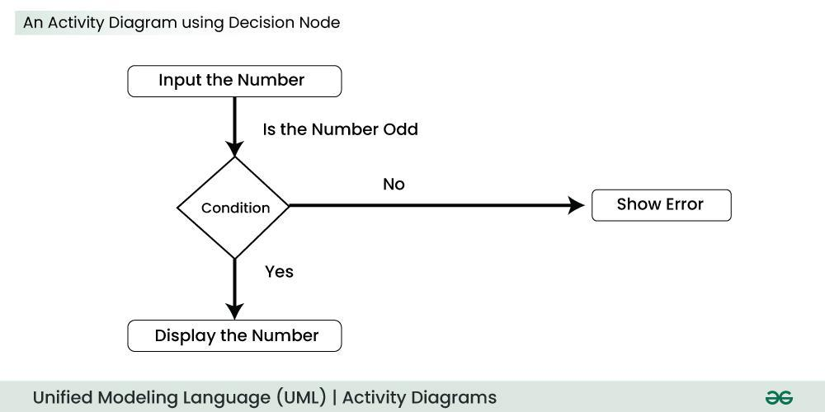Activity Diagram

[**Use Case Diagrams**](https://www.geeksforgeeks.org/system-design/use-case-diagram/)

Use Case Diagrams are used to depict the functionality of a system or a part of a system. They are widely used to illustrate the functional requirements of the system and its interaction with external agents(actors).

* A use case is basically a diagram representing different scenarios where the system can be used.
* A use case diagram gives us a high level view of what the system or a part of the system does without going into implementation details. '

[**Sequence Diagram**](https://www.geeksforgeeks.org/system-design/unified-modeling-language-uml-sequence-diagrams/)

A sequence diagram simply depicts interaction between objects in a sequential order i.e. the order in which these interactions take place.

* We can also use the terms event diagrams or event scenarios to refer to a sequence diagram.
* Sequence diagrams describe how and in what order the objects in a system function.
* These diagrams are widely used by businessmen and software developers to document and understand requirements for new and existing systems.

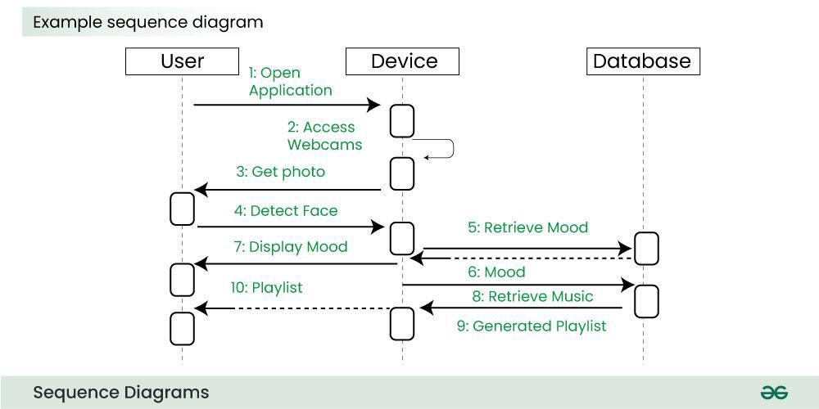Sequence Diagram

**Communication Diagram**

A Communication Diagram (known as Collaboration Diagram in UML 1.x) is used to show sequenced messages exchanged between objects.

* A communication diagram focuses primarily on objects and their relationships.
* We can represent similar information using Sequence diagrams, however communication diagrams represent objects and links in a free form.

Communication Diagram

**Timing Diagram**

Timing Diagram are a special form of Sequence diagrams which are used to depict the behavior of objects over a time frame. We use them to show time and duration constraints which govern changes in states and behavior of objects.

[**Interaction Overview Diagram**](https://www.geeksforgeeks.org/system-design/interaction-overview-diagrams-unified-modeling-language-uml/)

An Interaction Overview Diagram (IOD) is a type of UML (Unified Modeling Language) diagram that illustrates the flow of interactions between various elements in a system or process. It provides a high-level overview of how interactions occur, including the sequence of actions, decisions, and interactions between different components or objects.

Interaction Overview Diagram

**6.1. Additions in UML 2.0**

* Software development methodologies like agile have been incorporated and scope of original UML specification has been broadened.
* Originally UML specified 9 diagrams. UML 2.x has increased the number of diagrams from 9 to 13. The four diagrams that were added are : timing diagram, communication diagram, interaction overview diagram and composite structure diagram. UML 2.x renamed statechart diagrams to state machine diagrams.
* UML 2.x added the ability to decompose software system into components and sub-components.

**Tools for creating UML Diagrams**

There are several tools available for creating Unified Modeling Language (UML) diagrams, which are commonly used in software development to visually represent system architecture, design, and implementation. Here are some popular UML diagram creating tools:

* **Lucidchart:**Lucidchart is a web-based diagramming tool that supports UML diagrams. It's user-friendly and collaborative, allowing multiple users to work on diagrams in real-time.
* **Draw.io:**Draw.io is a free, web-based diagramming tool that supports various diagram types, including UML. It integrates with various cloud storage services and can be used offline.
* **Visual Paradigm:**Visual Paradigm provides a comprehensive suite of tools for software development, including UML diagramming. It offers both online and desktop versions and supports a wide range of UML diagrams.
* **StarUML:**StarUML is an open-source UML modeling tool with a user-friendly interface. It supports the standard UML 2.x diagrams and allows users to customize and extend its functionality through plugins.

**Requirements Engineering** is the process of identifying, eliciting, analyzing, specifying, validating, and managing the needs and expectations of stakeholders for a software system.

**Table of Content**

* [What is Requirements Engineering?](https://www.geeksforgeeks.org/software-engineering/software-engineering-requirements-engineering-process/#what-is-requirements-engineering)
* [Requirements Engineering Process](https://www.geeksforgeeks.org/software-engineering/software-engineering-requirements-engineering-process/#requirements-engineering-process)
* [Tools Involved in Requirement Engineering](https://www.geeksforgeeks.org/software-engineering/software-engineering-requirements-engineering-process/#tools-involved-in-requirement-engineering)
* [Advantages of Requirements Engineering Process](https://www.geeksforgeeks.org/software-engineering/software-engineering-requirements-engineering-process/#advantages-of-requirements-engineering-process)
* [Disadvantages of Requirements Engineering Process](https://www.geeksforgeeks.org/software-engineering/software-engineering-requirements-engineering-process/#disadvantages-of-requirements-engineering-process)
* [Stages in Software Engineering Process](https://www.geeksforgeeks.org/software-engineering/software-engineering-requirements-engineering-process/#stages-in-software-engineering-process)
* [Conclusion](https://www.geeksforgeeks.org/software-engineering/software-engineering-requirements-engineering-process/#conclusion)

In this article, we'll learn about its process, advantages, and disadvantages.

**What is Requirements Engineering?**

A systematic and strict approach to the definition, creation, and verification of requirements for a software system is known as requirements engineering. To guarantee the effective creation of a software product, the requirements engineering process entails several tasks that help in understanding, recording, and managing the demands of stakeholders.

**Requirements Engineering Process**

Requirements Engineering Process

1. **Feasibility Study**
2. **Requirements elicitation**
3. **Requirements specification**
4. **Requirements for verification and validation**
5. **Requirements management**

**1. Feasibility Study**

The feasibility study mainly concentrates on below five mentioned areas below. Among these Economic Feasibility Study is the most important part of the feasibility analysis and the Legal Feasibility Study is less considered feasibility analysis.

1. **Technical Feasibility**: In Technical Feasibility current resources both hardware software along required technology are analyzed/assessed to develop the project. This technical feasibility study reports whether there are correct required resources and technologies that will be used for project development. Along with this, the feasibility study also analyzes the technical skills and capabilities of the technical team, whether existing technology can be used or not, whether maintenance and up-gradation are easy or not for the chosen technology, etc.
2. **Operational Feasibility:**In Operational Feasibility degree of providing service to requirements is analyzed along with how easy the product will be to operate and maintain after deployment. Along with this other operational scopes are determining the usability of the product, Determining suggested solution by the software development team is acceptable or not, etc.
3. **Economic Feasibility:**In the Economic Feasibility study cost and benefit of the project are analyzed. This means under this feasibility study a detailed analysis is carried out will be cost of the project for development which includes all required costs for final development hardware and software resources required, design and development costs operational costs, and so on. After that, it is analyzed whether the project will be beneficial in terms of finance for the organization or not.
4. **Legal Feasibility:**In legal feasibility, the project is ensured to comply with all relevant laws, regulations, and standards. It identifies any legal constraints that could impact the project and reviews existing contracts and agreements to assess their effect on the project's execution. Additionally, legal feasibility considers issues related to intellectual property, such as patents and copyrights, to safeguard the project's innovation and originality.
5. **Schedule Feasibility:**In schedule feasibility, the project timeline is evaluated to determine if it is realistic and achievable. Significant milestones are identified, and deadlines are established to track progress effectively. Resource availability is assessed to ensure that the necessary resources are accessible to meet the project schedule. Furthermore, any time constraints that might affect project delivery are considered to ensure timely completion. This focus on schedule feasibility is crucial for the successful planning and execution of a project.

**2. Requirements Elicitation**

It is related to the various ways used to gain knowledge about the project domain and requirements. The various sources of domain knowledge include customers, business manuals, the existing software of the same type, standards, and other stakeholders of the project. The techniques used for requirements elicitation include interviews, brainstorming, task analysis, Delphi technique, prototyping, etc. Some of these are discussed [here.](https://www.geeksforgeeks.org/software-engineering/software-engineering-requirements-elicitation/) Elicitation does not produce formal models of the requirements understood. Instead, it widens the domain knowledge of the analyst and thus helps in providing input to the next stage.

Requirements elicitation is the process of gathering information about the needs and expectations of stakeholders for a software system. This is the first step in the requirements engineering process and it is critical to the success of the software development project. The goal of this step is to understand the problem that the software system is intended to solve and the needs and expectations of the stakeholders who will use the system.

Several techniques can be used to elicit requirements, including:

* **Interviews**: These are one-on-one conversations with stakeholders to gather information about their needs and expectations.
* **Surveys**: These are questionnaires that are distributed to stakeholders to gather information about their needs and expectations.
* **Focus Groups**: These are small groups of stakeholders who are brought together to discuss their needs and expectations for the software system.
* **Observation**: This technique involves observing the stakeholders in their work environment to gather information about their needs and expectations.
* **Prototyping**: This technique involves creating a working model of the software system, which can be used to gather feedback from stakeholders and to validate requirements.

It's important to document, organize, and prioritize the requirements obtained from all these techniques to ensure that they are complete, consistent, and accurate.

**3. Requirements Specification**

This activity is used to produce formal software requirement models. All the requirements including the functional as well as the non-functional requirements and the constraints are specified by these models in totality. During specification, more knowledge about the problem may be required which can again trigger the elicitation process. The models used at this stage include ER diagrams, data flow diagrams(DFDs), function decomposition diagrams(FDDs), data dictionaries, etc.

Requirements specification is the process of documenting the requirements identified in the analysis step in a clear, consistent, and unambiguous manner. This step also involves prioritizing and grouping the requirements into manageable chunks.

The goal of this step is to create a clear and comprehensive document that describes the requirements for the software system. This document should be understandable by both the development team and the stakeholders.

**Several types of requirements are commonly specified in this step, including**

1. [**Functional Requirements**](https://www.geeksforgeeks.org/software-engineering/functional-vs-non-functional-requirements/)**:** These describe what the software system should do. They specify the functionality that the system must provide, such as input validation, data storage, and user interface.
2. [**Non-Functional Requirements**:](https://www.geeksforgeeks.org/software-engineering/non-functional-requirements-in-software-engineering/) These describe how well the software system should do it. They specify the quality attributes of the system, such as performance, reliability, usability, and security.
3. **Constraints:**These describe any limitations or restrictions that must be considered when developing the software system.
4. **Acceptance Criteria**: These describe the conditions that must be met for the software system to be considered complete and ready for release.

To make the requirements specification clear, the requirements should be written in a natural language and use simple terms, avoiding technical jargon, and using a consistent format throughout the document. It is also important to use diagrams, models, and other visual aids to help communicate the requirements effectively.

Once the requirements are specified, they must be reviewed and validated by the stakeholders and development team to ensure that they are complete, consistent, and accurate.

**4. Requirements Verification and Validation**

**Verification:** It refers to the set of tasks that ensures that the software correctly implements a specific function.

**Validation:** It refers to a different set of tasks that ensures that the software that has been built is traceable to customer requirements. If requirements are not validated, errors in the requirement definitions would propagate to the successive stages resulting in a lot of modification and rework. The main steps for this process include:

1. The requirements should be consistent with all the other requirements i.e. no two requirements should conflict with each other.
2. The requirements should be complete in every sense.
3. The requirements should be practically achievable.

Reviews, buddy checks, making test cases, etc. are some of the methods used for this.

Requirements verification and validation (V&V) is the process of checking that the requirements for a software system are complete, consistent, and accurate and that they meet the needs and expectations of the stakeholders. The goal of V&V is to ensure that the software system being developed meets the requirements and that it is developed on time, within budget, and to the required quality.

1. Verification is checking that the requirements are complete, consistent, and accurate. It involves reviewing the requirements to ensure that they are clear, testable, and free of errors and inconsistencies. This can include reviewing the requirements document, models, and diagrams, and holding meetings and walkthroughs with stakeholders.
2. Validation is the process of checking that the requirements meet the needs and expectations of the stakeholders. It involves testing the requirements to ensure that they are valid and that the software system being developed will meet the needs of the stakeholders. This can include testing the software system through simulation, testing with prototypes, and testing with the final version of the software.
3. Verification and Validation is an iterative process that occurs throughout the software development life cycle. It is important to involve stakeholders and the development team in the V&V process to ensure that the requirements are thoroughly reviewed and tested.

It's important to note that V&V is not a one-time process, but it should be integrated and continue throughout the software development process and even in the maintenance stage.

**5. Requirements Management**

Requirement management is the process of analyzing, documenting, tracking, prioritizing, and agreeing on the requirement and controlling the communication with relevant stakeholders. This stage takes care of the changing nature of requirements. It should be ensured that the SRS is as modifiable as possible to incorporate changes in requirements specified by the end users at later stages too. Modifying the software as per requirements in a systematic and controlled manner is an extremely important part of the requirements engineering process.

Requirements management is the process of managing the requirements throughout the software development life cycle, including tracking and controlling changes, and ensuring that the requirements are still valid and relevant. The goal of requirements management is to ensure that the software system being developed meets the needs and expectations of the stakeholders and that it is developed on time, within budget, and to the required quality.

Several key activities are involved in requirements management, including:

1. **Tracking and controlling changes:** This involves monitoring and controlling changes to the requirements throughout the development process, including identifying the source of the change, assessing the impact of the change, and approving or rejecting the change.
2. **Version control**: This involves keeping track of different versions of the requirements document and other related artifacts.
3. **Traceability**: This involves linking the requirements to other elements of the development process, such as design, testing, and validation.
4. **Communication:**This involves ensuring that the requirements are communicated effectively to all stakeholders and that any changes or issues are addressed promptly.
5. **Monitoring and reporting**: This involves monitoring the progress of the development process and reporting on the status of the requirements.

Requirements management is a critical step in the software development life cycle as it helps to ensure that the software system being developed meets the needs and expectations of stakeholders and that it is developed on time, within budget, and to the required quality. It also helps to prevent scope creep and to ensure that the requirements are aligned with the project goals.

**Tools Involved in Requirement Engineering**

* Observation report
* Questionnaire ( survey, poll )
* Use cases
* User stories
* Requirement workshop
* Mind mapping
* Roleplaying
* Prototyping

**Advantages of Requirements Engineering Process**

* Helps ensure that the software being developed meets the needs and expectations of the stakeholders
* Can help identify potential issues or problems early in the development process, allowing for adjustments to be made before significant
* Helps ensure that the software is developed in a cost-effective and efficient manner
* Can improve communication and collaboration between the development team and stakeholders
* Helps to ensure that the software system meets the needs of all stakeholders.
* Provides an unambiguous description of the requirements, which helps to reduce misunderstandings and errors.
* Helps to identify potential conflicts and contradictions in the requirements, which can be resolved before the software development process begins.
* Helps to ensure that the software system is delivered on time, within budget, and to the required quality standards.
* Provides a solid foundation for the development process, which helps to reduce the risk of failure.

**Disadvantages of Requirements Engineering Process**

* Can be time-consuming and costly, particularly if the requirements-gathering process is not well-managed
* Can be difficult to ensure that all stakeholders' needs and expectations are taken into account
* It Can be challenging to ensure that the requirements are clear, consistent, and complete
* Changes in requirements can lead to delays and increased costs in the development process.
* As a best practice, Requirements engineering should be flexible, adaptable, and should be aligned with the overall project goals.
* It can be time-consuming and expensive, especially if the requirements are complex.
* It can be difficult to elicit requirements from stakeholders who have different needs and priorities.
* Requirements may change over time, which can result in delays and additional costs.
* There may be conflicts between stakeholders, which can be difficult to resolve.
* It may be challenging to ensure that all stakeholders understand and agree on the requirements.

**Stages in Software Engineering Process**

Requirements engineering is a critical process in software engineering that involves identifying, analyzing, documenting, and managing the requirements of a software system. The requirements engineering process consists of the following stages:

* **Elicitation:**In this stage, the requirements are gathered from various stakeholders such as customers, users, and domain experts. The aim is to identify the features and functionalities that the software system should provide.
* **Analysis:** In this stage, the requirements are analyzed to determine their feasibility, consistency, and completeness. The aim is to identify any conflicts or contradictions in the requirements and resolve them.
* **Specification:**In this stage, the requirements are documented in a clear, concise, and unambiguous manner. The aim is to provide a detailed description of the requirements that can be understood by all stakeholders.
* **Validation:** In this stage, the requirements are reviewed and validated to ensure that they meet the needs of all stakeholders. The aim is to ensure that the requirements are accurate, complete, and consistent.
* **Management:**In this stage, the requirements are managed throughout the software development lifecycle. The aim is to ensure that any changes or updates to the requirements are properly documented and communicated to all stakeholders.
* Effective requirements engineering is crucial to the success of software development projects. It helps ensure that the software system meets the needs of all stakeholders and is delivered on time, within budget, and to the required quality standards.

**Conclusion**

As the project develops and new information becomes available, the iterative requirements engineering process may involve going back and reviewing earlier phases. Throughout the process, stakeholders in the project must effectively communicate and collaborate to guarantee that the software system satisfies user needs and is in line with the company's overall goals.

**Requirements Validation Techniques - Software Engineering**

Last Updated : 11 Jul, 2025

Requirements validation techniques are essential processes used to ensure that software requirements are complete, consistent, and accurately reflect what the customer wants. These techniques help identify and fix issues early in the development process, reducing the risk of costly errors later on. By thoroughly validating requirements, teams can ensure that the final product meets user needs and expectations. This article focuses on discussing the requirement validation technique in detail.

**Table of Content**

* [What is Traceability?](https://www.geeksforgeeks.org/software-engineering/software-engineering-requirements-validation-techniques/#what-is-traceability)
* [What are Agile Methodologies?](https://www.geeksforgeeks.org/software-engineering/software-engineering-requirements-validation-techniques/#what-are-agile-methodologies)
* [What is Requirements Validation?](https://www.geeksforgeeks.org/software-engineering/software-engineering-requirements-validation-techniques/#what-is-requirements-validation)
* [Requirement Validation Techniques](https://www.geeksforgeeks.org/software-engineering/software-engineering-requirements-validation-techniques/#requirement-validation-techniques)
* [Importance of Requirements Validation Techniques](https://www.geeksforgeeks.org/software-engineering/software-engineering-requirements-validation-techniques/#importance-of-requirements-validation-techniques)
* [Advantages of Requirements Validation Techniques](https://www.geeksforgeeks.org/software-engineering/software-engineering-requirements-validation-techniques/#advantages-of-requirements-validation-techniques)
* [Disadvantages of Requirements Validation Techniques](https://www.geeksforgeeks.org/software-engineering/software-engineering-requirements-validation-techniques/#disadvantages-of-requirements-validation-techniques)
* [Questions For Practice](https://www.geeksforgeeks.org/software-engineering/software-engineering-requirements-validation-techniques/#questions-for-practice)
* [Conclusion](https://www.geeksforgeeks.org/software-engineering/software-engineering-requirements-validation-techniques/#conclusion)
* [Frequently Asked Questions on Requirements Validation Techniques - FAQ's](https://www.geeksforgeeks.org/software-engineering/software-engineering-requirements-validation-techniques/#frequently-asked-questions-on-requirements-validation-techniques-faqs)

**What is Traceability?**

The [traceability](https://www.geeksforgeeks.org/software-engineering/traceability-and-its-types/) technique involves tracing the requirements throughout the entire software development life cycle to ensure that they are being met and that any changes are tracked and managed.

**What are Agile Methodologies?**

[Agile Methodologies](https://www.geeksforgeeks.org/software-engineering/software-engineering-agile-software-development/) such as Scrum and Kanban, provide an iterative approach to validate requirements by delivering small chunks of functionality and getting feedback from the customer.

It is important to note that no single technique is sufficient on its own and a combination of different techniques is usually used to validate software requirements effectively.

**What is Requirements Validation?**

**Requirements validation** is the process of checking that requirements defined for development, define the system that the customer wants. To check issues related to requirements, we perform requirements validation. We typically use requirements validation to check errors at the initial phase of development as the error may increase excessive rework when detected later in the development process. In the requirements validation process, we perform a different type of test to check the requirements mentioned in the [Software Requirements Specification (SRS)](https://www.geeksforgeeks.org/software-engineering/software-engineering-quality-characteristics-of-a-good-srs/), these checks include:

1. **Completeness checks**
2. **Consistency checks**
3. **Validity checks**
4. **Realism checks**
5. **Ambiguity checks**
6. **Variability**

The output of requirements validation is the list of problems and agreed-on actions of detected problems. The lists of problems indicate the problem detected during the process of requirement validation. The list of agreed actions states the corrective action that should be taken to fix the detected problem.

**Requirement Validation Techniques**

There are several techniques that are used either individually or in conjunction with other techniques to check entire or part of the system:

1. Test Case Generation
2. [Prototyping](https://www.geeksforgeeks.org/software-engineering/what-is-a-prototype-and-how-to-create-it/)
3. [Requirements Reviews](https://www.geeksforgeeks.org/software-engineering/requirement-reviews-in-software-development/)
4. Automated Consistency Analysis
5. [Walk-through](https://www.geeksforgeeks.org/software-engineering/walkthrough-in-software-engineering/)
6. Simulation
7. Checklists for Validation

**1. Test Case Generation**

The requirement mentioned in the SRS document should be testable, the conducted tests reveal the error present in the requirement. It is generally believed that if the test is difficult or impossible to design, this usually means that the requirement will be difficult to implement and it should be reconsidered.

**2. Prototyping**

In this validation technique the prototype of the system is presented before the end-user or customer, they experiment with the presented model and check if it meets their need. This type of model is mostly used to collect feedback about the requirement of the user.

**3. Requirements Reviews**

In this approach, the SRS is carefully reviewed by a group of people including people from both the contractor organizations and the client side, the reviewer systematically analyses the document to check errors and ambiguity.

**4. Automated Consistency Analysis**

This approach is used for the automatic detection of an error, such as non-determinism, missing cases, a type error, and circular definitions, in requirements specifications. First, the requirement is structured in formal notation then the CASE tool is used to check the in-consistency of the system, The report of all inconsistencies is identified, and corrective actions are taken.

**5. Walk-through**

A walkthrough does not have a formally defined procedure and does not require a differentiated role assignment.

* Checking early whether the idea is feasible or not.
* Obtaining the opinions and suggestions of other people.
* Checking the approval of others and reaching an agreement.

**6. Simulation**

Simulating system behavior in order to verify requirements is known as simulation. This method works especially well for complicated systems when it is possible to replicate real-world settings and make sure the criteria fulfil the desired goals.

**7. Checklists for Validation**

It employs pre-made checklists to methodically confirm that every prerequisite satisfies predetermined standards. Aspects like completeness, clarity and viability can all be covered by checklists.

**Importance of Requirements Validation Techniques**

1. **Accuracy and Clarity:** It makes sure that the requirements are precise, unambiguous and clear. This helps to avoid miscommunications and misunderstandings that may result in mistakes and more effort in subsequent phases of the project.
2. **User Satisfaction:**It confirms that the requirements meet the wants and expectations of the users, which helps to increase user happiness. This aids in providing a product that satisfies consumer needs and improves user experience as a whole.
3. **Early Issue Identification:** It makes it easier to find problems, ambiguities or conflicts in the requirements early on. It is more economical to address these issues early in the development phase rather than later, when the project is far along.
4. **Prevents the Scope Creep:**It ensures that the established requirements are well stated and recorded, which helps to prevent scope creep. By establishing defined parameters for the project's scope, requirements validation helps to lower the possibility of uncontrollably changing course.
5. **Improving Quality:** It enhances the software product's overall quality. By detecting and resolving possible quality problems early in the development life cycle, requirements validation contributes to the creation of a more durable and dependable final product.

**Advantages of Requirements Validation Techniques**

1. **Improved quality of the final product:**By identifying and addressing requirements early on in the development process, using validation techniques can improve the overall quality of the final product.
2. **Reduced development time and cost:** By identifying and addressing requirements early on in the development process, using validation techniques can reduce the likelihood of costly rework later on.
3. **Increased user involvement:**Involving users in the validation process can lead to increased user buy-in and engagement in the project.
4. **Improved communication:** Using validation techniques can improve communication between stakeholders and developers, by providing a clear and visual representation of the software requirements.
5. **Easy testing and validation:** A prototype can be easily tested and validated, allowing stakeholders to see how the final product will work and identify any issues early on in the development process.
6. **Increased alignment with business goals:** Using validation techniques can help to ensure that the requirements align with the overall business goals and objectives of the organization.
7. **Traceability:** This technique can help to ensure that the requirements are being met and that any changes are tracked and managed.
8. **Agile methodologies:**Agile methodologies provide an iterative approach to validate requirements by delivering small chunks of functionality and getting feedback from the customer.

**Disadvantages of Requirements Validation Techniques**

1. **Increased time and cost:** Using validation techniques can be time-consuming and costly, especially when involving multiple stakeholders.
2. **Risk of conflicting requirements:** Using validation techniques can lead to conflicting requirements, which can make it difficult to prioritize and implement the requirements.
3. **Risk of changing requirements:**Requirements may change over time and it can be difficult to keep up with the changes and ensure that the project is aligned with the updated requirements.
4. **Misinterpretation and miscommunication:** Misinterpretation and miscommunication can occur when trying to understand the requirements.
5. **Dependence on the tool:** The team should be well-trained on the tool and its features to avoid dependency on the tool and not on the requirement.
6. **Limited validation:** The validation techniques can only check the requirement that is captured and may not identify the requirement that is missed
7. **Limited to functional requirements:** Some validation techniques are limited to functional requirements and may not validate non-functional requirements.

**Questions For Practice**

**1. Match the following in Software Engineering [**[UGC-NET 2018](https://www.geeksforgeeks.org/questions/match-the-following-in-software-engineering-list-i/)**].**

| **List - 1** | **List - 2** |
| --- | --- |
| (i) Product Complexity | (A) Software Requirements Definition |
| (ii) Structured System Analysis | (B) Software Design |
| (iii) Coupling and Cohesion | (C) Validation Technique |
| (iv) Symbolic Execution | (D) Software Cost Estimation |

**(A)** i - (B), ii - (C), iii - (D), iv - (A)

**(B)** i - (C), ii - (A), iii - (D), iv - (B)

**(C)** i - (D), ii - (A), iii - (B), iv - (C)

**(D)** i - (C), ii - (D), iii - (A), iv - (B)

**Solution:** Correct Answer is **(C).**

**2. Which is not a Requirement Validation Technique?**

**(A)**Reviews and Inspections

**(B)**Prototyping

**(C)**Requirement Traceability Matrix (RTM)

**(D)**Agile Development

**Solution:** Correct Answer is **(D).**

**Conclusion**

Requirements validation techniques are crucial for developing high-quality software. They help verify that all requirements are clear, feasible, and aligned with user needs, thereby preventing misunderstandings and reducing rework. By employing various validation methods such as test case generation, prototyping, reviews, automated consistency analysis, and walk-throughs, teams can improve communication, enhance user satisfaction, and ensure the final product aligns with business goals.

**Requirement Validation: Benefits & Best Practices**

Last Updated: July 17, 2024

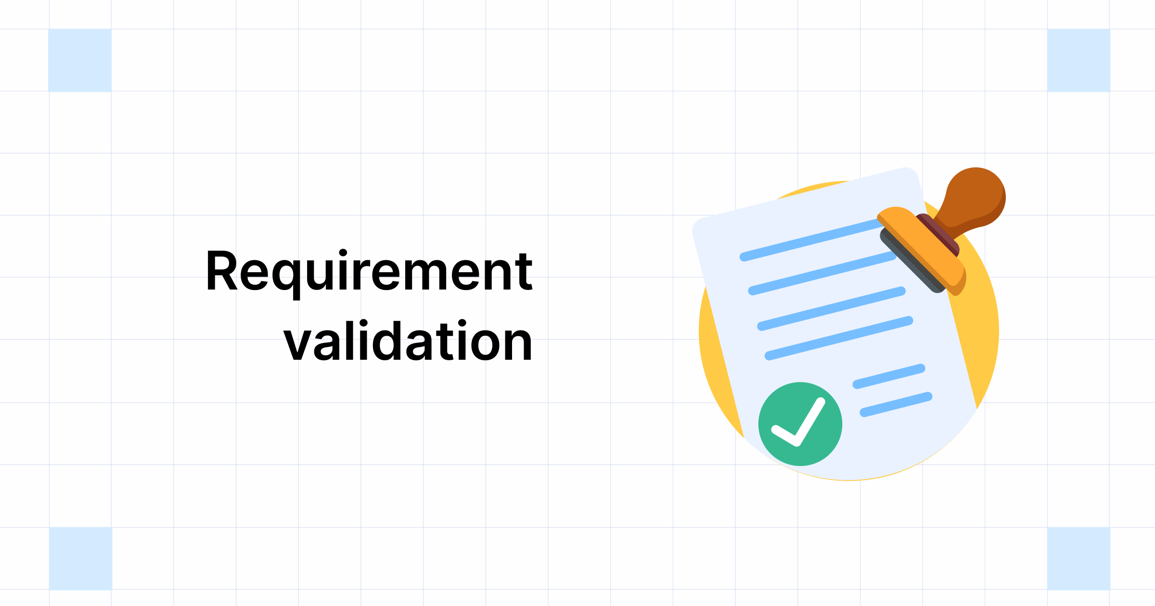

Making sure that software projects are successful is of utmost importance. One critical step in achieving this is **requirement validation.** This means carefully checking that the requirements for the project are accurate, complete, and consistent.

By doing so, we can ensure that the stakeholders’ expectations and the project’s goals are met. Validating requirements is essential because it helps us identify potential problems early on, which can save time and money later on.

Let’s look at what else is being discussed in this blog!

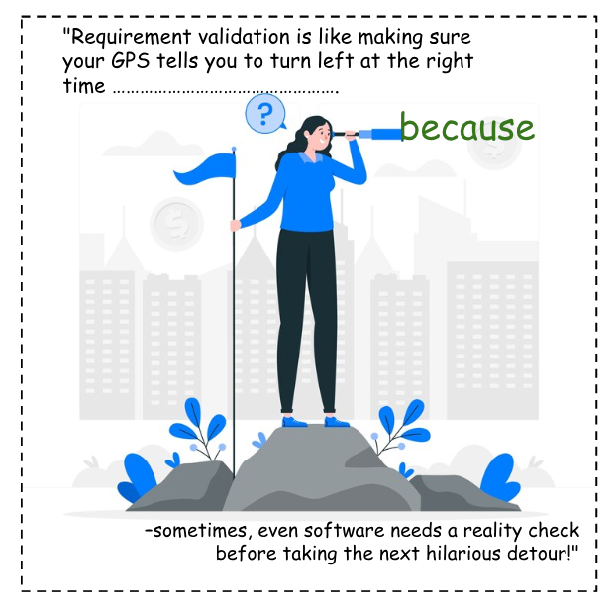

**What is Requirement Validation**

Requirement validation is the process of checking and confirming that the requirements defined for development accurately capture the needs and expectations of the stakeholders.

So now you know it’s a systematic approach ensuring the requirements are clear, unambiguous, verifiable, and achievable. Let us look into an example.

Say, a stakeholder wants an e-commerce platform that allows customers to search for and purchase products quickly. If the requirement is not validated properly, the development team may create a difficult-to-navigate platform or lack critical features.

By validating the requirements, the development team can ensure that the platform meets the stakeholder’s needs and expectations, resulting in a successful product.

**What Are the Benefits of Requirement Validation?**

Requirement validation offers a multitude of benefits to the software development process:

* **Improved software quality**: By identifying and rectifying errors early on, requirement validation reduces the likelihood of defects and bugs in the final product, leading to higher [**software quality**](https://testsigma.com/blog/software-quality-management/).

**Further improve your software quality with automated testing, with Testsigma**

[**Checkout how**](https://testsigma.com/signup)

* **Enhanced stakeholder satisfaction**: By ensuring that the requirements align with the stakeholders’ expectations, requirement validation enhances stakeholder satisfaction and reduces the risk of project dissatisfaction.
* **Reduced development costs**: By preventing rework and delays caused by unclear or incomplete requirements, requirement validation reduces development costs and improves project efficiency.
* **Improved user experience**: By refining requirements based on usability principles, requirement validation promotes a more intuitive and user-friendly software experience.
* **Reduced usability issues**: By identifying potential usability issues early on, requirement validation prevents them from becoming embedded in the final product.
* **Increased agility**: By validating requirements early on, teams can make changes more quickly and easily without worrying about cascading effects on the rest of the project.
* **Improved communication**: By clarifying and refining requirements, requirement validation fosters clear communication and collaboration among stakeholders and the development team.
* **Reduced risk of failure**: By identifying and mitigating potential risks early on, requirement validation reduces the overall risk of project failure.
* **Increased customer satisfaction**: By delivering a product that meets the customer’s needs, requirement validation increases customer satisfaction and loyalty.

**Disadvantages of Requirements Validation Techniques**

While requirement validation offers significant benefits, it also comes with some potential drawbacks:

* **Increased Time and Effort:** Conducting thorough requirement validation requires time and effort, which can potentially extend the project timeline and increase costs.
* **Potential for Misinterpretations:** There’s always a risk of misinterpreting requirements during validation, which can lead to further rework and delays.
* **Limited Scope:** Requirement validation techniques may only sometimes be able to identify all potential issues, especially those related to non-functional requirements or user experience.
* **Over-validation:** Excessive validation can lead to analysis paralysis, where teams get bogged down in the details and fail to progress.

***💡To address these disadvantages, consider the following strategies:***

* **Prioritize Validation Efforts:** Focus validation efforts on the most critical requirements to maximize the benefit while minimizing the time and effort involved.
* **Establish Clear Validation Criteria:** Define clear and objective criteria for evaluating requirements to reduce the risk of misinterpretations.
* **Involve Stakeholders:** Engage stakeholders throughout the validation process to ensure their input and alignment, minimizing the likelihood of overlooked issues.
* **Seek Diverse Perspectives:** Encourage participation from individuals with different backgrounds and expertise to understand the requirements better.
* **Balance Thoroughness with Agility:** Strike a balance between thorough validation and timely decision-making to avoid over-validation and project delays.

**How Do We Perform Requirement Validation?**

Here is a step-by-step guide on how to perform requirement validation:

**Step 1: Gather Requirements**

* Identify all relevant stakeholders, including users, project managers, and subject matter experts.
* Utilize various techniques to gather requirements, such as interviews, workshops, and surveys.
* Consolidate and document all gathered requirements, ensuring clarity and organization.

**Step 2: Analyze Requirements**

* Scrutinize each requirement for clarity, ensuring it is well-defined and easy to understand.
* Assess the completeness of each requirement, ensuring it captures all necessary details and considerations.
* Check for consistency among requirements, identifying any conflicts or contradictions.
* Evaluate the alignment of each requirement with the project’s overall objectives.

**Step 3: Validate Requirements**

* Employ inspections, where a team of reviewers examines the requirements for accuracy and consistency.
* Conduct reviews, where stakeholders provide feedback on the requirements, identifying potential issues and areas for improvement.
* Utilize prototyping to create mockups or simulations of the software to visualize and test the requirements.
* Consider using automated tools to check for syntax errors, format inconsistencies, and potential compliance issues.

**Step 4: Document Findings**

* Document the findings from the validation process, including any identified issues, their severity, and proposed solutions.
* Categorize the findings based on their type, such as ambiguity, incompleteness, inconsistency, or misalignment with objectives.
* Assign ownership and timelines for addressing the identified issues.

**Step 5: Refine Requirements**

* Collaborate with stakeholders to refine the requirements based on the validation findings.
* Incorporate the proposed solutions into the requirements documentation.
* Review the refined requirements to accurately reflect the customer’s needs and align with the project’s objectives.

**What Are the Best Practices for Requirement Validation?**

Here are some guidelines to follow for effective requirement validation:

**1. Involve stakeholders throughout the process:**

* Engage stakeholders to ensure their input and alignment throughout the validation process.
* Gather feedback from stakeholders at each validation stage to identify potential issues early on.
* Use stakeholder workshops or surveys to collect feedback and consider their perspectives.

**2. Utilize multiple validation techniques:**

* Employ a combination of validation techniques to understand the requirements fully.
* Use techniques such as inspections, reviews, prototyping, and user testing to validate requirements from different angles.
* Tailor the validation techniques to the specific type of requirement being validated.

**3. Document thoroughly and traceably:**

* Document all validation activities and findings to maintain traceability and accountability.
* Use clear and concise language to document requirements, validation findings, and proposed solutions.
* Link requirements to their corresponding validation activities and findings to facilitate traceability.

**4. Establish clear validation criteria:**

* Define clear and objective criteria for evaluating requirements to reduce the risk of misinterpretations.
* Base the validation criteria on the project’s objectives, stakeholder expectations, and industry standards.
* Use the validation criteria as a framework for consistently evaluating requirements.

**5. Prioritize validation efforts:**

* Prioritize validation efforts on the most critical requirements to maximize the benefit while minimizing the time and effort involved.
* Focus validation efforts on requirements that have the most significant impact on the project’s success.
* Use risk assessment techniques to identify and prioritize high-risk requirements.

**6. Seek diverse perspectives:**

* Encourage participation from individuals with different backgrounds and expertise to understand the requirements better.
* Involve representatives from various departments, such as engineering, marketing, and sales, in the validation process.
* Consider bringing in external consultants or subject matter experts to provide additional insights.

**7. Balance thoroughness with skill:**

* Try to balance thorough validation and timely decision-making to avoid over-validation and project delays.
* Set realistic deadlines for validation activities and adapt the validation process as needed.
* Use incremental validation to validate requirements in stages, allowing for early feedback and course correction.

**8. Use tools and automation:**

* Leverage requirement management tools and automation scripts to streamline the validation process.
* Use tools to automate [**requirements tracking**](https://en.wikipedia.org/wiki/Requirements_traceability), change management, and test case generation.
* Integrate requirement validation tools into the overall development workflow for seamless collaboration.

**How Does Requirement Validation Improve Software Quality?**

Requirement validation plays a pivotal role in enhancing software quality by:

* **Reduced Defects:** By identifying and rectifying errors early on, requirement validation significantly reduces the likelihood of software bugs and improves overall product quality.
* **Enhanced Requirements Fulfillment:** By verifying that requirements align with stakeholder expectations, requirement validation ensures that the software meets its intended purpose and delivers the desired functionality.
* **Promoted Clarity and Consistency:** By refining and clarifying requirements, requirement validation fosters clear communication and collaboration among stakeholders and the development team, leading to a consistent understanding of the project’s objectives and requirements.
* **Improved Traceability:** By documenting the validation process and findings, requirement validation establishes clear traceability between requirements, design decisions, and the final product, facilitating easier maintenance and future modifications.
* **Reduced Risk of Rework:** By preventing rework caused by unclear or incomplete requirements, requirement validation streamlines the development process, minimizing delays and optimizing resource utilization.

**How Does Requirement Validation Improve Software Usability?**

Validating requirements is crucial to making software more user-friendly. It helps identify and fix issues, gaps, or conflicting requirements, making the system much easier to use.

By checking requirements, developers learn more about users’ preferences, workflow, and problems. This allows them to design interfaces and features that match the end-users’ mental models.

This iterative process improves the user experience, making the software more intuitive and accessible. As a result, users are more satisfied and likely to use the software.

**Conclusion**

Requirement validation is a cornerstone of successful software development, ensuring that the product aligns with stakeholder expectations and delivers the desired value.

It’s super important for companies to make sure their requirements are on point.

By doing this, they can catch potential problems early, avoid expensive rework and delays, and create top-notch software that meets user needs.

Happy Testing!

Once your requirements are validated and you have a product to test and automate, use the right tool to automate your tests and save crucial time.

**Automate your tests for web, mobile, desktop applications and APIs, 5x faster, with Testsigma**

[**Try for free**](https://testsigma.com/signup)

**Frequently Asked Questions**

**Why is Requirement Validation Important?**

Requirements validation is crucial because it ensures that the software being developed is aligned with the needs and expectations of the stakeholders. It helps to prevent costly rework and delays caused by unclear or incomplete requirements.

**What is the Role of Prototyping in Requirements Validation Techniques?**

Prototyping is a valuable technique in requirement validation as it allows stakeholders to visualize and interact with the software early on, providing feedback and identifying potential usability issues.

**What Happens When Requirement Validation Uncovers an Error?**

When requirement validation uncovers an error, it’s essential to document the issue clearly and communicate it to the respective stakeholders. The error should be prioritized and addressed promptly to prevent it from impacting the development process.

What is Requirement Analysis in Software Development?

By Shweta Jain, Community Contributor - January 2, 2025

Requirement analysis is a foundational step in software development that focuses on identifying and documenting the needs of stakeholders. It serves as the blueprint for the entire development process, ensuring that the final software product meets user expectations and business goals.

During this phase, both functional and non-functional requirements are collected through communication with clients, users, and other stakeholders. A thorough and clear requirement analysis minimizes the risks of miscommunication, reduces costly changes later in the project, and sets the stage for efficient design and development.

This article explores the importance of requirement analysis and its role in ensuring successful software projects.

**Table of Contents**

* [What is Requirement Analysis?](https://www.browserstack.com/guide/requirement-analysis#toc0)
* [Importance of Requirement Analysis in Software Development](https://www.browserstack.com/guide/requirement-analysis#toc1)
* [Steps involved in the Requirement Analysis Process](https://www.browserstack.com/guide/requirement-analysis#toc2)
* [Requirement Analysis Techniques](https://www.browserstack.com/guide/requirement-analysis#toc3)
* [Why is Requirement Analysis an Essential Part of Test Case Management?](https://www.browserstack.com/guide/requirement-analysis#toc4)
* [Top 5 Tools for Requirement Analysis](https://www.browserstack.com/guide/requirement-analysis#toc5)
  + [1. JIRA](https://www.browserstack.com/guide/requirement-analysis#toc6)
  + [2. Trello](https://www.browserstack.com/guide/requirement-analysis#toc7)
  + [3. Jama Software](https://www.browserstack.com/guide/requirement-analysis#toc8)
  + [4.Visure Requirements](https://www.browserstack.com/guide/requirement-analysis#toc9)
  + [5.ReqSuite RM](https://www.browserstack.com/guide/requirement-analysis#toc10)
* [Challenges in Requirement Analysis](https://www.browserstack.com/guide/requirement-analysis#toc11)
* [Best Practices for Requirement Analysis](https://www.browserstack.com/guide/requirement-analysis#toc12)
* [Why choose BrowserStack for Test Case Management?](https://www.browserstack.com/guide/requirement-analysis#toc13)

What is Requirement Analysis?

Requirement analysis is a crucial stage in software development where the needs and expectations of stakeholders are identified and documented.

This phase ensures that the development team clearly understands what the software should achieve and the specific conditions it must meet. Thoroughly gathering and analyzing requirements at the start helps avoid misunderstandings and reduces the likelihood of costly changes later in development.

The requirements are typically categorized into two types: **functional requirements** and **non-functional requirements**.

* **Functional Requirements**: These define the specific actions the software must be able to perform. Functional requirements focus on the core features and operations that the system needs to support.  
  **Example**: For an online banking application, a functional requirement might be: “The system must allow users to transfer funds between accounts.”
* [**Non-Functional Requirements**](https://www.browserstack.com/guide/non-functional-requirements-examples): Unlike functional requirements, non-functional requirements address the quality and performance of the system. They include criteria such as speed, security, scalability, and user experience, and describe how the system should perform under various conditions.  
  **Example**: A non-functional requirement for the same banking system might be: “The application should be able to handle 1,000 transactions per minute without performance issues.”

Both functional and non-functional requirements are vital for ensuring that the software not only fulfills its intended tasks but also performs efficiently and meets user expectations. Properly defining these requirements upfront helps guide the development process, leading to a more successful project outcome.

**Read More**: [Functional Testing: A Detailed Guide](https://www.browserstack.com/guide/functional-testing)

Importance of Requirement Analysis in Software Development

Requirement analysis plays a critical role in the success of any software development project. It sets the foundation for the entire development process by ensuring that both the development team and stakeholders have a clear and shared understanding of what needs to be built.

Without a thorough requirement analysis, projects are at risk of delays, miscommunication, and cost overruns.

Here’s why requirement analysis is so important:

1. **Clear Understanding of Stakeholder Needs**: Through effective requirement analysis, developers gain a detailed understanding of the needs, expectations, and goals of all stakeholders, including clients, end-users, and business leaders. This helps ensure that the final product aligns with user needs and business objectives.
2. **Avoiding Scope Creep**: Properly defined requirements help prevent “scope creep,” which refers to uncontrolled changes or additions to the project’s scope. By clearly documenting the requirements at the beginning, it becomes easier to manage any changes or adjustments, ensuring they are made within the project’s boundaries.
3. **Improved Communication and Collaboration**: Requirement analysis encourages ongoing communication between developers, project managers, and stakeholders. This collaborative approach ensures that all parties are on the same page and can address potential misunderstandings before they become problems.
4. **Reduced Development Costs**: When requirements are clear and well-documented from the start, the development team can focus on delivering the right solution without needing frequent revisions. This helps minimize the time spent on rework and cuts down overall development costs.
5. **Minimized Risks and Errors**: Identifying and documenting requirements early helps to reduce the risks of technical errors and misalignments. A solid requirement analysis acts as a roadmap for the development team, helping them avoid building the wrong features or delivering incomplete solutions.
6. **Better Project Planning**: Requirement analysis provides the necessary input for creating detailed project timelines, resource allocation plans, and budget estimates. With clear requirements in hand, project managers can plan more accurately, ensuring that the project stays on track and within budget.
7. **Improved Quality and User Satisfaction**: By gathering functional and non-functional requirements carefully, the final product is more likely to meet both the technical specifications and user expectations. This leads to higher product quality and greater user satisfaction.

**Read More**: [15 Techniques to improve Software Quality](https://www.browserstack.com/guide/how-to-improve-software-quality)

Steps involved in the Requirement Analysis Process

The requirement analysis process ensures everyone understands exactly what needs to be built before development starts. It helps set clear expectations and ensures the app delivers what users want and what the business needs.

Here are the key steps involved using the example of developing a mobile shopping app:

Step 1: Identifying Stakeholders and Communicating Needs

* The first thing you need to do is identify the key stakeholders. These are the people who will be impacted by the app, such as business owners, users, and the marketing team. Once identified, having clear conversations with them is important to gather their needs and expectations.
* **Example**: For a shopping app, stakeholders might include the business owners (who want the app to be profitable), the customers (who want an easy shopping experience), and the marketing team (who want user data for promotions).

Step 2: Gathering Requirements

* Next, you’ll start collecting all the necessary details about what the app should do. You’ll talk to users and business leaders and look at competitors to determine the must-have features. Don’t forget the performance requirements, like how fast the app should be or how secure it needs to be.
* **Example**: After talking to users, you find out that they really want an easy way to search for products, add them to a shopping cart, and check out quickly. You also learn that fast load times and secure payment methods are critical.

Step 3: Analyzing and Prioritizing Requirements

* Once you have all the information, it’s time to analyze what’s feasible and prioritize what needs to be done first. Some features might be critical to launch, while others can wait for later updates.
* **Example**: You decide that the app must include features like user authentication and payment processing from day one, while features like user profiles and loyalty programs can come in later releases.

Step 4: Documenting Requirements

* With the prioritized list of features, it’s time to write them down clearly in a formal document. This is like your blueprint for the app, making sure everything is captured in one place.
* **Example**: You create a detailed Requirements Document outlining key features like browsing products by category, adding items to the cart, and securely checking out. You also include non-functional requirements like the app needing to handle up to 5,000 users at a time.

Step 5: Validating Requirements

* Once the requirements are written down, it’s crucial to go over them with the stakeholders to make sure everything matches their needs. This helps catch any misunderstandings early.
* **Example**: You share the document with the business owner to confirm that the features, such as a user-friendly search bar and a simple checkout process, align with their business vision for the app.

Step 6: Creating Use Cases or User Stories

* Now, you create user stories or use cases. These are short descriptions of how users will interact with the app, which will guide the design and development process.
* **Example**: You write a user story like: “As a user, I want to filter products by category so that I can quickly find what I’m looking for,” or “As a user, I want to pay using a credit card so that I can complete my purchase securely.”

Step 7: Getting Sign-off and Approval

* After validating the requirements, you’ll get the formal sign-off from stakeholders. This is a green light for development to begin, knowing that everyone’s on the same page.
* **Example**: After reviewing the requirements document, the client approves the features for the app, like login, product search, and payment processing, and you’re ready to start development.

Step 8: Managing Changes

* Throughout the development process, you may encounter new insights or feedback that require changes to the requirements. It’s important to have a plan for how to handle these changes without affecting the project’s scope or timeline.
* **Example**: After launching the app, users request a “wishlist” feature. You review this feedback with stakeholders, and once it’s approved, you update the requirements to include this feature in the next version.

By following these steps, the requirement analysis process ensures that the mobile shopping app is aligned with what users and the business need, helping the development team stay focused and efficient.

**Read More**: [Fundamentals of writing a good Test Case](https://www.browserstack.com/guide/writing-good-test-cases)

Requirement Analysis Techniques

Effective requirement analysis is key to ensuring that the final software product meets stakeholder needs and business goals. Here are some of the most popular techniques for requirement analysis:

1. Data Flow Diagrams (DFD)

* Data Flow Diagrams visually represent the flow of data within a system. They help to understand how data moves between different processes, stores, and external entities, making it clear how each part of the system interacts.
* **Example**: In a banking application, a DFD can show how a user submits a withdrawal request, how the system checks the account balance, and how data is returned to the user.

2. Entity-Relationship Diagrams (ERD)

* ERDs are used to represent the relationships between data entities in a system. This is essential for database design and understanding how different pieces of data interact with each other.
* **Example**: In an e-commerce app, an ERD would show relationships between “Customers,” “Orders,” “Products,” and “Payments.”

3. Unified Modeling Language (UML)

* UML is a standardized modeling language that provides a set of diagrams for visualizing the design of a system. It includes class diagrams, sequence diagrams, and use case diagrams, which help define both the static and dynamic aspects of a system.
* **Example**: A UML use case diagram can represent the interactions between a user and the system, like “Search for products” or “Place an order.”

4. Prototyping Tools

* Prototyping tools (like Figma, Adobe XD, or Sketch) allow analysts to create interactive prototypes that simulate the user interface (UI) of the system. These prototypes help stakeholders visualize the app’s user experience (UX) and refine requirements based on feedback.
* **Example**: Using Figma to create a clickable prototype of a mobile app to gather feedback from users on the design and user flows.

5. Business Process Model and Notation (BPMN)

* BPMN is a graphical representation of business processes, often used to map out workflows and business logic. It helps both technical and non-technical stakeholders understand system processes and their interactions in a structured format.
* **Example**: Mapping the workflow for order processing in an online store, from order placement to shipment.

6. Formal Methods (Specification Languages)

* Formal methods involve using mathematical models and specification languages (like Z notation or B-Method) to rigorously define system behaviors. These methods are used to ensure that complex systems have no ambiguity in requirements and can be mathematically verified.
* **Example**: Using Z notation to define the precise requirements of a banking system, ensuring that processes like account balance checks and transaction history are correctly specified.

7. State Diagrams

* State diagrams (or state machine diagrams) represent how the system or object transitions between various states based on events or conditions. This technique is particularly useful for systems with complex states, such as workflow applications or control systems.
* **Example**: A state diagram for an order processing system might show states like “Order Placed,” “Order Confirmed,” “Payment Pending,” and “Shipped.”

8. Flowcharts

* Flowcharts are used to map out the step-by-step sequence of processes and decisions in the system. They help ensure clarity around logic and operations, identifying potential bottlenecks or errors.
* **Example**: A flowchart to represent the process of user registration for a web app, including decision points for valid/invalid email or password format.

9. Agile User Stories with Acceptance Criteria

* In agile development, user stories are supplemented with acceptance criteria, which define the conditions under which a feature is considered complete. This technique is key in agile environments to ensure requirements are testable and deliverable.
* **Example**: A user story for an e-commerce site might be: “As a user, I want to receive email notifications when my order ships.” The acceptance criteria would include that an email is sent when the status changes to “Shipped.”

**Read More**: [All about Agile SDLC](https://www.browserstack.com/guide/agile-sdlc)

10. Traceability Matrix

* A requirement traceability matrix (RTM) links requirements to their corresponding test cases, ensuring that each requirement is tested during development. This tool is crucial for tracking how well the software meets its initial requirements and is commonly used in regulatory or high-compliance environments.
* **Example**: Creating an RTM to track that all user authentication features are tested, including login, registration, and password recovery.

These techniques help ensure the system is designed, built, and validated based on clear, actionable requirements. They’re especially helpful when dealing with complex systems, enabling the team to communicate requirements in a structured and precise way.

Why is Requirement Analysis an Essential Part of Test Case Management?

Requirement analysis is a crucial step in [test case management](https://www.browserstack.com/test-management/features/test-case-management/what-is-test-case-management) because it lays the groundwork for the entire testing process, ensuring that the software meets both business and user expectations.

Here’s why it is so important:

* **Clear Test Objectives and Scope**  
  A thorough requirement analysis clarifies what needs to be tested and defines the scope of the testing process. It ensures that testers focus on the right areas, prevents unnecessary testing, and thoroughly examines critical features.
* **Traceability Between Requirements and Test Cases**  
  Requirement analysis helps create a **Requirement**[**Traceability Matrix**](https://www.browserstack.com/guide/importance-of-traceability-matrix-in-testing)**(RTM)**, which links each requirement to corresponding test cases. This ensures that all requirements are covered and that each part of the system has associated test cases. It also helps track which requirements have been tested and which still need validation.

**Read More**: [Test Case Template with Examples](https://www.browserstack.com/guide/test-case-templates)

* **Identifying Test Priorities**  
  Test priorities are established through requirement analysis based on each requirement’s importance. Critical or high-risk areas are prioritized, ensuring that they are tested first and thoroughly. This helps efficiently allocate resources to the most important aspects of the system.
* **Preventing Ambiguities and Misunderstandings**  
  Clear and well-documented requirements reduce ambiguities and misunderstandings between stakeholders, developers, and testers. This ensures that the testing process is based on an accurate and agreed-upon understanding of the system’s functionality, minimizing the risk of errors in the testing phase.
* **Enabling Test Automation**  
  A detailed requirement analysis provides a solid foundation for writing automated test scripts. When requirements are clear and precise, [automated tests](https://www.browserstack.com/guide/automation-testing-tutorial) can be created that ensure the consistent validation of features throughout the software lifecycle. This also helps in [continuous testing](https://www.browserstack.com/guide/continuous-testing-in-devops) and [regression testing](https://www.browserstack.com/guide/regression-testing).
* **Risk Mitigation**  
  By analyzing requirements, potential risks—whether technical or business-related—are identified early. This allows the testing team to focus their efforts on high-risk areas, ensuring that the most critical aspects of the system are tested first to mitigate the impact of any issues.
* **Creating Detailed Test Plans and Strategies**  
  Requirement analysis is essential for developing comprehensive [test plans](https://www.browserstack.com/test-management/features/test-run-management/what-is-test-plan) and strategies that align with the project’s objectives and deadlines. It allows test managers to identify the resources required, the testing environment, tools, and timelines for effective test execution.

**Read More**: [DevOps Testing Strategy](https://www.browserstack.com/guide/devops-testing-strategy)

* **Improving Communication Among Teams**  
  A shared understanding of the requirements improves communication among testers, developers, and business stakeholders. This collaborative approach helps ensure that everyone is aligned and reduces the likelihood of misunderstandings during the development and testing phases.
* **Ensuring Compliance and Quality Standards**  
  Requirement analysis ensures the system meets these standards in industries with specific regulatory or compliance requirements. Test managers can create test cases that focus on compliance requirements, reducing the risk of non-compliance and ensuring the software adheres to quality standards.
* **Continuous Improvement**  
  As the project progresses, requirements may evolve. Requirement analysis allows test management teams to continuously adjust and refine the test cases and strategies to accommodate new or changing requirements. This ensures that testing remains relevant and that quality is maintained throughout the software development lifecycle.

**Activities involved in Software Requirement Analysis**

Last Updated : 15 Jul, 2025

[Software requirement](https://www.geeksforgeeks.org/software-engineering/software-engineering-classification-of-software-requirements/) means requirement that is needed by software to increase quality of [software product](https://www.geeksforgeeks.org/software-engineering/software-engineering-software-product/). These requirements are generally a type of expectation of user from software product that is important and need to be fulfilled by software. Analysis means to examine something in an organized and specific manner to know complete details about it.   
  
  
Therefore, **Software requirement analysis** simply means complete study, analyzing, describing software requirements so that requirements that are genuine and needed can be fulfilled to solve problem. There are several activities involved in analyzing Software requirements. Some of them are given below :

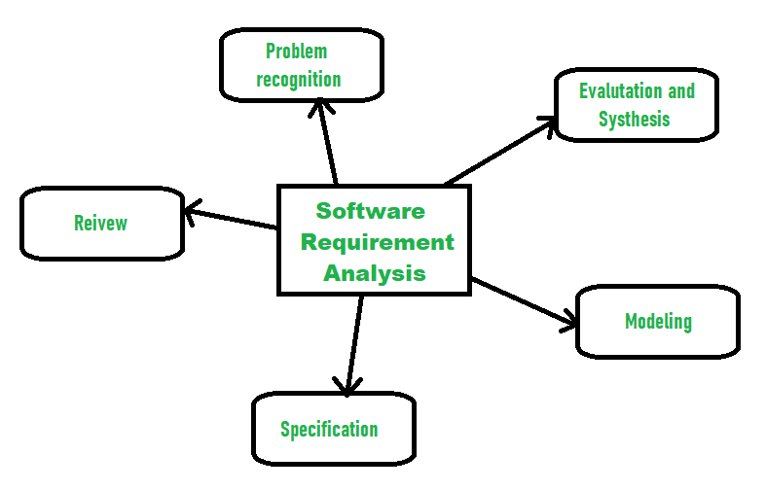

1. **Problem Recognition :**   
   The main aim of requirement analysis is to fully understand main objective of requirement that includes why it is needed, does it add value to product, will it be beneficial, does it increase quality of the project, does it will have any other effect. All these points are fully recognized in problem recognition so that requirements that are essential can be fulfilled to solve business problems.
2. **Evaluation and Synthesis :**   
   Evaluation means judgement about something whether it is worth or not and synthesis means to create or form something. Here are some tasks are given that is important in the evaluation and synthesis of software requirement :   
     
   * To define all functions of software that necessary.
   * To define all data objects that are present externally and are easily observable.
   * To evaluate that flow of data is worth or not.
   * To fully understand overall behavior of system that means overall working of system.
   * To identify and discover constraints that are designed.
   * To define and establish character of system interface to fully understand how system interacts with two or more components or with one another.
3. **Modeling :**   
   After complete gathering of information from above tasks, functional and behavioral models are established after checking function and behavior of system using a domain model that also known as the conceptual model.
4. **Specification :**   
   The [software requirement specification (SRS)](https://www.geeksforgeeks.org/software-engineering/software-requirement-specification-srs-format/) which means to specify the requirement whether it is functional or non-functional should be developed.
5. **Review :**   
   After developing the SRS, it must be reviewed to check whether it can be improved or not and must be refined to make it better and increase the quality.

**Elements of the Requirements Model**

Last Updated : 09 Nov, 2023

Requirements for a computer-based system can be seen in many different ways. Some software people argue that it's worth using a number of different modes of representation while others believe that it's best to select one mode of representation. The specific

**elements of the requirements model**

are dedicated to the analysis modeling method that is to be used.

* **Scenario-based elements :** Using a scenario-based approach, system is described from user's point of view. **For example**, basic use cases and their corresponding use-case diagrams evolve into more elaborate template-based use cases. Figure 1(a) depicts a UML activity diagram for eliciting requirements and representing them using use cases. There are three levels of elaboration.
* **Class-based elements :** A collection of things that have similar attributes and common behaviors i.e., objects are categorized into classes. **For example**, a UML case diagram can be used to depict a Sensor class for the SafeHome security function. Note that diagram lists attributes of sensors and operations that can be applied to modify these attributes. In addition to class diagrams, other analysis modeling elements depict manner in which classes collaborate with one another and relationships and interactions between classes.
* **Behavioral elements :** Effect of behavior of computer-based system can be seen on design that is chosen and implementation approach that is applied. Modeling elements that depict behavior must be provided by requirements model.

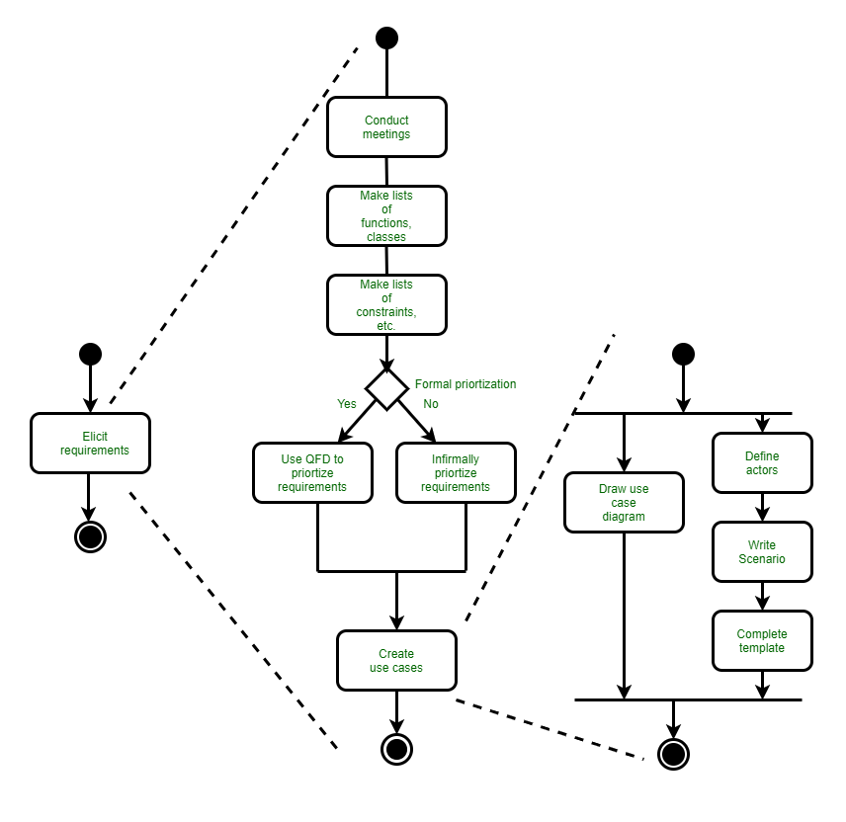Figure 1(a):UML activity diagrams for eliciting requirements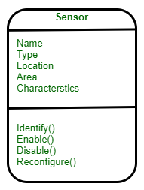Class diagram for sensor

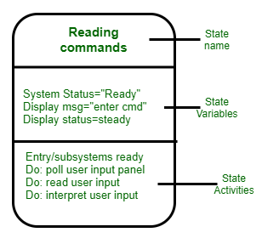Figure 2: UML state diagram notation

* Method for representing behavior of a system by depicting its states and events that cause system to change state is state diagram. A state is an externally observable mode of behavior. In addition, state diagram indicates actions taken as a consequence of a particular event. To illustrate use of a state diagram, consider software embedded within safeHome control panel that is responsible for reading user input. A simplified UML state diagram is shown in figure 2.
* **Flow-oriented elements :** As it flows through a computer-based system information is transformed. System accepts input, applies functions to transform it, and produces output in a various forms. Input may be a control signal transmitted by a transducer, a series of numbers typed by human operator, a packet of information transmitted on a network link, or a voluminous data file retrieved from secondary storage. Transform may compromise a single logical comparison, a complex numerical algorithm, or a rule-inference approach of an expert system. Output produce a 200-page report or may light a single LED. In effect, we can create a flow model for any computer-based system, regardless of size and complexity.

**What is the Difference Between Design Classes and Analysis classes?**

Last Updated : 23 Jul, 2025

In [System Design](https://www.geeksforgeeks.org/system-design/what-is-system-design-learn-system-design/), understanding the difference between design classes and analysis classes is crucial. Analysis classes are like detectives they investigate and understand the problem at hand. They focus on what the system needs to do, without diving into how it will be done. These classes help developers grasp the requirements and goals of the software. While the design classes are like architects they take the findings from analysis classes and create a plan for how the software will work.

**Important Topics for Difference Between Design Classes and Analysis classes**

* [What are Design Classes?](https://www.geeksforgeeks.org/system-design/what-is-the-difference-between-design-classes-and-analysis-classes/#what-are-design-classes)
* [What are Analysis Classes?](https://www.geeksforgeeks.org/system-design/what-is-the-difference-between-design-classes-and-analysis-classes/#what-are-analysis-classes)
* [Relationship between Design and Analysis Classes](https://www.geeksforgeeks.org/system-design/what-is-the-difference-between-design-classes-and-analysis-classes/#relationship-between-design-and-analysis-classes)
* [The Transition from Analysis to Design Classes](https://www.geeksforgeeks.org/system-design/what-is-the-difference-between-design-classes-and-analysis-classes/#the-transition-from-analysis-to-design-classes)
* [Real-World Examples of Analysis and Design Classes](https://www.geeksforgeeks.org/system-design/what-is-the-difference-between-design-classes-and-analysis-classes/#realworld-examples-of-analysis-and-design-classes)
* [Difference between design classes and analysis classes](https://www.geeksforgeeks.org/system-design/what-is-the-difference-between-design-classes-and-analysis-classes/#difference-between-design-classes-and-analysis-classes)

**What are Design Classes?**

In system design, design classes refer to the blueprint or structure of how a software system will be constructed. These classes outline the organization and behavior of various components within the system. Design classes delve into the specifics of how the system will operate, focusing on factors like efficiency, scalability, and maintainability.

* Design classes encapsulate the implementation details, such as methods, attributes, and relationships between different parts of the system.
* They define the internal workings of the software, including algorithms, data structures, and interactions between modules.
* Design classes build upon the findings from analysis classes, which identify the requirements and goals of the system without diving into implementation details.
* Design classes translate these requirements into a concrete plan for how the system will be built.

Overall, design classes play a crucial role in system design by providing a structured framework for developers to follow during the implementation phase.

**Characteristics of Design Classes**

* Focus on specifying how the system will be built and operated.
* Concrete representation detailing methods, attributes, and interactions.
* Incorporate implementation details, such as algorithms and data structures.
* Translate requirements into a structured plan for development.
* Typically depicted through class diagrams, sequence diagrams, or design patterns.

**Usage of Design Classes**

* Follow analysis classes to translate requirements into a detailed design.
* Specify the internal structure and behavior of software components.
* Address concerns related to efficiency, reusability, and maintainability.
* Serve as a blueprint for coding and implementation.
* Used to create class diagrams, sequence diagrams, and design documentation for developers.

**What are Analysis Classes?**

In system design, analysis classes are the initial step in understanding the problem domain and requirements of the software system. They focus on identifying and defining the key entities, attributes, and relationships within the system without delving into implementation details.

* Analysis classes serve as the investigators or detectives of the system design process.
* They gather information about what the system needs to accomplish, who will use it, and what data it will handle.
* This involves studying user needs, business processes, and any external systems the software will interact with.
* Analysis classes help developers gain a clear understanding of the problem domain and the goals of the software.

Overall, analysis classes are essential for ensuring that the software solution aligns with the needs of its users and stakeholders.

**Characteristics Analysis Classes**

* Focus on understanding the problem domain and requirements.
* Abstract representation of entities, attributes, and relationships.
* High-level view without delving into implementation details.
* Identify user needs, business processes, and external system interactions.
* Typically depicted through domain models, use cases, or user stories.

**Usage Analysis Classes**

* Serve as the initial step in system design to gather and analyze requirements.
* Facilitate communication between stakeholders to ensure a shared understanding of the system.
* Provide a foundation for further design and development phases.
* Help identify key functionalities and constraints of the system.
* Used to create user stories, use cases, and domain models to capture requirements.

**Relationship between Design and Analysis Classes**

**1. Dependency Relation**

* Design classes build upon the findings of analysis classes.
* Analysis classes provide the foundation and requirements for the design phase.
* Without a clear understanding of the problem domain and requirements established by analysis classes, it's challenging to create effective design classes.
* Analysis classes focus on identifying what the system needs to do and its essential components.
* Design classes then specify how those requirements will be implemented, detailing the structure, behavior, and interactions of the system's components.

**2. Iteration Relation**

* The relationship between analysis and design classes is often iterative.
* As design classes are developed, they may uncover additional requirements or constraints that were not initially identified during the analysis phase.
* Feedback from the design phase may lead to revisions or refinements in the analysis classes to ensure alignment with the evolving understanding of the system.

**The Transition from Analysis to Design Classes**

**Step 1. From Analysis to Design**

* The transition from analysis to design classes involves translating the requirements identified in analysis classes into a structured plan for implementation.
* Analysis classes provide the inputs for designing the system architecture, specifying the components, relationships, and behaviors needed to fulfill the requirements.

**Step 2. Creation of Design Classes**

* Once the requirements are understood, design classes are created to represent the internal structure and behavior of the software system.
* Design classes incorporate implementation details, such as algorithms, data structures, and system interactions, to fulfill the specified requirements.

**Step 3. Refinement and Iteration**

* Throughout the transition from analysis to design classes, there may be iterations and refinements based on feedback, new insights, or changes in requirements.
* Design classes may influence updates to analysis classes as new design considerations or constraints are identified.

**Real-World Examples of Analysis and Design Classes**

**1. Analysis Classes**

* **E-commerce System:**
  + **Use Case:**Identify analysis classes such as "Customer," "Product," "Order," and "Payment" to understand the entities and relationships involved in an e-commerce system.
  + **Purpose:**Analyze user requirements and business processes to determine what functionalities the system should support and how they interact.
  + **Example:** The "Customer" class may have attributes like name, email, and address, while the "Order" class may have attributes like order ID, items, and total price.
* **Hospital Management System:**
  + **Use Case:**Define analysis classes like "Patient," "Doctor," "Appointment," and "Medical Record" to capture the key entities and relationships in a hospital management system.
  + **Purpose:** Analyze the workflow of patients, doctors, and administrative staff to identify requirements for scheduling appointments, managing medical records, and coordinating patient care.
  + **Example:**The "Appointment" class may include attributes such as date, time, doctor ID, and patient ID, reflecting the scheduling process.

**2. Design Classes**

* **E-commerce System:**
  + **Use Case:**Translate analysis classes into design classes to specify how the system will be implemented.
  + **Purpose:**Define the internal structure and behavior of software components to fulfill the requirements identified during analysis.
  + **Example:** Design classes may include "CustomerManager," "ProductCatalog," "OrderProcessor," and "PaymentGateway," each responsible for specific functionalities and interactions within the system.
* **Hospital Management System:**
  + **Use Case:**Develop design classes like "AppointmentScheduler," "PatientRecordManager," "DoctorRegistry," and "BillingSystem" to detail the implementation of system components.
  + **Purpose:** Specify algorithms, data structures, and interfaces to support the functionalities required by the hospital management system.
  + **Example:**The "AppointmentScheduler" class may include methods for scheduling, canceling, and rescheduling appointments, with algorithms to optimize appointment slots and avoid conflicts.

**Difference between Design classes and Analysis classes**

This table illustrates the key differences between analysis classes and design classes:

| **Aspect** | **Analysis Classes** | **Design Classes** |
| --- | --- | --- |
| **Purpose** | Identify requirements and understand problem domain | Define how the system will be built and operated |
| **Focus** | What the system needs to do (functional requirements) | How the system will accomplish its tasks (implementation details) |
| **Level of Detail** | High-level, focusing on entities, attributes, and relationships | Detailed, specifying methods, attributes, and interactions |
| **Implementation** | No implementation details, abstract representation | Implementation details specified, concrete representation |
| **Dependencies** | Depends on user needs, business processes, and external systems | Builds upon analysis classes, translating requirements into a structured plan |
| **Deliverables** | Use cases, user stories, domain models | Class diagrams, sequence diagrams, design patterns |
| **Timing** | Early stage of system development, before design | Follows analysis, comes before implementation |
| **Flexibility** | More flexible and subject to change during analysis phase | Less flexible, changes may require more effort during design phase |

Analysis

1. Introduction

* Use-case model vs. Analysis model

|  |  |  |  |
| --- | --- | --- | --- |
|  | Use-Case Model | Analysis Model | |
| 1 | Described using the language of the customer | Described using the language of  the developer | |
|  |  |  | |
| 2 | External view of the system | Internal view of the system | |
|  |  |  |  |
| 3 | Structured by use cases;  Gives structure to the external view | Structured by stereotypical classes and packages; gives structure to the internal view |  |
|  |  |  | |
| 4 | Used primarily as a contract between the customer and the developer on what the system should and should not do | Used primarily by developers to understand how the system should be shaped, i.e. designed and implemented | |
|  |  |  | |
| 5 | May contain redundancies, inconsistencies, etc. among requirements | Should not contain redundancies, inconsistencies, etc. among requirements | |
|  |  |  | |
| 6 | Captures the functionality of the system, including architecturally significant functionality | Outlines how to realize the functionality within the system, including architecturally significant functionality; works as a first cut at design | |
|  |  |  | |
| 7 | Defines use cases that are further analyzed in the analysis model | Defines use-case realizations, each one representing the analysis of a use case from the use-case model | |

* Why analysis
* Yield a more precise specification of the requirements.
* Introduce formalism and reasoning about the internal system using the developer’s language
* Structure the requirements in a way to be ready for design and implementation.
* First cut at a design model.
* The role of analysis in the software life cycle

Most of analysis work is done in the elaboration phase.

1. Artifacts
2. Artifact: **Analysis Model**

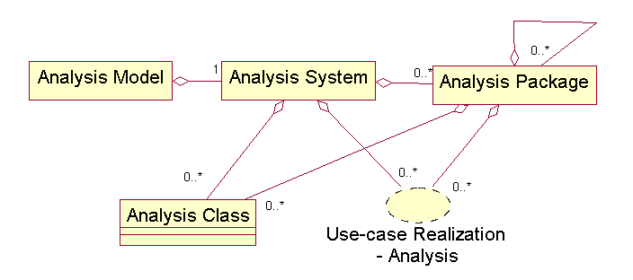

1. Artifact: **Analysis Class**

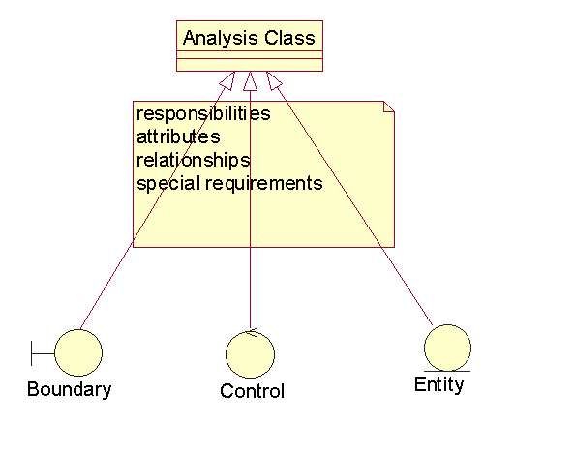

Example:

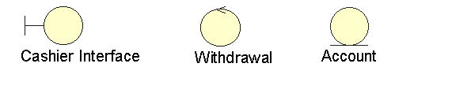

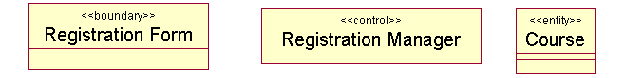

* An analysis class represents an abstraction of one or several classes and or subsystems in the system’s design
* Characteristics
* Focus on handling functional requirements (conceptual)
* Define behavior as responsibility, not operations
* Define conceptual attributes from problem domain
* Define conceptual relationships
* Boundary classes
* Responsibility:
  + Model interaction between the system and its actors
  + Model the parts of the system that depend on its actors
  + Clarify and collect the requirements on the system’s boundaries
  + Isolate user interfaces with the system’s internal structure
* Boundary classes represent abstractions of visual interface components
* Each boundary class should be related to at least one actor

Example:

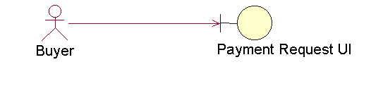

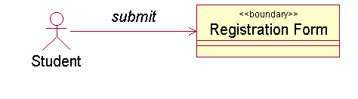

* Entity classes
* Responsibility
  + Model information that is long-lived and often persistent
  + Model information and associated behavior of some phenomenon or concept (e.g. individual, real-life object, real-life event)
  + Show logical data structure and contribute to the understanding of what information the system dependent upon.
* Usually derived from business entities from business model
* An entity object encapsulates its persistent data as attributes and behaviors or operations to manipulate the data.

Example:

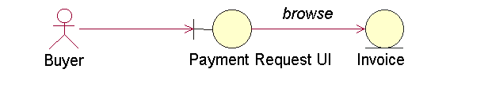

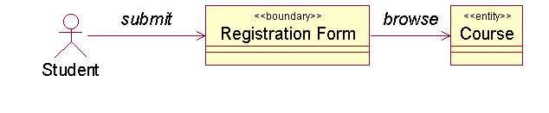

* Control classes
* Responsibility
  + Model dynamics of the system, including coordination, sequencing, transactions and control of other objects
  + Encapsulate control related to a use case
  + Represent business logic, complex derivation and calculations
* A control object coordinates the main actions and control flow of a use case, and delegate work to other (boundary, entity, as well as control) objects

Example:

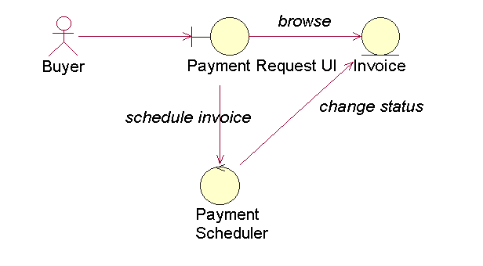

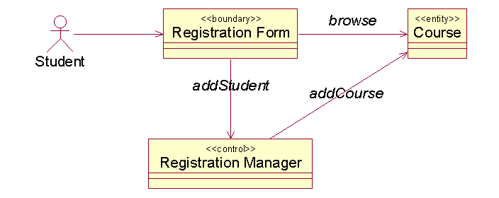

1. Artifact: **Use-case Realization – Analysis**

* What is a use-case realization – analysis
* A collaboration within the analysis model
* It describes how a specific use case is realized and performed in terms of analysis classes and their interacting analysis objects
* It provides a straightforward trace to a specific use case in the use-case model.

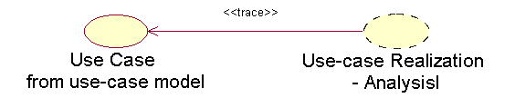

* What a use-case realization consists of
* Class diagrams
* Interaction diagrams
* Flow of events - analysis

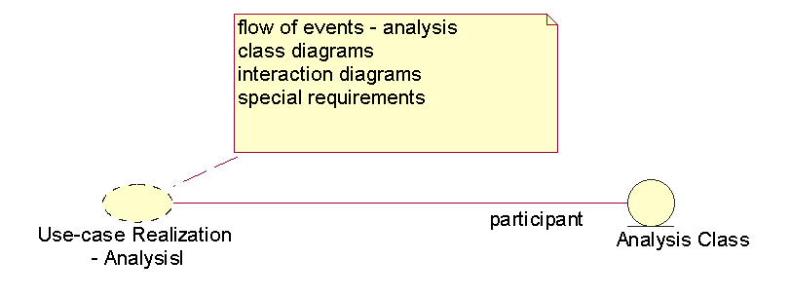

* Class diagrams
* For each use-case realization, show participating analysis classes and their collaboration through their relationships

Example: Class diagram for Pay Invoice use-case realization

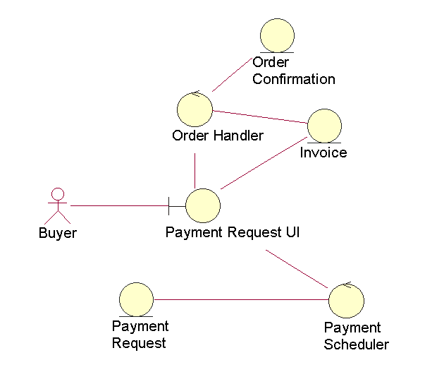

Example: Class diagram for register course use-case realization

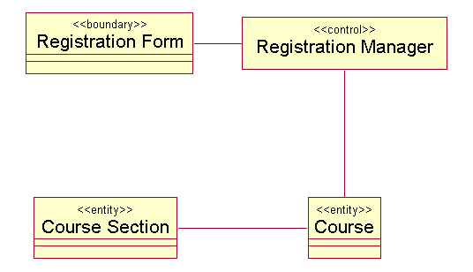

* Interaction diagrams (collaboration diagrams)
* Collaboration diagrams are used to describe how typical scenarios or use-case instances are realized with collaborations of objects from the participating analysis classes.
* Life cycles of analysis objects
  + Boundary and control object

Created: beginning of use-case realization(s)

Terminate: end of use-case realization(s)

* + Entity object: relatively long-lived

Example: Collaboration diagram for a realization of the Pay Invoice

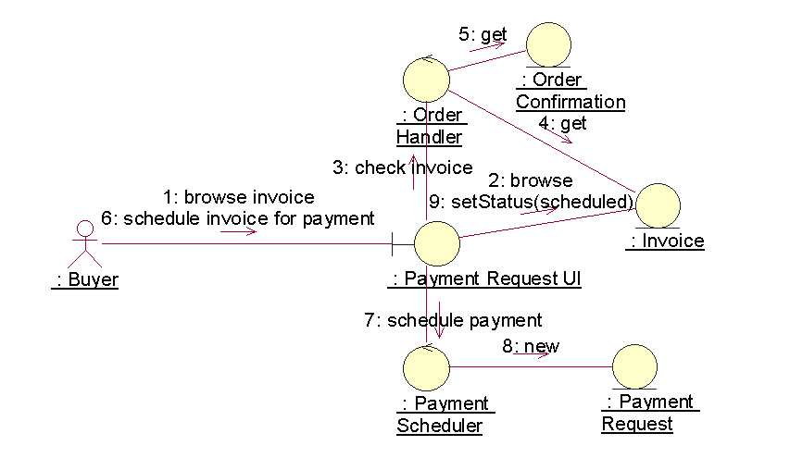

Example: collaboration diagram for Register Course use case

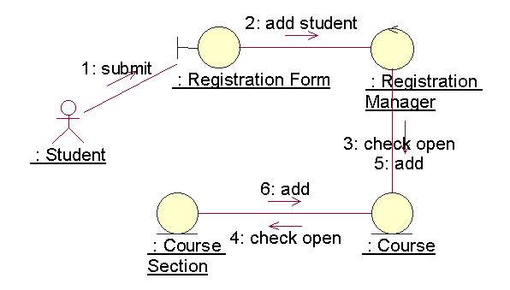

* Flow of events – analysis
* Rewrite in text the flow of events from the use-case model for each use-case realization using in terms of collaboration of analysis objects.
* No reference to objects’ attributes, responsibilities, and associations.

1. Artifact: **Analysis Package**

* What is an analysis package
* Provide a means of organizing the artifacts of the analysis model in manageable pieces.
* What an analysis package consists of
* Analysis classes
* Use-case realizations
* Other analysis packages
* What is a well-defined analysis package
* Cohesive

Its contents should be strongly related

* Loosely coupled

Its dependencies on others should be minimized

* What characteristics an analysis package should have
* Separation of concern
* Created based on functional requirements and on the problem domain
* Top-level layer(s) of design model
* What is a service package
* A service package represents a coherent set of functionally related actions that are employed in several use cases.
* A service package contains a set of functionally related classes
* Service packages are low-level elements in an analysis package’s aggregation hierarchy.
* Service vs. Use Case

|  |  |
| --- | --- |
| Service | Use Case |
| System functionality | Sequence of actions for an actor’s need and interaction |
| For customers (buyers) of the system | For users of the system |

1. Artifact: **Architecture Description** (view of the analysis model)

* Contains an architectural view of the analysis model
* Depicting the architecturally significant artifacts of the model.
* What artifacts are considered architecturally significant
  + The decomposition of the analysis model into analysis packages and their dependencies, for top-level design.
  + Key analysis classes
  + Important use-case realizations

1. Workers
2. Worker: **Architect**

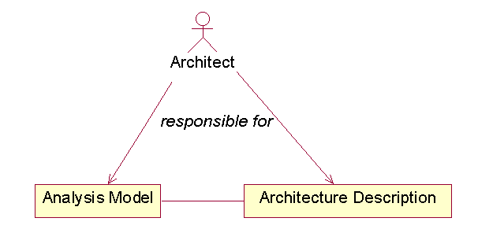

* Responsible for the integrity of the analysis model
* Ensure that the analysis model as a whole is correct, consistent, and readable.

1. Worker: **Use-case Engineer**

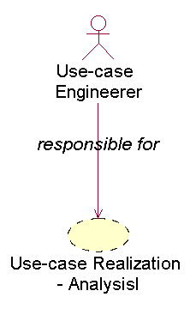

1. Worker: **Component Engineer**

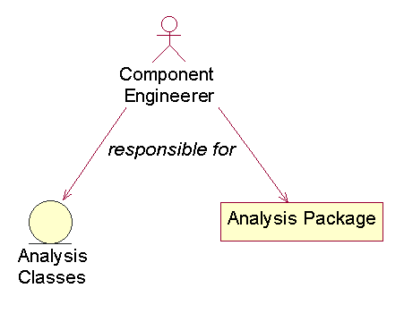

* + Responsible for analysis classes
  + Defines and maintains the responsibilities, attributes, relationships, and special requirements
  + Ensures that each analysis class fulfills the requirements made on it from the use-case realizations in which it participates.
  + Responsible for analysis packages
  + Maintains the integrity of analysis package(s)
  + Ensures correctness, cohesion, and loose coupling

**Class-Responsibility-Collaboration Card**

Last Updated : 15 Apr, 2024

A Class-Responsibility-Collaboration (CRC) card is a structured tool used in object-oriented software design. It captures essential information about a class, including its name, responsibilities, and collaborations with other classes. CRC cards facilitate collaborative discussions among team members and help in refining the design of software systems. Overall, they serve as valuable aids in the iterative process of designing and refining software solutions.

**Important Topics for Class-Responsibility-Collaboration Card**

* [What are CRC cards?](https://www.geeksforgeeks.org/system-design/class-responsibility-collaboration-card/#what-are-crc-cards)
* [Purpose of CRC cards in software design](https://www.geeksforgeeks.org/system-design/class-responsibility-collaboration-card/#purpose-of-crc-cards-in-software-design)
* [Components of CRC Cards](https://www.geeksforgeeks.org/system-design/class-responsibility-collaboration-card/#components-of-crc-cards)
* [Benefits of Using CRC Cards](https://www.geeksforgeeks.org/system-design/class-responsibility-collaboration-card/#benefits-of-using-crc-cards)
* [How to Create CRC Cards?](https://www.geeksforgeeks.org/system-design/class-responsibility-collaboration-card/#how-to-create-crc-cards)
* [Example of CRC cards](https://www.geeksforgeeks.org/system-design/class-responsibility-collaboration-card/#example-of-crc-cards)
* [Guidelines and Best Practices for CRC Cards](https://www.geeksforgeeks.org/system-design/class-responsibility-collaboration-card/#guidelines-and-best-practices-for-crc-cards)
* [Applications and Use Cases of CRC Cards](https://www.geeksforgeeks.org/system-design/class-responsibility-collaboration-card/#applications-and-use-cases-of-crc-cards)
* [Online CRC Card Generators and Templates](https://www.geeksforgeeks.org/system-design/class-responsibility-collaboration-card/#online-crc-card-generators-and-templates)
* [Integration with Software Development Environments](https://www.geeksforgeeks.org/system-design/class-responsibility-collaboration-card/#integration-with-software-development-environments)

**What are CRC cards?**

CRC (Class, Responsibility, Collaboration) cards are a design tool used in object-oriented programming to capture and organize information about classes, their responsibilities, and their collaborations within a software system.

**For Example:**

*Imagine you're building a house with Lego blocks. Each block represents a different part of the house. CRC cards are like index cards for each block.*

* **Class**: This is like the type of Lego block you're using, whether it's a roof piece, a door, or a window.
* **Responsibilities**: This tells you what each Lego block should do. For example, the roof piece's responsibility is to keep the rain out, and the door's responsibility is to let people in and out.
* **Collaborators**: These are the other Lego blocks that work together with the one you're looking at. For instance, the window block collaborates with the wall block to fit into the house.

So, CRC cards help you plan out how each Lego block (or class) will work, what it's responsible for, and how it'll work with the other blocks to build the whole house (or software system).

**Purpose of CRC cards in software design**

The purpose of CRC cards in software design include:

* **Clarify Class Responsibilities**: CRC cards help identify and define the responsibilities of each class in the system. By listing the responsibilities of a class on a card, developers can gain a clear understanding of what each class is supposed to do.
* **Identify Collaborations**: CRC cards also specify the collaborations between classes. This includes identifying which classes need to interact with each other to fulfill their responsibilities. By outlining these collaborations, developers can ensure that the interactions between classes are well-defined and appropriate.
* **Encourage Communication and Collaboration**: CRC cards are typically used in group settings, such as brainstorming sessions or design meetings. They encourage team members to actively participate in discussions about the system's design, fostering collaboration and communication among team members.
* **Iterative Design and Refinement**: CRC cards support an iterative approach to software design. As the design evolves and requirements change, CRC cards can be easily updated or revised to reflect these changes. This allows for continuous refinement of the system's design throughout the development process.

**Components of CRC Cards**

CRC (Class-Responsibility-Collaboration) cards consist of three main components:

* **Class**: The class represents a software entity or component in the system. It encapsulates data (attributes or properties) and behavior (methods or functions) related to a specific concept or functionality. On a CRC card, the class name is typically written at the top.
* **Responsibility**: Responsibility refers to the tasks or functions that a class is responsible for performing. It defines what the class does or what it is expected to accomplish within the system. Responsibilities are listed on the card below the class name, often as bullet points or short phrases.
* **Collaboration**: Collaboration describes the interactions or relationships that a class has with other classes in the system. It specifies how the class communicates or cooperates with other classes to fulfill its responsibilities. Collaborations are listed on the card alongside the responsibilities, indicating the classes with which the current class interacts.

These components work together to provide a concise and structured representation of the class's role, behavior, and relationships within the system. By organizing this information on index cards, developers can visually analyze and discuss the design of the system, identify potential design flaws, and iteratively refine the system's architecture.

**Benefits of Using CRC Cards**

Using CRC (Class-Responsibility-Collaboration) cards in software design offers several benefits:

* **Visualization**: CRC cards provide a tangible and visual representation of the system's design. This helps developers conceptualize the structure, behavior, and relationships between classes in the system more easily.
* **Collaboration**: CRC cards facilitate collaborative discussions among team members during design meetings or brainstorming sessions. They encourage active participation and help ensure that everyone's ideas and perspectives are considered.
* **Clarity and Understanding**: By breaking down the responsibilities and collaborations of each class into concise bullet points, CRC cards help clarify the purpose and role of each class in the system. This enhances understanding and ensures that all team members have a clear view of the system's design.
* **Iterative Design**: CRC cards support an iterative approach to software design. As the design evolves and requirements change, CRC cards can be easily updated or revised to reflect these changes. This allows for continuous refinement of the system's architecture throughout the development process.
* **Rapid Prototyping**: CRC cards enable rapid prototyping and exploration of design alternatives. Teams can quickly create, modify, and rearrange CRC cards to experiment with different class hierarchies, responsibilities, and collaborations.

**How to Create CRC Cards?**

Creating CRC (Class-Responsibility-Collaboration) cards involves several steps:

* **Step 1: Identify Classes**:
  + Start by identifying the classes or objects in your system. Classes represent the key entities or components in the software that encapsulate data and behavior related to specific concepts or functionalities.
* **Step 2: List Responsibilities**:
  + For each class, list down the responsibilities or tasks that it is responsible for performing. Responsibilities should describe what the class does or what it is expected to accomplish within the system. Be concise and specific when defining responsibilities.
* **Step 3: Define Collaborations**:
  + Determine how each class collaborates or interacts with other classes in the system. Specify the dependencies, relationships, or communications between classes to fulfill their responsibilities. Identify which classes send messages to or receive messages from the current class.
* **Step 4: Create Cards**:
  + Once you have identified the classes, responsibilities, and collaborations, create CRC cards for each class. You can use physical index cards or digital tools to create the cards. Write the class name at the top of each card and list the responsibilities and collaborations below.
* **Step 5: Organize Cards**:
  + Arrange the CRC cards on a table or board where they are visible to all team members. Organize the cards in a way that makes sense for the system's architecture, such as grouping related classes together or arranging them hierarchically.

**Example of CRC cards**

*Let's understand CRC Cards using example of* ***banking system.***

**1. Class: Account**

**Responsibilities:**

* Store account holder information (name, address, contact details).
* Maintain account balance.
* Perform transactions (deposit, withdrawal).
* Generate account statements.

**Collaborations:**

* Collaborates with Transaction class for performing deposit and withdrawal operations.
* Collaborates with Statement class to generate account statements.

**2. Class: Transaction**

**Responsibilities:**

* Record transaction details (date, type, amount).
* Update account balance based on deposit or withdrawal operations.

**Collaborations:**

* Collaborates with Account class to perform deposit and withdrawal operations.

**3. Class: Statement**

**Responsibilities:**

* Generate account statements for a specified period.
* Include transaction details (date, type, amount) in the statement.

**Collaborations:**

* Collaborates with Account class to access transaction data for generating statements.

**In this example:**

* The **Account** class represents bank accounts and is responsible for storing account holder information, maintaining balances, performing transactions, and generating statements.
* The **Transaction** class handles individual transactions and records transaction details such as date, type, and amount. It collaborates with the Account class to update account balances.
* The **Statement** class is responsible for generating account statements for a specified period. It collaborates with the Account class to access transaction data for generating statements.

These CRC cards provide a structured overview of the responsibilities and collaborations of each class in the banking system, helping to clarify the system's design and functionality.

**Guidelines and Best Practices for CRC Cards**

When using CRC (Class-Responsibility-Collaboration) cards, it's essential to follow guidelines and best practices to ensure their effectiveness in software design. Here are some guidelines and best practices for using CRC cards:

* **Keep it Simple and Concise**: Write clear and concise descriptions of class responsibilities and collaborations. Avoid including unnecessary details or technical jargon that may confuse team members.
* **Focus on Responsibilities**: Emphasize the responsibilities of each class rather than implementation details. This helps maintain a clear separation of concerns and ensures that each class has a single, well-defined purpose.
* **Use Active Collaboration**: Encourage active participation and collaboration among team members during CRC card sessions. Invite input from all team members and consider different perspectives when defining class responsibilities and collaborations.
* **Iterate and Refine**: Treat CRC cards as living documents that evolve throughout the design process. Continuously review and refine the cards as the system design progresses, incorporating feedback and insights gained from further analysis or discussions.
* **Validate Requirements**: Ensure that the responsibilities and collaborations listed on CRC cards accurately reflect the system's requirements and design goals. Validate each class's responsibilities against the system's use cases, user stories, or functional requirements.
* **Keep Cards Organized**: Organize CRC cards in a way that makes them easy to read and understand. Group related classes together, arrange them hierarchically if necessary, and use visual cues such as colors or borders to highlight important information.

**Applications and Use Cases of CRC Cards**

**CRC (Class-Responsibility-Collaboration)** cards find applications across various stages of software development, including analysis, design, and communication. Here are some specific applications and use cases of CRC cards:

* **Requirement Analysis**: CRC cards can be used during requirement analysis to identify classes, their responsibilities, and their collaborations. They help stakeholders visualize the system's structure and behavior, facilitating discussions about requirements and user needs.
* **System Design**: CRC cards are commonly used during system design to define class responsibilities and collaborations. They serve as a tool for brainstorming and refining the architecture of the system, ensuring that classes are well-defined and cohesive.
* **Object-Oriented Design**: CRC cards are particularly useful in object-oriented design, where classes and objects play a central role. They help designers identify objects and their relationships, promoting a modular and reusable design.
* **Domain Modeling**: CRC cards aid in domain modeling by mapping real-world concepts to classes in the software system. They enable domain experts and developers to collaborate on defining the domain model, ensuring that the software accurately reflects the problem domain.
* **Refactoring**: CRC cards can be used during refactoring to evaluate and redesign existing class structures. They help developers identify classes with unclear responsibilities or excessive dependencies and make informed decisions about restructuring the code.

**Online CRC Card Generators and Templates**

While there are not many dedicated online CRC card generators available, you can create CRC cards using various tools or templates that support collaborative editing and documentation. Here are some options:

* **Online Whiteboard Platforms**: Platforms like Miro, MURAL, or Lucidchart offer collaborative whiteboard tools where you can create CRC cards using digital sticky notes or text boxes. These platforms allow team members to collaborate in real-time and organize CRC cards visually.
* **Google Docs or Microsoft Word**: You can create CRC card templates in Google Docs or Microsoft Word and share them with team members for collaborative editing. Use tables or text boxes to structure CRC cards, and make use of formatting options to enhance readability.
* **Online Collaboration Tools**: Collaboration tools like Trello, Asana, or Notion can be used to create CRC card templates and organize them into boards or projects. These tools support collaborative editing and provide features for managing tasks and discussions related to CRC cards.
* **Online Diagramming Tools**: Diagramming tools like Draw.io, Creately, or Gliffy offer templates and shapes for creating CRC cards and visualizing class relationships. These tools allow you to create professional-looking diagrams and export them in various formats.
* **Code Repository Platforms**: Platforms like GitHub or GitLab provide support for markdown files, which you can use to create CRC card templates and store them alongside your codebase. Markdown syntax allows you to structure CRC cards using headings, lists, and formatting options.

**Integration with Software Development Environments**

Integrating CRC (Class-Responsibility-Collaboration) cards with software development environments can enhance collaboration, streamline documentation, and facilitate the design process. Here are some ways CRC cards can be integrated into software development environments:

* **Version Control Systems**: CRC cards can be stored alongside code in version control systems like Git, SVN, or Mercurial. By keeping CRC cards in the same repository as the codebase, developers can track changes to the design over time and ensure that the design remains aligned with the implementation.
* **Documentation Tools**: Integrate CRC card templates with documentation tools like Confluence, GitHub Wiki, or GitBook. This allows developers to create, edit, and reference CRC cards directly from the project documentation, ensuring that the design remains well-documented and accessible to team members.
* **IDE Plugins**: Develop plugins or extensions for integrated development environments (IDEs) like Visual Studio Code, IntelliJ IDEA, or Eclipse that provide features for creating and managing CRC cards. IDE plugins can offer syntax highlighting, auto-completion, and other productivity features tailored to CRC card creation and editing.
* **Code Review Tools**: Incorporate CRC cards into code review processes using tools like Gerrit, Crucible, or GitHub Pull Requests. Developers can include CRC cards as part of code review documentation, providing context for design decisions and architectural considerations.
* **Continuous Integration/Continuous Deployment (CI/CD) Pipelines**: Integrate CRC cards into CI/CD pipelines to automate validation and verification processes. For example, teams can use static analysis tools to check CRC card consistency, identify design smells, or detect violations of design principles.

**Conclusion**

In conclusion, CRC (Class-Responsibility-Collaboration) cards are a valuable tool in software design, providing a structured and collaborative approach to defining class responsibilities, identifying collaborations, and refining system architecture. By capturing class responsibilities and collaborations on index cards, teams can visualize and discuss the design of a software system, ensuring clarity, consistency, and alignment among team members.

A Class Responsibility Collaborator (CRC) model is a collection of standard index cards that have been divided into three sections, as depicted in [Figure 1](https://agilemodeling.com/artifacts/crcModel.htm#Figure1CRCCardLayout). A class represents a collection of similar objects, a responsibility is something that a class knows or does, and a collaborator is another class that a class interacts with to fulfill its responsibilities. [Figure 2](https://agilemodeling.com/artifacts/crcModel.htm#Figure2HandDrawnCRCCards) presents an example of two hand-drawn CRC cards.**Figure 1. CRC Card Layout.**

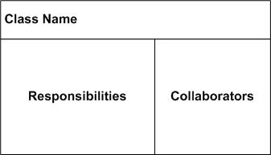

**Figure 2. Hand-drawn CRC Cards.**

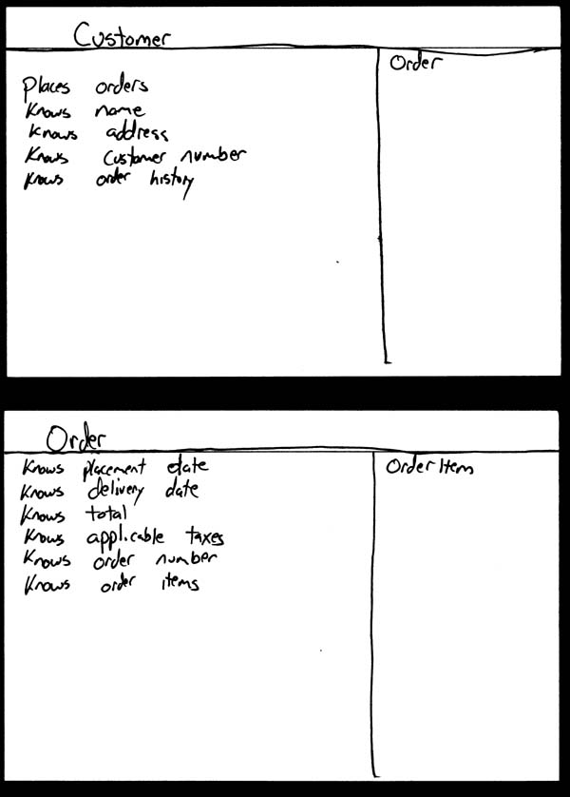

Although CRC cards were originally introduced as a technique for teaching object-oriented concepts, they have also been successfully used as a full-fledged modeling technique. My experience is that CRC models are an incredibly effective tool for conceptual modeling as well as for detailed design. CRC cards feature prominently in eXtreme Programming (XP) ([Beck 2000](http://www.amazon.com/exec/obidos/ASIN/0201616416/ambysoftinc)) as a design technique. My focus here is on applying CRC cards for conceptual modeling with your stakeholders.

A class represents a collection of similar objects. An object is a person, place, thing, event, or concept that is relevant to the system at hand. For example, in a university system, classes would represent students, tenured professors, and seminars. The name of the class appears across the top of a CRC card and is typically a singular noun or singular noun phrase, such as *Student*, *Professor*, and *Seminar*. You use singular names because each class represents a generalized version of a singular object. Although there may be the student John O’Brien, you would model the class *Student*. The information about a student describes a single person, not a group of people. Therefore, it makes sense to use the name *Student* and not *Students*. Class names should also be simple. For example, which name is better: *Student* or *Person who takes seminars*?

A responsibility is anything that a class knows or does. For example, students have names, addresses, and phone numbers. These are the things a student knows. Students also enroll in seminars, drop seminars, and request transcripts. These are the things a student does. The things a class knows and does constitute its responsibilities. Important: A class is able to change the values of the things it knows, but it is unable to change the values of what other classes know.

Sometimes a class has a responsibility to fulfill, but not have enough information to do it. For example, as you see in [Figure 3](https://agilemodeling.com/artifacts/crcModel.htm#Figure3StudentCRCCard) students enroll in seminars. To do this, a student needs to know if a spot is available in the seminar and, if so, he then needs to be added to the seminar. However, students only have information about themselves (their names and so forth), and not about seminars. What the student needs to do is collaborate/interact with the card labeled *Seminar* to sign up for a seminar. Therefore, *Seminar* is included in the list of collaborators of *Student*.

**Figure 3. Student CRC card.**

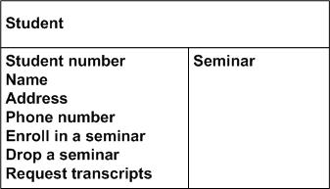

Collaboration takes one of two forms: A request for information or a request to do something. For example, the card *Student* requests an indication from the card *Seminar* whether a space is available, a request for information. *Student* then requests to be added to the *Seminar*, a request to do something. Another way to perform this logic, however, would have been to have *Student* simply request *Seminar* to enroll himself into itself. Then have *Seminar* do the work of determining if a seat is available and, if so, then enrolling the student and, if not, then informing the student that he was not enrolled.

So how do you create CRC models? Iteratively perform the following steps:

* **Find classes**. Finding classes is fundamentally an analysis task because it deals with identifying the building blocks for your application. A good rule of thumb is that you should look for the three-to-five main classes right away, such as *Student*, *Seminar*, and *Professor* in [Figure 4](https://agilemodeling.com/artifacts/crcModel.htm#Figure4CRCModel). I will sometimes include UI classes such as *Transcript* and *Student Schedule*, both are reports, although others will stick to just entity classes. Also, I’ll sometimes include cards representing actors when my stakeholders are struggling with the concept of a student in the real world (the actor) versus the student in the system (the entity).
* **Find responsibilities**. You should ask yourself what a class does as well as what information you wish to maintain about it. You will often identify a responsibility for a class to fulfill a collaboration with another class.
* **Define collaborators**. A class often does not have sufficient information to fulfill its responsibilities. Therefore, it must collaborate (work) with other classes to get the job done. Collaboration will be in one of two forms: a request for information or a request to perform a task. To identify the collaborators of a class for each responsibility ask yourself “does the class have the ability to fulfill this responsibility?”. If not then look for a class that either has the ability to fulfill the missing functionality or the class which should fulfill it. In doing so you’ll often discover the need for new responsibilities in other classes and maybe even the need for a new class or two.
* **Move the cards around**. To improve everyone’s understanding of the system, the cards should be placed on the table in an intelligent manner. Two cards that collaborate with one another should be placed close together on the table, whereas two cards that don’t collaborate should be placed far apart. Furthermore, the more two cards collaborate, the closer they should be on the desk. By having cards that collaborate with one another close together, it’s easier to understand the relationships between classes.

**Figure 4. CRC Model.**

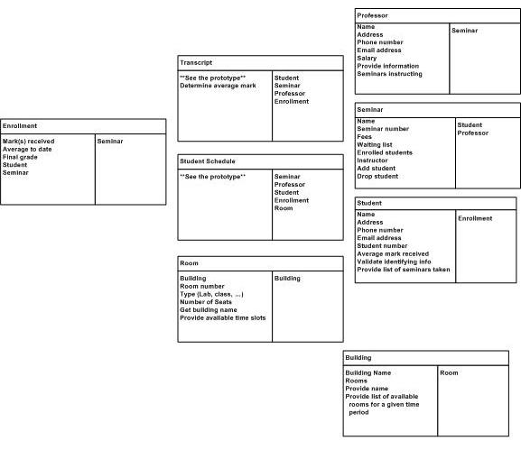

How do you keep your CRC modeling efforts agile? By following the AM practice [Model in Small Increments](https://agilemodeling.com/practices.htm#ModelInSmallIncrements). The best way to do this is to create a CRC model for a single requirement, such as a [user story](https://agilemodeling.com/artifacts/userStory.htm), [business rule](https://agilemodeling.com/artifacts/businessRule.htm), or [system use case](https://agilemodeling.com/artifacts/systemUseCase.htm), instead of the entire collection of requirements for your system. Because CRC cards are very simple tools they are inclusive, enabling you to follow AM’s [Active Stakeholder Participation](https://agilemodeling.com/practices.htm#ActiveStakeholderParticipation)practice.

It’s important to recognize that a CRC model isn’t carved in stone. When you evolve it into a [UML class diagram](https://agilemodeling.com/artifacts/classDiagram.htm), or perhaps straight into code, you’ll change the schema over time. Responsibilities will be reorganized, new classes will be introduced, existing classes will disappear, and so on. This is what happens when you take an evolutionary approach to development.

**Functional modelling and Information Flow modelling**

Last Updated : 12 Jul, 2025

In the **Functional Model**, software converts information. and to accomplish this, it must perform at least three common tasks- input, processing and output. When functional models of an application are created, the software engineer emphasizes problem specific tasks. The functional model begins with a single reference level model (i.e., be manufactured). In a series of iterations, more and more functional detail is given, until all system functionality is fully represented.   
  
Information is converted because it flows from a computer-based system. The system takes input in various forms; Hardware, software, and human elements are applied to replace it; And produces in various forms. The transformation (s) or function may be composed of a single logical comparison, a complex numerical method, or a rule- the invention approach of an expert system. The output can light an LED or provide a 200 page report. Instead, we can create a model or flow model for any computer- based system, regardless of size and complexity.   
  
Structural analysis started as an **Information Flow Modelling** technique. A computer-based system can be modeled as an information transform function as shown in figure.   
  
A rectangle represents an external unit. That is, a system element, such as a hardware, a person or another system that provides information for transformation by the software or receives information provided by the software. A circle is used to represent a process or transform or a function that is applied to data and changes it in some way. An arrow is used to represent one or more data items. 

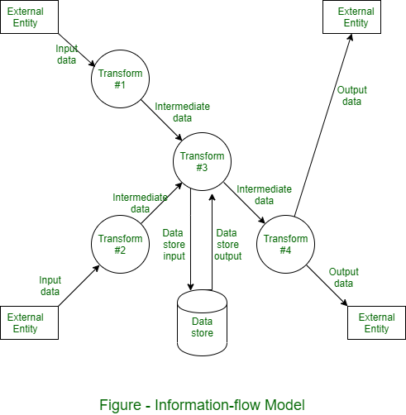

All arrows should be labeled in a [DFD](https://www.geeksforgeeks.org/software-engineering/levels-in-data-flow-diagrams-dfd/). The double line is used to represent data store. There may be implicit procedure or sequence in the diagram but explicit logical details are generally delayed until software design.

**Functional Modelling in object oriented analysis and design**

Last Updated : 12 Jul, 2025

**Functional Modelling:**

* A functional model of a system specifies how the output values are computed in the system from the input values, without considering the control aspects of the computation.
* This represents the functional view of the system - the mapping from inputs to outputs and the various steps involved in the mapping.
* The functional model of a system can be represented by a data flow diagram(DFD).
* As processes represent operations and in an object - oriented system, most of the processing is done by operations on classes, all processes should show up as operations on classes.

provides the outline that what the system is supposed to do .It does not describes what is the need of evaluation of data, when they are evaluated and how they are evaluated apart from all it only represent origin of data values. It describes the function of internal processes with the help of DFD.

[DFD (Data Flow Diagram)](https://www.geeksforgeeks.org/software-engineering/levels-in-data-flow-diagrams-dfd/)

. Data Flow Diagrams: Function modelling is represented with the help of DFDs. DFD is the graphically representation of data. It shows the input, output and processing of the system .When we are trying to create our own business, website, system, project then there is need to find out how information passes from one process to another so all are done by DFD. There are number of levels in DFD but upto third level DFD is sufficient for understanding of any system. The basic components of the DFD are:

1. **External Entity :** External entity is the entity that takes information and gives information to the system. It is represented with rectangle.
2. **Data Flow :** The data passes from one place to another is shown by data flow. Data flow is represented with arrow and some information written over it.
3. **Process :** It is also called function symbol .It is used to process all the information .If there are calculations so all are done in the process part .It is represented with circle and name of the process and level of DFD written inside it.
4. **Data Store :** It is used to store the information and retrieve the stored information .It is represented with double parallel lines.

Some Guidelines for creating a DFD:

1. Every process must have meaningful name and number.
2. Level 0 DFD must have only one process.
3. Every data flow and arrow has given the name.
4. DFD should be logical consistent.
5. DFD should be organised in such a way that it is easy to understand.
6. There should be no loop in the DFD.
7. Each DFD should not have more than 6 processes.
8. The process can only connected with process, external entity and data store.
9. External entity cannot be directly connected with external entity.
10. The direction of DFD is left to right and top to bottom representation.

Levels in Data Flow Diagrams (DFD)

Last Updated : 19 May, 2025

Data Flow Diagram is a visual representation of the flow of data within the system. It helps understand how data flows throughout the system and how it changes during processing. DFDs provide a graphical tool for system analysis and design, breaking down complex systems into simple, understandable components. Levels in DFDs represent the degree of detail captured in each diagram, ranging from high-level overviews to detailed process-specific diagrams.

What is a Data Flow Diagram (DFD) ?

A Data Flow Diagram (DFD) is a graphical representation of the flow of data within any system. It shows how input data is transformed into output through various processes and helps identify the data sources, data storage, and data destinations in the system. DFDs can effectively illustrate the incoming, outgoing, and stored data in a system.

DFDs help visualize how the data is processed, stored, and transferred between different entities. They are used in systems analysis, design, and development to model both current and future states of the system.

Levels in Data Flow Diagram (DFD)

DFDs can be divided into different levels, which provide varying degrees of detail about the system. The following are the four levels of DFDs:

Table of Content

0-Level Data Flow Diagram (DFD)

1-Level Data Flow Diagram (DFD)

2-Level Data Flow Diagram (DFD)

3-Level Data Flow Diagram (DFD)

The choice of DFD level depends on the complexity of the system and the level of detail required to understand the system. Higher levels of DFD provide a broad overview of the system, while lower levels provide more detail about the system's processes, data flows, and data stores. A combination of different levels of DFD can provide a complete understanding of the system.

0-Level Data Flow Diagram (DFD)

Level 0 is the highest-level Data Flow Diagram (DFD), which provides an overview of the entire system. It shows the major processes, data flows, and data stores in the system, without providing any details about the internal workings of these processes.

It is also known as a Context Diagram. It’s designed to be an abstraction view, showing the system as a single process with its relationship to external entities.

In Level 0 DFD, the system is represented as a single bubble or circle, and the data flows to and from external entities are represented by arrows. The focus is on high-level interactions, not the detailed workings of the processes inside the system.

1-Level Data Flow Diagram (DFD)

1-Level provides a more detailed view of the system by breaking down the major processes identified in the level 0 Data Flow Diagram (DFD) into sub-processes. Each sub-process is depicted as a separate process on the level 1 Data Flow Diagram (DFD). The data flows and data stores associated with each sub-process are also shown.

In 1-level Data Flow Diagram (DFD), the context diagram is decomposed into multiple bubbles/processes. In this level, we highlight the main functions of the system and breakdown the high-level process of 0-level Data Flow Diagram (DFD) into subprocesses. For example, if Level 0 DFD represents a payment system, Level 1 might break it down into sub-processes like payment processing, invoice generation, and confirmation of payment.

2-Level Data Flow Diagram (DFD)

2-Level provides an even more detailed view of the system by breaking down the sub-processes identified in the level 1 Data Flow Diagram (DFD) into further sub-processes. Each sub-process is depicted as a separate process on the level 2 DFD. The data flows and data stores associated with each sub-process are also shown.

Level 2 DFD is often used when a system is complex and needs further breakdown. It helps provide more granular information about the system’s functioning, ideal for specific requirements or technical documentation.

For instance, in a payment processing system, Level 2 DFD might decompose the payment processing sub-process into specific steps such as payment verification, funds deduction, and transaction completion.

3-Level Data Flow Diagram (DFD)

3-Level is the most detailed level of Data Flow Diagram (DFDs), which provides a detailed view of the processes, data flows, and data stores in the system. This level is typically used for complex systems, where a high level of detail is required to understand the system.

Each process on the level 3 DFD is depicted with a detailed description of its input, processing, and output. The data flows and data stores associated with each process are also shown, providing a comprehensive breakdown. Level 3 DFD helps in the detailed analysis of a specific process and is often used for system-level development and technical documentation.

Advantages of using Data Flow Diagrams (DFD)

Following are the Advantage of Data Flow Diagram (DFD) :

Easy to understand: DFDs are graphical representations that are easy to understand and communicate, making them useful for non-technical stakeholders and team members.

Improves system analysis: DFDs are useful for analyzing a system's processes and data flow, which can help identify inefficiencies, redundancies, and other problems that may exist in the system.

Supports system design: DFDs can be used to design a system's architecture and structure, which can help ensure that the system is designed to meet the requirements of the stakeholders.

Enables testing and verification: DFDs can be used to identify the inputs and outputs of a system, which can help in the testing and verification of the system's functionality.

Facilitates documentation: DFDs provide a visual representation of a system, making it easier to document and maintain the system over time.

Disadvantages of using Data Flow Diagram (DFD)

Following are the Disadvantage of Data Flow Diagram (DFD) :

Can be time-consuming: Creating DFDs can be a time-consuming process, especially for complex systems.

Limited focus: DFDs focus primarily on the flow of data in a system, and may not capture other important aspects of the system, such as user interface design, system security, or system performance.

Can be difficult to keep up-to-date: DFDs may become out-of-date over time as the system evolves and changes.

Requires technical expertise: While DFDs are easy to understand, creating them requires a certain level of technical expertise and familiarity with the system being analyzed.

Overall, the benefits of using DFDs outweigh the disadvantages. However, it is important to recognise the limitations of DFDs and use them in conjunction with other tools and techniques to analyse and design complex software systems.

Conclusion

The Levels of Data Flow Diagrams (DFD) offer a hierarchical way of visualizing system processes. By analyzing these levels, you can uncover the scope of the system, its data transformations, and potential inefficiencies. This helps in refining the system architecture, identifying improvements, and ensuring the system aligns with organizational goals. Overall, DFDs are a valuable tool for both system design and ongoing system maintenance, allowing teams to communicate and manage complex systems more effectively.

**Activity Diagrams - Unified Modeling Language (UML)**

Last Updated : 03 Jan, 2025

Activity diagrams are an essential part of the [Unified Modeling Language (UML)](https://www.geeksforgeeks.org/system-design/unified-modeling-language-uml-introduction/) that help visualize workflows, processes, or activities within a system. They depict how different actions are connected and how a system moves from one state to another. By offering a clear picture of both simple and complex workflows, activity diagrams make it easier for developers and stakeholders to understand how various elements interact in a system.

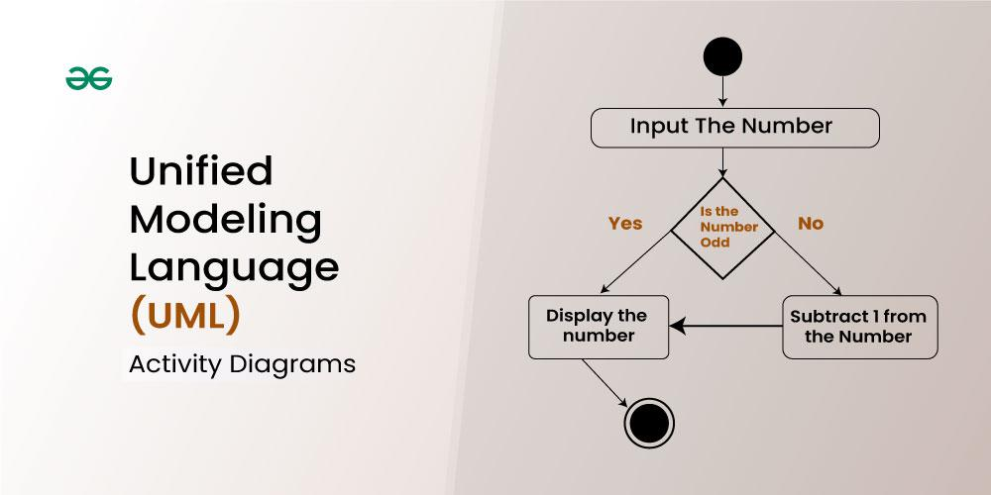

**Table of Content**

* [What is an Activity Diagram?](https://www.geeksforgeeks.org/system-design/unified-modeling-language-uml-activity-diagrams/#1-what-is-an-activity-diagram)
* [When to use Activity Diagram?](https://www.geeksforgeeks.org/system-design/unified-modeling-language-uml-activity-diagrams/#what-are-activity-diagrams-used-for)
* [Activity Diagram Notations](https://www.geeksforgeeks.org/system-design/unified-modeling-language-uml-activity-diagrams/#2-activity-diagram-notations)
* [How to Draw an Activity Diagram in UML?](https://www.geeksforgeeks.org/system-design/unified-modeling-language-uml-activity-diagrams/#3-how-to-draw-an-activity-diagram-in-uml)
* [What are the Differences between an Activity diagram and a Flowchart?](https://www.geeksforgeeks.org/system-design/unified-modeling-language-uml-activity-diagrams/#5-what-are-the-differences-between-an-activity-diagram-and-a-flowchart)

**What is an Activity Diagram?**

Activity diagrams show the steps involved in how a system works, helping us understand the flow of control. They display the order in which activities happen and whether they occur one after the other (sequential) or at the same time (concurrent). These diagrams help explain what triggers certain actions or events in a system.

* An activity diagram starts from an initial point and ends at a final point, showing different decision paths along the way.
* They are often used in business and process modeling to show how a system behaves over time.

**When to use Activity Diagram?**

Activity diagrams are useful in several scenarios, especially when you need to visually represent the flow of processes or behaviors in a system. Here are key situations when you should use an activity diagram:

1. **Modeling Workflows or Processes**: When you need to map out a business process, workflow, or the steps involved in a use case, activity diagrams help visualize the flow of activities.
2. **Concurrent or Parallel Processing**: If your system or process involves activities happening simultaneously, an activity diagram can clearly show the parallel flow of tasks.
3. **Understanding the Dynamic Behavior**: When it’s essential to depict how a system changes over time and moves between different states based on events or conditions, activity diagrams are effective.
4. **Clarifying Complex Logic**: Use an activity diagram to simplify complex decision-making processes with branching paths and different outcomes.
5. **System Design and Analysis**: During the design phase of a software system, activity diagrams help developers and stakeholders understand how different parts of the system interact dynamically.
6. **Describing Use Cases**: They are useful for illustrating the flow of control within a use case, showing how various components of the system interact during its execution.

**Activity Diagram Notations**

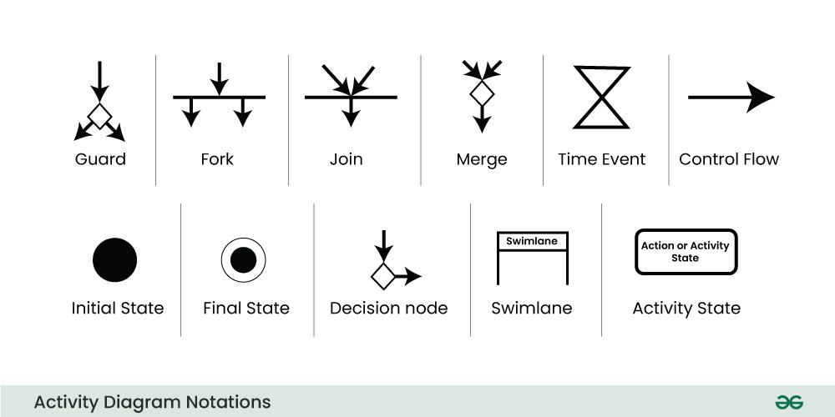

*In activity diagrams, the notations are like visual symbols that help represent different elements and actions in a simple way.*

**1. Initial State**

The starting state before an activity takes place is depicted using the initial state.

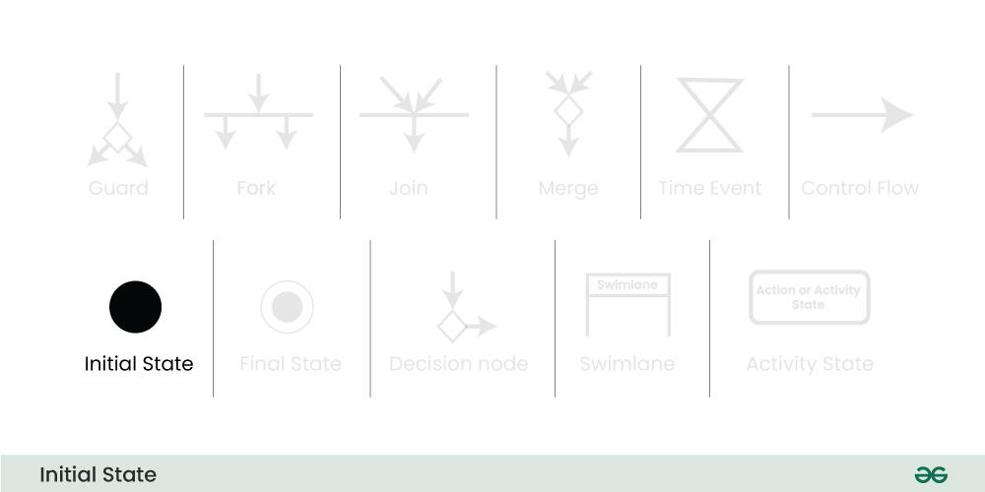

A process can have only one initial state unless we are depicting nested activities. We use a black filled circle to depict the initial state of a system. For objects, this is the state when they are instantiated. The Initial State from the UML Activity Diagram marks the entry point and the initial Activity State.

**For example:**

*Here the initial state of the system before the application is opened.*

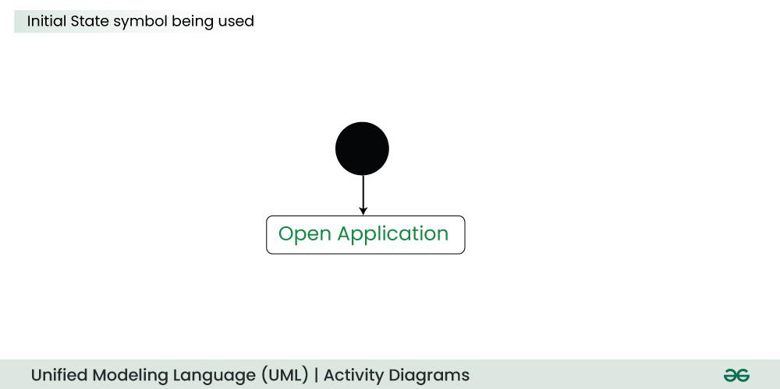

**2. Action or Activity State**

An activity represents execution of an action on objects or by objects. We represent an activity using a rectangle with rounded corners. Basically any action or event that takes place is represented using an activity.

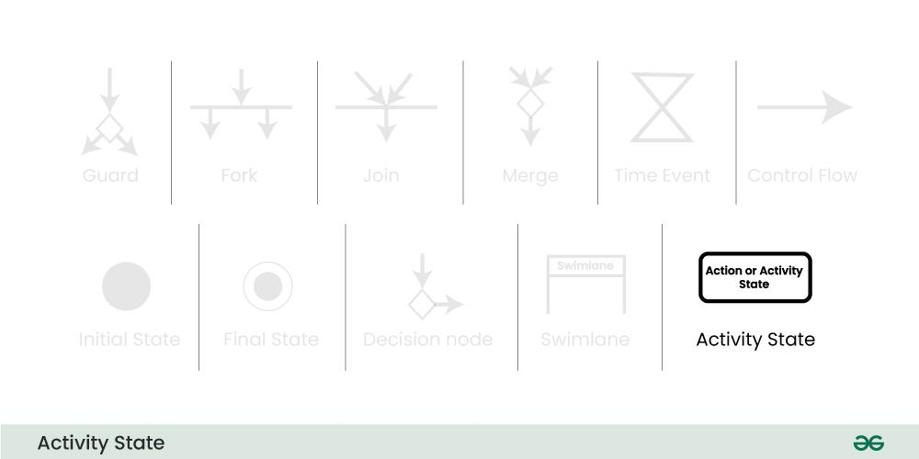**For example**:

*Consider the previous example of opening an application, opening the application is an activity state in the activity diagram.*

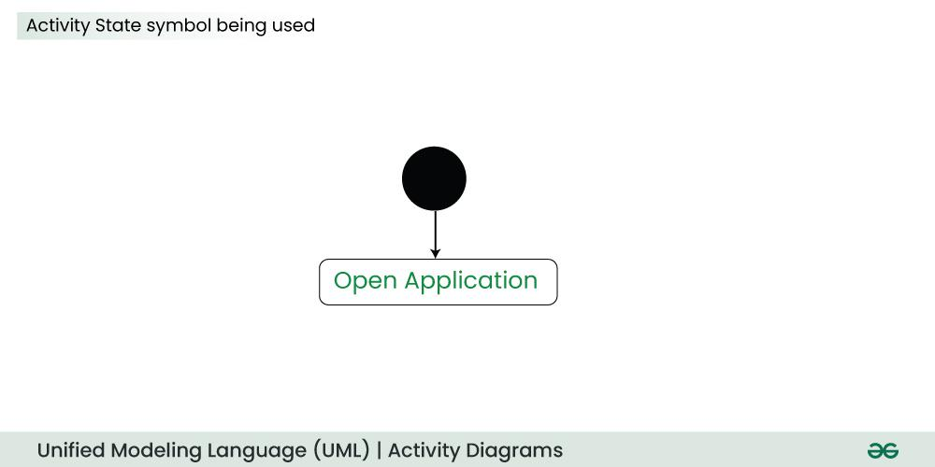

**3. Action Flow or Control flows**

Action flows or Control flows are also referred to as paths and edges. They are used to show the transition from one activity state to another activity state.

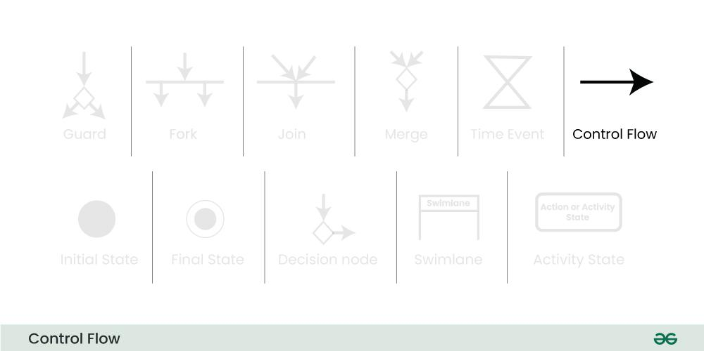

An activity state can have multiple incoming and outgoing action flows. We use a line with an arrow head to depict a Control Flow. If there is a constraint to be adhered to while making the transition it is mentioned on the arrow.

**For example**:

*Here both the states transit into one final state using action flow symbols i.e. arrows.*

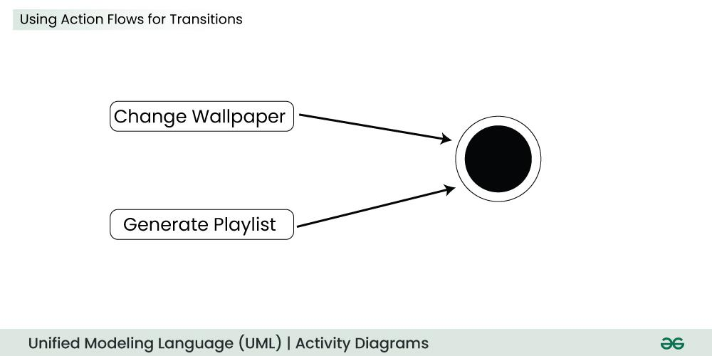

**4. Decision node and Branching**

When we need to make a decision before deciding the flow of control, we use the decision node. The outgoing arrows from the decision node can be labelled with conditions or guard expressions. It always includes two or more output arrows.

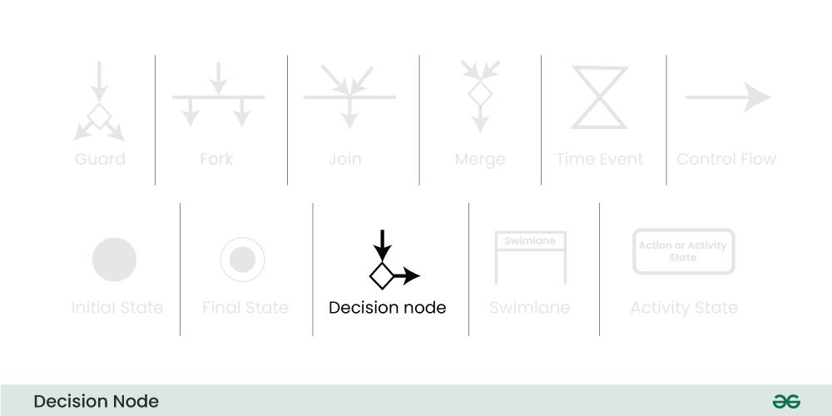

**For example:**

*We apply the conditions on input number to display the result :*

* *If number is odd then display the number.*
* *If number if even then display the error.*

**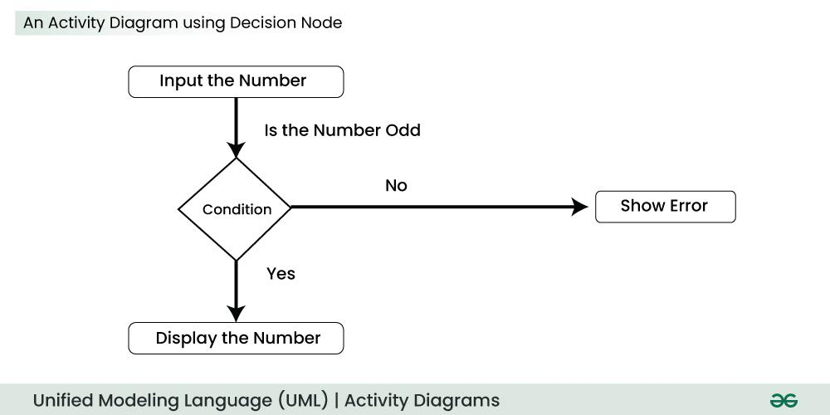5. Guard**

A Guard refers to a statement written next to a decision node on an arrow sometimes within square brackets.

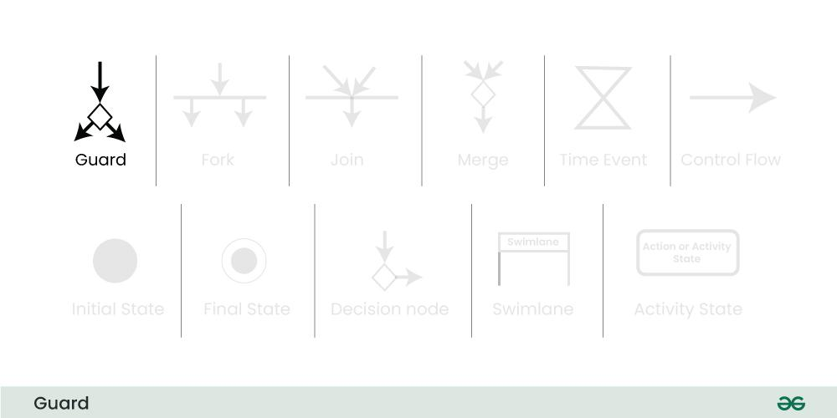

The statement must be true for the control to shift along a particular direction. Guards help us know the constraints and conditions which determine the flow of a process.

**6. Fork**

Fork nodes are used to support concurrent activities. When we use a fork node when both the activities get executed concurrently i.e. no decision is made before splitting the activity into two parts. Both parts need to be executed in case of a fork statement. We use a rounded solid rectangular bar to represent a Fork notation with incoming arrow from the parent activity state and outgoing arrows towards the newly created activities.

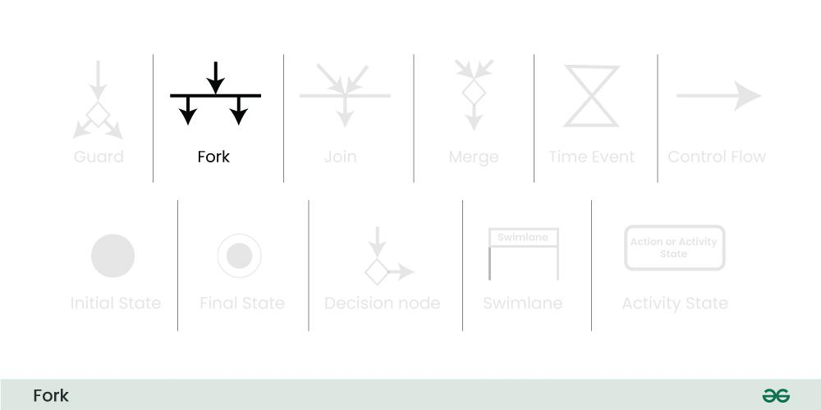

**For example:**

*In the example below, the activity of making coffee can be split into two concurrent activities and hence we use the fork notation.*

**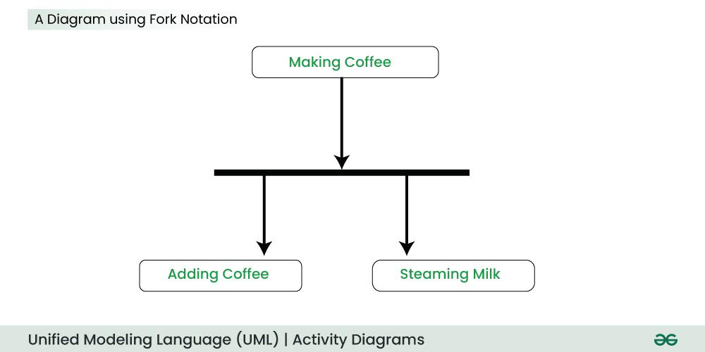7. Join**

Join nodes are used to support concurrent activities converging into one. For join notations we have two or more incoming edges and one outgoing edge.

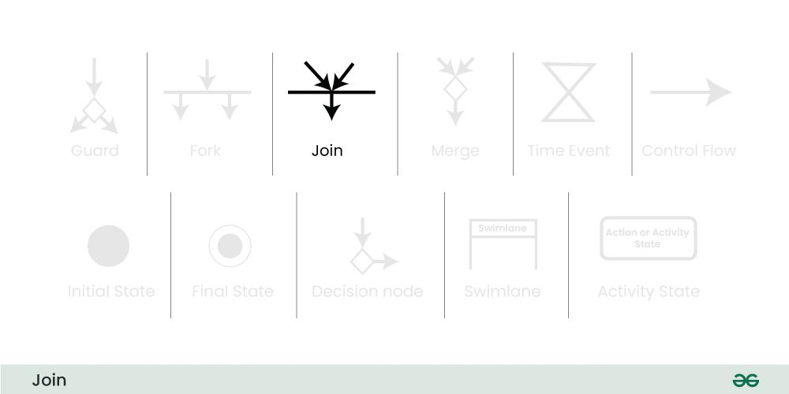

**For example:**

*When both activities i.e. steaming the milk and adding coffee get completed, we converge them into one final activity.*

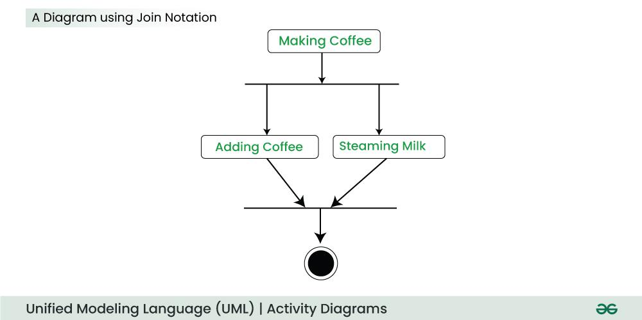

**8. Merge or Merge Event**

Scenarios arise when activities which are not being executed concurrently have to be merged. We use the merge notation for such scenarios. We can merge two or more activities into one if the control proceeds onto the next activity irrespective of the path chosen.

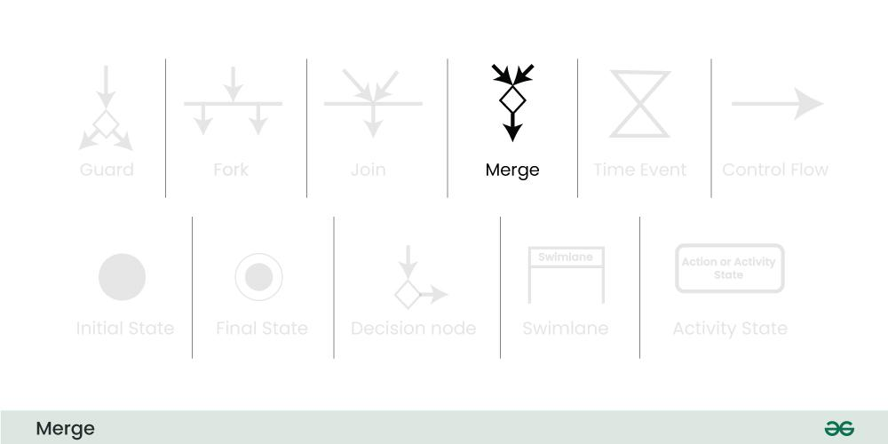

**For example:**

*In the diagram below: we can't have both sides executing concurrently, but they finally merge into one. A number can't be both odd and even at the same time.*

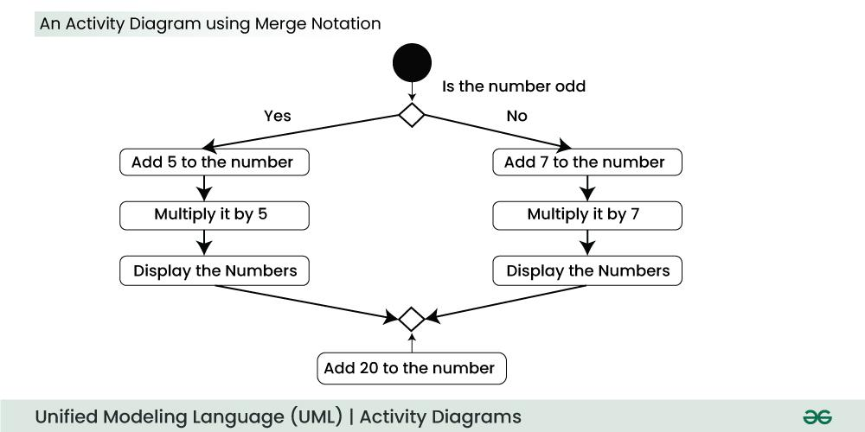

**9. Swimlanes**

We use Swimlanes for grouping related activities in one column. Swimlanes group related activities into one column or one row. Swimlanes can be vertical and horizontal. Swimlanes are used to add modularity to the activity diagram. It is not mandatory to use swimlanes. They usually give more clarity to the activity diagram. It's similar to creating a function in a program. It's not mandatory to do so, but, it is a recommended practice.

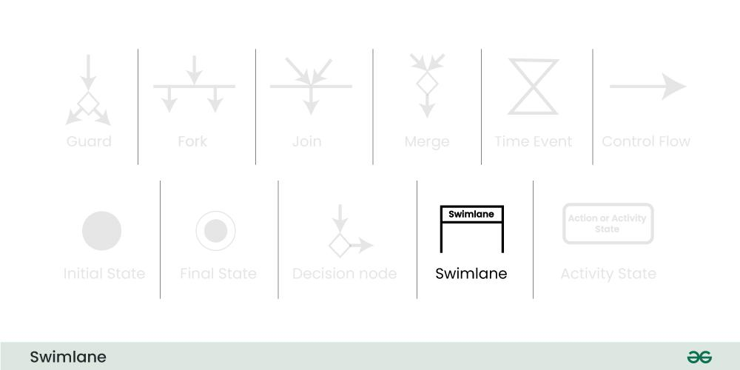

We use a rectangular column to represent a swimlane as shown in the figure above.

**For example:**

*Here different set of activities are executed based on if the number is odd or even. These activities are grouped into a swimlane.*

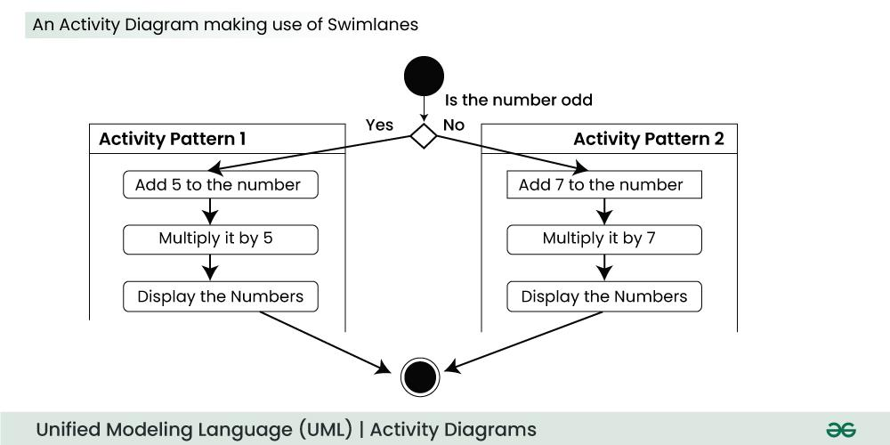

**10. Time Event**

This refers to an event that stops the flow for a time; an hourglass depicts it. We can have a scenario where an event takes some time to completed.

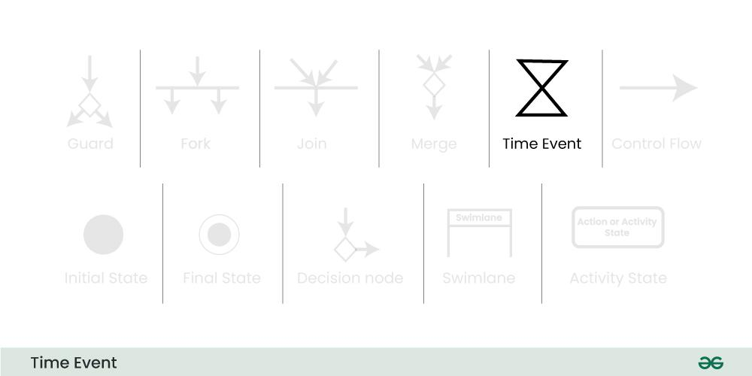

**For example:**

*Let us assume that the processing of an image takes a lot of time. Then it can be represented as shown below.*

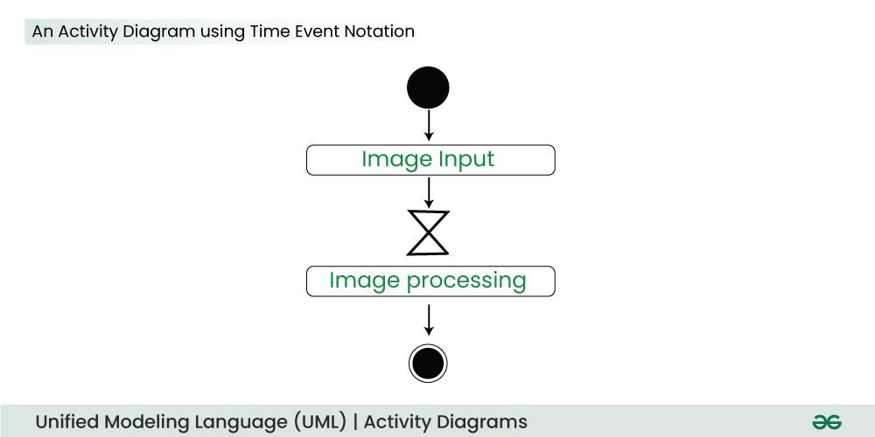

**11. Final State or End State**

The state which the system reaches when a particular process or activity ends is known as a Final State or End State. We use a filled circle within a circle notation to represent the final state in a state machine diagram. A system or a process can have multiple final states.

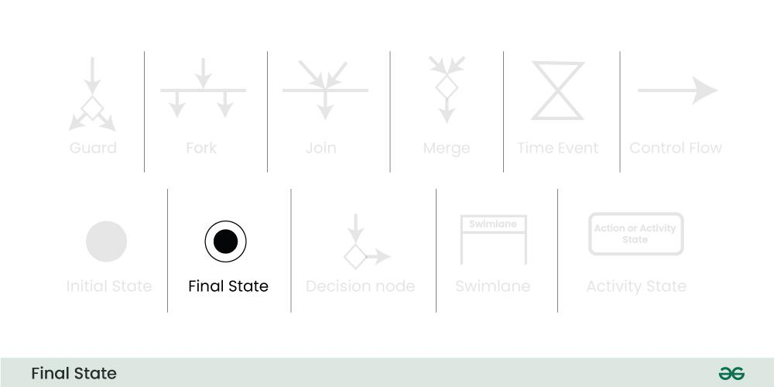

**How to Draw an Activity Diagram in UML?**

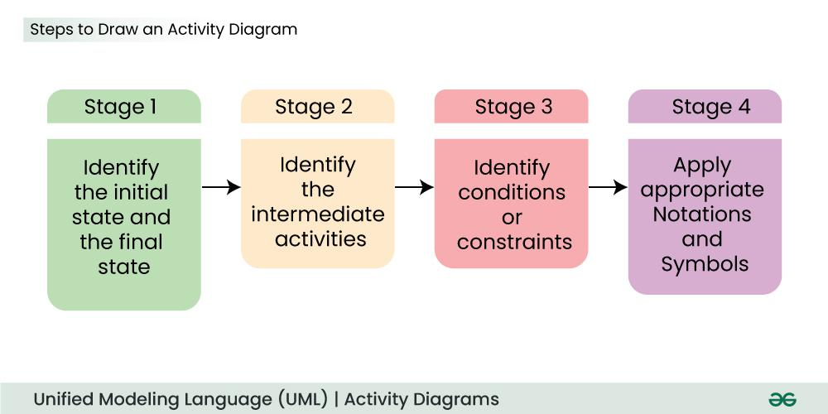

Below are the steps of how to draw the Activity Diagram in UML:

**Step 1. Identify the Initial State and Final States:**

* This is like setting the starting point and ending point of a journey.
* Identify where your process begins (initial state) and where it concludes (final states).
* For example, if you are modelling a process for making a cup of tea, the initial state could be "No tea prepared," and the final state could be "Tea ready."

**Step 2. Identify the Intermediate Activities Needed:**

* Think of the steps or actions required to go from the starting point to the ending point.
* These are the activities or tasks that need to be performed.
* Continuing with the tea-making , intermediate activities could include "Boil water," "Pour tea into a cup".

**Step 3. Identify the Conditions or Constraints:**

* Consider the conditions or circumstances that might influence the flow of your process.
* These are the factors that determine when you move from one activity to another.
* Using the tea-making scenario, a condition could be "Water is boiled," which triggers the transition to the next activity.

**Step 4. Draw the Diagram with Appropriate Notations:**

Now, represent the identified states, activities, and conditions visually using the appropriate symbols and notations in an activity diagram. This diagram serves as a visual map of your process, showing the flow from one state to another.

**Activity Diagram Example**

Here’s an example of an activity diagram that shows the process of making an online purchase:

**Steps:**

* Browse items on the website.
* Select products and add them to the cart.
* Proceed to checkout.
* Enter shipping details.
* Select payment method.
  + If the payment is successful, the order is confirmed, and a receipt is generated.
  + If the payment fails, the user is prompted to try again.
* End process.

**What are the Differences between an Activity diagram and a Flowchart?**

An activity diagram is very similar to a flowchart. So let us understand if activity diagrams or flowcharts are any different.

**What is a Flow Chart?**

An algorithm is like a set of clear instructions to solve a problem, and a flowchart is a picture that shows those instructions.

* When we're writing computer programs, a flowchart helps us map out the steps of the algorithm to solve the problem.
* Non programmers use Flow charts to model workflows.
* We can call a flowchart a primitive version of an activity diagram.
* Business processes where decision making is involved is expressed using a flow chart.

**Example:**

*A manufacturer uses a flow chart to explain and illustrate how a particular product is manufactured.*

| **Aspect** | **Activity Diagram** | **Flowchart** |
| --- | --- | --- |
| **Purpose** | Represents the flow of control in a system or process, focusing on activities and conditions. | Depicts the step-by-step flow of a process or algorithm, focusing on operations. |
| **Used In** | Primarily used in software and systems modeling, especially in UML (Unified Modeling Language). | Commonly used in various fields like programming, business, and process mapping. |
| **Complexity** | Can represent both simple and complex workflows, including concurrent processing. | Typically used for simpler, linear processes, though can handle limited complexity. |
| **Symbols** | Uses UML symbols like initial nodes, activity nodes, decisions, swimlanes, etc. | Uses basic symbols like rectangles (process), diamonds (decisions), and arrows (flow). |
| **Concurrency Representation** | Supports concurrent activities and parallel flows. | Does not support parallel processes explicitly; focuses on sequential flow. |

**Do we need to use both the diagrams and the textual documentation?**

Let's understand this with the help of an example:

* Different individuals have different preferences in which they understand something.
* To understand a concept, some people might prefer a written tutorial with images while others would prefer a video lecture.
* So we generally use both the diagram and the textual documentation to make our system description as clear as possible.

**Conclusion**

In conclusion, Activity Diagrams serve as invaluable tools in system design and analysis, offering a visual representation of dynamic processes within organizations. They are widely utilized to model business processes, illustrate user interactions, and guide software system design. By providing a clear and concise overview of activities, decision points, and interactions, activity diagrams enhance communication among project stakeholders and contribute to effective documentation.

**Activity diagrams**[[1]](https://en.wikipedia.org/wiki/Activity_diagram#cite_note-OMG-1) are graphical representations of [workflows](https://en.wikipedia.org/wiki/Workflow) of stepwise activities and actions[[2]](https://en.wikipedia.org/wiki/Activity_diagram#cite_note-2) with support for choice, iteration, and concurrency. In the [Unified Modeling Language](https://en.wikipedia.org/wiki/Unified_Modeling_Language), activity diagrams are intended to model both computational and organizational processes (i.e., workflows), as well as the data flows intersecting with the related activities.[[1]](https://en.wikipedia.org/wiki/Activity_diagram#cite_note-OMG-1)[[3]](https://en.wikipedia.org/wiki/Activity_diagram#cite_note-3) "Object nodes hold data that is input to and output from executable nodes, and moves across object flow edges. Control nodes specify sequencing of executable nodes via control flow edges."[[1]](https://en.wikipedia.org/wiki/Activity_diagram#cite_note-OMG-1) In other words, although activity diagrams primarily show the overall control flow, they can also include elements showing the data flow between activities through one or more data stores.[[1]](https://en.wikipedia.org/wiki/Activity_diagram#cite_note-OMG-1)

**Construction**

Activity diagrams are constructed from a limited number of shapes, connected with arrows.[[4]](https://en.wikipedia.org/wiki/Activity_diagram#cite_note-4) The most important shape types are as follows:

* [*stadia*](https://en.wikipedia.org/wiki/Stadium_(geometry)) represent *actions*;
* *diamonds* represent *decisions*;
* *bars* represent the start (*split*) or end (*join*) of concurrent activities;
* a *black circle* represents the start (*initial node*) of the workflow;
* an *encircled black circle* represents the end (*final node*).

Arrows run from the start towards the end and represent the order in which activities happen.

Activity diagrams can be regarded as a form of a structured [flowchart](https://en.wikipedia.org/wiki/Flowchart) combined with a traditional data flow diagram. Typical flowchart techniques lack constructs for expressing concurrency.[[5]](https://en.wikipedia.org/wiki/Activity_diagram#cite_note-5) However, the join and split symbols in activity diagrams only resolve this for simple cases. The meaning of the model is not clear when these symbols are arbitrarily combined with decisions or loops.[[*citation needed*](https://en.wikipedia.org/wiki/Wikipedia:Citation_needed)]

While in UML 1.x, activity diagrams were a specialized form of state diagram,[[6]](https://en.wikipedia.org/wiki/Activity_diagram#cite_note-6) in UML 2.x, the activity diagrams were reformalized to be based on [Petri net](https://en.wikipedia.org/wiki/Petri_net)-like semantics, increasing the scope of situations that can be modeled using activity diagrams.[[7]](https://en.wikipedia.org/wiki/Activity_diagram#cite_note-7) These changes cause many UML 1.x activity diagrams to be interpreted differently in UML 2.x.[[*citation needed*](https://en.wikipedia.org/wiki/Wikipedia:Citation_needed)]

UML activity diagrams in version 2.x can be used in various domains, e.g. in design of embedded systems. It is possible to verify such a specification using model checking techniques.[[8]](https://en.wikipedia.org/wiki/Activity_diagram#cite_note-8)

**Sequence Diagrams - Unified Modeling Language (UML)**

**Last Updated : 03 Jan, 2025**

A Sequence Diagram is a key component of [Unified Modeling Language (UML)](https://www.geeksforgeeks.org/system-design/unified-modeling-language-uml-introduction/) used to visualize the interaction between objects in a sequential order. It focuses on how objects communicate with each other over time, making it an essential tool for modeling dynamic behavior in a system. Sequence diagrams illustrate object interactions, message flows, and the sequence of operations, making them valuable for understanding use cases, designing system architecture, and documenting complex processes.

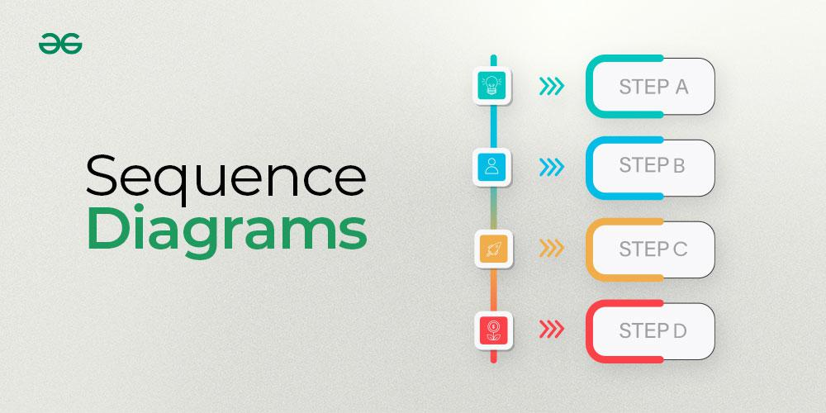

Table of Content

* [What are Sequence Diagrams?](https://www.geeksforgeeks.org/system-design/unified-modeling-language-uml-sequence-diagrams/#what-are-sequence-diagrams)
* [Why use Sequence Diagrams?](https://www.geeksforgeeks.org/system-design/unified-modeling-language-uml-sequence-diagrams/#why-use-sequence-diagrams)
* [Sequence Diagram Notations](https://www.geeksforgeeks.org/system-design/unified-modeling-language-uml-sequence-diagrams/#1-sequence-diagram-notation)
  + [Actors](https://www.geeksforgeeks.org/system-design/unified-modeling-language-uml-sequence-diagrams/#11-actors)
  + [Lifelines](https://www.geeksforgeeks.org/system-design/unified-modeling-language-uml-sequence-diagrams/#12-lifelines)
  + [Messages](https://www.geeksforgeeks.org/system-design/unified-modeling-language-uml-sequence-diagrams/#13-messages)
  + [Create message](https://www.geeksforgeeks.org/system-design/unified-modeling-language-uml-sequence-diagrams/#14-create-message)
  + [Delete Message](https://www.geeksforgeeks.org/system-design/unified-modeling-language-uml-sequence-diagrams/#15-delete-message)
  + [Self Message](https://www.geeksforgeeks.org/system-design/unified-modeling-language-uml-sequence-diagrams/#16-self-message)
  + [Reply Message](https://www.geeksforgeeks.org/system-design/unified-modeling-language-uml-sequence-diagrams/#17-reply-message)
  + [Found Message](https://www.geeksforgeeks.org/system-design/unified-modeling-language-uml-sequence-diagrams/#18-found-message)
  + [Lost Message](https://www.geeksforgeeks.org/system-design/unified-modeling-language-uml-sequence-diagrams/#19-lost-message)
  + [Guards](https://www.geeksforgeeks.org/system-design/unified-modeling-language-uml-sequence-diagrams/#110-guards)
* [How to create Sequence Diagrams?](https://www.geeksforgeeks.org/system-design/unified-modeling-language-uml-sequence-diagrams/#2-how-to-create-sequence-diagrams)
* [Use cases of Sequence Diagrams](https://www.geeksforgeeks.org/system-design/unified-modeling-language-uml-sequence-diagrams/#3-use-cases-of-sequence-diagrams)
* [Challenges of using Sequence Diagrams](https://www.geeksforgeeks.org/system-design/unified-modeling-language-uml-sequence-diagrams/#4-challenges-of-using-sequence-diagrams)

What are Sequence Diagrams?

Sequence diagrams are a type of UML (Unified Modeling Language) diagram that visually represent the interactions between objects or components in a system over time. They focus on the order and timing of messages or events exchanged between different system elements. The diagram captures how objects communicate with each other through a series of messages, providing a clear view of the sequence of operations or processes.

Why use Sequence Diagrams?

Sequence diagrams are used because they offer a clear and detailed visualization of the interactions between objects or components in a system, focusing on the order and timing of these interactions. Here are some key reasons for using sequence diagrams:

* Visualizing Dynamic Behavior: Sequence diagrams depict how objects or systems interact with each other in a sequential manner, making it easier to understand dynamic processes and workflows.
* Clear Communication: They provide an intuitive way to convey system behavior, helping teams understand complex interactions without diving into code.
* Use Case Analysis: Sequence diagrams are useful for analyzing and representing use cases, making it clear how specific processes are executed within a system.
* Designing System Architecture: They assist in defining how various components or services in a system communicate, which is essential for designing complex, distributed systems or service-oriented architectures.
* Documenting System Behavior: Sequence diagrams provide an effective way to document how different parts of a system work together, which can be useful for both developers and maintenance teams.
* Debugging and Troubleshooting: By modeling the sequence of interactions, they help identify potential bottlenecks, inefficiencies, or errors in system processes.

Sequence Diagram Notations

1. Actors

An actor in a UML diagram represents a type of role where it interacts with the system and its objects. It is important to note here that an actor is always outside the scope of the system we aim to model using the UML diagram.

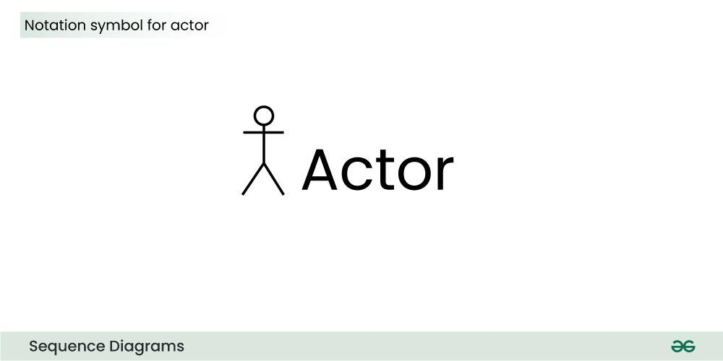

We use actors to depict various roles including human users and other external subjects. We represent an actor in a UML diagram using a stick person notation. We can have multiple actors in a sequence diagram.

For example:

*Here the user in seat reservation system is shown as an actor where it exists outside the system and is not a part of the system.*

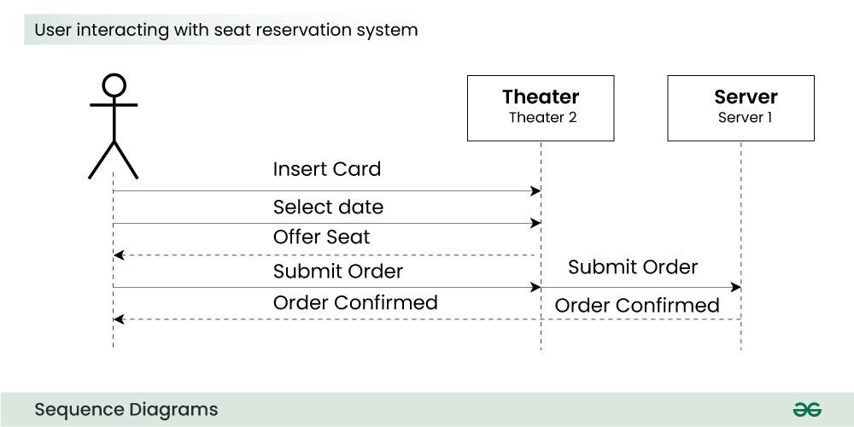

2. Lifelines

A lifeline is a named element which depicts an individual participant in a sequence diagram. So basically each instance in a sequence diagram is represented by a lifeline. Lifeline elements are located at the top in a sequence diagram. The standard in UML for naming a lifeline follows the following format:

*Instance Name : Class Name*

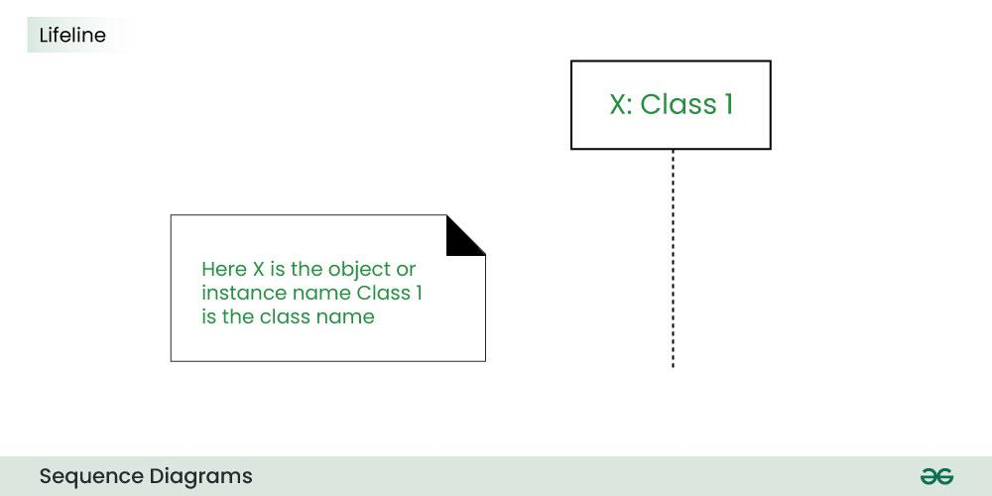

We display a lifeline in a rectangle called head with its name and type. The head is located on top of a vertical dashed line (referred to as the stem) as shown above.

* If we want to model an unnamed instance, we follow the same pattern except now the portion of lifeline's name is left blank.
* Difference between a lifeline and an actor
  + A lifeline always portrays an object internal to the system whereas actors are used to depict objects external to the system.

The following is an example of a sequence diagram:

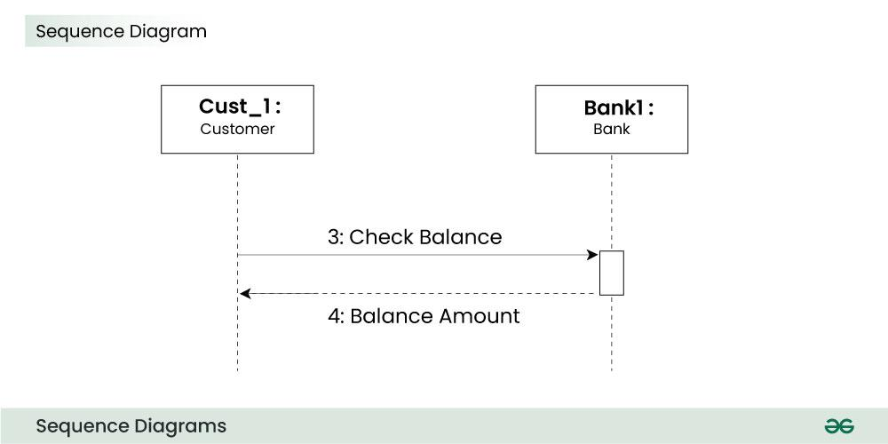

3. Messages

Communication between objects is depicted using messages. The messages appear in a sequential order on the lifeline.

* We represent messages using arrows.
* Lifelines and messages form the core of a sequence diagram.

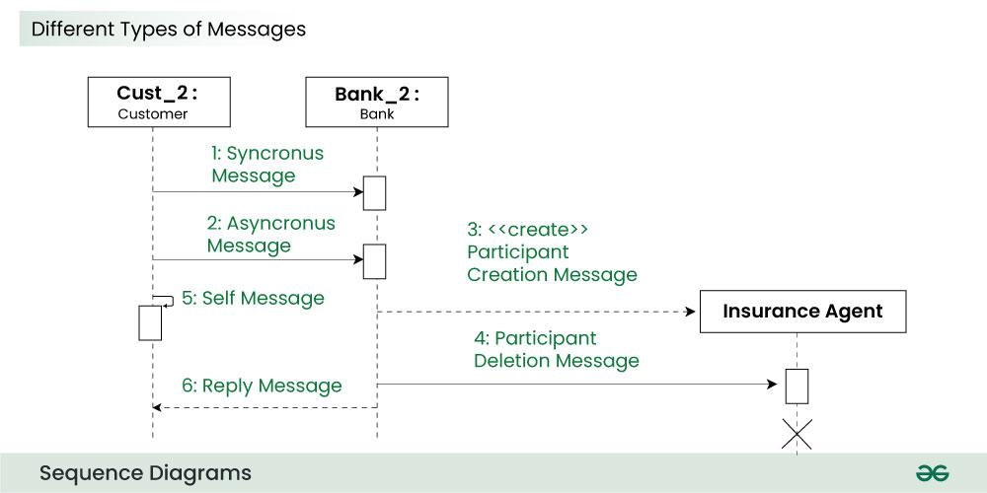

Messages can be broadly classified into the following categories:

1. Synchronous messages

A synchronous message waits for a reply before the interaction can move forward. The sender waits until the receiver has completed the processing of the message. The caller continues only when it knows that the receiver has processed the previous message i.e. it receives a reply message.

* A large number of calls in object oriented programming are synchronous.
* We use a solid arrow head to represent a synchronous message.

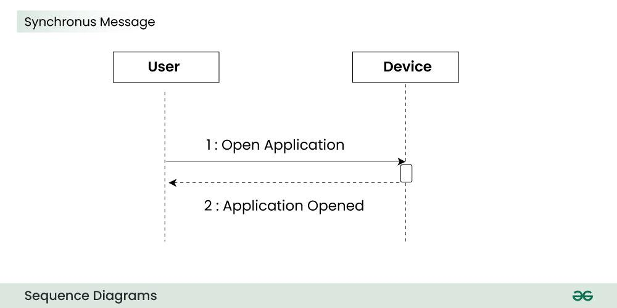

2. Asynchronous Messages

An asynchronous message does not wait for a reply from the receiver. The interaction moves forward irrespective of the receiver processing the previous message or not. We use a lined arrow head to represent an asynchronous message.

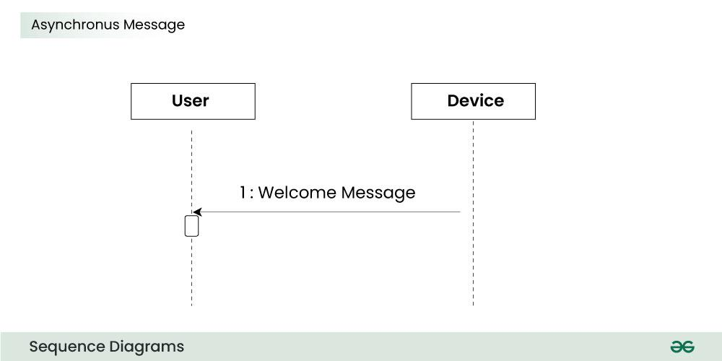

4. Create message

We use a Create message to instantiate a new object in the sequence diagram. There are situations when a particular message call requires the creation of an object. It is represented with a dotted arrow and create word labelled on it to specify that it is the create Message symbol.

For example:

*The creation of a new order on a e-commerce website would require a new object of Order class to be created.*

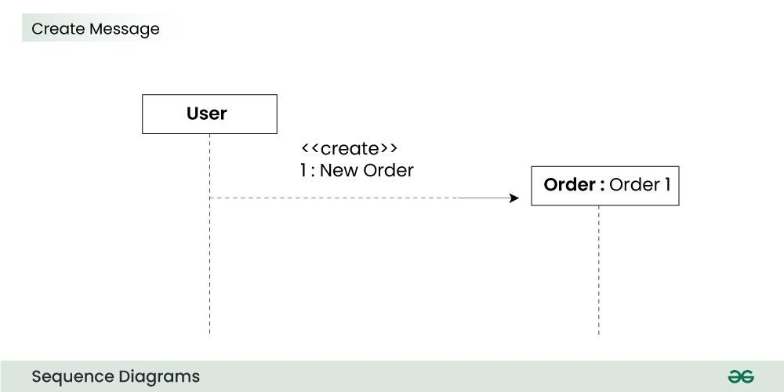

5. Delete Message

We use a Delete Message to delete an object. When an object is deallocated memory or is destroyed within the system we use the Delete Message symbol. It destroys the occurrence of the object in the system.It is represented by an arrow terminating with a x.

For example:

*In the scenario below when the order is received by the user, the object of order class can be destroyed.*

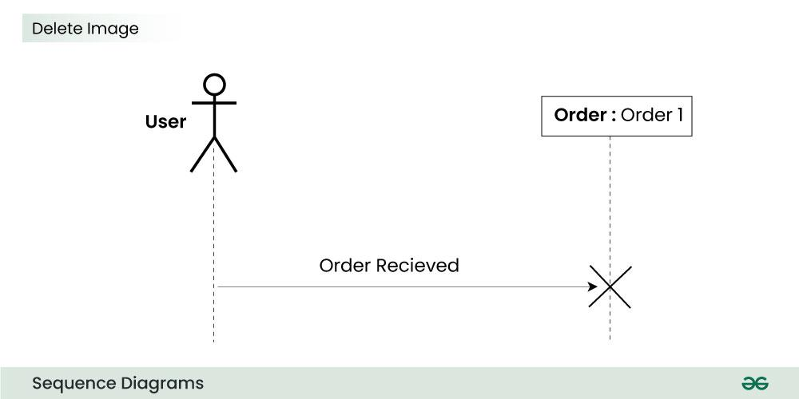

6. Self Message

Certain scenarios might arise where the object needs to send a message to itself. Such messages are called Self Messages and are represented with a U shaped arrow.

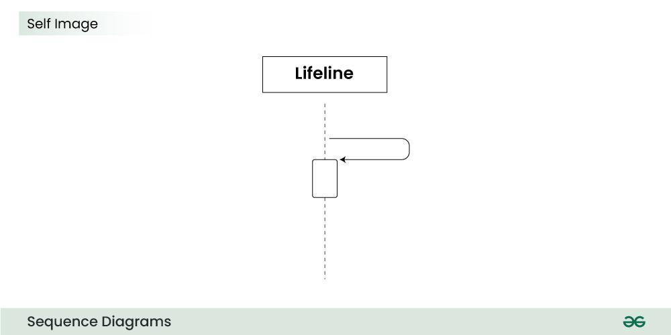

For example:

*Consider a scenario where the device wants to access its webcam. Such a scenario is represented using a self message.*

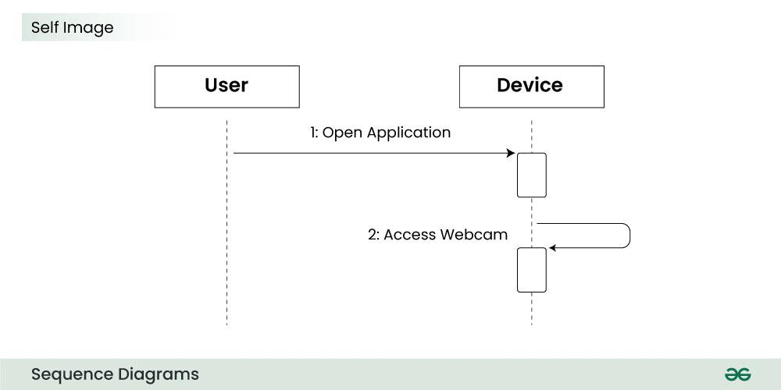

7. Reply Message

Reply messages are used to show the message being sent from the receiver to the sender. We represent a return/reply message using an open arrow head with a dotted line. The interaction moves forward only when a reply message is sent by the receiver.

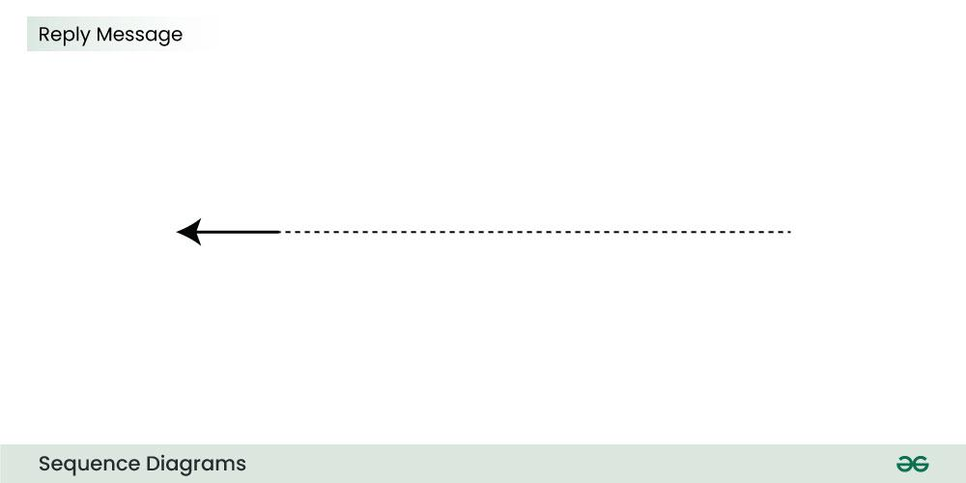

For example:

*Consider the scenario where the device requests a photo from the user. Here the message which shows the photo being sent is a reply message.*

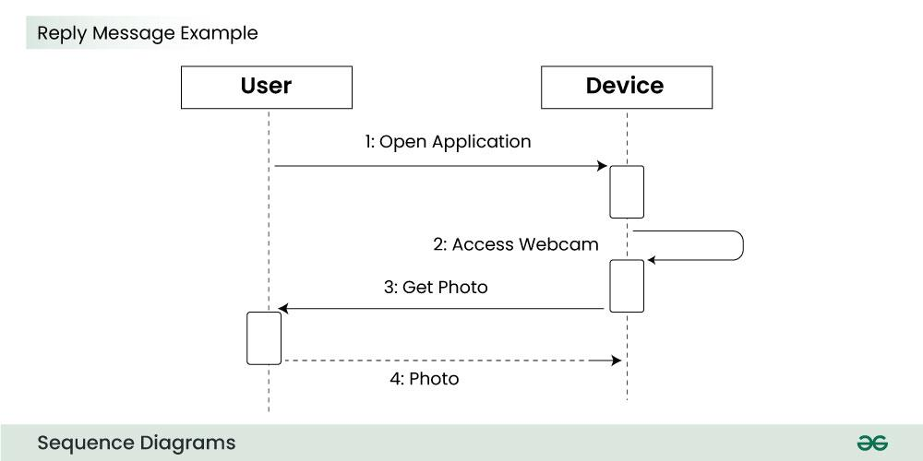

8. Found Message

A Found message is used to represent a scenario where an unknown source sends the message. It is represented using an arrow directed towards a lifeline from an end point.

For example:

*Consider the scenario of a hardware failure.*

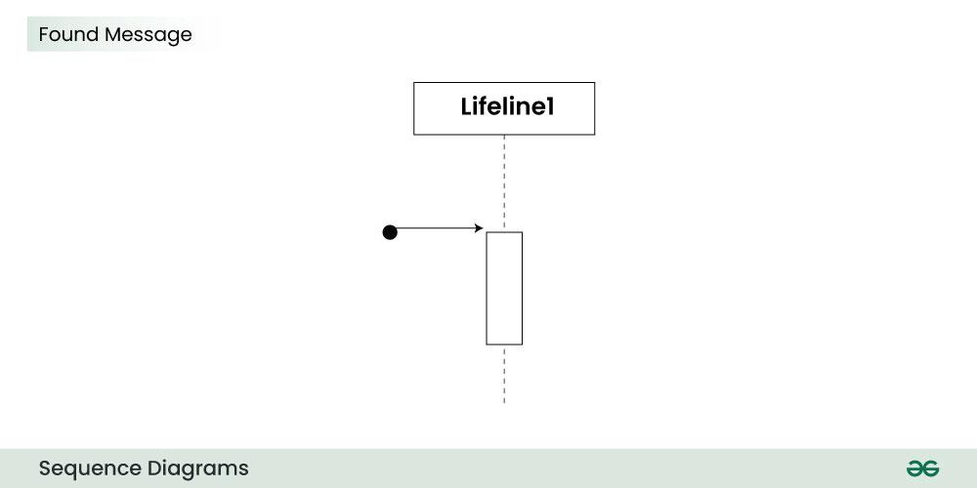

It can be due to multiple reasons and we are not certain as to what caused the hardware failure.

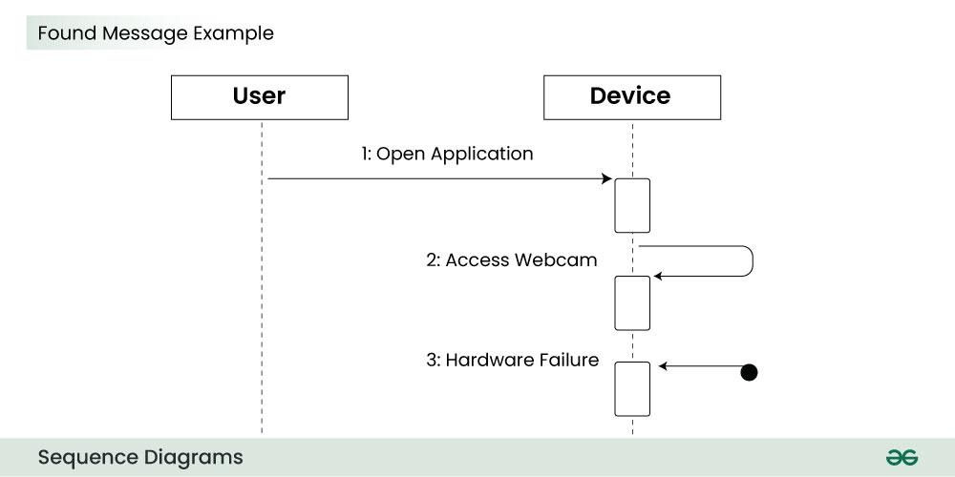

9. Lost Message

A Lost message is used to represent a scenario where the recipient is not known to the system. It is represented using an arrow directed towards an end point from a lifeline.

For example:

*Consider a scenario where a warning is generated.*

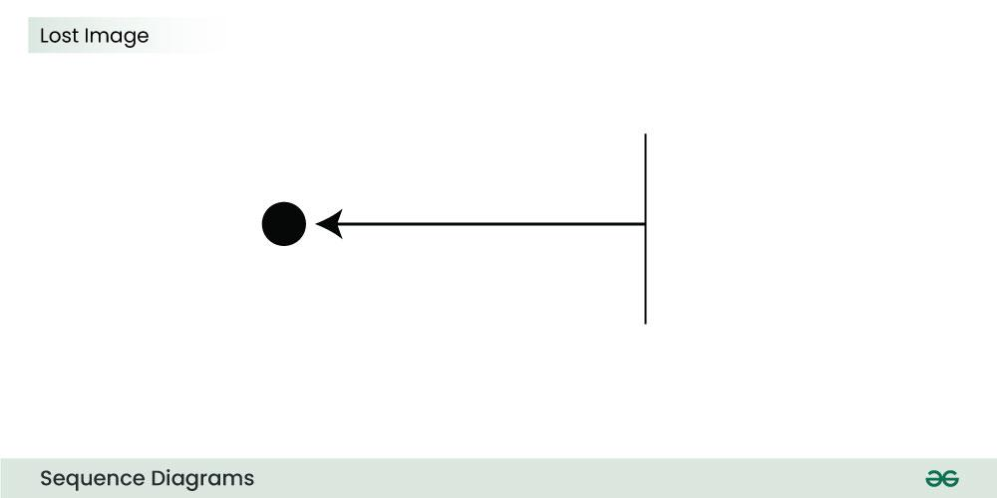

The warning might be generated for the user or other software/object that the lifeline is interacting with. Since the destination is not known before hand, we use the Lost Message symbol.

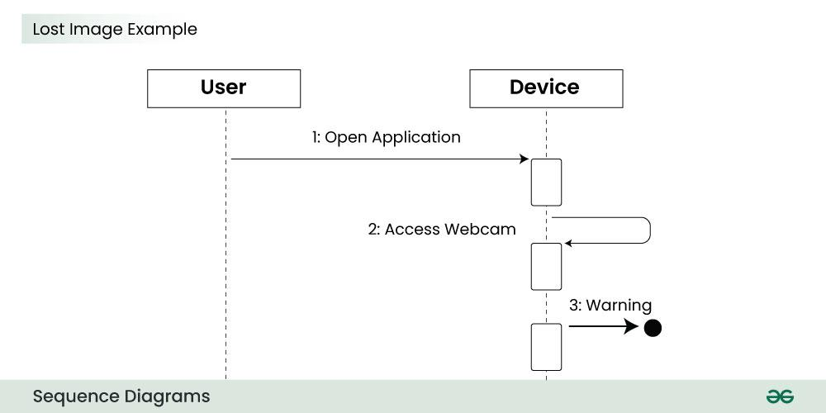

10. Guards

To model conditions we use guards in UML. They are used when we need to restrict the flow of messages on the pretext of a condition being met. Guards play an important role in letting software developers know the constraints attached to a system or a particular process.

For example:

*In order to be able to withdraw cash, having a balance greater than zero is a condition that must be met as shown below.*

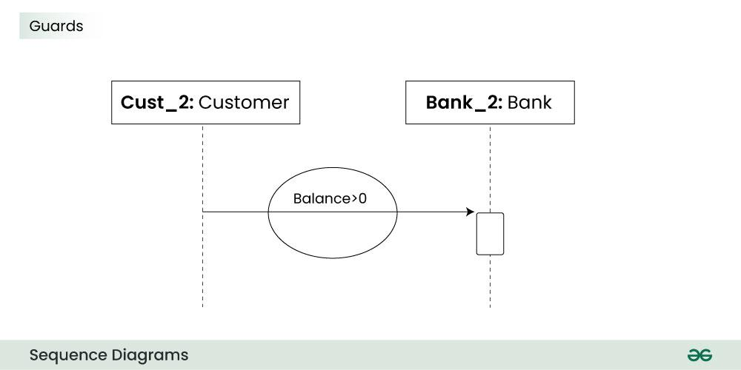

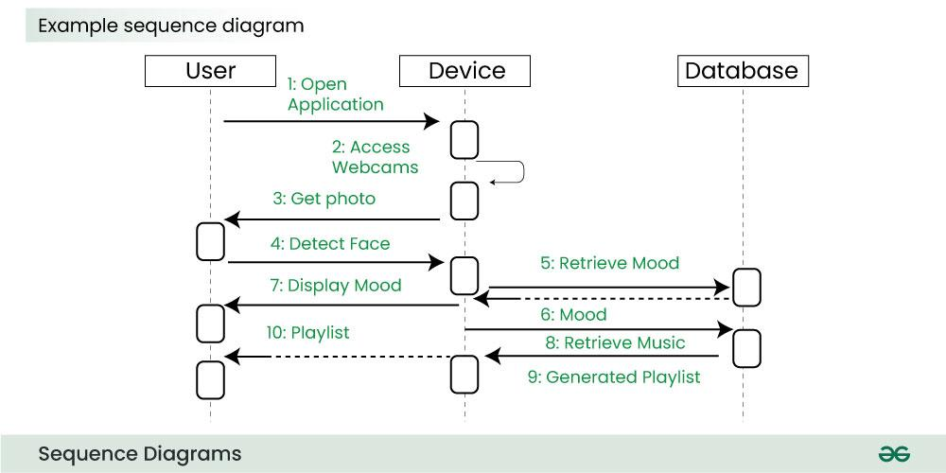

The above sequence diagram depicts the sequence diagram for an emotion based music player:

* Firstly the application is opened by the user.
* The device then gets access to the web cam.
* The webcam captures the image of the user.
* The device uses algorithms to detect the face and predict the mood.
* It then requests database for dictionary of possible moods.
* The mood is retrieved from the database.
* The mood is displayed to the user.
* The music is requested from the database.
* The playlist is generated and finally shown to the user.

How to create Sequence Diagrams?

Creating a sequence diagram involves several steps, and it's typically done during the design phase of software development to illustrate how different components or objects interact over time. Here's a step-by-step guide on how to create sequence diagrams:

* Step 1: Identify the Scenario:
  + Understand the specific scenario or use case that you want to represent in the sequence diagram. This could be a specific interaction between objects or the flow of messages in a particular process.
* Step 2: List the Participants:
  + Identify the participants (objects or actors) involved in the scenario. Participants can be users, systems, or external entities.
* Step 3: Define Lifelines:
  + Draw a vertical dashed line for each participant, representing the lifeline of each object over time. The lifeline represents the existence of an object during the interaction.
* Step 4: Arrange Lifelines:
  + Position the lifelines horizontally in the order of their involvement in the interaction. This helps in visualizing the flow of messages between participants.
* Step 5: Add Activation Bars:
  + For each message, draw an activation bar on the lifeline of the sending participant. The activation bar represents the duration of time during which the participant is actively processing the message.
* Step 6: Draw Messages:
  + Use arrows to represent messages between participants. Messages flow horizontally between lifelines, indicating the communication between objects. Different types of messages include synchronous (solid arrow), asynchronous (dashed arrow), and self-messages.
* Step 7: Include Return Messages:
  + If a participant sends a response message, draw a dashed arrow returning to the original sender to represent the return message.
* Step 8: Indicate Timing and Order:
  + Use numbers to indicate the order of messages in the sequence. You can also use vertical dashed lines to represent occurrences of events or the passage of time.
* Step 9: Include Conditions and Loops:
  + Use combined fragments to represent conditions (like if statements) and loops in the interaction. This adds complexity to the sequence diagram and helps in detailing the control flow.
* Step 10: Consider Parallel Execution:
  + If there are parallel activities happening, represent them by drawing parallel vertical dashed lines and placing the messages accordingly.
* Step 11: Review and Refine:
  + Review the sequence diagram for clarity and correctness. Ensure that it accurately represents the intended interaction. Refine as needed.
* Step 12: Add Annotations and Comments:
  + Include any additional information, annotations, or comments that provide context or clarification for elements in the diagram.
* Step 13: Document Assumptions and Constraints:
  + If there are any assumptions or constraints related to the interaction, document them alongside the diagram.
* Step 14: Tools:
  + Use a UML modeling tool or diagramming software to create a neat and professional-looking sequence diagram. These tools often provide features for easy editing, collaboration, and documentation.

Use cases of Sequence Diagrams

* System Behavior Visualization:
  + Sequence diagrams are used to illustrate the dynamic behavior of a system by showing the interactions among various components, objects, or actors over time.
  + They provide a clear and visual representation of the flow of messages and events in a specific scenario.
* Software Design and Architecture:
  + During the design phase of software development, sequence diagrams help developers and architects plan and understand how different components and objects will interact to accomplish specific functionalities.
  + They provide a blueprint for the system's behavior.
* Communication and Collaboration:
  + Sequence diagrams serve as a communication tool among stakeholders, including developers, designers, project managers, and clients.
  + They help in conveying complex interactions in an easy-to-understand visual format, fostering collaboration and shared understanding.
* Requirements Clarification:
  + When refining system requirements, sequence diagrams can be used to clarify and specify the expected interactions between system components or between the system and external entities.
  + They help ensure a common understanding of system behavior among all stakeholders.
* Debugging and Troubleshooting:
  + Developers use sequence diagrams as a debugging tool to identify and analyze issues related to the order and timing of messages during system interactions.
  + It provides a visual representation of the flow of control and helps in locating and resolving problems.

Challenges of using Sequence Diagrams

* Complexity and Size: As systems grow in complexity, sequence diagrams can become large and intricate. Managing the size of the diagram while still accurately representing the interactions can be challenging, and overly complex diagrams may become difficult to understand.
* Abstraction Level: Striking the right balance in terms of abstraction can be challenging. Sequence diagrams need to be detailed enough to convey the necessary information, but too much detail can overwhelm readers. It's important to focus on the most critical interactions without getting bogged down in minutiae.
* Dynamic Nature: Sequence diagrams represent dynamic aspects of a system, and as a result, they may change frequently during the development process. Keeping sequence diagrams up-to-date with the evolving system can be a challenge, especially in rapidly changing or agile development environments.
* Ambiguity in Messages: Sometimes, it can be challenging to define the exact nature of messages between objects. Ambiguity in message content or meaning may lead to misunderstandings among stakeholders and impact the accuracy of the sequence diagram.
* Concurrency and Parallelism: Representing concurrent and parallel processes can be complex. While sequence diagrams have mechanisms to indicate parallel execution, visualizing multiple interactions happening simultaneously can be challenging and may require additional diagrammatic elements.
* Real-Time Constraints: Representing real-time constraints and precise timing requirements can be challenging. While sequence diagrams provide a sequential representation, accurately capturing and communicating real-time aspects might require additional documentation or complementary diagrams.

In [software engineering](https://en.wikipedia.org/wiki/Software_engineering), a **sequence diagram**[[1]](https://en.wikipedia.org/wiki/Sequence_diagram#cite_note-OMG-1) shows process interactions arranged in time sequence. This diagram depicts the processes and objects involved and the sequence of messages exchanged as needed to carry out the functionality. Sequence diagrams are typically associated with use case realizations in the [4+1 architectural view model](https://en.wikipedia.org/wiki/4%2B1_architectural_view_model) of the system under development. Sequence diagrams are sometimes called **event diagrams** or **event scenarios**.

For a particular scenario of a [use case](https://en.wikipedia.org/wiki/Use_case), the diagrams show the events that external actors generate, their order, and possible inter-system events.[[2]](https://en.wikipedia.org/wiki/Sequence_diagram#cite_note-2) The diagram emphasizes events that cross the system boundary from actors to systems. A system sequence diagram should be done for the main success scenario of the [use case](https://en.wikipedia.org/wiki/Use_case), and frequent or complex alternative scenarios.

There are two kinds of sequence diagrams:

* **Sequence Diagram (SD)**: A regular version of sequence diagram describes how the system operates, and every object within a system is described specifically.
* **System Sequence Diagram (SSD)**: All [systems](https://en.wikipedia.org/wiki/Software_system) are treated as a [black box](https://en.wikipedia.org/wiki/Black_box), where all classes owned by the system are not depicted. Instead, only an object named System is depicted.

**Key elements of sequence diagrams**

A sequence diagram shows, as parallel vertical lines (*lifelines*), different processes or objects that live simultaneously, and, as horizontal arrows, the messages exchanged between them in the order in which they occur. This allows for the graphical specification of simple runtime scenarios.

A system sequence diagram should specify and show the following:

* External actors
* Messages (methods) invoked by these actors
* Return values (if any) associated with previous messages
* Indication of any loops or iteration area

**Reading a system sequence diagram**

Professionals, in developing a project, often use system sequence diagrams to illustrate how certain tasks are done between users and the system. These tasks may include repetitive, simple, or complex tasks. The purpose is to illustrate the [use case](https://en.wikipedia.org/wiki/Use_case) in a visual format. Familiarity with [unified modeling language](https://en.wikipedia.org/wiki/Unified_modeling_language) (UML) is needed to construct a system sequence diagram. These models show the logic behind the actors (people who affect the system) and the system in performing the task. Reading a sequence diagram begins at the top with the actor(s) or the system(s) (which is located at the top of the page). Under each actor or system there are long dotted lines, called "lifelines", which are attached to them. Actions are performed with lines that extend between these lifelines. The connection between an action line and a lifeline shows the interaction between the actor or system. Messages will often appear at the top or bottom of a system sequence diagram to illustrate the action in detail. For example, a request by an actor to log in would be represented by login (username, password). After each action is performed, the response or next action is located under the previous one. By reading down the lines, one can see in detail how certain actions are performed in the provided model, and in what order.

**Diagram building blocks**

If the lifeline is that of an object, it demonstrates a role. Leaving the instance name blank can represent anonymous and unnamed instances. → Messages, written with horizontal [arrows](https://en.wikipedia.org/wiki/Arrow_(symbol)) with the message name written above them, display interaction. Solid arrow heads represent synchronous calls, open arrow heads represent [asynchronous messages](https://en.wikipedia.org/wiki/Asynchronous_communication), and dashed lines represent reply messages.[[3]](https://en.wikipedia.org/wiki/Sequence_diagram#cite_note-3) If a caller sends a synchronous message, it must wait until the message is done, such as invoking a subroutine. If a caller sends an asynchronous message, it can continue processing and need not wait for a response. Asynchronous calls are present in multithreaded applications, event-driven applications, and in [message-oriented middleware](https://en.wikipedia.org/wiki/Message-oriented_middleware). Activation boxes, or [method](https://en.wikipedia.org/wiki/Method_(computer_science))-call boxes, are opaque rectangles drawn on top of lifelines to represent that processes are being performed in response to the message (ExecutionSpecifications in [UML](https://en.wikipedia.org/wiki/Unified_Modeling_Language)).

Objects calling methods on themselves use messages and add new activation boxes on top of any others to indicate a further level of [processing](https://en.wikipedia.org/wiki/Process_(computing)). If an object is [destroyed](https://en.wikipedia.org/wiki/Object_lifetime) (removed from [memory](https://en.wikipedia.org/wiki/Computer_storage)), an X is drawn below the lifeline, and the dashed line ceases to be drawn below it. It should be the result of a message, either from the object itself, or another.

A message sent from outside the diagram can be represented by a message originating from a filled-in circle (*found message* in UML) or from a border of the sequence diagram (*gate* in UML).

UML has introduced significant improvements to the capabilities of sequence diagrams. Most of these improvements are based on the idea of *interaction fragments*[[4]](https://en.wikipedia.org/wiki/Sequence_diagram#cite_note-4) which represent smaller pieces of an enclosing interaction. Multiple interaction fragments are combined to create a variety of *combined fragments*,[[5]](https://en.wikipedia.org/wiki/Sequence_diagram#cite_note-5) which are then used to model interactions that include parallelism, conditional branches, and optional interactions.

**Short note on Behavioral Model**

Last Updated : 17 Jun, 2020

Overall behavior of a system can be fully understood by Behavioral model. **Behavioral Model** is specially designed to make us understand behavior and factors that influence behavior of a System. Behavior of a system is explained and represented with the help of a diagram. This diagram is known as State Transition Diagram. It is a collection of states and events. It usually describes overall states that a system can have and events which are responsible for a change in state of a system. So, on some occurrence of a particular event, an action is taken and what action needs to be taken is represented by State Transition Diagram. **Example :** Consider an Elevator. This elevator is for n number of floors and has n number of buttons one for each floor. Elevator’s working can be explained as follows :

1. **Elevator buttons** are type of set of buttons which is there on elevator. For reaching a particular floor you want to visit, “elevator buttons” for that particular floor is pressed. Pressing, will cause illumination and elevator will start moving towards that particular floor for which you pressed “elevator buttons”. As soon as elevator reaches that particular floor, illumination gets canceled.
2. **Floor buttons** are another type of set of buttons on elevator. If a person is on a particular floor and he wants to go on another floor, then elevator button for that floor is pressed. Then, process will be same as given above. Pressing, will cause illumination and elevator to start moving, and when it reaches on desired floor, illumination gets canceled.
3. When there is no request for elevator, it remains closed on current floor.

State Transition Diagram for an elevator system is shown below -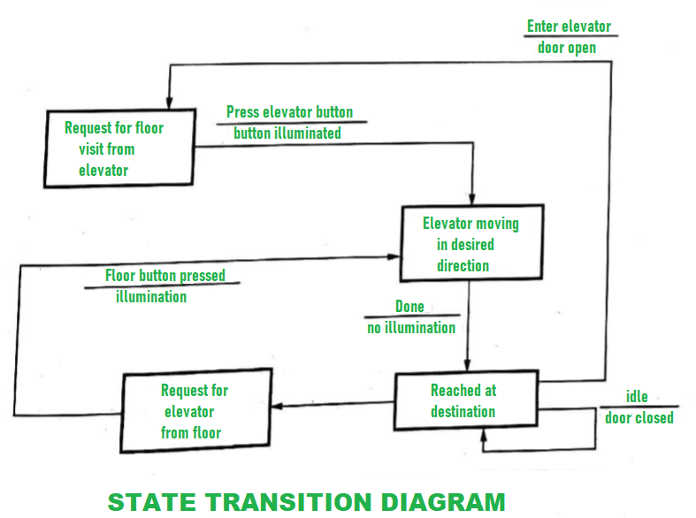**Advantages :**

* Behavior and working of a system can easily be understood without any effort.
* Results are more accurate by using this model.
* This model requires less cost for development as cost of resources can be minimal.
* It focuses on behavior of a system rather than theories.

**Disadvantages :**

* This model does not have any theory, so trainee is not able to fully understand basic principle and major concept of modeling.
* This modeling cannot be fully automated.
* Sometimes, it's not easy to understand overall result.
* Does not achieve maximum productivity due to some technical issues or any errors.
* Behavioral modeling is a key aspect of digital engineering that focuses on simulating and analyzing the behavior of systems and components under various conditions. This approach allows engineers to predict how products will perform in real-world scenarios, ensuring that they meet design specifications and functional requirements before physical prototypes are built.

## **The role of behavioral modeling in**[**product development**](https://www.technia.com/product-development/)**and manufacturing**

* Behavioral modeling enables engineers to create virtual models that replicate the behavior of physical systems. This process helps engineers to validate design choices earlier, minimizing reliance on costly physical prototypes. By identifying inefficiencies and potential failure modes, it helps optimize performance and mitigate risks, ultimately reducing development costs and accelerating time-to-market.
* Behavioral modeling also enhances manufacturing efficiency through process simulation, [quality control](https://www.technia.com/en/quality-compliance/), and maintenance planning. Simulating production workflows helps optimize processes, reduce waste, and improve operational efficiency. It also supports [quality assurance](https://www.technia.com/en/quality-assurance/) by predicting defects and ensuring adherence to standards. Additionally, it enables proactive maintenance by forecasting wear and tear, reducing downtime, and extending equipment lifespan.

**State Machine Diagrams | Unified Modeling Language (UML)**

Last Updated : 08 Apr, 2025

**A State Machine Diagram** is used to represent the condition of the system or part of the system at finite instances of time. It’s a behavioral diagram and it represents the behaviour using finite state transitions. In this article, we will explain what is a state machine diagram, the components, and the use cases of the state machine diagram.

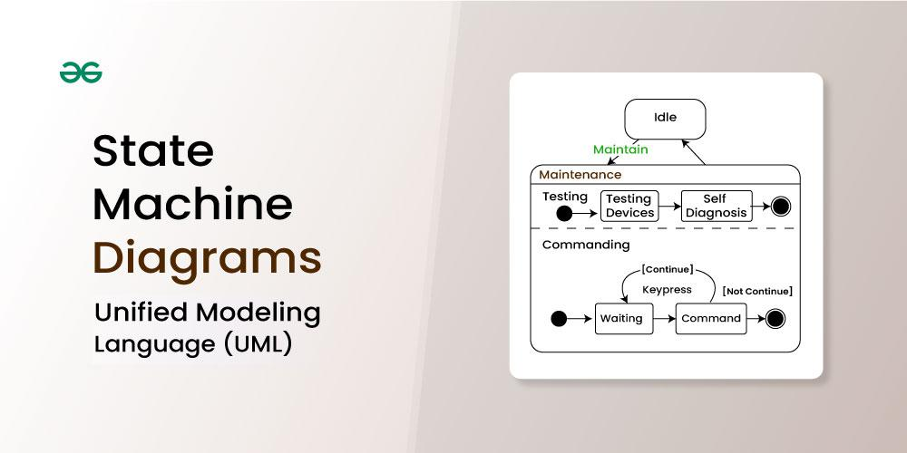

**Table of Content**

* [What is a State Machine Diagram?](https://www.geeksforgeeks.org/system-design/unified-modeling-language-uml-state-diagrams/#1-what-is-a-state-machine-diagram)
* [Basic components and notations of a State Machine diagram](https://www.geeksforgeeks.org/system-design/unified-modeling-language-uml-state-diagrams/#2-basic-components-and-notations-of-a-state-machine-diagram)
* [UseCases of State Machine Diagram](https://www.geeksforgeeks.org/system-design/unified-modeling-language-uml-state-diagrams/#4-usecases-of-state-machine-diagram)
* [What are the Differences between a State Machine Diagram and a Flowchart?](https://www.geeksforgeeks.org/system-design/unified-modeling-language-uml-state-diagrams/#5-what-are-the-differences-between-a-state-machine-diagram-and-a-flowchart)

**What is a State Machine Diagram?**

A S**tate diagram** is a UML diagram which is used to represent the condition of the system or part of the system at finite instances of time. It’s a behavioral diagram and it represents the behavior using finite state transitions.

* State Machine diagrams are also known as **State Diagrams**and **State-Chart Diagrams**. These both terms can be used interchangeably.
* A state machine diagram is used to model the dynamic behaviour of a class in response to time and changing external stimuli( events that cause the system to change its state from one to another).
* We can say that every class has a state but we don't model every class using State Machine diagrams.

Let's understand the State Machine Diagram with the help **user verification** example:

**Example:**

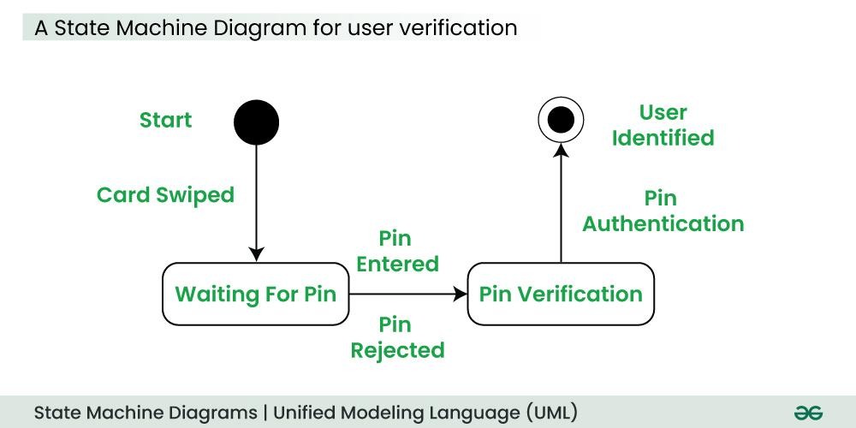

The State Machine Diagram above shows the different states in which the verification sub-system or class exists for a particular system.

**Basic Components and Notations of a State Machine Diagram**

Below are the basic components and their notations of a State Machine Diagram:

**1. Initial state**

We use a black filled circle represent the initial state of a System or a Class.

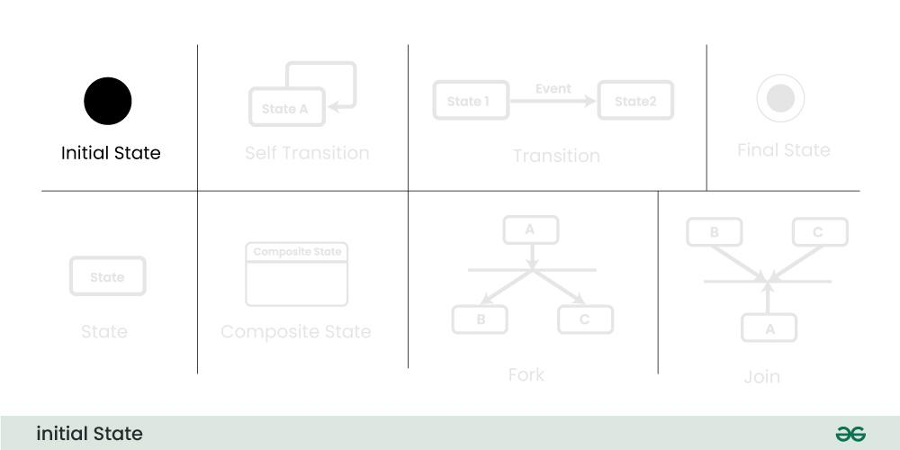

**2. Transition**

We use a solid arrow to represent the transition or change of control from one state to another. The arrow is labelled with the event which causes the change in state.

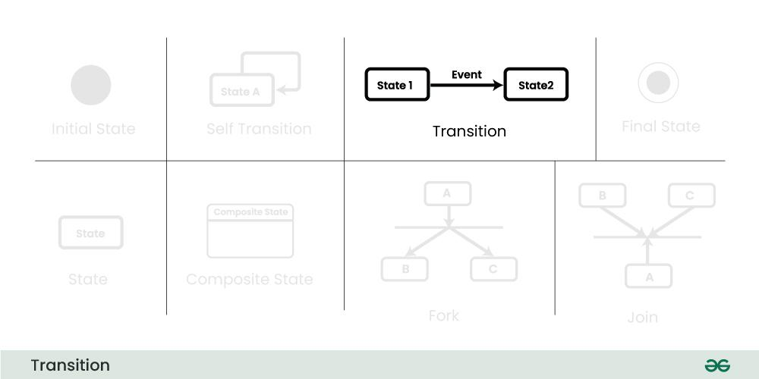

**3. State**

We use a rounded rectangle to represent a state. A state represents the conditions or circumstances of an object of a class at an instant of time.

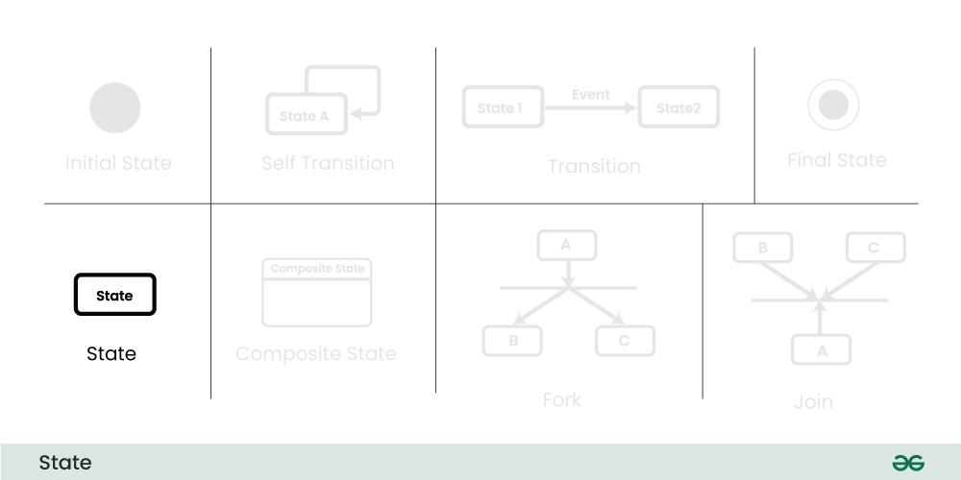

**4. Fork**

We use a rounded solid rectangular bar to represent a Fork notation with incoming arrow from the parent state and outgoing arrows towards the newly created states. We use the fork notation to represent a state splitting into two or more concurrent states.

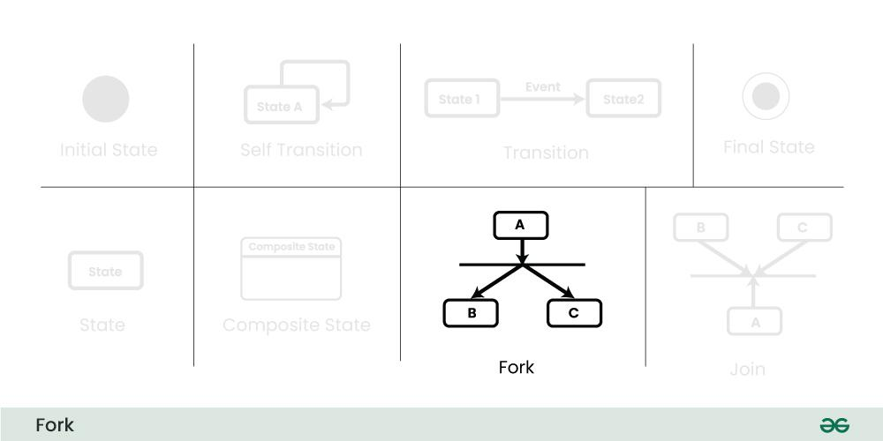

**5. Join**

We use a rounded solid rectangular bar to represent a Join notation with incoming arrows from the joining states and outgoing arrow towards the common goal state. We use the join notation when two or more states concurrently converge into one on the occurrence of an event or events.

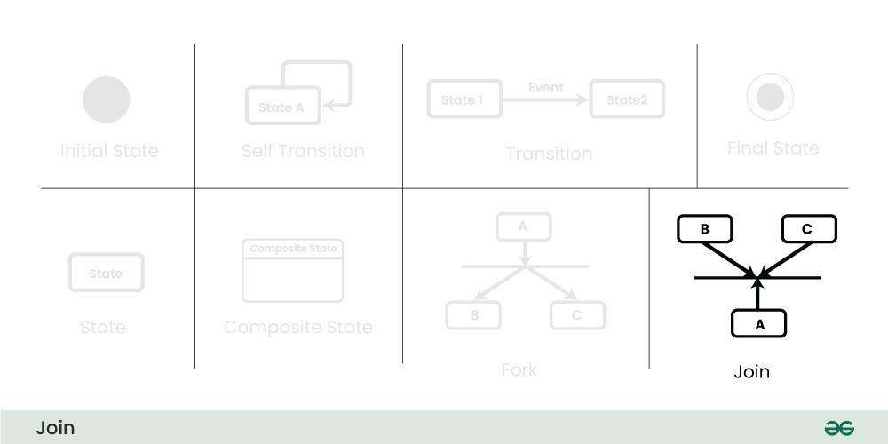

**6. Self transition**

We use a solid arrow pointing back to the state itself to represent a self transition. There might be scenarios when the state of the object does not change upon the occurrence of an event. We use self transitions to represent such cases.

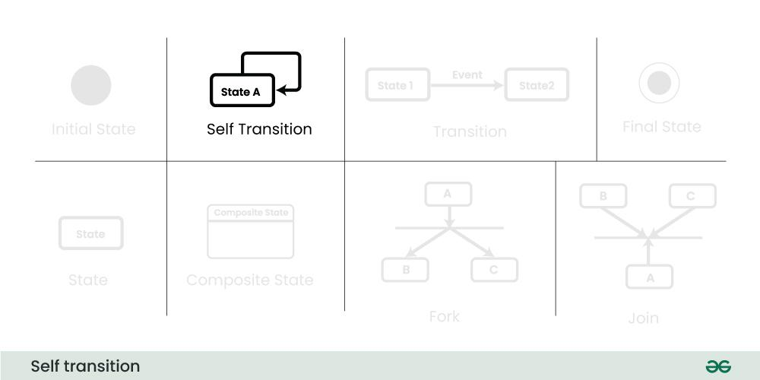

**7. Composite state**

We use a rounded rectangle to represent a composite state also. We represent a state with internal activities using a composite state.

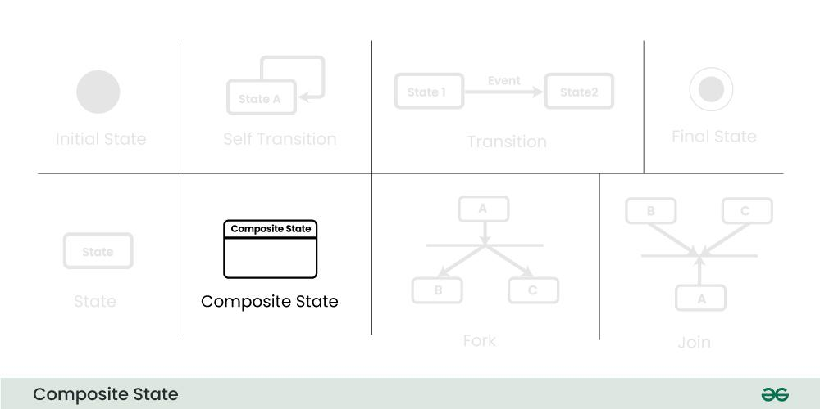

**8. Final State**

We use a filled circle within a circle notation to represent the final state in a state machine diagram.

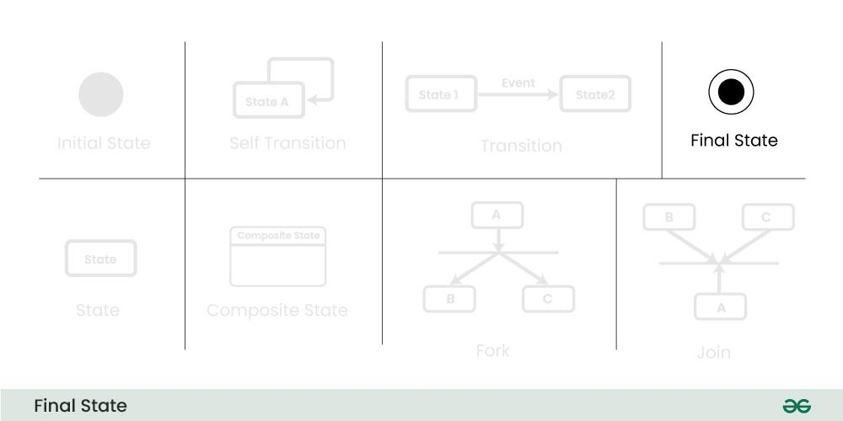

**How to draw a State Machine diagram in UML?**

Below are the steps on how to draw the State Machine Diagram in UML:

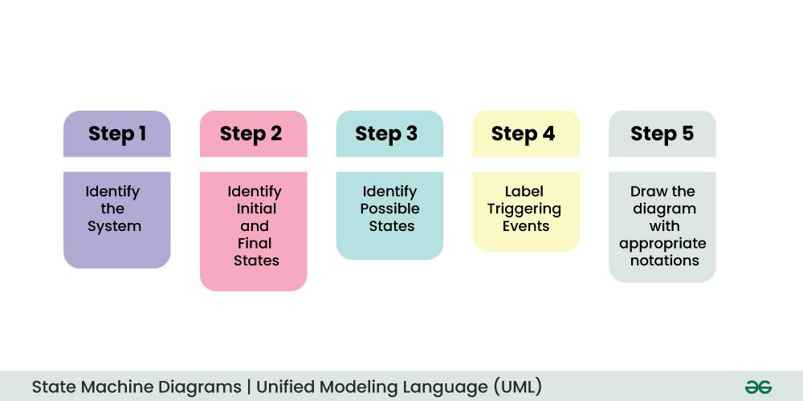

**Step 1: Identify the System:**

* Understand what your diagram is representing.
* Whether it's a machine, a process, or any object, know what different situations or conditions it might go through.

**Step 2: Identify Initial and Final States:**

* Figure out where your system starts (initial state) and where it ends (final state).
* These are like the beginning and the end points of your system's journey.

**Step 3: Identify Possible States:**

* Think about all the different situations your system can be in.
* These are like the various phases or conditions it experiences.
* Use boundary values to guide you in defining these states.

**Step 4: Label Triggering Events:**

* Understand what causes your system to move from one state to another.
* These causes or conditions are the events.
* Label each transition with what makes it happen.

**Step 5: Draw the Diagram with appropriate notations:**

* Now, take all this information and draw it out.
* Use rectangles for states, arrows for transitions, and circles or rounded rectangles for initial and final states.
* Be sure to connect everything in a way that makes sense.

**Example: Online Order System**

Let's understand State Machine diagram with the help of an example, ie for an **Online Order**:  
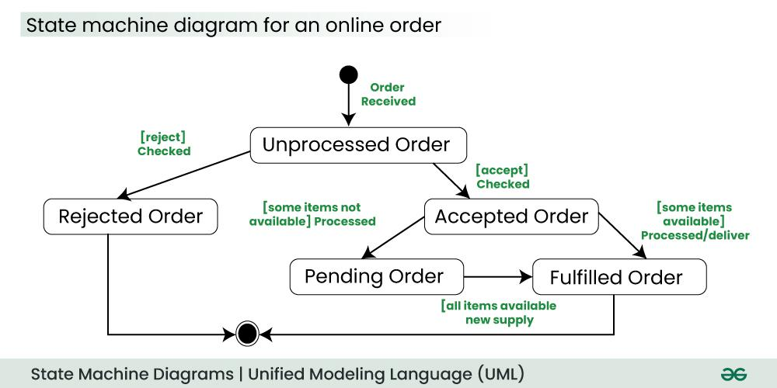

The UML diagrams we draw depend on the system we aim to represent. Here is just an example of how an online ordering system might look like :

* On the event of an order being received, we transition from our initial state to Unprocessed order state.
* The unprocessed order is then checked.
* If the order is rejected, we transition to the Rejected Order state.
* If the order is accepted and we have the items available we transition to the fulfilled order state.
* However if the items are not available we transition to the Pending Order state.
* After the order is fulfilled, we transition to the final state. In this example, we merge the two states i.e. Fulfilled order and Rejected order into one final state.

***Note:*** *Here we could have also treated fulfilled order and rejected order as final states separately.*

**Applications of State Machine Diagram**

Below are the main use cases of state machine diagram:

* State Machine Diagrams are very useful for modeling and visualizing the dynamic behavior of a system.
* They are also used in UI design where they help to illustrate how the interface changes in response to user actions, helping designers to create a better use experience.
* In game design, state machine diagrams can help model the behavior of characters or objects, detailing how they change states based on player interactions or game events
* In embedded systems, where hardware interacts with software to perform tasks, State Machine Diagrams are valuable for representing the control logic and behavior of the system.

**What are the Differences between a State Machine Diagram and a Flowchart?**

Before understanding the differences between a state machine diagram and a flowchart, firstly understand what is a flowchart:

**What is a**[**Flowchart**](https://www.geeksforgeeks.org/competitive-programming/an-introduction-to-flowcharts/)**?**

An algorithm is like a set of clear instructions to solve a problem, and a flowchart is a picture that shows those instructions.

* When we're writing computer programs, a flowchart helps us map out the steps of the algorithm to solve the problem.
* Non programmers use Flow charts to model workflows.
* We can call a flowchart a primitive version of an activity diagram.
* Business processes where decision making is involved is expressed using a flow chart.

**Example:**

*A manufacturer uses a flow chart to explain and illustrate how a particular product is manufactured.*

**State Machine Diagram vs. Flow Chart?**

Below are the main differences between a state machine diagram and a flowchart:

| **State Machine Diagram** | **Flow Chart** |
| --- | --- |
| An State Machine Diagram is associated with the UML(Unified Modelling Language) | A Flow Chart is associated with the programming. |
| The basic purpose of a state machine diagram is to portray various changes in state of the class and not the processes or commands causing the changes. | A flowchart on the other hand portrays the processes or commands that on execution change the state of class or an object of the class. |
| Primarily used for systems, emphasizing their states and transitions. | Often used for processes, procedures, or algorithms involving actions and decisions. |

**Conclusion**

State Machine Diagrams in UML are like pictures that tell us how things change in a system. They show the different situations a system can be in and how it moves between them. These diagrams help us understand what events make these changes happen. Whether it's for designing software or explaining how something works, State Machine Diagrams are like visual guides that make it easier to see and understand how a system behaves in different situations.

What is a Swimlane Diagram

Last Updated : 20 Feb, 2024

A swimlane diagram is also called a cross-functional diagram. The name, cross-functional process map, means the whole work process “crosses” several functions. By using swimlane diagrams in system design, you can create a clear and concise representation of your system architecture, promoting better understanding, collaboration, and ultimately, a more robust and efficient system. In this article, we will discuss the what is swimlane diagram, its benefits, attributes, elements, and steps to draw a swimlane diagram.

swimlane-diagram

Important Topics for the Swimlane Diagram

What is Swimlane Diagram?

Attributes in the Swimlane diagram

Entities of Swimlane Diagram

Steps to draw Swimlane Diagram

Tool for Creating Swimlane Diagram

Why the Swimlane diagram is useful

Uses of Swimlane Diagram

1. What is Swimlane Diagram?

In the context of system design, a swimlane diagram is a powerful tool for visualizing the interactions and responsibilities between different components within a system element like microservices, APIs, databases and external system.

A swimlane diagram is a popular tool for visualizing processes, but its journey to becoming a staple in various fields, including system design, has been an interesting evolution.

Swimlane diagrams and swimlane flowcharts are essentially the same thing.

Both terms refer to a type of flowchart that uses horizontal or vertical lanes to show the different steps in a process and who is responsible for each step.

2. Attributes in the Swimlane Diagram

Here we will discuss the Attributes of individual elements within the diagram

Name

Symbol

Description

Start/End

Screenshot-2024-01-22-124527

It indicates the start and end point in the flowchart

Process 1

Screenshot-2024-01-22-130140

It indicates a process, action, or operation.

Process 2

Screenshot-2024-01-22-130711

It indicates an automatic process that triggers another action.

Process 3

Screenshot-2024-01-22-134211

It indicates a setup to a subsequent step in a process.

Condition

Screenshot-2024-01-22-134514

It indicates a question.

Manual Operation

Screenshot-2024-01-22-135050

It indicates that the user must manually input information into the system.

Display

Screenshot-2024-01-22-135737

It indicates that information must be displayed.

Input / Output

Screenshot-2024-01-22-140753

It indicates that information should be entered in or should come out of the flow.

Document

Screenshot-2024-01-22-141007

It indicates a document or report that is involved in the process.

Multiple Document

Screenshot-2024-01-22-141213

It indicates that there are multiple documents involved in the flow.

Start Loop

Screenshot-2024-01-22-141819

It indicates the beginning of a loop.

End Loop

Screenshot-2024-01-22-141944

It indicates the point at which the loop ends.

Here, we will discuss about the Oil Change Example we will implement the step wise step flowchart.

2.1 Symbol for Activity:

Use a “box” to show the activities within a workflow or process. Shade the box if you have a separate map or flowchart of this activity.

Different shapes in a swimlane diagram can have specific meanings and attributes assigned to them. For example, a diamond might represent a decision point, while a rectangle might represent a simple task.

swimlane-diagram-

2.2 Symbol of Input and Output

Draw a line with an arrow to show an input or an output associated with each activity.

Label the inputs and outputs. This helps with subsequent interpretation.

The input should be the resource that the activity transforms. You should be able to see the transformation, and the value-creating work of an activity reflected in the progression of outputs throughout the workflow.

Arrows connecting lanes or tasks can have attributes defining the type of interaction they represent, such as information exchange, handoff of responsibility, or conditional flow.

Note: The direction of the arrow is also the direction of the flow of work

swimlane-diagram-2

2.3 Symbol of Left to Right conversion:

In this symbol it shows the conversion of left-to-right sequence of converting inputs into outputs.Let suppose we want to add more box then we can add it, it will show the other activity diagram.

These describe the individuals or teams assigned to each swimlane, such as their roles, responsibilities, and expertise.

swimlane-diagram-3

2.4 Symbol for Inputs and outputs pass over or under one another:

Arrows representing inputs or outputs should pass over or under one another, rather than intersect.

Change Oil “input” to, or “output” from Spent Oil Replacement Oil Symbols for inputs and outputs.

swimlane-diagram-4

2.5 Symbol for decision with two branches

Use the diamond symbol to indicate a decision (alternate branches and paths of flow). Often there are more than two options so label all the branches.

swimlane-diagram-5

2.6 Symbol for entities

We will drwa horizontal bands (swimlanes) to represent the “entity” that does the work. Inputs and outputs pass through these bands. From the above image we will show three entities: Vehicle Driver, Sales, and Service.

swimlane-diagram-6

2.7 Symbol for Split Diagram

Split (subdivide) the band if you want to show a subset of similar work within the same entity. In the diagram we can see the Inspection and Oil Change Bay is the subset.

swimlane-diagram-7

3. Entities of Swimlane Diagram:

Swimlane diagrams are built around the concept of entities, which represent individuals, teams, departments, systems, or even external stakeholders involved in a process. These entities play a crucial role in the diagram's clarity and effectiveness. Here's a breakdown of the different types of entities you might encounter in a swimlane diagram:

Participants:

Individuals: This is the most granular level, where specific people are assigned tasks or responsibilities within a swimlane.

Teams: Groups of individuals working together are often represented as a single entity with a shared swimlane.

Departments: Larger organizational units like departments can be used as entities, encompassing multiple teams or individuals with distinct roles.

Systems and Tools:

Software applications, databases, or other technological tools can be considered entities if they play a significant role in the process and require interaction from participants.

External services or vendors used within the process can also be included as entities.

Abstract Entities:

Roles or positions within an organization can be treated as entities if the tasks are not necessarily assigned to specific individuals but rather to whoever holds that role.

Concepts or stages in a more abstract process can also be represented as entities to highlight their importance and flow within the diagram.

Choosing the right entities:

The complexity of a process and the desired level of detail will determine which entities are most relevant to include in a swimlane diagram.

It's crucial to keep the audience in mind and choose entities that are familiar and meaningful to them.

Focusing on entities that have distinct roles and responsibilities will enhance the clarity and communication value of the diagram.

4. Steps to draw Swimlane Diagram

Creating a swimlane diagram can be a great way to visually represent and understand complex processes. Here's a breakdown of the steps involved:

Step-1: Define the process and participants:

Identify the process you want to map. What are the main steps involved? What are you trying to achieve?

Determine the participants. Who are the different individuals or teams involved in each step of the process?

Step-2: Create the swimlanes:

Draw horizontal or vertical lanes across your canvas. Each lane should represent a participant or group responsible for a specific set of tasks.

Label each lane clearly with the participant's name or role.

Step-3: Map the process steps:

Within each lane, list the tasks or activities performed by that participant. Use simple shapes like rectangles or rounded rectangles to represent tasks.

Connect the tasks with arrows to show the flow of the process. Use different arrow styles to indicate different types of interactions, like handoffs or decisions.

Step-4: Add details and formatting:

Include additional information, such as durations, decision points, or inputs and outputs. You can use diamonds for decisions, ovals for start and end points, and parallelograms for inputs and outputs.

Customize the appearance of your diagram. Use different colors, fonts, and line styles to make it visually appealing and easy to understand.

Problem Statement:

Here, we will discuss about the oil changer flowchart for understanding the swimlane diagram flowchart:

Someone from Sales greets the customer, discusses the work to be done, writes a service order, and confirms with the customer the work to be done.

Sales gives the service order to the next available oil change Service tech, who reviews it and prepares to start the job. He takes the keys out of the job packet, locates the customer’s car, and moves it to the oil change bay.

Then, he prepares the vehicle for an oil change. Next, he changes the oil. Then, he places a reminder sticker on the front windshield of the car, and does a quality check.

Once he confirms that everything is okay, he moves the car to the pick-up area, and notifies Sales that the job is complete. At this point, he returns the job packet to the Sales person who wrote the service order.

Once the Service technician notifies Sales, they prepare the bill for the customer and collect payment.

Overall Diagram by using Swimlane Diagram:

swimlane-Diagram-2

5. Tool for Creating Swimlane Diagram:

Choosing the right tool for creating swimlane diagrams depends on your needs and budget. Here are some popular options, categorized by type:

Online Collaboration Tools:

ClickUp: Offers a whiteboard feature with drag-and-drop swimlane templates and real-time collaboration.

Lucidchart: A popular online diagramming tool with intuitive swimlane functionality and extensive templates.

Swimlanes: Web-based tool specifically designed for creating swimlane diagrams, with powerful features and integrations.

Diagramming Software:

Microsoft Visio: A classic desktop diagramming tool with built-in swimlane templates and advanced customization options.

Visual Paradigm Online: Offers both online and desktop versions with various diagram types, including swimlanes.

Creately: Affordable online diagramming tool with basic swimlane functionality and easy-to-use interface.

Paid Tools:

Lucidchart: A popular online diagramming tool with a rich feature set, including swimlane diagrams with advanced formatting options, real-time collaboration, and integrations with other tools.

Visio: Microsoft's diagramming software known for its powerful features and professional look. It offers pre-made swimlane templates and advanced customization options, but comes with a hefty price tag.

ClickUp: A project management tool with a built-in whiteboard feature that allows you to create swimlane diagrams and other visuals. It's a great option if you already use ClickUp for project management.

6. Why the Swimlane Diagram is useful

Swimlane diagram is a flowchart that visually breaks down a process into steps or activities, each assigned to a specific participant or team. They are often used in business to map out workflows, procedures, and cross-functional collaborations. Here are some of the benefits of using swimlane diagrams:

Improved Clarity and Communication:

Swimlane diagrams provide a clear and concise visual representation of a process, making it easier for everyone involved to understand the steps, dependencies, and handoffs.

Enhanced Efficiency and Productivity:

Swimlane diagrams can help to identify bottlenecks and inefficiencies in a process. By seeing how different steps interact, it is easier to spot areas where things are slowing down or where there is duplication of effort.

Once inefficiencies are identified, they can be addressed and eliminated, leading to a more streamlined and efficient process.

Documentation and Training:

Swimlane diagrams can be used as a form of documentation, providing a clear and concise reference for anyone who needs to understand a process.

They can also be used for training purposes, helping new employees to quickly learn the ropes.

Optimized efficiency and problem-solving:

Bottleneck identification: Swimlane diagrams highlight handoffs and dependencies between different roles, making it easier to identify bottlenecks and areas for improvement. This allows for streamlining processes and eliminating unnecessary delays.

Reduced redundancies: The visual representation can reveal duplication of efforts across different lanes, prompting opportunities for consolidation and optimization.

Enhanced communication: By providing a shared visual reference, swimlane diagrams facilitate communication between teams and departments, leading to smoother collaboration and problem-solving.

7. Uses of Swimlane Diagram

Swimlane diagrams have a broad range of applications and can be used for various purposes across different industries. Here are some common use cases:

Process Mapping and Improvement:

Visualize and analyze existing workflows to identify bottlenecks, inefficiencies, and redundancies.

Design and communicate optimized processes with clearly defined roles and responsibilities.

Track progress and measure the effectiveness of process improvements.

Project Management:

Plan and manage complex projects by breaking them down into manageable tasks and assigning them to different teams or individuals.

Clearly communicate dependencies and handoffs between different project phases.

Monitor progress and identify potential risks or delays.

Business Process Documentation:

Standardize and document standard operating procedures (SOPs) for internal reference and training.

Improve consistency and quality by ensuring everyone follows the same process steps.

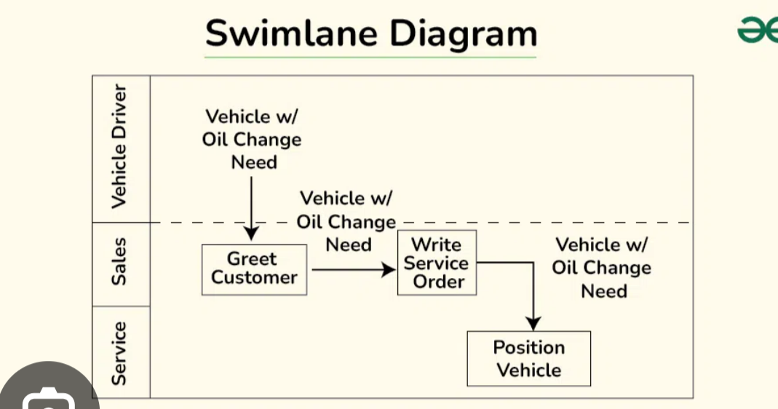

**Software Design Process - Software Engineering**

Last Updated : 11 Jul, 2025

The **Design Phase** of software development deals with transforming the customer requirements as described in the SRS(Software Requirement Specification) documents into a form implementable using a programming language.

**What is Software Design Process?**

**Software Design Process**is the phase where developers plan how to turn a set of requirements into a working system. Like a blueprint for the software. Instead of going straight into writing code, developers break down complex requirements into smaller, manageable pieces, design the system architecture, and decide how everything will fit together and work.

The software design process can be divided into the following three levels or phases of design:

Software Design Levels

**1. Interface Design**

**Interface Design**is the specification of the interaction between a system and its environment. This phase proceeds at a high level of abstraction with respect to the inner workings of the system i.e, during interface design, the internal of the systems are completely ignored, and the system is treated as a black box. Attention is focused on the dialogue between the target system and the users, devices, and other systems with which it interacts. The design problem statement produced during the problem analysis step should identify the people, other systems, and devices which are collectively called agents.

Interface design should include the following details:

1. Precise description of events in the environment, or messages from agents to which the system must respond.
2. Precise description of the events or messages that the system must produce.
3. Specification of the data, and the formats of the data coming into and going out of the system.
4. Specification of the ordering and timing relationships between incoming events or messages, and outgoing events or outputs.

**2. Architectural Design**

Architectural design is the specification of the major components of a system, their responsibilities, properties, interfaces, and the relationships and interactions between them. In architectural design, the overall structure of the system is chosen, but the internal details of major components are ignored. Issues in architectural design includes:

1. Gross decomposition of the systems into major components.
2. Allocation of functional responsibilities to components.
3. Component Interfaces.
4. Component scaling and performance properties, resource consumption properties, reliability properties, and so forth.
5. Communication and interaction between components.

The architectural design adds important details ignored during the interface design. Design of the internals of the major components is ignored until the last phase of the design.

**3. Detailed Design**

Detailed design is the specification of the internal elements of all major system components, their properties, relationships, processing, and often their algorithms and the data structures. The detailed design may include:

1. Decomposition of major system components into program units.
2. Allocation of functional responsibilities to units.
3. User interfaces.
4. Unit states and state changes.
5. Data and control interaction between units.
6. Data packaging and implementation, including issues of scope and visibility of program elements.
7. Algorithms and data structures.

**Software Design Phases**

The Actual Software Design process travel through the one end to another end of making and Software well with completion of requirements and the phases which included in the same that are bellow:

Software Design Phases

**1. Understanding Project Requirements**

Before jumping into the design, the first step is to make sure the team understands what the users need, what the business goals are, and any potential challenges. This understanding sets the foundation for creating a design that meets both user and business needs.

**2. Research, Analysis, and Planning**

During this phase, the team gathers data through methods like interviews, surveys, and focus groups. This helps get a clearer picture of what the users want and allows the team to design with the user in mind, ensuring the software will truly meet their needs.

**3. Designing the Software**

In the design phase, the team starts creating visual elements like wireframes, user stories, and flow diagrams to map out how the system will work. Based on the feedback, prototypes are created and fine-tuned to make sure the design is moving in the right direction.

**4. Technical Design**

After gathering feedback, the team gets into more details with the technical design. This phase involves creating a thorough technical document that outlines exactly how the software will be implemented, including specific components and how they will work together.

**5. User Interface Design**

The focus here is on making sure the software is easy to use. UI designers work on the visual elements, navigation, and overall user experience to ensure the interface is intuitive and friendly.

**6. Prototyping**

Prototypes are created to visualize the design and functionality before the full development process begins. These can range from simple wireframes (low fidelity) to fully interactive models (high fidelity) depending on the stage of development.

**Elements of Software Design**

Good software design is built on several core element that work together to create effective system.

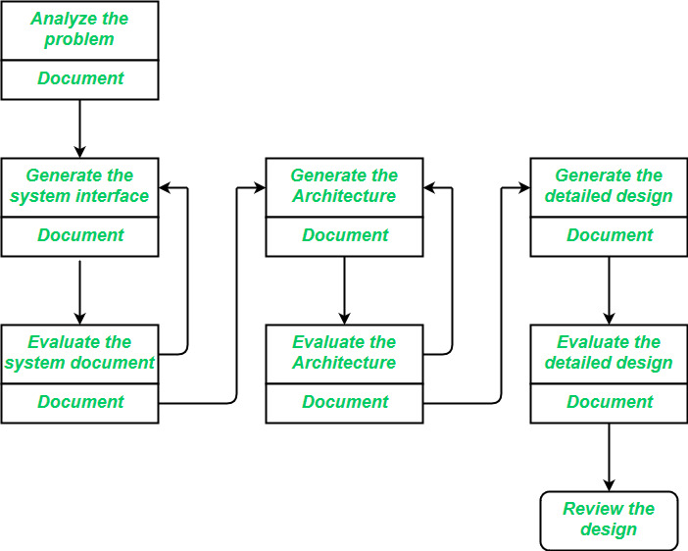Software Design Process

**1. Architecture:**This is the conceptual model that defines the structure, behavior, and views of a system. We can use flowcharts to represent and illustrate the architecture.

A solid architecture verify the system is flexible, stable, and easy to maintain over time.

**2. Modules:**Modules as the building blocks of the system. Each one handles a specific task or feature. Breaking a system into smaller modules makes it easier to develop, test, and maintain the system.

These are components that handle one specific task in a system. A combination of the modules makes up the system.

**3. Components:**This provides a particular function or group of related functions. They are made up of modules. Organising the system into components helps keep the code clean and makes the system more adaptable.

**4. Interfaces:**These are smaller units within modules that focus on specific functions. This is the shared boundary across which the components of a system exchange information and relate.

**5. Data:**Data is at the heart of any system. It’s all about how information is stored, accessed, and shared.This is the management of the information and data flow.

**How Software Design Fits into the SDLC?**

Software Design comes when the project requirement are done and when we are about to start the Development process, He.re is How Software Design fits into the Software Development Life Cycle.

After **planning**, the designing of software phase starts. This is where the team uses tools like wireframes, data flow diagrams, and UI designs to map out how the system will work. It’s like drawing the roadmap for how everything will come together and how we can use each component well with proper functionality. After the Designing phase the Actual process of Software Development begins.

**Software Design Principles**

To make sure software is easy to manage, maintain, and update, there are a few important principles that should guide the design process:

1. **Modularity**: Think of modularity as breaking down the software into smaller, independent sections or "**modules**". Each module handles a specific task, which makes it much easier to test, maintain, and update without affecting the entire system.
2. **Coupling**: Coupling refers to how much one part of the software depends on others. The goal is to keep the connections between modules to a minimum, so that changing one module won’t impact others. This makes the software more flexible and easier to update in the future.
3. **Abstraction**: Abstraction is about simplifying the software by hiding its complexity. It only shows users the essential features they need, making the software easier to use and understand, without overwhelming them with unnecessary details.
4. **Anticipation of Change**: It's important to design software with future changes in mind. This means building it in a way that allows for easy updates or adjustments, whether it's adding new features or adapting to new technologies.
5. **Simplicity**: Simple designs are the best. Keeping things simple means less room for errors, and it’s easier to maintain and improve over time. The goal is to avoid overcomplicating things, keeping the design clean and efficient.
6. **Sufficiency & Completeness**: The design should make sure the software meets all the required functions without unnecessary extras. It’s about striking a balance making sure everything needed is there, but avoiding unnecessary features that can slow things down or create confusion.

**Tools for Software Design**

There are many tools that make the process easier and more efficient, whether you're working on wireframes, prototypes, or documentation. Here are some popular tools:

1. **Figma**
2. **Balsamiq**
3. **Axure RP**
4. **Sketch**
5. **InVision Studio**

**Conclusion**

Software Design is a important part of the Software Development process and it play a major role for clean and clear development of product. Here we learned about the Software Design in detail, you can refer [**SDLC**](https://www.geeksforgeeks.org/software-engineering/software-development-life-cycle-sdlc/) process for more information of Software development.

Software engineers and software developers both work with code. But engineers focus more on system-level design, while developers build specific applications and features. Education paths often overlap, but developers often enter the field through nontraditional routes like bootcamps or self-teaching

In [software engineering](https://en.wikipedia.org/wiki/Software_engineering), a **software design pattern** or **design pattern** is a general, [reusable](https://en.wikipedia.org/wiki/Reusability) solution to a commonly occurring problem in many contexts in [software design](https://en.wikipedia.org/wiki/Software_design).[[1]](https://en.wikipedia.org/wiki/Software_design_pattern#cite_note-1) A design pattern is not a rigid structure to be transplanted directly into [source code](https://en.wikipedia.org/wiki/Source_code). Rather, it is a description or a template for solving a particular type of problem that can be deployed in many different situations.[[2]](https://en.wikipedia.org/wiki/Software_design_pattern#cite_note-2) Design patterns can be viewed as formalized [best practices](https://en.wikipedia.org/wiki/Best_practice) that the programmer may use to solve common problems when designing a software application or system.

[Object-oriented](https://en.wikipedia.org/wiki/Object-oriented_programming) design patterns typically show relationships and interactions between [classes](https://en.wikipedia.org/wiki/Class_(computer_science)) or [objects](https://en.wikipedia.org/wiki/Object_(computer_science)), without specifying the final application classes or objects that are involved.[[*citation needed*](https://en.wikipedia.org/wiki/Wikipedia:Citation_needed)] Patterns that imply mutable state may be unsuited for [functional programming](https://en.wikipedia.org/wiki/Functional_programming) languages. Some patterns can be rendered unnecessary in languages that have built-in support for solving the problem they are trying to solve, and object-oriented patterns are not necessarily suitable for non-object-oriented languages.[[*citation needed*](https://en.wikipedia.org/wiki/Wikipedia:Citation_needed)]

Design patterns may be viewed as a structured approach to [computer programming](https://en.wikipedia.org/wiki/Computer_programming) intermediate between the levels of a [programming paradigm](https://en.wikipedia.org/wiki/Programming_paradigm) and a concrete [algorithm](https://en.wikipedia.org/wiki/Algorithm).[[*citation needed*](https://en.wikipedia.org/wiki/Wikipedia:Citation_needed)]

**History**

Patterns originated as an [architectural concept](https://en.wikipedia.org/wiki/Pattern_(architecture)) by [Christopher Alexander](https://en.wikipedia.org/wiki/Christopher_Alexander) as early as 1977 in [A Pattern Language](https://en.wikipedia.org/wiki/A_Pattern_Language) (cf. his article, "The Pattern of Streets," JOURNAL OF THE AIP, September, 1966, Vol. 32, No. 5, pp. 273–278). In 1987, [Kent Beck](https://en.wikipedia.org/wiki/Kent_Beck) and [Ward Cunningham](https://en.wikipedia.org/wiki/Ward_Cunningham) began experimenting with the idea of applying patterns to programming – specifically [pattern languages](https://en.wikipedia.org/wiki/Pattern_language) – and presented their results at the [OOPSLA](https://en.wikipedia.org/wiki/OOPSLA) conference that year.[[3]](https://en.wikipedia.org/wiki/Software_design_pattern#cite_note-Smith1987-3)[[4]](https://en.wikipedia.org/wiki/Software_design_pattern#cite_note-Beck1987-4) In the following years, Beck, Cunningham and others followed up on this work.

Design patterns gained popularity in [computer science](https://en.wikipedia.org/wiki/Computer_science) after the book [*Design Patterns: Elements of Reusable Object-Oriented Software*](https://en.wikipedia.org/wiki/Design_Patterns) was published in 1994 by the so-called "Gang of Four" (Erich Gamma, Richard Helm, Ralph Johnson and John Vlissides), which is frequently abbreviated as "GoF". That same year, the first [Pattern Languages of Programming](https://en.wikipedia.org/wiki/Pattern_Languages_of_Programming) Conference was held, and the following year the [Portland Pattern Repository](https://en.wikipedia.org/wiki/Portland_Pattern_Repository) was set up for documentation of design patterns. The scope of the term remains a matter of dispute. Notable books in the design pattern genre include:

* [*Gamma, Erich*](https://en.wikipedia.org/wiki/Erich_Gamma)*;*[*Helm, Richard*](https://en.wikipedia.org/wiki/Richard_Helm)*;*[*Johnson, Ralph*](https://en.wikipedia.org/wiki/Ralph_Johnson_(computer_scientist))*;*[*Vlissides, John*](https://en.wikipedia.org/wiki/John_Vlissides)*(1994).*[*Design Patterns: Elements of Reusable Object-Oriented Software*](https://en.wikipedia.org/wiki/Design_Patterns_(book))*.*[*Addison-Wesley*](https://en.wikipedia.org/wiki/Addison-Wesley)*.*[*ISBN*](https://en.wikipedia.org/wiki/ISBN_(identifier))[*978-0-201-63361-0*](https://en.wikipedia.org/wiki/Special:BookSources/978-0-201-63361-0)*.*
* [*Brinch Hansen, Per*](https://en.wikipedia.org/wiki/Per_Brinch_Hansen)*(1995). Studies in Computational Science: Parallel Programming Paradigms. Prentice Hall.*[*ISBN*](https://en.wikipedia.org/wiki/ISBN_(identifier))[*978-0-13-439324-7*](https://en.wikipedia.org/wiki/Special:BookSources/978-0-13-439324-7)*.*
* [*Buschmann, Frank*](https://en.wikipedia.org/w/index.php?title=Frank_Buschmann&action=edit&redlink=1)*; Meunier, Regine; Rohnert, Hans; Sommerlad, Peter (1996). Pattern-Oriented Software Architecture, Volume 1: A System of Patterns. John Wiley & Sons.*[*ISBN*](https://en.wikipedia.org/wiki/ISBN_(identifier))[*978-0-471-95869-7*](https://en.wikipedia.org/wiki/Special:BookSources/978-0-471-95869-7)*.*
* [*Beck, Kent*](https://en.wikipedia.org/wiki/Kent_Beck)*(1997). Smalltalk Best Practice Patterns. Prentice Hall.*[*ISBN*](https://en.wikipedia.org/wiki/ISBN_(identifier))[*978-0134769042*](https://en.wikipedia.org/wiki/Special:BookSources/978-0134769042)*.*
* [*Schmidt, Douglas C.*](https://en.wikipedia.org/wiki/Douglas_C._Schmidt)*; Stal, Michael; Rohnert, Hans; Buschmann, Frank (2000). Pattern-Oriented Software Architecture, Volume 2: Patterns for Concurrent and Networked Objects. John Wiley & Sons.*[*ISBN*](https://en.wikipedia.org/wiki/ISBN_(identifier))[*978-0-471-60695-6*](https://en.wikipedia.org/wiki/Special:BookSources/978-0-471-60695-6)*.*
* [*Fowler, Martin*](https://en.wikipedia.org/wiki/Martin_Fowler_(software_engineer))*(2002). Patterns of Enterprise Application Architecture.*[*Addison-Wesley*](https://en.wikipedia.org/wiki/Addison-Wesley)*.*[*ISBN*](https://en.wikipedia.org/wiki/ISBN_(identifier))[*978-0-321-12742-6*](https://en.wikipedia.org/wiki/Special:BookSources/978-0-321-12742-6)*.*
* *Hohpe, Gregor; Woolf, Bobby (2003).*[*Enterprise Integration Patterns: Designing, Building, and Deploying Messaging Solutions*](https://en.wikipedia.org/wiki/Enterprise_Integration_Patterns)*.*[*Addison-Wesley*](https://en.wikipedia.org/wiki/Addison-Wesley)*.*[*ISBN*](https://en.wikipedia.org/wiki/ISBN_(identifier))[*978-0-321-20068-6*](https://en.wikipedia.org/wiki/Special:BookSources/978-0-321-20068-6)*.*
* *Freeman, Eric T.; Robson, Elisabeth; Bates, Bert;*[*Sierra, Kathy*](https://en.wikipedia.org/wiki/Kathy_Sierra)*(2004). Head First Design Patterns.*[*O'Reilly Media*](https://en.wikipedia.org/wiki/O%27Reilly_Media)*.*[*ISBN*](https://en.wikipedia.org/wiki/ISBN_(identifier))[*978-0-596-00712-6*](https://en.wikipedia.org/wiki/Special:BookSources/978-0-596-00712-6)*.*
* [*Larman, Craig*](https://en.wikipedia.org/wiki/Craig_Larman)*(2004). Applying UML and Patterns (3rd Ed, 1st Ed 1995). Pearson.*[*ISBN*](https://en.wikipedia.org/wiki/ISBN_(identifier))[*978-0131489066*](https://en.wikipedia.org/wiki/Special:BookSources/978-0131489066)*.*

Although design patterns have been applied practically for a long time, formalization of the concept of design patterns languished for several years.[[5]](https://en.wikipedia.org/wiki/Software_design_pattern#cite_note-Baroni2003-5)

**Practice**

Design patterns can speed up the development process by providing proven development paradigms.[[6]](https://en.wikipedia.org/wiki/Software_design_pattern#cite_note-6) Effective software design requires considering issues that may not become apparent until later in the implementation. Freshly written code can often have hidden, subtle issues that take time to be detected; issues that sometimes can cause major problems down the road. Reusing design patterns can help to prevent such issues,[[7]](https://en.wikipedia.org/wiki/Software_design_pattern#cite_note-7) and enhance code readability for those familiar with the patterns.

Software design techniques are difficult to apply to a broader range of problems.[[*citation needed*](https://en.wikipedia.org/wiki/Wikipedia:Citation_needed)] Design patterns provide general solutions, [documented](https://en.wikipedia.org/wiki/Documentation) in a format that does not require specifics tied to a particular problem.

In 1996, Christopher Alexander was invited to give a [Keynote Speech](https://www.patternlanguage.com/archive/ieee.html) to the 1996 OOPSLA Convention. Here he reflected on how his work on Patterns in Architecture had developed and his hopes for how the Software Design community could help Architecture extend Patterns to create living structures that use generative schemes that are more like computer code.

**Motif**

A pattern describes a *design motif*, a.k.a. *prototypical micro-architecture*, as a set of program constituents (e.g., classes, methods...) and their relationships. A developer adapts the motif to their codebase to solve the problem described by the pattern. The resulting code has structure and organization similar to the chosen motif.

**Domain-specific patterns**

Efforts have also been made to codify design patterns in particular domains, including the use of existing design patterns as well as domain-specific design patterns. Examples include [user interface](https://en.wikipedia.org/wiki/User_interface) design patterns,[[8]](https://en.wikipedia.org/wiki/Software_design_pattern#cite_note-8) [information visualization](https://en.wikipedia.org/wiki/Information_visualization),[[9]](https://en.wikipedia.org/wiki/Software_design_pattern#cite_note-9) secure design,[[10]](https://en.wikipedia.org/wiki/Software_design_pattern#cite_note-10) "secure usability",[[11]](https://en.wikipedia.org/wiki/Software_design_pattern#cite_note-11) Web design [[12]](https://en.wikipedia.org/wiki/Software_design_pattern#cite_note-12) and business model design.[[13]](https://en.wikipedia.org/wiki/Software_design_pattern#cite_note-13)

The annual [Pattern Languages of Programming](https://en.wikipedia.org/wiki/Pattern_Languages_of_Programming) Conference proceedings [[14]](https://en.wikipedia.org/wiki/Software_design_pattern#cite_note-14) include many examples of domain-specific patterns.

**Object-oriented programming**

[Object-oriented](https://en.wikipedia.org/wiki/Object-oriented_programming) design patterns typically show relationships and interactions between [classes](https://en.wikipedia.org/wiki/Class_(computer_science)) or [objects](https://en.wikipedia.org/wiki/Object_(computer_science)), without specifying the final application classes or objects that are involved. Patterns that imply mutable state may be unsuited for [functional programming](https://en.wikipedia.org/wiki/Functional_programming) languages. Some patterns can be rendered unnecessary in languages that have built-in support for solving the problem they are trying to solve, and object-oriented patterns are not necessarily suitable for non-object-oriented languages.

**Architectural Design - Software Engineering**

Last Updated : 03 Jan, 2025

The software needs an architectural design to represent the design of the software. IEEE defines architectural design as "the process of defining a collection of hardware and software components and their interfaces to establish the framework for the development of a computer system." The software that is built for computer-based systems can exhibit one of these many architectural styles.

**System Category Consists of**

* A set of components(eg: a database, computational modules) that will perform a function required by the system.
* The set of connectors will help in coordination, communication, and cooperation between the components.
* Conditions that defines how components can be integrated to form the system.
* Semantic models that help the designer to understand the overall properties of the system.

The use of architectural styles is to establish a structure for all the components of the system.

**Taxonomy of Architectural Styles**

**1] Data centered architectures:**

* A data store will reside at the center of this architecture and is accessed frequently by the other components that update, add, delete, or modify the data present within the store.
* The figure illustrates a typical data-centered style. The client software accesses a central repository. Variations of this approach are used to transform the repository into a blackboard when data related to the client or data of interest for the client change the notifications to client software.
* This data-centered architecture will promote integrability. This means that the existing components can be changed and new client components can be added to the architecture without the permission or concern of other clients.
* Data can be passed among clients using the blackboard mechanism.

**Advantages of Data centered architecture:**

* Repository of data is independent of clients
* Client work independent of each other
* It may be simple to add additional clients.
* Modification can be very easy

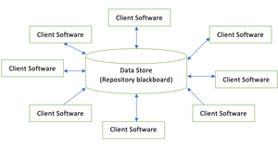Data centered architecture

**2] Data flow architectures:**

* This kind of architecture is used when input data is transformed into output data through a series of computational manipulative components.
* The figure represents pipe-and-filter architecture since it uses both pipe and filter and it has a set of components called filters connected by lines.
* Pipes are used to transmitting data from one component to the next.
* Each filter will work independently and is designed to take data input of a certain form and produces data output to the next filter of a specified form. The filters don't require any knowledge of the working of neighboring filters.
* If the data flow degenerates into a single line of transforms, then it is termed as batch sequential. This structure accepts the batch of data and then applies a series of sequential components to transform it.

**Advantages of Data Flow architecture:**

* It encourages upkeep, repurposing, and modification.
* With this design, concurrent execution is supported.

**Disadvantage of Data Flow architecture:**

* It frequently degenerates to batch sequential system
* Data flow architecture does not allow applications that require greater user engagement.
* It is not easy to coordinate two different but related streams

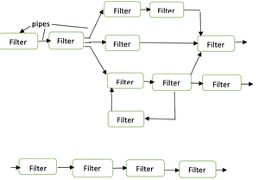Data Flow architecture

**3] Call and Return architectures**

It is used to create a program that is easy to scale and modify. Many sub-styles exist within this category. Two of them are explained below.

* **Remote procedure call architecture:** This components is used to present in a main program or sub program architecture distributed among multiple computers on a network.
* **Main program or Subprogram architectures:** The main program structure decomposes into number of subprograms or function into a control hierarchy. Main program contains number of subprograms that can invoke other components.

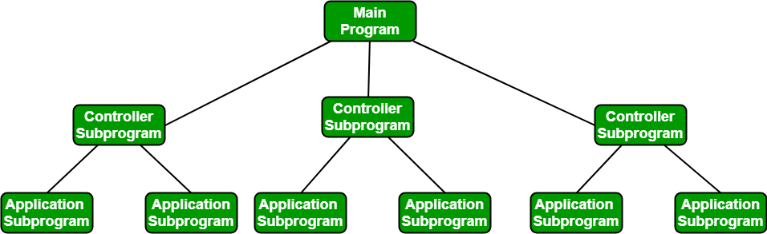

**4] Object Oriented architecture**

The components of a system encapsulate data and the operations that must be applied to manipulate the data. The coordination and communication between the components are established via the message passing.

**Characteristics of  Object Oriented architecture:**

* Object protect the system's integrity.
* An object is unaware of the depiction of other items.

**Advantage of Object Oriented architecture:**

* It enables the designer to separate a challenge into a collection of autonomous objects.
* Other objects are aware of the implementation details of the object, allowing changes to be made without having an impact on other objects.

**5] Layered architecture**

* A number of different layers are defined with each layer performing a well-defined set of operations. Each layer will do some operations that becomes closer to machine instruction set progressively.
* At the outer layer, components will receive the user interface operations and at the inner layers, components will perform the operating system interfacing(communication and coordination with OS)
* Intermediate layers to utility services and application software functions.
* One common example of this architectural style is OSI-ISO (Open Systems Interconnection-International Organisation for Standardisation) communication system.

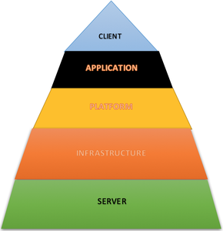Layered architecture

**Software architecture** is the set of structures needed to reason about a [software system](https://en.wikipedia.org/wiki/Software_system) and the discipline of creating such structures and systems. Each structure comprises software elements, relations among them, and properties of both elements and relations.[[1]](https://en.wikipedia.org/wiki/Software_architecture#cite_note-DSA2-1)

The *architecture* of a software system is a [metaphor](https://en.wikipedia.org/wiki/Metaphor), analogous to the [architecture](https://en.wikipedia.org/wiki/Architecture) of a building.[[2]](https://en.wikipedia.org/wiki/Software_architecture#cite_note-PERRY1992-2) It functions as the blueprints for the system and the development project, which [project management](https://en.wikipedia.org/wiki/Project_management) can later use to extrapolate the tasks necessary to be executed by the teams and people involved.

Software architecture is about making fundamental structural choices that are costly to change once implemented. Software architecture choices include specific structural options from possibilities in [the design of the software](https://en.wikipedia.org/wiki/Software_design). There are two fundamental laws in software architecture:[[3]](https://en.wikipedia.org/wiki/Software_architecture#cite_note-3)[[4]](https://en.wikipedia.org/wiki/Software_architecture#cite_note-O'Reilly_Media-4)

1. Everything is a trade-off
2. "Why is more important than how"

"Architectural Kata" is a teamwork which can be used to produce an architectural solution that fits the needs. Each team extracts and prioritizes architectural characteristics (aka [non functional requirements](https://en.wikipedia.org/wiki/Non-functional_requirement)) then models the components accordingly. The team can use [C4 Model](https://en.wikipedia.org/wiki/C4_model) which is a flexible method to model the architecture just enough. Note that synchronous communication between architectural components, entangles them and they must share the same architectural characteristics.[[4]](https://en.wikipedia.org/wiki/Software_architecture#cite_note-O'Reilly_Media-4)

[Documenting software](https://en.wikipedia.org/wiki/Software_documentation) architecture facilitates communication between [stakeholders](https://en.wikipedia.org/wiki/Stakeholder_(corporate)#In_management), captures early decisions about the high-level design, and allows the reuse of design components between projects.[[5]](https://en.wikipedia.org/wiki/Software_architecture#cite_note-SAP2-5): 29–35

Software architecture design is commonly juxtaposed with [software application design](https://en.wikipedia.org/w/index.php?title=Software_application_design&action=edit&redlink=1). Whilst application design focuses on the design of the processes and data supporting the required functionality (the services offered by the system), software architecture design focuses on designing the infrastructure within which application functionality can be realized and executed such that the functionality is provided in a way which meets the system's [non-functional requirements](https://en.wikipedia.org/wiki/Non-functional_requirement).

Software architectures can be categorized into two main types: [monolith](https://en.wikipedia.org/wiki/Monolithic_application) and [distributed architecture](https://en.wikipedia.org/wiki/Distributed_computing), each having its own subcategories.[[4]](https://en.wikipedia.org/wiki/Software_architecture#cite_note-O'Reilly_Media-4)

Software architecture tends to become more complex over time. [Software architects](https://en.wikipedia.org/wiki/Software_architect) should use "[fitness functions](https://en.wikipedia.org/wiki/Fitness_function)" to [continuously](https://en.wikipedia.org/wiki/Continuous_design) keep the architecture in check.[[4]](https://en.wikipedia.org/wiki/Software_architecture#cite_note-O'Reilly_Media-4)

🥚you found a hidden easter egg! have a cookie as a reward 🍪

**User Interface Design**

Last Updated : 04 Jul, 2024

The user interface is the **front-end application** view to which the **user interacts**to use the software. The software becomes more popular if its user interface is:

1. **Attractive**
2. **Simple to use**
3. **Responsive in a short time**
4. **Clear to understand**
5. **Consistent on all interface screens**

User Interface Design

**Types of User Interface**

1. **Command Line Interface:** The Command Line Interface provides a command prompt, where the user types the command and feeds it to the system. The user needs to remember the syntax of the command and its use.
2. **Graphical User Interface:** Graphical User Interface provides a simple interactive interface to interact with the system. GUI can be a combination of both hardware and software. Using GUI, the user interprets the software.

**User Interface Design Process**

The **analysis**and **design**process of a user interface is iterative and can be represented by a **spiral model**. The analysis and design process of user interface consists of four framework activities.

UI Design Stages

**1. User, Task, Environmental Analysis, and Modeling**

Initially, the focus is based on the profile of users who will interact with the system, i.e., understanding, skill and knowledge, type of user, etc., based on the user's profile users are made into categories. From each category requirements are gathered. Based on the requirement's developer understand how to develop the interface. Once all the requirements are gathered a detailed analysis is conducted. In the analysis part, the tasks that the user performs to establish the goals of the system are identified, described and elaborated. The analysis of the user environment focuses on the physical work environment. Among the questions to be asked are:

1. Where will the interface be located physically?
2. Will the user be sitting, standing, or performing other tasks unrelated to the interface?
3. Does the interface hardware accommodate space, light, or noise constraints?
4. Are there special human factors considerations driven by environmental factors?

**2. Interface Design**

The goal of this phase is to define the set of interface objects and actions i.e., control mechanisms that enable the user to perform desired tasks. Indicate how these control mechanisms affect the system. Specify the action sequence of tasks and subtasks, also called a user scenario. Indicate the state of the system when the user performs a particular task. Always follow the three golden rules stated by Theo Mandel. Design issues such as response time, command and action structure, error handling, and help facilities are considered as the design model is refined. This phase serves as the foundation for the implementation phase.

**3. Interface Construction and Implementation**

The implementation activity begins with the creation of a prototype (model) that enables usage scenarios to be evaluated. As iterative design process continues a User Interface toolkit that allows the creation of windows, menus, device interaction, error messages, commands, and many other elements of an interactive environment can be used for completing the construction of an interface.

**4. Interface Validation**

This phase focuses on testing the interface. The interface should be in such a way that it should be able to perform tasks correctly, and it should be able to handle a variety of tasks. It should achieve all the user's requirements. It should be easy to use and easy to learn. Users should accept the interface as a useful one in their work.

**User Interface Design Golden Rules**

The following are the golden rules stated by Theo Mandel that must be followed during the design of the interface. **Place the user in control:**

1. **Define the interaction modes in such a way that does not force the user into unnecessary or undesired actions:**The user should be able to easily enter and exit the mode with little or no effort.
2. **Provide for flexible interaction:** Different people will use different interaction mechanisms, some might use keyboard commands, some might use mouse, some might use touch screen, etc., Hence all interaction mechanisms should be provided.
3. **Allow user interaction to be interruptible and undoable:** When a user is doing a sequence of actions the user must be able to interrupt the sequence to do some other work without losing the work that had been done. The user should also be able to do undo operation.
4. **Streamline interaction as skill level advances and allow the interaction to be customized:** Advanced or highly skilled user should be provided a chance to customize the interface as user wants which allows different interaction mechanisms so that user doesn't feel bored while using the same interaction mechanism.
5. **Hide technical internals from casual users:**The user should not be aware of the internal technical details of the system. He should interact with the interface just to do his work.
6. **Design for direct interaction with objects that appear on-screen:**The user should be able to use the objects and manipulate the objects that are present on the screen to perform a necessary task. By this, the user feels easy to control over the screen.

**Reduce the User's Memory Load**

1. **Reduce demand on short-term memory:** When users are involved in some complex tasks the demand on short-term memory is significant. So the interface should be designed in such a way to reduce the remembering of previously done actions, given inputs and results.
2. **Establish meaningful defaults:** Always an initial set of defaults should be provided to the average user, if a user needs to add some new features then he should be able to add the required features.
3. **Define shortcuts that are intuitive:**Mnemonics should be used by the user. Mnemonics means the keyboard shortcuts to do some action on the screen.
4. **The visual layout of the interface should be based on a real-world metaphor:** Anything you represent on a screen if it is a metaphor for a real-world entity then users would easily understand.
5. **Disclose information in a progressive fashion:**The interface should be organized hierarchically i.e., on the main screen the information about the task, an object or some behavior should be presented first at a high level of abstraction. More detail should be presented after the user indicates interest with a mouse pick.

**Make the Interface Consistent**

1. **Allow the user to put the current task into a meaningful context:**Many interfaces have dozens of screens. So it is important to provide indicators consistently so that the user know about the doing work. The user should also know from which page has navigated to the current page and from the current page where it can navigate.
2. **Maintain consistency across a family of applications:**in The development of some set of applications all should follow and implement the same design, rules so that consistency is maintained among applications.
3. If past interactive models have created user expectations do not make changes unless there is a compelling reason.

User interface design is a crucial aspect of software engineering, as it is the means by which users interact with software applications. A well-designed user interface can improve the usability and user experience of an application, making it easier to use and more effective.

**Key Principles for Designing User Interfaces**

1. **User-centered design:** User interface design should be focused on the needs and preferences of the user. This involves understanding the user's goals, tasks, and context of use, and designing interfaces that meet their needs and expectations.
2. **Consistency:** Consistency is important in user interface design, as it helps users to understand and learn how to use an application. Consistent design elements such as icons, color schemes, and navigation menus should be used throughout the application.
3. **Simplicity:**User interfaces should be designed to be simple and easy to use, with clear and concise language and intuitive navigation. Users should be able to accomplish their tasks without being overwhelmed by unnecessary complexity.
4. **Feedback:** Feedback is significant in user interface design, as it helps users to understand the results of their actions and confirms that they are making progress towards their goals. Feedback can take the form of visual cues, messages, or sounds.
5. **Accessibility:** User interfaces should be designed to be accessible to all users, regardless of their abilities. This involves considering factors such as color contrast, font size, and assistive technologies such as screen readers.
6. **Flexibility:**User interfaces should be designed to be flexible and customizable, allowing users to tailor the interface to their own preferences and needs.

**Conclusion**

Overall, user interface design is a key component of software engineering, as it can have a significant impact on the usability, effectiveness, and user experience of an application. Software engineers should follow best practices and design principles to create interfaces that are user-centered, consistent, simple, and accessible.

What is Software Engineering

Software engineering is the coding that makes digital products work. It is a branch of computer science where software engineers develop software, implement visual design, test, and continuously maintain its functionality.

The goal of software engineering is to create reliable, scalable software that meets users' and business needs.

Interface design in software engineering has a front-end application that creates visuals for users to interact with. For example, UX/UI Designers create an “Add to Cart” button that users click while Software Designers develop the code so that the chosen item appears in the user’s Cart. The [visual interface design](https://www.flexy.global/resources/interface-design/top-5-elements-to-elevate-your-visual-interface-design) is visible to the user, while the software engineering stays behind the backdrop.

Types of Interface Design in Software Engineering

User interface design has two categories, let’s go through them briefly.

1. The Command Line Interface is the bare minimum interface a software can provide to its users. CLI looks like lines of code where the user types a text-based command that the system then completes.
2. Graphical User Interface design began the day the first screen was designed to show visuals other than text. It uses more computer resources than CLI because it has interactive visual graphics that users use to interpret the software. Simply put, instead of reading code and writing commands, users can view icons and click on a button to send a command.

Interface Design Golden Rules

User interface design has two categories, let's go through them briefly.

The basic rule of interface design in software engineering is — the user should be in control.

You can use Theo Mandel’s golden rules to guide your interface design process. Mandel is an internationally acclaimed UX/UI author with over 40 years of experience and a PhD in Cognitive Psychology.

1. The user should not be forced/pushed into actions that they do not want to make. The interface should always be designed in a way so the user can easily enter and exit a page/section.
2. Make interactions flexible so that users can use different modes of interaction and still have the same experience. For example, some might use a keyboard, a mouse, or a touch screen but the UX should be designed to be roughly the same.
3. Users must be able to interrupt an interaction without losing the work done.
4. Users with advanced digital literacy should be given the option to customize the interface to suit their needs.
5. Interface design in software engineering should hide how the software works so that the user can effortlessly interact with the GUI.

Interface Design Tools

UX/UI designers use different tool types to create an interface design in software engineering depending on the interface specs. Some tools are made to only create a GUI while others offer code customization.

Here are a few tools we use at Flexy:

* Figma
* Adobe
* Webflow
* CorelDRAW

Check out the top 11 interface design software available in the design industry as of 2024. There, you’ll find a detailed list with all the individual key features, prices, and insights from our designers.

The Interface Design Process in Software Engineering

There are more specialists involved in the interface design process than you might think. Starting from the product designer to the information architect, everyone involved aims to create an interface that is functional, accessible, and engaging.

Any implementation model can be used for GUI. Here at Flexy, we follow the Agile model because of its iterative structure, which best suits our line of work and our clients.

01. Planning

We call the first stage of the process Project Kickoff. It starts with our project managers and co-founders holding meetings with the client to talk about the scope of work, the client’s objectives, challenges, and expectations. We aim to understand what the client needs, their vision for their digital product design, and the pain points to solve.

02. Research

After the Kickoff our team researches the client’s industry, their users and competitors, and current trends. Using this information, we create user personas and finalize the target audience, which will guide the interface design.

03. Design

Interface design in software engineering has a three-part process.

* Ideation & Conceptualization

Our designers collaborate with the client’s team to brainstorm, have calls, and exchange creative ideas for the look and feel of the interface. Usually, one of the most important questions in this process is “Does this style communicate my brand?” The answer to this question is an approved moodboard and concepts to outline the visual style of the future interface design.

* Wireframes

Now our designers know what message the design should communicate to the users, they design low-fidelity layouts for the digital product to create a comfortable user experience (UX). The wireframes will look like blocks and shapes that will divide the website or app into a hero banner, menu bar, and so on. We then move on to all the nitty-gritty visual elements.

* UI Design

Leaning on the moodboards made earlier, our designers create an interactive model of the interface design that can test the design’s functionality. Interface Design involves typography, color, texture, spacing, icons, and other visuals.

04. Usability Testing

Feedback is worth more than gold in our work because the best designs go through several lines of user testing, changes, and interactions before reaching the final stage. This process helps us ensure that the design solves all potential challenges users might face and creates an interface design that checks all of our client’s goals.

05. Delivery

The next step is to provide our client’s team with all the files and kits necessary to transform the visual design into a functioning product. We gather all the UI designs into organized folders along with the UI Kit that holds all the visual styles (i.e. fonts, button styles, colors, illustrations), which can be used as a style guide in the future.

06. Iteration and Improvement

Yes, we deliver all the files for our clients to implement but the testing doesn’t stop! Flexy often continues to support the client’s team and makes minor adjustments along the way, which makes sure the design will be adaptable and function properly.

07. Development

The development stage is either passed onto our client’s in-house developers or can be carried out by our skilled dev team. Depending on the project type, our developers can implement the interface designs in Webflow, Shopify, Wordpress, and other platforms.

‍

**User interface** (**UI**) **design** or **user interface engineering** is the [design](https://en.wikipedia.org/wiki/Design) of [user interfaces](https://en.wikipedia.org/wiki/User_interface) for [machines](https://en.wikipedia.org/wiki/Machine) and [software](https://en.wikipedia.org/wiki/Software), such as [computers](https://en.wikipedia.org/wiki/Computer), [home appliances](https://en.wikipedia.org/wiki/Home_appliance), [mobile devices](https://en.wikipedia.org/wiki/Mobile_device), and other [electronic devices](https://en.wikipedia.org/wiki/Electronics), with the focus on maximizing [usability](https://en.wikipedia.org/wiki/Usability) and the [user experience](https://en.wikipedia.org/wiki/User_experience). In computer or software design, user interface (UI) design primarily focuses on information architecture. It is the process of building interfaces that clearly communicate to the user what's important. UI design refers to graphical user interfaces and other forms of interface design. The goal of user interface design is to make the [user](https://en.wikipedia.org/wiki/User_(computing))'s interaction as simple and efficient as possible, in terms of accomplishing user goals ([user-centered design](https://en.wikipedia.org/wiki/User-centered_design)). User-centered design is typically accomplished through the execution of modern [design thinking](https://en.wikipedia.org/wiki/Design_thinking) which involves empathizing with the target audience, defining a problem statement, ideating potential solutions, prototyping [wireframes](https://en.wikipedia.org/wiki/Website_wireframe), and testing prototypes in order to refine final interface [mockups](https://en.wikipedia.org/wiki/Mockup_(software)).

User interfaces are the points of interaction between users and designs.

**Three types of user interfaces**

[**Graphical**](https://en.wikipedia.org/wiki/Graphical_user_interface)**user interfaces (GUIs)**

Users interact with visual representations on a computer's screen. The desktop is an example of a GUI.

**Interfaces controlled through**[**voice**](https://en.wikipedia.org/wiki/Voice_user_interface)

Users interact with these through their voices. Most smart assistants, such as [Siri](https://en.wikipedia.org/wiki/Siri) on smartphones or Alexa on Amazon devices, use voice control.

**Interactive interfaces utilizing**[**gestures**](https://en.wikipedia.org/wiki/Gesture_recognition)

Users interact with 3D design environments through their bodies, e.g., in [virtual reality](https://en.wikipedia.org/wiki/Virtual_reality) (VR) games.

Interface design is involved in a wide range of projects, from computer systems, to cars, to commercial planes; all of these projects involve much of the same basic human interactions yet also require some unique skills and knowledge. As a result, designers tend to specialize in certain types of projects and have skills centered on their expertise, whether it is [software design](https://en.wikipedia.org/wiki/Software_design), user research, [web design](https://en.wikipedia.org/wiki/Web_design), or [industrial design](https://en.wikipedia.org/wiki/Industrial_design).

Good user interface design facilitates finishing the task at hand without drawing unnecessary attention to itself. [Graphic design](https://en.wikipedia.org/wiki/Graphic_design) and [typography](https://en.wikipedia.org/wiki/Typography) are utilized to support its [usability](https://en.wikipedia.org/wiki/Usability), influencing how the user performs certain interactions and improving the [aesthetic](https://en.wikipedia.org/wiki/Aesthetics) appeal of the design; design aesthetics may enhance or detract from the ability of users to use the functions of the interface.[[1]](https://en.wikipedia.org/wiki/User_interface_design#cite_note-NormanAttractiveWorksBetter-1) The design process must balance technical functionality and visual elements (e.g., [mental model](https://en.wikipedia.org/wiki/Mental_model)) to create a system that is not only operational but also usable and adaptable to changing user needs.

**UI design vs. UX design**

User interface design is a craft in which designers perform an important function in creating the user experience. UI design should keep users informed about what is happening, giving appropriate feedback in a timely manner. The visual look and feel of UI design sets the tone for the user experience.[[2]](https://en.wikipedia.org/wiki/User_interface_design#cite_note-2) On the other hand, the term UX design refers to the entire process of creating a user experience.

[Don Norman](https://en.wikipedia.org/wiki/Don_Norman) and [Jakob Nielsen](https://en.wikipedia.org/wiki/Jakob_Nielsen_(usability_consultant)) said:

It's important to distinguish the total user experience from the user interface (UI), even though the UI is obviously an extremely important part of the design. As an example, consider a website with movie reviews. Even if the UI for finding a film is perfect, the UX will be poor for a user who wants information about a small independent release if the underlying database only contains movies from the major studios.[[3]](https://en.wikipedia.org/wiki/User_interface_design#cite_note-3)

**Design thinking**

[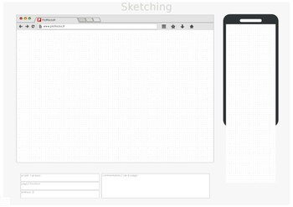](https://en.wikipedia.org/wiki/File:Mobile_sketch_template.pdf)Printable template for mobile and desktop app design ([PDF](https://en.wikipedia.org/wiki/PDF))

User interface design requires a good understanding of user needs. It mainly focuses on the needs of the platform and its user expectations. There are several phases and processes in the user interface design, some of which are more demanded upon than others, depending on the project.[[4]](https://en.wikipedia.org/wiki/User_interface_design#cite_note-4) The modern [design thinking](https://en.wikipedia.org/wiki/Design_thinking) framework was created in 2004 by [David M. Kelley](https://en.wikipedia.org/wiki/David_M._Kelley), the founder of Stanford’s d.school, formally known as the [Hasso Plattner Institute of Design](https://en.wikipedia.org/wiki/Hasso_Plattner_Institute_of_Design).[[5]](https://en.wikipedia.org/wiki/User_interface_design#cite_note-5) EDIPT is a common acronym used to describe Kelley’s design thinking framework—it stands for empathize, define, ideate, prototype, and test.[[6]](https://en.wikipedia.org/wiki/User_interface_design#cite_note-6) Notably, the EDIPT framework is non-linear, therefore a UI designer may jump from one stage to another when developing a user-centric solution. Iteration is a common practice in the design thinking process; successful solutions often require testing and tweaking to ensure that the product fulfills user needs.[[7]](https://en.wikipedia.org/wiki/User_interface_design#cite_note-7)

**EDIPT**

**Empathize**

Conducting user research to better understand the needs and pain points of the target audience. UI designers should avoid developing solutions based on personal beliefs and instead seek to understand the unique perspectives of various users. Qualitative data is often gathered in the form of [semi-structured interviews](https://en.wikipedia.org/wiki/Semi-structured_interview).[[8]](https://en.wikipedia.org/wiki/User_interface_design#cite_note-8)

Common areas of interest include:

* What would the user want the system to do?
* How would the system fit in with the user's normal workflow or daily activities?
* How technically savvy is the user and what similar systems does the user already use?
* What interface aesthetics and functionalities styles appeal to the user?

**Define**

Solidifying a [problem statement](https://en.wikipedia.org/wiki/Problem_statement) that focuses on user needs and desires; effective problem statements are typically one sentence long and include the user, their specific need, and their desired outcome or goal.

**Ideate**

Brainstorming potential solutions to address the refined problem statement. The proposed solutions should ideally align with the stakeholders' feasibility and viability criteria while maintaining user desirability standards.

**Prototype**

Designing potential solutions of varying fidelity (low, mid, and high) while applying user experience principles and methodologies. Prototyping is an iterative process where UI designers should explore multiple design solutions rather than settling on the initial concept.

**Test**

Presenting the prototypes to the target audience to gather feedback and gain insights for improvement. Based on the results, UI designers may need to revisit earlier stages of the design process to enhance the prototype and [user experience](https://en.wikipedia.org/wiki/User_experience).

**Usability testing**

The [Nielsen Norman Group](https://en.wikipedia.org/wiki/Nielsen_Norman_Group), co-founded by [Jakob Nielsen](https://en.wikipedia.org/wiki/Jakob_Nielsen_(usability_consultant)) and [Don Norman](https://en.wikipedia.org/wiki/Don_Norman) in 1998, promotes user experience and interface design education. Jakob Nielsen pioneered the interface [usability](https://en.wikipedia.org/wiki/Usability) movement and created the "10 Usability Heuristics for User Interface Design."[[9]](https://en.wikipedia.org/wiki/User_interface_design#cite_note-9) Usability is aimed at defining an interface’s quality when considering ease of use; an interface with low usability will burden a user and hinder them from achieving their goals, resulting in the dismissal of the interface. To enhance usability, user experience researchers may conduct [usability testing](https://en.wikipedia.org/wiki/Usability_testing)—a process that evaluates how users interact with an interface. Usability testing can provide insight into user pain points by illustrating how efficiently a user can complete a task without error, highlighting areas for design improvement.[[10]](https://en.wikipedia.org/wiki/User_interface_design#cite_note-10)

**Usability inspection**

Letting an evaluator inspect a user interface. This is generally considered to be cheaper to implement than usability testing (see step below), and can be used early on in the development process since it can be used to evaluate prototypes or specifications for the system, which usually cannot be tested on users. Some common usability inspection methods include [cognitive walkthrough](https://en.wikipedia.org/wiki/Cognitive_walkthrough), which focuses the simplicity to accomplish tasks with the system for new users, [heuristic evaluation](https://en.wikipedia.org/wiki/Heuristic_evaluation), in which a set of heuristics are used to identify usability problems in the UI design, and [pluralistic walkthrough](https://en.wikipedia.org/wiki/Pluralistic_walkthrough), in which a selected group of people step through a task scenario and discuss usability issues.

**Usability testing**

Testing of the prototypes on an actual user—often using a technique called [think aloud protocol](https://en.wikipedia.org/wiki/Think_aloud_protocol) where the user is asked to talk about their thoughts during the experience. User interface design testing allows the designer to understand the reception of the design from the viewer's standpoint, and thus facilitates creating successful applications.

**Requirements**

[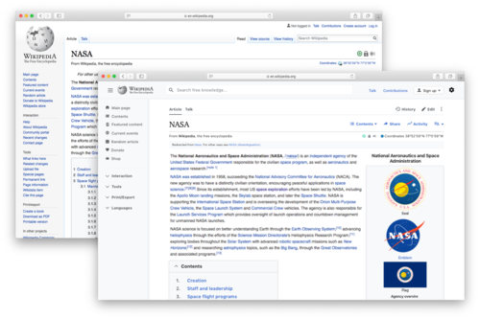](https://en.wikipedia.org/wiki/File:Updated_Wikipedia_desktop_interface_sketch_for_Wikimania_poster.png)Updated Wikipedia desktop interface sketch for Wikimania poster

The dynamic characteristics of a system are described in terms of the dialogue requirements contained in seven principles of part 10 of the ergonomics standard, the [ISO 9241](https://en.wikipedia.org/wiki/ISO_9241). This standard establishes a framework of ergonomic "principles" for the dialogue techniques with high-level definitions and illustrative applications and examples of the principles. The principles of the dialogue represent the dynamic aspects of the interface and can be mostly regarded as the "feel" of the interface.

**Seven dialogue principles**

**Suitability for the task**

The dialogue is suitable for a task when it supports the user in the effective and efficient completion of the task.

**Self-descriptiveness**

The dialogue is self-descriptive when each dialogue step is immediately comprehensible through feedback from the system or is explained to the user on request.

**Controllability**

The dialogue is controllable when the user is able to initiate and control the direction and pace of the interaction until the point at which the goal has been met.

**Conformity with user expectations**

The dialogue conforms with user expectations when it is consistent and corresponds to the user characteristics, such as task knowledge, education, experience, and to commonly accepted conventions.

**Error tolerance**

The dialogue is error-tolerant if, despite evident errors in input, the intended result may be achieved with either no or minimal action by the user.

**Suitability for individualization**

The dialogue is capable of individualization when the interface software can be modified to suit the task needs, individual preferences, and skills of the user.

**Suitability for learning**

The dialogue is suitable for learning when it supports and guides the user in learning to use the system.

The concept of usability is defined of the [ISO 9241](https://en.wikipedia.org/wiki/ISO_9241) standard by effectiveness, efficiency, and satisfaction of the user.

Part 11 gives the following definition of usability:

* Usability is measured by the extent to which the intended goals of use of the overall system are achieved (effectiveness).
* The resources that have to be expended to achieve the intended goals (efficiency).
* The extent to which the user finds the overall system acceptable (satisfaction).

Effectiveness, efficiency, and satisfaction can be seen as quality factors of usability. To evaluate these factors, they need to be decomposed into sub-factors, and finally, into usability measures.

The information presented is described in Part 12 of the [ISO 9241](https://en.wikipedia.org/wiki/ISO_9241) standard for the organization of information (arrangement, alignment, grouping, labels, location), for the display of graphical objects, and for the coding of information (abbreviation, colour, size, shape, visual cues) by seven attributes. The "attributes of presented information" represent the static aspects of the interface and can be generally regarded as the "look" of the interface. The attributes are detailed in the recommendations given in the standard. Each of the recommendations supports one or more of the seven attributes.

**Seven presentation attributes**

**Clarity**

The information content is conveyed quickly and accurately.

**Discriminability**

The displayed information can be distinguished accurately.

**Conciseness**

Users are not overloaded with extraneous information.

**Consistency**

A unique design, conformity with user's expectation.

**Detectability**

The user's attention is directed towards information required.

**Legibility**

Information is easy to read.

**Comprehensibility**

The meaning is clearly understandable, unambiguous, interpretable, and recognizable.

**Usability**

The user guidance in Part 13 of the [ISO 9241](https://en.wikipedia.org/wiki/ISO_9241) standard describes that the user guidance information should be readily distinguishable from other displayed information and should be specific for the current context of use.

User guidance can be given by the following five means:

* Prompts indicating explicitly (specific prompts) or implicitly (generic prompts) that the system is available for input.
* Feedback informing about the user's input timely, perceptible, and non-intrusive.
* Status information indicating the continuing state of the application, the system's hardware and software components, and the user's activities.
* Error management including error prevention, error correction, user support for error management, and error messages.
* On-line help for system-initiated and user-initiated requests with specific information for the current context of use.

**Research**

User interface design has been a topic of considerable research, including on its [aesthetics](https://en.wikipedia.org/wiki/Aesthetics).[[11]](https://en.wikipedia.org/wiki/User_interface_design#cite_note-The_role_of_context_in_perceptions_of_the_aesthetics_of_web_pages_over_time-11) Standards have been developed as far back as the 1980s for defining the usability of software products. One of the structural bases has become the IFIP user interface reference model.

The model proposes four dimensions to structure the user interface:

* The input/output dimension (the look)
* The dialogue dimension (the feel)
* The technical or functional dimension (the access to tools and services)
* The organizational dimension (the communication and co-operation support)

This model has greatly influenced the development of the international standard [ISO 9241](https://en.wikipedia.org/wiki/ISO_9241) describing the interface design requirements for usability. The desire to understand application-specific UI issues early in software development, even as an application was being developed, led to research on GUI rapid prototyping tools that might offer convincing simulations of how an actual application might behave in production use.[[12]](https://en.wikipedia.org/wiki/User_interface_design#cite_note-HUMANOID-12) Some of this research has shown that a wide variety of programming tasks for GUI-based software can, in fact, be specified through means other than writing program code.[[13]](https://en.wikipedia.org/wiki/User_interface_design#cite_note-ACM_Transactions_on_Programming_Languages_and_Systems-13)

Research in recent years is strongly motivated by the increasing variety of devices that can, by virtue of [Moore's law](https://en.wikipedia.org/wiki/Moore%27s_law), host very complex interfaces.[[14]](https://en.wikipedia.org/wiki/User_interface_design#cite_note-ACM_Transactions_on_Computer%E2%80%93Human_Interaction_(TOCHI)-14)

As a [software engineer](https://www.mrtellerz.com/2023/03/what-is-the-definition-of-software-engineer.html), you understand the importance of solid architecture in building a successful product. The foundation of any software architecture is component-level design — you break a system into its component parts and define how they interact. Done well, component-level design facilitates reuse, reduces complexity, and enables parallel development.

However, many engineers struggle with determining the right level of granularity for components and defining clear interfaces. This article provides an overview of key principles and best practices for component-level design that you can apply to your next project. We explore strategies for identifying components, defining interfaces, managing dependencies, and achieving the right level of abstraction.

Finally, With a thoughtful approach to component design, you can create a flexible, scalable architecture that stands the test of time. Strong components form the building blocks of strong systems, so investing in this foundational layer will pay dividends as your software grows in scope and complexity.

**What Is Component Level Design?**

Component level design refers to the process of breaking down a system into its constituent parts to better understand how they interact and connect. In software engineering, it is the phase that focuses on defining and developing the software components that will be used to build the overall system architecture.

***Component level design has two main goals:***

* Identify the components that are needed to build the system. This includes determining the boundaries of each component and how they relate to one another.
* Define the interfaces between components. This makes the components loosely coupled and independent, allowing them to be developed and tested separately before being integrated into the full system.

***When designing components, software engineers consider:***

* **Functionality**: What is the purpose of the component? What features will it provide?
* **Data**: What data does the component need to operate? What data does it produce? How will it interface with data from other components?
* **Dependencies**: On what other components does this component rely? How will those dependencies be handled?
* **Reusability**: Can this component be reused in other systems? If so, how can its design be made more generic?
* **Scalability**: How will this component handle increases in load or volume? Can its performance be optimized?

Component-level design is a fundamental step in building a robust, modular software architecture. By determining how to break a complex system into discrete, interconnected parts, software engineers can create solutions that are flexible, extensible, and resilient to changes in requirements. The end result is a system that is greater than the sum of its parts.

**The Benefits of Component Level Design**

Component level design is an essential part of software architecture that provides many benefits. **Include**,

* **Increased reusability**: Well-designed components can be reused in other systems, saving time and resources. Components are self-contained and independent, so they can function in a variety of applications.
* **Improved maintainability**: When software needs updating or fixing, clearly defined components make the system easier to understand, modify and debug. Changes to one component do not impact others, reducing issues.
* **Enhanced flexibility**: The modular nature of components allows them to be arranged and combined in different ways. New components can also be added to expand functionality without disrupting existing ones. This makes the overall system adaptable to changing needs.
* **Reduced complexity**: Breaking a large system into discrete components simplifies development and management. Components have specific, limited functions that are easier to build and comprehend than an overly broad, monolithic system.
* **Increased reliability**: Properly designed components are thoroughly tested to ensure they function correctly. They also have defined interfaces that limit unintended interactions with other components. This results in a robust, stable system.

In summary, component level design is key to crafting a high-quality software architecture. When done well, it yields reusable, maintainable and flexible systems that can handle complexity, evolve over time and provide reliable performance. For any software project, it is a foundation worth building upon.

**Types of Components in Software Engineering**

There are several types of components used in software engineering and component-level design. Understanding the distinctions between them will help in selecting the appropriate components for your system.

**Procedural Components**

Procedural components, also known as modules, contain a sequence of steps to perform a specific function. They have a single entry and exit point, encapsulating the steps into a reusable block. Procedural components are best for simple, linear tasks without complex logic.

[Object-oriented components](https://www.mrtellerz.com/2023/06/what-is-object-oriented-design-in-software-engineering.html), or objects, combine data and procedures into a single unit. They have a defined interface to interact with the object while hiding the implementation details. Objects are well-suited for modeling real-world entities or abstract concepts. They enable encapsulation, inheritance, and polymorphism.

Services, or [*application programming interfaces (APIs)*](https://en.m.wikipedia.org/wiki/API), provide a defined interface to access a set of related functions or resources. They abstract away the implementation details of the service, allowing it to be used by various clients. Services are commonly used for accessing data or business logic over a network. They enable loose coupling between systems.

**Data Stores**

Data stores, such as databases, files, and data structures, contain organized collections of data. They provide a mechanism to persistently store and access data for use throughout a system. Selecting an appropriate data store involves considering factors like query performance, scalability, and data integrity.

In summary, procedural components, objects, services, and data stores are fundamental building blocks used in component-level design. By understanding their unique characteristics and relationships, you can craft a robust architecture with components that are cohesive, loosely coupled, and highly reusable.

**Guidelines for Component Design**

When designing components in software architecture, *following some guidelines will help ensure robust, reusable, and maintainable components.*

Components should have a loose coupling, meaning little interdependence. Loosely coupled components can be changed or replaced independently without affecting other components. Some ways to achieve loose coupling include:

* Defining clear interfaces that encapsulate implementation details.
* Using asynchronous messaging instead of direct function calls.
* Avoiding global variables and sharing data only through interfaces.

Components should have a high cohesion, focusing on a single, well-defined purpose. High cohesion makes components easier to understand, maintain, test, and reuse. Some tips for high cohesion include:

* Assigning components logical and closely related responsibilities.
* Not combining unrelated responsibilities in the same component.
* Naming components clearly and consistently based on their purpose.

Components should provide abstraction, hiding their internal implementation details behind interfaces. This allows components to be used without understanding their inner workings. Some examples of abstraction include:

* Defining interfaces that specify the services a component provides without specifying how they work.
* Using access modifiers like “private” to hide implementation details.
* Choosing descriptive names that convey a component’s purpose without revealing implementation.

Components should be designed with reusability in mind. Reusable components reduce duplication and improve maintainability. To design reusable components:

* Make them self-contained, independent, and focused on a single purpose.
* Define a clear interface and keep implementation details private.
* Avoid assumptions about the context the component will be used in.
* Make the component flexible and customizable through configuration rather than modification.

Following these guidelines will help you design robust, maintainable software components that can be reused and combined in many ways. Well-designed components form the foundation for a flexible, adaptable software architecture.

**Common Mistakes in Component Level Design**

**Lack of Cohesion**

Cohesion refers to the degree to which the elements of a component belong together. A cohesive component has a singular, focused purpose and contains closely related elements. Lack of cohesion is one of the most common mistakes in component level design. It often results in components that are difficult to understand, reuse, and maintain.

**Excessive Coupling**

Coupling refers to the degree of interdependence between components. Excessively coupled components are too dependent on each other, making them hard to reuse and maintain independently. Loose coupling, on the other hand, reduces interdependencies and allows components to operate independently. Excessive coupling is a frequent mistake that contradicts the goals of component-based design.

**Violating Encapsulation**

Encapsulation means hiding the internal details and implementation of a component from the outside. It enables the internal workings of a component to change without impacting other components. Failing to properly encapsulate components exposes their inner workings, creating tight coupling and dependencies on implementation details that may change. This mistake compromises the flexibility and maintainability of the overall system.

**Lack of Abstraction**

Abstraction involves suppressing irrelevant details about a component in order to reduce complexity and facilitate understanding. Lack of abstraction results in low-level components that are overly complex, difficult to understand, and reuse. Effective abstraction focuses on the essential purpose and functionality of a component, hiding unnecessary details.

**Not Considering Reusability**

If components are not designed with reuse in mind, the system will end up with many redundant components that cannot be reused in other contexts. This error leads to increased development and maintenance efforts. On the other hand, reusable components can be used in multiple systems, reducing their development cost.

In summary, avoiding the common mistakes in component-level design-lack of synchronization, over-coupling, content overload, lack of abstraction, and failure to consider reuse-will result in a flexible, maintainable software architecture with high-quality components.

**Conclusion**

As you’ve seen, [component-level design](https://en.m.wikipedia.org/wiki/Component-based_software_engineering) is the foundation for building a robust, scalable software architecture. By focusing on loosely coupled, highly coherent components, you create a flexible system that can adapt to change. Although this requires an upfront investment of time and effort, the benefits are substantial for both the short-term development cycle and the long-term evolution of the system.

Approach your next [software](https://en.m.wikipedia.org/wiki/Software) project with an emphasis on component design, and you’ll find a maintainable, extensible architecture that stands the test of time. The core principles of abstraction, coupling, and modularity have been proven time and time again to drive great software. Take the time to design at the component level, and your system will reap the rewards.

**What is Component Design?**

Last Updated : 23 Jul, 2025

Component design is all about taking complex software systems and making them into small, reusable pieces or simply modules. These parts are responsible for directing certain functionalities, so programming them is like building a puzzle with small pieces, which eventually create more complex architectures. Component design exhibits a modularized approach to software development where the units are organized systematically to facilitate control of complexity and increase manageability.

* Elements being the fundamental building blocks of software architecture, they are mostly responsible for enriching the software's functionality or offering their services.
* When several features are executed in independent units called components, with this approach modularity, reusability, and maintainability are ensured.
* This technique promotes flexibility and [scalability](https://www.geeksforgeeks.org/system-design/what-is-scalability/), enabling the formation of dynamic systems that are composed of more basic units that interlock each other.

**Important Topics for Component Design**

* [Importance of Component-Based Design in Software Development](https://www.geeksforgeeks.org/system-design/what-is-component-design/#importance-of-componentbased-design-in-software-development)
* [Characteristics of Component-Based Design](https://www.geeksforgeeks.org/system-design/what-is-component-design/#characteristics-of-componentbased-design)
* [Types of Components](https://www.geeksforgeeks.org/system-design/what-is-component-design/#types-of-components)
* [Principles of Component Design](https://www.geeksforgeeks.org/system-design/what-is-component-design/#principles-of-component-design)
* [Component Design Patterns](https://www.geeksforgeeks.org/system-design/what-is-component-design/#component-design-patterns)
* [Component Lifecycle Management](https://www.geeksforgeeks.org/system-design/what-is-component-design/#component-lifecycle-management)
* [Tools and Technologies for Component Design](https://www.geeksforgeeks.org/system-design/what-is-component-design/#tools-and-technologies-for-component-design)
* [Challenges of Component Design](https://www.geeksforgeeks.org/system-design/what-is-component-design/#challenges-of-component-design)
* [Real world Examples of Component Design](https://www.geeksforgeeks.org/system-design/what-is-component-design/#real-world-examples-of-component-design)

**Importance of Component-Based Design in Software Development**

Component-based design leads to various beneficial outcomes at all the development life stages of the software.

* It improves modularity, giving the possibility for all developers to work with different parts separately without changing the whole system. This modularity enables code reusability since components can be reused across several projects as this will save time and effort.
* Component-based design is so important for maintainability as it results from being broken down into different parts and depicts functionality, with which errors are easily traced, and debugging, and testing are made possible.
* When it comes to scalability, component-based design forms another vital benefit. A situation when a particular software system, as it turns out to be more complex, has to be scalable enough, leads to making this ability the priority.
* Breaking down elements and establishing logical interfaces facilitate the creation of a modular system that permits effortless integration of more capabilities without causing the architecture to buckle. It highlights the fact that adaptable software systems can not only be quickly modified but also evolve according to the changing requirements.

**Characteristics of Component-Based Design**

Below are the characteristics of component-based design:

* **Modularity:**Some parts of a program retain a certain function or service, essentially serve as reusable software modules, interchangeable and therefore independent components, enhancing flexibility in development, testing, and maintenance.
* **Reusability:**Component architectural features are envisioned to be adaptable to and reusable on different projects giving rise to shorter development time and lower overheads and making the work of developers much more easier and scientific.
* **Interoperability:**Components are connected through clearly defined interfaces, ensuring that software systems maintain interaction continuity and carry out various functions within their ecosystems.
* **Encapsulation:**Components have got encapsulated constructs, which precisely reveal internal details at the interface level, through a provision of only a few interfaces essential for interacting with other components, thus enforcing abstraction by hiding underlying implementation details.
* **Scalability:** Component-based architectures simplify scalability by providing a way for systems to grow organically via the addition or modification of components without the impacting overall the architecture.

**Types of Components**

* **UI Components**
  + User Interface components provide an easy and more convenient way to encapsulate logic by combining presentational and visible elements such as buttons, forms, and widgets.
* **Service Components**
  + Service components are the base of business logic or application services, in which they serve as the platform for activities such as data processing, authentication, and communication with external systems.
* **Data Components**
  + Through data abstraction and provision of interfaces for data access, data components take care of database interaction issues and provide data structures for querying, updating, and saving data.
* **Infrastructure Components**
  + The hardware elements regard as fundamental services or resources like logging, caching, security and communication protocols which a software system depends on.
* **Integration Components**
  + Integrated components for data communication and data exchange between different systems or modules are the integration components, which enable protocol translation, workflow orchestration, and data exchange.
* **Reusable Components**
  + A reusable component, in turn, encapsulates common functionality or algorithms that can be utilized across multiple projects as well as different domains, which promotes code reuse and uniformity.

**Principles of Component Design**

Below are some important principles of component design:

* **Single Responsibility Principle (SRP):**Each element should have a comprehensive and coherent task to ensure that the system is easily understandable, coherent, and stable.
* **Open/Closed Principle (OCP):** Module extendibility is an important aspect, while at the same time when it comes to stability, developers should be able to extend or customize functionality without the need to change the existing codebase.
* **Interface Segregation Principle (ISP):**Components must provide consistent interfaces, which are purposeful to the specific needs of clients, and there shouldn't be any excess dependencies that are being carried along with it.
* **Dependency Inversion Principle (DIP):** Some parts need to be derived interfaces and not implementation-specific ones, hence the functionality and exchangeability.
* **Separation of Concerns (SoC):** Components should broadly include different aspects of job, such as display, business logic, and data accessing and these block does separate the whole functionality to make it clear, maintainable and reusable.

**Component Design Patterns**

Component design patterns present the designer with patterns that can be reused to solve typical problems that design architects face in the construction of component-based architectures Such patterns carry guidance on the effective design and implementation of components as well as the art of integrating these effectively. Some popular component design patterns include:Some popular component design patterns include:

* [**Composite Pattern**](https://www.geeksforgeeks.org/system-design/composite-method-software-design-pattern/)**:**The Composite pattern allows objects to be composed into tree structures, treating individual objects and compositions of objects uniformly.
* [**Decorator Pattern**](https://www.geeksforgeeks.org/system-design/decorator-pattern/)**:** The decorator pattern provides the facility of dynamic enhancement in the object behavior by wrapping decorators that are added to existing functionalities without changing the interface.
* [**Adapter Pattern**](https://www.geeksforgeeks.org/system-design/adapter-pattern/)**:** Through Adapter pattern, interface incompatibility issues are solved as a bridge is built that translates requests from one interface to another by using this one.
* [**Factory Pattern:**](https://www.geeksforgeeks.org/system-design/factory-method-for-designing-pattern/)Factory pattern comprehends the process of preparing objects, with the outcome of providing customers the ability to create objects without specifying their concrete classes, hence facilitating flexibility and decoupling.
* [**Observer Pattern**](https://www.geeksforgeeks.org/system-design/observer-pattern-set-1-introduction/)**:** The Observer pattern constitutes a unidirectional link between objects, a one-to-many dependency, where objects notifying and updating other objects automatically, as their state changes.
* [**Facade Pattern**](https://www.geeksforgeeks.org/system-design/facade-design-pattern-introduction/)**:** The Facade pattern provides a simplified interface to a complex system, encapsulating its intricate details and presenting a unified interface to clients.
* [**Singleton Pattern**](https://www.geeksforgeeks.org/system-design/singleton-design-pattern/)**:** The Singleton pattern, which ensures that a class has only one instance and grants global access to that object, enables one to control centralized access to shared objects and data.

**Component Lifecycle Management**

Component Lifecycle Management is a systematic approach to managing the lifecycle of software components from their creation to decommissioning.

* **Stage 1: Creation:** Components either get initialized statically or dynamically at design time based on the needs of the program and according to the entire program or system architecture.
* **Stage 2: Initialization:**Components are set up, configured and prepared for use, usually this include parameterization, allocation of resources and the side setup.
* **Stage 3: Utilization:** Components are utilized within the software system, fulfilling their designated functionalities and interacting with other components as necessary.
* **Stage 4: Maintenance:** Components undergo maintenance activities such as updates, bug fixes, and optimizations to ensure continued functionality and performance.
* **Stage 5: Decommissioning:**Components are decommissioned, or disposed, when they are no longer needed, either from obsolescence, redundancy, or architectural changes.

**Tools and Technologies for Component Design**

* **Component Frameworks:** Components frameworks for instance, Angular, React, and Vue.js include a variety of pre-built components, templates, and utilities for building user interfaces that users can interact.
* **Dependency Injection Containers:** Injection Containers of IoC nature like Spring IoC, Guice and Dagger can take the control of inversion by managing the component dependencies as well as the producing the instances for the dependent classes.
* **Middleware Platforms:** API middleware systems like Apache Camel or MuleSoft or RabbitMQ connect different system and services by means of message routing, transformation, and mediation.
* **Component Repositories:**These repositories like npm, Maven Central, and NuGet pool together the storage, sharing, and discovery of libraries and reusable components.
* **Component Testing Tools:**Tools like Jest, JUnit, and Mockito are used for automated testing of components; this lets their functionality, reliability and adherence to specification to be verified.

**Challenges of Component Design**

Below are the challenges of component design:

* **Granularity:**Proper level of granularity is what designers of components need to choose accurately, as excessively fine components tend to clutter and increase overhead, while coarse grained ones are inappropriately inflexible and have a limited ability to reuse.
* **Interoperability:** Maintaining the seamless operation of components from unmixed vendors or technologies may be a difficult task. For this reason standardized interfaces, protocols and compatibility tests have to be carried out.
* **Dependency Management:**Keeping dependencies between the components, such as versions, compatibility, and conflicts can be extremely difficult especially in the bigger systems, which have a augmented number of dependencies.
* **Performance Overhead:**The component-based architectures may produce performance overhead for its added levels of abstraction, communication and runtime dependency which require meticulous optimization and profiling thus may result in runtime performance issues.

**Real world Examples of Component Design**

Below are some real-world examples of component design:

* **E-commerce Platforms:**There are e-commerce platforms such as Amazon, eBay and Shopify, that apply component-based architecture to fulfill the diverse functionalities of their products like product catalog management, order processing, credit card processing and customer relationship management.
* **Content Management Systems (CMS):**The majority of content management systems like WordPress, Drupal, and Joomla, with component based design, offer modular functionality through plugins, themes, and extensions which permit users to do things like build, manage, and publish content.
* **Enterprise Resource Planning (ERP) Systems:**The ERP systems SAP, Oracle, and Microsoft Dynamics have components in order to integrate the business processes and functionalities from a variety of fields, including finance, human resources, supply chain management, and customer relationship management.

**Conclusion**

In conclusion, Component design gets the credit for being the foundation of all modern software developments plus bringing in a concept that spawns complex systems using the modular and reusable elements. The component-based design that promotes modularity, reusable and hidden code patterns, will allow developers to achieve agility, scalability, and maintainability, which respectively provide a relevant solution to the modern software issues.

**Types of Models in Object Oriented Modeling and Design**

Last Updated : 08 Jul, 2022

Intention of object oriented modeling and design is to learn how to apply object -oriented concepts to all the stages of the software development life cycle.Object-oriented modeling and design is a way of thinking about problems using models organized around real world concepts. The fundamental construct is the object, which combines both data structure and behavior. **Purpose of Models:**

1. Testing a physical entity before building it
2. Communication with customers
3. Visualization
4. Reduction of complexity

**Types of Models:** There are 3 types of models in the object oriented modeling and design are: Class Model, State Model, and Interaction Model. These are explained as following below.

1. **Class Model:** The class model shows all the classes present in the system. The class model shows the attributes and the behavior associated with the objects. The class diagram is used to show the class model.The class diagram shows the class name followed by the attributes followed by the functions or the methods that are associated with the object of the class.Goal in constructing class model is to capture those concepts from the real world that are important to an application.

1. **State Model:** State model describes those aspects of objects concerned with time and the sequencing of operations – events that mark changes, states that define the context for events, and the organization of events and states.Actions and events in a state diagram become operations on objects in the class model. State diagram describes the state model.

1. **Interaction Model:** Interaction model is used to show the various interactions between objects, how the objects collaborate to achieve the behavior of the system as a whole. The following diagrams are used to show the interaction model:
   * Use Case Diagram
   * Sequence Diagram
   * Activity Diagram

**Software Quality - Software Engineering**

Last Updated : 27 Sep, 2025

Traditionally, a high-quality product is outlined in terms of its fitness of purpose. That is, a high-quality product will specifically be what the users need to try. For code products, the fitness of purpose is typically taken in terms of satisfaction of the wants arranged down within the SRS document.

Though “fitness of purpose” could be a satisfactory definition of quality for some products like an automobile, a table fan, a grinding machine, etc. – for code products, “fitness of purpose” isn't a completely satisfactory definition of quality.

**What is Software Quality?**

Software Quality shows how good and reliable a product is. To convey an associate degree example, think about functionally correct software. It performs all functions as laid out in the [SRS document](https://www.geeksforgeeks.org/software-engineering/software-requirement-specification-srs-document-checklist/). But, it has an associate degree virtually unusable program. even though it should be functionally correct, we tend not to think about it to be a high-quality product.

Another example is also that of a product that will have everything that the users need but has an associate degree virtually incomprehensible and not maintainable code. Therefore, the normal construct of quality as “fitness of purpose” for code products isn't satisfactory.

**Factors of Software Quality**

The modern read of high-quality associates with software many quality factors like the following:

1. **Portability:** A software is claimed to be transportable, if it may be simply created to figure in several package environments, in several machines, with alternative code products, etc.
2. **Usability:** A software has smart usability if completely different classes of users (i.e. knowledgeable and novice users) will simply invoke the functions of the products.
3. **Reusability:** A software has smart reusability if completely different modules of the products will simply be reused to develop new products.
4. **Correctness:** Software is correct if completely different needs as laid out in the SRS document are properly enforced.
5. **Maintainability:** A software is reparable, if errors may be simply corrected as and once they show up, new functions may be simply added to the products, and therefore the functionalities of the products may be simply changed, etc
6. **Reliability:**Software is more reliable if it has fewer failures. Since software engineers do not deliberately plan for their software to fail, reliability depends on the number and type of mistakes they make. Designers can improve reliability by ensuring the software is easy to implement and change, by testing it thoroughly, and also by ensuring that if failures occur, the system can handle them or can recover easily.
7. **Efficiency.** The more efficient software is, the less it uses of CPU-time, memory, disk space,[network bandwidth](https://www.geeksforgeeks.org/computer-networks/introduction-to-bandwidth/), and other resources. This is important to customers in order to reduce their costs of running the software, although with today’s powerful computers, CPU time, memory and disk usage are less of a concern than in years gone by.

**Software Quality Management System**

[Software Quality Management](https://www.geeksforgeeks.org/software-engineering/software-engineering-software-project-management-spm/) System contains the methods that are used by the authorities to develop products having the desired quality.

Some of the methods are:

* **Managerial Structure:**Quality System is responsible for managing the structure as a whole. Every Organization has a managerial structure.
* **Individual Responsibilities:** Each individual present in the organization must have some responsibilities that should be reviewed by the top management and each individual present in the system must take this seriously.
* **Quality System Activities:** The activities which each quality system must have been
  + Project Auditing.
  + Review of the quality system.
  + It helps in the development of methods and guidelines.

**Evolution of Quality Management System**

Quality Systems are basically evolved over the past some years. The evolution of a Quality Management System is a four-step process.

1. **Inspection:** Product inspection task provided an instrument for quality control (QC).
2. **Quality Control:**The main task of [quality control](https://www.geeksforgeeks.org/software-engineering/differences-between-quality-assurance-and-quality-control/) is to detect defective devices, and it also helps in finding the cause that leads to the defect. It also helps in the correction of bugs.
3. **Quality Assurance:** [Quality Assurance](https://www.geeksforgeeks.org/software-testing/software-engineering-software-quality-assurance/)helps an organization in making good quality products. It also helps in improving the quality of the product by passing the products through security checks.
4. **Total Quality Management (TQM):** [Total Quality Management(TQM)](https://www.geeksforgeeks.org/business-studies/what-is-total-quality-management-tqm-and-just-in-time-jit-kanban/) checks and assures that all the procedures must be continuously improved regularly through process measurements.

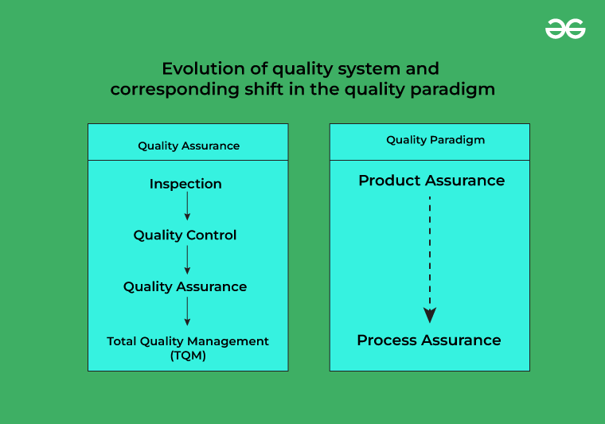Evolution of Quality Management System

**Questions for Practice**

**1. In**[software testing](https://www.geeksforgeeks.org/software-testing/software-testing-basics/)**, how the error, fault, and failure are related to each other? [UGC-NET 2015]**

**(A)** Error leads to failure, but fault is not related to error and failure.

**(B)** Fault leads to failure, but error is not related to fault and failure.

**(C)** Error leads to fault and fault leads to failure.

**(D)** Fault leads to error and error leads to failure.

**Solution:** Correct Answer is **(C)**.

**2. A**[Software Requirement Specification](https://www.geeksforgeeks.org/software-engineering/importance-of-software-requirements-specification-srs/)**(SRS) document should avoid discussing which one of the following? [GATE CS 2015]**

**(A)**User Interface Issues

**(B)**Non-Functional Requirements

**(C)**Design Specification

**(D)**Interfaces with Third-Party Software

**Solution:** Correct Answer is **(C)**.

**Conclusion**

Software quality ensures a product is reliable, maintainable, and user-friendly, going beyond just meeting requirements. It involves key factors like portability, usability, correctness, and efficiency. A robust quality management system and continuous improvement processes help achieve these standards. High-quality software is functional, efficient, and adaptable to user needs.

**What is quality assurance?**

Quality assurance (QA) is a process that ensures a company’s products meet set quality standards. The International Software Testing Qualifications Board (ISTQB®) defines[**quality assurance**](https://glossary.istqb.org/en/search/quality) as “activities focused on providing confidence that quality requirements will be fulfilled.”  
  
Ultimately, QA is about delivering the best possible products and services, and preventing quality failures.   
  
QA activities involve meeting specific industry requirements, as well as meeting the needs and expectations of customers and end-users.

What is quality control?

The terms quality assurance and quality control (QC) are sometimes used interchangeably, but these refer to distinct processes.

The ISTQB® defines quality control as “activities designed to evaluate the quality of a component or system.” While QA is about examining the **process** that leads to the end-result, QC examines the final outcome – it looks at the quality of the **end-products**.

Put simply, QA is process-oriented and focused on preventing defects, and QC is product-oriented and focused on identifying defects.

Quality assurance and software testing

Software testing – also known as QA testing – is a procedure to ensure the software products or services provided to customers are up to par.

There are a few different levels of software quality that need to be tested, which are all important to ensure customer satisfaction:

* **Functional testing**: Do all functions of the software application comply with functional requirements and specifications? Testing can be done either manually, or with automation (which we’ll get into soon).
* **Non-functional testing**: Do the non-functional aspects of the software application like usability, reliability, and efficiency meet customers’ expectations? This would be difficult to test manually.
* **Statistical testing:**Use statistical methods to determine the reliability of the program and find out how faulty programs affect the operating conditions.

**Software quality assurance** involves designing the entire software development process to prevent issues and ensure quality, while **software testing**involves testing a product to locate any bugs and check that they’re fixed.

**Why is quality assurance important in software development?**

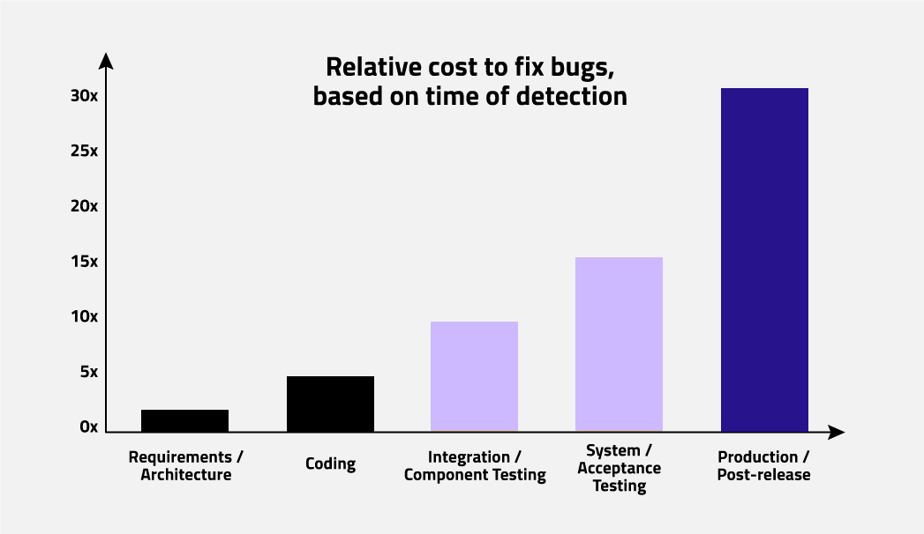

Quality assurance plays a critical role in any [**software development lifecycle**](https://www.qt.io/4cs-of-ux-design?hsLang=en). To compete in today’s increasingly competitive market, companies need to avoid the reputational damage that comes with launching subpar software.

What’s more, fixing a bug in any software application gets more costly the further the product is developed or released.

​In the worst case, products need to be recalled or they can cause accidents involving loss of human life. Companies in the automotive, railway, aerospace, and medical industries have to deal with such risks.

**How to do quality assurance: Key steps to follow**

There are a few different models you can follow to ensure quality assurance throughout the entire software development cycle. One model is the [**PDCA cycle**](https://www.geeksforgeeks.org/overview-of-pdca-cycle/), which refers to plan, do, act, and check. These steps are repeated to ensure a company simultaneously improves quality and reduces costs.

Whichever quality assurance model you choose to follow, you’ll want to ensure you cover the basic steps, including:

* Identify your organizational goals. For example, do you need to improve company productivity and spot bugs more efficiently?
* Identify the software requirements (both [**functional and non-functional**](https://www.guru99.com/functional-vs-non-functional-requirements.html)). Doing so can help you prevent bugs from the start rather than fix them later.
* Plan & design the tests. Based on the identified requirements, plan the needed software tests, and clarify the responsibilities of individual testers.
* Run the tests (either manually or with an [**automation tool**](https://www.qt.io/product/quality-assurance/squish?hsLang=en)), and do regression testing to ensure the software is still up to par after making any changes.

The V-model in software testing is also commonly used to describe testing activities as part of the software development process. This model shows the relationship between each development phase and a corresponding test activity.

Use GUI test automation to launch better software

With the rise of touch-screen devices and desktop and mobile applications – from the automotive to medical industries – more user interfaces are created, which all need to be tested. End-to-end software testing has become crucial to [**keep pace with the ever-increasing demand for higher software quality**](https://resources.qt.io/videos/how-to-launch-better-software-with-froglogic-quality-assurance-on-demand-webinar-3?hsLang=en).

As applications become more powerful and complex, manually testing GUIs becomes increasingly tedious and time-consuming. That’s why automating at least some GUI testing has become a common practice for many companies.

To be able to release software in a reasonable time frame, the only solution is to automate testing.

**Manual testing vs. automated testing**

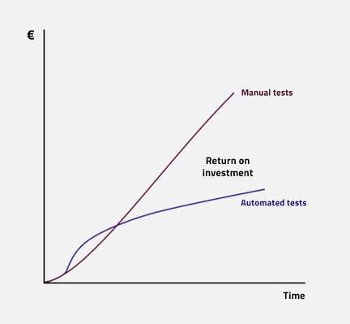

Automated GUI testing isn’t likely to entirely replace manual testing. Many companies still use manual testing for exploratory testing, customer-centric testing, testing for new features, and verifying bugs found in fields.

Keep in mind that when you first invest in automated testing, you’ll need to put more effort into getting everything up and running. But once that’s all in good shape, you’ll spend way less effort in maintaining tests and adding new tests than you would with manual testing.

**When would it not make sense for a company to invest in automated testing?** ​If the product is short-lived or very cheap, automated testing might not pay off in the long run. The effort needed for automation, which cannot be denied, pays off only after some time.

Some types of software, like animated computer games, are also very difficult to test. With games, the testing is often crowdsourced to players outside, meaning many software makers let the users be their testers. This method is known as bananaware: when the software is still green and will have to ripen on the customer's end.

**Read more:** [**How to choose between manual and automated testing for your software**](https://www.qt.io/blog/quality-assurance/how-to-choose-between-manual-or-automated-testing-for-your-software?hsLang=en)

**Quality assurance mistakes to avoid**

Doing nothing

The most common mistake companies make when it comes to quality assurance is to not perform it at all. This is either due to costs, or not knowing how to do quality assurance effectively.

Only by taking the right approach and tools will the investment in quality assurance start to pay off big time.

Using the wrong methods

Another common mistake is to wrongly perform quality assurance testing. For example, some companies might bet on manual testing, which seems cheap and easy at first, but the costs pile up at the end of the year.

While people can be quite creative with testing, there’s also a limit to how much we can do. This means that it’s impossible for humans to check everything in all possible configurations of the software.

Even when automating testing, however, things can be done wrong. Developers or testers might use inadequate tools, fragile test scripts, or unstable environments. They might also have dependencies on external hardware that is not under their control.

Not measuring code coverage

It’s best for testers and developers to focus on the most important tests first as not everything will be tested in the end. A [**code coverage tool like Coco**](https://www.qt.io/product/quality-assurance/coco?hsLang=en) can be used to find out what's not yet tested, or whether tests overlap and could be dropped.

Without the right tools, it’s impossible to say with certainty how much code is covered by the tests. By measuring code coverage, developers can run only the relevant tests and get faster results.

**The benefits of automated quality assurance testing**

Faster testing

Not surprisingly, automation speeds up software testing. With automation, tests can be run more often and even in parallel – instead of just testing a product before a release, the tests can be run every night. Tests can also be run after every change made by the developers, which is called continuous integration (CI).

The bigger a product – and the more safety-critical a product is – the more tests are needed. The more tests are automated, the more time is saved. So the investment in automation is especially worth it for companies with these needs.

Vendors in some industries like medical and automotive are forced to test by regulations. While they can do this manually, they’ll save time and money by automating testing. The reports generated by a tool will likely also be more welcomed by an auditor compared to manual tests since a human can cheat and will not test that regularly.

Broader coverage

Automation also provides better coverage of software platforms or configurations. For example, a human tester may only test the latest version of an operating system, like Windows 11. With automated tests, it's a piece of cake to also run the same tests on Windows 10, or with different browsers. This way, you can reach a much broader coverage than what human resources (and nerves) would allow for.

Without any automation quality assurance systems, the information on your code coverage is based on the most recent test round, which may have been done who knows when.

More time for meaningful work

Testing manually can be a very monotonous and time-consuming task, as previously mentioned. No one wants to perform the same actions again and again, and repeatedly test old features.

Automating testing frees up people’s time to do the important work that only humans can do.

Launch products faster

Product owners want a short time to market – they need to get their products out of the door as fast as possible. If the QA team says "Wait, we need one month to give our blessing," then no one is happy.

With automated testing, you’ll also find regressions sooner than with manual testing, which makes fixing them much easier.

In software testing, quality, value, and price are all connected – automated testing helps to reduce risks and costs, and enable revenue growth.

Maintain and improve your brand reputation

Automating GUI testing helps to improve your software quality and lower risks.

You want your company to have a reputation that your products simply work (think of Apple, for example). Once a bug reaches your company, a professional reviewer could damage your product's reputation even before it’s launched. Individual users may also badmouth the company in online forums or social media.

Automated testing helps you avoid these potentially embarrassing situations.

**Read more about the benefits from this blog:**[**What Are the Benefits of Automated Software Testing?**](https://www.qt.io/blog/quality-assurance/benefits-of-automated-software-testing?hsLang=en)

**Modularity and its Properties**

Last Updated : 30 Mar, 2023

The module simply means the software components that are been created by dividing the software. The software is divided into various components that work together to form a single functioning item but sometimes they can perform as a complete function if not connected with each other. This process of creating software modules is known as **Modularity** in software engineering. It simply measures the degree to which these components are made up than can be combined. Some of the projects or software designs are very complex that it's not easy to understand its working and functioning. In such cases, modularity is a key weapon that helps in reducing the complexity of such software or projects. The basic principle of Modularity is that “Systems should be built from cohesive, loosely coupled components (modules)” which means s system should be made up of different components that are united and work together in an efficient way and such components have a well-defined function. To define a modular system, several properties or criteria are there under which we can evaluate a design method while considering its abilities. These criteria are defined by Meyer. Some of them are given below:

1. **Modular Decomposability -** Decomposability simply means to break down something into smaller pieces. Modular decomposability means to break down the problem into different sub-problems in a systematic manner. Solving a large problem is difficult sometimes, so the decomposition helps in reducing the complexity of the problem, and sub-problems created can be solved independently. This helps in achieving the basic principle of modularity.
2. **Modular Composability -** Composability simply means the ability to combine modules that are created. It’s actually the principle of system design that deals with the way in which two or more components are related or connected to each other. Modular composability means to assemble the modules into a new system that means to connect the combine the components into a new system.
3. **Modular Understandability -** Understandability simply means the capability of being understood, quality of comprehensible. Modular understandability means to make it easier for the user to understand each module so that it is very easy to develop software and change it as per requirement. Sometimes it's not easy to understand the process models because of its complexity and its large size in structure. Using modularity understandability, it becomes easier to understand the problem in an efficient way without any issue.
4. **Modular Continuity -** Continuity simply means unbroken or consistent or uninterrupted connection for a long period of time without any change or being stopped. Modular continuity means making changes to the system requirements that will cause changes in the modules individually without causing any effect or change in the overall system or software.
5. **Modular Protection -** Protection simply means to keep something safe from any harms, to protect against any unpleasant means or damage. Modular protection means to keep safe the other modules from the abnormal condition occurring in a particular module at run time. The abnormal condition can be an error or failure also known as run-time errors. The side effects of these errors are constrained within the module.

**Example to understand modularity better:**

In the object-oriented approach, the concept of modularity revolves around the concept of well-organized interactions between different components. Modularity refers to an organizing structure in which different components of a software system are divided into separate functional units.

For example, a house or apartment can be viewed as consisting of several interacting units; electrical, heating, cooling, plumbing, structure, etc. Rather than viewing it as one giant jumble of wires, vents, pipes, and boards, the organized architect designing a house or apartment will view them as separate modules that interact in well-defined ways. In doing so, he/she is using the concept of modularity to bring clarity of thought that provides a natural way of organizing functions into distinct manageable units. Likewise, using modularity in a software system can also provide a powerful organizing framework that brings clarity to an implementation.

Modular programming has been around since the 60s and is a foundation of any good software architecture. Across many industries that were once hardware-dominated, software architecture is surfacing as a critical bottleneck for delivering the best products to the market first. Simultaneously, the share of R&D spending on software development is increasing rapidly.

The main issue is that software has grown organically within these products. If the perspective hasn't been raised and a unified modular software architecture has been set up, there is an evident risk that you end up with many different monolithic software platforms, each designed for a narrow subset of your products. This issue makes your development slow and costly, with poor output.

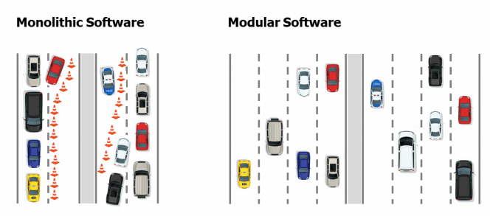

One could argue that lack of strategic software modularity is the main reason traditional hardware-first companies have difficulty competing with new, focused competitors that don't have the burden of an existing portfolio.

In this blog post, we will explain what software modularity is, why it matters to your business, and what you can do to improve your software.

**What is Software Modularity?**

Software modularity is measured by how well software is decomposed into smaller pieces with standardized interfaces. It is analogous to modularity for hardware. We want to create products by combining reusable chunks of code, so you only implement a feature or functionality once and then maximize reuse.

A software module exposes its interface to other modules, both internally within the module system but also externally towards other systems. Externally exposed interfaces belong to the module system's external Application Program Interface (API). They should be carefully designed since changes in APIs will impact other applications. There are plenty of APIs freely available today for cloud services, for example, [SkyScanner API](https://www.partners.skyscanner.net/affiliates/travel-apis) (to build your own travel app) or [Open Weather API](https://openweathermap.org/api) (to build your own weather app). If any of these services suddenly change their API, many apps across the globe will be broken, generating a lot of frustration and extra work. To have a stable modular software system, careful design and governance of interfaces must also be implemented for interfaces between modules for internal use.

The intent of software modularity is different depending on the strategic targets of the software author. Here are some examples of strategy and intent:

* When software and hardware are combined, **software portability** might be a key target of modularity. Software portability is defined as software that is independent of the hardware it runs on. This autonomy can be achieved with carefully designed interfaces that abstract the hardware level from the application level.
* **Automated testing** is typically a major concern for software that is changed often. By being able to test faster and spot issues earlier, less time and resources can be spent on integrating the changes. Automated testing is something that can be achieved better with smart software modularity. By isolating changing parts with interfaces, we can test smaller chunks which is faster both in testing and in finding bugs.
* For software where updates and features are implemented on an installed base, **Over-the-Air (OTA) update capability** is the tale of the century. To push software updates in a controlled and efficient matter, it is essential to separate frequently updated modules from fundamental critical modules where changes are high risk. Updating small chunks of the software is also faster and less resource consuming.

To achieve the intent of the software modularity requires a [solid approach](https://www.modularmanagement.com/blog/best-practices-for-software-architecture-in-hardware-companies?hsLang=en). It starts with a clear definition of the goals and trying to determine what parts of the system you need to apply the modular strategy on, i.e. determining which parts belong together in a software module.

 What is a Software Module?

In software, the term Module has a wide range of different definitions, much like the term Component. Even though it is a term with many different definitions, there are commonalities in the descriptions. Let's have a look at some of these descriptions.

Starting with:

*A module is a****piece of code****that can be****independently****created and maintained to be****(re)used in different systems****.*

 and [Wikipedia describes modular programming](https://en.wikipedia.org/wiki/Modular_programming#:~:text=Modular%20programming%20is%20a%20software,aspect%20of%20the%20desired%20functionality.) as:

*"Modular programming is a software design technique that emphasizes****separating the functionality****of a program into****independent, interchangeable modules****…"*

Which are the commonalities?

A Software Module is Independent

A software module is independent of other modules in the sense that it is possible to develop and maintain a module with minimal to no impact on other modules. It does not mean that a module has no dependencies on other modules when running the program.

This autonomy is an important aspect of a software module because it helps to increase productivity. Independent modules enable engineering teams to be independent of each other when creating, maintaining, and testing the code.

A Software Module is Reusable and Interchangeable

A module can be reused in different systems, and it is also interchangeable (replaceable) within a system. Reusing modules in different systems or products without modification is very beneficial and will help shorten the time to market.

Interchangeable means you can replace a module without impacting the rest of the system. This flexibility is essential when upgrading a system because of new features or bug corrections. If you can limit changes to one or a few modules, less time is needed to test and implement changes. More frequent and smaller releases, in terms of impacted parts of the system, enable agility. Smaller releases also mean that you take less risk when releasing new features.

A Software Module is a Piece of Code and a Function

A module is a part of a module system. The first description above defines the decomposition in terms of code and the second in terms of functionality. Is that a similarity or a difference?

- We would say both. It is about decomposing the system into smaller parts, but:

* Decomposition in terms of code is about organizing the code where a module is a structural unit. Different programming languages support the software modularization concept but not in precisely the same way. For example, a [Python module](https://docs.python.org/3/tutorial/modules.html) is a file, but a Java module is much more. A [Java module](http://tutorials.jenkov.com/java/modules.html#java-module-basics) consists of one or many packages (another structural unit) and a descriptor that defines the packages that are exported from the module and the other modules that it requires to work. It is only the exported packages that are accessible for other modules to use.
* Separating functionality is about organizing logical functions into logical software modules. This organization is beneficial when specifying and documenting the architecture of a system. A logical module may be realized by a code module or another structural unit, like a package. In [UML](https://www.visual-paradigm.com/guide/uml-unified-modeling-language/uml-practical-guide/)(Unified Modelling Language), a modular system can be described with a UML Component diagram.

**How Can a Software Module be Independent, Reusable, and Interchangeable?**

There are some important properties of a software module that make it possible for teams to work independently, making the software module reusable in many systems and interchangeable.

A module…

1. **encapsulates functionality and data**. Encapsulation is about hiding the implementation details of a module. The less a module knows about other modules, the less dependent it will be on changes in other modules. Other modules can only access functionality and data via the provided interface. Generally, it is good to encapsulate as much as possible.
2. **provides an interface**to other modules for accessing its functionality and data. The software module interface should be as abstracted and as small as possible. Fewer details mean looser coupling between software modules and make them more independent, reusable, and interchangeable.
3. **requires interfaces**provided by other software modules. To realize the functionality of a software module, it must sometimes use the provided interfaces of other modules. A software module that uses another module through its interface has a dependency on that other module. The fewer dependencies, the better. Since non-backward compatible interface changes may occur in a software module's lifecycle, an update to a module can be forced without any benefit to customers, such as better performance, functionality, or quality. Forced software updates that do not improve customer benefit should be considered a [cost of complexity in software development](https://www.modularmanagement.com/blog/what-is-cost-of-complexity?hsLang=en).

 Let's illustrate.

A module has a provided interface, that other modules in the system can consume as well as a required interface, i.e. an interface that is required for the module to function correctly:

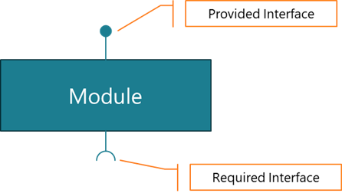

*Figure 1. A software module provides and requires interfaces*

In the example below we have 4 modules, A, B, C and D. Module B, with its Module Variant 1 provides an interface B to Module A and requires both Module C and Module D provided interfaces according to below.

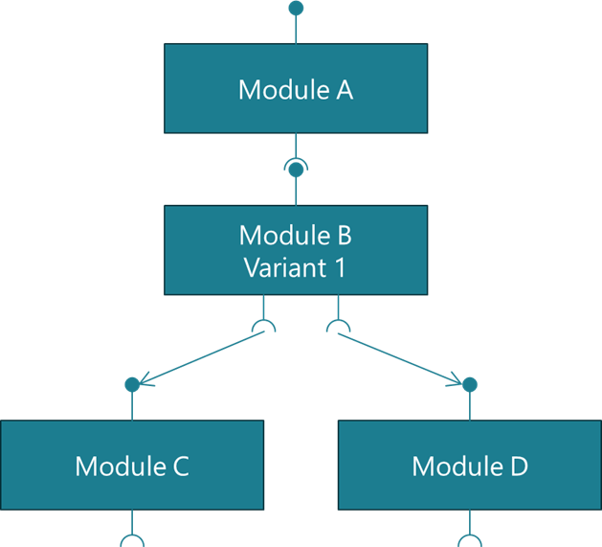

*Figure 2. Two software modules that provide and require the same interfaces are interchangeable*

Assume we have a new Module B, Variant 2, with improved performance. If variant 2 provides the same interface and requires the same interfaces as variant 1, then it is interchangeable with Module B, Variant 1.

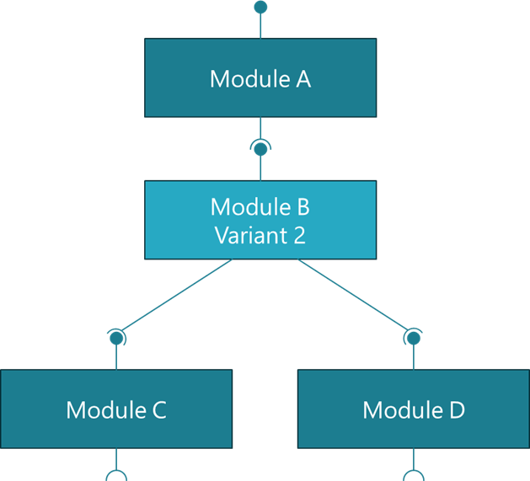

*Figure 3. Two software modules that provide and require the same interfaces are interchangeable*

A module that defines provided and required interfaces become reusable in other systems, e.g., Module B, Variant 1, can be reused in another system as long as the required interfaces are provided.

**What is a Strategic Software Module?**

An often-overlooked aspect of forming software modules is company strategy. When creating a module with the properties described above, we typically have a specific intent in mind. This purpose should be explicitly decided and documented. The intent is expressed by answering strategic questions, such as:

* Is the module formed to collect aspects of the system that will frequently change?
* Is the module formed to allow for sourcing the code from a strategic partner?
* Is the module formed because it requires a specific skill set to develop that only very few people have?

 As software architecture can easily be circumvented or misunderstood by the coders, it is vital to repeatedly look back at why certain functions were grouped into modules. For this reason, we believe it is crucial to state and document the strategic intent of a module. In fact, a defined module strategy should be considered a criterion to call something a module. A software module with a defined module strategy is a strategic software module.

 Our colleague's blog post "[What is a good modular system](https://www.modularmanagement.com/blog/what-is-a-good-modular-system?hsLang=en)" explains that a [modular system](https://www.modularmanagement.com/blog/modular-systems?hsLang=en) must be flexible for a large scope and live for a long time. Creating strategic software modules increases the chance of a longer lifetime, and robustness becomes less person-dependent.

**How to Document a Strategic Software Module**

Documenting a strategic software module is different from traditional software documentation. The strategic software module should encapsulate function, define interfaces, and be driven by strategy. This information needs to be documented to easily communicate, discuss, and explain. One way of doing it is to create a one-page strategic software module specification stored in your document management system. Another flexible way to document these aspects is a wiki.

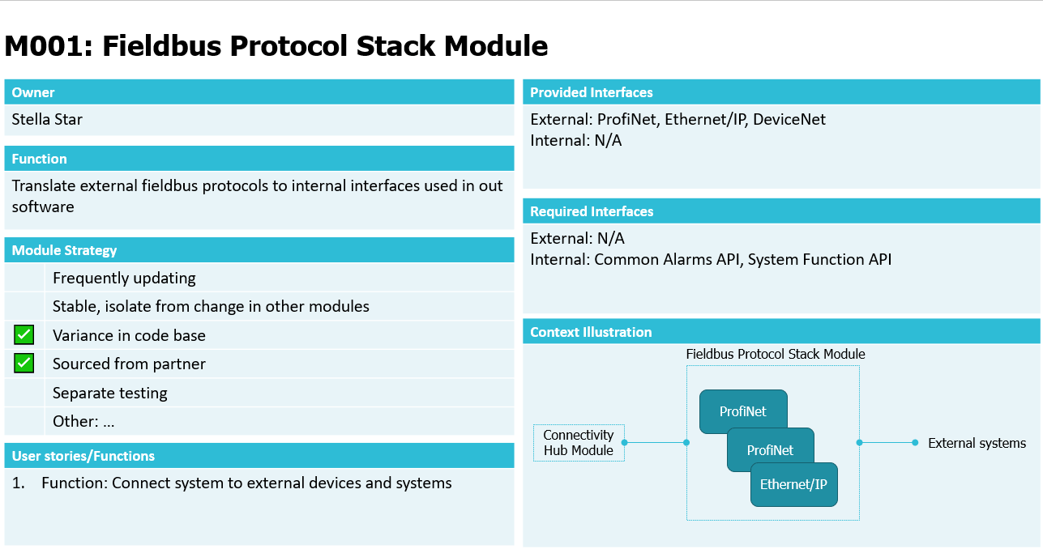

*Figure 4. Example of a Strategic Software Module Specification in a one-page slide*

**Strategic Software Modules Deliver Increased Value Over Time**

To enable efficiency, flexibility, and agility, large and complex systems must be decomposed into smaller parts or modules. Independent modules make the development teams more autonomous, resulting in improved efficiency and shorter time to market. A module is also reusable in different products. Companies with a modularized product portfolio build their products from a mix of common reusable modules.

 By defining the strategic intent of a software module, you create a strategic software module. These modules will be more resilient to change since the reasons why the modules were formed are documented.

 It is fascinating that a module with only three simple attributes - encapsulation, interfaces, and strategy – can deliver so much value.

If you want to read more about how to create a modular architecture using a proven method called the Modular Function Deployment you can download our 5-step guide here below:

**Modular Thinking and Refactoring Improve the Speed of Innovation**

If you are planning to improve your software architecture with, for instance, support for automatic Over-the-Air software updates (OTA) or introduce new innovative AI functions, it can be tempting to rewrite all the software from scratch with the latest tools and technologies that promise faster implementation speeds, higher innovation and easier maintenance in the future. This is true if the software you are trying to replace is very old or the functionality or technologies you aim to add is highly innovative.

While this may seem like a good idea on the drawing board, re-factoring what you have first into strategic software modules is a much safer and less costly way to go. If done correctly, you will reap the benefits of future technologies faster while keeping or improving the performance of the software you already have.

This blog digs deeper into why: [Improve your Software Architecture by Code Refactoring, Not Rewriting.](https://www.modularmanagement.com/blog/improve-your-software-architecture-by-code-refactoring-not-rewriting?hsLang=en)

**Modularize to Support the Transition to Modern and Agile Ways of Working and Improved Hardware**

Many companies are looking at Agile development methodologies to improve their ways of working and becoming better at adopting to new and changing market requirements.

Not only is modularity a key way to achieve these benefits for both software and also [hardware](https://www.modularmanagement.com/blog/agile-development-for-hardware-platforms?hsLang=en), but it can also be used to address difficult development resource shortages.

If you are able to pro-actively modularize an old monolithic software system, using the previously mentioned re-factoring techniques, it could potentially prepare the development organization to a world where the software platform can be migrated to never and more powerful hardware without a massive workload and hard deadlines. It could also be used to support 2nd sourcing critical hardware components that the software relies on, improving platform resilience and potentially lowering purchasing costs.

Modular programming has been around since the 60s and is a foundation of any good software architecture. Across many industries that were once hardware-dominated, software architecture is surfacing as a critical bottleneck for delivering the best products to the market first. Simultaneously, the share of R&D spending on software development is increasing rapidly.

The main issue is that software has grown organically within these products. If the perspective hasn't been raised and a unified modular software architecture has been set up, there is an evident risk that you end up with many different monolithic software platforms, each designed for a narrow subset of your products. This issue makes your development slow and costly, with poor output.



One could argue that lack of strategic software modularity is the main reason traditional hardware-first companies have difficulty competing with new, focused competitors that don't have the burden of an existing portfolio.

In this blog post, we will explain what software modularity is, why it matters to your business, and what you can do to improve your software.

**What is Software Modularity?**

Software modularity is measured by how well software is decomposed into smaller pieces with standardized interfaces. It is analogous to modularity for hardware. We want to create products by combining reusable chunks of code, so you only implement a feature or functionality once and then maximize reuse.

A software module exposes its interface to other modules, both internally within the module system but also externally towards other systems. Externally exposed interfaces belong to the module system's external Application Program Interface (API). They should be carefully designed since changes in APIs will impact other applications. There are plenty of APIs freely available today for cloud services, for example, [SkyScanner API](https://www.partners.skyscanner.net/affiliates/travel-apis) (to build your own travel app) or [Open Weather API](https://openweathermap.org/api) (to build your own weather app). If any of these services suddenly change their API, many apps across the globe will be broken, generating a lot of frustration and extra work. To have a stable modular software system, careful design and governance of interfaces must also be implemented for interfaces between modules for internal use.

The intent of software modularity is different depending on the strategic targets of the software author. Here are some examples of strategy and intent:

* When software and hardware are combined, **software portability** might be a key target of modularity. Software portability is defined as software that is independent of the hardware it runs on. This autonomy can be achieved with carefully designed interfaces that abstract the hardware level from the application level.
* **Automated testing** is typically a major concern for software that is changed often. By being able to test faster and spot issues earlier, less time and resources can be spent on integrating the changes. Automated testing is something that can be achieved better with smart software modularity. By isolating changing parts with interfaces, we can test smaller chunks which is faster both in testing and in finding bugs.
* For software where updates and features are implemented on an installed base, **Over-the-Air (OTA) update capability** is the tale of the century. To push software updates in a controlled and efficient matter, it is essential to separate frequently updated modules from fundamental critical modules where changes are high risk. Updating small chunks of the software is also faster and less resource consuming.

To achieve the intent of the software modularity requires a [solid approach](https://www.modularmanagement.com/blog/best-practices-for-software-architecture-in-hardware-companies?hsLang=en). It starts with a clear definition of the goals and trying to determine what parts of the system you need to apply the modular strategy on, i.e. determining which parts belong together in a software module.

 What is a Software Module?

In software, the term Module has a wide range of different definitions, much like the term Component. Even though it is a term with many different definitions, there are commonalities in the descriptions. Let's have a look at some of these descriptions.

Starting with:

*A module is a****piece of code****that can be****independently****created and maintained to be****(re)used in different systems****.*

 and [Wikipedia describes modular programming](https://en.wikipedia.org/wiki/Modular_programming#:~:text=Modular%20programming%20is%20a%20software,aspect%20of%20the%20desired%20functionality.) as:

*"Modular programming is a software design technique that emphasizes****separating the functionality****of a program into****independent, interchangeable modules****…"*

Which are the commonalities?

A Software Module is Independent

A software module is independent of other modules in the sense that it is possible to develop and maintain a module with minimal to no impact on other modules. It does not mean that a module has no dependencies on other modules when running the program.

This autonomy is an important aspect of a software module because it helps to increase productivity. Independent modules enable engineering teams to be independent of each other when creating, maintaining, and testing the code.

A Software Module is Reusable and Interchangeable

A module can be reused in different systems, and it is also interchangeable (replaceable) within a system. Reusing modules in different systems or products without modification is very beneficial and will help shorten the time to market.

Interchangeable means you can replace a module without impacting the rest of the system. This flexibility is essential when upgrading a system because of new features or bug corrections. If you can limit changes to one or a few modules, less time is needed to test and implement changes. More frequent and smaller releases, in terms of impacted parts of the system, enable agility. Smaller releases also mean that you take less risk when releasing new features.

A Software Module is a Piece of Code and a Function

A module is a part of a module system. The first description above defines the decomposition in terms of code and the second in terms of functionality. Is that a similarity or a difference?

- We would say both. It is about decomposing the system into smaller parts, but:

* Decomposition in terms of code is about organizing the code where a module is a structural unit. Different programming languages support the software modularization concept but not in precisely the same way. For example, a [Python module](https://docs.python.org/3/tutorial/modules.html) is a file, but a Java module is much more. A [Java module](http://tutorials.jenkov.com/java/modules.html#java-module-basics) consists of one or many packages (another structural unit) and a descriptor that defines the packages that are exported from the module and the other modules that it requires to work. It is only the exported packages that are accessible for other modules to use.
* Separating functionality is about organizing logical functions into logical software modules. This organization is beneficial when specifying and documenting the architecture of a system. A logical module may be realized by a code module or another structural unit, like a package. In [UML](https://www.visual-paradigm.com/guide/uml-unified-modeling-language/uml-practical-guide/)(Unified Modelling Language), a modular system can be described with a UML Component diagram.

**How Can a Software Module be Independent, Reusable, and Interchangeable?**

There are some important properties of a software module that make it possible for teams to work independently, making the software module reusable in many systems and interchangeable.

A module…

1. **encapsulates functionality and data**. Encapsulation is about hiding the implementation details of a module. The less a module knows about other modules, the less dependent it will be on changes in other modules. Other modules can only access functionality and data via the provided interface. Generally, it is good to encapsulate as much as possible.
2. **provides an interface**to other modules for accessing its functionality and data. The software module interface should be as abstracted and as small as possible. Fewer details mean looser coupling between software modules and make them more independent, reusable, and interchangeable.
3. **requires interfaces**provided by other software modules. To realize the functionality of a software module, it must sometimes use the provided interfaces of other modules. A software module that uses another module through its interface has a dependency on that other module. The fewer dependencies, the better. Since non-backward compatible interface changes may occur in a software module's lifecycle, an update to a module can be forced without any benefit to customers, such as better performance, functionality, or quality. Forced software updates that do not improve customer benefit should be considered a [cost of complexity in software development](https://www.modularmanagement.com/blog/what-is-cost-of-complexity?hsLang=en).

 Let's illustrate.

A module has a provided interface, that other modules in the system can consume as well as a required interface, i.e. an interface that is required for the module to function correctly:



*Figure 1. A software module provides and requires interfaces*

In the example below we have 4 modules, A, B, C and D. Module B, with its Module Variant 1 provides an interface B to Module A and requires both Module C and Module D provided interfaces according to below.



*Figure 2. Two software modules that provide and require the same interfaces are interchangeable*

Assume we have a new Module B, Variant 2, with improved performance. If variant 2 provides the same interface and requires the same interfaces as variant 1, then it is interchangeable with Module B, Variant 1.



*Figure 3. Two software modules that provide and require the same interfaces are interchangeable*

A module that defines provided and required interfaces become reusable in other systems, e.g., Module B, Variant 1, can be reused in another system as long as the required interfaces are provided.

**What is a Strategic Software Module?**

An often-overlooked aspect of forming software modules is company strategy. When creating a module with the properties described above, we typically have a specific intent in mind. This purpose should be explicitly decided and documented. The intent is expressed by answering strategic questions, such as:

* Is the module formed to collect aspects of the system that will frequently change?
* Is the module formed to allow for sourcing the code from a strategic partner?
* Is the module formed because it requires a specific skill set to develop that only very few people have?

 As software architecture can easily be circumvented or misunderstood by the coders, it is vital to repeatedly look back at why certain functions were grouped into modules. For this reason, we believe it is crucial to state and document the strategic intent of a module. In fact, a defined module strategy should be considered a criterion to call something a module. A software module with a defined module strategy is a strategic software module.

 Our colleague's blog post "[What is a good modular system](https://www.modularmanagement.com/blog/what-is-a-good-modular-system?hsLang=en)" explains that a [modular system](https://www.modularmanagement.com/blog/modular-systems?hsLang=en) must be flexible for a large scope and live for a long time. Creating strategic software modules increases the chance of a longer lifetime, and robustness becomes less person-dependent.

**How to Document a Strategic Software Module**

Documenting a strategic software module is different from traditional software documentation. The strategic software module should encapsulate function, define interfaces, and be driven by strategy. This information needs to be documented to easily communicate, discuss, and explain. One way of doing it is to create a one-page strategic software module specification stored in your document management system. Another flexible way to document these aspects is a wiki.



*Figure 4. Example of a Strategic Software Module Specification in a one-page slide*

**Strategic Software Modules Deliver Increased Value Over Time**

To enable efficiency, flexibility, and agility, large and complex systems must be decomposed into smaller parts or modules. Independent modules make the development teams more autonomous, resulting in improved efficiency and shorter time to market. A module is also reusable in different products. Companies with a modularized product portfolio build their products from a mix of common reusable modules.

 By defining the strategic intent of a software module, you create a strategic software module. These modules will be more resilient to change since the reasons why the modules were formed are documented.

 It is fascinating that a module with only three simple attributes - encapsulation, interfaces, and strategy – can deliver so much value.

If you want to read more about how to create a modular architecture using a proven method called the Modular Function Deployment you can download our 5-step guide here below:

**Modular Thinking and Refactoring Improve the Speed of Innovation**

If you are planning to improve your software architecture with, for instance, support for automatic Over-the-Air software updates (OTA) or introduce new innovative AI functions, it can be tempting to rewrite all the software from scratch with the latest tools and technologies that promise faster implementation speeds, higher innovation and easier maintenance in the future. This is true if the software you are trying to replace is very old or the functionality or technologies you aim to add is highly innovative.

While this may seem like a good idea on the drawing board, re-factoring what you have first into strategic software modules is a much safer and less costly way to go. If done correctly, you will reap the benefits of future technologies faster while keeping or improving the performance of the software you already have.

This blog digs deeper into why: [Improve your Software Architecture by Code Refactoring, Not Rewriting.](https://www.modularmanagement.com/blog/improve-your-software-architecture-by-code-refactoring-not-rewriting?hsLang=en)

**Modularize to Support the Transition to Modern and Agile Ways of Working and Improved Hardware**

Many companies are looking at Agile development methodologies to improve their ways of working and becoming better at adopting to new and changing market requirements.

Not only is modularity a key way to achieve these benefits for both software and also [hardware](https://www.modularmanagement.com/blog/agile-development-for-hardware-platforms?hsLang=en), but it can also be used to address difficult development resource shortages.

If you are able to pro-actively modularize an old monolithic software system, using the previously mentioned re-factoring techniques, it could potentially prepare the development organization to a world where the software platform can be migrated to never and more powerful hardware without a massive workload and hard deadlines. It could also be used to support 2nd sourcing critical hardware components that the software relies on, improving platform resilience and potentially lowering purchasing costs.

What are Software Design Principles? Why we should apply Software Design Principles? This article will answer that.

This article will cover some principles, design patterns that will help developers make a good system design.

After reading this article, you can understand things:

* Why are Software Design Principles important?
* SOLID principles
* Other principles (DRY, KISS, YAGNI)
* Some notes for developers

**What are Software Design Principles?**

***Software Design Principles are a set of guidelines that helps developers to make a good system design.***

In the development process, the time for writing code will only consume from 20 to 40 percent, remaining we will read code and maintain the system. So, Making a good system design is very important. In my opinion, a good system should have a good code base: easy to read, easy to understand, easy to maintain(add/modify feature and fix bugs), and easy to extend the system in the future. That will reduce development time, resources, and make us happy more.

Basically, Software Design is only a part of the development process in the Design Step(Please take a look at the below image about the development process). Before we do **Software Design(low-level)** we have to complete **Software Architecture (high-level)**. ***Choosing an architecture will determine how to deal with performance, fault tolerance, scalability, and reliability. Software Design is responsible for code level(low-level) such as, what each module is doing, class scope, methods purposes, and so on***. You can imagine like when you build a house or a building.

Press enter or click to view image in full size

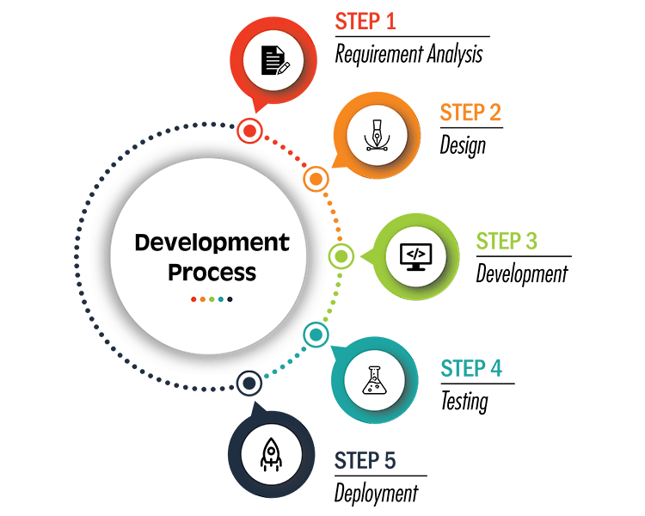

Development Process. Source: Internet

**Why are Software Design Principles important?**

You can write code without Software Design Principles. That’s the truth. But in my opinion, if you **want to become a Senior level** you should **understand and apply Sofware Design Principles** in your work. We have **many solutions to apply** Software Design Principles to your project. You can t**hink and apply your solution or use the Design Patterns**. The design pattern is the best solution to resolve common problems that repeat many times in software development. Using the design pattern will reduce risks and make your code easy to maintain.

Have you ever **read the code of frameworks**such as Laravel or Spring Framework? Reading the code of frameworks is **a way to improve your skills**and could very **difficult understanding** because they applied **many design patterns**: Decorator Pattern, Strategy Pattern, and so on. These frameworks **applied Software Design principles wisely**. I have worked with the Laravel 5 and Spring framework and I saw both frameworks use the Dependency Inversion Principle (IoC Container, Dependency Injection) for their core.

Besides, if you want to **contribute to open-source** which often **uses a lot of Design Patterns**: Singleton, Factory Method, Decorator Pattern, Strategy Pattern, Proxy, and so on. I think you have to **understand those patterns** then **you can contribute to it**. Moreover, if you can want to **create a framework like Lavarel Framework**(Taylor Otwell), I think you **should deeply understanding Software Design Principles and Design Patterns**. **Learning** Design Pattern **isn’t difficult**, you can search on the internet or watch them on youtube **but identify and apply them** in the real project **is very difficult**. You can achieve it after working with many projects in many years.

Basically, **Sofware Design Principles** are **Object-Oriented Design Principles** which based on OOP. We are very familiar with OOP. So, I won’t write about it. Besides, We have a lot of paradigms such as Procedural Programming, Functional Programming, Reactive Programming, Aspect-Oriented Programming, and so on. Please take a look at below image:

Press enter or click to view image in full size

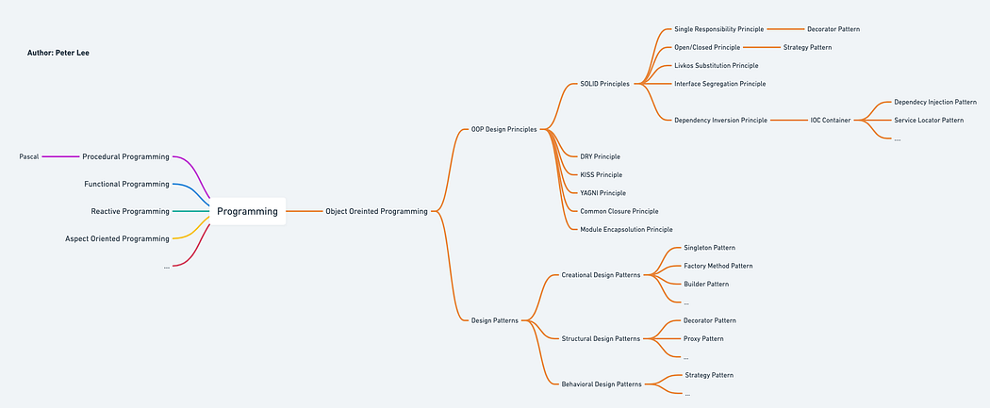

OO Design Principles

As far as I know, OOP Design Principles has 10 principles. In my opinion, we should understand the 8/10 principles that are enough. We can split these principles by group them in types:

* SOLID Principles
* DRY (Don’t repeat yourself) Principle
* KISS (Keep it simple, stupid!!) Principle
* YAGNI (You ain’t gonna need it) Principle

**SOLID Principles**

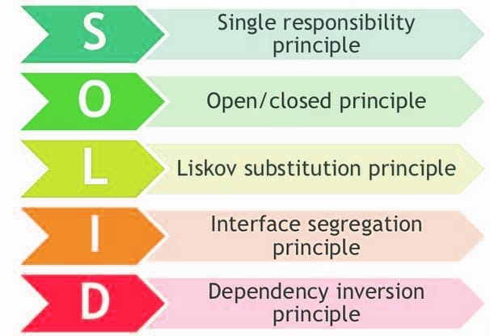

SOLID principles. Source: dev.to

**Single Reponsitibily Principle**

***“A class should have one and only one reason to change, meaning that a class should have only one job.”***

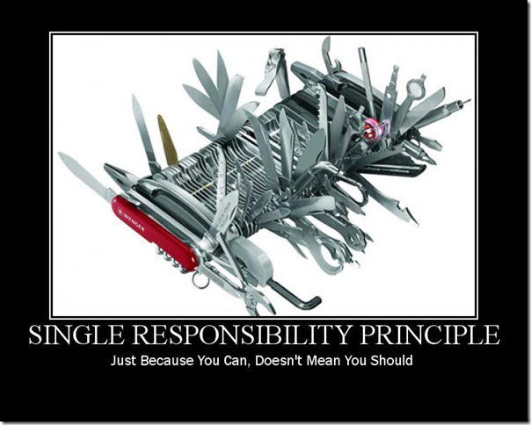

Single Responsibility Principle (SRP)

I have worked on a lot of projects in many years. In my experience, The Helper/Utility class often violates this principle. You should avoid them. To guarantee your code complies with this principle you can use the Decorator Pattern.

**Open/Closed Principle**

***“Objects or entities should be open for extension but closed for modification.”***

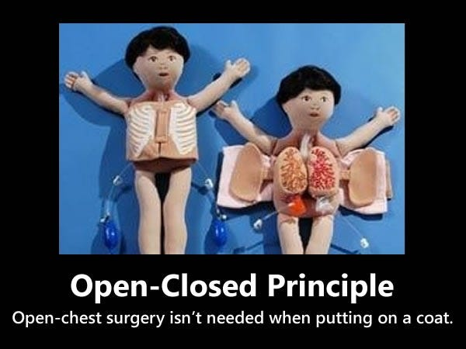

Open/Closed Principle (OCP)

This principle is applied widely in everywhere. For instance, you can imagine to Plugin Architecture in IntelliJ IDEA/Visual Studio Code/Eclipse: easy to add/remove a feature with an available plugin. Example: Lombok and Docker plugin in IntelliJ IDEA. To guarantee your code complies with this principle you can use the Strategy Pattern.

**Liskov Substitution Principle**

***“Objects in a program should be replaceable with instances of their subtypes without altering the correctness of that program.”***



Liskov Substitution Principle (LSP)

This principle states that objects of a parent’s class should be replaceable with objects of the child’s class without breaking the logic of the application. That requires the objects of your child’s class to behave in the same way as the objects of your parent’s class.

**Interface Segregation Principle**

***“Many client-specific interfaces are better than one general-purpose interface.”***

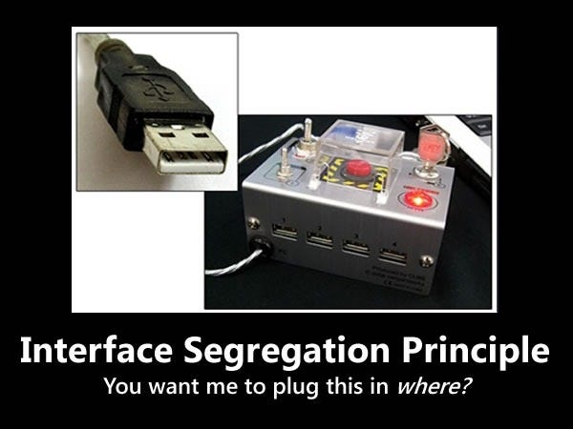

Interface Segregation Principle (ISP)

Like the Single Responsibility Principle(SRP), the target of the Interface Segregation Principle is to reduce the side effects and frequency of required changes by splitting the code into multiple/independent parts.

**Dependency Inversion Principle**

***Entities must depend on abstractions, not on concretions. It states that the high-level module must not depend on the low-level module, but they should depend on abstractions.***

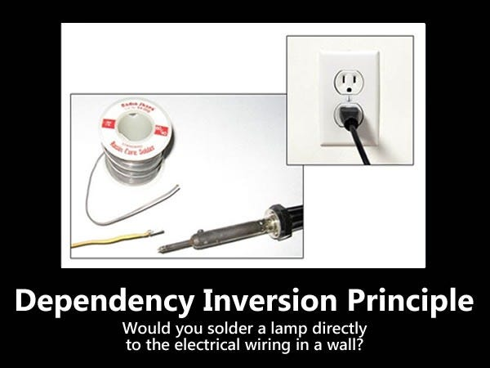

Dependency Inversion Principle (DIP)

This principle is difficult to understanding but it very close to people. If you are using Spring Framework then you are using it. Some people can confuse between Dependency Inversion Principle and Dependency Injection (DI). Please see the below image:

Press enter or click to view image in full size

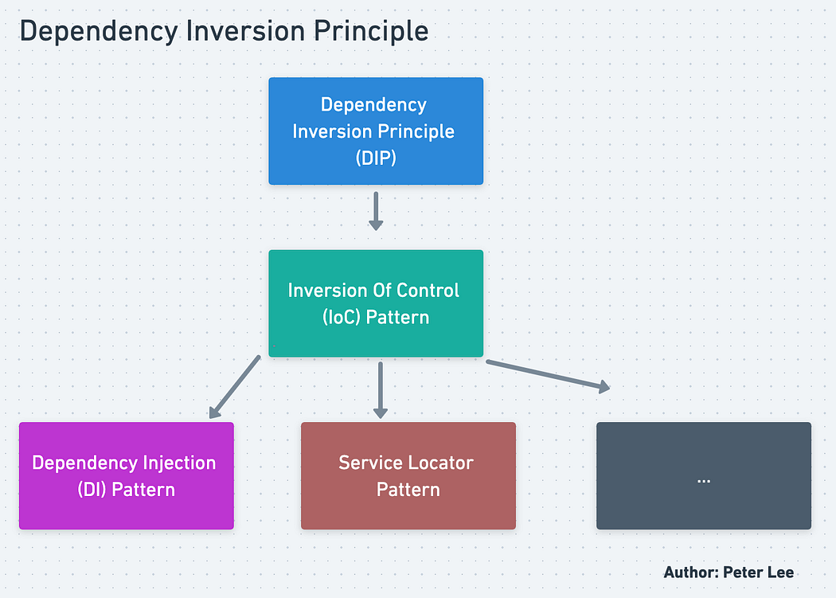

Dependency Inversion Principle(DIP) vs Inversion Of Control (IoC) vs Dependency Injection(DI)

Martin Fowler called Inversion Of Control is a principle(or Hollywood principle) but I think it’s only a Design Pattern. We have many solutions to guarantee code abide by with IoC: Dependency Injection(DI), Service Locator, and so on.

**Other principles (DRY, KISS, YAGNI)**

**DRY (Don’t repeat yourself)**

This principle states that each small pieces of knowledge (code) may only occur exactly once in the entire system.

**KISS (Keep it simple, stupid!)**

This principle states that try to keep each small piece of software simple and unnecessary complexity should be avoided.

**YAGNI (You ain’t gonna need it)**

This principle states that always implement things when you actually need them never implements things before you need them.

Designing a model is an important phase and is a multi-process that represents the data structure, program structure, interface characteristic, and procedural details. It is mainly classified into four categories — Data design, architectural design, interface design, and component-level design.

* **Data Modeling/Design**: It represents the data objects and their interrelationship in an entity-relationship diagram. Entity-relationship consists of information required for each entity or data objects as well as it shows the relationship between these objects. It shows the structure of the data in terms of the tables. It shows three type of relationship — One to one, one to many, and many to many. In one to one relation, one entity is connected to another entity. In one many relations, one Entity is connected to more than one entity. In many to many relations one entity is connected to more than one entity as well as another entity also connected with the first entity using more than one entity.
* **Architectural design**: It defines the relationship between major structural elements of the software. It is about decomposing the system into interacting components. It is expressed as a block diagram defining an overview of the system structure — features of the components and how these components communicate with each other to share data. It defines the structure and properties of the components that are involved in the system and also the inter-relationship among these components.
* **User Interfaces design**: It represents how the Software communicates with the user i.e. the behavior of the system. It refers to the product where users interact with controls or displays of the product. For example, Military, vehicles, aircraft, audio equipment, computer peripherals are the areas where user interface design is implemented. UI design becomes efficient only after performing usability testing. This is done to test what works and what does not work as expected. Only after making the repair, the product is said to have an optimized interface.
* **Component level design**: It transforms the structural elements of the software architecture into a procedural description of software components. It is a perfect way to share a large amount of data. Components need not be concerned with how data is managed at a centralized level i.e. components need not worry about issues like backup and security of the data.

**What is Data Modeling/Design?**

The method of creating a data store model is called [data processing](https://www.educba.com/what-is-data-processing/) in a database. This introduces theoretical data objects and connections between different data objects. Data modelling is a data formulation process in a standardized format in an information system. It helps to quickly analyze data, which helps to meet business needs. The [data modelling](https://www.educba.com/what-is-data-modeling/) process requires data modelers who work correctly with stakeholders and prospective IT users. Data modelling ends with the development of a model of data supporting the infrastructure for the business information system.

**Understanding Data Modeling/Design**

It occurs at three different layers:

* Physical model: It is a schema that says how data is stored physically in the database.
* Conceptual model: It is the user’s view of the data, i.e. the high level which the user sees.
* Logical model: It sits between the Physical model and conceptual model, and it represents the data logically, separate from its physical stores.

Hierarchical Data Modeling: These models were used to replace file-based systems. The data was kept in a tree-like one too many arrangements.

Relational Data Modeling: It’s true that the hierarchical model helped us to move from file-based systems, which reduced complexity but still, one had known the specific physical data storage employed. The relational database follows the relational model where data is stored in tables, unlike the Hierarchical database, where it is stored in a tree-like structure. In short, it reduced the complexity more when compared to the hierarchical model.

**How does Data Modeling/Design make work so easy/why should we use it?**

It helps us in a visual representation of data and enforces business logic, regulations, policies, etc., on data. It is a guide that is used by scientists and analysts in the designing and implementation of a database. So, without data modeling, the job of analysts and scientists to implement the business requirements on a database becomes difficult.

**Why do we need Data Modeling/Design? / What can you do with it?**

The main goal of using it is:

* To ensure that all data objects are represented correctly as if it is not done correctly, we would get incorrect results.
* It helps, as stated earlier, to design a database at conceptual, physical, and logical levels.
* It helps to design the relational tables, primary keys, foreign keys, etc.
* Database developers can create a better physical database with a good model as it becomes a guiding tool for them.
* It helps to identify missing and redundant data.
* It helps us to have a better IT infrastructure and to have easy and cheap maintenance when required in the long run though it’s time-consuming initially.

**Working of Data Modeling/Design**

Now let’s create a sample data model to understand how to work with a model. To do this, we have to follow certain steps:

* First, we have to understand the requirements; In this case, we will create a model for an online store. So, keeping that in mind, we need two tables a) customers b) products.
* The next step is to get the attributes of the tables or entities.

a. customer table can have attributes like:

* Id
* Name
* Email
* Address

b. Product table can have attributes like:

* Id
* Name

In the customer table, we can have Id as Primary key and similarly, Product Id in the Product table will be the primary key as shown in the below diagrams.

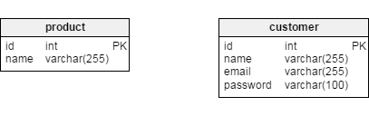

Now, we will design the relationship between these two tables. So to connect the customer and product table, we will create a table called purchase which will be like an order table (i.e. which customer ordered which product).

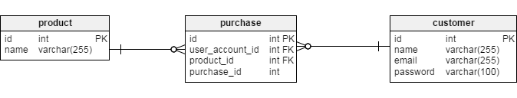

If you look at the figure above, the customer-purchase reference is OK because every purchase has one customer, and one customer has many purchases. So, this reference is okay. One more thing we have taken user\_account\_id as a foreign key (the reference to the id in customer key). Similarly product\_id. There is still a problem with product-purchase reference as several products can be bought in one purchase as well several purchases can include the same product.

To overcome this, we will design an intermediary table known as purchase\_item, which will be connected with purchase and product. In the below figure, we can see the problem resolved.

Press enter or click to view image in full size

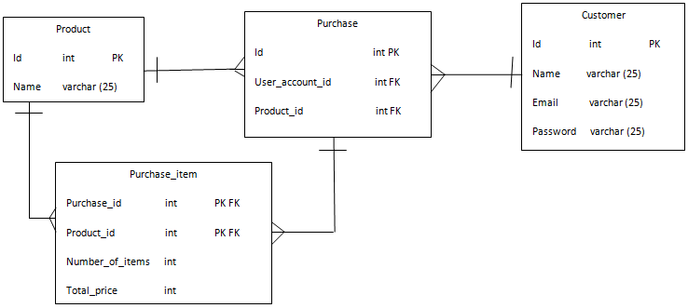

**Introduction to Architectural Design in Software Engineering**

Architectural design in software engineering is about decomposing the system into interacting components. It is expressed as a block diagram defining an overview of the system structure, features of the components, and how these components communicate with each other to share data. It identifies the components that are necessary for developing a computer-based system and communication between them i.e. relationship between these components. It defines the structure and properties of the components that are involved in the system and also the interrelationships between these components. The architectural design process is about identifying the components i.e. subsystems that makeup the system and structure of the sub-system and they’re interrelationship. It is an early stage of the system design phase. It acts as a link between specification requirements and the design process.

**System properties of Architectural Design**

In software engineering, during the architectural design process, some system properties are focused. Some of them are as follows

* **Security**: The system is secured against malicious users by encryption or any other security measures. The architectural design process uses a layered architecture with critical assets in the innermost layers.
* **Performance**: It is nothing but a meantime taken between request and response of the page. The performance of a system can be improved by avoiding critical operations and reducing communication between components. This is possible by using large components instead of small and fine-grained components.
* **Maintainability**: Architectural design process uses easily modifiable and replaceable components. Consider the components in a manner so that it is easy to change them over time according to the new requirements and build the software with the flexibility to change or maintain.
* **Safety**: Avoid critical functionalities in small components of the system.
* **Availability**: Architectural design process includes redundant components and corresponding functions for handling the occurrence of any type of errors.

**Decisions for Architectural Design**

In software engineering, the architectural design process differs as the system differs depending upon the type of system being developed. But still, there are some common decisions that should be taken care of in any design process are as follows

* How can the system be distributed across the network?
* Which approach can be used to structure the system?
* Is there a generic application architecture procedure that can be used which can act as a template for the proposed system that is being designed and developed?
* Which architectural styles are suitable for the proposed system?
* How can software architecture be documented?
* How can the system be decomposed into modules?
* What control strategy must be used to control the operation of the components in the system?
* How can architectural design be analyzed?

**Software Architectural Models**

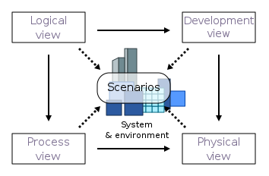

<https://en.wikipedia.org/wiki/4%2B1_architectural_view_model>

To document the architectural design process, architectural models are used

1. Static type of architectural structural model represents the major system components.
2. Dynamic type of architectural process model represents the process structure of the system.
3. Distribution type of architectural model represents how the component is distributed across various computers.
4. Interface type of architectural model represents the interface of the components.
5. Relationships type of architectural model represent models such as data flow diagram to represent the component interrelationship.

Architectural design models are application domain-specific and the most common two types of domain-specific models are:

1. **Generic model**: These models are abstractions derived from a number of real systems and encapsulated the characteristics of these systems. This type of model usually follows a bottom-up approach.
2. **Reference models**: These models provide information regarding the class of the system. They are derived from the application domain rather than from existing systems. It usually follows the top-down approach. It provides a comparison between different Software architectures.

**Advantages of Architectural Design in Software Engineering**

* Architectural design works as a tool for stakeholder communication. It is used as a support or roadmap in the discussion with system stakeholders
* It is used for system analysis. Architectural design is used to analyze whether the system will be able to meet its non-functional requirements or not.
* It facilitates large-scale re-use. The software architecture that is the output of the architectural design process can be reused across a range of the system.

**Disadvantages of Architectural Design in Software Engineering**

* Architectural design re-use the components, the use of redundant components improves the availability but makes the security of the system difficult to handle.
* Use of large components may improve the performance as large components include all the related properties and function into one component but it reduces the maintainability as it becomes difficult to modify and replace the large component. It involves a very tiresome task.
* Avoiding critical features inside the small components leads to more communication among the components which in turn degrades the performance.

**Introduction to User Interface Design**

Press enter or click to view image in full size

User interface design refers to the products where a user interacts with controls or display of the product. Good programming technology alone is not enough to achieve user’s acceptance of software products. It also needs a good user interface; else, it fails in the market. While programming technology focuses on the software functions, user interface design focus on the usability specialists. User interfaces design becomes efficient only after performing the usability testing. This is done to test what works and what does not work as expected. Only after making the repair, the product is said to have an optimized interface. When it is applied to software, it is called as HCI, i.e. Human-Computer Interaction.

**User Interface Design Process**

Press enter or click to view image in full size

The user interface design process is categorized into 4 activities which are as follows:

* Interface Analysis: It evaluates the UI design with end-users in order to understand the users who will interact with the system through UI design, to confirm the tasks that user will perform to complete their work, to understand the environment in which these tasks will be conducted, to understand the content of the interface. Once all requirements are gathered, the end-user carries out the task analysis.
* Interface Design: It defines the interface objects and actions that allow the user to perform all tasks that are defined in the user requirements analysis phase. It is an attempt to confirm that the designed tasks meet every usability goal defined in the user requirements.
* Implementation: It involves prototyping and then the actual implementation. The output of the prototyping is used for the implementation.
* Interface Validation: It validates the ability of the user interface to implement every user tasks correctly, user acceptance of the interface as an efficient tool in their work. Its focus is on the degree to which the user interface design is easy to use and learn.

**Principles of User Interface Design**

Given below are the principles mentioned:

* **User Familiarity**: The interface should provide user terms and concepts which are determined from the experience of the people who will make the most use of the system in that application domain instead of using new terms. This helps users to understand the working of the software better.
* **Minimal Surprise**: Users never like to see the system working in an unexpected manner. They get frustrated in such cases. Users must never be surprised by the behavior of the system because they build a mental perception of how the system works, and if this perception is broken, then the users get surprised seeing the system unexpected type of behavior, and they get stressed up.
* **Consistency**: It should be consistent, i.e. the system command and menus should have the same format, and the same parameter should be passed to all commands in the same way.
* **Recoverability**: Users most often make mistakes while working with the system. These mistakes can be reduced but cannot be completely eliminated. But there can be a provision to tolerate these mistakes and allow the system to come back to its working position. This is known as recoverability. It should include a mechanism to allow users to recover from errors.
* **User Diversity**: The interface should provide appropriate interaction facilities for the various types of the system user. This is based upon the third human described above.
* **User Guidance:** The user interface should provide meaningful feedback when errors occur and provide different levels of help and advice. This helping level ranges from providing basic information to the level of providing a complete description of system facilities.

**User Interfaces Design Issues**

Some issues need to be considered while designing a good user interface design. These issues should be taken care of so that they do not cause any technical problems.

* **Response Time**: This is the mean time between request and response or the software with the desired output. It can be measured in length and variability. If the response time is too long, then the user becomes frustrated.
* **Error Handling**: Poor error message may result in rejecting the product rather than accepting it. An error message should describe the problem in words that are easy to understand by the user.
* **Help Facilities**: The end-user requires help when he needs some information, and he cannot find it or if the user is in trouble. Both of these requirements are considered in the help system design and must be available all the time.
* **Application Accessibility**: It states whether the application is simple to interact with or not. Special guidelines are given to users while interacting with software.

**What is a Component Level Design?**

Component level design is the definition and design of components and modules after the architectural design phase. Component-level design defines the data structures, algorithms, interface characteristics, and communication mechanisms allocated to each component for the system development. A complete set of software components is defined during architectural design. But the internal data structures and processing details of each component are not represented at a level of abstraction that is close to code. Component-level design defines the data structures, algorithms, interface characteristics, and communication mechanisms allocated to each component.

**Steps of Component Level Design**

**Steps 1 & 2 — Identify Classes**

Most classes from the problem domain are analysis classes created as part of the analysis model.

The infrastructure design classes are introduced as components during architectural design.

**Step 3 — Class Elaboration**

Specify message details when classes or components collaborate.

Identify appropriate interfaces for each component.

Elaborate attributes and define data structures required to implement them.

Describe processing flow within each operation in detail.

**Step 4 — Persistent Data**

The persistent data sources are described (databases and files) and the classes required to manage them are identified

**Step 5 — Elaborate Behavior**

It is sometimes necessary to model the behavior of a design class. Transitions from state to state have the form:

Event-name (parameter-list) [guard-condition] / action expression.

**Step 6 — Elaborate Deployment Diagrams**

Deployment diagrams are elaborated to represent the location of key packages or components.

**Step 7 — Redesign/Reconsider**

The first component-level model you create will not be as complete, consistent, or accurate as the nth iteration you apply to the model. The best designers will consider many alternative design solutions before settling on the final design model.

**Concluding with principles of Design Modeling.**

Press enter or click to view image in full size

**Design must be traceable to the analysis model:**

Analysis model represents the information, functions, and behavior of the system. Design model translates all these things into architecture — a set of subsystems that implement major functions and a set of component level design that are the realization of Analysis classes. This implies that the design model must be traceable to the analysis model.

**Always consider architecture of the system to be built:**

Software architecture is the skeleton of the system to be built. It affects interfaces, data structures, behavior, program control flow, the manner in which testing is conducted, maintainability of the resultant system, and much more.

**Focus on the design of the data:**

Data design encompasses the manner in which the data objects are realized within the design. It helps to simplify the program flow, makes the design and implementation of the software components easier, and makes overall processing more efficient.

**User interfaces should consider the user first:**

The user interface is the main thing of any software. No matter how good its internal functions are or how well designed its architecture is but if the user interface is poor and end-users don’t feel ease to handle the software then it leads to the opinion that the software is bad.

**Components should be loosely coupled:**

Coupling of different components into one is done in many ways like via a component interface, by messaging, or through global data. As the level of coupling increases, error propagation also increases, and overall maintainability of the software decreases. Therefore, component coupling should be kept as low as possible.

**Interfaces both user and internal must be designed:**

The data flow between components decides the processing efficiency, error flow, and design simplicity. A well-designed interface makes integration easier and testers can validate the component functions more easily.

**Component level design should exhibit Functional independence:**

It means that functions delivered by component should be cohesive i.e. it should focus on one and only one function or sub-function.

**Software Deployment in Software Development**

Last Updated : 23 Jul, 2025

The goal of software deployment is to make a product available for usage in a way that provides maximum optimization, security, and compatibility. Because software solutions differ in their applications and performance, the software deployment procedure must be tailored to their needs.

Software Deployment in Software Development

**Table of Content**

* [What is Software Deployment?](https://www.geeksforgeeks.org/software-engineering/software-deployment-in-software-development/#what-is-software-deployment)
* [Importance of Software Deployment:](https://www.geeksforgeeks.org/software-engineering/software-deployment-in-software-development/#importance-of-software-deployment)
* [Software Deployment vs Software Release:](https://www.geeksforgeeks.org/software-engineering/software-deployment-in-software-development/#software-deployment-vs-software-release)
* [Software Deployment Methodologies:](https://www.geeksforgeeks.org/software-engineering/software-deployment-in-software-development/#software-deployment-methodologies)
* [Software Deployment Processes:](https://www.geeksforgeeks.org/software-engineering/software-deployment-in-software-development/#software-deployment-processes)
* [Best Practices for Software Deployment:](https://www.geeksforgeeks.org/software-engineering/software-deployment-in-software-development/#best-practices-for-software-deployment)
* [Conclusion:](https://www.geeksforgeeks.org/software-engineering/software-deployment-in-software-development/#conclusion)

**What is Software Deployment?**

**Software deployment**is the process of making a software application available for use. It encompasses a series of activities, from preparing the software for release to installing and configuring it on target systems. The primary objective is to transition the software from the development environment to a production environment while ensuring its functionality and performance meet user expectations.

**Importance of Software Deployment:**

Efficient software deployment is vital for delivering new features, fixing bugs, and implementing improvements promptly. It facilitates a smooth transition from the development phase to production, reducing downtime and disruptions. A well-executed deployment also contributes to system reliability, security, and overall user satisfaction.

* **Fixing bugs and Enhancing Performance:** The release of updates, bug fixes, and performance enhancements is made possible by deployment. It guarantees that consumers are utilizing reliable and effective software versions.
* **Competitiveness and Time-to-Market:** Time-to-market is shortened by quick and effective deployment, which helps businesses remain competitive in ever-changing markets. Having the capacity to release updates rapidly can give you a competitive edge.
* **User Experience and Satisfaction:** Updates that are regularly released guarantee that consumers receive the newest enhancements, which raises user happiness. Promptly implementing deployment in response to customer input improves the overall user experience.
* **Feedback System for Ongoing Improvement:**Frequent deployment establishes a feedback loop that offers insightful information about how consumers engage with the programme. This information can be utilized to guide future development and deployment strategies and promote continual improvement.
* **Optimizing Resources and Cutting Costs:**Optimizing resources and cutting costs are two benefits of efficient deployment techniques. Processes for deployment can be automated to save manual labor, cut down on mistakes, and guarantee consistent outcomes in all situations.

**Software Deployment vs Software Release:**

Software deployment involves the entire process of making the software available for use, including installation and configuration. Software release, on the other hand, specifically refers to the distribution of a new version or update to users. Deployment is the broader process that includes release activities.

| **Parameters** | **Software Deployment** | **Software Release** |
| --- | --- | --- |
| **Definition** | The process of making software or updates usable in a particular environment is referred to as deployment. | A software release is when a particular version is made accessible to users outside of the development team. |
| **Timing** | The software may not always be available to end users even after deployment, which is a possible step in the release process. It can be carried either as part of standard maintenance procedures or in advance of a release. | When software is released, it becomes accessible to end users. Choosing when to release the programme to the public requires considerations that are frequently in line with marketing plans or user expectations. |
| **Scope** | The technical side of delivering and installing software is the main emphasis of deployment. | Release covers more ground than just deployment. It also includes documentation, marketing, and user communication. |
| **Goals** | Ensuring that the programme is deployed accurately and effectively in the target environment is the main objective of deployment. | Delivering a software version that satisfies quality criteria and offers users value is the main objective of a release. |

**Software Deployment Methodologies:**

Several methodologies guide software deployment:

* **Continuous Deployment:** Involves automatically releasing every code change to production, ensuring a rapid and continuous delivery pipeline.
* **Continuous Delivery:** Focuses on maintaining a state where the software is always in a deployable condition, even if not deployed immediately.
* **Staged Deployment:**Releases the software in phases, starting with a small user group before expanding to a broader audience. This helps identify and address issues progressively.
* **Blue-Green Deployment:**Involves maintaining two identical production environments (blue and green), with only one actively serving users at a time. This minimizes downtime during updates by switching between environments.

**Software Deployment Processes:**

* **Planning:**Define deployment goals, assess potential risks, and create a detailed deployment plan outlining tasks and responsibilities.
* **Build:**Compile the code and create the executable software package. This involves generating artifacts, binaries, or installers.
* **Testing:**Conduct thorough testing, including unit, integration, and system testing, to identify and fix any issues before moving to the next stage.
* **Staging:**Deploy the software in a controlled staging environment that closely mirrors the production environment. This step allows for further testing and validation.
* **Deployment:**Distribute the software to the target production systems. This can involve manual or automated processes, depending on the scale and complexity of the deployment.
* **Monitoring:**Continuously monitor the deployed software to detect and address any issues promptly. Monitoring helps ensure that the software operates as expected in the production environment.

**Best Practices for Software Deployment:**

* **Automation:**Automate repetitive and error-prone tasks to streamline the deployment process and reduce the likelihood of human errors.
* **Rollback Plan:** Develop a rollback plan in case issues arise during deployment, enabling a quick return to the previous stable state.
* **Environment Parity:**Ensure consistency between development, test, and production environments to minimize unexpected behavior due to environmental differences.
* **Communication:**Maintain clear communication channels between development, operations, and other stakeholders. This ensures everyone is aware of the deployment status and any potential issues.
* **Testing:**Rigorously test the software before deployment, including regression testing to ensure that existing functionality remains unaffected.
* **Version Control:**Use version control systems to manage and track changes to the software, providing a clear history and allowing for easy collaboration among team members.

**Conclusion:**

Software deployment in a[software development](https://www.geeksforgeeks.org/software-engineering/what-is-software-development/) is a critical phase in the [software development lifecycle,](https://www.geeksforgeeks.org/software-engineering/software-development-life-cycle-sdlc/) demanding careful planning, testing, and execution. It plays a pivotal role in delivering reliable and high-quality software to end-users. By adhering to best practices and utilizing appropriate deployment methodologies, development teams can optimize their processes and enhance the success of software deployments.

**What is Software Architecture?**

***Software architecture*** is the process of defining the high-level structure and organization of a software system. It involves identifying and selecting the right components, deciding how they should interact with each other, and determining how they should be organized to achieve specific goals. The goal of software architecture is to create a system that is maintainable, scalable, and secure, and that can meet the needs of users and organizations over time.

**Why do we need Software Architecture?**

A robust architecture provides a solid foundation for building software that meets the needs of users and stakeholders. It ensures that the system meets its functional and non-functional requirements, such as performance, security, and reliability. With a well-designed architecture, developers can build software that is easy to modify and extend, making it easier to adapt to changing business needs.

Software architecture is also essential for managing complexity. As software systems become more complex, it becomes challenging to understand how different components interact with each other. A well-designed architecture provides a high-level view of the system, making it easier to understand its structure and operation. This, in turn, helps developers to identify potential issues and make informed decisions about how to modify the system.

**How do we Document Architecture? We use 4C Model.**

**Context Level**

At the highest level, the Context level, we describe the system’s external environment, such as users, other systems, regulations, etc. This level provides a high-level overview of the system’s purpose and its relationship to the external world. It helps to identify the stakeholders who will interact with the system and the factors that will influence its design and development.

**Containers level**

The next level is the Containers level, which describes the runtime environment of the system, such as servers, databases, or message queues. This level helps to identify the major technology choices and deployment decisions. It provides an understanding of the physical infrastructure that will support the system and the tools and resources that will be required to deploy and maintain it.

**Components level**

The third level is the Components level, which describes the major functional building blocks of the system. This level helps to identify the modules, classes, or functions that make up the system. It provides an understanding of the system’s functionality and the relationships between its different components.

**Code level**

Finally, the Code level is the lowest level, which describes the actual code and how it implements the components. This level provides a detailed understanding of how the system works and how its different components interact with each other. It is essential for developers who will be working with the code to have a clear understanding of how it is structured and how it works.

Using the C4 model, software architects can create diagrams and written documentation that describe each of these levels, providing a comprehensive view of the system’s architecture. This approach helps to identify potential issues and trade-offs, as well as facilitating scalability, maintainability, and adaptability. By documenting the architecture in this way, developers and stakeholders can have a clear and easy-to-understand view of the system, making it easier to modify and extend as business needs change.

**Here are the 12 Software Architecture Styles Software Engineer Should Know**

**1. Client Server**

The client-server architecture is a model in which the client, a user or an application, sends a request to the server, which in turn responds with the requested data or service. The client and server can be on the same machine or on different machines connected through a network.

The client is responsible for initiating communication with the server and sending a request. The server, on the other hand, listens for incoming requests from clients, processes them, and returns a response.

**Advantages of Client-Server Architecture**

**Scalability:***Client-server architecture is highly scalable, as it allows multiple clients to connect to the same server and share resources.*

**Security:***Client-server architecture provides better security than other network models, as the server can control access to resources and data.*

**Reliability:***Client-server architecture is highly reliable, as the server can provide backup and recovery services in case of failures.*

**2. Layering**

It’s a common way to design complex software systems, and it involves breaking down the system into layers, where each layer is responsible for a specific set of functions. This approach helps to organize code and makes it easier to maintain and modify the system over time.

**A typical layering architecture consists of three main layers: presentation, business logic, and data access.**

***Presentation Layer:****The presentation layer is responsible for displaying information to the user and gathering input. This layer includes the user interface and any other components that interact directly with the user. The user interface is what the user sees and interacts with, such as buttons, text boxes, and menus. The presentation layer also includes any logic related to the user interface, such as event handlers and validation.*

***Business Logic Layer:****The business logic layer is responsible for implementing the business rules of the application. This layer contains the code that processes and manipulates data, as well as any other application logic. The business logic layer is where the magic happens, so to speak. It’s where the software performs calculations, makes decisions, and carries out tasks. This layer is where the software really earns its keep.*

***Data Access Layer:****The data access layer is responsible for interacting with the database or other external data sources. This layer contains the code that reads and writes data to and from the database. The data access layer is where the software retrieves data from the database, makes changes to the data, and saves the changes back to the database. This layer is critical to the functioning of the software, as it enables the software to store and retrieve data.*

**3. Pipe and Filter**

Pipe and Filter Architecture is a design pattern that allows software systems to process data by separating the processing tasks into multiple independent components. This architecture is particularly useful for systems that need to handle large amounts of data, as it can help to improve performance, scalability, and maintainability.

The Pipe and Filter Architecture is based on the idea of a pipeline, where data flows through a series of processing steps, each of which performs a specific task. Each processing step is implemented as a separate component, or filter, that accepts data as input, performs some operation on the data, and produces output data. The output data is then passed on to the next filter in the pipeline.

The filters in the pipeline are independent of each other, which means that they can be developed, tested, and deployed separately. This makes it easy to add new filters to the pipeline or modify existing ones without affecting the rest of the system.

**Benefits**

***Scalability:****The architecture can be scaled horizontally by adding more filters to the pipeline, which allows the system to handle larger amounts of data.*

***Performance:****The architecture can be optimized for performance by parallelizing the processing of data across multiple filters.*

***Maintainability:****The architecture promotes modularity and separation of concerns, which makes it easier to maintain and update the system over time.*

**4. Master-Slave**

Master-Slave architecture is a design pattern used in distributed systems, where one node (the master) controls one or more nodes (the slaves) to perform specific tasks. The master node is responsible for distributing the workload across the slaves and for coordinating their activities. The slave nodes do not have the same level of control as the master node and only perform tasks that are assigned to them by the master.

**Benefits**

*One of the most significant advantages is that it allows for the efficient distribution of workload across multiple nodes. This helps to reduce the load on any one node and ensures that the system can handle large amounts of data and traffic.*

*Another advantage of using a master-slave architecture is that it provides fault tolerance. If one of the slave nodes fails, the master node can redistribute its workload to the other slave nodes. This ensures that the system can continue to function even if one or more nodes fail.*

**5. MicroKernel**

MicroKernel architecture is a software design pattern that allows developers to build more modular and flexible systems. It separates the core system functionality from additional features, which are implemented in separate modules. The core functionality of the system is implemented in the MicroKernel, a minimalistic core system that provides only the most essential services required to run the system. It is plug and play concept.

***Example:***

*Let’s consider the example of an e-commerce website. The MicroKernel would provide essential services such as handling user authentication, managing user sessions, and processing payments. Additional features, such as product recommendations, user reviews, and social media integration, would be implemented in separate modules.*

*If the website wants to add a new feature, such as a loyalty program, it can be developed and added as a separate module without affecting the core functionality of the system. This modularity makes it easier to add new features or remove existing ones without affecting the core system functionality.*

*Furthermore, if the website wants to customize its system to meet the specific needs of different users, it can choose the modules it needs for each user. For example, a user who frequently buys electronics can be provided with a module that recommends electronic products. On the other hand, a user who frequently buys cosmetics can be provided with a module that recommends cosmetic products.*

*Finally, if the website wants to scale its system to handle more users or changes in hardware, it can easily add or remove modules as needed. This scalability makes it easier to adapt the system to changes in user requirements or changes in the underlying hardware.*

**6. DDD (Domain Driven Design)**

At its core, DDD is a way of thinking about software architecture that emphasizes the domain or problem space of a project. This means that developers focus on the business logic of the software, rather than just the technical implementation.

In practice, this means that developers start by understanding the domain they are working in and break it down into smaller, more manageable parts. They then use this understanding to create a domain model, which is a representation of the different entities within the domain and how they interact with one another.

Once the domain model is created, developers can use it to guide the rest of the architecture of the software. This includes creating bounded contexts, which are areas of the software that are defined by a specific language and context, and aggregates, which are collections of related entities that are treated as a single unit.

**7. Component Based**

In software engineering, component-based architecture (CBA) is an approach to software design and development that emphasizes the use of reusable software components. The idea behind CBA is that software development can be made more efficient and effective by breaking down complex systems into smaller, more manageable components.

***What is a component?***

*A software component is a modular, self-contained unit of software that can be reused across different systems. A component typically has a well-defined interface, which specifies how other components can interact with it. This interface includes information about the component’s inputs, outputs, and behavior.*

*Components can be classified into different types based on their functionality, such as user interface components, data access components, and business logic components. Each type of component has a specific role in the software system and can interact with other components through their interfaces.*

**8. SOA**

SOA is an architectural style that aims to create modular, reusable services that can be easily integrated with other services to create a larger system. In this approach, services expose their functionality through interfaces, which can be accessed by other services or applications.

At its core, SOA is about building software by breaking it down into smaller pieces, or modules, that can be reused across different applications. This modular approach allows developers to focus on building specific pieces of functionality and then integrating them with other pieces to create a larger system.

**Core Components of SOA**

***Service Provider:****The service provider is responsible for creating and exposing services to the outside world. These services can be used by other services, applications, or end-users. For example, a payment processing service provider might create and expose a service that allows other applications to process payments.*

***Service Registry:****The service registry is a directory of available services that can be accessed by other services or applications. The service registry provides information about the service, such as its name, location, and interface. For example, if an application needs to process payments, it can use the service registry to find the payment processing service and access its interface.*

***Service Requestor:****The service requestor is responsible for consuming the services exposed by the service provider. This can be done by using the service registry to find the appropriate service and then invoking its interface. For example, an application might use the service registry to find the payment processing service and then use its interface to process payments.*

**9. Monolithic**

Monolithic architecture is a software design pattern that has been around for decades. It’s a way of structuring an application as a single, cohesive unit, rather than splitting it up into individual, smaller components.

In a monolithic architecture, the entire application is built as a single, self-contained unit. All of the code and dependencies are packaged together, so the application can be deployed and run on a single server.

This makes it easy to develop and deploy the application, since everything is in one place. It also makes it easier to scale the application horizontally, by adding more servers.

**Advantages of Monolithic Architecture**

*One of the biggest advantages of monolithic architecture is its simplicity. Since everything is contained in a single unit, there are fewer moving parts to worry about. This makes it easier to develop, test, and deploy the application.*

*Another advantage is that it’s easier to maintain and debug a monolithic application. Since everything is in one place, it’s easier to track down issues and fix them.*

**Disadvantages of Monolithic Architecture**

*One of the biggest disadvantages of monolithic architecture is that it can be difficult to scale the application vertically. Since everything is running on a single server, there’s a limit to how much traffic the application can handle.*

*Another disadvantage is that it can be difficult to adopt new technologies and languages in a monolithic application. Since everything is packaged together, it can be hard to update individual components without breaking the entire application.*

**10. Microservice**

Microservice architecture is a style of software architecture that structures an application as a collection of small, independent services that communicate with each other over a network. Each service is focused on a specific business capability and can be developed, deployed, and scaled independently of other services in the system.

The main idea behind microservice architecture is to break down a large, monolithic application into smaller, more manageable services. This approach brings several benefits, such as improved scalability, increased flexibility, and quicker time-to-market for new features. With a microservice architecture, each service can be scaled independently, making it easier to handle traffic spikes or changes in demand. Developers can also modify or add new services without affecting other parts of the system, which speeds up the development process.

**Challenges of Microservice Architecture**

*Despite the benefits of microservice architecture, it also introduces additional complexity. One of the biggest challenges is managing inter-service communication. Services need to be able to discover each other and communicate effectively, which can be difficult to do at scale. Load balancing and fault tolerance are also more complex in a microservice architecture.*

*Another challenge is ensuring that each service has its own data store. In a monolithic application, all data is typically stored in a single database. With microservices, each service should have its own data store to ensure that changes to one service do not affect other services in the system. This can lead to increased complexity in data management and synchronization.*

**Best Practices for Microservice Architecture**

*To ensure the success of a microservice-based system, developers should follow best practices for designing and implementing microservices. Some of these best practices include:*

*1. Design services that are loosely coupled and highly cohesive, with clear boundaries and well-defined interfaces.*

*2. Use containerization technology, such as Docker, to package and deploy each service as a separate container. This allows for easy scaling and deployment of individual services as needed.*

*3. Implement effective monitoring and management tools to ensure that the system is running smoothly and to detect and address issues quickly.*

*4. Use a service mesh, such as Istio, to manage inter-service communication and load balancing.*

*5. Implement a continuous integration and deployment (CI/CD) pipeline to automate the testing and deployment of microservices.*

**11. Event Driven**

Event Driven Architecture (EDA) is an approach to designing software systems that enables rapid and efficient communication between different components or services. In this paradigm, different software components communicate with each other using events, rather than through direct requests or responses.

In EDA, events are generated by different components of a software system, such as a user interface or a backend service. These events are then broadcast to other components of the system, which can subscribe to them and act on them as needed.

For example, consider a simple e-commerce application. When a new order is placed, the order processing service can generate an “order created” event, which is then broadcast to other services such as inventory management, shipping, and billing. Each of these services can then process the event and make updates to their respective systems.

**Benefits of EDA**

*One of the key benefits of EDA is its ability to decouple different components of a software system. When different components communicate through events rather than direct requests, they become less dependent on each other. This makes it easier to change or update individual components of the system without affecting the rest of the system.*

*Another benefit of EDA is its scalability. Because events are broadcast to multiple components of the system, it is possible to process large volumes of data and transactions in parallel. This makes it easier to handle high traffic and spikes in demand.*

**Challenges of EDA**

*While EDA has many benefits, it also has some challenges. One of the main challenges is managing the complexity of event-driven systems. Because events can be generated and consumed by many different components, it can be difficult to track and debug issues that arise.*

*Another challenge is ensuring that events are processed in the correct order. Because events can be generated and processed asynchronously, it is possible for events to be processed out of order. This can cause issues such as data inconsistencies or incorrect calculations.*

**12. Stream Based**

As software development becomes more complex and demands greater scalability, traditional architectures are becoming less and less effective. Stream-based architecture is emerging as a promising alternative that enables developers to build systems that can handle massive amounts of data in real-time.

At its core, stream-based architecture is based on the principles of event-driven programming. Instead of processing data in batches, stream-based systems process data as it is generated in real-time. This allows developers to build systems that can respond to changes in data with minimal latency.

**Benefit of Stream-Based Architecture**

*One of the key benefits of stream-based architecture is its scalability. Because data is processed in real-time, stream-based systems can handle massive amounts of data without the need for complex batch processing pipelines. This makes it possible to build systems that can process millions of events per second, making it ideal for use cases like sensor data processing, financial trading, and online advertising.*

*Another benefit of stream-based architecture is its flexibility. Because data is processed in real-time, it is possible to build systems that can respond to changes in data with minimal latency. This makes it possible to build complex, event-driven systems that can adapt to changing business requirements. For example, in an e-commerce platform, stream-based architecture can be used to track user activity in real-time and respond with personalized recommendations and promotions based on the user’s browsing and purchasing history.*

*Furthermore, stream-based architecture can provide significant cost savings. Traditional batch processing pipelines require expensive hardware and complex software infrastructure to manage the data processing. On the other hand, stream-based systems can be built on inexpensive commodity hardware, making it much easier to scale and maintain.*

*Finally, stream-based architecture is highly fault-tolerant. Because data is processed in real-time, it is possible to build systems that can automatically recover from failures without the need for manual intervention. This makes it possible to build systems that can operate at scale with high levels of reliability, reducing the risk of data loss or system downtime.*

**Conclusion**

In conclusion, software architecture is critical for building successful software systems that meet the needs of users and stakeholders. It provides a blueprint for designing and developing software systems, ensures that the system meets its functional and non-functional requirements, facilitates adaptability, and helps manage complexity. Therefore, it is essential to invest time and resources in designing a robust architecture at the beginning of a software development project. Hope you enjoy and Happy Learning.

In data flow architecture, the whole software system is seen as a series of transformations on consecutive pieces or set of input data, where data and operations are independent of each other. In this approach, the data enters into the system and then flows through the modules one at a time until they are assigned to some final destination (output or a data store).

The connections between the components or modules may be implemented as I/O stream, I/O buffers, piped, or other types of connections. The data can be flown in the graph topology with cycles, in a linear structure without cycles, or in a tree type structure.

The main objective of this approach is to achieve the qualities of reuse and modifiability. It is suitable for applications that involve a well-defined series of independent data transformations or computations on orderly defined input and output such as compilers and business data processing applications. There are three types of execution sequences between modules−

* Batch sequential
* Pipe and filter or non-sequential pipeline mode
* Process control

Batch Sequential

Batch sequential is a classical data processing model, in which a data transformation subsystem can initiate its process only after its previous subsystem is completely through −

* The flow of data carries a batch of data as a whole from one subsystem to another.
* The communications between the modules are conducted through temporary intermediate files which can be removed by successive subsystems.
* It is applicable for those applications where data is batched, and each subsystem reads related input files and writes output files.
* Typical application of this architecture includes business data processing such as banking and utility billing.

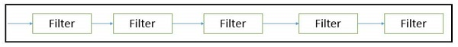

Advantages

* Provides simpler divisions on subsystems.
* Each subsystem can be an independent program working on input data and producing output data.

Disadvantages

* Provides high latency and low throughput.
* Does not provide concurrency and interactive interface.
* External control is required for implementation.

Pipe and Filter Architecture

This approach lays emphasis on the incremental transformation of data by successive component. In this approach, the flow of data is driven by data and the whole system is decomposed into components of data source, filters, pipes, and data sinks.

The connections between modules are data stream which is first-in/first-out buffer that can be stream of bytes, characters, or any other type of such kind. The main feature of this architecture is its concurrent and incremented execution.

Filter

A filter is an independent data stream transformer or stream transducers. It transforms the data of the input data stream, processes it, and writes the transformed data stream over a pipe for the next filter to process. It works in an incremental mode, in which it starts working as soon as data arrives through connected pipe. There are two types of filters − **active filter** and **passive filter**.

**Active filter**

Active filter lets connected pipes to pull data in and push out the transformed data. It operates with passive pipe, which provides read/write mechanisms for pulling and pushing. This mode is used in UNIX pipe and filter mechanism.

**Passive filter**

Passive filter lets connected pipes to push data in and pull data out. It operates with active pipe, which pulls data from a filter and pushes data into the next filter. It must provide read/write mechanism.

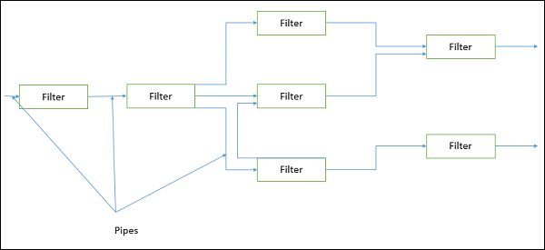

Advantages

* Provides concurrency and high throughput for excessive data processing.
* Provides reusability and simplifies system maintenance.
* Provides modifiability and low coupling between filters.
* Provides simplicity by offering clear divisions between any two filters connected by pipe.
* Provides flexibility by supporting both sequential and parallel execution.

Disadvantages

* Not suitable for dynamic interactions.
* A low common denominator is needed for transmission of data in ASCII formats.
* Overhead of data transformation between filters.
* Does not provide a way for filters to cooperatively interact to solve a problem.
* Difficult to configure this architecture dynamically.

Pipe

Pipes are stateless and they carry binary or character stream which exist between two filters. It can move a data stream from one filter to another. Pipes use a little contextual information and retain no state information between instantiations.

Process Control Architecture

It is a type of data flow architecture where data is neither batched sequential nor pipelined stream. The flow of data comes from a set of variables, which controls the execution of process. It decomposes the entire system into subsystems or modules and connects them.

Types of Subsystems

A process control architecture would have a **processing unit** for changing the process control variables and a **controller unit** for calculating the amount of changes.

A controller unit must have the following elements −

* **Controlled Variable** − Controlled Variable provides values for the underlying system and should be measured by sensors. For example, speed in cruise control system.
* **Input Variable** − Measures an input to the process. For example, temperature of return air in temperature control system
* **Manipulated Variable** − Manipulated Variable value is adjusted or changed by the controller.
* **Process Definition** − It includes mechanisms for manipulating some process variables.
* **Sensor** − Obtains values of process variables pertinent to control and can be used as a feedback reference to recalculate manipulated variables.
* **Set Point** − It is the desired value for a controlled variable.
* **Control Algorithm** − It is used for deciding how to manipulate process variables.

Application Areas

Process control architecture is suitable in the following domains −

* Embedded system software design, where the system is manipulated by process control variable data.
* Applications, which aim is to maintain specified properties of the outputs of the process at given reference values.
* Applicable for car-cruise control and building temperature control systems.
* Real-time system software to control automobile anti-lock brakes, nuclear power plants, etc.

Software architecture is a blueprint of step-by-step instructions that will aid in the development of software. It aids in determining the true purpose of the project because it contains detailed descriptions of the functionalities that will be provided by the software project. It also helps with the proper planning of all necessary activities.

Architecture styles give a specific solution to a particular software which further particularly helps in the organization of the code. Data-centered architecture, data-flow architecture, call and return architecture and object-oriented architecture are the architecture styles in software engineering.

***Data-centered architecture:***

In this architecture, data stored in the database/file is central, with each component frequently accessing, modifying, and deleting data. This data-centric design will help to ensure reliability. This means that existing components can be updated while new client components can be added to the architecture without affecting other clients. The blackboard technique allows data to be exchanged between clients.

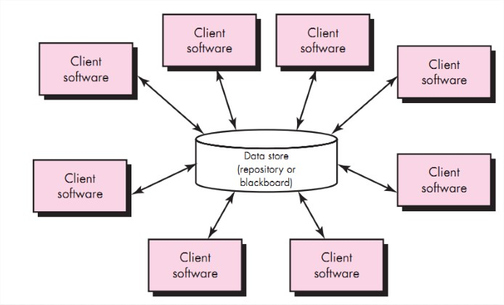

***Data-flow architecture:***

The entire software system is viewed as a series of transformations of successive pieces or sets of input data in a dataflow architecture, where the data and operations are independent of each other. In this, until data are assigned to some final destination(output or a data store) data enters the system and then flows through the modules one at a time. Connections between components or modules can be implemented as I / O streams, I / O buffers, pipelines, or other types of connections. The data can be flown in a linear structure without cycles, in the graph topology with cycles, or in a tree-type structure.

***Call and return architecture:***

This form of architecture improves scalability by allowing us to design scalable and easy-to-modify program structures.

The sub-styles that exist in this category are as follows:

1. Architecture of the main program or subprogram:

* The program is broken down into smaller components and organized in a hierarchical fashion. The main program, which is separated into subprograms in the hierarchy, invokes several software components.

2. Architecture for Remote Procedure Calls

* The main program or subprogram’s components are scattered throughout a network of several computers.
* The basic objective is to raise performance.

***Object-oriented architectures :***

The most important concept for developing software is object-oriented architecture. Here, objects are the collection of entities to view a software system.

Basic concepts are Object, class, inheritance, encapsulation, polymorphism, message passing, composition and aggregation, and association.

**The Advantages of Object-Oriented Architecture :**

1. An object-oriented architecture links an application to real-world objects to make it more intelligible.
2. Because of the reused programs, it is simple to maintain and increases the system’s quality.
3. Through polymorphism and abstraction, this design ensures reusability.
4. It has the ability to handle mistakes while running. (Robustness)
5. It has the ability to add new features without affecting the system’s functioning.
6. Encapsulating code enhances testability.
7. The development time and expense of an object-oriented architecture are reduced.

**The Disadvantages of Object-Oriented Architecture :**

1. The determination of all the essential classes and objects for a system with an object-oriented design is difficult.
2. Because object-oriented design offers a new sort of project management, it is difficult to deliver a solution within the stated time and budget.
3. Without a clear reuse mechanism, this technique does not result in successful large-scale reuse.

***Layered architecture:***

This is also called n-tier architecture or multi-layer architecture. The main aim of the layer architect is to organize the components of an application into horizontal logical layers and physical tiers.

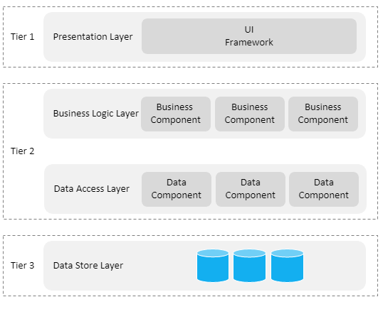

As seen above, there are 4 main layers,

1. Presentation Layer: All user interfaces presented to a user are included in this layer. It may offer a variety of user interfaces, including web, desktop, and native mobile apps.
2. Business Logic Layer: This layer is responsible for all business logic, validations, and procedures.
3. Data Access Layer: This layer consists of communicating with a database. The persistence layer is another name for it.
4. Data Store Layer: This layer is where the application’s data is stored.

The following is a list of the tiers:

* Tier 1: The Presentation Tier This tier is where the front-end code, or presentation layer, is stored. This is the application’s highest level, and it’s effectively a layer that users may access directly.
* Tier 2: Application Tier This tier contains the back-end code, which includes the business logic layer and data access layer. The middle tier is another name for it.
* Tier 3: The Data Tier The data store, also known as the data store layer, is hosted on this tier. Databases, file systems, blob storage, document databases, and other resources are examples of data storage resources.

**Closed Layered Architecture:**

A layer in a closed layered architecture can only call the layer directly below it. Consider the layered architecture diagram below.

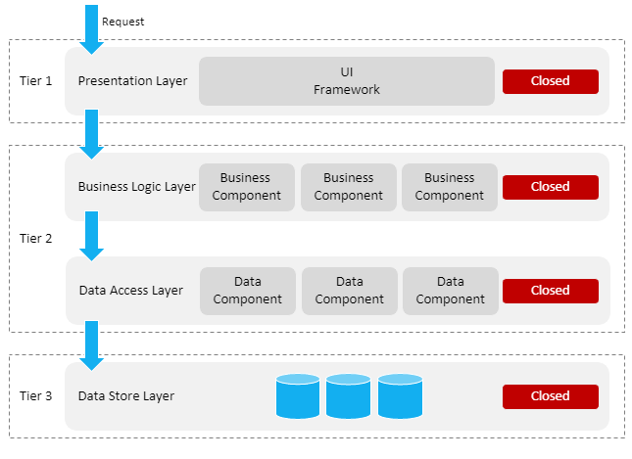

Each layer is indicated as closed in the architectural diagram above. This implies that in order for a request to reach the bottommost layer, it must pass through all of the layers. When a request is made through the presentation layer, it will first pass through the business logic layer, then the data access layer, and ultimately the data storage layer.

The goal of a closed layered architecture is to guarantee that layers are totally isolated from one another, such that changes made in one layer have no effect on other levels. To put it another way, layers are loosely connected, with one layer knowing little to nothing about the others.

**Opened Layered Architecture:**

A layer can be called any layer below it in an open layered architecture, as long as the layer below it is declared as open. Consider the layered architecture diagram below.

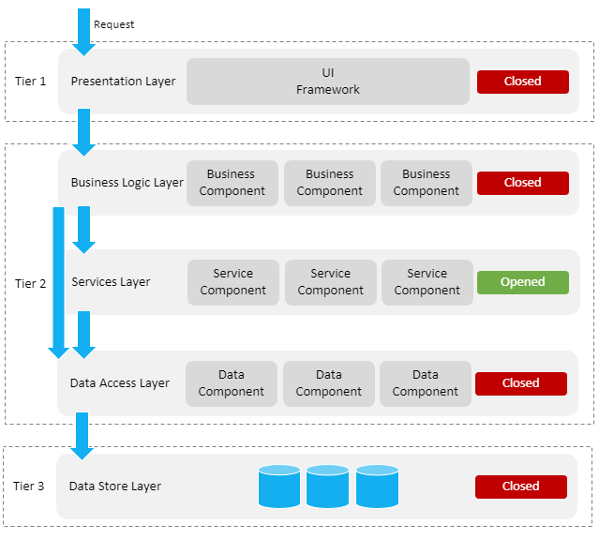

A new service layer is shown in the figure above. A variety of service components are provided by this layer. The services layer’s service components do not all interface with a database. As a result, the layer has been tagged as open. This indicates that the business logic layer has access to both the services layer and the data access layer and that it does not need to travel via the services layer to reach the data access layer.

***Conclusion:***

In this blog, we have mentioned various architectural styles. Architectural styles, weaknesses, strengths, and application areas with their component, connector, and interface have all been discovered by the researcher for the chosen architectural styles.

**Context Diagrams**

Last Updated : 21 Mar, 2024

Context diagrams serve as a foundational tool, helping designers and stakeholders grasp the scope and boundaries of a system under consideration. These diagrams provide a high-level view, illustrating how the system interacts with external entities and the environment. This article explores the significance of context diagrams in system design, their key components, and how to create them.

**Important Topics for Context Diagrams**

* [What are Context Diagrams?](https://www.geeksforgeeks.org/system-design/context-diagrams/#what-are-context-diagrams)
* [Importance of Context Diagrams in Systems Analysis](https://www.geeksforgeeks.org/system-design/context-diagrams/#importance-of-context-diagrams-in-systems-analysis)
* [Components of Context Diagrams](https://www.geeksforgeeks.org/system-design/context-diagrams/#components-of-context-diagrams)
* [Different Types of Relationships and Interactions in Context Diagrams](https://www.geeksforgeeks.org/system-design/context-diagrams/#different-types-of-relationships-and-interactions-in-context-diagrams)
* [Steps to create a Context Diagram](https://www.geeksforgeeks.org/system-design/context-diagrams/#steps-to-create-a-context-diagram)
* [Benefits of using Context Diagram](https://www.geeksforgeeks.org/system-design/context-diagrams/#benefits-of-using-context-diagram)
* [Challenges of using Context Diagram](https://www.geeksforgeeks.org/system-design/context-diagrams/#challenges-of-using-context-diagram)
* [Real-World Example of Context Diagrams](https://www.geeksforgeeks.org/system-design/context-diagrams/#realworld-example-of-context-diagrams)
* [Use-Cases of Context Diagram](https://www.geeksforgeeks.org/system-design/context-diagrams/#usecases-of-context-diagram)

**What are Context Diagrams?**

Context Diagrams are high-level visual representations that show the interactions between a system being developed and its external entities, such as users, other systems, or processes. They provide a big-picture view of how the system fits into its environment without diving into the internal details of the system itself.

* Typically, they consist of a central system surrounded by external entities, with arrows representing data flow or interactions between them.
* They're useful for understanding system boundaries and dependencies.

**Importance of Context Diagrams in Systems Analysis**

* **Scope Definition:** Context diagrams define the system's boundaries by highlighting its interactions with external entities, ensuring that the analysis focuses on pertinent components and processes.
* **Requirement Gathering:** These diagrams visualize how the system interacts with its environment, aiding in identifying both functional and non-functional requirements. They offer clarity on the system's objectives and its external interactions.
* **Communication:**Acting as a bridge between stakeholders, such as business users, developers, and project managers, context diagrams foster shared understanding of the system's scope and context. They streamline discussions and decision-making throughout the development process.
* **Risk Identification:** Context diagrams assist in spotting potential risks stemming from the system's interactions with external entities. They help stakeholders assess the implications of external factors on the system's performance, security, and reliability.

**Components of Context Diagrams**

**1. System/Product:**

This is the primary focus of the diagram, representing the system being analyzed or designed.

**2. External Entities**

These are entities outside the system boundary that interact with the system. They could be users, other systems, or processes that provide input to or receive output from the system.

**3. Data Flow**

These are arrows representing the flow of data or information between the system and external entities. They illustrate the exchange of data between the system and its environment.

**1. Unidirectional Data Flow**

Unidirectional data flow indicates that data moves in only one direction between two components. For example, data flows from an external entity to a process, or from a process to a data store, but not in the opposite direction. This type of data flow is represented by a single arrow indicating the direction of data movement.

**2. Bidirectional Data Flow**

Bidirectional data flow indicates that data can move in both directions between two components. For example, data flows between a process and an external entity can be bidirectional, allowing the process to send data to the external entity and receive data back. This type of data flow is represented by a double-headed arrow indicating that data can move in both directions.

**Different Types of Relationships and Interactions in Context Diagrams**

Below are the different types of relationships and interactions in Context Diagram:

* **Input/Output Relationships:**
  + **Input:** Data or information flowing into the system from external entities.
  + **Output:** Data or information flowing out of the system to external entities.
* **Control Relationships:**
  + **Control:** External entities influencing or directing the system's behavior or processes.
  + **Controlled by:**The system may be subject to control or influence by external entities.
* **Mechanism Relationships:**
  + **Mechanism:** Describes how the system operates or responds to external stimuli or events.
  + **Trigger:** External events prompting the system to execute specific actions or behaviors.

**Steps to create a Context Diagram**

Below are the steps of how to draw Context Diagram:

* **Step1: Define the System:**Start by clearly defining the system you're analyzing or designing, outlining its boundaries and objectives.
* **Step2: Identify External Entities:** Recognize all external entities that interact with the system, including users, other systems, or processes that exchange data with it.
* **Step3: View the Data Flows:** Determine how data flows between the system and external entities, specifying the types of data and their direction (input or output).
* **Step4: Sketch the Diagram:**Utilize standardized symbols and notation to create the context diagram. Position the system at the center and surround it with external entities, using arrows to depict data flow.
* **Step5: Label the Components:** Ensure each element of the diagram is clearly labeled, including the system, external entities, and data flows, providing concise descriptions for clarity.
* **Step6: Review and Verify:**Collaborate with stakeholders to review the context diagram, confirming its accuracy and completeness in representing the system's interactions.
* **Step7: Maintain Stage:** Regularly update the diagram to reflect changes in the system or its external environment, ensuring it remains an accurate depiction of the system's context.

**Benefits of using Context Diagram**

Below are the benefits of using Context Diagram:

* **Clarity:** Context diagrams offer a straightforward and clear snapshot of how the system interacts with its surroundings, aiding stakeholders in grasping its scope and context with ease.
* **Communication:** Serving as effective communication aids, these diagrams streamline discussions and decision-making among stakeholders, fostering collaboration between business users, developers, and project managers.
* **Scope Definition:** By delineating the system's boundaries and external entities, context diagrams assist in defining the project's scope, ensuring that efforts are focused on pertinent components and processes.
* **Dependency Management:** Understanding the system's relationships with external entities facilitates the management of dependencies, empowering stakeholders to anticipate and prepare for potential impacts of external changes.
* **Risk Identification:**Context diagrams help pinpoint potential risks stemming from the system's interactions with external elements, empowering stakeholders to identify, assess, and mitigate risks effectively.

**Challenges of using Context Diagram**

Below are the challenges of using Context Diagram:

* **Scope Creep:**Maintaining focus on relevant external entities and interactions can be challenging amidst attempts to expand the diagram's scope beyond necessity.
* **Complexity Management:** Diagrams for intricate systems may become convoluted, making it difficult to sustain simplicity and clarity.
* **Accuracy:** Ensuring the diagram faithfully represents the system's interactions demands rigorous analysis and validation, which can consume significant time and resources.
* **Dependency Identification:** Understanding dynamic dependencies between the system and external entities poses a challenge, especially in environments where dependencies frequently change.
* **Consensus Building:**Reaching agreement among stakeholders on the diagram's content and representation proves challenging, particularly when differing perspectives and priorities come into play.
* **Maintenance:** Keeping diagrams current as systems evolve and external factors shift demands ongoing effort and coordination among stakeholders.

**Real-World Example of Context Diagrams**

*Let's understand Context Diagram using an example of Library Management System.*

* **Student Database:** A system or a collection of data related to students, which can include information such as names, IDs, and academic records.
* **Students info:** Requesting or providing information related to students.
* **Staff:** People employed by an organization, often having a specific role or responsibility.
* **Library management system:** A system used to manage and organize library resources, such as books, periodicals, and multimedia materials.
* **Stock:**Inventory or resources available in a system.
* **Supplier:** An entity that provides goods or services to another entity.
* **Book details:** Information related to books, such as titles, authors, and publication dates.
* **Availability:**The state of being accessible or usable. In the context, it likely refers to the availability of books or other resources.
* **Management:**The process of coordinating and controlling resources to achieve specific goals.

**A context diagram for this information would include the following elements:**

* **External entities:** Students, Staff, Supplier
* **Processes:**Requesting information (Students info, Book details, Availability), Managing resources (Library management system, Stock, Student Database)
* **Data stores:**Student Database, Library management system, Book Database.

**Use-Cases of Context Diagram**

Below are the Use-Cases of Context Diagram:

* **Business Operations Analysis:** Within business operations, such as supply chain management or customer relationship management, context diagrams elucidate the interplay between departments, systems, and external entities like vendors or clients.
* **Software Engineering and Development:**In software creation, context diagrams provide a foundational understanding during the initial design phase by delineating how the system interacts with users, external systems, and data sources. This clarity guides developers in meeting system requirements.
* **IT Infrastructure Planning:** Professionals engaged in IT infrastructure planning leverage context diagrams to gain insight into network components' interactions, such as servers, routers, and end-users, within the network architecture.
* **Project Management:**Context diagrams serve as valuable communication tools in project management, aiding in articulating project scope and dependencies to stakeholders, ensuring alignment with project objectives.
* **Supply Chain Optimization:**Context diagrams are instrumental in supply chain management, enabling the mapping of supply chain processes and fostering a deeper understanding of interactions among suppliers, manufacturers, distributors, and retailers, thereby optimizing logistical operations.

Architectural Context Diagram is a graphic representation of your system and of the external components that interact with the system. This components are linked to the system via interfaces, ilustred by a rectangle above your system, like in this image: tinyurl.com/jabyt3q

There are 4 elements in ACD:

1. Superiors Systems - systems wich uses the main system for realize your functions
2. Subordinated Systems - system wich are used by main system for it realize your functions
3. Peers - systems (components) in the same level of the main system
4. Actors - external entities wich uses the main system produzing and consuming data

What is a Software Architectural Review?

A software architecture review is an analysis of an IT system’s components, design decisions, codebase, documentation, and technical strategies. This assessment highlights the design’s strengths and weaknesses, unnecessary dependencies and applications, potential security gaps, and outdated or low-quality code segments.

Software architecture reviews are divided into roadmap and design reviews.

* **An architecture roadmap review** helps determine if a project, update, or major tech stack change should proceed (considering readiness, risks, and potential benefits).
* **An architecture design review** focuses on optimizing the current architectural approach.

The software architecture review process includes interviews, codebase testing, and documentation research.

Why Do You Need an Architecture Review?

All IT systems and products develop technical complexities and operational issues over time. A structured architectural design review can help in several ways:

* **Reduced risk of technical debt.** Technical debt arises when simple solutions lead to code issues and scalability problems. Timely reviews can identify suboptimal components, allowing you to replace or refactor them before they further degrade performance.
* **Minimized resource wastage.** Roadmap reviews help determine whether a project aligns with organizational priorities and the technical stack, enabling you to avoid initiatives that lack strategic value.
* **Alignment with business goals.** Reviews verify whether current design choices and scaling capabilities align with business objectives and meet defined security, usability, and performance requirements.
* **Improved team collaboration.** Code audits and stakeholder feedback reduce misunderstandings and highlight any need for additional tools to enhance collaboration.
* **Enhanced developer experience.** Poorly designed workflows and overly complex databases can slow developers and complicate onboarding. Architecture reviews identify these issues and eliminate unnecessary friction.
* **Consistency in standards.** Reviews ensure uniformity in organizational policies, [coding standards](https://devcom.com/tech-blog/coding-standards-and-best-practices-guide-implementation-tips/), API designs, and other practices, simplifying development and maintenance.
* **Regulatory compliance.** Regular reviews ensure adherence to data privacy laws and regional regulations, helping to maintain IT security and avoid penalties for non-compliance.

In essence, architecture reviews help businesses address technical challenges and keep the system scalable.

The Key Components of a Successful Software Architecture Review

* **Business goals and metrics**

Your team should go into the review with a complete understanding of organizational priorities, business goals, domain requirements, and user needs. This involves identifying outcomes, critical information, constraints, and a list of acceptable alternative tech solutions.

* **Stakeholder input**

A review should involve diverse viewpoints from the right stakeholders. Engage your product managers, architects, engineers, testers, and business users—each role can help uncover hidden issues and produce well-rounded recommendations.​

A fintech company must consult security officers to evaluate how the architecture handles sensitive transaction data for a design review. Similarly, you can involve DevOps leads to validate whether the infrastructure aligns with your goals.  
​

* **Documentation and artifacts**

The review should be based on comprehensive documentation with up-to-date architecture diagrams, artifacts, code snapshots, deployment processes, and performance logs. These items should be continuously updated throughout the assessment to reduce misunderstandings during the current and future reviews.

* **Key performance metrics**

Metrics help evaluate the software architecture before and after optimization. Define clear, quantifiable objectives, such as response times, system reliability targets, throughput, cost per transaction, and others. Also, find ways to gauge developer and user satisfaction.

* **Risk analysis and mitigation**

All systems have risks of technical debt, system failures, breaches, future incompatibility, and other breakdown points. Identify potential weak points before and during the review as a basis for your optimization.

* **Consolidated recommendations**

Organize your findings into actionable recommendations that suggest improvements and address root causes. The document should outline specific steps that prioritize tasks based on their system impact. Recommendations often lead to phased rollouts, such as introducing new tools, refactoring code, or restructuring system components.

* **Continuous learning and retrospection**

Your software is continuously updated with technology implementations, code updates, and changing requirements. The team should conduct systematic software architecture reviews and schedule follow-ups to ensure sustainability.

It helps to document the lessons learned during the review to find ways to improve the process.

**Component-based software engineering** (**CBSE**), also called **component-based development** (**CBD**), is a style of [software engineering](https://en.wikipedia.org/wiki/Software_engineering) that aims to construct a [software system](https://en.wikipedia.org/wiki/Software_system) from [components](https://en.wikipedia.org/wiki/Software_component) that are [loosely coupled](https://en.wikipedia.org/wiki/Coupling_(computer_programming)) and [reusable](https://en.wikipedia.org/wiki/Reusability). This emphasizes the [separation of concerns](https://en.wikipedia.org/wiki/Separation_of_concerns) among components.[[1]](https://en.wikipedia.org/wiki/Component-based_software_engineering#cite_note-1)[[2]](https://en.wikipedia.org/wiki/Component-based_software_engineering#cite_note-2)

To find the right level of component granularity, [software architects](https://en.wikipedia.org/wiki/Software_architect) have to continuously iterate their component designs with [developers](https://en.wikipedia.org/wiki/Software_developer). Architects need to take into account [user requirements](https://en.wikipedia.org/wiki/Software_requirements), responsibilities, and [architectural characteristics](https://en.wikipedia.org/wiki/Non-functional_requirement).[[3]](https://en.wikipedia.org/wiki/Component-based_software_engineering#cite_note-3)

**Overview**

CBSE grew out of earlier paradigms such as [structured programming](https://en.wikipedia.org/wiki/Structured_programming) and [object-oriented programming](https://en.wikipedia.org/wiki/Object-oriented_programming), but it places greater emphasis on building software by assembling and integrating pre-existing components. Unlike [objects](https://en.wikipedia.org/wiki/Objects), which typically encapsulate both data and behavior, components are higher-level constructs that provide well-defined interfaces and can be deployed independently.[[4]](https://en.wikipedia.org/wiki/Component-based_software_engineering#cite_note-4)

Component orientation underlies many modern [software frameworks](https://en.wikipedia.org/wiki/Software_framework) and [architectural styles](https://en.wikipedia.org/wiki/Software_architecture), including [service-oriented architecture](https://en.wikipedia.org/wiki/Service-oriented_architecture) (SOA), [microservices](https://en.wikipedia.org/wiki/Microservices), and widely used [frontend frameworks](https://en.wikipedia.org/w/index.php?title=Frontend_framework&action=edit&redlink=1) such as [React](https://en.wikipedia.org/wiki/React_(software)), [Angular](https://en.wikipedia.org/wiki/Angular_(web_framework)), and [Vue](https://en.wikipedia.org/wiki/Vue.js).

**Considerations**

[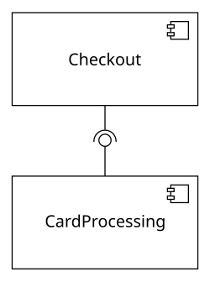](https://en.wikipedia.org/wiki/File:Component-based_Software_Engineering_(CBSE)_-_example_1.svg)An example of two components in [UML](https://en.wikipedia.org/wiki/Unified_Modeling_Language): Checkout processes a customer's order, which requires the other one to bill the credit card.

For large-scale systems developed by large teams, a disciplined [culture and process](https://en.wikipedia.org/wiki/Software_development_process) is required to achieve the benefits of CBSE.[[5]](https://en.wikipedia.org/wiki/Component-based_software_engineering#cite_note-5) [Third-party components](https://en.wikipedia.org/wiki/Third-party_software_component) are often utilized in large systems, raising issues of [integration](https://en.wikipedia.org/wiki/Integrated_software), [licensing](https://en.wikipedia.org/wiki/Licensing), and [software quality](https://en.wikipedia.org/wiki/Software_quality).

The system can be designed visually with the [Unified Modeling Language](https://en.wikipedia.org/wiki/Unified_Modeling_Language) (UML). Each [component](https://en.wikipedia.org/wiki/Software_component) is shown as a rectangle, and an [interface](https://en.wikipedia.org/wiki/Interface_(computing)) is shown as a lollipop to indicate a provided interface and as a socket to indicate consumption of an interface. This graphical representation helps clarify the relationships and dependencies between components.

[Component-based usability testing](https://en.wikipedia.org/wiki/Component-based_usability_testing) is applied when components interact directly with the [end user](https://en.wikipedia.org/wiki/End_user), ensuring both functionality and user experience are preserved when components are reused or replaced.

**Applications**

CBSE principles are used across multiple domains:

* In [enterprise software](https://en.wikipedia.org/wiki/Enterprise_software), component-based approaches enable large-scale modular applications such as [ERP](https://en.wikipedia.org/wiki/Enterprise_resource_planning) and [CRM](https://en.wikipedia.org/wiki/Customer_relationship_management) systems.
* In [embedded systems](https://en.wikipedia.org/wiki/Embedded_system), components are reused to reduce development costs and time-to-market.
* In [frontend development](https://en.wikipedia.org/w/index.php?title=Frontend_development&action=edit&redlink=1), component-oriented architectures dominate modern [web application](https://en.wikipedia.org/wiki/Web_application) design, with [design systems](https://en.wikipedia.org/wiki/Design_system) often mapped directly to reusable code components. Tools have emerged that automate this process, such as [Bitloops](https://en.wikipedia.org/w/index.php?title=Bitloops&action=edit&redlink=1),[[6]](https://en.wikipedia.org/wiki/Component-based_software_engineering#cite_note-6) which uses AI to translate design specifications into reusable frontend components.
* In [cloud computing](https://en.wikipedia.org/wiki/Cloud_computing), [microservices architecture](https://en.wikipedia.org/wiki/Microservices_architecture) can be viewed as a natural evolution of component orientation, where components are independently deployed services.

**Challenges**

While component-based development improves [maintainability](https://en.wikipedia.org/wiki/Maintainability) and reusability, it introduces challenges such as:

* Ensuring [interoperability](https://en.wikipedia.org/wiki/Interoperability) among components developed by different vendors.
* Managing [dependencies](https://en.wikipedia.org/wiki/Dependency_(computer_science)) and versioning.
* Guaranteeing [performance](https://en.wikipedia.org/wiki/Performance) and [security](https://en.wikipedia.org/wiki/Security) when integrating external components.

**Collaboration Diagrams | Unified Modeling Language(UML)**

Last Updated : 23 Jul, 2025

In [UML (Unified Modeling Language)](https://www.geeksforgeeks.org/system-design/unified-modeling-language-uml-introduction/), a Collaboration Diagram is a type of Interaction Diagram that visualizes the interactions and relationships between objects in a system. It shows how objects collaborate to achieve a specific task or behavior. Collaboration diagrams are used to model the dynamic behavior of a system and illustrate the flow of messages between objects during a particular scenario or use case.

**Table of Content**

* [What are Collaboration Diagrams?](https://www.geeksforgeeks.org/system-design/collaboration-diagrams-unified-modeling-languageuml/#what-are-collaboration-diagrams)
* [Importance of Collaboration Diagrams](https://www.geeksforgeeks.org/system-design/collaboration-diagrams-unified-modeling-languageuml/#importance-of-collaboration-diagrams)
* [Components and their Notations in Collaboration Diagrams](https://www.geeksforgeeks.org/system-design/collaboration-diagrams-unified-modeling-languageuml/#components-and-their-notations-in-collaboration-diagrams)
* [How to draw Collaboration Diagrams?](https://www.geeksforgeeks.org/system-design/collaboration-diagrams-unified-modeling-languageuml/#how-to-draw-collaboration-diagrams-)
* [Use cases of Collaboration Diagrams](https://www.geeksforgeeks.org/system-design/collaboration-diagrams-unified-modeling-languageuml/#use-cases-of-collaboration-diagrams)
* [Real-World Example of Collaboration Diagram](https://www.geeksforgeeks.org/system-design/collaboration-diagrams-unified-modeling-languageuml/#realworld-example-of-collaboration-diagram)
* [When to use Collaboration Diagram](https://www.geeksforgeeks.org/system-design/collaboration-diagrams-unified-modeling-languageuml/#when-to-use-collaboration-diagram)
* [Benefits of Collaboration Diagrams](https://www.geeksforgeeks.org/system-design/collaboration-diagrams-unified-modeling-languageuml/#benefits-of-collaboration-diagrams)
* [Challenges of Collaboration Diagrams](https://www.geeksforgeeks.org/system-design/collaboration-diagrams-unified-modeling-languageuml/#challenges-of-collaboration-diagrams)

**What are Collaboration Diagrams?**

A collaboration diagram is a [behavioral UML diagram](https://www.geeksforgeeks.org/system-design/behavior-diagrams-unified-modeling-languageuml/) which is also referred to as a communication diagram***.***It illustrates how objects or components interact with each other to achieve specific tasks or scenarios within a system.

*In simpler terms, they visually represents the interactions between objects or components in a system and show how they collaborate to accomplish tasks within a system, and also illustrate the system's object architecture.*

**Importance of Collaboration Diagrams**

Collaboration diagrams is important for understanding communication, design, analysis, and documentation of the system's architecture and behavior.

* **Visualizing Interactions:**
  + These diagrams offer a clear visual representation of how objects or components interact within a system.
  + This visualization helps stakeholders in understanding the flow of data and control for easier understanding.
* **Understanding System Behavior:**
  + By showing interactions, collaboration diagrams provide insights into the system's dynamic behavior during operation.
  + Understanding this behavior is important for identifying potential issues, optimizing performance, and ensuring the system functions smoothly.
* **Facilitating Communication:**
  + Collaboration diagrams provide an effective communication tools among team members.
  + They facilitate discussions, enabling refinement of the system's design, architecture, and functionality.

**Components and their Notations in Collaboration Diagrams**

There are several components in Collaboration Diagram. Let's see those components and their notations:

**1. Objects/Participants**

Objects are represented by rectangles with the object's name at the top. Each object participating in the interaction is shown as a separate rectangle in the diagram. Objects are connected by lines to indicate messages being passed between them.

**2. Multiple Objects**

Multiple objects are represented by rectangles,each with the object's name inside, and interactions between them are shown using arrows to indicate message flows.

**3. Actors**

They are usually shown at the top or side of the diagram. Actors indicate their involvement in the interactions with the system's objects or components. They are connected to objects through messages, showing the communication with the system.

**4. Messages**

Messages represent communication between objects. Messages are shown as arrows between objects, indicating the flow of communication. Each message may include a label indicating the type of message (e.g., method call, signal). Messages can be **asynchronous**(indicated by a dashed arrow) or **synchronous**(solid arrow).

**5. Self Message**

This is a message that an object sends to itself. It represents an action or behavior that the object performs internally without involving any other objects. Self-messages are useful for modeling scenarios where an object triggers its own methods or processes.

**6. Links**

Links represent associations or relationships between objects. Links are shown as lines connecting objects, with optional labels to indicate the nature of the relationship. Links can be uni-directional or bi-directional, depending on the nature of the association.

**7. Return Messages**

Return messages represent the return value of a message. They are shown as dashed arrows with a label indicating the return value. Return messages are used to indicate that a message has been processed and a response is being sent back to the calling object.

**How to draw Collaboration Diagrams?**

Below are the steps to draw collaboration diagrams:

* **Step 1: Identify Objects/Participants:** Start by figuring out the objects or participants in the system. These can be classes, modules, actors, or any other important entities.
* **Step 2: Define Interactions:**Determine how these objects work together to complete tasks or scenarios in the system. Identify the messages they exchange during these interactions.
* **Step 3: Add Messages:**Draw arrows between lifelines to show the messages exchanged between objects. Label each arrow with the message name and any relevant parameters or data being sent.
* **Step 4: Consider Relationships:**If there are connections or dependencies between objects, show these using the right notations, like dashed lines or arrows.
* **Step 5: Documentation:**Once you’re done, document the collaboration diagram with any necessary explanations or notes. Make sure the diagram clearly communicates the system's interactions to stakeholders

**Use cases of Collaboration Diagrams**

Below are the main use cases of collaboration diagrams:

* Collaboration diagrams help developers see how various parts of a system work together, making it easier to build and test software.
* They assist in visualizing interactions within the system, helping analysts and designers improve the system’s architecture.
* They are crucial for documenting system architecture and design choices, serving as useful reference materials for developers and testers.
* Collaboration diagrams help trace message flow and spot system issues, helping in debugging and troubleshooting tasks

**Real-World Example of Collaboration Diagram**

*Let's understand collaboration diagram using the example of Job Recruitment System.*

The recruiter object interacts with the database object to verify the login, check the jobs, select a talented applicant, and send interview details.

* The applicant object interacts with the database object to provide details and attend the test.
* The collaboration diagram shows the sequential order of these interactions and the relationship between the objects involved.

**1. Applicant**

This object represents a job candidate applying for a position. The Applicant interacts with the Recruiter to share personal and professional information and participate in the interview. After the interview, the Recruiter selects the promising candidate and sends a joining letter to the Applicant.

***Applicant --attend test --> Database***

***Applicant --provide details --> Database***

**2. Recruiter**

This object represents the person or system responsible for hiring new employees. The Recruiter interacts with the Applicant to verify login details, check available job positions, select suitable candidates, send interview information, and issue joining letters. The Recruiter also works with the Database to retrieve and update necessary information.

***Recruiter --verify login--> Database***

***Recruiter <-- confirms login --> Database***

***Recruiter --check jobs positions --> Database***

***Recruiter --select talented applicant --> Applicant***

***Recruiter --send interview details --> Applicant***

***Recruiter --send joining letter --> Applicant***

**3. Database**

This object represents the system that stores important information for the recruitment process. The Database interacts with the Recruiter to provide job positions, verify logins, and send details about applicants. It also interacts with the Applicant to store and retrieve necessary information about them.

***Database --send jobs --> Recruiter***

**When to use Collaboration Diagram**

Collaboration diagrams in UML are often used in the early stages of software development to:

* They show how objects in a system work together to accomplish specific tasks or behaviors.
* These diagrams help clarify system requirements by visualizing how objects interact to fulfill specific functions.
* By visualizing object interactions, collaboration diagrams can help pinpoint potential problems or bottlenecks in the system's design.
* They are valuable for sharing the system design with stakeholders, such as developers, designers, and project managers

**Benefits of Collaboration Diagrams**

Below are the benefits of collaboration diagram:

* Collaboration diagrams simplify how system components interact, minimizing confusion among team members.
* They enhance discussions and decision-making by offering a visual representation of system interactions that everyone can understand.
* Collaboration diagrams help visualize data and control flow within the system that support system's analysis, design, and documentation.
* They help in debugging by showing the sequence of interactions and potential error sources.
* By making streamlined development and reducing misunderstandings, collaboration diagrams enhance overall efficiency in system development and maintenance.

**Challenges of Collaboration Diagrams**

Below are the challenges of Collaboration Diagram:

* Keeping collaboration diagrams clear in large systems with many objects and interactions can be tough.
* Sometimes, interpreting the interactions in diagrams isn't straight forward, leading to mis-understandings.
* Diagrams might not fully capture systems where interactions change over time, like those with continously processing and improvising.
* Ensuring that diagrams effectively convey complex interactions to all stakeholders can be challenging.

**Behavioral Diagrams | Unified Modeling Language(UML)**

Last Updated : 23 Jul, 2025

Complex applications need collaboration and planning from multiple teams and hence require a clear and concise way to communicate amongst them. So [UML](https://www.geeksforgeeks.org/system-design/unified-modeling-language-uml-introduction/) becomes essential to communicate with non-programmers about essential requirements, functionalities, and processes of the system. UML is linked with object-orienteddesign and analysis. [UML](https://www.geeksforgeeks.org/system-design/unified-modeling-language-uml-introduction/) makes use of elements and forms associations between them to form diagrams.

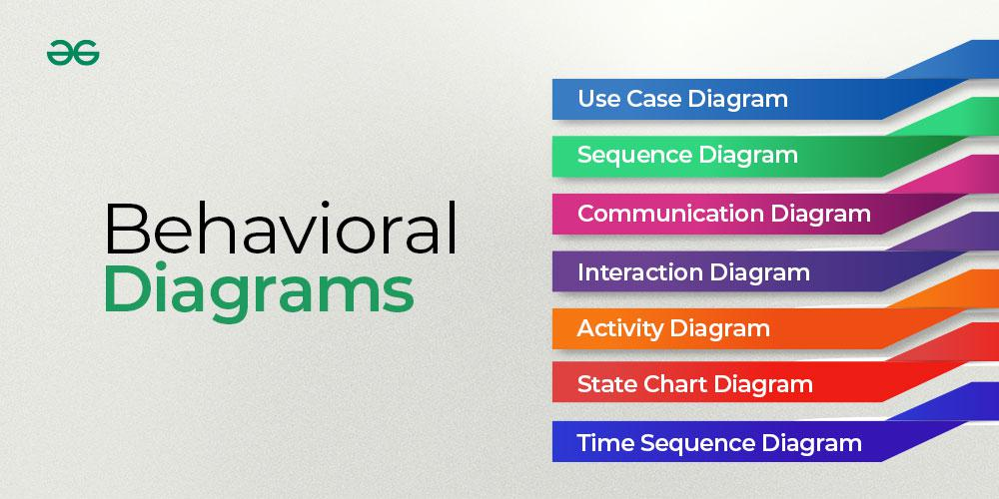

**Important topics for Behaviour UML diagrams**

* [Behavior UML diagrams](https://www.geeksforgeeks.org/system-design/behavior-diagrams-unified-modeling-languageuml/#behavior-uml-diagrams)
* [Types of Behavior UML diagrams](https://www.geeksforgeeks.org/system-design/behavior-diagrams-unified-modeling-languageuml/#types-of-behavior-uml-diagrams)
* [Benefits of using Behavior UML diagrams](https://www.geeksforgeeks.org/system-design/behavior-diagrams-unified-modeling-languageuml/#benefits-of-using-behavior-uml-diagrams)
* [Challenges faced in developing Behavior UML diagrams](https://www.geeksforgeeks.org/system-design/behavior-diagrams-unified-modeling-languageuml/#challenges-faced-in-developing-behavior-uml-diagrams)
* [Best Practices for developing Behavior UML diagrams](https://www.geeksforgeeks.org/system-design/behavior-diagrams-unified-modeling-languageuml/#best-practices-for-developing-behavior-uml-diagrams)
* [Conclusion](https://www.geeksforgeeks.org/system-design/behavior-diagrams-unified-modeling-languageuml/#conclusion)

**Behavioral UML diagrams**

Behavioral UML diagrams focus on illustrating the dynamic aspects of a software system, showcasing how it behaves, responds to stimuli, and undergoes state changes during runtime.

**Types of Behavioral UML diagrams**

**1.**[**State Machine Diagrams**](https://www.geeksforgeeks.org/system-design/unified-modeling-language-uml-state-diagrams/)

A state diagram is used to represent the condition of the system or part of the system at finite instances of time. It’s a behavioral diagram and it represents the behavior using finite state transitions.

* State diagrams are also referred to as **State machines** and **State-chart Diagrams**.
* These terms are often used interchangeably. So simply, a state diagram is used to model the dynamic behavior of a class in response to time and changing external stimuli.

**2.**[**Activity Diagrams**](https://www.geeksforgeeks.org/system-design/unified-modeling-language-uml-activity-diagrams/)

We use Activity Diagrams to illustrate the flow of control in a system. We can also use an activity diagram to refer to the steps involved in the execution of a use case.

* We model sequential and concurrent activities using activity diagrams. So, we basically depict workflows visually using an activity diagram.
* An activity diagram focuses on condition of flow and the sequence in which it happens.
* We describe or depict what causes a particular event using an activity diagram.

**3.**[**Use Case Diagrams**](https://www.geeksforgeeks.org/system-design/use-case-diagram/)

Use Case Diagrams are used to depict the functionality of a system or a part of a system. They are widely used to illustrate the functional requirements of the system and its interaction with external agents(actors).

* A use case is basically a diagram representing different scenarios where the system can be used.
* A use case diagram gives us a high level view of what the system or a part of the system does without going into implementation details.

**4.**[**Sequence Diagram**](https://www.geeksforgeeks.org/system-design/unified-modeling-language-uml-sequence-diagrams/)

A sequence diagram simply depicts interaction between objects in a sequential order i.e. the order in which these interactions take place.

* We can also use the terms event diagrams or event scenarios to refer to a sequence diagram.
* Sequence diagrams describe how and in what order the objects in a system function.
* These diagrams are widely used by businessmen and software developers to document and understand requirements for new and existing systems.

**5. Communication Diagram**

A Communication Diagram (known as Collaboration Diagram in UML 1.x) is used to show sequenced messages exchanged between objects.

* A communication diagram focuses primarily on objects and their relationships.
* We can represent similar information using Sequence diagrams, however communication diagrams represent objects and links in a free form.

**6. Time Sequence Diagram**

* Time Sequence Diagram are a special form of Sequence diagrams which are used to depict the behavior of objects over a time frame.
* We use them to show time and duration constraints which govern changes in states and behavior of objects.

**7. Interaction Overview Diagram**

* An Interaction Overview Diagram models a sequence of actions and helps us simplify complex interactions into simpler occurrences.
* It is a mixture of activity and sequence diagrams.

**Benefits of using Behavioral UML diagrams**

* **Understanding How Things Work:**
  + These diagrams act like visual stories, helping everyone on the team understand how different parts of a computer program or system work together.
* **Seeing the Order of Actions:**
  + They show the order in which things happen when you use a program.
* **Planning Step-by-Step Processes:**
  + When designing a program, these diagrams help plan step-by-step processes, making it easier for developers to know what to do next.
* **Spotting Changes and Decisions:**
  + They highlight moments where things change or decisions are made in a program. It's like marking important points on a map.
* **Showing Different States:**
  + For programs that can be in different states (like a traffic light changing colors), these diagrams help show how things move from one state to another.
* **Team Collaboration:**
  + When a team is working on a project, these diagrams become a shared language. Everyone can look at the pictures and quickly understand what's going on.
* **Fixing Problems Early:**
  + By looking at these diagrams, teams can catch and fix problems early on, avoiding headaches later in the project.

**Challenges faced in developing Behavioral UML diagrams**

* **Deciding What to Show:**
  + Figuring out what to include in the pictures and what to leave out can be a bit like deciding which parts of a movie to show in a trailer.
  + It needs to be just enough to get the idea across.
* **Dealing with Changes:**
  + When things in the program change, updating the pictures to match can be a bit like trying to edit a video.
  + It needs to stay in sync with what's really happening in the program.
* **Understanding Different Perspectives:**
  + People might look at the pictures and see things in different ways.
  + Making sure everyone agrees on what the pictures mean can be a bit challenging.
* **Showing Time and Order:**
  + Expressing the order in which things happen or showing how a program changes over time can be a bit like drawing a comic strip.
  + It needs to be clear and in the right sequence.
* **Balancing Detail and Simplicity:**
  + Striking the right balance between showing enough detail without making the pictures too complicated can be a bit like finding the perfect recipe. Too much or too little can be a problem.
* **Making Sure It's Useful for Everyone:**
  + Ensuring that the pictures are helpful for different people on the team, like designers and developers, is a bit like creating a map that everyone can use.
* **Spotting Mistakes Early:**
  + Catching and fixing mistakes in the pictures early on is a bit like proofreading a story.
  + It's important to get it right before everyone starts working on the program.
* **Keeping It Simple and Clear:**
  + Making sure the pictures stay simple and clear can be a bit challenging. It's important that everyone can easily understand them.

**Best Practices for developing Behavioral UML diagrams**

* **Tell a Clear Story:**
  + Make sure your pictures tell a clear and easy-to-understand story about how the program behaves.
* **Include Important Steps:**
  + Be careful not to leave out important steps in how the program works
* **Choose What to Show Wisely:**
  + Decide what to include in the pictures carefully.
* **Update When Things Change:**
  + When things in the program change, make sure to update the pictures accordingly. Think of it like editing a video to match the latest script.
* **Consider Different Views:**
  + Remember that people might see things differently. It's like making sure a picture book can be understood by readers of all ages and backgrounds.
* **Show the Order of Events:**
  + Express the order in which things happen clearly.
* **Balance Detail and Simplicity:**
  + Find the right balance between showing enough detail without making the pictures too complicated.
* **Make It Useful for Everyone:**
  + Ensure that the pictures are helpful for different team members. It's like designing a map that works for both beginners and experts.
* **Catch Mistakes Early:**
  + Check for mistakes in the pictures early on. It's similar to proofreading a storybook before it gets published.
* **Keep It Simple and Clear:**
  + Strive to keep the pictures simple and clear.

**Conclusion**

In conclusion, Behavioral UML diagrams serve as essential tools in the world of software development. They help teams understand, communicate, and plan how a program behaves during different scenarios. From illustrating user interactions to showcasing the sequence of actions and decision-making processes, these diagrams provide a visual narrative of a software system's dynamic aspects.

Life is made up of processes. Hiring a new employee? Recruitment processes. Checking products are up to scratch? Quality control processes. Making a cup of coffee?

Okay, so not every process is formally acknowledged, and nor should it be — but in the workplace, it makes sense to standardize the many complex tasks and items that form your business and its offering. This is what’s known as ‘process flow’.

Process flow is all about keeping projects on track and making sure everything runs as smoothly as possible. Let’s take a closer look at how to master this project management essential.

**What is process flow and a process flow diagram (PFD)?**

**Process flow refers to the sequential movement of tasks, information, and products that move through a system.**And a process flow diagram is the visual representation of all of these moving parts.

Think of it as being like a map that helps you see the path of a task or item from beginning to end. This makes everything easier to understand and manage, which, in turn, boosts communication and efficiency.

**Why do we use process flow diagrams?**

By clearly mapping out each step from start to finish, everyone knows what their role and responsibilities are.

This clarity helps you avoid misunderstandings and mistakes. Plus, process flow really boosts efficiency. When tasks are laid out clearly, people can cut down on wasted time and effort.

It also helps you spot problems before they arise. When you can see the whole process, it’s easier to identify [bottlenecks](https://nulab.com/learn/project-management/what-is-a-bottleneck-and-how-do-you-avoid-it/) or areas that need a little tweaking.

**Process flow diagrams —**

* Help visualize the journey of tasks, information, or products through a system.
* Clarify roles and responsibilities within an organization.
* Boost efficiency by outlining tasks clearly.
* Reduce misunderstandings and mistakes.
* Identify potential bottlenecks or issues early on.
* Ensure projects stay on track and run smoothly.
* Helps the organization achieve goals with minimal delays.

Ultimately, it’s all about keeping things running smoothly so the team can hit its targets without unnecessary holdups or confusion.

**Examples of process flow diagrams**

Now we know why it works, let’s look at what process flows look like in the real world.

**1. Standardizing manufacturing processes**

Let’s say a car manufacturing plant reviews its assembly process flow. By standardizing each step—from welding to painting and final assembly—the team realizes it has a few too many inspections. By cutting these out, the manager realizes they can streamline production.

This optimization not only lowers production times but reduces errors, boosting quality across all vehicles and making it easier to stick to production schedules.

**2. Analyzing and optimizing software development**

A software development company uses process flow charts to track its [Agile](https://nulab.com/learn/project-management/agile-guide/) development cycles.

Once the manager reviews these charts, they notice that code review delays are a bottleneck. To address this issue, they streamline the review process and use [continuous delivery](https://nulab.com/learn/software-development/what-is-continuous-delivery-and-how-can-it-help-you/) techniques. This enhances the overall speed and quality of product delivery, ultimately optimizing their [workflow](https://nulab.com/workflows/workflow-management/).

**3. Boosting team accountability in retail**

A big retail chain sets up process flow maps for its inventory management system.

When new stock arrives, employees can see their specific roles — from checking in deliveries to updating databases. This clarity boosts accountability and ensures tasks get completed accurately and on time, leading to improved store performance.

**A step-by-step guide to creating a business process flow diagram**

Here’s a detailed guide to help you design your own process flow diagram.

**1. Define the process**

Start by identifying a specific process you want to map out. This could range from employee onboarding to managing customer service calls.

Next, define a start and an endpoint to keep your focus sharp. For example, if you’re mapping onboarding, your start point might be the acceptance of a job offer, and the endpoint could be the new employee’s first day.

**2. Gather input from stakeholders**

Chat with team members who are directly involved in the process. Their insights will help you understand a fuller picture of the process, plus how each step works.

You might want to set up interviews or [brainstorming](https://nulab.com/learn/keywords/brainstorming/) sessions to encourage idea-sharing. Ask team members [open-ended questions](https://nulab.com/learn/collaboration/the-8-essential-questioning-techniques-you-need-to-know/) about their experiences, what challenges they face, and any suggestions they might have.

This collaborative approach supports your diagram with real-world perspectives.

**3. List all steps and tasks**

Write down every step involved in the process, regardless of how minor it may seem. Be thorough because each task will contribute to the overall flow.

Use a bullet-point list to organize these tasks and group related activities together. For example, if your process includes training sessions, you might list preparation, delivery, and feedback collection as grouped tasks.

**4. Identify inputs and outputs**

Now you need to clarify what inputs you need trigger each step, and the outputs you expect after each action. This might be as straightforward as a form submission leading to data entry, or a completed analysis producing a report.

Knowing how these elements work together will help make sure your diagram accurately reflects the process flow and the various task [dependencies](https://nulab.com/learn/project-management/a-no-fuss-guide-to-project-dependencies/).

**5. Choose diagramming tools**

Now it’s time to visualize your process. You can use Word or Google Docs, or an old-fashioned pen and paper — and the latter isn’t bad for a first draft. But when it comes to formatting, editing, and sharing, none of these options is ideal. So get diagramming tools involved.

Choose a tool that fits your personal style and the preferences of your team. Familiarize yourself with its features, and get creative. Ideally, your chosen tool will allow you to share with others, so you can [get their input](https://support.nulab.com/hc/en-us/articles/8304742976409-How-to-manage-access-to-shared-folders-in-Cacoo) before finalizing.

**6. Use standardized symbols**

There’s no need to reinvent the wheel. Stick to commonly accepted flowchart symbols to make sure your diagram is easy to understand and follows convention.

* Use ovals to denote start and end points
* Use rectangles for tasks
* You’ll want diamonds for decision points
* And arrows to indicate the flow of the process.

By standardizing your symbols, you make it easier for others to follow and interpret your diagram without ambiguity.

**7. Draft the diagram**

Now it’s time to position your identified tasks in the order they happen. Connect each step with arrows to illustrate the flow of the process clearly.

Don’t forget to include decision points where choices need to happen. These are essential for understanding the potential paths through the process. Aim for a logical and straightforward layout that guides the viewer from start to finish, and don’t be afraid to run it by others on the team just to make sure it makes sense.

**8. Review and refine**

Once you have a draft, share it with the wider team and other [stakeholders](https://nulab.com/learn/project-management/identifying-managing-project-stakeholders/) for their feedback.

Be open to their suggestions since they’ll have a valuable perspective and might spot things you’ve missed. This step helps you make sure your PFD isn’t just accurate but also comprehensive. Make adjustments based on new input to keep it effective.

**9. Label clearly**

Each task and decision point needs to have a clear and concise label. Avoid using jargon or overly technical language. Instead, go for simplicity so everyone can understand the labels at a glance.

For example, instead of “Conduct HR evaluation,” you might say “Review candidate qualifications” to make it more relatable.

**10. Distribute the final diagram**

After finalizing your PFD, share it with your entire team. You might want to host a short session to walk everyone through the diagram, answer any questions, and clarify roles within the process. This helps everyone know what’s going on and how they fit into the workflow.

**What is Web App**

Last Updated : 23 Jul, 2025

A Web Application (Web App) is a software program that runs on a remote server and is accessed through a web browser over the internet. Unlike traditional apps that require installation on your device, web apps work directly from your browser whether it's **Chrome**, **Safari**, or **Firefox**.

**How do Web Apps work?**

Web applications run on a [client-server model](https://www.geeksforgeeks.org/system-design/client-server-model/), meaning users access them through a web browser without needing to download or install anything. They rely on three key components:

**Web Server** – Handles user requests and directs them to the right place.

**Application Server** – Processes tasks and generates responses.

**Database**– Stores and retrieves data as needed.

**Working:**

**User Request**: A user accesses the web app, sending a request to the server.

**Processing**: The server processes the request, retrieves or updates data if needed.

**Response**: The processed data is sent back and displayed in the browser.

**Technologies Behind Web Apps**

**Front-end** (User Interface): Built using [HTML](https://www.geeksforgeeks.org/html/html-tutorial/), [CSS](https://www.geeksforgeeks.org/css/css-tutorial/), and [JavaScript](https://www.geeksforgeeks.org/javascript/introduction-to-javascript/)for interactive elements.

**Back-end** (Server Logic): Uses languages like [Python](https://www.geeksforgeeks.org/python/python-programming-language-tutorial/), [Java](https://www.geeksforgeeks.org/java/java/), [Ruby](https://www.geeksforgeeks.org/ruby/ruby-on-rails-introduction/), or [PHP](https://www.geeksforgeeks.org/php/php-introduction/)to handle logic and database interactions.

**Data Storage**: Information is stored in databases, often in cloud-based systems for easy access from any device.

Unlike desktop applications, web apps work on any device with a browser, making them widely accessible and easy to update.

**Examples of Web Apps**

**Google Docs**: Think of Google Docs as an online notepad that lets you write, edit, and collaborate in real time. Whether you’re working on a story or making a list, multiple people can edit the same document from anywhere.

**Trello**: Trello is like a digital task board that helps you stay organized. Whether you’re planning an event or managing a project, you can create, move, and track tasks using virtual cards. It’s a simple and effective way to manage work, assign tasks, and track progress making it perfect for teams.

**Gmail**: Gmail is your online mailbox, letting you send and receive emails from any device. No need for special software, just open your browser, log in, and you’re ready to go. You can even attach files, send images, and chat with friends effortlessly

**Facebook**: Facebook is like a virtual hangout where you can connect with friends, share posts, and chat. It’s a space to upload photos, like and comment on updates, and stay connected.

**Key Characteristics of Web App**

**Accessibility**: Consider having a powerful tool or game that you can access from anywhere. With a web app, you're not limited to a single device. Whether you're on a computer, tablet, or phone, you can use the app directly from your browser, no need for downloads or installations. Just open your browser and get started!

**Platform Independence**: One of the best things about web apps is that they work on any operating system. Whether you're using Windows, macOS, or Linux, a web app runs smoothly without compatibility issues.

**Automatic Updates**: All of us have experienced the manual effort of updating software. Web apps update automatically because they run on a remote server. That means every time you open the app, you’re using the latest version, without needing to install anything.

**Collaboration**: Many web apps allow real-time collaboration, making teamwork easier. Whether you're working on a document, project, or design, multiple people can edit and contribute at the same time, even from different locations.

**Benefits**

**Cross-Platform Compatibility**: Web apps run on computers, tablets, and phones without needing different versions. Just open a browser, and you're ready to use it.

**Automatic Updates**: No need to manually update apps. Since everything runs on a server, web apps always load the latest version automatically.

**Cost-Efficiency**: Developers create a single app that works across all devices, saving time and resources instead of building separate versions for different platforms.

**Real-Time Collaboration**: Web apps allow multiple users to work together at the same time, no matter where they are. Changes appear instantly, making teamwork smoother.

**No Installation Needed**: Unlike traditional apps, web apps don’t require downloads or installations. Just open the browser, enter the app’s URL, and start using it instantly.

**Challenges**

**Need for Internet Connection**: Web apps need a good internet connection for smooth use. Some offer limited offline features, but full functionality requires online access.

**Performance Concerns**: Speed depends on app quality and internet speed. A well-optimized app with fast internet runs smoothly; otherwise, it may lag.

**Security Measures**: Web apps store data on servers, so encryption and secure connections protect against threats.

**Difference Between Web Applications And Websites**

Many people confuse web apps and websites since both are accessed through a **web browser** and need an **internet connection**. However, they serve different purposes.

Websites are mainly for sharing information. They are mostly static, meaning the content doesn’t change often, and users only view the information. Examples include blogs, news sites, and restaurant menus.

On the other hand, Web Applications are interactive and allow users to perform tasks. They often include features like [user authentication](https://www.geeksforgeeks.org/ethical-hacking/what-is-user-authentication-and-why-is-it-important/), [data processing,](https://www.geeksforgeeks.org/data-science/introduction-to-data-processing/) and real-time updates. Examples include online banking, social media, and e-commerce platforms.

| **Feature** | **Website** | **Web Application** |
| --- | --- | --- |
| Purpose | Provides information | Allows user interaction and functionality |
| Interactivity | Mostly static (read-only) | Dynamic and interactive |
| User Involvement | Users only view content | Users can input data and perform actions |
| Functionality | Displays text, images, videos, and links | Offers features like forms, authentication, and data processing |
| Examples | Blogs, news sites, company websites | Online banking, social media, e-commerce platforms |
| Development Complexity | Simpler, mainly uses HTML, CSS, and basic JavaScript | More complex, involving backend logic, databases, and APIs |
| Updates | Content updates occasionally | Requires regular updates for new features and improvements |
| Authentication | Usually not required | Often requires login and user authentication |

**What is a web application?**

A web application is an application software that does not require installation and can instead be accessed from a remote server via web browser. Web applications are made for interaction, allowing users to send and consume data between the browser and the web server. This interaction can be as simple as logging in to an account, or as complex as making a payment with your credit card.

**What are the benefits of web applications?**

Web applications offer numerous advantages:

**Cross-Platform Compatibility**: Work seamlessly across different operating systems and devices through any modern web browser

**No Installation Required**: Users can access applications immediately without downloading or installing software

**Automatic Updates**: Updates deploy automatically on the server side, ensuring all users have the latest features and security patches

**Cost-Effective Development**: Single [web app](https://www.codecademy.com/article/what-is-a-web-app) serves all platforms, more economical than developing multiple native applications

**Enhanced Security**: Centralized security management with immediate deployment of updates and patches

**Scalability**: Easily accommodate growing user bases by upgrading server infrastructure

**Examples of web apps**

Web applications are everywhere in our digital lives:

**Productivity Applications**

Google Workspace (Docs, Sheets, Slides): Collaborative document editing and sharing

Microsoft Office 365: A Comprehensive office suite accessible through browsers

Notion: All-in-one workspace for notes, tasks, and project management

**Communication Platforms**

Gmail: Email management and communication

Slack: Team messaging and collaboration

Zoom: Video conferencing and virtual meetings

**E-commerce and Financial Services**

Amazon: Online shopping and marketplace

PayPal: Digital payment processing

Online Banking: Account management and transactions

**Entertainment and Social Media**

Netflix: Video streaming service

Spotify: Music streaming platform

Facebook: Social networking and content sharing

**How do web apps work?**

Web applications operate on a client-server model where the web browser acts as the client, and remote servers host the application logic and data.

**Basic Process:**

User Request: When users interact with a web app, their browser sends [HTTP requests](https://www.codecademy.com/article/http-requests) to the web server

Server Processing: The server processes the request, potentially querying databases or executing business logic

Response Generation: The server generates a response, typically in HTML, CSS, and [JavaScript](https://www.codecademy.com/article/what-is-javascript)

Browser Rendering: The browser receives and renders the response, displaying the updated interface to the user

**Three-Layer Architecture**

Most web applications follow a three-layer architecture pattern:

Presentation Layer (Frontend): User interface elements including HTML, CSS, and JavaScript

Application Layer (Backend): Business logic, web servers, and APIs that handle processing

Data Layer (Database): Manages persistent storage and data operations

**What is the Difference Between a Website and a Web Application?**

While the terms “website” and “web application” are often used interchangeably, they represent distinct concepts:

Websites are primarily designed to present information to visitors. They consist of interconnected web pages that display static content such as text, images, and videos. Users primarily read or view content with limited interactivity.

Web applications are designed for user interaction and task completion. They provide functionality that allows users to manipulate data and perform specific actions with dynamic content that changes based on user input.

| **Aspect** | **Website** | **Web Application** |
| --- | --- | --- |
| **Primary purpose** | Information display | Task completion and interaction |
| **User role** | Passive consumer | Active participant |
| **Content type** | Static information | Dynamic, interactive content |
| **Examples** | News sites, blogs, portfolios | Gmail, online banking, social media |

**Web app vs. native app vs. hybrid app**

Understanding the differences between web applications, native apps, and hybrid apps helps in choosing the right development approach:

Web Applications are browser-based and cross-platform, requiring no installation as they’re accessed directly through URLs. They depend on internet connectivity and offer good performance that varies based on browser and connection quality. Development costs are lower since a single codebase serves all platforms, but they have limited access to device features.

Native Apps are platform-specific applications built for iOS or Android that must be downloaded from app stores. They can work offline and deliver excellent performance optimized for each platform. While development costs are higher due to separate codebases, they provide full access to all device features.

Hybrid Apps combine elements of both approaches, using cross-platform development with native wrappers that allow app store distribution. They offer moderate performance and development costs while providing good access to device features through plugins.

**What are the disadvantages of web apps?**

Internet dependency: Requires a constant internet connection for most functionality

Performance limitations: Generally slower than native applications

Browser compatibility: May behave differently across various browsers

Limited device access: Restricted access to device-specific features and hardware

Security concerns: Data transmission over networks creates potential vulnerabilities

Offline functionality: Limited capabilities without internet access

**Conclusion**

Web applications have revolutionized how we interact with software, providing accessible, cost-effective solutions that work across all devices. The key advantages of web apps – including cross-platform compatibility, automatic updates, and reduced development costs – make them attractive for many use cases, though considerations like internet dependency and browser limitations must be weighed against these benefits.

As web technologies continue to evolve, web applications are becoming increasingly sophisticated, offering near-native performance and functionality. Understanding the strengths and limitations of web apps is essential for making informed technology decisions in today’s digital landscape.

**Frequently asked questions**

**1. What is the difference between a web app and a website?**

A website primarily displays information for users to consume, while a web application is interactive software that allows users to perform tasks and manipulate data. Web apps focus on functionality, whereas websites focus on content.

**2. Do web applications require internet to work?**

Most web applications require internet connection since they rely on server-side processing. Some modern web apps use Progressive Web App features for limited offline functionality.

**3. Are web applications secure?**

Web applications can be secure when properly developed with encryption, secure authentication, and regular updates. They benefit from centralized security management for rapid patch deployment.

**4. Can web applications work on mobile devices?**

Yes, web applications work on smartphones and tablets through web browsers. Many use responsive design to optimize for mobile screens and touch interfaces.

**5. What programming languages are used for web applications?**

Web applications typically use HTML, CSS, and JavaScript for the frontend. Backend development may use languages like Python, Java, PHP, Ruby, [Node.js](https://www.codecademy.com/article/what-is-node), or C#. The choice depends on project requirements and team expertise.

**Design Patterns for Mobile Development**

Last Updated : 04 Jan, 2024

Design patterns are reusable solutions to common software development problems. They have had a significant impact on software development, including mobile app development. The implementation of mobile apps has established some proven models and standards to overcome the challenges and limitations of mobile app development.

Most mobile applications were built with low code and were not based on architecture. Mobile app development with the right design patterns can effectively integrate user interfaces with data models and business logic. This will affect the quality of your source code.

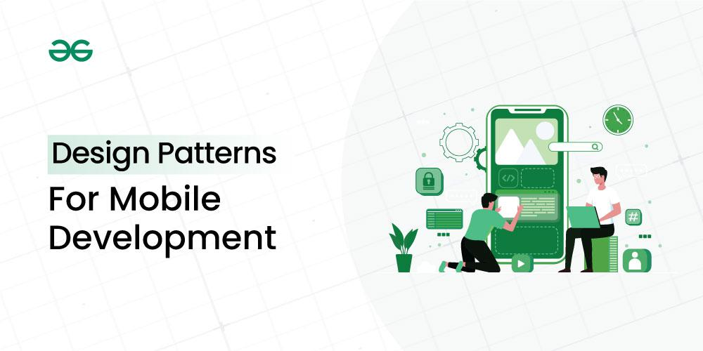

Important Topics for Mobile Development Design Patterns

[Model View Controller (MVC) Architecture](https://www.geeksforgeeks.org/system-design/design-patterns-for-mobile-development/#model-view-controller-mvc-architecture)

[Model View Presenter (MVP) Architecture](https://www.geeksforgeeks.org/system-design/design-patterns-for-mobile-development/#model-view-presenter-mvp-architecture)

[Model View View Model (MVVM) Architecture](https://www.geeksforgeeks.org/system-design/design-patterns-for-mobile-development/#model-view-view-model-mvvm-architecture)

[VIPER Architecture](https://www.geeksforgeeks.org/system-design/design-patterns-for-mobile-development/#viper-architecture)

[Singleton](https://www.geeksforgeeks.org/system-design/design-patterns-for-mobile-development/#singleton)

[Factory Method](https://www.geeksforgeeks.org/system-design/design-patterns-for-mobile-development/#factory-method)

[Observer](https://www.geeksforgeeks.org/system-design/design-patterns-for-mobile-development/#observer)

[Dependency Injection (DI)](https://www.geeksforgeeks.org/system-design/design-patterns-for-mobile-development/#dependency-injection-di)

[Adapter](https://www.geeksforgeeks.org/system-design/design-patterns-for-mobile-development/#adapter)

[Strategy](https://www.geeksforgeeks.org/system-design/design-patterns-for-mobile-development/#strategy)

[Composite](https://www.geeksforgeeks.org/system-design/design-patterns-for-mobile-development/#composite)

[Conclusion](https://www.geeksforgeeks.org/system-design/design-patterns-for-mobile-development/#conclusion)

There are very few architectural design patterns available for mobile development.

**Model View Controller (MVC) Architecture**

MVC is a design model that separates an application into three interacting parts: Model, View, and Controller. This separation allows for better code design and modularization.

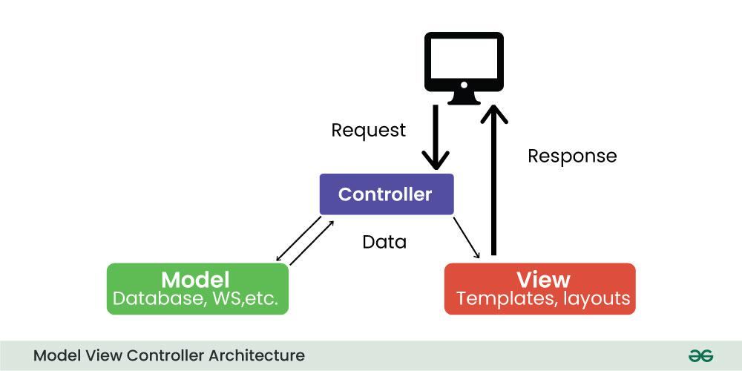Model View Controller

**Model:** Represents application data and business logic.

**View:** Displays data to the user.

**Controller:** Processes user input and controls data flow between Model and View.

**For Example:**

*Imagine a mobile weather app. The model stores weather information, the View displays it to the user, and the controller handles user interactions such as updating the displayed location or converting units (e.g. from Celsius to Fahrenheit).*

**Model View Presenter (MVP) Architecture**

MVP is a new architecture that separates an application into three parts: Model, View, and Presenter. This is similar to MVC but puts more responsibility on the Teacher to manage the interaction between Model and View.

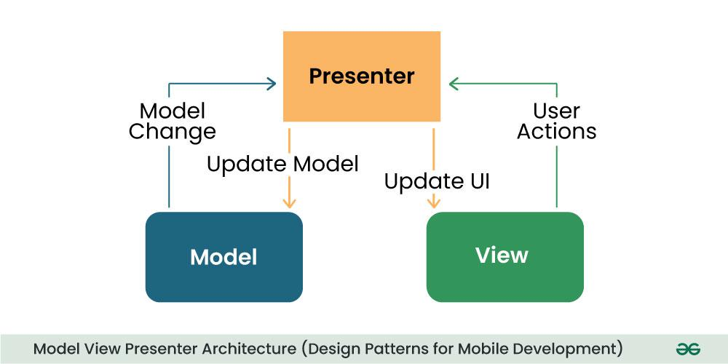Model View Presenter

**Model:** Manages data and business logic.

**View**: Represents the user interface.

**Designer:** Acts as an intermediary processing user input and updating the View and Model.

**For Example:**

*In a note-taking app, the Model would store the text, the View would display it, and the provider would handle user input such as typing, editing, or deletes the process.*

**Model View View Model (MVVM) Architecture**

MVVM is a design model widely used in mobile development, especially in frameworks like Android’s Jetpack. Its purpose is to separate the application into three parts: Model, View, and ViewModel.

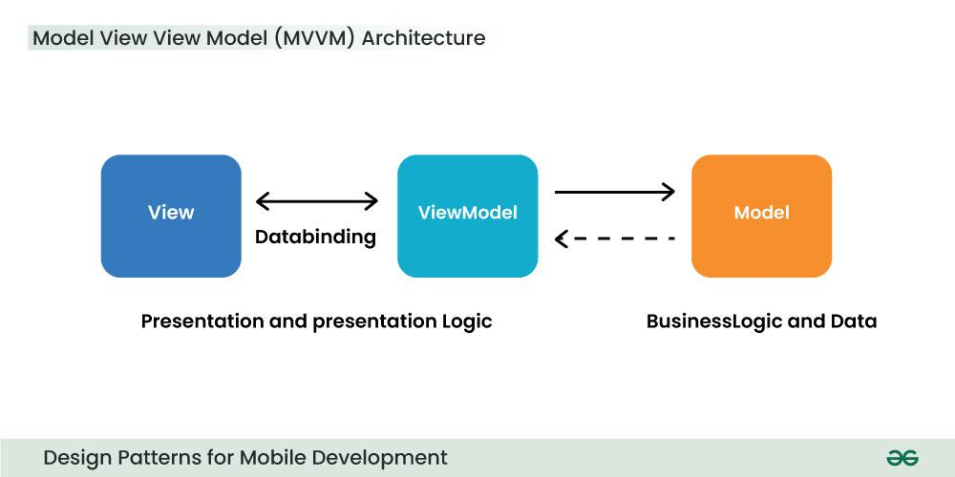Model View View Model

**Model:** Represents data and business logic.

**View:** Represents the user interface.

**ViewModel:** Acts as an interface between the Model and the View, which contains the reference logic.

**For Example:**

*In an e-commerce application, the Model contains product data, the View displays product information, and the ViewModel manages interactions, such as adding items to a cart.*

**VIPER Architecture**

VIPER stands for View, Interactor, Presenter, Entity, and Router. VIPER is primarily based at the clean architecture ideas, which purpose to separate the concerns of different layers of the utility. Each layer has a single duty and communicates with different layers through properly-defined interfaces.

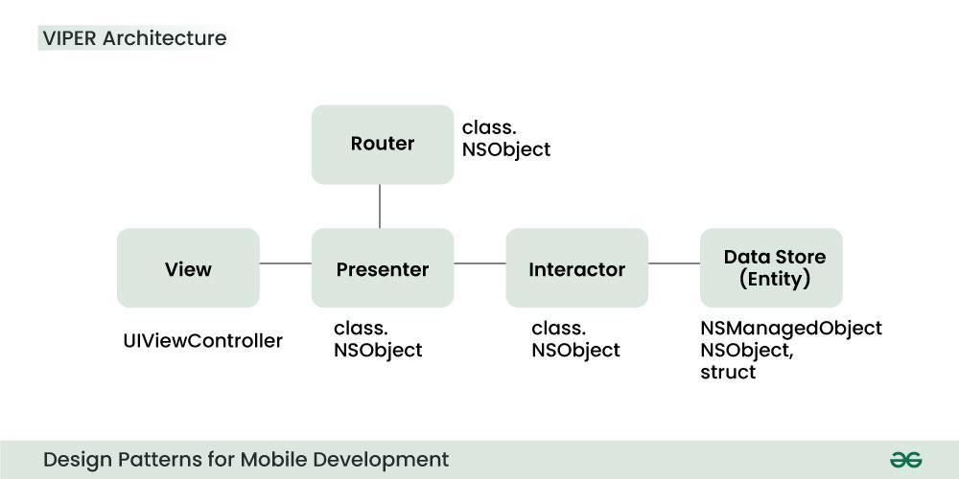VIPER Architecture

Let’s briefly explain the function of every element:

**View:** This is the consumer interface layer, wherein the perspectives and look at controllers are defined. The view is chargeable for showing the information provided by way of the presenter and forwarding the person moves to the presenter.

**Presenter:** This is the presentation layer, where the good judgment for formatting and imparting the records is defined. The presenter is liable for fetching the records from the interactor, reworking it right into a suitable layout for the view, and updating the view hence. The presenter additionally handles the consumer movements acquired from the view and calls the router to navigate to other screens.

**Interactor:** This is the enterprise good judgment layer, where the common sense for manipulating the data and interacting with external services is described. The interactor is accountable for gaining access to the facts from the service layer, acting any vital operations on it, and returning it to the presenter. The interactor additionally communicates with the entity layer to store and retrieve the information fashions.

**Entity:** This is the information layer, wherein the data models and systems are described. The entity is responsible for representing the data in a constant and coherent manner throughout the software. The entity layer also can encompass records get entry to gadgets (DAOs) or repositories that summary the information of records patience and retrieval.

**Router:** This is the navigation layer, where the logic for routing and transitioning among different monitors is defined. The router is chargeable for developing and providing the view controllers, passing any vital facts to them, and coping with any dependencies or configurations. The router also communicates with the presenter to get hold of the navigation requests and execute them.

**Singleton Method Design Pattern**

The singleton policy ensures that there is only one instance of a class and provides global access. This is especially useful when you want to manage a single instance of an object or control access to a delayed object.

**For Example:**

*Singleton can be used to manage player’s score in mobile game. There can only be one instance that is responsible for tracking scores and is updated throughout the game.*

**Factory Method Design Pattern**

The Factory Method model defines an interface for creating an object but allows subclasses to modify the type of the created object. Especially useful when you need to create objects with a common interface but different functionality.

**For Example:**

*In a mobile app that supports multiple payment gateways, payments can be made using the Factory Method. Each payment gateway (e.g., PayPal, Stripe) is a small business and provides its services.*

**Observer Method Design Pattern**

The observer structure defines one to many dependencies between objects, so when one object changes its state, all its dependents are automatically notified and updated. This is useful for scheduling distributed events.

**For Example:**

*In the reports app, many features (Observers) such as the title widget, the report feed view, and the notification provider (Themes) can subscribe to updates when new information arrives. The observer model ensures that they are created all registered parts report, and accordingly You can update it.*

**Dependency Injection (DI) Method Design Pattern**

Dependency Injection is a method of providing class dependencies from the outside, rather than creating them in the class. It improves code modularity and testability by making classes independent of their dependencies.

**For Example:**

*In an Android app, instead of creating a single database connection object in the class, you can place the database object externally, allowing you to easily test and modify database operations.*

**Adapter Method Design Pattern**

The adapter configuration allows you to use the interface of an existing class as a link to a new one. It is often used to work with others without modifying the source code of existing classes.

**For Example:**

*If you want to use a third-party library that provides data in a different way, you can create an adapter that will convert the library's results to the format your app would expect and make sure that they are compatible meet without changing the library code.*

**Strategy Method Design Pattern**

The strategy model defines a family of algorithms, contains each of them, and provides them with flexibility. It allows you to select the appropriate algorithm at runtime. This example is useful when you want to provide different options for a task.

**For Example:**

*In a weather application, you can use various methods to retrieve weather information, such as using a REST API, WebSocket, or local storage. The user can change these options, and the app adapts to his preferences.*

**Composite Method Design Pattern**

A composite pattern allows you to arrange objects in a tree structure to represent a part-of-the-whole structure. This is helpful when you have to deal with individual objects and sets of objects accurately.

**For Example:**

*You can use Composite pattern to create complex shapes from simple shapes in the mobile drawing app. Complex designs can contain individual designs, allowing users to manipulate and categorize resources as needed.*

**Conclusion**

Design processes play an important role in mobile app development by providing proven solutions to common software design challenges. Using this framework allows developers to create maintainable, extensible, and efficient applications. Understanding when and how to apply these options can significantly improve the quality of your mobile app codebase. Whether you’re working for Android, iOS, or any other mobile platform, a solid understanding of these design patterns will allow you to create robust, scalable mobile applications

**Component Based Software Engineering**

Last Updated : 21 Jun, 2022

**Component-Based Software Engineering (CBSE)** is a process that focuses on the design and development of computer-based systems with the use of reusable software components.

It not only identifies candidate components but also qualifies each component's interface, adapts components to remove architectural mismatches, assembles components into a selected architectural style, and updates components as requirements for the system change.

The process model for component-based software engineering occurs concurrently with *component-based development.*

**Component-based development:**

*Component-based development (CBD)* is a CBSE activity that occurs in parallel with domain engineering. Using analysis and architectural design methods, the software team refines an architectural style that is appropriate for the analysis model created for the application to be built.

**CBSE Framework Activities:**

Framework activities of Component-Based Software Engineering are as follows:

**Component Qualification:** This activity ensures that the system architecture defines the requirements of the components for becoming a reusable components. Reusable components are generally identified through the traits in their interfaces. It means “the services that are given and the means by which customers or consumers access these services ” are defined as a part of the component interface.

**Component Adaptation:** This activity ensures that the architecture defines the design conditions for all components and identifies their modes of connection. In some cases, existing reusable components may not be allowed to get used due to the architecture’s design rules and conditions. These components should adapt and meet the requirements of the architecture or be refused and replaced by other, more suitable components.

**Component Composition:** This activity ensures that the Architectural style of the system integrates the software components and forms a working system. By identifying the connection and coordination mechanisms of the system, the architecture describes the composition of the end product.

**Component Update:** This activity ensures the updation of reusable components. Sometimes, updates are complicated due to the inclusion of third-party (the organization that developed the reusable component may be outside the immediate control of the software engineering organization accessing the component currently).

**What is User Experience (UX) Design?**

Last Updated : 14 Jul, 2025

**User Experience (UX) Design** is all about creating products that provide meaningful and enjoyable experiences for users. This involves making products easy to use, efficient, and pleasant, which helps meet the users' needs and expectations. UX design covers everything from physical products to digital experiences, ensuring that every interaction a user has with a product is positive.

In today's digital age, UX design is crucial for the success of any product or service. It not only focuses on the usability and functionality of a product but also on making the entire user journey seamless and engaging. Good UX design can lead to higher **customer satisfaction**,**increased sales**, and better **brand loyalty**.

User Experience

UX design involves understanding user behavior through research and testing, and then using this information to create intuitive and attractive interfaces. By prioritizing the user's needs and preferences, UX designers can help businesses create products that users love and recommend.

In this article, we will explore what **User Experience (UX) Design** is, why it is important, and how you can get started in this exciting field. Whether you are a beginner or looking to improve your UX skills, understanding the basics of UX design is essential for creating successful and user-friendly products.

**Table of Content**

[What is UX Design and Why is it Important](https://www.geeksforgeeks.org/techtips/user-experience-or-ux-design/#what-is-user-experience-ux-design)

[Key Components of UX Design:](https://www.geeksforgeeks.org/techtips/user-experience-or-ux-design/#key-components-of-ux-design)

[Why is UX Design Important?](https://www.geeksforgeeks.org/techtips/user-experience-or-ux-design/#why-is-ux-design-important)

[What is the Difference between UI and UX?](https://www.geeksforgeeks.org/techtips/user-experience-or-ux-design/#what-is-the-difference-between-ui-and-ux)

[How to Get Started With UX Design?](https://www.geeksforgeeks.org/techtips/user-experience-or-ux-design/#how-to-get-started-with-ux-design)

[UX Design Process](https://www.geeksforgeeks.org/techtips/user-experience-or-ux-design/#ux-design-process)

[What does a UX designer do?](https://www.geeksforgeeks.org/techtips/user-experience-or-ux-design/#what-does-a-ux-designer-do)

[User's Needs in UX Design](https://www.geeksforgeeks.org/techtips/user-experience-or-ux-design/#users-needs-in-ux-design)

[How to become a UX designer?](https://www.geeksforgeeks.org/techtips/user-experience-or-ux-design/#how-to-become-a-ux-designer)

[Advantages of User Experience (UX) Design](https://www.geeksforgeeks.org/techtips/user-experience-or-ux-design/#advantages-of-user-experience-ux-design)

[Disadvantages of User Experience (UX) Design](https://www.geeksforgeeks.org/techtips/user-experience-or-ux-design/#disadvantages-of-user-experience-ux-design)

**What is UX Design and Why is it Important**

User experience (UX) is how people feel when they use a product or service. It’s about making things easy, enjoyable, and effective for users. Good UX means the product is simple to use and meets the users' needs. UX Design is all about the user interaction or overall experience of a user with the product, webpage, or application. How the customer feels about the product when he/she is using the service if he/she is facing any problem while interacting with the product or application, also how easy it is for a user to perform a certain task to use a product.

*UX can have everything from* ***physical products to digital experiences.*** *It considers a user’s journey to solve a problem. Think of e-commerce, online food delivery, or online travel company website where how easy it is for a user to order something make the payment, and how long it takes to complete the need whether it might be ordering a book or food or anything. This is considered as UX design.*

**Key Components of UX Design:**

**Usability**: Ensures that a product is easy to use and understand.

**Accessibility**: Makes products usable for people with a wide range of abilities.

**Functionality**: Ensures the product performs its intended tasks effectively.

**Aesthetics**: Involves creating a visually pleasing interface.

**Interaction Design**: Focuses on creating engaging interfaces with logical and thought-out behaviors.

**User Research**: Involves understanding the needs, behaviors, and pain points of users through interviews, surveys, and usability testing.

**Why is UX Design Important?**

**User Experience (UX) Design** is crucial because it focuses on creating products that are easy to use, meet user needs, and provide a positive experience. Here are a few reasons why UX design is important:

**1. Improves User Satisfaction:**

A well-designed user experience leads to higher satisfaction, which increases the likelihood of users returning to the product. Satisfied users are more likely to recommend the product to others, enhancing its reputation and reach​ .

**2. Increases Conversions:**

Good UX design can significantly increase conversion rates by making it easier for users to accomplish their goals, such as completing a purchase or signing up for a service. Intuitive design and clear calls to action can guide users smoothly through the process​ .

**4. Reduces Development Costs:**

Investing in UX design early in the development process can help identify and solve usability issues before they become costly problems. This proactive approach can save time and resources by reducing the need for extensive revisions post-launch​.

**5. Enhances Accessibility:**

UX design aims to make products accessible to as many people as possible, including those with disabilities. This not only broadens the user base but also complies with legal standards and improves overall user satisfaction​ .

**6. Supports SEO and Digital Marketing:**

Search engines prioritize websites that offer a good user experience. Factors such as mobile-friendliness, fast loading times, and intuitive navigation can improve search engine rankings, driving more organic traffic to the site​

**7. Builds Brand Loyalty:**

A positive user experience can foster strong emotional connections between users and the brand. When users find a product easy and enjoyable to use, they are more likely to remain loyal to the brand and continue using its products and services​ .

**What is the Difference between UI and UX?**

Though [**User Interface**](https://www.geeksforgeeks.org/web-templates/user-interface-ui/)**(UI)** and **User Experience (UX)** are closely related concepts in the field of software and [website development,](https://www.geeksforgeeks.org/web-tech/web-development/) they differ in the aspects of the overall user interaction with a product.

Difference between UI and UX

**How to Get Started With UX Design?**

Getting started with **User Experience (UX) Design** involves learning the basics and gaining practical experience. Here are some simple steps to help you begin your journey:

**Step 1. Learn the Fundamentals and Principles of UX Design**

Start by understanding the basics of UX design, such as user research, wireframing, and prototyping. These principles will help you create user-friendly and effective designs.

**Step 2. Learn and Start Working with a UX Design Tool like Figma and Adobe XD**

Get hands-on experience with popular UX design tools like Figma and Adobe XD. These tools will help you create and test your designs efficiently.

**Step 3. Start Making Mock Designs and Projects**

Practice by creating mock designs and personal projects. This helps you apply what you've learned and build a strong portfolio.

**Step 4. Join Design Communities**

Connect with other designers by joining online design communities. These communities offer support, feedback, and valuable resources.

**Step 5. Start Looking for Freelance Work from Various Services**

Begin seeking freelance work on platforms like Upwork or Fiverr. This will give you real-world experience and help you build your professional network.

**UX Design Process**

The **User Experience (UX) Design** process involves several steps to ensure that the final product is user-friendly and meets the needs of its users. Here’s a simple breakdown of the UX design process.

**1. Requirements:**

Identify the problem or task that needs improvement. Understand the user needs and the gaps in the current design.

**2. Design Alternatives:**

Explore different design options to find better solutions than the existing software. Consider various approaches to improve the user experience.

**3. Prototyping:**

Create prototypes to test how well your design meets user needs. This helps ensure your new design is more effective and user-friendly.

**4. Evaluation:**

Assess your design to make sure it improves the user experience. Use feedback and testing to confirm that your UX design is better than the previous version.

**What does a UX designer do?**

A **UX (User Experience) designer** focuses on making products easy and enjoyable to use. They consider the user's needs and behaviors to create a seamless interaction with the product. Here’s a simple breakdown of what a UX designer does:

**1. Conduct User Research:**

UX designers start by understanding the users. They conduct interviews, surveys, and usability tests to gather information about what users need and any problems they face.

**2. Create User Personas:**

They develop user personas, which are fictional characters representing different types of users. This helps them understand and design for various user needs and behaviors.

**3. Define User Problems:**

Based on their research, UX designers identify the main problems users face. They set clear goals for what the design should achieve to solve these problems.

**4. Generate Design Ideas:**

UX designers brainstorm different ideas and solutions. They use creativity to explore various design concepts that can address user needs.

**5. Create Wireframes and Prototypes:**

They make wireframes, which are simple sketches of the product layout, and prototypes, which are more detailed models. These help visualize the design and test its functionality.

**6. Conduct Usability Testing:**

UX designers test the prototypes with real users to get feedback. This helps them identify any issues and areas for improvement.

**7. Iterate on Designs:**

Based on the feedback from usability testing, they refine and improve the design. This process might involve several rounds of testing and adjustments.

**8. Collaborate with Developers:**

UX designers work closely with developers to ensure the design is feasible and implemented correctly. They provide detailed specifications and support during the development process.

**9. Monitor and Improve:**

Even after the product is launched, UX designers continue to monitor its performance and gather user feedback. They make ongoing improvements to enhance the user experience.

**10. Focus on Accessibility and Ethics:**

They ensure the product is accessible to all users, including those with disabilities, and maintain ethical standards by considering user privacy and avoiding manipulative design practices.

**User's Needs in UX Design**

UX designing is based upon the user's interaction with the design. Now to understand what a user thinks and wants, there are some methods discussed as follows. These methods are required to be followed by a designer to collect some vital information about his/her product by getting reviews.

**Naturalistic Observation:** In this section just watch the user using the design in their own environment. In this type of observation, the user does not interact with the designer. Data collected in such an observation is quantitative as well as qualitative.

**Surveys:** Get the user's opinions. It requires physical interaction with the user.

**Focus groups:** In this type of observation a group of users is made to communicate with each other in a room where a moderator who controls the team is required, basically who looks upon the actions and decisions of that group.

**Communicate:** This is a face to face or one to one interaction with the user and the designer.

All of these methods have their pros and cons discussed as follows:

| **Steps** | **Advantages** | **Disadvantages** |
| --- | --- | --- |
| **Naturalistic Observation** | The user is in his/her comfort zone.  Designers get quality feedback because the user uses the design in their environment | This leads to incorrect notes a few times.  There is no privacy for the user’s information. |
| **Surveys** | Efficient data collection.  Easy data analysis. | The information provided could be superficial. |
| **Focus groups** | A rich amount of data can be collected | A moderator is required.  The ideas could depend on the influential member in the team, it means that the views could of any one member only.  The ideas could get affected by social influence. |
| **Communicate** | An in-depth conversation can lead to greater results in knowing how a user wishes to use a specified product. | Skilled communicators are required.  It is time-intensive. A lot of time is required to interview with so many users. |

**How to become a UX designer?**

Becoming a UX designer means creating easy-to-use and enjoyable products for people. Here’s a simple guide to help you start your journey:

**1. Learn What a UX Designer Does**

UX designers make sure products like websites and apps are easy to use.

They study how people use things, create plans, and test designs to improve them.

**2. Get Educated**

**College Degrees**: Study subjects like design, psychology, or computer science.

**Online Courses**: Take UX design courses online. Websites like Coursera and Udacity offer great programs.

**3. Build Important Skills**

**Technical Skills**: Learn to use design tools like Sketch, Figma, and Adobe XD.

**Soft Skills**: Improve how you communicate and solve problems.

**Research Skills**: Learn how to gather and analyze user feedback.

**4. Create a Portfolio**

Show your work by creating case studies that detail your design process.

Include your designs, from early sketches to finished products.

**5. Gain Experience**

**Internships and Entry-Level Jobs**: Work as an intern or junior designer to get hands-on experience.

**Freelance**: Take on small projects for real clients.

**Volunteer**: Offer your skills to help non-profits or small businesses.

**6. Stay Updated on Trends**

Follow UX design blogs, podcasts, and join professional groups to keep up with new trends.

Learn continuously to stay ahead in the field.

**7. Network with Other Designers**

Go to industry events and meetups to connect with other professionals.

Join online communities to share ideas and get advice.

**8. Keep Learning**

UX design is always changing. Take advanced courses and workshops to keep your skills sharp.

Explore related fields like UI design and product design to broaden your expertise.

**9. Apply for Jobs**

Make your resume and portfolio stand out by highlighting your best work.

Practice answering common interview questions and be ready to discuss your designs.

**Advantages of User Experience (UX) Design**

Some advantages of User Experience (UX) are mentioned below:

A good UX design focuses on meeting the **needs and preferences of users**, resulting in products and services that leads to increased user satisfaction and loyalty.

UX design optimizes the usability of digital products thereby, **reducing user frustration** and errors.

Increases User Engagement by making users **spend more time interacting** with the product or services, increasing time on site, click-through rates, and conversions metrics.

A positive user experience foster strong emotional connection of the user with the brand which leads to increased brand loyalty.

**Disadvantages of User Experience (UX) Design**

Some disadvantages of User Experience (UX) are mentioned below:

The process of performing**extensive user research, iterative testing, and refining design solutions** can be time-consuming and may delay the given deadlines.

The tools used for UX Design can be **expensive for smaller businesses**with limited budgets.

As individual **preferences and perceptions may vary**, the use of User Experience (UX) can be considered as subjective. Providing an optimal User Experience for all can be a challenging task.

**Conclusion**

**User Experience (UX) Design** is essential for creating products that are not only functional but also enjoyable and easy to use. By focusing on the needs and behaviors of users, UX design ensures that products provide meaningful and satisfying experiences. This leads to higher user satisfaction, increased sales, and stronger brand loyalty.

Understanding **User Experience (UX) Design** involves learning about user research, usability testing, and the principles of effective design. Whether you're designing a website, app, or physical product, incorporating good UX practices can make a significant difference in how your product is received and used.

In today's competitive market, investing in **UX design** is more important than ever. It helps businesses stand out by creating products that users love and recommend. By continually refining and improving the user experience, companies can build lasting relationships with their customers and achieve long-term success.

In this article, we've explored the basics of **UX design**, its importance, and how you can get started. By applying these principles, you can create products that truly meet the needs of your users and provide a positive, engaging experience.

The goal of any user experience project is to ensure users have a positive experience with a product. Yet, between the initial idea and the polished final product rests a complex web of decisions that impact the user experience in big and small ways. To provide structure and direction to the process of making these decisions –  and to ensure each decision is made at the appropriate point in the process – the 5 elements of UX design act as a guide for every designer.

These 5 elements of UX design were first introduced to us by innovative user experience designer Jesse James Garrett, who wrote a book called [The Elements of User of Experience](https://www.amazon.com/o/ASIN/0735712026/ref=nosim/jjgnet-20/). In it, he explains the steps user experience projects should go through, as well as the issues UX designers should consider at each step.

Because his book was published in 2002, well before the first smartphone was released, Garrett’s ideas were specific to user experiences designed for websites. However, his elements turned out to align so well with the process of creating smart, well-considered user-centric designs, they can be used as a framework for any project that requires a satisfying, cohesive user experience.

[[GET CERTIFIED IN UX]](https://www.uxdesigninstitute.com/courses/ux-design?utm_source=blog&utm_medium=blog_panel_pdux&utm_campaign=blog_promo)

[Take our Professional Diploma in UX Design course](https://www.uxdesigninstitute.com/courses/ux-design?utm_source=blog&utm_medium=blog_panel_pdux&utm_campaign=blog_promo)

**The 5 elements of UX design**

As can be seen in the diagram below, the 5 elements of user experience exist on 5 separate planes, each one stacked on top of the previous one to create an outline of the process [UX teams](https://www.uxdesigninstitute.com/blog/how-to-lead-a-design-team/) can follow for every new project they design. From bottom to top those planes are strategy, scope, structure, skeleton and surface. Each one builds on the next as the project goes from abstract to increasingly more concrete until arriving at the finished product. In addition, each plane requires meeting different goals or completing different tasks.

Let’s look at each plane in more detail.

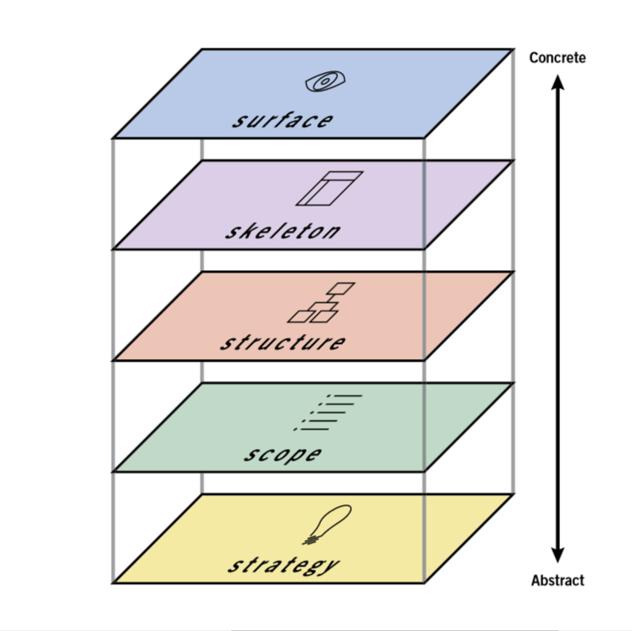

[**Strategy**](https://www.uxdesigninstitute.com/blog/ux-strategy/)

The bottom plane of the model is Strategy. As the most abstract and least constrained part of the project, this is where decisions should be made about what objectives the product should be designed to meet. These objectives should include the goals that both the clients and stakeholders behind the product want to meet and the goals of the users, who will eventually look to the product to solve specific problems for them.

For example, let’s say we’ve been hired to build an app that helps people find charging stations for electric cars. On the one hand, we must be sure to meet the product objectives, which in this case would be goals such as, “Informing electric car owners of the nearest place to charge their cars”.

On the other hand, we need to meet user needs if we want users to come to our app for information. That means we need to understand what goals users would have when using the app, which we can discover through [user research](https://www.uxdesigninstitute.com/blog/what-is-user-research/). In this case, we might want to learn if users would want our product to provide directions to the nearest charging station, information about how many chargers are available there and how much it costs to charge a car at each listed charging station.

**Scope**

After deciding on the strategy, the scope of the product can be determined and laid out in detail. It’s here that all a product’s features are decided upon, including the information that users can find and the functionality that users can interact with. On this plane, the UX team will create a set of functional specifications that identifies and describes every single feature of the product and a list of content requirements that identifies every single piece of content that will be included.

For instance, in our car charger finding app, on the functional specifications side we might want to include a feature to save previously discovered charging stations in our functional specifications. Meanwhile, in our content requirements we might list information like images of each charging station, maps of their locations, and details about the voltage of each available charger.

[[GET CERTIFIED IN USER RESEARCH]](https://www.uxdesigninstitute.com/courses/user-research?utm_source=blog&utm_medium=%20blog_panel_text&utm_campaign=blog_promo)

[Take our Professional Certificate in User Research](https://www.uxdesigninstitute.com/courses/user-research?utm_source=blog&utm_medium=%20blog_panel_text&utm_campaign=blog_promo)

**Structure**

Once the scope of the product has been outlined, it’s time to start working on the structure. This is where each element of navigation will be decided, including where in the product each page can be found and where users can go after arriving at a given page. This involves defining the interaction design and information architecture of the product.

On the interaction design side, we need to decide how users will interact with the site and how the system will respond, including what will happen if errors are made. This can be conveyed through conceptual models that explain each part of the user interface – usually in a flow chart format – that defines what users can do and how the product will react to each potential choice the user makes.

On the information architecture side, we need to structure the content the product offers in a way that makes it easy for users to find what they’re looking for. This can be conveyed through documents like site maps that outline the hierarchy and pattern of each part of the product.

For example, to convey the structure of our electric car charger finder app, we might create a site map that shows the hierarchy of the product. This could include a home page where users can enter a location to find car charging stations. This could then lead to a list of stations each with a link that takes users to pages for individual stations.

In addition, we could also create a user flow where we show how the system responds after a user enters their location information. It can account for what happens if the system finds nearby charging stations and if there’s an error that prevents the system from successfully understanding the location information provided.

[**Skeleton**](https://www.uxdesigninstitute.com/blog/whats-a-skeleton-screen/)

After deciding how the product will be structured, its skeleton can be designed. This entails deciding where the navigation and functional elements from the previous plane will go on each product page. It’s here that UX designers will make decisions about the product’s information design, creating [wireframes](https://www.uxdesigninstitute.com/blog/best-ux-wireframe-tools/) and [prototypes](https://www.uxdesigninstitute.com/blog/best-prototyping-tools-for-ux-designers/) that arrange each part of the product, including the buttons, links, images and text. These are laid out in a way that ensures that users can quickly move through each page to find the information they need, while also understanding which elements of each page are interactive and which are not.

For instance, in our app, if we want to explain what users will see when they navigate to a page that describes a specific electric car charging station, we would create a wireframe that provides a blueprint of where each component of the page would go. Perhaps we have a header with the app logo and navigation back to the complete list of stations. This will be followed by an image of the charging station, followed by a link to a map of the location followed by text providing practical information about the station. This will help visualise each piece of functionality and content that will appear on the page and its placement.

**Surface**

The wireframes and prototypes created on the skeleton plane will be used on the surface plane – the top and most concrete plane – to create the final pages for the product. At this stage, we’re concerned with the users’ sensory experience. This includes how the colours and textures employed in the visual design help them understand how to navigate through and interact with the site, and how the presentation of content draws their eye to key information.

For our electric car charging app, this could mean creating a consistent colour palette and layout, where the logo appears at the top of the page, the most important information appears in a wide column in the middle of the page, and less important information is relegated to each side of the page. This layout anchors users with its consistent visual style while enabling them to easily find the information they’re seeking.

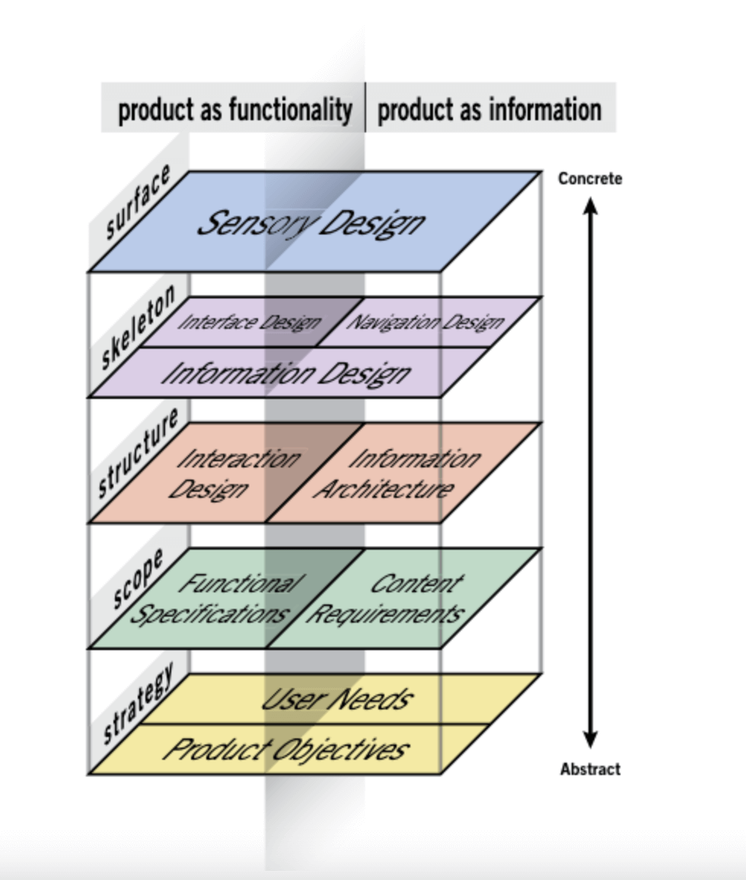

While the diagram above is a neat and tidy way of laying out the 5 elements of UX design, the reality is much messier. In an ideal world the work required for each plane would be wrapped up before tackling the next one. But in real life, you’ll work on more than one plane simultaneously and each decision made on one plane will impact every plane above it. As a result, you’ll want to finish work on each plane before work on the plane above it is completed. This will ensure that the decisions on each plane align with one another.

**What does universal design have to do with the 5 elements?**

According to the [Centre for Excellence in Universal Design](https://universaldesign.ie/): “Universal Design is the design and composition of an environment so that it can be accessed, understood and used to the greatest extent possible by all people, regardless of their age, size or disability.”

This doesn’t just mean we should design products, services and environments that take account of the needs of people with disabilities or other special requirements but that we should create designs with the needs of all users in mind so that our designs are accessible to as many people as possible.

The process of utilising the 5 elements is intended to help UX designers systematically consider and account for every user need and functionality requirement of each product. This should include considering the needs and requirements of people of all kinds.

For example, the users of our car charging finder app are owners of electric vehicles, however those owners are likely to encompass a wide range of ages and abilities. As a result, in using the 5 elements as a framework for designing the app, we should consider the wide range of users who might access it. In the process, we will also be practicing universal design.

**What does design thinking have to do with the 5 elements?**

Tim Brown, the Executive Chair of the design firm [IDEO](https://www.ideo.com/eu) defined design thinking as “a [human-centered approach](https://www.uxdesigninstitute.com/blog/design-for-better-world-don-norman/) to innovation that draws from the designer’s toolkit to integrate the needs of people, the possibilities of technology, and the requirements for business success”.

Like the 5 elements of UX design, design thinking is an approach to solving design problems that starts with working to understand the problem and ends with a final product. The intent of design thinking is to enable people to be as creative as possible while keeping the people a product is designed for at the centre of every decision, even as business requirements and the limitations and possibilities of technology are also considered.

In many ways, design thinking dovetails nicely with the 5 elements and both approaches share the same basic goals and perspectives. As a result, implementing the 5 elements is one way to practice design thinking, as long as the designers involved maintain an open-minded, user-centric approach to the design process, something all UX designers should strive for in every project.

**Information Architecture: A Complete Guide For Beginners**

Last Updated : 23 Jul, 2025

**Information architecture** is the **practice of arranging and structuring content** in a way that makes it easy for users to find and understand. Think of it as the **blueprint for a website** or app, guiding users through the information and helping them navigate efficiently. Good information architecture ensures that users can locate what they need quickly, enhancing their overall experience.

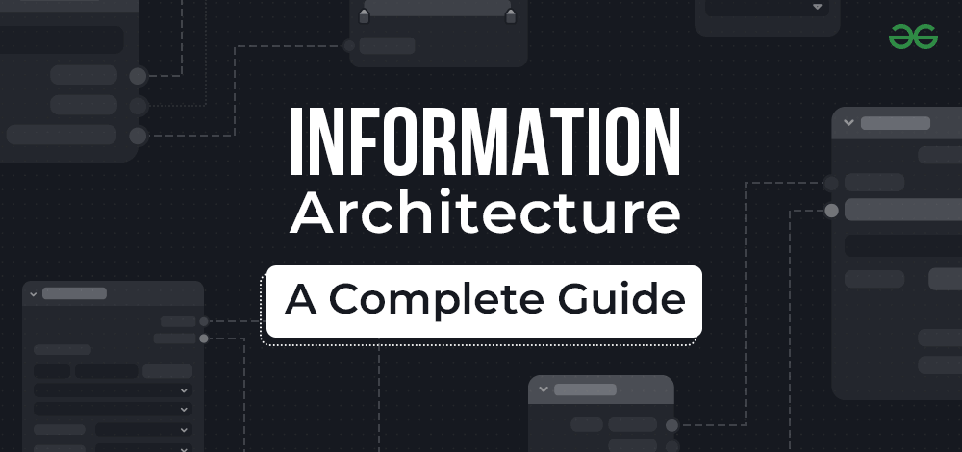

In this article, we will explore **what information architecture is, why it is important, and how it can be implemented effectively**. Whether you're designing a new website or improving an existing one, understanding the **principles of information architecture** can help you create a more user-friendly and intuitive digital product. You'll have a firm understanding of **how to design simple, structured, and user-centric systems** by the end of this article, enabling users to discover what they need quickly and easily. Let's begin this insightful investigation into the world of Information Architecture together!

**Table of Content**

[Types of Data Organizing Structure](https://www.geeksforgeeks.org/blogs/information-architecture/#types-of-data-organizing-structure)

[What is Card Sorting in Information Architecture?](https://www.geeksforgeeks.org/blogs/information-architecture/#card-sorting-in-information-architecture)

[Types of Card Sorting in Information Architecture](https://www.geeksforgeeks.org/blogs/information-architecture/#types-of-card-sorting-in-information-architecture)

[How Card Sorting Helps in Information Architecture?](https://www.geeksforgeeks.org/blogs/information-architecture/#how-card-sorting-helps-in-information-architecture)

**What is Information Architecture (IA)?**

Information Architecture (IA) is the practice of structuring, organizing, and presenting information in a way that makes it easy for users to find and navigate. It plays a key role in User Experience (UX) design, ensuring that digital products like websites, apps, and software are user-friendly and intuitive. By focusing on how content is arranged and accessed, IA helps users quickly locate the information user need ie. improving overall usability and satisfaction.

**The Main Goals of Information Architecture**

**User-Centered Organization**: IA is designed with the user in mind. It involves understanding users' needs, goals, and mental models to organize content in a way that aligns with their expectations. This user-centered approach enhances the overall experience, making it easier for users to navigate and find the information they seek.

**Findability**: One of the primary objectives of IA is to ensure that information is easy to find. A well-structured IA provides clear and intuitive pathways, so users can quickly access the content they’re looking for without frustration. This improves the user’s ability to efficiently navigate through the digital product.

**Scalability**: As digital products grow and evolve, their IA needs to adapt seamlessly. A scalable IA allows for the easy integration of new content and features, ensuring the system remains organized and functional, even as more information is added over time.

**Consistency Across Designs**: IA promotes uniformity in how information is presented and organized across different sections of a product. When users encounter consistent patterns and structures, it becomes easier for them to understand and navigate the system, leading to a more intuitive and cohesive user experience.

**Efficiency**: An effective IA minimizes the cognitive load on users by making the layout and structure of the content clear and logical. This helps users quickly grasp how to find and interact with information, leading to more efficient and satisfying experiences.

This approach not only enhances the usability of digital products but also ensures that they remain adaptable and user-friendly as they grow and evolve over time.

**Types of Data Organizing Structure**

There are numerous sorts of data organizing structures that designers can employ in [**Information Architecture**](https://www.geeksforgeeks.org/blogs/information-architecture/) (**IA**) for [**User Experience**](https://www.geeksforgeeks.org/techtips/user-experience-or-ux-design/) (**UX**) **design** to produce intuitive and user-friendly interfaces. These structures make it easier for user to access and navigate the required information. In terms of **UX design**, the following are some common **forms of data organizing structures in IA :**

**Hierarchical Structure:**

The hierarchical structure is one of the most common and straightforward ways to organize information. It arranges content in a top-down manner, similar to a tree, where broad categories are at the top and subcategories branch out underneath. This structure helps users navigate through large amounts of information by drilling down from general topics to more specific details. It’s especially useful for websites or applications with a lot of content that needs to be organized clearly, such as government websites, corporate sites, or educational platforms.

**Sequential Structure:**

A sequential structure organizes information in a linear or chronological order. This structure is ideal for guiding users through a step-by-step process, like tutorials, onboarding processes, or instructional content. It ensures that users follow a specific path to complete a task, making it easier to understand and retain information.

**Matrix Structure:**

The matrix structure allows information to be organized based on multiple criteria or dimensions, forming a grid-like arrangement. Users can filter and explore data from different perspectives, making it easier to compare and analyze information. This structure is particularly useful in situations where users need to look at information from various angles, such as product comparisons on e-commerce sites or [data analysis](https://www.geeksforgeeks.org/data-analysis/what-is-data-analysis/)in research tools.

**Network Structure:**

A network structure connects different pieces of information like nodes in a web, where each node can link to multiple others. This structure is useful when dealing with complex relationships between different types of information. It is often used in social networks, knowledge graphs, and interconnected [databases](https://www.geeksforgeeks.org/dbms/what-is-database/), where users need to explore relationships and connections between various elements.

**Database or Faceted Structure:**

The faceted structure organizes information using multiple attributes or filters, allowing users to refine their search results. This structure is commonly used in e-commerce websites, online catalogs, and large databases, where users need to narrow down their options based on specific criteria, like price, color, size, or category.

**Alphabetical or A-Z Structure:**

The alphabetical or A-Z structure arranges information alphabetically, making it easy for users to find specific items when they know the name or title. This structure is useful for directories, glossaries, or any content where users need to quickly locate information by name.

**Search-based Structure:**

The search-based structure allows users to find information through a search bar. Instead of navigating through menus or categories, users enter keywords, and the system retrieves relevant results. This structure is essential for platforms with a vast amount of content, such as large [websites](https://www.geeksforgeeks.org/blogs/what-is-a-website/), databases, or content-rich applications.

**Spatial Structure:**

Spatial structures organize information in a way that mirrors physical environments or virtual spaces. This structure is often used in virtual reality (VR) experiences or physical navigation systems, where users interact with information based on its location in space. It helps users explore and discover information by moving through an environment, whether it’s a virtual museum or an augmented reality app.

**What is Card Sorting in Information Architecture?**

**Card sorting is a user research approach in Information Architecture (IA) that is used to investigate how people categorize and organize information in a system**. It assists information architects and user experience specialists in developing successful **navigation structures**, **labels**, and **information hierarchies** that correspond with users' mental models and expectations. Card sorting entails people categorizing things or themes written on physical cards or in digital media into meaningful groups. These groupings can then influence the information structure in the final product.

**Process of Card Sorting**

**Preparation**: Before starting a card sorting session, the information architecture (IA) designer defines the study's goals and objectives. They also create a list of items or topics to be sorted. These items can include website pages, app features, or blog content categories.

**Recruitment**: Participants are recruited to take part in the card sorting exercise. It's generally recommended to have at least 5-10 participants to gather a range of opinions and insights.

**Making Cards**: Each item or topic from the list is written on a separate card. These can be physical cards or digital versions using online card sorting tools.

**Instructions**: Participants are given clear instructions on how to perform the card sorting task. They are usually asked to sort the cards into groups that make sense to them and to name these groups.

**Data Collection**: During the card sorting process, the IA designer observes and records the participants' sorting choices, the reasons behind their decisions, and any comments they make.

**Analysis**: After the card sorting sessions, the IA designer analyzes the collected data. This involves identifying common patterns, trends, and similarities in how participants organized the items. The analysis helps in determining potential categories, hierarchies, and naming conventions for the IA design.

Card sorting is a useful tool for user-centered design since it directly incorporates users in the process of organizing and categorization. IA designers may construct systems that better suit users' demands by understanding how they naturally arrange information, resulting in improved user experiences and increased usability.

Now let's also explore, what are few common types of card sorting techniques used to create and test the information architectural structure among users.

**Types of Card Sorting in Information Architecture**

Card sorting is a valuable technique in information architecture used to organize and structure content, making it more user-friendly and intuitive for website or application users. There are basically **four types of card sorting**, Let's explore each of them:

**1. Open Card Sorting**

Participants in an **Open Card Sorting** session are given a set of cards representing items or subjects with no predefined categories. They are instructed to group the cards depending on their own understanding and mental models. This method allows researchers to get insights into how consumers intuitively organize content and identify potential new groupings that designers may not have considered. **Open card sorting is useful when starting from scratch with an information architecture** or when there is minimal existing knowledge about user mental models.

**2. Closed Card Sorting**

In a **Closed Card Sorting** session, participants are given pre-defined category labels and must sort the cards into these predefined categories. The predefined categories might reflect the existing IA or any structure that the designers choose to evaluate. **Closed card sorting can be used to assess the efficacy of an existing IA design** or to validate certain categories and naming conventions. This method is useful when designers wish to assess the compatibility of users' mental models with the preset structure.

**3. Reverse Card Sorting**

Participants in **Reverse Card Sorting** are given category cards rather than item cards. They are then instructed to sort the things into the predetermined groups. This strategy is especially effective when designers know exactly which categories they want to employ and want to examine how customers perceive the fit of various things inside those categories.

**4. Hybrid Card Sorting**

**Hybrid Card Sorting method combines parts of Open and Closed Card sorting**. Participants are given some predefined categories, but they are also free to establish their own if they so desire. This method creates a balance between the open card sorting's flexibility and the structure of closed card sorting. It enables researchers to learn about users' natural categorization patterns while also evaluating some specified groupings.

**How Card Sorting Helps in Information Architecture?**

**Card sorting is a powerful user research approach** that helps designers understand how consumers intuitively organize and categorize information. It is used extensively in Information Architecture (IA). It gives designers insights into their users' mental models and cognitive processes, allowing them to construct an effective and user-friendly IA structure.

**Here's how card sorting can help you with IA:**

**Identifying User Mental Models:** Card sorting allows designers to study how consumers organize and categorize information depending on their mental models. A mental model is an internal depiction of how things work or how information should be structured by an individual.

**Creating Intuitive Information Hierarchies:** Card sorting assists designers in determining the most natural and intuitive hierarchy for arranging content. Designers can develop logical and useful information hierarchies that mirror users' mental models by observing how people arrange similar objects together.

**Labelling and Nomenclature:** Card sorting, in addition to putting objects into groups, aids in the selection of acceptable labels for categories. Understanding how consumers label the groupings can help designers choose clear and descriptive category names that resonate with users and correspond to their mental models.

**Existing IA Structure Validation:**Card sorting can be used to examine and validate an existing IA structure. Designers can analyze whether the present IA matches with users' mental models or whether there are areas for improvement by having users sort cards into predetermined categories.

**Resolving Navigation and Find-ability concerns:** The results of card sorting can highlight potential navigation and findability concerns in the IA. If users struggle to identify or locate specific things during the experiment, it suggests that the IA design has to be improved.

***Must Read:***

[***How to Become a UI/UX Designer: A Complete Roadmap***](https://www.geeksforgeeks.org/blogs/how-to-become-a-ui-ux-designer-a-complete-roadmap/)

[***10 Best UX Design Frameworks For Your Projects***](https://www.geeksforgeeks.org/blogs/best-ux-design-frameworks/)

[***Wireframe in UX Design - A Beginner's Guide***](https://www.geeksforgeeks.org/blogs/wireframe-in-ux-design-a-beginners-guide/)

**Conclusion**

The **foundation of UX design**, information architecture fills the void between information and users' cognitive processes. Its thoughtful implementation speeds interactions, gives consumers more control, and fosters memorable digital experiences. Designers set the stage for creating **user-centric**, **accessible**, and **pleasurable digital environments** by recognising the **importance of IA** and addressing the variety of needs of today's digital users. Hope this article give you better and details understanding about **what is IA**, its need and how card sorting intervenes in IA.

If you’ve heard about UX design, you’ve probably come across information architecture, or as it’s often written for short ‘IA’.

Maybe you’re attracted to IA because you enjoy solving problems, or you have a natural talent for organizing complex information in a clear and logical way.

The world certainly needs information architects. In the information age we live in, it’s more important than ever before that every organization working with data is conscious of IA; that they plan ahead, plan carefully, and make sure that their content doesn’t turn into an unruly, illogical beast.

As consumers, we’re accustomed to finding exactly what we need, where we expect it to be. And when we find it easily, it’s generally no coincidence. It’s usually the result of extensive [**user research and testing**](https://careerfoundry.com/en/blog/ux-design/the-importance-of-user-research-and-how-to-do-it/). And what happens if we don’t find it? We give up within a few seconds and move on.

**In short, we don’t have much patience when it comes to bad user experience.**

As a result, near perfection has become a must to survive in the competitive tech environment. The job of an information architect is to maintain a competitive advantage by making sure things are where they should be, and believe me, it’s not always easy. As you’ll soon discover, there is a lot to think about.

So what do we really mean by [**information architecture**](https://careerfoundry.com/en/blog/ux-design/what-is-information-architecture/) (IA)? I’ll begin by explaining, in simple terms, what it means. If you scroll down, you’ll find 8 easy principles that highlight some crucial things to think about when designing the IA of a website. I’ll then explain the many ways that good IA will benefit both the user and your bottom line, and finally I’ll share some handy processes to get you started, plus a list useful tools to use when designing the IA of a site. And if you’re an audiovisual learner, you can check out the video below, presented by one of our wonderful student advisors.

Ready to get to grips with it? You can select a topic from the list below to jump straight to it, or else we can simply start from the very beginning. Let’s get cracking!

[**What is information architecture?**](https://careerfoundry.com/en/blog/ux-design/a-beginners-guide-to-information-architecture/#what-is-information-architecture)

[**8 Principles of information architecture**](https://careerfoundry.com/en/blog/ux-design/a-beginners-guide-to-information-architecture/#8-principles-of-information-architecture)

[**What’s The Value Of Information Architecture?**](https://careerfoundry.com/en/blog/ux-design/a-beginners-guide-to-information-architecture/#whats-the-value-of-information-architecture)

[**What are the key processes for information architecture?**](https://careerfoundry.com/en/blog/ux-design/a-beginners-guide-to-information-architecture/#what-are-the-key-processes-for-information-architecture)

[**How to define the information architecture of your site**](https://careerfoundry.com/en/blog/ux-design/a-beginners-guide-to-information-architecture/#how-to-design-the-information-architecture-of-your-site)

[**What tools do information architects use?**](https://careerfoundry.com/en/blog/ux-design/a-beginners-guide-to-information-architecture/#what-tools-do-information-architects-use)

[**Further Reading And Resources**](https://careerfoundry.com/en/blog/ux-design/a-beginners-guide-to-information-architecture/#further-reading-and-resources)



**1. What is information architecture?**

The famous UX designer, Jared Spool, once said: “Good design, when it’s done well, becomes invisible. It’s only when it’s done poorly that we notice it.”

**The same applies for information architecture (IA). When all is in order, it becomes invisible.** Interestingly enough, this ‘science of order’ does not have one unified definition that experts would agree on. But they all agree that, in one way or another, IA is the practice of organizing content in an effective way.

The history of IA goes as far into the past as ancient Egypt. Librarians in the library of Alexandria listed the content of the library on a 120-scroll bibliography. The principle is the same, only it wasn’t called information architecture, it was just good sense.

In fact, one of the first mentions of IA happened in the early 1970s, when XEROX Labs addressed the need for information structuring practices, and developed technology that would support it.

After that, things were relatively quiet on the IA front, until all of a sudden the internet came along and changed everything.

In 1998 Peter Morville and Louis Rosenfeld wrote the book ‘Information Architecture for the World Wide Web’ and even though the authors didn’t expect much success, the book became Amazon’s best internet book that year. So what did this show?

You could see that people were really standing up and paying attention. In the so-called information age, the work of information architects, UX designers, interaction designers, and content managers is more important than ever before. Without them, the web would descend into chaos. So, where should you begin?

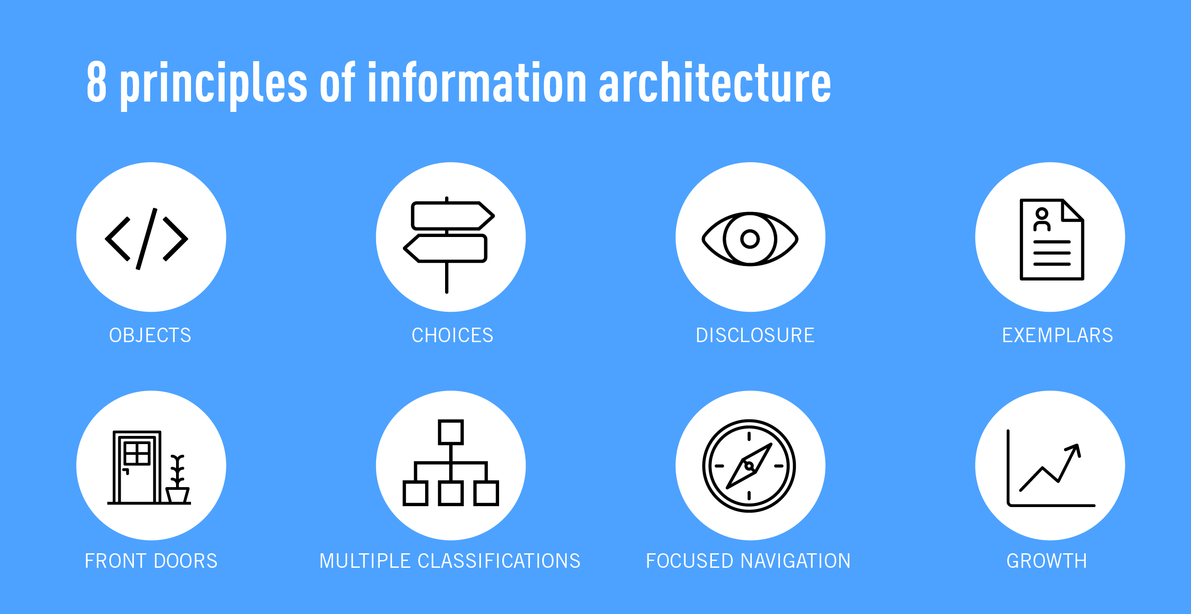

**2. 8 Principles of information architecture**

Building the information architecture for a website should not be done in a vacuum. From user behavior, to future-proofing, there are lots of things to take into account, beyond organizing the information in a logical way.

In his quest to design a good site structure, information architect Dan Brown laid out [**8 principles**](https://www.designprinciplesftw.com/collections/eight-principles-of-information-architecture) that he keeps coming back to.

These principles are based on the understanding that the architect’s focus should be purely the structure – something that can be shown with maps and flowcharts.

To do this, the architect should get a good understanding of the functionality of the site, and they should also have a complete inventory of the content. Once these requirements are met, the information architect can begin optimizing the IA using these 8 principles:

**The principle of objects:** Content should be treated as a living, breathing thing. It has lifecycles, behaviors, and attributes.

**The principle of choices:** Less is more. Keep the number of choices to a minimum.

**The principle of disclosure:**Show a preview of information that will help users understand what kind of information is hidden if they dig deeper.

**The principle of exemplars:** Show examples of content when describing the content of the categories.

**The principle of front doors:** Assume that at least 50% of users will use a different entry point than the home page.

**The principle of multiple classifications:** Offer users several different classification schemes to browse the site’s content.

**The principle of focused navigation:** Keep navigation simple and never mix different things.

**The principle of growth:** Assume that the content on the website will grow. Make sure the website is scalable.

As you can see, there are many things to take into consideration. Depending on the size of a website, IA can be a complex task requiring ongoing maintenance. But, it is one which is very much needed. Otherwise, it can mean failure for a business.

**3. What’s the value of information architecture?**

With Facebook and Google both blocking websites with low valued content, it’s even more important that we produce content that the users will find valuable.

But, the most valuable content will not get discovered if the information architecture is bad, which is bad news for both the user and for the business.

[**The Value For The User**](https://careerfoundry.com/en/blog/ux-design/a-beginners-guide-to-information-architecture/#the-value-for-the-user)

[**The Value For The Business**](https://careerfoundry.com/en/blog/ux-design/a-beginners-guide-to-information-architecture/#the-value-for-the-business)

**The value for the user**

We live in a world where people want instant gratification. This, combined with an overload of information and choice means you really have to deliver the right content at the right time. If the process of finding information is too complicated or too slow, the user will simply abandon the process and move on.

According to Peter Morville and Louis Rosenfeld (Information Architecture for the World Wide Web, 3rd edition) the IA of a website needs to address different user needs.

They distinguish 4 main types of needs as:

**Known-item seeking**: Users will come to the website to search for something desirable and known.

**Exploratory seeking**: Users will come to the website looking for inspiration. They’re looking for something desirable but not sure what exactly.

**Exhaustive research**: Users are in a process of an extensive research. They want to find as much information as possible.

**Re-finding:**A user needs a desired items again and are trying to find it.

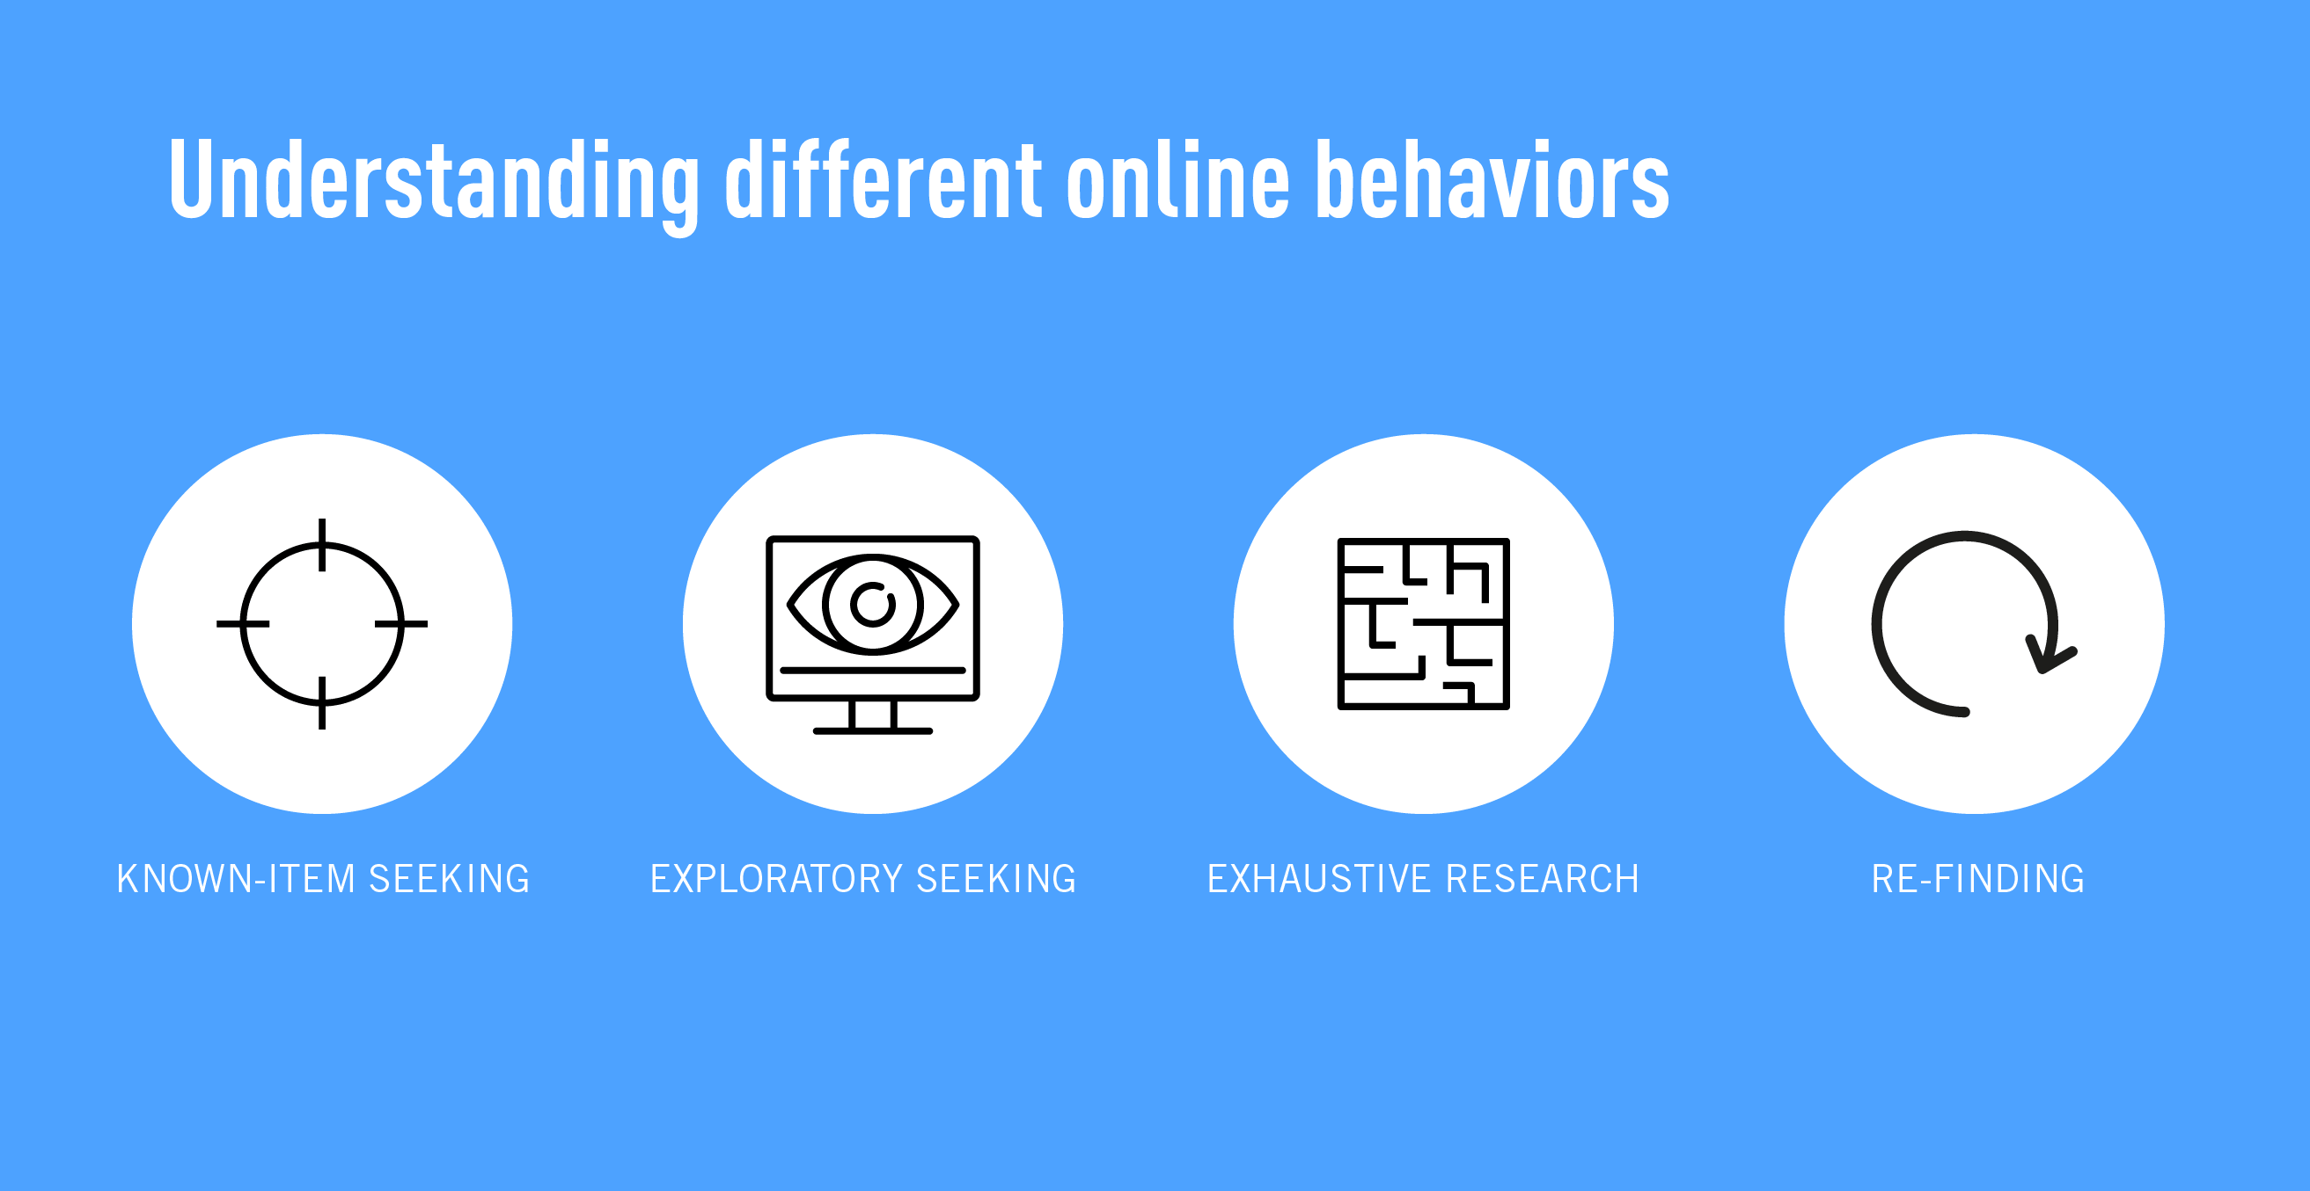  
When thinking about information architecture, it’s important to think about the different users and how they will navigate, search, or use filters.

Think of an e-commerce website. If you’re looking for new shoes for a wedding, you might want to filter by style and by color. But if you’re after a gift, you might want to see some curated gift ideas. If you know exactly what you want, you want the option to quickly find it without browsing.

Good information architecture greatly impacts the user experience. The faster the users get to their final destination, even if that destination includes multiple options, the greater their satisfaction. Therefore, we should never forget that knowing the users and their information seeking behaviors is the key to success. Once we know our users’ needs we can we can prioritize which architectural components to build.

**The value for the business**

If users and customers cannot find critical information or perform the most important tasks, businesses can lose out in many ways. IA can play a crucial role in the following.

[**Employee Productivity**](https://careerfoundry.com/en/blog/ux-design/a-beginners-guide-to-information-architecture/#employee-productivity)

[**Sales And Reputation**](https://careerfoundry.com/en/blog/ux-design/a-beginners-guide-to-information-architecture/#sales-and-reputation)

[**Acquiring New Members**](https://careerfoundry.com/en/blog/ux-design/a-beginners-guide-to-information-architecture/#acquiring-new-members)

[**Reducing Marketing Costs**](https://careerfoundry.com/en/blog/ux-design/a-beginners-guide-to-information-architecture/#reducing-marketing-costs)

[**Reputation And SEO Ranking**](https://careerfoundry.com/en/blog/ux-design/a-beginners-guide-to-information-architecture/#reputation-and-seo-ranking)

[**Reducing The Cost Of Live Help And Support Documentation**](https://careerfoundry.com/en/blog/ux-design/a-beginners-guide-to-information-architecture/#reducing-the-cost-of-live-help-and-support-documentation)

**Employee productivity**

If there is a bad IA for internal content, it can result in wasted time and reduced productivity. In 1999, the International Data Corporation (IDC) conducted research into knowledge workers to find out the financial cost of this. They considered things like how long workers spend searching for information each week and how much time they spend creating content that already exists because they couldn’t find it. They estimated the cost of this “knowledge work deficit” at $5000 per employer every year.

**Sales and reputation**

Lost business is one of the most obvious consequences of poor customer-facing IA. If users cannot find desired products, sales will go down, and the effects can be long-lasting. When people abandon a website (or a brick and mortar shop) it is more difficult to bring them back. They’ll usually find a competitor who’ll solve their problem (e.g. offer a desired product) without the hassle. And, because so many sales still rely on word of mouth, especially in the service sector, this can have a knock-on effect and impact their whole network of potential customers.

**Acquiring new members**

Depending on your business model, getting new members could be one of your key targets. If so, your sign-up pages – and how to get there – should be carefully crafted with UX research. If it’s too complicated, no one will register or give their personal data, which means you’ll struggle to make profits or demonstrate traction.

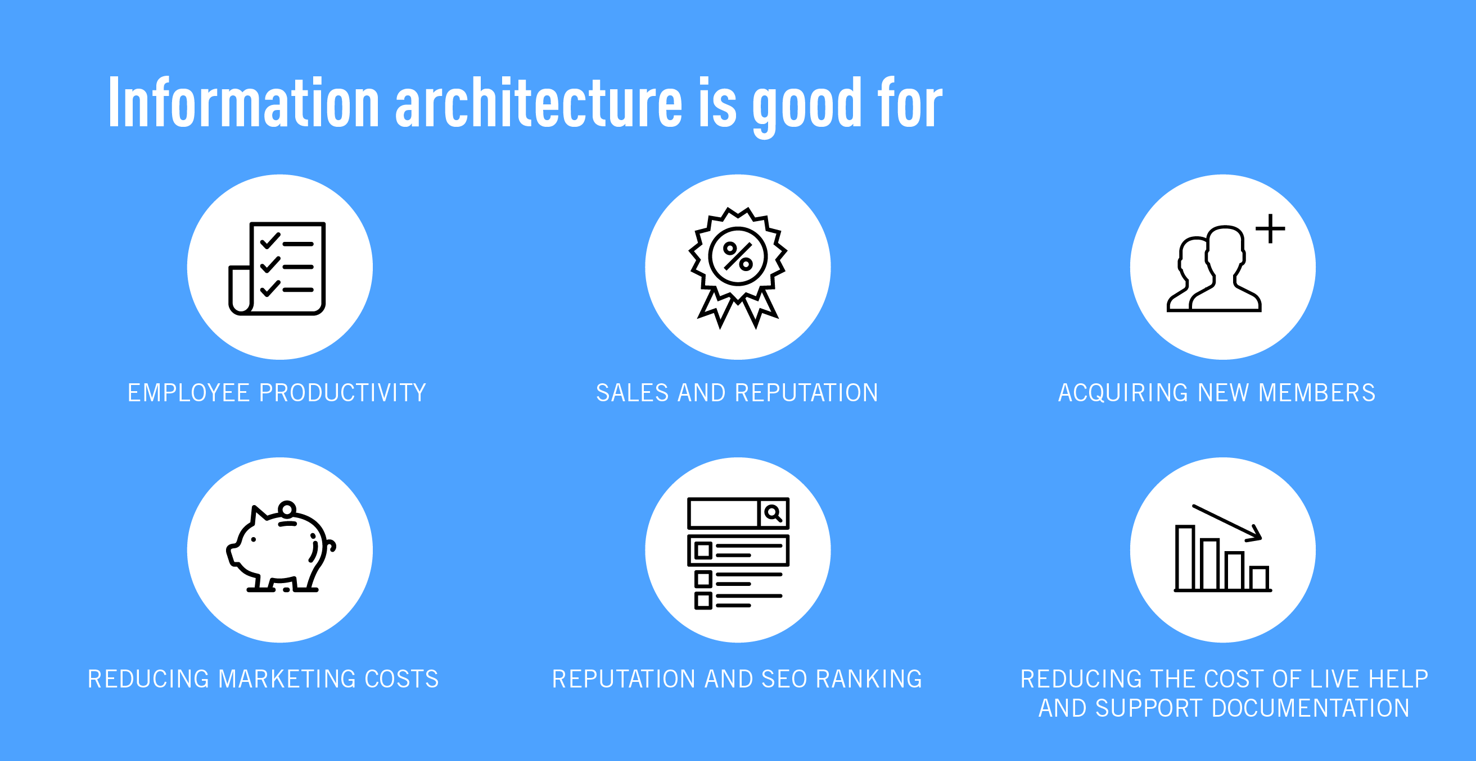

**Reducing marketing costs**

If users cannot find desirable information, product or services, marketing costs will skyrocket to achieve the same results. If you’re sending paid traffic to a page, it should be easy for people to navigate from that page to where they want to go. If people regularly leave the site before completing the desired action, you may even end up spending lots on remarketing – i.e. trying to win them back! Also, poor website structure can result in less organic traffic, due to a lower page rank in search results – see next!

**Reputation and SEO ranking**

IA has a big impact on the SEO. Organizing website’s data and content affects usability, conversions, and ranking. Ranking places the website higher in the search results, usability makes the website easy to use, and a seamless flow leads to a higher conversion rate. If you have repetitive content, or index huge amounts of poorly defined content, it could adversely affect your SEO.

**Reducing the cost of live help and support documentation**

When the information architecture makes it easy for users to find what they are searching for, the cost of live help will decrease significantly and so will the need of the written documentation.

So as you can see, the costs of poor IA can quickly add up. What processes does a business employ to ensure they don’t waste money or miss out on potential revenue?

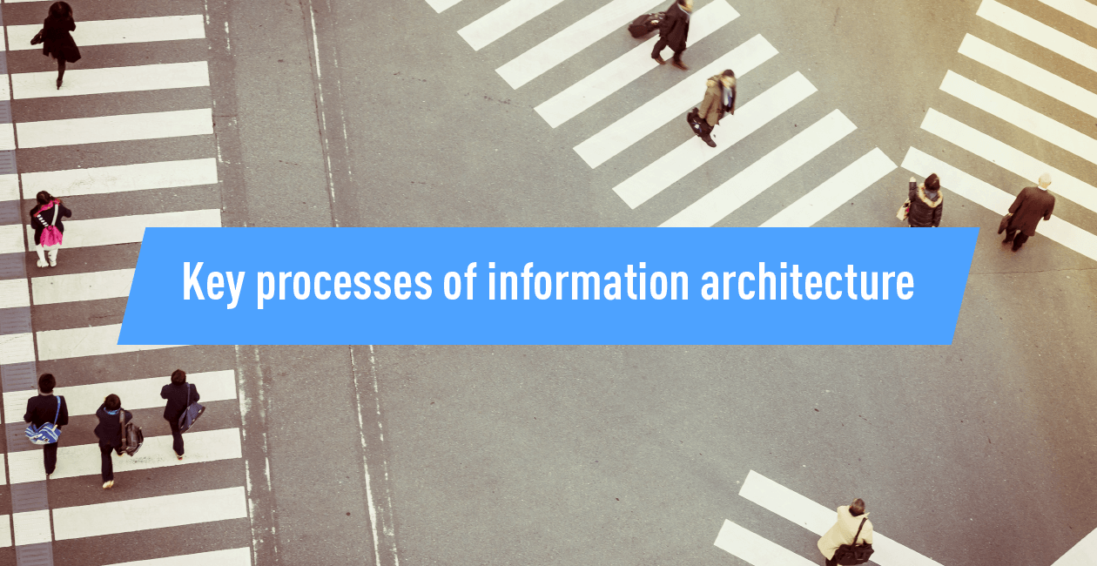

**4. What are the key processes for information architecture?**

Information architecture is to a website, library or shop, what the concrete foundations are to a house. **To create the best possible foundations, we need to create an IA document.**

Creating the document happens in a few stages that will be explained below. Companies should spend time on this, and see it as a worthwhile investment.

The process below is tailored to creating IA for a website, but you can easily take the process and adapt it to non-digital products.

So, first things first:

**1. Define the company goals**

In order to determine goals of creating IA you can ask yourself two questions: why do you want to do it, and what do you want to achieve with it? Work with all key stakeholders to determine that. You want them to feel involved and agree on the final version.

If you cannot clearly articulate the reason for doing the work, and the desired outcome, stop right now. Don’t go any further until this is clear. – Donna Spencer, Information Architect

Donna also explains that usually goals fall into three categories:

Making more money

Reducing costs

Helping people make better decisions

Consider whether there are any constraints that affect the goals?

**2. Define the user’s goals**

Who are the people that will be using the website? Follow UX practices: conduct user interviews, create personas, create scenarios and answer the questions:

What are these users going to do on the website?

What are their goals?

[**Use a storytelling approach**](https://careerfoundry.com/en/blog/ux-design/ux-design-team-story/) so that stakeholders can easily visualize and understand what you are explaining. Together find best-case scenarios, and worst-case scenarios, and think of how to prevent the latter.

This is also a good moment to think about any constraints that users may have, for example, what technology are they using?

**3. Analyze competitors**

Sometimes inventing hot water all over again is very unnecessary and can actually hurt you. Go all out and make sure you know your competition.

Think about their information architecture.

Where do they display information?

Which information is common denominator?

Is the website easy to navigate?

What makes is good and what makes it bad?

**4. Define content**

If a website already has content, go through that first and decide what to keep and what to get rid of. If the website is new, start from scratch. You need to have a clear understanding of the content.

When your website already has content you can do one of the following:

**Full inventory**  
Write down everything that you have on the site. This might take a long time and perhaps even a team of people, but it’s the most useful. When you decide for this option include all pages, all downloadable content, and also any media or interactive content.

**Partial inventory**  
A partial inventory is still better than nothing. Focus on the important parts and higher levels.

**Content audit**  
This approach gives us the least information, but it’s quicker and simpler. We focus on determining how useful, accurate, and overall how effective the content is.



**5. How to design the information architecture of your site**

Whatever approach you choose to define your content, you will want to collect link names, page names, URLs, the type of the content, information about how current the page is, and who created it or who owns it. Adding comments can also be useful.

If your website is still in the making and you are just starting to think about content, start by building a connection with the content creators – content is the heart of the website it should be taken seriously at the very start of the project. Build your website around content, not the other way around.

In the process of creating strong foundations for your website, content creators are your best friends and you should treat them as such. Involve them in the process and help them understand what you are doing.

Guide them to create a high-level overview of the content first, the detail should come second.

**Step 1: Group and label the content**

Once you have a list of all content, prioritize it and group. Use card-sorting techniques to help you group the content.

Card sorting is a participatory design technique, which we use to determine how users group different items into different categories. They are given cards with printed terms, features, or concepts and are asked to sort them into groups.

In the end group names can be refined into a menu and sitemap.

**Step 2: Define navigation and create site map**

You have content, and you have groups that make sense. Now the big question – how will users get to this content?

Before you can create sitemap and navigation, your IA needs to be defined. The navigation is most of the times just the tip of the iceberg.

Information architecture isn’t really visible to the visitors, but it presents a backbone of the website, and can be visually presented in spreadsheets and different types of diagrams and is then called a sitemap.

To create a sitemap, you need to have content, which is grouped and labeled, and then presented in a diagram.

Once that is done, you can create navigation – collection of UI elements that are connected in a meaningful way. Those can be anything from global navigation – menu, to local navigation, breadcrumbs, filters, footer…

**Step 3: User testing**

Test early and test often.

There are a couple of ways how to test to see if the information architecture works. The Nielsen Norman Group suggest four different types of testing, depending on the design phase and goals:

**Test #1: Tree testing**

This test is used to determine if the key information can be found in the IA of the website. Participants navigate through the website only by using link names. Tree testing is a quantitative testing method.

Tree testing shows us if the names of the categories are understandable, if they convey the content correctly, if the content is categorized in a user-centered manner, if the titles are distinguishable from one another, and if the information is easy to find.

**Test #2: Closed card sorting**

The test is used to determine the strength of category names. It is both a quantitative and qualitative testing method.

It shows if the names of categories are accurately conveyed and if they accurately convey the content. It also shows us if the categorization is done in a user-centered manner, and if the titles are distinguishable from one another.

**Test #3: Click testing**

The test shows us how users use the available UI components. It is a quantitative testing method.

It shows us which navigation elements are used and which are overlooked or avoided.

**Test #4: Usability testing**

The test is used to determine how and why users use a website (or a product). It is one of the qualitative testing techniques.

It reveals how users find information, which ways do they use and which do they ignore or just plainly refuse to use and why.

If you cannot do all 4, make sure you at least do the usability testing in combination with an interview at the end. That will give you valuable insight into what features people are using and what they do on your website and why.

The answer to the question ‘why?’ is such valuable information that can help you design and get better results.

What is Content Architecture?

Wondering [how to improve content development](https://www.madcapsoftware.com/blog/how-to-improve-your-content-development-process/)? Content architecture is one of the steps how to create one. It is the process of designing a structure that can utilize content effectively, efficiently, and create outputs that satisfy the stated or implied user needs of the target audience. Similar to information architecture in web design, there are so many factors that can affect the content architecture. In this article, I will review some of these factors, and suggest a model which can pave the way for the information architect. It is important to note that the process of improving content architecture can be different from business to business.

Some organizations may use a one-time waterfall process while others might use an agile approach. To make it simple, a good content architecture should provide the best solutions for the missions and strategies of an organization. Contents go through various stages of development. Following is a content model to categorize these stages.

While the mission of content determines why content should be published and available at all, the [content strategy](https://www.madcapsoftware.com/blog/smart-companies-their-content-strategy-it-all-comes-down-to-roi/) determines how to accomplish missions. The bridge between content strategies and content management is the content architecture which identifies how specifically content should be created, designed, and published to achieve the goals of content marketing strategies.

In content architecture, the role of a content architect is critical to make the functional decisions that facilitate the content operational activities for effective content management. Content architecture provides a road map for developers who want to have a clear content workflow from production to publishing, also known as end-to-end production. Tools such as [content authoring software](https://xyleme.com/products/create/) play a pivotal role in this process, enabling the creation and management of structured, reusable content that aligns with the defined architecture. Content architecture is where you should think big, but you can start with small steps.

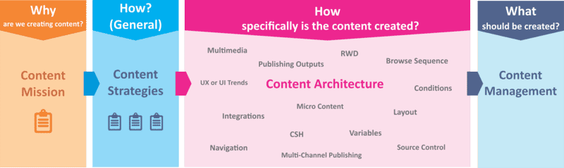

In content architecture, the role of a content architect is critical to make the functional decisions which facilitate the operational activities for effective content management. Content architecture provides a road map for content developers who want to have a clear workflow from production to publishing, also known as end-to-end production. Content architecture is where you should think big, but you can start with small steps.

Why is Content Architecture Important?

A content architect should see the big picture as much as possible. If an organization's content mission is modified and its strategy is revised accordingly, the architecture should be flexible enough to correspond with the changes in a way that minimizes the response time for providing the right content type for the audience, enhancing their overall digital experience.

Another reason that underlines the importance of an effective content architecture is that the demand for structured and meaningful content is on the rise. Companies want to provide just-in-time content that is well-organized, and the target audience needs the information which is faster to find and easier to understand.

If users cannot find the right information quickly and easily, they skip the content for other potentially more costly resources, ignore the service, or ask for a redesign of the content item. At the end of the day, the company should bear the cost of quality for reworking the content.

A good content architecture, supported by a robust [content delivery platform](https://xyleme.com/products/syndicate/), helps readers answer their own questions without contacting various departments of a company.

What Happens Without Content Architecture?

Without content architecture, it is a laborious task to develop content and escape the following consequences:

The final content might not satisfy the users, which can impose the cost of quality if redesigning the architecture is necessary. This happens when companies jump to content management without designing the architecture.

Unmanageable content is growing in size, scope, and complexity, and the big mess of data needs to be structured and organized separately for each output.

The content developers do not have a clear and specific plan to follow. It can feel like a mess too big to take it on[1](https://uxdesign.cc/the-beauty-of-content-architecture-e6e75e63892d?gi=2cad9a588556). The user won't enjoy meaningful user experience, and the content may not look as attractive as it should be, negatively impacting the overall web design.

Content is a strategic business asset. If the right information does not find the right person in the right way, the business is not successful to deliver the required service that the audience or the user needs.

Internal and External Benefits of Content Architecture

Content architecture brightens the mind and shows the path to content developers to design the workflow of operations in the content management stage. Consistency of content increases by predefined layouts, structure, etc. which is necessary, especially when a number of authors work in a group. A specified architecture brings less variability which speeds up decision-making processes for different types of content.

Excellent content architecture can bring more user engagement, increase customer satisfaction, and decrease the number of emails and contacts to an organization.

A content architect, technical writer, or project manager must successfully address the following critical decisions to reduce the cost of quality and response time, make the architecture flexible enough to support future changes, and maximize the internal and external benefits for an organization.

Critical Decisions of Content Architecture

The following checklist of critical decisions specifies almost all the important criteria that a content architect must consider before starting a project. However, a content architect may think deeper about or even ignore a decision from the checklist based on the size of the project.

The desired quality of outputs specifies how much time should be dedicated on each structured content item. Structuring great content takes time and requires investment in the content design process and purchasing necessary technologies.

Sometimes there is not a clear cut to put a critical decision into a specific stage, and a decision or question may be reviewed in other stages as well to align with content strategies and content management stages.

|  |  |  |  |
| --- | --- | --- | --- |
| Area of Decision | Decisions / Questions | Best Practices | Next Step |
| Strategy | What kind of content should be created? A single page file, a long document that will be published to multiple channels, or a video? | Choose the appropriate Technology (MadCap Flare, MS Word, Doc-To-Help, MadCap Mimic, etc.) | n/a |
| Strategy | Do we need feedback or comments from the readers? | MadCap Central for usage intelligence, and ways for readers to provide proactive comments and feedback | Integration with Flare projects |
| Strategy | Single or Multiple Authors | Team Design (Cross-training, Job Design, Job Rotation, etc.) | Refer to HR or Project manager |
| Content Architecture | What is the best [Source / Version Control Systems](https://www.madcapsoftware.com/products/flare/document-version-control/) and Backups system to store my projects? | Madcap Central, Github, Apache Subversion, Perforce, etc. | Test to find the best practice for your project |

|  |  |  |  |
| --- | --- | --- | --- |
| Area of Decision | Decisions / Questions | Best Practices | Next Step |
| Strategy and Content Architecture | Should I support multiple Languages? | MadCap Lingo, or liaise with [MadTranslations](https://www.madcapsoftware.com/services/translation/) | Integration with Flare projects |
| Strategy and Content Architecture | Should I publish content to other platforms? | Salesforce Knowledge, Zendesk Guide, other content management systems | Integration with Flare projects |
| Strategy and Content Architecture | What kind of outputs should be published? | Responsive HTML5, PDF, CHM, Word, etc. | Add necessary targets, design skins, page layouts, master pages, etc. to your Flare projects |
| Content Architecture | Concept-based, Hierarchy-based, or combine architecture? (taxonomy) | Design topic templates or information types, TOCs and publishing targets | n/a |
| Strategy and Content Architecture | Who is your target audience? What is the level of your audience's sophistication? | Grammar, voice, tone, lay, and readability scores | Identify the least / lowest common denominator, use text analysis in MadCap Flare |

|  |  |  |  |
| --- | --- | --- | --- |
| Area of Decision | Decisions / Questions | Best Practices | Next Step |
| Strategy and Content Architecture | What techniques and features can save time for content developers? | Micro content, auto suggestions for variables snippets, shortcut modifications, scheduling build and publish | Review Flare's [online Help](https://help.madcapsoftware.com/flare2019r2/Content/Flare/Introduction/Home.htm) |
| Content Architecture | What project structure should I use? | Single or multiple projects? | Review Flare’s [project structure guide](https://help.madcapsoftware.com/flare2019r2/Content/Flare/Architecture/External-Architecture/Flare-Project-Structures.htm) |
| Content Architecture | What contents are reusable? | Single-sourcing (topics, snippets, variables, micro content, etc.) | Use Flare’s internal Analyzer for reuse suggestions |
| Content Architecture | Do we need responsive outputs (RWD)? | Ready-to-use templates and layouts or start from scratch, media queries, responsive conditions, etc. | n/a |
| Content Architecture | Do we need to link the outputs to a software application? (Context-sensitive help) | CSH Alias Files | Add IDs and link topics |

|  |  |  |  |
| --- | --- | --- | --- |
| Area of Decision | Decisions / Questions | Best Practices | Next Step |
| Content Architecture | Do you need different outputs that all stem from the same set of source files? | TOCs, Conditions, Snippet Conditions, Variables | n/a |
| Content Architecture | How can we help users find information easier? | Elasticsearch, MadCapSearch, Micro Content, Glossary, Index, FAQ, etc. | MadCap Central for output analytics |
| Content Architecture | Navigation Strategies | Top / Side Navigation, relationship tables, browse sequence, mini-TOCs, cross-references, breadcrumbs, etc. | Review Flare's [online Help](https://help.madcapsoftware.com/) |
| Content Architecture | What UX or UI is suitable for the reader? | [Flare's](https://www.madcapsoftware.com/downloads/madcap-flare-project-templates/) free project [templates](https://www.madcapsoftware.com/downloads/madcap-flare-project-templates/)  [Madcap](https://www.madcapsoftware.com/customers/customer-showcase/) [Customer](https://www.madcapsoftware.com/customers/customer-showcase/) [Showcase](https://www.madcapsoftware.com/customers/customer-showcase/) for ideas | 1. Preview and download project templates. 2. Decide on any changes for layout, fonts, themes, styles, etc. |

|  |  |  |  |
| --- | --- | --- | --- |
| Area of Decision | Decisions / Questions | Best Practices | Next Step |
| Content Architecture | Do we need search engine optimization? | Metadata and SEO techniques | n/a |
| Content Architecture | How should I analyze and report the issues in my project? | MadCap Flare’s internal Analyzer | Review Flare's [online Help](https://help.madcapsoftware.com/) |
| Content Architecture | How should I name the files and folders? (nomenclature) | Various methods can be used | Be consistent with your method. Review Flare’s [project architecture guide](https://help.madcapsoftware.com/flare2019r2/Content/Flare/Architecture/Internal-Architecture/Naming-Conventions.htm) |
| Content Architecture | Do we have existing content files to import? | It depends on your legacy content and what you want to repurpose | Review Flare's [online Help](https://help.madcapsoftware.com/) |

**Fundamentals of Software Architecture**

Last Updated : 13 May, 2025

In today's world, people of all ages, from children to adults, use smartphones, laptops, computers, and PDAs to solve both simple and complex tasks online using various software programs. To the user, everything may seem simple and easy to use. And that’s the point of good software to provide high-quality services in a **user-friendly** environment.

There the overall abstraction of any **software product** makes it looks like simple and very easier for user to use. But in back if we will see building a complex software application includes complex processes which comprises of a number of elements of which coding being just one part of the puzzle. After gathering of business requirement by a business analyst then developer team begins working on the Software Requirement Specification (SRS).

This is followed by steps like testing, acceptance, deployment, maintenance etc. Every software development process is carried out by following some sequential steps which comes under Software Development Life Cycle (SDLC). In the design phase of Software Development Life Cycle the software architecture is defined and documented. This article delves into the importance of software architecture within the SDLC.

**What is Software Architecture?**

Software Architecture defines **fundamental organization** of a system and more simply defines a structured solution. It determines how the various components of a software system are assembled, how they relate to one another, and how they communicate. Essentially, it serves as a **blueprint**for the application and a foundation for the **development team** to build upon.

**Software architecture** defines a list of things which results in making many things easier in the software development process.

**System structure**: The organization and arrangement of components.

**System behavior**: The expected functionality and performance.

**Component relationships**: How different parts of the system interact.

**Communication structure**: The way components communicate with each other.

**Stakeholder balance**: Meeting the needs and expectations of all stakeholders.

**Team structure**: How the development team is organized and coordinated.

**Early design decisions**: Making important choices early on to guide development.

**Key Characteristics of Software Architecture**

Software architecture is a multifaceted concept, and architects often categorize its characteristics based on various factors such as operation, requirements, and structure. Here are some important characteristics to consider:

**Operational Architecture Characteristics**

**Availability**: The system should be accessible when needed.

**Performance**: The system should meet performance goals such as speed and responsiveness.

**Reliability**: The system should work consistently without failure.

**Fault tolerance**: The system should gracefully handle errors and failures.

**Scalability**: The system should be able to handle increasing loads without performance degradation.

**Structural Architecture Characteristics**

**Configurability**: The ability to configure the system according to needs.

**Extensibility**: The system should be easily extendable to add new features.

**Supportability**: The ease with which the system can be maintained and supported.

**Portability**: The system should work across different environments.

**Maintainability**: The system should be easy to update and fix over time.

**Cross-Cutting Architecture Characteristics**

**Accessibility**: Ensuring the system is usable by a wide range of people, including those with disabilities.

**Security**: Protecting the system from unauthorized access and data breaches.

**Usability**: Ensuring the system is easy to use and intuitive for users.

**Privacy**: Protecting users’ sensitive information.

**Feasibility**: The system should be realistic to develop within the constraints.

**SOLID principles of Software Architecture**

Each character of the word **SOLID**defines one principle of software architecture. The **SOLID** principles are key guidelines for creating well-structured, maintainable software architectures This SOLID principle is followed to avoid product strategy mistakes. A software architecture must adhere to SOLID principle to avoid any **architectural**or **developmental failure**.

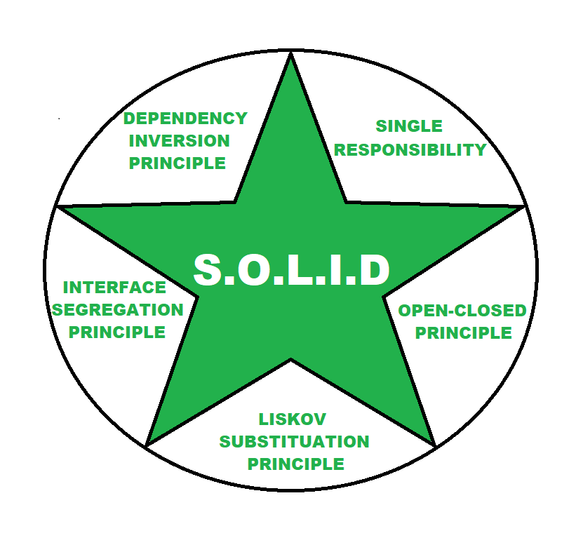S.O.L.I.D PRINCIPLE

**Single Responsibility -** Each services or module should have only one responsibility or purpose .

**Open-Closed Principle -** Software modules should be independent and expandable.

**Liskov Substitution Principle -** Objects or services should be interchangeable without altering the correctness of the system.

**Interface Segregation Principle -** Software should be divided into such microservices there should not be any redundancies.

**Dependency Inversion Principle -** Higher-levels modules should not be depending on low-lower-level modules and changes in higher level will not affect to lower level.

**Why is Software Architecture Important?**

**Software architecture** comes under **design phase** of software development life cycle. It serves as one of the first steps in the software development process. Without software architecture proceeding to software development is like building a house without designing architecture of house. So software architecture is one of important part of software application development. In **technical**and **developmental**aspects point of view below are reasons software architecture are important.

**Optimizes quality attributes**: Architects select quality attributes to focus on, such as performance and scalability.

**Facilitates early prototyping**: Architecture allows for early prototypes to be built, offering insight into system behavior.

**Component-based development**: Systems are often built using components, which makes them easier to develop, test, and maintain.

**Adapts to changes**: Architecture helps manage and integrate changes smoothly throughout the development process.

Besides all these **software architecture** is also important for many other factors like quality of software, reliability of software, maintainability of software, Supportability of software and performance of software and so on.

**Advantages of Software Architecture**

Good software architecture provides several advantages:

**Solid foundation**: It lays the groundwork for a successful project, guiding development.

**Improved performance**: A well-designed architecture can improve system efficiency.

**Reduced costs**: Efficient development practices reduce costs over time.

**Scalability and flexibility**: The system can adapt to future changes or demands.

**Disadvantages of Software Architecture**

While software architecture is essential, it does come with some challenges:

**Tooling and standardization**: Obtaining the right tools and maintaining consistent standards can sometimes be a challenge.

**Uncertain predictions**: It's not always possible to predict the success of a project based solely on its architecture.

**Conclusion**

In conclusion, **software architecture is fundamental to the successful development of any software application.** It ensures that the system is scalable, maintainable, and adaptable to future changes. A good software architecture provides a blueprint that guides developers throughout the software development life cycle, helping to deliver high-quality, reliable, and efficient software products.

**Usability Principles**

Main content start

**What is it?**

12 industry-standard usability principles are used to formally evaluate the usability of systems, applications, and interfaces. These principles are informed by several industry usability guidelines, including:

[**The Eight Golden Rules of Interface Design, Ben Shneiderman**](https://www.cs.umd.edu/users/ben/goldenrules.html)

[**First Principles of Interaction Design, Bruce Tognazzini**](https://asktog.com/atc/principles-of-interaction-design/)

[**10 Usability Heuristics for User Interface Design, Jakob Nielsen**](https://www.nngroup.com/articles/ten-usability-heuristics/)

Weinschenk & Barker's Classification, Susan Weinschenk and Dean Barker

**Why does it matter?**

Consistent principles allow us to better align to improved standards for user experience.

**When would you use these?**

The usability principles are useful during the design phase and during the evaluation of designs or production interfaces. By adhering to these principles, you will ensure that your experience will meet usability standards. Having an expert user experience designer conduct a usability review of your interface, you can identify usability issues before rolling it out to users or to add to your enhancements backlog.

**What is included?**

Below are the usability principles we use to evaluate systems, applications, and interfaces.

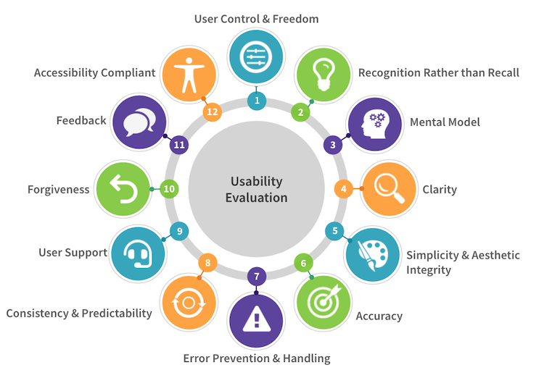

| **#** | **Principle** | **Description** | **Examples** |
| --- | --- | --- | --- |
| 1 | **User Control and Freedom** | The interface will allow the user to perceive that they are in control and will allow appropriate control. Users should understand where they are on a website or stepped process at all times. | Let the user choose when to advance to the next page, instead of automatically redirecting them.  Ensure users can complete tasks efficiently without relying on workarounds or repetitive processes.  Dashboards let you customize what you see.  Options for user to choose settings between list view and grid view of items.  Showing "recently viewed" items to the user.  "Quick links" menu to frequent actions. |
| 2 | **Recognition vs. Recall** | Reduce short-term memory load by assisting user and providing needed information through the interface. | If asking a user for their account number, provide it for them if possible.  If a user is filling out a multi-page form, show the information they have already submitted when asking for confirmation.  Chrome autofill will fill out a form based on a user's contact information that it knows. |
| 3 | **Mental Model** | The system should match the mental models that the user holds of the real world. The design should speak the users' language. | If a person was looking for rooms in multiple buildings, show the rooms grouped by building, not in an alphabetical list. |
| 4 | **Clarity** | The interface will communicate as clearly and efficiently as possible. | Text, links, labels, and menu items should be clear and concise to avoid confusing users  Navigation menus, text, and images combined should make it clear what a website or web page is about.  Icons, images, and highlights should be self-explanatory.  The difference between similar elements should be clearly described so that users can easily compare and choose between elements |
| 5 | **Simplicity & Aesthetic Integrity** | The interface will present elements simply and have an attractive and appropriate design. | Instead of adding extra styles, graphics, words, and lots of functionality, reduce the complexity of the page and simplify it down to the essential information/elements.  Interface styles support the user focusing on the actions they are completing, not distracting them. |
| 6 | **Accuracy** | The interface will be free from errors. | Titles, labels, messages, content do not contain typos or erroneous/misleading information  Calculations done in the background are accurate |
| 7 | **Error Handling & Prevention** | The system will prevent errors as much as possible and provide simple error handling in meaningful terms. | Assume people will make mistakes. Anticipate what they will be and try to prevent them.  Validation of form fields to prevent user error.  Helpful instructions in the context of the interface to assist the user.  Plain language in the user's terms to explain errors. |
| 8 | **Consistency & Predictability** | Consistency is key! Strive for consistency across the interface and system. | The interface uses the same names for menu items as their corresponding page titles.  The logo is always in the top left, and the search is always in the top right and does not change on different pages of the interface.  Instead of having a button that says "Go!" provide a "Submit form" button with text telling the user what will happen next.  The action button on the multi-step form could say "Complete order and proceed to shipping details" |
| 9 | **User Support** | The interface will provide additional assistance as needed or requested. | Contextual help is provided through information links to explain form fields and why they are needed.  A permanent link to customer support in the interface.  Live help within a website/application |
| 10 | **Forgiveness** | Users often perform actions by mistake. They need a clearly marked "emergency exit" to leave the unwanted action without having to go through an extended process and to easily reverse an action. | If the user submits the form, let the user edit the form.  Provide an "undo" and “redo” button when editing.  Revision history |
| 11 | **Feedback** | The interface should always keep users informed about what is going on, through appropriate feedback within a reasonable time. | Confirmation message upon action completed, confirming to the user that it was a success.  If a user has not filled out a required field, highlight the field in red and have text saying "This field is required." |
| 12 | **Accessibility Compliant** | The interface is designed so that people with disabilities can use them and meets AA WCAG level 2 accessibility compliance. | All links should have accessible active/focus/hover states.  All interfaces should be navigable by tabbing (keyboard only).  All images have alt-text labels |

**Information architecture** is the structural design of shared [information](https://en.wikipedia.org/wiki/Information) environments, in particular the organisation of [websites](https://en.wikipedia.org/wiki/Website) and [software](https://en.wikipedia.org/wiki/Software) to support [usability](https://en.wikipedia.org/wiki/Usability) and findability.

The term information architecture was coined by [Richard Saul Wurman](https://en.wikipedia.org/wiki/Richard_Saul_Wurman).[[*citation needed*](https://en.wikipedia.org/wiki/Wikipedia:Citation_needed)] Since its inception, information architecture has become an emerging [community of practice](https://en.wikipedia.org/wiki/Community_of_practice) focused on applying principles of [design](https://en.wikipedia.org/wiki/Design), [architecture](https://en.wikipedia.org/wiki/Architecture) and [information science](https://en.wikipedia.org/wiki/Information_science) in digital spaces.[[1]](https://en.wikipedia.org/wiki/Information_architecture#cite_note-What-1)

Typically, a [model](https://en.wikipedia.org/wiki/Scientific_modelling) or [concept](https://en.wikipedia.org/wiki/Concept) of [information](https://en.wikipedia.org/wiki/Information) is used and applied to activities which require explicit details of complex [information systems](https://en.wikipedia.org/wiki/Information_system). These activities include [library](https://en.wikipedia.org/wiki/Library) systems and [database](https://en.wikipedia.org/wiki/Database) development.[[*citation needed*](https://en.wikipedia.org/wiki/Wikipedia:Citation_needed)]

**Definition**

The term *information architecture* has different meanings in different branches of [information systems](https://en.wikipedia.org/wiki/Information_system) or [information technology](https://en.wikipedia.org/wiki/Information_technology).[[2]](https://en.wikipedia.org/wiki/Information_architecture#cite_note-:0-2)

**User experience**

In [user experience design](https://en.wikipedia.org/wiki/User_experience_design), information architecture has been described as the structural design of shared information environments,[[3]](https://en.wikipedia.org/wiki/Information_architecture#cite_note-FOOTNOTEMorvilleRosenfeld2007-3): 4 comprising the study and practice of organising and labelling web sites, intranets, online communities, and software to support [user experience](https://en.wikipedia.org/wiki/User_experience), in particular, the [findability](https://en.wikipedia.org/wiki/Findability) and [usability](https://en.wikipedia.org/wiki/Usability) of information.[[1]](https://en.wikipedia.org/wiki/Information_architecture#cite_note-What-1)[[4]](https://en.wikipedia.org/wiki/Information_architecture#cite_note-4)[[5]](https://en.wikipedia.org/wiki/Information_architecture#cite_note-5) It has also been described as an emerging [community of practice](https://en.wikipedia.org/wiki/Community_of_practice) focused on bringing principles of design and architecture to the digital landscape.[[3]](https://en.wikipedia.org/wiki/Information_architecture#cite_note-FOOTNOTEMorvilleRosenfeld2007-3): 4[[6]](https://en.wikipedia.org/wiki/Information_architecture#cite_note-6)

**Information systems**

Technically speaking, information architecture comprises the combination of organization, labeling, search and navigation systems within websites and intranets,[[3]](https://en.wikipedia.org/wiki/Information_architecture#cite_note-FOOTNOTEMorvilleRosenfeld2007-3): 4 serving as a navigational aid to the content of information-rich systems.[[7]](https://en.wikipedia.org/wiki/Information_architecture#cite_note-7)

**Data architecture**

Information architecture can be described as a subset of [data architecture](https://en.wikipedia.org/wiki/Data_architecture) where usable data is constructed, designed, and arranged in a fashion most useful to the users of data.[[*citation needed*](https://en.wikipedia.org/wiki/Wikipedia:Citation_needed)]

**Systems design**

In the field of [systems design](https://en.wikipedia.org/wiki/Systems_design), for example, information architecture is a component of [enterprise architecture](https://en.wikipedia.org/wiki/Enterprise_architecture) that deals with the information component when describing the structure of an enterprise.[[2]](https://en.wikipedia.org/wiki/Information_architecture#cite_note-:0-2) Some system design practitioners regard information architecture as strictly the application of [information science](https://en.wikipedia.org/wiki/Information_science) to [web design](https://en.wikipedia.org/wiki/Web_design), which considers such issues as [classification](https://en.wikipedia.org/wiki/Classification) and [information retrieval](https://en.wikipedia.org/wiki/Information_retrieval), and not factors like [user experience](https://en.wikipedia.org/wiki/User_experience) and [information design](https://en.wikipedia.org/wiki/Information_design).[[2]](https://en.wikipedia.org/wiki/Information_architecture#cite_note-:0-2)

**What Are Mental Models?**

A **mental model** is what the user believes about the system (web, application, or other kind of product) at hand. Mental models help the user predict how a system will work and, therefore, influence how they interact with an interface.

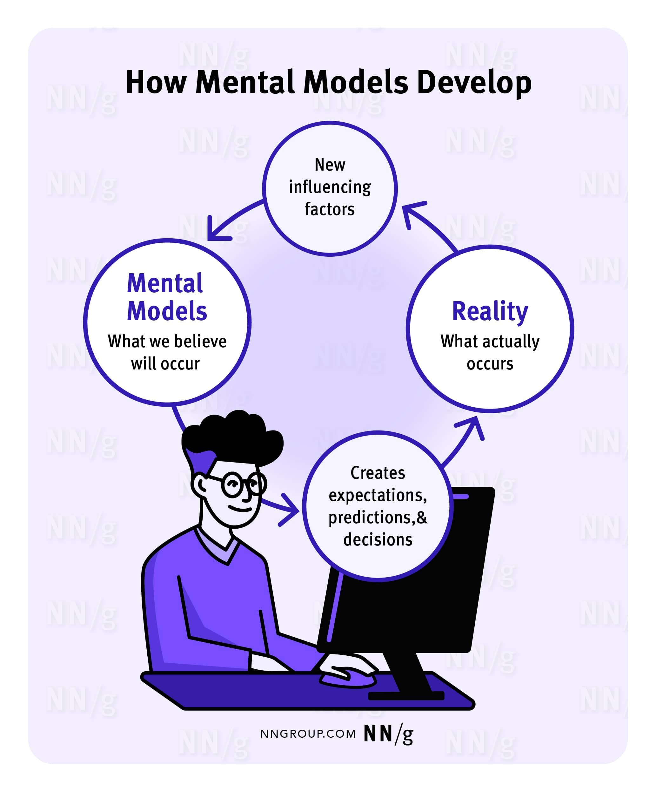*This diagram illustrates the ongoing development of users’ mental models, highlighting how users’ experiences shape future expectations, predictions, and decisions.*

**A Mental Model Is Based on Belief, Not Facts**

A mental model is a model of what users know (or think they know) about a system such as your website.Users form their predictions about the system based on their mental models and plan their future actions accordingly. A prime goal for designers is to ensure that the user interface clearly communicates the nature of the system so that users form accurate (and thus useful) mental models.

How do users create mental models? Often, they just use the knowledge they have about the world to create them. Remember[Jakob's law of the internet user experience](https://www.nngroup.com/videos/jakobs-law-internet-ux/): Users spend most of their time on websites other than yours. Thus, a big part of customers' mental models of your site will be influenced by information gleaned from other sites. People [expect websites to act alike](https://www.nngroup.com/articles/the-need-for-web-design-standards/).

**Each User Has Their Own Mental Model**

A mental model is based on each user’s individual background knowledge and past experiences, so different users might construct different mental models of the same system. One of the biggest dilemmas in usability is the gap between designers' and users' mental models. Designers form wonderfully detailed mental models of their own creations, leading them to believe that each feature is easy to understand. On the other hand, most users’ mental models of the system are usually less developed; as a result, they are more likely to make mistakes and find the design harder to use.

Mental**models can change over time**— due to additional experience with your system or with other systems.

**Mental Models in Web UX**

As users navigate the web, they construct mental models based on the patterns they encounter. This section discusses a few mental models common in web design. These mental models serve as the foundation for design [standards](https://www.nngroup.com/articles/consistency-and-standards/), enabling designers to create interfaces that align with users’ expectations.

**Online Shopping Carts**

When shopping online, users browse through products, add items to their shopping carts, and then check out. This experience is like shopping in a brick-and-mortar store, and people’s expectations are influenced by their experience with physical shopping.

Online shopping experiences that depart from the physical shopping model create confusion. In real life, the shopper controls what goes into the shopping cart, so this expectation is carried to online shopping. When an ecommerce website violates this expectation, problems arise.

For example, Nomad Lane automatically adds shipping insurance to the total cost when users check out. Users must, first, notice this additional cost and second, actively opt out of shipping insurance. Automatic shipping insurance is not part of users’ shopping cart mental model, so this leads to frustration for anyone who accidentally pays for insurance. Adding unexpected items to a shopping cart is a deceptive pattern in UX design known as [sneaking or preselection](https://www.nngroup.com/articles/deceptive-patterns/).

*Shipping insurance is automatically included when an item is added to the shopping cart. If users do not want shipping insurance, they must notice the additional expense and actively opt-out. This design violates users’ mental models for online shopping.*

***Back* Button**

The *Back* button is a long-standing essential in browser navigation. Over time, users have built a strong mental model for it: namely, *Back*is supposed to lead back to the previous screen, essentially acting as an undo.

When mobile smartphones became popular, users found themselves presented with another use of the *Back*button in mobile apps. Unlike on the web, where *Back*was used to take users to the previous screen, in some mobile apps, *Back*took users up in the hierarchy of the site. For example, if, while the user was reading a news story A, they tapped on a link to another news story B, the *Back*button would take them to the list of all news articles instead of taking them back to the news story A.

This behavior violated users’ expectations. Over the years, designers have luckily understood that, and now it is rare to find that implementation for *Back* in mobile apps. Some remnants, however, are still in place. For example, in Android, if you happen to be on the homepage of any app, doing the *Back*gesture (or tapping the *Back*button) will take you “up” — that is, outside of the app, regardless of whether you arrived to the homepage from another page inside the app or you just tapped on the app icon.

[Using the *Back* button with an open overlay](https://www.nngroup.com/articles/accidental-overlay-dismissal/) can also lead to confusion. When a user opens an overlay, it feels like they are opening a new page entirely, especially when the overlay takes up the whole screen. So, when the user clicks the *Back* button, they expect to exit the overlay. However, in many cases, the user is instead taken two steps back to the page they were on before visiting the page that triggered the overlay.

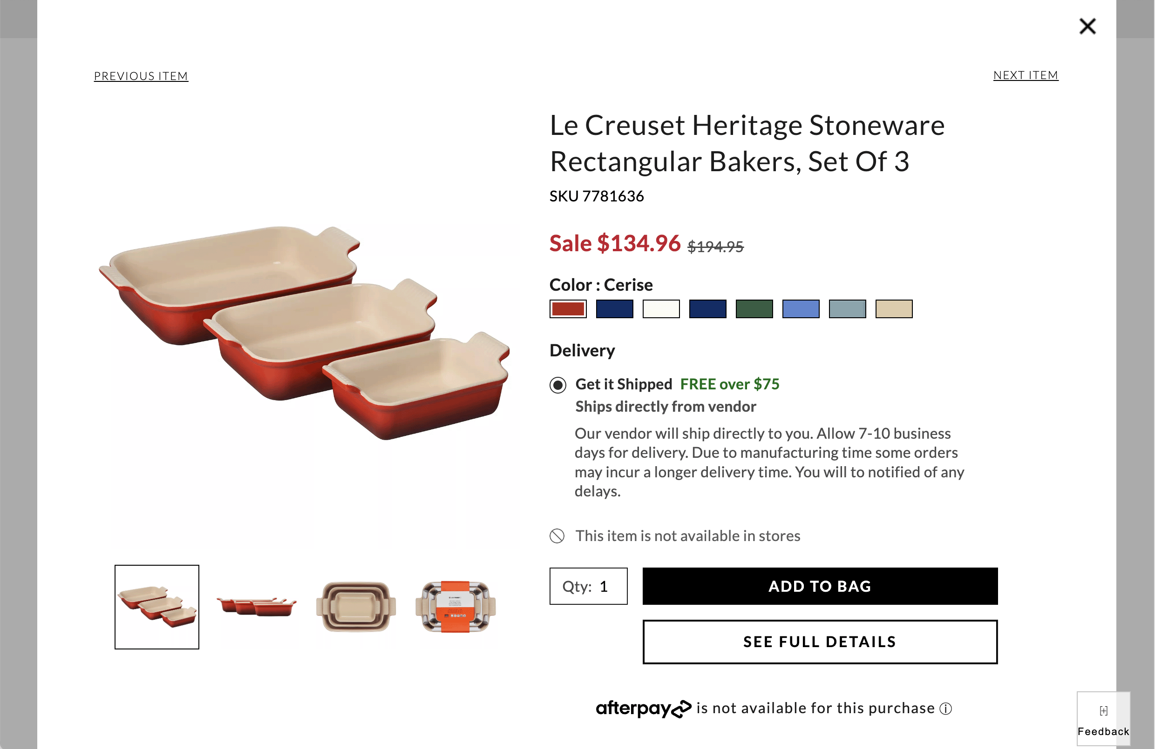*Users expect the browser*Back*button to exit the overlay; instead, it takes them two steps back to the page visited before landing on the page that triggered the overlay.*

**Search Bars**

Users expect to be able to input keywords and phrases into a search bar to find any information on a website. A single, well-placed search bar aligns with their expectations, offering a clear point for queries.

When a website has [several search features on the same page](https://www.nngroup.com/articles/employee-directory-search/), users often get confused. They’ll enter their query in the wrong box and assume that the site doesn’t have the answer if nothing comes back. (In reality, they might have used a specialized search that doesn’t cover everything.)

In the example below, the University of Michigan Library has two search boxes on the same page, each attached to its own database. The search box on the top right of the page is dedicated to logistical library information, while the search bar in the middle of the page is for academic research. The help text and [placeholder text](https://www.nngroup.com/articles/form-design-placeholders/) associated with each search bar allude to the purpose of each; however, users often perceive search bars as universal. The presence of multiple search bars introduces complexity and a potential for confusion.

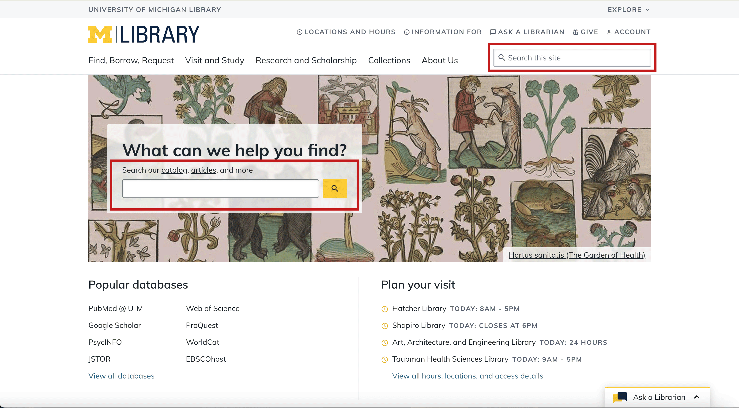*University of Michigan Library’s homepage includes two search bars – one for library logistics and the other for academic research. This type of design causes confusion, as users will often use the wrong search bar.*

**Mental-Model Inertia**

**There's great inertia in users' mental models**: stuff that people know well tends to stick, even when it's not helpful. This alone is an argument for [being conservative and not coming up with new interaction styles](https://www.nngroup.com/videos/consistency-vs-innovation/).  Sometimes, you do need to innovate, but it's best to do so only when the new approach is clearly superior to the old, well-known ways.

When you come up with a new design pattern, you face an immense challenge: How do you explain the new concept so users will construct a valid mental model of your system?

It's amazing how one misconception can thwart users throughout an entire session and cause them to systematically misinterpret everything that happens. Through failure after failure, they never question their basic assumptions. This is yet another argument for complying with preexisting user expectations whenever possible. If you don't, then make certain that you're clearly explaining what you're doing — while also realizing that you face the added challenge of users' [reluctance to read instructions and help messages](https://www.nngroup.com/articles/how-little-do-users-read/).

Designers are better off **leveraging this mental-model inertia instead of fighting it**. One example is skeuomorphism, a design trend that involves incorporating elements from the physical world into digital interfaces to guide users in acclimating to new interaction styles. Drawing on familiar, real-world mental models makes new, unfamiliar designs easier to understand.

In the realm of [children's apps](https://www.nngroup.com/articles/childrens-websites-usability-issues/), [skeuomorphism](https://www.nngroup.com/articles/skeuomorphism/) plays a particularly beneficial role. Since young users may not yet have well-established mental models for digital navigation, apps designed for kids often use physical-space metaphors, such as maps or doors, as seen in Duo ABC, an app that teaches children reading fundamentals. This approach mimics the tangible experiences that children encounter in physical spaces, like exploring a map or opening doors to discover new areas.

*Duo ABC uses skeuomorphism to guide young users who may not have mental models related to digital navigation. A door symbolizes the start of the user’s journey. A map walks users through completing lessons.*

**Acting on Mental Models**

Understanding the concept of mental models can help you make sense of usability problems in your design. If people make mistakes on your site, it is often because they've formed erroneous mental models. Even if you cannot change the UI at that point, you can still teach users a more accurate mental model earlier in the user experience. Or, you might have to acknowledge that users won't understand certain distinctions and then stop making those distinctions.

In case of a mental model mismatch, you basically have two different options:

**Make the system conform**to users' mental models — assuming most users’ models are similar. This is the approach we usually recommend to [fix IA problems](https://www.nngroup.com/articles/fixing-information-architecture/): if people look for something in the wrong place, then move it to the place where they look for it. [Card sorting](https://www.nngroup.com/articles/card-sorting-definition/) is a useful way to discover users' mental model of an information space so that you can design your navigation accordingly.

**Improve users' mental models** so that they more accurately reflect your system. You can, for example, explain things better and [make labels clearer](https://www.nngroup.com/videos/icon-text-labels/) to guide users to form the right model (even though the underlying system remains unchanged).

Mental models are a key concept in the development of instructions, documentation, [tutorials](https://www.nngroup.com/articles/onboarding-tutorials/), demos, and other [forms of user assistance](https://www.nngroup.com/articles/help-and-documentation/). All such information must be short while teaching the key concepts that people need to know to make sense of the overall system.

One of the main reasons we recommend the [think-aloud method of user testing](https://www.nngroup.com/articles/thinking-aloud-the-1-usability-tool/) is that it gives us insights into a user's mental model. When users verbalize what they think, believe, and predict while they use your design, you can piece together much of their mental models. There are more advanced [knowledge-elicitation methods](https://www.nngroup.com/articles/cognitive-mind-concept/) for gaining deeper insights into mental models, but for most design teams, a few quick think-aloud sessions will suffice. In any case, simple [user testing](https://www.nngroup.com/articles/usability-testing-101/) is certainly the first step to take if you suspect that erroneous mental models are costing you business.

**Conclusion**

Mental models are an essential concept in UX design and significantly influence the decisions users make while navigating an interface. Understanding users' mental models helps designers create interfaces that resonate with users’ expectations.

**What is the UI design process? 7 steps**

Just as Rome wasn’t built in a day, designing beautiful, functional user interfaces is a (sometimes lengthy) process. Let’s take a closer look at what you can expect at each stage.

**Step 1: User research**

You might want to start getting creative from the get-go, but the first step in the [UI design](https://www.uxdesigninstitute.com/blog/what-is-ui-design/)process is wrapping your head around the project. Who is it for? What’s the end goal? Answering these questions will help you build a solid foundation for the project.

To get there, jumping into [user research](https://www.uxdesigninstitute.com/blog/user-research-in-ux-design/) is critical. Surveys, competitor analysis, focus groups, and [user interviews](https://www.uxdesigninstitute.com/blog/user-interviews-for-ux-research/) will help you understand your users’ expectations and pain points, so you can design user interfaces that are both beautiful and relevant. During this stage, you’ll work closely with the UX designer to establish [user personas](https://www.uxdesigninstitute.com/blog/what-are-ux-personas/) that keep everyone on track.

**Read next:** [How do UX and UI designers work together?](https://www.uxdesigninstitute.com/blog/ux-and-ui-designers/)

**Step 2: Define objectives**

Based on the insights that came out of the user research, it’s time to translate them into clear design objectives and goals that will shape the foundation of your design strategy.

This involves identifying the key features, functionalities, and user tasks that the interface should support, keeping the target audience in mind as you start to think about what elements and content will be included in the digital product.

Establishing measurable goals will help guide your design decisions, as well as provide a reference point for how successful your design is upon launch.

**Step 3: Wireframing**

It’s time to start creating—and [wireframing](https://www.uxdesigninstitute.com/blog/what-is-wireframing/) is an indispensable step. Wireframing involves generating low-fidelity outlines of the layout and structure of the interface. They serve as a blueprint for the design, helping you get clear on the placement of elements, information hierarchy, and overall flow before diving into the visual design.

Wireframes also help you validate your design with all key stakeholders, allowing everyone to have their say about what goes where before anything gets finalised. Wireframing is highly collaborative—you might find yourself tearing the design down and starting from scratch, but this is the stage to do it.

**Step 4: Visual design**

Once the wireframes are in place, it’s time to move on to the exciting visual design phase! Prior to this point, you might have created a [mood board](https://www.uxdesigninstitute.com/blog/mood-boards-for-ui-designers/) complete with colours, typography and animations reflecting the users’ needs and design goals.

Now’s the time to develop a clear visual strategy, which involves deciding on an appropriate colour scheme, choosing fonts and typefaces, and designing a library of visual elements that align with the company’s branding. With the visual strategy agreed upon, you can start developing your wireframes from low-fidelity sketches to mid-fidelity designs, adding branding and personality to bring them to life.

This is a highly iterative stage that’ll see you continuously share your designs with stakeholders and refine them as you go. After a few rounds of feedback, you should end up with beautiful, static mockups that closely resemble the finished product.

**Step 5: Prototyping**

Once you’ve designed a user interface, it’s time to take your designs from static files to interactive prototypes. Not only does [prototyping](https://www.uxdesigninstitute.com/blog/prototyping-guide/)showcase your design’s functionality and flow to stakeholders, but it also lets you see (and test) your designs in action. There are several [great prototyping tools](https://www.uxdesigninstitute.com/blog/best-prototyping-tools-for-ux-designers/) to choose from, ranging from simple click-through mockups to advanced interactive simulations, which allow you to navigate the digital product in users’ shoes and refine the design ahead of the product development stage.

[[GET CERTIFIED IN CONTENT DESIGN]](https://www.uxdesigninstitute.com/courses/content-design?utm_source=blog&utm_medium=blog_panel_text&utm_campaign=blog_promo)

[Take our Professional Certificate in Content Design course](https://www.uxdesigninstitute.com/courses/content-design?utm_source=blog&utm_medium=blog_panel_text&utm_campaign=blog_promo)

**Step 6: Testing and iteration**

User testing plays a crucial role in the UI design process. Your design might look tip-top from where you’re standing—but it’s important to remember you’re not the end user! Testing your prototypes with real users will help you identify any usability issues or pain-points you might have missed along the way. It also helps you get a sense of how your visual design strategy is resonating with real users—and how it meets (or exceeds) their expectations. You might need to go through multiple rounds of user feedback and improvements to get to a design that both you and your users love.

We explore [the importance of UX testing in this comprehensive guide](https://www.uxdesigninstitute.com/blog/why-ux-testing-is-so-important/).

**Step 7: Development handoff**

Once the design is finalised, it’s handoff time. This stage will see you prepare detailed design specifications and assets for the developers so they can ensure the final product closely matches your design vision. Depending on the complexity of your design, you’ll also need to provide interaction guidelines that explain how interactions like hover effects, transitions, or animations should behave.

Some UI designers create style guides, which serve as comprehensive documentation of the visual and interaction design guidelines, branding elements, and UI components used in the design. Style guides help establish and maintain a consistent visual language across the digital product.

**What tools do UI designers use?**

UI designers rely on a variety of tools to bring their creative vision to life. Let’s take a closer look at some of the most popular UI design tools available.

**Wireframing tools**

[Balsamiq](http://balsamiq.com/): This user-friendly tool offers a range of pre-built UI components and a hand-drawn style to help designers quickly create low-fidelity wireframes.

[Sketch](http://sketch.com/): Although primarily known for visual design, Sketch also offers extensive wireframing capabilities, providing an intuitive interface, reusable symbols, and a wide range of plugins to enhance wireframing workflows.

[Adobe XD](https://helpx.adobe.com/uk/xd/get-started.html): Boasting an intuitive interface, Adobe XD offers robust wireframing features, including collaboration functionality for easy teamwork.

**Read next:**[The best UX wireframing tools of 2023](https://www.uxdesigninstitute.com/blog/best-ux-wireframe-tools/)

**Prototyping tools**

[Figma](http://figma.com/), a best-in-class design tool with comprehensive prototyping capabilities, including transitions, animations, and real-time collaboration features.

[InVision](http://invision.com/), a widely-used prototyping tool that provides an end-to-end design and collaboration platform, with features like interactive hotspots, animations, and easy feedback-gathering capabilities.

[Axure RP](https://www.googleadservices.com/pagead/aclk?sa=L&ai=DChcSEwj13rK4x6D_AhUatu0KHWfrCt0YABAAGgJkZw&ohost=www.google.com&cid=CAESbeD2oKmfOOx_W2OIBBsin3GftwdiMILWwf-iLL-JAP_jTTuuaTYvOSrsHeH-AfMu5_f9_hBP1piW5ip_XCA20PI1GzueKo8zIYENwDrlc7-Hu63kr9GIsR2A9Jb0ucbruWGyGE2sN99cmw4xpFI&sig=AOD64_0wFihjMF2KNW7RJGwQSUWopCqYZg&q&adurl&ved=2ahUKEwjlk6u4x6D_AhWPXcAKHbwoBGEQ0Qx6BAgJEAE), an interactive design tool for complex prototyping through advanced features like conditional logic, dynamic content, and variable-driven interactions.

**Visual design tools**

[Gravit Designer](https://cloud.gravit.io/signin), a web-based vector design tool for UI design. Gravit has an intuitive interface, robust vector editing tools, multi-page/artboard support, and reusable components to help you keep your designs consistent. It’s also completely free!

[Framer](https://www.framer.com/), a design and prototyping tool geared towards creating beautiful, pixel-perfect prototypes. It combines visual design tools with a powerful code editor, allowing designers to create custom animations, interactions, and responsive designs.

[Figma](http://figma.com/): We know we already mentioned Figma—but besides its prototyping capabilities, Figma is one of the world’s most popular visual design tools. It provides a robust set of vector editing tools, shared styles, and design libraries for collaborative visual design work.

**Collaboration and design handoff tools**

[Zeplin](http://zeplin.com/)streamlines the design handoff process by automatically generating style guides, providing design specs, and allowing developers to inspect and export design assets directly from the tool.

[Avocode](https://avocode.com/) simplifies the design-to-code handoff process by offering features like design version control, design inspection, and generating production-ready code snippets for developers.

[Abstract](http://abstract.com/) is a version control and collaboration platform specifically designed for designers, allowing them to manage design files and provide design reviews.

**User testing tools**

[UserTesting](http://usertesting.com/) allows designers to conduct remote usability tests by providing access to a large panel of users who’ll provide design feedback.

[Maze](http://maze.com/) is a user testing platform that enables designers to create and run usability tests, and easily synthesise feedback.

Check out our full list of the [best user interface (UI) design tools](https://www.uxdesigninstitute.com/blog/user-interface-ui-design-tools/).

**How to create an effective UI design process that works for you**

No two UI design processes look the same—and as a [UI designer](https://www.uxdesigninstitute.com/blog/what-does-a-ui-designer-do/), it’s important to tailor the UI design process to your specific needs so you can create a better final design. Let’s explore some of the ways you can make the UI design process work for you.

**Define your workflow**

Consider the specific stages and activities involved in your design project, and create a roadmap that outlines each of these steps—and how they interconnect. By establishing a clear workflow, you can better manage your time, prioritise tasks, and ensure a smooth progression from one stage to another.

**Choose the right tools**

While the saying “a worker is only as good as their tools” is a little controversial, the tools you choose can have a huge impact on how effective your UI design process is. It’s all about finding the right tools for your project and design style, with the features and functionalities that make your life easier. Don’t forget to explore integrations and collaboration features that help you work better with UX designers, developers, and other stakeholders.

**Collaborate the right way**

Speaking of collaboration, it really is the secret sauce of successful UI design processes. Aim to foster open lines of communication, and establish regular checkpoints to align on project goals. Involve UX designers in the early stages to ensure the UI design is user-focused. Work closely with developers to understand technical constraints to help you create realistic designs.

**Ask for feedback**

Working iteratively helps you stay on track and avoid wasted time or resources. To work iteratively, you need feedback from users, clients, team members, and other stakeholders at different stages of the UI design process. Embrace a culture of continuous improvement and use feedback to refine your designs, so the final product meets the needs and expectations of both the users and the business.

**Document and share design guidelines**

Documenting UI design principles, visual styles, colour palettes, typography guidelines, and interaction patterns is crucial for consistency and efficient collaboration. Share these guidelines with stakeholders to provide a clear reference for design decisions and foster a shared understanding. This keeps everyone on the same page, and helps you feel more in control of the UI design process overall.

**Tips and best practices for better UI design**

Maybe you’re new to the UI game, or a seasoned designer looking to keep your skill set updated. There’s always room for improvement. Here are five tips and best practices to make your UI designs even better.

**Maintain consistency**

While it might seem like an obvious (or even boring) checkbox exercise, consistency plays a crucial role in UI design. Consistency helps users develop mental models and reduce cognitive load, resulting in a more enjoyable user experience. Creating a cohesive visual language by using consistent colours, typography, and UI elements throughout the interface will also help establish brand recognition and add credibility to your digital product by making it look more professional.

**Design for accessibility**

Accessibility is a fundamental aspect of UI design and should never be an afterthought. Before you get carried away with the creative side of UI design, you need to first make sure that the interface is easy to navigate for users with varying abilities. Be sure to use colour combinations that meet contrast accessibility guidelines, provide alternative text for images, and design with keyboard navigation in mind.

**Include microinteractions**

Microinteractions are subtle, purposeful animations or visual responses that happen in response to user actions. They provide feedback, communicate system status, and enhance the overall user experience by bringing the interface to life. Incorporating meaningful microinteractions, like button hover effects or progress indicators, will no doubt take your designs to the next level. Learn more about the importance of microinteractions (and how to create your own) in [this guide](https://www.uxdesigninstitute.com/blog/microinteractions-in-ui-design/).

**Don’t forget the details**

Small details can have a big impact on the overall user experience—and adding unexpected design elements or animations that surprise and delight users. These could be anything from subtle transitions to playful loading animations. Paying attention to the details can create small moments of joy, leaving a lasting impression on users and helping your design stand out.

**Stay inspired**

UI design is an ever-evolving field, and staying updated with the latest design trends, emerging technologies, and best practices is vital to keeping your designs competitive. Start by joining [design communities](https://www.uxdesigninstitute.com/blog/ux-communities-that-are-ready-to-welcome-you/) or following design influencers on social media. Constantly learning about emerging UI design techniques will help you push the boundaries of your designs and create innovative user experiences.

**Read next:**[15 UX influencers you should be following in 2023](https://www.uxdesigninstitute.com/blog/top-ux-influencers-you-should-follow/)

**Final thoughts**

The UI design process can be long—but incredibly rewarding. Over these seven steps, you’ll take your ideas from conceptual conversations to functional, responsive websites that delight and engage users.

It’s also important to note that each project will require different strategies and approaches, so take your time researching to find the right tools that work for you. The more user interfaces you design, the more confident you’ll feel in your process!

User Interface Analysis & Design • UI analysis and design– Three golden rules Outline– UI models : user model, mental model, design model, implementation model– UI process : iterative steps - UI interface analysis and modeling, interface design, interface construction, interface validation • User interface analysis elements : – (1) User analysis– (1) User analysis– (2) Task analysis and modeling : Techniques – use case, task elaboration, object elaboration, workflow analysis(swimlane diagram), hierarchical representation. – (3) Analysis of display content– (4) Analysis of the work environment • UI design steps– User interface object and actions : target object, source object, application object, action UI Analysis and Design • Three golden rules for UI analysis and design :– Place the user in control.– Reduce the user’s memory load.– Make the interface consistent. • The overall process for analyzing and designing a user interface begins with the creation of different models of system function. • Four different models come into play when a user interface is to be • Four different models come into play when a user interface is to be analyzed and designed.– a user model, – design model, – mental model – implementation model UI Analysis and Design (Contd..) • The user model establishes the profile of end users of the system. Users can be categorized as: (1) Novices, (2) Knowledgeable, intermittent users, (3) Knowledgeable frequent users. • The user’s mental model (system perception) is the image of the system that end users carry in their heads. the system that end users carry in their heads. • The implementation model combines the computer based system coupled with all supporting information. • The design model should accommodate the information contained in the user model. • Most important principle of user interface design: “Know the user, know the tasks.” UI Analysis and Design • Analysis and design process : The analysis and design process for user interfaces is iterative and can be represented using a spiral model. • Four distinct framework activities : – (1) interface analysis and modeling, – (2) interface design, – (3) interface construction, – (4) interface validation.– (4) interface validation. UI analysis and Design (contd..) • Interface analysis focuses on the profile of the users who will interact with the system.– A more detailed task analysis is conducted. – Analysis of the user environment focuses on the physical work environment. Eg. Where will the interface be located physically? Will the user be sitting, standing, or performing other tasks unrelated to the interface? • Interface design defines a set of interface objects and actions (and their screen representations) to perform all defined tasks to meet every usability goal defined for the system. • Interface construction evaluates usage scenarios by creating prototype. As the • Interface construction evaluates usage scenarios by creating prototype. As the iterative design process continues, a user interface tool kit may be used to iterative design process continues, a user interface tool kit may be used to complete the construction of the interface. • Interface validation focuses on – User task correctness– task variations – Cover user requirement– Ease of use – Easy to learn – the users’ acceptance UI Analysis • User interface analysis elements include :– (1) User analysis– (2) Task analysis and modeling– (3) Analysis of display content– (4) Analysis of the work environment • 1. User analysis : The goal of the user analysis to understand the users and their use. Understanding the users and their use can be accomplished as follows: – User Interviews, sales input, marketing input, support input. – Question to better understand the user of a system. Eg. Are users trained professionals, – Question to better understand the user of a system. Eg. Are users trained professionals, technicians, clerical, or manufacturing workers? What level of formal education does the average user have? • 2. Task Analysis and Modeling : The goal of task analysis is to answer the following questions:– What work will the user perform in specific circumstances? Use case techniques is used.– What tasks and subtasks will be performed as the user does the work? Task elaboration is used. – What specific problem domain objects will the user manipulate as work is performed? Object elaboration. – What is the sequence of work tasks—the workflow? Workflow analysis– What is the hierarchy of tasks? Hierarchical representation is used. UI Analysis (Contd..) • (2) Task Analysis and Modeling : Techniques • Use case -When used as part of task analysis, the use case is developed to show how an end user performs some specific work-related task. From use case, it is possible to extract tasks, objects, and the overall flow of the interaction. • Task elaboration – Elaborate approach assist in understanding the human activities the user interface must accommodate. Can be done in two ways. First approach is to derive a set of tasks that will accommodate the user model, design model, and the system perspective. Second use stepwise elaboration to elaborate the major tasks into subtasks. elaboration to elaborate the major tasks into subtasks. • Object elaboration – From use case and other information extract the physical objects. These objects can be categorized into classes. Attributes of each class are defined, and provide a list of operations. As the design is elaborated, the details of each operation are defined. • Workflow analysis can be represented effectively with a UML UML swimlane swimlane diagram (a variation on the activity diagram). • Hierarchical representation- The hierarchy is derived by a stepwise elaboration of each task identified for the user. Swimlane diagram(activity diagram) UI Analysis (Contd..) • User interface analysis elements (Contd..) • (3) Analysis of display content : Display content can range from reports, graphical displays or specialized information. During this interface analysis step, the format is considered. analysis step, the format is considered. • (4) Analysis of the work environment : The user interface for a computer-based system, but in others, noise may be a factor, a keyboard or mouse may not be an option. The interface designer may consider these factors. UI Design • The definition of interface objects and the actions is an important step in interface design. Interface design, is an iterative process. • Target, source, and application objects are identified. • A source object (e.g., a report icon) is dragged and dropped onto a target object (e.g., a printer icon). The implication of this action is to create a hard-copy report. • An application object represents application-specific data that are not directly manipulated as part of screen interaction. not directly manipulated as part of screen interaction. • When all important objects and actions have been defined (for one design iteration), screen layout is performed. • Screen layout is an interactive process in which graphical design and placement of icons, definition of descriptive screen text, specification and titling for windows, and definition of major and minor menu items are conducted.

What is a customer journey map?

A customer journey map is a visual representation of every experience that a customer has with a brand, product or service. Ideally, a customer journey map captures the customer experience from the consumer perspective, visualizing the touchpoints, emotions and potential pain points they encounter during their relationship with a brand.

Businesses use customer journey maps to identify areas for improvement, optimize processes and create seamless customer-centric experiences. A customer journey map captures the entire customer experience through the stages of awareness, research, purchase and postpurchase. Other maps might focus on specific aspects of the customer-company interaction, such as the research phase or the customer journey toward purchasing a specific product.

Customer journey maps have become a critical tool in customer experience design and analysis. As customer interactions often span multiple departments—such as sales, marketing, product development and support—these visual representations foster collaboration across teams, providing a unified view of complex interactions. They also help organizations center the consumer in business decisions by emphasizing customer needs, motivations and experiences.

By creating detailed customer journey maps, brands gain valuable insights into how each customer touchpoint functions and, where there are pain points, how it can be improved.

Customer journey map vs. buyer journey map

While buyer journey maps and customer journey maps can include similar customer data points, they differ in scope. A buyer journey map visualizes the steps that a customer goes through specifically as they come to a purchasing decision. Customer journey maps, by contrast, address a broader range of the customer lifecycle including postpurchase interactions like brand advocacy.

The evolution of the customer journey map

As digital technologies have transformed customer experience, customer journey mapping has become more complex. Until the advent of digital commerce, a customer might complete only one or two steps before deciding on a purchase, browsing in a brick-and-mortar store or speaking with a sales professional. The idea of a single sales funnel, a methodical and linear progression from brand awareness to purchase, was the dominant way to map a customer journey.

Today, a customer journey map might include a vast number of touchpoints including websites, apps, chatbots, support centers and stores. Before deciding to purchase from a brand, most potential customers consult friends or extensively research online reviews, adding layers of complexity to their journey map. In the late 2000s, the business management consultancy McKinsey noted a change.

They argued that the consumer journey resembled a continuous cycle where active evaluation occurs simultaneously with postpurchase experiences. This ideally facilitates what McKinsey termed an ongoing "loyalty loop."1 Today, customer journey mapping resembles this loop and includes an array of customer actions and user experiences, some of which happen concurrently.

Benefits of customer journey mapping

Customer journey maps, whether they focus on a single set of interactions or visualize the entire brand-to-consumer relationship, can provide actionable insights about an organization’s sales funnel and customer support practices. In today’s always-on, omnichannel commercial landscape, such tools can be critical: A good customer experience can generate on average as much as three times in returns to shareholders.2 Some of the major benefits of a methodical, customer-focused map include:

Improving the customer experience

Increasing customer retention

Better alignment between teams

Iteration and enhanced product development

More effective marketing

Understanding customer psychology

Identifying touchpoints that matter

Increasing competitive advantage

Improving customer experience: A customer journey map helps brands discover where the customer experience might be optimized. Doing so reduces friction, enhances consumer satisfaction and increases brand loyalty.

Increasing customer retention: Identifying pain points in the postpurchase or support phase of the customer journey allows businesses to identify problems that might otherwise lead to customer churn, increasing customer retention.

Better alignment between teams: Visualizations of the customer journey can act as a unifying tool for various departments, providing a precise and clear collective understanding of the customer experience.

Iteration and enhanced product development: Insights from customer journeys can inform new product features and improvements, making them more aligned with customer needs.

More effective marketing: By better understanding the customer journey, businesses can create targeted campaigns that meet customers where they are, increasing engagement and conversion from marketing effforts.

Understanding customer psychology: A customer journey map provides deeper insight into how customers think, feel and behave throughout their journey with a brand. By mapping emotional responses at various stages, organizations can better understand consumer motivations, pain points and decision-making processes. These insights enable companies to create more empathetic and targeted experiences that resonate with customers.

Identifying touchpoints that matter: A customer journey map helps businesses identify which touchpoints have the most significant impact on customer decisions and satisfaction. This helps them to prioritize resources, eliminate unnecessary steps and optimize high-impact touchpoints to improve the overall customer experience.

Increasing competitive advantage: A well-run customer journey map has the potential to give businesses a strategic edge by facilitating superior customer experiences. An organization might use a customer journey map to identify where competitors fall short, create less generic customer journey experiences or design targeted communications specific to their ideal customer base.

Types of customer journey maps

There are various ways to design a customer journey map, depending on the particular demographic and user journey an organization wants to focus on. Common types of customer journey maps include:

Current state map

Future state map

Day-in-the-life map

Service blueprint

Current state map: This is the most common type of customer journey map, and portrays customer behavior as it presently exists. This can be helpful for diagnosing current challenges and identifying areas for improvement.

Future state map: A future state map projects the ideal customer journey based on the wanted customer experience. It can help for planning strategic changes and setting benchmarks for improvement.

Day-in-the-life map: This type of customer journey map focuses on the customer’s broader daily life, and how the product or service fits into it. The day-in-the-life map can be useful for understanding the broader context of customer expectations and challenges.

Service blueprint: Service blueprints are more detailed that standard customer journey maps, and include the behind-the-scenes workflows. They might outline internal processes, staff interactions and technical systems that support a customer’s journey. They’re most effectively used to identify the root causes of an inadequate customer journey.

Components of a customer journey map

A customer journey map is typically created through a combination of solicited and unsolicited data. Solicited data might include a net promotor score (NPS) created by collecting customer feedback, the results of customer satisfaction surveys, or other information offered by consumers. This is typically combined with various forms of unsolicited data, the information an organization captures through its day-to-day interactions with customers and leads. This might include metrics like purchase histories, churn rates, time spent on a webpage or transcripts from chats and calls.

Though customer journey maps differ based on their scope and intended use, the common components of a customer journey map include:

Stages of the customer journey (or buyer’s journey)

Customer personas

Customer expectations

Customer touchpoints

Customer actions

Emotions

Channels

Opportunities

Stages of the customer journey

Whether they’re occurring individually or in tandem, there are some distinct phases a customer goes through during their relationship with a brand, from initial awareness to postpurchase engagement. These different stages will typically be outlined in a customer experience map. Common stages might include:

Awareness: This is when a customer becomes aware of a need, a brand or a specific product. During this stage, a customer might have been initially introduced to a business through its marketing practices, or independently identified a need, such as the need for a new car.

Consideration: During this phase, a customer evaluates their options and conducts research. This might include reading reviews of a particular brand, speaking with friends or family, interacting with sales or customer service associates, or conducting a side-by-side comparison of individual products.

Decision: During this step, a customer decides to buy a specific product or service.

Onboarding: In this phase, the customer enters the postpurchase stage, engaging with the product or service they decided to buy. Through the onboarding process, the focus shifts to retaining customers. Brands might communicate with a customer in this phase by providing ongoing customer service or easy-to-access troubleshooting.

Loyalty: The post-onboarding phase transforms captured customers into stakeholders and advocates. It might involve metrics like usage and feedback, and measures the level of support and loyalty a consumer might have over the long term.

Customer personas

Customer personas are fictional, data-driven profiles representing different segments of a target audience. These personas are designed to capture the specific demographics, behaviors, goals and pain points for a group. These personas are often included in customer journey maps to identify and analyze the customer journey from the point of view of specific segments. This allows organizations to create more relevant customer journeys for specific audiences with individual needs.

Customer expectations

Customer expectations are the standards and assumptions customers have when interacting with a brand. These expectations generally vary across different stages of the customer journey. They are shaped by several factors including prior experience, industry norms and competitors’ offerings. A customer journey map might include these expectations to deliver touchpoint-specific experiences and help ensure the most pressing customer goals are being met.

Customer touchpoints

Touchpoints are the specific interactions between the customer and the business during each stage of the customer journey. They might include visiting a website, reading an online review, contacting customer service or receiving a product in the mail. A customer journey map outlines each of these specific touchpoints, identifying potential roadblocks or unsatisfying experiences.

Customer actions

These are the behaviors and decisions that a customer takes at each stage. For instance, at the consideration stage a customer might read a product review or compare features on different websites. At the purchase stage, they might buy other service agreements or opt for expedited shipping. These potential actions are typically outlined on a customer journey map.

Emotions

Mapping out the customer’s emotional experience helps businesses understand how customers feel, and thus are likely to act, at various stages in the customer journey. A customer journey map might take advantage of both solicited and unsolicited data to highlight moments of frustration, confusion or satisfaction to identify customer pain points and instances of customer success.

Channels

The platforms and mediums through which customer interactions take place are also outlined on a customer journey map. For most businesses, several channels are in play at a given moment. Channels outlined might include social media, web, phone and chat interactions with a brand’s team members, and visits to a physical store. They might also involve engagement with a mobile app or clicking on an email newsletter.

Opportunities

These are the insights derived from the map that outline silos, highlight missed connections and present opportunities for improvement. For example, if customers consistently express frustration at the checkout process, streamlining that stage can reduce cart abandonment. If customers feel it is difficult to find product information, an organization might opt to focus on simplifying that process.

Steps to creating a customer journey map

While customer journey maps differ depending on an organization's specific needs and business goals, common steps in the customer journey mapping process include:

Set clear objectives

Gather customer data

Create customer personas

Identify key stages

Determine touchpoints and channels

Highlight emotions and pain points

Validate the journey

Act on insights

Set clear objectives: Before creating a map, an organization typically establishes precisely what it hopes to achieve. Sales, marketing and product leaders might initially brainstorm which processes they would like to improve. Areas of focus might include optimizing the purchasing process, understanding why customers abandon a service or creating better onboarding processes to improve customer loyalty. During this phase, an organization might introduce specific KPIs it is hoping to improve.

Gather customer data: To build an accurate map, an organization typically collects data from multiple sources including customer feedback, surveys, interviews, chat transcripts, support logs and web analytics. This helps the brand to see the decision-making process from the customer’s point of view.

Create customer personas: Buyer personas are fictional, yet data-driven, representations of different customer types. They highlight customer demographics, motivations and behaviors to provide context for the customer journey. With advanced customer analytics and automation, customer personas have become more precise, allowing organizations to segment customers based on more granular behaviors and locations. Using these personas, a brand might choose to focus a customer journey map on a specific target audience it hopes to capture.

Identify key stages: During this step, an organization defines the critical stages in its customer journey. This might span from awareness to postpurchase, focus solely on the postpurchase follow-up stage, or include any journey specific to a product or feature.

Determine touchpoints and channels: During this phase, an organization identifies where and how customers interact with its brand. This might include advertisements, email campaigns, social media, customer support or a mobile app.

Highlight emotions and pain points: During this step, an organization analyzes customer data to understand the emotional highs and lows customers experience at each stage. For example, frustration during onboarding or satisfaction after resolving an issue can provide valuable insights.

Validate the journey: Once the map is created, an organization might validate it with real-life customers or through testing. This can help confirm that the customer experience map accurately represents the customer experience.

Act on insights: Once a map is validated, an organization can use it to drive improvements. At this stage, a brand might opt to enhance communication at critical touchpoints, shift resources to postpurchase experiences or invest in new technology to make the journey smoother.

Overcoming common challenges in customer journey mapping

Prioritizing clean data

To accurately map the customer journey, an organization typically needs a large swath of accurate data about its users’ purchases and sentiments. To properly represent real-life conditions, data must typically be clean, error-free and trustworthy. An organization might opt to use multiple data sources—including customer surveys, interviews, web analytics and social media interactions—to gain a more comprehensive view of the customer journey. By regularly auditing data sources and tools, brands can help ensure that customer journey maps are always accurate and up-to-date.

Avoiding oversimplification

Customer journeys in today’s real-time, omnichannel commercial landscape can be complex. If an organization simplifies the journey too much, a map might miss key pain points or emotional moments that are essential to improving the experience. To avoid such oversimplification, an organization might consider building multiple maps for individual personas or creating maps with multiple layers and datapoints.

Focusing on internal operations

A customer journey map is only as good as the business reforms that it can inspire. If an organization focuses solely on the customer journey without considering internal processes, it risks overlooking bottlenecks and inefficiencies that could be negatively impacting customer experiences. An organization might create a service blueprint to focus on internal processes or collaborate with internal teams to understand key dependencies and workflows.

Fostering a collaborative team environment

Without cross-departmental collaboration and a strong methodology, a customer journey map might miss key insights from different areas of the business. This might lead to a less accurate or useful representation of the customer experience. Setting shared KPIs, by using collaborative tools and fostering cross-departmental collaboration, can avoid fragmented mapping initiatives.

[*Personas*](https://www.interaction-design.org/literature/topics/personas)*are fictional characters, which you create based upon your research to represent the different user types that might use your service, product, site, or brand in a similar way. Creating personas will help you understand your users’ needs, experiences, behaviors and goals. Creating personas can help you step out of yourself. It can help you recognize that different people have different needs and expectations, and it can also help you identify with the user you’re designing for. Personas make the design task at hand less complex, they guide your*[*ideation*](https://www.interaction-design.org/literature/topics/ideation)*processes, and they can help you to achieve the goal of creating a good user experience for your target user group.*

As opposed to designing products, services, and solutions based upon the preferences of the design team, it has become standard practice within many [human-centered design](https://www.interaction-design.org/literature/topics/human-centered-design) disciplines to collate research and personify specific trends and patterns in the data as personas. Hence, personas do not describe real people, but you compose your personas based on actual data collected from multiple individuals. Personas add the human touch to what would largely remain cold facts in your research. Creating persona profiles of typical or atypical (extreme) users will help you understand patterns in your research, which synthesizes the types of people you seek to design for. Personas are also known as model characters or composite characters.

Personas provide meaningful archetypes which you can use to assess your design development against. Constructing personas will help you ask the right questions and answer those questions in line with the users you are designing for. For example, “How would Peter, Joe, and Jessica experience, react, and behave in relation to feature X or change Y within the given context?” and “What do Peter, Joe, and Jessica think, feel, do and say?” and “What are their underlying needs we are trying to fulfill?”

**Personas in Design Thinking**

In the [design thinking](https://www.interaction-design.org/literature/topics/design-thinking) process, designers will often start creating personas during the second phase, the Define phase. In the Define phase, Design Thinkers synthesize their research and findings from the very first phase, the [Empathise](https://www.interaction-design.org/literature/topics/empathize) phase. Using personas is just one method, among others, that can help designers move on to the third phase, the Ideation phase. The personas will be used as a guide for ideation sessions such as [Brainstorm](https://www.interaction-design.org/literature/topics/brainstorming), Worst Possible Idea and [SCAMPER](https://www.interaction-design.org/literature/topics/scamper).

**Four Different Types of Personas**

In her [Interaction Design](https://www.interaction-design.org/literature/topics/interaction-design) Foundation [encyclopedia article, Personas,](https://www.interaction-design.org/literature/book/the-encyclopedia-of-human-computer-interaction-2nd-ed/personas#heading_Four_different_perspectives_page_12414) Ph.D. and specialist in personas, Lene Nielsen, describes four perspectives that your personas can take to ensure that they add the most value to your design project and the fiction-based perspective. Let’s take a look at each of them:

**1. Goal-directed Personas**

This persona cuts straight to the nitty-gritty. “It focusses on: What does my typical user want to do with my product?”. The objective of a goal-directed persona is to examine the process and workflow that your user would prefer to utilize to achieve their goals in interacting with your product or service. There is an implicit assumption that you have already done enough [user research](https://www.interaction-design.org/literature/topics/user-research) to recognize that your product has value to the user and that by examining their goals, you can bring their requirements to life. The goal-directed personas are based upon the perspectives of Alan Cooper, an American software designer and programmer who is widely recognized as the “Father of Visual Basic.”

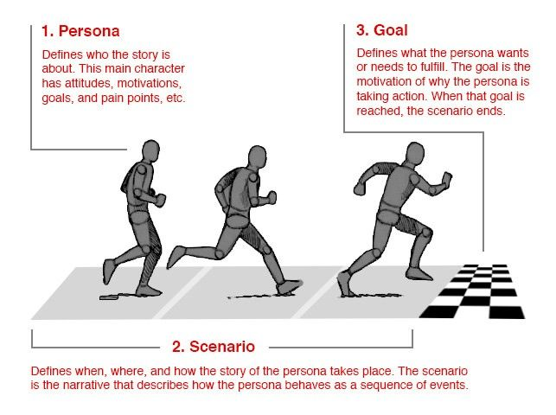

*© Smashing Magazine, All rights reserved.*[*Image Source*](https://www.smashingmagazine.com/wp-content/uploads/2014/06/04-running-persona-opt.jpg)

**2. Role-Based Personas**

The role-based perspective is also goal-directed, and it also focuses on [behavior](https://www.interaction-design.org/literature/topics/user-behavior). The personas of the role-based perspectives are massively data-driven and incorporate data from both [qualitative](https://www.interaction-design.org/literature/topics/qualitative-research) and [quantitative](https://www.interaction-design.org/literature/topics/quantitative-research) sources. The role-based perspective focuses on the user’s role in the organization. In some cases, our designs need to reflect upon the part that our users play in their organizations or wider lives. An examination of the roles that our users typically play in real life can help inform better [product design](https://www.interaction-design.org/literature/topics/product-design) decisions. Where will the product be used? What’s this role’s purpose? What business objectives are required of this role? Who else is impacted by the duties of this role? What functions are served by this role? Jonathan Grudin, John Pruitt, and Tamara Adlin are advocates for the role-based perspective.

**3. Engaging Personas**

*“The engaging perspective is rooted in the ability of stories to produce involvement and insight. Through an understanding of characters and stories, it is possible to create a vivid and realistic description of fictitious people. The purpose of the engaging perspective is to move from designers seeing the user as a stereotype with whom they are unable to identify and whose life they cannot envision, to designers actively involving themselves in the lives of the personas. The other persona perspectives are criticized for causing a risk of stereotypical descriptions by not looking at the whole person, but instead focusing only on behavior.”  
– Lene Nielsen*

Engaging personas can incorporate both **goal** and **role-directed** personas, as well as the more **traditional** rounded personas. These engaging personas are designed so that the designers who use them can become more engaged with them. The idea is to create a 3D rendering of a user through the use of personas. The more people engage with the persona and see them as ’real’, the more likely they will be to consider them during the process design and want to serve them with the best product. These personas examine the**emotions** of the user, their **psychology**, **backgrounds** and make them relevant to the task at hand. The perspective emphasizes how **stories** can engage and bring the personas to life. One of the advocates for this perspective is Lene Nielsen.

One of the main difficulties of the persona method is getting participants to use it (Browne, 2011). In a short while, we’ll let you in on Lene Nielsen’s model, which sets out to cover this problem through a 10‑step process of creating an engaging persona.

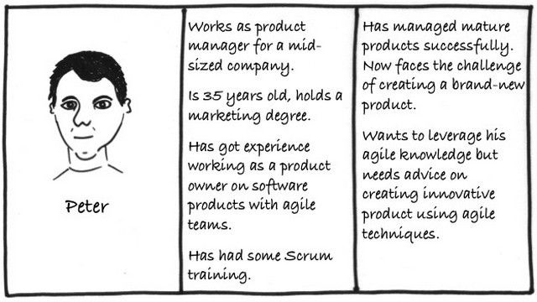

Bottom of Form

**4. Fictional Personas**

The fictional persona does not emerge from user research (unlike the other personas), but it emerges from the experience of the [UX design](https://www.interaction-design.org/literature/topics/ux-design) team. It requires the team to make assumptions based upon past interactions with the user base and products to deliver a picture of what, perhaps, typical users look like. There’s no doubt that these personas can be deeply flawed (and there are endless debates on just how flawed). You may be able to use them as an initial [sketch](https://www.interaction-design.org/literature/topics/sketch) of [user needs](https://www.interaction-design.org/literature/topics/user-needs). They allow for early involvement with your users in the [UX design process](https://www.interaction-design.org/literature/topics/ux-design-processes), but they should not, of course, be trusted as a guide for your development of products or services.

**10 steps to Creating Your Engaging Personas and Scenarios**

As described above, engaging personas can incorporate both goal and role-directed personas, as well as the more traditional rounded personas. Engaging personas emphasize how stories can engage and bring the personas to life. This 10-step process covers the entire process from preliminary data collection, through active use, to the continued development of personas. There are four main parts:

**Data collection** and **analysis of data** (steps 1, 2),

Persona **descriptions** (steps 4, 5),

[**Scenarios**](https://www.interaction-design.org/literature/topics/user-scenarios) for problem analysis and idea development (steps 6, 9),

**Acceptance** from the organization and**involvement** of the design team (steps 3, 7, 8, 10).

The 10 steps are an ideal process, but sometimes it is not possible to include all the steps in the project. Here we outline the 10-step process as described by Lene Nielsen in her Interaction Design Foundation [encyclopedia article, Personas.](https://www.interaction-design.org/literature/book/the-encyclopedia-of-human-computer-interaction-2nd-ed/personas#heading_Four_different_perspectives_page_12414)

***Collect data.***Collect as much knowledge about the users as possible. Perform high-quality user research of actual users in your target user group. In Design Thinking, the research phase is the first phase, also known as the Empathise phase.

***Form a hypothesis****.* Based upon your initial research, you will form a general idea of the various users within the focus area of the project, including the ways users differ from one another – For instance, you can use [Affinity Diagrams](https://www.interaction-design.org/literature/topics/affinity-diagrams) and [Empathy](https://www.interaction-design.org/literature/topics/empathy) Maps.

***Everyone accepts the hypothesis****.* The goal is to support or reject the first hypothesis about the differences between the users. You can do this by confronting project participants with the hypothesis and comparing it to existing knowledge.

***Establish a number.*** You will decide upon the final number of personas, which it makes sense to create. Most often, you would want to create more than one persona for each product or service, but you should always choose just one persona as your primary focus.

***Describe the personas.*** The purpose of working with personas is to be able to develop solutions, products and services based upon the needs and goals of your users. Be sure to describe personas in such a way as to express enough understanding and empathy to understand the users.

You should include details about the user’s education, lifestyle, interests, values, goals, needs, limitations, desires, attitudes, and patterns of behavior.

Add a few **fictional personal details** to make the persona a realistic character.

Give each of your personas a **name**.

Create 1–2 pages of descriptions for each persona.

***Prepare situations or scenarios for your personas.*** This engaging persona method is directed at creating scenarios that describe solutions. For this purpose, you should describe a number of specific situations that could trigger the use of the product or service you are designing. In other words, situations are the basis of a scenario. You can give each of your personas life by creating scenarios that feature them in the role of a user. Scenarios usually start by placing the persona in a specific context with a problem they want to or have to solve.

***Obtain acceptance from the organization.*** It is a common thread throughout all 10 steps that the goal of the method is to involve the project participants. As such, as many team members as possible should participate in the development of the personas, and it is important to obtain the acceptance and recognition of the participants of the various steps. In order to achieve this, you can choose between two strategies: You can ask the participants for their opinion, or you can let them participate actively in the process.

***Disseminate knowledge.*** In order for the participants to use the method, the persona descriptions should be disseminated to all. It is important to decide early on how you want to disseminate this knowledge to those who have not participated directly in the process, to future new employees, and to possible external partners. The dissemination of knowledge also includes how the project participants will be given access to the underlying data.

***Everyone prepares scenarios.*** Personas have no value in themselves. Until the persona becomes part of a scenario – the story about how the persona uses a future product – it does not have real value.

***Make ongoing adjustments.*** The last step is the future life of the persona descriptions. You should revise the descriptions on a regular basis. New information and new aspects may affect the descriptions. Sometimes you would need to rewrite the existing persona descriptions, add new personas, or eliminate outdated personas.

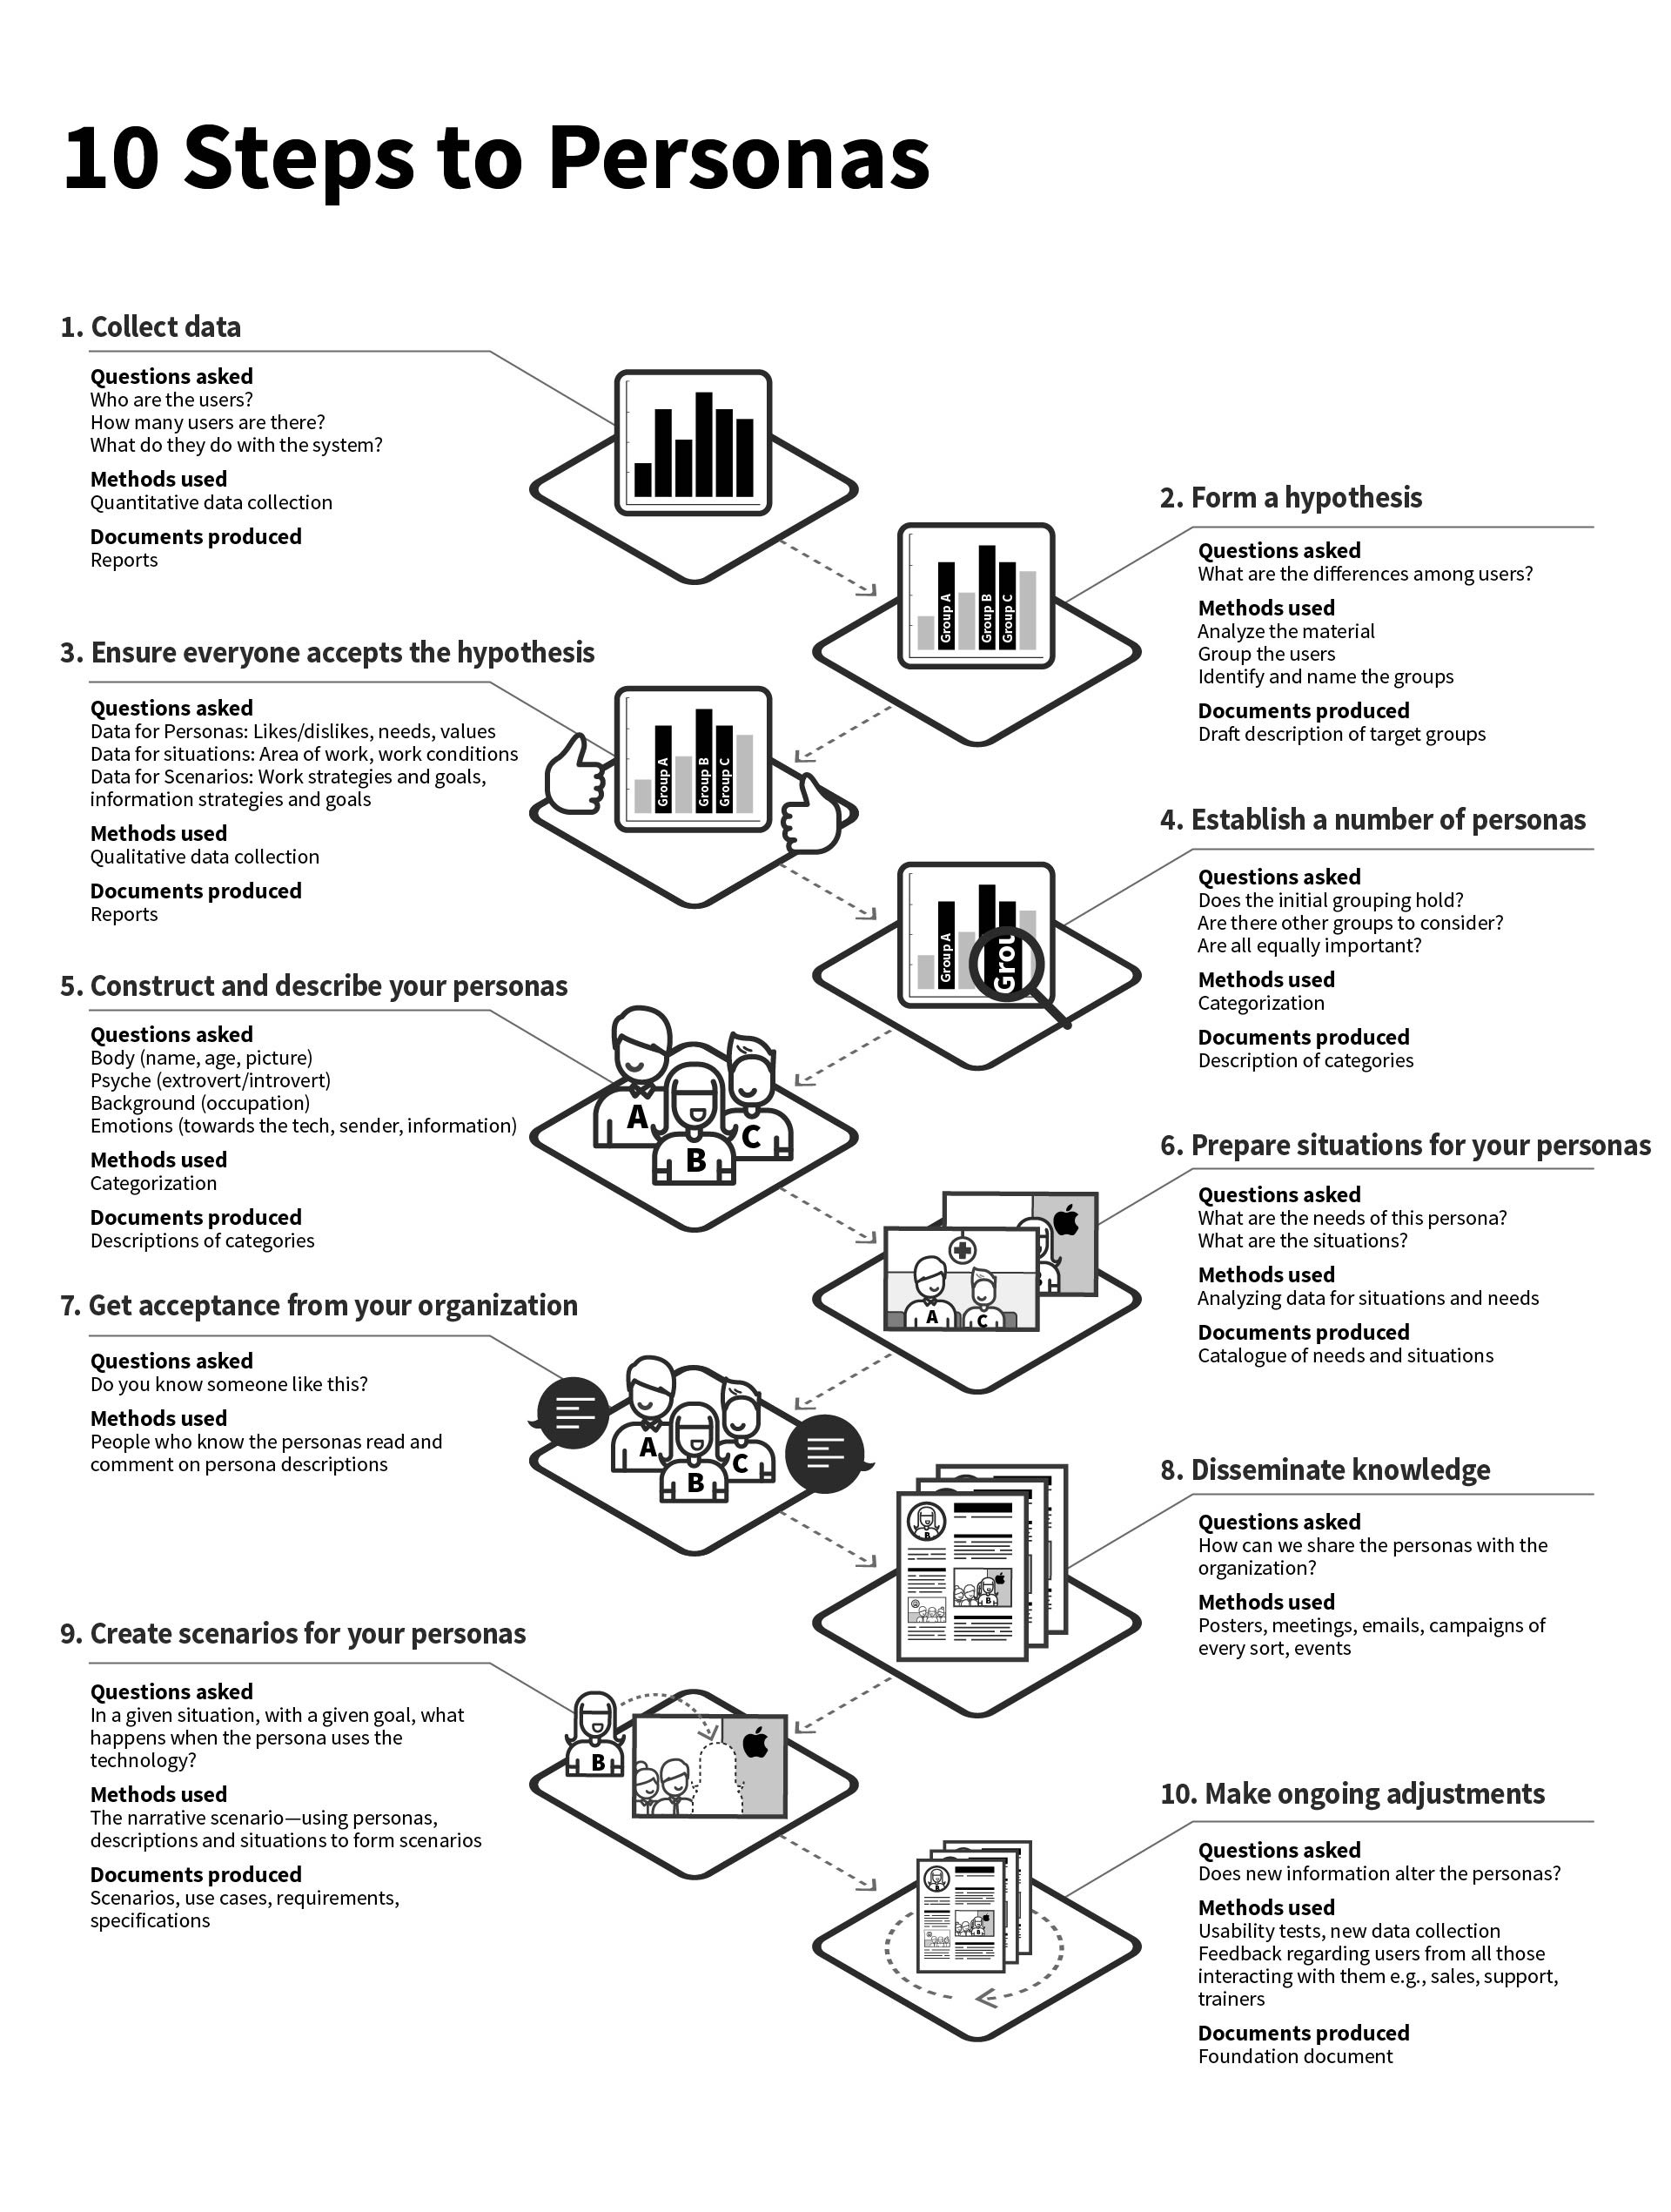

Imagine you’re starving to death so you open your favorite food delivery app.

When you click on the app, you realize the app has been updated, welcoming new features.

You’re starving, scrolling through options, but the app keeps throwing curveballs.

A button you can’t find, confusing add-ons, or a checkout process that feels endless.

It’s annoying, right?

It’s natural for customers to feel annoyed if a product/service doesn’t align with their regular way of using them.

Frustration builds, and before you know it, your customers are gone.

But you can avoid this mishap by using task analysis.

And before you ask us, what UX task analysis is, we’ve already prepared this guide to cover everything about task analysis from what it is, how it works, and how it can benefit you. Let’s dive right in!

What is task analysis?

Task analysis UX refers to a UX research method that focuses on how users take a step-by-step approach to fulfill a task. It identifies what users are trying to do, their goals, and the tasks they go through to achieve their goals.

Source: NN Group

‍

Let’s continue our online food delivery example. The goal is to get your meal, while the tasks would include browsing menus, selecting an item, and completing payment. Analyzing these steps can help researchers find roadblocks and improve the overall user experience.

It's all about understanding the user's flow to design smoother, more intuitive interactions!

Types of task analysis

Source: Collidu

User task analysis is not a one-size-fits-all approach. There are different types of approaches catered to different research objectives. Here are two commonly used types:

1. Hierarchical task analysis (HTA)

It breaks down tasks into subtasks and smaller actions, providing a high-level view of the structure. This is quite handy in indicating task flow, dependencies, and areas where users might struggle. Task analysis example: For online shopping, HTA would map the process as:

Browse categories

Select a product

Add to cart

Checkout and pay.

2. Cognitive task analysis (CTA)

Unlike hierarchical task analysis, this approach focuses on the mental processes behind actions, like decision-making, problem-solving, and memory. It is ideal for tasks that require critical thinking. It helps find hidden challenges users face in a process.For example, when deciding the fastest route to work using Google Maps, CTA would analyze how you consider traffic updates, time of day, and familiarity with routes before choosing the final route.

‍Related read: How to Organize UX Research: From Chaos to Clarity in 5 Simple Steps

‍3. Sequential Task Analysis

Unlike hierarchical or cognitive analysis, sequential task analysis zeroes in on the exact order of steps users take. Think of it as creating a detailed timeline of user actions.Task analysis example: Consider using a coffee machine at work:

Turn on machine (30 seconds)

Select drink type (10 seconds)

Place cup (5 seconds)

Wait for brewing (45 seconds)

Add condiments (15 seconds)

This type helps designers understand not just what users do, but exactly when they do it. It's perfect for spotting timing issues or unnecessary delays in your user flow!

4. Job Task Analysis (JTA)

This approach looks at the bigger picture – all tasks needed for a specific job role. It's like creating a comprehensive manual for a position.Task analysis example: For a content creator role, JTA would analyze:

Content planning skills

Writing and editing abilities

SEO knowledge requirements

Social media management

Analytics understanding

Collaboration needs

It's particularly useful when you're designing tools or platforms for specific professions. By understanding all aspects of a job, you can create interfaces that truly support users' professional needs.

Steps to conduct task analysis

Here are the steps you should follow to conduct a successful task analysis.

Define the task: Select a specific user task to be analyzed, such as booking a flight or completing an online profile, based on your research goals.

Data collection: Observe users performing the task or interview them about their process, its pain points, and its context.

Task breakdown: Break the task into smaller, logical sub-activities or elements. Booking a flight could include search, select, and payment processes.

Sequence and hierarchy: Organize these steps so that they reflect the proper order and priority. What comes first? What is optional?

Validation: Share your findings with the users or stakeholders to check for accuracy and find out what's missing.

Benefits of task analysis in UX research

Task analysis is a game-changer to improve user experience and make informed decisions. Here are a few benefits of task analysis:

Promotes user-centered designs: Task analysis ensures the design and UI of your app/website is as per real user’s behavior and customer feedback and not based on assumptions.

Figure out pain points: Breaking down and analyzing the steps taken by users helps them figure out the problems they’re facing.

Enables intuitive interfaces: By understanding how tasks flow, designers can create interfaces that feel natural and efficient. It helps build interfaces that users like and use.

Challenges in conducting task analysis

‍Every coin has two sides. Similarly, while task analysis comes with a lot of benefits, there are a few challenges too. These are as follows:

Time-sensitive process: While task analysis might yield great results for your research, it is a very time-consuming process to gather relevant data and then analyze such detailed and vast data.

Complexity in behavior analysis: Understanding user behavior and the steps they undertake is not as easy as it looks. Human behavior is not just complicated but also changes with every new participant you analyze. Doing this manually can lead to a lot of errors.

Risk of observer bias: Observers may unintentionally let their personal biases or assumptions affect how they interpret user actions and data.

Conclusion

Knowing how users interact with your product can help you design something that works for them. Task analysis gives you those insights, but the process can be time-consuming and generally complex.This is why you can automate the analysis process using Looppanel. It is an AI-powered tool that not only gives you accurate insights but in minimum time so that you focus on deriving decisions that make an impact. Ready to see the difference? Request a demo today!

Frequently asked questions (FAQs)

1. What are the 5 steps of task analysis? The 5 core steps are:

Selecting the task to analyze

Breaking the task into sequential steps

Noting required knowledge/skills for each step

Recording time, tools, and safety requirements

Validating the analysis with subject experts

2. What are examples of task analysis? Common examples include:

Making coffee (steps from grinding beans to brewing)

Teaching a child to tie shoelaces

Operating industrial machinery safely

Completing a software installation

Following medical procedures/protocols

3. What are the four types of task analysis?The main types are:

Hierarchical Task Analysis (HTA) - breaks tasks into goals and sub-goals

Cognitive Task Analysis (CTA) - focuses on mental processes and decision-making

Sequential Task Analysis - examines tasks in chronological order

Job Task Analysis (JTA) - analyzes specific job role requirements

UX design is not a one-and-done proposition. There are so many shifts and changes during the process that our designs are constantly changing. That’s why the iterative design process is so great. It allows teams to bake flexibility, user research, and continuous improvement into a process involving brainstorming, prototyping, and testing cycles.

Let’s learn what the iterative design process is all about.

**Table of Contents**

[What is the iterative design process?](https://www.uxdesigninstitute.com/blog/what-is-iterative-design-process/#What_is_the_iterative_design_process)

[What are the benefits of the iterative design process?](https://www.uxdesigninstitute.com/blog/what-is-iterative-design-process/#What_are_the_benefits_of_the_iterative_design_process)

[The 5 stages of the iterative design process](https://www.uxdesigninstitute.com/blog/what-is-iterative-design-process/#The_5_stages_of_the_iterative_design_process)

[Examples of the iterative design process in action](https://www.uxdesigninstitute.com/blog/what-is-iterative-design-process/#Examples_of_the_iterative_design_process_in_action)

[Key takeaways](https://www.uxdesigninstitute.com/blog/what-is-iterative-design-process/#Key_takeaways)

**What is the iterative design process?**

Iterative design is the process of improving a product by repeatedly going through short cycles of design, called “iterations.” This includes brainstorming, prototyping, and testing designs through everything from low-fidelity sketches to high-fidelity prototypes. Whatever moves the process forward.

The point of the iterative design process is to learn as you’re designing using user research and feedback. The traditional design process takes an incremental approach, with each phase being finished in a discrete amount of time. The iterative design process, on the other hand, isn’t linear. At any given time, the team may decide to start again from the beginning because they’ve acquired new information. But it will continuously make the product better.

UX and UI designers can use the iterative approach to design, and developers and even whole project teams can use it too. It’s just a matter of what the project is after. For UX and UI designers, iteration is a key aspect of many methodologies, such as:

[**Human-centered design**](https://www.uxdesigninstitute.com/blog/what-is-human-centered-design/)**:** a people-centred design approach in which new solutions come from cultivating deep empathy

[**Lean UX**](https://www.uxdesigninstitute.com/blog/what-is-lean-ux/)**:** a collaborative, iterative way of designing and building products which operates by continuously thinking, making, and testing

[**Design sprints:**](https://www.uxdesigninstitute.com/blog/how-do-design-sprints-ux/)a small team designs and tests a solution to a design challenge in a brief, concentrated burst.

**What are the benefits of the iterative design process?**

There are several benefits to the iterative design process. They include:

**Incorporates user feedback**  
The iterative design process requires you to constantly check in with real users of your product to ensure it works for them. This ensures you won’t get too bogged down in your own point of view and helps prioritise the best ways to improve designs based on user needs. This is also the best way to ensure that the product improves through each new iteration.

**Requires collaboration**.  
The iterative design process requires deep collaboration between team members. As a result, it enables you to gain insights from others and helps keep your designs on the right path.

**Solves real-world problems**.  
The iterative design process constantly asks real users about their opinions about your product. As a result, you have a better chance of solving problems they really face with your product rather than problems you think they have.

**Saves time**.  
The iterative design process saves time because it requires regular user feedback to constantly improve designs. If you get positive feedback, you can keep going, but if you get negative feedback, you can stop and pivot to address those comments. Either way, you’re never wasting your time and you won’t bring something that users will reject to market.

**Improves client relationships**.  
The iterative design process lets you provide clients and stakeholders with updates at regular intervals that show the evolution of your designs, instead of just showing them the finished product. This can show clients the effort that’s going into their product and improve your relationship with them.

**The 5 stages of the iterative design process**

1. **Plan**

This stage is all about what problem you decide to solve. To do that, you gather user feedback, whether it’s user surveys from previous rounds of iteration, user interviews on their views of a general design trend, or something else. Either way, this stage is driven by your research, which allows you to understand user needs and any pain points they may experience.

2. **Brainstorming**

Now that you know what problem you’ll be tackling, it’s time to look for potential solutions. This involves design sessions where your team brainstorms as many ideas as possible, as communicated with rough sketches. This way you can explore a wide range of solutions before landing on a specific one. You’ll go through several rounds of sketching and feedback until you choose one or two ideas that your team can move forward with.

3. **Prototype**

In this stage, you take the idea or ideas you settled on in the previous round and create prototypes of them. You should polish these designs so the design team, stakeholders, and users can see how they’d work in real life, but not have them be so polished that you can’t throw them out. If you have more than one idea, you can take your prototyping in a couple different directions.

4. **Test**

Now that you have a prototype (or prototypes), your goal is to show it to target users by conducting usability tests. You’ll be looking at how well users can perform given tasks with the prototype and collecting their feedback. This will tell you if you’re on the right track with your design or if you need to change something.

5. **Review**

From the feedback you’ve collected and analysed on your prototypes, you can now come to a conclusion about what you should do. If the feedback from user testing showed that the prototype was problematic — for example, users couldn’t find the shopping cart faster than they do with the current design — we should do at least one more round of brainstorming, prototyping, and testing; if we got mostly good feedback on our prototypes but there’s one or two things that could still be fixed, we should go for another round of prototyping and testing; if the feedback we got was mostly flawless, we should start implementing our designs.

**Examples of the iterative design process in action**

People who design computer software and hardware often use an iterative design process. For example, Apple uses an iterative design process to make its smartphones. You can see this by the numerous updates it does so no matter what smartphone you have, you have the latest version of the operating system. However, they don’t let perfection be the enemy of good. They put out the best smartphone they can, and continue to update it as user feedback (and new corporate requirements) come in.

Another example is website wikis, which allow users to update content continuously. For instance, Wikipedia lets users add new information to keep content current and remove anything outdated or inaccurate. These platforms evolve through an iterative process, driven by user contributions that keep the content improving over time.

**Key takeaways**

The iterative design process is the process of improving a product by repeatedly going through brief cycles of design, called “iterations.”

The point of the iterative design process is to learn from user research and feedback.

The iterative design process isn’t linear, but it will continuously improve the product.

Iteration is a key aspect of many design methodologies, including human-centred design, lean UX, and design sprints.

The benefits of the iterative design process include it incorporates user feedback, it requires collaboration, it solves real-world problems, it saves time, and it improves client relationships.

The five stages of the iterative design process are plan, brainstorm, prototype, test, and review.

Examples of the iterative design process in real life include the frequent updates to Apple’s smartphones and the user-generated content of website wikis.

Scrum sprints are the heartbeat of Agile project delivery. It's what drives teams to deliver incremental value within fixed timeframes.

While that sounds simple enough, sprints are often mistaken for general project deadlines rather than opportunities for [continuous improvement](https://www.atlassian.com/agile/project-management/continuous-improvement) and adaptation. Sprint execution demands discipline, clear goals, and a commitment to collaboration.

Without these, teams risk falling into the trap of rushed work, scope creep, or missed objectives.

Running effective scrum sprints should be considered a must-have for teams and organizations wanting predictable progress, rapid feedback, and sustained project momentum. In this article, we'll outline the do's and don'ts, as well as the best practices for sprint optimization.

**What are sprints in project management?**

A sprint is a short, time-boxed period when a scrum team works to complete a set amount of work. Sprints are at the very heart of scrum and agile methodologies, and getting sprints right will help your agile team ship better software with fewer headaches.

“With scrum, a product is built in a series of iterations called sprints that break down big, complex projects into bite-sized pieces," said Megan Cook, Head of Product for Jira at Atlassian.

Many associate scrum sprints with agile software development, so much so that scrum and agile are often thought to be the same thing. They’re not. [Agile](https://www.atlassian.com/agile) is a set of principles and [scrum](https://www.atlassian.com/agile/scrum) is a framework for getting s#it done.

The many similarities between agile values and scrum processes lead to a fair association. Sprints help teams follow the agile principle of "delivering working software frequently," as well as live the agile value of "responding to change over following a plan." The scrum values of transparency, inspection, and adaptation are complementary to agile and central to the concept of sprints.

[The Scrum Guide](https://www.scrumguides.org/scrum-guide.html) lays solid, theoretical groundwork for this discussion about sprints. Our goal is to add some color to the topic by uncovering best practices from people who do this work every single day.

**How to plan and execute scrum sprints**

The scrum folks really did think of everything. In order to plan your upcoming sprint, you use the sprint planning meeting! [Sprint planning](https://www.atlassian.com/agile/scrum/sprint-planning) is a collaborative event where the team answers two basic questions: What work can get done in this sprint and how will the chosen work get done?

Choosing the right work items for a sprint is a collaborative effort between the product owner, scrum master, and development team. The [product owner](https://www.atlassian.com/agile/product-management) discusses the objective that the sprint should achieve and the [product backlog](https://www.atlassian.com/agile/scrum/backlogs) items that, upon completion, would achieve the sprint goal.

The team then creates a plan for how they will build the backlog items and get them “Done” before the end of the sprint. The work items chosen and the plan for how to get them done is called the sprint backlog. By the end of sprint planning the team is ready to start work on the sprint backlog, taking items from the backlog, to “In-progress,” and “Done."

During a sprint, the team checks in during the daily scrum, or [standup](https://www.atlassian.com/agile/scrum/standups), about how the work is progressing. The goal of this meeting is to surface any blockers and challenges that would impact the teams ability to deliver the sprint goal.

After a sprint, the team demonstrates what they’ve completed during the [sprint review](https://www.atlassian.com/agile/scrum/sprint-reviews). This is your team’s opportunity to showcase their work to stakeholders and teammates before it hits production.

Round out your sprint cycle with my favorite meeting, the [sprint retrospective](https://www.atlassian.com/agile/scrum/retrospectives). This is your teams opportunity to identify areas of improvement for the next sprint. With that, you’re ready to start your next sprint cycle. Onward!

**Do's and Don’ts**

Even with the basics down, most teams will stumble as they start to run sprints. Megan Cook rounds out this discussion with some Do's and Don’ts she's picked up over the years.

Do:

Make sure the team sets and understands the sprint goal and how success will be measured. This is the key to keeping everyone aligned and moving forward toward a common destination.

Do ensure you have a well-groomed backlog with your priorities and dependencies in order. This can be a big challenge that could derail the process if it’s not properly managed.

Ensure you have a good understanding of velocity, and that it reflects things like leave and team meetings.

Do use the sprint planning meeting to flesh out intimate details of the work that needs to get done. Encourage team members to sketch out tasks for all stories, bugs, and tasks that come into the sprint.

Leave out work where you won’t be able to get the dependencies done, like work from another team, designs, and legal sign-off.

Finally, once a decision or plan is made, make sure someone captures that information in your project management or collaboration tool, like your Jira tickets. That way, both the decision and the rationale are easy for everyone to see later.

While you’re working on being a scrum all-star with these “do’s,” watch out for a few red flags too:

Don't:

Don’t pull in too many stories, overestimate velocity, or pull in tasks that can’t be completed in the sprint. You don’t want to set yourself or your team up for failure.

Don’t forget about quality or technical debt. Make sure to budget time for QA and non-feature work, like bugs and engineering health.

Don’t let the team have a fuzzy view of what's in the sprint. Nail it down, and don’t focus so much on moving *fast* that you forget to make sure everyone’s moving in *the same direction*.

Also, don’t take on a large amount of unknown or high-risk work. Break down stories that are large or have high uncertainty, and don't be afraid to leave some of that work for the next sprint.

If you hear concerns from the team, whether it’s about velocity, low-certainty work, or work they think is bigger than what they estimated, don’t ignore it. Address the issue, and recalibrate when necessary.

**Optimize your sprints with automation**

Once you have mastered how sprints work, you can optimize your processes using automation. Here are three of the most common automation rules used for sprints in Jira.

Send a weekly Slack message with all work items still open in the sprint. [Go to rule](https://www.atlassian.com/software/jira/automation-template-library/rules#/rule/1363405).

When a sprint finishes, then assign outstanding work items to the next sprint. [Go to rule](https://www.atlassian.com/software/jira/automation-template-library/rules#/rule/1357182).

When a work item moves to ‘In Progress’ and the sprint is empty, then move the work item to the next active sprint. [Go to rule](https://www.atlassian.com/software/jira/automation-template-library/rules#/rule/1309924).

See these automation rules and 100s more in the Jira Automation Template Library.

[Go to library](https://www.atlassian.com/software/jira/automation-template-library)

**Learn more about sprints**

Sprints are so well known (and so effective!) that they’re often seen as the first step on the path towards greater agility. As we’ve learned, mastering sprints requires a mastery of a handful of scrum and agile concepts that build upon each other. Please use [the rest of our articles on scrum](https://www.atlassian.com/agile/scrum) to round out your knowledge and inch ever closer towards scrum bliss.

You can easily get started on the right foot by planning your sprint (and incorporating do’s and don’ts) with our [scrum template](https://www.atlassian.com/software/jira/templates/scrum), which includes everything you need to plan, track and manage work across sprints. Also, [learn how to use sprints in Jira](https://www.atlassian.com/agile/tutorials/sprints).

**10 Usability Heuristics for User Interface Design**

Summary:  Jakob Nielsen's 10 general principles for interaction design. They are called "heuristics" because they are broad rules of thumb and not specific usability guidelines.

**1: Visibility of System Status**

**The design should always keep users informed about what is going on, through appropriate feedback within a reasonable amount of time.**

When users know the current system status, they learn the outcome of their prior interactions and determine next steps. Predictable interactions create trust in the product as well as the brand.

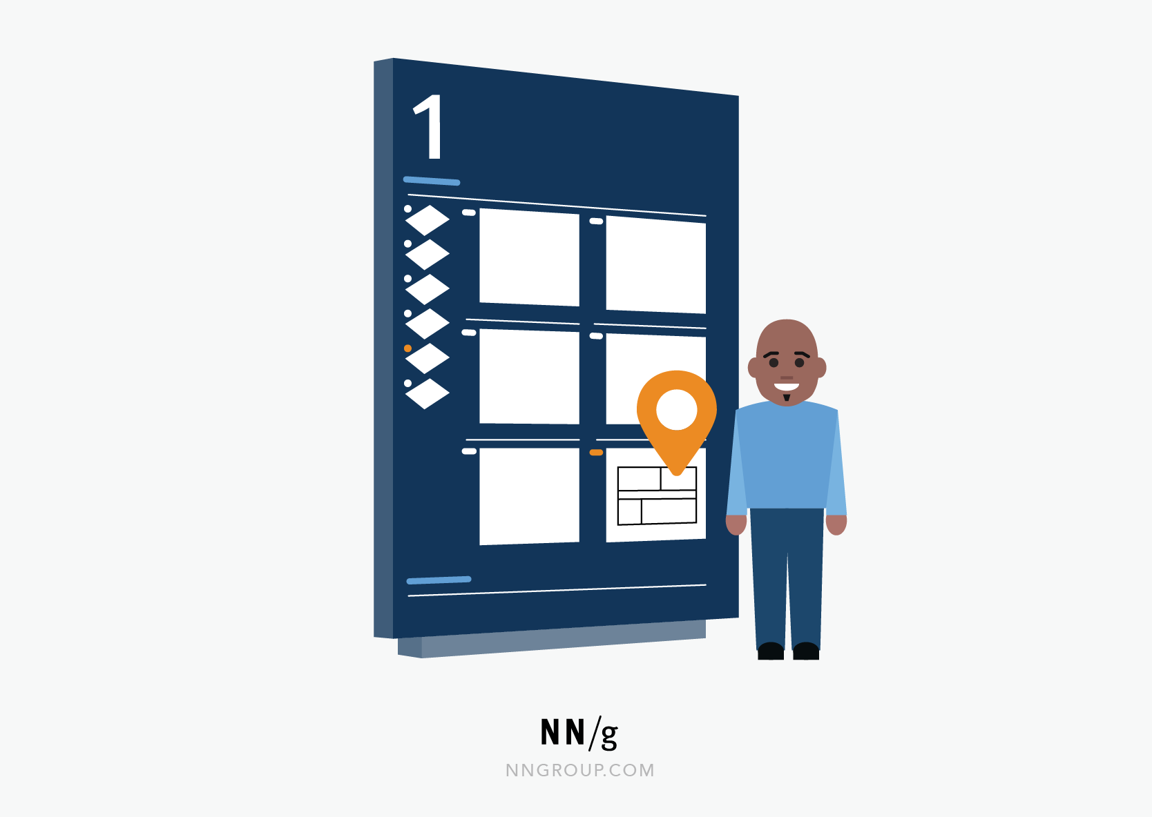***Example of Usability Heuristic #1:***  
You Are Here*indicators on mall maps show people where they currently are, to help them understand where to go next.*

**Tips**

Communicate clearly to users what the system’s state is — no action with consequences to users should be taken without informing them.

Present feedback to the user as quickly as possible (ideally, immediately).

Build trust through open and [continuous communication](https://www.nngroup.com/articles/microinteractions/).

**2: Match Between the System and the Real World**

**The design should speak the users' language. Use words, phrases, and concepts familiar to the user, rather than internal jargon. Follow real-world conventions, making information appear in a natural and logical order.**

The way you should design depends very much on your specific users. Terms, concepts, icons, and images that seem perfectly clear to you and your colleagues may be unfamiliar or confusing to your users.

When a design’s controls follow real-world conventions and correspond to desired outcomes (called [natural mapping](https://www.nngroup.com/articles/natural-mappings/)), it’s easier for users to learn and remember how the interface works. This helps to build an experience that feels intuitive.

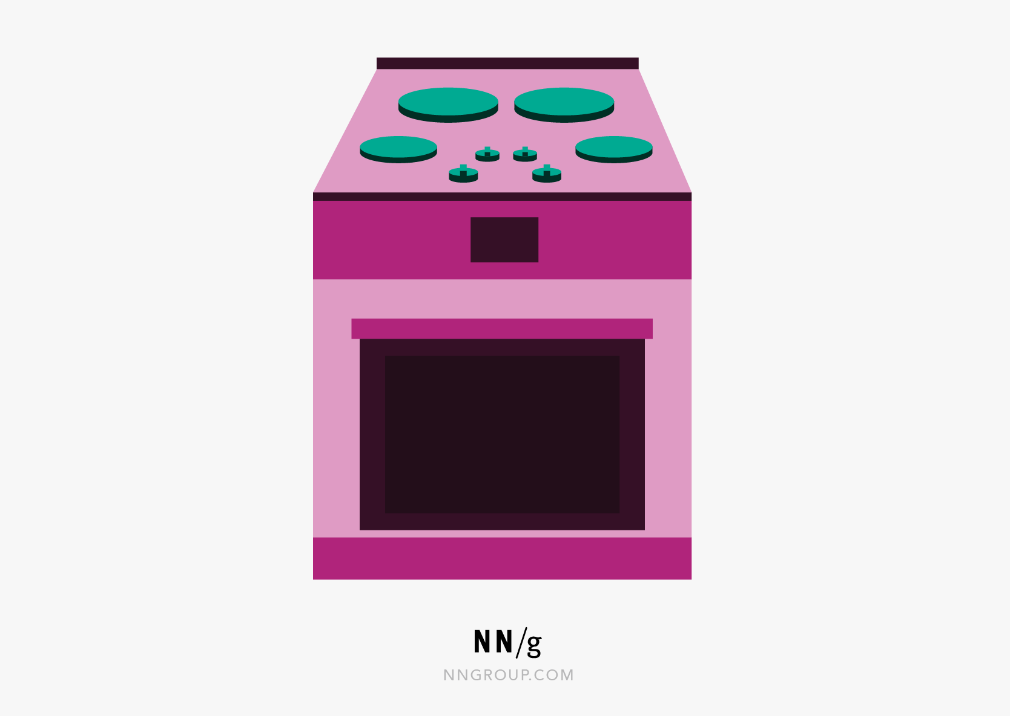***Example of Usability Heuristic #2:***  
*When stovetop controls match the layout of heating elements, users can quickly understand which control maps to which heating element.*

**Tips**

Ensure that users can understand meaning without having to go look up a word’s definition.

Never assume your understanding of words or concepts will match that of your users.

User research will uncover your [users' familiar terminology,](https://www.nngroup.com/articles/user-centric-language/) as well as their mental models around important concepts.

**3: User Control and Freedom**

**Users often perform actions by mistake. They need a clearly marked "emergency exit" to leave the unwanted action without having to go through an extended process.**

When it's easy for people to back out of a process or undo an action, it fosters a sense of freedom and confidence. Exits allow users to remain in control of the system and avoid getting stuck and feeling frustrated.

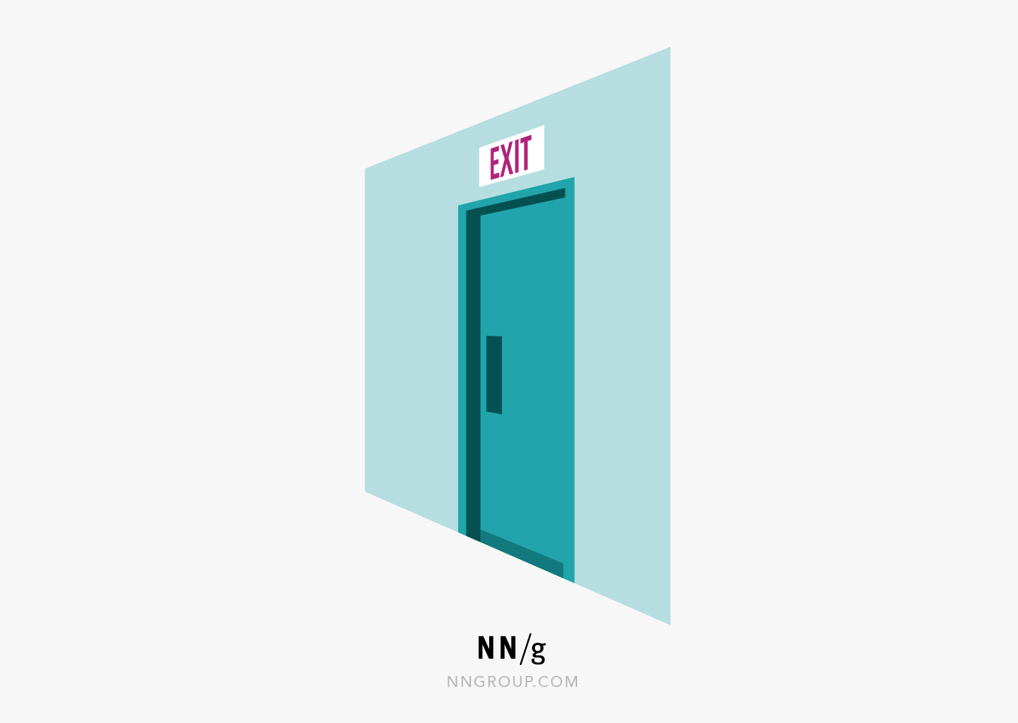***Example of Usability Heuristic #3:***  
*Digital spaces need quick emergency exits, just like physical spaces do.*

**Tips**

Support *Undo* and *Redo*.

Show a clear way to exit the current interaction, like a [*Cancel* button](https://www.nngroup.com/articles/reset-and-cancel-buttons/).

Make sure the exit is clearly labeled and discoverable.

**4: Consistency and Standards**

**Users should not have to wonder whether different words, situations, or actions mean the same thing. Follow platform and industry conventions.**

[Jakob's Law](https://www.nngroup.com/videos/jakobs-law-internet-ux/) states that people spend most of their time using digital products*other than yours*. Users’ experiences with those other products set their expectations. Failing to maintain consistency may increase the users' [cognitive load](https://www.nngroup.com/articles/minimize-cognitive-load/) by forcing them to learn something new.

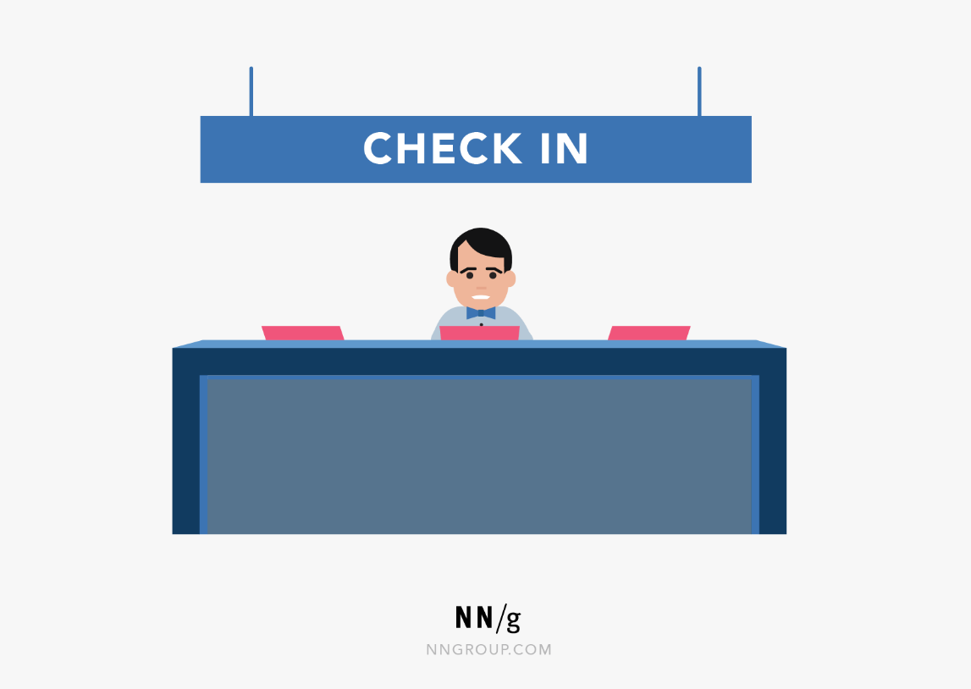***Example of Usability Heuristic #4:***  
*Checkin counters are usually located at the front of hotels. This consistency meets customers’ expectations.*

**Tips**

Improve [learnability](https://www.nngroup.com/videos/learnability-efficiency-ui-design/) by maintaining both types of consistency: internal and external.

Maintain [consistency](https://www.nngroup.com/articles/omnichannel-consistency/) within a single product or a [family of products (internal consistency).](https://www.nngroup.com/videos/design-systems/)

Follow established [industry conventions](https://www.nngroup.com/articles/do-interface-standards-stifle-design-creativity/) (external consistency).

[3-minute video: *Consistency and Standards*](https://www.nngroup.com/videos/usability-heuristic-consistency-standards/)

**5: Error Prevention**

**Good error messages are important, but the best designs carefully prevent problems from occurring in the first place. Either eliminate error-prone conditions, or check for them and present users with a confirmation option before they commit to the action.**

There are two types of errors: [slips and mistakes](https://www.nngroup.com/videos/slips-vs-mistakes/). Slips are unconscious errors caused by inattention. Mistakes are conscious errors based on a mismatch between the user’s mental model and the design.

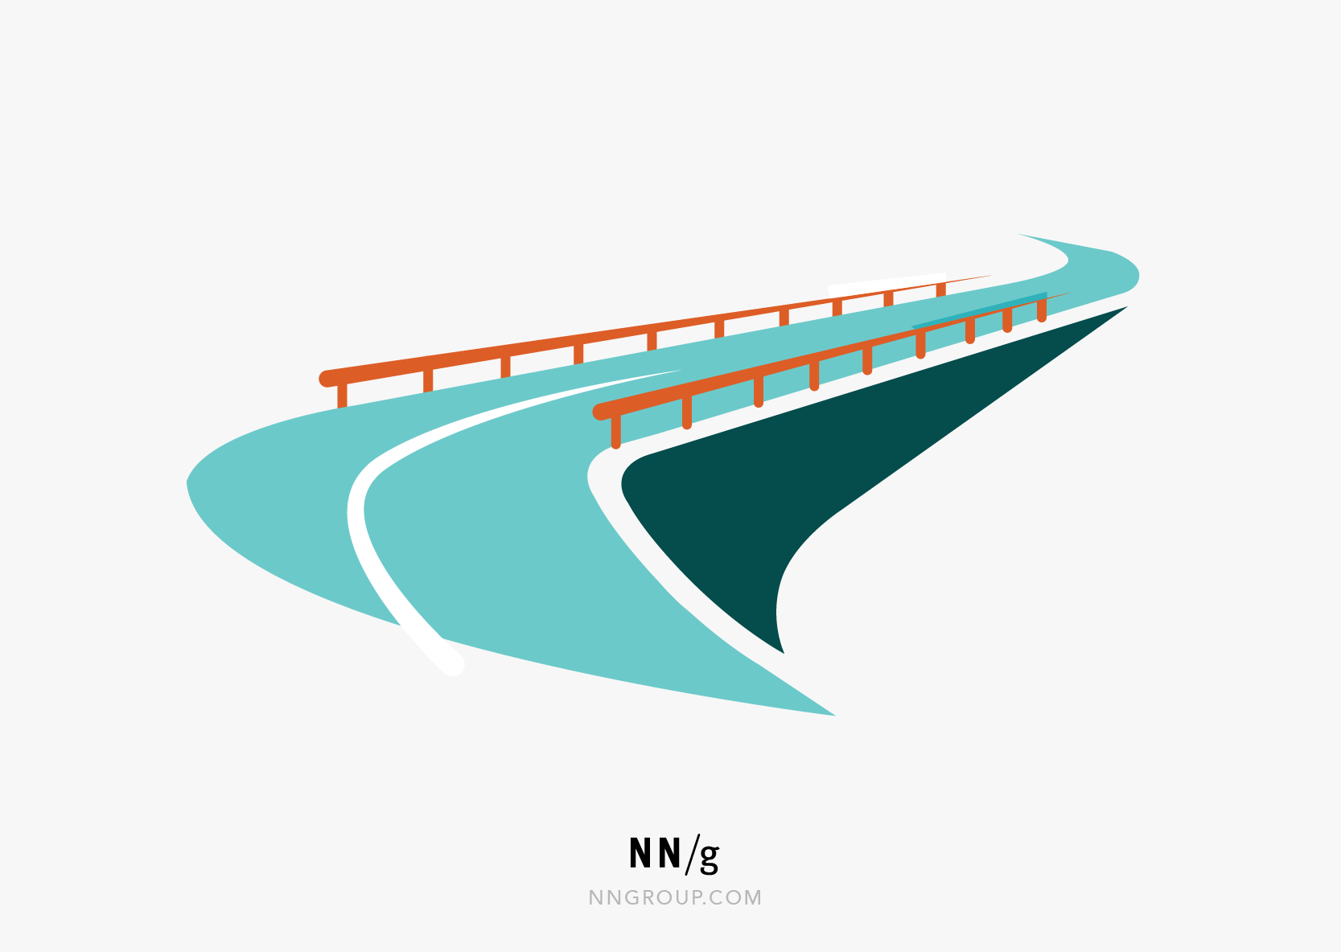***Example of Usability Heuristic #5:***  
​​​​*Guard rails on curvy mountain roads prevent drivers from falling off cliffs.*

**Tips**

Prioritize your effort: Prevent high-cost errors first, then little frustrations.

[Avoid slips](https://www.nngroup.com/articles/slips/) by providing helpful constraints and good [defaults](https://www.nngroup.com/articles/the-power-of-defaults/).

Prevent mistakes by removing memory burdens, supporting undo, and [warning your users](https://www.nngroup.com/articles/confirmation-dialog/).

**6: Recognition Rather than Recall**

**Minimize the user's memory load by making elements, actions, and options visible. The user should not have to remember information from one part of the interface to another. Information required to use the design (e.g. field labels or menu items) should be visible or easily retrievable when needed.**

Humans have limited short-term [memories](https://www.nngroup.com/articles/working-memory-external-memory/). Interfaces that promote recognition reduce the amount of cognitive effort required from users.

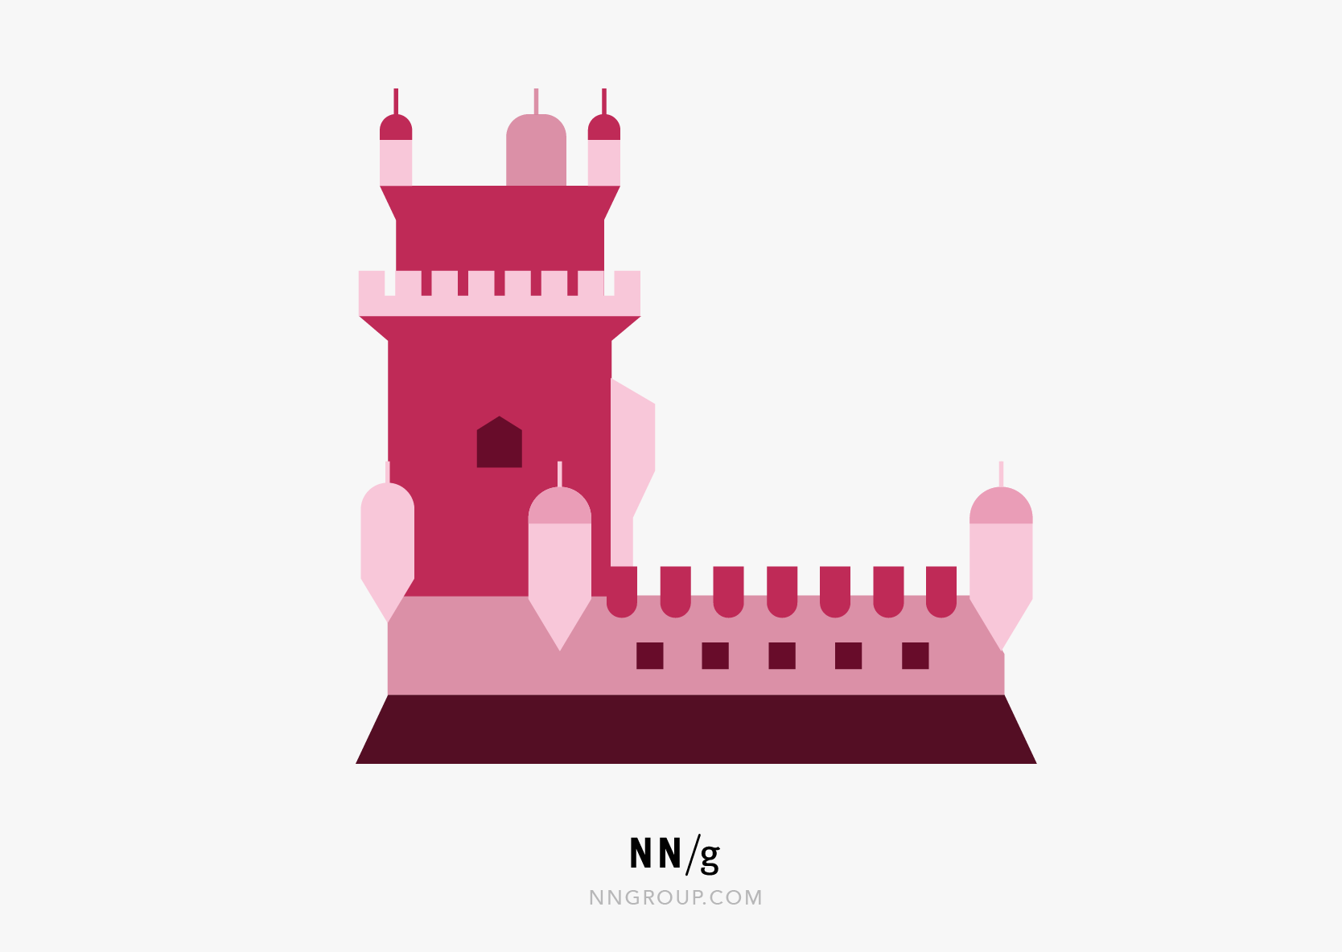***Example of Usability Heuristic #6:***  
*It’s easier for most people to recognize the capitals of countries, instead of having to remember them. People are more likely to correctly answer the question*Is Lisbon the capital of Portugal?*rather than*What’s the capital of Portugal?

**Tips**

Let people recognize information in the interface, rather than forcing them to remember (“recall”) it.

Offer [help in context](https://www.nngroup.com/videos/just-in-time-help/), instead of giving users a long tutorial to memorize.

Reduce the information that users have to remember.

**Learn more**

[Full article: *Recognition vs. Recall in UX*](https://www.nngroup.com/articles/recognition-and-recall/)

[3-minute video: *Recognition vs. Recall*](https://www.nngroup.com/videos/recognition-vs-recall/)

**7: Flexibility and Efficiency of Use**

**Shortcuts — hidden from novice users — may speed up the interaction for the expert user so that the design can cater to both inexperienced and experienced users. Allow users to tailor frequent actions.**

Flexible processes can be carried out in different ways, so that people can pick whichever method works for them.

***Example of Usability Heuristic #7:***  
*Regular routes are listed on maps, but locals with knowledge of the area can take shortcuts.*

**Tips**

Provide [accelerators](https://www.nngroup.com/articles/ui-accelerators/) like keyboard shortcuts and touch gestures.

Provide [personalization](https://www.nngroup.com/articles/personalization/) by tailoring content and functionality for individual users.

Allow for [customization](https://www.nngroup.com/articles/customization-personalization/), so users can make selections about how they want the product to work.

**Learn more**

[Full article: *Flexibility and Efficiency of Use: The 7th Usability Heuristic Explained*](https://www.nngroup.com/articles/flexibility-efficiency-heuristic/)

[3-minute video: *Flexibility and Efficiency of Use*](https://www.nngroup.com/videos/flexibility-efficiency-use/)

**8: Aesthetic and Minimalist Design**

**Interfaces should not contain information that is irrelevant or rarely needed. Every extra unit of information in an interface competes with the relevant units of information and diminishes their relative visibility.**

This heuristic doesn't mean you have to use a [flat design](https://www.nngroup.com/articles/flat-design/) — it's about making sure you're keeping the content and visual design focused on the essentials. Ensure that the visual elements of the interface support the user's primary goals.

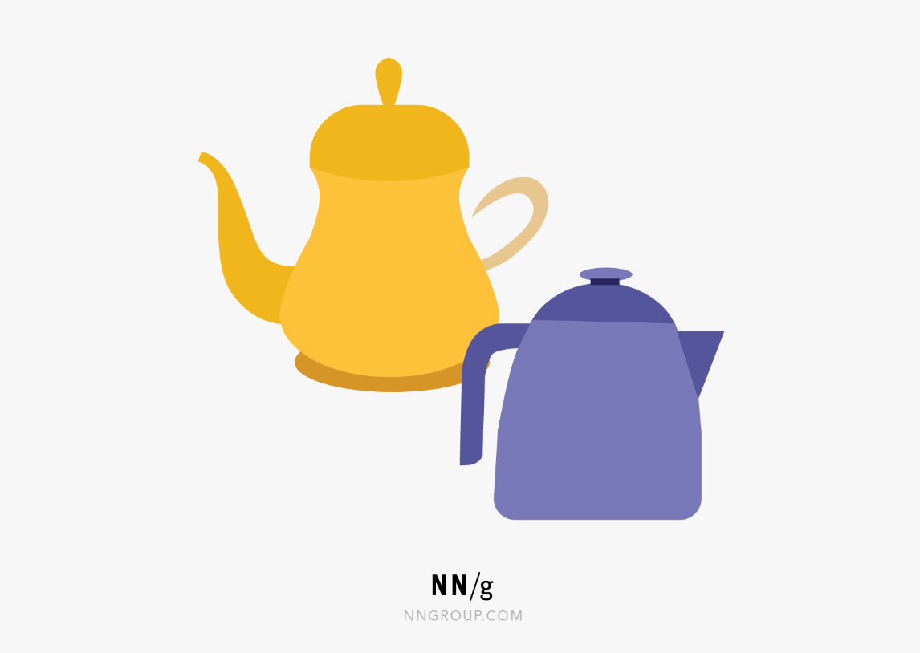***Example of Usability Heuristic #8:***  
​​​​​​*An ornate teapot may have excessive decorative elements, like an uncomfortable handle or hard-to-wash nozzle, that can interfere with usability.*

**Tips**

Keep the [content](https://www.nngroup.com/articles/how-little-do-users-read/) and [visual design](https://www.nngroup.com/articles/principles-visual-design/) of UI focused on the essentials.

Don't let unnecessary elements distract users from the information they really need.

[Prioritize the content and features](https://www.nngroup.com/videos/less-is-more/) to support primary goals.

**Learn more**

[Full article: *Aesthetic and Minimalist Design (Usability Heuristic #8)*](https://www.nngroup.com/articles/aesthetic-minimalist-design/)

[3-minute video: *Aesthetic and Minimalist Design*](https://www.nngroup.com/videos/aesthetic-and-minimalist-design/)

**9: Help Users Recognize, Diagnose, and Recover from Errors**

**Error messages should be expressed in plain language (no error codes), precisely indicate the problem, and constructively suggest a solution.**

These error messages should also be presented with visual treatments that will help users notice and recognize them.

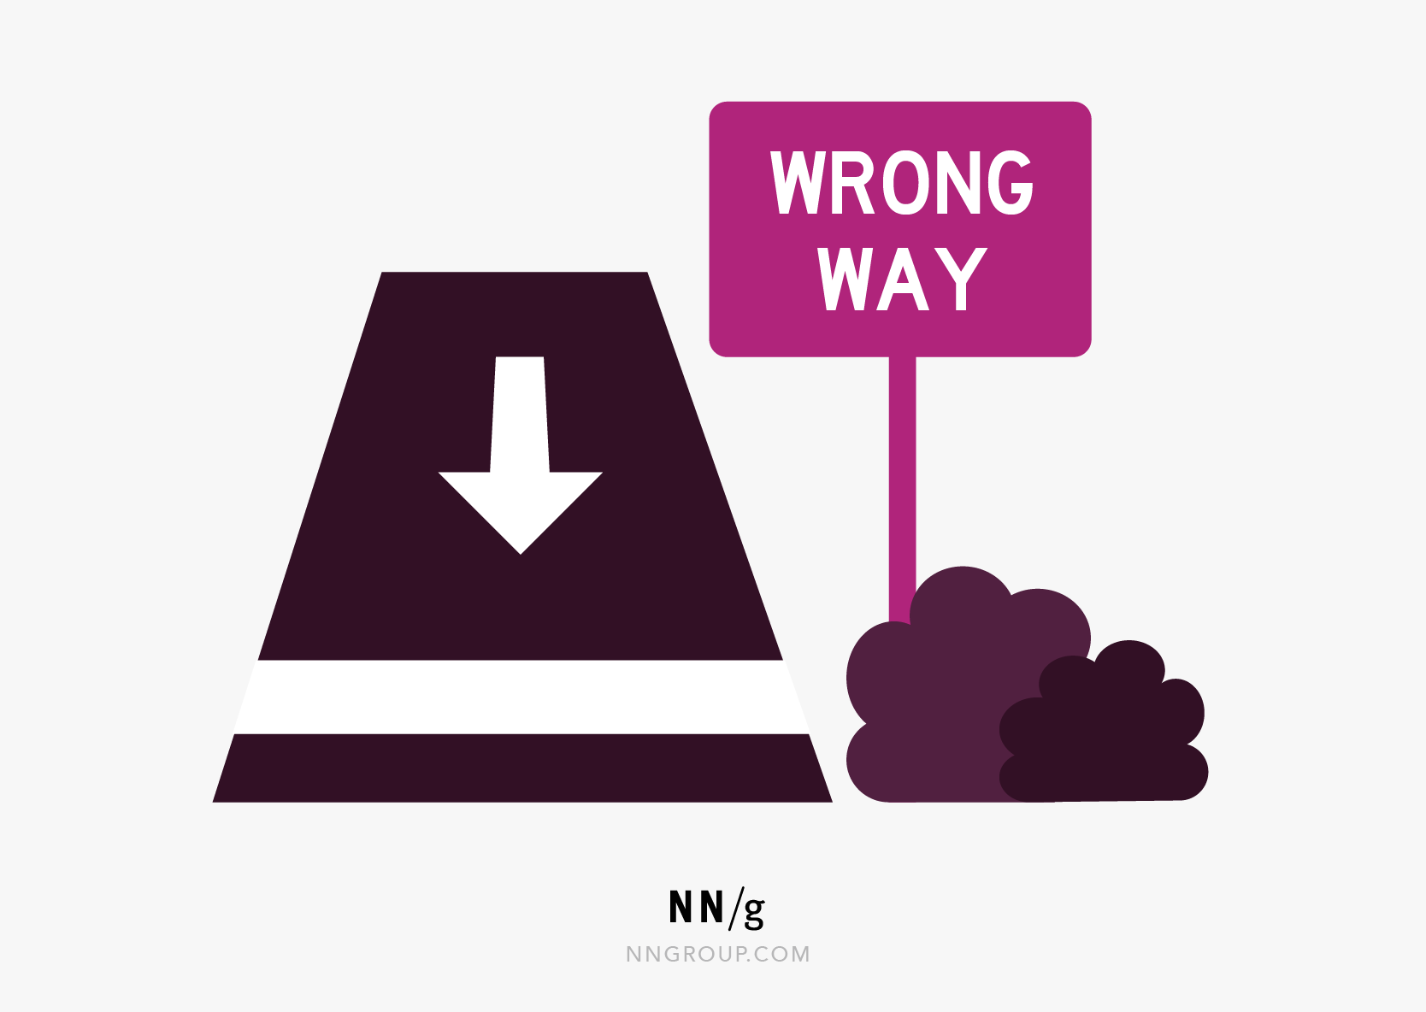***Example of Usability Heuristic #9:***  
Wrong way*signs on the road remind drivers that they are heading in the wrong direction and ask them to stop.*

**Tips**

Use traditional [error-message](https://www.nngroup.com/articles/error-message-guidelines/) visuals, like bold, red text.

Tell users what went wrong in [language they will understand](https://www.nngroup.com/articles/plain-language-experts/) — avoid technical jargon.

Offer users a solution, like a shortcut that can solve the error immediately.

**10: Help and Documentation**

**It’s best if the system doesn’t need any additional explanation. However, it may be necessary to provide documentation to help users understand how to complete their tasks.**

Help and documentation content should be easy to search and focused on the user's task. Keep it concise, and list concrete steps that need to be carried out.

***Example of Usability Heuristic #10:***  
*Information kiosks at airports are easily recognizable and solve customers’ problems in context and immediately.*

**Tips**

Ensure that the help documentation is easy to [search](https://www.nngroup.com/articles/search-visible-and-simple/).

Whenever possible, present the documentation in context right at the moment that the user requires it.

List concrete steps to be carried out.

oftware Quality - Software Engineering

Last Updated : 27 Sep, 2025

Traditionally, a high-quality product is outlined in terms of its fitness of purpose. That is, a high-quality product will specifically be what the users need to try. For code products, the fitness of purpose is typically taken in terms of satisfaction of the wants arranged down within the SRS document.

Though “fitness of purpose” could be a satisfactory definition of quality for some products like an automobile, a table fan, a grinding machine, etc. – for code products, “fitness of purpose” isn't a completely satisfactory definition of quality.

Software-Quality-Software-Engineering

What is Software Quality?

Software Quality shows how good and reliable a product is. To convey an associate degree example, think about functionally correct software. It performs all functions as laid out in the SRS document. But, it has an associate degree virtually unusable program. even though it should be functionally correct, we tend not to think about it to be a high-quality product.

Another example is also that of a product that will have everything that the users need but has an associate degree virtually incomprehensible and not maintainable code. Therefore, the normal construct of quality as “fitness of purpose” for code products isn't satisfactory.

Factors of Software Quality

The modern read of high-quality associates with software many quality factors like the following:

Factors-of-Software-Quality

Portability: A software is claimed to be transportable, if it may be simply created to figure in several package environments, in several machines, with alternative code products, etc.

Usability: A software has smart usability if completely different classes of users (i.e. knowledgeable and novice users) will simply invoke the functions of the products.

Reusability: A software has smart reusability if completely different modules of the products will simply be reused to develop new products.

Correctness: Software is correct if completely different needs as laid out in the SRS document are properly enforced.

Maintainability: A software is reparable, if errors may be simply corrected as and once they show up, new functions may be simply added to the products, and therefore the functionalities of the products may be simply changed, etc

Reliability: Software is more reliable if it has fewer failures. Since software engineers do not deliberately plan for their software to fail, reliability depends on the number and type of mistakes they make. Designers can improve reliability by ensuring the software is easy to implement and change, by testing it thoroughly, and also by ensuring that if failures occur, the system can handle them or can recover easily.

Efficiency. The more efficient software is, the less it uses of CPU-time, memory, disk space, network bandwidth, and other resources. This is important to customers in order to reduce their costs of running the software, although with today’s powerful computers, CPU time, memory and disk usage are less of a concern than in years gone by.

Software Quality Management System

Software Quality Management System contains the methods that are used by the authorities to develop products having the desired quality.

Some of the methods are:

Managerial Structure: Quality System is responsible for managing the structure as a whole. Every Organization has a managerial structure.

Individual Responsibilities: Each individual present in the organization must have some responsibilities that should be reviewed by the top management and each individual present in the system must take this seriously.

Quality System Activities: The activities which each quality system must have been

Project Auditing.

Review of the quality system.

It helps in the development of methods and guidelines.

Evolution of Quality Management System

Quality Systems are basically evolved over the past some years. The evolution of a Quality Management System is a four-step process.

Inspection: Product inspection task provided an instrument for quality control (QC).

Quality Control: The main task of quality control is to detect defective devices, and it also helps in finding the cause that leads to the defect. It also helps in the correction of bugs.

Quality Assurance: Quality Assurance helps an organization in making good quality products. It also helps in improving the quality of the product by passing the products through security checks.

Total Quality Management (TQM): Total Quality Management(TQM) checks and assures that all the procedures must be continuously improved regularly through process measurements.

software-quality

Evolution of Quality Management System

Questions for Practice

1. In software testing, how the error, fault, and failure are related to each other? [UGC-NET 2015]

(A) Error leads to failure, but fault is not related to error and failure.

(B) Fault leads to failure, but error is not related to fault and failure.

(C) Error leads to fault and fault leads to failure.

(D) Fault leads to error and error leads to failure.

Solution: Correct Answer is (C).

2. A Software Requirement Specification (SRS) document should avoid discussing which one of the following? [GATE CS 2015]

(A) User Interface Issues

(B) Non-Functional Requirements

(C) Design Specification

(D) Interfaces with Third-Party Software

Solution: Correct Answer is (C).

Conclusion

Software quality ensures a product is reliable, maintainable, and user-friendly, going beyond just meeting requirements. It involves key factors like portability, usability, correctness, and efficiency. A robust quality management system and continuous improvement processes help achieve these standards. High-quality software is functional, efficient, and adaptable to user needs.

In the context of [software engineering](https://en.wikipedia.org/wiki/Software_engineering), **software quality** refers to two related but distinct notions:[[*citation needed*](https://en.wikipedia.org/wiki/Wikipedia:Citation_needed)]

Software's functional quality reflects how well it complies with or conforms to a given design, based on [functional requirements](https://en.wikipedia.org/wiki/Functional_requirements) or specifications.[[1]](https://en.wikipedia.org/wiki/Software_quality#cite_note-1) That attribute can also be described as the fitness for the purpose of a piece of software or how it compares to competitors in the marketplace as a worthwhile [product](https://en.wikipedia.org/wiki/Product_(business)).[[2]](https://en.wikipedia.org/wiki/Software_quality#cite_note-2) It is the degree to which the [correct](https://en.wikipedia.org/wiki/Software_verification_and_validation#Software_validation) software was produced.

Software structural quality refers to how it meets [non-functional requirements](https://en.wikipedia.org/wiki/Non-functional_requirements) that support the delivery of the functional requirements, such as robustness or maintainability. It has a lot more to do with the degree to which the software works as [needed](https://en.wikipedia.org/wiki/Software_verification_and_validation#Software_verification).

Many aspects of structural quality can be evaluated only [statically](https://en.wikipedia.org/wiki/Static_testing) through the analysis of the software's inner structure, its source code (see [Software metrics](https://en.wikipedia.org/wiki/Software_metric)),[[3]](https://en.wikipedia.org/wiki/Software_quality#cite_note-3) at the unit level, and at the system level (sometimes referred to as end-to-end testing[[4]](https://en.wikipedia.org/wiki/Software_quality#cite_note-4)), which is in effect how its architecture adheres to sound principles of [software architecture](https://en.wikipedia.org/wiki/Software_architecture) outlined in a paper on the topic by [Object Management Group](https://en.wikipedia.org/wiki/Object_Management_Group) (OMG).[[5]](https://en.wikipedia.org/wiki/Software_quality#cite_note-5)

Some structural qualities, such as [usability](https://en.wikipedia.org/wiki/Usability), can be [assessed](https://en.wikipedia.org/wiki/Usability_testing#Methods) only [dynamically](https://en.wikipedia.org/wiki/Dynamic_testing) (users or others acting on their behalf interact with the software or, at least, some prototype or partial implementation; even the interaction with a mock version made in cardboard represents a dynamic test because such version can be considered a prototype). Other aspects, such as reliability, might involve not only the software but also the underlying hardware, therefore, it can be assessed both statically and dynamically ([stress test](https://en.wikipedia.org/wiki/Stress_testing_(software))).[[*citation needed*](https://en.wikipedia.org/wiki/Wikipedia:Citation_needed)]

Using [automated tests](https://en.wikipedia.org/wiki/Test_automation) and [fitness functions](https://en.wikipedia.org/wiki/Fitness_function) can help to maintain some of the quality related attributes.[[6]](https://en.wikipedia.org/wiki/Software_quality#cite_note-6)

Functional quality is typically assessed dynamically but it is also possible to use static tests (such as [software reviews](https://en.wikipedia.org/wiki/Software_review)).[[*citation needed*](https://en.wikipedia.org/wiki/Wikipedia:Citation_needed)]

Historically, the structure, classification, and terminology of attributes and metrics applicable to [software quality management](https://en.wikipedia.org/wiki/Software_quality_management) have been derived or extracted from the [ISO 9126](https://en.wikipedia.org/wiki/ISO_9126) and the subsequent [ISO/IEC 25000](https://en.wikipedia.org/w/index.php?title=ISO_25000&action=edit&redlink=1) standard.[[7]](https://en.wikipedia.org/wiki/Software_quality#cite_note-7) Based on these models (see Models), the [Consortium for IT Software Quality](https://en.wikipedia.org/wiki/CISQ) (CISQ) has defined five major desirable structural characteristics needed for a piece of software to provide [business value](https://en.wikipedia.org/wiki/Business_value):[[8]](https://en.wikipedia.org/wiki/Software_quality#cite_note-:6-8) Reliability, Efficiency, Security, Maintainability, and (adequate) Size.[[9]](https://en.wikipedia.org/wiki/Software_quality#cite_note-9)[[10]](https://en.wikipedia.org/wiki/Software_quality#cite_note-:1-10)[[11]](https://en.wikipedia.org/wiki/Software_quality#cite_note-:2-11)

Software quality measurement quantifies to what extent a software program or system rates along each of these five dimensions. An aggregated measure of software quality can be computed through a qualitative or a quantitative scoring scheme or a mix of both and then a weighting system reflecting the priorities. This view of software quality being positioned on a linear continuum is supplemented by the analysis of "critical programming errors" that under specific circumstances can lead to catastrophic outages or performance degradations that make a given system unsuitable for use regardless of rating based on aggregated measurements. Such programming errors found at the system level represent up to 90 percent of production issues, whilst at the unit-level, even if far more numerous, programming errors account for less than 10 percent of production issues (see also [Ninety–ninety rule](https://en.wikipedia.org/wiki/Ninety%E2%80%93ninety_rule)). As a consequence, code quality without the context of the whole system, as [W. Edwards Deming](https://en.wikipedia.org/wiki/W._Edwards_Deming) described it, has limited value.[[*citation needed*](https://en.wikipedia.org/wiki/Wikipedia:Citation_needed)]

To view, explore, analyze, and communicate software quality measurements, concepts and techniques of [information visualization](https://en.wikipedia.org/wiki/Information_visualization) provide visual, interactive means useful, in particular, if several software quality measures have to be related to each other or to components of a software or system. For example, [software maps](https://en.wikipedia.org/wiki/Software_map) represent a specialized approach that "can express and combine information about software development, software quality, and system dynamics".[[12]](https://en.wikipedia.org/wiki/Software_quality#cite_note-12)

Software quality also plays a role in the release phase of a software project. Specifically, the quality and establishment of the [release processes](https://en.wikipedia.org/wiki/Release_management) (also [patch processes](https://en.wikipedia.org/wiki/Patch_(computing))),[[13]](https://en.wikipedia.org/wiki/Software_quality#cite_note-13)[[14]](https://en.wikipedia.org/wiki/Software_quality#cite_note-14) [configuration management](https://en.wikipedia.org/wiki/Configuration_management)[[15]](https://en.wikipedia.org/wiki/Software_quality#cite_note-15) are important parts of an overall software engineering process.[[16]](https://en.wikipedia.org/wiki/Software_quality#cite_note-16)[[17]](https://en.wikipedia.org/wiki/Software_quality#cite_note-17)[[18]](https://en.wikipedia.org/wiki/Software_quality#cite_note-18)

**Motivation**

Software quality is motivated by at least two main perspectives:

[Risk management](https://en.wikipedia.org/wiki/Risk_Management): Software failure has caused more than inconvenience. Software errors can cause human fatalities (see for example: [List of software bugs](https://en.wikipedia.org/wiki/List_of_software_bugs)). The causes have ranged from poorly designed user interfaces to direct [programming errors](https://en.wikipedia.org/wiki/Programming_error),[[19]](https://en.wikipedia.org/wiki/Software_quality#cite_note-19)[[20]](https://en.wikipedia.org/wiki/Software_quality#cite_note-20)[[21]](https://en.wikipedia.org/wiki/Software_quality#cite_note-21) see for example [Boeing 737 case](https://en.wikipedia.org/wiki/Boeing_737#Accidents_and_incidents) or [Unintended acceleration](https://en.wikipedia.org/wiki/Sudden_unintended_acceleration) cases[[22]](https://en.wikipedia.org/wiki/Software_quality#cite_note-22)[[23]](https://en.wikipedia.org/wiki/Software_quality#cite_note-23) or [Therac-25](https://en.wikipedia.org/wiki/Therac-25) cases.[[24]](https://en.wikipedia.org/wiki/Software_quality#cite_note-24) This resulted in requirements for the development of some types of software, particularly and historically for [software embedded](https://en.wikipedia.org/wiki/Embedded_software) in medical and other devices that regulate critical infrastructures: "[Engineers who write embedded software] see Java programs stalling for one third of a second to perform garbage collection and update the user interface, and they envision airplanes falling out of the sky.".[[25]](https://en.wikipedia.org/wiki/Software_quality#cite_note-25) In the United States, within the [Federal Aviation Administration](https://en.wikipedia.org/wiki/Federal_Aviation_Administration) (FAA), the FAA Aircraft Certification Service provides software programs, policy, guidance and training, focus on software and Complex Electronic Hardware that has an effect on the airborne product (a "product" is an aircraft, an engine, or a propeller).[[26]](https://en.wikipedia.org/wiki/Software_quality#cite_note-26) Certification standards such as [DO-178C](https://en.wikipedia.org/wiki/DO-178C), [ISO 26262](https://en.wikipedia.org/wiki/ISO_26262), [IEC 62304](https://en.wikipedia.org/wiki/IEC_62304), etc. provide guidance.

[Cost management](https://en.wikipedia.org/wiki/Cost_management): As in any other fields of engineering, a software product or service governed by good software quality costs less to maintain, is easier to understand and can change more cost-effective in response to pressing business needs.[[27]](https://en.wikipedia.org/wiki/Software_quality#cite_note-27) Industry data demonstrate that poor application structural quality in core [business applications](https://en.wikipedia.org/wiki/Business_application) (such as [enterprise resource planning](https://en.wikipedia.org/wiki/Enterprise_resource_planning) (ERP), [customer relationship management](https://en.wikipedia.org/wiki/Customer_relationship_management) (CRM) or large [transaction processing](https://en.wikipedia.org/wiki/Transaction_processing) systems in financial services) results in cost, schedule overruns and creates waste in the form of rework (see [Muda (Japanese term)](https://en.wikipedia.org/wiki/Muda_(Japanese_term))).[[28]](https://en.wikipedia.org/wiki/Software_quality#cite_note-28)[[29]](https://en.wikipedia.org/wiki/Software_quality#cite_note-29)[[30]](https://en.wikipedia.org/wiki/Software_quality#cite_note-30) Moreover, poor structural quality is strongly correlated with high-impact business disruptions due to corrupted data, application outages, security breaches, and performance problems.[[31]](https://en.wikipedia.org/wiki/Software_quality#cite_note-31)

CISQ reports on the cost of poor quality estimates an impact of:

$2.08 trillion in 2020[[32]](https://en.wikipedia.org/wiki/Software_quality#cite_note-32)[[33]](https://en.wikipedia.org/wiki/Software_quality#cite_note-33)

[$2.84 trillion in 2018](https://www.it-cisq.org/the-cost-of-poor-quality-software-in-the-us-a-2018-report/The-Cost-of-Poor-Quality-Software-in-the-US-2018-Report.pdf)

IBM's Cost of a Data Breach Report 2020 estimates that the average global costs of a data breach:[[34]](https://en.wikipedia.org/wiki/Software_quality#cite_note-34)[[35]](https://en.wikipedia.org/wiki/Software_quality#cite_note-35)

$3.86 million

**Definitions**

**ISO**

Software quality is the "capability of a software product to conform to requirements."[[36]](https://en.wikipedia.org/wiki/Software_quality#cite_note-36)[[37]](https://en.wikipedia.org/wiki/Software_quality#cite_note-37) while for others it can be synonymous with customer- or value-creation[[38]](https://en.wikipedia.org/wiki/Software_quality#cite_note-:4-38)[[39]](https://en.wikipedia.org/wiki/Software_quality#cite_note-39) or even defect level.[[40]](https://en.wikipedia.org/wiki/Software_quality#cite_note-40) Software quality measurements can be split into three parts: process quality, product quality which includes internal and external properties and lastly, quality in use, which is the effect of the software.[[41]](https://en.wikipedia.org/wiki/Software_quality#cite_note-41)

**ASQ**

[ASQ](https://en.wikipedia.org/wiki/American_Society_for_Quality) uses the following definition: *Software quality* describes the desirable attributes of software products. There are two main approaches exist: defect management and quality attributes.[[42]](https://en.wikipedia.org/wiki/Software_quality#cite_note-42)

**NIST**

Software Assurance (SA) covers both the property and the process to achieve it:[[43]](https://en.wikipedia.org/wiki/Software_quality#cite_note-43)

[Justifiable] confidence that software is free from vulnerabilities, either intentionally designed into the software or accidentally inserted at any time during its life cycle and that the software functions in the intended manner

The planned and systematic set of activities that ensure that software life cycle processes and products conform to requirements, standards, and procedures

**PMI**

The [Project Management Institute](https://en.wikipedia.org/wiki/Project_Management_Institute)'s [PMBOK](https://en.wikipedia.org/wiki/Project_Management_Body_of_Knowledge) Guide "Software Extension" defines not *"Software quality"* itself, but Software Quality Assurance (SQA) as *"a continuous process that audits other software processes to ensure that those processes are being followed (includes for example a software quality management plan)."* whereas Software Quality Control (SCQ) means *"taking care of applying methods, tools, techniques to ensure satisfaction of the work products toward quality requirements for a software under development or modification."*[[44]](https://en.wikipedia.org/wiki/Software_quality#cite_note-44)

**Other general and historic**

The first definition of quality in recorded history is from Shewhart in the beginning of 20th century: *"There are two common aspects of quality: one of them has to do with the consideration of the quality of a thing as an objective reality independent of the existence of man. The other has to do with what we think, feel or sense as a result of the objective reality. In other words, there is a subjective side of quality."*[[45]](https://en.wikipedia.org/wiki/Software_quality#cite_note-45)

[Kitchenham](https://en.wikipedia.org/wiki/Barbara_Kitchenham) and Pfleeger, further reporting the teachings of David Garvin, identify five different perspectives on quality:[[46]](https://en.wikipedia.org/wiki/Software_quality#cite_note-46)[[47]](https://en.wikipedia.org/wiki/Software_quality#cite_note-47)

The transcendental perspective deals with the metaphysical aspect of quality. In this view of quality, it is "something toward which we strive as an ideal, but may never implement completely".[[48]](https://en.wikipedia.org/wiki/Software_quality#cite_note-Kitchenham1996-48) It can hardly be defined, but is similar to what a federal judge once commented about obscenity: "I know it when I see it".[[49]](https://en.wikipedia.org/wiki/Software_quality#cite_note-49)

The user perspective is concerned with the appropriateness of the product for a given context of use. Whereas the transcendental view is ethereal, the user view is more concrete, grounded in the product characteristics that meet user's needs.[[48]](https://en.wikipedia.org/wiki/Software_quality#cite_note-Kitchenham1996-48)

The manufacturing perspective represents quality as conformance to requirements. This aspect of quality is stressed by standards such as ISO 9001, which defines quality as "the degree to which a set of inherent characteristics fulfills requirements" (ISO/IEC 9001[[50]](https://en.wikipedia.org/wiki/Software_quality#cite_note-ISO9001-50)).

The product perspective implies that quality can be appreciated by measuring the inherent characteristics of the product.

The final perspective of quality is value-based.[[38]](https://en.wikipedia.org/wiki/Software_quality#cite_note-:4-38) This perspective recognizes that the different perspectives of quality may have different importance, or value, to various stakeholders.

The problem inherent in attempts to define the quality of a product, almost any product, was stated by the master Walter A. Shewhart. The difficulty in defining quality is to translate the future needs of the user into measurable characteristics, so that a product can be designed and turned out to give satisfaction at a price that the user will pay. This is not easy, and as soon as one feels fairly successful in the endeavor, he finds that the needs of the consumer have changed, competitors have moved in, etc.[[51]](https://en.wikipedia.org/wiki/Software_quality#cite_note-Deming1988-51)

— [W. Edwards Deming](https://en.wikipedia.org/wiki/W._Edwards_Deming)

Quality is a customer determination, not an engineer's determination, not a marketing determination, nor a general management determination. It is based on the customer's actual experience with the product or service, measured against his or her requirements -- stated or unstated, conscious or merely sensed, technically operational or entirely subjective -- and always representing a moving target in a competitive market.[[52]](https://en.wikipedia.org/wiki/Software_quality#cite_note-Feigenbaum-52)

The word quality has multiple meanings. Two of these meanings dominate the use of the word: 1. Quality consists of those product features which meet the need of customers and thereby provide product satisfaction. 2. Quality consists of freedom from deficiencies. Nevertheless, in a handbook such as this it is convenient to standardize on a short definition of the word quality as "fitness for use".[[53]](https://en.wikipedia.org/wiki/Software_quality#cite_note-Juran1988-53)

[Tom DeMarco](https://en.wikipedia.org/wiki/Tom_DeMarco) has proposed that "a product's quality is a function of how much it changes the world for the better."[[*citation needed*](https://en.wikipedia.org/wiki/Wikipedia:Citation_needed)] This can be interpreted as meaning that functional quality and user satisfaction are more important than structural quality in determining software quality.

Another definition, coined by [Gerald Weinberg](https://en.wikipedia.org/wiki/Gerald_Weinberg) in Quality Software Management: Systems Thinking, is "Quality is value to some person."[[54]](https://en.wikipedia.org/wiki/Software_quality#cite_note-54)[[55]](https://en.wikipedia.org/wiki/Software_quality#cite_note-55)

**Other meanings and controversies**

One of the challenges in defining quality is that "everyone feels they understand it"[[56]](https://en.wikipedia.org/wiki/Software_quality#cite_note-56) and other [definitions of software quality](https://en.wikipedia.org/wiki/Quality_(business)#Notable_definitions) could be based on extending the various descriptions of the concept of quality used in business.

Software quality also often gets mixed-up with [Quality Assurance](https://en.wikipedia.org/wiki/Quality_assurance) or Problem Resolution Management[[57]](https://en.wikipedia.org/wiki/Software_quality#cite_note-57) or [Quality Control](https://en.wikipedia.org/wiki/Quality_control)[[58]](https://en.wikipedia.org/wiki/Software_quality#cite_note-:3-58) or [DevOps](https://en.wikipedia.org/wiki/DevOps). It does overlap with these areas (see also PMI definitions), but it is distinctive as it does not solely focus on testing but also on processes, management, improvements, assessments, etc.[[58]](https://en.wikipedia.org/wiki/Software_quality#cite_note-:3-58)

**Measurement**

Although the concepts presented in this section are applicable to both structural and functional software quality, measurement of the latter is essentially performed through [software testing](https://en.wikipedia.org/wiki/Software_testing).[[59]](https://en.wikipedia.org/wiki/Software_quality#cite_note-59) Testing is not enough: According to one study, "individual programmers are less than 50% efficient at finding bugs in their own software. And most forms of testing are only 35% efficient. This makes it difficult to determine [software] quality."[[60]](https://en.wikipedia.org/wiki/Software_quality#cite_note-60)

**Introduction**

[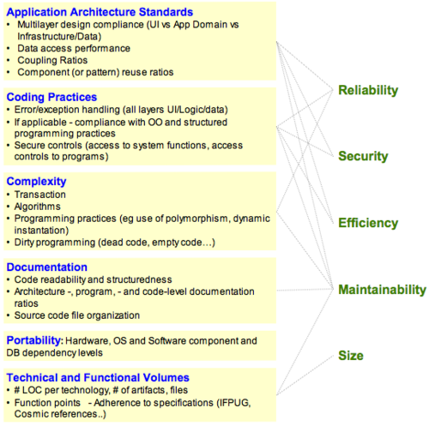](https://en.wikipedia.org/wiki/File:SoftwareQualityCharacteristicAttributeRelationship.png)Relationship between software desirable characteristics (right) and measurable attributes (left)

Software quality measurement is about quantifying to what extent a system or software possesses desirable characteristics. This can be performed through qualitative or quantitative means or a mix of both. In both cases, for each desirable characteristic, there are a set of measurable attributes the existence of which in a piece of software or system tend to be correlated and associated with this characteristic. For example, an attribute associated with portability is the number of target-dependent statements in a program. More precisely, using the [Quality Function Deployment](https://en.wikipedia.org/wiki/Quality_Function_Deployment) approach, these measurable attributes are the "hows" that need to be enforced to enable the "whats" in the Software Quality definition above.

The structure, classification and terminology of attributes and metrics applicable to software quality management have been derived or extracted from the [ISO 9126-3](https://en.wikipedia.org/wiki/ISO_9126) and the subsequent ISO/IEC 25000:2005 quality model. The main focus is on internal structural quality. Subcategories have been created to handle specific areas like business application architecture and technical characteristics such as data access and manipulation or the notion of transactions.

The dependence tree between software quality characteristics and their measurable attributes is represented in the diagram on the right, where each of the 5 characteristics that matter for the user (right) or owner of the business system depends on measurable attributes (left):

Application Architecture Practices

Coding Practices

Application Complexity

Documentation

Portability

Technical and Functional Volume

Correlations between programming errors and production defects unveil that basic code errors account for 92 percent of the total errors in the source code. These numerous code-level issues eventually count for only 10 percent of the defects in production. Bad software engineering practices at the architecture levels account for only 8 percent of total defects, but consume over half the effort spent on fixing problems, and lead to 90 percent of the serious reliability, security, and efficiency issues in production.[[61]](https://en.wikipedia.org/wiki/Software_quality#cite_note-61)[[62]](https://en.wikipedia.org/wiki/Software_quality#cite_note-62)

**Code-based analysis**

Many of the existing software measures count structural elements of the application that result from parsing the source code for such individual instructions[[63]](https://en.wikipedia.org/wiki/Software_quality#cite_note-63) tokens[[64]](https://en.wikipedia.org/wiki/Software_quality#cite_note-64) control structures ([Complexity](https://en.wikipedia.org/wiki/Software_complexity)), and objects.[[65]](https://en.wikipedia.org/wiki/Software_quality#cite_note-65)

Software quality measurement is about quantifying to what extent a system or software rates along these dimensions. The analysis can be performed using a qualitative or quantitative approach or a mix of both to provide an aggregate view [using for example weighted average(s) that reflect relative importance between the factors being measured].

This view of software quality on a linear continuum has to be supplemented by the identification of discrete [Critical Programming Errors](https://en.wikipedia.org/wiki/Software_quality#CriticalProgrammingErrors). These vulnerabilities may not fail a test case, but they are the result of bad practices that under specific circumstances can lead to catastrophic outages, performance degradations, security breaches, corrupted data, and myriad other problems[[66]](https://en.wikipedia.org/wiki/Software_quality#cite_note-66) that make a given system de facto unsuitable for use regardless of its rating based on aggregated measurements. A well-known example of vulnerability is the [Common Weakness Enumeration](https://en.wikipedia.org/wiki/Common_Weakness_Enumeration),[[67]](https://en.wikipedia.org/wiki/Software_quality#cite_note-67) a repository of vulnerabilities in the source code that make applications exposed to security breaches.

The measurement of critical application characteristics involves measuring structural attributes of the application's architecture, coding, and in-line documentation, as displayed in the picture above. Thus, each characteristic is affected by attributes at numerous levels of abstraction in the application and all of which must be included in calculating the characteristic's measure if it is to be a valuable predictor of quality outcomes that affect the business. The layered approach to calculating characteristic measures displayed in the figure above was first proposed by Boehm and his colleagues at TRW (Boehm, 1978)[[68]](https://en.wikipedia.org/wiki/Software_quality#cite_note-68) and is the approach taken in the ISO 9126 and 25000 series standards. These attributes can be measured from the parsed results of a static analysis of the application source code. Even dynamic characteristics of applications such as reliability and performance efficiency have their causal roots in the static structure of the application.

Structural quality analysis and measurement is performed through the analysis of the [source code](https://en.wikipedia.org/wiki/Source_code), the [architecture](https://en.wikipedia.org/wiki/Software_architecture), [software framework](https://en.wikipedia.org/wiki/Software_framework), [database schema](https://en.wikipedia.org/wiki/Database_schema) in relationship to principles and standards that together define the conceptual and logical architecture of a system. This is distinct from the basic, local, component-level code analysis typically performed by [development tools](https://en.wikipedia.org/wiki/Development_tool) which are mostly concerned with implementation considerations and are crucial during [debugging](https://en.wikipedia.org/wiki/Debugging) and [testing](https://en.wikipedia.org/wiki/Software_testing) activities.

**Reliability**

The root causes of poor reliability are found in a combination of non-compliance with good architectural and coding practices. This non-compliance can be detected by measuring the static quality attributes of an application. Assessing the static attributes underlying an application's reliability provides an estimate of the level of business risk and the likelihood of potential application failures and defects the application will experience when placed in operation.

Assessing reliability requires checks of at least the following software engineering best practices and technical attributes:

Application Architecture Practices

Coding Practices

Complexity of algorithms

Complexity of programming practices

Compliance with Object-Oriented and Structured Programming best practices (when applicable)

Component or pattern re-use ratio

Dirty programming

Error & Exception handling (for all layers - GUI, Logic & Data)

Multi-layer design compliance

Resource bounds management

Software avoids patterns that will lead to unexpected behaviors

Software manages data integrity and consistency

Transaction complexity level

Depending on the application architecture and the third-party components used (such as external libraries or frameworks), custom checks should be defined along the lines drawn by the above list of best practices to ensure a better assessment of the reliability of the delivered software.

**Efficiency**

As with Reliability, the causes of performance inefficiency are often found in violations of good architectural and coding practice which can be detected by measuring the static quality attributes of an application. These static attributes predict potential operational performance bottlenecks and future scalability problems, especially for applications requiring high execution speed for handling complex algorithms or huge volumes of data.

Assessing performance efficiency requires checking at least the following software engineering best practices and technical attributes:

Application Architecture Practices

Appropriate interactions with expensive and/or remote resources

Data access performance and data management

Memory, network and disk space management

Compliance with Coding Practices[[69]](https://en.wikipedia.org/wiki/Software_quality#cite_note-:0-69) ([Best coding practices](https://en.wikipedia.org/wiki/Best_coding_practices))

**Security**

Software quality includes [software security](https://en.wikipedia.org/wiki/Software_security).[[70]](https://en.wikipedia.org/wiki/Software_quality#cite_note-70) Many security vulnerabilities result from poor coding and architectural practices such as SQL injection or cross-site scripting.[[71]](https://en.wikipedia.org/wiki/Software_quality#cite_note-71)[[72]](https://en.wikipedia.org/wiki/Software_quality#cite_note-72) These are well documented in lists maintained by CWE,[[73]](https://en.wikipedia.org/wiki/Software_quality#cite_note-73) and the SEI/Computer Emergency Center [(CERT)](https://en.wikipedia.org/wiki/CERT_Coordination_Center) at Carnegie Mellon University.[[69]](https://en.wikipedia.org/wiki/Software_quality#cite_note-:0-69)

Assessing security requires at least checking the following software engineering best practices and technical attributes:

Implementation, Management of a security-aware and hardening development process, e.g. [Security Development Lifecycle](https://en.wikipedia.org/wiki/Security_Development_Lifecycle) (Microsoft) or IBM's Secure Engineering Framework.[[74]](https://en.wikipedia.org/wiki/Software_quality#cite_note-74)

Secure Application Architecture Practices[[75]](https://en.wikipedia.org/wiki/Software_quality#cite_note-75)[[76]](https://en.wikipedia.org/wiki/Software_quality#cite_note-76)

Multi-layer design compliance

Security best practices (Input Validation, SQL Injection, Cross-Site Scripting, Access control etc.)[[77]](https://en.wikipedia.org/wiki/Software_quality#cite_note-77)[[78]](https://en.wikipedia.org/wiki/Software_quality#cite_note-78)

Secure and good Programming Practices[[69]](https://en.wikipedia.org/wiki/Software_quality#cite_note-:0-69)

Error & Exception handling

**Maintainability**

[Maintainability](https://en.wikipedia.org/wiki/Maintainability) includes concepts of [modularity](https://en.wikipedia.org/wiki/Modularity), understandability, changeability, testability, reusability, and transferability from one development team to another. These do not take the form of critical issues at the code level. Rather, poor maintainability is typically the result of thousands of minor violations with best practices in documentation, complexity avoidance strategy, and basic programming practices that make the difference between clean and easy-to-read code vs. unorganized and difficult-to-read code.[[79]](https://en.wikipedia.org/wiki/Software_quality#cite_note-79)

Assessing maintainability requires checking the following software engineering best practices and technical attributes:

Application Architecture Practices

Architecture, Programs and Code documentation embedded in source code

Code readability

[Code smells](https://en.wikipedia.org/wiki/Code_smells)

Complexity level of transactions

Complexity of algorithms

Complexity of programming practices

Compliance with Object-Oriented and Structured Programming best practices (when applicable)

Component or pattern re-use ratio

Controlled level of dynamic coding

Coupling ratio

Dirty programming

Documentation

Hardware, OS, middleware, software components and database independence

Multi-layer design compliance

Portability

Programming Practices (code level)

Reduced [duplicate code](https://en.wikipedia.org/wiki/Duplicate_code) and functions

Source code file organization cleanliness

Maintainability is closely related to Ward Cunningham's concept of [technical debt](https://en.wikipedia.org/wiki/Technical_debt), which is an expression of the costs resulting of a lack of maintainability. Reasons for why maintainability is low can be classified as reckless vs. prudent and deliberate vs. inadvertent,[[80]](https://en.wikipedia.org/wiki/Software_quality#cite_note-80)[[81]](https://en.wikipedia.org/wiki/Software_quality#cite_note-81) and often have their origin in developers' inability, lack of time and goals, their carelessness and discrepancies in the creation cost of and benefits from documentation and, in particular, maintainable [source code](https://en.wikipedia.org/wiki/Source_code).[[82]](https://en.wikipedia.org/wiki/Software_quality#cite_note-82)

**Size**

Measuring software size requires that the whole source code be correctly gathered, including database structure scripts, data manipulation source code, component headers, configuration files etc. There are essentially two types of software sizes to be measured, the technical size (footprint) and the functional size:

There are several [software technical sizing](https://en.wikipedia.org/wiki/Software_Sizing) methods that have been widely described. The most common technical sizing method is number of [Lines of Code](https://en.wikipedia.org/wiki/Lines_of_Code) (#LOC) per technology, number of files, functions, classes, tables, etc., from which backfiring Function Points can be computed;

The most common for measuring functional size is [function point](https://en.wikipedia.org/wiki/Function_point) analysis. Function point analysis measures the size of the software deliverable from a user's perspective. Function point sizing is done based on user requirements and provides an accurate representation of both size for the developer/estimator and value (functionality to be delivered) and reflects the business functionality being delivered to the customer. The method includes the identification and weighting of user recognizable inputs, outputs and data stores. The size value is then available for use in conjunction with numerous measures to quantify and to evaluate software delivery and performance (development cost per function point; delivered defects per function point; function points per staff month.).

The function point analysis sizing standard is supported by the International Function Point Users Group ([IFPUG](https://en.wikipedia.org/wiki/IFPUG)). It can be applied early in the software development life-cycle and it is not dependent on lines of code like the somewhat inaccurate Backfiring method. The method is technology agnostic and can be used for comparative analysis across organizations and across industries.

Since the inception of Function Point Analysis, several variations have evolved and the family of functional sizing techniques has broadened to include such sizing measures as COSMIC, NESMA, Use Case Points, FP Lite, Early and Quick FPs, and most recently Story Points. Function Point has a history of statistical accuracy, and has been used as a common unit of work measurement in numerous application development management (ADM) or outsourcing engagements, serving as the "currency" by which services are delivered and performance is measured.

One common limitation to the Function Point methodology is that it is a manual process and therefore it can be labor-intensive and costly in large scale initiatives such as application development or outsourcing engagements. This negative aspect of applying the methodology may be what motivated industry IT leaders to form the Consortium for IT Software Quality focused on introducing a computable metrics standard for automating the measuring of software size while the IFPUG keep promoting a manual approach as most of its activity rely on FP counters certifications.

[CISQ](https://en.wikipedia.org/wiki/CISQ) defines Sizing as to estimate the size of software to support cost estimating, progress tracking or other related software project management activities. Two standards are used: *Automated Function Points* to measure the functional size of software and *Automated Enhancement Points* to measure the size of both functional and non-functional code in one measure.[[83]](https://en.wikipedia.org/wiki/Software_quality#cite_note-83)

**Identifying critical programming errors**

Critical Programming Errors are specific architectural and/or coding bad practices that result in the highest, immediate or long term, business disruption risk.[[84]](https://en.wikipedia.org/wiki/Software_quality#cite_note-84)

These are quite often technology-related and depend heavily on the context, business objectives and risks. Some may consider respect for naming conventions while others – those preparing the ground for a knowledge transfer for example – will consider it as absolutely critical.

Critical Programming Errors can also be classified per CISQ Characteristics. Basic example below:

Reliability

Avoid software patterns that will lead to unexpected behavior ([Uninitialized variable](https://en.wikipedia.org/wiki/Uninitialized_variable), null pointers, etc.)

Methods, procedures and functions doing Insert, Update, Delete, Create Table or Select must include error management

Multi-thread functions should be made thread safe, for instance servlets or [struts](https://en.wikipedia.org/wiki/Apache_Struts) action classes must not have instance/non-final static fields

Efficiency

Ensure centralization of client requests (incoming and data) to reduce network traffic

Avoid SQL queries that don't use an index against large tables in a loop

Security

Avoid fields in servlet classes that are not final static

Avoid data access without including error management

Check control return codes and implement error handling mechanisms

Ensure input validation to avoid cross-site scripting flaws or SQL injections flaws

Maintainability

Deep inheritance trees and nesting should be avoided to improve comprehensibility

Modules should be loosely coupled (fanout, intermediaries) to avoid propagation of modifications

Enforce homogeneous naming conventions

**Operationalized quality models**

Newer proposals for quality models such as [Squale](https://en.wikipedia.org/wiki/Squale) and Quamoco[[85]](https://en.wikipedia.org/wiki/Software_quality#cite_note-85) propagate a direct integration of the definition of quality attributes and measurement. By breaking down quality attributes or even defining additional layers, the complex, abstract quality attributes (such as reliability or maintainability) become more manageable and measurable. Those quality models have been applied in industrial contexts but have not received widespread adoption.

A **software review** is "a process or meeting during which a software product is examined by a project personnel, managers, users, customers, user representatives, or other interested parties for comment or approval".[[1]](https://en.wikipedia.org/wiki/Software_review#cite_note-ieee35-1)

In this context, the term "software product" means "any technical document or partial document, produced as a deliverable of a software development activity", and may include documents such as contracts, project plans and budgets, requirements documents, specifications, designs, source code, user documentation, support and maintenance documentation, test plans, test specifications, standards, and any other type of specialist work product.

**Varieties of software review**

Software reviews may be divided into three categories:

[Software peer reviews](https://en.wikipedia.org/wiki/Software_peer_review) are conducted by one or more colleagues of the author, to evaluate the technical content and/or quality of the work.[[2]](https://en.wikipedia.org/wiki/Software_review#cite_note-2)

[Software management reviews](https://en.wikipedia.org/wiki/Software_management_review) are conducted by management representatives to evaluate the status of work done and to make decisions regarding downstream activities.

[Software audit reviews](https://en.wikipedia.org/wiki/Software_audit_review) are conducted by personnel external to the software project, to evaluate [compliance](https://en.wikipedia.org/wiki/Compliance_(regulation)) with specifications, standards, contractual agreements, or other criteria.

**Different types of peer reviews**

[Code review](https://en.wikipedia.org/wiki/Code_review) is systematic examination (often as [peer review](https://en.wikipedia.org/wiki/Software_peer_review)) of computer source code.

[Pair programming](https://en.wikipedia.org/wiki/Pair_programming) is a type of code review where two persons develop code together at the same workstation.

[Inspection](https://en.wikipedia.org/wiki/Software_inspection) is a very formal type of peer review where the reviewers are following a well-defined process to find defects.

[Walkthrough](https://en.wikipedia.org/wiki/Software_walkthrough) is a form of peer review where the author leads members of the development team and other interested parties go through a software product and the participants ask questions and make comments about defects.

[Technical review](https://en.wikipedia.org/wiki/Software_technical_review) is a form of peer review in which a team of qualified personnel examines the suitability of the software product for its intended use and identifies discrepancies from specifications and standards.

**Formal versus informal reviews**

"Formality" identifies the degree to which an activity is governed by agreed (written) rules. Software review processes exist across a spectrum of formality, with relatively unstructured activities such as "buddy checking" towards one end of the spectrum, and more formal approaches such as walkthroughs, technical reviews, and software inspections, at the other. IEEE Std. 1028-1997 defines formal structures, roles and processes for each of the last three ("formal peer reviews"), together with [software audits](https://en.wikipedia.org/wiki/Software_quality_assurance).[[1]](https://en.wikipedia.org/wiki/Software_review#cite_note-ieee35-1) IEEE 1028-1997 was succeeded by IEEE 1028-2008.[[3]](https://en.wikipedia.org/wiki/Software_review#cite_note-3)

Research studies[[*who?*](https://en.wikipedia.org/wiki/Wikipedia:Manual_of_Style/Words_to_watch#Unsupported_attributions)] tend to support the conclusion that formal reviews greatly outperform informal reviews in cost-effectiveness. Informal reviews may often be unnecessarily expensive (because of time-wasting through lack of focus) and frequently provide a sense of security which is quite unjustified by the relatively small number of real defects found and repaired.

**IEEE 1028 generic process for formal reviews**

**IEEE 1028** defines a common set of activities for "formal" reviews (with some variations, especially for software audit). This standard applies distinctions between [management review](https://en.wikipedia.org/wiki/Software_management_review), [technical review](https://en.wikipedia.org/wiki/Software_technical_review), [inspection](https://en.wikipedia.org/wiki/Software_inspection), [walk-through](https://en.wikipedia.org/wiki/Software_walkthrough), [audit](https://en.wikipedia.org/wiki/Software_audit_review), etc.

The stipulated sequence of standard activities is largely based on the software inspection process originally developed at IBM by [Michael Fagan](https://en.wikipedia.org/wiki/Fagan_inspection).[[4]](https://en.wikipedia.org/wiki/Software_review#cite_note-MFaganPapers-4) Differing types of review may apply this structure with varying degrees of rigour, but all activities are mandatory for inspection:

**0. [Entry evaluation]:** The review leader uses a standard checklist of entry criteria to ensure that optimum conditions exist for a successful review.

**1. Management preparation:** Responsible management ensure that the review will be appropriately resourced with staff, time, materials and tools, and will be conducted according to policies, standards or other relevant criteria.

**2. Planning the review:** The review leader identifies or confirms the objectives of the review, organises a team of reviewers and ensures that the team is equipped with all necessary resources for conducting the review.

**3. Overview of review procedures:** The review leader, or some other qualified person, ensures (at a meeting if necessary) that all reviewers understand the review goals, the review procedures, the materials available to them and the procedures for conducting the review.

**4. [Individual] Preparation:** The reviewers individually prepare for group examination of the work under review, by examining it carefully for "anomalies" (potential defects), the nature of which will vary with the type of review and its goals.

**5. [Group] Examination:** The reviewers meet at a planned time to pool the results of their preparation activity and arrive at a consensus regarding the status of the document (or activity) being reviewed.

**6. Rework/follow-up:** The author of the work product (or other assigned person) undertakes whatever actions are necessary to repair defects or otherwise satisfy the requirements agreed to at the examination meeting. The review leader verifies that all action items are closed.

**7. [Exit evaluation]:** The review leader verifies that all activities necessary for successful review have been accomplished and that all outputs appropriate to the type of review have been finalized.

**Value of reviews**

The most obvious value of software reviews (especially formal reviews) is that they can identify issues earlier and more cheaply than they would be identified by testing or by field use (the "defect detection process").[[5]](https://en.wikipedia.org/wiki/Software_review#cite_note-5) The cost to find and fix a defect by a well-conducted review may be one or two orders of magnitude less than when the same defect is found by test execution or in the field.[[*citation needed*](https://en.wikipedia.org/wiki/Wikipedia:Citation_needed)]

A second, but ultimately more important, value of software reviews is that they can be used to train technical authors in the development of extremely low-defect documents, and also to identify and remove process inadequacies that encourage defects (the "defect prevention process").

This is particularly the case for [peer reviews](https://en.wikipedia.org/wiki/Software_peer_review) if they are conducted early and often, on samples of work, rather than waiting until the work has been completed. Early and frequent reviews of small work samples can identify systematic errors in the author's work processes, which can be corrected before further faulty work is done. This improvement in author skills can dramatically reduce the time it takes to develop a high-quality technical document and dramatically decrease the error-rate in using the document in downstream processes.

As a general principle, the earlier a technical document is produced, the greater will be the impact of its defects on any downstream activities and their work products. Accordingly, greatest value will accrue from early reviews of documents such as marketing plans, contracts, project plans and schedules and requirements specifications. Researchers and practitioners have shown the effectiveness of reviewing process in finding bugs and security issues.[[6]](https://en.wikipedia.org/wiki/Software_review#cite_note-6)

**Software Review - Software Engineering**

Last Updated : 29 Jan, 2024

**Software Review** is a systematic inspection of software by one or more individuals who work together to find and resolve errors and defects in the software during the early stages of the Software Development Life Cycle (SDLC). A software review is an essential part of the Software Development Life Cycle (SDLC) that helps software engineers in validating the quality, functionality, and other vital features and components of the software. It is a whole process that includes testing the software product and it makes sure that it meets the requirements stated by the client.   
  
Usually performed manually, software review is used to verify various documents like requirements, system designs, codes, test plans, and test cases.

**Objectives of Software Review**

The objective of the software review is:

To improve the productivity of the development team.

To make the testing process time and cost-effective.

To make the final software with fewer defects.

To eliminate the inadequacies.

**Process of Software Review**

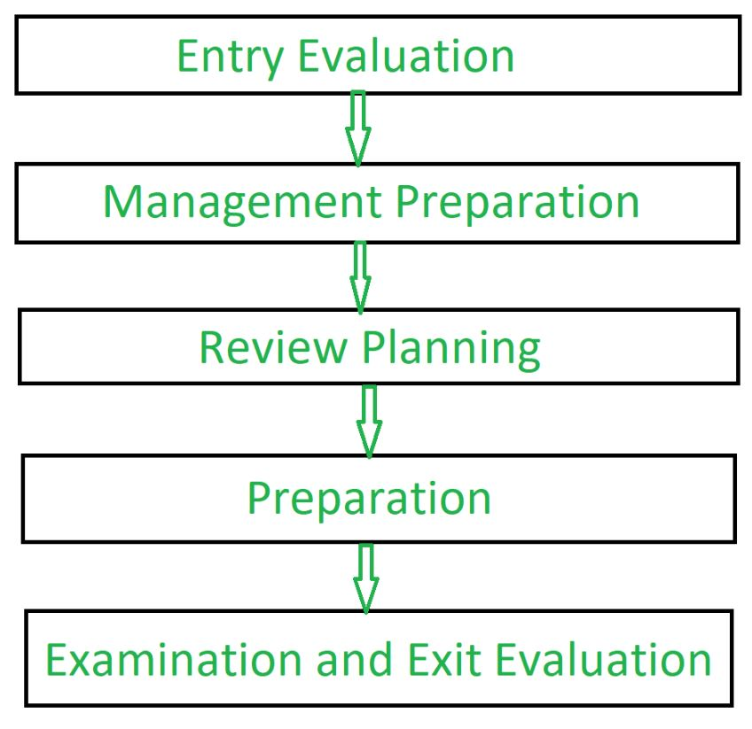Software Review process

**Entry Evaluation:** By confirming documentation, fulfilling entry requirements and assessing stakeholder and team preparation, you can determine the software's availability.

**Management Preparation**: To get ready for the review process, assign roles, gather resources and provide brief management.

**Review Planning:** Establish the review's goals and scope, invite relevant parties and set a time for the meeting.

**Preparation**: Distribute appropriate resources, give reviewers time to get familiar and promote issue identification to help them prepare.

**Examination and Exit Evaluation:** Reviewers should collaborate to examine the results, record concerns, and encourage candid communication in meetings. It  assess the results, make remedial plans based on flaws that have been reported and assess the process's overall efficacy.

**Types of Software Reviews**

There are mainly 3 types of software reviews:

**1. Software Peer Review**

Peer review is the process of assessing the technical content and quality of the product and it is usually conducted by the author of the work product along with some other developers.   
Peer review is performed in order to examine or resolve the defects in the software, whose quality is also checked by other members of the team.

Peer Review has following types:

**Code Review:** Computer source code is examined in a systematic way.

**Pair Programming:** It is a code review where two developers develop code together at the same platform.

**Walkthrough:** Members of the development team is guided by author and other interested parties and the participants ask questions and make comments about defects.

**Technical Review:** A team of highly qualified individuals examines the software product for its client's use and identifies technical defects from specifications and standards.

**Inspection:** In inspection the reviewers follow a well-defined process to find defects.

**2. Software Management Review**

Software Management Review evaluates the work status. In this section decisions regarding downstream activities are taken.

**3. Software Audit Review**

Software Audit Review is a type of external review in which one or more critics, who are not a part of the development team, organize an independent inspection of the software product and its processes to assess their compliance with stated specifications and standards. This is done by managerial level people.

**Advantages of Software Review**

Defects can be identified earlier stage of development (especially in formal review).

Earlier inspection also reduces the maintenance cost of software.

It can be used to train technical authors.

It can be used to remove process inadequacies that encourage defects.

**Software reviews**

Software reviews are an essential part of the Software Development Life Cycle (SDLC).

A **software review** is a task in which a group of people tries to resolve the errors and defects in particular software.

Reviews play an important role in developing any software model.

**Objectives of a software review**

We can use software reviews to discover the expectations that clients have from us.

We can use them to identify and eliminate any errors and defects in the software.

We can utilize them to reduce the gap between the clients’ demands and the developer’s supply of products.

Process of software review

**Types of software reviews**

There are three types of software reviews:

*Software peer reviews*

*Software management reviews*

*Software audit reviews*

**Software peer review**

Generally, a **software peer review** is performed to detect any errors in the software and correct them. The quality of the software is also checked during this process.

A peer review may be categorized as:

**Code review**: In this type of software peer review, the written code is scrutinized to detect any possible errors.

**Pair programming**: In this type of peer review, two developers work on the same code and develop it.

**Walkthrough**: In this type of peer review, the senior-most members guide the development team to work and correct errors and/or defects in the software.

**Technical review**: In this type of peer review, the senior-most members of the team test the products and give their feedback on them.

**Inspection**: In this type of peer review, the inspection process is carried out step by step to find any possible errors in the software.

**Software management review**

The **software management review** process involves a team of reviewers checking the status of the work that is performed by developers.

**Advantages of a software management review**

A software management review helps us check the status of the work.

We can use this type of review to see whether the project is up-to-date or not.

**Software audit review**

**Software audit reviews** are reviewed in which people from the development team participate in discussions and suggest ideas for the project. They also try to create solutions for any errors that they encounter in the software under discussion.

**Advantages of a software audit review**

We can use software reviews to detect errors at an early stage of the software’s development.

Software reviews help us save time, in cases where an error is detected at an early stage of the software’s development process.

We can use software reviews to discover what the client’s expectations are from the developers.

Top 30+ Software Development Metrics to Track in 2025

Engineering leaders must deliver quality products while keeping morale high and tech debt low. Key software engineering metrics provide visibility to spot issues, manage risks, and boost productivity.

Read this guide to learn more about the software engineering metrics, their types, benefits, key uses, and limitations.

What are Software Engineering Metrics?

Software engineering metrics are quantitative measures used to assess the efficiency, quality, and performance of software development processes, teams, and systems. These metrics provide insights into various aspects of the software lifecycle, including code quality, testing effectiveness, delivery speed, and project health.

Why measure Software Development Metrics?

Here are the reasons why software development metrics should be measured:

Monitor productivity and efficiency: Identify areas where teams are improving or falling behind.

Detect issues early: Spot bugs, performance issues, or process inefficiencies before they escalate.

Improve code quality and system reliability: Track test coverage, technical debt, and refactoring to maintain code health.

Align development with business outcomes: Checks that the engineering work supports key company goals.

Track team health and issues: Monitor lead time, rework, and responsiveness to support a sustainable pace.

Software Measurement Principles

Some of the basic principles of software measurement are:

Use metrics to promote improvement, and not assign blame to anyone.

Confirm that the data collection is consistent and automated to reduce manual effort and human error.

Focus on long-term trends, not isolated data points.

Keep metrics transparent and context-rich so that teams can interpret them correctly.

Align metrics with business and team goals to stay relevant and actionable.

Read More: All about Agile SDLC (Software Development Life Cycle)

Characteristics of Software Metrics

Here are the characteristics of software metrics:

Measurable: The metric must be quantifiable with numerical values.

Reproducible: Results should remain consistent under the same conditions.

Actionable: Should offer insights that allow for informed decisions and improvements.

Simple: Easy to understand and interpret by all stakeholders.

Cost-effective: The effort and resources to collect the metric should be justified by its value.

Types of Software Engineering Metrics

Some of the types of software engineering metrics are:

Product Metrics: Focus on the quality and performance of the software product, like code complexity or test coverage.

Process Metrics: Track efficiency and effectiveness of software development processes, such as cycle time or deployment frequency.

Project Metrics: Help to track the progress and health of software projects, including burndown rate and cost variance.

Resource Metrics: Measure how well teams and tools are utilized during development.

Maintenance Metrics: Evaluate the effort spent on ongoing tasks like bug fixes, refactoring, and updates.

Quality Metrics: Reflect factors such as system reliability, stability, and user satisfaction.

Read More: What is Quality Assurance Testing?

Key Engineering Areas for Measurement

Check out these key engineering areas for measurement:

Code quality and complexity

Testing and automation effectiveness

Team performance and speed

Deployment and release health

User experience and feedback

Delivery timelines and predictability

BrowserStack Quality Engineering Insights

30+ Software Engineering Metrics to Track in 2025

Tracking the correct software engineering metrics helps organizations to improve product quality, team performance, and delivery efficiency.

These metrics help in strong decision-making, support agile practices, and align strategically with business goals.

Here are 30+ software engineering metrics that has been categorized into product, process and project metrics:

Product Metrics

Test and Code Coverage Percentage: Shows the extent to which the codebase is covered by automated tests, indicating test completion. Higher coverage improves confidence in code stability but doesn’t guarantee bug-free software.

Read More: Code Coverage vs Test Coverage

Cyclomatic Complexity: Measures the number of independent paths through the code, helping assess its maintainability. Lower complexity often means simpler, easier-to-test code, while high values may signal refactoring needs.

Defect Leakage: Tracks bugs found post-release to identify gaps in testing or quality checks. A high leakage rate indicates issues in the testing lifecycle or requirements clarity.

Read More: Defect Management in Software Testing

Technical Debt: Calculates the long-term cost of quick fixes or sub-optimal code implementations and helps teams prioritize refactoring and maintainability to avoid future development slowdowns.

Pull Request Size: Monitors lines of code in a PR to manage review effort and reduce integration issues. Smaller, focused PRs are easier to review, test, and merge with fewer conflicts.

Response Time: Measures the time taken by the application to respond to a user’s action. It has a direct impact on user experience as lower response times lead to higher satisfaction.

Throughput: Indicates the amount of work delivered in a given time, such as features or fixes. Useful for assessing team productivity and identifying process bottlenecks.

Automation Health: Evaluates the pass/fail rate of automated tests, showcasing the test suite stability. Frequent failures may highlight flaky tests or unstable environments needing attention.

Release Velocity: Tracks how frequently production releases occur, showing delivery pace. It encourages smaller, faster iterations that reduce risk and improve feedback cycles.

Error Rate: Monitors the frequency of errors encountered in production environments in multiple phases. A high error rate can indicate system instability, poor testing, or scaling issues.

Net Promoter Score (NPS): Net Promoter Score is a leading indicator of product-market fit and overall user happiness. It captures customer loyalty and satisfaction by measuring willingness to recommend.

User Engagement: Measures how often and how deeply users interact with your software or features. High engagement often correlates with usability, value delivery, and retention success.

Read More: What is End User Experience Monitoring?

Process Metrics

Lead Time for Changes: Measures how often and how deeply users interact with your software or features.  A shorter lead time means faster feedback loops and quicker customer value delivery.

Deployment Frequency: Tracks how often code is pushed to production, reflecting team agility and DevOps maturity.  High frequency often indicates robust automation and a stable CI/CD pipeline.

Rework: Identifies how much code is rewritten shortly after delivery, often signaling quality issues or unclear requirements.   Frequent rework may highlight misalignment between design, development, and testing phases.

Commit Complexity: Analyze the difficulties of a code commit to predict potential risk or review effort required.   Complex commits tend to introduce more bugs and require more thorough reviews.

Development Velocity: Monitors the volume of work completed in a sprint, usually measured in story points or tasks.   This helps assess if the team is maintaining a steady and predictable delivery pace.

Scope Completion Ratio: Compares planned work at the start of a sprint versus what was actually delivered.   Low ratios may indicate over-commitment, technical blockers, or team capacity issues.

Scope Added After Sprint Start: Measures the amount of unplanned work added mid-sprint, helping flag scope creep.  Frequent mid-sprint changes can disrupt flow and reduce sprint focus and stability.

Cycle Time and Lead Time: Cycle time measures from work start to finish, while lead time includes wait time from request to delivery.   Monitoring both helps identify delays and streamline the development pipeline.

Change Failure Rate: Calculates the percentage of deployments that result in failures or require fixes.  A lower rate signifies better pre-release testing and stronger release readiness.

Mean Time to Repair (MTTR): Tracks how long it takes to recover from failures, impacting system resilience.  Faster recovery minimizes downtime and helps maintain user trust.

Responsiveness: Indicates how quickly the team responds to pull requests, bugs, or internal requests.   Quick responses improve collaboration and reduce wait time for contributors.

PR Iteration Time: Shows how many rounds of review a pull request undergoes before merging.   More iterations may reflect complex code, unclear goals, or low initial quality.

Thoroughly Reviewed PRs: Tracks the percentage of pull requests that go through complete and detailed peer reviews. Consistent reviews contribute to higher code quality and team knowledge sharing.

Time to Merge: Measures the time between PR creation and when it is merged, indicating review process efficiency.   Long merge times may slow down delivery and cause integration delays.

Time to First Comment: Calculates how long it takes for a reviewer to leave feedback on a new PR, showing engagement speed.  Faster first comments help maintain momentum and developer engagement.

Project Metrics

Legacy Refactor: Measures the effort spent on modernizing or improving old codebases to improve maintainability and reduce technical debt.

Burndown Chart:A Visual tool that plots remaining work versus time during a sprint, helping teams track progress and forecast sprint completion.

Cost Variance: Checks the difference between planned and actual costs to keep the project within budget and assess financial efficiency.

Scope Creep: Tracks unplanned work additions during a project lifecycle, often indicating a lack of scope control or changing requirements.

**What is an Informal Review?**

An informal review is a type of software review that is conducted in an informal setting, without strict guidelines or procedures. Unlike formal reviews, which are typically conducted by a designated [team](https://thecodest.co/es/diccionario/como-dirigir-un-equipo-de-desarrollo-de-software/) with a specific agenda, informal reviews are more ad hoc and are often conducted by individuals or small groups without a formal structure or process.

Informal reviews can take many forms, including [code](https://thecodest.co/es/diccionario/que-es-la-refactorizacion-del-codigo/) reviews, design reviews, and testing reviews. They can be conducted by peers, managers, or even customers, and can be used to identify potential issues, assess the quality of the software, and provide feedback for improvement.

One of the benefits of informal reviews is that they are often less time-consuming and less formal than formal reviews. This makes them more accessible to developers and other stakeholders who may not have the time or resources to participate in a formal review process. Informal reviews can also be more flexible, allowing participants to focus on specific areas of interest or concern.

However, informal reviews also have some limitations. Because they are less structured than formal reviews, they may not provide the same level of rigor or depth of analysis. Additionally, because they are often conducted by individuals or small groups, they may not provide a comprehensive view of the software or its quality.

Overall, informal reviews can be a valuable tool for [software development](https://thecodest.co/es/blog/8-preguntas-clave-para-su-socio-de-desarrollo-de-software-outsourcing/) teams looking to improve the quality of their software. By providing a more flexible and accessible review process, informal reviews can help identify potential issues and provide feedback for improvement, ultimately leading to higher-quality software and better outcomes for users.

Review

A review is a type of testing where a group of people discuss the product produced by the developer, detect errors, and try to correct them in a systematic manner.

Reviews play a key role in the software testing process.

Types of reviews

There are two types of reviews:

Informal reviews

Formal reviews

Informal reviews

Informal reviews take place between two or three people. The review conference is scheduled at their convenience.

This meeting is generally scheduled during the free time of the team members.

There is no planning for the meeting.

If any errors occur, they are not corrected in the informal reviews.

There is no guidance from the team.

This review is less effective compared to the formal review.

Formal reviews

Formal reviews take place among a team of three to five members. In the formal review, the members discuss the software model.

This meeting is scheduled beforehand. This gives the team members time to prepare.

This meeting consists of a professional team that identifies and corrects errors in the model.

This meeting does not exceed two hours.

Review meeting

At the end of the meeting, there is an acceptance stage. It involves the following three rules:

If the project meets the expectations, they accept the model.

If the project has a significant amount of errors, they reject the model, ask to modify it, and have another review meeting.

If the project has only a few errors, the team asks to correct the mistakes, and there are no further review meetings.

In addition, a formal technical review summary report is taken.

This report answers three questions:

What was reviewed?

Who reviewed it?

What were the findings and conclusions?

**Different Phases of Formal Review**

Last Updated : 15 Jul, 2025

**Formal Review** generally takes place in piecemeal approach that consists of six different steps that are essential. Formal review generally obeys formal process. It is also one of the most important and essential techniques required in static testing.

Six steps are extremely essential as they allow team of developers simply to ensure and check [software quality](https://www.geeksforgeeks.org/software-engineering/software-engineering-software-quality/), efficiency, and effectiveness. These steps are given below :

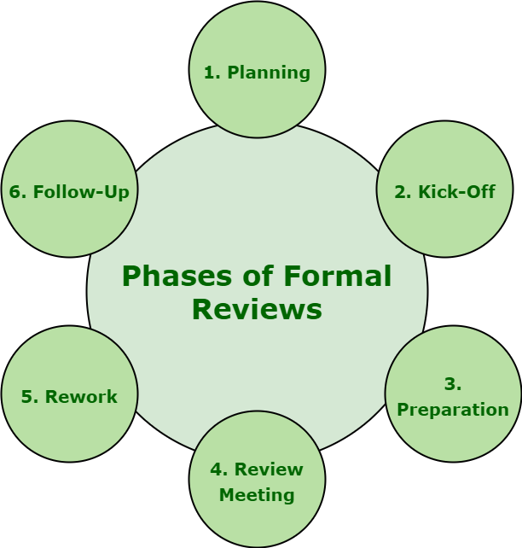Phases of Formal Reviews

**Planning :** For specific review, review process generally begins with ‘request for review’ simply by author to moderator or inspection leader. Individual participants, according to their understanding of document and role, simply identify and determine defects, questions, and comments. Moderator also performs entry checks and even considers exit criteria.

**Kick-Off :** Getting everybody on the same page regarding document under review is the main goal and aim of this meeting. Even entry result and exit criteria are also discussed in this meeting. It is basically an optional step. It also provides better understanding of team about relationship among document under review and other documents. During kick-off, Distribution of document under review, source documents, and all other related documentation can also be done.

**Preparation :** In preparation phase, participants simply work individually on document under review with the help of related documents, procedures, rules, and provided checklists. Spelling mistakes are also recorded on document under review but not mentioned during meeting. These reviewers generally identify and determine and also check for any defect, issue or error and offer their comments, that later combined and recorded with the assistance of logging form, while reviewing document.

**Review Meeting :** This phase generally involves three different phases i.e. logging, discussion, and decision. Different tasks are simply related to document under review is performed.

**Rework :** Author basically improves document that is under review based on the defects that are detected and improvements being suggested in review meeting. Document needs to be reworked if total number of defects that are found are more than an unexpected level. Changes that are done to document must be easy to determine during follow-up, therefore author needs to indicate changes are made.

**Follow-Up :** Generally, after rework, moderator must ensure that all satisfactory actions need to be taken on all logged defects, improvement suggestions, and change requests. Moderator simply makes sure that whether author has taken care of all defects or not. In order to control, handle, and optimize review process, moderator collects number of measurements at every step of process. Examples of measurements include total number of defects that are found, total number of defects that are found per page, overall review effort, etc.

**Individual Assessment:**The stage prior to the official group meeting during which each reviewer conducts an independent examination of the artefacts.

**Meeting for Group Review:** The cooperative stage in which the review panel discusses over results, resolves conflicts and makes choices regarding the examined artifacts.

**Finalization and Record-Keeping**: Completing the formal review procedure, recording the results and being ready for any necessary follow-up measures.

**Metrics and Ongoing Improvement:** Finding opportunities for ongoing improvement and evaluating the success of the formal review process through the tracking and analysis of review metrics.

**Importance of Different Phases of Formal Review**

**Early Defect Detection:**By catching errors early in the development process, formal reviews lower the effort and expense involved in fixing them.

**Knowledge Sharing:** Team members collaborate and share knowledge during various stages, which promotes a culture of ongoing learning and development.

**Process Improvement:** Through the formal review process, reoccurring issues are found, which helps development processes become more refined and improved over time.

**Quality Assurance:**By verifying that the programme complies with established standards and criteria, formal reviews make an important contribution to quality assurance.

**Conclusion**

The many stages of formal review are essential for guaranteeing effectiveness, integrity, and quality of the software development process. In the pursuit of software development excellence, it is imperative for organizations to embrace and optimize the various stages of formal review in order to produce software products that are strong, dependable and of superior quality.

ey takeaways

Project managers should involve all key stakeholders in the design review process by setting clear expectations and facilitating open, balanced discussions that capture everyone’s input.

After the review, they should thoroughly document the feedback, assign tasks, and set deadlines to keep the project moving forward and aligned with everyone’s expectations.

Using tools like Jira, Wrike, and ClickUp to organize feedback, track tasks, and facilitate communication can make each stage of the design process smoother and more efficient.

What is a design review?

Definition and purpose

A design review is a formal process used to evaluate the design aspects of a project or product to make sure they meet the defined requirements and standards before proceeding to the next phase of development.

The goal is to identify potential issues, validate design decisions, and establish alignment with project objectives, thereby minimizing risks and preventing costly changes later in the project lifecycle.

**Objectives of a design review include the following:**

**Ensure design feasibility:** Confirm that the design can be realistically implemented within the project’s technical, financial, and time constraints.

**Validate requirements compliance:** See to it that the design meets all the functional, performance, and regulatory requirements defined at the project’s outset.

**Identify and mitigate risks:** Detect any potential design flaws or risks that could lead to failures or delays in later stages.

**Enhance stakeholder alignment:** Ensure that all stakeholders are on the same page regarding the design, reducing the likelihood of misunderstandings or misaligned expectations.

**Facilitate informed decision-making:** Provide a basis for making informed decisions about moving forward with the design, making adjustments, or revisiting [earlier project phases](https://technologyadvice.com/blog/project-management/phases-of-project-management/) if necessary.

Why does design review matter?

Design reviews are crucial because they serve as a quality control mechanism. They keep the project on track and aligned with its intended goals, making them a crucial consideration when [defining a project management system](https://technologyadvice.com/blog/project-management/project-management-system/).

They provide a structured opportunity to catch potential issues early, saving time and resources by preventing costly rework.

**Key reasons why design reviews matter:**

**Quality assurance:** Design reviews help maintain high standards by ensuring the design meets all required specifications and quality benchmarks.

**Risk management:** They allow teams to identify and address potential risks early in the process, reducing the likelihood of significant issues arising later.

**Cost efficiency:** By catching errors or design flaws before development begins, design reviews help avoid expensive rework and delays.

**Stakeholder alignment:** Regular reviews keep all stakeholders informed and aligned, ensuring that everyone has a clear understanding of the project’s direction and progress.

**Innovation and improvement:** The review process encourages feedback and brainstorming, which can lead to improvements in the design and potentially uncover better solutions.

In essence, design reviews are a proactive step in project management that not only safeguard the project’s success but also contribute to more efficient and effective project execution.

Types of design reviews

Stakeholder design reviews

A stakeholder design review involves gathering feedback from key stakeholders, including clients, end-users, and team members, to ascertain that the design aligns with their expectations and project objectives.

During the stakeholder design review, the design is presented in detail, and stakeholders are invited to provide their input, ask questions, and express any concerns they might have. The goal is to make sure that all stakeholder perspectives are considered before the project moves forward.

**Key aspects of a stakeholder design review:**

**Alignment with stakeholder needs:** Guarantees the design addresses the specific needs and requirements of all key stakeholders.

**Early detection of issues:** Provides an opportunity to identify and address potential concerns or misalignments early in the process.

**Enhanced buy-in:** Involving stakeholders in the review process fosters a sense of ownership and increases their buy-in and support for the project.

**Clear communication:** Facilitates open communication between the design team and stakeholders, ensuring that everyone is on the same page.

**Decision-making support:** Offers a platform for making informed decisions about design adjustments or approvals based on stakeholder feedback.

Peer design reviews

A peer design review is a collaborative process where members of the design team or professionals with similar expertise evaluate each other’s work to ensure it meets the project’s technical and quality standards.

This type of review is particularly valuable because peers can provide insightful feedback based on their own experience and knowledge, which can lead to improvements in the design.

The goal is to catch errors, improve the design’s quality, and ensure that it adheres to the project’s technical requirements.

**Key aspects of a peer design review:**

**Expert feedback:** Leverages the expertise of peers who understand the technical nuances and challenges of the design.

**Error detection:** Helps identify mistakes or oversights that may have been missed by the original designer, improving overall design quality.

**Knowledge sharing:** Encourages the exchange of ideas and best practices within the team, fostering a culture of continuous improvement.

**Technical validation:** Ensures that the design aligns with technical standards and project requirements, reducing the risk of issues later in the project.

**Collaboration and learning:** Provides a platform for team members to learn from one another and collaboratively refine the design.

Customer design reviews

A customer design review is a process that involves presenting the design to the end customer for their evaluation and feedback.

Unlike internal reviews, this type of review focuses on ensuring that the design meets the customer’s specific needs, preferences, and expectations.

It’s an opportunity to verify that the design aligns with what the customer envisioned and provides them with a chance to suggest changes before [the project plan](https://technologyadvice.com/blog/project-management/project-plan-examples/) advances to later stages.

**Key aspects of a customer design review:**

**Customer satisfaction:** Ensures that the design meets or exceeds the customer’s expectations and requirements, leading to higher satisfaction.

**Direct feedback:** Provides the design team with direct input from the customer, allowing for adjustments that align more closely with their vision.

**Pre-delivery validation:** Acts as a final checkpoint before the project moves into development or production, reducing the risk of rework or dissatisfaction later.

**Relationship building:** Strengthens the relationship between the project team and the customer by involving them in the design process and showing that their input is valued.

**Expectation management:** Helps to manage and clarify expectations, ensuring that both the design team and the customer have a shared understanding of the project’s direction.

Steps of the design review process

Whether you’re using an [innovative project management strategy](https://technologyadvice.com/blog/project-management/innovative-project-management-strategies/) or employing a top-down approach, there are a few clear steps you should follow during design review.

Planning the design review

This initial step ensures the design review process is focused and productive. During this phase, it’s crucial to organize all the necessary details such as the scope of the work, objectives, and participants of the review. Some of the main considerations during this step are:

**Defining the scope:** Clearly outline which aspects of the design will be reviewed to keep the meeting focused and prevent it from becoming too broad.

**Setting objectives:** Establish what the review is meant to achieve, whether it’s validating the design against requirements, identifying potential issues, or gathering stakeholder feedback.

**Selecting participants:** Choose the right mix of participants, including designers, engineers, stakeholders, and possibly customers, to ensure a comprehensive review.

**Preparing materials:** Gather all necessary design documents, models, or prototypes in advance so that the review can proceed smoothly.

**Creating an agenda:** Develop a structured agenda that outlines the topics to be covered, the sequence of discussions, and the time allotted for each section.

Conducting the review

Building on the foundation set in the planning phase, the review kicks off with a brief recap of the objectives and scope to ensure everyone is on the same page. Once the groundwork is laid, the design is presented for evaluation.

During this step, it’s essential to focus on a few key actions:

**Facilitating discussion:** Encourage open and constructive dialogue among participants, making sure that all perspectives are considered and that the discussion remains aligned with the review’s objectives.

**Documenting feedback:** Capture all the feedback, questions, and concerns raised during the review, ensuring nothing is overlooked and that each point is addressed in the next steps.

**Managing time:** Adhere closely to the agenda to keep the review on track and ensure that each aspect of the design receives the attention it deserves without unnecessary delays.

**Clarifying next steps:** Before wrapping up, summarize the main takeaways and clearly outline any follow-up actions or decisions that need to be made, providing a clear path forward.

Documenting and following up

Documenting the design review is crucial across all [project management methodologies](https://technologyadvice.com/blog/project-management/project-management-methodologies/).

Documentation and further discussion guarantee that all the insights, feedback, and decisions from the review are captured accurately. It also gives the team a chance to confirm any necessary actions are clearly defined.

Some important tasks to focus on during this phase include:

**Detailed documentation:** Compile all feedback, decisions, and action items from the review into a clear and comprehensive document. This serves as a reference point for the team and stakeholders moving forward.

**Assigning responsibilities:** Clearly define who is responsible for each follow-up action or task, ensuring accountability and clarity on next steps.

**Setting deadlines:** Establish timelines for when each action item should be completed, helping to maintain momentum and keep the project on schedule.

**Communicating outcomes:** Share the documented outcomes with all relevant stakeholders to keep everyone informed and aligned on the next steps.

The role of a project manager in design reviews

A project manager plays an important role in design review. They organize the process, involve key stakeholders, and make sure feedback translates into actionable steps.

Facilitate effective reviews

To begin, project managers prepare a clear agenda that outlines the key areas of the design to be reviewed. By selecting the right mix of stakeholders, such as designers, engineers, and end users, they guarantee that the review benefits from diverse perspectives and expertise.

During the review, project managers guide the discussion to stay aligned with the objectives, stepping in to refocus the conversation if it drifts off-topic. Effective time management is also a key responsibility, as project managers make certain that the review progresses according to the agenda, giving each section the appropriate amount of attention without allowing any part to dominate the meeting.

After the discussion, project managers are responsible for documenting the key takeaways, decisions, and action items, which ensures that the feedback gathered during the review leads to tangible improvements. Following up on these action items, the project manager helps to keep the team informed, maintaining momentum and ensuring that the project continues to move forward smoothly.

Ensure stakeholder alignment

Project managers make sure that all relevant stakeholders are included in the review process and that their perspectives are heard and considered. Before the review, the project manager clearly communicates the review’s objectives, scope, and agenda to all participants, seeing to it that everyone understands the purpose and expectations.

During the review, the project manager facilitates discussions in a way that balances differing viewpoints, helping to mediate any conflicts and guiding the group towards consensus. They ensure that all feedback is documented and that any decisions made are agreed upon by all stakeholders. Later, the project manager follows up with a summary of the key outcomes and action items, providing a clear path forward that reflects the input from all parties.

Manage feedback and revisions

Building on the alignment achieved during the review, the project manager then takes on the task of managing feedback and revisions. They carefully compile all the feedback provided, ensuring that it is well-documented and clearly communicated to the design team. The project manager then categorizing the feedback based on priority categories like:

Immediate fixes

Essential changes

Suggestions for future consideration

Once the feedback is organized, the project manager coordinates with the design team to develop a clear plan for implementing the revisions. Throughout this process, the project manager continues to monitor progress, addressing any new issues that arise and ensuring that the revisions are aligned with the project’s goals and stakeholder expectations.

Best practices for conducting effective design reviews

To be successful during the design review process, it’s important that project managers focus on cooperation and make use of the right [project management software](https://technologyadvice.com/project-management/) for the job.

Communication and collaboration

It’s essential to create an open and inclusive environment where all participants feel comfortable sharing their insights and concerns. This begins with clear expectations at the start of the review.

Active listening is also key in communication during design reviews. Encouraging participants to listen carefully to each other’s input not only fosters respect but also helps to make sure that all viewpoints are considered. It’s equally important to facilitate a balanced discussion, where quieter team members are encouraged to contribute and dominant voices are managed to prevent them from overpowering the conversation.

When it comes to collaboration, project managers should see to it that all relevant stakeholders are involved in the review process. This includes not only the design team but any key stakeholders whose input is vital.

Formal Review

A formal review is a structured process in which a team of individuals evaluates a software product or project to identify errors, defects, or areas for improvement.

This review process typically follows a defined set of guidelines and procedures to ensure consistency and thoroughness in the evaluation process. During a formal review, team members will examine the software product or project in detail, looking for issues such as bugs, usability problems, or inconsistencies.

The goal of the review is to identify any potential problems early in the development process, before they have a chance to impact the overall quality of the final product. Formal reviews are typically conducted by a team of individuals with diverse backgrounds and expertise, including developers, testers, and end users.

Each team member brings a unique perspective to the review process, helping to ensure that all aspects of the software product or project are thoroughly evaluated. The formal review process is an essential part of the software development lifecycle, helping to ensure that the final product meets the highest standards of quality and reliability.

By identifying and addressing issues early in the development process, formal reviews can help to reduce the time and cost associated with fixing problems later on. Overall, a formal review is a critical step in the software development process, providing valuable feedback and insights that can help to improve the quality and performance of a software product or project.

By following a structured and systematic approach to the review process, teams can identify and address issues early on, ultimately leading to a more successful and efficient development process.

**Postmortems in Software Development**

22 November 2023 · 6,142 views · Updated 08 February 2024

[development](https://vadimkravcenko.com/tag/development/) [long-read](https://vadimkravcenko.com/tag/long-read/) [management](https://vadimkravcenko.com/tag/management/) [newsletter](https://vadimkravcenko.com/tag/newsletter/) [startups](https://vadimkravcenko.com/tag/startups/)

On August 1, 2012, Knight Capital Group suffered a severe trading loss due to a software error. A technician's failure to update one of the eight servers with new code led to the unintended activation of an obsolete function, 'Power Peg', causing significant market disruption. This resulted in erratic pricing for 148 NYSE-listed stocks and generated 4 million trades over 45 minutes, translating to a [pre-tax loss of $440 million](https://en.wikipedia.org/wiki/Knight_Capital_Group). Knight Capital's stock plummeted by over 70%, leading to a $400 million rescue investment.

Or another one: In 1990, AT&T faced a catastrophic network failure due to a single line of errant code in a software update, [resulting in a $60 million loss](https://engineercodex.substack.com/p/how-one-line-of-code-caused-a-60) and widespread disruption. AT&T's network, a model of efficiency, was brought to its knees because someone, somewhere, messed up a line of code. A misplaced 'break' statement in a C program caused data overwrites and system resets across the network. The fallout? Over 60,000 Americans lost phone service, 500 flights got delayed, affecting 85,000 people, and AT&T's wallet got $60 million lighter​​​​​​.

This would’ve been nice post-mortems to read about, sadly I didn’t find them on the internet, but I’m sure they spent months investigating what led to those failure and implemented fail-safes.

Let's face the truth. If you're a CTO, or any kind of leader in tech, you're going to face a crisis — probably not at the scale as the above Knight Capital Group or AT&T — but there’s definitely going to be a crisis. It's not a question of if, but when. I've dealt with several myself — ranging from a project spiraling out of control to a full-blown multi-hour datacenter outage that had huge impact for our clients. It's like watching a slow-motion car crash — you see the car in front of you, but there's not a damn thing you can do to stop it. Brace for impact.

I remember this one time, we had a major product release lined up. Huge presentation, go-live time announced, partners aligned, marketing engaged, clients notified. We had all our ducks in a row, or so we thought. Then, during the launch, everything went to shit. The payments didn’t work. [Signing](https://vadimkravcenko.com/shorts/contracts-you-should-never-sign/) certificates mismatch. It was the kind of nightmare scenario you read about and think, "Thank God that's not me."

Well, it was me. And let me tell you, the weight of that responsibility hits you like a freight train. The customers trusted you to deliver, and things did not go as planned. To keep this story short — We hopped on an emergency call, pulling in our best minds to assess the issue, check the logs, find the culprit. It was a race against time, but thank god the team was amazing. We were fully transparent about what happened with our client, they were still pissed. We did an internal investigation and learned from our mistake by implementing processes so it never happens again.

🏄 That’s why I think post-mortems are a great thing. They are, in a nutshell, an autopsy of a failure. Dissecting the what, why, and how of every screw-up and success. I think they should be done more often.

Look at aviation or construction engineering. In these fields, post-mortems are conducted with a near-religious fervor. When a plane crashes or a bridge collapses, experts meticulously pick apart every detail, from mechanical failures to human errors. It’s a brutal, often sobering process, but it's how these industries have achieved remarkable safety records. They embrace the hard truth that the best lessons are often written in the aftermath of failure.

In software engineering, the stakes might not always be life and death like in aviation, but they're pretty damn high. A coding error can cost millions, a security breach can compromise thousands of personal data records, and a system failure can cripple a business.

We need to adopt this same unflinching attitude as in aviation and construction engineering. Postmortems should not be mere formalities or blame games. They should be part of every process. Something went wrong? BAM, full analysis, transparent report, checklist added to the process, so it never happens again. Things will go wrong. Of course, you should be prepared, and plan, but no amount of planning can prepare you for the moment when the plan goes out the window. But that's the job. That's what you signed up for. Welcome to the big leagues.

Also the crisis are relative in how they are perceived by the people who are involved and those who are observing it from a distance. It’s easy to say “you should’ve done this and that” after the incident has concluded and you have the knowledge of things that happened. In the moment, it’s a different story. But never doubt the decisions that you made with the information that you had at the time. Don't assume events that happened were more predictable than they were.

In the end, the only real failure is the failure to learn from our mistakes. That's what post-mortems are all about – turning our f\*ck-ups into future successes.

So let’s talk more about how to get ready and what to do when a f\*ck-up happens.

**Get your team ready**

A fancy term that basically means your team doesn't shit their pants every time something goes sideways. For this to happen, you need an environment where people can screw up, own it, learn from it, and move on without being haunted by the fear of getting axed.

I’m going to repeat again: mistakes are going to happen. Hell, they need to happen for growth. But the key is how you handle them. You've got to keep people accountable, sure, but this isn't the Spanish Inquisition. Post-mortems are crucial, but they're not blame games; they're learning opportunities. Leave emotions at the door.

[Google SRE Book](https://sre.google/sre-book/table-of-contents/), has a good example of a dealing with blame culture:

*Responding when a senior executive uses blameful language can be challenging. Consider the following statement made by senior leadership at a meeting about an outage:   
VP Ash: I know we are supposed to be blameless, but this is a safe space. Someone must have known beforehand this was a bad idea, so why didn’t you listen to that person?   
Mitigate the damage by moving the narrative in a more constructive direction. For example:   
SRE Dana: Hmmm, I’m sure everyone had the best intent, so to keep it blameless, maybe we ask generically if there were any warning signs we could have heeded, and why we might have dismissed them.*

The real impact of psychological safety hits when the fan gets dirty. If your team is cool and collected, with a problem-solving [mindset](https://vadimkravcenko.com/shorts/engineering-scarcity-mindset/), you're golden. But if they're scared stiff of making a mistake or getting fired, you're basically trying to defuse a bomb with someone shaking your ladder. Not fun.

Enjoyed the read? Join a growing community of more than 2,500 (🤯) future CTOs.

Top of Form

Subscribe

Free, no spam, unsubscribe at any time.

Bottom of Form

So how do you asses your team psychological safety? Start by showing an example. As a leader, your reaction to issues sets the tone. Show your team that it's okay to not have all the answers immediately, and encourage open communication to find solutions together.

Then move on observing how your team acts, pay attention to how they handle minor setbacks, then move on to conversations, ask directly — Can they handle a code red without imploding? What happens if the shit really hits the fan? Discuss it with the team, in 1:1s. Understanding this gives you a sense of what kind of crisis your team can take on and how they'll react when things get ugly, really ugly. Because trust me, they will.

Simulate f\*ckups. Go through scenarios with your team where some major outage happened, or personal data leaked, or someone got compromised. Play it out with them and discuss the steps that need to happen to make sure the crisis is dealt with properly.

**Before sh\*t hits the fan**

Before anything goes wrong, you need a plan. And not some half-assed, "we'll-cross-that-bridge-when-we-come-to-it" plan. I'm talking about a solid, "this-is-what-we-do-when-the-world-ends" kind of plan.

This means knowing exactly what to do in case of a security breach, data center meltdown, or any other apocalyptic tech scenario you can think of. I mean, if you’re ISO [27001 compliant](https://www.iso.org/standard/78974.html), you should already have a list of scenarios that are most probable to happen as well as a clear, step-by-step response plan for each of those scenarios.

A simplified disaster plan looks like this:

A list of things that need to be done.

The order of the things that needs to be done.

The people who are responsible for doing those things.

The results that need to be achieved.

Sounds straightforward right? Good. Make sure your team knows their roles. Like, who handles communications? Who's on tech duty? In crisis mode, you don't want to be crafting emails from scratch. Set up communication protocols for internal teams, stakeholders, and customers. This isn't just about being prepared; it's about being smart. Because when the storm hits, you don't have time to build a shelter. You need to be ready to weather it from the get-go.

I don’t know about you, but I enjoy reading postmortems, here’s a great collection. I suggest you read up on then, there’s nothing better than reading [how others f\*cked up](https://github.com/danluu/post-mortems) (great list btw) and how they handled things.

And talking about client communication — honesty is your only policy. If it's a security breach and it's time to call the cops, then do it. No second-guessing. Your integrity and your company's reputation are hanging by a thread. This is where you earn your stripes as a leader. No sugarcoating, no evasive maneuvers. Just straight talk, responsibility, and a clear path to damage control.

**After sh\*t hits the fan**

Phew, breathe out, it was a hard day, everything is under control now. The crisis might be over, but as a CTO, you're just getting started. Now comes the part where you stand in front of the board, maybe even the CEO, and lay it all out. It's not just about giving a report; it's about owning your shit.

Assemble your best CSI [tech team](https://vadimkravcenko.com/shorts/what-cto-does/) for a deep dive. Dissect the 'why' and 'how' of the failure. [Timeline](https://vadimkravcenko.com/shorts/project-estimates/) every commit, every log message, every deployment, every network packet, everything that led to it and happened after. Summarize the findings and make them understandable.

Best case you draft it collaboratively by everyone who was involved. Present it, discuss it, and lay out the steps to ensure this disaster doesn't repeat. Emotions? Leave them at the door. This is about hard facts, even if it means swallowing your pride and admitting to mistakes.

Here’s an example of a how to [write up a post-mortem](https://sre.google/sre-book/example-postmortem/):

**Title and Ownership:** A clear title for the postmortem and identification of the document's owner(s).  
**Incident Date and Time:** When the incident occurred.  
**Authors and Participants:** Names of people who wrote the postmortem and those involved in the incident.  
**Status:**Indicate if the postmortem is in draft form, under review, or finalized.  
**Executive Summary:**A brief overview of the incident, including the impact and the root cause.  
**Impact Analysis:** Detailed information on what was affected during the incident.  
**Root Cause Analysis:** In-depth exploration of the causes of the incident.  
**Timeline of Events:**A chronological account of how the incident unfolded.  
**Action Items and Remediations:** Specific, actionable steps to prevent recurrence, with assigned owners and due dates.  
**Lessons Learned:** Key takeaways and insights gained from the incident.  
**Who’s to blame:** I said no! Here’s another article for [blameless Postmortem](https://www.atlassian.com/incident-management/postmortem/blameless).

Some rules of thumb for post-mortems:

**Dive into the Details:** When encountering a backend error, don't settle for a surface-level explanation. Investigate the specific error and its underlying causes comprehensively. Could a better QA, more peer reviews, or better exception handling prevent future occurrences? Did automatic CI failed? What tests were missing? What automation we didn’t have? Why didn’t we have it?

**Concrete Resolution Steps:** Avoid vague “corporate” solutions like “We need better deployment” or "improve documentation" or “more training". Instead, develop specific, actionable steps to address the issue directly, for example “X will add fuzzy testing to the deployment pipeline. Y will add configuration variable checking before deployment”

**Focus on immediate Solutions first,** and long-term solutions second: Prioritize fixes that can quickly prevent recurrence, e.g. those that can be implemented right now. While post-mortem analysis will lead to long-term changes, your immediate goal is rapid resolution. Avoid measures like “lets refactor everything in this module” or “I think it’s time to switch to Rust”.

**Challenge the Status Quo:** Use the post-mortem to question and test the team's assumptions. Just because a belief is widely held doesn't make it true. Be open to discovering and addressing underlying misconceptions.

**Common Mistakes**

So a screw-up happened. There’s several things that you should avoid doing during any screw-up at any cost:

Finger pointing and shaming.

Vague communication with customers.

Not owning up to your mistake

Sweeping everything under the rug.

Every one of the above points isn't just bad management; it's like throwing gasoline on a dumpster fire.

For example, I remember reading a post mortem on Hacker News, there was some kind of major outage happened. While writing this I tried to find the link to it, but couldn’t remember what company it was. The post-mortem was as clear as mud, filled with tech jargon no one outside the IT could possible understand. It was unnecessary complicated, the whole communication a masterpiece of vagueness, and no mention of “we’re sorry”. Even the status page showed simply “We're addressing some technical difficulties." No shit, Sherlock.

Clients don’t forget the time you left them in the dark or the time their data was hanging out in the wind because of your team's mistake. Customers have long memories and Twitter accounts. They'll remember how you handled (or mishandled) a crisis, and they'll be damn sure to remind you.

The above is an example of what you should avoid at all costs. I don’t think your post-mortems will end up on Hacker News, but write them as if they will and be as transparent as possible.

I've had fun reading [Postmortem Culture](https://sre.google/workbook/postmortem-culture/), highly recommend it.

**Conclusion**

Alright, let's wrap this up. TL;DR;

Incidents are going to happen. Systems will fail, code will break, and sometimes, despite your best efforts, things will go south.

How you handle it matters.

Communication matters.

Learning from incidents matters.

When shit hits the fan, keep your cool, rally your team and keep them informed.

Component testing, also known as unit testing or module testing, is a level of software testing that focuses on verifying the individual components or units of a system.

A component refers to a self-contained module or a group of related functions within the software.

The purpose of **software component testing** is to ensure that each component functions correctly and meets the specified requirements.

Component testing is typically performed by developers or dedicated testers. It is an essential part of the software development lifecycle. Its main aim is to find defects or issues within individual components before integrating them into the larger system.  By isolating and testing components in isolation, it becomes easier to pinpoint and fix any problems, reducing the complexity of debugging and troubleshooting.

During software component testing, each component is tested independently. This ensures that it behaves as expected and produces the desired outputs with various inputs.  Test cases are designed to cover various scenarios, including normal cases, boundary conditions, error handling, and exception handling. The tests focus on the functionality, interfaces, and interactions of the component being tested.

**The Importance of Component Testing in Software Testing**

Below is a list of key points that illustrate the importance of component testing in software testing development:

**Early Bug Detection:**Component testing helps identify [software bugs](https://www.functionize.com/automated-testing/bug) early, making bug fixes easier and more cost-effective.

**Focused Testing:**Each component is tested in isolation, allowing developers to focus on specific application parts. This makes it easier to understand the root cause of any issues.

**Verification of Functionality:**Component testing ensures that each application part works as intended.

**Facilitation of Continuous Integration:**Automated component tests can be integrated into the continuous integration (CI) pipeline. This allows for frequent testing and immediate feedback.

**Cost Efficiency:**Early detection and resolution of issues reduce the cost of fixing bugs later in the development cycle. Component testing helps avoid the high costs associated with late-stage bug fixes. It also minimizes the expenses related to post-release maintenance.

**Improved Software Quality:**Regular and thorough testing of individual components ensures that the overall software meets high standards of quality.

**Types of Component Testing**

1. Unit Testing

Unit testing focuses on testing individual units or components of a software application. A unit is the smallest testable part of an application, such as a function or method. The goal of unit testing is to ensure that each unit works as expected. It helps in identifying bugs early and simplifies the debugging process. Unit tests are usually automated and run frequently to provide continuous feedback to developers.

2. Integration Testing

[Automated Integration testing](https://www.functionize.com/automated-testing/automated-integration-testing-guide) involves testing the interaction between different units or components of an application. The purpose is to ensure that these units work together correctly. This type of testing helps identify issues that may arise when individual components are combined. It verifies that the interfaces between units are functioning properly and that data is being passed correctly.

3. Interface Testing

Interface testing focuses on testing the interfaces between different software components or systems. The goal is to ensure that the communication between these components is seamless and error-free. Interface testing checks the interactions at the points where components connect, such as APIs or user interfaces. This ensures that data is correctly transmitted and received without loss or corruption.

4. Component Interface Testing

Component interface testing specifically targets the interfaces of individual components within a system. This testing ensures that each component works well with others through its set interfaces and checks for proper communication, data exchange, and functionality.

**Strategies for Effective Component Testing**

**Component testing** can be performed using white-box or black-box approaches, with the aim of ensuring that each component behaves as expected. Let's explore these approaches in more detail.

White-Box Testing

In white-box testing, the tester has access to the component's internal structure and implementation details. They can examine the code, logic, and data flows within the component to design test cases that cover different paths and conditions.

**Example:**

Let's say we have a component that calculates the factorial of a number. In white-box testing, the tester would have access to the internal structure and implementation of the component. They could design test cases that cover different paths and conditions within the component.

**Test Case 1: Input of 5**

Expected Output: 120 (5! = 5 \* 4 \* 3 \* 2 \* 1)

‍**Test Case 2: Input of 0**

Expected Output: 1 (0! is defined as 1)

‍**Test Case 3: Input of a negative number, -3**

Expected Output: Error or exception handling (factorial is not defined for negative numbers)

‍

By examining the code and logic, the white-box tester can ensure that all code paths are tested, including boundary conditions and error handling scenarios.

Black-Box Testing

In black-box testing, the tester treats the component as a "black box" and focuses on testing its inputs, outputs, and behavior as observed from the outside. Limited assumptions are made about the inner workings of the component.

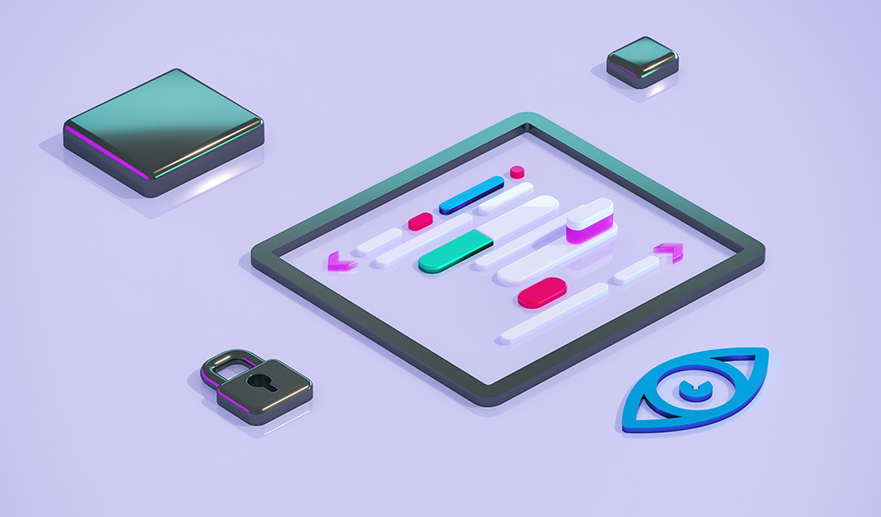

**Example:**

Consider a login component for a web application. In black-box testing, the tester focuses on the inputs, outputs, and behavior of the component without knowing the internal implementation. Test cases are designed to cover various scenarios.

‍**Test Case 1: Valid username and password combination**

Expected Output: Successful login and access granted

‍**Test Case 2: Invalid username and password combination**

Expected Output: Login failure and access denied

‍**Test Case 3: Empty username and password fields**

Expected Output: Validation error messages displayed

The black-box tester doesn't need to know how the login component verifies the credentials internally. They test based on the expected behavior and observed outputs.

Integration Testing

In integration testing, the focus is on testing the interactions between combined components to ensure they work together correctly. The tester examines how different parts of the system collaborate. They also check for issues that may arise from their integration.

**Example:**

Consider a shopping cart system in an e-commerce application. Integration testing involves checking how the shopping cart component interacts with the product catalog, user authentication, and payment processing components.

**Test Case 1: Adding items to the cart**

**Expected Output:** Items are successfully added to the cart, and the cart reflects the correct total price.

**Test Case 2: Removing items from the cart**

**Expected Output:** Items are successfully removed, and the cart updates the total price accordingly.

**Test Case 3: Proceeding to checkout with items in the cart**

**Expected Output:** The system successfully transitions to the payment processing component, and the items in the cart are displayed for review.

**Test Case 4: Checkout with an invalid payment method**

**Expected Output:** The system displays an error message indicating the payment method is invalid and prompts the user to enter valid payment details.

**Best Practices for Component Testing**

When it comes to software component testing, following best practices can significantly enhance the effectiveness and efficiency of the process:

**Test early and often**: Begin testing as soon as possible in the development process and continue testing regularly throughout. This helps catch bugs early, making them easier and less costly to fix.

**Utilize automated testing tools**: Incorporate automated testing tools into the testing process. These tools streamline testing efforts and increase test coverage. They also provide quick feedback on the quality of components. [Automated testing tools](https://www.functionize.com/automated-testing/automation-testing-tools-deep-dive) can include unit testing frameworks, integration testing tools, and continuous integration systems.

**Isolate components for testing**: Test each component in isolation whenever possible. By isolating components, it becomes easier to identify and fix issues.

**Prioritize critical components**: Identify and prioritize critical components that are crucial to the software's overall functionality and performance. Allocate more testing resources and effort to these components to ensure they meet the highest standards of quality and reliability.

**Test Coverage:** Achieving sufficient test coverage during software component testing is essential. Test coverage refers to the extent to which the component's functionality is tested. This includes ensuring that all code paths, branches, and conditions within the component are exercised by the test cases.

**Test Data:** Choosing appropriate test data is crucial for effective component testing. It involves selecting input values that cover a wide range of scenarios, including normal cases, boundary conditions, error conditions, and exceptional cases. Test data should be diverse enough to uncover potential issues or vulnerabilities within the component.

**Isolation:**Component testing aims to isolate the tested component from its dependencies. By isolating the component, the focus remains solely on its functionality and behavior without interference from other components or external factors. This helps in identifying and addressing issues specific to the component being tested.

**Test Oracles:** Having clear test oracles, which define the expected outputs or behaviors for a given set of inputs, is crucial in component testing. Test oracles serve as a reference to determine whether the component's actual outputs match the expected results. They can be defined through specifications, requirements, or predefined criteria.

**Test Automation:** As mentioned earlier, automation plays a significant role in component testing. Automating test execution and verification can save time and effort, especially when dealing with large-scale projects or frequent code changes. Automated tests can be executed repeatedly, allowing for regression testing and ensuring that the component continues to function correctly after modifications.

**Collaboration:**Component testing often involves collaboration between developers, testers, and stakeholders. Close communication and collaboration among team members help ensure that the testing process aligns with the desired objectives, requirements, and quality standards. Feedback and insights from different perspectives can further enhance the effectiveness of component testing.

Test Driven Development (TDD)

**Test Driven Development (TDD)** is a methodology where tests are written before the actual code. This approach ensures that developers have a clear understanding of what needs to be implemented. By writing tests first, developers can focus on meeting specific requirements and design components with testability in mind. TDD helps in improving code quality, reducing bugs, and promoting a better understanding of the software's behavior.

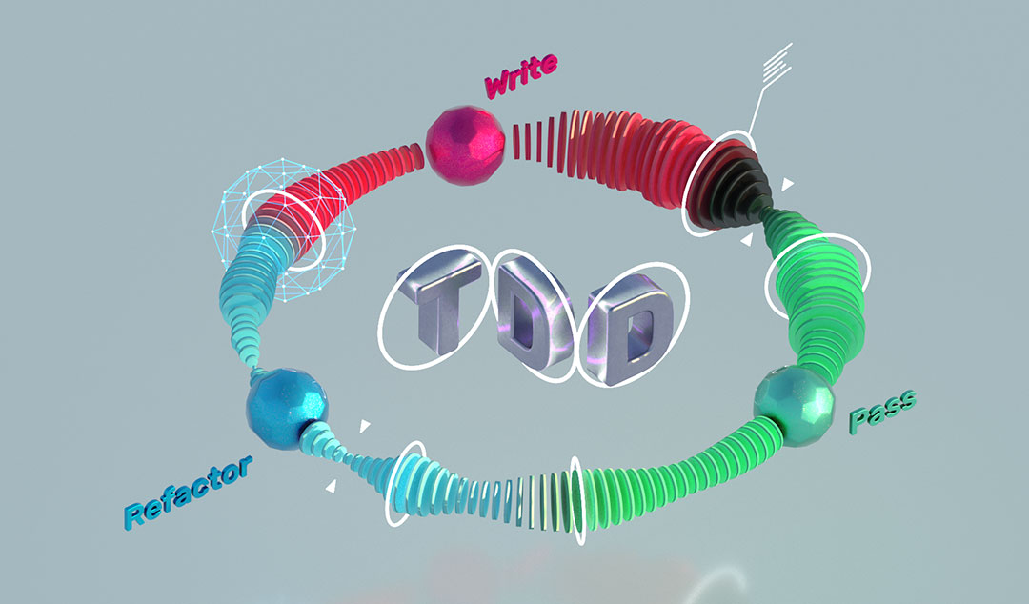

Continuous Integration (CI) and Continuous Deployment (CD)

**Continuous Integration (CI)** and **Continuous Deployment (CD)** are practices that involve automating the process of integrating code changes into a shared repository and deploying them to production. By integrating code changes frequently, developers can detect issues early and ensure that components work together seamlessly. Automated testing tools play a crucial role in CI/CD pipelines by running tests automatically whenever new code is pushed. This ensures that changes don't introduce regressions and that the software remains in a deployable state at all times.

**The Role of Automated Testing in Component Testing**

[Automated testing](https://www.functionize.com/automated-testing) can be utilized in both white-box and black-box testing to enhance the efficiency and effectiveness of component testing.

In white-box testing, automated testing frameworks or tools can be employed to execute test cases that are designed based on the internal structure and implementation of the component. These tools can simulate inputs, evaluate outputs, and compare them with expected results, thereby automating the testing process and reducing manual effort.

Similarly, in black-box testing, automated testing can be used to automate the execution of test cases that focus on the inputs, outputs, and external behavior of the component. Testing tools can interact with the component's user interface or APIs to simulate user actions, validate responses, and perform various checks automatically.

By utilizing automated testing, you can create scripts or test suites that can be executed repeatedly, enabling efficient regression testing, quick identification of potential issues, and faster feedback cycles. Automated testing also allows for the generation of detailed reports and logs, facilitating traceability and aiding in debugging when failures occur.

**Challenges in Component Testing**

Component testing brings its share of hurdles to the software development process. Addressing these challenges requires a keen eye for detail and strategic thinking.

**Handling dependencies**: Components often rely on external dependencies such as databases, APIs, or third-party libraries. Testing these components can be challenging due to the need to manage and control these dependencies, which may not always be available or predictable.

**Ensuring comprehensive coverage**: Achieving comprehensive test coverage, where all possible scenarios and edge cases are tested, can be difficult. It requires careful planning and execution to ensure that every aspect of the component's functionality is thoroughly tested.

**Managing test data**: Generating and managing test data can pose a challenge, especially when dealing with complex data structures or large datasets. Ensuring that the test data accurately reflects real-world scenarios and covers all possible inputs can be time-consuming and resource-intensive.

**Overhead of maintaining tests**: As software evolves and changes over time, maintaining and updating tests to reflect these changes can become a significant overhead.

**Future Trends in Component Testing**

**Adoption of AI in testing**: The future of component testing involves increased integration of artificial intelligence (AI) and machine learning (ML) technologies. AI-powered testing tools can automate test case generation, identify patterns in test results, and predict potential areas of failure.

**Shift-left testing approaches**: There is a growing trend towards adopting shift-left testing approaches, where testing activities are moved earlier in the software development lifecycle. By incorporating testing activities such as unit testing and integration testing earlier in the development process, teams can detect and address defects sooner.

**Continuous integration and delivery**: Continuous integration (CI) and continuous delivery (CD) practices are expected to become even more prevalent in component testing. These practices emphasize automating the build, test, and deployment processes, enabling teams to deliver software updates quickly and reliably.

**FAQs on Software Component Testing**

How does component testing differ from system testing?

Component testing focuses on testing individual units or components of a software application in isolation, whereas system testing involves testing the entire system as a whole to ensure that all components work together correctly. Component testing typically occurs earlier in the development process, while system testing occurs later, after components have been integrated.

Is component testing applicable to all types of software projects?

Yes, component testing is applicable to all types of software projects, regardless of size or complexity. Whether it's a small standalone application or a large-scale enterprise system, component testing helps ensure that individual components function correctly and meet the required specifications. However, the extent and depth of component testing may vary depending on the specific requirements and constraints of each project.

How can developers ensure comprehensive test coverage during component testing?

Developers can ensure comprehensive test coverage during component testing by designing and executing various test cases that cover different aspects of the component's functionality. This includes testing various input combinations, boundary conditions, error-handling scenarios, and performance characteristics. Additionally, developers can leverage automated testing tools to increase test coverage and efficiency.

**Conclusion**

Component testing ensures individual components function correctly, forming the basis of software quality.

It facilitates early bug detection, making fixes easier and more cost-effective.

Component testing allows for focused testing, simplifying debugging and issue resolution.

Thoroughly tested components can be reused, saving time and reducing bugs.

Regular testing leads to more reliable and user-friendly software.

Trends like AI adoption and shift-left testing aim to enhance testing efficiency.

**What is Component Testing? (with Examples)**

Component testing is used when you want to ensure each part of an application works as intended before integrating it with others. It helps catch issues early by validating components in isolation.

**Overview**

**What is Component Testing?**

Component testing, also known as unit or module testing, verifies the behavior and output of individual software components. Each component is tested independently from the system to catch issues early.

**Key Aspects of Component Testing**

Effective component testing depends on these core principles:

**Isolation**: Components are tested separately without relying on other parts of the system

**Verification**: Ensures that a component returns the correct output for a given input

**Mocking and Stubbing**: Replaces external dependencies with controlled versions to simulate specific scenarios

**Debugging**: Makes it easier to trace and fix issues within a specific component

**Benefits of Component Testing**

Component testing supports reliable and efficient development through:

**Early bug detection**: Issues are identified before components are integrated

**Improved code qualit**y: Independent checks ensure components are well-defined and function as intended, leading to fewer defects and better overall design

**Better maintainability**: Changes in one component don’t affect the rest of the system

This article explains what component testing is, its objective, types, strategies, and how to perform it.

**What is Component Testing?**

Component Testing is a software testing technique that verifies the functionality, usability, and behavior of individual components of an application in isolation to ensure they meet specified requirements.

In component testing, each component is tested independently before integration with other modules. This approach helps identify defects early in the development cycle, saving time and reducing the cost of fixing issues later.

Components are tested in a controlled and isolated environment using [debugging tools](https://www.browserstack.com/guide/debugging-tools) or [test frameworks](https://www.browserstack.com/guide/best-test-automation-frameworks), often supported by an [IDE](https://www.browserstack.com/guide/what-does-ide-stand-for). By focusing on individual components, this testing ensures their correctness and reliability, forming a strong foundation for subsequent integration and system testing phases.

**Why is Component Testing necessary?**

Some key points that shows the importance of Component testing:

**Early Bug Detection**: Component testing helps catch bugs early in the development process, making them easier and cheaper to fix.

**Focused Testing**: Testing components in isolation allows developers to concentrate on specific parts of the application, making it easier to pinpoint issues.

**Functionality Verification**: Ensures that each part of the application performs as expected.

**Support for**[**Continuous Integration**](https://www.browserstack.com/guide/continuous-integration-with-agile): Automated component tests can be added to the CI pipeline, enabling frequent testing and quick feedback.

**Read More**: [How to optimize test cases for Continuous Integration](https://www.browserstack.com/guide/optimize-tests-for-continuous-integration)

**Cost Efficiency**: Early issue detection reduces the cost of fixing bugs later and minimizes expenses for post-release maintenance.

**Enhanced**[**Software Quality**](https://www.browserstack.com/guide/how-to-improve-software-quality): Thorough and regular testing of individual components ensures the software meets high-quality standards.

**Read More**: [How to set goals for a QA Tester to Improve Software Quality](https://www.browserstack.com/guide/how-to-set-goals-for-qa-tester)

[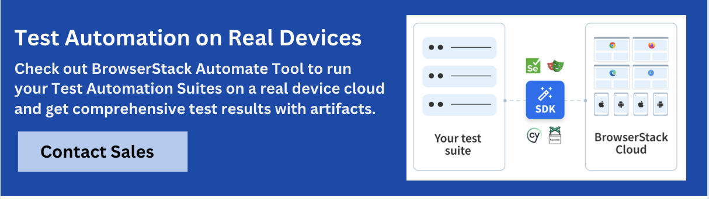](https://www.browserstack.com/guide/what-is-component-testing)

**Objective of Component Testing**

The objective of Component Testing is:

Verify the system’s input and output behavior.

Ensure each component is user-friendly and easy to understand.

Test the usability of individual components.

Check the state and functionality of each component.

**Read More**: [Test Case Templates with Example](https://www.browserstack.com/guide/test-case-templates)

**Component Testing Process**

The process of Component testing involves the following:

**Requirement Analysis**: Identify and understand the user requirements for each component.

**Test Planning**: Plan the testing process based on the analyzed requirements.

**Test Specification**: Decide which test cases to execute and which to skip.

**Test Execution**: Run the selected test cases to verify the component’s behavior against user requirements.

**Test Recording**: Document any defects identified during testing.

**Test Verification**: Confirm whether the component meets the specified requirements.

**Completion**: Analyze the results and ensure all objectives of the testing process are met.

**Types of Software Component Testing**

There are three types of software component testing.

**1. Unit Testing**

[Unit testing](https://www.browserstack.com/guide/unit-testing-a-detailed-guide) is a method that focuses on testing the smallest unit of code, such as a single function or method, in isolation. It ensures that individual components or units behave as expected.

Developers often use mock objects to simulate dependencies and test the unit without relying on other parts of the system. Unit tests are automated during the coding phase to detect issues early and ensure each unit works correctly.

**Read More**: [Best Practices for Unit Testing](https://www.browserstack.com/guide/unit-testing-best-practices)

**2. Integration Testing**

[Integration testing](https://www.browserstack.com/guide/integration-testing) checks how different components or modules work together within the system. It helps identify issues that occur when components interact, such as incorrect data flow or failed communication between them. The main goal of integration testing is to ensure that components function correctly when combined, even if they were developed separately.

**Read More**: [Unit Test vs Integration Test: What are the differences?](https://www.browserstack.com/guide/unit-testing-vs-integration-testing)

**3. Component Interface Testing**

Component [interface testing](https://www.browserstack.com/guide/interface-testing) verifies that components interact correctly through their defined inputs and outputs. It checks that data is exchanged in the correct format and that each side processes it as expected. Component interface testing is essential in systems that depend on internal modules or external APIs, where consistent and accurate communication is critical.

**4. Functional Testing**

[Functional testing](https://www.browserstack.com/guide/functional-testing) checks that a component performs its intended functions correctly. It ensures that the component meets its requirements and specifications by validating each feature and behavior defined in its functionality. This can include checking calculations, data processing, or specific operations for which the component is responsible.

**Read More**: [Top 15 Functional Testing Tools and Frameworks](https://www.browserstack.com/guide/top-functional-testing-tools)

**5. Error Handling Testing**

Error handling testing verifies how a component handles invalid inputs, exceptions, or unexpected situations. It ensures the component can manage errors without crashing or producing incorrect results. This also checks that error messages are clear and the system can recover from failure scenarios.

**Read More**: [Exception Handling in JavaScript](https://www.browserstack.com/guide/exception-handling-in-javascript)

**Component Testing Techniques**

The concept of component testing can be varied from project to project and organization to organization. It mainly depends on the project’s complexity, the software development methodology used, and the component’s dependency on other components.

**Based on the complexity of the application, it is derived mainly in two ways:**

Component testing in small (CTIS)

Component testing in large (CTIL)

**Also Read:**[Types of Mobile Testing](https://www.browserstack.com/guide/mobile-testing-types)

**Component Testing in Small**

Testing is performed on the individual components without any dependency on another component of the application, it is called component testing in small. This testing best fits smaller applications.

There is a web application of practice questions for multiple subjects for different grades for a  school. Each subject page is developed and tested individually without any dependency on the other subject pages.

**Component Testing in Large**

Component testing is to validate the individual components with the help of other components, which means when the input or output of one component is required for testing the other component, it is called component testing in large.

If any component development is yet to be completed, but there is a dependency to test, then dummy code snippets are placed to proceed with testing, called STUB or DRIVER.

**Strategies for Effective Component Testing**

There are two primary strategies for module testing.

**1. White Box Testing**

[White box testing](https://www.browserstack.com/guide/white-box-testing), also known as structural testing, involves testing a component’s internal workings. The tester must have complete knowledge of the component’s code, logic, and structure. Because it involves testing individual components’ internal structure and logic, it is often used for unit testing or component-level testing.

White box testing allows testers to test specific code paths, conditions, and logic within a single unit. This makes it especially useful for verifying correctness, ensuring code coverage, and detecting bugs within the code.

**2. Black Box Testing**

[Black box testing](https://www.browserstack.com/guide/black-box-testing) checks the component’s functionality without knowing its internal code. The tester focuses solely on input and output to verify that the component meets its requirements and performs the expected tasks.

**Read More**: [Differences between Black Box Testing and White Box Testing](https://www.browserstack.com/guide/black-box-testing-and-white-box-testing)

**Drivers and Stubs in Component Testing**

In software component testing, drivers and stubs simulate undeveloped components and enable isolated testing of other components.

**1. Driver**

A driver is dummy code used in component testing to simulate the behavior of a higher-level component that is missing or not developed. When unavailable, it acts as a placeholder for the calling function.

The driver calls the lower-level module, provides necessary inputs, and receives outputs as though the actual calling function were present. This allows components to be tested independently, even when the full system is incomplete.

**2. Stubs**

A stub is dummy code used to simulate the behavior of a lower-level component required for testing higher-level components. It accepts inputs from the higher-level component and returns predefined outputs to mimic the actual behavior of the missing module.

For example, in a system with components A, B, C, and D, where B (the output of A) and C (the input for D) are not developed yet, stubs simulate component B. This allows component A to be tested while drivers simulate component D.

**Role of Automated Testing in Component Testing**

[Automated testing](https://www.browserstack.com/guide/automation-testing-tutorial) improves the efficiency and reliability of software component testing. It allows test cases to run consistently across changes, detect regressions early, and support fast development cycles. Here’s how it contributes to module testing.

**Faster feedback**: Automated tests provide quick results when testing individual components to help developers catch issues early.

**Repeatability**: Tests can be run consistently across different environments or after each code change without manual intervention.

[**Regression testing**](https://www.browserstack.com/guide/regression-testing?searchUuid=5dc1a89e-431b-4a2f-8b5b-48c47fc7fb7b): Automated component tests ensure that changes in one part of the system don’t break existing functionality in isolated modules.

**Scalability**: As the codebase grows, automated tests help maintain quality without increasing the time or effort needed for testing.

**Integration readiness**: Verified components are easier to integrate, since automated tests confirm their reliability before moving to integration testing.

**Supports**[**CI/CD**](https://www.browserstack.com/guide/what-is-ci-cd)**:** Automated component tests are easy to plug into[CI pipelines](https://www.browserstack.com/guide/building-ci-cd-pipeline) to enable continuous quality checks.

**How is Component testing performed?**

QA team will do the component testing once the development and unit testing of the component is completed. Test strategy is vital in this method; the QA team will proceed with testing based on the planned [testing methodology](https://www.browserstack.com/guide/software-testing-methodologies).

**Irrespective of the testing model, everyday activities performed in component testing are as follows:**

QA lead will develop a [test plan](https://www.browserstack.com/guide/test-planning) and strategy document.

Testers will develop [test scenarios](https://www.browserstack.com/guide/how-to-create-test-scenarios) and [test cases](https://www.browserstack.com/guide/how-to-create-selenium-test-cases).

All the functional and non-functional aspects are tested.

Issues observed will be reported to the development team.

If automation testing is in the scope of the test strategy, automation scripts are created for the stable components.

**Also Read**: [Test Plan vs Test Case: Core Differences](https://www.browserstack.com/guide/test-plan-vs-test-case)

**Component Testing Example**

Assume while [testing a banking domain application](https://www.browserstack.com/guide/how-to-test-banking-domain-applications) for XYZ bank. The website will be designed with different pages like Accounts, Cards, Insurance, Investments Offers..etc, based on the services provided by the bank. Login pages are designed based on user levels like personal and business access. So if all the pages are designed as multiple components there after the completion of each component, testing can be done.

Based on customer requirements application is developed for different users, and each page is an independent component, so we test them without the dependency on other components (CTIS).

Assuming the login page is yet to develop, the concept of the driver is applied here to ensure the testing of the accounts page

Similarly,  if we have to test the fund transfer page the concept of Stubs is applied to the Addpayee page.

**Follow-Up Read:**[How to Test Banking Apps on Real iOS & Android Devices?](https://www.browserstack.com/guide/how-to-test-banking-apps)

**Component Testing vs Unit Testing**

Component testing focuses on testing individual components or modules in isolation to ensure they function correctly within a system, Unit testing, on the other hand, tests small, isolated units of code (like functions or methods) for correctness.

While Component Testing often considering interactions with other components, Unit Testing typically without dependencies on other modules.

|  |  |  |
| --- | --- | --- |
| **Feature** | **Component Testing** | **Unit Testing** |
| **Purpose** | Testing of the components individually with or without isolation to ensure the functionality of the requirements. | Testing of the developed code at the program level to ensure design specifications.  QA team will do the component testing. |
| **Responsibility** | QA team will do the component testing. | The developer’s team will do the unit testing. |
| **Timing** | Testing is performed after Unit testing and before Integration testing | Unit testing is performed before component testing |
| **Testing Type** | It is a black box testing method, and the internal structure of the code is unknown to the tester | It is a white box testing method, and the internal structure of the code is known to developers |
| **Completion of Development** | Testing is performed after the completion of the total development of the component | Testing is performed after each development step of the component |
| **Validation Basis** | Validation is done based on Test scenarios and functional specifications | Validation is done based on design specification documents |
| **Environment** | Components may be tested in a simulated or isolated environment | Tested in the actual development environment, often with mock objects for dependencies |
| **Scope** | Focuses on testing the functionality and behavior of a component in isolation | Focuses on testing specific code logic or individual functions in isolation |
| **Automation** | Often automated, but may require more complex setup for component interaction | Frequently automated and easier to implement due to smaller scope |

**Advantages and Limitations of Component Testing**

It is important to understand the benefits and drawbacks of component testing to implement it effectively. Here’s a table that explains them in detail.

|  |  |
| --- | --- |
| **Benefits of Component Testing** | **Limitations of Component Testing** |
| Detects [bugs](https://www.browserstack.com/guide/how-to-find-bugs-in-software) early in development | Tests only individual components in isolation |
| Focuses on specific functionality | Cannot validate interactions between components |
| Improves code modularity and design | Simulated dependencies may hide real issues |
| Simplifies error tracing and fixing | Passing tests may not reflect integration success |
| Enables fast and frequent automation | Frequent changes can require test updates |
| Enhances unit-level test coverage | Does not validate complex workflows or end-to-end behavior |

**Challenges in Component Testing**

Component testing has several challenges that can impact its effectiveness and accuracy. It includes,

**Mocking dependencies**: Components often rely on external services or modules, such as APIs or databases. Simulating these dependencies during testing can be difficult since mocks may not accurately reflect real-world behavior.

[**Test management**](https://www.browserstack.com/guide/benefits-of-test-management-and-bdd): Testing components require specific and varied data sets to ensure comprehensive coverage. Generating, maintaining, and managing this data across test cases can be time-consuming and complex.

**Read More**: [11 Best Open Source Test Management Tools](https://www.browserstack.com/guide/best-open-source-test-management-tools)

**Frequent changes**: Components frequently undergo updates or modifications. These changes can cause previously stable tests to fail or become outdated, requiring ongoing maintenance and adjustment of test cases.

**Limited integration testing**: Components are often tested in isolation, so their interactions with other system parts are not fully explored. This limits the ability to catch integration issues that may only appear in a fully integrated environment.

**Read More**: [How to optimize test cases for Continuous Integration](https://www.browserstack.com/guide/optimize-tests-for-continuous-integration)

**Overhead in maintaining tests**: Writing detailed tests for each component takes considerable time. As components evolve, keeping these tests to ensure they remain relevant adds additional overhead to the development process.

**Best Practices for Component Testing**

Some of the best practices are:

**Test Early, Test Often**: Begin testing early in the development process and continue regularly to catch bugs when they’re easier and cheaper to fix.

**Use Automated Testing Tools**: Integrate automated tools to simplify testing, improve coverage, and quickly assess component quality.

**Isolate Components for Testing**: Test components independently to easily identify and fix issues without interference from other parts of the system.

**Prioritize Critical Components**: Focus on testing the most crucial components that are essential to the system’s functionality and performance.

**Ensure Sufficient Test Coverage**: Make sure all code paths, branches, and conditions are tested to ensure comprehensive component functionality.

**Choose Relevant Test Data**: Select test data that represents various scenarios, including edge cases and error conditions, to uncover potential weaknesses.

**Isolate the Testing Environment**: Ensure components are tested in isolation to focus solely on their functionality without external influences.

**Use Test Oracles**: Define clear expectations for the component’s output to compare against actual results, ensuring the component meets its requirements.

**Leverage Test Automation**: Automate tests to save time and effort, especially for large projects or frequent code changes, and use regression testing to ensure continued functionality.

**Encourage Collaboration**: Foster communication between developers, testers, and stakeholders to align on goals and improve testing effectiveness.

[**Talk to an Expert**](https://www.browserstack.com/guide/what-is-component-testing)

**Future Trends in Component Testing**

Future trends in component testing include increased AI-driven testing, shift-left testing, microservices testing, and smarter automation. These trends will enhance testing effectiveness and make it faster and more reliable.

[**AI-driven testing**](https://www.browserstack.com/guide/artificial-intelligence-in-test-automation): Artificial intelligence will generate and optimize test cases. AI can analyze past test results, predict areas of the code most likely to fail, and adjust test cases to target these areas more efficiently. This will lead to smarter, more focused testing strategies that reduce manual effort.

**Smarter automation**: [Test automation tools](https://www.browserstack.com/guide/codeless-automation-testing-tools) will continue to evolve and become more intelligent. These tools will automatically execute tests, detect errors, analyze results, and suggest improvements.

[**Microservices testing**](https://www.browserstack.com/guide/end-to-end-testing-in-microservices): As more companies adopt microservices, component testing will adapt to ensure proper testing of individual services within a larger distributed system. The focus will shift to testing interactions and dependencies between services, ensuring they communicate correctly and handle failures gracefully.

[**Shift-left testing**](https://www.browserstack.com/guide/what-is-shift-left-testing): The shift-left approach will become more prevalent, with testing happening earlier in the development lifecycle. Developers will take on more responsibility for writing and running tests as they code, not just at the end. This forward-thinking approach will help catch issues sooner and prevent them from escalating into bigger problems later.

**Read More**: [Why does DevOps recommend Shift Left Principles](https://www.browserstack.com/guide/why-does-devops-recommend-shift-left-principles)

**Conclusion**

Component testing is crucial for ensuring individual parts of a system work correctly before integration. By testing early, automating where possible, and isolating components, teams can quickly identify defects, reduce costs, and improve software quality. Focusing on critical components and collaborating effectively enhances the testing process, leading to more reliable and robust applications.

**Frequently Asked Questions**

**1. Is component testing applicable to all types of software projects?**

Component testing is widely applicable across most software projects, especially those with modular or layered architectures. It is most effective in projects with complex systems that need to validate individual parts before integration.

**2. How does Component testing fit with other QA methods?**

Component testing works alongside other QA methods like integration and[system testing](https://www.browserstack.com/guide/what-is-system-testing). It focuses on testing individual components in isolation to ensure each works as expected before they are integrated or tested at a system level.

**3. How does Component testing differ from Interface, Integration, and System testing?**

Component testing focuses on verifying individual units or modules in isolation. Interface testing checks how different components interact with each other. Integration testing validates the interaction between multiple components or systems, while system testing checks the entire system’s functionality as a whole.

**Component Software Testing**

Last Updated : 12 Jul, 2025

**Component Testing** is a type of [software testing](https://www.geeksforgeeks.org/software-testing/software-testing-basics/) in which usability of each individual component is tested. Along with the usability test, behavioral evaluation is also done for each individual component. To perform this type of testing, each component needs to be in independent state and also should be in controllable state. Each component of the software should be user comprehensible. Assume in a software application consists of five components. The testing of each component is done independently by the tester as part of the development cycle before integration testing is performed on it. It helps in saving time by finding the bugs at a very early stage in the cycle. Test structure tools or debugging tools are used for this type of testing as this is performed by programmers on the code written by them and with the support of IDE. Defects detected during component testing are fixed as soon as possible when they are found without maintaining the records. Component testing has an important role in finding the issue. Before processing with the integration testing, component testing is performed in order to ensure that each component of the application is working correctly and as per requirement. **Objective of Component Testing:** The objective of Component Testing is:

To verify the input and output behavior of the system.

To check the usability of each component.

To test the user comprehensibility of the software.

To test the state of the each components of the system.

**Component Testing Process:**  
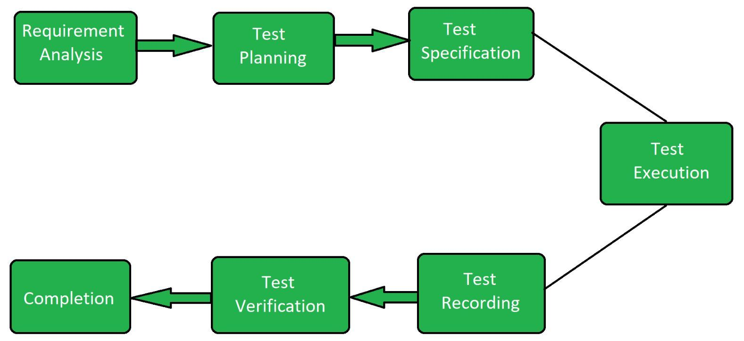

**Requirement Analysis:** User requirement related to each component is observed.

**Test Planning:** Test is planned according to the analysis of the requirements of the user.

**Test Specification:** In this section it is specified that which test case must be run and which test case should be skipped.

**Test Execution:** Once the test cases are specified according to the user requirements, test cases are executed.

**Test Recording:** Test recording is the having record of the defects that are detected.

**Test Verification:** Test verification is the process to determine whether the product meet specification.

**Completion:** This is the last phase of the testing process in which the result is analyzed.

What is a Test Strategy?

A test strategy is a high-level document that outlines the overall approach and guiding principles for software testing. It provides a structured framework that directs the testing team on how to efficiently and effectively conduct tests, ensuring that all key aspects of the software are validated.

Benefits of Test Strategy

Provides clear direction and focus for testing activities.

Identifies and mitigates critical risks early.

Streamlines processes, optimizing resource use and timelines.

Promotes adherence to industry and regulatory standards.

Enhances teamwork by aligning all members with project goals.

Aids in effective allocation of resources.

Facilitates efficient monitoring and reporting of test progress.

Ensures comprehensive validation of all critical functionalities.

Types of Test Strategy

We identify 3 major types of test strategies:

1. Static vs Dynamic Test Strategy

**Static testing** reviews code and documents without execution, catching issues early.

**Dynamic testing** runs the software to check its behavior in real scenarios.

Benefits:

Static testing helps catch defects before they become costly.

Dynamic testing ensures the software works as expected in real use cases.

2. Preventive vs. Reactive Test Strategy

**This strategy balances preventing defects before they occur and reacting to unexpected issues after deployment.**

Benefits:

**Preventive testing** addresses known risks early, reducing costs.

**Reactive testing** handles unforeseen issues, especially during integration or real-world use.

Since not all problems can be predicted, a mix of both strategies is essential to catch hidden or emerging defects.

3. Hybrid Test Strategy

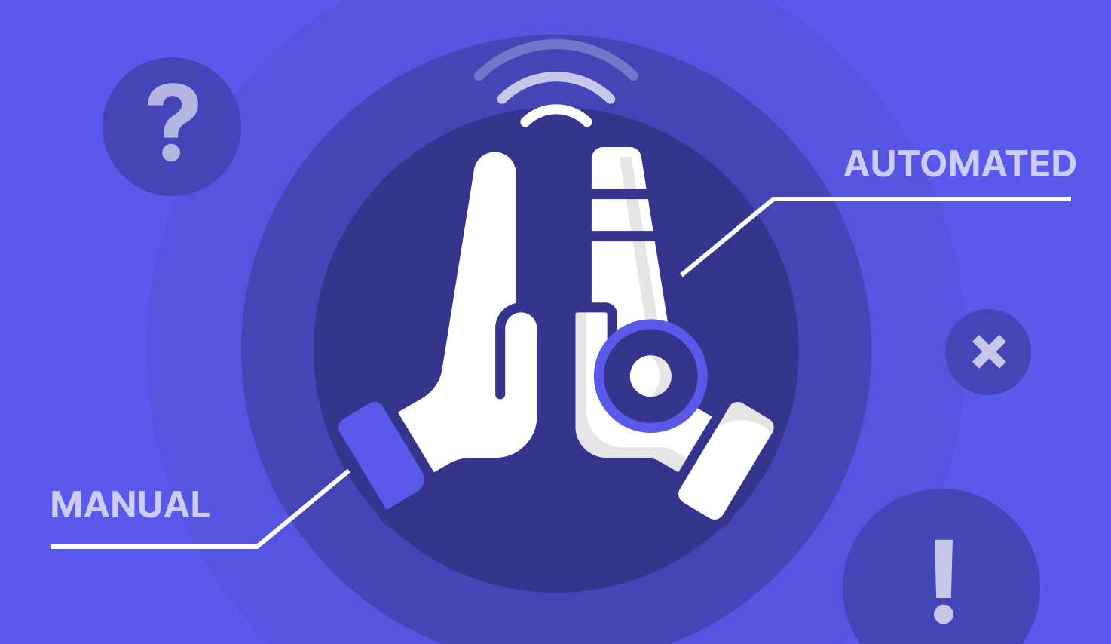

Here we want to strike a balance between manual testing and automation testing.

Why balance them? Manual testing is awesome as a starting point. A common best practice is conducting exploratory testing sessions to find bugs. After that, through automation feasibility assessment, the team decides if that specific test scenario is worth automating or not. If the answer is yes, the team can leverage automation test scripts/testing tools to automate it for future executions.

📚 Read More: [How to do automation testing?](https://katalon.com/resources-center/blog/what-is-automation-testing)

What To Include in a Test Strategy Document

1. Test level

Start your test strategy with the concept of a test pyramid, which consists of 3 levels:

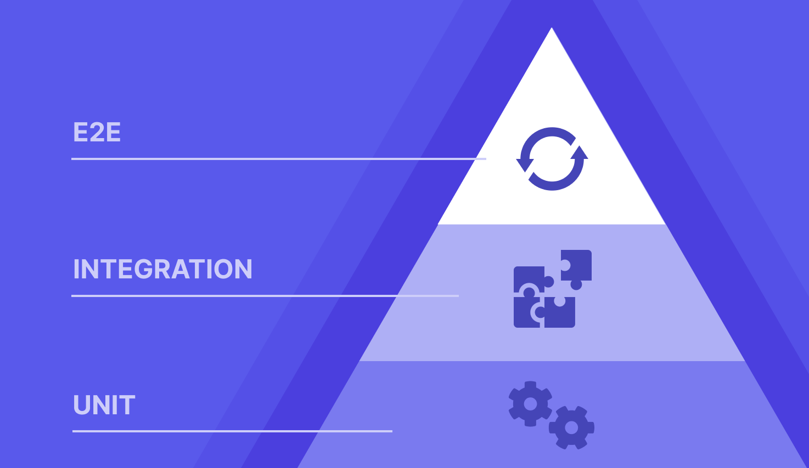

[Unit tests](https://katalon.com/resources-center/blog/unit-testing)**(Base)** – Test individual components in isolation. Fast, automated, and high in coverage (70-80%).

[Integration tests](https://katalon.com/resources-center/blog/integration-testing)**(Middle)** – Verify data flow between components. Moderate speed and coverage (15-20%).

[E2E tests](https://katalon.com/resources-center/blog/end-to-end-e2e-testing)**(Top)** – Validate the full system. Slow, complex, but crucial for key workflows (5-10%).

A balanced strategy prioritizes unit tests for efficiency, with fewer integration and E2E tests to maintain stability without slowing development.

2. Objectives and scope

**Set Objectives** – Determine what to validate: functional (features) or non-functional (security, performance, usability). Align with project requirements.

**Define Scope** – Outline what will and won’t be tested to avoid scope creep. Include:

Features to test

Features to exclude

Testing types

Test environment

Prioritize Critical Areas:

High-risk and frequently used features

User flows that drive engagement

Third-party dependencies (APIs, payments)

Recent changes prone to defects

3. Testing types

There are so many types of testing to choose from, each serving a different purpose. Testing types can be divided into the following groups:

**By Application Under Test (AUTs)**: Grouping tests according to the type of software being evaluated, such as web, mobile, or desktop applications.

**By Application Layer**: Organizing tests based on layers in traditional three-tier software architecture, including the user interface (UI), backend, or APIs.

**By Attribute**: Categorizing tests based on the specific features or attributes being evaluated, such as visual, functional, or performance testing.

**By Approach**: Classifying tests by the overall testing method, whether manual, automated, or driven by AI.

**By Granularity**: Grouping tests by the scope and level of detail, like unit testing or end-to-end testing.

**By Testing Techniques**: Organizing tests based on the methods used for designing and executing tests. This is more specific than general approaches and includes techniques like black-box, white-box, and gray-box testing.

📚 Read More: [15 Types of QA Testing You Should Know](https://katalon.com/resources-center/blog/different-types-of-qa-testing)

4. Test approach

Agile is the go-to approach for most QA teams today. Instead of treating testing as a separate phase, it is integrated throughout the development process. Testing occurs continuously at each step, enabling testers to work closely with developers to ensure fast, frequent, and high-quality delivery.

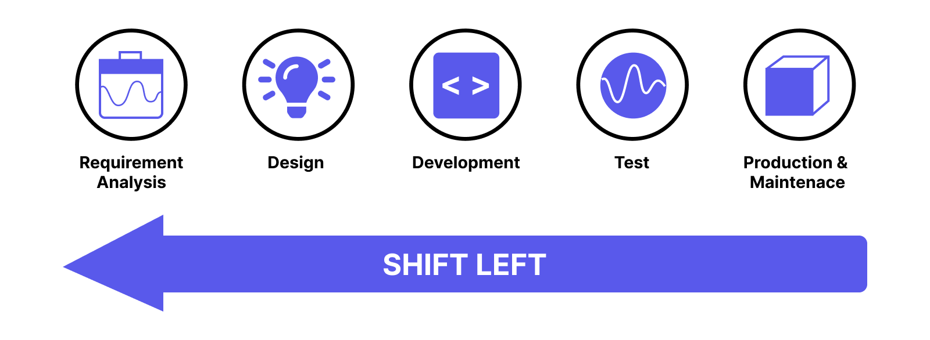

Agile allows for shift-left testing where you essentially “push” testing to earlier stages of development and weave development with testing.

📚 Read More: [What is Shift Left Testing? How To Shift Left Your Test Strategy?](https://katalon.com/resources-center/blog/shift-left-testing-approach)

5. Test Criteria

The criteria act as checkpoints to ensure the product is both stable and testable before major testing efforts, and that it is ready to move forward after testing is complete.

Entry Criteria (Required system conditions before testing starts):

Code complete, only bug fixes allowed

Unit & integration tests passed

Core functionality (login, navigation, etc.) works

Test environment set up

Bugs documented

Test data prepared

Exit Criteria (Required system conditions before testing ends):

All test cases executed

Critical issues fixed, defects within limits

Key workflows validated

Test reports reviewed

Stable, deployable build

**📚 Read More:**[How to make a test execution report?](https://katalon.com/resources-center/blog/what-is-a-test-execution-report)

6. Hardware-software configuration

This is your test environment: where the actual testing takes place. They should mirror the production environment as closely as possible, and there should be additional tools/features to assist testers with their job. They have 2 major parts:

**Hardware:**servers, computers, mobile devices, or specific hardware setups such as routers, network switches, and firewalls

**Software:**operating systems, browsers, databases, APIs, testing tools, third-party services, and dependent software packages

For performance testing specifically, you’ll also need to set up the network components to simulate real-world networking conditions (network bandwidth, latency simulations, proxy settings, firewalls, VPN configurations, or network protocols).

Here’s an example for you:

|  |  |  |
| --- | --- | --- |
| Category | Mobile Testing | Web Testing |
| Hardware | - iPhone 13 Pro (iOS 15)  - iPad Air (iOS 14)  - Google Pixel 6 (Android 12)  - Samsung Galaxy S21 (Android 11) | - Windows 10: Intel Core i7, 16GB RAM, 256GB SSD  - macOS Monterey: Apple M1 Chip, 16GB RAM, 512GB SSD |
|  |
|  |
|  |
| Software | - Google Chrome (across versions) - Mozilla Firefox (across versions) - Safari (across versions) - Edge (across versions) - Opera (across versions) - Brave (across versions) | |  |
| Network Config | - Simulate 3G, 4G, 5G, and high-latency environments  - Wi-Fi and Ethernet connections | |  |
| Database | MySQL 8.0 | |  |
| CI/CD Integration | Jenkins or GitLab CI | |  |

7. Testing tools

If you go with manual testing, you would need a test management system to keep track of all of those manual test results. Most commonly we have Jira as an all-in-one project management tool to help with bug tracking.

After testing, they can document their bug in a Google Sheet document that looks like this.

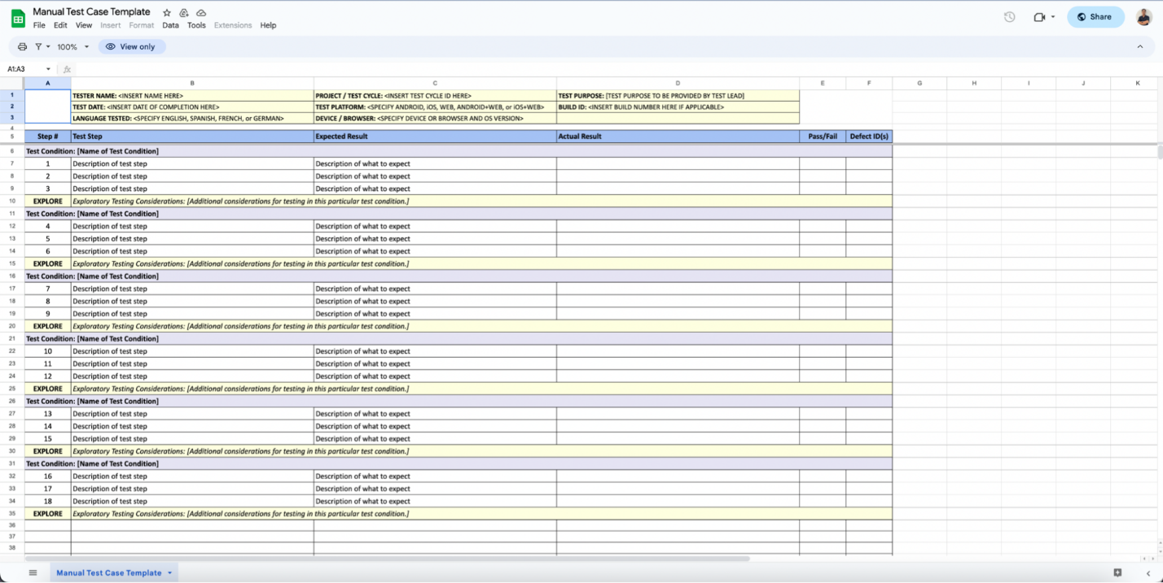  
 Of course, as you scale, this approach proves to be inefficient. At a certain point, a dedicated test management system that seamlessly integrates with other test activities (including test creation, execution, reporting) is a better option. This system should also support automation testing.

Imagine a system where you can write your test scripts, store all of the test objects, test data, artifacts, where you can also run your tests in the environment of your choice, then generate detailed reports for your findings.

To achieve such a level of comprehensiveness, testers have 2 options:

Build a tailor-made test automation framework from scratch

Find a vendor-based solution

Each comes with their own advantages and disadvantages. The former is highly customizable, but requires a significant level of technical expertise to pull off, while the latter comes with out-of-the-box features that you can immediately enjoy, but there is some investment required.

The real question is: what is the ROI you can get if you go with one of those choices? Check out our article on how to calculate test automation ROI.

[](https://katalon.com/katalon-studio)

8. Test deliverables

This is what success looks like. Test deliverables come from test objectives you set out earlier.

Define what artifacts and documents should be produced during the testing process to communicate the progress and findings of testing activities. As test strategy is a high-level document, you don’t need to go into minute details of each deliverable, but rather only a brief outline of the items that the team wants to create.

9. Testing measurements and metrics

Establish the key performance indicators (KPI) and success metrics for the project. These metrics will not only be the means to measure the efficiency and quality of the testing process but also provide a common goal and language of communication among team members.

Some common testing metrics include:

**Test Coverage**: Measures the percentage of the codebase that is tested by your suite of tests.

**Defect Density**: Indicates the number of defects found in a specific module or unit of code, typically calculated as defects per thousand lines of code (KLOC). A lower defect density reflects better code quality, while a higher one suggests more vulnerabilities.

**Defect Leakage**: Refers to defects that escape detection in one testing phase and are found in subsequent phases or after release.

**Mean Time to Failure (MTTF)**: Represents the average time that a system or component operates before failing.

These metrics will later be visualized in a [test report](https://katalon.com/resources-center/blog/what-is-a-test-report).

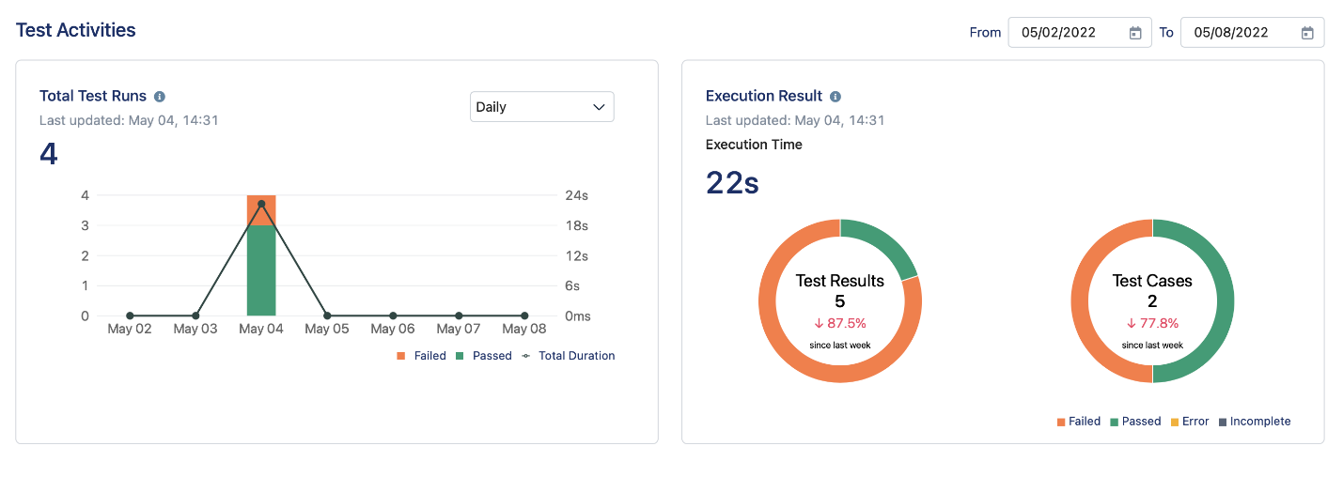

10. Risks

List out the potential risks and clear plans to mitigate them, or even contingency plans to adopt in case these risks do show up in reality.

Testers generally conduct a level of risk analysis (= probability of it occurring x impact) to see which risk should be addressed in priority.

For example, after planning, the team realizes that the timeline is extremely tight, but they are lacking the technical expertise to deliver the objectives. This is a High Probability High Impact scenario, and they must have a contingency plan: either changing the objectives, investing into the team’s expertise, or outsourcing entirely to meet the delivery date.

All of these items in the document should be carefully reviewed by the business team, the QA Lead, and the Development Team Lead. From this document, you will be able to develop detailed test plans for sub-projects, or for each iteration of the sprint.  

📚 Read More: [Risk-based approach to regression testing: A simple guide](https://katalon.com/resources-center/blog/risk-based-approach-for-regression-testing)

Sample Test Strategy Document

Here’s a sample test strategy for your reference:

|  |  |
| --- | --- |
| Section | Details |
| 1. Product, Revision, and Overview | - Product Name: E-commerce Web Application  - Revision: v1.5  - Overview: The product is an online e-commerce platform allowing users to browse products, add items to the cart, and make secure purchases. It includes a responsive web interface, a mobile app, and backend systems for inventory and payment processing. |
| 2. Product History | - Previous Versions: v1.0, v1.2, v1.3  - Defect History: Previous versions had issues with payment gateway integration and cart item persistence. These issues have been addressed through unit and integration testing, leading to improvements in overall system reliability. |
| 3. Features to Be Tested | - User Features: Product search, cart functionality, user registration, and checkout.  - Application Layer: Frontend (React.js), Backend (Node.js), Database (MySQL), API integrations.  - Mobile App: Shopping experience, push notifications.  - Server: Load balancing, database synchronization. |
| 4. Features Not to Be Tested | - Third-party Loyalty Program Integration: This will be tested in a separate release cycle.  - Legacy Payment Method: No longer supported and excluded from testing in this release. |
| 5. Configurations to Be Tested | - Mobile: iPhone 13 (iOS 15), Google Pixel 6 (Android 12).  - Desktop: Windows 10, macOS Monterey.  - Browsers: Chrome 95, Firefox 92, Safari 15, Edge 95.  Excluded Configurations: Older versions of Android (<9.0) and iOS (<12). |
| 6. Environmental Requirements | - Hardware: Real mobile devices, desktop systems (Intel i7, Apple M1).  - Network: Simulated network conditions (3G, 4G, Wi-Fi).  - Software: Testing tools (Selenium, Appium, JMeter).  - Servers: Cloud-hosted environments on AWS for testing scalability. |
| 7. System Test Methodology | - Unit Testing: Verify core functions like search, add-to-cart.  - Integration Testing: Test interactions between the cart, payment systems, and inventory management.  - System Testing: Full end-to-end user scenarios (browse, add to cart, checkout, receive confirmation).  - Performance Testing: Stress testing with JMeter to simulate up to 5,000 concurrent users.  - Security Testing: OWASP ZAP for vulnerability detection. |
| 8. Initial Test Requirements | - Test Strategy: Written by QA personnel and reviewed by the product team.  - Test Environment Setup: Environments must be fully configured, including staging servers, test data, and mock payment systems.  - Test Data: Create dummy users and product listings for system-wide testing. |
| 9. System Test Entry Criteria | - Basic Functionality Works: All core features (search, login, cart) must function.  - Unit Tests Passed: 100% of unit tests must pass without error.  - Code Freeze: All features must be implemented and code must be checked into the repository.  - Known Bugs Logged: All known issues must be posted to the bug-tracking system. |
| 10. System Test Exit Criteria | - All System Tests Executed: All planned tests must be executed.  - Pass Critical Scenarios: All "happy path" scenarios (user registration, product purchase) must pass.  - Successful Build: Executable builds must be generated for all supported platforms.  - Zero Showstopper Bugs: No critical defects or blockers.  - Maximum Bug Threshold: No more than 5 major bugs and 10 minor bugs. |
| 11. Test Deliverables | - Test Plan: Detailed plan covering system, regression, and performance tests.  - Test Cases: Documented test cases in Jira/TestRail.  - Test Execution Logs: Record of all tests executed.  - Defect Reports: Bug-tracking system reports from Jira.  - Test Coverage Report: Percentage of features and code covered by tests. |
| 12. Testing Measurements & Metrics | - Test Coverage: Target 95% coverage across unit, integration, and system tests.  - Defect Density: Maintain a defect density of < 1 defect per 1,000 lines of code.  - Performance: Ensure 2-second or less response times for key transactions.  - Defect Leakage: Ensure no more than 2% defect leakage into production. |
| 13. Risks | - Payment Gateway Instability: Could cause transaction failures under high load.  - Cross-Browser Issues: Potential inconsistencies across older browser versions.  - High User Load: Performance degradation under concurrent users > 5,000.  - Security: Risk of vulnerabilities due to new user authentication features. |
| 14. References | - Product Documentation: Internal API documentation for developers.  - Test Tools Documentation: Selenium and JMeter configuration guides.  - External References: OWASP guidelines for security testing. |

When creating a test strategy document, you can create a table with all of the items listed above, and have a brainstorming session with the important stakeholders (project manager, business analyst, QA Lead, and the Development Team Lead) to fill in the necessary information for each item. You can use the table below as a starting point:

[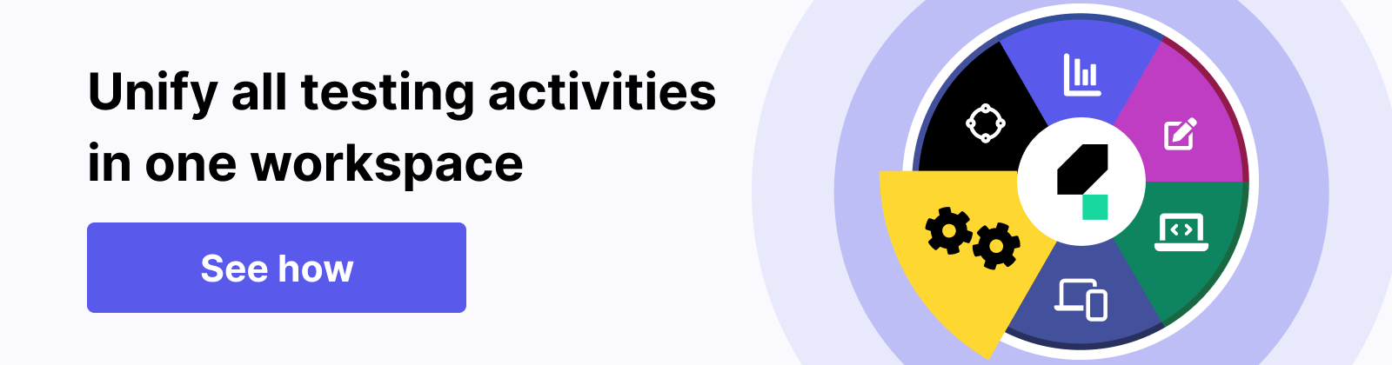](https://katalon.com/)

Test Plan vs. Test Strategy

The test strategy document gives a higher level perspective than the test plan, and contents in the test plan must be aligned with the direction of the test strategy.

[Test strategy](https://katalon.com/resources-center/blog/test-strategy) provides general methods for product quality, tailored to different software types, organizational needs. quality policy compliance, and the overall testing approach.

The [test plan](https://katalon.com/resources-center/blog/test-plan), on the other hand, is created for specific projects, and considers goals, stakeholders, and risks.

In Agile development, a master plan for the project can be made, with specific sub-plans for each iteration. The table below provides a detailed comparison between the two:  

|  |  |  |
| --- | --- | --- |
|  | Test Strategy | Test Plan |
| Purpose | Provides a high-level approach, objectives, and scope of testing for a software project | Specifies detailed instructions, procedures, and specific tests to be conducted |
| Focus | Testing approach, test levels, types, and techniques | Detailed test objectives, test cases, test data, and expected results |
| Audience | Stakeholders, project managers, senior testing team members | Testing team members, test leads, testers, and stakeholders involved in testing |
| Scope | Entire testing effort across the project | Specific phase, feature, or component of the software |
| Level of Detail | Less detailed and more abstract | Highly detailed, specifying test scenarios, cases, scripts, and data |
| Flexibility | Allows flexibility in accommodating changes in project requirements | Relatively rigid and less prone to changes during the testing phase |
| Longevity | Remains relatively stable throughout the project lifecycle | Evolves throughout the testing process, incorporating feedback and adjustments |

How Katalon Fits in With Any Test Strategy

Katalon is a comprehensive solution that supports test planning, creation, management, execution, maintenance, and reporting for web, API, desktop, and even mobile applications across a wide variety of environments, all in one place, with minimal engineering and programming skill requirements. You can utilize Katalon to support any test strategy without having to adopt and manage extra tools across teams.



Katalon allows QA teams [to quickly move from manual testing to automation testing](https://katalon.com/resources-center/blog/from-manual-to-automation-testing) thanks to the built-in keywords feature. These keywords are essentially ready-to-use code snippets that you can quickly drag-and-drop to construct a full test script without having to write any code. There is also the record-and-playback feature that records the sequence of action you take on your screen then turns it into an automated test script that you can re-execute across a wide range of environments.

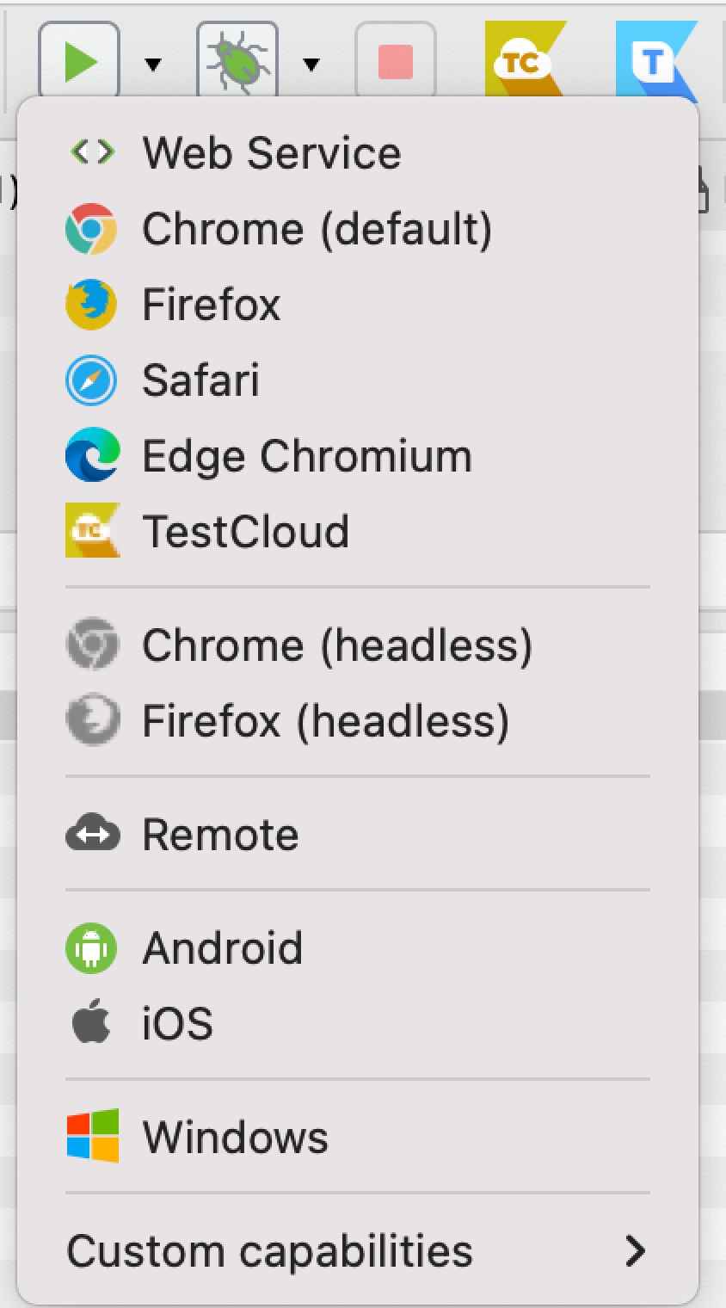

After that, all of the test objects, test cases, test suites, and test artifacts created are managed in a centralized Object Repository, enabling better test management. You can even map automated tests to existing manual tests thanks to Jira and Xray integration.

For test execution, Katalon makes it easy to run tests in parallel across browsers, devices, and OS, while everything related to setup and maintenance is already preconfigured. AI-powered features such as Smart Wait, self-healing, scheduling, and parallel execution enable effortless test maintenance.

Finally, for test reporting, Katalon generates detailed analytics on coverage, release, flakiness, and pass/fail trend reports to make faster, more confident decisions.

**Unit Testing - Software Testing**

Last Updated : 22 Jul, 2025

Unit testing is the process of testing the smallest parts of your code, like it is a method in which we verify the code's correctness by running one by one. It's a key part of software development that improves code quality by testing each unit in isolation.

You write unit tests for these code units and run them automatically every time you make changes. If a test fails, it helps you quickly find and fix the issue. Unit testing promotes modular code, ensures better test coverage, and saves time by allowing developers to focus more on coding than manual testing.

**What is a Unit Test?**

A unit test is a small piece of code that checks if a specific function or method in is an application works correctly. It will work as the function inputs and verifying the outputs. These tests check that the code work as expected based on the logic the developer intended.

Unit Test

In these multiple tests are written for a single function to cover different possible scenarios and these are called test cases. While it is ideal to cover all expected behaviors, it is not always necessary to test every scenario.

Unit tests should run one by one, it means that they do not depend on other system parts like databases or networks. Instead, data stubs can be used to simulate these dependencies. Writing unit tests is easiest for simple, self-contained code blocks.

**Unit testing strategies**

To create effective unit tests, follow these basic techniques to ensure all scenarios are covered:

**Logic checks**: Verify if the system performs correct calculations and follows the expected path with valid inputs. Check all possible paths through the code are tested.

**Boundary checks**: Test how the system handles typical, edge case, and invalid inputs. For example, if an integer between 3 and 7 is expected, check how the system reacts to a 5 (normal), a 3 (edge case), and a 9 (invalid input).

**Error handling**: Check the system properly handles errors. Does it prompt for a new input, or does it crash when something goes wrong?

**Object-oriented checks**: If the code modifies objects, confirm that the object's state is correctly updated after running the code.

**Unit Test Example**

Here is the example of the java with unit test cases with the proper unit test code.

Step 1. Create the Calculator Class.

**public** **class** **Calculator** {

*// Method to add two numbers*

**public** int add(int a, int b) {

**return** a + b;

}

*// Method to subtract two numbers*

**public** int subtract(int a, int b) {

**return** a - b;

}

}

Step 2. Create the TestNG Test Class.

**package** **com.example.tests**;

**import** **org.testng.Assert**;

**import** **org.testng.annotations.BeforeMethod**;

**import** **org.testng.annotations.Test**;

**public** **class** **CalculatorTest** {

**private** Calculator calculator;

*// This method runs before each test method*

@BeforeMethod

**public** void setUp() {

calculator = **new** Calculator();

}

*// Test for the 'add' method*

@Test

**public** void testAdd() {

int result = calculator.add(5, 3);

*// Assert that the result of 5 + 3 is 8*

Assert.assertEquals(result, 8, "Addition result is incorrect");

}

*// Test for the 'subtract' method*

@Test

**public** void testSubtract() {

int result = calculator.subtract(5, 3);

*// Assert that the result of 5 - 3 is 2*

Assert.assertEquals(result, 2, "Subtraction result is incorrect");

}

}

Output:

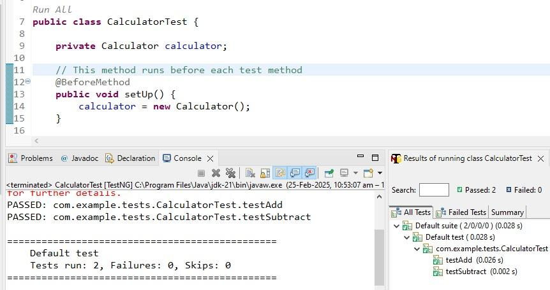Unit Testing Example Output

**Benefits of Unit Testing**

Here are the Unit testing benefits which used in the software development with many ways:

**Early Detection of Issues:** Unit testing allows developers to detect and fix issues early in the development process before they become larger and more difficult to fix.

**Improved Code Quality:**Unit testing helps to ensure that each unit of code works as intended and meets the requirements, improving the overall quality of the software.

**Increased Confidence:** Unit testing provides developers with confidence in their code, as they can validate that each unit of the software is functioning as expected.

Benifits of Unit testing

**Faster Development:**Unit testing enables developers to work faster and more efficiently, as they can validate changes to the code without having to wait for the full system to be tested.

**Better Documentation:**Unit testing provides clear and concise documentation of the code and its behavior, making it easier for other developers to understand and maintain the software.

**Facilitation of Refactoring:**Unit testing enables developers to safely make changes to the code, as they can validate that their changes do not break existing functionality.

**Reduced Time and Cost:**Unit testing can reduce the time and cost required for later testing, as it helps to identify and fix issues early in the development process.

**Disadvantages of Unit Testing**

Here are the Unit testing dis-advantages which are follows:

**Time and Effort:**Unit testing requires a significant investment of time and effort to create and maintain the test cases, especially for complex systems.

**Dependence on Developers:** The success of unit testing depends on the developers, who must write clear, concise, and comprehensive test cases to validate the code.

**Difficulty in Testing Complex Units:**Unit testing can be challenging when dealing with complex units, as it can be difficult to isolate and test individual units in isolation from the rest of the system.

**Difficulty in Testing Interactions:**Unit testing may not be sufficient for testing interactions between units, as it only focuses on individual units.

**Difficulty in Testing User Interfaces:**Unit testing may not be suitable for testing user interfaces, as it typically focuses on the functionality of individual units.

**Over-reliance on Automation:** Over-reliance on automated unit tests can lead to a false sense of security, as automated tests may not uncover all possible issues or bugs.

**Maintenance Overhead:**Unit testing requires ongoing maintenance and updates, as the code and test cases must be kept up-to-date with changes to the software.

**How do developers use unit tests?**

**Unit testing** plays an important role throughout the software development process:

[**Test-Driven Development (TDD)**](https://www.geeksforgeeks.org/software-engineering/test-driven-development-tdd/)**:** InTDD, developers write tests before writing the actual code. This ensures that once the code is completed, it instantly meets the functional requirements when tested, saving time on debugging.

**After Completing Code Blocks:** After a section of code is finished, unit tests are created (if not already done through TDD). These tests are then run to verify that the code works as expected. Unit tests are rarely the first set of tests run during broader system testing.

[**DevOps**](https://www.geeksforgeeks.org/courses/devops-live)**and**[**CI/CD**](https://www.geeksforgeeks.org/devops/what-is-ci-cd/)**:** In DevOps environments, Continuous Integration/Continuous Delivery (CI/CD) automatically runs unit tests whenever new code is added. This ensures that changes are integrated smoothly, tested thoroughly, and deployed efficiently, maintaining overall code quality.

How do developers use unit tests

**When is Unit Testing Less Beneficial?**

Unit testing is not always necessary for every piece of code in every project. Here are some situations where it might be okay to skip unit tests:

**Time Constraints:** Writing unit tests can take a lot of time, even with automated tools. If your team is under pressure, they might get distract while writing tests and miss deadlines, leading to budget issues.

**UI/UX Focus:** If the main focus of the application is on design and user experience rather than complex logic, manual testing might be more effective than unit testing.

**Legacy Code:** Testing old or legacy code can be very challenging. If the existing code is not written well then it may be hard to add tests without reference writing, which can be time-consuming.

**Changing Requirements:** In projects where requirements are frequently changing, it may not be practical to write tests for all code, as the code may change before the tests are even run.

**Difference Between Unit Testing and other Types of Testing**

There are several types of software testing methods, each having its specific role:

[Integration Testing](https://www.geeksforgeeks.org/software-testing/software-engineering-integration-testing/) will be check that different parts of the system work together as expected.

[Functional Testing](https://www.geeksforgeeks.org/software-testing/software-testing-functional-testing/) checks if the software meets the pre-planned requirements.

[Performance Testing](https://www.geeksforgeeks.org/software-testing/performance-testing-software-testing/) will make if the software runs smoothly, such as in the terms of speed and memory usage.

[Acceptance Testing](https://www.geeksforgeeks.org/software-engineering/acceptance-testing-software-testing/) is performed manually by stakeholders to verify the software behaves as expected as we wants.

[Security Testing](https://www.geeksforgeeks.org/software-testing/security-testing/) examines the software for vulnerabilities, including third-party risks in the Software development process.

These tests will require specialized tools and are usually performed after the main functionality is developed. Unlike these, unit tests are run every time the code is built, it can be written as soon as the code exists, and do not need special tools for the same, making unit testing one of the most fundamental testing types.

**Types of Unit Testing**

Unit testing can be performed manually or automatically:

**1. Manual unit testing**

[Manual Testing](https://www.geeksforgeeks.org/software-testing/software-testing-manual-testing/) is like checking each part of a project by hand, without using any special tools. People, like developers, do each step of the testing themselves. But manual unit testing isn't used much because there are better ways to do it and it has some problems:

It costs more because workers have to be paid for the time they spend testing, especially if they're not permanent staff.

It takes a lot of time because tests have to be done every time the code changes.

It is hard to find and fix problems because it is tricky to test each part separately.

Developers often do manual testing themselves to see if their code works correctly.

Types of Unit Testing

**2. Automated unit testing**

[Automation Unit Testing](https://www.geeksforgeeks.org/software-testing/automation-testing-software-testing/) is a way of checking if software works correctly without needing lots of human effort. We use special tools made by people to run these tests automatically. These are part of the process of building the software. Here's how it works:

Developers write a small piece of code to test a function in the software. This code is like a little experiment to see if everything works as it should.

Before the software is finished and sent out to users, these test codes are taken out. They're only there to make sure everything is working properly during development.

Automated testing can help us check each part of the software on its own. This helps us find out if one part depends too much on another. It's like putting each piece of a puzzle under a magnifying glass to see if they fit together just right.

We usually use special tools or frameworks to do this testing automatically. These tools can tell us if any of our code doesn't pass the tests we set up.

The tests we write should be really small and focus on one specific thing at a time. They should also run on the computer's memory and not need internet connection.

So, automated unit testing is like having a helper that checks our work as we build software, making sure everything is in its right place and works as expected.

**Workflow of Unit Testing**

The unit testing workflow includes the following step-by-step process:

Workflow of Unit Testing

**Unit Testing Techniques**

There are 3 types of Unit Testing Techniques. They are follows:

[**Black Box Testing**](https://www.geeksforgeeks.org/software-testing/software-engineering-black-box-testing/)**:**This testing technique is used in covering the unit tests for input, user interface, and output parts.

[**White Box Testing**](https://www.geeksforgeeks.org/software-testing/software-engineering-white-box-testing/)**:**This technique is used in testing the functional behavior of the system by giving the input and checking the functionality output including the internal design structure and code of the modules.

[**Gray Box Testing**](https://www.geeksforgeeks.org/software-testing/gray-box-testing-software-testing/)**:**This technique is used in executing the relevant test cases, test methods, and test functions, and analyzing the code performance for the modules.

**Unit Testing Tools**

Choosing the correct unit testing tool is important for the following reasons:

Ensures that every system component is benefitted from achieving better product quality.

The debugging process is simplified.

Code Refactoring and debugging of the code becomes simpler.

If bugs are present, they would be defined earlier in the SDLC process.

Bug fixing costs would be reduced significantly

Following are some of the unit testing tools:

**LambdaTest**: A cloud-based platform for cross-browser testing, supporting unit tests in various frameworks.

**JUnit**: A widely-used Java testing framework for creating and running unit tests.

**NUnit**: A .NET framework for unit testing C# applications.

**TestNG**: An advanced Java testing framework with features like parallel testing.

**PHPUnit**: A PHP testing framework for unit and integration tests.

**Mockito**: A Java mocking framework for simulating dependencies.

**Cantata**: A tool for unit and integration testing in C/C++.

**Karma**: A JavaScript test runner for browser-based testing.

**Mocha**: A flexible JavaScript testing framework for Node.js and browsers.

**TypeMock**: A .NET mocking framework for isolating dependencies.

**Conclusion**

Unit testing will validate individual units of software in a proper manner, checking if the function works correctly and meets the requirements of the project. While it may offer benefits such as early issue detection and improved code quality, it requires significant time and effort, which depends on the developers' skills.

Checking the challenges, such as the difficulty in testing complex units and UI elements, unit testing is crucial for ensuring software quality and the longevity of the software.

What is unit testing?

Unit testing is the process where you test the smallest functional unit of code. Software testing helps ensure code quality, and it's an integral part of software development. It's a software development best practice to write software as small, functional units then write a unit test for each code unit. You can first write unit tests as code. Then, run that test code automatically every time you make changes in the software code. This way, if a test fails, you can quickly isolate the area of the code that has the bug or error. Unit testing enforces modular thinking paradigms and improves test coverage and quality. Automated unit testing helps ensure you or your developers have more time to concentrate on coding.

What is a unit test?

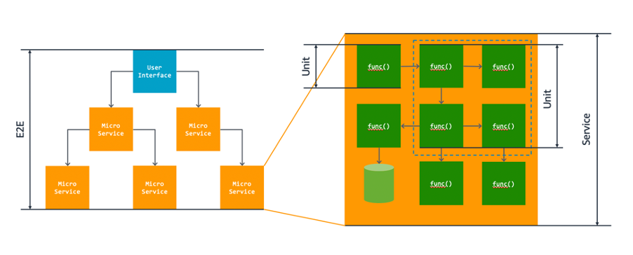

A *unit test*is a block of code that verifies the accuracy of a smaller, isolated block of application code, typically a function or method. The unit test is designed to check that the block of code runs as expected, according to the developer’s theoretical logic behind it. The unit test is only capable of interacting with the block of code via inputs and captured asserted (true or false) output.

A single block of code may also have a set of unit tests, known as *test cases*. A complete set of test cases cover the full expected behavior of the code block, but it’s not always necessary to define the full set of test cases.

When a block of code requires other parts of the system to run, you can’t use a unit test with that external data. The unit test needs to run in isolation. Other system data, such as databases, objects, or network communication, might be required for the code’s functionality. If that's the case, you should use data stubs instead. It’s easiest to write unit tests for small and logically simple blocks of code.

Unit testing strategies

To create unit tests, you can follow some basic techniques to ensure coverage of all test cases.

*Logic checks*

Does the system perform the right calculations and follow the right path through the code given a correct, expected input? Are all paths through the code covered by the given inputs?

*Boundary checks*

For the given inputs, how does the system respond? How does it respond to typical inputs, edge cases, or invalid inputs?

Let’s say you expect an integer input between 3 and 7. How does the system respond when you use a 5 (typical input), a 3 (edge case), or a 9 (invalid input)?

*Error handling*

When there are errors in inputs, how does the system respond? Is the user prompted for another input? Does the software crash?

*Object-oriented checks*

If the state of any persistent objects is changed by running the code, is the object updated correctly?

Unit test example

Here is an example of a very basic method in Python and some test cases with corresponding unit test code.

*Python method*

*def add\_two\_numbers(x, y):*

*return x + y*

*Corresponding unit tests*

*def test\_add\_positives():*

*result = add\_two\_numbers(5, 40)*

*assert result == 45*

*def test\_add\_negatives():*

*result = add\_two\_numbers(-4, -50)*

*assert result == -54*

*def test\_add\_mixed():*

*result = add\_two\_numbers(5, -5)*

*assert result == 0*

What are the benefits of unit testing?

Unit testing benefits software development projects in many ways.

Efficient bug discovery

If there are any input, output, or logic-based errors within a code block, your unit tests help you catch them before the bugs reach production. When code changes, you run the same set of unit tests—alongside other tests such as integration tests—and expect the same results. If tests fail (also called *broken tests*) it indicates regression-based bugs.

Unit testing also helps finds bugs faster in code. Your developers don’t spend a large amount of time on debugging activities. They can quickly pinpoint the exact part of the code that has an error.

Documentation

It's important to document code to know exactly what that code is supposed to be doing. That said, unit tests also act as a form of documentation.

Other developers read the tests to see what behaviors the code is expected to exhibit when it runs. They use the information to modify or refactor the code. Refactoring code makes it more performant and well-composed. You can run the unit testing again to check that code works as expected after changes.

How do developers use unit tests?

Developers use unit tests at various stages of the software development lifecycle.

Test-driven development

Test-driven development (TDD) is when developers build tests to check the functional requirements of a piece of software before they build the full code itself. By writing the tests first, the code is instantly verifiable against the requirements once the coding is done and the tests are run.

After completing a block of code

Once a block of code is considered complete, unit tests should be developed if they have not been already thanks to TDD. Then, you can immediately run unit tests to verify the results. Unit tests are also run as part of the full suite of other software tests during system testing. They're typically the first set of tests that run during full system software testing.

DevOps efficiency

One of the core activities in the application of DevOps to software development practices is continuous integration and continuous delivery (CI/CD). Any changes to the code are automatically integrated into the wider codebase, run through automated testing, and then deployed if the tests pass.

Unit tests make up part of the test suite alongside integration testing. They run automatically in the CI/CD pipeline to ensure code quality as it is upgraded and changed over time.

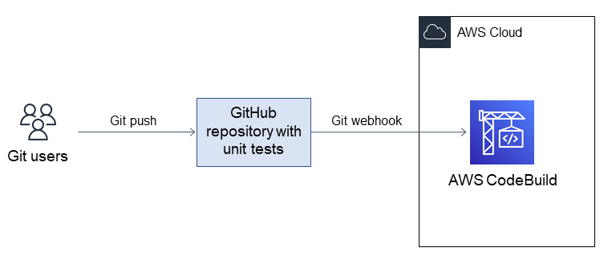

When is unit testing less beneficial?

Unit testing isn’t always required for every single test case in every single block of code in every single project. Here are some examples of when unit testing could potentially be omitted.

When time is constrained

Even with generative unit testing frameworks, writing new unit tests takes a significant amount of your developers' time. While input and output-based unit tests may be easy to generate, logic-based checks are more difficult.

Once your developers start writing tests, they also see refactoring opportunities in the block of code and get distracted from completing them. This can lead to extended development timelines and budget issues.

UI/UX applications

When the main system is concerned with look and feel rather than logic, there may not be many unit tests to run. Other types of testing, such as manual testing, are a better strategy than unit testing in these cases.

Legacy codebases

Writing tests to wrap around existing legacy code can prove to be near impossible, depending on the style of the written code. Because unit tests require dummy data, it can also be too time-intensive to write unit tests for highly interconnected systems with a lot of data parsing.

Rapidly evolving requirements

Depending on the project, the software can grow, change directions, or have whole parts scrapped altogether in any given work sprint. If requirements are likely to change often, there's not much reason to write unit tests each time a block of code is developed.

What are unit testing best practices?

We give some unit testing best practices to get the most out of your process.

Use a unit test framework

It wastes time to write explicit, fully customized unit tests for every single block of code. There are automated testing frameworks for every popular programming language.

For instance, Python has pytest and unittest as two different frameworks for unit testing. Testing frameworks are used extensively throughout software development projects of all sizes.

Automate unit testing

Unit testing should be triggered on different events within software development. For example, you can use them before you push changes to a branch using version control software or before you deploy a software update.

Unit testing may also run on a complete project, set on a timed schedule. Automated unit testing ensures tests run in all appropriate events and cases throughout the development lifecycle.

Assert once

For each unit test, there should only be one true or false outcome. Make sure that there is only one assert statement within your test. A failed *assert statement*in a block of multiple ones can cause confusion on which one produced the issue.

Implement unit testing

Unit testing is an important part of building software, but many projects don’t dedicate resources to it. When projects start as prototypes, are small community-based efforts, or are simply coded quickly, unit testing can be left out due to time constraints.

However, when you build projects with unit testing as a standard practice from the beginning, the process becomes far easier to follow and repeat.

What's the difference between unit testing and other types of testing?

There are many other types of software test methods alongside unit testing. They all have specific roles to play in the software development lifecycle:

Integration testing checks that different parts of the software system that are designed to interact do so correctly.

Functional testing checks whether the software system passes the software requirements outlined before building.

Performance testing checks whether the software runs to expected performance requirements, such as speed and memory size.

Acceptance testing is when the software is tested manually by stakeholders or user groups to check whether it is working as they anticipate.

Security testing checks the software against known vulnerabilities and threats. This includes analysis of the threat surface, including third-party entry points to the software.

These testing methods usually require specialized tools and independent processes to check the software. Many of them are also performed after basic application functionality has been developed.

In contrast, unit tests run every time the code builds. They can be written as soon as any code is written and don’t require any special tools to run. Unit testing is considered to be one of the most basic types of software testing.

**Integration Testing - Software Engineering**

Last Updated : 20 Jul, 2025

Integration Testing is a [Software Testing Technique](https://www.geeksforgeeks.org/software-testing/software-testing-techniques/)that focuses on verifying the interactions and data exchange between different components or modules of a [Software Application](https://www.geeksforgeeks.org/computer-science-fundamentals/what-is-application-software/). The goal of [Integration Testing](https://www.geeksforgeeks.org/software-testing/software-engineering-integration-testing/)is to identify any problems or bugs that arise when different components are combined and interact with each other.

It mainly tests interface between two software units or modules. It focuses on determining the correctness of the interface. Once all the modules have been unit-tested, integration testing is performed.

Integration testing can be done by picking module by module. This can be done so that there is a proper sequence to be followed.

Exposing the defects is the major focus of the integration testing and the time of interaction between the integrated units.

Integration Testing

**Why is Integration Testing Important?**

Integration testing is important because it verifies that individual software modules or components work together correctly as a whole system. This ensures that the integrated software functions as intended and helps identify any compatibility or communication issues between different parts of the system. By detecting and resolving integration problems early, integration testing contributes to the overall reliability, performance, and quality of the software product.

**How to Write Integration Tests?**

Designing integration test cases is a key part of ensuring that the different components of your software work well together. Here's a simplified approach to designing these tests:

**Identify the components to be tested**: Start by pinpointing which parts of your software need to be tested together. These are usually modules that interact or depend on each other.

**Determine the test objectives**: Define what you want to achieve with the test. Are you testing if data flows correctly between modules? Or perhaps checking if the system behaves as expected when components interact?

**Define the test data**: Decide what data you’ll use to test the integration. Make sure the data represents real-world scenarios so that your tests are relevant and meaningful.

**Design the test cases**: Plan out the specific steps for each test. Think about what actions the test will take and what results you expect.

**Develop test scripts**: Write the code that will automate your tests. If your tests are manual, ensure the steps are clearly documented and easy to follow.

**Set up the testing environment**: Make sure the environment where the tests will run mimics the real-world setup as closely as possible. This will give you more accurate results.

**Execute the tests**: Run your tests, paying close attention to how the components interact and whether they perform as expected.

**Evaluate the results**: Finally, review the test outcomes. Did the components work as intended? Were there any errors or unexpected behaviors?

**Types of Integration Testing**

There are four main strategies for executing integration testing: big-bang, top-down, bottom-up, and sandwich (or hybrid) testing. Each of these methods comes with its own set of advantages and challenges, so it's important to choose the right one based on the specific needs of your project. Those approaches are the following:

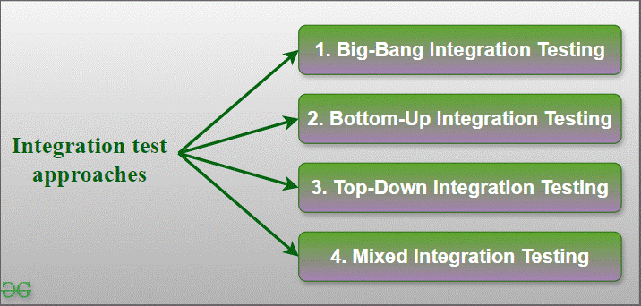Integration Test Approaches

**1. Big-Bang Integration Testing**

It is the simplest integration testing approach, where all the modules are combined and the functionality is verified after the completion of individual module testing. In simple words, all the modules of the system are simply put together and tested. This approach is practicable only for very small systems. If an error is found during the integration testing, it is very difficult to localize the error as the error may potentially belong to any of the modules being integrated.

In debugging errors reported during Big Bang integration testing is very expensive to fix.

Big-bang integration testing is a software testing approach in which all components or modules of a software application are combined and tested at once.

This approach is typically used when the software components have a low degree of interdependence or when there are constraints in the development environment that prevent testing individual components.

The goal of big-bang integration testing is to verify the overall functionality of the system and to identify any integration problems that arise when the components are combined.

While big-bang integration testing can be useful in some situations, it can also be a high-risk approach, as the complexity of the system and the number of interactions between components can make it difficult to identify and diagnose problems.

**Advantages of Big-Bang Integration Testing**

It is convenient for small systems.

Simple and straightforward approach.

Can be completed quickly.

Does not require a lot of planning or coordination.

May be suitable for small systems or projects with a low degree of interdependence between components.

**Disadvantages of Big-Bang Integration Testing**

There will be quite a lot of delay because you would have to wait for all the modules to be integrated.

High-risk critical modules are not isolated and tested on priority since all modules are tested at once.

Not Good for long projects.

High risk of integration problems that are difficult to identify and diagnose.

This can result in long and complex debugging and troubleshooting efforts.

This can lead to system downtime and increased development costs.

May not provide enough visibility into the interactions and data exchange between components.

This can result in a lack of confidence in the system’s stability and reliability.

This can lead to decreased efficiency and productivity.

This may result in a lack of confidence in the development team.

This can lead to system failure and decreased user satisfaction.

**2. Bottom-Up Integration Testing**

In bottom-up testing, each module at lower levels are tested with higher modules until all modules are tested. The primary purpose of this integration testing is that each subsystem tests the interfaces among various modules making up the subsystem. This integration testing uses test drivers to drive and pass appropriate data to the lower-level modules.

**Advantages of Bottom-Up Integration Testing**

In bottom-up testing, no stubs are required.

A principal advantage of this integration testing is that several disjoint subsystems can be tested simultaneously.

It is easy to create the test conditions.

Best for applications that uses bottom up design approach.

It is Easy to observe the test results.

**Disadvantages of Bottom-Up Integration Testing**

Driver modules must be produced.

In this testing, the complexity that occurs when the system is made up of a large number of small subsystems.

As Far modules have been created, there is no working model can be represented.

**3. Top-Down Integration Testing**

Top-down integration testing technique is used in order to simulate the behaviour of the lower-level modules that are not yet integrated. In this integration testing, testing takes place from top to bottom. First, high-level modules are tested and then low-level modules and finally integrating the low-level modules to a high level to ensure the system is working as intended.

**Advantages of Top-Down Integration Testing**

Separately debugged module.

Few or no drivers needed.

It is more stable and accurate at the aggregate level.

Easier isolation of interface errors.

In this, design defects can be found in the early stages.

**Disadvantages of Top-Down Integration Testing**

Needs many Stubs.

Modules at lower level are tested inadequately.

It is difficult to observe the test output.

It is difficult to stub design.

**4. Mixed Integration Testing**

A mixed integration testing is also called sandwiched integration testing. A mixed integration testing follows a combination of top down and bottom-up testing approaches. In top-down approach, testing can start only after the top-level module have been coded and unit tested. In bottom-up approach, testing can start only after the bottom level modules are ready. This sandwich or mixed approach overcomes this shortcoming of the top-down and bottom-up approaches. It is also called the hybrid integration testing. also, stubs and drivers are used  in mixed integration testing.

**Advantages of Mixed Integration Testing**

Mixed approach is useful for very large projects having several sub projects.

This Sandwich approach overcomes this shortcoming of the top-down and bottom-up approaches.

Parallel test can be performed in top and bottom layer tests.

**Disadvantages of Mixed Integration Testing**

For mixed integration testing, it requires very high cost because one part has a Top-down approach while another part has a bottom-up approach.

This integration testing cannot be used for smaller systems with huge interdependence between different modules.

**Applications of Integration Testing**

Integration testing is all about making sure that different parts of a software application work well together. While unit testing checks individual components, integration testing focuses on how those components interact with each other. Here are the few application of Integration Testing:

**Identify the components:**Identify the individual components of your application that need to be integrated. This could include the frontend, backend, database, and any third-party services.

**Create a test plan:**Develop a test plan that outlines the scenarios and test cases that need to be executed to validate the integration points between the different components. This could include testing data flow, communication protocols, and error handling.

**Set up test environment:**Set up a test environment that mirrors the production environment as closely as possible. This will help ensure that the results of your integration tests are accurate and reliable.

**Execute the tests:**Execute the tests outlined in your test plan, starting with the most critical and complex scenarios. Be sure to log any defects or issues that you encounter during testing.

**Analyze the results:**Analyze the results of your integration tests to identify any defects or issues that need to be addressed. This may involve working with developers to fix bugs or make changes to the application architecture.

**Repeat testing:**Once defects have been fixed, repeat the integration testing process to ensure that the changes have been successful and that the application still works as expected.

**Difference between Manual Testing and Automated Testing**

Here is the [Manual Testing vs Automated Testing](https://www.geeksforgeeks.org/software-testing/software-engineering-differences-between-manual-and-automation-testing/)difference in detailed manner:

| **Parameters** | **Manual Testing** | **Automation Testing** |
| --- | --- | --- |
| **Definition** | In manual testing, the test cases are executed by the human tester. | In automated testing, the test cases are executed by the software tools. |
| **Processing Time** | Manual testing is time-consuming. | Automation testing is faster than manual testing. |
| **Resources requirement** | Manual testing takes up human resources. | Automation testing takes up automation tools and trained employees. |
| **Exploratory testing** | Exploratory testing is possible in manual testing. | Exploratory testing is not possible in automation testing. |
| **Framework requirement** | Manual testing doesn’t use frameworks. | Automation testing uses frameworks like Data Drive, Keyword, etc. |
| **Reliability** | Manual testing is not reliable due to the possibility of manual errors. | Automated testing is more reliable due to the use of automated tools and scripts. |
| **Investment** | In manual testing, investment is required for human resources. | In automated testing, investment is required for tools and automated engineers. |
| **Test results availability** | In manual testing, the test results are recorded in an excel sheet so they are not readily available. | In automated testing, the test results are readily available to all the stakeholders in the dashboard of the automated tool. |

**Unit Testing vs Integration Testing**

Here is theDifference between [Unit Testing vs Integration Testing](https://www.geeksforgeeks.org/software-engineering/difference-between-unit-testing-and-integration-testing/)in detailed manner:

| **S. No.** | **Unit Testing** | **Integration Testing** |
| --- | --- | --- |
| 1. | In unit testing, each module of the software is tested separately. | In integration testing, all modules of the software are tested combined. |
| 2. | In unit testing tester knows the internal design of the software. | Integration testing doesn’t know the internal design of the software. |
| 3. | Unit testing is performed first of all testing processes. | Integration testing is performed after unit testing and before system testing. |
| 4. | Unit testing is white box testing. | Integration testing is black box testing. |
| 5. | Unit testing is performed by the developer. | Integration testing is performed by the tester. |

**Conclusion**

Integration testing is a critical [Phase in Software Development](https://www.geeksforgeeks.org/software-engineering/what-is-sdlc-model-and-its-phases/)that ensures all components work together seamlessly. Various approaches like Big-Bang, Bottom-Up, Top-Down, and Mixed Integration Testing help validate the integration points and interactions between modules. Each approach has its advantages and disadvantages, catering to different project needs. Proper integration testing helps identify defects early, ensuring the reliability, performance, and quality of the software product.

Integration testing, defined

Integration testing is a software-testing approach in which various application components or modules are joined and tested to evaluate how well they work together. Integration testing seeks to help ensure that these assembled parts can communicate with each other and interact successfully.

The concept of integration testing raises several questions. The first is whether integration testing is necessary. The answer to that depends at least partially on the company in question. Smaller organizations with limited public interaction can be exempt from the need for integration testing.

However, for any company that works extensively with the public, integration testing becomes increasingly crucial. And if it’s a tech company that engages in releasing new software applications and tools, integration testing is even more vital.

An adage holds that a person never gets a second chance at making a good first impression. The same concept holds true for contemporary companies. Most of them are engaged in trying desperately to attract users, turn them into regular subscribers or consumers and maintain a successful and lucrative ongoing relationship with them. Such companies can’t afford to make many missteps when unveiling their blockbuster new programs or apps.

Consumers expect the technology in question to work as advertised, from its installation through how it interacts with other programs and systems. For this reason, for many organizations, integration testing is a necessary step of doing business.

In short, the goal of integration testing is to make sure that parts and systems work together dependably. But from a PR perspective, another goal of integration testing is to help protect the organization’s identity as a responsible company capable of doing business reliably in a modern context.

Industry newsletter

The latest tech news, backed by expert insights

Stay up to date on the most important—and intriguing—industry trends on AI, automation, data and beyond with the Think newsletter. See the [IBM Privacy Statement](https://www.ibm.com/us-en/privacy).

Top of Form

Business email

Subscribe

Bottom of Form

How integration testing works

The term integration testing was developed over time to describe certain “waterfall” methodologies. In earlier times, software modules and related projects were created in a vacuum, leaving QA teams the considerable chore of testing pieces of the codebase individually and analyzing those test results before introducing them into a software system.

Integration testing is done through the creation and evaluation of test cases. The first phase involves successfully identifying integration points, which are the areas within an application where the different modules interact. When the integration points have been established, test cases are designed around them. These test cases are created to show how the integration points operate, depending on various input scenarios, real-world situations and anticipated outcomes.

With the data gleaned from test coverage, project stakeholders can make the necessary adjustments to the codebase, where all project data is stored.

Test cases used in integration testing help developers zero in on several specific areas of operation:

Data flow

Data that passes through a system takes a journey, moving from its source to its destination. That information receives processing as it moves through the different processing steps and components. This process of motion is known as [data flow](https://www.ibm.com/docs/en/spems/6.2.3?topic=manager-data-flows).

**Key questions:** How well does the data flow between components? Are there any potential impediments that need to be identified and corrected?

Interface coordination

Just as most effective teams require leadership, there is a “higher intelligence” that guides the smooth operation and interaction between software components. This management process is known as interface coordination.

**Key questions:** Are there any foreseeable problems in the accommodation between the interfaces that exist between modules? In other words, do these interfaces match up properly?

Communication protocols

Communication protocols decide how devices share data. Such protocols establish rules for data transference and determine how messages are structured. Communication protocols also specify how systems should correct themselves in times of errors.

**Key questions:** Can integration testing reveal problems with the synchronization between individual units? What measures should be put into place to help ensure secure data transmissions?

Another aspect of integration testing that escalates its overall complexity involves [dependencies](https://www.ibm.com/docs/en/workload-automation/10.2.3?topic=objects-dependencies), which are relationships that exist between modules and/or components. Typical dependencies require that for one component to function, a related component must first operate as needed. Such dependencies must be considered when attempting to sort out potential problems in program execution.

**How Infrastructure is Powering the Age of AI**

Is Your Infrastructure Ready for the Age of AI?

Learn how infrastructure decisions shape AI success. This conversation sets the stage, then the guide helps you explore how IT teams are adapting systems and strategies to support automation and enterprise AI.

[Explore the Guide](https://www.ibm.com/account/reg/signup?formid=urx-52631)

Testing process sequence

There’s a standard sequence to the individual testing steps conducted when performing integration testing because such an ordered sequence gives developers a way to systematically evaluate different pieces of code in a structured fashion. The testing sequence typically begins with the checking of the simplest, individual components first—correcting bugs in lower-level modules before they negatively impact operation later. Then, the testing moves on to more elaborate integrations and evaluates their performance.

In addition to early detection of bugs, the usual testing sequence uses logical progression to mimic the code’s data flow, making sure that component interactions are tested in the correct order. Further, the testing sequence assigns a lower priority to less critical tests concerning low-level modules, allowing developers to dedicate their focus to the most essential operations.

In a traditional testing sequence, testing formats are examined in the following order:

[Unit testing](https://www.ibm.com/docs/en/baw/24.x?topic=debugging-unit-testing), which evaluates individual functions.

Integration testing, to see how components interact.

[System testing](https://www.ibm.com/docs/en/devops-test-workbench/11.0.4?topic=phases-system-integration-testing), for determining the overall functions of whole systems.

Acceptance testing, which checks functions from a user’s perspective.

Integration testing is not the initial testing step in this standard sequence. Integration testing appears where it does in the process because the testing of interactions between individual components has already been accomplished through unit testing. The next level, system testing, moves the sense of scale-out even further to give testers a more macro view of an entire system and how well it all works together.

Types of integration testing

There are numerous types of integration testing techniques, but these are the most used to evaluate software systems.

Top-down integration testing

The top-down approach is one of the two main types of incremental integration testing. It focuses on the main module and its workings before then evaluating the submodules and subroutines. One of the strongest attributes of this approach is that it can be used early in the process—even before the lower-level modules have been fully identified. Testers can use placeholders (called stubs) as a substitute for low-level modules.

Bottom-up integration testing

Another primary example of integration testing is bottom-up integration testing, which switches the order of the testing sequence. In the bottom-up approach, the submodules and subroutines are the first to be evaluated. Then, this approach moves on to test the main module. And just as top-down testing uses stubs as placeholders when needed, bottom-up integration testing uses temporary modules called drivers as substitutes for high-level components that haven’t yet been identified.

Mixed integration testing

Mixed integration (sometimes called sandwiched integration) combines the top-down and bottom-up methods. The main advantage of mixed integration is how it overcomes the enforced process sequence that limits both top-down and bottom-up testing (in directly opposite ways). With mixed integration, the testing can begin with either the main module or with the submodules and subroutines, as user needs dictate.

Big bang integration testing

Another key way to conduct integration testing is through big bang integration testing. Here, all the individual units, components and modules present within a system are integrated and tested together at one time, as if it were a single unit. Big bang testing can provide a quick answer when the system works with all its various parts.

However, this form of testing is limited. If the process reveals that the system doesn’t work as expected, big bang testing can’t reveal which individual parts are failing to work in unison.

Integration testing methods

The following are some popular integration testing methods. Because they all might be the correct methodology for a software company—depending on its needs—they are listed here alphabetically:

**API integration testing:**[Application programming interfaces (APIs)](https://www.ibm.com/think/topics/api) are essential parts of computing, allowing software applications to interface with each other and successfully share data. API testing is a means of software testing that checks how the different APIs within a system work together. The goal is to see them functioning flawlessly as if these APIs were part of a single organized unit. The smoother the APIs operate with each other, the better the operation of the entire system.

**Automated integration testing:**An essential part of the software development process, [automated testing](https://www.ibm.com/docs/en/engineering-lifecycle-management-suite/test-management/7.1?topic=scripts-automated-testing) is another method that evaluates how software components work together. This integration testing process runs test cases based on the work of specialized testing tools and scripts. In this way, integration issues can be detected and fixed before deployment occurs. And because it’s automated, the entire system becomes more efficient and agile. Automated testing is a key element of [continuous integration](https://www.ibm.com/think/topics/continuous-integration), the [DevOps](https://www.ibm.com/think/topics/devops) practice that relies upon a shared repository for constantly updated code changes.

**Black box testing:**The [black box](https://www.ibm.com/think/topics/black-box-ai) analogy can be applied to any situation where it’s understood that the internal workings of the black box (whether that involves computer code or some other operational aspect, such as reported company earnings) are not subject to being fully understood. In the case of black box integration testing, it means that testers don’t want to pore over the specific codes used within different modules; instead, they prefer a simpler and quicker answer about whether the systems, components and modules work harmoniously.

**End-to-end testing:**As the name suggests, [end-to-end testing](https://www.ibm.com/docs/en/configurepricequote/10.0?topic=steps-build-end-end-test-cases) (sometimes called E2E testing) provides testers a way to check the functions of the entire system, from start to finish. Beyond that, E2E testing can mimic real-world test scenarios and set the stage for integration testing by incorporating test plans that determines which units are to be tested. E2E testing typically appears later in the integration testing process, after integration testing has been accomplished but before user acceptance testing.

**Functional testing:**Of all software testing types, the one most dedicated to learning the sheer function of a system is [functional integration testing (FIT)](https://www.ibm.com/docs/en/devops-test-ui/11.0.4?topic=ide-create-functional-test). FIT provides validation that different modules or components can interact as needed and is useful in the way it can locate defects early in the software development lifecycle, before those issues can become full-blown problems. Testers typically perform functional testing after unit testing is conducted but before full system testing begins.

**Regression testing:**Another testing framework is found through [regression testing](https://www.ibm.com/docs/kk/cics-ts/6.x?topic=descriptions-regression-testing), which serves as an after-the-fact test environment for checking to see whether any changes made during the integration process have inadvertently introduced glitches to other parts of the system. When new features—such as new online payment avenues—are introduced, regression testing is used to help ensure that additions don’t derail systems that are already working correctly.

**White box testing:**In direct contrast to black box testing, white box testing assumes that testers want to examine relevant code during the testing process in hopes of pinpointing problem areas and making corrective code changes to debug those problems, even though such an approach will almost certainly be more time-consuming. The phrase “white box” reflects this desire for clarity in the system’s inner workings—although the expression “clear box” might be a more accurate description of what testers seek.

Popular integration testing tools

Here again, this marketplace niche is served by numerous integration testing tools and frameworks. Here are some of the most popular:

**Citris:**Citris serves [Java’s](https://www.ibm.com/think/topics/java) huge user base (which makes it one of the world’s [most popular programming languages](https://softjourn.com/insights/is-java-still-used)) with an open source JavaTM framework. Citris can manage API usage (such as transactions) and generate testing messages.

**Katalon:**Katalon Studio’s automation testing software incorporates the [open source](https://www.ibm.com/think/topics/open-source) framework Selenium—a browser-based tool that lets testers write test scripts in various programming languages, including JavaScript, NodeJS and Python.

**Postman:**API integration testing is well served by Postman. The tool also excels in the way that it enables collaboration and accommodates [automation](https://www.ibm.com/think/topics/automation). Further, users can write a test without having to put that test in a collection or even save it. The tester makes a request in Postman and receives a corresponding URL.

**SoapUI:**SoapUI provides an open source tool capable of testing web applications and executing integration testing. With it, testers get a graphical interface that supports the creation of test cases and enables users to easily work with test data.

Which integration tool works for you?

Whether your company needs call for [front-end](https://developer.ibm.com/technologies/front-end-development/) or back-end evaluation and remediation, integration testing offers the means to evaluate the success of the connections that are now vitally important to making businesses operate with peak efficiency and maximized profitability.

As previously mentioned, there’s a considerable number of different integration testing methods, as software creators work to identify and develop an integration testing method for every possible need and all relevant configurations. And it’s working, because most software development companies understand the need for such testing. Some estimates assess that roughly 70% of businesses engaged in DevOps work are already using some form of integration testing.

So, which is the right integration tool for your business? Thanks to a receptive marketplace, it’s likely you can find one that capably suits your company needs. To figure out exactly what those needs are, we suggest you turn to one more famous old saying: “Know thyself.” As sayings go, it’s still useful advice—even for a postmodern world.

What Is Validation Testing? Software Testing Guide

[Dominik Szahidewicz](https://bugbug.io/blog/author/dominik-szahidewicz/)

June 10, 2025

Software developers and QA teams rely on a variety of testing techniques to validate that the software meets the necessary standards. Whether working on a new software product or updating an existing one, developers can perform validation testing at multiple stages to confirm that the product functions as expected. This is especially important in modern development environments, where the software product may contain complex integrations and rely on numerous external systems to function properly.

🎯 TL;DR - Validation Testing Guide

**Validation vs. Verification**: Validation ensures the product meets user needs, while verification checks if the product is built correctly according to design specifications.

**Validation Testing Goals**: Confirm that software meets business requirements, fulfills user needs, and operates under real-world conditions.

**Key Validation Testing Types**: Includes functional testing, non-functional testing, user acceptance testing (UAT), system testing, regression testing, and beta testing.

**Validation Techniques**: Black box, white box, and automation testing are commonly used to evaluate the software.

**Continuous Process**: Validation testing occurs throughout the development lifecycle to ensure software quality and functionality.

**Check also:**

👉 [What is Performance Testing?](https://bugbug.io/blog/software-testing/performance-testing-in-software-testing/)

👉 [Why Should You Use data-testid Attributes?](https://bugbug.io/blog/software-testing/data-testid-attributes/)

👉 [Best Selenium Practice Websites](https://bugbug.io/blog/testing-frameworks/best-selenium-practice-websites/)

👉 [Selenium Cheat Sheet](https://bugbug.io/blog/testing-frameworks/selenium-cheat-sheet/)

[🎯 TL;DR - Validation Testing Guide](https://bugbug.io/blog/software-testing/validation-testing/#%F0%9F%8E%AF-tl%3Bdr---validation-testing-guide)

[Understanding Validation Testing](https://bugbug.io/blog/software-testing/validation-testing/#understanding-validation-testing)

[Key Objectives of Validation Testing:](https://bugbug.io/blog/software-testing/validation-testing/#key-objectives-of-validation-testing%3A)

[The Difference Between Verification and Validation](https://bugbug.io/blog/software-testing/validation-testing/#the-difference-between-verification-and-validation)

[Types of Validation Testing](https://bugbug.io/blog/software-testing/validation-testing/#types-of-validation-testing)

[Validation Testing Techniques](https://bugbug.io/blog/software-testing/validation-testing/#validation-testing-techniques)

[Example of Validation Testing](https://bugbug.io/blog/software-testing/validation-testing/#example-of-validation-testing)

[The Role of Validation Testing in the Development Process](https://bugbug.io/blog/software-testing/validation-testing/#the-role-of-validation-testing-in-the-development-process)

[Validation Testing - Why Is It Important?](https://bugbug.io/blog/software-testing/validation-testing/#validation-testing---why-is-it-important%3F)

Understanding Validation Testing

Validation testing is the process of evaluating a software product to ensure that it meets the intended use and satisfies business requirements. This type of testing ensures that the final product meets the expectations of end users, confirming that the software operates as designed.

In the software development process, validation involves testing the product after it has been built, typically during the later stages, such as user acceptance testing (UAT) or system testing. It answers the critical question: "Are we building the right product?" This is different from verification testing, which focuses on ensuring that the software is built correctly according to design specifications.

**Automate your tests for free**

Test easier than ever with BugBug test recorder. Faster than coding. Free forever.

**[Get started](https://app.bugbug.io/sign-up/" \t "_blank)**

Validation testing, along with verification and validation [testing practices](https://bugbug.io/blog/test-automation/software-testing-best-practices/), is fundamental to the software engineering discipline. While verification testing ensures the software is built according to design specifications, validation testing ensures the product works correctly and fulfills the needs of the users. This distinction highlights the importance of conducting both forms of testing throughout the software development life cycle to ensure software quality.

**Key Objectives of Validation Testing:**

Confirm that the software meets business requirements.

Ensure the software fulfills user needs and expectations.

Validate that the product operates under real-world conditions.

The Difference Between Verification and Validation

One common area of confusion is the distinction between verification and validation in software testing. Both processes are critical to the overall software development life cycle (SDLC), but they serve different purposes:

Verification checks if the product is built correctly by ensuring that the design specifications and coding meet required standards. It involves testing techniques like unit testing, integration testing, and functional testing. Verification ensures that the software functions as intended and adheres to the set guidelines.

Validation checks if the right product has been built, verifying whether the software meets user expectations and business requirements. This process typically involves higher-level testing, including system testing, user acceptance testing, and beta testing.

In simpler terms, verification testing ensures the software is correctly built, while validation testing ensures the software is fit for use.

Types of Validation Testing

There are various types of validation testing that software teams can perform throughout the development process to ensure the software meets user needs:

[**Functional Testing**](https://bugbug.io/blog/software-testing/functional-testing/): Ensures the software's features work according to the specified requirements. It involves testing individual functionalities of the application to ensure the software behaves as expected.

**Non-Functional Testing**: Assesses aspects like performance, security, and usability to ensure the software can handle real-world conditions. [**Accessibility testing**](https://bugbug.io/blog/software-testing/accessibility-testing/), for example, ensures the product is accessible to all users, including those with disabilities.

[**User Acceptance Testing (UAT)**](https://bugbug.io/blog/software-testing/qa-vs-uat/): In this phase, real users test the software to verify that it meets their needs and expectations before release.

**System Testing**: Involves evaluating the software as a whole to ensure all components work together correctly. This includes end-to-end testing of the entire system.

[**Regression Testing**](https://bugbug.io/blog/software-testing/everything-you-need-to-know-about-regression-testing/): Ensures that new updates or changes to the software don’t negatively impact existing functionality. Validation can help confirm that the software update doesn't introduce new bugs.

**Beta Testing**: Performed in a real-world environment by end users, beta testing helps identify any issues that may have been overlooked during earlier testing phases.

Validation Testing Techniques

Various testing techniques can be applied to validation testing in software development. These include:

**Black Box Testing**: Focuses on testing the software without looking at the underlying code. The tester inputs data and examines the outputs, verifying whether the software behaves as expected.

**White Box Testing**: Involves testing the internal structures of the application, with a focus on understanding the code and how it functions.

[**Test Automation**](https://bugbug.io/blog/software-testing/test-automation/): Tools can be employed to automate repetitive tasks in validation testing, ensuring consistency and efficiency. Automation testing is particularly useful for running large sets of test cases during regression testing.

**Example of Validation Testing**

Let’s consider an e-commerce website that allows users to purchase products online. **Validation testing** would involve checking whether the checkout process works smoothly, whether payment methods are functioning, and whether the final **product meets** the user’s needs. This might include **UAT**, where real customers simulate purchases to verify the system is user-friendly and performs as expected.

The Role of Validation Testing in the Development Process

Validation testing occurs throughout the development process, from the early stages of product design to the final stages before release. It is a continuous activity in the software testing process aimed at ensuring that the software not only works as intended but also fulfills user expectations.

By conducting validation activities at different stages—such as functional testing, integration testing, and non-functional testing—software developers can ensure the software product meets the requirements and functions correctly within the system. Ultimately, validation testing verifies that the software meets both the technical and user-centric goals.

Validation Testing - Why Is It Important?

In the software development lifecycle, validation testing is essential for ensuring the final product meets user needs, business requirements, and design specifications. It is the process of evaluating a software system to verify that it operates as expected and delivers the desired results. Validation testing involves various testing phases such as system testing, user acceptance testing, and regression testing.

By incorporating validation testing techniques throughout the development process, you can ensure that the software is built correctly and performs well in real-world scenarios. This ensures a high-quality software application that meets the requirements of both developers and end users, driving confidence in the final product.

**Verification and Validation in Software Engineering**

Last Updated : 11 Jul, 2025

**Verification and Validation** are the processes of investigating whether a software system satisfies specifications and standards and fulfills the required purpose. Verification and Validation both play an important role in developing good software. Verification helps in examining whether the product is built right according to requirements, while validation helps in examining whether the right product is built to meet user needs.

Here we are learning about the Verification and Validation in detail:

**Table of Content**

[What is Verification?](https://www.geeksforgeeks.org/software-engineering/software-engineering-verification-and-validation/#what-is-verification)

[What is Validation?](https://www.geeksforgeeks.org/software-engineering/software-engineering-verification-and-validation/#what-is-validation)

[Example Scenario of Verification and Validation](https://www.geeksforgeeks.org/software-engineering/software-engineering-verification-and-validation/#example-scenario-of-verification-and-validation)

[Differences between Verification and Validation](https://www.geeksforgeeks.org/software-engineering/software-engineering-verification-and-validation/#differences-between-verification-and-validation)

[Why Verification and Validation Important?](https://www.geeksforgeeks.org/software-engineering/software-engineering-verification-and-validation/#why-verification-and-validation-important)

**What is Verification?**

**Verification** is the process of checking that software achieves its goal without any bugs. It is the process to ensure whether the product that is developed is right or not. It verifies whether the developed product fulfills the requirements that we have. Verification is static testing. Verification means **Are we building the product right?**

**Static Testing**

Verification Testing is known as Static Testing, and it can be simply termed as checking whether we are developing the right product or not, and also whether our software is fulfilling the customer's requirement or not.Here are some of the activities that are involved in verification.

**Inspections**: This is when we carefully look over the software’s design or code to spot any potential problems or areas that could be improved.

**Reviews**: This is a team effort, where everyone gets together to assess the software’s requirements, design, or code. The goal is to make sure everything is on track and meets the specified objectives.

**Walkthroughs**: In a walkthrough, the developer or designer gives a casual presentation of their work, explaining how it meets the project’s requirements. It’s a great way to get everyone on the same page.

**Desk-Checking**: This is when a developer manually reviews their own code or design to catch any mistakes or issues before moving forward.

Verification and Validation

**What is Validation?**

**Validation** is the process of checking whether the [**Software Product**](https://www.geeksforgeeks.org/software-engineering/software-engineering-software-product/) is up to the mark, or in other words product has high-level requirements. It is the process of checking the validation of the product i.e., it checks whether what we are developing is the right product. It is a validation of the actual and expected products. Validation is dynamic testing. Validation means **Are we building the right product?**

**Dynamic Testing**

Validation Testing is known as [**Dynamic Testing**](https://www.geeksforgeeks.org/software-engineering/software-testing-dynamic-testing/) in which we examine whether we have developed the product right or not and also about the business needs of the client.Here are some of the activities that are involved in Validation.

[**Black Box Testing**](https://www.geeksforgeeks.org/software-testing/software-engineering-black-box-testing/): This is all about testing the software from the user’s perspective. You don’t need to know how the code works internally. Instead, you just focus on whether the software behaves as expected when you use it, like clicking buttons or entering information.

[**White Box Testing**](https://www.geeksforgeeks.org/software-testing/software-engineering-white-box-testing/): In this case, you have access to the internal workings of the software. You’re testing the logic, the flow, and how the code is structured to make sure everything is functioning as it should behind the scenes.

[**Unit Testing**](https://www.geeksforgeeks.org/software-testing/unit-testing-software-testing/): This involves testing individual parts or functions of the software to make sure each piece works properly on its own, before they’re combined with other parts of the system.

[**Integration Testing**](https://www.geeksforgeeks.org/software-testing/software-engineering-integration-testing/): Once individual pieces are tested, integration testing checks how well different parts of the software work together. It’s like making sure all the components play nicely when combined.

**Example Scenario of Verification and Validation**

**Verification**: During development, the team takes a step back to check the system’s design and code. They focus on key features like user registration, the shopping cart, and payment processing. Through inspections and walkthroughs, they make sure each part of the software is being built according to the initial plan and specifications.

**Validation**: Once the software is finished, it’s time to test it. First, the team runs **unit tests** to check individual features, like making sure the shopping cart calculates prices correctly. Then, **integration tests** ensure all features work well together. After that, **system testing** checks if everything functions as a whole. Finally, the client does **acceptance testing** to confirm that the software meets their needs and expectations.

**Differences between Verification and Validation**

Here is the [**Differences Between Verification and Validation**](https://www.geeksforgeeks.org/software-engineering/differences-between-verification-and-validation/).

|  | **Verification** | **Validation** |
| --- | --- | --- |
| **Definition** | Verification refers to the set of activities that ensure software correctly implements the specific function | Validation refers to the set of activities that ensure that the software that has been built is traceable to customer requirements. |
| **Focus** | It includes checking documents, designs, codes, and programs. | It includes testing and validating the actual product. |
| **Type of Testing** | Verification is the [**Static testing**](https://www.geeksforgeeks.org/software-engineering/software-testing-static-testing/). | Validation is [**Dynamic testing**.](https://www.geeksforgeeks.org/software-engineering/software-testing-dynamic-testing/) |
| **Execution** | It does *not* include the execution of the code. | It includes the execution of the code. |
| **Methods Used** | Methods used in verification are reviews, walkthroughs, inspections and desk-checking. | Methods used in validation are [**Black Box Testing**](https://www.geeksforgeeks.org/software-testing/software-engineering-black-box-testing/), [**White Box Testing**](https://www.geeksforgeeks.org/software-testing/software-engineering-white-box-testing/)and [**Non-Functional testing**](https://www.geeksforgeeks.org/software-testing/software-testing-non-functional-testing/). |

**Note:** Verification is followed by Validation.

verification and validation

**Why Verification and Validation Important?**

Both verification and validation are key to delivering high-quality software, and while they focus on different things, they work together to make sure your product is as per requirements. Here’s the reason why its important:

**Verifying Correctness**: Verification helps catch mistakes early in development. It ensures that you’re building the software the right way, according to the original plan and specifications.

**Meeting User Needs**: Validation is about making sure the final product actually solves the problem for the user. It checks that the software delivers what the customer wants and performs as expected in real-world conditions.

**Preventing Bugs and Issues**: Verification helps find bugs or errors before the software even gets tested. That means you can fix problems early on. Validation, on the other hand, ensures the product works well in real-world use, preventing surprises later.

**Improving Efficiency**: By using both verification and validation, teams can catch issues sooner and reduce the time spent on bug fixes later in the process. This makes development more efficient and helps release products faster.

**Conclusion**

Verification and validation are essential processes in software development that ensure the quality and effectiveness of a software product. Verification checks if the software is built correctly according to specifications, while validation ensures the software meets user needs and performs well in real-world conditions. Together, they help identify and fix issues early, improving the reliability and user satisfaction of the final product.

In [software project management](https://en.wikipedia.org/wiki/Software_project_management), [software testing](https://en.wikipedia.org/wiki/Software_testing), and [software engineering](https://en.wikipedia.org/wiki/Software_engineering), [**verification and validation**](https://en.wikipedia.org/wiki/Verification_and_validation) is the process of checking that a software system meets specifications and requirements so that it fulfills its intended purpose. It may also be referred to as [software quality control](https://en.wikipedia.org/wiki/Software_quality_control). It is normally the responsibility of [software testers](https://en.wikipedia.org/wiki/Software_testing) as part of the [software development lifecycle](https://en.wikipedia.org/wiki/Software_development_process). In simple terms, software verification is: "Assuming we should build X, does our software achieve its goals without any bugs or gaps?" On the other hand, software validation is: "Was X what we should have built? Does X meet the high-level requirements?"

**Definitions**

Verification and validation are not the same thing, although they are often confused. [Boehm](https://en.wikipedia.org/wiki/Barry_Boehm) succinctly expressed the difference as[[1]](https://en.wikipedia.org/wiki/Software_verification_and_validation#cite_note-PhamSoft99-1)

Verification: Are we building the product right?

Validation: Are we building the right product?

"Building the product right" checks that the *specifications* are correctly implemented by the system while "building the right product" refers back to the *user's needs*. In some contexts, it is required to have written requirements for both as well as formal procedures or protocols for determining compliance. Ideally, [formal methods](https://en.wikipedia.org/wiki/Formal_methods) provide a mathematical guarantee that software meets its specifications.

Building the product right implies the use of the Requirements Specification as input for the next phase of the development process, the design process, the output of which is the Design Specification. Then, it also implies the use of the Design Specification to feed the construction process. Every time the output of a process correctly implements its input specification, the software product is one step closer to final verification. If the output of a process is incorrect, the developers have not correctly implemented some component of that process. This kind of verification is called "artifact or specification verification".

**Software verification**

It would imply to verify if the specifications are met by running the software but this is not possible (e.g., how can anyone know if the architecture/design/etc. are correctly implemented by running the software?). Only by reviewing its associated artifacts, can someone conclude whether or not the specifications are met.

**Artifact or specification verification**

The output of each software development process stage can also be subject to verification when checked against its input specification (see the definition by CMMI below).

Examples of artifact verification:

Of the design specification against the requirement specification: Do the architectural design, detailed design and database logical model specifications correctly implement the functional and non-functional requirements specifications?

Of the construction artifacts against the design specification: Do the source code, user interfaces and database physical model correctly implement the design specification?

**Software validation**

Software validation checks that the software product satisfies or fits the intended use (high-level checking), i.e., the software meets the user requirements, not as specification artifacts or as needs of those who will operate the software only; but, as the needs of all the stakeholders (such as users, operators, administrators, managers, investors, etc.). There are two ways to perform software validation: internal and external. During internal software validation, it is assumed that the goals of the stakeholders were correctly understood and that they were expressed in the requirement artifacts precisely and comprehensively. If the software meets the requirement specification, it has been internally validated. External validation happens when it is performed by asking the stakeholders if the software meets their needs. Different software development methodologies call for different levels of user and stakeholder involvement and feedback; so, external validation can be a discrete or a continuous event. Successful final external validation occurs when all the stakeholders accept the software product and express that it satisfies their needs. Such final external validation requires the use of an [acceptance test](https://en.wikipedia.org/wiki/Acceptance_testing) which is a [dynamic test](https://en.wikipedia.org/wiki/Dynamic_testing).

However, it is also possible to perform internal static tests to find out if the software meets the requirements specification but that falls into the scope of static verification because the software is not running.

**Artifact or specification validation**

Requirements should be validated before the software product as a whole is ready (the waterfall development process requires them to be perfectly defined before design starts; but iterative development processes do not require this to be so and allow their continual improvement).

Examples of artifact validation:

User Requirements Specification validation: User requirements as stated in a document called User Requirements Specification are validated by checking if they indeed represent the will and goals of the stakeholders. This can be done by interviewing the stakeholders and asking them directly (static testing) or even by releasing prototypes and having the users and stakeholders to assess them (dynamic testing).

User input validation: User input (gathered by any peripheral such as a keyboard, bio-metric sensor, etc.) is [validated](https://en.wikipedia.org/wiki/Data_validation) by checking if the input provided by the software operators or users meets the domain rules and constraints (such as data type, range, and format).

**Validation vs. verification**

According to the [Capability Maturity Model](https://en.wikipedia.org/wiki/Capability_Maturity_Model) (CMMI-SW v1.1),[[2]](https://en.wikipedia.org/wiki/Software_verification_and_validation#cite_note-2)

Software Validation: The process of evaluating software during or at the end of the development process to determine whether it satisfies specified requirements. [IEEE-STD-610]

Software Verification: The process of evaluating software to determine whether the products of a given development phase satisfy the conditions imposed at the start of that phase. [IEEE-STD-610]

Validation during the software development process can be seen as a form of User Requirements Specification validation; and, that at the end of the development process is equivalent to Internal and/or External Software validation. Verification, from CMMI's point of view, is evidently of the artifact kind.

In other words, software verification ensures that the output of each phase of the software development process effectively carries out what its corresponding input artifact specifies (requirement -> design -> software product), while software validation ensures that the software product meets the needs of all the stakeholders (therefore, the requirement specification was correctly and accurately expressed in the first place). Software verification ensures that "you built it right" and confirms that the product, as provided, fulfills the plans of the developers. Software validation ensures that "you built the right thing" and confirms that the product, as provided, fulfills the intended use and goals of the stakeholders.

This article has used the strict or [narrow](https://en.wikipedia.org/wiki/Software_verification#Narrow_scope) definition of verification.

From a testing perspective:

Fault – wrong or missing function in the code.

Failure – the manifestation of a fault during execution. The software was not effective. It does not do "what" it is supposed to do.

Malfunction – according to its specification the system does not meet its specified functionality. The software was not efficient (it took too many resources such as CPU cycles, it used too much memory, performed too many I/O operations, etc.), it was not usable, it was not reliable, etc. It does not do something "how" it is supposed to do it.

**Related concepts**

Both verification and validation are related to the concepts of [quality](https://en.wikipedia.org/wiki/Quality_(business)) and of [software quality assurance](https://en.wikipedia.org/wiki/Software_quality_assurance). By themselves, verification and validation do not guarantee software quality; planning, [traceability](https://en.wikipedia.org/wiki/Traceability), configuration management and other aspects of software engineering are required.

Within the [modeling and simulation](https://en.wikipedia.org/wiki/Modeling_and_simulation) (M&S) community, the definitions of verification, validation and accreditation are similar:

M&S Verification is the process of determining that a [computer model](https://en.wikipedia.org/wiki/Computer_model), simulation, or federation of models and simulation implementations and their associated data accurately represent the developer's conceptual description and specifications.[[3]](https://en.wikipedia.org/wiki/Software_verification_and_validation#cite_note-Missile_Defense_Agency-3)

M&S Validation is the process of determining the degree to which a model, simulation, or federation of models and simulations, and their associated data are accurate representations of the real world from the perspective of the intended use(s).[[3]](https://en.wikipedia.org/wiki/Software_verification_and_validation#cite_note-Missile_Defense_Agency-3)

[Accreditation](https://en.wikipedia.org/wiki/Accreditation) is the formal certification that a model or simulation is acceptable to be used for a specific purpose.[[3]](https://en.wikipedia.org/wiki/Software_verification_and_validation#cite_note-Missile_Defense_Agency-3)

The definition of M&S validation focuses on the accuracy with which the M&S represents the real-world intended use(s). Determining the degree of M&S accuracy is required because all M&S are approximations of reality, and it is usually critical to determine if the degree of approximation is acceptable for the intended use(s). This stands in contrast to software validation.

**System Testing - Software Engineering**

Last Updated : 20 Jul, 2025

System Testing is a type of [software testing](https://www.geeksforgeeks.org/software-testing/software-testing-basics/)that is performed on a completely integrated system to evaluate the compliance of the system with the corresponding requirements. In system testing, integration testing passed components are taken as input.

The goal of integration testing is to detect any irregularity between the units that are integrated. System testing detects defects within both the integrated units and the whole system. The result of system testing is the observed behavior of a component or a system when it is tested.

System Testing is carried out on the whole system in the context of either system requirement specifications or functional requirement specifications or the context of both. System testing tests the design and behavior of the system and also the expectations of the customer.

It is performed to test the system beyond the bounds mentioned in the [software requirements specification (SRS)](https://www.geeksforgeeks.org/software-engineering/software-engineering-quality-characteristics-of-a-good-srs/). System Testing is performed by a testing team that is independent of the development team and helps to test the quality of the system impartial.

It has both functional and non-functional testing. System Testing is performed after the integration testing and before the acceptance testing.

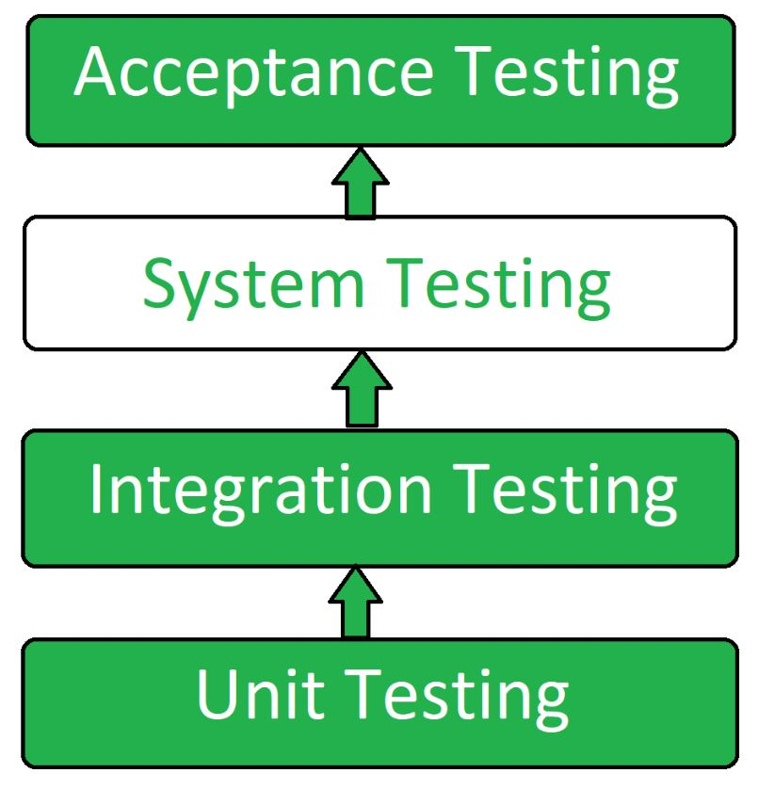System Testing

**System Testing Process**

System Testing is performed in the following steps:

**Test Environment Setup:**Create testing environment for the better quality testing.

**Create Test Case:**Generate test case for the testing process.

**Create Test Data:**Generate the data that is to be tested.

**Execute Test Case:**After the generation of the test case and the test data, test cases are executed.

**Defect Reporting:**Defects in the system are detected.

**Regression Testing:**It is carried out to test the side effects of the testing process.

**Log Defects:**Defects are fixed in this step.

**Retest:**If the test is not successful then again test is performed.

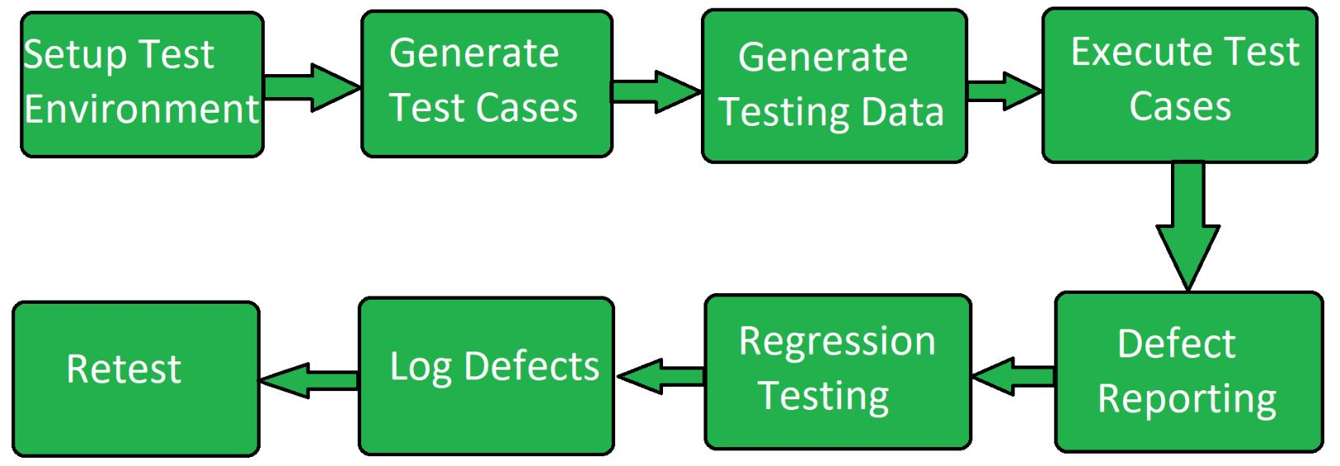System Testing Process

**Types of System Testing**

Here are the Types of System Testing are follows:

Types of testing

[**Functional Testing**](https://www.geeksforgeeks.org/software-testing/software-testing-functional-testing/)**:** This checks if the system’s features work as expected and meet the defined requirements.

[**Performance Testing**](https://www.geeksforgeeks.org/software-testing/performance-testing-software-testing/)**:** This tests how the system performs under different conditions, like high traffic or heavy use, to ensure it can handle the expected load.

[**Security Testing**](https://www.geeksforgeeks.org/software-testing/security-testing/)**:** This ensures the system’s security measures protect sensitive data from unauthorized access or attacks.

[**Compatibility Testing**](https://www.geeksforgeeks.org/software-engineering/compatibility-testing-in-software-engineering/)**:** This makes sure the system works well across different hardware, software, and network environments.

[**Usability Testing**](https://www.geeksforgeeks.org/software-testing/usability-testing/)**:** This evaluates how easy and user-friendly the system is, making sure it provides a good experience for users.

[**Regression Testing**](https://www.geeksforgeeks.org/software-engineering/software-engineering-regression-testing/)**:** This ensures that any new code or features don’t break or negatively affect the system’s existing functionality.

[**Acceptance Testing**](https://www.geeksforgeeks.org/software-engineering/acceptance-testing-software-testing/)**:** This tests the system at a high level to make sure it meets customer expectations and requirements before release.

**Tools used for System Testing**

Here are the Tools used for System Testing are follows:

JMeter

Gallen Framework

HP Quality Center/ALM

IBM Rational Quality Manager

Microsoft Test Manager

Selenium

Appium

LoadRunner

Gatling

JMeter

Apache JServ

SoapUI

***Note:*** *The choice of tool depends on various factors like the technology used, the size of the project, the budget, and the testing requirements.*

**Advantages of System Testing**

Here are the Advantages of System Testing are follows:

In System Testing The testers do not require more knowledge of programming to carry out this testing.

It will test the entire product or software so that we will easily detect the errors or defects which cannot be identified during the unit testing and integration testing.

The testing environment is similar to that of the real time production or business environment.

It checks the entire functionality of the system with different test scripts and also it covers the technical and business requirements of clients.

After this testing, the product will almost cover all the possible bugs or errors and hence the development team will confidently go ahead with acceptance testing

Verifies the overall functionality of the system.

Detects and identifies system-level problems early in the development cycle.

Helps to validate the requirements and ensure the system meets the user needs.

Improves system reliability and quality.

Facilitates collaboration and communication between development and testing teams.

Enhances the overall performance of the system.

Increases user confidence and reduces risks.

Facilitates early detection and resolution of bugs and defects.

Supports the identification of system-level dependencies and inter-module interactions.

Improves the system’s maintainability and scalability.

**Disadvantages of System Testing**

Here are the Disadvantages of System Testing are follows:

System Testing is time consuming process than another testing techniques since it checks the entire product or software.

The cost for the testing will be high since it covers the testing of entire software.

It needs good debugging tool otherwise the hidden errors will not be found.

Can be time-consuming and expensive.

Requires adequate resources and infrastructure.

Can be complex and challenging, especially for large and complex systems.

Dependent on the quality of requirements and design documents.

Limited visibility into the internal workings of the system.

Can be impacted by external factors like hardware and network configurations.

Requires proper planning, coordination, and execution.

Can be impacted by changes made during development.

Requires specialized skills and expertise.

May require multiple test cycles to achieve desired results.

**Best Practices for System Testing**

To make system testing effective, follow these best practices:

**Clear Test Plan and Requirements:** Make sure you have a well-defined test plan and clear requirements. This ensures all parts of the system are covered and tested correctly.

**Test Early and Often:** Start testing as soon as possible in the development process and continue testing regularly. Finding and fixing issues early helps save time and money.

**Use Automation for Repetitive Tests:** Automate tests that you run repeatedly, like regression or performance tests. This saves time and allows you to focus on more complex testing.

**Create Realistic Test Scenarios:** Design test cases based on how users will actually use the system. This includes testing for edge cases, unusual inputs, and potential system failures.

**Collaborate with Developers:** Work closely with developers throughout the testing process. They can help identify problems faster and provide insights into how the system functions.

**Conclusion**

System testing is a important step in [software development](https://www.geeksforgeeks.org/software-engineering/what-is-software-development/) that verify the system works as expected and meets the required standards. By testing the entire system, developers and testers can catch problems early, improve the software's quality, and provide a better user experience. Whether it's testing for functionality, performance, or security, system testing makes sure the software meets the needs of users and stakeholders, while reducing risks and errors. Successful system testing relies on careful planning, effective execution, and strong teamwork.

Software testing, an essential part of software development life cycle, is quite a vast and complex process that requires ample time and efforts of testers to validate software product’s quality and effectiveness. Moreover, there are multifarious requirements that need to be considered and tested, which sometimes become a source of uncertainty for testers, mostly regarding where to commence & terminate testing. To avoid this confusion, specific conditions and requirements are established by the QA team, before the inception of testing that helps testers throughout the testing life cycle. These conditions are termed as entry and exit criteria, which play a crucial role in software testing life cycle.

This article provides more information about SDLC and STLC ???

What Is? SDLC vs STLC

Software development is the process of planning, designing, creating, testing, and deploying a software product to…

medium.com

The entry and exit criteria in software testing are determined based on the test strategy. It defines the project’s approach to testing. Below are some of the considerations of the test strategy:

Characteristics of the developing system,

Project timelines and budget,

Planning of testing effort across the length and breadth of the project

Broadly, the Testing Strategy impacts the tasks related to test planning, test types, test script development, and test execution.

Generally, the entry and exit criteria are determined for the four test levels of Software Testing:

Unit Testing,

Integration Testing,

System Testing,

Acceptance Testing

Test durumlari mevcuttur.

Each test type requires distinct entry and exit criteria for testing phases. It ensures that the objectives of the test strategy and product requirements are met. Additionally, the QA professionals can utilize the outlined entry-exit criteria of the test strategy to map and analyze before sign off the outcomes.

The stages in STLC have specific entry and exit criteria. Now let’s move on to what these entry and exit criteria are.

Entry Criteria

Entry criteria for testing can be defined as “Specific conditions or on-going activities that must be present before a process can begin.” The Software Testing Life Cycle (STLC) specifies the entry criteria required during each testing phase. It also defines the time interval or the expected amount of lead-time to make the entry criteria item available to the process. The inputs can be divided into two categories:

1) received from development

Become a member

2) produced from the test phases at the end of STLC.

The inputs from the testing phase include:

Defined and Approved Requirements

Test Plan

Test Cases and Test Data

Test Tools

Testable Code with Appropriate Test Environment

Executing the primary functional/business flows successfully by leveraging various test inputs and ensuring that they are working fine

Across organizations, some of the entry criteria generally used to mark the beginning of the testing cycle include:

Availability of complete or partially testable code

Appropriately defined and approved requirements

Access to sufficient and desired test data

The readiness of test cases

Setting up of test environment with all the necessary resources like tools and devices

The entry criteria is mainly determined for four specific test levels i.e., unit testing, integration testing, system testing and acceptance testing. Each of these test levels require distinct entry criteria to validate the objective of test strategy and to ensure fulfilment of product requirements.

Unit Testing:

Planning phase has been completed.

System design, technical design and other relevant documents are properly reviewed, analysed and approved.

Business and functional requirements are defined and approved.

Testable codes or units are available.

Availability of test environment.

Integration Testing:

Completion of unit testing phase.

Priority bugs found during unit testing has been fixed and closed.

Integration plan and test environment to carry out integration testing is ready.

Each module has gone through unit testing before the integration process.

System Testing:

Successful completion of integration testing process.

Priority bugs found during previous testing activities has been fixed and closed.

System testing environment is available.

Test cases are available to execute.

Acceptance Testing:

Successful completion of system testing phase.

Priority bugs found during previous testing activities has been fixed and closed.

Functional and Business requirement has been met.

Acceptance testing environment is ready.

Test cases are available.

Spot checks to ensure all the preconditions are met, and eradicate any defects or tasks that are delaying the process timelines

Exit Criteria

Exit criteria in testing are often viewed as a single document commemorating the end of a life cycle phase. It can be defined as “The specific conditions or on-going activities that should be fulfilled before completing the software testing life cycle. STLC specifies which exit criteria is required at each testing phase”. The exit criteria can identify the intermediate deliverables and enable you to track them as independent events.

The following exit criteria should be considered for completion of a testing phase:

Ensuring all critical Test Cases are passed

Achieving complete Functional Coverage

Identifying and fixing all the high-priority defects

Fixing all the ‘Show Stopper defects’ or ‘Blockers’ and ensuring that none of the identified Critical/Severity 1 defects are in Open Status

Re-testing and closing all the high-priority defects to execute corresponding Regression scenarios successfully

The following output is achieved through the exit criteria:

Test Logs

Test Incident Report Log

Test Summary Report/Findings Report

Listed below are some of the commonly considered exit criteria for terminating or concluding the testing process:

Budgeting challenges

Deadlines not meet

Complete execution of all the test cases

Meets the desired and sufficient coverage requirements and functionalities

Closure of all the identified defects

Similar to entry criteria, exit criteria is also defined for all different levels of testing. Few of them are:

Unit Testing:

Successful execution of the unit tests.

All the identified bugs have been fixed and closed.

Project code is complete.

Integration Testing:

Successful execution of the integration tests.

Satisfactory execution of stress, performance and load tests.

Priority bugs have been fixed and closed.

System testing

Successful execution of the system tests.

All specified business and functional requirements has been met.

Priority bugs have been fixed and closed.

System’s compatibility with supported hardware and software.

Acceptance testing

Successful execution of the user acceptance tests.

Approval from management to stop UAT.

Business requirements got fulfilled.

No critical defects have been left out.

Signing off acceptance testing.

Defining entry and exit criteria for a software testing process is an essential, as it helps the testing team to finish the testing tasks within the stipulated deadlines without compromising the quality, functionality, effectiveness, efficiency of the software.

**Development Testing in Software Engineering**

Last Updated : 23 Jul, 2025

**Prerequisite -** [**Types of Software Testing**](https://www.geeksforgeeks.org/software-testing/types-software-testing/)

**Development Testing -**It is a method of applying testing practices consistently throughout the software development life cycle process. This testing ensures the detection of bugs or errors at the right time which further ensures delay of any kind of risk in terms of time and cost. Development Testing aims to establish a framework to verify whether the requirements of a given project are met in accordance with the rules of the mission to be accomplished. This testing is performed by the software developers or other engineers during the construction phase of the software development lifecycle (SDLC). Development Testing is a continuous or a running process in the development of a product in the entire software development life cycle. This testing is done only once as compared to other testings which can be performed many times. To meet the deadline date, development testing is performed during the development phase of a software product,

In Development Testing, the phases are more tightly integrated so that code that is being written and checked in is automatically tested. In this way, the problems can be more quickly discovered and can be addressed.

Development Testing

**When to perform Development Testing?**

When writing new code or building a new software product.

When development cost is low, the client should perform development Testing so that the client doesn't have to face the debugging and another testing cost.

Development testing requires some metric depending upon the organization to organization, and these may include the following :

**Static code Analysis :** Static code analysis is a technique of debugging by analyzing the source code before running a program. It is carried out by analyzing a set of code against a set or multiple sets of coding rules. This involves analyzing the source code, without actually executing the program.  
By performing static code analysis, the developers will know early on if there are any problems in their code and by this, it will be easier to fix those problems.

[**Data Flow Analysis**](https://www.geeksforgeeks.org/software-testing/data-flow-testing/)**:** This concept uses the Control flow Graph mechanism to check the flow of the program, at different levels. Data Flow Testing is a type of structural testing. It is a method that is used to find the test paths of a program according to the locations of definitions and uses of variables in the program. It has nothing to do with data flow diagrams. This testing uses the control flow graph to check the anomalies in the code which can interrupt the flow of the program.

[**Metric Analysis**](https://www.geeksforgeeks.org/software-engineering/software-measurement-and-metrics/)**:**Metric is a synonym for measurement. To calculate the efficiency of a program, various software metrics like calculating cyclomatic complexity, counting Lines of code (LOC), function points, etc. are used in that case. In metric analysis, Test metrics are used in taking the decision for the next phase of activities like cost estimating & future projects, recognizing the type of improvement required to succeed the project, or in taking a decision on the process or technology to be modified, etc.

**Code review :** The source code is inspected and is checked for any flaws in it. It can be used to find and remove flaws in the code such as memory leaks and buffer overflows.  It is very important to do a code review in the early phase like a peer review, carry out this step earlier than you send your code to be tested for development. Also, do some functionality testing of your code so that it becomes easy for code review. There are various approaches to do code reviews such as The Email thread, Pair programming, Over shoulder, and Tool-assisted.

**Benefits of Development Testing**

**Early Bug Detecting:**Early in the development process, faults and bugs can be identified and corrected thanks to development testing, which stops problems from spreading to subsequent phases.

**Savings on costs:** Early fault detection and correction is more economical than addressing problems later in the software development life cycle or after it has been deployed.

**Improved Coding Quality:** By enforcing coding standards and highlighting areas for improvement, routine testing aids in the maintenance and enhancement of code quality.

**Increased Output:** Development testing tools and methods contribute to greater developer productivity by simplifying repetitive testing processes and allowing developers to focus on coding.

**Easy Maintenance:**Tested code is simpler to update and alter. Since the current functionality won't be compromised, developers can make modifications with confidence.

**Disadvantages of Development Testing**

**Limitations on Time and Resources:**Complete testing can take a lot of time, and there might be pressure to finish it by a given date, which could result in partial testing or the removal of some test cases.

**An excessive focus on unit testing:** If unit testing is prioritized above other testing stages, such integration or system testing, problems in the way components interact with one another could go unnoticed.

**False Feeling of Safety:** If the testing environment is not a true duplicate of the production environment, passing tests in a development environment might lead to a false sense of security.

**Dependence on tools for testing**: If automated testing technologies are used excessively, some issues that can only be found by human or exploratory testing may go unnoticed.

**Insufficient User Input:** The variety of end-user behaviors and preferences may not be fully captured by development testing, and usability problems that are only revealed by user testing may go unnoticed.

**Tools required for Development Testing**

For conducting testing of a software product, there are many automated testing tools are available in the market and some of them I have given below. The most commonly used tools for software testing are:

Selenium

TestingWhiz

HPE Unified Functional Testing

Watir

Katalon Studio

**Conclusion**

A crucial and essential part of the software development life cycle is development testing in software engineering. It accomplishes a number of goals, all of which are to guarantee the software's accuracy, dependability and quality from the beginning to the end. As software development processes advance, the significance of development testing remains vital in providing effective and impactful software solutions.

What is a Test Case?

Last Updated : 23 Jul, 2025

A Test Case is a step-by-step guide used to check if a specific part of a software application works correctly as expected. It defines the actions to be taken, the required data, and the expected result to validate that a feature functions as per the requirements.

Components:

Test Case ID: A unique name or number to identify the test case.

Title/Description: What the test case is meant to check.

Preconditions: What needs to be set up before running the test?

Test Steps: The actions to perform during the test.

Test Data: The specific information needed for the test.

Expected Result: What should happen if the software is working right?

Actual Result: What happens when the test is run.

Status: Whether the test passed or failed.

Postconditions: What should be true after the test.

Test Case Format

Below is a sample test case for manually testing a feature of the Login functionality.

Field Description

Test Case ID TC\_001

Title Check if the login works with the correct details

Description Test if a user can log in with the right username and password.

Preconditions The user must have a registered and active account.

Test Steps 1. Open the login page.

2. Enter the correct username.

3. Enter the correct password.

4. Click the login button.

Test Data Username: testuser

Password: password123

Expected Result The user should be redirected to the main dashboard page.

Actual Result [To be filled in after testing]

Status [Pass/Fail]

Postconditions The user is logged in and sees the dashboard.

Why Test Cases are Important?

Test cases are a key part of software development. It help to make sure features work as they supposed to and meet all the requirements. By using test cases, we can find bugs early, keep the quality high, and follow a clear, organized way of testing.

Here are some reasons why test cases are important:

Check if Software Works: Test cases are used to make sure each part of the software works correctly. They outline specific steps to follow and what the result should be. If the test case shows the software behaves as expected, it means that feature is working well. This helps catch problems before the software is used by real people.

Consistency in Testing: Using the same test cases every time helps ensure that testing is done in a consistent way. This means each time a feature is tested, the same steps and data are used. This consistency makes it easier to compare results and see if new changes have caused any new issues.

Find Problems Early: Test cases help find bugs and issues early in the development process. If problems are discovered and fixed early on, it’s usually easier and cheaper than dealing with them after the software is released. This helps make the software more reliable.

Keep a Record: Test cases provide a record of what has been tested and what the expected results were. This documentation is useful for understanding what testing has been done and for showing that testing was thorough. It can also help explain the testing process to others and provide proof for audits.

Improve Team Communication: Test cases help everyone involved in the project—like developers, testers, and managers—understand what needs to be tested. They provide a clear and shared understanding of the testing process, which improves teamwork and makes the testing more organized.

Types of Test Cases

Different types of test cases are crucial for delivering a reliable product. Understanding these test case types helps in organizing and structuring tests to ensure comprehensive coverage and successful software deployment.

1. Functional Test Cases: These test cases check if specific features of the software work correctly. For example, if your software has a login feature, a functional test case would test whether users can log in using the right username and password. Essentially, they make sure that each feature does what it’s supposed to do.

2. Integration Test Cases: Integration test cases look at how different parts of the software work together. For instance, if the software has a feature to save user data, these test cases would check if the saved data appears correctly in the user’s profile and is stored properly in the database. They help ensure that different parts of the software communicate and work together smoothly.

3. System Test Cases: System test cases test the entire software system to see if it meets all the requirements. This means checking the whole application to make sure it works well as a complete system. For example, they would test how the software performs under different conditions and if it handles various inputs correctly. This type of testing checks the overall behavior and performance of the whole software.

4. Acceptance Test Cases: Acceptance test cases are used to confirm that the software meets the needs of the end users or clients. They are often done before the software is released to make sure it meets all the necessary requirements. For example, they might check if all the features requested by the client are included and working correctly. This helps ensure the software is ready for its final users.

5. Regression Test Cases: Regression test cases check if new changes or updates to the software have caused any problems with features that were already working. For example, if a new button is added to the software, regression tests would ensure that this new button doesn’t break existing features like the login process or data storage. They help make sure that updates don’t introduce new issues.

Test Case Writing Best Practices

Writing good test cases is important for making sure software works right. Here are five best practices to follow:

1. Be Clear and Specific: Each test case should be easy to understand. Write in simple terms so anyone can follow it. For example, instead of saying "Test login," say "Type the correct username and password, then click 'Login.' Check if you see the homepage." This helps testers know exactly what to do and what to expect.

2. Include All Necessary Details: Make sure your test case has all the needed information:

Test Case ID: A unique number or name to identify it.

Title: A short name that explains what the test is for.

Preconditions: What needs to be set up before you start.

Test Steps: The actions you need to take during the test.

Test Data: The information you will use.

Expected Result: What should happen if everything is working correctly.

These details make sure the test is complete and that everything needed for the test is included.

3. Keep Test Cases Simple: Test cases should be straightforward. Avoid making them too complicated or including too many steps in one test case. If a test has many steps, split it into smaller, simpler tests. This makes it easier to find problems and to update or fix the tests later.

4. Ensure Test Cases Are Reusable: Write test cases so they can be used again in different tests or later on. This means avoiding specific details that might change. Instead of using fixed values, use placeholders or variables. Reusable test cases save time and help keep testing consistent.

5. Review and Update Regularly: Regularly check and update your test cases to keep them accurate. As the software changes or new features are added, the test cases might need to be updated. Regular reviews help make sure the tests are still relevant and effective.

Test Script Vs. Test Case Vs. Test Scenario

In software testing, test scripts, test cases, and test scenarios are essential tools, but each serves a unique purpose. Here are we comparing the details about the same.

Aspect

Test Script

Test Case

Test Scenario

Definition

A test script is a detailed guide or set of instructions used for automated testing, often written in code.

A test case is a detailed plan for testing one specific thing in the software to see if it works correctly.

A test scenario is a broad description of a situation or feature that needs to be tested, without detailed steps.

Purpose

Test scripts automate the testing process so you don't have to do it manually each time.

Test cases are used to check if certain features or functions in the software work as expected.

Test scenarios help you understand what needs to be tested, focusing on the overall feature or situation.

Detail Level

Test scripts include specific steps and code for running automated tests.

Test cases describe what to test, how to test it, and what should happen, often with specific steps and data.

Test scenarios describe the general feature or condition to test but do not include detailed steps.

Usage

Test scripts are used by automation tools to test the software automatically.

Test cases are used by testers to manually or automatically check that software features work correctly.

Test scenarios are used to plan testing by outlining the main features or conditions to be checked.

Creation

Test scripts are written by those who know how to use automation tools and write code.

Test cases are written by testers who create detailed plans to ensure features work as they should.

Test scenarios are written by testers or project planners to outline what needs to be tested.

Test cases are essential for verifying software quality, catching bugs early, and ensuring consistent testing. They help validate features, support functional and regression testing, and, when combined with test scenarios and automation scripts, enable faster, more reliable software delivery. Clear, reusable test cases are key to building high-quality software.

A **test plan document** is a record of the test planning process that describes the scope, approach, resources, and schedule of intended test activities.

A comprehensive test plan is the cornerstone of successful software testing, serving as a strategic document guiding the testing team throughout the Software Development Life Cycle (SDLC).

By meticulously outlining the scope, approach, resources, and schedule of [testing activities](https://www.testrail.com/blog/teaching-software-testing-with-games/), a well-crafted test plan ensures thorough coverage, minimizes risks, and aligns testing efforts with business goals. This guide delves into the key components of an effective test plan, step-by-step instructions for creating one, and best practices to enhance your test planning process.

Key components of a test plan

Components of a test plan include:

**Scope**

Defines the boundaries of the testing endeavor

Specifies the subject of the test

Specifies any features or functionalities to be tested

**Out of Scope**

Describes the features/functionalities that are purposefully left out of the testing effort

Defines what is not being tested

**Timeline**

Sets expectations for testing completion

Outlines the timetable for each testing phase, including milestones and deliverables

**Resource Allocation/Roles and Responsibilities**

Describes the roles and responsibilities of team members involved in the testing effort

Defines resource allocation for each testing phase

**Tools**

Describe the testing tools to be used (test management tools, automation tools, CI/CD tools…etc.)

**Environment**

Defines the criteria for the test environment

Describes the hardware, software, and network configurations that make up the test environment

**Deliverables**

Describes what you expect to come out of each testing phase (such as test reports, test results, and other relevant documents)

[**Exit Criteria**](https://www.testrail.com/blog/agile-exit-criteria/)

Defines the criteria for finishing each testing phase

Defines the criteria for accepting or rejecting the system under test

**Defect Management**

Describes how to report, track, and manage bugs found during testing

Defines the severity levels of the bugs and how to fix them

Six steps to creating a test plan

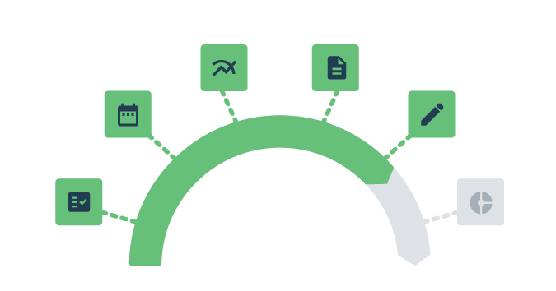

1. Define the release scope

Clearly outline the boundaries of the testing effort by defining the scope of the release. This involves identifying the features and functionalities that will be included in the testing process.

Tasks to address include:

Specify the modules or components to be tested

Identify any excluded features (out of scope) and reasons for exclusion

Collaborate with stakeholders to ensure a shared understanding of the release scope

2. Schedule timelines

Establish a timeline for the testing process to ensure that [testing activities](https://www.testrail.com/blog/teaching-software-testing-with-games/) align with the overall project schedule.

Tasks to address include:

Set milestones and deadlines for each testing phase

Consider dependencies on development activities and adjust timelines accordingly

Communicate the testing schedule to all relevant team members

3. Define test objectives

Clearly articulate the[test objectives](https://istqb-glossary.page/test-objective/) or goals and objectives of the testing effort to align it with the overall project goals.

Tasks to address include:

Specify functional and non-functional testing objectives

Align test objectives with business requirements and user expectations

Ensure that test objectives contribute to the overall quality of the software

4. Determine test deliverables

Identify the documentation and reports that will be produced as part of the testing process.

Tasks to address include:

List expected deliverables for each testing phase (e.g., test plans, test cases, test reports)

Define the format and structure of each deliverable

Clarify the audience for each deliverable and the purpose it serves

5. Design the test strategy

Develop a high-level strategy that outlines how testing will be conducted, considering the testing approach and methodologies.

Tasks to address include:

Define the testing levels (unit, integration, system, acceptance)

Specify testing types (functional/ non-functional testing, regression testing, performance testing)

Determine the use of manual and automated testing (if applicable)

Consider risk analysis and mitigation strategies

Consider approaches to test design

Test design approaches to consider

A test design approach is a systematic and strategic method used to create test cases and define testing conditions based on specific criteria. It outlines the way [testing activities](https://www.testrail.com/blog/teaching-software-testing-with-games/) will be conducted to ensure comprehensive coverage of the software under test.

|  |  |  |
| --- | --- | --- |
| **Test Design Approach** | **Description** | **Considerations** |
| **Feature List** | Identifies and tests specific features of the software | Build a feature list and make the features into test cases. Sometimes called a traceability matrix, this can show holes in coverage and, sometimes, features that don’t need further work. |
| **User Journey Map** | Tests scenarios based on user interactions and experiences | Instead of listing features, consider the user behavior flow, from check-in to check-out. Some features that do not show up in any user journey might warrant less testing and less future development, especially if they are not popular in the logs. |
| **Log Mining** | Analyzes system logs to uncover potential issues | Organize log entries by feature and sort to find the features with the heaviest use; focus test design time on those core features. |
| **Exception Conditions** | Tests error handling and exceptional situations in the code | These are tests for when things go wrong: The database is down, the website is declined, the API does not return for so long that the browser times out. [Quick attacks](https://searchsoftwarequality.techtarget.com/tip/Ten-quick-attacks-for-web-based-software) can overlap with this category. |
| **SFDIPOT (structure, function, data, interfaces, platform, operations, and time)** | Considers different aspects of test design | One possible exercise for test planning is to list these as nodes and then create sub-notes for the risks related to these elements of the software.  Once complete, review that list of risks with the test plan to ensure they are covered. A large program may have one SFDIPOT diagram per major feature. |
| [**Heuristic Test Strategies**](https://www.satisfice.com/download/heuristic-test-strategy-model) | Applies various heuristic approaches for exploratory testing | This approach is a treasure trove of considerations for understanding testing mission, product goal, and quality objectives. Use it to develop new test approaches, and then review the plan to see if they are included. |
| **Domain-Based Testing** | Focuses on testing within specific application domains. A domain approach recognizes the different potential conditions and tries to find relevant and powerful tests for as many conditions that make sense | Domain testing requires a careful analysis of the requirements; [decision tables](https://www.toolsqa.com/software-testing/istqb/decision-table-testing/) are an example of domain-based testing.  Simply put, when the requirements create a “wall of text” that implies more than a dozen [test ideas](https://www.testrail.com/blog/generate-quick-test-ideas/v), consider visualization as an intermediate step before finalizing the test plan.A decision tree creates a structured, visual foundation from which detailed test cases can derive. |
| [**RCRCRC**](https://searchsoftwarequality.techtarget.com/tip/A-software-experts-heuristic-for-regression-testing) | Evaluates code quality and readability for testing | This mnemonic is: Readability, complexity, relevance, consistency, robustness, and comprehensibility.  Considering those elements can allow the team to find the highest priority areas for retesting, especially for regression. |

6. Plan the test environment and test data

Ensure the testing environment is set up with the required hardware, software, and configurations. Plan for the necessary test data to simulate real-world scenarios.

Tasks to address include:

Define the criteria for the test environment, including hardware specifications and software configurations

Ensure that the test environment mirrors the production environment

Plan for the creation and management of test data

Consider any tools or resources needed for test data generation and management

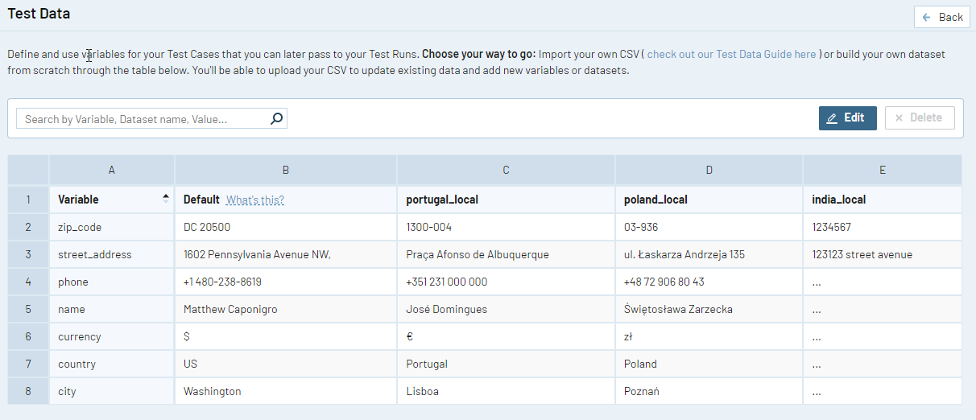

***Image:****Each project in TestRail includes a dashboard dedicated to viewing and managing test data available for that project.*

These six steps to create a test plan establish a solid foundation for organized and effective testing, addressing key aspects of scope, timelines, objectives, deliverables, strategy, and the testing environment.

Agile test planning best practices

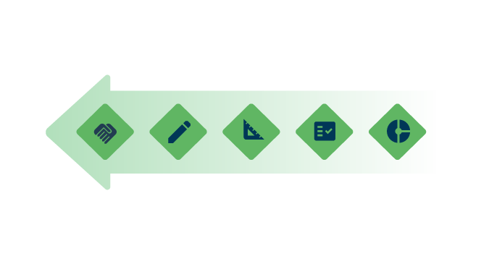

Iterative planning

Plan in short iterations or sprints

Adapt to changes and refine the plan iteratively

Prioritize user stories

Prioritize testing based on user stories

Align testing efforts with delivering value incrementally

Shift-left testing

Move testing activities earlier in the development phase

Emphasize collaboration for early defect detection

Automate regression testing

Implement automated regression testing

Ensure quick and reliable validation after code changes

Encourage collaboration

Foster collaboration among cross-functional team members

Promote a shared understanding of testing requirements

Continuous improvement

Regularly reflect on the testing process

Identify areas for improvement and refine practices

Tailoring to project requirements

Tailor testing to project requirements to recognize the diversity of projects and promote a flexible and adaptive testing approach. This results in more relevant and impactful testing efforts.

**Key considerations when tailoring to project requirements**:

|  |  |
| --- | --- |
| **Understand project dynamics** | Gain deep insights into the project’s size, complexity, and industry context. Understand how these factors impact testing strategies and overall project success. |
| **Adapt test levels and types** | Align the selection of test levels and types with the criticality of different aspects within the project and adhere to industry-specific testing requirements. |
| **Customize test design techniques** | Thoughtfully select test design techniques that are suitable for the project’s complexity and adaptable to changes, ensuring a robust and future-proof testing approach. |
| **Optimize test environment setup** | Tailor the test environment to replicate production conditions accurately. Consider hardware, software, and network configurations to ensure realistic and reliable testing scenarios. |
| **Balance test coverage and efficiency** | Strive for a balanced testing approach that combines comprehensive test coverage with efficiency. Prioritize critical areas while optimizing testing processes to ensure resource efficiency. |
| **Customize documentation standards** | Adjust documentation standards to meet the unique regulatory needs and project culture. Strike a balance between providing comprehensive documentation and maintaining agility in an evolving environment. |

Utilizing advanced test strategies (with examples)

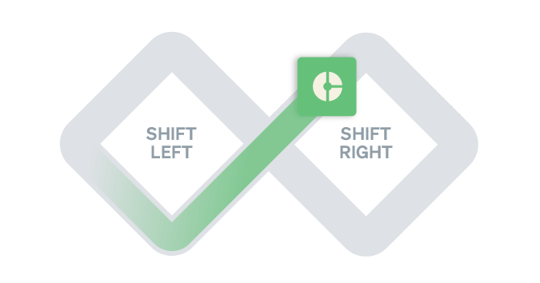

Advanced test strategies incorporate techniques to address specific challenges, improve efficiency, and enhance the overall quality of the testing process.

Shift-left testing

[Shift-left testing](https://www.testrail.com/blog/shift-left/) is an approach that involves moving testing activities earlier in the software development lifecycle, typically to the development phase. It emphasizes collaboration between developers and testers, enabling early defect detection and faster feedback loops.

Shift-left strategies influence the way test plans are formulated. Test planning considers how testing activities can be integrated into early development stages, defining the types of tests to be conducted during coding and unit testing phases.

Collaboration between development and testing teams is emphasized in the test planning process ensuring that testing efforts align with the [continuous integration](https://www.testrail.com/blog/continuous-integration-metrics/) and continuous delivery (CI/CD) pipeline.

Shift-right testing

[Shift-right testing](https://www.techtarget.com/searchsoftwarequality/definition/shift-right-testing#:~:text=Shift%2Dright%20testing%20is%20a,detected%20within%20the%20development%20environment.) involves extending testing activities into the post-production phase, focusing on monitoring and feedback from real users. It aims to uncover issues that might only manifest in a live environment and gather insights for continuous improvement.

Test planning considers the implementation of shift-right testing strategies by outlining post-production testing activities. This includes planning for monitoring tools, feedback mechanisms, and strategies for capturing and analyzing real user data.

The test plan incorporates how the testing process will adapt to the continuous feedback received from the live environment, enabling quick responses to issues and continuous enhancement of the software.

 The shift-left and shift-right testing strategies complement each other by covering different phases of the software testing lifecycle.

Examples of Continuous Integration (CI) and Continuous Deployment (CD) pipeline

**Shift-Left:**

**Scenario:**Developers write code and perform unit tests locally during the development phase.

**Example:** Unit tests are automated and run as part of the developer’s local build process, ensuring early detection of issues within the code.

**Shift-Right:**

**Scenario:**Real user data and feedback are collected after deployment to a staging environment.

**Example:**Real user interactions, [performance metrics](https://www.testrail.com/blog/performance-testing-metrics), and feedback from the staging environment are continuously monitored, providing insights into the application’s behavior in a realistic setting.

Incorporating DevOps principles into test planning

DevOps principles influence the integration of testing into the continuous integration and continuous delivery (CI/CD) pipeline. The test plan outlines how [testing activities](https://www.testrail.com/blog/teaching-software-testing-with-games/) seamlessly fit into the DevOps workflow, ensuring that testing is integral to the development process.

Automation is a key component of DevOps, and the test plan details how test automation will be implemented to support continuous testing, allowing for quick feedback and rapid release cycles.

Examples of DevOps principles in test planning

**Automation Integration**:

**Shift-left approach:** To ensure early defect identification, include automated unit tests and integration tests as part of the development process.

**Test planning example:** Outline how automated testing will be seamlessly integrated into the CI/CD pipeline to enable continuous testing from development through deployment.

**Continuous Integration (CI):**

**Shift-left approach example:**Developers commit code changes to a shared repository, triggering automated builds and basic testing.

**Test planning example:** Define testing activities within the CI pipeline, including unit tests, integration tests, and code quality checks, to ensure early and rapid feedback.

**Continuous Deployment (CD):**

**Shift-left approach example:** Automated deployments to staging environments for further testing and validation.

**Test planning example:** Specify how testing activities extend into CD, ensuring comprehensive validation in production-like environments before actual deployment.

One-page agile test plan template:

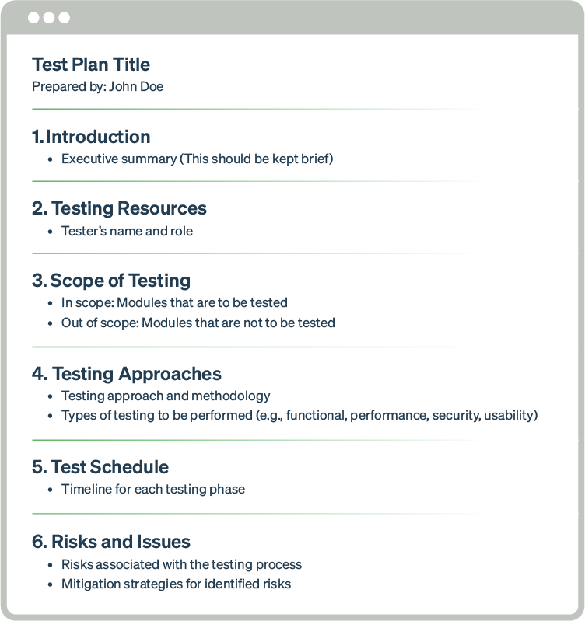

A[test plan’s content and structure](https://www.testrail.com/blog/create-a-test-plan/) will differ depending on the context in which it is used. For instance, in agile development, the [agile test plan](https://www.testrail.com/blog/simplify-test-planning/) might need to be changed often to keep up with changing goals.

If you are using DevOps processes, the test plan may need to explain how testing will integrate with your development pipeline, what parts of your testing will be covered by existing automated tests, and what new tests you will try to automate during this test cycle.

The bottom line is that if your test plan doesn’t fit onto one page, don’t worry. The intention is to minimize extraneous information and capture the necessary information your stakeholders and testers need to execute the plan.

Test planning with a test case management tool

A test case management tool like TestRail supports QA teams in effective test planning:

Customizable test cases

In TestRail, you can reuse your test case templates across different projects and test suites and customize them [to align with](https://www.testrail.com/blog/align-devops/) specific testing methodologies and project requirements. These capabilities make it a robust and adaptable testing tool for maintaining consistency, efficiency, and organization in the testing process.

When writing test cases in TestRail, there are[four default templates](https://support.testrail.com/hc/en-us/articles/14927678348052-Test-case-templates#exploratory-session-0-2) you can customize:

Test Case (Text):

TestRail simplifies the process of linking defects tracked in your team’s chosen project management tool (Jira, GitHub, Azure DevOps, or another defect management system) to objects in TestRail like tests, test runs, plans, and milestones for full traceability and visibility into coverage.

If you’re using an [issue-tracking tool integrated with TestRail](https://support.testrail.com/hc/en-us/articles/7747085183636-Configuring-defect-integrations), you can seamlessly populate and push new defects from TestRail to that tool without manual copying and pasting. This speeds up the reporting process and saves you time and enhances visibility for development and product teams, highlighting potential areas of risk in your application.

nto any organization’s test planning efforts — [Try TestRail for free](https://secure.testrail.com/customers/testrail/trial/) to see how it can help with your test planning!

Test Plan - Software Testing

Last Updated : 23 Jul, 2025

Software testing is important to make sure applications work properly and meet user needs. A clear and detailed test plan is the foundation of successful testing, guiding everything from creating test cases to fixing issues.

In this article, we will break down what a test plan is, why it’s important, and how to create one that leads to better results.

What is a Test Plan?

A test plan is a document that consists of all future testing-related activities. It is prepared at the project level and in general, it defines work products to be tested, how they will be tested, and test type distribution among the testers. Before starting testing there will be a test manager who will be preparing a test plan.

In any company whenever a new project is taken up before the tester is involved in the testing the test manager of the team would prepare a test Plan.

The test plan serves as the blueprint that changes according to the progressions in the project and stays current at all times.

It serves as a base for conducting testing activities and coordinating activities among a QA team.

It is shared with Business Analysts, Project Managers, and anyone associated with the project.

A test plan is a comprehensive document outlining all testing-related activities for a project. It details what will be tested, how, and by whom, serving as a blueprint for testing and coordinating among the QA team. To understand how to create and use a test plan effectively, explore the Complete Guide to Software Testing & Automation by GeeksforGeeks , which provides valuable insights into test planning and management for successful project outcomes.

Factors Roles

Who writes Test Plans? Test lead, Test Manager, Test Engineer

Who reviews the Test Plan? Test Lead, Test Manager, Test Engineer, Customer, Development Team

Who approves the Test Plan? Customer, Test Manager

Who writes Test Cases? Test Lead, Test Engineer

Who reviews Test Cases? Test Engineer, Test Lead, Customer, Development Team

Who approves Test Cases? Test Manager, Test Lead, Customer

Types of Test Plan

There are three main types of test plans, each focusing on different levels and aspects of testing:

Types-of-Test-Plan

Types of Test Plan

1. Master Test Plan

A Master Test Plan is a high-level document that outlines the overall testing strategy, scope, and phases for a project. It provides a roadmap for the entire testing process and shows how different levels of testing connect with each other. This plan ensures that all testing activities are aligned and helps keep the project on track.

2. Specific Test Plan

A Specific Test Plan focuses on particular types of testing, like load testing, performance testing, or security testing. It provides detailed instructions and guidelines for carrying out these specialized tests, ensuring that each area is tested thoroughly.

3. Analytical Test Strategies

Analytical Test Strategies are based on specific factors like project requirements, specifications, or risks. For example:

User Acceptance Testing is based on user requirements to make sure the software meets the needs of the end-users.

System Testing is based on the technical specifications to check if each part of the system functions correctly.

How to create a Test Plan?

Below are the eight steps that can be followed to write a test plan:

create-test-plan

Test Plan creation process

1. Analyze the product

This phase focuses on analyzing the product, Interviewing clients, designers, and developers, and performing a product walkthrough. This stage focuses on answering the following questions:

What is the primary objective of the product?

Who will use the product?

What are the hardware and software specifications of the product?

How does the product work?

2. Design the test strategy

The test strategy document is prepared by the manager and details the following information:

Scope of testing which means the components that will be tested and the ones that will be skipped.

Type of testing which means different types of tests that will be used in the project.

Risks and issues that will list all the possible risks that may occur during testing.

Test logistics mentions the names of the testers and the tests that will be run by them.

3. Define test objectives

This phase defines the objectives and expected results of the test execution. Objectives include:

A list of software features like functionality, GUI, performance standards, etc.

The ideal expected outcome for every aspect of the software that needs testing.

4. Define test criteria

Two main testing criteria determine all the activities in the testing project:

Suspension criteria: Suspension criteria define the benchmarks for suspending all the tests.

Exit criteria: Exit criteria define the benchmarks that signify the successful completion of the test phase or project. These are expected results and must match before moving to the next stage of development.

5. Resource planning

This phase aims to create a detailed list of all the resources required for project completion. For example, human effort, hardware and software requirements, all infrastructure needed, etc.

6. Plan test environment

This phase is very important as the test environment is where the QAs run their tests. The test environments must be real devices, installed with real browsers and operating systems so that testers can monitor software behavior in real user conditions.

7. Schedule and Estimation

Break down the project into smaller tasks and allocate time and effort for each task. This helps in efficient time estimation. Create a schedule to complete these tasks in the designated time with a specific amount of effort.

8. Determine test deliverables

Test deliverables refer to the list of documents, tools, and other equipment that must be created, provided, and maintained to support testing activities in the project.

Why is Test Plan creation important?

The following are some of the key benefits of making a test plan:

Defines Objectives: A test plan clearly outlines the testing objectives and the scope of testing activities, ensuring that all team members understand what needs to be achieved.

Structured Approach : It provides a systematic approach to testing, detailing the steps and processes involved, which helps in organizing the testing effort.

Avoids Scope Creep : By defining what will and will not be tested, the test plan helps manage the scope of testing activities, preventing unnecessary work and focusing on irrelevant areas.

Resource Allocation : Helps in identifying the necessary resources, including personnel, tools, and environments, ensuring they are available when needed.

Identifies Risks : A test plan identifies potential risks and outlines mitigation strategies, helping to address issues proactively rather than reactively.

Contingency Plans : These include contingency plans for dealing with unexpected events or issues that may arise during testing.

Stakeholder Alignment : Facilitates communication among stakeholders, including developers, testers, project managers, and clients, ensuring everyone is aligned on the testing objectives, approach, and schedule.

Documentation : Serves as a comprehensive document that can be referred to by all team members, aiding in knowledge sharing and transparency.

Resource Optimization : Helps in efficiently utilizing available resources, including time and personnel, by providing a clear plan of action.

Focus on Priorities : Ensures that testing efforts are focused on high-priority areas that are critical to the success of the project.

Objectives of the Test Plan

Overview of testing activities: The test plan provides an overview of the testing activities and where to start and stop the work.

Provides timeline: The test plan helps to create the timeline for the testing activities based on the number of hours and the workers needed.

Helps to estimate resources: The test plan helps to create an estimate of the number of resources needed to finish the work.

Serves as a blueprint: The test plan serves as a blueprint for all the testing activities, it has every detail from beginning to end.

Helps to identify solutions: A test plan helps the team members They consider the project's challenges and identify the solutions.

Serves as a rulebook: The test plan serves as a rulebook for following rules when the project is completed phase by phase.

Difference between Test Strategy and Test Plan

Aspect

Test Strategy

Test Plan

Definition

A high-level document outlining the overall testing approach and goals.

A detailed document that describes the specific testing activities, resources, schedule, and scope for a particular project.

Purpose

Provides a framework and general guidelines for testing across multiple projects or the entire organization.

Specifies the exact process, tasks, and timelines for testing a specific project or release.

Scope

Broad and generic, applicable to all projects within the organization.

Narrow and project-specific, tailored to the needs of a particular project.

Level of Detail

High-level, focusing on overall methodologies, standards, and tools to be used.

Detailed, including specific test cases, environments, schedules, and resources.

Responsibility

Typically created by senior management or test architects.

Typically created by test managers or test leads for a specific project.

Components

More static and less frequently updated, serving as a long-term guide.

More dynamic, updated regularly to reflect changes in project scope, requirements, and timelines.

Audience

Intended for stakeholders, project managers, and senior management.

Intended for the project team, including testers, developers, and project managers.

Examples

Describes the use of automated testing tools, defect tracking processes, and overall testing standards.

Outlines specific test cases, test environments, and test data requirements for a particular application.

Focus

Emphasizes the "what" and "why" of testing processes and standards.

Emphasizes the "how," "when," and "who" of the testing activities for a specific project.

Timeframe

Long-term, spanning multiple projects and releases.

Short-term, aligned with the project lifecycle and specific release schedules.

Updates

Less frequent, typically reviewed annually or semi-annually.

More frequent, updated as the project evolves and new requirements emerge.

Components and Attributes of Test Plan

There is no hard and fast rule for preparing a test plan but it has some standard 15 attributes that companies follow:

componants-and-attribute-test-plan

Components and Attributes of Test Plan

1. Objective: It describes the aim of the test plan, whatever the good process and procedure they are going to follow to give quality software to customers. The overall objective of the test is to find as many defects as possible and to make software bug-free. The test objective must be broken into components and sub-components. In every component following activities should be performed.

List all the functionality and performance to be tested.

Make goals and targets based on the application feature.

2. Scope: It consists of information that needs to be tested concerning an application. The scope can be divided into two parts:

In-Scope: The modules that are to be tested rigorously.

Out Scope: The modules that are not to be tested rigorously.

Example: In an application A, B, C, and D features have to be developed, but the B feature has already been designed by other companies. So the development team will purchase B from that company and perform only integrated testing with A, B, and C.

3. Testing Methodology: The methods that are going to be used for testing depend on application to application. The testing methodology is decided based on the feature and application requirements. Since the testing terms are not standard, one should define what kind of testing will be used in the testing methodology. So that everyone can understand it.

4. Approach: The approach of testing different software is different. It deals with the flow of applications for future reference. It has two aspects:

High-Level Scenarios: For testing critical features high-level scenarios are written. For Example, login to a website, and book from a website.

The Flow Graph: It is used when one wants to make benefits such as converging and merging easy.

5. Assumption: In this phase, certain assumptions will be made.

Example:

The testing team will get proper support from the development team.

The tester will get proper knowledge transfer from the development team.

Proper resource allocation will be given by the company to the testing department.

6. Risk: All the risks that can happen if the assumption is broken. For Example, in the case of wrong budget estimation, the cost may overrun. Some reason that may lead to risk is:

Test Manager has poor management skills.

Hard to complete the project on time.

Lack of cooperation.

7. Mitigation Plan: If any risk is involved then the company must have a backup plan, the purpose is to avoid errors. Some points to resolve/avoid risk:

Test priority is to be set for each test activity.

Managers should have leadership skills.

Training course for the testers.

8. Roles and Responsibilities: All the responsibilities and role of every member of a particular testing team has to be recorded.

Example:

Test Manager: Manages the project, takes appropriate resources, and gives project direction.

Tester: Identify the testing technique, verify the test approach, and save project costs.

9. Schedule: Under this, it will record the start and end date of every testing-related activity. For Example, writing the test case date and ending the test case date.

10. Defect Tracking: It is an important process in software engineering as lots of issue arises when you develop a critical system for business. If there is any defect found while testing that defect must be given to the developer team. There are the following methods for the process of defect tracking:

Information Capture: In this, we take basic information to begin the process.

Prioritize: The task is prioritized based on severity and importance.

Communication: Communication between the identifier of the bug and the fixer of the bug.

Environment: Test the application based on hardware and software.

Example: The bug can be identified using bug-tracking tools such as Jira, Mantis, and Trac.

11. Test Environments: It is the environment that the testing team will use i.e. the list of hardware and software, while testing the application, the things that are said to be tested will be written under this section. The installation of software is also checked under this.

Example:

Software configuration on different operating systems, such as Windows, Linux, Mac, etc.

Hardware Configuration depends on RAM, ROM, etc.

12. Entry and Exit Criteria: The set of conditions that should be met to start any new type of testing or to end any kind of testing.

Entry Condition:

Necessary resources must be ready.

The application must be prepared.

Test data should be ready.

Exit Condition:

There should not be any major bugs.

Most test cases should be passed.

When all test cases are executed.

Example of Test Plan: If the team member reports that 45% of the test cases failed, then testing will be suspended until the developer team fixes all defects.

example-test-plan

Example of Test Plan

13. Test Automation: It consists of the features that are to be automated and which features are not to be automated.

If the feature has lots of bugs then it is categorized as Manual Testing.

If the feature is frequently tested then it can be automated.

14. Effort Estimation: This involves planning the effort that needs to be applied by every team member.

15. Test Deliverables: It is the outcome from the testing team that is to be given to the customers at the end of the project.

Before the testing phase:

Test plan document.

Test case document.

Test design specification.

During the testing phase:

Test scripts.

Test data.

Error logs.

After the testing phase:

Test Reports.

Defect Report.

Installation Report.

It contains a test plan, defect report, automation report, assumption report, tools, and other components that have been used for developing and maintaining the testing effort.

16. Template: This is followed by every kind of report that is going to be prepared by the testing team. All the test engineers will only use these templates in the project to maintain the consistency of the product.

Best Practices for Creating an effective Test Plan

Creating an effective test plan is essential for ensuring a comprehensive and systematic approach to software testing. Here are some best practices to consider when developing a test plan:

1. Understand the Project Requirements:

Gather Information: Ensure a thorough understanding of both functional and non-functional requirements.

Stakeholder Input: Involve stakeholders to gather expectations and address specific concerns.

2. Define Clear Objectives and Scope:

Purpose of Testing : Clearly state the objectives and what you aim to achieve.

In-Scope and Out-of-Scope: Define what will be tested and what will not, to manage expectations and focus resources.

3. Develop a Comprehensive Test Strategy:

Approach : Outline the types of testing to be performed (e.g., functional, regression, performance).

Techniques and Tools: Specify testing techniques (e.g., black-box, white-box) and tools (e.g., Selenium, JIRA) to be used.

4. Create Detailed Test Cases:

Test Case Design : Develop detailed test cases covering all scenarios, including positive, negative, edge, and boundary cases.

Traceability : Ensure each test case is traceable to specific requirements to verify comprehensive coverage.

5. Establish a Test Environment:

Setup Requirements : Define hardware, software, network configurations, and tools required for testing.

Environment Management: Ensure the test environment closely mirrors the production environment to identify environment-specific issues.

6. Plan for Test Data and Reporting Mechanisms:

Data Requirements : Identify and manage realistic, consistent test data securely, especially if it includes sensitive information.

Status Reporting: Establish processes for regular status updates on testing progress, issues, and results, and use defect tracking systems effectively.

Conclusion

A test plan is an important document in software testing that helps re-sure the quality of a software product. It outlines the testing goals, what will be tested, the resources needed, and how testing will be done.

By following best practices like understanding project needs, setting clear goals, and preparing a good testing environment, teams can manage testing better and improve software quality. A good test plan keeps the team focused, makes efficient use of resources, reduces risks, and helps meet stakeholder expectations.

Just like a real [scaffolding](https://en.wikipedia.org/wiki/Scaffolding) in a building construction site, scaffolding gives you some kind of a (**fast**, **simplified**, **temporary**) **structure** for your project, on which you can rely to build the ***real*** project.

It can be (and is today) used to describe many things - from abstracting DB layers, to web apps folder structures, and to generating and managing project dependencies .

It is **not** something that is specific to any language / technology, just like the term skeleton or boilerplate is platform agnostic.

It is just a term borrowed from [real scaffolding](https://www.google.com.hk/search?newwindow=1&biw=1821&bih=908&tbm=isch&sa=1&q=scaffolding&oq=scaffolding&gs_l=img.3...3468.3468.0.3971.1.1.0.0.0.0.0.0..0.0....0...1c.1.64.img..1.0.0.GsIVz5OnV-w) (like mentioned above). You build some fast, simplified, (sometimes external, sometimes temporary) structure that will help you to build the real, more complex, finalized structure under, above, inside or outside of that temporary structure .

.. And just like the real scaffolding, the scaffolding structure is meant to support the **building process** of the project, rather than the **project itself** (with some exceptions).

**Module Testing**

Last Updated : 23 Jul, 2025

Module testing is a type of software testing where individual units or components of the software are tested. The purpose of module testing is to isolate a section of code and verify its correctness. Module testing is usually performed by the development team during the early stages of software development. However, it can also be done by independent testers as part of regression testing. There are various methods of module testing, but the most common one is black-box testing. In black-box testing, the test cases are designed based on the functionality of the code, without taking into consideration its internal structure. Other methods include white-box testing (which looks at the internal structure), grey-box testing (which combines both black-box and white-box testing), and glass-box testing (which tests all possible inputs and outputs). No matter which method you choose, module testing is an important part of ensuring the quality of your software. In this blog post, we will take a closer look at module testing and how it can benefit your software development process.

The following topics will be discussed here:

**What is Module Testing?**

**Objectives of Module Testing**

**Inputs to Module Testing**

**Why Module Testing is Important?**

**Steps for Module Testing**

**Who does Module Testing?**

**When Module Testing is done?**

**Module Testing Best Practices**

**Module Testing Test Strategy**

**What are Stubs and Drivers?**

**Module Testing vs Integration Testing**

**Module Testing vs Unit Testing**

**Module Testing Example**

**Module Testing Tools**

**Tips for Effective Module Testing**

Let's start discussing each of these topics in detail.

**What is Module Testing?**

Module testing is a type of [software testing](https://www.geeksforgeeks.org/software-testing/software-testing-basics/) that focuses on individual modules or units of code. This is in contrast to system testing, which looks at the entire system as a whole. Module testing is typically done by the developers themselves as they are familiar with the code and can easily identify any potential issues. However, it can also be done by independent testers.

The goal of module testing is to ensure that each module is working correctly and meets all the requirements. This includes verifying the functionality of the code, as well as checking for any errors or bugs. To do this, various test cases are designed that exercise different input values and scenarios. The results of these tests are then analyzed to see if the module meets all the criteria. Module testing is an important part of the software development process and should not be overlooked. It can help to find and fix any defects in the code before they cause problems in the final product.

**Objectives of Module Testing**

There are several objectives of module testing:

**Module working as expected:**To ensure that each module is working as expected.

**Interfaces working properly:**To ensure that the interfaces between modules are working as expected.

**Overall system working properly:**To ensure that the overall system functions as expected.

**Detect errors introduced during development:**To find errors that may have been introduced during the development process.

**Increase confidence in software:**To provide confidence that the system is ready for release.

**Inputs to Module Testing**

Inputs to module testing include the following:

**Requirements:**The first input to module testing is the requirements. The tester must have a clear understanding of what the module is supposed to do. This understanding is typically captured in the form of requirements, which can be in the form of user stories, use cases, or functional specifications.

**Design:** The second input to module testing is the design. The design provides the tester with a high-level view of how the module is implemented. The design should include a description of the interfaces between the module and the rest of the system.

**Code:**The third input to module testing is the code. The code is the actual implementation of the module. The tester will use the code to execute tests and verify the results.

**Test Cases:** The fourth input to module testing is the test cases. The test cases define the specific tests that will be executed against the module. The test cases should be designed to exercise all the functionality of the module.

**Test Data:**The fifth input to module testing is the test data. The test data is used to execute the test cases. The test data should be designed to exercise all the different inputs to the module.

**Test Environment:** The sixth input to module testing is the test environment. The test environment is the environment in which the tests will be executed. The test environment should be set up so that it is representative of the production environment.

**Test Tools:** The seventh input to module testing is the test tools. The test tools are the software and hardware that will be used to execute the tests. The test tools should be chosen so that they are appropriate for the type of testing that is being done.

**Why Module Testing is Important?**

Module testing is a type of software testing that verifies the functionality of individual modules or components of a system. A module can be defined as a self-contained unit of code with a well-defined interface. There are some of the factors why module testing is important:

**To ensure each module works correctly:**Module testing is important because it helps to ensure that each module or component of a system works as expected and that the interactions between modules are working as intended.

**Helps to identify errors early:**By verifying the functionality of individual modules, module testing can help to identify errors early in the development process before they become expensive and time-consuming to fix.

**Improve software quality:**Module testing can help to improve the overall quality of a system by helping to ensure that each module or component meets its requirements and functions as intended.

**Prevents errors from propagating:**By identifying and resolving errors in individual modules, module testing can help to prevent errors from propagating throughout the system and causing other issues.

**The complexity of testing can be managed:** Module testing helps to manage the complexity of testing the whole software.

**Supports parallel testing:**In module testing, multiple modules can be tested simultaneously thus it supports parallel testing.

**Steps for Module Testing**

Module testing is a type of software testing where individual units/components of the software are tested in isolation. This is to ensure that these units/components work as expected.

There are different ways to carry out module testing:

One way is to use stubs and drivers. Stubs are used to replace the functionality of modules that are not yet implemented. Drivers are used to providing an interface to test the modules.

Another way to carry out module testing is to use mock objects. Mock objects are simulated versions of modules that mimic the behavior of the real modules. This allows you to test the modules without having to depend on other parts of the system working correctly.

When carrying out module testing, it is important to keep in mind that the goal is not just to find bugs but also to verify that the module meets its functional requirements. Therefore, it is important to have a good test plan and test cases that cover all the requirements of the module.

Below are the steps to carry out module testing:

**Design test cases:**designing test cases in module testing is an important step, here tester must consider the specification of the module and the module's source code. The module's logic must be analyzed carefully using the white box testing methods and apply black box testing methods to the module specification to supplement the test cases.

**Combine modules for testing:**Next step after designing the test cases is to combine the modules for testing. Here, 2 approaches can be used. The tester can either use a non-incremental approach or an incremental approach.

**Incremental approach:**In this approach, each module is tested first and then incremented to the tested collection. In this stepwise retesting is done.

**Non-incremental approach:**In this approach, all modules are tested independently. First, all modules are combined and then the whole program is tested.

**Capture results:**The driver is required to supply the test data, monitor the execution, and capture the results.

**Report results:**Recorded results are reported and carefully analyzed to determine the next step to be taken to resolve the identified errors.

**Who does Module Testing?**

There are various ways that module testing can be conducted, and it really depends on the type of module being tested as to who is responsible for conducting the tests.

In general, however, it is the responsibility of the module developer to create unit tests for their code and to ensure that all aspects of the module are covered.

These unit tests can then be run by the development team or by a separate QA team to verify the functionality of the code.

If the module is a complex one, or if it is part of a larger system, then it may be necessary to conduct integration testing as well.

This type of testing is typically done by the QA team, and it involves testing how the module interacts with the rest of the system.

This can be a very important step in ensuring that the module works correctly in the overall context of the system.

**When Module Testing is Done?**

Module testing is done when the module is complete and all its functionality has been tested. A module is a self-contained unit of code that performs a specific task. A module can be a function, a class, or a library.

Module testing is a type of white box testing where the internal structure of the module is known and tests are designed based on this knowledge.

Module testing is typically done using a combination of manual and automated tests. Automated tests can be used to test the functionality of the module, while manual tests can be used to test the user interface and usability of the module. Module testing is an important part of the software development process and can help to ensure that the module is working as intended.

**Module Testing Best Practices**

There are a few things to keep in mind when writing tests:

**Small focused tests:**Keep your tests small and focused. Each test should test one specific thing.

**Self-contained tests:**Make your tests self-contained. This means that each test should not depend on any other test.

**Write tests before code:**Write your tests before you write the code that they are testing. This will help you think about what you need to test and will make it easier to write tests that are focused and self-contained.

**Run tests often:**Run your tests often. This will help you catch errors early and will make it easier to find the source of any problems.

**Use test runner:**Using a test runner will automate the process of running your tests and can provide additional features such as code coverage.

**Tests are comprehensive:**Make sure your tests are comprehensive. This means testing all the different parts of your code, including the happy path and edge cases.

**Keep tests up to date:**Keep your tests up to date. As your code changes, so should your tests.

**Use meaningful test names:**Write meaningful test names. This will make it easier to understand what each test is doing and will make your test suite more readable.

**Use assertions:**Assertions are like a check that your code is doing what you expect it to. They will make it easier to find problems in your code.

**Using tools:**Use a tool like JUnit or TestNG. These tools will help you write and run your tests.

**Module Testing Test Strategy**

A test strategy is a document that outlines the approach that will be taken to test a software application. The test strategy should be aligned with the overall software development strategy and should take into account the risks and objectives associated with the project.

The test strategy should address the following areas:

**Test levels:**Which types of testing will be performed (e.g. unit, integration, system, acceptance)?

**Test types:**Which specific tests will be performed (e.g. functional, non-functional, regression, stress)?

**Test tools:**Which tools will be used to support the testing effort?

**Test environment:**What environment will be used for testing (e.g. development, staging, production)?

**Test data:**What data will be used for testing?

**Test coverage:**What areas of the application will be covered by tests?

**Exit criteria:**What conditions must be met before testing can be considered complete?

The test strategy should be reviewed and updated regularly as the project progresses and as new risks and objectives are identified.

Module testing is conducted by dividing the process into 2 parts:

**Component testing in small (CTIS):**It is performed in complete isolation without integrating one component with another.

**Component testing in large (CTIL):**It is performed without isolating components from each other as when one component is dependent on another component, isolating them may lead to functionality issues.

**What are Stubs and Drivers?**

**Stub:**A stub is a small piece of code that typically stands in for a larger component or system.

One common use of a stub is in testing. When testing code that interacts with a large or complex system, it is often impractical or impossible to test against the actual system. In these cases, a stub can be used to stand in for the system. The stub code may simply return hard-coded values, or it may execute some basic functionality to mimic the system.

Another common use of stubs is in application integration. When two applications need to communicate with each other, they often do so through an intermediary component called a messaging bus. The applications send messages to the bus, which then routes the messages to the appropriate destination. The applications are not aware of the existence of the other applications; they simply interact with the bus.

**Driver:**A driver is a software component that provides a specific interface to a hardware device. In many cases, a driver acts as a translator between the hardware device and the software application that uses the device.

A driver is typically a piece of low-level code that provides an interface to a hardware device. The driver code is usually specific to the device and the operating system. Drivers typically handle tasks such as memory management, I/O operations, and interrupts. Most devices require a driver in order to work properly. For example, a video card needs a driver in order to display images on the screen. A printer needs a driver in order to print documents.

In some cases, a device may have multiple drivers. For example, a video card may have a separate driver for each operating system that it supports. In other cases, a single driver may work with multiple devices.

For example, a printer driver may work with multiple printers from different manufacturers.

The line between a stub and a driver is often blurry. In many cases, a piece of code may start out as a stub and evolve into a driver over time. For example, a video card driver may start out as a simple stub that only supports a small number of display modes. As the driver is further developed, it may gain support for more display modes, more features, and more hardware devices.

**Module Testing vs Integration Testing**

Below are the differences between module testing and integration testing:

| **Parameters** | **Module Testing** | **Integration Testing** |
| --- | --- | --- |
| **Objective** | Tests the functionality of a single module. | Tests the interaction between components. |
| **Error location** | Identifies errors in the functionality of the module. | Identifies errors in the interfaces and dependencies between components. |
| **Testing order** | Is typically performed before integration testing. | Is typically performed after unit testing. |
| **Access to source code** | Does not require access to the source code. | May require access to the source code. |
| **Requirement of test harness or driver** | Does not require special test harnesses or drivers. | May require special test harnesses or drivers. |
| **Testing level** | Is typically performed at the component level. | Can be performed at the component, subsystem, or system level. |
| **Automatic/ Manual** | Is often performed automatically. | Is often performed manually. |
| **Time taken** | Usually takes less time to execute than integration tests. | Usually takes longer to execute than unit tests. |
| **Cost** | Is less expensive to execute than integration tests. | Is more expensive to execute than unit tests. |

**Module Testing vs Unit Testing**

Below are the differences between module testing and unit testing:

| **Parameters** | **Module Testing** | **Unit Testing** |
| --- | --- | --- |
| **Testing level** | Module testing is done at the tester's level. | Unit testing is done at the developer's level |
| **Testing approach** | Module testing is a top-down approach. | Unit testing is a bottom-up approach |
| **Before/ After integration testing** | Module testing is done after the integration of the modules. | Unit testing is done before the integration of the modules |
| **Objective** | Module testing is done to test the functionality of the module. | Unit testing is done to test the functionality of the code |
| **Who performs?** | Module testing, the test cases are written by the testers. | In unit testing, the test cases are written by the developers |
| **Testing input** | Module testing is done on the module. | Unit testing is done on the code |
| **Blackbox/ Whitebox testing** | Module testing can be either white box or black box testing. | Unit testing is white-box testing |
| **Testing site** | Module testing is done at the customer's site. | Unit testing is done at the developer's site |
| **Scope** | The scope of module testing is larger than the scope of unit testing. | The scope of unit testing is smaller than the scope of module testing. |
| **Testing machine** | Module testing is done on the remote machine. | Unit testing is done on the local machine |

**Module Testing Example**

Module testing is testing the functionality of an individual module or component.

For example, testing the login functionality of a website. This would involve testing the input fields, the functionality of the login button, and the correct redirection to the home page after a successful login.

Other examples of module testing include testing the search functionality of a website or testing the Add to Cart button on an eCommerce website.

**Module Testing Tools**

Module testing tools help test individual software components or modules. Common module testing tools include:

**Static code analysis tools:**These analyze source code for potential bugs without actually executing the code. Examples include FindBugs, Fortify, and Klocwork.

**Unit testing frameworks:**These allow you to create and run tests on individual modules to ensure they work as expected. Examples include JUnit and NUnit.

**Mutation testing tools:** These modify your source code in small ways and then re-run your tests to see if any bugs are found. This can help find hidden defects that might not be caught by traditional unit tests. Examples include Major Mutation and mutation++.

**Tips for Effective Module Testing**

There is no one-size-fits-all answer to the question of how to effectively test modules, as the approach that works best will vary depending on the specific module being tested and the software system as a whole. However, there are some general tips that can help make module testing more effective:

**Define clear objectives for the test:**What are you trying to achieve? What do you need to know in order to determine whether the module is working correctly?

**Test plan that covers all aspects:**Design a test plan that covers all aspects of the module. This should include both functional and non-functional tests.

**Test cases that represent real-world scenarios:** Create test cases that are representative of real-world scenarios. This will help ensure that the module is tested thoroughly and that any potential problems are uncovered.

**Track results carefully:**Execute the tests and track results carefully. This will enable you to identify any issues that need to be addressed and also allows you to see how the module performs under various conditions.

**Perform regression testing after incorporating changes:**Make sure to perform regression testing after making changes to the module or other parts of the system. This ensures that previously identified issues have not been reintroduced and that new functionality does not break existing functionality.

**Traceability and its types**

Last Updated : 05 Jan, 2024

**Traceability** comprises two words i.e., trace and ability. Trace means to find someone or something and ability means to a skill or capability or talent to do something. Therefore, traceability simply means the ability to trace the requirement, to provide better quality, to find any risk, to keep and verify the record of history and production of an item or product by the means of documented identification. Due to this, it’s easy for the suppliers to reduce any risk or any issue if found and to improve the quality of the item or product. So, it’s important to have traceability rather than no traceability. Using traceability, finding requirements, and any risk to improve the quality of the product becomes very easy.

**Types of Traceability**

**Source traceability:**These are basically the links from requirement to stakeholders who propose these requirements.

**Requirements traceability:** These are the links between dependent requirements.

**Design traceability:** These are the links from requirement to design.

**Testing traceability:** These are the links between requirements and test cases, which ensure that each requirement has been properly tested.

**Code traceability:** These are the links between the requirements and the actual code that is developed to implement those requirements.

**Version traceability:** These are the links between different versions of software or documents, which allow for tracking of changes and updates over time.

**Release traceability:**These are the links between the requirements and the specific software release or version in which they were implemented.

**Risk traceability:** These are the links between risks identified in the project and the mitigating actions taken to address those risks.

**Business traceability:** These are the links between project requirements and overall business goals and objectives.

**Quality traceability:** These are the links between requirements, design, testing, and implementation, which ensure that quality is maintained throughout the software development process.

**Regulatory Traceability:**The capacity to track compliance to legal requirements, making sure that actions, outcomes or procedures follow rules and guidelines.

**Data Traceability:**The capacity to track the creation, modification and use of data inside an information system while maintaining the accuracy and integrity of the data.

**Supplier Traceability:**The capacity to track and authenticate the origins and actions of vendors in order to guarantee the level of quality and consistency of components or materials.

**Process Traceability:** The capacity to track the actions and phases in a process, guaranteeing that each step is carried out accurately and that differences may be found and fixed.

**Biological Traceability:**The capacity to track the beginning, development and spread of biological things, including human cells, animals and plants.

**Traceability Matrix**

Traceability matrix is generally used to represent the information of traceability. For mentioning the traceability of small systems usually the traceability matrix is maintained. If one requirement is dependent upon another requirement then in that row-column cell ‘D’ is mentioned and if there is a weak relationship between the requirements than corresponding entry can be denoted by ‘R’.

**For Example:**

| **Requirement ID** | **A** | **B** | **C** | **D** | **E** | **F** |
| --- | --- | --- | --- | --- | --- | --- |
| **A** |  | **D** |  |  | **R** |  |
| **B** |  |  | **D** |  |  |  |
| **C** |  |  |  | **R** |  |  |
| **D** |  |  | **D** |  |  | **R** |
| **E** |  |  |  |  |  |  |
| **F** | **R** |  |  | **D** |  |  |

**Traceability Matrix Structure: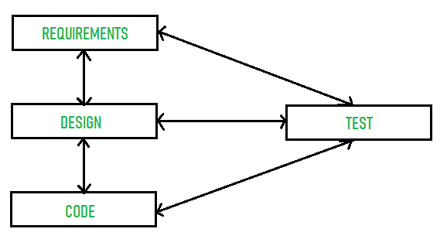**

Basis path testing in software testing is a white box method where the tester examines the codebase to identify all possible paths that could be taken by the user to achieve their aims. These paths are then written as test cases to ensure all the different identified scenarios in the main branches are covered. Higher test coverage is then achieved when test cases are executed, typically through a form of unit testing.

Basis Path Testing

The tester established a baseline by selecting the most critical, common, or obvious path through the code selection. Then, with each test case, the tester will choose different options through the baseline to change the outcomes. This enables the tester to create relevant test cases, ensuring branch coverage. It also prevents duplicate or overlapping tests by ensuring each decision is only covered once.

Steps to Performing Basis Path Testing

The first step is to create a control flow graph for a specified code section. A control flow graph is a section of code displayed as a graph along with the possible paths that could be executed.

Here is a simplified control flow graph for an if-then-else statement. The circles are nodes that represent blocks, and the lines connecting them are edges, which represent control flow paths.

Control Flow Graph

The second step is to select a baseline path through the code. This baseline path should be the path most likely used. It is also the most critical path to test, as it will be the foundation for all other tests. Typically, a product manager will provide the baseline path labeled as the critical path.

Once the baseline path is selected, generate the second path by changing the outcome of the first decision. Remember, you are not necessarily changing every decision along the path. The emphasis is on ensuring a different outcome after the decisions are made. The maximum number of decision outcomes should remain the same as the initial baseline path.

Generate a third path by changing the outcome of the second decision on the path. When there are multiple options for a decision, each decision outcome should be exercised before moving on to the next decision.

Continue generating new paths by repeating these steps. The most important outcome should be chosen first if new decisions are encountered.

Finally, once all the decision outcomes on the baseline path have been covered, apply the same approach to all subsequent paths until all the decision outcomes in the specified code have been exercised.

Example

An example may help for better understanding. Let’s say we want to perform basis path testing on a basic block of code. First, we will create our control flow graph.

x = 0

print(x)

if x > 10

print (‘try again’)

else

print (‘success’)

end

The control flow graph could look something like this:

However, we know that we often have a more complicated scenario than that. Let’s show what happens when we have a compound statement.

x = 0

while x < 10

if x > 2

print (x)

else

print ('x is less than 3')

end

x += 1

end

Basis Path Testing 1

As you can see, this path is more involved and will require more testing than the first example. But how do we know how many test cases need to be created to ensure branch coverage?

For step 2, we will determine a baseline path using our control flow graph. Let’s say the most likely path looks like this:

Basis Path Testing 2

This would be our first test case. We can use a simple equation called cyclomatic complexity to determine how many test cases we need for full branch coverage. Don’t let the word ‘complexity’ concern you because the equation is straightforward:

C = E – N + 2P

where,

C = Cyclomatic Complexity = Number of test cases

E = the number of edges on the graph,

N = the number of nodes on the graph,

P = the number of connected components, which for a single program, or section of code, P will always equal 1.

The cyclomatic complexity tells you how ‘complex’ the code is, as it equals the number of linearly independent paths within the code, which equates to the number of required test cases. So, to determine the number of test cases, we can say, for our example:

C = E – N + 2P

C = 8 – 7+ 2×1

C = 3

For step 3, we will use our baseline path, but we will ensure that we have a different outcome. We also want to make certain we are prioritizing the outcomes. If necessary, we can use a risk-based approach for these decisions. Our new path could possibly look like this:

Basis Path Testing 3

We can continue changing the paths until all outcomes are evaluated. By using our cyclomatic complexity equation, we know we have 3 different outcomes. Our final path could look like this:

Basis Path Testing 4

Tools to use in basis path testing

If equations and creating graphs aren’t your specialty, you’ll probably be glad to know there are tools that can help with basis path testing in software testing.

LucidChart – LucidChart has an easy, user-friendly interface for creating, editing, and collaborating on workflows. It is excellent for brainstorming across multiple teams or projects. There are free and paid versions available.

Eclipse CFG Generator – Eclipse Control Flow Graph Generator is a plug-in for Eclipse IDE that can create control flow graphs based on the source code. It only works with Java and is open-source.

OmniGraffle – OmniGraffle by The Omni Group is a powerful diagramming, prototyping, and design tool for Mac and iOS products that promotes collaboration with style. It has paid version available and offers a 14-day free trial.

Benefits and Challenges

There are benefits to basis path testing in software testing.

Basis path testing increases test coverage by revealing outcomes that may not be otherwise evident without examination of the codebase. A tester should attempt to achieve different outcomes, but it can be difficult (especially for large or complex systems) to know all the possible outcomes.

Basis path testing also ensures branch coverage. This is important because, in agile development, many developers work on branches of code before merging that code with the existing repository. They can also be assured they aren’t creating unnecessary or overlapping tests.

Basis path testing also comes with challenges.

Today, many DevOps setups require a certain amount of unit coverage before deploying to the next environment. If this is not the case, enforcing this type of testing may be difficult because it can be considered unnecessary or extra work.

If performed as a method other than unit testing, the tester must be able to understand the code, which could alienate some resources.

Finally, basis path testing can be time-consuming, which may take away from further development or alternative testing methods.

Conclusion

Basis path testing is a white box testing method that ensures branch coverage by testing each outcome of a section of code. While it may seem complicated because of its mathematical association, the intent behind the math is to simplify testing. The tester must understand the code to be prepared to meet any unit testing requirements. Basis path testing may be time-consuming, but the outcomes are more beneficial because the code is covered.

Control Structure Testing

Last Updated : 03 Oct, 2022

Control structure testing is used to increase the coverage area by testing various control structures present in the program. The different types of testing performed under control structure testing are as follows-

1. Condition Testing

2. Data Flow Testing

3. Loop Testing

1. Condition Testing : Condition testing is a test cased design method, which ensures that the logical condition and decision statements are free from errors. The errors present in logical conditions can be incorrect boolean operators, missing parenthesis in a booleans expression, error in relational operators, arithmetic expressions, and so on. The common types of logical conditions that are tested using condition testing are-

A relation expression, like E1 op E2 where 'E1' and 'E2' are arithmetic expressions and 'OP' is an operator.

A simple condition like any relational expression preceded by a NOT (~) operator. For example, (~E1) where 'E1' is an arithmetic expression and 'a' denotes NOT operator.

A compound condition consists of two or more simple conditions, Boolean operator, and parenthesis. For example, (E1 & E2)|(E2 & E3) where E1, E2, E3 denote arithmetic expression and '&' and '|' denote AND or OR operators.

A Boolean expression consists of operands and a Boolean operator like 'AND', OR, NOT. For example, 'A|B' is a Boolean expression where 'A' and 'B' denote operands and | denotes OR operator.

2. Data Flow Testing : The data flow test method chooses the test path of a program based on the locations of the definitions and uses all the variables in the program. The data flow test approach is depicted as follows suppose each statement in a program is assigned a unique statement number and that theme function cannot modify its parameters or global variables. For example, with S as its statement number.

DEF (S) = {X | Statement S has a definition of X}

USE (S) = {X | Statement S has a use of X}

If statement S is an if loop statement, them its DEF set is empty and its USE set depends on the state of statement S. The definition of the variable X at statement S is called the line of statement S' if the statement is any way from S to statement S' then there is no other definition of X. A definition use (DU) chain of variable X has the form [X, S, S'], where S and S' denote statement numbers, X is in DEF(S) and USE(S'), and the definition of X in statement S is line at statement S'. A simple data flow test approach requires that each DU chain be covered at least once. This approach is known as the DU test approach. The DU testing does not ensure coverage of all branches of a program. However, a branch is not guaranteed to be covered by DU testing only in rare cases such as then in which the other construct does not have any certainty of any variable in its later part and the other part is not present. Data flow testing strategies are appropriate for choosing test paths of a program containing nested if and loop statements. 3. Loop Testing : Loop testing is actually a white box testing technique. It specifically focuses on the validity of loop construction. Following are the types of loops.

Simple Loop - The following set of test can be applied to simple loops, where the maximum allowable number through the loop is n.

Skip the entire loop.

Traverse the loop only once.

Traverse the loop two times.

Make p passes through the loop where p<n.

Traverse the loop n-1, n, n+1 times.

Concatenated Loops - If loops are not dependent on each other, contact loops can be tested using the approach used in simple loops. if the loops are interdependent, the steps are followed in nested loops.

Nested Loops - Loops within loops are called as nested loops. when testing nested loops, the number of tested increases as level nesting increases. The following steps for testing nested loops are as follows-

Start with inner loop. set all other loops to minimum values.

Conduct simple loop testing on inner loop.

Work outwards.

Continue until all loops tested.

Unstructured loops - This type of loops should be redesigned, whenever possible, to reflect the use of unstructured the structured programming constructs.

Software testing is mainly of two types [**white box**](https://www.tutorialspoint.com/software_testing_dictionary/white_box_testing.htm) and [**black box**](https://www.tutorialspoint.com/software_testing_dictionary/black_box_testing.htm) testing. While performing the white box testing, internal code, data structures, algorithms, logic, flow and other interiors of the software are verified. Condition coverage testing is one of the concepts under the white box testing technique. It involves validating every conditional expression in the program source code for all possible results of the conditions described in the conditional expressions.

What is Software Condition Coverage Testing?

The software condition coverage testing is a part of the white box testing. It is used by the developers to design white box test cases. It is primarily focused on covering all the conditions in the program source code. It is also referred to as predicate coverage testing.

In the software condition coverage testing every Boolean expression described in the conditions expression is evaluated to both true and false outcomes. As a result, it ensures that both the branches in a decision statement are tested. In case, a decision statement comprises various conditions namely OR, and AND, the condition coverage testing confirms that all the various combinations of the conditions are included in the test cases.

Formula to Calculate the Software Condition Coverage Percentage

The software condition coverage can be calculated by dividing the total count of conditions executed with the total count of conditions in the source code, and then multiplied by hundred.

Condition Coverage = (Total count of conditions executed / Total count of conditions in the source code) \* 100

Why is Software Condition Coverage Testing Required?

The software condition coverage testing is required to ensure that the program source code is working properly, and is able to satisfy the given requirements. It is observed that the traditional testing methodologies sometimes miss particular paths in the code, thereby some of the critical defects remain undetected. The software condition coverage testing takes care of these situations by methodically verifying all the conditions inside the decision points. Thus it improves the overall quality, and performance of the software.

How is Software Condition Coverage Testing Performed?

The software condition coverage testing are performed by following the steps listed below −

**Step 1** − Determine the decision points or conditional statements in the program source code like the if, else if, if, switch etc.

**Step 2** − Every decision point may consist of more than one condition. These conditions are evaluated, and split into simpler modules to have an exhaustive testing.

**Step 3** − Design test cases to include every possible result of all the conditions namely true, and false. It helps to cover every branch of code at the time of testing.

**Step 4** − Execute the white box test cases, and evaluate the results. A coverage report is generated to measure the extent of verification of the conditions. It also describes the validated, and invalidated conditions, thereby it gives an idea if more fine tuning of the test cases are needed.

Advantages of Software Condition Coverage Testing

The advantages of the software condition coverage testing are listed below −

The software condition coverage testing guarantees that all the conditions in the code are checked at least once.

The software condition coverage testing detects defects from the early stages of the software development life cycle(SDLC).

The condition coverage testing improves the quality, maintainability, and reliability of the software.

The software condition coverage testing helps in faster troubleshooting of errors in the code.

The condition coverage testing gives higher confidence, and trust on the code developed for the software.

Example

Let us take an example of the below code snippet to determine the count of the condition coverage.

Input X, Y, Z, and W

IF (X == 0 || Y == 0)

THEN PRINT 100

ELSE IF (Z == 0 && W == 0)

THEN PRINT 200

END IF

END

Let us now calculate the condition coverage with the first test case, with the inputs X = 0, Y = 0, Z = 0, W = 0. With these values, the first condition of the OR operator with the expression X == 0, holds true. Since the result of the left side of the OR is already true, so the right side of the expression, Y == 0 of it, will be skipped from evaluation.

So, the condition Y == 0 remained unchecked. Then, the statement 3 will be executed resulting in printing 100 and the condition IF (Z == 0 && W == 0) in the ELSE part(at the line 4) will not be executed. Hence, out of a total four conditions, only one of them got executed. The total condition coverage as per formula:

Condition Coverage = (Total count of conditions executed / Total count of conditions in the source code) \* 100

Condition Coverage = (1 / 4) \* 100 = 25 %.

Let us now calculate the condition coverage with the second test case, with the inputs X = 1, Y = 0, Z = 0, W = 0. With these values, the first condition having the OR operator with the expression X == 1, holds false. As the result of the left side of the OR is false, so the right side expression Y == 0 of it, will be evaluated. So this time, the condition Y == 0 is checked. Then, the statement 3 will be executed resulting in printing 100 and the condition IF (Z == 0 && W == 0) in the ELSE part(at the line 4) will remain unchecked. Hence, out of a total four conditions, two of them got executed. The total condition coverage as per formula

Condition Coverage = (Total count of conditions executed / Total count of conditions in the source code) \* 100

Condition Coverage = (2 / 4) \* 100 = 50 %.

Let us now calculate the condition coverage with the third test case, with the inputs X = 1, Y = 1, Z = 0, W = 0. With these values, the first condition having the OR operator with the expression X == 1, holds false. As the left side of the OR is false, so the right side expression Y == 1 of it, will be evaluated. Since both sides of the OR operator result in false, so this time, the condition IF (Z == 0 && W == 0) in the ELSE part(at the line 4) will be executed.

The first condition having the AND operator with the expression Z == 0, holds true. Though the left side of the AND operator is true, the right side expression W == 0 will also need to be evaluated. Since both of them are true, then, the statement 5 will be executed resulting in printing 200. Hence, out of total four conditions, four of them got executed this time. The total condition coverage as per formula

Condition Coverage = (Total count of conditions executed / Total count of conditions in the source code) \* 100

Condition Coverage = (4 / 4) \* 100 = 100 %.

Conclusion

This concludes our comprehensive take on the tutorial on Software Condition Coverage Testing. Weve started with describing what is software condition coverage testing, formula to calculate the software condition coverage percentage, why is software condition coverage testing required, how is software condition coverage testing performed, what are the advantages of software condition coverage testing, and an example to obtain the software condition coverage percentage. This equips you with in-depth knowledge of Software Condition Coverage Testing. It is wise to keep practicing what youve learned and exploring others relevant to Software Testing to deepen your understanding and expand your horizons.

**Data Flow Testing**

Last Updated : 23 Jul, 2025

Data Flow Testing is a structural testing method that examines how variables are defined and used throughout a program. It uses control flow graphs to identify paths where variables are defined and then utilized, aiming to uncover anomalies such as unused variables or incorrect definitions. By focusing on the flow of data, it helps ensure that variables are properly handled and used in the code.

**Table of Content**

[What is Data Flow Testing?](https://www.geeksforgeeks.org/software-testing/data-flow-testing/#what-is-data-flow-testing)

[Types of Data Flow Testing](https://www.geeksforgeeks.org/software-testing/data-flow-testing/#types-of-data-flow-testing)

[Advantages of Data Flow Testing:](https://www.geeksforgeeks.org/software-testing/data-flow-testing/#advantages-of-data-flow-testing)

[Disadvantages of Data Flow Testing](https://www.geeksforgeeks.org/software-testing/data-flow-testing/#disadvantages-of-data-flow-testing)

[Control flow graph of above example:](https://www.geeksforgeeks.org/software-testing/data-flow-testing/#control-flow-graph-of-above-example)

[Define/use of variables of above example:](https://www.geeksforgeeks.org/software-testing/data-flow-testing/#defineuse-of-variables-of-above-example)

[Conclusion](https://www.geeksforgeeks.org/software-testing/data-flow-testing/#conclusion)

[Frequently Asked Questions on Data Flow Testing - FAQs](https://www.geeksforgeeks.org/software-testing/data-flow-testing/#frequently-asked-questions-on-data-flow-testing-faqs)

**What is Data Flow Testing?**

Data Flow Testing is a type of [structural testing](https://www.geeksforgeeks.org/software-engineering/structural-software-testing/). It is a method that is used to find the test paths of a program according to the locations of definitions and uses of variables in the program. It has nothing to do with data flow diagrams. Furthermore, it is concerned with:

Statements where variables receive values,

Statements where these values are used or referenced.

By analyzing control flow graphs, this technique aims to identify issues such as unused variables or incorrect definitions, ensuring proper handling of data within the code. To gain a deeper understanding of Data Flow Testing and enhance your testing skills, explore the [**Complete Guide to Software Testing & Automation by GeeksforGeeks**](https://www.geeksforgeeks.org/courses/software-testing-course-online?utm_campaign=517_data_flow_testing&utm_medium=gfgcontent_pcp&utm_source=geeksforgeeks). This course provides detailed insights into Data Flow Testing, including its types, advantages, and practical applications, helping you implement effective testing strategies and improve software quality.

To illustrate the approach of data flow testing, assume that each statement in the program is assigned a unique statement number. For a statement number S-

DEF(S) = {X | statement S contains the definition of X}  
USE(S) = {X | statement S contains the use of X}

If a statement is a loop or if condition then its DEF set is empty and the USE set is based on the condition of statement s. Data Flow Testing uses the control flow graph to find the situations that can interrupt the flow of the program. Reference or defined anomalies in the flow of the data are detected at the time of associations between values and variables. These anomalies are:

A variable is defined but not used or referenced,

A variable is used but never defined,

A variable is defined twice before it is used

**Types of Data Flow Testing**

**Testing for All-Du-Paths:**It Focuses on "All Definition-Use Paths. All-Du-Paths is an acronym for "All Definition-Use Paths." Using this technique, every possible path from a variable's definition to every usage point is tested.

**All-Du-Path Predicate Node Testing:**This technique focuses on predicate nodes, or decision points, in the control flow graph.

**All-Uses Testing:**This type of testing checks every place a variable is used in the application.

**All-Defs Testing:**This type of testing examines every place a variable is specified within the application's code.

**Testing for All-P-Uses:**All-P-Uses stands for "All Possible Uses." Using this method, every potential use of a variable is tested.

**All-C-Uses Test:**It stands for "All Computation Uses." [Testing](https://www.geeksforgeeks.org/software-testing/software-testing-basics/)every possible path where a variable is used in calculations or computations is the main goal of this technique.

**Testing for All-I-Uses:**All-I-Uses stands for "All Input Uses." With this method, every path that uses a variable obtained from outside inputs is tested.

**Testing for All-O-Uses:**It stands for "All Output Uses." Using this method, every path where a variable has been used to produce output must be tested.

**Testing of Definition-Use Pairs:**It concentrates on particular pairs of definitions and uses for variables.

**Testing of Use-Definition Paths:**This [type of testing](https://www.geeksforgeeks.org/software-testing/types-software-testing/)examines the routes that lead from a variable's point of use to its definition.

**Advantages of Data Flow Testing:**

Data Flow Testing is used to find the following issues-

To find a variable that is used but never defined,

To find a variable that is defined but never used,

To find a variable that is defined multiple times before it is use,

Deallocating a variable before it is used.

**Disadvantages of Data Flow Testing**

Time consuming and costly process

Requires knowledge of programming languages

**Example:**

**1.** read x, y;  
**2.** if(x>y)  
**3.** a = x+1  
else  
**4.** a = y-1  
**5.** print a;

**Control flow graph of above example:**

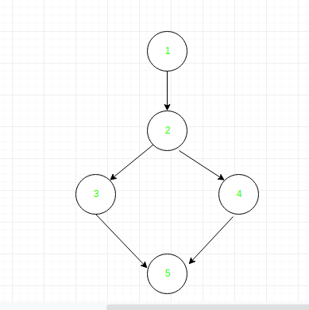

**Define/use of variables of above example:**

| **Variable** | **Defined at node** | **Used at node** |
| --- | --- | --- |
| x | 1 | 2, 3 |
| y | 1 | 2, 4 |
| a | 3, 4 | 5 |

**Conclusion**

Data Flow Testing effectively identifies issues related to variable definitions and usages, such as unused variables or multiple definitions before use. While it provides valuable insights into variable handling, it can be time-consuming and requires a good understanding of programming. Overall, it helps improve code quality by addressing potential data flow issues early in the development process.

**Loop Software Testing**

Last Updated : 21 Jul, 2025

Loop Testing is a type of [white-box testing](https://www.geeksforgeeks.org/software-testing/software-engineering-white-box-testing/) used to validate loops in software programs. As a form of Control Structure Testing, its primary aim is to verify that loops are working correctly and efficiently.

Here are the Objectives of Loop Testing:

**Prevent infinite loops:**To fix the infinite loop repetition problem.

**Check Performance:**To know the performance after applying any loops.

**Identify initialization issues:** Identify loop initialization problems.

**Uncover uninitialized variables:** determine all variables within loops are properly initialized.

**Types of Loop Testing**

Loop testing is categorized based on the structure of loops in the program. Each type targets specific loop configurations to validate their behavior.

Loop Testing

**1. Simple Loop Testing**

Testing performed in a simple loop is known as Simple loop testing. A simple loop is a normal (like for, while, or do-while) in which a condition is given and the loop runs and terminates according to the true and false occurrence of the condition, respectively. This type of testing is performed basically to test the condition of the loop whether the condition is sufficient to terminate loop after some point of time.

**Example:**

while(condition)

{

statement(s);

}

**2. Nested Loop Testing**

Testing performed in a nested loop in known as Nested loop testing. Nested loop is basically one loop inside the another loop. In nested loop there can be finite number of loops inside a loop and there a nest is made. It may be either of any of three loops i.e., for, while or do-while.

**Example:**

while(condition 1)

{

while(condition 2)

{

statement(s);

}

}

**3. Concatenated Loop Testing**

Testing performed in a concatenated loop is known as Concatenated loop testing. It is performed on the concatenated loops. Concatenated loops are loops after the loop. It is a series of loops. Difference between nested and concatenated is that in nested loop is inside the loop but here loop is after the loop.

**Example:**

while(condition 1)

{

statement(s);

}

while(condition 2)

{

statement(s);

}

**4. Unstructured Loop Testing**

Testing performed in an unstructured loop is known as Unstructured loop testing. Unstructured loop is the combination of nested and concatenated loops. It is basically a group of loops that are in no order.

**Example:**

while()

{

for()

{}

while()

{}

}

**Advantages of Loop Testing**

The advantages of Loop testing are:

Loop testing limits the number of iterations of loop.

Loop testing ensures that program doesn't go into infinite loop process.

Loop testing endures initialization of every used variable inside the loop.

Loop testing helps in identification of different problems inside the loop.

Loop testing helps in determination of capacity.

**Disadvantages of Loop Testing**

The dis-advantages of Loop testing are:

Loop testing is mostly effective in bug detection in low-level software.

Testing nested or unstructured loops requires extensive test case design, increasing effort.

White-box technique, demands familiarity with the codebase.

Loop testing is not useful in bug detection.

Loop testing is a testing technique that ensures loops in a program function correctly and efficiently as per their expectation.

**Software Testing - Boundary Value Analysis**

Last Updated : 23 Jul, 2025

[Functional testing](https://www.geeksforgeeks.org/software-testing/software-testing-functional-testing/)is a type of software testing in which the system is tested against the functional requirements of the system. It is conducted to ensure that the requirements are properly satisfied by the application. Functional testing verifies that each function of the software application works in conformance with the requirement and specification. Boundary Value Analysis(BVA) is one of the functional testings.

**Boundary Value Analysis**

[Boundary Value Analysis](https://www.geeksforgeeks.org/software-engineering/boundary-value-analysis-triangle-problem/)is based on testing the boundary values of valid and invalid partitions. The behavior at the edge of the equivalence partition is more likely to be incorrect than the behavior within the partition, so boundaries are an area where testing is likely to yield defects.

It checks for the input values near the boundary that have a higher chance of error. Every partition has its maximum and minimum values and these maximum and minimum values are the boundary values of a partition.

In simple terms boundary value Analysis is like testing the edge cases of our software where most of the time it will get broke so it is important to do BVA before deploying the code. There are many other test that are done if you wish to learn them all then you can join our [complete software testing course](https://www.geeksforgeeks.org/courses/software-testing-course-online?utm_campaign=517_software_testing_boundary_value_analysis&utm_medium=gfgcontent_pcp&utm_source=geeksforgeeks)

**Note:**

A boundary value for a valid partition is a valid boundary value.

A boundary value for an invalid partition is an invalid boundary value.

For each variable we check-

Minimum value.

Just above the minimum.

Nominal Value.

Just below Max value.

Max value.

**Example:**Consider a system that accepts ages from 18 to 56.

| **Boundary Value Analysis(Age accepts 18 to 56)** | | |
| --- | --- | --- |
| Invalid  (min-1) | Valid  (min, min + 1, nominal, max - 1, max) | Invalid  (max + 1) |
| 17 | 18, 19, 37, 55, 56 | 57 |

**Valid Test cases:**Valid test cases for the above can be any value entered greater than 17 and less than 57.

Enter the value- 18.

Enter the value- 19.

Enter the value- 37.

Enter the value- 55.

Enter the value- 56.

**Invalid Testcases:**When any value less than 18 and greater than 56 is entered.

Enter the value- 17.

Enter the value- 57.

**Single Fault Assumption:**When more than one variable for the same application is checked then one can use a single fault assumption. Holding all but one variable to the extreme value and allowing the remaining variable to take the extreme value. For n variable to be checked:

***Maximum of 4n+1 test cases***

**Problem:**Consider a Program for determining the Previous Date.

***Input:*** *Day, Month, Year with valid ranges as-*

*1 ≤ Month≤12   
1 ≤ Day ≤31   
1900 ≤ Year ≤ 2000*

Design Boundary Value Test Cases.

**Solution:**Taking the year as a Single Fault Assumption i.e. year will be having values varying from 1900 to 2000 and others will have nominal values.

| **Test Cases** | **Month** | **Day** | **Year** | **Output** |
| --- | --- | --- | --- | --- |
| 1 | 6 | 15 | 1900 | 14 June 1900 |
| 2 | 6 | 15 | 1901 | 14 June 1901 |
| 3 | 6 | 15 | 1960 | 14 June 1960 |
| 4 | 6 | 15 | 1999 | 14 June 1999 |
| 5 | 6 | 15 | 2000 | 14 June 2000 |

Taking Day as Single Fault Assumption i.e. Day will be having values varying from 1 to 31 and others will have nominal values.

| **Test Case** | **Month** | **Day** | **Year** | **Output** |
| --- | --- | --- | --- | --- |
| 6 | 6 | 1 | 1960 | 31 May 1960 |
| 7 | 6 | 2 | 1960 | 1 June 1960 |
| 8 | 6 | 30 | 1960 | 29 June 1960 |
| 9 | 6 | 31 | 1960 | Invalid day |

Taking Month as Single Fault Assumption i.e. Month will be having values varying from 1 to 12 and others will have nominal values.

| **Test Case** | **Month** | **Day** | **Year** | **Output** |
| --- | --- | --- | --- | --- |
| 10 | 1 | 15 | 1960 | 14 Jan 1960 |
| 11 | 2 | 15 | 1960 | 14 Feb 1960 |
| 12 | 11 | 15 | 1960 | 14 Nov 1960 |
| 13 | 12 | 15 | 1960 | 14 Dec 1960 |

For the n variable to be checked Maximum of 4n + 1 test case will be required. Therefore, for n = 3, the maximum test cases are-

***4 × 3 + 1 =13***

**The focus of BVA:**BVA focuses on the input variable of the function. Let's define two variables X1 and X2, where X1 lies between a and b and X2 lies between c and d.

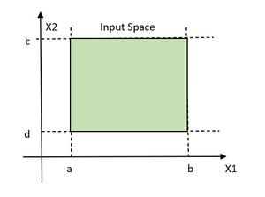Showing legitimate domain

The idea and motivation behind BVA are that errors tend to occur near the extremes of the variables. The defect on the boundary value can be the result of countless possibilities.

**Typing of Languages:**BVA is not suitable for free-form languages such as COBOL and FORTRAN, These languages are known as weakly typed languages. This can be useful and can cause bugs also.

PASCAL, ADA is the strongly typed language that requires all constants or variables defined with an associated data type.

**Limitation of Boundary Value Analysis:**

It works well when the product is under test.

It cannot consider the nature of the functional dependencies of variables.

BVA is quite rudimentary.

**Equivalence Partitioning**

It is a type of [black-box testing](https://www.geeksforgeeks.org/software-testing/software-engineering-black-box-testing/)that can be applied to all levels of [software testing](https://www.geeksforgeeks.org/software-testing/software-testing-basics/). In this technique, input data are divided into the equivalent partitions that can be used to derive test cases-

In this input data are divided into different equivalence data classes.

It is applied when there is a range of input values.

**Example:**Below is the example to combine Equivalence Partitioning and Boundary Value.

Consider a field that accepts a minimum of 6 characters and a maximum of 10 characters. Then the partition of the test cases ranges 0 - 5, 6 - 10, 11 - 14.

| **Test Scenario** | **Test Description** | **Expected Outcome** |
| --- | --- | --- |
| 1 | Enter value 0 to 5 character | Not accepted |
| 2 | Enter 6 to 10 character | Accepted |
| 3 | Enter 11 to 14 character | Not Accepted |

**Why Combine Equivalence Partitioning and Boundary Analysis Testing:**Following are some of the reasons why to combine the two approaches:

In this test cases are reduced into manageable chunks.

The effectiveness of the testing is not compromised on test cases.

Works well with a large number of variables.

Object Oriented Testing in Software Testing

Last Updated : 23 Jul, 2025

In traditional software testing, the focus was on checking how functions or procedures operated on data. But with the rise of object-oriented programming (OOP), the approach to testing has shifted.

Now, testing is more about checking how objects and classes behave and how they interact with each other. This shift has led to the creation of Object-Oriented Testing (OOT), which is designed specifically for testing applications built with OOP principles like encapsulation, inheritance, and polymorphism.

Table of Content

What is Object-Oriented Testing?

Testing Classes in Object-Oriented Testing

Object-Oriented Testing Issues and Levels

Purpose of Object Oriented Testing

Best Practices for Object-Oriented Testing

What is Object-Oriented Testing?

Object-oriented testing is a process used to test software that follows object-oriented principles like encapsulation, inheritance, and polymorphism. Instead of focusing on just individual functions, this type of testing looks at how different objects and classes in the software interact with one another.

Just like any other software, object-oriented programs go through various stages of testing, from testing small pieces of code (unit testing) to testing the entire system (system or acceptance testing). Each stage verifies that the software works as expected and meets the required standards.

Read more about Software Testing

As information systems are becoming more complex, the object-oriented paradigm is gaining popularity because of its benefits in analysis, design, and coding. Conventional testing methods cannot be applied for testing classes because of problems involved in testing classes, abstract classes, inheritance, dynamic binding, message passing, polymorphism, concurrency, etc.

Testing Classes in Object-Oriented Testing

Testing classes is a fundamentally different issue than testing functions. A function (or a procedure) has a clearly defined input-output behavior, while a class does not have an input-output behavior specification. We can test a method of a class using approaches for testing functions, but we cannot test the class using these

approaches.

Data dependencies between variables

Calling dependencies between modules

Functional dependencies between a module and the variable it computes

Definitional dependencies between a variable and its types.

But in Object-Oriented systems, there are the following additional dependencies:

Class-to-class dependencies

Class to method dependencies

Class to message dependencies

Class to variable dependencies

Method to variable dependencies

Method to message dependencies

Method to method dependencies

Object-Oriented Testing Issues and Levels

Additional testing Issue of interest is that it is not possible to test the class dynamically, only its instances i.e, objects can be tested. Similarly, the concept of inheritance opens various issues e.g., if changes are made to a parent class or superclass, in a larger system of a class it will be difficult to test subclasses individually and isolate the error to one class. In object-oriented programs, control flow is characterized by message passing among objects, and the control flow switches from one object to another by inter-object communication.

Fault Based Testing: This type of checking permits for coming up with test cases supported the consumer specification or the code or both. It tries to identify possible faults (areas of design or code that may lead to errors.). For all of these faults, a test case is developed to "flush" the errors out. These tests also force each time of code to be executed. This method of testing does not find all types of errors. However, incorrect specification and interface errors can be missed. These types of errors can be uncovered by function testing in the traditional testing model. In the object-oriented model, interaction errors can be uncovered by scenario-based testing. This form of Object oriented-testing can only test against the client's specifications, so interface errors are still missed.

Class Testing Based on Method Testing: This approach is the simplest approach to test classes. Each method of the class performs a well defined cohesive function and can, therefore, be related to unit testing of the traditional testing techniques. Therefore all the methods of a class can be involved at least once to test the class.

Random Testing: It is supported by developing a random test sequence that tries the minimum variety of operations typical to the behavior of the categories

Partition Testing: This methodology categorizes the inputs and outputs of a category so as to check them severely. This minimizes the number of cases that have to be designed.

Scenario-based Testing: It primarily involves capturing the user actions then stimulating them to similar actions throughout the test. These tests tend to search out interaction form of error.

Purpose of Object Oriented Testing

Object Interaction Validation: Check to make sure objects interact with one another appropriately in various situations. Testing makes ensuring that the interactions between objects in object-oriented systems result in the desired results.

Determining Design Errors: Find the object-oriented design's limitations and design faults. Testing ensures that the design complies with the desired architecture by assisting in the identification of problems with inheritance, polymorphism, encapsulation and other OOP concepts.

Finding Integration Problems: Evaluate an object's ability to integrate and communicate with other objects when it is part of a bigger component or subsystem. This helps in locating integration difficulties, such improper method calls or issues with data exchange.

Assessment of Reusable Code: Evaluate object-oriented code's reusability. Code reuse is promoted by object-oriented programming via features like inheritance and composition. Testing ensures that reusable parts perform as intended in various scenarios.

Verification of Handling Exceptions: Confirm that objects respond correctly to error circumstances and exceptions. The purpose of object-oriented testing is to make sure that the software responds carefully and is durable in the face of unforeseen occurrences or faults.

Verification of Uniformity: Maintain uniformity inside and between objects and the object-oriented system as a whole. Maintainability and readability are enhanced by consistency in naming standards, coding styles and compliance to design patterns.

Best Practices for Object-Oriented Testing

1. Keep Test Cases Clear and Simple: The simpler your test cases are, the better. Each test case should focus on one specific function or method, ensuring that you can easily trace any issues back to a specific area. This makes your tests easier to understand, maintain, and modify over time.

2. Test in Layers: Instead of testing everything at once, break it down into layers. Start by testing individual objects and classes to make sure they work as expected. Once you've ensured these pieces function on their own, move on to testing how they interact with each other.

3. Use Mocks and Stubs: Sometimes, not all parts of your system are ready to be tested, especially when you're working with multiple interacting components. This is where mocks and stubs come in handy.

4. Automate Testing: Automating your tests is a great way to make sure your tests are run consistently and efficiently. Especially when dealing with repetitive tasks like regression testing, automation can save a lot of time and reduce the risk of human error.

5. Focus on Object Interactions: In object-oriented programming, the core of the system lies in how objects interact with each other. While it’s important to test individual methods, don’t forget to focus on testing how objects communicate and work together.

Conclusion

Object-Oriented Testing (OOT) is a important part of testing applications that are built using object-oriented principles. By focusing on testing individual classes, how they interact with each other, and the overall system, OOT makes sure that all parts of the system work together smoothly. If you want to learn more types of Software testing refer these one "Software Testing Types".

In the dynamic realm of software development, ensuring that our digital creations function flawlessly and deliver a seamless user experience is paramount. This is where software testing, a critical component of the development process, assumes its pivotal role.

Among the array of testing methodologies, behavior testing stands tall as a formidable approach that scrutinizes the software’s behavior against predefined expectations, revealing the true essence of its capabilities.



This article delves deep into this testing type in software development, unearthing its significance and shedding light on how it contributes to creating high-quality, dependable, and user-friendly software. We embark on a journey that acquaints both novices and seasoned professionals with the core principles of this approach, unlocking the potential to elevate their development endeavors to new heights.

What is Behavior Testing?

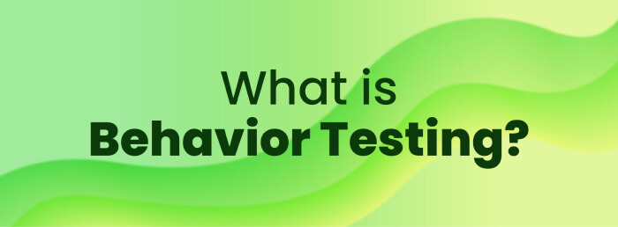

Behavior testing is a comprehensive and crucial aspect of software testing that evaluates a software application’s behavior in response to various inputs and scenarios. It aims to ensure the software functions as intended, meets user requirements, and behaves as expected in different usage situations.

By validating the entire system’s behavior rather than individual components, It offers a holistic approach to assessing the software’s performance and reliability.

**Importance of Behavior Testing**

Behavior testing can be important in many scenarios.

Scenario-Based Testing: A scenario-based approach to designing test cases replicating real-life user interactions, ensuring the software behaves as expected in various usage situations.

High-Level Testing: Unlike unit testing, which focuses on individual code components, high-level testing evaluates the entire software system as a cohesive entity, including end-to-end, functional, and acceptance testing.

Collaboration and Shared Understanding: This promotes effective communication and collaboration between technical and non-technical stakeholders by using a common language, such as Gherkin syntax in BDD, to foster a shared understanding of the software’s behavior and requirements.

Validation of Business Requirements: The core objective of this approach is to validate the software against specified business requirements and objectives, ensuring that it serves its intended purpose and aligns with the organization’s goals.

Detection of Defects and Early Issue Identification: Detecting defects and identifying issues early in the development process is crucial, allowing developers to address problems promptly and prevent them from escalating into critical bugs.

Usability and User Experience Assessment: This approach incorporates usability testing, evaluating the software’s user interface and overall user experience to ensure that it functions correctly and provides a user-friendly and enjoyable experience.

Continuous Integration and Regression Testing: It supports continuous integration practices by enabling rapid and frequent testing of code changes while conducting regression testing to [maintain software](https://www.qodo.ai/blog/software-maintainability/) stability and verify existing functionalities.

Types of Behavior Testing

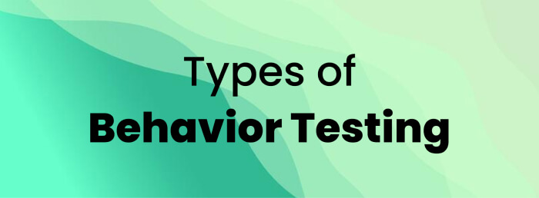

This type of testing encompasses various methodologies, each focused on evaluating different aspects of the software’s behavior and functionality.

Functional Testing**:**

Functional testing is a foundational type of this approach that verifies whether the software performs specific functions and actions as intended. [Functional testing](https://www.qodo.ai/glossary/functional-testing/)primarily aims to guarantee the application’s compliance with specified functional requirements and the generation of expected outputs for provided inputs. It examines the application’s behavior against functional specifications, business rules, and user requirements.

Unit Testing: This form of functional testing concentrates on examining individual units or code components in isolation. It ensures that each [code unit,](https://www.qodo.ai/glossary/unit-testing/) such as functions or methods, works correctly and delivers the intended functionality.

Integration Testing: Integration testing ensures the seamless coordination and communication between diverse components or modules within the software, verifying their interactions and interfaces. It ensures that integrated components work cohesively and exchange data correctly.

System Testing: System testing evaluates the entire software system as a complete and integrated entity. It ensures all components work cohesively as expected and meet specified requirements.

[blog-subscribe]

Acceptance Testing

Acceptance testing validates whether the software meets user expectations and business requirements. It is performed to ensure that the application satisfies user needs, aligns with business objectives, and is ready for deployment. There are two main types of [acceptance testing](https://www.qodo.ai/glossary/acceptance-testing/):

User Acceptance Testing (UAT): UAT is conducted by end-users or business stakeholders to validate that the software fulfills their needs and requirements. It ensures the application is user-friendly and meets users’ expectations.

Business Acceptance Testing (BAT): BAT is conducted by business analysts or subject matter experts to ensure the software aligns with the defined business objectives and requirements.

Usability Testing

Usability testing evaluates the software’s user interface and overall user experience. The primary goal is to identify usability issues, such as confusing navigation, poor layout, or unclear instructions. Usability testing ensures the application is intuitive, easy to navigate, and provides a pleasant user experience.

Regression Testing

After code changes or updates, [regression testing](https://www.qodo.ai/glossary/regression-testing/) is performed to verify that the modifications have not adversely affected existing functionalities. The main objective is to ensure that new changes do not introduce defects or regressions in previously tested application areas.

End-to-End Testing

[End-to-end testing](https://www.qodo.ai/glossary/end-to-end-testing/) examines the entire software application flow, from start to finish, to validate that all components work together seamlessly. It ensures data and information flow correctly between different modules and verifies the application’s behavior across the user journey.

Getting Started with Behavior Testing

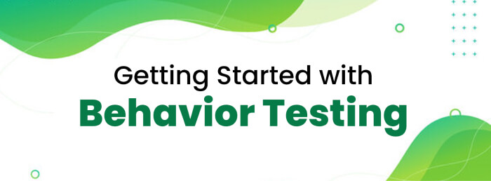

Below are the simple steps to begin with this approach.

**1. Define Test Scenarios**

Identify the different scenarios that the software should be able to handle. These scenarios should be based on real-life user interactions and represent various use cases that users might encounter while using the application.

In the context of an online shopping website, the test scenarios could include:

User login and registration

Searching for products

Adding items to the cart

Checking out and completing the purchase

Applying discounts or promotional codes

Viewing order history and tracking shipments

2. Formulate Test Cases

For each defined test scenario, create detailed test cases that outline the steps required to execute the scenario and the expected outcomes. These test cases should be precise and easy to follow, helping testers and developers understand the behavior expected from the application.

For the “User login and registration” scenario, a test case might be:

Test Scenario: User Registration

Test Steps:

Navigate to the registration page.

Enter valid user details (name, email, password).

Click on the “Register” button.

Expected Outcome: The user should be registered successfully and redirected to the login page.

3. Set Up Test Environment

Prepare a test environment replicating the production environment but allowing for controlled testing. Ensure that the necessary hardware, software, and configurations are in place to execute the behavior tests effectively.

For the given example, create a test environment with a web server, database, and necessary software to host the online shopping website. Make sure to isolate the test environment from the production environment to avoid interference.

4. Choose a Behavior Testing Tool

Select a suitable behavioral testing software or framework that fits your project requirements. Popular tools like Cucumber, SpecFlow, or Behave enable you to write behavior-driven tests in a natural language format, making them more accessible to technical and non-technical stakeholders.

5. Write Behavior Tests

Write behavior-driven tests based on the formulated test cases using the chosen tool. Behavior tests are written in a format known as “Given-When-Then,” where each test scenario begins with a given set of preconditions, followed by actions (when) that trigger the behavior, and concludes with expected outcomes (then).

An example behavior test in Gherkin syntax might look like this:

Feature: User Registration  
Scenario: Successful User Registration  
Given the user is on the registration page  
When the user enters valid name, email, and password  
And clicks on the "Register" button  
Then the user should be redirected to the login page

6. Implement Application Code

Develop the application code to support the functionality being tested. Ensure that the application code aligns with the defined behavior test scenarios and meets the expected behavior outlined in the test cases.

Develop the application code for user registration, ensuring it captures and stores user details correctly. The code should validate user inputs, handle registration requests, and redirect users to the appropriate pages.

7. Execute Behavior Tests

Run the behavior tests against the implemented application code. The chosen tool will execute the tests and compare the actual and expected outcomes specified in the test cases.

8. Analyze Test Results

Carefully review the test results to identify any discrepancies between the actual behavior and the expected behavior of the software. If any issues are found, developers should address them promptly and rerun the behavior tests to ensure a successful resolution.

Review the behavior test results to ensure the user registration functionality passes successfully without errors. If any issues are identified, developers should address them and rerun the behavior tests to validate the fixes.

9. Incorporate this into CI/CD Pipeline

To leverage the full benefits of this approach, integrate it into your Continuous Integration/Continuous Deployment (CI/CD) pipeline. By automating behavior tests with each code change, you can ensure that new modifications do not introduce unintended regressions and maintain consistent software quality.

10. Iterate and Improve

Behavioral testing is an iterative process, evolving with experience and feedback, leading to continuous improvement of behavior test scenarios and cases. Regularly review and update the behavior tests to accommodate software changes and requirements.

By following these steps, you can effectively integrate this testing type into your software development process, improving software quality, enhancing user experience, and increasing confidence in the application’s behavior and functionality.

Now let’s dive into some best practices.

Best Practices for Behavior Testing in Software Testing:

Here is a list of best practices for consideration.

Define Clear and Specific Test Scenarios: Ensure the test scenarios are well-defined, clear, and specific to capture various aspects of the software’s behavior. Collaborate with stakeholders to gather requirements and use cases to create comprehensive and meaningful test scenarios.

Focus on User-Centric Testing: This should prioritize user expectations and experiences. Craft test scenarios that simulate real-life user interactions, allowing you to verify that the application delivers a user-friendly experience and meets user needs.

Use Behavior-Driven Language: Adopt Behavior-Driven Development ([BDD](https://www.qodo.ai/glossary/behavior-driven-development/)) language such as Gherkin syntax, which is easily understandable by technical and non-technical team members. Writing tests in a natural language format fosters better stakeholder communication and collaboration.

Reusability and Modularity: Design behavior tests with reusability and modularity in mind. Create reusable test steps and functions to avoid duplicating test code and ensure easier maintenance and scalability.

Prioritize Test Coverage: Attain extensive test coverage by encompassing diverse scenarios, incorporating both positive and negative test cases. Cover edge cases, boundary values, and unusual scenarios to validate the application’s robustness and error-handling capabilities.

Isolate Behavior Tests: Keep behavior tests isolated from other types of tests to maintain a clear distinction between different testing methodologies. Isolation ensures that any issues arising from other testing types do not interfere with test results.

Integrate Behavior Testing into CI/CD: Integrate behavior tests into your Continuous Integration/Continuous Deployment (CI/CD) pipeline to automate testing with each code change. Automating helps catch issues early and ensures quick feedback to developers.

Regularly Update And Maintain Tests: Regularly review and update behavior tests to keep them aligned with changes in the application and requirements. Maintaining up-to-date tests ensures their accuracy and effectiveness.

Analyze Test Results Thoroughly: Carefully analyze test results to identify the root cause of any failures or discrepancies. Conduct root cause analysis to address underlying issues and prevent future occurrences.

**Steps in Top Down Integration Testing**

Last Updated : 15 Jul, 2025

**Top-down testing** is a type of incremental [integration testing](https://www.geeksforgeeks.org/software-testing/software-engineering-integration-testing/) approach in which testing is done by integrating or joining two or more modules by moving down from top to bottom through the control flow of the architecture structure. In these, high-level modules are tested first, and then low-level modules are tested. Then, finally, integration is done to ensure that the system is working properly. Stubs and drivers are used to carry out this project. This technique is used to increase or stimulate the behavior of Modules that are not integrated into a lower level. **Processing:**

**The following are the steps that need to be followed during processing :**

**Steps of Top-Down Integration Testing**

The test driver represents the main control module also known as a high-level module and stubs are generally used for all low-level modules that directly subordinate (present or rank below another) to high-level modules.

In this, testing takes place from to bottom. So, too, high-level modules are tested first in isolation.

After this, low-level modules subordinated modules, or stubs replace high-level modules one by one at a time. This can be done using methods like depth-first or breadth search.

The process is repeated until each module is integrated and tested.

Another stub replaces the present real or control module after the completion of each set of tests. These stubs act as s temporary replacement for a called module (stubs) and give the same result or output as the actual product gives.

To check if there is any defect or any error occurred or is present, regression testing is done and it's important to reduce any side effects that might be caused due to errors that occurred.

**Shortcomings of Top Down Integration Testing**

Following are some of the logical problems that might arise in top-down integration testing :

Upper models or high-level modules should be tested properly to maintain quality and for processing lower-level modules or stubs of top-down testing.

As we know in this type of pf testing, stubs temporarily replace a lower-level module, but data do not move upwards with this replacement. Due to this, testing cannot be done on time which results in delays in testing.

Due to replacement, stubs might become more and more complex after each replacement.

Losing control over correspondence between specific tests and specific modules is the main problem that might arise during process.

Sometimes, modules at lower levels are tested inadequately (unsatisfactory that lacks quality).

**Example of Top Down Integration Testing**

In the top-down integration testing, if the depth-first approach is adopted then we will start integration from module M1. Then we will integrate M2, then M3, M4, M5, M6, and at last M7.

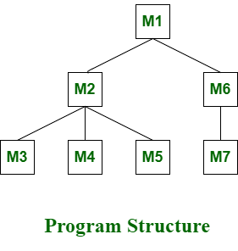Top-Down Integration Testing

In the top-down integration testing, if the breadth-first approach is adopted, then we will integrate module M1 first, then M2,and M6. Then we will integrate module M3, M4, M5, and at last M7.

**Advantages Top Down Integration Testing**

There is no need to write drivers.

Interface errors are identified at an early stage and fault localization is also easier.

Low-level utilities that are not important are not tested well and high-level testers are tested well in an appropriate manner.

Representation of test cases is easier and simple once Input-Output functions are added.

**Disadvantages Top Down Integration Testing**

It requires a lot of stubs and mock objects.

Representation of test cases in stubs can be not easy and might be difficult before Input-Output functions are added.

Low-level utilities that are important are also not tested well.

**Steps in Bottom Up Integration Testing**

Last Updated : 15 Jul, 2025

**Bottom-up Testing** is a type of incremental [integration testing](https://www.geeksforgeeks.org/software-testing/software-engineering-integration-testing/) approach in which testing is done by integrating or joining two or more modules by moving upward from bottom to top through the control flow of the architecture structure. In these, low-level modules are tested first, and then high-level modules are tested. This type of testing or approach is also known as inductive reasoning and is used as a synthesis synonym in many cases. Bottom-up testing is user-friendly testing and results in an increase in overall software development. This testing results in high success rates with long-lasting results.

**Steps of Bottom-Up Integration Testing**

Following are the steps that are needed to be followed during the processing :

Clusters are formed by merging or combining low-level modules or elements. These clusters are also known as builds that are responsible for performing certain secondary or subsidiary functions of software.

It is important to write a control program for testing. These control programs are also known as drivers or high-level modules. It simply coordinates the input and output of a test case.

Testing is done on the entire build or cluster containing low-level modules.

lastly, the control program or drivers or high-level modules are removed and clusters are integrated by moving upward from bottom to top in the program structure with the help of control flow.

**Example of Bottom-Up Integration Testing**

In the last, modules or components are combined to form cluster 1 and cluster 2. After this, each cluster is tested with the help of a control program. The cluster is present below the high-level module or driver. After testing, the driver is removed and clusters are combined and moved upwards with modules.

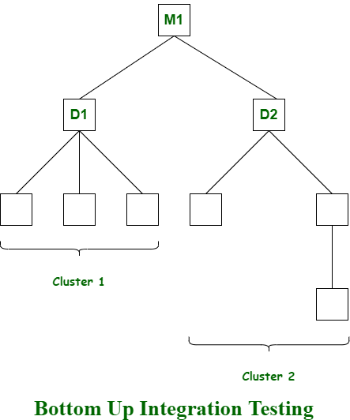Bottom-Up Integration Testing

**Advantages of Bottom-Up Integration Testing**

It is easy and simple to create and develop test conditions.

It is also easy to observe test results.

It is not necessary to know about the details of the structural design.

Low-level utilities are also tested well and are also compatible with the object-oriented structure.

**Disadvantages of Bottom-Up Integration Testing**

Towards the top of the Hierarchy, it becomes very complicated.

There is no concept regarding the early skeletal system.

There will be an impact on sibling and higher-level unit tests due to changes.

Continuous integration (CI) is the practice of automating the integration of code changes from multiple contributors into a single software project. It’s a primary DevOps best practice, allowing developers to frequently merge code changes into a central repository where builds and tests then run. Automated tools are used to assert the new code’s correctness before integration.

A source code version control system is the crux of the CI process. The version control system is also supplemented with other checks like automated code quality tests, syntax style review tools, and more.

How to get to continuous integration

Learn about how to adopt continuous integration and automated testing in five steps. Read the article

Five tips for CI-friendly Git repos

Five tips to make the best out of Git and your continuous integration tool! Read the article

Continuous integration tools

Five tips to make the best out of Git and your continuous integration tool! Read the article

Trunk-based development

Learn about trunk-based development, a version control management practice where developers merge small, frequent updates to a core “trunk” or main branch. Read the article

The importance of continuous integration

In order to understand the importance of CI, it’s helpful to first discuss some pain points that often arise due to the absence of CI. Without CI, developers must manually coordinate and communicate when they are contributing code to the end product. This coordination extends beyond the development teams to operations and the rest of the organization. Product teams must coordinate when to sequentially launch features and fixes and which team members will be responsible.

The communication overhead of a non-CI environment can become a complex and entangled synchronization chore, which adds unnecessary bureaucratic cost to projects. This causes slower code releases with higher rates of failure, as it requires developers to be sensitive and thoughtful towards the integrations. These risks grow exponentially as the engineering team and codebase sizes increase.

Without a robust CI pipeline, a disconnect between the engineering team and the rest of the organization can form. Communication between product and engineering can be cumbersome. Engineering becomes a black box which the rest of the team inputs requirements and features and maybe gets expected results back. It will make it harder for engineering to estimate time of delivery on requests because the time to integrate new changes becomes an unknown risk.

What CI does

CI helps to scale up headcount and delivery output of engineering teams. Introducing CI to the aforementioned scenario allows software developers to work independently on features in parallel. When they are ready to merge these features into the end product, they can do so independently and rapidly. CI is a valuable and well-established practice in modern, high performance software engineering organizations.

How CI can be used

CI is generally used alongside an agile software development workflow. An organization will compile list of tasks that comprise a product roadmap. These tasks are then distributed amongst software engineering team members for delivery. Using CI enables these software development tasks to be developed independently and in parallel amongst the assigned developers. Once one of theses tasks is complete, a developer will introduce that new work to the CI system to be integrated with the rest of the project.

CI vs. continuous deployment vs. continuous delivery

Continuous integration, deployment, and delivery are three phases of an automated software release pipeline, including a DevOps pipeline. These three phases take software from idea to delivery to the end-user. The integration phase is the first step in the process. Continuous integration covers the process of multiple developers attempting to merge their code changes with the main code repository of a project.

Continuous delivery is the next extension of continuous integration. The delivery phase is responsible for packaging an artifact together to be delivered to end-users. This phase runs automated building tools to generate this artifact. This build phase is kept ‘green,’ which means that the artifact should be ready to deploy to users at any given time.

Continuous deployment is the final phase of the pipeline. The deployment phase is responsible for automatically launching and distributing the software artifact to end-users. At deployment time, the artifact has successfully passed the integration and delivery phases. Now it is time to automatically deploy or distribute the artifact. This will happen through scripts or tools that automatically move the artifact to public servers or to another mechanism of distribution, like an app store.

Benefits and challenges of continuous integration

Continuous integration is an essential aspect of DevOps and high-performing software teams. Yet CI benefits are not limited to the engineering team but greatly benefit the overall organization. CI enables better transparency and insight into the process of software development and delivery. These benefits enable the rest of the organization to better plan and execute go to market strategies. The following are some of the overall organizational benefits of CI.

Enable scaling

CI enables organizations to scale in engineering team size, codebase size, and infrastructure. By minimizing code integration bureaucracy and communication overhead, CI helps build DevOps and agile workflows. It allows each team member to own a new code change through to release. CI enables scaling by removing any organizational dependencies between development of individual features. Developers can now work on features in an isolated silo and have assurances that their code will seamlessly integrate with the rest of the codebase, which is a core DevOps process.

Improve the feedback loop

Faster feedback on business decisions is another powerful side effect of CI. Product teams can test ideas and iterate product designs faster with an optimized CI platform. Changes can be rapidly pushed and measured for success. Bugs or other issues can be quickly addressed and repaired.

Enhance communication

CI improves overall engineering communication and accountability, which enables greater collaboration between development and operations in a DevOps team. By introducing pull request workflows tied to CI, developers gain passive knowledge share. Pull requests allow developers to observe and comment on code from other team members. Developers can now view and collaborate on feature branches with other developers as the features progress through the CI Pipeline. CI can also be used to help QA resource expenses. An efficient CI pipeline with high-confidence automated test coverage will safeguard from regressions and ensure that new features match a specification. Before new code is merged it must pass the CI test assertion suite which will prevent any new regressions.

The benefits of CI far outweigh any challenges in adoption. That said, it is important to be aware of the challenges of CI. The real challenges of CI arise when transitioning a project from no CI to CI. Most modern software projects will adopt CI from early inception stages and alleviate the challenges of later adoption.

Adoption and installation

The challenges of continuous integration are primarily around team adoption and initial technical installation. If a team doesn't currently have a CI solution in place, it can require some effort to pick one and get started. Thus, considerations need to be made around the existing engineering infrastructure when installing a CI pipeline.

Technology learning curve

CI functionality comes with a list of supportive technologies that may be learning curve investments for the team to undertake. These technologies are version control systems, hosting infrastructure, and orchestration technologies.

CI best practices

Test driven development

Once a project has established a CI pipeline with automatic test coverage, it is a best practice to constantly develop and improve the test coverage. Each new feature coming down the CI pipeline should have an accompanying set of tests to assert that the new code is behaving as expected.

Test Driven Development (TDD) is the practice of writing out the test code and test cases before doing any actual feature coding. Pure TDD can closely involve the product team to help craft an expected business behavior specification, which can then be transformed into the test cases. In a pure TDD scenario, developers and product team will meet and discuss a spec or list of requirements. This list of requirements will then be converted into a checklist of code assertions. The developers will then write code that matches these assertions.

Pull requests and code review

Most modern software development teams practice a pull request and code review workflow. Pull requests are a critical practice to effective CI. A pull request is created when a developer is ready to merge new code into the main codebase. The pull request notifies other developers of the new set of changes that are ready for integration.

Pull requests are an opportune time to kick off the CI pipeline and run the set of automated approval steps. An additional, manual approval step is commonly added at pull request time, during which a non-stakeholder engineer performs a code review of the feature.. This allows for a fresh set of eyes to review the new code and functionality. The non-stakeholder will make edit suggestions and approve or deny the pull request.

Pull requests and code review are a powerful tool to foster passive communication and knowledge share among an engineering team. This helps guard against technical debt in the form of knowledge silos, where specific engineers are the only stakeholders for certain features of a code base.

Optimize pipeline speed

Given that the CI pipeline is going to be a central and frequently used process, it is important to optimize its execution speed. Any small delay in the CI workflow will compound exponentially as the rate of feature releases, team size, and codebase size grows. It is a best practice to measure the CI pipeline speed and optimize as necessary.

A faster CI pipeline enables a faster product feedback loop. Developers can rapidly push changes and experiment with new feature ideas to help improve the user experience. Any bug fixes can be quickly patched and resolved as discovered. This increased execution speed can offer both an advantage over other competitors and an overall higher-quality experience to your customers.

Getting started with continuous integration

The foundational dependency of CI is a version control system (VCS). If the target code base for a CI install does not have a VCS, step one is installing a VCS. The absence of a VCS should be very unlikely on modern codebases. Some popular VCSs are Git, Mercurial, and Subversion.

Once version control is in place, finding a version control hosting platform is the next move. Most modern version control hosting tools have support and features built in for CI. Some popular version control hosting platforms are Bitbucket, Github, and Gitlab.

After version control has been established on the project, integration approval steps should be added. The most valuable integration approval step to have in place is automated tests. Adding automated tests to a project can have an initial cost overhead. A testing framework has to be installed, then test code and test cases must be written by developers.

Some ideas for other, less expensive CI approval mechanisms to add are syntax checkers, code style formatters, or dependency vulnerability scans. Once you have a version control system setup with some merge approval steps in place, you’ve established continuous integration!

CI is not purely an engineering specific business process. The rest of the organization, marketing, sales, and product teams will also benefit from a CI pipeline. Product teams will need to think how to parallelize execution of simultaneous streams of development. Product and engineering will work closely to determine the qualifying business functionality expectations that will make up the automated test suite.

Marketing and sales will be able to reference the CI pipeline to coordinate with customer facing communications efforts and events. CI gives a level of transparency to the rest of the organization on how engineering execution is progressing. This transparency and communication utility integrates gracefully with an agile project development workflow.

In conclusion...

If your organization strives to reap the benefits of a DevOps approach or simply has a multiple-developer software team, CI is important. It will help your engineering organization execute quicker and more effectively.

CI is a standard fixture of modern high efficiency software development organizations. The best companies have robust CI pipelines and don’t think twice about further efficiency investments. The benefits of CI are not limited to the engineering team and applicable to the whole organization.

Many third-party tools exist to aid in CI management and installation. Some popular options are Codeship, Bitbucket Pipelines, SemaphoreCI, CircleCI, Jenkins, Bamboo, Teamcity, and many others. These tools have their own in-depth setup guides and documentation to help get started.

Try out some of the best CI tools provided by Atlassian:

Bitbucket pipelines is a great utility to bring a project up to speed with modern CI features.

Jira is one of the world's most popular agile and DevOps project management tools. It tightly integrates with other Bitbucket projects and when coupled with a CI pipeline, can give a very transparent view into the execution health of an organization.

**Smoke Testing - Software Testing**

Last Updated : 23 Jul, 2025

Smoke testing, also known as "Build Verification Testing" or "Build Acceptance Testing," is a[type of software testing](https://www.geeksforgeeks.org/software-testing/types-software-testing/)that is typically performed at the beginning of the [development process](https://www.geeksforgeeks.org/software-engineering/software-development-process/) to ensure that the most critical functions of a [software application](https://www.geeksforgeeks.org/software-engineering/application-software/) are working correctly. It is used to quickly identify and fix any major issues with the software before more detailed testing is performed. The goal of smoke testing is to determine whether the build is stable enough to proceed with further [types of testing](https://www.geeksforgeeks.org/software-testing/types-software-testing/).

**Table of Content**

[What is Smoke Testing?](https://www.geeksforgeeks.org/software-engineering/smoke-testing-software-testing/#what-is-smoke-testing)

[Characteristics of Smoke Testing](https://www.geeksforgeeks.org/software-engineering/smoke-testing-software-testing/#characteristics-of-smoke-testing)

[Goal of Smoke Testing](https://www.geeksforgeeks.org/software-engineering/smoke-testing-software-testing/#goal-of-smoke-testing)

[Types of Smoke Testing](https://www.geeksforgeeks.org/software-engineering/smoke-testing-software-testing/#types-of-smoke-testing)

[Applying Smoke Testing at Different Levels](https://www.geeksforgeeks.org/software-engineering/smoke-testing-software-testing/#applying-smoke-testing-at-different-levels)

[Tools used for Smoke Testing:](https://www.geeksforgeeks.org/software-engineering/smoke-testing-software-testing/#tools-used-for-smoke-testing)

[Advantages of Smoke Testing](https://www.geeksforgeeks.org/software-engineering/smoke-testing-software-testing/#advantages-of-smoke-testing)

[Disadvantages of Smoke Testing](https://www.geeksforgeeks.org/software-engineering/smoke-testing-software-testing/#disadvantages-of-smoke-testing)

[Important Points remember for Smoke testing](https://www.geeksforgeeks.org/software-engineering/smoke-testing-software-testing/#important-points-remember-for-smoke-testing)

[References](https://www.geeksforgeeks.org/software-engineering/smoke-testing-software-testing/#references)

[Conclusion](https://www.geeksforgeeks.org/software-engineering/smoke-testing-software-testing/#conclusion)

[Frequently Asked Questions on Smoke Testing](https://www.geeksforgeeks.org/software-engineering/smoke-testing-software-testing/#frequently-asked-questions-on-smoke-testing)

*Prerequisite -* [*Types of Software Testing*](https://www.geeksforgeeks.org/software-testing/types-software-testing/)

**What is Smoke Testing?**

**Smoke Testing** is a [software testing](https://www.geeksforgeeks.org/software-testing/software-testing-basics/) method that determines whether the employed build is stable or not. It acts as a confirmation of whether the quality assurance team can proceed with further [testing](https://www.geeksforgeeks.org/software-testing/types-software-testing/). Smoke tests are a minimum set of tests run on each build. Smoke testing is a process where the [software](https://www.geeksforgeeks.org/software-testing/software-testing-basics/) build is deployed to a[quality assurance](https://www.geeksforgeeks.org/software-testing/software-engineering-software-quality-assurance/) environment and verified to ensure the application's stability. Smoke Testing is also known as ***Confidence Testing*** or ***Build Verification Testing***.

In other words, we verify whether the important features are working and there are no showstoppers in the build that are under testing. It is a mini and quick regression test of major functionality. Smoke testing shows that the product is ready for testing. This helps in determining if the build is flawed to make any further testing a waste of time and resources.

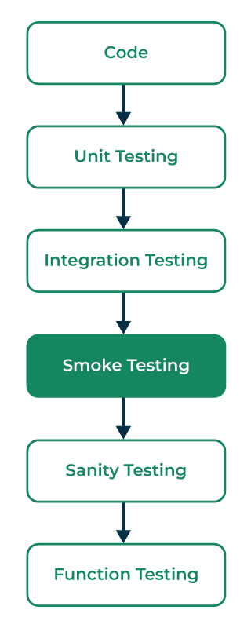Smoke Testing

**Characteristics of Smoke Testing**

The following are the characteristics of the smoke testing:

**Level of Testing**: Without delving into specific functionality, the testing procedure is superficial and broad-based, covering only the most important features.

**Automation**: Automated smoke tests are a common way to quickly and effectively confirm fundamental system functionality.

**Frequency of execution**: Usually, smoke testing is done following the release of a new build or following significant code modifications. In order to identify major issues early on, it can be run either daily or per build.

**Time Management:** The process of determining the build's stability is usually swift, requiring little time.

**Environment:** Usually, smoke tests are carried out in a controlled setting that is quite similar to the production setting.

Smoke Testing is usually carried out by quality assurance engineers.

**Goal of Smoke Testing**

The aim of Smoke Testing is:

**Stop Wasting Resources:** Refrain from wasting resources on extensive testing if the core functions aren't working properly.

**Time Management**: Save time by recognizing show-stopping concerns early on, so that development teams may rapidly handle important issues.

**Making Objective Decisions:** Establish a transparent and impartial framework for determining whether a software build is ready for more, in-depth testing or if it has to be fixed right away.

**Continuous Integration:** Make sure that before every new build is integrated into the bigger codebase, it satisfies basic quality criteria in order to support the continuous integration approach.

**Communication**: Give quick feedback on the stability of the build to the development and testing teams to help them communicate effectively.

**Types of Smoke Testing**

There are three types of Smoke Testing:

**Manual Testing:**In this, the tester has to write, develop, modify, or update the test cases for each built product. Either the tester has to write test scripts for existing features or new features.

**Automated Testing:**In this, the tool will handle the testing process by itself providing the relevant tests. It is very helpful when the project should be completed in a limited time.

**Hybrid Testing:**As the name implies, it is the combination of both manual and automated testing. Here, the tester has to write test cases by himself and he can also automate the tests using the tool. It increases the performance of the testing as it combines both manual checking and tools.

**Daily Smoke Testing:** Daily smoke testing entails conducting smoke tests every day, particularly for projects where the development process includes frequent builds and continuous integration. It aids in making sure every daily build satisfies minimal requirements for quality.

**Acceptance Smoke Testing:** This kind of smoke testing is carried out to confirm if an application build satisfies the fundamental acceptance standards established by clients or stakeholders. It frequently takes place prior to more thorough acceptance testing.

**UI Smoke Testing:**The user interface components of an application are the only focus of UI smoke testing. It checks that the fundamental user interface elements and interactions are operating as intended.

**Applying Smoke Testing at Different Levels**

It is applicable at 3 levels of testing. They are

**Acceptance Testing Level:** Smoke testing verifies that the software build or application satisfies the minimal acceptance criteria established by stakeholders or clients during the acceptance testing stage. The main emphasis is on confirming the essential features and functionalities that are required for the application to be approved.

**System Testing Level:**Smoke testing confirms that the integrated system operates appropriately overall at the system testing level. It verifies the system's overall functionality, making sure that all the main parts and modules operate in unison.

**Integration testing Level:** Smoke testing is used at the integration testing stage to verify how integrated modules or components interact with one another. Its main goal is to guarantee that the system's integrated components can properly communicate and work together.

**Tools used for Smoke Testing:**

[Selenium](https://www.geeksforgeeks.org/software-engineering/software-engineering-selenium-an-automation-tool/)

[Cypress](https://www.geeksforgeeks.org/software-testing/how-to-install-cypress-on-windows/)

[JUnit](https://www.geeksforgeeks.org/software-testing/junit-5-assertions/)/[TestNG](https://www.geeksforgeeks.org/software-engineering/assertion-in-selenium-webdriver-using-testng/)

[PyTest](https://www.geeksforgeeks.org/python/fixtures-in-pytest/)

[Postman](https://www.geeksforgeeks.org/software-testing/postman-tutorial/)

[Jest](https://www.geeksforgeeks.org/javascript/testing-with-jest/)

[SoapUI](https://www.geeksforgeeks.org/software-engineering/difference-between-soapui-and-postman/)

[Robot Framework](https://www.geeksforgeeks.org/python/robot-framework-in-python/)

These tools are used while implementing the automated test cases.

**Advantages of Smoke Testing**

Smoke testing is easy to perform.

It helps in identifying defects in the early stages.

It improves the quality of the system.

Smoke testing reduces the risk of failure.

Smoke testing makes progress easier to access.

It saves test effort and time.

It makes it easy to detect critical errors and helps in the correction of errors.

It runs quickly.

It minimizes integration risks.

**Disadvantages of Smoke Testing**

Smoke Testing does not cover all the functionality in the application. Only a certain part of the testing is done.

Errors may occur even after implementing all the smoke tests.

In the case of manual smoke testing, it takes a lot of time to execute the testing process for larger projects.

It will not be implemented against the negative tests or with the invalid input.

It usually consists of a minimum number of test cases and hence we cannot find the other issues that happened during the testing process.

**Important Points remember for Smoke testing**

Smoke testing is a type of software testing performed early in the development process

The goal is to quickly identify and fix major issues with the software

It tests the most critical functions of the application

Helps to determine if the build is stable enough to proceed with further testing

It is also known as Build Verification Testing or Build Acceptance Testing.

**References**

Several reference books provide information on smoke testing and software testing in general. Some popular ones include:

"Effective Software Testing: 50 Specific Ways to Improve Your Testing" by Elfriede Dustin

"Software Testing: A Guide to the TMap® Approach" by Joost Schouten

"Testing Computer Software" by Cem Kaner, Jack Falk, Hung Q. Nguyen

"A Practitioner's Guide to Software Test Design" by Lee Copeland

"Agile Testing: A Practical Guide for Testers and Agile Teams" by Lisa Crispin, Janet Gregory  
These books provide detailed information on various testing methodologies, techniques, and best practices and are considered good references for software testing professionals and students.

**Conclusion**

Smoke testing easily assesses critical software functions, by applying the early defect detection and risk identification. with checking its advantages, it has limitations like incomplete coverage. In between, executed effectively, smoke testing improve the software quality and accelerates development.

**Regression Testing - Software Engineering**

Last Updated : 22 Jul, 2025

**Regression Testing**involves re-executing a previously created test suite to verify that recent code changes haven't caused new issues. This verifies that updates, bug fixes, or enhancements do not break the functionality of the application.

Regression Testing

**When to do Regression Testing?**

Regression testing is necessary in several scenarios to maintain software quality:

When new functionality is added to the system and the code has been modified to absorb and integrate that functionality with the existing code.

When some defect has been identified in the software and the code is debugged to fix it.

When the code is modified to optimize its working.

**Process of Regression Testing**

Here is the step-by-step process of the regression testing:

Process Regression testing

**Identify Code Changes**: Analyze the source code to determine which areas have been modified, such as new features, bug fixes, or optimizations.

**Debug and Fix Failures**: If existing test cases fail due to changes, debug the code to identify and resolve defects.

**Modify Code**: Apply necessary updates to the code to incorporate changes or fixes.

**Select Test Cases**: Choose relevant test cases from the existing test suite that cover modified and affected areas. Add new test cases if needed to address new functionality.

**Execute Regression Tests**: Run the selected test cases, either manually or using automated tools, to verify system behavior.

**Analyze Results**: Review test outcomes to identify regressions, document issues, and recommend fixes.

**Retest as Needed**: If defects are found, fix them and re-run tests to confirm resolution.

**Techniques for Selecting Test Cases for Regression Testing**

Selecting the right test cases is critical for efficient regression testing. Common techniques include:

Selection of Test cases for Regression Testing

**Select all test cases:**In this technique, all the test cases are selected from the already existing test suite. It is the simplest and safest technique but not very efficient.

**Select test cases randomly:**In this technique, test cases are selected randomly from the existing test suite, but it is only useful if all the test cases are equally good in their fault detection capability which is very rare. Hence, it is not used in most of the cases.

**Select modification traversing test cases:**In this technique, only those test cases are selected that cover and test the modified portions of the source code and the parts that are affected by these modifications.

**Select higher priority test cases:**In this technique, priority codes are assigned to each test case of the test suite based upon their bug detection capability, customer requirements, etc. After assigning the priority codes, test cases with the highest priorities are selected for the process of regression testing. The test case with the highest priority has the highest rank. For example, a test case with priority code 2 is less important than a test case with priority code.

**Regression Testing Example**

E-Commerce Website Core Functionality: In this regression test, we will check:

Login functionality.

Add to Cart functionality.

Logout functionality.

Regression testing ensures that no new changes or fixes break the existing system.

Basetest.java

**package** **Test**;

**import** **org.openqa.selenium.WebDriver**;

**import** **org.openqa.selenium.chrome.ChromeDriver**;

**import** **org.testng.annotations.AfterMethod**;

**import** **org.testng.annotations.BeforeMethod**;

**public** **class** **BaseTestMain** {

**protected** WebDriver driver;

**protected** String Url = "https://ecommerce.artoftesting.com/";

*// Set up the ChromeDriver*

@BeforeMethod

**public** void setup() {

*// Set the path to your chromedriver executable*

System.setProperty("webdriver.chrome.driver", "C:\\Users\\path of the chromedriver\\drivers\\chromedriver.exe");

*// Initialize the ChromeDriver*

driver = **new** ChromeDriver();

}

*// Close the browser after each test*

@AfterMethod

**public** void teardown() {

**if** (driver != **null**) {

driver.quit();

}

}

}

**1. Test Login Functionality:**

Verify that the user can still log in successfully after updates.

**Test Steps:**

Open the login page.

Input valid username and password.

Submit the login form.

Verify the user is redirected to the correct URL (i.e., logged in successfully).

Verify that the user session has been created (this can be done optionally by checking cookies, or session IDs).

LoginPageTest.java

**package** **ArtOfTesting**;

**import** **org.openqa.selenium.By**;

**import** **org.openqa.selenium.WebDriver**;

**import** **org.testng.Assert**;

**import** **org.testng.annotations.Test**;

**import** **Test.BaseTestMain**;

**public** **class** **LoginPageTest** **extends** BaseTestMain {

@Test

**public** void TestLogin() {

*// Step 1: Navigate to the login page*

driver.get(Url);

*// Step 2: Enter valid username and password*

driver.findElement(By.name("uname")).clear();

driver.findElement(By.name("uname")).sendKeys("auth\_user");

driver.findElement(By.name("pass")).clear();

driver.findElement(By.name("pass")).sendKeys("auth\_password");

*// Step 3: Click on the Login button*

driver.findElement(By.className("Login\_btn\_\_pALc8")).click();

*// Step 4: Verify successful login by checking the URL*

Assert.assertEquals(driver.getCurrentUrl(), "https://ecommerce.artoftesting.com/");

System.out.println("Login Successful");

}

}

**2. Test Add to Cart Functionality:**

Ensure that users can successfully add products to the cart and the cart updates accordingly.

**Test Steps:**

Log in (reuse the login test).

Select a product to add to the cart.

Click the "Add to Cart" button.

Verify that the cart is updated with the added item.

Optionally, check if the correct number of items is displayed in the cart.

AddToCartTest.java

**package** **ArtOfTesting**;

**import** **org.openqa.selenium.By**;

**import** **org.openqa.selenium.WebElement**;

**import** **org.openqa.selenium.interactions.Actions**;

**import** **org.testng.Assert**;

**import** **org.testng.annotations.Test**;

**import** **Test.BaseTestMain**;

**public** **class** **AddToCartTest** **extends** BaseTestMain {

@Test

**public** void TestAddToCart() {

*// Step 1: Log in (reuse the login test)*

driver.get(Url);

driver.findElement(By.className("Login\_btn\_\_pALc8")).click(); *// Log in*

*// Step 2: Navigate to the product*

driver.findElement(By.xpath("/html/body/div/div/div[3]/div/div/select")).click();

WebElement filterOption = driver.findElement(By.className("Header\_select\_\_8rhX+"));

Actions action = **new** Actions(driver);

action.sendKeys(filterOption, "Down").perform();

action.sendKeys("ENTER").perform();

*// Step 3: Select a product and add to cart*

WebElement bookAddition = driver.findElement(By.cssSelector("#root > div > div.Products\_body\_\_ifIXG > div > div:nth-child(1) > div.Products\_quantity\_\_54gJ2 > svg:nth-child(3) > path"));

action.doubleClick(bookAddition).perform();

driver.findElement(By.cssSelector("#root > div > div.Products\_body\_\_ifIXG > div > div:nth-child(1) > div.Products\_priceSection\_\_j7qrQ > button")).click();

*// Step 4: Check if the cart is updated (URL check)*

driver.findElement(By.className("Header\_cart\_\_Jnfkn")).click();

String cartURL = "https://ecommerce.artoftesting.com/cart";

String currentURL = driver.getCurrentUrl();

Assert.assertEquals(currentURL, cartURL);

System.out.println("Item successfully added to the cart.");

}

}

**3. Test Logout Functionality:**

Ensure that users can log out successfully and are redirected to the login page.

**Test Steps:**

Log in (reuse the login test).

Click the logout button.

Verify that the user is logged out and redirected to the login page.

LogoutTest.java

**package** **ArtOfTesting**;

**import** **org.openqa.selenium.By**;

**import** **org.openqa.selenium.WebElement**;

**import** **org.openqa.selenium.interactions.Actions**;

**import** **org.testng.Assert**;

**import** **org.testng.annotations.Test**;

**import** **Test.BaseTestMain**;

**public** **class** **LogoutTest** **extends** BaseTestMain {

@Test

**public** void TestLogout() {

*// Step 1: Log in (reuse the login test)*

driver.get(Url);

driver.findElement(By.name("uname")).clear();

driver.findElement(By.name("uname")).sendKeys("auth\_user");

driver.findElement(By.name("pass")).clear();

driver.findElement(By.name("pass")).sendKeys("auth\_password");

driver.findElement(By.className("Login\_btn\_\_pALc8")).click();

*// Step 2: Log out by clicking the logout button*

WebElement logoutButton = driver.findElement(By.xpath("/html/body/div/div/div[1]/div/div[2]/button/div/span"));

Actions actions = **new** Actions(driver);

actions.doubleClick(logoutButton).perform();

*// Step 3: Verify user is logged out and redirected to login page*

Assert.assertEquals(driver.getCurrentUrl(), "https://ecommerce.artoftesting.com/login");

System.out.println("Logout Successful");

}

}

**Running the Regression Tests:**

Once the individual tests for login, add to cart, and logout are written, you can combine them into a regression test suite.

**RegressionTestSuite.java**

package TestSuite;

import ArtOfTesting.LoginPageTest;

import ArtOfTesting.AddToCartTest;

import ArtOfTesting.LogoutTest;

import org.testng.annotations.Test;

import org.testng.TestNG;

public class RegressionTestSuite {

@Test

public void runRegressionTests() {

TestNG testng = new TestNG();

testng.setTestClasses(new Class[] { LoginPageTest.class, AddToCartTest.class, LogoutTest.class });

testng.run();

}

}

Regression testing aims to ensure that the core features continue to work after any new changes or updates in the system. Here’s how this applies to your code:

**Login Functionality**: Ensures that the login feature works as expected after any backend or UI changes.

**Add to Cart**: Verifies that the user can still add items to the cart and that the cart behaves correctly.

**Logout**: Confirms that users can still log out successfully and are redirected properly.

Output:

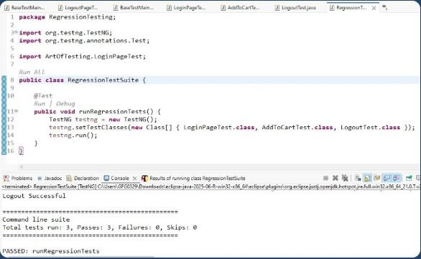Output of Regression Test Case

**Regression Testing Tools**

In regression testing, we generally select the[Test Cases](https://www.geeksforgeeks.org/software-testing/test-case/) from the existing test suite itself and hence, we need not compute their expected output, and it can be easily automated due to this reason. Automating the process of regression testing will be very effective and time-saving.

The most commonly used tools for regression testing are:

**Selenium:** Open-source, supports multiple browsers and programming languages, and is widely used for automating web application tests.

**Ranorex Studio:** A comprehensive solution for testing web, desktop, and mobile applications with both codeless and coded automation options.

**testRigor:** AI-powered test automation tool that simplifies test creation with natural language processing and requires no coding skills.

**Sahi Pro:** A user-friendly tool that supports cross-browser testing and integrates well with continuous integration systems like Jenkins.

**Testlio:** A cloud-based solution with a global network of testers, ideal for on-demand testing, especially for regression testing in real-world scenarios.

Regression testingis like a safety net for software changes, making sure they do not bring in new problems. It picks test cases from existing suites, sometimes focusing on modified parts. Popular tools like Selenium and [QTP](https://www.geeksforgeeks.org/software-testing/difference-between-selenium-and-qtp/)automate this process. While it ensures thorough testing, doing it manually can up time and encounter[data management issues](https://www.geeksforgeeks.org/dbms/dbms/).

When you are building a software application, there are several steps to successfully develop and deploy the application to be available to the users. In this process, there can be several errors we could encounter. To understand the different errors that can occur, we use fault-based testing.

**What is Fault-Based Testing?**

Fault-based testing is a software testing method that identifies faults, errors, and defects within a software system. It introduces various types of faults like syntax and semantic errors to assess the system’s ability to handle unexpected inputs effectively. By employing techniques like mutation testing and fuzz testing, it aims to uncover vulnerabilities and weaknesses that might lead to software failures.

Fault-based testing is crucial for enhancing software quality, improving robustness, and proactively addressing potential issues before they impact end-users. It is often integrated with other testing approaches to provide a comprehensive assessment of a software application’s reliability and resilience.

**A Theory of Fault-Based Testing**

This theory is built on the principle that software is prone to faults and errors, and the systematic identification and evaluation of these faults can lead to the discovery of potential vulnerabilities and weaknesses. The theory posits that by intentionally introducing various types of faults, such as coding errors, logical mistakes, or boundary condition violations, testers can assess how a software system responds to these issues and determine the effectiveness of error-handling mechanisms. This approach helps improve software quality and reliability by proactively addressing defects before they can manifest in real-world scenarios.

These techniques are applied in a controlled manner to explore various fault scenarios, ensuring that the software is robust and resilient in the face of unexpected inputs and errors. Overall, a theory of fault-based testing provides a systematic framework for enhancing software quality and uncovering hidden issues, contributing to more reliable and resilient software systems.

**Fault-Based Testing Techniques**

Fault-based testing techniques are critical methods used to introduce and evaluate faults, errors, and defects in software to ensure its robustness and reliability. Several key fault-based testing techniques are commonly employed:

**Mutation Testing**

Mutation testing involves the deliberate introduction of artificial faults (mutations) into the source code. These mutations represent common programming mistakes, such as changing an operator or variable. Test cases are then executed against the mutated code to assess whether they can detect and reveal the introduced faults. The effectiveness of the test suite is measured by its mutation score, indicating how many mutations were successfully detected.

[**Fuzz Testing**](https://testsigma.com/blog/fuzz-testing/)

Fuzz testing, or fuzzing, focuses on feeding the software with a variety of malformed, random, or unexpected inputs. This technique is particularly useful for uncovering vulnerabilities and security flaws in a system. Fuzzers automatically generate and send inputs to the software, monitoring its behavior for crashes or unexpected responses. By doing so, fuzz testing helps identify issues in input validation, boundary checking, and exception handling.

**Boundary Value Analysis**

Boundary value analysis concentrates on testing at the extreme boundaries of input domains. Test cases are designed to assess how the software handles values near the edges of the valid input range. For example, if a software system accepts integers from 1 to 100, boundary value analysis would test values like 0, 1, 100, and 101 to uncover potential errors or misbehavior caused by boundary conditions. This technique is effective at exposing off-by-one errors and similar issues.

[**Error Guessing**](https://testsigma.com/blog/error-guessing/)

Error guessing is an informal testing technique that relies on testers’ experience and intuition to identify potential fault scenarios. Testers use their knowledge of common programming mistakes, system vulnerabilities, or areas where errors are likely to occur. They then create test cases based on these insights, attempting to provoke errors based on their educated guesses. While less systematic than other fault-based testing techniques, error guessing can be a valuable addition to the testing process, leveraging the tester’s domain expertise.

These fault-based testing techniques play a crucial role in the software testing process, collectively contributing to the identification and resolution of defects and vulnerabilities that may compromise the reliability and performance of a software system. By intentionally introducing and assessing faults, software testers can enhance software quality and reduce the risk of unexpected failures in real-world scenarios.

**Fault-Based Test Suite Prioritization for**[**Specification-Based Testing**](https://testsigma.com/blog/specification-based-testing/)

Fault-based test suite prioritization for specification-based testing is a strategy to determine the order in which test cases are executed based on their likelihood of uncovering defects in the software. The basic idea of this strategy is to identify and fix critical issues early in the testing process.

For example, imagine a software application for online shopping. A prioritization method could start by running test cases that involve fundamental functionalities like user login and product search. These are considered high-priority because issues in these areas could affect the entire application. As testing proceeds, lower-priority [**test cases**](https://testsigma.com/guides/what-is-test-case/) for less critical features, such as user preferences or advanced filtering options, can be executed. By following this prioritization, if a major fault is detected early during testing, it can be addressed promptly, reducing the risk of high-impact issues in the final product. This approach optimizes testing efforts by focusing on areas that have the potential to cause significant problems.

**Assumptions in Fault-Based Testing**

Fault-based testing relies on several key assumptions to effectively identify and address faults and defects in software. One such assumption is that the intentional introduction of faults will expose weaknesses in the software. Here are some assumptions of fault-based testing along with an example:

**Introducing Known Faults:** One of the core assumptions in fault-based testing is that by deliberately injecting known faults into the software, you can assess how well it handles these issues. This assumes that the presence of these faults will lead to observable defects.

For instance, consider a web application, you intentionally introduce a fault by modifying the login process code to reject valid usernames and passwords. When you test the system with this fault, you expect it to fail to authenticate users and generate an error message.

**Defects Correspond to Faults:** Fault-based testing assumes that the defects observed in the software are directly related to the introduced faults. This means that when you identify a problem, it can be traced back to a specific fault that was introduced during testing.

While performing mutation testing, you change a multiplication operator (\*) to a division operator (/) in a critical calculation function. If the test cases that rely on this function produce incorrect results, you can trace the defect back to the introduced fault, which is the operator change.

**Test Cases Detect Introduced Faults:** Fault-based testing assumes that the test cases are capable of detecting the introduced faults. Test cases are designed to expose the errors that are introduced into the software, ensuring they can effectively reveal these issues.

Let’s say you introduce a fault in a sorting algorithm that causes it to produce incorrect results when presented with a sorted input. Test cases are then executed to determine if the algorithm can identify and correct this error, showing that the test cases are capable of detecting the introduced fault.

**Detected Faults Represent All Faults**: This assumption implies that the faults discovered during testing are representative of the entire spectrum of potential faults in the software. It assumes that if the introduced faults are detected, other similar faults in the code will also be uncovered.

During mutation testing, you introduce a set of specific faults into the code. If these introduced faults are detected and resolved, it’s assumed that similar types of faults within the codebase will also be addressed.

These assumptions underpin the effectiveness of fault-based testing in identifying and addressing issues in software. However, it’s important to recognize that fault-based testing may not uncover all types of faults or defects, as not all issues are related to the specific introduced faults. Nevertheless, this methodology remains a valuable tool in improving software quality and robustness.

**What Are the Benefits of Fault-Based Testing?**

Fault-based testing offers several benefits for software development and quality assurance processes. Here are some of the key advantages:

**Defect Detection**: is effective in identifying defects and weaknesses within a software system. We do this by intentionally introducing faults and errors and this methodology can reveal issues that might remain hidden during regular testing.

**Improved Software Quality:** Identifying and addressing defects early in the development process leads to improved software quality. By fixing issues proactively, the software becomes more reliable, robust, and resilient.

**Security Vulnerability Identification**: Fault-based testing, particularly techniques like fuzz testing, can uncover security vulnerabilities, such as buffer overflows and injection attacks. By exposing these vulnerabilities, the software can be hardened against potential cyber threats.

**Cost Savings:** Detecting and fixing defects early in the software development process is more cost-effective than addressing issues after the software is deployed. Fault-based testing can save organizations substantial time and resources in the long run.

[**Quality Assurance**](https://testsigma.com/guides/quality-assurance/)**:**Integrating fault-based testing with other testing methodologies ensures comprehensive quality assurance. It complements techniques like unit testing, [**integration testing**](https://en.wikipedia.org/wiki/Integration_testing), and system testing to provide a well-rounded assessment of software reliability.

**Compliance and Regulation:** In industries with stringent compliance and regulatory requirements, such as healthcare and finance, fault-based testing helps ensure that software meets these standards by identifying and addressing potential issues.

**Conclusion**

In conclusion, fault-based testing stands as an indispensable pillar of [**software quality assurance**](https://testsigma.com/blog/software-quality-assurance-plan/), enabling developers and testers to unearth hidden defects, vulnerabilities, and weaknesses in software systems. By introducing known faults, this systematic methodology offers a unique perspective, shedding light on how a software application responds to errors and erroneous inputs. Through techniques like mutation testing, fuzz testing, boundary value analysis, and error guessing, fault-based testing provides a structured approach to enhance software quality and robustness. With its ability to mitigate risks, improve reliability, and reduce the likelihood of costly software failures, this testing approach not only safeguards an organization’s reputation but also leads to greater user satisfaction. As software development continues to advance, fault-based testing remains a cornerstone in the pursuit of more secure, reliable, and resilient software solutions.

[**Automate your tests for web, mobile, desktop and APIs, 10x faster, with Testsigma**](https://testsigma.com/signup)

**Frequently Asked Questions**

**Is There Any Difference between Fault-Based and Stress-Based Testing?**

While fault-based testing looks for errors and how the software handles them, stress-based testing checks how well the software can handle a big load. Both are important to make sure software works well, but they have different focuses.

**What is Fault-Based Testing Also Known As?**

Fault-based testing is also known as error-based testing or failure-based testing. These terms are often used interchangeably to describe the testing methodology that focuses on identifying and evaluating faults, errors, and defects in a software system.

**Project Size Estimation Techniques - Software Engineering**

Last Updated : 11 Jul, 2025

In the fast-paced world of Software Engineering, accurately estimating the size of a project is key to its success. Understanding how big a project will be helps predict the resources, time, and cost needed, ensuring the project starts off on the right foot.

Project Size Estimation Techniques are vital because they allow you to plan and allocate the necessary resources effectively. This is a critical step in software engineering that ensures projects are feasible and managed efficiently from the start.

**Table of Content**

[What is Project Size Estimation?](https://www.geeksforgeeks.org/software-engineering/software-engineering-project-size-estimation-techniques/#what-is-project-size-estimation)

[Importance of Project Size Estimation](https://www.geeksforgeeks.org/software-engineering/software-engineering-project-size-estimation-techniques/#importance-of-project-size-estimation)

[Who Estimates Projects Size?](https://www.geeksforgeeks.org/software-engineering/software-engineering-project-size-estimation-techniques/#who-estimates-projects-size)

[Different Methods of Project Estimation](https://www.geeksforgeeks.org/software-engineering/software-engineering-project-size-estimation-techniques/#good-estimation-techniques)

[Estimating the Size of the Software](https://www.geeksforgeeks.org/software-engineering/software-engineering-project-size-estimation-techniques/#estimating-the-size-of-the-software)

[When Should Estimates Take Place?](https://www.geeksforgeeks.org/software-engineering/software-engineering-project-size-estimation-techniques/#when-should-estimates-take-place)

[Challenges in Project Size Estimation](https://www.geeksforgeeks.org/software-engineering/software-engineering-project-size-estimation-techniques/#challenges-in-project-size-estimation)

[Improving Accuracy in Project Size Estimation](https://www.geeksforgeeks.org/software-engineering/software-engineering-project-size-estimation-techniques/#improving-accuracy-in-project-size-estimation)

[Future of Project Size Estimation](https://www.geeksforgeeks.org/software-engineering/software-engineering-project-size-estimation-techniques/#future-of-software-project-size-estimation)

**What is Project Size Estimation?**

Project size estimation is determining the scope and resources required for the project.

It involves assessing the various aspects of the project to estimate the effort, time, cost, and resources needed to complete the project.

Accurate project size estimation is important for effective and efficient project planning, management, and execution.

**Importance of Project Size Estimation**

Here are some of the reasons why project size estimation is critical in project management:

**Financial Planning:**Project size estimation helps in planning the financial aspects of the project, thus helping to avoid financial shortfalls.

**Resource Planning:**It ensures the necessary resources are identified and allocated accordingly.

**Timeline Creation:**It facilitates the development of realistic timelines and milestones for the project.

**Identifying Risks:**It helps to identify potential risks associated with overall project execution.

**Detailed Planning:**It helps to create a detailed plan for the project execution, ensuring all the aspects of the project are considered.

**Planning Quality Assurance:**It helps in planning quality assurance activities and ensuring that the project outcomes meet the required standards.

**Who Estimates Projects Size?**

Here are the key roles involved in estimating the project size:

**Project Manager:**Project manager is responsible for overseeing the estimation process.

**Subject Matter Experts (SMEs):**SMEs provide detailed knowledge related to the specific areas of the project.

**Business Analysts:**Business Analysts help in understanding and documenting the project requirements.

**Technical Leads:**They estimate the technical aspects of the project such as system design, development, integration, and testing.

**Developers:**They will provide detailed estimates for the tasks they will handle.

**Financial Analysts:**They provide estimates related to the financial aspects of the project including labor costs, material costs, and other expenses.

**Risk Managers:**They assess the potential risks that could impact the projects' size and effort.

**Clients:**They provide input on project requirements, constraints, and expectations.

**Different Methods of Project Estimation**

**Expert Judgment:** In this technique, a group of experts in the relevant field estimates the project size based on their experience and expertise. This technique is often used when there is limited information available about the project.

**Analogous Estimation:** This technique involves estimating the project size based on the similarities between the current project and previously completed projects. This technique is useful when historical data is available for similar projects.

**Bottom-up Estimation:** In this technique, the project is divided into smaller modules or tasks, and each task is estimated separately. The estimates are then aggregated to arrive at the overall project estimate.

**Three-point Estimation:** This technique involves estimating the project size using three values: optimistic, pessimistic, and most likely. These values are then used to calculate the expected project size using a formula such as the PERT formula.

**Function Points:** This technique involves estimating the project size based on the functionality provided by the software. Function points consider factors such as inputs, outputs, inquiries, and files to arrive at the project size estimate.

**Use Case Points:** This technique involves estimating the project size based on the number of use cases that the software must support. Use case points consider factors such as the complexity of each use case, the number of actors involved, and the number of use cases.

**Parametric Estimation:** For precise size estimation, mathematical models founded on project parameters and historical data are used.

**COCOMO (Constructive Cost Model):** It is an algorithmic model that estimates effort, time, and cost in software development projects by taking into account several different elements.

**Wideband Delphi:**Consensus-based estimating method for balanced size estimations that combines expert estimates from anonymous experts with cooperative conversations.

**Monte Carlo Simulation:** This technique, which works especially well for complicated and unpredictable projects, estimates project size and analyses hazards using statistical methods and random sampling.

Each of these techniques has its strengths and weaknesses, and the choice of technique depends on various factors such as the project's complexity, available data, and the expertise of the team.

**Estimating the Size of the Software**

Estimation of the size of the software is an essential part of Software Project Management. It helps the project manager to further predict the effort and time that will be needed to build the project. Here are some of the measures that are used in project size estimation:

**1. Lines of Code (LOC)**

As the name suggests, LOC counts the total number of lines of source code in a project. The units of LOC are:

**KLOC:**Thousand lines of code

**NLOC:** Non-comment lines of code

**KDSI:** Thousands of delivered source instruction

The size is estimated by comparing it with the existing systems of the same kind. The experts use it to predict the required size of various components of software and then add them to get the total size.

It's tough to estimate LOC by analyzing the problem definition. Only after the whole code has been developed can accurate LOC be estimated. This statistic is of little utility to project managers because project planning must be completed before development activity can begin.

Two separate source files having a similar number of lines may not require the same effort. A file with complicated logic would take longer to create than one with simple logic. Proper estimation may not be attainable based on LOC.

The length of time it takes to solve an issue is measured in LOC. This statistic will differ greatly from one programmer to the next. A seasoned programmer can write the same logic in fewer lines than a newbie coder.

**Advantages:**

Universally accepted and is used in many models like COCOMO.

Estimation is closer to the developer's perspective.

Both people throughout the world utilize and accept it.

At project completion, LOC is easily quantified.

It has a specific connection to the result.

Simple to use.

**Disadvantages:**

Different programming languages contain a different number of lines.

No proper industry standard exists for this technique.

It is difficult to estimate the size using this technique in the early stages of the project.

When platforms and languages are different, LOC cannot be used to normalize.

**2. Number of Entities in ER Diagram**

[ER model](https://www.geeksforgeeks.org/dbms/introduction-of-er-model/) provides a static view of the project. It describes the entities and their relationships. The number of entities in the ER model can be used to measure the estimation of the size of the project. The number of entities depends on the size of the project. This is because more entities needed more classes/structures thus leading to more coding.

**Advantages:**

Size estimation can be done during the initial stages of planning.

The number of entities is independent of the programming technologies used.

**Disadvantages:**

No fixed standards exist. Some entities contribute more to project size than others.

Just like FPA, it is less used in the cost estimation model. Hence, it must be converted to LOC.

**3. Total Number of Processes in DFD**

[Data Flow Diagram(DFD)](https://www.geeksforgeeks.org/software-engineering/what-is-dfddata-flow-diagram/) represents the functional view of software. The model depicts the main processes/functions involved in software and the flow of data between them. Utilization of the number of functions in DFD to predict software size. Already existing processes of similar type are studied and used to estimate the size of the process. The sum of the estimated size of each process gives the final estimated size.

**Advantages:**

It is independent of the programming language.

Each major process can be decomposed into smaller processes. This will increase the accuracy of the estimation.

**Disadvantages:**

Studying similar kinds of processes to estimate size takes additional time and effort.

All software projects are not required for the construction of DFD.

**4. Function Point Analysis**

In this method, the number and type of functions supported by the software are utilized to find FPC(function point count). The steps in function point analysis are:

Count the number of functions of each proposed type.

Compute the Unadjusted Function Points(UFP).

Find the Total Degree of Influence(TDI).

Compute Value Adjustment Factor(VAF).

Find the Function Point Count(FPC).

The explanation of the above points is given below:

**1. Count the number of functions of each proposed type:**

Find the number of functions belonging to the following types:

External Inputs: Functions related to data entering the system.

External outputs: Functions related to data exiting the system.

External Inquiries: They lead to data retrieval from the system but don't change the system.

Internal Files: Logical files maintained within the system. Log files are not included here.

External interface Files: These are logical files for other applications which are used by our system.

**2. Compute the Unadjusted Function Points(UFP):**

Categorize each of the five function types as simple, average, or complex based on their complexity. Multiply the count of each function type with its weighting factor and find the weighted sum. The weighting factors for each type based on their complexity are as follows:

| **Function type** | **Simple** | **Average** | **Complex** |
| --- | --- | --- | --- |
| **External Inputs** | 3 | 4 | 6 |
| **External Output** | 4 | 5 | 7 |
| **External Inquiries** | 3 | 4 | 6 |
| **Internal Logical Files** | 7 | 10 | 15 |
| **External Interface Files** | 5 | 7 | 10 |

**3. Find the Total Degree of Influence:**

Use the '14 general characteristics of a system to find the degree of influence of each of them. The sum of all 14 degrees of influence will give the TDI. The range of TDI is 0 to 70. The 14 general characteristics are: Data Communications, Distributed Data Processing, Performance, Heavily Used Configuration, Transaction Rate, On-Line Data Entry, End-user Efficiency, Online Update, Complex Processing Reusability, Installation Ease, Operational Ease, Multiple Sites and Facilitate Change.   
Each of the above characteristics is evaluated on a scale of 0-5.

**4. Compute Value Adjustment Factor(VAF):**

Use the following formula to calculate VAF:

*VAF = (TDI \* 0.01) + 0.65*

**5. Find the Function Point Count:**

Use the following formula to calculate FPC:

*FPC = UFP \* VAF*

**Advantages:**

It can be easily used in the early stages of project planning.

It is independent of the programming language.

It can be used to compare different projects even if they use different technologies(database, language, etc).

**Disadvantages:**

It is not good for real-time systems and embedded systems.

Many cost estimation models like COCOMO use LOC and hence FPC must be converted to LOC.

**When Should Estimates Take Place?**

Project size estimates must take place at multiple key points throughout the project lifecycle. It should take place during the following stages to ensure accuracy and relevance:

**Project Initiation:**Project is assessed to determine its feasibility and scope.

**Project Planning:**Precise estimates are done to create a realistic budget and timeline.

**Project Execution:**Res-estimation when there are significant changes in scope.

**Project Monitoring and Control:**Regular reviews to make sure that the project is on track.

**Project Closeout:**Comparing original estimates with actual outcomes and documenting estimation accuracy.

**Challenges in Project Size Estimation**

Project size estimation can be challenging due to multiple factors. Here are some factors that can affect the accuracy and reliability of estimates:

**Unclear Requirements:**Initial project requirements can be vague or subject to change, thus making it difficult to estimate accurately.

**Lack of Historical Data:**Without access to the data of similar past projects, it becomes difficult to make informed estimates, thus estimates becoming overly optimistic or pessimistic and leading to inaccurate planning.

**Interdependencies:**Project with numerous interdependent tasks are harder to estimate due to the complicated interactions between components.

**Productivity Variability:**Estimating the productivity of resources and their availability can be challenging due to fluctuations and uncertainties.

**Risks:** Identifying and quantifying risks and uncertainties is very difficult. Underestimating the potential risks can lead to inadequate contingency planning, thus causing the project to go off track.

**Improving Accuracy in Project Size Estimation**

Improving the accuracy of project size estimation involves a combination of techniques and best practices. Here are some key strategies to enhance estimation accuracy:

**Define Clear Requirements:**Ensure all project requirements are thoroughly documented and engage all stakeholders early and frequently to clarify and validate the requirements.

**Use Historical Data:**Use data from similar past projects to make informed estimates.

**Use Estimation Techniques:**Use various estimation techniques like Analogue Estimation, Parametric Estimation, Bottom-Up Estimation, and Three-Point Estimation.

**Break Down the Project:**Use Work Breakdown Structure (WBS) and detailed take analysis to make sure that each task is specific and measurable.

**Incorporate Expert Judgement:**Engage subject matter experts and experienced team members to provide input on estimates.

**Future of Project Size Estimation**

The future of project size estimation will be shaped by the advancements in technology and methodologies. Here are some key developments that can define the future of project size estimation:

**Smarter Technology:** Artificial intelligence (AI) could analyze past projects and code to give more accurate forecasts, considering how complex the project features are.

**Data-Driven Insights:** Instead of just lines of code, estimates could consider factors like the number of users, the type of software (mobile app vs. web app), and how much data it handles.

**Human-AI Collaboration:**Combining human expertise with AI can enhance the decision-making process in project size estimation.

**Collaborative Platforms:**Tools that facilitate collaboration among geographically dispersed teams can help to enhance the project size estimation process.

**Agile Methodologies:**The adoption of agile methodologies can promote continuous estimation and iterative refinement.

**Conclusion**

In conclusion, accurate project size estimation is crucial for [software project success.](https://www.geeksforgeeks.org/software-engineering/phases-project-management-processes/) Traditional techniques like lines of code have limitations. The future of estimation lies in AI and [data-driven](https://www.geeksforgeeks.org/data-analysis/what-is-data-driven-decision-making/)insights for better resource allocation, risk management, and project planning.

**How to Define the Scope of a Project?**

Last Updated : 21 Aug, 2025

Project scope refers to the detailed description of the deliverables, objectives, tasks, and goals that need to be achieved within a project. In this article, we will learn how to define the scope of a Project.

**Table of Content**

[What is Project Scope?](https://www.geeksforgeeks.org/software-engineering/how-to-define-the-scope-of-a-project/#what-is-project-scope)

[The Importance of Defining a Project Scope](https://www.geeksforgeeks.org/software-engineering/how-to-define-the-scope-of-a-project/#the-importance-of-defining-a-project-scope)

[Managing Project Scope in Agile Environments](https://www.geeksforgeeks.org/software-engineering/how-to-define-the-scope-of-a-project/#managing-project-scope-in-agile-environments)

[How to Define the Scope of a Project?](https://www.geeksforgeeks.org/software-engineering/how-to-define-the-scope-of-a-project/#how-to-define-the-scope-of-a-project)

[Role of Project Management Software in Scope Management](https://www.geeksforgeeks.org/software-engineering/how-to-define-the-scope-of-a-project/#role-of-project-management-software-in-scope-management)

[Integration of Project Scope with Other Management Processes](https://www.geeksforgeeks.org/software-engineering/how-to-define-the-scope-of-a-project/#integration-of-project-scope-with-other-management-processes)

[Stakeholder Involvement in Scope Definition and Management](https://www.geeksforgeeks.org/software-engineering/how-to-define-the-scope-of-a-project/#stakeholder-involvement-in-scope-definition-and-management)

[Project Scope vs Product Scope](https://www.geeksforgeeks.org/software-engineering/how-to-define-the-scope-of-a-project/#project-scope-vs-product-scope)

[Conclusion](https://www.geeksforgeeks.org/software-engineering/how-to-define-the-scope-of-a-project/#conclusion)

[Define the Scope of a Project - FAQs](https://www.geeksforgeeks.org/software-engineering/how-to-define-the-scope-of-a-project/#define-the-scope-of-a-project-faqs)

**What is Project Scope?**

Project scope is the detailed description of all the goals and objectives that must be met in order to successfully complete a project. The document outlines the Project's goals, expectations, tasks, deadlines, and budget. The degree outlines specific deadlines and expectations for each partner involved in the project, outlining what will and won't be completed as part of it.

The Scope is the part of the Project Management that is responsible for the boundaries, objectives, and deliverables of the Project. In other words, it is the total amount of activities or tasks that need to be done under the [Project Execution](https://www.geeksforgeeks.org/software-engineering/why-do-companies-execute-projects/).

*for more:* [*What is Scope in Project Management?*](https://www.geeksforgeeks.org/software-engineering/what-is-scope-in-project-management/)

**The Importance of Defining a Project Scope**

Here are the following reasons for which Defining a Project Scope is important:

The Importance of Defining a Project Scope

**Clarity of Objectives:** A well-defined scope clearly specifies the project's objectives, deliverables, and constraints. By doing this, confusion is avoided and scope creep is prevented because everyone involved is aware of what is expected of them and what is not.

**Alignment**: It aligns stakeholders' expectations with project goals. When everyone agrees on the project's scope upfront, there's less likelihood of disagreements or misunderstandings later on.

**Resource Management**: Resource allocation benefits from having a clear scope. Project managers are able to precisely predict the amount of time, money, and labour needed. Resource waste on activities that aren't necessary for the [project's success](https://www.geeksforgeeks.org/software-engineering/maximizing-project-success-a-comprehensive-sprint-zero-checklist/) can occur when there are unclear boundaries.

**Quality Control**: Defining a clear scope facilitates the establishment of quality standards. Teams can measure and assure the quality of the end product or service more easily when they know exactly what they're expected to offer.

**Client Satisfaction**: Customer satisfaction is increased by a clearly defined scope. Customers are more likely to be happy with the outcome when they are aware of exactly what they will receive and when they will receive it.

**Control Scope Creep**: When there is no clear scope for a project, it might be subject to scope creep, which is the unanticipated addition of more work over time, beyond budget, and causing delays. Setting limits on the scope aids in containing these alterations.

**Managing Project Scope in Agile Environments**

Here is a 7 step Process of Managing project scope in Agile environments :

Managing Project Scope in Agile Environments

**Step 1: Set your undertaking vision and extension with an arranging meeting**

When launching a new Agile environment, it's important to identify a clear business need that your company is addressing. To put it another way, what is the ultimate goal of these Agile settings and how can you achieve it? Higher perspective ideas are covered in Agile approach meetings, but they should also be reasonable. You can start to consider how much work there will be, but keep in mind that Agile projects need to be flexible and able to respond to feedback.

**Step 2: Build out your product road-map**

Now that your plan is in place, the [product owner](https://www.geeksforgeeks.org/business-studies/product-owner-definition-roles-and-responsibilities/)needs to turn that idea into a roadmap for the product. This includes an overview of the requirements, revised user stories, and an approximate timeline for completion.

**Step 3: Make a delivery plan**

The goal of agile project management is to consistently and dependably deliver acceptable programming, not to cater to short-term needs. The item owner then creates a major level timetable for each delivery once you have an unquestionable level guide set up. [Agile project management](https://www.geeksforgeeks.org/software-engineering/agile-project-management/) will involve multiple deliveries, you'll need to focus on the highlights expected to inspire you to send off first.

**Step 4: Sprint Planning**

It’s time to move from the macro to the micro view. Together with the product owner, the development team plans “sprints”—short cycles of development in which specific project and goals will be carried out.

**Step 5: Keep your group on target with everyday stand-ups**

Agile projects move rapidly It is essential that you have the allotted minutes to make sure everything is running smoothly and to check in. These are designated "stand-ups" in Agile talk. A standup is a daily, 10–15-minute meeting where your team comes together to discuss.

**Step 6: Sprint reviews**

Each sprint cycle ends with a functioning piece of software getting shipped. And while this is a huge milestone to celebrate, it’s also an opportunity to review what was done and show this off to people on your team and any key stakeholders.

**Step 7: Decide what to focus on next in your sprint retrospective**

One of the core principles of Agile project management is that it’s sustainable. This means you should be ready to start on the next sprint as soon as the previous one ends. To make sure you’re actually learning from each release (and not just moving forward blindly), you need to dig in with a sprint retrospective.

**How to Define the Scope of a Project?**

Characterizing the Scope of a Project can be effectively characterized in the more obliged variety displayed below:

**Points:**Obviously express the Project points and wanted results.

**Example**: "The objective of this project is to develop and implement a new customer relationship management (CRM) system that will streamline customer interactions and improve customer satisfaction by 20% within the first year post-implementation."

**Tips**: Ensure objectives are Specific, Measurable, Achievable, Relevant, and Time-bound (SMART).

**Necessities:** Accumulate and investigate key functionalities and objectives.

**Example**: "The new CRM system must support integration with the existing email marketing platform, provide real-time customer analytics, offer a user-friendly interface, and comply with GDPR regulations."

**Tips**: Engage stakeholders to capture all necessary requirements through workshops, interviews, and surveys.

**Assumptions:**Depict unquestionable outcomes or anticipated results from the drive.

**Example**: "It is assumed that the current IT infrastructure will support the new CRM system without requiring significant upgrades."

**Tips**: Document assumptions to manage risks and clarify uncertainties. Validate them periodically throughout the project.

**Boundaries:**Determine what is incorporated and barred from the Project scope.

**Example**: "This project will include the design, development, and initial training of staff on the new CRM system but will exclude ongoing maintenance and support."

**Tips**: Clearly define deliverables and non-deliverables to manage stakeholder expectations effectively.

**Requirements:** Identify obstructions like financial plan, time, and resources.

**Example**: "The project has a budget of $500,000, must be completed within 12 months, and has limited availability of in-house IT staff."

**Tips**: Prioritize constraints and plan accordingly to mitigate their impact on the project.

**Assumptions:** Record any secret suppositions about the Project.

**Example**: "Assumptions include the availability of key project stakeholders for bi-weekly status meetings and the stability of market conditions."

**Tips**: Regularly review and update assumptions as the project progresses to ensure they remain valid.

**Scope Declaration:**Sum up all parts in a brief expansion clarification for underwriting.

**Example**: "The CRM project aims to develop a new system to enhance customer satisfaction by 20% within a year. It includes design, development, and initial training within a $500,000 budget and a 12-month timeline.

**Tips**: Ensure the scope statement is clear, concise, and easily understandable by all stakeholders.

**Change the leaders:**Take part in a communication to address scope changes.

**Example**: "A change management plan will be in place to evaluate, approve, and implement any changes to the project scope. All changes will be documented, reviewed by the project steering committee, and communicated to stakeholders."

**Tips**: Establish a clear change management process with defined roles, responsibilities, and approval workflows to handle scope changes efficiently.

**Role of Project Management Software in Scope Management**

The role of [project management software](https://www.geeksforgeeks.org/software-engineering/software-engineering-software-project-management-spm/) in scope management plays an crucial roles in the project, which are mentioned below;

**1. Necessities Following:**Catching and sorting out project requirements.

**Role:** Capture and organize project requirements.

**Features**: Requirements management modules, custom fields, traceability matrices.

**Benefits**: Ensures all stakeholder needs are documented, reducing risk of missing critical functionalities.

**2. Scope Definition:** Separating expectations and laying out assignments.

**Role:** Break down deliverables into tasks.

**Features**: Work breakdown structures (WBS), task lists, charts.

**Benefits:** Provides clear task outlines, preventing scope creep.

**3. Arranging and Control:** Assessing assets, expenses, and checking progress.

**Role:** Estimate resources, costs, and monitor progress.

**Features**: Resource allocation tools, cost estimation modules, progress tracking dashboards.

**Benefits**: Enables accurate planning, keeping the project within scope, budget, and time constraints.

**4. Change The executives:** Following and overseeing Scope changes.

**Role**: Track and manage scope changes.

**Features**: Change request forms, approval workflows, change logs.

**Benefits**: Ensures systematic evaluation and approval of changes, preventing unauthorized changes.

**5. Coordination:** Adjusting Scope to timetable, cost, and hazard the board.

**Role:** Align scope with schedule, cost, and risk management.

**Feature**s: Integrated [project plans](https://www.geeksforgeeks.org/software-engineering/project-plan/), risk management tools, scheduling features.

**Benefits**: Promotes coherence, ensuring scope changes align with project objectives.

**6. Correspondence:** Working with joint effort and partner commitment.

**Role:**Facilitate collaboration and stakeholder engagement.

**Features:** Messaging systems, discussion forums, stakeholder management tools.

**Benefits**: Enhances teamwork and keeps stakeholders informed.

**7. Documentation and Revealing:** Creating extension related archives and reports.

**Role**: Generate scope-related documents and reports.

**Features**: Reporting tools, document management systems, automated report generation.

**Benefits:** Provides clear documentation and insights, ensuring accountability.

Fundamentally, Project management software enhances productivity and control all through the [project life-cycle](https://www.geeksforgeeks.org/software-engineering/project-management-life-cycle/), guaranteeing that scope stays accurate reasonable, and lined up with project goals.

**Integration of Project Scope with Other Management Processes**

Integrating Project Scope with other management processes guarantees arrangement and intelligibility across the Project. This is further explained below:

**Schedule Management:** The Project Scope characterizes what should be finished, which straightforwardly impacts the Project plan. By integrating Scope with schedule management, you guarantee that assignments and achievements line up with the characterized scope, assisting with keeping the Project on target.

**Cost Management:**Project scope straightforwardly influences project costs. By integrating Scope with cost management, you can precisely appraise the assets expected to convey the characterized Scope and track financial plan designations all through the Project life cycle.

**Quality Management:**The Project scope sets assumptions for the nature of expectations.

**Asset Management:**The Project Scope characterizes the assignments and exercises that should be finished, which straightforwardly influences asset portion. By integrating Scope with asset management processes, you guarantee that the ideal assets are accessible brilliantly to proficiently convey the characterized scope.

**Communication Management :**By integrating Scope with this communication management, you can build transparent communication between teammates, stakeholders and clients.

Generally speaking, integrating project scope with other management processes guarantees that all parts of the Project are adjusted, composed, and enhanced for progress. It limits gambles, augment productivity, and guarantee that project targets are met inside the characterized Scope, spending plan, and timetable.

**Stakeholder Involvement in Scope Definition and Management**

Stakeholders play an essential part in scope definition and management by:

**1. Giving Information:** Offering bits of knowledge and prerequisites to shape the project scope.

**Role:**Provide insights and requirements.

**Involvement:** Share needs and expectations during initial meetings and ongoing discussions.

**Impact:** Ensures the project scope reflects necessary functionalities and goals.

**2. Surveying Expectations:**Guaranteeing that expectations address their issues and assumptions.

**Role:** Ensure deliverables meet needs and expectations.

**Involvement:**Review scope documents and deliverables.

**Impact**: Validates that outcomes will satisfy stakeholder requirements and objectives.

**3. Endorsing Changes:**Approving scope changes and changes as needs be.

**Role**: Approve scope changes.

**Involvement:** Participate in change control processes, reviewing and authorizing modifications.

**Impact:** Ensures agreed-upon changes keep the project aligned with stakeholder interests.

**4. Giving Feedback:** Giving criticism all through the project to guarantee arrangement with their needs.

**Role:**Provide continuous feedback.

**Involvement:** Review progress, deliverables, and reports regularly.

**Impact:** Keeps the project on track and ensures deliverables meet quality standards.

**5. Resolving Errors:**Teaming up to determine errors in scope understanding.

**Role:** Collaborate to resolve scope misunderstandings.

**Involvement:** Address discrepancies and issues with the project team.

**Impact:**Prevents scope creep and ensures project success.

**Project Scope vs Product Scope**

Here are the following difference between Project Scope and Product Scope:

| **Parameters** | **Project Scope** | **Product Scope** |
| --- | --- | --- |
| **Definition** | Defines the work expected to convey a particular project, including undertakings, expectations, courses of events, and assets. | Defines about the highlights, functionalities, and qualities of the finished product or administration being created, focusing in on what the product will do and how it will address client issues. |
| **Focus** | On the other hand, the project scope envelops basically everything expected to convey an item or administration. | Product scope identifies the characteristics and functions of a product or service. |
| **Objectives** | In short, the project scope describes how the mission will be accomplished. | These characteristics include physical features such as size and materials, as well as functional specifications. |
| **Examples** | It includes identifying and documenting the project's goals, deliverables, tasks, project members, deadlines, and milestones. | Functional considerations include what the product is designed to do and its purpose or end-use. |

**Related Articles:**

[What is Project Scope Management Plan?](https://www.geeksforgeeks.org/software-engineering/what-is-project-scope-management-plan/)

[Define Scope Planning](https://www.geeksforgeeks.org/business-studies/define-scope-planning/)

[What Is Scope Creep in Project Management?](https://www.geeksforgeeks.org/business-studies/what-is-scope-creep-in-project-management/)

[What is a Project in Project Management?](https://www.geeksforgeeks.org/software-engineering/what-is-a-project-in-project-management/)

[Project Management Process Activities](https://www.geeksforgeeks.org/software-engineering/project-management-process-activities/)

**Conclusion**

A project scope that is well defined that communicates goals, tasks, expectations, and more helps to keep projects productive and on schedule. The project scope articulation helps you manage assumptions and ensures that teams understand what is expected of them in general. Choose your goals and the metrics you'll use to measure them before you start describing the scope of your project. Additionally, it's crucial to confirm that you've distributed the necessary resources and that you recognise any obstacles and rejections.

You already know how important deadlines and budgets are in software development projects, but are you estimating time and effort accurately? That’s where things get tricky. A slight miscalculation can throw off your timeline, drain resources, and create unnecessary stress for your entire team.

That’s why using the proper project estimation techniques can significantly affect how smoothly your projects run. You need an approach that helps you plan realistically while accounting for uncertainties.

This guide will teach you practical techniques for creating accurate estimates, reducing risks, and improving planning. Thus, you can keep projects on track without guesswork.

**What Are Estimation Techniques in Software Engineering?**

Estimation techniques in software engineering help you gauge the time, resources, and cost needed to complete a project. These methods guide you in creating realistic estimates by analyzing project requirements, breaking down individual tasks, and considering past data. Without a structured process for estimation, you risk delays, budget overruns, and unrealistic expectations.

If you're a project manager, choosing the right technique can help you with resource allocation and reduce uncertainty. You need reliable methods to improve accuracy in project estimation and ensure work stays on track from start to finish.

**Project Estimation Components**

Many software projects struggle with inaccurate estimates, which can lead to delays and budget overruns. In fact,[McKinsey's research](https://www.mckinsey.com/capabilities/mckinsey-digital/our-insights/delivering-large-scale-it-projects-on-time-on-budget-and-on-value) shows that, on average, IT projects go **45% over budget** and **7% over time**.

Large projects face even bigger issues because they exceed **budgets by 66%** and **schedules by 33%**. To avoid these setbacks, you need a clear understanding of what affects your project estimate.

Here are the key components to consider:

**Tasks:** You need to break work into smaller development tasks so your estimates stay realistic. The more detailed your breakdown, the better.

**Resources:** A project requires the right people, tools, and infrastructure. Without considering all of these factors, your estimates will fail.

**Rate:**You should calculate costs based on hourly wages, service fees, or fixed pricing to stay within budget.

**Duration:** Setting realistic timeframes for every effort estimation step is essential to avoid surprises.

**Third-party services:** If your project relies on cloud hosting, consultants, or other providers, you must factor in those costs early.

Getting these right improves estimation accuracy and keeps your current project on track.

**Why Use Estimation Techniques?**

Estimation techniques are needed to improve your planning based on real numbers. This will prevent unpleasant surprises during the development phase (as well as other phases of the SDLC).

With accurate estimates, you can set realistic expectations, allocate resources efficiently, and improve project predictability. They also help identify potential bottlenecks early, reducing the risk of delays and budget overruns. They also help you negotiate better with stakeholders.

However, [an empirical study](https://www.researchgate.net/publication/222077161_An_empirical_study_of_maintenance_and_development_estimation_accuracy) revealed that **63% of effort estimates** used for project budgets were close enough to be considered reliable. So, more than a third of companies don’t use good estimation practices.

***"A good estimate is an estimate that provides a clear enough view of the project reality to allow the project leadership to make good decisions about how to control the project to hit its targets."   
  
-***[Steve McConnell](https://www.amazon.fr/Software-Estimation-Demystifying-Black-Art/dp/0735605351)***, Author of Software Estimation: Demystifying the Black Art***

The wrong approach to estimation gives you poor control over your project scope. It makes it harder to allocate resources and set achievable deadlines. By contrast, planning carefully allows you to reduce risks and improve your chances of success.

Reliable estimates lead to smoother projects, effective risk management, and a clear path to meeting your goals.

**Good Software Estimation Methodologies**

Choosing the right estimation method helps you confidently plan and avoid costly surprises. These techniques can work for simple and complex projects with strict budgets and timelines.

Here are some of the most effective project estimation methods to improve planning and decision-making.

**1. Analogy**

[Analogous estimation](https://monday.com/blog/project-management/analogous-estimating) compares your current project to similar past projects to estimate time, cost, and effort. You adjust for differences in scope, complexity, or resources. While it’s helpful when detailed data is unavailable, it relies on past accuracy.

**Pros**:

Saves time by leveraging past data.

Helps with early-stage planning.

**Cons:**

Assumes previous projects are reliable references.

It may not account for unique challenges.

**Best for:** When you need quick estimates without detailed breakdowns.

**2. Bottom-Up Estimation**

You break the project into detailed estimates for smaller tasks, then add them to get the total. [This method](https://www.projectmanagement.com/wikis/368761/bottom-up-estimating) gives a clear picture but requires significant effort to set up.

**Pros:**

Highly accurate estimation.

Works well for complex, large-scale projects.

**Cons:**

Time-consuming.

Requires a[well-defined project lifecycle](https://axify.io/blog/what-is-sdlc) and task breakdown.

**Best for:** Experienced teams managing detailed Agile project management workflows.

**3. The Three-Point Estimation**

[This method](https://www.invensislearning.com/blog/three-point-estimating/)considers three scenarios: best case, worst case, and most likely. Averaging them allows you to get a balanced estimate that accounts for uncertainty.

**Pros:**

Reduces overconfidence in initial estimates.

Accounts for potential risks.

Simple method.

**Cons:**

Relies on subjective inputs.

Requires subject matter experts for better accuracy.

**Best for:** Projects with uncertainty in effort, scope, or dependencies.

**4. Parametric Estimation**

This project estimation method uses mathematical models and historical data to estimate effort and cost. It scales well for repetitive tasks.

**Pros:**

Works well for data-driven projects.

Improves consistency.

**Cons:**

Needs accurate past data.

Can be complex.

**Best for:** Large projects with a well-documented estimation process.

**5. Case Points**

You estimate [use case points](https://en.wikipedia.org/wiki/Use_case_points) based on functional requirements and system complexity. Each user story or feature is assigned a value, determining overall effort.

**Pros:**

Helps structure sprint planning.

Focuses on actual software functionality.

**Cons:**

Can be subjective.

Needs experience to assign accurate values.

**Best for:** Agile teams working with defined story point estimates.

**6. What-If**

[This method](https://support.microsoft.com/en-us/office/introduction-to-what-if-analysis-22bffa5f-e891-4acc-bf7a-e4645c446fb4#:~:text=What%2DIf%20Analysis%20is%20the,values%20and%20determine%20possible%20results.) tests different scenarios to see how changes in scope, resources, or effort affect the actual effort needed. It helps you anticipate potential risks and adjust your plans before issues arise.

**Pros:**

Helps with risk management.

Supports informed decision-making.

**Cons:**

Requires multiple data inputs.

Can be time-consuming.

**Best for:** Projects with shifting requirements or dependencies.

**7. Expert Judgment**

With this method, you [rely on input](https://asana.com/resources/expert-judgment) from project stakeholders, business analysts, and experienced developers to make an informed estimate. Their insights help you gauge effort, costs, and potential risks based on similar past projects.

**Pros:**

Quick and practical when data is limited.

Uses industry experience.

**Cons:**

Subjective.

Can vary based on individual expertise.

**Best for:** Early-stage estimates or when historical data is lacking.

**8. Function Points**

[Functional Point Analysis](https://www.geeksforgeeks.org/software-engineering-functional-point-fp-analysis/) measures the functionality of your software rather than lines of code. You assign values to inputs, outputs, and system interactions, then calculate the overall effort needed for development. This method helps standardize estimates, regardless of programming language.

**Pros:**

Gives precise estimations based on system functionality.

Works well for early-stage detailed planning.

**Cons:**

Can be complex to apply.

Requires experience to assign accurate values.

**Best for:** When you need a structured, language-independent way to estimate effort.

**Side note**: The [COSMIC](https://cosmic-sizing.org/) (Common Software Measurement International Consortium) Function Point method is a modern alternative to traditional FPA. While FPA measures functionality using predefined function types, COSMIC Function Points focus on data movements (entry, exit, read, and write).

As such, COSMIC provides finer-grained measurement, so it’s more suitable for modern software architectures. COSMIC function points can also be calculated more systematically, which reduces manual effort compared to traditional function points. On the other hand, COSMIC applies to real-time, embedded, and business applications, while traditional FPA is mainly used for business systems.

**9. COCOMO**

The [Constructive Cost Model (COCOMO)](https://www.geeksforgeeks.org/software-engineering-cocomo-model/) is a mathematical model that estimates effort based on project size, complexity, and past data. It considers different development stages and adjusts estimates accordingly.

**Pros:**

Useful for large projects.

Accounts for project constraints and various effort levels.

**Cons:**

Requires detailed input.

Can be less flexible for Agile approaches.

**Best for:** Large-scale projects needing structured, formula-based effort estimation.

**10. Wide-Band Delphi**

[This method](https://www.tutorialspoint.com/estimation_techniques/estimation_techniques_wideband_delphi.htm) gathers estimates from multiple experts through anonymous discussions to avoid bias. The estimates are refined over several rounds until the team reaches a consensus.

**Pros:**

Leverages expert judgment for more reliable estimates.

Reduces individual bias.

**Cons:**

Time-consuming.

Requires experienced professionals to participate.

**Best for:** Projects needing input from multiple experts for better accuracy of estimates.

**11. Monte Carlo**

[Monte Carlo simulation](https://www.ibm.com/think/topics/monte-carlo-simulation) runs multiple scenarios to predict possible outcomes. It assesses risks using past data and provides a range of estimates instead of a single number.

**Pros:**

Helps with project time estimation by considering uncertainties.

Supports future sprints with data-driven forecasts.

**Cons:**

Requires historical data for accuracy.

Can be complex to set up without proper tools.

**Best for:** Teams who want probability-based forecasts.

**Pro Tip** : Axify has already tackled that for you; our platform uses this calculation method for its [software delivery forecasting tool](https://axify.io/features/software-delivery-forecasting).

**12. Planning Poker**

[Planning Poker](https://asana.com/resources/planning-poker) is an Agile estimation technique where your team assigns effort values to tasks using numbered cards. After revealing the estimates, your development team discusses and re-votes until reaching a consensus. This method helps prevent bias and encourages collaboration.

**Pros:**

Engages the team in discussions.

Helps estimate the complexity of user stories more accurately.

**Cons:**

Can take extra time for larger teams or complex projects.

Requires every participant’s input for best results.

It can lead people to a false sense of performance, hiding the real bottlenecks.

**Best for:** Agile estimating in teams that want a collaborative and structured way to assess effort.

**13. PERT**

[PERT (Program Evaluation and Review Technique)](https://project-management.info/three-point-estimating-pert/) is a project management method developed by the US Navy in the 1950s to improve scheduling accuracy. It expands on **three-point estimation**, using **optimistic, pessimistic, and most likely values** to create a weighted average for more realistic time predictions.

Unlike **triangular distribution**, which treats all estimates equally, **PERT skews towards the most likely estimate**, forming a bell-shaped probability curve. This allows teams to calculate the likelihood of completing tasks within a given timeframe.

PERT is commonly used alongside the [Critical Path Method (CPM)](https://asana.com/resources/critical-path-method) for scheduling, especially in complex, uncertain projects.

**Pros:**

Provides structured estimates.

Useful for projects with multiple dependencies.

**Cons:**

Requires detailed data, which makes it time-consuming.

Less effective for teams without historical metrics.

**Best for:** Large projects with multiple dependencies where precise time estimation is critical.

**14. Large Small Uncertain (LSU)**

[LSU](https://trustedinstitute.com/concept/pmi-acp/agile-estimation-techniques/large-uncertain-small/) groups tasks into three categories: large, small, or uncertain. You assign effort estimates based on size and complexity. Large tasks require significant effort, uncertain tasks involve unknowns, and small tasks are easy to estimate. This approach aims to help you adjust for uncertainty better.

**Pros:**

Simple to apply.

Helps manage estimation effort for tasks with varying uncertainty levels.

**Cons:**

Requires a shared understanding of task complexity.

Differences in team opinions can create inconsistencies.

**Best for:** Teams managing projects with a mix of predictable and uncertain work.

**15. Work Breakdown Structure (WBS)**

[WBS](https://www.atlassian.com/work-management/project-management/work-breakdown-structure) helps you break large tasks into smaller, manageable pieces. You start by defining high-level tasks and then divide them into sub-tasks. This method enables you to clarify scope, assign responsibilities, and track progress.

**Side note**: Both Work Breakdown Structure (WBS) and Bottom-Up Estimation involve breaking a project into smaller tasks, but they serve different purposes.

**WBS** structures tasks hierarchically to define scope, clarify deliverables, and track progress. **The bottom-up estimation** uses a similar breakdown but aims to estimate costs, time, and resources by aggregating detailed task-level estimates. Essentially, WBS organizes work, while Bottom-Up Estimation quantifies it for planning and budgeting.

**Pros:**

Makes complex work easier to estimate.

Improves task organization and project success.

**Cons:**

Requires detailed project plans.

Can be time-consuming for small projects.

**Best for:** Large projects where structured planning and task breakdown are key.

**16. Distribution in Percentage**

This method assigns effort percentages to different project stages. You allocate resources based on the expected workload of each phase to ensure balanced effort distribution.

It gives you quick, accessible estimates without deep expertise, so it’s helpful in early planning. However, it lacks precision and may not account for unique project complexities. Adjust percentages to fit project needs, and combine it with other estimation techniques to improve accuracy

**Pros:**

A simple technique that helps prioritize tasks.

Doesn’t require specialized tools.

**Cons:**

Assumes effort can be evenly distributed.

Can be less precise for dynamic projects.

**Best for:** Projects where effort distribution across phases is predictable.

**17. Ad-hoc Testing**

[Ad-hoc testing](https://en.wikipedia.org/wiki/Ad_hoc_testing) is an unstructured method for exploring a system without predefined test cases. The goal is to find unexpected issues by interacting with the software in unpredictable ways.

**Pros:**

No need for documentation.

Helps uncover issues early in the development process.

**Cons:**

Hard to track or replicate findings.

Lacks consistency in test coverage.

**Best for:** Identifying hidden defects when you need quick, flexible testing.

**18. T-Shirt Sizing**

[T-shirt sizing](https://asana.com/resources/t-shirt-sizing) assigns effort estimates using sizes like small, medium, large, and extra-large. It’s a quick way to categorize work but lacks precision since different people interpret sizes differently.

**Pros:**

Simple to use.

Helps teams make rough effort comparisons.

**Cons:**

Highly subjective.

Doesn’t provide data-backed accuracy.

**Best for:** Teams needing a fast but general estimate when precision isn’t critical.

**19. Bucket System**

The [bucket system](https://doasync.com/blog/the-bucket-system-estimation-technique/) groups tasks into predefined effort categories. Instead of using numbers or[story points](https://axify.io/blog/story-points), you place work into labeled "buckets" based on size and complexity.

**Pros:**

Quick to apply.

Works for high-level effort discussions.

**Cons:**

Too vague for detailed estimates.

Can lead to inconsistent results.

**Best for:** Teams needing a broad view of workload distribution without deep analysis.

**20. Affinity Mapping**

[Affinity mapping](https://www.easyagile.com/blog/affinity-mapping) is an agile technique for organizing ideas and solving complex problems collaboratively. Teams brainstorm solutions, add them to sticky notes, and group similar ideas to identify patterns and key themes.

Tasks are based on similarities so teams can organize work before assigning effort values.

This process helps prioritize tasks, uncover new insights, and reach consensus efficiently. It’s commonly used in UX research, design thinking, and agile development. By facilitating structured discussions, affinity mapping ensures all voices are heard, leading to better decision-making and problem-solving while minimizing conflicts and confusion.

**Pros:**

Encourages team collaboration.

Useful for structuring tasks.

**Cons:**

Lacks measurable accuracy.

Overlooks complexities in work.

**Best for:** Organizing tasks before applying a more structured estimation method.

**21. Dot Voting**

[Dot voting](https://www.nngroup.com/articles/dot-voting/) allows team members to estimate effort by placing dots next to tasks they believe require more effort. While democratic, it doesn’t account for actual complexity or dependencies.

**Pros:**

Simple and engaging.

Gives every team member a say.

**Cons:**

Relies on subjective opinions.

Lacks a structured estimation approach.

**Best for:** Teams looking for quick, collaborative input rather than precise estimates.

**Challenges in Project Size Estimation**

Estimating project size accurately is hard, and minor miscalculations can throw off your entire timeline and budget. You deal with changing requirements, evolving priorities, and unpredictable challenges. Without the right approach, your estimates can be way off, causing delays and unnecessary stress.

Here are some common challenges you might face:

**Lack of historical data**: Without past project data, you have no baseline to compare effort. This makes your estimates more of a guess than a calculation.

**Massive projects with too many tasks**: The more tasks you juggle, the harder it is to stay productive. Research shows multitasking can[reduce efficiency by **40%**](https://www.apa.org/topics/research/multitasking), which makes it even more challenging to track effort accurately.

**Product variability**: If your product requirements change constantly, your estimates will too. Changing features can lead to inaccurate planning and wasted effort.

**Not having the right tools**: Without proper tracking and forecasting tools, you’re left estimating blindly. Better estimation tools can significantly cut development costs and improve quality if used wisely.

**Uncertainty about the future**: Estimation techniques can sometimes miss the mark because of unknowns, especially at the beginning of a project. Early on, limited knowledge leads to highly variable estimates, but as research and development progress, uncertainty decreases. In fact, early estimates can be off [by a factor of four](https://en.wikipedia.org/wiki/Cone_of_uncertainty). That’s why some projects end up **100% over budget** while others are underestimated by **50%**.

**Missing requirements**: Nearly[**40%** of software failures](https://www.betabreakers.com/software-survival-in-2024-understanding-2023-project-failure-statistics-and-the-role-of-quality-assurance/) happen due to poor requirements gathering. If you don’t have clear project needs from the start, your estimates won’t be reliable.

**Other Software Development Estimation Methods**

So far, we’ve covered estimation techniques like T-shirt sizing, planning poker, and function points. These methods help teams scope projects, communicate with stakeholders, and allocate resources effectively. **While useful, they have limitations:** they rely on assumptions, can be highly subjective, and don’t always reflect how teams work.

In Agile, the goal isn’t just to estimate effort—it’s to deliver value efficiently, reduce uncertainty, and continuously improve.

That’s why we’re big advocates of using metrics to make predictions.

The problem is that some metrics focus on outputs (e.g., story points, and lines of code) rather than outcomes (e.g., efficiency, or delivery speed).

We prefer a metrics-driven approach based on actual team performance. The best estimation methods rely on:

[DORA Metrics](https://axify.io/blog/understanding-dora-metrics-complete-guide): Deployment Frequency, Lead Time for Changes, Change Failure Rate, and Failed Deployment Recovery Time

[Flow Metrics](https://axify.io/blog/flow-metrics): Cycle Time, Work in Progress, Throughput, Flow Efficiency, Issue Type Time Investment

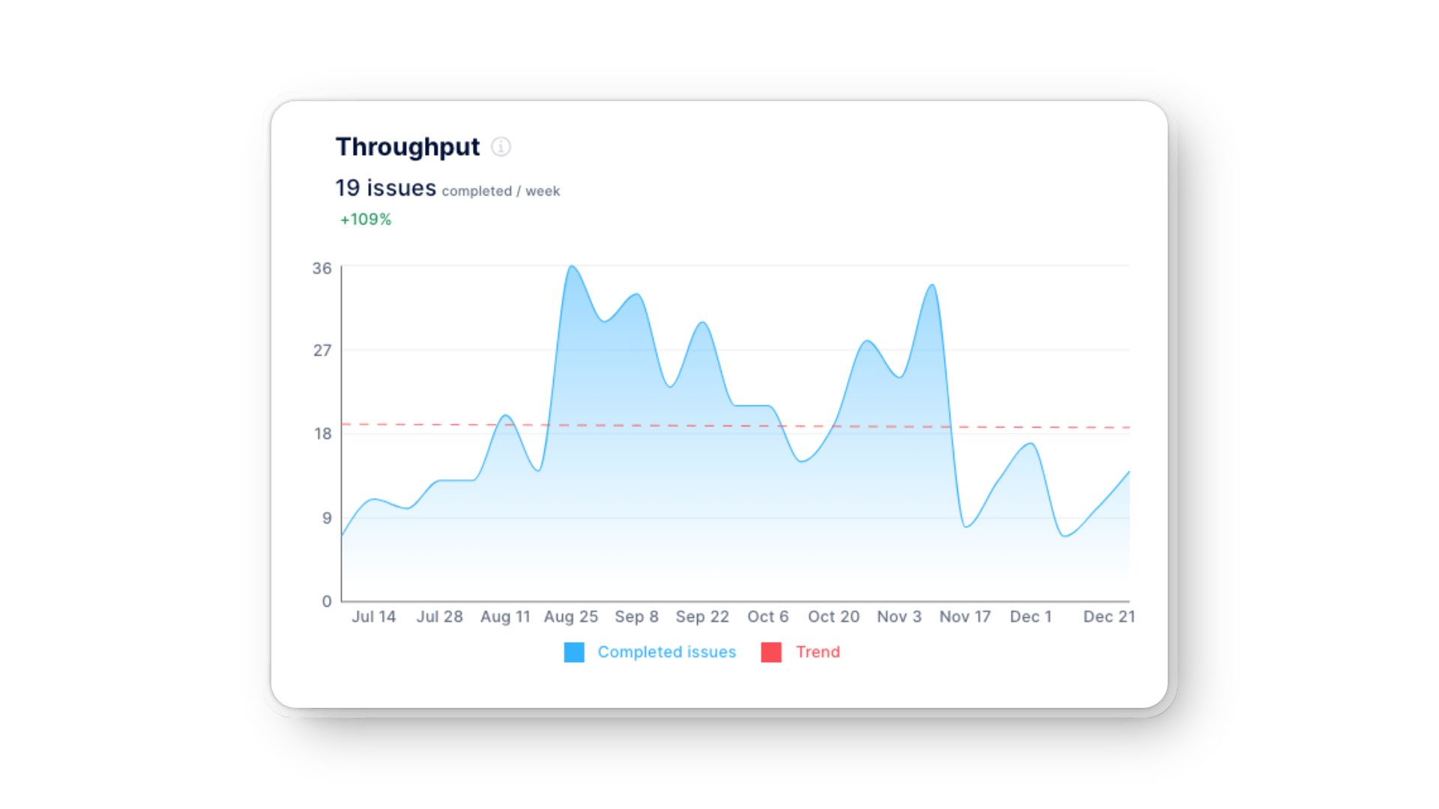

These KPIs offer real-time insights into trends and bottlenecks; use them to make solid process improvements.

But even tracking and analyzing these metrics with our intuitive dashboards can take time. That’s where Axify’s [software delivery tracker](https://axify.io/features/software-delivery-forecasting)comes in—it automates data collection and visualizes trends to help teams make probability-based estimates instead of rough guesses.

**Pro tip:** Our forecasting tool uses Monte Carlo simulations, which rely on historical throughput to give you probability-based estimates. This means you get realistic projections instead of rough guesses, making your planning far more accurate.

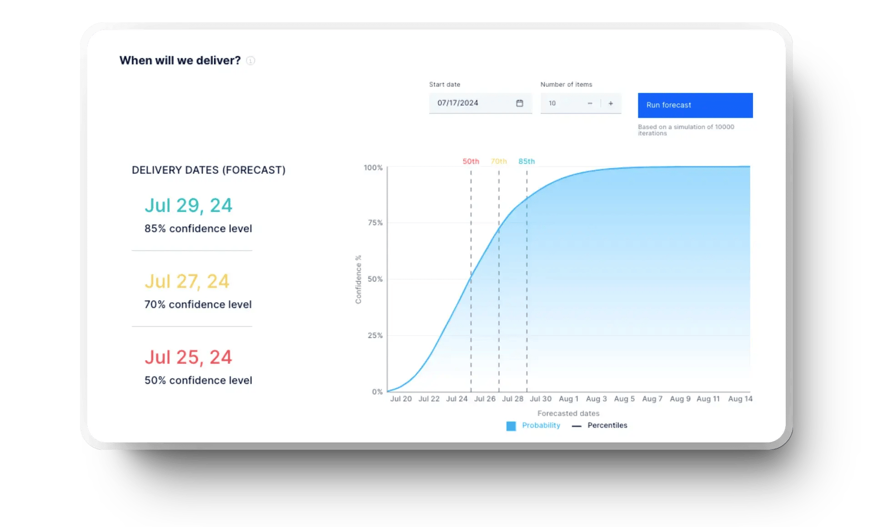

**Estimation Techniques: Limitations and Better Solutions**

No estimation technique is perfect. Relying on expert judgment or guessing based on past experience typically leads to inaccurate results.

Human intuition doesn’t account for everything because **context switching, interruptions, and unexpected incidents** all impact the time it takes to complete tasks. That’s why using historical data is a much better approach.

Axify allows you to track real team performance and use data-driven forecasts instead of rough estimates. Our Monte Carlo simulation model analyzes your past throughput to predict timelines with far more accuracy. No more guessing – just precise, probability-based estimates that help you plan with confidence.

**Want to see how it works?** [Book a demo](https://axify.io/contact) **with Axify today.**

[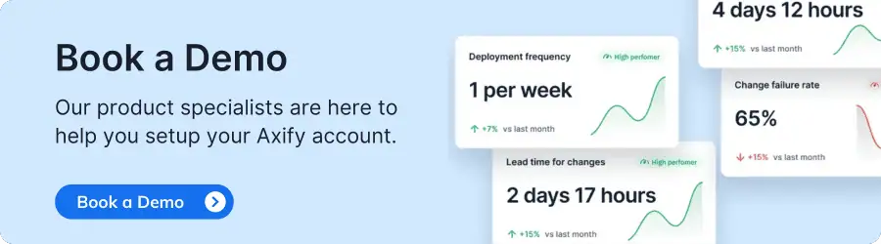](https://axify.io/hs/cta/wi/redirect?encryptedPayload=AVxigLJlacpeRR4RveXYyclfT1aesXTlVMMITydkmosRPWIjhxdqgKHE3JiKFA%2BS3eWhhtn54ybRzRirp4qasQ%2B%2BltHulzmshfRrusfqRZzuOm0SOxCTRQKtCV%2FlwhUgK9yXYj2tj%2BDCUsYSG1laKmNKcQmA6NYmTNOEvn95BRpR6T7inFQhJ%2Fbj12RJ06OAEEQhpSGzPAAFx4BR6gqT&webInteractiveContentId=181615977321&portalId=4300744)

**FAQ**

**1. Which technique is used for project estimation?**

There isn’t a single best technique for project estimation because it depends on your needs. You can use analogous estimation for quick comparisons, bottom-up estimation for detailed breakdowns, or Monte Carlo simulations for probability-based forecasts.

Each method has strengths and weaknesses, so choosing the right one depends on your project size, complexity, and available data.

**2. What is a project estimation tool?**

A project estimation tool helps you predict **cost, time, and resources** for a project. In Agile project management, these tools assist withresource allocation and planning. Instead of relying on intuition, you get data-driven estimates that improve decision-making.

**3. What are the methods of estimation?**

Estimation methods are techniques used to predict the time, effort, and resources required to complete a project or task. These methods can be quantitative (data-driven) or qualitative (expert judgment-based). The best approach depends on how much detail and accuracy you need.

Functional Point (FP) Analysis - Software Engineering

Last Updated : 27 Sep, 2025

Functional Point Analysis (FPA) is a software measurement technique used to assess the size and complexity of a software system based on its functionality. It involves categorizing the functions of the software, such as input screens, output reports, inquiries, files, and interfaces, and assigning weights to each based on their complexity. By quantifying these functions and their associated weights, FPA provides an objective measure of the software's size and complexity.

What is Functional Point Analysis?

Function Point Analysis was initially developed by Allan J. Albrecht in 1979 at IBM and has been further modified by the International Function Point User's Group (IFPUG) in 1984, to clarify rules, establish standards, and encourage their use and evolution. Allan J. Albrecht gave the initial definition, Functional Point Analysis gives a dimensionless number defined in function points which we have found to be an effective relative measure of function value delivered to our customer. A systematic approach to measuring the different functionalities of a software application is offered by function point metrics. Function point metrics evaluate functionality from the perspective of the user, that is, based on the requests and responses they receive.

Objectives of Functional Point Analysis

Encourage Approximation: FPA helps in the estimation of the work, time, and materials needed to develop a software project. Organizations can plan and manage projects more accurately when a common measure of functionality is available.

To assist with project management: Project managers can monitor and manage software development projects with the help of FPA. Managers can evaluate productivity, monitor progress, and make well-informed decisions about resource allocation and project timeframes by measuring the software's functional points.

Comparative analysis: By enabling benchmarking, it gives businesses the ability to assess how their software projects measure up to industry standards or best practices in terms of size and complexity. This can be useful for determining where improvements might be made and for evaluating how well development procedures are working.

Improve Your Cost-Benefit Analysis: It offers a foundation for assessing the value provided by the program concerning its size and complexity, which helps with cost-benefit analysis. Making educated judgements about project investments and resource allocations can benefit from having access to this information.

Comply with Business Objectives: It assists in coordinating software development activities with an organization's business objectives. It guarantees that software development efforts are directed toward providing value to end users by concentrating on user-oriented functionality.

Types of Functional Point Analysis

There are two types of Functional Point Analysis:

Types-of-Functional-Points-Analysis

Types of Functional Point Analysis

1. Transactional Functional Type

External Input (EI): EI processes data or control information that comes from outside the application’s boundary. The EI is an elementary process.

External Output (EO): EO is an elementary process that generates data or control information sent outside the application’s boundary.

External Inquiries (EQ): EQ is an elementary process made up of an input-output combination that results in data retrieval.

2. Data Functional Type

Internal Logical File (ILF): A user-identifiable group of logically related data or control information maintained within the boundary of the application.

External Interface File (EIF): A group of users recognizable logically related data allusion to the software but maintained within the boundary of another software.

functional-point-analysis

Functional Point Analysis

Benefits of Functional Point Analysis

Following are the benefits of Functional Point Analysis:

Technological Independence: It calculates a software system's functional size independent of the underlying technology or programming language used to implement it. As a result, it is a technology-neutral metric that makes it easier to compare projects created with various technologies.

Better Accurate Project Estimation: It helps to improve project estimation accuracy by measuring user interactions and functional needs. Project managers can improve planning and budgeting by using the results of the FPA to estimate the time, effort and resources required for development.

Improved Interaction: It provides a common language for business analysts, developers, and project managers to communicate with one another and with other stakeholders. By communicating the size and complexity of software in a way that both technical and non-technical audiences can easily understand this helps close the communication gap.

Making Well-Informed Decisions: FPA assists in making well-informed decisions at every stage of the software development life cycle. Based on the functional requirements, organizations can use the results of the FPA to make decisions about resource allocation, project prioritization, and technology selection.

Early Recognition of Changes in Scope: Early detection of changes in project scope is made easier with the help of FPA. Better scope change management is made possible by the measurement of functional requirements, which makes it possible to evaluate additions or changes for their effect on the project's overall size.

Disadvantage of Functional Point Analysis

Given below are some disadvantages of Functional Point Analysis:

Subjective Judgement: One of the main disadvantages of Functional Point Analysis is it's dependency on subjective judgement i.e. relying on personal opinions and interpretations instead of just using clear, measurable standards.

Low Accuracy: It has low evaluation accuracy as it's dependency on subjective judgement.

Time Consuming: Functional Point Analysis is a time consuming process, particularly during the initial stages of implementation.

Steep Learning Curve: Learning FPA can be challenging due to its complexity and the length of time required to gain proficiency.

Less Research Data: Compared to LOC-based metrics, there is relatively less research data available on function points.

Costly: The need for thorough analysis and evaluation can result in increased project timelines and associated costs.

Characteristics of Functional Point Analysis

We can calculate the functional point with the help of the number of functions and types of functions used in applications. These are classified into five types:

Types of FP Attributes or Information Domain Characteristics

Measurement Parameters

Examples

Number of External Inputs (EI)

Input screen and tables

Number of External Output (EO)

Output screens and reports

Number of external inquiries (EQ)

Prompts and interrupts

Number of internal files (ILF)

Databases and directories

Number of external interfaces (EIF)

Shared databases and shared routines

Functional Point helps in describing system complexity and also shows project timelines.

It is majorly used for business systems like information systems.

FP is language and technology independent, meaning it can be applied to software systems developed using any programming language or technology stack.

All the factors mentioned above are given weights, and these weights are determined through practical experiments in the following table.

Weights of 5 Functional Point Attributes

Measurement Parameter

Low

Average

High

Number of external inputs (EI)

3

4

6

Number of external outputs (EO)

4

5

7

Number of external inquiries (EQ)

3

4

6

Number of internal files (ILF)

7

10

15

Number of External Interfaces (EIF) 5 7 10

Functional Complexities help us in finding the corresponding weights, which results in finding the Unadjusted Functional point (UFp) of the Subsystem. Consider the complexity as average for all cases. Below-mentioned is the way how to compute FP.

Measurement Parameter

Count

Weighing Factor

Total\_Count Simple Average Complex

Number of external inputs (EI)

32

32\*4=128

3

4

6

Number of external outputs (EO)

60

60\*5=300

4

5

7

Number of external inquiries (EQ)

24

24\*4=96

3

4

6

Number of internal files (ILF)

8

8\*10=80

7

10

15

Number of external interfaces (EIF)

2

2\*7=14

5

7

10

Algorithms used Count total →

618

From the above tables, Functional Point is calculated with the following formula

FP = Count-Total \* [0.65 + 0.01 \* ⅀(fi)]

= Count \* CAF

Here, the count-total is taken from the chart.

CAF = [0.65 + 0.01 \* ⅀(fi)]

⅀(fi) = sum of all 14 questions and it also shows the complexity factor - CAF.

CAF varies from 0.65 to 1.35 and ⅀(fi) ranges from 0 to 70.

When ⅀(fi) = 0, CAF = 0.65 and when ⅀(fi) = 70, CAF = 0.65 + (0.01\*70) = 0.65 + 0.7 = 1.35

Questions on Functional Point

1. Consider a software project with the following information domain characteristic for the calculation of function point metric.

Number of external inputs (I) = 30

Number of external output (O) = 60

Number of external inquiries (E) = 23

Number of files (F) = 08

Number of external interfaces (N) = 02

It is given that the complexity weighting factors for I, O, E, F, and N are 4, 5, 4, 10, and 7, respectively. It is also given that, out of fourteen value adjustment factors that influence the development effort, four factors are not applicable, each of the other four factors has value 3, and each of the remaining factors has value 4. The computed value of the function point metric is \_\_\_\_\_. [GATE CS 2015]

(A) 612.06

(B) 404.66

(C) 305.09

(D) 806.9

Solution: Correct Answer is (A).

For more, refer to GATE CS 2015 | Question 65.

2. While estimating the cost of the software, Lines of Code(LOC) and Function Points (FP) are used to measure which of the following? [UGC-NET CSE 2013]

(A) Length of Code

(B) Size of Software

(C) Functionality of Software

(D) None of the Above

Solution: Correct Answer is (B).

3. In functional point analysis, the number of complexity adjustment factors is [UGC-NET CS 2014]

(A) 10

(B) 12

(C) 14

(D) 20

Solution: Correct Answer is (C).

Conclusion

Functional Point Analysis (FPA) offers a structured approach to measure the size and complexity of software systems based on their functionality. By categorizing functions and assigning weights, FPA provides an objective measurement that helps in estimating project timelines, resource requirements, and overall system complexity. It focuses on user-centric features, making it valuable for business systems like management information systems (MIS).

**Lines of Code (LOC) in Software Engineering**

Last Updated : 23 Jul, 2025

A **line of code (LOC)**is any line of text in a code that is not a comment or blank line, and also header lines, in any case of the number of statements or fragments of statements on the line. LOC consists of all lines containing the declaration of any variable, and executable and non-executable statements.

**Table of Content**

[Features of Lines of Code (LOC)](https://www.geeksforgeeks.org/software-engineering/lines-of-code-loc-in-software-engineering/#features-of-lines-of-code-loc)

[Advantages of Lines of Code (LOC)](https://www.geeksforgeeks.org/software-engineering/lines-of-code-loc-in-software-engineering/#advantages-of-lines-of-code-loc)

[Disadvantages of Lines of Code (LOC)](https://www.geeksforgeeks.org/software-engineering/lines-of-code-loc-in-software-engineering/#disadvantages-of-lines-of-code-loc)

As Lines of Code (LOC) only counts the volume of code, you can only use it to compare or estimate projects that use the same language and are coded using the same coding standards.

**Features of Lines of Code (LOC)**

**Change Tracking:**Variations in LOC as time passes can be tracked to analyze the growth or reduction of a codebase, providing insights into project progress.

**Limited Representation of Complexity:**Despite LOC provides a general idea of code size, it does not accurately depict code complexity. It is possible for two programs having the same LOC to be incredibly complex.

**Ease of Computation:**LOC is an easy measure to obtain because it is easy to calculate and takes little time.

**Easy to Understand:**The idea of expressing code size in terms of lines is one that stakeholders, even those who are not technically inclined, can easily understand.

Lines of Code (LOC) measures the volume of code by counting all non-comment and non-blank lines, including variable declarations and statements. It helps track codebase growth and is easy to compute and understand. However, it does not reflect code complexity and is best used for comparing projects in the same language and coding standards. To explore more about LOC and its implications for software development, check out the [**Complete Guide to Software Testing & Automation by GeeksforGeeks**](https://www.geeksforgeeks.org/courses/software-testing-course-online?utm_campaign=517_lines_of_code_in_software_engineering&utm_medium=gfgcontent_pcp&utm_source=geeksforgeeks), which covers various metrics and methods for assessing code and improving project outcomes.

**Advantages of Lines of Code (LOC)**

Effort Estimation: LOC is occasionally used to estimate development efforts and project deadlines at a high level. Although caution is necessary, project planning can begin with this.

Comparative Analysis: High-level productivity comparisons between several projects or development teams can be made using LOC. It might provide an approximate figure of the volume of code generated over a specific time frame.

Benchmarking Tool: When comparing various iterations of the same program, LOC can be used as a benchmarking tool. It may bring information on how modifications affect the codebase's total size.

**Disadvantages of Lines of Code (LOC)**

Challenges in Agile Work Environments: Focusing on initial LOC estimates may not adequately reflect the iterative and dynamic nature of development in agile development, as requirements may change.

Not Considering Into Account External Libraries: Code from other libraries or frameworks, which can greatly enhance a project's overall usefulness, is not taken into account by LOC.

Challenges with Maintenance: Higher LOC codebases are larger codebases that typically demand more maintenance work.

Research has shown a rough correlation between LOC and the overall cost and length of developing a project/ product in Software Development and between LOC and the number of defects. This means the lower your LOC measurement is, the better off you probably are in the development of your product.

Let's take an example and check how the Line of code works in the simple sorting program given below:

void selSort(int x[], int n) {

*//Below function sorts an array in ascending order*

int i, j, min, temp;

**for** (i = 0; i < n - 1; i++) {

min = i;

**for** (j = i + 1; j < n; j++)

**if** (x[j] < x[min])

min = j;

temp = x[i];

x[i] = x[min];

x[min] = temp;

}

}

So, now If LOC is simply a count of the number of lines then the above function shown contains **13 lines of code (LOC).**But when comments and blank lines are ignored, the function shown above contains **12 lines of code (LOC)**.

Let's take another example and check how does the Line of code work the given below:

void main()

{

int fN, sN, tN;

cout << "Enter the 2 integers: ";

cin >> fN >> sN;

*// sum of two numbers in stored in variable sum*

sum = fN + sN;

*// Prints sum*

cout << fN << " + " << sN << " = " << sum;

**return** 0;

}

Here also, If LOC is simply a count of the numbers of lines then the above function shown contains 11 lines of code (LOC). But when comments and blank lines are ignored, the function shown above contains 9 lines of code (LOC).

A Use-Case is a series of related interactions between a user and a system that enables the user to achieve a goal.

Use-Cases are a way to capture functional requirements of a system. The user of the system is referred to as an Actor. Use-Cases are fundamentally in text form.

Use-Case Points Definition

Use-Case Points (UCP) is a software estimation technique used to measure the software size with use cases. The concept of UCP is similar to FPs.

The number of UCPs in a project is based on the following −

The number and complexity of the use cases in the system.

The number and complexity of the actors on the system.

Various non-functional requirements (such as portability, performance, maintainability) that are not written as use cases.

The environment in which the project will be developed (such as the language, the teams motivation, etc.)

Estimation with UCPs requires all use cases to be written with a goal and at approximately the same level, giving the same amount of detail. Hence, before estimation, the project team should ensure they have written their use cases with defined goals and at detailed level. Use case is normally completed within a single session and after the goal is achieved, the user may go on to some other activity.

History of Use-Case Points

The Use-Case Point estimation method was introduced by Gustav Karner in 1993. The work was later licensed by Rational Software that merged into IBM.

Use-Case Points Counting Process

The Use-Case Points counting process has the following steps −

Calculate unadjusted UCPs

Adjust for technical complexity

Adjust for environmental complexity

Calculate adjusted UCPs

Step 1: Calculate Unadjusted Use-Case Points.

You calculate Unadjusted Use-Case Points first, by the following steps −

Determine Unadjusted Use-Case Weight

Determine Unadjusted Actor Weight

Calculate Unadjusted Use-Case Points

Step 1.1 − Determine Unadjusted Use-Case Weight.

Step 1.1.1 − Find the number of transactions in each Use-Case.

If the Use-Cases are written with User Goal Levels, a transaction is equivalent to a step in the Use-Case. Find the number of transactions by counting the steps in the Use-Case.

Step 1.1.2 − Classify each Use-Case as Simple, Average or Complex based on the number of transactions in the Use-Case. Also, assign Use-Case Weight as shown in the following table −

Use-Case Complexity Number of Transactions Use-Case Weight

Simple ≤3 5

Average 4 to 7 10

Complex >7 15

Step 1.1.3 − Repeat for each Use-Case and get all the Use-Case Weights. Unadjusted Use-Case Weight (UUCW) is the sum of all the Use-Case Weights.

Step 1.1.4 − Find Unadjusted Use-Case Weight (UUCW) using the following table −

Use-Case Complexity Use-Case Weight Number of Use-Cases Product

Simple 5 NSUC 5 × NSUC

Average 10 NAUC 10 × NAUC

Complex 15 NCUC 15 × NCUC

Unadjusted Use-Case Weight (UUCW) 5 × NSUC &plus; 10 × NAUC &plus; 15 × NCUC

Where,

NSUC is the no. of Simple Use-Cases.

NAUC is the no. of Average Use-Cases.

NCUC is the no. of Complex Use-Cases.

Step 1.2 − Determine Unadjusted Actor Weight.

An Actor in a Use-Case might be a person, another program, etc. Some actors, such as a system with defined API, have very simple needs and increase the complexity of a Use-Case only slightly.

Some actors, such as a system interacting through a protocol have more needs and increase the complexity of a Use-Case to a certain extent.

Other Actors, such as a user interacting through GUI have a significant impact on the complexity of a Use-Case. Based on these differences, you can classify actors as Simple, Average and Complex.

Step 1.2.1 − Classify Actors as Simple, Average and Complex and assign Actor Weights as shown in the following table −

Actor Complexity Example Actor Weight

Simple A System with defined API 1

Average A System interacting through a Protocol 2

Complex A User interacting through GUI 3

Step 1.2.2 − Repeat for each Actor and get all the Actor Weights. Unadjusted Actor Weight (UAW) is the sum of all the Actor Weights.

Step 1.2.3 − Find Unadjusted Actor Weight (UAW) using the following table −

Actor Complexity Actor Weight Number of Actors Product

Simple 1 NSA 1 × NSA

Average 2 NAA 2 × NAA

Complex 3 NCA 3 × NCA

Unadjusted Actor Weight (UAW) 1 × NSA &plus; 2 × NAA &plus; 3 × NCA

Where,

NSA is the no. of Simple Actors.

NAA is the no. of Average Actors.

NCA is the no. of Complex Actors.

Step 1.3 − Calculate Unadjusted Use-Case Points.

The Unadjusted Use-Case Weight (UUCW) and the Unadjusted Actor Weight (UAW) together give the unadjusted size of the system, referred to as Unadjusted Use-Case Points.

Unadjusted Use-Case Points (UUCP) = UUCW &plus; UAW

The next steps are to adjust the Unadjusted Use-Case Points (UUCP) for Technical Complexity and Environmental Complexity.

Step 2: Adjust For Technical Complexity

Step 2.1 − Consider the 13 Factors that contribute to the impact of the Technical Complexity of a project on Use-Case Points and their corresponding Weights as given in the following table −

Factor Description Weight

T1 Distributed System 2.0

T2 Response time or throughput performance objectives 1.0

T3 End user efficiency 1.0

T4 Complex internal processing 1.0

T5 Code must be reusable 1.0

T6 Easy to install .5

T7 Easy to use .5

T8 Portable 2.0

T9 Easy to change 1.0

T10 Concurrent 1.0

T11 Includes special security objectives 1.0

T12 Provides direct access for third parties 1.0

T13 Special user training facilities are required 1.0

Many of these factors represent the projects nonfunctional requirements.

Step 2.2 − For each of the 13 Factors, assess the project and rate from 0 (irrelevant) to 5 (very important).

Step 2.3 − Calculate the Impact of the Factor from Impact Weight of the Factor and the Rated Value for the project as

Impact of the Factor = Impact Weight × Rated Value

Step (2.4) − Calculate the sum of Impact of all the Factors. This gives the Total Technical Factor (TFactor) as given in table below −

Factor Description Weight (W) Rated Value (0 to 5) (RV) Impact (I = W × RV)

T1 Distributed System 2.0

T2 Response time or throughput performance objectives 1.0

T3 End user efficiency 1.0

T4 Complex internal processing 1.0

T5 Code must be reusable 1.0

T6 Easy to install .5

T7 Easy to use .5

T8 Portable 2.0

T9 Easy to change 1.0

T10 Concurrent 1.0

T11 Includes special security objectives 1.0

T12 Provides direct access for third parties 1.0

T13 Special user training facilities are required 1.0

Total Technical Factor (TFactor)

Step 2.5 − Calculate the Technical Complexity Factor (TCF) as −

TCF = 0.6 &plus; (0.01 × TFactor)

Step 3: Adjust For Environmental Complexity

Step 3.1 − Consider the 8 Environmental Factors that could affect the project execution and their corresponding Weights as given in the following table −

Factor Description Weight

F1 Familiar with the project model that is used 1.5

F2 Application experience .5

F3 Object-oriented experience 1.0

F4 Lead analyst capability .5

F5 Motivation 1.0

F6 Stable requirements 2.0

F7 Part-time staff -1.0

F8 Difficult programming language -1.0

Step 3.2 − For each of the 8 Factors, assess the project and rate from 0 (irrelevant) to 5 (very important).

Step 3.3 − Calculate the Impact of the Factor from Impact Weight of the Factor and the Rated Value for the project as

Impact of the Factor = Impact Weight × Rated Value

Step 3.4 − Calculate the sum of Impact of all the Factors. This gives the Total Environment Factor (EFactor) as given in the following table −

Factor Description Weight (W) Rated Value (0 to 5) (RV) Impact (I = W × RV)

F1 Familiar with the project model that is used 1.5

F2 Application experience .5

F3 Object-oriented experience 1.0

F4 Lead analyst capability .5

F5 Motivation 1.0

F6 Stable requirements 2.0

F7 Part-time staff -1.0

F8 Difficult programming language -1.0

Total Environment Factor (EFactor)

Step 3.5 − Calculate the Environmental Factor (EF) as −

1.4 &plus; (-0.03 × EFactor)

Step 4: Calculate Adjusted Use-Case Points (UCP)

Calculate Adjusted Use-Case Points (UCP) as −

UCP = UUCP × TCF × EF

Advantages and Disadvantages of Use-Case Points

Advantages of Use-Case Points

UCPs are based on use cases and can be measured very early in the project life cycle.

UCP (size estimate) will be independent of the size, skill, and experience of the team that implements the project.

UCP based estimates are found to be close to actuals when estimation is performed by experienced people.

UCP is easy to use and does not call for additional analysis.

Use cases are being used vastly as a method of choice to describe requirements. In such cases, UCP is the best suitable estimation technique.

Disadvantages of Use-Case Points

UCP can be used only when requirements are written in the form of use cases.

Dependent on goal-oriented, well-written use cases. If the use cases are not well or uniformly structured, the resulting UCP may not be accurate.

Technical and environmental factors have a high impact on UCP. Care needs to be taken while assigning values to the technical and environmental factors.

UCP is useful for initial estimate of overall project size but they are much less useful in driving the iteration-to-iteration work of a team.

Estimation Technique in Agile

Last Updated : 12 Jul, 2025

Estimation is the process of finding an estimate, or approximation. It is an Art of guessing. Estimation includes four main factors - money, effort, resources, and time needed to build a specific system or product. There are many techniques available in today's world for doing estimations in an Agile Project. The main objectives for doing estimations include Relative Estimation, discussions to get more information on items whose estimations need to be done and ensuring the commitment and enthusiasm of the whole team towards the tasks assigned to them. Agile Project Estimation Techniques are:

Dot Voting: In Dot Voting Techniques all the user stories along with their description are posted on the board. Each member put a dot in front of those stories that they consider most important. This way the stories are sorted according to their priorities. This is done to select the most important stories that should be taken forward.

T-Shirt Size: This technique helps in open and mutual collaborative discussions. In this technique, t-shirt sizes -XS (Extra Small), S (Small), M (Medium), L (Large), and XL (Extra Large) are used. User stories are given t-shirt sizes according to the member's understanding. This technique provides rough estimation very fast.

Planning Poker: Planning Poker is the most famous Estimation technique in Agile. This technique makes sure that every member participates in the estimation and shares his/her opinion. In this technique cards with numbers on them, are given to each member of the team. The Product Owner reads the story, after which every member has to hold the card showing the level of effort they will make for the user story. Discussion and Re-estimation go on until the whole team reaches a consensus.

The Bucket System: The Bucket System estimation technique is much faster than the Planning Poker technique. In this buckets are created with random values: 0, 1, 2, 3, 4, 5, 8, 13, 20, 30, 50. The whole team estimates the items by placing them in these “buckets”. In the Bucket System Divide and Conquer approach is followed.

Large/Uncertain/Small: This technique is for doing rough estimation and it is simpler than the Bucket system technique. All the items are categorized in Large/Uncertain/Small. First simple user stories are chosen for estimation then more complex ones are taken. It's a good technique when comparable items are in the Product Backlog.

Relative Estimation: In this technique, teams estimate user stories according to one another rather than giving them exact numerical values. For instance, they can state, without assigning specific point values, that Story X is twice as complex as Story Y. This method prioritizes selection and ranking while simplifying estimation.

Story Points: In this estimation technique, user stories are given story points based on complexities, effort, and risk by teams. Story points are a metric without units and can stand in for any comparable value decided by the team. This method is adaptable and frequently used alongside Planning Poker.

Estimation Based on Velocity: This technique states the amount of work a team can accomplish in a sprint is measured by the team's velocity. Teams calculate the amount of user story points that can commit to in the following sprint using their average velocity over several sprints.

Conclusion

The choice of the estimation technique depends on the context of the project and the amount of detail required for it. The teams can use more than one technique at the same time to look for different aspects of the work together.

**Short note on Project Scheduling**

Last Updated : 08 Jul, 2020

A schedule in your project's time table actually consists of sequenced activities and milestones that are needed to be delivered under a given period of time. **Project schedule** simply means a mechanism that is used to communicate and know about that tasks are needed and has to be done or performed and which organizational resources will be given or allocated to these tasks and in what time duration or time frame work is needed to be performed. Effective project scheduling leads to success of project, reduced cost, and increased customer satisfaction. Scheduling in project management means to list out activities, deliverables, and milestones within a project that are delivered. It contains more notes than your average weekly planner notes. The most common and important form of project schedule is Gantt chart.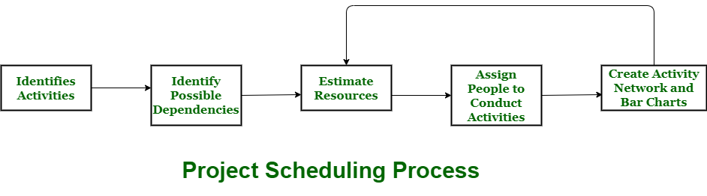**Process :** The manager needs to estimate time and resources of project while scheduling project. All activities in project must be arranged in a coherent sequence that means activities should be arranged in a logical and well-organized manner for easy to understand. Initial estimates of project can be made optimistically which means estimates can be made when all favorable things will happen and no threats or problems take place. The total work is separated or divided into various small activities or tasks during project schedule. Then, Project manager will decide time required for each activity or task to get completed. Even some activities are conducted and performed in parallel for efficient performance. The project manager should be aware of fact that each stage of project is not problem-free. **Problems arise during Project Development Stage :**

People may leave or remain absent during particular stage of development.

Hardware may get failed while performing.

Software resource that is required may not be available at present, etc.

The project schedule is represented as set of chart in which work-breakdown structure and dependencies within various activities are represented. To accomplish and complete project within a given schedule, required resources must be available when they are needed. Therefore, resource estimation should be done before starting development. **Resources required for Development of Project :**

Human effort

Sufficient disk space on server

Specialized hardware

Software technology

Travel allowance required by project staff, etc.

**Advantages of Project Scheduling :** There are several advantages provided by project schedule in our project management:

It simply ensures that everyone remains on same page as far as tasks get completed, dependencies, and deadlines.

It helps in identifying issues early and concerns such as lack or unavailability of resources.

It also helps to identify relationships and to monitor process.

It provides effective budget management and risk mitigation.

An Activity Network Diagram is a diagram of project activities that shows the sequential relationships of activities using arrows and nodes. An activity network diagram tool is used extensively in and is necessary for the identification of a project’s critical path (which is used to determine the expected completion time of the project).

Example: Suppose the team is tasked with improving the process of building a house. The team lists the major steps involved – everything from the excavation step through the landscaping step.

Activity Network Diagram Example Chart

The team creates a chart – Activity Network Diagram – where the nodes (the boxes) represent the nine major steps involved in building a house. Arrows that connect the nodes show the flow of the process.

Some of the process steps (nodes A, B, and C) run in series, while other process steps (nodes D, E, and F) run in parallel. Notice that Step B cannot happen until step A has been completed. Likewise, step C cannot happen until step B has completed. Step H cannot happen until steps D, E, and F have completed – and ALL need to be completed before Step H. So, nodes A, B, and C are running in series. Nodes D, E, and F run in parallel. This is important to know because those steps that are running in parallel most likely will have different expected completion times.

Activity Network Diagram Example Chart

Critical Path

The team’s job is to take note of which of the nodes D, E, and F, will be taking the most amount of time, and which of those nodes is expected to take the least amount of time. This is essential when creating the Critical Path. For instance, if node D is expected to take the most amount of time as compared with nodes E and F, it is not important that nodes D and E start at the exact same time as node F. Those steps can start later, but they have to be finished no later than the most time consuming of the three steps that run in parallel. The team evaluates the nine steps and come to a consensus on how many days each of the nine steps will take. The critical path is a line that goes through all of the nodes that have the longest expected completion times.

Most Likely Time

Nodes A, B, and C run in series, so the critical path is straightforward. Notice that between the three nodes that run in parallel, (nodes D, E, and F) node D is expected to take the longest to complete as compared to the other two nodes. The critical path would run through nodes D and G because those particular nodes have the longest expected completion times. The line above shows the critical path. By looking at the Activity Network Diagram the team can easily see that the expected completion time as defined by the critical path is 50 days. (5+2+12+9+10+7+5 = 50 days) That’s the MOST LIKELY time.

Optimistic Time

The team might want to know what the best case (Optimistic Time), in terms of time, would be. To come up with that number, the team would decide upon the shortest possible time for each of the nodes, and then add those up. The numbers in parenthesis are the most optimistic times. (4+2+10+8+8+7+4 = 43)

Activity Network Optimistic Time

Pessimistic Time

The team also might want to know what the worst case (Pessimistic Time), in terms of time, would be. To come up with that number, the team would decide upon the longest possible time for each of the nodes, and then add those up. Note: To determine the best case or the worst case, the critical path line must be followed. The numbers in parentheses are the most pessimistic times. (7+3+14+10+11+8+6 = 59) Remember, you are only calculating the numbers along the critical path when calculating the most optimistic and pessimistic times.

Activity Network Pessimistic Time

Expected Time

So what does all of this mean? It means the project most likely will take 50 days, but it could take 59 days, or it can be done as soon as 43 days.

Activity Network Expected Time

Control Bands

We could calculate control bands around the average. Here’s how we do that:

Activity Network Control Bands

For the critical path, we can expect the project to take from 47.6 days to 53.0 days

50.3 + 2.7 = 53 on the high side

50.3 – 2.7 = 47.6 on the low side.

What is Risk Management?

Last Updated : 11 Dec, 2025

Risk Management is a systematic process of recognizing, evaluating, and handling threats or risks that have an effect on the finances, capital, and overall operations of an organization. These risks can come from different areas, such as financial instability, legal issues, errors in strategic planning, accidents, and natural disasters.

A risk is a probable problem; it might happen, or it might not. There are two main characteristics of risk.

Uncertainty: the risk may or may not happen, which means there are no 100% risks.

Loss: If the risk occurs in reality, undesirable results or losses will occur.

The main goal of risk management is to predict possible risks and find solutions to deal with them successfully.

risk\_management\_process.webprisk\_management\_process.webp

Why is Risk Management Important?

Risk management helps organizations prepare for unexpected events and protect their financial health, operations, and long-term stability.

For Example - If a key developer in a software project falls ill, collaborative tools allow the team to continue smoothly. With proper resources and a consistent, systematic approach, organizations can reduce negative impacts and improve outcomes.

In short, Risk Management:

Helps organizations prepare for unexpected situations, from minor issues to major crises.

Protects financial health and ensures smooth and continuous operations.

Effective risk management requires proper resources and a structured, systematic approach.

Supports better identification, assessment, and mitigation of major risks.

The Risk Management Process

Risk management is a sequence of steps that help a software team to understand, analyze, and manage uncertainty.

The risk management process consists of:

Risk Identification

Risk identification refers to the systematic process of recognizing and evaluating potential threats or hazards that could negatively impact an organization, its operations, or its workforce. This involves identifying various types of risks, ranging from IT security threats like viruses and phishing attacks to unforeseen events such as equipment failures and extreme weather conditions.

Risk analysis

Risk analysis is the process of evaluating and understanding the potential impact and likelihood of identified risks on an organization. It helps determine how serious a risk is and how to best manage or mitigate it. Risk Analysis involves evaluating each risk's probability and potential consequences to prioritize and manage them effectively.

Risk Planning

Risk planning involves developing strategies and actions to manage and mitigate identified risks effectively. It outlines how to respond to potential risks, including prevention, mitigation, and contingency measures, to protect the organization's objectives and assets.

Risk Monitoring

Risk monitoring involves continuously tracking and overseeing identified risks to assess their status, changes, and effectiveness of mitigation strategies. It ensures that risks are regularly reviewed and managed to maintain alignment with organizational objectives and adapt to new developments or challenges.

Understanding Risks in Software Projects

A computer code project may be laid low with an outsized sort of risk. To be ready to consistently establish the necessary risks that could affect a computer code project, it's necessary to group risks into completely different categories. The project manager will then examine the risks from every category square measure relevant to the project.

There are mainly 3 classes of risks that may affect a computer code project:

1. Project Risks:

Project risks concern various sorts of monetary funds, schedules, personnel, resources, and customer-related issues. A vital project risk is schedule slippage. Since computer code is intangible, it's tough to observe and manage a computer code project. It's tough to manage one thing that can not be seen. For any producing project, like producing cars, the project manager will see the merchandise taking form.

For example - See that the engine is fitted, at the moment the area of the door unit is fitted, the automotive is being painted, etc. so he will simply assess the progress of the work and manage it. The physical property of the merchandise being developed is a vital reason why several computer codes come to suffer from the danger of schedule slippage.

2. Technical Risks:

Technical risks concern potential style, implementation, interfacing, testing, and maintenance issues. Technical risks conjointly embody ambiguous specifications, incomplete specifications, dynamic specifications, technical uncertainty, and technical degeneration. Most technical risks occur thanks to the event team’s lean information concerning the project.

3. Business Risks:

This type of risk embodies the risks of building a superb product that nobody needs, losing monetary funds or personal commitments, etc.

Classification of Risk in a project

Example: Let us consider a satellite-based mobile communication project. The project manager can identify many risks in this project. Let us classify them appropriately.

What if the project cost escalates and overshoots what was estimated? - Project Risk

What if the mobile phones that are developed become too bulky to conveniently carry? Business Risk

What if call hand-off between satellites becomes too difficult to implement? Technical Risk

Risk management Standards and Frameworks

Risk management standards and frameworks give organizations guidelines on how to find, evaluate, and handle risks effectively. They provide a structured way to manage risks, making sure that everyone follows consistent and reliable practices. Here are some well-known risk management standards and frameworks:

1. COSO ERM Framework:

COSO ERM Framework was introduce in 2004. Its main purpose is to addresses the growing complexity of Enterprise Risk Management (ERM).

Key Features:

20 principles grouped into five components: Governance and culture, Strategy and objective-setting, Performance, Review and revision, Information, communication, and reporting.

It promote integrating risk into business strategies and operations.

2. ISO 31000:

ISO 31000 was introduce in 2009, revised in 2018. It provides principles and a framework for ERM.

Key Features:

It offers guidance on applying risk management to operations.

It focuses on identifying, evaluating, and mitigating risks.

It promote senior management's role and integrating risk management across the organization.

3. BS 31100:

This framework is British Standard for Risk Management and latest version issued in 2001. It offers a structured approach to applying the principles outlined in ISO 31000:2018, covering tasks like identifying, evaluating, and addressing risks, followed by reporting and reviewing risk management efforts.

Benefits of risk management

Here are some benefits of risk management:

Helps protect against potential losses.

Improves decision-making by considering risks.

Reduces unexpected expenses.

Ensures adherence to laws and regulations.

Builds resilience against unexpected challenges.

Safeguards company reputation.

Limitation of Risk Management

Here are Some Limitation of Risk Management

Too much focus on risk can lead to missed opportunities.

Implementing risk management can be expensive.

Risk models can be overly complex and hard to understand.

Having risk controls might make people feel too safe.

Relies on accurate human judgment and can be prone to mistakes.

Some risks are hard to predict or quantify.

Managing risks can take a lot of time and resources.

Risk management is an essential component of project planning. Risk management in software engineering entails identifying and estimating the likelihood of risks in order of their impact on the project.

Software development is a high-level activity that employs a wide range of technological advancements. Every software development project contains elements of uncertainty due to these and other factors. The amount of risk associated with each project activity determines the success of a software development project. It is not enough to simply be aware of the dangers. To achieve success, project management must identify, assess, prioritize, and manage all major risks.

Most software development and software engineering projects strive to be unique, whether they are creating new features or improving efficiency. Any software project manager will agree that taking advantage of such opportunities doesn't come without risk.

**What Is the Definition of Risk in Software Engineering?**

Simply put, a risk is a potential problem. It is an activity or event that has the potential to jeopardize the success of a software development project. Risk is the possibility of experiencing loss, and total risk exposure to a specific project will account for both the likelihood and magnitude of the potential loss. Therefore, risk management should be made an integral part of any project management.

**Main Risk Types in Software Development**

We can identify five major risk impact areas for most software development projects every project manager should be aware of:

Unproven or new technologies

Functional and user requirements

Architecture of applications and systems

Performance

Organizational

Guesswork and crisis management are never effective. Risk identification and aggregation is the only predictive method to determine the likelihood that unplanned or unacceptable events will occur in a software development project. Terminations, discontinuities, schedule delays, cost underestimation, and project resource overruns are examples of these.

**Examples of Various Types of Project Risks in Software Engineering**

There is no such thing as a risk-free project. However, there are numerous methods, risk response strategies, and project risk management tools that we can use during project management to identify, analyze, and then reduce threats. Let's discuss some of the potential risks that may arise during software development, as well as solutions that can be implemented by the project manager and the team.

**Internal Risk**

**Example:** One of the team members is no longer able to contribute to the product.

**Tip for risk management:** In software development, it is important to organize work so that each team member is aware of all tasks, including those of colleagues. This allows one developer to substitute for another.

**External Risk**

**Example:** Changes in an external provider's policy in a given country.

**Risk management advice:** Usually, developers in the team evaluate the task of integrating with an external provider, taking into account potential risks and consulting with the team that has previously done such integration. This approach allows us to determine what might be problematic or pose a problem, as well as our options. Furthermore, if we know that something like that is possible, we focus on the worst-case scenario and plan our next steps in risk analysis.

**Internal and External Risks Combined**

**Example:** Communication is linked to commitment, which is also an important aspect of software development. And it is multifaceted in this case because it affects everyone involved in the software development process – developers, designers, software testing team, product owners, stakeholders, and, of course, the client. There is a problem if there is a lack of commitment.

**Risk management advice:** A product owner's role is to support, engage, and assist the team and everyone involved in the digital product development process in any way possible. Close collaboration between developers, a UX/UI designer, the client, and stakeholders has to be an integral part of any successful digital product.

**What is Risk Management in Software Engineering?**

Risk analysis and management is the process of identifying, addressing, and eliminating potential problems before they have a negative impact on the project.

**The following tasks are included in risk management:**

Determine the risks and the factors that cause them.

All risks should be classified and prioritized.

Create a plan that connects each risk to a mitigation strategy.

Throughout the project, keep an eye out for risk triggers.

If a risk occurs, take the appropriate mitigation measures.

Throughout the project, communicate the status of risks.

Example of Risk Management Plan

**Principles of Risk Management in Software Engineering**

**Global Perspective:** In this step of project management, we will go over the overall system description, design, and implementation. We consider the risk and its potential consequences.

**Keep an Eye on the Future:** Consider the threat that might appear in the future and make plans to direct the next events.

**Open Communication:** This allows for the free flow of information between the client and the team members, allowing them to be confident about the risks.

**Integrated Management:** Risk management is integrated into project management in this method.

**Continuous Process:** The risks are tracked constantly throughout the risk management paradigm during this phase.

**Steps of Risk Management**

Let's take a detailed look at the steps that need to be followed in risk analysis to reduce harm and understand how to practice risk management in software engineering. This practice will help any project manager to successfully deliver a product.

**1. Risk Identification**

Risk identification entails brainstorming. It also entails the creation of a risk list. Brainstorming is a group discussion technique in which the whole project management team is present. This technique generates new ideas and encourages creative thinking. The preparation of a risk list entails identifying risks that have occurred repeatedly in previous software projects.

**2. Risk Assessment and Prioritization**

It is a procedure within project management that includes the following steps:

Identifying the issues that are causing risk in projects

Determining the likelihood of a problem occurring

Determining the problem's impact

Assigning probability and impact values ranging from 1 to 10

Determining the risk exposure factor

The project manager should make a table with all of the values and rank the risks according to the risk exposure factor.

**3. Risk Avoidance and Mitigation**

The goal of this technique is to eliminate the occurrence of risks entirely. To avoid risks, reduce the scope of projects by eliminating non-essential requirements. Risk avoidance involves identifying potential risks and then eliminating them as much as possible, or reducing their impact if they cannot be eliminated.

**Examples of risk avoidance:**

Not using certain features in the software due to the potential for bugs or other problems to occur;

Increase software testing activities using test cases to ensure no bugs exist in a product before it goes live;

Making sure that any changes made to software are thoroughly tested before they are deployed.

**4. Risk Transfer**

This technique is used in software engineering to reduce the risk of a project. Risk transfer is usually used when the scope of a project is too large for any one team to handle, and there is no way to split up the work so that each team can be responsible for its own piece of it. In this case, you have to find an outside company that can take on some portion of your project.

For example, if you're working on a video editor app and your team doesn't have enough designers or programmers to make it happen, project management could decide to hire someone else who does have the necessary resources. That way, you don't have to worry about handling all parts of the app yourself and can focus on what's most important--making sure that everything comes together in an enjoyable way!

**5. Risk Acceptance**

In software engineering, risk acceptance is a technique that involves taking on risks in order to complete the system. It can be a good idea if there is a lot of uncertainty about which features will be required and when they'll be needed. In this case, it makes sense to accept some level of risk in order to have time to figure out what needs to be done and how long it will take. The only way to know whether this will work is by trying it out—you may find that you were right all along, or you may discover that you need more time than expected.

**6. Risk Monitoring**

The risk should be continuously monitored by reevaluating the risks, the impact of the risk, and the probability of the risk occurring.

**This guarantees that:**

The dangers have been discovered and reduced.

The magnitude and impact of risk are assessed.

**Risk Management Software**

Risk management software helps in identifying the sources of risk, analyzing and prioritizing them based on their probability of occurrence, impact on business objectives, and cost of mitigation. It also provides recommendations for avoiding or reducing risks by implementing effective controls.

To manage risks in software development, you can also use the [**Agile Security Platform**](https://solutionshub.epam.com/solution/agile-security-platform). This platform provides security services to engineering teams by performing Penetration Testing as a Service (PTaaS). The testing is integrated into the software delivery cycles so that security posture is continuously monitored, and all vulnerabilities are detected on time.

**AI-Powered Risk Management in Software Development**

As software becomes more complex and development moves faster, traditional ways of finding and managing risks can't keep up. [**Artificial intelligence (AI)**](https://solutionshub.epam.com/blog/post/generative-ai-vs-predictive-ai) and machine learning (ML) make it easier to spot and fix issues throughout the software development lifecycle (SDLC).

**Early and Continuous Risk Detection**

AI can analyze huge codebases, track dependencies, and monitor development activity in real-time. This helps catch potential risks like vulnerabilities, bad code patterns, or risky changes long before humans would notice, making it faster to take action and fix problems.

**Seamless DevOps Integration**

AI risk checks are built directly into CI/CD pipelines. Automated analysis tools powered by ML flag security flaws and quality issues without slowing down the development process. Developers get instant feedback and recommendations, helping them fix problems quickly.

**Smart Threat Monitoring**

AI doesn't just stop at code; it keeps an eye on how the system behaves after deployment. By continuously monitoring for anomalies, performance issues, or potential security threats, AI helps teams respond to real-world problems as soon as they arise.

**Better Collaboration and Transparency**

AI organizes risk data in user-friendly dashboards, linking vulnerabilities to their potential business impact. This makes it easy for teams to collaborate and for management to oversee and prioritize the most important risks, ensuring nothing critical gets missed.

**Risk Prediction and Prioritization**

Advanced AI algorithms use historical data and patterns to predict the riskiest areas. This helps teams focus their testing and reviews more effectively, reducing the chance of late-stage defects and saving time and money.

**Key Benefits**

Using AI for risk management leads to fewer bugs making it into production, faster response times for fixing issues, and better compliance with security and quality standards.

**Keeping it Responsible**

AI in risk management requires ethical oversight. Companies need to ensure the system is transparent, avoids biased decisions, and includes human oversight where necessary, balancing automation with accountability.

Conclusion

So what is risk management? It is the process of performing risk analysis by identifying and assessing risks, threats, and opportunities. It is also the process of deciding on how to respond to them. Risk management in software engineering is important as it can lead to better business outcomes by enabling organizations to make informed decisions that minimize risk exposure and maximize opportunity benefits. It helps your organization identify possible threats or challenges before they happen so you can take proactive steps that will keep your projects on schedule and under budget. Risk management does not mean avoiding hazards altogether; rather, it means managing them effectively so they don't derail your business objectives or cause damage to other aspects of your operations or reputation.

**Short note on Risk Assessment and Risk Mitigation**

Last Updated : 25 Apr, 2024

**Software Risk** is a problem that may or may not occur that shows the uncertainty of risks but if occurs, unwanted losses threats, or consequences will occur. It is generally caused due to a lack of incomplete information, control, or time.

**Table of Content**

[What is Risk Assessment?](https://www.geeksforgeeks.org/software-engineering/short-note-on-risk-assessment-and-risk-mitigation/#what-is-risk-assessment)

[What is Risk Mitigation?](https://www.geeksforgeeks.org/software-engineering/short-note-on-risk-assessment-and-risk-mitigation/#what-is-risk-mitigation)

[Risk management](https://www.geeksforgeeks.org/software-engineering/short-note-on-risk-assessment-and-risk-mitigation/#risk-management)

Risk Assessment and Risk Mitigation is a process in which identifying, assessing, and mitigating risk takes place to the scope, schedule, cost, and quality of the project.

**What is Risk Assessment?**

Risk assessment simply means to describe the overall process or method to identify risk and problem factors that might cause harm. It is a systematic examination of a task or project that you perform to simply identify significant risks, problems, and hazards, and then to find out control measures that you will take to reduce risk. The best approach is to prepare a set of questions that can be answered by project managers to assess overall project risks.   
  
**These questions are shown below:**

Will the project get proper support from the customer manager?

Are end-users committed to software that has been produced?

Is there a clear understanding of the requirements?

Is there an active involvement of customers in the requirement definition?

Are the expectations set for the product are realistic?

Is the project scope stable?

Are there team members with the required skills?

Are project requirements stable?

Is the technology used for software known to developers?

Is the size of the team sufficient to develop the required product?

Do all customers know the importance of the product/requirements of the system to be built?

Thus, the number of negative answers to these questions represents the severity of the impact of risk on the overall project. It is not about creating or making a large number of work papers, but rather simply identifying and finding out measures to control risks in your workplace.

**What is Risk Mitigation?**

Risk mitigation simply means to reduce adverse effects and impact of risks that are harmful to project and Business continuity. It includes introducing measures and steps taken into a project plan to mitigate, reduce, eliminate, or control risk. Risk mitigation means preventing risks from occurring (risk avoidance).   
The following are measures and steps to be taken to mitigate risks:

Communicate with concerned staff to find probable risks.

Identify and eliminate all those causes and issues that can create risk before the beginning of project work.

Develop a policy in an organization that will help to continue the project even though some staff leave the organization.

Everybody in the project team should be acquainted i.e. should be aware of and familiar with current development activity.

Maintain corresponding documents promptly. This documentation should be strictly followed as per standards set by the organization.

Conduct timely reviews to speed up work.

For conducting every critical activity during software development, additional staff is required.

**Risk management**

**Maintain a worldwide perspective:** view software risks within the context of a system and therefore the business drawback planned to solve.

**Take an advanced view:** ink regarding the risk that can occur in the longer term and make plans for managing future events.

**Encourage open communication:**Encourage all the stakeholders and users to suggest risks at any time.

**Integrate:** A thought of risk should be integrated into the software process.

**Emphasize never-ending process:** Modify the known risk that a lot of info is understood and add new risks as higher insight is achieved.

**Develop a shared product vision:** If all the stakeholders share a similar vision of the software then it's easier for better risk identification.

**Encourage teamwork:**conducting risk management activities pool the skills and knowledge of all stakeholders.

**Steps of Risk Management Process**

Last Updated : 12 Jul, 2025

[Risk Management](https://www.geeksforgeeks.org/software-engineering/risk-management-software-engineering/) is an important part of project planning activities. It involves identifying and estimating the probability of risks with their order of impact on the project.   
  
**Risk Management Steps:**   
Some steps need to be followed to reduce risk. These steps are as follows:   
  
**1. Risk Identification:**   
Risk identification involves brainstorming activities. It also involves the preparation of a risk list. Brainstorming is a group discussion technique where all the stakeholders meet together. This technique produces new ideas and promotes creative thinking.   
Preparation of a risk list involves the identification of risks that are occurring continuously in previous software projects.   
  
**2. Risk Analysis and Prioritization:**   
It is a process that consists of the following steps:

Identifying the problems causing risk in projects

Identifying the probability of occurrence of the problem

Identifying the impact of the problem

Assigning values to step 2 and step 3 in the range of 1 to 10

Calculate the risk exposure factor which is the product of values of Step 2 and Step 3

Prepare a table consisting of all the values and order risk based on risk exposure factor

For example,   
  
**TABLE (Required)**

| **Risk No** | **Problem** | **Probability of occurrence of problem** | **Impact of problem** | **Risk exposure** | **Priority** |
| --- | --- | --- | --- | --- | --- |
| R1 | Issue of incorrect password | 2 | 2 | 4 | 10 |
| R2 | Testing reveals a lot of defects | 1 | 9 | 9 | 7 |
| R3 | The design is not robust | 2 | 7 | 14 | 5 |

**3. Risk Avoidance and Mitigation:**   
The purpose of this technique is to eliminate the occurrence of risks. so the method to avoid risks is to reduce the scope of projects by removing non-essential requirements.   
  
**4. Risk Monitoring:**   
In this technique, the risk is monitored continuously by reevaluating the risks, the impact of risk, and the probability of occurrence of the risk.   
This ensures that: 

Risk has been reduced

New risks are discovered

The impact and magnitude of risk are measured

Risk Exposure = Risk Impact X Probability

Software analytics is the analytics specific to the domain of software systems taking into account source code, static and dynamic characteristics (e.g., software metrics) as well as related processes of their development and evolution. It aims at describing, monitoring, predicting, and improving the efficiency and effectiveness of software engineering throughout the software lifecycle, in particular during software development and software maintenance. The data collection is typically done by mining software repositories, but can also be achieved by collecting user actions or production data.

Definitions

"Software analytics aims to obtain insightful and actionable information from software artifacts that help practitioners accomplish tasks related to software development, systems, and users."[1] --- centers on analytics applied to artifacts a software system is composed of.

"Software analytics is analytics on software data for managers and software engineers with the aim of empowering software development individuals and teams to gain and share insight form their data to make better decisions."[2] --- strengthens the core objectives for methods and techniques of software analytics, focusing on both software artifacts and activities of involved developers and teams.

"Software analytics (SA) represents a branch of big data analytics. SA is concerned with the analysis of all software artifacts, not only source code. [...] These tiers vary from the higher level of the management board and setting the enterprise vision and portfolio management, going through project management planning and implementation by software developers."[3] --- reflects the broad scope including various stakeholders.

Aims

Software analytics aims at supporting decisions and generating insights, i.e., findings, conclusions, and evaluations about software systems and their implementation, composition, behavior, quality, evolution as well as about the activities of various stakeholders of these processes.

Insightful information obtained by software analytics conveys meaningful and useful understanding or knowledge towards performing target tasks. Typically, it cannot be easily obtained by direct examining raw big data without the aid of analytics methods and techniques.

Actionable information obtained by software analytics steers or prescribes solutions that stakeholders in software engineering processes may take (e.g., software practitioners, development leaders, or C-level management).

Approach

Methods, techniques, and tools of software analytics typically rely on gathering, measuring, analyzing, and visualizing information found in the manifold data sources stored in software development environments and ecosystems. Software systems are well suited for applying analytics because, on the one hand, mostly formalized and precise data is available and, on the other hand, software systems are extremely difficult to manage ---in a nutshell: "software projects are highly measurable, but often unpredictable."[2]

Core data sources include source code, "check-ins, work items, bug reports and test executions [...] recorded in software repositories such as CVS, Subversion, GIT, and Bugzilla."[4] Telemetry data as well as execution traces or logs can also be taken into account.

Automated analysis, massive data, and systematic reasoning support decision-making at almost all levels. In general, key technologies employed by software analytics include analytical technologies such as machine learning, data mining, statistics, pattern recognition, information visualization as well as large-scale data computing & processing. For example, software analytics tools allow users to map derived analysis results by means of software maps, which support interactively exploring system artifacts and correlated software metrics. There are also software analytics tools using analytical technologies on top of software quality models in agile software development companies, which support assessing software qualities (e.g., reliability), and deriving actions for their improvement.[5]

**Metrics for the Design Model of the Product**

Last Updated : 24 Jul, 2024

Metrics measures quantitative assessment that focuses on countable values most commonly used for comparing and tracking the performance of a system. Metrics are used in different scenarios like analyzing models, designing models, source code, testing, and maintenance. This article focuses on discussing metrics for the design model of the product.

**Table of Content**

[What are Metrics?](https://www.geeksforgeeks.org/software-engineering/metrics-for-the-design-model-of-the-product/#what-are-metrics)

[Metrics by Glass and Card](https://www.geeksforgeeks.org/software-engineering/metrics-for-the-design-model-of-the-product/#metrics-by-glass-and-card)

[Complexity Metrics](https://www.geeksforgeeks.org/software-engineering/metrics-for-the-design-model-of-the-product/#complexity-metrics)

[Quality Metrics](https://www.geeksforgeeks.org/software-engineering/metrics-for-the-design-model-of-the-product/#quality-metrics)

[Performance Metrics](https://www.geeksforgeeks.org/software-engineering/metrics-for-the-design-model-of-the-product/#performance-metrics)

[Usability Metrics](https://www.geeksforgeeks.org/software-engineering/metrics-for-the-design-model-of-the-product/#usability-metrics)

[Reliability Metrics](https://www.geeksforgeeks.org/software-engineering/metrics-for-the-design-model-of-the-product/#reliability-metrics)

[Security Metrics](https://www.geeksforgeeks.org/software-engineering/metrics-for-the-design-model-of-the-product/#security-metrics)

[Scalability Metrics](https://www.geeksforgeeks.org/software-engineering/metrics-for-the-design-model-of-the-product/#scalability-metrics)

[Cost Metrics](https://www.geeksforgeeks.org/software-engineering/metrics-for-the-design-model-of-the-product/#cost-metrics)

[Conclusion](https://www.geeksforgeeks.org/software-engineering/metrics-for-the-design-model-of-the-product/#conclusion)

[FAQs](https://www.geeksforgeeks.org/software-engineering/metrics-for-the-design-model-of-the-product/#faqs)

**What are Metrics?**

Metrics for the design model of the product focus on evaluating various aspects of the design process and the resulting model.

These are essential for evaluating the design model's quality, efficiency, maintainability, and overall effectiveness.

Metrics for design modeling allow developers or software engineers to evaluate or estimate the design quality and include various architecture and component-level designs.

**Metrics by Glass and Card**

In designing a product, it is very important to have efficient management of complexity. Complexity itself means very difficult to understand. We know that systems are generally complex as they have many interconnected components that make them difficult to understand. Glass and Card are two scientists who have suggested three design complexity measures. These are given below :

**1. Structural Complexity**

Structural complexity depends upon fan-out for modules. It can be defined as :

*S(k) = f2out(k)*

Where

**fout** represents fanout for module k (fan-out means several modules that are subordinating module k).

**2. Data Complexity**

Data complexity is complexity within the interface of the internal module. It is the size and intricacy of data. For some module k, it can be defined as :

*D(k) = tot\_var(k) / [fout(k)+1]*

Where *tot\_var* is the total number of input and output variables going to and coming out of the module.

**3. System Complexity**

System complexity is a combination of structural and data complexity. It can be denoted as:

*Sy(k) = S(k)+D(k)*

When structural, data, and system complexity increased, overall architectural complexity also increased.

**Complexity Metrics**

Complexity metrics are used to measure the complexity of overall software. These aim to quantify the intricacy and potential difficulties in understanding, maintaining, and evolving the software design.

**1. Cyclomatic Complexity**

Cyclomatic complexity measures the number of independent paths through a program's source code. The Cyclomatic complexity is a useful metric to indicate the complexity of a software system. Without the use of complexity metrics, it is very difficult and time-consuming to determine complexity in designing products where risk cost emanates. Even continuous complexity analysis makes it difficult for the project team and management to solve problems. Measuring Software complexity leads to improved code quality, increased productivity, meeting architectural standards, reduced overall cost, increased robustness, etc.

**Formula:**

*Cyclomatic complexity = E - N + 2*

Where E is the total number of edges and N is the total number of nodes.

**Example:**

In the diagram given below, you can see several edges and several nodes.

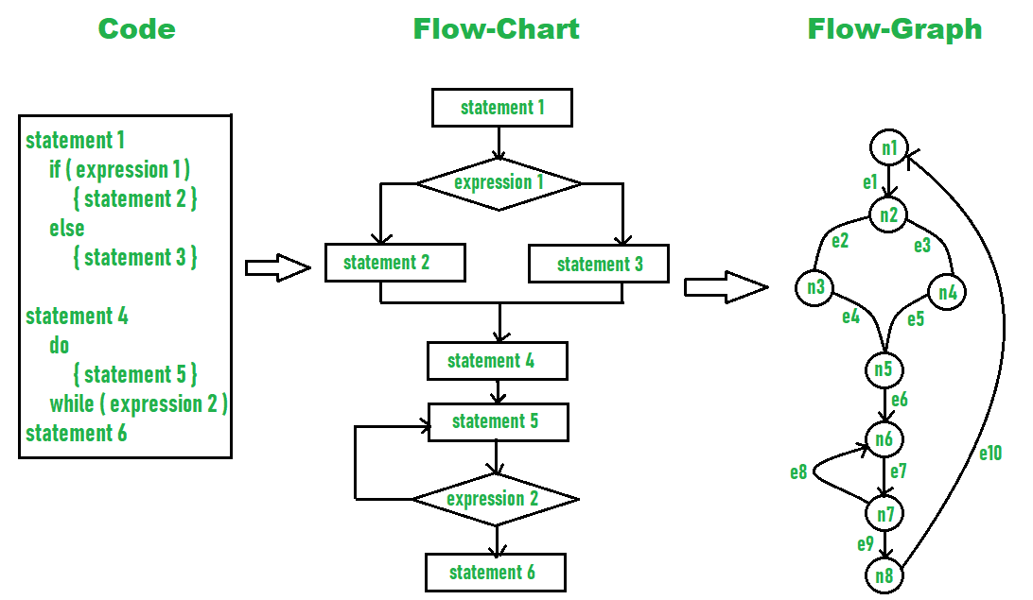

So, the Cyclomatic complexity can be calculated as -

*Given,  
E = 10,   
N = 8  
  
So,  
Cyclomatic complexity   
= E - N + 2   
= 10 – 8 + 2  
= 4*

**2. Depth of Inheritance Tree (DIT)**

It measures the levels in the inheritance hierarchy for a class or module. A DIT can indicate increased complexity as changes to the base classes can impact multiple levels of derived classes.

**3. Coupling**

This quantifies the number of classes that are coupled to a particular class. It suggests strong dependencies, which can increase the complexity and reduce the flexibility of the product.

**4. Weighted Methods per Class (WMC)**

This calculates the sum of complexities of methods within a class. It provides an estimate of the overall complexity of the class based on the size and the complexity of its methods.

**5. Component Dependency Metrics**

These are used to analyze the dependencies between different components within the design. Metrics such as fan-in and fan-out can indicate the complexity due to tight coupling.

**6. Architectural Complexity**

This evaluates the overall complexity of the architecture itself. High architectural complexity implies increased development and maintenance efforts.

**Quality Metrics**

Quality metrics for the design model focus on evaluating aspects that contribute to the overall quality, maintainability, and effectiveness of the design. They help to ensure that the design meets requirements, easy to understand, and is maintainable. Here are some commonly used quality metrics:

**Modularity:**This measures how well the design can be divided into cohesive and loosely coupled modules,

**Complexity:**Evaluate the complexity of the design model using metrics like cyclomatic complexity or the number of classes/ interfaces per package/ module.

**Abstraction:**Assess the level of abstraction in the design, indicating how well the design captures the essential aspects while hiding the unnecessary details.

**Coupling:**Measures the degree of interdependence between the modules.

**Cohesion:**This evaluates how well elements within a module belong together. High cohesion means that the elements within the module are closely related.

**Maintainability:**Assesses how easily design can be understood, modified, and extended over time. This includes ease of making changes and code readability.

**Compatibility:**Measures the compatibility of the design with the existing systems. This involves assessing the adherence to the standards and design patterns.

**Reusability:**Measures how easily the components within the design can be reused in other parts of the system. This may include the number of reusable components.

**Testability:**Measures how easily the design can be tested to ensure correctness and reliability. This includes the ease of writing the unit tests and integration tests.

**Scalability:**Measures how well the design can accommodate growing amounts of data, users, or transactions without sacrificing performance.

**Performance Metrics**

Performance metrics focus on evaluating how well the design supports the expected performance characteristics of the software system. These help in assessing the efficiency, scalability, responsiveness, and resource utilization of the design. Here are some commonly used performance metrics:

**Scalability:**It measures how well the design model accommodates the increase in workload. This includes evaluating the ability to handle large datasets, higher user loads, or increased complexity without significant degradation in performance.

**Response Time:**The time taken by the design model to respond to a user request. This metric is important for assessing the responsiveness of the product.

**Throughput:**Measure of the rate at which the design model can process tasks within a given time frame. This metric is important for systems handling large volumes of transactions.

**Resource Utilization:**Evaluation of the resources such as CPU, memory, and network bandwidth consumed by the design model during the operation. Efficient resource utilization ensures optimal performance.

**Latency:**The time taken for a request to travel from the source to the destination and back. Low latency is critical for real-time applications where timely responses are important.

**Memory Usage:**Involves the memory assessment of the design model as efficient memory management ensures optimal performance and minimizes resource contention.

**Energy Efficiency:**This involves energy assessment of the design model. This is important for mobile devices.

**Maintainability:**This relates to how easy is to maintain and modify the design model over time. This includes metrics like code complexity, modularity, and ease of debugging.

**Usability Metrics**

Usability metrics for the design model of the product focus on evaluating how user-friendly and effective is the design in meeting user expectations. It helps to ensure that the design model supports efficient navigation and overall user satisfaction. Here are some key usability metrics for the design model of the product:

**Efficiency:**Evaluates how quickly a user can complete the tasks once they are familiar with the design model. This includes metrics like task completion time and number of steps required to complete common actions.

**Effectiveness:**Evaluate the accuracy with which the users can achieve their goals using the design model. It includes metrics like error rates and task success rates.

**Learnability:**This measures how easy it is for first-time users to understand and navigate the design model. This can be assessed through the time taken to complete basic tasks and ease of understanding navigation pathways.

**Satisfaction:**Measures user satisfaction of the design model. This can be assessed through user feedback, user surveys, and qualitative assessment of user experiences.

**Visual Design Clarity:**Evaluate the clarity of visual elements within the design model. This involves assessing the layout, iconography, and color scheme.

**Accessibility:**Measures the extent to which the design model is accessible to users with special needs. This involves assessing compliance with accessibility standards (e.g., WCAG), support for assistive technologies, and ease of use for users with impairments.

**Navigation:**Evaluate the clarity and organization of the design model's navigation structure. This includes assessing the ease of finding information and consistency in navigation.

**Task Complexity:**Measures the complexity of tasks performed using the design model.

**Reliability Metrics**

Reliability metrics of the design model assess the ability to consistently perform as expected under various conditions over time. These metrics help stakeholders assess the robustness and dependability of the design model. Here are some common reliability metrics:

**Fault Tolerance:**Measures the design model's ability to continue operating properly in the presence of faults and failures. This includes assessing how well the design model handles unexpected inputs, errors in data, or component failures.

**Failure Rate:**Measures the frequency of failures encountered during operation. This involves evaluating the number of failures per unit of time.

**Mean Time Between Failure (MTBF):**Calculates the average time interval between consecutive failures of the design model. A higher MTBF indicates better reliability.

**Mean Time To Failure (MTTF):**Measures the average time until the design model experiences its first failure during operation.

**Robustness:**Evaluate the ability of the design model to function accurately even with unexpected inputs or variations in workload.

**Resilience:**Measures the ability of the design model to recover quickly from failures, thus minimizing the downtime and impact on users.

**Security Metrics**

Security metrics focus on evaluating the effectiveness of the design model in addressing security threats and vulnerabilities. These help in assessing the robustness of the design model's security mechanism. They help organizations identify weaknesses and prioritize security improvements. Here are some common security metrics for the design model of the product:

**Threat Modelling Coverage:**Measures the extent to which the potential threats and vulnerabilities are identified and addressed in the design model.

**Vulnerability Density:**Measures the density of the security vulnerabilities identified within the design model. This metric can be derived from code reviews, vulnerability scanning tools, and security assessments.

**Security Testing Coverage:**Measures the extent to which the security testing has been conducted on the design model.

**Resilience to Known Attacks:**Evaluate how well the design model withstands the known security threats. This includes assessing resilience to common threats such as SQL injection, cross-site scripting (XSS), etc.

**Completeness of Security Documentation:**Assess the completeness of the security-related documentation for the design model. This includes evaluating the security architecture diagrams, threat models, and security requirements.

**Scalability Metrics**

Scalability metrics for the design model of the product assess the ability to handle the increasing workload while maintaining performance and functionality. It is important that the product can adapt to the changing needs without significant redesign. Here are some common scalability metrics:

**Response Time Under Load:**Evaluate the response time of the design model when exposed to different levels of concurrent users.

**Concurrency Handling:**Assess the ability of the design model to manage multiple concurrent users without significant degradation in performance. This includes throughput and resource utilization under varying concurrent levels.

**Scaling Efficiency:**Measures how effectively the design model scales out by adding more nodes. This assesses the increase in workload capacity achieved by adding nodes.

**Database Scalability:**Assess the scalability of the database components within the design model. This includes database response times and transaction throughput.

**Network Scalability:**Measures the scalability of the network components used within the design model. These metrics include network latency, bandwidth utilization, and the ability to handle increased data traffic.

**Cost Metrics**

Cost metrics for the design model of the product are important for evaluating the financial implications associated with developing and maintaining the product. This helps stakeholders understand and manage costs effectively throughout the product lifecycle. Here are key cost metrics relevant to the design model:

**Development Cost:**Measures the total expenses incurred during the design phase. This includes salaries of designers, software tools and licenses, and other development expenses.

**Equipment Costs:**This includes the costs associated with specialized tools, equipment, and software used in the design process.

**Testing Costs:**Measures the expenses related to building prototypes, conducting testing, and validating the design model. This includes material costs and labor costs for testing.

**Maintenance Costs:**Measures the ongoing costs to maintain and support the design model. This includes costs for updates, bug fixes, and user support.

**Training Costs:**Measures the expenses related to training personnel on effectively using the design model. This includes training sessions and external training services.

**Conclusion**

In conclusion, the metrics for the design model of the product are essential for guiding development towards our goals. Tracking factors such as usability, scalability, and maintainability helps to ensure that the design meets the customer's requirements. These metrics serve as a benchmark for success and enable us to innovate effectively and deliver a product that stands out in both performance and user satisfaction.

**Software Measurement and Metrics**

Last Updated : 02 Apr, 2024

**Software Measurement:** A measurement is a manifestation of the size, quantity, amount, or dimension of a particular attribute of a product or process. Software measurement is a titrate impute of a characteristic of a software product or the software process.

**Table of Content**

[Software Measurement Principles](https://www.geeksforgeeks.org/software-engineering/software-measurement-and-metrics/#software-measurement-principles)

[Need for Software Measurement](https://www.geeksforgeeks.org/software-engineering/software-measurement-and-metrics/#need-for-software-measurement)

[Classification of Software Measurement](https://www.geeksforgeeks.org/software-engineering/software-measurement-and-metrics/#classification-of-software-measurement)

[Software Metrics](https://www.geeksforgeeks.org/software-engineering/software-measurement-and-metrics/#software-metrics)

[Characteristics of software Metrics](https://www.geeksforgeeks.org/software-engineering/software-measurement-and-metrics/#characteristics-of-software-metrics)

[Types of Software Metrics](https://www.geeksforgeeks.org/software-engineering/software-measurement-and-metrics/#types-of-software-metrics)

[Advantages of Software Metrics](https://www.geeksforgeeks.org/software-engineering/software-measurement-and-metrics/#advantages-of-software-metrics)

[Disadvantages of Software Metrics](https://www.geeksforgeeks.org/software-engineering/software-measurement-and-metrics/#disadvantages-of-software-metrics)

It is an authority within software engineering. The software measurement process is defined and governed by ISO Standard.

**Software Measurement Principles**

The software measurement process can be characterized by five activities-

**Formulation:**The derivation of software measures and metrics appropriate for the representation of the software that is being considered.

**Collection:** The mechanism used to accumulate data required to derive the formulated metrics.

**Analysis:** The computation of metrics and the application of mathematical tools.

**Interpretation:**The evaluation of metrics results in insight into the quality of the representation.

**Feedback:**Recommendation derived from the interpretation of product metrics transmitted to the software team.

**Need for Software Measurement**

Software is measured to:

Create the quality of the current product or process.

Anticipate future qualities of the product or process.

Enhance the quality of a product or process.

Regulate the state of the project concerning budget and schedule.

Enable data-driven decision-making in project planning and control.

Identify bottlenecks and areas for improvement to drive process improvement activities.

Ensure that industry standards and regulations are followed.

Give software products and processes a quantitative basis for evaluation.

Enable the ongoing improvement of software development practices.

**Classification of Software Measurement**

There are 2 types of software measurement:

**Direct Measurement:** In direct measurement, the product, process, or thing is measured directly using a standard scale.

**Indirect Measurement:** In indirect measurement, the quantity or quality to be measured is measured using related parameters i.e. by use of reference.

**Software Metrics**

A metric is a measurement of the level at which any impute belongs to a system product or process.

Software metrics are a quantifiable or countable assessment of the attributes of a software product. There are 4 functions related to software metrics:

**Planning**

**Organizing**

**Controlling**

**Improving**

**Characteristics of software Metrics**

**Quantitative:** Metrics must possess a quantitative nature. It means metrics can be expressed in numerical values.

**Understandable:** Metric computation should be easily understood, and the method of computing metrics should be clearly defined.

**Applicability:** Metrics should be applicable in the initial phases of the development of the software.

**Repeatable:** When measured repeatedly, the metric values should be the same and consistent.

**Economical:** The computation of metrics should be economical.

**Language Independent:** Metrics should not depend on any programming language.

**Types of Software MetricsTypes of Software Metrics**

**Product Metrics:** Product metrics are used to evaluate the state of the product, tracing risks and undercover prospective problem areas. The ability of the team to control quality is evaluated. Examples include lines of code, cyclomatic complexity, code coverage, defect density, and code maintainability index.

**Process Metrics:** Process metrics pay particular attention to enhancing the long-term process of the team or organization. These metrics are used to optimize the development process and maintenance activities of software. Examples include effort variance, schedule variance, defect injection rate, and lead time.

**Project Metrics:** The project metrics describes the characteristic and execution of a project. Examples include effort estimation accuracy, schedule deviation, cost variance, and productivity. Usually measures-

Number of software developer

Staffing patterns over the life cycle of software

Cost and schedule

Productivity

**Advantages of Software Metrics**

Reduction in cost or budget.

It helps to identify the particular area for improvising.

It helps to increase the product quality.

Managing the workloads and teams.

Reduction in overall time to produce the product,.

It helps to determine the complexity of the code and to test the code with resources.

It helps in providing effective planning, controlling and managing of the entire product.

**Disadvantages of Software Metrics**

It is expensive and difficult to implement the metrics in some cases.

Performance of the entire team or an individual from the team can't be determined. Only the performance of the product is determined.

Sometimes the quality of the product is not met with the expectation.

It leads to measure the unwanted data which is wastage of time.

Measuring the incorrect data leads to make wrong decision making.

Object Oriented Metrics in Software Engineering

Last Updated : 20 Aug, 2022

These are used to determine success or failure of a person also to quantify the improvements in the software throughout its process. These metrics can be used to reinforce good OO programming technique which lead to more reliable code. Object-oriented software engineering metrics are units of measurement that are used to characterize:

object-oriented software engineering products, e.g., designs source code, and the test cases.

object-oriented software engineering processes, e.g., designing and coding.

object-oriented software engineering people, e.g., productivity of an individual designer.

Why are Object-Oriented Software Engineering Metrics Different?

OOSE is different because of the following reasons as depicted in the following figure:

Localization : It is the process of placing items in close physical nearness to each other.

Functional decomposition processes localize information around functions.

Data-driven approaches localize information around data.

Object-oriented approaches localize information around objects.

In object-oriented software , from the name suggests the localization is based on objects. This means:

Although we may speak of the functionality provided by an object, atleast some of our metrics identification and gathering effort must recognize the "object" as basic unit of software.

Within systems of objects, localization between functionality and objects is not one-to-one relationships. For example, there are many objects for one function and also one object can have many functions.

Encapsulation : It is the packaging of a collection of items.

Low-level examples of encapsulation include records and arrays.

Subprograms are mid level mechanisms for encapsulation.

There are still very long encapsulation mechanisms for the object-oriented programming languages, e.g., C++'s, classes, Ada's packages, and Modula 3's modules.

Objects encapsulates:

Knowledge of state

Advertised capabilities

Other objects

Exceptions

Constants

Concepts

Information Hiding: It is the suppression or hiding of the objects.

We show only the information which is needed to accomplish our goals.

Degree of information hiding ranges from partially restricted visibility to total invisibility.

Encapsulation and information hiding are not same thing e.g., an item can be encapsulated but still be to totally visible.

It plays a direct role in such metrics as object coupling and the degree of information hiding.

Inheritance: It is mechanism where one object acquires the characteristics from one, or more , other objects.

Some object-oriented languages support only single inheritance.

Some object-oriented languages support only multiple inheritance.

Inheritance type and their semantics vary from language to language.

There are many object-oriented software engineering metrics which are based on inheritance e.g.,

number of children

number of parents

class hierarchy nesting level

Abstraction: It is the mechanism where we focus only on important details of a concept, while ignoring the in essential details.

It is a relative concept.

There are also different categories of abstraction, e.g., functional data, process and object abstraction.

Objects are treated as high-level entities in object abstraction.

Classes: There are three commonly used views on the definition for "class".

Class as a cookie cutter: For the structurally identically items, a class is a pattern, template, or a blueprint. The items which can be created using class are called instances.

Class as an instance factory: Basically class is a thing which contains both a pattern and a mechanism for creating items based on that pattern and instances are like individual items that are "manufactured" by using class creation mechanism.

A class is a set of all the items which are created using a specific pattern, i.e., the class is the set of all instances of that pattern.

**Measuring Software Quality using Quality Metrics**

Last Updated : 15 Jul, 2025

In [Software Engineering](https://www.geeksforgeeks.org/software-engineering/software-engineering-introduction-to-software-engineering/), Software Measurement is done based on some [Software Metrics](https://www.geeksforgeeks.org/software-engineering/software-measurement-and-metrics/) where these software metrics are referred to as the measure of various characteristics of a [Software](https://www.geeksforgeeks.org/computer-science-fundamentals/software-concepts/).   
  
In Software engineering [Software Quality Assurance (SAQ)](https://www.geeksforgeeks.org/software-testing/software-engineering-software-quality-assurance/) assures the quality of the software. A set of activities in SAQ is continuously applied throughout the software process. [Software Quality](https://www.geeksforgeeks.org/software-engineering/software-engineering-software-quality/) is measured based on some software quality metrics.   
  
There is a number of metrics available based on which software quality is measured. But among them, there are a few most useful metrics which are essential in software quality measurement. They are -

Code Quality

Reliability

Performance

Usability

Correctness

Maintainability

Integrity

Security

**Now let's understand each quality**metric**in detail -**   
  
**1. Code Quality -** Code quality metrics measure the quality of code used for software project development. Maintaining the software code quality by writing Bug-free and semantically correct code is very important for good software project development. In code quality, both Quantitative metrics like the number of lines, complexity, functions, rate of bugs generation, etc, and Qualitative metrics like readability, code clarity, efficiency, and maintainability, etc are measured.   
  
**2. Reliability -** Reliability metrics express the reliability of software in different conditions. The software is able to provide exact service at the right time or not checked. Reliability can be checked using Mean Time Between Failure (MTBF) and Mean Time To Repair (MTTR).   
  
**3. Performance -** Performance metrics are used to measure the performance of the software. Each software has been developed for some specific purposes. Performance metrics measure the performance of the software by determining whether the software is fulfilling the user requirements or not, by analyzing how much time and resource it is utilizing for providing the service.   
  
**4. Usability -** Usability metrics check whether the program is user-friendly or not. Each software is used by the end-user. So it is important to measure that the end-user is happy or not by using this software.   
  
**5. Correctness -** Correctness is one of the important software quality metrics as this checks whether the system or software is working correctly without any error by satisfying the user. Correctness gives the degree of service each function provides as per developed.   
  
**6. Maintainability -** Each software product requires maintenance and up-gradation. Maintenance is an expensive and time-consuming process. So if the software product provides easy maintainability then we can say software quality is up to mark. Maintainability metrics include the time required to adapt to new features/functionality, Mean Time to Change (MTTC), performance in changing environments, etc.   
  
**7. Integrity -** Software integrity is important in terms of how much it is easy to integrate with other required software which increases software functionality and what is the control on integration from unauthorized software's which increases the chances of cyberattacks.   
  
**8. Security -** Security metrics measure how secure the software is. In the age of cyber terrorism, security is the most essential part of every software. Security assures that there are no unauthorized changes, no fear of cyber attacks, etc when the software product is in use by the end-user.

Software Project Management (SPM) - Software Engineering

Last Updated : 11 Jul, 2025

Software Project Management (SPM) is a proper way of planning and leading software projects. It is a part of project management in which software projects are planned, implemented, monitored, and controlled.

In this article, we are discussing Software Project Management (SPM) topics that are useful to learn.

Table of Content

What is Software Project Management (SPM)?

Need for Software Project Management

Types of Management in SPM

Aspects of Software Project Management

Drawbacks of Software Project Management

What is Software Project Management (SPM)?

Software Project Management (SPM) is all about planning, organizing, and observing the software development process to make sure the project is completed successfully, on time, and within budget. It involves tasks like planning, defining the project scope, calculating how much time and resources are needed, scheduling tasks, allocating resources, and tracking progress.

The ultimate goal is to deliver a high-quality software product that meets the needs and expectations of the users.

Need for Software Project Management

Software is a non-physical product. Software Development is a new stream in business, and there is very little experience in building software products. Most of the software products are made to fit clients’ requirements. The most important thing is that basic technology changes and advances so frequently and rapidly that the experience of one product may not be applied to another one.

Such types of business and environmental constraints increase Risk in Software Development hence it is essential to manage software projects efficiently. It is necessary for an organization to deliver quality products, keep the cost within the client’s budget constraint, and deliver the project as per schedule. Hence, in order, software project management is necessary to incorporate user requirements along with budget and time constraints.

Types of Management in SPM

1. Conflict Management

Conflict management is the process to restrict the negative features of conflict while increasing the positive features of conflict. The goal of conflict management is to improve learning and group results including efficacy or performance in an organizational setting. Properly managed conflict can enhance group results.

2. Risk Management

Risk management is the analysis and identification of risks that is followed by synchronized and economical implementation of resources to minimize, operate and control the possibility or effect of unfortunate events or to maximize the realization of opportunities.

3. Requirement Management

It is the process of analyzing, prioritizing, tracking, and documenting requirements and then supervising change and communicating to pertinent stakeholders. It is a continuous process during a project.

4. Change Management

Change Management is a systematic approach to dealing with the transition or transformation of an organization's goals, processes, or technologies. The purpose of change management is to execute strategies for effecting change, controlling change, and helping people to adapt to change.

5. Software Configuration Management

Software configuration management is the process of controlling and tracking changes in the software, part of the larger cross-disciplinary field of configuration management. Software Configuration Management includes revision control and the inauguration of baselines.

6. Release Management

Release Management is the task of planning, controlling, and scheduling the built-in deploying releases. Release management ensures that the organization delivers new and enhanced services required by the customer while protecting the integrity of existing services.

Aspects of Software Project Management

Software project management involves several key aspects that help guide the development process from start to finish. These aspects verify that the project stays on track, meets user needs, and is delivered within time and budget constraints. Here are the main aspects of software project management:

aspects-project-management

Aspects of Project Management

1. Planning

The Software Project Manager lays out the complete project's blueprint. The project plan will outline the scope, resources, timelines, techniques, strategy, communication, testing, and maintenance steps. SPM can aid greatly here.

2. Leading

A software project manager brings together and leads a team of engineers, strategists, programmers, designers, and data scientists. Leading a team necessitates exceptional communication, interpersonal, and leadership abilities. One can only hope to do this effectively if one sticks with the core SPM principles.

3. Execution

SPM comes to the rescue here also as the person in charge of software projects (if well versed with SPM/Agile methodologies) will ensure that each stage of the project is completed successfully. measuring progress, monitoring to check how teams function, and generating status reports are all part of this process.

4. Time Management

Abiding by a timeline is crucial to completing deliverables successfully. This is especially difficult when managing software projects because changes to the original project charter are unavoidable over time. To assure progress in the face of blockages or changes, software project managers ought to be specialists in managing risk and emergency preparedness. This Risk Mitigation and

Management is one of the core tenets of the philosophy of SPM.

5. Budget

Software Project Managers, like conventional project managers, are responsible for generating a project budget and adhering to it as closely as feasible, regulating spending, and reassigning funds as needed. SPM teaches us how to effectively manage the monetary aspect of projects to avoid running into a financial crunch later on in the project.

6. Maintenance

Software project management emphasizes continuous product testing to find and repair defects early, tailor the end product to the needs of the client, and keep the project on track. The Software Project Manager makes ensuring that the product is thoroughly tested, analyzed, and adjusted as needed. Another point in favor of SPM.

Drawbacks of Software Project Management

Numerous issues can develop if a Software project manager lacks the necessary expertise or knowledge. Software Project management has several drawbacks, including resource loss, scheduling difficulty, data protection concerns, and interpersonal conflicts between Developers/Engineers/Stakeholders.

1. Costs are High

Consider spending money on various kinds of project management tools, software, & services if ones engage in Software Project Management strategies. These initiatives can be expensive and time-consuming to put in place. Because your team will be using them as well, they may require training. One may need to recruit subject-matter experts or specialists to assist with a project, depending on the circumstances. Stakeholders will frequently press for the inclusion of features that were not originally envisioned. All of these factors can quickly drive up a project's cost.

2. Complexity will be increased

Software Project management is a multi-stage, complex process. Unfortunately, some specialists might have a propensity to overcomplicate everything, which can lead to confusion among teams and lead to delays in project completion. Their expressions are very strong and specific in their ideas, resulting in a difficult work atmosphere. Projects having a larger scope are typically more arduous to complete, especially if there isn't a dedicated team committed completely to the project. Members of cross-functional teams may lag far behind their daily tasks, adding to the overall complexity of the project being worked on.

3. Overhead in Communication

Recruits enter your organization when we hire software project management personnel. This provides a steady flow of communication that may or may not match a company's culture. As a result, it is advised that you maintain your crew as

small as feasible. The communication overhead tends to skyrocket when a team becomes large enough. When a large team is needed for a project, it's critical to identify software project managers who can conduct effective communication with a variety of people.

4. Lack of Originality

Software Project managers can sometimes provide little or no space for creativity. Team leaders either place an excessive amount of emphasis on management processes or impose hard deadlines on their employees, requiring them to develop and operate code within stringent guidelines. This can stifle innovative thought and innovation that could be beneficial to the project. When it comes to Software project management, knowing when to encourage creativity and when to stick to the project plan is crucial. Without Software project management personnel, an organization can perhaps build and ship code more quickly. However, employing a trained specialist to handle these areas, on the other hand, can open up new doors and help the organization achieve its objectives more

quickly and more thoroughly.

Conclusion

Software Project Management (SPM) plays a important role in the success of software development. It requires project managers to have strong leadership, communication, and problem-solving skills. When project managers manage their projects effectively, they can guide their teams toward achieving business goals and delivering high-quality software products.

What is Stakeholder? Defination, Types and Examples

Last Updated : 08 Jan, 2024

In simple words, anyone having any type of relation/interest in the project is known as a stakeholder. The term Software Project Stakeholder refers to, "a person, group or company that is directly or indirectly involved in the project and who may affect or get affected by the outcome of the project".

Table of Content

What is Stakeholder?

Understanding Stakeholders

Why Are Stakeholders Important?

Different Types of Stakeholders

Issues Concerning Stakeholders

Stakeholders vs. Shareholders

What Is an Example of a Stakeholder?

What Are the Stakeholders in a Business?

Are Stakeholders and Shareholders are Same?

Conclusion

stakeholders

What is Stakeholder?

It is the process of a company that can impact or get impacted by a decision, activity, or the outcome of the software project. It is important to identify the exact requirements of the project and what various stakeholders are expecting from the project outcome.

Understanding Stakeholders

Stakeholders are either inside or outside the company. Internal ones are like employees or owners and are directly connected to the business. External ones are suppliers or the public that are the part of the company but still influenced by the actions.

Why Are Stakeholders Important?

Stakeholders are the significant for the several Reasons.

In internal Stakeholders employees are more significant because they need to collaborate effective to achieve the company the goals.

External Stakeholders are included the suppliers and governments can impact the business indirectly.

For Example, customer may change how they can buy, suppliers alter they make and deliver the products and governments can modify laws. overall the building the good relationship with both internal and external Stakeholders is essential for a business to success in the long run.

Different Types of Stakeholders

stakeholders-types

Type of Stakeholders

Internal Stakeholder

An internal stakeholder is a person, group, or company that is directly involved in the project. For Example,

Project Manager: Responsible for managing the whole project. The project Manager is generally never involved in producing the end product but he/she controls, monitors, and manages the activities involved in the production.

Project Team: Performs the actual work of the project under the Project Manager including development, testing, etc.

Company: An organization that has taken up the project and whose employees are directly involved in the development of the project.

Funders: Provides funds and resources for the successful completion of the project.

External Stakeholder

An external stakeholder is linked indirectly to the project but has a significant contribution to the successful completion of the project. For example,

Customer: Specifies the requirements of the project and helps in the elicitation process of the requirement-gathering phase. The customer is the one for whom the project is being developed.

Supplier: Supplies essential services and equipment for the project.

Government: Makes policies that help in better working of the organization.

Issues Concerning Stakeholders

Companies often face challenges when they need and goals of different group involved knows as a stakeholder isn't match up.

The stakeholders want the company can make money as much they can possible.

These can lead the company to make the money.

The best ways to find balanced and meets the needs of all their stakeholders.

Stakeholders vs. Shareholders

Shareholders are the group of people in a company, and all stakeholders having reasons to connected to the company Usually it's a long time because they want something from the company. Shareholders are always interested in a money, but they can sell their ownership in the company and whenever they want.

If a company is not doing well financially, the suppliers providing materials or service to the company may be affected and that reason the employees might lose their jobs, as per comparison the shareholder can sell their ownership in the company and avoid spending too much money.

What Is an Example of a Stakeholder?

When a business fails and can't pay its debts in the specific order. The different groups of people get their money back.

Firstly which one having full guarantee that will get paid then come others without a guarantee with the instruction which told by the stakeholders and last commonly stock owners, Unfortunately the common stock owner having not gets that much.

This situation shows that everyone which involved that having the rights.

For example, the workers in the failed company might lose their jobs without receiving any extra payment.

What Are the Stakeholders in a Business?

Stakeholders in a business are anyone connected to how a company runs and whether it succeeds or fails.

The owners both active and passive investors are the first group.

Creditors like banks come next if there are loans.

Employees and suppliers who depend on the company goods or services are also stakeholders.

Are Stakeholders and Shareholders are Same?

While shareholders matter, they're not the only ones. Employees, Customers, Suppliers, Governments, and the public are also Stakeholders. These are a way to consider the wider range of people connected to a business.

Conclusion

Stakeholders are people or group of who care about how which organization perform. They can be inside the organization include the customer's shareholders, communities and governments.

This is the fourth in a series of posts on effective software development. This series [has discussed](https://medium.com/@JoeEmison/good-software-development-its-not-like-construction-f65e00d26a51) of what makes modern software development so much more effective than traditional software development: frequent releases and constant velocity forever. And then it continued with an explanation of how [an organization should run](https://medium.com/@JoeEmison/software-development-starts-with-the-product-5e038264507e) its products and technology teams so that the amount of work delivered to the development team to build is small enough and iterative enough so that these frequent releases can actually be done.

But even if your organization is doing this product side right and down-scoping features and iterating designs against users and subject-matter experts for validation, if you are not following effective software development lifecycle practices, you will fail to execute this modern software development.

In effective modern software development, development teams have a knowable velocity with minimal regression. This means that the development team can turn out new features and bug fixes and other things that need to be implemented in code frequently enough so that it is possible to release software all the time and for those releases to have meaningful changes at each release.This means that the number of bugs that come up — regressions — has to be minimal. Otherwise, the team will spend all of its time fixing bugs.

Below, I describe the four key processes that software development teams have to practice if they are going to be able to execute in this way.

**Small Stories**

Here’s process number one: small story sizes. Developers get their work in tickets, often called “stories” today because each should be written as a “user story” so that the developer understands why the work is being done and has empathy for and understanding of the user.

Small stories are great for several reasons. First, if the story calls for no more than about a day and a half of work, then if a developer miscalculates the time estimate for the job by 25 percent, that is still less than a day of additional work. This means that it’s easily possible on a weekly basis to understand whether a project is on schedule or not. If stories are estimated to take weeks, then it’s incredibly difficult to know you’re behind until after the deadline has passed.

Second, large stories tend to not be very well-specified. If a developer is given a story that she thinks will take about two weeks to do, she almost certainly will need more information than what has been written down for her. If, instead, that two weeks of work is broken down into ten different stories, each one of those probably has a rigorous enough definition so that she doesn’t have to go hunting around for whoever wrote the story to understand the additional details she needs to write the code.

**Branching / Separate Work Spaces**

The second critical practice is branching (or allowing each development to work separately in her own space) on every piece of work that needs to be done. It is still quite common for development teams to all be working on the same copy of the code stored somewhere centrally.

[[](https://medium.com/plans?source=upgrade_membership---post_li_non_moc_upsell--ee568eb40515---------------------------------------)](https://medium.com/plans?source=upgrade_membership---post_li_non_moc_upsell--ee568eb40515---------------------------------------)

If you are a developer working on the same copy of the code in which another developer is breaking things, your work will be disrupted, and the day and a half that you estimated for the ticket may turn into three or four days because errors created by other developers.

In addition, if you are creating regressions in your code, you should identify those and fix those before you merged more new code in with the general population. Otherwise, whoever finds the problem that you have created now has to go track you down (which is usually difficult if everyone’s editing the same copy of the code) or has to go diagnose the problem herself, causing more delay.

**Automated Testing**

The third critical practice is automated testing. When you are a developer and you are working in your branch, you need an easy way to know whether or not you broke something by adding your new code. This means that someone needs to write a bunch of automated tests to validate that people aren’t breaking things.

I find that most effective development organizations have developers write their own tests to protect the features that they have added, but the key here is to have them deliver automated testing instead of manual quality assurance (QA) process that takes days. Also, manual QA almost never works in an environment where you have a branch for each separate piece of work that is being done. That is simply too many different things to test for manual QA to make sense financially. So manual QA can only be run once the individual branches have been merged, which means that each bug requires the “find who broke this” process, which is an unnecessarily slow and painful process vs. having automated tests.

Manual QA is often still necessary for some parts of applications, where automated testing is very difficult or impractical. But it is essentially impossible to do multiple releases per week if you have a substantial amount of manual QA to do for each release.

Many people think that it is impossible to get automated testing in place on existing projects where there is no test coverage or mechanism in place for writing or running tests already. For all of you, please stay tuned for the next post, where I will discuss how to adopt these practices with existing applications, without having to stop all forward progress on feature development for weeks or months.

**Code Review**

The fourth critical practice is code review. There is a traditional programmer adage which says “write code like the next programmer who has to work with your code is holding a gun to your head.” Code review is like getting that next programmer to look at your code and give you comments before you merge your code with the general population.

Code review does a number of great things. It means that there are several sets of eyes on code before it gets merged with the existing code base. Really effective teams usually have a fairly strict style guide, and so there is usually only one correct way to write a particular section of code. In addition, most great teams have every developer reviewing code, not just one or two senior developers. This enables really good cross-understanding of the code base, making it much easier for everyone to continue working with this code base into the future and delivering the kind of velocity and frequent releases that are necessary.

While there are other great processes that effective teams often follow, the above four elements are critical to effective modern software development. If you lack any one of the above four, you will not be able to deliver a constant velocity with minimal regressions with a scalable team for an extended period of time.

**System configuration management - Software Engineering**

Last Updated : 11 Jul, 2025

Whenever software is built, there is always scope for improvement and those improvements bring picture changes. Changes may be required to modify or update any existing solution or to create a new solution for a problem. Requirements keep on changing daily so we need to keep on upgrading our systems based on the current requirements and needs to meet desired outputs. Changes should be analyzed before they are made to the existing system, recorded before they are implemented, reported to have details of before and after, and controlled in a manner that will improve quality and reduce error. This is where the need for System Configuration Management comes. **System Configuration Management (SCM)** is an arrangement of exercises that controls change by recognizing the items for change, setting up connections between those things, making/characterizing instruments for overseeing diverse variants, controlling the changes being executed in the current framework, inspecting and revealing/reporting on the changes made. It is essential to control the changes because if the changes are not checked legitimately then they may wind up undermining a well-run programming. In this way, SCM is a fundamental piece of all project management activities.

**Processes involved in SCM -** Configuration management provides a disciplined environment for smooth control of work products. It involves the following activities:

**Identification and Establishment -** Identifying the configuration items from products that compose baselines at given points in time (a baseline is a set of mutually consistent Configuration Items, which has been formally reviewed and agreed upon, and serves as the basis of further development). Establishing relationships among items, creating a mechanism to manage multiple levels of control and procedure for the change management system.

**Version control -** Creating versions/specifications of the existing product to build new products with the help of the SCM system. A description of the version is given below: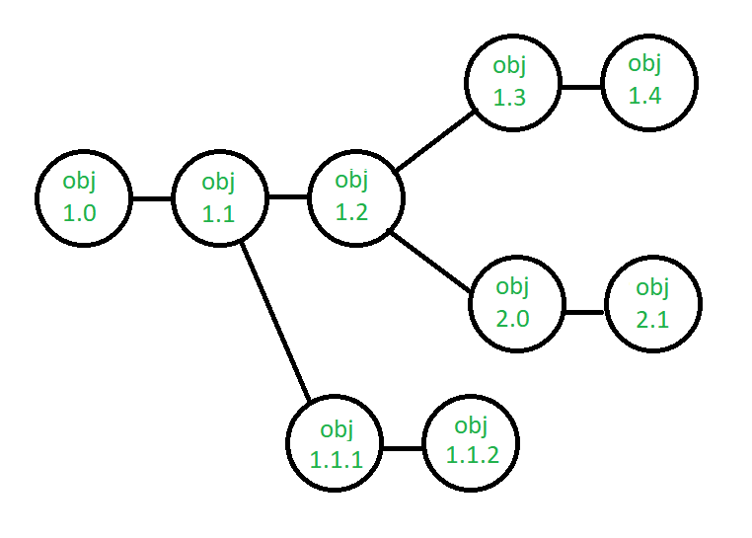Suppose after some changes, the version of the configuration object changes from 1.0 to 1.1. Minor corrections and changes result in versions 1.1.1 and 1.1.2, which is followed by a major update that is object 1.2. The development of object 1.0 continues through 1.3 and 1.4, but finally, a noteworthy change to the object results in a new evolutionary path, version 2.0. Both versions are currently supported.

**Change control -** Controlling changes to Configuration items (CI). The change control process is explained in Figure below: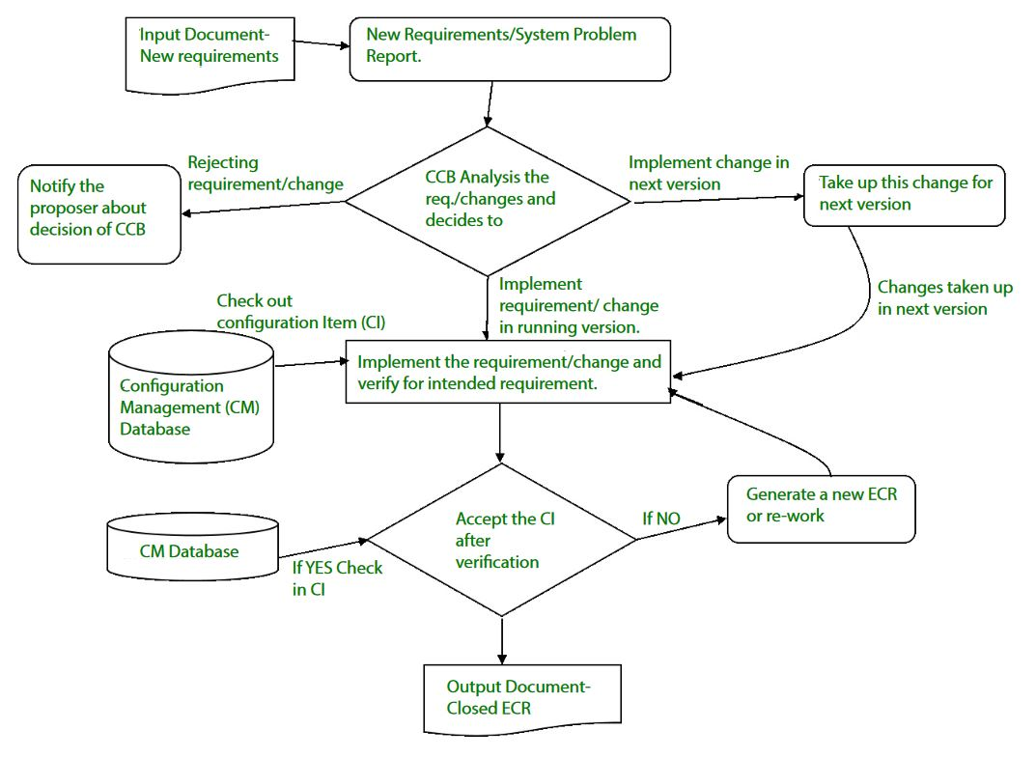A change request (CR) is submitted and evaluated to assess technical merit, potential side effects, the overall impact on other configuration objects and system functions, and the projected cost of the change. The results of the evaluation are presented as a change report, which is used by a change control board (CCB) —a person or group who makes a final decision on the status and priority of the change. An engineering change Request (ECR) is generated for each approved change. Also, CCB notifies the developer in case the change is rejected with proper reason. The ECR describes the change to be made, the constraints that must be respected, and the criteria for review and audit. The object to be changed is "checked out" of the project database, the change is made, and then the object is tested again. The object is then "checked in" to the database and appropriate version control mechanisms are used to create the next version of the software.

**Configuration auditing -** A software configuration audit complements the formal technical review of the process and product. It focuses on the technical correctness of the configuration object that has been modified. The audit confirms the completeness, correctness, and consistency of items in the SCM system and tracks action items from the audit to closure.

**Reporting -** Providing accurate status and current configuration data to developers, testers, end users, customers, and stakeholders through admin guides, user guides, FAQs, Release notes, Memos, Installation Guide, Configuration guides, etc.

System Configuration Management (SCM) is a software engineering practice that focuses on managing the configuration of software systems and ensuring that software components are properly controlled, tracked, and stored. It is a critical aspect of [software development](https://www.geeksforgeeks.org/software-engineering/software-development/), as it helps to ensure that changes made to a software system are properly coordinated and that the system is always in a known and stable state.

SCM involves a set of processes and tools that help to manage the different components of a software system, including source code, documentation, and other assets. It enables teams to track changes made to the software system, identify when and why changes were made, and manage the integration of these changes into the final product.

**Importance of Software Configuration Management**

Effective Bug Tracking: Linking code modifications to issues that have been reported, makes bug tracking more effective.

Continuous Deployment and Integration: SCM combines with continuous processes to automate deployment and testing, resulting in more dependable and timely software delivery.

Risk management: SCM lowers the chance of introducing critical flaws by assisting in the early detection and correction of problems.

Support for Big Projects: Source Code Control (SCM) offers an orderly method to handle code modifications for big projects, fostering a well-organized development process.

Reproducibility: By recording precise versions of code, libraries, and dependencies, source code versioning (SCM) makes builds repeatable.

Parallel Development: SCM facilitates parallel development by enabling several developers to collaborate on various branches at once.

**Why need for System configuration management?**

Replicability: Software version control (SCM) makes ensures that a software system can be replicated at any stage of its development. This is necessary for testing, debugging, and upholding consistent environments in production, testing, and development.

Identification of Configuration: Source code, documentation, and executable files are examples of configuration elements that SCM helps in locating and labeling. The management of a system's constituent parts and their interactions depend on this identification.

Effective Process of Development: By automating monotonous processes like managing dependencies, merging changes, and resolving disputes, SCM simplifies the development process. Error risk is decreased and efficiency is increased because of this automation.

**Key objectives of SCM**

**Control the evolution of software systems:**SCM helps to ensure that changes to a software system are properly planned, tested, and integrated into the final product.

**Enable collaboration and coordination:**SCM helps teams to collaborate and coordinate their work, ensuring that changes are properly integrated and that everyone is working from the same version of the software system.

**Provide version control:** SCM provides version control for software systems, enabling teams to manage and track different versions of the system and to revert to earlier versions if necessary.

**Facilitate replication and distribution:** SCM helps to ensure that software systems can be easily replicated and distributed to other environments, such as test, production, and customer sites.

SCM is a critical component of [software development](https://www.geeksforgeeks.org/software-engineering/what-is-software-development/), and effective SCM practices can help to improve the quality and reliability of software systems, as well as increase efficiency and reduce the risk of errors.

**The main advantages of SCM**

Improved productivity and efficiency by reducing the time and effort required to manage software changes.

Reduced risk of errors and defects by ensuring that all changes were properly tested and validated.

Increased collaboration and communication among team members by providing a central repository for software artifacts.

Improved quality and stability of software systems by ensuring that all changes are properly controlled and managed.

**The main disadvantages of SCM**

Increased complexity and overhead, particularly in large software systems.

Difficulty in managing dependencies and ensuring that all changes are properly integrated.

Potential for conflicts and delays, particularly in large development teams with multiple contributors.

**What Is Configuration Management in Software Engineering?**

[**Configuration management**](https://configu.com/blog/configuration-management-what-devops-teams-need-to-know/) in software engineering refers to the systematic approach to managing changes to configuration in software applications. It is crucial for maintaining the integrity and traceability of software products, helping manage complexity and ensure consistency in performance and functionality. It also reduces security risks that can stem from unauthorized or unintended configuration changes.

The primary goal of configuration management is to provide a stable, reliable software environment, facilitating teamwork and communication, and enabling the early detection and correction of errors.

This is part of a series of articles about [**Configuration Management**](https://configu.com/blog/configuration-management-what-devops-teams-need-to-know/)

In this article:

[**What Is Configuration Management in Software Engineering?**](https://configu.com/blog/configuration-management-in-software-engineering-a-practical-guide/#What_Is_Configuration_Management_in_Software_Engineering)

[**How Does Configuration Management Fit into Agile, DevOps, and CI/CD Practices?**](https://configu.com/blog/configuration-management-in-software-engineering-a-practical-guide/#How_Does_Configuration_Management_Fit_into_Agile_DevOps_and_CICD_Practices)

[**Key Steps to Software Configuration Management**](https://configu.com/blog/configuration-management-in-software-engineering-a-practical-guide/#Key_Steps_to_Software_Configuration_Management)

[**Tips From the Expert**](https://configu.com/blog/configuration-management-in-software-engineering-a-practical-guide/#Tips_From_the_Expert)

[**Why Use a Configuration Management Platform?**](https://configu.com/blog/configuration-management-in-software-engineering-a-practical-guide/#Why_Use_a_Configuration_Management_Platform)

[**Key Features of Software Configuration Management Platforms**](https://configu.com/blog/configuration-management-in-software-engineering-a-practical-guide/#Key_Features_of_Software_Configuration_Management_Platforms)

[**Configu: The Leading Configuration Management Platform for Your Applications**](https://configu.com/blog/configuration-management-in-software-engineering-a-practical-guide/#Configu_The_Leading_Configuration_Management_Platform_for_Your_Applications)

**How Does Configuration Management Fit into Agile, DevOps, and CI/CD Practices?**

Configuration management plays an important role in modern software development practices such as agile, DevOps, and Continuous Integration/Continuous Delivery (CI/CD).

**Agile Configuration Management**

In agile software development, which champions iterative development, configuration management helps in managing the frequent changes made to software configuration. It allows teams to keep track of all the changes made during each iteration and ensures that the final product is consistent with the initial requirements.

Agile teams typically use version control systems and other tools to manage iterative development of their source code. However, version control and collaboration over configuration files is an emerging trend. By versioning configurations, teams can improve visibility, consistency, and quality of deployed software.

**DevOps Configuration Management**

In DevOps, configuration management is essential for maintaining the health and stability of the software development and operations pipeline. It helps in automating deployment, scaling, and management of applications, reducing manual errors and increasing productivity.

DevOps configuration management tools such as Puppet, Ansible, and Chef can automate the entire software delivery process, from code integration and testing to deployment, monitoring, and feedback. They help ensure consistency in the application environment, irrespective of the number of developers working on the project or the complexity of the software.

**CI/CD Configuration Management**

In the CI/CD pipeline, configuration management plays a key role in managing the configurations of development, testing, and production environments. It ensures that the software works consistently across all environments and that any changes made are correctly reflected.

CI/CD tools like Jenkins, Bamboo, and TeamCity can fully automate the build and deployment process. By integrating configuration management into the CI/CD pipelines, teams can ensure they apply the same level of attention and the same quality standards to configuration files as they do to application code.

**Key Steps to Software Configuration Management**

The configuration management process should include the following steps.

**1. Version Control and Baseline**

Version control is the process of managing and tracking changes to configuration files and environment variables. This includes keeping a record of all modifications, additions, and deletions to these artifacts. It is a critical best practice to ensure all configuration files are checked into a source control system, alongside the application code.

A baseline is a reference point against which all changes are measured. It represents a stable state of the configuration files at a particular point in time. Establishing a baseline is important as it provides a point of comparison for future changes, enabling the team to understand what has changed, why it has changed, and what impact the change has had.

**2. Change Control**

Change control involves managing and controlling changes to the configuration items. This includes assessing the impact of proposed changes, authorizing or rejecting changes, and implementing approved changes.

A simple way to implement change control is to use Git pull requests to make changes to configuration files. This ensures that every change to a configuration file is reviewed by other team members, and committed to source control with a meaningful message indicating the nature of the changes. Alternatively, teams can use configuration management platforms that can provide more advanced tracking and visibility over configuration files and changes.

Change control ensures that all changes are carefully evaluated and controlled. This helps prevent unnecessary or harmful changes and ensures that all approved changes are implemented correctly and effectively.

**3. Audits and Reviews**

Audits and reviews are critical components of the configuration management process, ensuring that the software configuration remains aligned with defined standards and requirements.

During audits and reviews, development teams assess the current state of software configurations against the baseline to identify discrepancies, unauthorized changes, or deviations from best practices. This step is vital for maintaining the integrity of the software environment, ensuring that it is secure, efficient, and compliant with regulatory standards.

***Related content: Read our guide to***[***configuration management software***](https://configu.com/blog/configuration-management-software-infrastructure-vs-applications/)

**Tips From the Expert**

In my experience, here are tips that can help you better manage configuration management in software engineering:

**Decouple environment-specific variables**: Use environment files (.env) to separate environment-specific configurations for smoother transitions between dev, test, and prod.

**Implement layered configuration structures**: Organize configurations hierarchically, allowing flexible overrides per environment.

**Tag baseline versions**: Use tags in version control systems to mark stable configuration versions for quick rollback.

**Automate baseline audits**: Regularly schedule automated audits to compare active configurations against baselines.

**Embrace declarative configurations**: Use tools like Kubernetes or Terraform for infrastructure-as-code, maintaining environment consistency.

**Pre-emptive validation**: Automate pre-deployment validation of configurations to catch misconfigurations before release.



**Ran Cohen**

CTO & Co-Founder. Configu

Before co-founding Configu, Ran was a full stack developer at Testim.io and previously served in an elite cybersecurity unit in the Israeli Defense Forces.

**Why Use a Configuration Management Platform?**

Many organizations use a dedicated configuration management platform instead of managing configurations manually or via ad-hoc processes. Here are the key benefits of using a platform:

**Ensures System Consistency**

Configuration management platforms ensure uniformity across all system environments. This consistency reduces compatibility issues, simplifies troubleshooting, and makes software deployments predictable and less error-prone. Teams can confidently replicate environments, knowing each setup reflects the expected state accurately.

Moreover, this uniformity facilitates smoother transitions between development stages, from coding to testing to production. Consistent environments mean developers and operations teams spend less time fixing environment-specific issues and more time delivering value.

**Enabling System Replication**

Effective configuration management eases the replication of systems and environments. Whether scaling up operations, setting up new instances, or creating development and testing environments, the process becomes streamlined and reliable. Replication based on well-defined and managed configurations ensures that each copy precisely mirrors the original blueprint.

This capability also allows for efficient testing of system changes in isolated environments before they are rolled out to production, minimizing risks to business operations.

**Enhancing Security Through Controlled Changes**

A configuration management platform enhances security by meticulously controlling changes to the system. It ensures that only authorized modifications are made, preventing unauthorized access or alterations that could introduce vulnerabilities. This level of control significantly reduces the risk of security breaches.

Additionally, the audit trails created through managed changes support compliance with regulatory standards. They provide clear evidence of the system’s integrity and the measures taken to safeguard data, which is crucial for meeting industry regulations and building trust with stakeholders.

**Streamlining System Recovery and Backup**

Configuration management platforms streamline system recovery and backup processes. By maintaining detailed records of system configurations and enabling easy replication, they facilitate quick restoration after failures or data loss incidents. This capability is essential for minimizing downtime and preventing loss of valuable data.

Automated backups, aligned with current configurations, ensure data integrity and quick recovery. This resilience is critical for maintaining business continuity, safeguarding against potential losses, and ensuring systems can be promptly brought back online after unexpected events.

**Key Features of Software Configuration Management Platforms**

**Automated Configuration Tracking**

Automated configuration tracking is a key feature, significantly reducing manual tracking efforts. It ensures accurate, real-time monitoring of system states and changes, enhancing visibility across all configuration items. This automation helps in identifying discrepancies quickly, enabling timely corrections.

Automated tracking also supports effective version control by continuously documenting the evolution of system components. This capability is vital for understanding the impact of changes and maintaining system reliability throughout its lifecycle.

**Version Control**

Version control allows development teams to save, retrieve, and collaborate on various versions of code and configurations, facilitating parallel development and minimizing conflicts between changes.

By securely storing historical versions, version control systems enable quick rollbacks to previous states if needed, ensuring stability and continuity. They also provide a clear audit trail of modifications, supporting transparency and accountability in the development process.

**Change Management**

Change management features help manage adjustments to software and configurations systematically. They provide tools for tracking change requests, assessing impacts, and ensuring that changes are implemented smoothly. These features ensure that modifications align with project goals and don’t introduce new risks.

Effective change management enhances collaborative efforts, keeping all stakeholders informed and involved in decision-making processes. It ensures that changes are evaluated, approved, and documented, maintaining system integrity and alignment with strategic objectives.

**Audit Trails**

Audit trails systematically record changes, providing a detailed history of who made what change and when. This transparency is crucial for compliance, troubleshooting, and understanding the evolution of a system.

Audit trails help identify unauthorized changes or errors quickly, facilitating corrective actions. They also play a significant role in security and regulatory compliance, offering clear evidence of adherence to established processes and standards.

**Reporting and Analytics**

Reporting and analytics capabilities offer insights into the configuration management process, highlighting trends, issues, and opportunities for improvement. These tools provide valuable data for decision-making, allowing teams to optimize processes and systems based on accurate, timely information.

Advanced analytics can predict potential issues before they impact the system, enabling proactive management. Reporting tools also facilitate communication with stakeholders, providing clear, concise information on system status, change histories, and compliance positions.

**Baseline items in Software Development**

Last Updated : 15 Jul, 2025

In software development, baseline items are important factors that serve as reference factors throughout the project lifecycle. These objects, including requirements, layout documents, and code variations, help to ensure consistency and traceability. Establishing baselines enables effective project management, permitting teams to monitor progress and manage adjustments systematically.

**IEEE**

(IEEE Std. No. 610.12-1990) defines baseline as an agreed description and review of product attributes, that afterwards serve as the basis for further development and defining change, and this changing can be done only through formal change control procedures". A baseline is a milestone and a reference point in software development marked by completion or delivery of one or more software configuration items and formal approval of a set of predefined products is obtained through formal technical review. The baseline is a shared project database. It is the task of [Software Configuration Management](https://www.geeksforgeeks.org/software-engineering/software-engineering-system-configuration-management/) (SCM) that is used to maintain the integrity of a set of products. The main aim of the baseline is to reduce and control vulnerability i.e. Weakness of projects that can easily affect projects and lead to uncontrollable changes. This can be achieved by fixing and changing configuration items (various key deliverables) in the [product's development life cycle](https://www.geeksforgeeks.org/software-engineering/product-development-life-cycle-and-its-stages/) at some critical points. Each element that is associated with the baseline needs to be kept under formal change control.

**Process :**

Elements need to be documented properly and reviewed to find if there is an issue with the design model. If any error or defect is found, then these errors and defects are corrected and fixed.

All parts of the model are being reviewed properly and all problems found are being fixed and approved.

The design base model is now the Baseline.

Any further changes in the program architecture that are documented in the design model can be allowed to be done only after each has been evaluated and approved.

**Baseline Components :**

A typical baseline includes the following components :

**Functional Baseline -** Operation Document, System Requirements.

**Allocated Baseline -** High-level document, Preliminary Design, Interface control documents.

**Design Baseline -** Detailed design documents.

**Product Baseline -** Source and executable code units, final system specifications, user and maintenance manuals, Hardware and software specifications,

**Operational Baseline -** Source and executable code units, final system specifications, user and maintenance manuals, acceptance test plans, test procedures, site integration test cases and data sets and test reports

**Acceptance Test -** Source and executable code units, integration test plans, test procedures, test cases, and data sets and test reports

**Integration Test -** Source and executable code units, unit test plans, test procedures, test cases, and data sets and test reports

**Unit Test -** Source and executable code modules

**Example :**

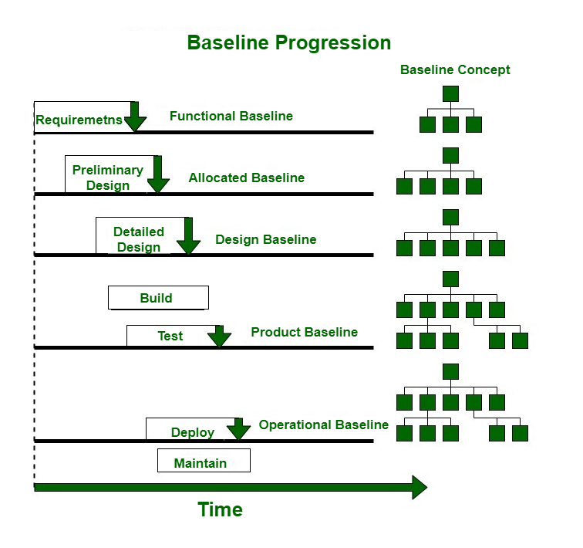

**What is Heuristic Evaluation (HE)?**

Heuristic Evaluation (HE) is a usability inspection technique in which professionals check a user interface against usability principles or heuristics. This technique helps to pick out usability problems early inside the layout system, making it a cost-powerful and efficient to increase user satisfaction. Typically, evaluators search for issues which includes system feedback, user control, and consistency, supplying actionable insights for development. Unlike user testing, it does now not contain real users but relies on the understanding of the evaluators.

**Conclusion**

Baselines in [software development](https://www.geeksforgeeks.org/software-engineering/what-is-software-development/) are important to manage the project and ensuring that all individuals work from the same foundation. By adhering to well-defined baseline items, teams can attain extra readability, stability, and alignment in their projects.

In [configuration management](https://en.wikipedia.org/wiki/Configuration_management), a **baseline** is an agreed description of the attributes of a product, at a point in time, which serves as a basis for defining change.[[1]](https://en.wikipedia.org/wiki/Baseline_(configuration_management)#cite_note-1) A change is a movement from this baseline [state](https://en.wikipedia.org/wiki/State_(computer_science)) to a next state. The identification of significant changes from the baseline state is the central purpose of baseline identification.[[2]](https://en.wikipedia.org/wiki/Baseline_(configuration_management)#cite_note-2)

Typically, significant states are those that receive a formal approval status, either explicitly or implicitly. An approval status may be attributed to individual items, when a prior definition for that status has been established by project leaders, or signified by mere association to a particular established baseline. Nevertheless, this approval status is usually recognized publicly. A baseline may be established for the singular purpose of marking an approved configuration item, e.g. a [project plan](https://en.wikipedia.org/wiki/Project_plan) that has been signed off for execution. Associating multiple configuration items to such a baseline indicates those items as also being approved. Baselines may also be used to mark [milestones](https://en.wikipedia.org/wiki/Milestone). A baseline may refer to a single work product, or a set of work products that can be used as a logical basis for comparison.

Most baselines are established at a fixed point in time[[3]](https://en.wikipedia.org/wiki/Baseline_(configuration_management)#cite_note-swebok-3) and serve to continue to reference that point (identification of state). However, some baselines, dynamic baselines, are established to carry forward as a reference to the item itself regardless of any changes to the item. These latter baselines evolve with the progression of the work effort but continue to identify notable work products in the project. Retrieving such a dynamic baseline obtains the current revision of only these notable items in the project.

While marking approval status covers the majority of uses for a baseline, multiple fixed baselines may also be established to monitor the progress of work through the passage of time. In this case, each baseline is a visible measure through an endured team effort, e.g. a series of developmental baselines. This progression is revealed when the baselines are compared with each other. A baseline may also be established as the basis for subsequent exclusive activities when the baselined products have met certain criteria. For example, certain activities reserved for items with a prior formal approval, such as formal change control procedures.

Baselines themselves are valued not only to identify the notable state of work product(s) but also provide historical views of how work product elements have progressed together over time. When a fixed baseline is retrieved, the state of the work product(s) in that subset share the same significance in their history of changes; this allows project leaders to compare the relative progress of single parts of a project to the project as a whole, which allows project leaders to identify individual items that lag or lead in progress toward better functionality or performance. For this reason, baseline identification, monitoring, and retrieval are critical to the success of configuration management, and ultimately, project quality.

Conversely, the configuration of a project includes all of its baselines, the status of the configuration, all audits, and all metrics collected. The current configuration refers to the current status, current audit, and current metrics. Similarly, but less common, a baseline may refer to all items in a project. This may include the latest revision of all items or only specific revisions of all items in the project, depending on the nature of the baseline, dynamic or fixed respectively. Once retrieved, the baseline may be compared to a particular configuration or another baseline. In configuration management, the configuration of a project is not the same as a baseline in the project but the two could coincide.

Fixed baselines often coincide with or signify project milestones, such as the set of items at a particular certifying [review](https://en.wikipedia.org/wiki/Design_review_(U.S._government)).[[3]](https://en.wikipedia.org/wiki/Baseline_(configuration_management)#cite_note-swebok-3) Some examples include:

Functional baseline: initial specifications established; contract, et cetera

Allocated baseline: state of work products after requirements are approved

Developmental baseline: state of work products amid development

Product baseline: contains the releasable contents of the project

Others, based upon proprietary business practices

**Configuration management** (**CM**) is a management process for establishing and maintaining consistency of a product's performance, functional, and physical attributes with its requirements, design, and operational information throughout its life.[[1]](https://en.wikipedia.org/wiki/Configuration_management#cite_note-1)[[2]](https://en.wikipedia.org/wiki/Configuration_management#cite_note-2) The CM process is widely used by military engineering organizations to manage changes throughout the [system lifecycle](https://en.wikipedia.org/wiki/System_lifecycle) of [complex systems](https://en.wikipedia.org/wiki/Complex_system), such as [weapon](https://en.wikipedia.org/wiki/Weapon) systems, [military vehicles](https://en.wikipedia.org/wiki/Military_vehicles), and [information systems](https://en.wikipedia.org/wiki/Information_system). Outside the military, the CM process is also used with IT service management as defined by [ITIL](https://en.wikipedia.org/wiki/ITIL), and with other [domain models](https://en.wikipedia.org/wiki/Domain_model) in the civil engineering and other [industrial engineering](https://en.wikipedia.org/wiki/Industrial_engineering) segments such as roads, bridges, [canals](https://en.wikipedia.org/wiki/Canal), dams, and buildings.[[3]](https://en.wikipedia.org/wiki/Configuration_management#cite_note-3)[[4]](https://en.wikipedia.org/wiki/Configuration_management#cite_note-4)[[5]](https://en.wikipedia.org/wiki/Configuration_management#cite_note-5)

**Introduction**

CM applied over the life cycle of a system provides visibility and control of its performance, functional, and physical attributes. CM verifies that a system performs as intended, and is identified and documented in sufficient detail to support its projected life cycle. The CM process facilitates orderly management of system information and system changes for such beneficial purposes as to revise capability; improve performance, reliability, or maintainability; extend life; reduce cost; reduce risk and liability; or correct defects. The relatively minimal cost of implementing CM is returned manyfold in cost avoidance. The lack of CM, or its ineffectual implementation, can be very expensive and sometimes can have such catastrophic consequences such as failure of equipment or loss of life.

CM emphasizes the functional relation between parts, subsystems, and systems for effectively controlling system change. It helps to verify that proposed changes are systematically considered to minimize adverse effects. Changes to the system are proposed, evaluated, and implemented using a standardized, systematic approach that ensures consistency, and proposed changes are evaluated in terms of their anticipated impact on the entire system. CM verifies that changes are carried out as prescribed and that documentation of items and systems reflects their true configuration. A complete CM program includes provisions for the storing, tracking, and updating of all system information on a component, subsystem, and system basis.[[6]](https://en.wikipedia.org/wiki/Configuration_management#cite_note-6)

A structured CM program ensures that documentation (e.g., requirements, design, test, and acceptance documentation) for items is accurate and consistent with the actual physical design of the item. In many cases, without CM, the documentation exists but is not consistent with the item itself. For this reason, engineers, contractors, and management are frequently forced to develop documentation reflecting the actual status of the item before they can proceed with a change. This [reverse engineering](https://en.wikipedia.org/wiki/Reverse_engineering) process is wasteful in terms of human and other resources and can be minimized or eliminated using CM.

What is an SCM repository

In computer software engineering, software configuration management (SCM) is any kind of practice that tracks and provides control over changes to source code. Software developers sometimes use revision control software to maintain documentation and configuration files as well as source code. Revision control may also track changes to configuration files.

As teams design, develop and deploy software, it is common for multiple versions of the same software to be deployed in different sites and for the software's developers to be working simultaneously on updates. Bugs or features of the software are often only present in certain versions (because of the fixing of some problems and the introduction of others as the program develops). Therefore, for the purposes of locating and fixing bugs, it is vitally important to be able to retrieve and run different versions of the software to determine in which version(s) the problem occurs. It may also be necessary to develop two versions of the software concurrently (for instance, where one version has bugs fixed, but no new features (branch), while the other version is where new features are worked on (trunk).

At the simplest level, developers could simply retain multiple copies of the different versions of the program, and label them appropriately. This simple approach has been used in many large software projects. While this method can work, it is inefficient as many near-identical copies of the program have to be maintained. This requires a lot of self-discipline on the part of developers and often leads to mistakes. Since the code base is the same, it also requires granting read-write-execute permission to a set of developers, and this adds the pressure of someone managing permissions so that the code base is not compromised, which adds more complexity. Consequently, systems to automate some or all of the revision control process have been developed. This ensures that the majority of management of version control steps is hidden behind the scenes.

Moreover, in software development, legal and business practice and other environments, it has become increasingly common for a single document or snippet of code to be edited by a team, the members of which may be geographically dispersed and may pursue different and even contrary interests. Sophisticated revision control that tracks and accounts for ownership of changes to documents and code may be extremely helpful or even indispensable in such situations.

Software development relies on a delicate balance between innovation and stability. Every change – a new feature, a system upgrade, or an architectural shift – can disrupt operations, strain resources, and introduce unforeseen risks. Yet, many teams push changes forward without fully understanding their broader impact, leading to costly setbacks and operational inefficiencies. This is where impact analysis comes in.

Impact analysis is the key to making informed decisions in a complex and interconnected environment.

It provides a structured approach to evaluating how proposed changes will affect existing systems, workflows, and stakeholders. Far from being just a precautionary measure, impact analysis is a strategic enabler – helping teams align changes with business goals, avoid redundant efforts, and deliver seamless user experiences.

This article delves into the core aspects of impact analysis, exploring its significance, the different types that organizations can leverage, the step-by-step process to conduct it effectively, and practical use cases that showcase its value in real-world software scenarios.

A Practical Guide to Impact Analysis

What is Impact Analysis?

Impact analysis is the process of evaluating the potential consequences of a requirement before the team implements it. It helps organizations understand how modifications – whether in software, business processes, or project workflows – might affect existing systems, resources, and stakeholders.

Simply put, it allows teams to foresee challenges and plan accordingly, reducing risks and optimizing outcomes.

The primary goals of conducting impact analysis include:

**✔** **Identifying Consequences:**Understanding the direct and indirect effects of a proposed change.

**✔ Predicting Outcomes:**Assessing potential risks and opportunities associated with the change.

**✔ Mitigating Risks:**Developing strategies to prevent negative impacts and ensure business continuity.

Why is Impact Analysis Important?

Impact analysis plays a crucial role in reducing the [cost of bad requirements,](https://brewstudio.in/the-true-cost-of-bad-requirements-how-to-avoid-project-failures-with-impact-analysis/) which, if left unchecked, can result in project delays, budget overruns, and operational inefficiencies. In –

**Project Management:**It ensures proposed changes align with timelines, budgets, and stakeholder expectations, preventing scope creep and unexpected delays.

**Business Processes:**It helps maintain operational efficiency by identifying dependencies and bottlenecks before they disrupt workflows.

**Software Development:**Even minor code changes can introduce unexpected performance issues, security vulnerabilities, or compatibility problems. Impact analysis helps teams proactively assess risks and ensure smooth deployment.

Types of Impact Analysis

You can categorize impact analysis into several types, each offering a unique perspective on assessing changes. Understanding these types can help you choose the right approach based on your organization’s specific needs and operational complexities.

1. Forward Impact Analysis

Forward impact analysis focuses on understanding how a proposed change will affect future elements within a system. This approach helps teams anticipate potential consequences and plan accordingly to avoid disruptions.

2. Backward Impact Analysis

Backward impact analysis involves tracing the origins and dependencies of an issue to understand what factors contributed to its occurrence. This type of analysis is useful when identifying the root cause of a problem and ensuring future changes don’t reintroduce the same errors.

3. Dynamic Impact Analysis

Dynamic impact analysis evaluates changes in real time, allowing teams to monitor evolving impacts as they occur. This type is particularly useful for live environments where changes are continuously happening, and immediate feedback is required.

4. Static Impact Analysis

Static impact analysis takes a structured approach by evaluating predefined factors before implementing any change. It relies on historical data, documentation, and static code reviews to understand potential impacts without executing the changes in a live environment.

The Impact Analysis Process: A Step-by-Step Guide

By following a step-by-step process, you can identify risks, anticipate challenges, and implement changes with confidence.

Step 1: Identify the Change

The first step in the impact analysis process is to clearly define what change is being assessed. Whether it’s a new feature, an infrastructure upgrade, or regulatory compliance, having a precise understanding of the change sets the foundation for effective analysis.

Step 2: Gather Relevant Data

The next step is to collect all necessary information that could influence its impact. This includes stakeholder inputs, historical performance data, and potential risks associated with similar past changes.

Step 3: Assess Impact Areas

After gathering data, it’s crucial to evaluate how the change will affect various aspects of the business, such as operations, financials, regulatory compliance, and customer experience. This holistic assessment helps in understanding the full scope of the impact.

Step 4: Analyze Dependencies

Every system has internal and external dependencies. Analyzing dependencies helps in understanding how the change will affect different components—such as third-party tools, databases, and legacy systems..

Step 5: Evaluate Risk Levels

Once dependencies are mapped, quantify the risks associated with the change. This involves assessing factors like financial implications, potential downtime, security vulnerabilities, and compliance risks.

Step 6: Develop Mitigation Strategies

The product teams must address identified risks with proactive mitigation plans. These strategies could include contingency planning, phased rollouts, resource allocation adjustments, and stakeholder communication plans.

Step 7: Document Findings and Report

The final step is to document all insights gathered during the analysis process and compile them into a structured report. This documentation serves as a reference for stakeholders and guides decision-making throughout the implementation process.

Why is Impact Analysis Important?

Impact analysis provides a clear understanding of potential risks, helping businesses stay agile and competitive.

**Risk Mitigation:** Identifies potential issues early, preventing disruptions and costly errors.

**Cost Efficiency:** Reduces waste by optimizing resources and avoiding unnecessary expenditures.

**Strategic Decision-Making:** Offers data-driven insights to align changes with business goals.

**Regulatory Compliance:** Ensures adherence to industry standards and legal requirements.

**Stakeholder Confidence:** Builds trust by demonstrating a proactive approach to change management.

Real-world Use Cases of Impact Analysis in Software Development

Below are real-world scenarios where impact analysis plays a crucial role in ensuring smooth transitions and operational stability.

Software Upgrades and Releases

***Scenario:*** A SaaS company is planning a major feature update for its cloud-based CRM platform. The new feature aims to enhance user collaboration and automate routine tasks.

***Impact Analysis Outcome:*** The team evaluates potential disruptions to existing integrations, identifies performance bottlenecks, and anticipates user adoption challenges. The team carefully assesses dependencies with third-party plugins and internal reporting systems.

***Result:*** The team implements a phased rollout strategy, ensuring minimal downtime and a smooth transition for users, with proactive communication and support channels to address potential issues.

Cloud Migration

***Scenario:*** An enterprise is shifting its on-premise applications to a cloud infrastructure to enhance scalability and cost-efficiency.

***Impact Analysis Outcome:*** The assessment focuses on risks related to data security, latency issues, and the compatibility of legacy applications with the cloud environment. The analysis also considers compliance requirements and potential performance changes.

***Result:*** The team develops a well-structured migration plan, allowing for a seamless transition with minimal operational disruptions and optimal utilization of cloud resources.

Security Patch Implementation

***Scenario:*** A fintech company is deploying a critical security update to its mobile banking application following recent cybersecurity threats.

***Impact Analysis Outcome:*** The impact on app performance, third-party API integrations, and customer experience is thoroughly analyzed. The team ensures the patch does not inadvertently affect core functionalities such as payment processing and authentication mechanisms.

***Result:*** A controlled rollout strategy is adopted, preventing disruptions while maintaining security compliance and providing users with a seamless banking experience.

Third-Party API Integrations

***Scenario:*** An e-commerce platform is integrating a new payment gateway to offer more flexible payment options to customers.

***Impact Analysis Outcome:*** Compatibility with the existing order management system, potential data flow changes, and downtime risks are carefully reviewed. The team evaluates transaction speed, error handling, and customer support requirements.

***Result:*** A successful integration is achieved through rigorous pre-deployment testing, ensuring uninterrupted transactions and an enhanced user experience.

Regulatory Compliance Changes

***Scenario:*** A healthcare software provider is updating its system to comply with new regulatory standards such as GDPR and HIPAA.

***Impact Analysis Outcome:*** The analysis identifies system-wide changes required to meet compliance, including data encryption enhancements, stricter access controls, and updated audit trails. The team also considers potential workflow disruptions.

***Result:*** Full compliance is achieved without compromising system performance or user experience, while the staff is trained to adapt to the new processes efficiently.

Infrastructure Scaling

***Scenario:*** A gaming company is experiencing a surge in user traffic and needs to scale its infrastructure to handle increased demand.

***Impact Analysis Outcome:*** System scalability is assessed, including load balancing, server capacity, and potential performance bottlenecks. Cost implications and failover strategies are also considered.

***Result:*** The team allocates resources efficiently, ensuring optimal performance during peak traffic periods and maintaining a seamless gaming experience for users.

Tools and Techniques for Effective Impact Analysis

Effective impact analysis relies on a mix of strategic frameworks and advanced tools to identify, assess, and mitigate potential risks. Commonly used techniques include:

**SWOT Analysis:** Helps teams evaluate strengths, weaknesses, opportunities, and threats associated with a proposed change.

**Fishbone Diagrams:** Also known as cause-and-effect diagrams, these help identify root causes and visualize dependencies.

**Impact Matrices:** Provide a structured way to assess the severity and likelihood of different change impacts, aiding in prioritization.

In addition to these traditional methods, automated software solutions such as [Jira](https://www.atlassian.com/software/jira/service-management?campaign=17879825186&adgroup=139892810296&targetid=aud-2204202926820:kwd-337837004861&matchtype=p&network=g&device=c&device_model=&creative=688006323065&keyword=jira%20service&placement=&target=&ds_eid=700000001721198&ds_e1=GOOGLE&gad_source=1&gclid=Cj0KCQiAqL28BhCrARIsACYJvkfTUFl7ALsjRRKoNo_d41rOTiMm18gxp0BVuyTP3CXxPX0OErJwfpsaAk7PEALw_wcB), [ServiceNow](https://www.servicenow.com/), and [ChangeGear](https://www.serviceaide.com/solutions/change-management) offer advanced impact assessment capabilities. These tools integrate with existing workflows, providing real-time insights, dependency mapping, and risk evaluation to support informed decision-making.

We are also building a [tool](https://brew.studio/?utm_source=blog&utm_medium=website&utm_content=impactanalysis) that helps identify all the above types of impacts – what’s more we even break it down by category and provide an implementation for coders (AI agents and Humans) to be able to complete implementation and proactively ensure there are no bugs. We also analyse a code commit and highlight the drift, in other words we can tell you what you really asked for and what was done by the developer all at the click of a button so you know where to focus your testing on.

In a landscape where changes are frequent and business objectives are constantly evolving, understanding the potential consequences of every modification is critical to ensuring stability, efficiency, and growth.

Businesses can proactively address risks, optimize resources, and align changes with long-term goals, by integrating impact analysis into the development lifecycle . As technology continues to advance, embracing impact analysis as a core practice will be key to staying competitive, resilient, and future-ready.

Configuration Status Accounting and Reporting ensures that all configuration data and documentation are recorded as each CI progresses through its life cycle from test to production to retirement. Configuration information should be kept current and made available for planning, decision making, and managing changes to the defined configurations.

Configuration Status Accounting and Reporting keeps track of the following CI status changes:

New items received (as evidenced by a goods receipt procedure or from development)

Installation of items

Transition from test to production

System down (based upon events)

Retired or disposed items

Lost or stolen items

Unauthorized CIs and Version changes of CIs

Current and accurate configuration records should be maintained to reflect changes in the status, location, and versions of CIs. The history of each CI must be maintained. Changes to CIs are tracked through various states, such as ordered, received, in acceptance test, live, under change, withdrawn, or disposed.

Where required, configuration information should be accessible to users, customers, suppliers, and partners to assist them in their planning and decision making. For example, an external service provider may make configuration information accessible to the customer and other parties to support the other service management processes in an end-to-end service. Archiving procedures should be defined for data related to retired or disposed CIs.

Configuration Management reports should be available to all relevant parties. The reports should cover the identification and status of the CIs, including their versions and associated documentation. A large set of different reports are needed for the different stakeholders (for example, audit reports, software compliance reports, and charge back reports).

Details for this process can be seen in the following figure and table.

The Configuration Status Accounting and Reporting workflow is illustrated in the following figure:

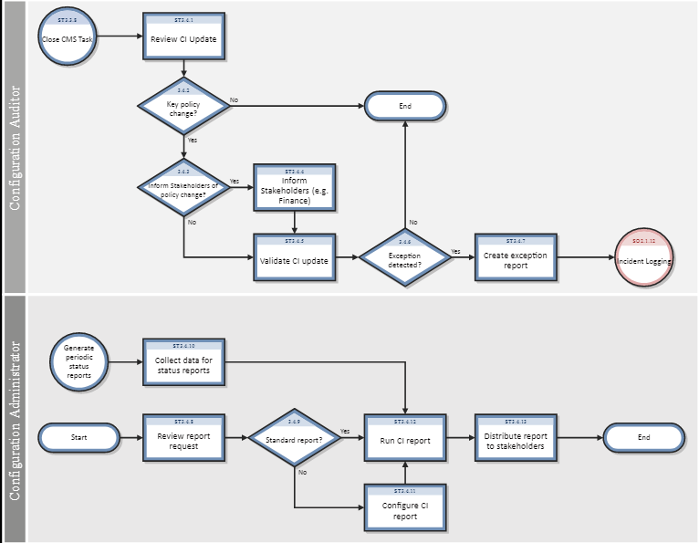

View Fullscreen

|  |  |  |  |
| --- | --- | --- | --- |
| Configuration Status Accounting and Reporting process | | | |
| **Process ID** | **Procedure or Decision** | **Description** | **Role** |
| ST 3.4.1 | Review CI update | Modifications of key attributes of the CI are logged in the history log and verified. During Configuration Identification and control activities, configuration status records are created. These records enable key changes to be visible and traceable. CI attributes that can be logged include:  status (for example, system down)  version number  serial number  installation date  audit status (for example, missing or lost)  removed from a contract  Critical CI changes are logged with entries for reason, date stamp, time stamp, and person recording the status change. | Configuration Auditor |
| ST 3.4.2 | Key policy change? | Determine whether the policy must be reviewed or validated, based on the documented Configuration Management policies (and policies related to finance, procurement, Contract Management, and security). | Configuration Auditor |
| ST 3.4.3 | Inform stakeholders of policy change? | Specific changes must be reported to the stakeholders. These include:  Procurement  Finance (for example, by linking to the general ledger)  Contract Manager  Verify that the event must be reported. If not, go to ST 3.4.5. If yes, continue with ST 3.4.4. | Configuration Auditor |
| ST 3.4.4 | Inform stakeholders | Inform stakeholders of the event (for example, the Contract Manager when an asset is included in the contract, or procurement when an item is received). Examples of events that should trigger stakeholder notification include:  Received and accepted items  Installation of the asset (for example, for depreciation start date)  Lost or stolen item  Retirement or disposal of an item (for finance) | Configuration Auditor |
| ST 3.4.5 | Validate CI update | Confirm that all relevant status data documented in the CI is complete and correct, according to Configuration Management policies derived from agreements, relevant legislation, and standards.  Ensure that the status change or version update is a result of an authorized change. | Configuration Auditor |
| ST 3.4.6 | Exception detected? | If the CI update or CI details aren't correct or complete according to the Configuration policies, continue with SO3.4.7. | Configuration Auditor |
| ST 3.4.7 | Create exception report | Create a new incident (see SO 2.1.11). | Configuration Auditor |
| ST 3.4.8 | Review report request | The Configuration Administrator reviews the request for Configuration Management information. | Configuration Administrator |
| ST 3.4.9 | Standard report? | Configuration Management has defined a number of standard reports (for example, overview of CIs in stock or by status). If this is a standard report, continue with ST 3.4.12. If not, go to ST 3.4.11. | Configuration Administrator |
| ST 3.4.10 | Collect data for status reports | Periodically, Configuration Management procedures provide reports for the different stakeholders, such as financial asset managers, contract managers, or procurement. | Configuration Administrator |
| ST 3.4.11 | Configure CI report | If a standard report doesn't exist, the Configuration Administrator creates a query to select the data to display from the CMS. | Configuration Administrator |
| ST 3.4.12 | Run CI report | The report or query is run against the database. The data is collected in a standard format. | Configuration Administrator |
| ST 3.4.13 | Distribute report to stakeholders | Provide the requested data to the stakeholders. Close the request (if applicable). | Configuration Administrator |

**Agile Change Management**

Last Updated : 09 Aug, 2024

Change is an irreversible phenomenon that exists at all times, especially nowadays. The dynamic business context demands flexibility to survive through competition. It is here that the concept of agile change management is introduced. Agile change management is a fluid, flexible model that fits well within the tenets of the Agile process for effective organizational change.

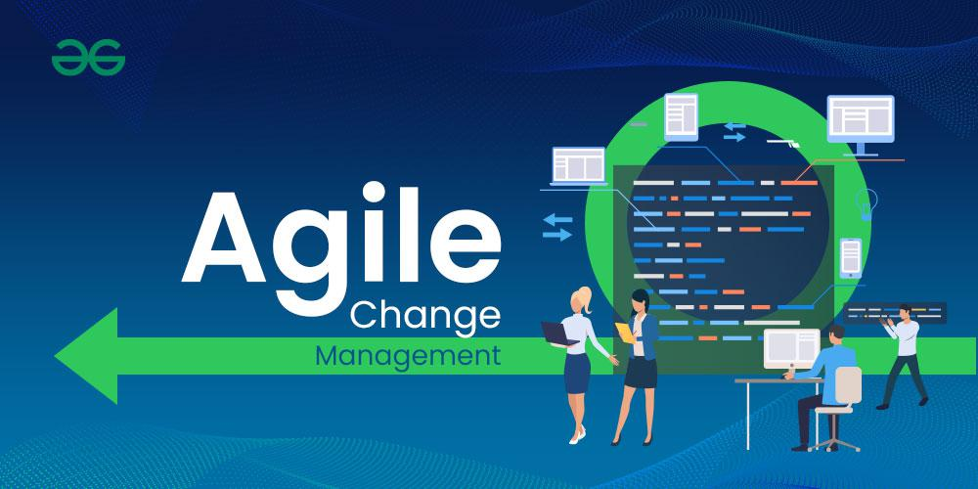

**What is Agile Change Management?**

*The term agile Change Management refers to an iterative and incremental methodology that reacts to change instead of rigid adherence to a fixed plan. The approach is based on teamwork, flexibility, and constant enhancement according to the principles behind the Agile technique. This implies that change is a continuous phenomenon that requires an adaptable and dynamic approach.*

Agile methods are concerned with iterative delivery, delivering early in the lifecycle to maximize return on investment. This early return on investment helps to fund additional deliveries that occur regularly throughout the life of the change initiative.

**What is the relationship between Agile and Change Management?**

Agile and change management have mutual values like being flexible, focusing on the customers, collaborating, and more. Agile refers mainly to project management and product development; however, Agile change management goes beyond that for the organization. It blends perfectly with Agile methodologies forming a whole approach of management by ensuring effective changes.

Silo-busting, open communication; Feedback, and learning in mind are the basic pillars of Agile-CM collaboration. Integration of this change makes sure that all change procedures take into consideration organization objectives and that the whole group is motivated to participate in the transformation process.

**Why Agile methods are so popular?**

Agile approaches, have grown exponentially in popularity because they are a logical response to uncertainty. Begin small, don't plan everything at once, and be prepared for changes. A natural reaction to uncertainty is not to devote all of your resources to a solution that may or may not be the best solution. It is preferable to create a portion of the solution, test it, and get feedback from those affected on how effective it is before deciding which component of the overall solution to deliver next.

Certainty required to plan any initiative in detail at the outset and manage that plan over time is no longer appropriate. It is preferable to start with an idea of the capability you want to achieve while remaining open to how it will become a reality. In this way, it is possible to respond to market shifts and changes, customer and supplier requirements, system innovations, and data use.

**How Agile adapts to Change Management:**

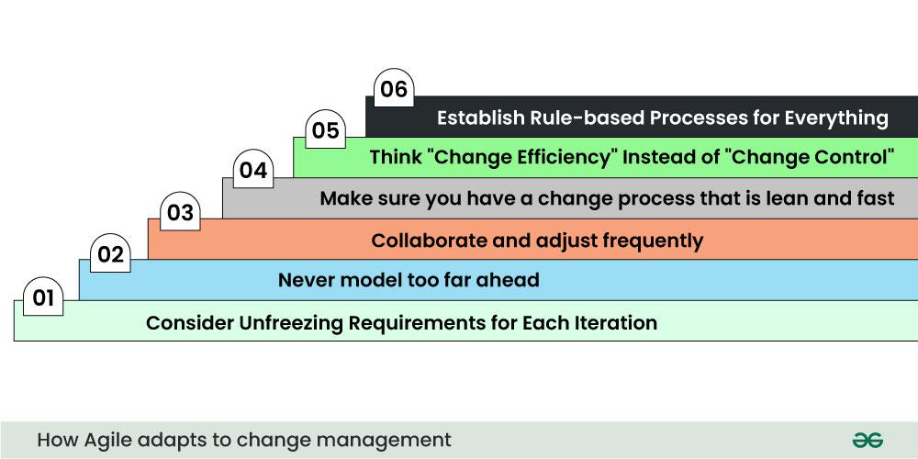

*Whether the project is small or large, there are several ways to apply Agile thinking to change management. By following these steps, the project can remain lean, nimble, and agile, allowing it to respond to changes effectively. In a complex and uncertain world, agile processes enable change. An iterative process of continuous review and adaptation characterizes an agile change management plan.*

**Consider Unfreezing Requirements for Each Iteration:** This approach allows your project to respond to changes more quickly, but it requires your developers to be more comfortable with unpredictability.

**Never model too far ahead:** The further ahead you model, the less responsive your design is to change requests. This requirement, however, must be balanced against the availability of stakeholders.

**Collaborate and adjust frequently:**First and foremost, collaborate with your customers because they are the ones who drive your products. Then, as needed, collaborate with stakeholders and other teams.

**Make sure you have a change process that is lean and fast:**This serves as the foundation for an agile change management workflow. It is not agile if you do not have a system in place for changing your project.

**Think “Change Efficiency” Instead of “Change Control”:**Change is both desirable and natural in agile. This perspective shift is crucial in making your change management process more efficient.

**Establish Rule-based Processes for Everything**: There's a reason scrum is held every day: it works. Routines, habits, and systems are established to ensure that policies are followed. Create documentation for all of the above, including collaboration, change management, and so on. As we can see, agile change management is about being flexible when it comes to project scope, product features, and other aspects.

**How to achieve Agile Change Management:**

Because of the frequency of change generated by Agile approaches, traditional change management activities must be accelerated. Essentially, we are creating mini waves of change to occur concurrently with the delivery of business change. These mini waves of change are only possible if the organization has a well-developed approach to leading its employees through change.

Each of these mini-waves of change contains key elements of the change process that are required to help people transition through change. They are interconnected, as shown in this diagram, with each contributing to the successful adoption of new ways of working.

**Scope:**It specifies what, if anything, will change as a result of the project deliverables. What needs to change will influence who needs to be involved and what changes they must make, so it is critical that there is a lot of information sharing in Agile change management between those responsible for project delivery and those responsible for creating new ways of working.

**Stakeholder Analysis and Impact Assessment:** determine who must change their working methods in response to the tangible changes being delivered and conduct a tactical impact assessment to determine what processes, standards, metrics, and data must change as a result.

**Change Message:** Determine how much information customers or suppliers need to know about the change and decide on the key messages that employees must receive.

**Change Plan:** Identify and document all of the change activities that allow those affected to participate in the change.

As people transition to new ways of working, provide the necessary training and coaching, and pair this with Readiness Assessments to ensure that all preparations have been completed.

**Traditional Change Management Approach (waterfall) vs Agile Change Management:**

The classic Waterfall method of change management entails careful planning of changes which are implemented step-by-step. It is usually hard to adopt to emerging situations because such procedures require an extended period of planning. In contrast, Agile Change management operates iteratively and incrementally, enabling frequent shifts in response to changing customer demands.

On the contrary, waterfall model is inflexible and unwilling to change, whereas agile change management embraces change as an integral and spontaneous part of the business processes. Such flexibility means quick responses in an ever-changing environment such as market shifts, innovations, as well as changing demand.

**Steps to Implement Agile Change Management:**

In order for this to happen, there is need of cultural shift in the organization. Here are key steps to implement this approach successfully:

**Leadership Support:** Agility is also driven by leadership. Involve leaders actively and make sure they show support openly for the changes. Take for example a CEO who conducts town hall meetings emphasizing the merits of being nimble.

**Cross-functional Collaboration:**In essence, Agile Change Management must involve breaking down of departmental silos. Foster teamwork through cross-functional systems and projects. For instance, while implementing a digital transformation, the marketing team may work together with IT in order to enhance the flow of information towards customers.

**Iterative Planning:**Iterative planning facilitates for flexibility in responding to changing situations. Provide an example of a fictitious situation for an organization in which multiple revisions of plans were made to ensure that changes in customer preferences could be reflected well within the scope of projects.

**Clear Communication:**Successful change initiatives depend upon transparent communication. Outline measures for ensuring open channels of communications by offering frequent updates using various media. What is an example of a company that employed transparency in communicating employee issues during a significant reorganization ?

**Feedback Mechanisms:** Feedback loops must therefore be put in place, so as to make the improvement of performance sustainable. Demonstrate key feedback mechanisms like monthly surveys or open forums where one can access perspectives of employees, clients, and other individuals. Report about a successful case involving useful comments from workers with regard to the incorporation of a new information system platform.

**Benefits of Agile Change Management:**

Promoting a common understanding of the possibilities for change has a huge positive impact on the solutions.

An agile mindset assists with the people side of change management by emphasizing meaningful participation.

Delivering workable solutions on time helps businesses stay productive.

Iterative approaches can aid in adapting to new problems and discoveries.

**Challenges of Agile in Change Management**

May appear disarray, even thought it is a well-structured and organized process.

Emphasis on short-term goals in agile change management may make it more challenging to achieve long-term objectives.

Finally, agile change management requires an experienced project team for success.

**6 Common Agile Processes**

**Scrum**: Scrum is on of the most applied frameworks of the Agile methodologies. It also takes identifying work and completing it in brief, repeating cycles known as sprints, which generally last from two to four weeks. Sprint consists of planning the work, executing the work, review, and retrospective stakeholders meetings. Scrum roles are; There is the product owner, the scrum master, and the development team.

**Kanban**: Kanban is a type of a system for the visualization of work that aims at improving work flow by using visual tangible tools such as boards. It extends Scrum without focus on sprints and it’s an agile principle dealing with sustainable functioning. It is articulated in Kanban by Use cards that transition through columns (e. g., To Do, In Progress, Done).

**Extreme Programming (XP):** XP is the Agile software developments approaches that are centred on technical issues and customer value. In the long-term it focuses on behavior such as test-driven development, pair programming, continuous integration and short releases.

**Lean:** Lean on the other hand is a process that took its origin from Lean manufacturing system. Lean on the other hand is a set of principles that aims at reducing the wastes that are in the system as much as possible and create value for the customer in the quickest way possible. It fosters the policy of Kaizen and the just-in-time production.

**Feature-Driven Development (FDD)**: FDD is one of Agile frameworks of software development that reminds on frequent delivery and shippable functionality. There is the feature list creation, followed by the design, development, and testing of distinctive features in short cycles.

**Crystal:** Crystal is one of the Agile methodologies that differ in conditions such as the number of team members, the relevance of the system, and priority of the project. Here, people, interaction and communication are stressed over process and tools and as a result the working approach highly depends on the specific project. XP is the Agile software developments approaches that are centred on technical issues and customer value. In the long-term it focuses on behavior such as test-driven development, pair programming, continuous integration and short releases.

**When Should Organizations Take an Agile Approach?**

Organizations should consider an Agile approach when:

**Project Requirements are Uncertain:** Agile is suitable for project situations which may be characterized by constantly changing needs throughout the project’s lifecycle.

**Frequent Customer Feedback is Needed**: Agile principle also requires frequent communication with the customer for the solution to meet the required quality matching the client’s expectations.

**Quick Delivery is a Priority:**Kent (2000) established that agile methodologies are focusses more on the provision of small, working increments of the product frequently to the market early enough in order to achieve fast time to market.

**Cross-Functional Collaboration is Beneficial:** Agile works best under conditions that allow team work, cross-functional and rotation and improvement mentallity.

I**nnovation and Experimentation are Key**: Agile supports the culture of taking risks hence is appropriate for use in projects that need innovation.

**How Do Agile Teams Prioritize?**

Agile teams prioritize work using several techniques:

**Backlog Prioritization:** The Product Owner controls a list of tasks (backlog) and often uses MoSCoW principle (Must have, Should have, Could have, and Won’t have) or others.

**User Story Mapping:**Epics are broken down into user stories (requirements) to establish how significant or valuable a story is compared to the size of the product, to know which stories to develop earliest.

**Value vs. Effort:**The elements of work are also sorted by value/complexity ratio since the main objective of teams is to work through as many issues as possible while minimizing the potential level of difficulty.

**Continuous Re-prioritization:** In Agile, important things are considered continuously relative to new information, fresh perspectives and conditions surrounding the project.

**Agile Frameworks**

**Scrum:** Stresses SD with fixed roles, ceremonies, and artifacts in the process of iteration improvement.

**Kanban**: Implements ‘workflow visualization,’ and uses a method of defining ‘maximum WIP’ to reduce WIP.

**XP (Extreme Programming):** Stresses on such technical disciplines as test driven development, pair programming, and continuous integration.

**Lean:**Emphasizes on avoiding extravagance as well as providing value to consumers in the most effective manner.

**FDD (Feature-Driven Development):** Focused on the creation of features ad hoc, in small time frames.

**Crystal:** Flexible and depends on the size of the team working on the project or the degree of system importance and other aspects.

**Agile Change Management Process**

An Agile change management process involves:

**Continuous Feedback Loops:** Ensuring that the changes are done in harmony with stakeholders and customers through the periodical feedback collection.

**Incremental Changes:** Practical in that they mean changes to processes are made gradually, rather than in large steps which may cause problems.

**Cross-Functional Collaboration:**Able to obtain commitment to change from all the stakeholders because of the belief that it is the only way change will work.

**Adaptive Planning:** Discussing the plans and recurrently coming back to the appropriate points and reviewing them on a continuous basis.

**Empowering Teams:** Enabling implementers own their changes by letting them experiment and be more innovative.

**Agile Change Management Plan**

An Agile change management plan typically includes:An Agile change management plan typically includes:

**Vision and Goals**: What is important is that one should clearly outline the change objectives and the behavioral changes that are expected.

**Stakeholder Engagement:** Stakeholder mapping and the methods for engaging and influencing the stakeholders.

**Incremental Rollout**: Schedule changes in phases or iterations as this will help in having changes implemented and reviewed to come up with better changes.

**Training and Support:** Ensuring all the teams and stakeholders have undergone through the appropriate trainings and have the resources which will enable them to cope with the change.

**Measurement and Feedback:** Designing metrics for assessing the effects of the alterations and incorporating the received feedback into the subsequent versions.

Change management is a vital part of any organization and needs to be managed thoroughly and properly; this is where an agile approach to change management comes into play.

**An Agile approach to change management**

**Flexibility:**Transition as the strategy instead of a threat.

**Customer-Centricity:**They must be positive and lead to the right changes that enhance the value that the customers receive from the firm.

**Collaboration:**Engaging by the change agents all the employees in the organisation to achieve the change goals to enable them to understand and support the process of change.

**Iterative Implementation**: Splitting changes into workable portions which can be effectively developed and tested before the combination into a sophisticated single system.

**Continuous Improvement:** Using feedback and lessons learned from each change to improve future processes.

**Conclusion**

Finally, agile change management is a strategic tool for dealing with complexities in organizational transformation and is aligned with the principles of agile methods. When adaptability, teamwork and constant development are put on board by organizations to cope with this rapid changing environment, they become more resilient and competent for survival in the current economic scenario. While the business environment is in flux, Agile Change Management proves an effective guide for businesses operating under unpredictability and intricacy.

In the ever-evolving landscape of software development, one set of principles has stood the test of time, providing crucial insights into the dynamics of software evolution: Lehman’s Laws. Formulated by Dr. Meir M. Lehman in the late 20th century, these laws offer a comprehensive framework for understanding how software systems change over time. Let’s delve into these laws and their implications for modern software engineering.

**1. Law of Continuing Change**

**“A program that is used in a real-world environment must change, or become progressively less useful in that environment.”**

This law highlights the inevitability of change in software systems. As the environment in which software operates evolves — due to new user requirements, technological advancements, or regulatory changes — software must adapt to remain relevant and useful. Failure to do so results in obsolescence. For software engineers, this underscores the importance of designing systems with flexibility and adaptability in mind.

**2. Law of Increasing Complexity**

**“As a program evolves, it becomes more complex, and extra resources are needed to preserve and simplify its structure.”**

With each modification and addition, software systems tend to become more complex. This increasing complexity can lead to higher maintenance costs and greater potential for defects. To manage this complexity, developers must invest in continuous refactoring, code reviews, and the use of modular architectures. Techniques such as microservices and clean coding practices are modern responses to this challenge.

**3. Law of Large Program Evolution**

**“Program evolution is a self-regulating process. System attributes such as size, time between releases, and the number of reported errors are approximately invariant for each system release.”**

This law implies a level of predictability in software evolution. By analyzing past releases, project managers can estimate future resource requirements and timelines. Agile methodologies and iterative development processes embody this principle by promoting regular, incremental updates and continuous feedback loops.

**4. Law of Organizational Stability**

**“Over a program’s lifetime, its rate of development is approximately constant and independent of the resources devoted to system development.”**

[[](https://medium.com/plans?source=upgrade_membership---post_li_non_moc_upsell--04de16bb3979---------------------------------------)](https://medium.com/plans?source=upgrade_membership---post_li_non_moc_upsell--04de16bb3979---------------------------------------)

This law suggests that merely increasing resources (e.g., adding more developers) does not linearly accelerate development. Known as Brooks’ Law, this principle highlights the importance of efficient team collaboration and well-defined processes over mere manpower. Effective communication, agile frameworks, and lean development practices are essential to maintaining productivity.

**5. Law of Conservation of Familiarity**

**“During the active life of a program, the content of successive releases is statistically invariant.”**

Software systems must balance the need for innovation with the need to remain familiar to their users. Drastic changes can lead to user frustration and steep learning curves. Therefore, incremental improvements and consistent user interfaces are crucial for maintaining user satisfaction and ensuring a smooth transition between versions.

**6. Law of Continuing Growth**

**“The functional content of a program must continually increase to maintain user satisfaction over its lifetime.”**

User expectations evolve, often requiring additional features and enhancements to meet new demands. To remain competitive and satisfy users, software must continually grow in functionality. This law drives the need for ongoing research and development, user feedback mechanisms, and robust product roadmaps.

**7. Law of Declining Quality**

**“The quality of a program will appear to be declining unless it is rigorously maintained and adapted to operational environment changes.”**

Perceived software quality tends to degrade over time unless proactive measures are taken. Regular maintenance, updates, and performance tuning are essential to counteract this decline. Automated testing, continuous integration, and deployment pipelines are modern strategies to ensure sustained software quality.

**8. Law of Feedback System**

**“Evolving a large program is like running a multi-loop, multi-person, multi-level feedback system.”**

Effective software evolution relies on feedback from various sources, including users, developers, and automated monitoring tools. This law emphasizes the complexity of managing software projects and the necessity of feedback loops. Agile practices, user feedback sessions, and monitoring systems help gather and integrate feedback to guide development.

**Implications for Modern Software Engineering**

Lehman’s Laws provide valuable insights into the challenges and necessities of software evolution. In the context of modern software engineering, these laws advocate for adaptive planning, continuous improvement, and user-centric development. By understanding and applying these principles, software engineers and project managers can better navigate the complexities of software development, ensuring their systems remain relevant, efficient, and high-quality over time.

In conclusion, the enduring relevance of Lehman’s Laws in today’s fast-paced technological landscape underscores their foundational significance. As we continue to innovate and push the boundaries of what software can achieve, these laws remind us of the fundamental truths about software evolution and the importance of strategic, well-managed change.

Software support, or customer service is a service typically offered to customers after a sale. The purpose of the service is to provide customers with the aim of offering assistance in addressing issues, particularly those of a technical nature. Whether you’ve called your software support line in the past or any other customer service line, we’ve all been there. Needing after-sales assistance is not uncommon and yet we tend to have the same experience. Do any of the below sound familiar?

You were re-routed to a representative in another country

You waited on hold for a long time before speaking with someone

When you finally reached someone they spent a considerable amount of time looking up your account and orienting themselves around your business and problem

The good news is that good [ERP software support](https://www.bluelinkerp.com/blog/blue-link-erp-customer-service-support/) does exist; you just have to look for it. When [evaluating a software system,](https://www.bluelinkerp.com/blog/erp-vendor-selection-support/)do not ignore tech support; it is just as important as other decision criteria.

Sometimes smaller and more specialized software companies can provide a level of personalized support that just isn’t available from the so-called “brand names” of the ERP world. With off-the-shelf horizontal software vendors, you and your business are just numbers – numbers among many others.

Let’s take a moment to examine what good software support looks like:

You call in to one number to handle all problems

After selecting a single menu option, you are immediately connected with a support representative located in the company’s head office along with the rest of the team

This “support representative” is, in fact, one of the people that assisted you with your software implementation. They know your business inside and out and you will continue to deal with them for support requests going forward

They help you work out your issue on-the-spot without having to determine who you are and how your business operates

Believe it or not, some software solutions offer support in this way. If you are not getting this level of support, you should know that you should be – that there are options out there.

Not only do you want to look for a software vendor with good support practices, but you’ll also want to take into consideration the future of the software support. I’m not talking about their vendors team expanding and you having a different support representative, I’m talking about Software End of Support.



*"Blue Link's system is easy to use and very intuitive once you under it and the multitude of features. The new interface is visually appealing and allows for an even better experience. Blue Link's customer support staff are fantastic and are always available to help and guide anyone from our team through both high level issues and minor details. Highly recommend!" Tal Dehtiar, Olibertè*

We’ve all received that ominous notice that the software we are using will soon no longer be supported – with the most recent example coming from [Microsoft](http://www.microsoft.com/en-ca/default.aspx) in regards to the [end of support for Windows 8.1](https://learn.microsoft.com/en-us/lifecycle/end-of-support/end-of-support-2023#products-reaching-end-of-support) Even though this news tends to be received negatively, it doesn’t always have to be, as there are many legitimate reasons as to why a company would discontinue software support and benefits that can come as a result of having to upgrade. The worst approach to dealing with the end of support is to “do nothing”, and it is important to fully understand the reasons behind the decision and your options for moving forward.

What does “end of support” mean?

Before we begin, let’s first take a look at what the dreaded “end of support” means, and why many software companies choose to do this. When companies discontinue a site or service and stop development and support, this is referred to as “sunsetting” the product. Many large companies do this as a way of herding customers into larger concentrated groups of users.  For smaller companies though, this is usually performed when several newer versions of the software have been released, and the cost to support older systems outweighs the benefits of maintaining them.

More specifically, vendors who offer several versions of software must have their support team trained on all versions in order to manage any issues. Once a system has reached a certain age, and only a minimum number of customers are using it, it becomes cumbersome to train new employees on old versions and load applicable technology in order to continue to support them.  There may also be several improvements to the system or inherent reasons why the product was never good from the start, which would validate sunsetting the product and ending support. Not to mention, applications tend to run on various technologies and so as those technologies also upgrade, this can cause compatibility issues.

Do I have to upgrade?

Although no one will force your company to upgrade, once you have received an end of support message, not taking action will lead to other issues down the road.  Without support, your company will no longer be able to receive outside help for bug fixes, error messages, custom work or any other issues.  In addition, your system may not be compatible with other newer technologies and could cause your business to lose valuable company information in the case of a system crash.

What to do?

The first step to take with an end of support message is to ask yourself why you’re still using the old version of the system.  Is it a budget issue? Has your business completely changed? Are you even still using the software? Answering these will help you better determine if you need to replace the system and with what type of software.  This is the perfect opportunity to [evaluate current processes](https://www.bluelinkerp.com/blog/2013/11/04/the-importance-of-evaluating-processes-during-the-inventory-management-software-search/) with a view to increase efficiencies and reduce costs and to look for system features that have been on your wish-list for the past several years.   Assess how the business and technology have changed over the years and what implications these have for finding a new software system. Technologies that weren't previously available such as [cloud implementations](https://www.bluelinkerp.com/hosted-saas-cloud-software/) and [wireless barcode scanning](https://www.bluelinkerp.com/warehouse-inventory-software-barcode-scanning/) may provide new benefits to your company.

*Download Now:*[*Software Buying Guide*](https://learnmore.bluelinkerp.com/software-buying-guide)

How to avoid "end of support" in the future.

Many software vendors include [maintenance costs](https://www.bluelinkerp.com/blog/2011/10/13/the-importance-of-software-maintenance/) built into the cost of software licenses. Typically, businesses pay a small percentage of total license costs on a monthly or yearly basis (known as maintenance costs) to keep the application in warranty and guarantee regular system upgrades. Paying these nominal fees means you never have to worry about losing support for your system as it will be regularly upgraded once new versions are released.

As with any business investment, the cost to implement a new software system will be significant, so make sure you look at all your options and not just upgrading to the latest version of the system you’re on.  Be prepared to make the investment and consider systems that offer maintenance programs which will give you access to regular upgrades in the future in order to keep up with the latest versions and technology.  End of support does not have to be a bad thing - take it as an opportunity to improve your processes and grow your business!

Release Management in Software Engineering

Last Updated : 05 Jul, 2022

Release system is version of system which is distributed to customers. System release managers are responsible for deciding when system can be released to customers, managing process of creating release and distribution media and documenting release for only ensurity that it can be re-created same as distributed if it is possible. A system release is not just executable code of system. Release may also include following :

Configuration files : It defines release should be configured for particular installations.

Data Files : These are needed for successful system operation.

Installation Program : It is used to help install system on target hardware.

Electronic and Paper documentation : It describes system.

Packaging and associated publicity : It defines that have been designed for that release.

It is not assumed by release managers that every time customer have to install new system releases because there are some customers who are happy with an existing system. May consider it not worth cost of changing to a new release. Therefore there is no dependency on new releases of system that they cannot be used without installations of previous releases. To illustrate this problem, consider following scenario :

Release 1 : It should be distributed and put into use.

Release 2 : It requires installation of new data files, but some customers do not need customers do not need facilities of release 2 so remain with release 1.

Release 3 : It require data files which are already installed in release 2 and has no new data files of its own.

It is not assume by software distributors that files required for release 3 have already been installed in all sites. Some sites may go directly from release 1 to release 3, by skipping release 2. To reflect local circumstances, some sites may have modified data files associated with release 2. For this reason, data files need to be distributed and must installed with release 3 of system.

Release decision making - It is an expensive process for preparing and distributing a system release especially for mass-market software products. It release are too frequent, customers may not upgrade to new release, especially if it is not free. In case of infrequent system release, customers may move to alternate systems results in loss of market share.

Release creation - As from name suggests, it is used for creation. Basically it process of creation of collections of files and documentation that includes all of components of system release. For identification, executable code of programs and all associated data files must be collected. There is a need to write configuration descriptions for different hardware and operating systems and instructions prepared for customers who need to configure their own systems. In case of distributed machine readable manuals, then electronic copies must be stored with software. Also, scripts for installations program may have to be written. At end, when all information is available, release directory is handed over for distribution.

Release documentation - When a system release is produced, it must be documented to ensure that it can be recreated exactly in future. This particularly important for customized long lifetime embedded systems such as those controlling complex machines.

terative Enhancement Model in Software Development

Last Updated : 23 Jul, 2025

In software development, the Iterative Enhancement Model stands out due to its incremental and iterative nature, it is also known as an incremental model. This approach focuses on incremental development and improvement rather than trying to complete a software product in a single phase. This model is based on segmenting the project into smaller units, or iterations, with a set of tasks completed.

Iterative-Enhancement-Model-(1)

Iterative Enhancement Model

Table of Content

What is the Iterative Enhancement Model?

Advantages of Iterative Enhancement Model

Disadvantages of Iterative Enhancement Model

Specific use cases where this model proves beneficial include:

Conclusion

What is the Iterative Enhancement Model?

Software development uses a dynamic and adaptable method called the iterative enhancement Model. The iterative enhancement model encourages a software product's ongoing evolution and improvement. This methodology is noticeable due to its concentration on adaptability, flexibility and change responsiveness. It makes it easier for a product to evolve because it gives developers the freedom to progressively enhance the software, making sure that it complies with evolving specifications, user demands, and market demands. This helps products evolve more easily.

Life-Cycle-of-Iterative-Enhancement-Model

Life-Cycle of Iterative Enhancement Model

The Iterative Enhancement Model creates an environment where development teams can more effectively adjust to changing requirements by segmenting the software development process into smaller, more manageable parts. Every iteration improves on the one before it, adding new features and fixing problems found in earlier stages. Members of the team, stakeholders and end users are encouraged to collaborate and communicate continuously to make sure the software meets changing needs and expectations. Until the software is finished being built, the iteration process is carried out, which involves giving the user the increments.

Advantages of Iterative Enhancement Model

Adaptation to changing requirements is made possible by its flexibility in accomodating modifications and improvement during each iteration.

Early software iterations provide clients with functional portions of the product, facilitating prompt feedback and validation.

Problems and risks can be identified and addressed early in the developement process, reduces chances of issue for future stages.

Feedback and constant client involvement are encouraged to make sure the finished product lives up to user expectations.

Every iteration is put through testing and improvement, leading to higher quality product.

Disadvantages of Iterative Enhancement Model

Especially in larger projects, managing several iterations at once can add complexity.

Higher cost

Due to constant changes, there may be delays in documentation, making it more difficult to maintain comprehensive documentation.

Continuous customer engagement may not be possible in all scenarios, which impacts the effectiveness of the model.

Specific use cases where this model proves beneficial include:

Mobile app developement: Updates and improvements are often needed for mobile apps to stay current with new devices, operating system versions and user preferences. By using an iterative process developers can release the beta versions of their apps, get user feedback and then improve functionality of those iterations in future release.

Web Application Development: The requirements for developing web applications frequently change as a result of shifting user demand and advancements in technology. The Iterative Enhancement Model makes it possible to developed features incrementally and guaranteeing that the application can be modified to satisfy changing user and market demands. In later iterations it also makes it easier to incorporate new features based on input from users.

E-commerce Platforms: Developement in e-commerece field often involves constant updates. Implementing an iterative approach enables the introduction of new functionality.

Conclusion

In the conclusion, the Iterative enhanced model has advantages such as delivery, reducing risk, checking quality, and flexibility. But it also has drawbacks like complexity, conflict deadlines, increased expenses, documentation problems. Determing whether to use this model in light of the particular requirements and properties of the software developement project requires an understanding of both of its benefits and drawbacks.

Software Maintenance - Software Engineering

Last Updated : 29 Sep, 2025

Software Maintenance refers to the process of modifying and updating a software system after it has been delivered to the customer. This involves fixing bugs, adding new features, and adapting to new hardware or software environments. Effective maintenance is crucial for extending the software's lifespan and aligning it with evolving user needs. It is an essential part of the software development life cycle (SDLC), involving planned and unplanned activities to keep the system reliable and up-to-date. This article focuses on discussing Software Maintenance in detail.

What is Software Maintenance?

Software maintenance is a continuous process that occurs throughout the entire life cycle of the software system.

The goal of software maintenance is to keep the software system working correctly, efficiently, and securely, and to ensure that it continues to meet the needs of the users.

This can include fixing bugs, adding new features, improving performance, or updating the software to work with new hardware or software systems.

It is also important to consider the cost and effort required for software maintenance when planning and developing a software system.

It is important to have a well-defined maintenance process in place, which includes testing and validation, version control, and communication with stakeholders.

It's important to note that software maintenance can be costly and complex, especially for large and complex systems. Therefore, the cost and effort of maintenance should be taken into account during the planning and development phases of a software project.

It's also important to have a clear and well-defined maintenance plan that includes regular maintenance activities, such as testing, backup, and bug fixing.

Several Key Aspects of Software Maintenance

Bug Fixing: The process of finding and fixing errors and problems in the software.

Enhancements: The process of adding new features or improving existing features to meet the evolving needs of the users.

Performance Optimization: The process of improving the speed, efficiency, and reliability of the software.

Porting and Migration: The process of adapting the software to run on new hardware or software platforms.

Re-Engineering: The process of improving the design and architecture of the software to make it more maintainable and scalable.

Documentation: The process of creating, updating, and maintaining the documentation for the software, including user manuals, technical specifications, and design documents.

Several Types of Software Maintenance

Corrective Maintenance: This involves fixing errors and bugs in the software system.

Patching: It is an emergency fix implemented mainly due to pressure from management. Patching is done for corrective maintenance but it gives rise to unforeseen future errors due to lack of proper impact analysis.

Adaptive Maintenance: This involves modifying the software system to adapt it to changes in the environment, such as changes in hardware or software, government policies, and business rules.

Perfective Maintenance: This involves improving functionality, performance, and reliability, and restructuring the software system to improve changeability.

Preventive Maintenance: This involves taking measures to prevent future problems, such as optimization, updating documentation, reviewing and testing the system, and implementing preventive measures such as backups.

Maintenance can be categorized into proactive and reactive types. Proactive maintenance involves taking preventive measures to avoid problems from occurring, while reactive maintenance involves addressing problems that have already occurred.

Maintenance can be performed by different stakeholders, including the original development team, an in-house maintenance team, or a third-party maintenance provider. Maintenance activities can be planned or unplanned. Planned activities include regular maintenance tasks that are scheduled in advance, such as updates and backups. Unplanned activities are reactive and are triggered by unexpected events, such as system crashes or security breaches. Software maintenance can involve modifying the software code, as well as its documentation, user manuals, and training materials. This ensures that the software is up-to-date and continues to meet the needs of its users.

Software maintenance can also involve upgrading the software to a new version or platform. This can be necessary to keep up with changes in technology and to ensure that the software remains compatible with other systems. The success of software maintenance depends on effective communication with stakeholders, including users, developers, and management. Regular updates and reports can help to keep stakeholders informed and involved in the maintenance process.

Software maintenance is also an important part of the Software Development Life Cycle (SDLC). To update the software application and do all modifications in software application so as to improve performance is the main focus of software maintenance. Software is a model that runs on the basis of the real world. so, whenever any change requires in the software that means the need for real-world changes wherever possible.

Need for Maintenance

Software Maintenance must be performed in order to:

Correct faults.

Improve the design.

Implement enhancements.

Interface with other systems.

Accommodate programs so that different hardware, software, system features, and telecommunications facilities can be used.

Migrate legacy software.

Retire software.

Requirement of user changes.

Run the code fast

Challenges in Software Maintenance

The various challenges in software maintenance are given below:

The popular age of any software program is taken into consideration up to ten to fifteen years. As software program renovation is open-ended and might maintain for decades making it very expensive.

Older software programs, which had been intended to paint on sluggish machines with much less reminiscence and garage ability can not maintain themselves tough in opposition to newly coming more advantageous software programs on contemporary-day hardware.

Changes are frequently left undocumented which can also additionally reason greater conflicts in the future.

As the era advances, it turns into high prices to preserve vintage software programs.

Often adjustments made can without problems harm the authentic shape of the software program, making it difficult for any next adjustments.

There is a lack of Code Comments.

Lack of documentation: Poorly documented systems can make it difficult to understand how the system works, making it difficult to identify and fix problems.

Legacy code: Maintaining older systems with outdated technologies can be difficult, as it may require specialized knowledge and skills.

Complexity: Large and complex systems can be difficult to understand and modify, making it difficult to identify and fix problems.

Changing requirements: As user requirements change over time, the software system may need to be modified to meet these new requirements, which can be difficult and time-consuming.

Interoperability issues: Systems that need to work with other systems or software can be difficult to maintain, as changes to one system can affect the other systems.

Lack of test coverage: Systems that have not been thoroughly tested can be difficult to maintain as it can be hard to identify and fix problems without knowing how the system behaves in different scenarios.

Lack of personnel: A lack of personnel with the necessary skills and knowledge to maintain the system can make it difficult to keep the system up-to-date and running smoothly.

High-Cost: The cost of maintenance can be high, especially for large and complex systems, which can be difficult to budget for and manage.

To overcome these challenges, it is important to have a well-defined maintenance process in place, which includes testing and validation, version control, and communication with stakeholders. It is also important to have a clear and well-defined maintenance plan that includes regular maintenance activities, such as testing, backup, and bug fixing. Additionally, it is important to have personnel with the necessary skills and knowledge to maintain the system.

Categories of Software Maintenance

Maintenance can be divided into the following categories.

Corrective maintenance: Corrective maintenance of a software product may be essential either to rectify some bugs observed while the system is in use, or to enhance the performance of the system.

Adaptive maintenance: This includes modifications and updations when the customers need the product to run on new platforms, on new operating systems, or when they need the product to interface with new hardware and software.

Perfective maintenance: A software product needs maintenance to support the new features that the users want or to change different types of functionalities of the system according to the customer's demands.

Preventive maintenance: This type of maintenance includes modifications and updations to prevent future problems with the software. It goals to attend to problems, which are not significant at this moment but may cause serious issues in the future.

Reverse Engineering

Reverse Engineering is the process of extracting knowledge or design information from anything man-made and reproducing it based on the extracted information. It is also called back engineering. The main objective of reverse engineering is to check out how the system works. There are many reasons to perform reverse engineering. Reverse engineering is used to know how the thing works. Also, reverse engineering is to recreate the object by adding some enhancements.

Software Reverse Engineering

Software Reverse Engineering is the process of recovering the design and the requirements specification of a product from an analysis of its code. Reverse Engineering is becoming important, since several existing software products, lack proper documentation, are highly unstructured, or their structure has degraded through a series of maintenance efforts.

Why Reverse Engineering?

Providing proper system documentation.

Recovery of lost information.

Assisting with maintenance.

The facility of software reuse.

Discovering unexpected flaws or faults.

Implements innovative processes for specific use.

Easy to document the things how efficiency and power can be improved.

Uses of Software Reverse Engineering

Software Reverse Engineering is used in software design, reverse engineering enables the developer or programmer to add new features to the existing software with or without knowing the source code.

Reverse engineering is also useful in software testing, it helps the testers to study or detect the virus and other malware code.

Software reverse engineering is the process of analyzing and understanding the internal structure and design of a software system. It is often used to improve the understanding of a software system, to recover lost or inaccessible source code, and to analyze the behavior of a system for security or compliance purposes.

Malware analysis: Reverse engineering is used to understand how malware works and to identify the vulnerabilities it exploits, in order to develop countermeasures.

Legacy systems: Reverse engineering can be used to understand and maintain legacy systems that are no longer supported by the original developer.

Intellectual property protection: Reverse engineering can be used to detect and prevent intellectual property theft by identifying and preventing the unauthorized use of code or other assets.

Security: Reverse engineering is used to identify security vulnerabilities in a system, such as backdoors, weak encryption, and other weaknesses.

Compliance: Reverse engineering is used to ensure that a system meets compliance standards, such as those for accessibility, security, and privacy.

Reverse-engineering of proprietary software: To understand how a software works, to improve the software, or to create new software with similar features.

Reverse-engineering of software to create a competing product: To create a product that functions similarly or to identify the features that are missing in a product and create a new product that incorporates those features.

It's important to note that reverse engineering can be a complex and time-consuming process, and it is important to have the necessary skills, tools, and knowledge to perform it effectively. Additionally, it is important to consider the legal and ethical implications of reverse engineering, as it may be illegal or restricted in some jurisdictions.

Advantages of Software Maintenance

Improved Software Quality: Regular software maintenance helps to ensure that the software is functioning correctly and efficiently and that it continues to meet the needs of the users.

Enhanced Security: Maintenance can include security updates and patches, helping to ensure that the software is protected against potential threats and attacks.

Increased User Satisfaction: Regular software maintenance helps to keep the software up-to-date and relevant, leading to increased user satisfaction and adoption.

Extended Software Life: Proper software maintenance can extend the life of the software, allowing it to be used for longer periods of time and reducing the need for costly replacements.

Cost Savings: Regular software maintenance can help to prevent larger, more expensive problems from occurring, reducing the overall cost of software ownership.

Better Alignment with business goals: Regular software maintenance can help to ensure that the software remains aligned with the changing needs of the business. This can help to improve overall business efficiency and productivity.

Competitive Advantage: Regular software maintenance can help to keep the software ahead of the competition by improving functionality, performance, and user experience.

Compliance with Regulations: Software maintenance can help to ensure that the software complies with relevant regulations and standards. This is particularly important in industries such as healthcare, finance, and government, where compliance is critical.

Improved Collaboration: Regular software maintenance can help to improve collaboration between different teams, such as developers, testers, and users. This can lead to better communication and more effective problem-solving.

Reduced Downtime: Software maintenance can help to reduce downtime caused by system failures or errors. This can have a positive impact on business operations and reduce the risk of lost revenue or customers.

Improved Scalability: Regular software maintenance can help to ensure that the software is scalable and can handle increased user demand. This can be particularly important for growing businesses or for software that is used by a large number of users.

Disadvantages of Software Maintenance

Cost: Software maintenance can be time-consuming and expensive, and may require significant resources and expertise.

Schedule disruptions: Maintenance can cause disruptions to the normal schedule and operations of the software, leading to potential downtime and inconvenience.

Complexity: Maintaining and updating complex software systems can be challenging, requiring specialized knowledge and expertise.

Risk of introducing new bugs: The process of fixing bugs or adding new features can introduce new bugs or problems, making it important to thoroughly test the software after maintenance.

User resistance: Users may resist changes or updates to the software, leading to decreased satisfaction and adoption.

Compatibility issues: Maintenance can sometimes cause compatibility issues with other software or hardware, leading to potential integration problems.

Lack of documentation: Poor documentation or lack of documentation can make software maintenance more difficult and time-consuming, leading to potential errors or delays.

Technical debt: Over time, software maintenance can lead to technical debt, where the cost of maintaining and updating the software becomes increasingly higher than the cost of developing a new system.

Skill gaps: Maintaining software systems may require specialized skills or expertise that may not be available within the organization, leading to potential outsourcing or increased costs.

Inadequate testing: Inadequate testing or incomplete testing after maintenance can lead to errors, bugs, and potential security vulnerabilities.

End-of-life: Eventually, software systems may reach their end-of-life, making maintenance and updates no longer feasible or cost-effective. This can lead to the need for a complete system replacement, which can be costly and time-consuming.

Questions For Practice

1. Match the software maintenance activities in List 1 to their meaning in List 2. [UGC NET 2016]

List 1

List 2

i. Corrective

a. Concerned with performing activities to reduce the software complexity thereby improving program understandability and increasing software maintainability.

ii. Adaptive

b. Concerned with fixing errors that are observed when the software is in use.

iii. Perfective

c. Concerned with the change in the software that takes place to make the software adaptable to new environments (both hardware and software).

iv. Preventive

d. Concerned with the changes in the software that takes place to make the software adaptable to changing user requirements.

(A) i-b, ii-d, iii-c, iv-a

(B) i-b, ii-c, iii-d, iv-a

(C) i-c, ii-b, iii-d, iv-a

(D) i-a, ii-d, iii-b, iv-c

Solution: Correct Answer is (B).

Conclusion

In summary, software maintenance is important for ensuring that software continues to meet user needs and perform optimally over time. It involves a range of activities, from bug fixes to performance enhancements and adaptation to new technologies. Despite the challenges and costs associated with maintenance, its benefits, such as improved software quality, enhanced security, and extended software life, make it indispensable for sustainable software development.

Software maintenance is the process of changing, modifying, and updating software to keep up with customer needs. Software maintenance is done after the product has launched for several reasons including improving the software overall, correcting issues or bugs, to boost performance, and more.

Software maintenance is a natural part of SDLC (software development life cycle). Software developers don’t have the luxury of launching a product and letting it run, they constantly need to be on the lookout to both correct and improve their software to remain competitive and relevant.

Using the right software maintenance techniques and strategies is a critical part of keeping any software running for a long period of time and keeping customers and users happy.

Why is software maintenance important?

Creating a new piece of software and launching it into the world is an exciting step for any company. A lot goes into creating your software and its launch including the actual building and coding, licensing models, marketing, and more. However, any great piece of software must be able to adapt to the times.

This means monitoring and maintaining properly. As technology is changing at the speed of light, software must keep up with the market changes and demands.

What are the 4 types of software maintenance?

The four different types of software maintenance are each performed for different reasons and purposes. A given piece of software may have to undergo one, two, or all types of maintenance throughout its lifespan.

The four types are:

Corrective Software Maintenance

Preventative Software Maintenance

Perfective Software Maintenance

Adaptive Software Maintenance

Corrective Software Maintenance

Corrective software maintenance is the typical, classic form of maintenance (for software and anything else for that matter). Corrective software maintenance is necessary when something goes wrong in a piece of software including faults and errors. These can have a widespread impact on the functionality of the software in general and therefore must be addressed as quickly as possible.

Many times, software vendors can address issues that require corrective maintenance due to bug reports that users send in. If a company can recognize and take care of faults before users discover them, this is an added advantage that will make your company seem more reputable and reliable (no one likes an error message after all).

Preventative Software Maintenance

Preventative software maintenance is looking into the future so that your software can keep working as desired for as long as possible.

This includes making necessary changes, upgrades, adaptations and more. Preventative software maintenance may address small issues which at the given time may lack significance but may turn into larger problems in the future. These are called latent faults which need to be detected and corrected to make sure that they won’t turn into effective faults.

Perfective Software Maintenance

As with any product on the market, once the software is released to the public, new issues and ideas come to the surface. Users may see the need for new features or requirements that they would like to see in the software to make it the best tool available for their needs. This is when perfective software maintenance comes into play.

Perfective software maintenance aims to adjust software by adding new features as necessary and removing features that are irrelevant or not effective in the given software. This process keeps software relevant as the market, and user needs, change.

Adaptive Software Maintenance

Adaptive software maintenance has to do with the changing technologies as well as policies and rules regarding your software. These include operating system changes, cloud storage, hardware, etc. When these changes are performed, your software must adapt in order to properly meet new requirements and continue to run well.

The Software Maintenance Process

software maintenance process

The software maintenance process involves various software maintenance techniques that can change according to the type of maintenance and the software maintenance plan in place.

Most software maintenance process models include the following steps:

1. Identification & Tracing – The process of determining what part of the software needs to be modified (or maintained). This can be user-generated or identified by the software developer itself depending on the situation and specific fault.

2. Analysis – The process of analyzing the suggested modification including understanding the potential effects of such a change. This step typically includes cost analysis to understand if the change is financially worthwhile.

3. Design – Designing the new changes using requirement specifications

4. Implementation – The process of implementing the new modules by programmers.

5. System Testing – Before being launched, the software and system must be tested. This includes the module itself, the system and the module, and the whole system at once.

6. Acceptance Testing- Users test the modification for acceptance. This is an important step as users can identify ongoing issues and generate recommendations for more effective implementation and changes.

7. Delivery – Software updates or in some cases new installation of the software. This is when the changes arrive at the customers.

Software Maintenance Cost

The cost of software maintenance can be high. However, this doesn’t negate the importance of software maintenance. In certain cases, software maintenance can cost up to two-thirds of the entire software process cycle or more than 50% of the SDLC processes.

The costs involved in software maintenance are due to multiple factors and vary depending on the specific situation. The older the software, the more maintenance will cost, as technologies (and coding languages) change over time. Revamping an old piece of software to meet today’s technology can be an exceptionally expensive process in certain situations.

In addition, engineers may not always be able to target the exact issues when looking to upgrade or maintain a specific piece of software. This causes them to use a trial and error method, which can result in many hours of work.

There are certain ways to try and bring down software maintenance costs. These include optimizing the top of programming used in the software, strong typing, and functional programming.

When creating new software as well as taking on maintenance projects for older models, software companies must take software maintenance costs into consideration. Without maintenance, any software will be obsolete and essentially useless over time.

Software maintenance strategies

software maintenance strategies

All software companies should have a specific strategy in place to tackle software maintenance in an effective and complete manner.

Documentation is one important strategy in software development. If software documentation isn’t up to date, upgrading can be seemingly impossible. The documentation should include info about how the code works, solutions to potential problems, etc.

QA is also an important part of a software maintenance plan. While QA is important before an initial software launch, it can also be integrated much earlier in the process (as early as the planning stage) to make sure that the software is developed correctly and to give insight into making changes when necessary.

Reverse Engineering - Software Engineering

Last Updated : 16 Jan, 2024

Software Reverse Engineering is a process of recovering the design, requirement specifications, and functions of a product from an analysis of its code. It builds a program database and generates information from this. This article focuses on discussing reverse engineering in detail.

What is Reverse Engineering?

Reverse engineering can extract design information from source code, but the abstraction level, the completeness of the documentation, the degree to which tools and a human analyst work together, and the directionality of the process are highly variable.

Objective of Reverse Engineering:

Reducing Costs: Reverse engineering can help cut costs in product development by finding replacements or cost-effective alternatives for systems or components.

Analysis of Security: Reverse engineering is used in cybersecurity to examine exploits, vulnerabilities, and malware. This helps in understanding of threat mechanisms and the development of practical defenses by security experts.

Integration and Customization: Through the process of reverse engineering, developers can incorporate or modify hardware or software components into pre-existing systems to improve their operation or tailor them to meet particular needs.

Recovering Lost Source Code: Reverse engineering can be used to recover the source code of a software application that has been lost or is inaccessible or at the very least, to produce a higher-level representation of it.

Fixing bugs and maintenance: Reverse engineering can help find and repair flaws or provide updates for systems for which the original source code is either unavailable or inadequately documented.

Reverse Engineering Goals:

Cope with Complexity: Reverse engineering is a common tool used to understand and control system complexity. It gives engineers the ability to analyze complex systems and reveal details about their architecture, relationships and design patterns.

Recover lost information: Reverse engineering seeks to retrieve as much information as possible in situations where source code or documentation are lost or unavailable. Rebuilding source code, analyzing data structures and retrieving design details are a few examples of this.

Detect side effects: Understanding a system or component's behavior requires analyzing its side effects. Unintended implications, dependencies, and interactions that might not be obvious from the system's documentation or original source code can be found with the use of reverse engineering.

Synthesis higher abstraction: Abstracting low-level features in order to build higher-level representations is a common practice in reverse engineering. This abstraction makes communication and analysis easier by facilitating a greater understanding of the system's functionality.

Facilitate Reuse: Reverse engineering can be used to find reusable parts or modules in systems that already exist. By understanding the functionality and architecture of a system, developers can extract and repurpose components for use in other projects, improving efficiency and decreasing development time.

reverse-engineering

Reverse Engineering

Reverse Engineering to Understand Data:

Reverse engineering of data occurs at different levels of abstraction .It is often the first reengineering task.

At the program level, internal program data structures must often be reverse engineered as part of an overall reengineering effort.

At the system level, global data structures (e.g., files, databases) are often reengineered to accommodate new database management paradigms (e.g., the move from flat file to relational or object-oriented database systems).

Internal Data Structures

Reverse engineering techniques for internal program data focus on the definition of classes of objects.

This is accomplished by examining the program code with the intent of grouping related program variables.

In many cases, the data organization within the code identifies abstract data types.

For example, record structures, files, lists, and other data structures often provide an initial indicator of classes.

Database Structures

A database allows the definition of data objects and supports some method for establishing relationships among the objects. Therefore, reengineering one database schema into another requires an understanding of existing objects and their relationships.

The following steps define the existing data model as a precursor to reengineering a new database model:

Build an initial object model.

Determine candidate keys (the attributes are examined to determine whether they are used to point to another record or table; those that serve as pointers become candidate keys).

Refine the tentative classes.

Define generalizations.

Reverse Engineering to Understand Processing:

To understand processing begins with an attempt to understand and then extract procedural abstractions represented by the source code. To understand procedural abstractions, the code is analyzed at varying levels of abstraction :system, program, component, pattern, and statement.

Each of the programs that make up the application system represents a functional abstraction at a high level of detail. A block diagram, representing the interaction between these functional abstractions, is created.

Each component performs some subfunction and represents a defined procedural abstraction. A processing narrative for each component is developed.

For large systems, reverse engineering is generally accomplished using a semiautomated(partial automation) approach. Automated tools can be used to help you understand the semantics of existing code. The output of this process is then passed to restructuring and forward engineering tools to complete the reengineering process.

Steps of Software Reverse Engineering:

Collection Information: This step focuses on collecting all possible information (i.e., source design documents, etc.) about the software.

Examining the Information: The information collected in step-1 is studied so as to get familiar with the system.

Extracting the Structure: This step concerns identifying program structure in the form of a structure chart where each node corresponds to some routine.

Recording the Functionality: During this step processing details of each module of the structure, charts are recorded using structured language like decision table, etc.

Recording Data Flow: From the information extracted in step-3 and step-4, a set of data flow diagrams is derived to show the flow of data among the processes.

Recording Control Flow: The high-level control structure of the software is recorded.

Review Extracted Design: The design document extracted is reviewed several times to ensure consistency and correctness. It also ensures that the design represents the program.

Generate Documentation: Finally, in this step, the complete documentation including SRS, design document, history, overview, etc. is recorded for future use.

Reverse Engineering Tools:

Reverse engineering tools accept source code as input and produce a variety of structural, procedural, data, and behavioral design. Reverse engineering if done manually would consume a lot of time and human labor and hence must be supported by automated tools. Some of the tools are given below:

CIAO and CIA: A graphical navigator for software and web repositories and a collection of Reverse Engineering tools.

Rigi: A visual software understanding tool.

Bunch: A software clustering/modularization tool.

GEN++: An application generator to support the development of analysis tools for the C++ language.

PBS: Software Bookshelf tools for extracting and visualizing the architecture of programs.

In [computer programming](https://en.wikipedia.org/wiki/Computer_programming) and [software design](https://en.wikipedia.org/wiki/Software_design), **code refactoring** is the process of restructuring existing [source code](https://en.wikipedia.org/wiki/Source_code)—changing the [*factoring*](https://en.wikipedia.org/wiki/Decomposition_(computer_science))—without changing its external behavior. Refactoring is intended to improve the design, structure, and/or implementation of the [software](https://en.wikipedia.org/wiki/Software) (its [*non-functional*](https://en.wikipedia.org/wiki/Non-functional_requirement) attributes), while preserving its [functionality](https://en.wikipedia.org/wiki/Functional_requirement). Potential advantages of refactoring may include improved code [readability](https://en.wikipedia.org/wiki/Readability) and reduced [complexity](https://en.wikipedia.org/wiki/Cyclomatic_complexity); these can improve the source code's [maintainability](https://en.wikipedia.org/wiki/Maintainability) and create a simpler, cleaner, or more expressive internal [architecture](https://en.wikipedia.org/wiki/Software_architecture) or [object model](https://en.wikipedia.org/wiki/Object_model) to improve [extensibility](https://en.wikipedia.org/wiki/Extensibility). Another potential goal for refactoring is improved performance; software engineers face an ongoing challenge to write programs that perform faster or use less memory.

Typically, refactoring applies a series of standardized basic *micro-refactorings*, each of which is (usually) a tiny change in a computer program's source code that either preserves the behavior of the software, or at least does not modify its conformance to functional requirements. Many [development environments](https://en.wikipedia.org/wiki/Development_environment_(software_development_process)) provide automated support for performing the mechanical aspects of these basic refactorings. If done well, code refactoring may help software developers discover and fix hidden or dormant [bugs](https://en.wikipedia.org/wiki/Software_bug) or [vulnerabilities](https://en.wikipedia.org/wiki/Vulnerability_(computing)) in the system by simplifying the underlying logic and eliminating unnecessary levels of complexity. If done poorly, it may fail the requirement that external functionality not be changed, and may thus introduce new bugs.

By continuously improving the design of code, we make it easier and easier to work with. This is in sharp contrast to what typically happens: little refactoring and a great deal of attention paid to expediently add new features. If you get into the hygienic habit of refactoring continuously, you'll find that it is easier to extend and maintain code.

— Joshua Kerievsky, *Refactoring to Patterns*[[1]](https://en.wikipedia.org/wiki/Code_refactoring#cite_note-kerievsky-1)

**Motivation**

Refactoring is usually motivated by noticing a [code smell](https://en.wikipedia.org/wiki/Code_smell).[[2]](https://en.wikipedia.org/wiki/Code_refactoring#cite_note-fowler-2) For example, the method at hand may be very long, or it may be a near [duplicate](https://en.wikipedia.org/wiki/Duplicate_code) of another nearby method. Once recognized, such problems can be addressed by *refactoring* the source code, or transforming it into a new form that behaves the same as before but that no longer "smells".

For a long routine, one or more smaller subroutines can be extracted; or for duplicate routines, the duplication can be removed and replaced with one shared function. Failure to perform refactoring can result in accumulating [technical debt](https://en.wikipedia.org/wiki/Technical_debt); on the other hand, refactoring is one of the primary means of repaying technical debt.[[3]](https://en.wikipedia.org/wiki/Code_refactoring#cite_note-3)

**Benefits**

There are two general categories of benefits to the activity of refactoring.

[Maintainability](https://en.wikipedia.org/wiki/Maintainability). It is easier to fix bugs because the source code is easy to read and the intent of its author is easy to grasp.[[4]](https://en.wikipedia.org/wiki/Code_refactoring#cite_note-martin-4) This might be achieved by reducing large monolithic routines into a set of individually concise, well-named, single-purpose methods. It might be achieved by moving a method to a more appropriate class, or by removing misleading comments.

[Extensibility](https://en.wikipedia.org/wiki/Extensibility). It is easier to extend the capabilities of the application if it uses recognizable [design patterns](https://en.wikipedia.org/wiki/Design_pattern_(computer_science)), and it provides some flexibility where none before may have existed.[[1]](https://en.wikipedia.org/wiki/Code_refactoring#cite_note-kerievsky-1)

Performance engineering can remove inefficiencies in programs, known as software bloat, arising from traditional software-development strategies that aim to minimize an application's development time rather than the time it takes to run. Performance engineering can also tailor [software](https://en.wikipedia.org/wiki/Software) to the [hardware](https://en.wikipedia.org/wiki/Hardware_security_module) on which it runs, for example, to take advantage of parallel processors and vector units.[[5]](https://en.wikipedia.org/wiki/Code_refactoring#cite_note-5)

**Timing and responsibility**

There are two possible times for refactoring.

Preventive refactoring – the original developer of the code makes the code more robust when it is still free of [smells](https://en.wikipedia.org/wiki/Code_smell) to prevent the formation of smells in the future.[[6]](https://en.wikipedia.org/wiki/Code_refactoring#cite_note-fraivert2022-6)

Corrective refactoring – a subsequent developer performs refactoring to correct [code smells](https://en.wikipedia.org/wiki/Code_smell) as they occur.[[6]](https://en.wikipedia.org/wiki/Code_refactoring#cite_note-fraivert2022-6)

A method that balances preventive and corrective refactoring is "shared responsibility for refactoring". This approach splits the refactoring action into two stages and two roles. The original developer of the code just prepares the code for refactoring, and when the [code smells](https://en.wikipedia.org/wiki/Code_smell) form, a subsequent developer carries out the actual refactoring action.[[6]](https://en.wikipedia.org/wiki/Code_refactoring#cite_note-fraivert2022-6)

**Challenges**

Refactoring requires extracting software system structure, data models, and intra-application dependencies to get back knowledge of an existing software system.[[7]](https://en.wikipedia.org/wiki/Code_refactoring#cite_note-7) The turnover of teams implies missing or inaccurate knowledge of the current state of a system and about design decisions made by departing developers. Further code refactoring activities may require additional effort to regain this knowledge.[[8]](https://en.wikipedia.org/wiki/Code_refactoring#cite_note-8) Refactoring activities generate architectural modifications that deteriorate the structural architecture of a software system. Such deterioration affects architectural properties such as maintainability and comprehensibility which can lead to a complete re-development of software systems. [[9]](https://en.wikipedia.org/wiki/Code_refactoring#cite_note-9)

Code refactoring activities are secured with [software intelligence](https://en.wikipedia.org/wiki/Software_intelligence) when using tools and techniques providing data about algorithms and sequences of code execution.[[10]](https://en.wikipedia.org/wiki/Code_refactoring#cite_note-10) Providing a comprehensible format for the inner-state of software system structure, data models, and intra-components dependencies is a critical element to form a high-level understanding and then refined views of what needs to be modified, and how.[[11]](https://en.wikipedia.org/wiki/Code_refactoring#cite_note-11)

**Testing**

Automatic [unit tests](https://en.wikipedia.org/wiki/Unit_testing) should be set up before refactoring to ensure routines still behave as expected.[[12]](https://en.wikipedia.org/wiki/Code_refactoring#cite_note-12) Unit tests can bring stability to even large refactors when performed with a single [atomic commit](https://en.wikipedia.org/wiki/Atomic_commit#Revision_control). A common strategy to allow safe and atomic refactors spanning multiple projects is to store all projects in a single [repository](https://en.wikipedia.org/wiki/Repository_(version_control)), known as [monorepo](https://en.wikipedia.org/wiki/Monorepo).[[13]](https://en.wikipedia.org/wiki/Code_refactoring#cite_note-13)

With unit testing in place, refactoring is then an iterative cycle of making a small [program transformation](https://en.wikipedia.org/wiki/Program_transformation), testing it to ensure correctness, and making another small transformation. If at any point a test fails, the last small change is undone and repeated in a different way. Through many small steps the program moves from where it was to where you want it to be. For this very iterative process to be practical, the tests must run very quickly, or the programmer would have to spend a large fraction of their time waiting for the tests to finish. Proponents of [extreme programming](https://en.wikipedia.org/wiki/Extreme_programming) and other [agile software development](https://en.wikipedia.org/wiki/Agile_software_development) describe this activity as an integral part of the [software development cycle](https://en.wikipedia.org/wiki/Software_development_process).

**Re-engineering - Software Engineering**

Last Updated : 21 Aug, 2025

**Software Re-engineering** is a process of software development that is done to improve the maintainability of a software system. Re-engineering is the examination and alteration of a system to reconstitute it in a new form. This process encompasses a combination of sub-processes like reverse engineering, forward engineering, reconstructing, etc.

**Table of Content**

[What is Re-engineering?](https://www.geeksforgeeks.org/software-engineering/software-engineering-re-engineering/#what-is-reengineering)

[Objective of Re-engineering](https://www.geeksforgeeks.org/software-engineering/software-engineering-re-engineering/#objective-of-reengineering)

[Process of Software Re-engineering](https://www.geeksforgeeks.org/software-engineering/software-engineering-re-engineering/#process-of-software-reengineering)

[Why Perform Re-engineering?](https://www.geeksforgeeks.org/software-engineering/software-engineering-re-engineering/#why-perform-reengineering)

[Steps involved in Re-engineering](https://www.geeksforgeeks.org/software-engineering/software-engineering-re-engineering/#steps-involved-in-reengineering)

[Re-engineering Cost Factors](https://www.geeksforgeeks.org/software-engineering/software-engineering-re-engineering/#reengineering-cost-factors)

[Factors Affecting Cost of Re-engineering](https://www.geeksforgeeks.org/software-engineering/software-engineering-re-engineering/#factors-affecting-cost-of-reengineering)

[Advantages of Re-engineering](https://www.geeksforgeeks.org/software-engineering/software-engineering-re-engineering/#advantages-of-reengineering)

[Disadvantages of Re-engineering](https://www.geeksforgeeks.org/software-engineering/software-engineering-re-engineering/#disadvantages-of-reengineering)

[Conclusion](https://www.geeksforgeeks.org/software-engineering/software-engineering-re-engineering/#conclusion)

[Frequently Asked Questions (FAQs) on Re-engineering](https://www.geeksforgeeks.org/software-engineering/software-engineering-re-engineering/#frequently-asked-questions-faqs-on-reengineering)

**What is Re-engineering?**

Re-engineering, also known as software re-engineering, is the process of analyzing, designing, and modifying existing software systems to improve their quality, performance, and maintainability.

This can include updating the software to work with new hardware or software platforms, adding new features, or improving the software's overall design and architecture.

Software re-engineering, also known as software restructuring or software renovation, refers to the process of improving or upgrading existing software systems to improve their quality, maintainability, or functionality.

It involves reusing the existing [software artifacts](https://www.geeksforgeeks.org/software-engineering/artifact-software-development/), such as code, design, and documentation, and transforming them to meet new or updated requirements.

**Objective of Re-engineering**

The primary goal of software re-engineering is to improve the quality and maintainability of the software system while minimizing the risks and costs associated with the redevelopment of the system from scratch. Software re-engineering can be initiated for various reasons, such as:

To describe a cost-effective option for system evolution.

To describe the activities involved in the [software maintenance process](https://www.geeksforgeeks.org/software-engineering/software-engineering-software-maintenance/).

To distinguish between software and data re-engineering and to explain the problems of data re-engineering.

Overall, software re-engineering can be a cost-effective way to improve the quality and functionality of existing software systems, while minimizing the risks and costs associated with starting from scratch.

**Process of Software Re-engineering**

**The process of software re-engineering involves the following steps:**

Process of Software Re-engineering

**Planning:** The first step is to plan the re-engineering process, which involves identifying the reasons for re-engineering, defining the scope, and establishing the goals and objectives of the process.

**Analysis:** The next step is to analyze the existing system, including the code, documentation, and other artifacts. This involves identifying the system's strengths and weaknesses, as well as any issues that need to be addressed.

**Design:** Based on the analysis, the next step is to design the new or updated software system. This involves identifying the changes that need to be made and developing a plan to implement them.

**Implementation:** The next step is to implement the changes by modifying the existing code, adding new features, and updating the documentation and other artifacts.

**Testing:** Once the changes have been implemented, the software system needs to be tested to ensure that it meets the new requirements and specifications.

**Deployment:** The final step is to deploy the re-engineered software system and make it available to end-users.

**Why Perform Re-engineering?**

Re-engineering can be done for a variety of reasons, such as:

**To improve the software's performance and scalability:**By analyzing the existing code and identifying bottlenecks, re-engineering can be used to improve the software's performance and scalability.

**To add new features:** Re-engineering can be used to add new features or functionality to existing software.

**To support new platforms**: Re-engineering can be used to update existing software to work with new hardware or software platforms.

**To improve maintainability:** Re-engineering can be used to improve the software's overall design and architecture, making it easier to maintain and update over time.

**To meet new regulations and compliance**: Re-engineering can be done to ensure that the software is compliant with new regulations and standards.

**Improving software quality:** Re-engineering can help improve the quality of software by eliminating defects, improving performance, and enhancing reliability and maintainability.

**Updating technology:** Re-engineering can help modernize the software system by updating the technology used to develop, test, and deploy the system.

**Enhancing functionality:** Re-engineering can help enhance the functionality of the software system by adding new features or improving existing ones.

**Resolving issues:** Re-engineering can help resolve issues related to scalability, security, or compatibility with other systems.

**Steps involved in Re-engineering**

**Inventory Analysis**

**Document Reconstruction**

[**Reverse Engineering**](https://www.geeksforgeeks.org/software-engineering/software-engineering-reverse-engineering/)

**Code Reconstruction**

**Data Reconstruction**

**Forward Engineering**

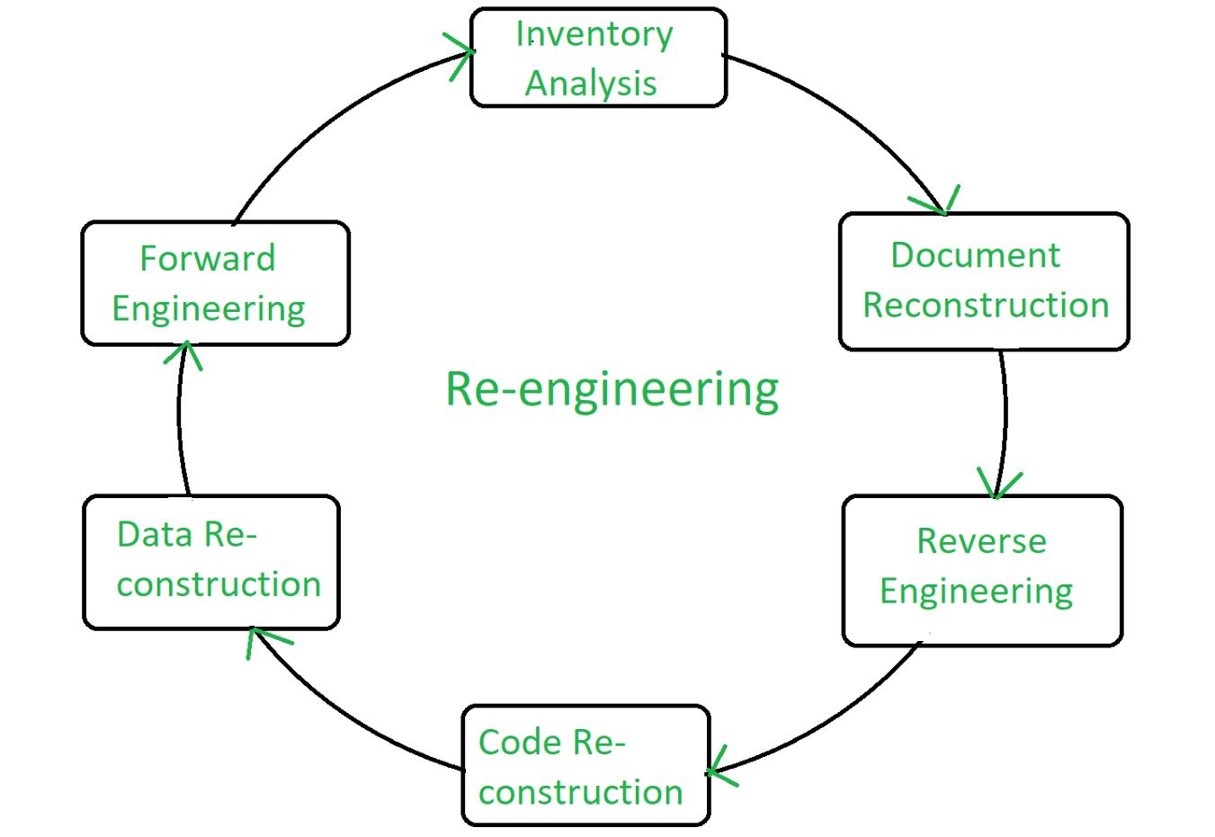Steps of Re-Engineering

**Re-engineering Cost Factors**

The quality of the software to be re-engineered.

The tool support available for re-engineering.

The extent of the required data conversion.

The availability of expert staff for re-engineering.

**Factors Affecting Cost of Re-engineering**

**Re-engineering can be a costly process, and there are several factors that can affect the cost of re-engineering a software system:**

**Size and complexity of the software:** The larger and more complex the software system, the more time and resources will be required to analyze, design, and modify it.

**Number of features to be added or modified:**The more features that need to be added or modified, the more time and resources will be required.

**Tools and technologies used:** The cost of re-engineering can be affected by the tools and technologies used, such as the cost of software development tools and the cost of hardware and infrastructure.

**Availability of documentation:** If the documentation of the existing system is not available or is not accurate, then it will take more time and resources to understand the system.

**Team size and skill level:** The size and skill level of the development team can also affect the cost of re-engineering. A larger and more experienced team may be able to complete the project faster and with fewer resources.

**Location and rate of the team:**The location and rate of the development team can also affect the cost of re-engineering. Hiring a team in a lower-cost location or with lower rates can help to reduce the cost of re-engineering.

**Testing and quality assurance:**Testing and quality assurance are important aspects of re-engineering, and they can add significant costs to the project.

**Post-deployment maintenance:**The cost of post-deployment maintenance such as bug fixing, security updates, and feature additions can also play a role in the cost of re-engineering.

In summary, the cost of re-engineering a software system can vary depending on a variety of factors, including the size and complexity of the software, the number of features to be added or modified, the tools and technologies used, and the availability of documentation and the skill level of the development team. It's important to carefully consider these factors when estimating the cost of re-engineering a software system.

**Advantages of Re-engineering**

**Reduced Risk:** As the software is already existing, the risk is less as compared to new software development. Development problems, staffing problems and specification problems are the lots of problems that may arise in new [software development](https://www.geeksforgeeks.org/software-engineering/what-is-software-development/).

**Reduced Cost:**  The cost of re-engineering is less than the costs of developing new software.

**Revelation of Business Rules:** As a system is re-engineered , business rules that are embedded in the system are rediscovered.

**Better use of Existing Staff:**Existing staff expertise can be maintained and extended accommodate new skills during re-engineering.

**Improved efficiency:** By analyzing and redesigning processes, re-engineering can lead to significant improvements in productivity, speed, and cost-effectiveness.

**Increased flexibility:** Re-engineering can make systems more adaptable to changing business needs and market conditions.

**Better customer service:** By redesigning processes to focus on customer needs, re-engineering can lead to improved customer satisfaction and loyalty.

**Increased competitiveness:** Re-engineering can help organizations become more competitive by improving efficiency, flexibility, and customer service.

**Improved quality:** Re-engineering can lead to better quality products and services by identifying and eliminating defects and inefficiencies in processes.

**Increased innovation:** Re-engineering can lead to new and innovative ways of doing things, helping organizations to stay ahead of their competitors.

**Improved compliance:** Re-engineering can help organizations to comply with industry standards and regulations by identifying and addressing areas of non-compliance.

**Disadvantages of Re-engineering**

Major architectural changes or radical reorganizing of the systems data management has to be done manually. Re-engineered system is not likely to be as maintainable as a new system developed using modern software Re-engineering methods.

**High costs:**Re-engineering can be a costly process, requiring significant investments in time, resources, and technology.

**Disruption to business operations:**Re-engineering can disrupt normal business operations and cause inconvenience to customers, employees and other stakeholders.

**Resistance to change:** Re-engineering can encounter resistance from employees who may be resistant to change and uncomfortable with new processes and technologies.

**Risk of failure:** Re-engineering projects can fail if they are not planned and executed properly, resulting in wasted resources and lost opportunities.

**Lack of employee involvement:**Re-engineering projects that are not properly communicated and involve employees, may lead to lack of employee engagement and ownership resulting in failure of the project.

**Difficulty in measuring success:**Re-engineering can be difficult to measure in terms of success, making it difficult to justify the cost and effort involved.

**Difficulty in maintaining continuity:** Re-engineering can lead to significant changes in processes and systems, making it difficult to maintain continuity and consistency in the organization.

**Conclusion**

Software re-engineering is a systematic process aimed at improving existing software systems. It involves analyzing, restructuring, and sometimes rebuilding software to enhance its functionality, adapt it to new requirements, or migrate it to a new platform. By employing techniques such as reverse engineering and forward engineering, reengineering helps ensure that software remains relevant, maintainable, and efficient.

What is Agile Maintenance?

Just as modern cars use smart sensors to detect issues before they become serious, Agile Maintenance is about staying proactive. It relies on continuous monitoring to track real-time equipment health, responsiveness to make quick, data-driven adjustments, and collaboration between maintenance teams, operators, and IT to prevent breakdowns before they happen.

In simpler terms, agile maintenance means having the ability to be flexible and respond to production demands and equipment wear or react to external disruption, be it supply chain or technical. It maximizes the performance and longevity of machines. With changing times, conventional maintenance techniques are proving less effective, and the emphasis has moved to smarter & responsive systems.

The Core Principles of Agile Maintenance

Agile maintenance is based on a few key ideas that help keep machines running smoothly while reducing unnecessary labor and time, as well as reducing costs.

Efficiency & Speed

With agile maintenance, failures and changes in asset conditions are handled quickly to help reduce downtime and improve productivity. It helps teams identify problems early, respond quickly, and plan maintenance effectively, reducing interference with operations.

Iterative Improvement

Sensors do real-time data collection and alert teams before the issue occurs instead of waiting for a failure. This allows for faster decision-making.

Flexibility

Instead of being on a fixed maintenance schedule, maintenance teams adjust what they do for the machine based on machine conditions. Agile maintenance does not adhere to a strict maintenance schedule, and maintenance interventions are performed only when needed.

Collaboration

Execution thrives on teamwork in Agile Maintenance. Maintenance teams, IT specialists, and machine operators join forces, relying on their individual skill sets to prevent problems, resolve issues, and maximize the machine’s performance. Maintenance teams are empowered to make quicker and smarter decisions, minimizing downtime and ensuring efficiencies by sharing data and insights in real time.

Data-Driven Decision Making

Data-driven decisions underpin the agile maintenance approach. To streamline this process, AI and IoT look at performance trends to predict and solve issues before they arise.

Advantages of Agile Maintenance

“A stitch in time saves nine.” The sooner you fix small issues, the less likely they are to turn into costly problems. Here are some of the key benefits of Agile Maintenance:

Lower Maintenance Costs

Traditional preventive maintenance involves performing unnecessary preventive tasks and inspections, consuming valuable resources. With an agile maintenance approach, companies do maintenance only when required. This avoids using additional labor and incurring extra costs for spare parts when not needed.

Increased Equipment Lifespan

Just like regular oil changes help a car last longer, Agile maintenance prevents excessive wear and tear on industrial machinery. By continuously monitoring equipment health and addressing minor issues before they escalate, companies extend the lifespan of critical assets, reducing the need for costly replacements of parts or the whole machine. Fixed scheduled maintenance often results in performing tasks that are not necessary (over maintenance) but also runs the risk of missing corrective maintenance when needed, which can result in costly failures and longer downtime.

Enhanced Predictive Maintenance

IoT sensors, AI, and machine learning are used in agile maintenance to detect failures ahead of time. Rather than reacting to breakdowns, companies get advance warnings about asset performance degradation. This enables service technicians to make repairs as needed and before a more serious and expensive breakdown happens. This minimizes emergency repairs, prevents production interruptions, and maximizes operational efficiency by keeping machines in optimal condition.

Increased Productivity

Fewer chronic breakdowns and streamlined maintenance schedules equate to more staff time spent producing instead of troubleshooting broken-down equipment. Forecasting upkeep has resulted in better availability of the machine in the oil & gas, DNA, and energy sectors and has induced a substantial rise in the return on investment (ROI). This results in businesses receiving greater output from their equipment while incurring lower spending on repairs and downtime.

These advantages have allowed many companies to function more effectively, eliminate wasteful spending, and, most importantly, increase overall asset dependability.

Agile vs. Traditional Maintenance

The old saying is, ‘Fix the roof while the sun is shining.’ Traditional maintenance in the usual sense waits for it to rain, while with agile maintenance, teams are aware that a storm is coming and strengthen the roof so that it does not leak.

Traditional maintenance methods are working on a precisely scheduled basis, maintaining equipment regardless of the need, or taking action once failure has occurred. Either way, the result is inefficiency, wasting resources and/or time through performing unnecessary maintenance tasks or dealing with unexpected service outages that could have been avoided.

Agile maintenance, by contrast, adjusts in real time to actual conditions and employs smart technology like AI and sensors to anticipate issues before they arise. This leads to quicker response times, decreased breakdowns, and reduced costs. Conventional maintenance wastes money by either carrying out unnecessary work or waiting too long to correct a problem.

**Software Evolution - Software Engineering**

Last Updated : 03 Jan, 2024

Software Evolution is a term that refers to the process of developing software initially, and then timely updating it for various reasons, i.e., to add new features or to remove obsolete functionalities, etc. This article focuses on discussing Software Evolution in detail.

**What is Software Evolution?**

The software evolution process includes fundamental activities of change analysis, release planning, system implementation, and releasing a system to customers.

The cost and impact of these changes are accessed to see how much the system is affected by the change and how much it might cost to implement the change.

If the proposed changes are accepted, a new release of the software system is planned.

During release planning, all the proposed changes (fault repair, adaptation, and new functionality) are considered.

A design is then made on which changes to implement in the next version of the system.

The process of change implementation is an iteration of the development process where the revisions to the system are designed, implemented, and tested.

**Necessity of Software Evolution**

Software evaluation is necessary just because of the following reasons:

**Change in requirement with time:**With time, the organization's needs and modus Operandi of working could substantially be changed so in this frequently changing time the tools(software) that they are using need to change to maximize the performance.

**Environment change:**As the working environment changes the things(tools) that enable us to work in that environment also changes proportionally same happens in the software world as the working environment changes then, the organizations require reintroduction of old software with updated features and functionality to adapt the new environment.

**Errors and bugs:**As the age of the deployed software within an organization increases their preciseness or impeccability decrease and the efficiency to bear the increasing complexity workload also continually degrades. So, in that case, it becomes necessary to avoid use of obsolete and aged software. All such obsolete Pieces of software need to undergo the evolution process in order to become robust as per the workload complexity of the current environment.

**Security risks:**Using outdated software within an organization may lead you to at the verge of various software-based cyberattacks and could expose your confidential data illegally associated with the software that is in use. So, it becomes necessary to avoid such security breaches through regular assessment of the security patches/modules are used within the software. If the software isn't robust enough to bear the current occurring Cyber attacks so it must be changed (updated).

**For having new functionality and features:**In order to increase the performance and fast data processing and other functionalities, an organization need to continuously evolute the software throughout its life cycle so that stakeholders & clients of the product could work efficiently.

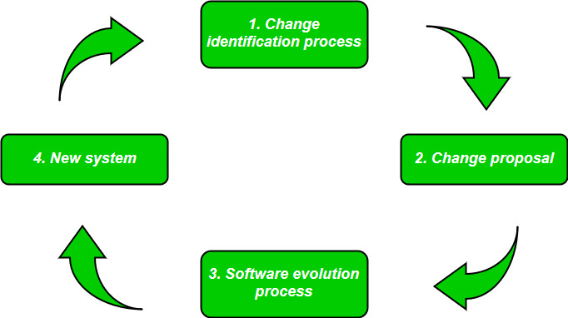Software Evolution

**Laws used for Software Evolution**

**1. Law of Continuing Change**

This law states that any software system that represents some real-world reality undergoes continuous change or become progressively less useful in that environment.

**2. Law of Increasing Complexity**

As an evolving program changes, its structure becomes more complex unless effective efforts are made to avoid this phenomenon.

**3. Law of Conservation of Organization Stability**

Over the lifetime of a program, the rate of development of that program is approximately constant and independent of the resource devoted to system development.

**4. Law of Conservation of Familiarity**

This law states that during the active lifetime of the program, changes made in the successive release are almost constant.

**Software Re-Engineering**

Last Updated : 15 Dec, 2022

**Software Re-Engineering** is the examination and alteration of a system to reconstitute it in a new form. The principle of Re-Engineering when applied to the software development process is called software re-engineering. It positively affects software cost, quality, customer service, and delivery speed. In Software Re-engineering, we are improving the software to make it more efficient and effective.

It is a process where the software's design is changed and the source code is created from scratch. Sometimes software engineers notice that certain software product components need more upkeep than other components, necessitating their re-engineering.

The re-Engineering procedure requires the following steps

**Decide** which components of the software we want to re-engineer. Is it the complete software or just some components of the software?

**Do**Reverse Engineering to learn about existing software functionalities.

**Perform restructuring  of source code** if needed for example modifying functional-Oriented programs in Object-Oriented programs

**Perform restructuring of data** if required

**Use Forward Engineering** ideas to generate re-engineered software



**The need for software Re-engineering:**Software re-engineering is an economical process for software development and quality enhancement of the product. This process enables us to identify the useless consumption of deployed resources and the constraints that are restricting the development process so that the development process could be made easier and cost-effective (time, financial, direct advantage, optimize the code, indirect benefits, etc.) and maintainable. The software reengineering is necessary for having-

**a) Boost up productivity:**Software reengineering increase productivity by optimizing the code and database so that processing gets faster.

**b) Processes in continuity:** The functionality of older software products can be still used while the testing or development of software.

**c) Improvement opportunity:**Meanwhile the process of software reengineering, not only software qualities, features, and functionality but also your skills are refined, and new ideas hit your mind. This makes the developer's mind accustomed to capturing new opportunities so that more and more new features can be developed.

**d) Reduction in risks:**Instead of developing the software product from scratch or from the beginning stage, developers develop the product from its existing stage to enhance some specific features brought in concern by stakeholders or its users. Such kind of practice reduces the chances of fault fallibility.

**e) Saves time:**As stated above, the product is developed from the existing stage rather than the beginning stage, so the time consumed in software engineering is lesser.

**f) Optimization:**This process refines the system features, and functionalities and reduces the complexity of the product by consistent optimization as maximum as possible.   
  
**Re-Engineering cost factors:** 

The quality of the software is to be re-engineered.

The tool support availability for engineering.

The extent of the data conversion is required.

The availability of expert staff for Re-engineering.

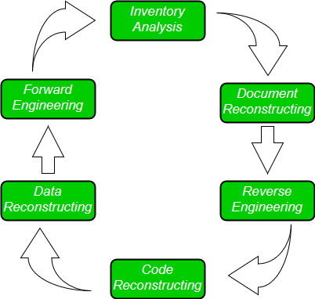

**Software Re-Engineering Activities:**   
  
  
**1. Inventory Analysis:**   
Every software organization should have an inventory of all the applications. 

Inventory can be nothing more than a spreadsheet model containing information that provides a detailed description of every active application.

By sorting this information according to business criticality, longevity, current maintainability, and other local important criteria, candidates for re-engineering appear.

The resource can then be allocated to a candidate application for re-engineering work.

**2. Document reconstructing:**   
Documentation of a system either explains how it operates or how to use it. 

Documentation must be updated.

It may not be necessary to fully document an application.

The system is business-critical and must be fully re-documented.

**3. Reverse Engineering:**   
Reverse engineering is a process of design recovery. Reverse engineering tools extract data and architectural and procedural design information from an existing program. 



**4. Code Reconstructing:** 

To accomplish code reconstruction, the source code is analyzed using a reconstructing tool. Violations of structured programming construct are noted and code is then reconstructed.

The resultant restructured code is reviewed and tested to ensure that no anomalies have been introduced.

**5. Data Restructuring:** 

Data restructuring begins with a reverse engineering activity.

The current data architecture is dissected, and the necessary data models are defined.

Data objects and attributes are identified, and existing data structures are reviewed for quality.

**6. Forward Engineering:**   
Forward Engineering also called renovation or reclamation not only recovers design information from existing software but uses this information to alter or reconstitute the existing system to improve its overall quality.



Difference between Forward Engineering and Reverse Engineering

Last Updated : 11 Jul, 2025

Forward engineering and reverse engineering are two approaches to software development, with different goals and processes. Forward engineering involves creating new software systems from scratch using given requirements and design specifications. It focuses on building new applications through a structured process of analysis, design, implementation, and testing. Reverse engineering, on the other hand, involves analyzing and understanding existing software to extract its design, structure, and functionality. This approach is used to modify, improve, or document existing applications by working backward from the existing code.

What is Forward Engineering?

Forward Engineering is a method of creating or making an application with the help of the given requirements. Forward engineering is also known as Renovation and Reclamation. Forward engineering requires high proficiency skills. It takes more time to construct or develop an application. Forward engineering is a technique of creating high-level models or designs to make complexities and low-level information. Therefore this kind of engineering has completely different principles in numerous packages and information processes. Forward Engineering applies all the software engineering process that contains SDLC to recreate associated existing applications. It is near to full fill new needs of the users into re-engineering.

Characteristics of forward engineering

Forward engineering is a variety of engineering that has different principles in numerous package and information processes.

Forward engineering is vital in IT as a result of it represents the 'normal’ development process.

Forward engineering deals with the conversion of business processes, services, and functions into applications.

In this method, the business model is developed first. Then, a top-down approach is followed to urge the package from the model developed.

Forward engineering tools are accustomed to moving from implementation styles and logic to the event of supply code.

It essentially permits the user to develop a business model which may then be translated into data system components.

These tools follow the top-down approach. System creator and visual Analyst is a forward engineering CASE tool.

Forward engineering

What is Reverse Engineering?

Reverse Engineering is also known as backward engineering, is the process of forward engineering in reverse. In this, the information is collected from the given or existing application. It takes less time than forward engineering to develop an application. In reverse engineering, the application is broken to extract knowledge or its architecture.

Reverse Engineering

Key Elements of Forward engineering and reverse engineering

Here are some key differences between the two:

Goal: The goal of forward engineering is to develop new software from scratch, while the goal of reverse engineering is to analyze and understand an existing software system.

Process: Forward engineering involves designing and implementing a new software system based on requirements and specifications. Reverse engineering involves analyzing an existing software system to understand its design, structure, and behavior.

Tools and Techniques: Forward engineering often involves the use of software development tools, such as IDEs, code generators, and testing frameworks. Reverse engineering often involves the use of reverse engineering tools, such as decompilers, disassemblers, and code analyzers.

Focus: Forward engineering focuses on the creation of new code and functionality, while reverse engineering focuses on understanding and documenting existing code and functionality.

Output: The output of forward engineering is a new software system, while the output of reverse engineering is documentation of an existing software system, such as a UML diagram, flowchart, or software specification.

In summary, forward engineering is focused on the creation of new software systems, while reverse engineering is focused on understanding and documenting existing software systems. Both approaches use different tools and techniques to achieve their goals and produce different outputs.

Difference between Forward Engineering and Reverse Engineering

Aspect

Forward Engineering Reverse Engineering

Process

In forward engineering, the application are developed with the given requirements. In reverse engineering or backward engineering, the information are collected from the given application.

Skill Level

Forward Engineering is a high proficiency skill. Reverse Engineering or backward engineering is a low proficiency skill.

Development Time

Forward Engineering takes more time to develop an application. While Reverse Engineering or backward engineering takes less time to develop an application.

Nature

The nature of forward engineering is Prescriptive. The nature of reverse engineering or backward engineering is Adaptive.

Production Start Point

In forward engineering, production is started with given requirements. In reverse engineering, production is started by taking the existing products.

Examples

The example of forward engineering is the construction of electronic kit, construction of DC MOTOR , etc. An example of backward engineering is research on Instruments etc.

Development Steps

Forward engineering Starts with requirements analysis and design, then proceeds to implementation and testing. Reverse engineering Starts with an existing software system and works backward to understand its structure, design, and requirements.

Use Case

Forward engineering is used to create new software applications from scratch. Reverse engineering is Used to modify and improve an existing software application.

Abstraction Level

Forward engineering is process of moving from a high-level abstraction to a detailed implementation. Reverse engineering is a process of moving from a low-level implementation to a higher-level abstraction.

Requirements and Design Specifications

Requires a clear set of requirements and design specifications. Requirements and design specifications may not be available, making it necessary to reconstruct them from the code itself.

Time and Cost

Forward engineering is generally more time-consuming and expensive. Reverse engineering is generally less time-consuming and less expensive.

Final Product

The final product is completely new and independent of any existing software system. The final product is typically a modified or improved version of an existing software system.

Development Steps

Involves a series of steps such as requirements gathering, design, implementation, testing, and deployment. Involves steps such as code analysis, code understanding, design recovery, and documentation.

Software Development Life Cycle Stage

Forward engineering is commonly used in the initial stages of software development. Reverse engineering is commonly used in the maintenance stage of the software development life cycle.

**Software development process**

A [software development process](https://en.wikipedia.org/wiki/Software_development_process) is concerned primarily with the production aspect of [software development](https://en.wikipedia.org/wiki/Software_development), as opposed to the technical aspect, such as [software tools](https://en.wikipedia.org/wiki/Software_tools). These processes exist primarily for supporting the management of software development, and are generally skewed toward addressing business concerns. Many software development processes can be run in a similar way to general project management processes. Examples are:

[Interpersonal communication](https://en.wikipedia.org/wiki/Interpersonal_communication) and [conflict management and resolution](https://en.wikipedia.org/wiki/Organizational_conflict#Conflict_management_and_resolution). Active, frequent and honest communication is the most important factor in increasing the likelihood of project success and mitigating problematic projects. The development team should seek end-user involvement and encourage user input in the development process. Not having users involved can lead to misinterpretation of requirements, insensitivity to changing customer needs, and unrealistic expectations on the part of the client. Software developers, users, project managers, customers and [project sponsors](https://en.wikipedia.org/wiki/Project_sponsor) need to communicate regularly and frequently. The information gained from these discussions allows the [project team](https://en.wikipedia.org/wiki/Project_team) to analyze the strengths, weaknesses, opportunities and threats (SWOT) and to act on that information to benefit from opportunities and to minimize threats. Even bad news may be good *if* it is communicated relatively early, because problems can be mitigated if they are not discovered too late. For example, casual conversation with users, team members, and other stakeholders may often surface potential problems sooner than formal meetings. All communications need to be [intellectually honest](https://en.wikipedia.org/wiki/Intellectual_honesty) and authentic, and regular, frequent, [high quality criticism](https://en.wikipedia.org/wiki/Criticism#Quality) of development work is necessary, as long as it is provided in a calm, respectful, [constructive](https://en.wikipedia.org/wiki/Criticism#Techniques_of_constructive_criticism), non-accusatory, non-angry fashion. Frequent casual communications between developers and end-users, and between project managers and clients, are necessary to keep the project relevant, useful and effective for the end-users, and within the bounds of what can be completed. Effective interpersonal communication and conflict management and resolution are the key to software project management. *No methodology or process improvement strategy can overcome serious problems in communication or mismanagement of interpersonal conflict.* Moreover, outcomes associated with such methodologies and process improvement strategies are enhanced with better communication. The communication must focus on whether the team understands the [project charter](https://en.wikipedia.org/wiki/Project_charter) and whether the team is making progress towards that goal. End-users, software developers and project managers must frequently [ask the elementary](https://en.wikipedia.org/wiki/Question), simple questions that [help identify problems](https://en.wikipedia.org/wiki/Management_by_wandering_around) before they fester into near-disasters. *While end-user participation, effective communication and*[*teamwork*](https://en.wikipedia.org/wiki/Teamwork)*are not sufficient, they are necessary to ensure a good outcome, and their absence will almost surely lead to a bad outcome.*[[3]](https://en.wikipedia.org/wiki/Software_project_management#cite_note-Producing-oss-pdf-3)[[4]](https://en.wikipedia.org/wiki/Software_project_management#cite_note-IEEE-TMC-Dec-2014-4)[[5]](https://en.wikipedia.org/wiki/Software_project_management#cite_note-5)

[Risk management](https://en.wikipedia.org/wiki/Risk_management) is the process of measuring or [assessing risk](https://en.wikipedia.org/wiki/Risk_assessment) and then developing strategies to manage the risk. In general, the strategies employed include transferring the risk to another party, avoiding the risk, reducing the negative effect of the risk, and accepting some or all of the consequences of a particular risk. Risk management in software project management begins with the [business case](https://en.wikipedia.org/wiki/Business_case) for starting the project, which includes a [cost-benefit analysis](https://en.wikipedia.org/wiki/Cost-benefit_analysis) as well as a list of fallback options for project failure, called a [contingency plan](https://en.wikipedia.org/wiki/Contingency_plan).

A subset of risk management is [Opportunity Management](https://en.wikipedia.org/wiki/Opportunity_Management), which means the same thing, except that the potential risk outcome will have a positive, rather than a negative impact. Though theoretically handled in the same way, using the term "opportunity" rather than the somewhat negative term "risk" helps to keep a team focused on possible positive outcomes of any given [risk register](https://en.wikipedia.org/wiki/Risk_register) in their projects, such as spin-off projects, windfalls, and free extra resources.

[Requirements management](https://en.wikipedia.org/wiki/Requirements_management) is the process of identifying, [eliciting](https://en.wikipedia.org/wiki/Requirements_elicitation), documenting, analyzing, [tracing](https://en.wikipedia.org/wiki/Requirements_traceability), prioritizing and agreeing on requirements and then controlling change and communicating to relevant stakeholders. New or altered [computer system](https://en.wikipedia.org/wiki/Computer_system)[[1]](https://en.wikipedia.org/wiki/Software_project_management#cite_note-Stellman05-1) Requirements management, which includes [Requirements analysis](https://en.wikipedia.org/wiki/Requirements_analysis), is an important part of the [software engineering](https://en.wikipedia.org/wiki/Software_engineering) process; whereby business analysts or [software developers](https://en.wikipedia.org/wiki/Software_developers) identify the needs or requirements of a client; having identified these requirements they are then in a position to design a solution.

[Change management](https://en.wikipedia.org/wiki/Change_management) is the process of identifying, documenting, analyzing, prioritizing and agreeing on changes to [scope (project management)](https://en.wikipedia.org/wiki/Scope_(project_management)) and then controlling changes and communicating to relevant stakeholders. [Change impact analysis](https://en.wikipedia.org/wiki/Change_impact_analysis) of new or altered scope, which includes [Requirements analysis](https://en.wikipedia.org/wiki/Requirements_analysis) at the change level, is an important part of the [software engineering](https://en.wikipedia.org/wiki/Software_engineering) process; whereby business analysts or [software developers](https://en.wikipedia.org/wiki/Software_developers) identify the altered needs or requirements of a client; having identified these requirements they are then in a position to re-design or modify a solution. Theoretically, each change can impact the timeline and budget of a software project, and therefore by definition must include [risk-benefit analysis](https://en.wikipedia.org/wiki/Risk-benefit_analysis) before approval.

[Software configuration management](https://en.wikipedia.org/wiki/Software_configuration_management) is the process of identifying, and documenting the scope itself, which is the software product underway, including all sub-products and changes and enabling communication of these to relevant stakeholders. In general, the processes employed include [version control](https://en.wikipedia.org/wiki/Version_control), [naming convention (programming)](https://en.wikipedia.org/wiki/Naming_convention_(programming)), and software archival agreements.

[Release management](https://en.wikipedia.org/wiki/Release_management) is the process of identifying, documenting, prioritizing and agreeing on releases of software and then controlling the release schedule and communicating to relevant stakeholders. Most software projects have access to three software environments to which software can be released; Development, Test, and Production. In very large projects, where distributed teams need to integrate their work before releasing to users, there will often be more environments for testing, called [unit testing](https://en.wikipedia.org/wiki/Unit_testing), [system testing](https://en.wikipedia.org/wiki/System_testing), or [integration testing](https://en.wikipedia.org/wiki/Integration_testing), before release to [User acceptance testing](https://en.wikipedia.org/wiki/User_acceptance_testing) (UAT).

A subset of release management that is gaining attention is [Data Management](https://en.wikipedia.org/wiki/Data_Management), as obviously the users can only test based on data that they know, and "real" data is only in the software environment called "production". In order to test their work, programmers must therefore also often create "dummy data" or "data stubs". Traditionally, older versions of a production system were once used for this purpose, but as companies rely more and more on outside contributors for software development, company data may not be released to development teams. In complex environments, datasets may be created that are then migrated across test environments according to a test release schedule, much like the overall software release schedule.

Maintenance and update is the process where Requirements and customer needs are always involving. They will undoubtedly find bugs, may request new features and ask for different functionality and more updates. So, all of these requests need to check and fulfill the customer's requirements and satisfaction.

**W5HH Principle**

Last Updated : 04 Oct, 2021

**Barry Boehm** gave a philosophy that prepares easy and manageable designs or outlines for software projects. He also gave a technique to discuss objectives, management, duties, and technical approach of the project and its necessary resources. Then he named it the **W5HH principle**when few questions resulted in project properties, definition, and resultant plan to make the project successful. Those questions are :   
  
The W5HH principle in software management exists to help project managers guide objectives, timelines, responsibilities, management styles, and resources. In this lesson, we'll explore each part.

**W5HH questions :**

**Why the system is going to be developed?**   
For the purpose of software work, all stakeholders must assess the validity of the system product/project. Here Barry questions that whether the project's purpose will justify the cost, time spent on it by people?   
  
**What is activities are needed to be done in this?**   
In this Barry questions what task is needed to be done for a project currently.   
  
**When is this done?**   
Project Scheduling is done by the team after recognizing when project tasks will be started and when they enter into the final stage to reach the goal.   
  
**Who are the reasons for these activities in this project?**  
Every member who is part of the software team is responsible for this. And their roles are defined.   
  
**Where are these authoritatively located?**   
Not only do software practitioners have roles in this but also users, customers, stakeholders also have roles and responsibilities organizationally.   
  
**How is**the **job technically and managerially finished?**   
All technical strategies, management rules of the project are defined after knowing the scope of the project which is being built.   
  
**How much part of each resource is required?**   
This is known by software developers after the estimation of each resource as per the needs of customers/users.   
  
This W5HH principle of Bohem is appropriate irrespective of the scale or difficulty of software projects being developed. These questions help in planning the outline of the project for the software team.

The **W5HH principle** outlines a series of questions that can help project managers more efficiently manage software projects. Each letter in W5HH stands for a question in the series of questions to help a project manager lead. (Notice there are five ''W'' questions and two ''H'' questions).

|  |  |  |
| --- | --- | --- |
| **W5HH** | **The Question** | **What It Means** |
| Why? | Why is the system being developed? | This focuses a team on the business reasons for developing the software. |
| What? | What will be done? | This is the guiding principle in determining the tasks that need to be completed. |
| When? | When will it be completed? | This includes important milestones and the timeline for the project. |
| Who? | Who is responsible for each function? | This is where you determine which team member takes on which responsibilities. You may also identify external stakeholders with a claim in the project. |
| Where? | Where are they organizationally located? | This step gives you time to determine what other stakeholders have a role in the project and where they are found. |
| How? | How will the job be done technically and managerially? | In this step, a strategy for developing the software and managing the project is concluded upon. |
| How Much? | How much of each resource is needed? | The goal of this step is to figure out the number of resources necessary to complete the project. |

**BIG OL GLOSSARY**

**specification.** **(1)** information item that identifies, in a complete, precise, and verifiable manner, the requirements, design, behavior, or other expected characteristics of a system, service, or process *(*[*ISO/IEC/IEEE 15289:2019 Systems and software engineering--Content of life-cycle information items (documentation)*](http://www.iso.org/iso/en/CatalogueListPage.CatalogueList)*, 5.24)* **(2)** detailed formulation, in document form, which provides a definitive description of a system for the purpose of developing or validating the system *(*[*ISO/IEC 2382:2015 Information technology -- Vocabulary*](http://www.iso.org/iso/en/CatalogueListPage.CatalogueList)*)* **(3)** precise statement of the needs to be satisfied and the essential characteristics that are required *(*[*A Guide to the Project Management Body of Knowledge (PMBOK(R) Guide) -- Seventh Edition*](http://www.pmibookstore.org/PMIBookStore/index.aspx)*)* **(4)** concrete representation of a model in some notation *(*[*ISO/IEC 10746-2:2009 Information technology -- Open Distributed Processing -- Reference Model: Foundations*](http://www.iso.org/iso/en/CatalogueListPage.CatalogueList)*, 7.4)* **(5)** information part that identifies, in a complete, precise and verifiable manner, the requirements, design, behavior, or other expected characteristics of an entity *(*[*ISO/IEC/IEEE 42010:2022, Software, systems and enterprise  Architecture description*](http://www.iso.org/iso/en/CatalogueListPage.CatalogueList)*, 3.16)*

**validation.** **(1)** confirmation, through the provision of objective evidence, that the requirements for a specific intended use or application have been fulfilled *(*[*ISO/IEC 25000:2014 Systems and software Engineering--Systems and software product Quality Requirements and Evaluation (SQuaRE) -- Guide to SQuaRE*](http://www.iso.org/iso/en/CatalogueListPage.CatalogueList)*, 4.41)* *(*[*ISO/IEC/IEEE 12207:2026 Systems and software engineering--Software life cycle processes*](http://www.iso.org/iso/en/CatalogueListPage.CatalogueList)*, 3.1.71)* **(2)** process of providing evidence that the system, software, or hardware and its associated products satisfy requirements allocated to it at the end of each life cycle activity, solve the right problem (e.g., correctly model physical laws, implement business rules, and use the proper system assumptions), and satisfy intended use and user needs *(*[*IEEE 1012-2024 IEEE Standard for System, Software, and Hardware Verification and Validation*](http://www.techstreet.com/ieeegate.html)*, 3.1.35)* **(3)** assurance that a product, service, or system meets the needs of the customer and other identified stakeholders *(*[*A Guide to the Project Management Body of Knowledge (PMBOK(R) Guide) -- Seventh Edition*](http://www.pmibookstore.org/PMIBookStore/index.aspx)*)* **(4)** confirmation in a timely manner, through automated techniques where possible, through the provision of objective evidence, that the requirements for a specific intended use or application have been fulfilled *(*[*IEEE 2675-2021, IEEE Standard for DevOps: Building Reliable and Secure Systems Including Application Build, Package, and Deployment*](http://www.techstreet.com/ieeegate.html)*, 3.1)* *Note:* Validation in a system life cycle context is the set of activities for gaining confidence that a system is able to accomplish its intended use, goals, and objectives (meet stakeholder requirements) in the intended operational environment. The right system has been built or is operating to meet business objectives. Validation demonstrates that the system can be used by the users for their specific tasks. "Validated" is used to designate the corresponding status. *See Also:* verification

**correctness.** **(1)** degree to which a system or component is free from faults in its specification, design, and implementation *(*[*ISO/IEC/IEEE 24765:2017 Systems and software engineering-Vocabulary*](http://www.iso.org/iso/en/CatalogueListPage.CatalogueList)*)* **(2)** degree to which software, documentation, or other items meet specified requirements *(*[*ISO/IEC/IEEE 24765:2017 Systems and software engineering-Vocabulary*](http://www.iso.org/iso/en/CatalogueListPage.CatalogueList)*)* **(3)** degree to which software, documentation, or other items meet user needs and expectations, whether specified or not *(*[*ISO/IEC/IEEE 24765:2017 Systems and software engineering-Vocabulary*](http://www.iso.org/iso/en/CatalogueListPage.CatalogueList)*)* **(4)** degree to which an IT service uses the correct process and produces the correct results with accurate data *(*[*ISO/IEC TS 25011:2017 Information technology--Systems and software Quality Requirements and Evaluation (SQuaRE)--Service quality models*](http://www.iso.org/iso/en/CatalogueListPage.CatalogueList)*, 3.2.1.2)*

**stakeholder analysis.** **(1)** method of systematically gathering and analyzing quantitative and qualitative information to determine whose interests should be taken into account throughout the project *(*[*A Guide to the Project Management Body of Knowledge (PMBOK(R) Guide) -- Seventh Edition*](http://www.pmibookstore.org/PMIBookStore/index.aspx)*)*

**software engineering.** **(1)** systematic application of scientific and technological knowledge, methods, and experience to the design, implementation, testing, and documentation of software *(*[*ISO/IEC 2382:2015 Information technology -- Vocabulary*](http://www.iso.org/iso/en/CatalogueListPage.CatalogueList)*)* *(*[*ISO/IEC/IEEE 24748-5:2017 Systems and software engineering--Life cycle management--Part 5: Software development planning*](http://www.iso.org/iso/en/CatalogueListPage.CatalogueList)*, 3.16)* **(2)** application of a systematic, disciplined, quantifiable approach to the development, operation, and maintenance of software; that is, the application of engineering to software *(*[*ISO/IEC TR 19759:2016 Software Engineering -- Guide to the Software Engineering Body of Knowledge (SWEBOK)*](http://www.iso.org/iso/en/CatalogueListPage.CatalogueList)*)* *(*[*ISO/IEC/IEEE 12207:2026 Systems and software engineering--Software life cycle processes*](http://www.iso.org/iso/en/CatalogueListPage.CatalogueList)*, 3.1.52)* *Syn:* SE, SWE

**requirement.** **(1)** statement that translates or expresses a need and its associated constraints and conditions *(*[*ISO/IEC/IEEE 12207:2026 Systems and software engineering--Software life cycle processes*](http://www.iso.org/iso/en/CatalogueListPage.CatalogueList)*, 4.1.31)* *(*[*ISO/IEC/IEEE 15288:2023 Systems and software engineering--System life cycle processes*](http://www.iso.org/iso/en/CatalogueListPage.CatalogueList)*, 3.36)* **(2)** condition or capability that is met or possessed by a system, system component, product, or service to satisfy an agreement, standard, specification, or other formally imposed documents *(*[*IEEE 730-2014 IEEE Standard for Software Quality Assurance Processes*](http://www.techstreet.com/ieeegate.html)*, 3.2)* **(3)** provision that conveys criteria to be fulfilled *(*[*ISO/IEC 14143-2:2011 Information technology -- Software measurement -- Functional size measurement -- Part 2: Conformity evaluation of software size measurement methods to ISO/IEC 14143-1*](http://www.iso.org/iso/en/CatalogueListPage.CatalogueList)*, 3.10)* **(4)** condition or capability that is necessary to be present in a product, service, or result to satisfy a business need *(*[*A Guide to the Project Management Body of Knowledge (PMBOK(R) Guide) -- Seventh Edition*](http://www.pmibookstore.org/PMIBookStore/index.aspx)*)* **(5)** need or expectation that is stated, generally implied, or obligatory *(*[*ISO/IEC 19770-1:2017 Information technology -- IT asset management -- Part 1: IT asset management systems--Requirements*](http://www.iso.org/iso/en/CatalogueListPage.CatalogueList)*, 3.47)* **(6)** condition or capability that is necessary in a system, system component, product, or service to satisfy an agreement, standard, specification, or other formally imposed documents *(*[*IEEE 982:2024, Standard for Measures of the Software Aspects of Dependability*](http://www.techstreet.com/ieeegate.html)*, 3.1)* *Example:* software component requirement *Note:* Requirements exist at different tiers and express the need in high-level form. A requirement is denoted by the word 'shall' and includes both the exclusive and applicable optional requirements. Requirements provide value when delivered, satisfied, or met. Requirements include the quantified and documented needs, wants, and expectations of the sponsor, customer, and other stakeholders. Well-formed requirements are unambiguous, clear, unique, consistent, stand-alone (not grouped), verifiable, and necessary for stakeholder acceptability. *See Also:* design requirement, functional requirement, implementation requirement, interface requirement, performance requirement, physical requirement

**software requirements specification (SRS).** **(1)** documentation of the essential requirements (functions, performance, design constraints, and attributes) of the software and its external interfaces *(*[*IEEE 1012-2024 IEEE Standard for System, Software, and Hardware Verification and Validation*](http://www.techstreet.com/ieeegate.html)*, 3.1.29)*

**derived requirement.** **(1)** requirement deduced or inferred from the collection and organization of requirements into a particular system configuration and solution *(*[*ISO/IEC/IEEE 29148:2018 Systems and software engineering-Life cycle processes-Requirements engineering*](http://www.iso.org/iso/en/CatalogueListPage.CatalogueList)*, 4.1.8)* **(2)** a requirement deduced or inferred from the collection and organization of requirements into a particular system configuration and solution *Note:* Derived requirements can arise during analysis and design of components of the product or service. *See Also:* product requirement

**black box.** **(1)** system or component whose inputs, outputs, and general function are known but whose contents or implementation are unknown or irrelevant *(*[*ISO/IEC/IEEE 24765:2017 Systems and software engineering-Vocabulary*](http://www.iso.org/iso/en/CatalogueListPage.CatalogueList)*)* **(2)** external view of the system (attributes) *(*[*INCOSE Systems Engineering Handbook, 5th ed.*](http://www.iso.org/iso/en/CatalogueListPage.CatalogueList)*)* *Syn:* closed box, opaque box *See Also:* glass box

**glass box.** **(1)** system or component whose internal contents or implementation are known *(*[*ISO/IEC/IEEE 24765:2017 Systems and software engineering-Vocabulary*](http://www.iso.org/iso/en/CatalogueListPage.CatalogueList)*)* *Syn:* white box, transparent box *See Also:* black box

**conceptual model.** **(1)** model of the concepts relevant to some endeavor *(*[*ISO/IEC/IEEE 24765n:2025*](http://www.iso.org/iso/en/CatalogueListPage.CatalogueList)*, 3.1.39)*

**framework.** **(1)** reusable design (models or code) that can be refined (specialized) and extended to provide some portion of the overall functionality of many applications *(*[*ISO/IEC/IEEE 24765n:2025*](http://www.iso.org/iso/en/CatalogueListPage.CatalogueList)*, 3.1.64)* **(2)** for a component content management system, essential data structures, operations, and rules that form the foundation from which all other features of the CCMS are built *(*[*ISO/IEC/IEEE 26531:2023 Systems and software engineering -- Content management for product lifecycle, user and service management information for users*](http://www.iso.org/iso/en/CatalogueListPage.CatalogueList)*, 3.1.16)*

**agile.** **(1)** approach to development, delivery, and maintenance of products and services by enabling rapid response to feedback *(*[*ISO/IEC 33202:2024, Software and systems engineering  Core agile practices*](http://www.iso.org/iso/en/CatalogueListPage.CatalogueList)*, 3.2)* *Note:* The specification for the software under development is elaborated with specific requirements only when the work is started. This lean principle is meant to avoid waste of work and to provide the agile team with means of prioritizing their work

**sprint.** **(1)** short time frame, in which a set of software features is developed, leading to a working product that can be demonstrated to stakeholders *(*[*ISO/IEC 29110-1-2:2024, Systems and software engineering  Lifecycle profiles for Very Small Entities (VSEs)  Part 1-2: Vocabulary*](http://www.iso.org/iso/en/CatalogueListPage.CatalogueList)*, 3.99)* **(2)** time box of one month or less during which a done, usable and potentially releasable product increment is created *(*[*ISO/IEC TR 7052:2023, Software engineering--Controlling frequently occurring risks during development and maintenance of custom software*](http://www.iso.org/iso/en/CatalogueListPage.CatalogueList)*, 3.42)* **(3)** short time interval within a project during which a usable and potentially releasable increment of the product is created *(*[*A Guide to the Project Management Body of Knowledge (PMBOK(R) Guide) -- Seventh Edition*](http://www.pmibookstore.org/PMIBookStore/index.aspx)*)* *Note:* In some organizations, a sprint is known as an iteration.

**increment.** **(1)** tested, deliverable version of a software product that provides new or modified capabilities *(*[*Software Extension to the PMBOK(R) Guide Fifth Edition*](http://www.pmibookstore.org/PMIBookStore/index.aspx)*)*

**incremental development.** **(1)** software development technique in which requirements definition, design, implementation, and testing occur in an overlapping, iterative (rather than sequential) manner, resulting in incremental completion of the overall software product *(*[*ISO/IEC/IEEE 24765:2017 Systems and software engineering-Vocabulary*](http://www.iso.org/iso/en/CatalogueListPage.CatalogueList)*)* *See Also:* waterfall model, data structure-centered design, input-process-output, modular decomposition, object-oriented design

**incremental analysis.** **(1)** consideration of the relative differences between alternatives *(*[*ISO/IEC/IEEE 24765:2017 Systems and software engineering-Vocabulary*](http://www.iso.org/iso/en/CatalogueListPage.CatalogueList)*)* *Note:* If the incremental benefit of a second alternative over the first is more than the incremental investment between them, the second alternative is a better investment than the first.

**error.** **(1)** discrepancy between a computed, observed, or measured value or condition and the true, specified, or theoretically correct value or condition *(*[*ISO/IEC/IEEE 15026-1:2019 Systems and software engineering--Systems and software assurance--Part 1: Concepts and vocabulary*](http://www.iso.org/iso/en/CatalogueListPage.CatalogueList)*, 3.4.5)* *Example:* omission or misinterpretation of user requirements in a software specification, incorrect translation, or omission of a requirement in the design specification *See Also:* failure, defect

**defect.** **(1)** imperfection or deficiency in a work product or characteristic that does not meet its requirements or specifications *(*[*IEEE 2675-2021, IEEE Standard for DevOps: Building Reliable and Secure Systems Including Application Build, Package, and Deployment*](http://www.techstreet.com/ieeegate.html)*, 3.1)* **(2)** fault or deviation from the intended level of performance of a system or software *(*[*ISO/IEC 23643:2020, Software and systems engineering--Capabilities of software safety and security verification tools*](http://www.iso.org/iso/en/CatalogueListPage.CatalogueList)*, 3.4)* **(3)** imperfection or deficiency in a work product where that work product does not meet its requirements or specifications and needs to be either repaired or replaced *(*[*ISO/IEC 23531:2020, Systems and software engineering--Capabilities of issue management tools*](http://www.iso.org/iso/en/CatalogueListPage.CatalogueList)*, 3.1)* *Example:* (1) omissions and imperfections found during early life cycle phases and (2) faults contained in software sufficiently mature for test or operation *See Also:* fault

**software development cycle.** **(1)** period of time that begins with the decision to develop a software product and ends when the software is delivered *(*[*ISO/IEC/IEEE 24765:2017 Systems and software engineering-Vocabulary*](http://www.iso.org/iso/en/CatalogueListPage.CatalogueList)*)* *Example:* null *Note:* This cycle typically includes a requirements phase, design phase, implementation phase, test phase, and sometimes, installation and checkout phase. The phases listed above can overlap or be performed iteratively, depending upon the software development approach used. This term is sometimes used to mean a longer period of time, either the period that ends when the software is no longer being enhanced by the developer, or the entire software life cycle. *See Also:* software life cycle

**model.** **(1)** representation of a real-world process, device, or concept *(*[*IEEE 7014-2024, IEEE Standard for Ethical Considerations in Emulated Empathy in Autonomous and Intelligent Systems*](http://www.techstreet.com/ieeegate.html)*, 3.1)* **(2)** representation of something that suppresses certain aspects of the modeled subject *(*[*ISO/IEC/IEEE 24765l:2024*](http://www.iso.org/iso/en/CatalogueListPage.CatalogueList)*)* **(3)** abstract representation of an entity or collection of entities that provides the ability to portray, understand or predict the properties or characteristics of the entity or collection under conditions or situations of interest *(*[*ISO/IEC/IEEE 42020:2019 Software, systems and enterprise -- Architecture processes*](http://www.iso.org/iso/en/CatalogueListPage.CatalogueList)*, 3.13)* **(4)** related collection of instances of meta-objects, representing (describing or prescribing) an information system, or parts thereof, such as a software product *(*[*ISO/IEC 15474-1:2002 Information technology -- CDIF framework -- Part 1: Overview*](http://www.iso.org/iso/en/CatalogueListPage.CatalogueList)*, 4.2)* **(5)** output of a machine learning algorithm trained with a training dataset that generates predictions using patterns in the input data *(*[*ISO/IEC TR 29119-11:2020, Software and systems engineering--Software testing--Part 11: Guidelines on the testing of AI-based systems*](http://www.iso.org/iso/en/CatalogueListPage.CatalogueList)*, 3.1.46)* **(6)** system of postulates, value declarations and inference rules presented as a description of a state of affairs (universe of discourse) *(*[*ISO/IEC 10746-2:2009 Information technology -- Open Distributed Processing -- Reference Model: Foundations*](http://www.iso.org/iso/en/CatalogueListPage.CatalogueList)*, 7.3)* **(7)** representation of a system of interest, from the perspective of a related set of concerns *(*[*ISO/IEC/IEEE 24765l:2024*](http://www.iso.org/iso/en/CatalogueListPage.CatalogueList)*)* **(8)** algorithm or calculation combining one or more base or derived measures with associated decision criteria *(*[*ISO/IEC/IEEE 15939:2017 Systems and software engineering--Measurement process*](http://www.iso.org/iso/en/CatalogueListPage.CatalogueList)*, 3.27)* *Note:* The representation of the concepts or properties of an entity and governing principles is captured in architecture models.

**development.** **(1)** specification, construction, testing and delivery of a new application or of a discrete addition to an existing application *(*[*ISO/IEC 20968:2002 Software engineering -- Mk II Function Point Analysis -- Counting Practices Manual*](http://www.iso.org/iso/en/CatalogueListPage.CatalogueList)*, 10)* **(2)** activity of preparing information for users after it has been designed *(*[*ISO/IEC/IEEE 26512:2018 Systems and software engineering--Requirements for acquirers and suppliers of information for users*](http://www.iso.org/iso/en/CatalogueListPage.CatalogueList)*, 3.9)*

**function.** **(1)** a task, action, or activity that must be accomplished to achieve a desired outcome. **(2)** defined objective or characteristic action of a system or component *(*[*ISO/IEC/IEEE 26514:2022, Systems and software engineering -- Design and development of information for users*](http://www.iso.org/iso/en/CatalogueListPage.CatalogueList)*, 3.1.23)* **(3)** software module that performs a specific action, is invoked by the appearance of its name in an expression, receives input values, and returns a single value *(*[*ISO/IEC/IEEE 24765:2017 Systems and software engineering-Vocabulary*](http://www.iso.org/iso/en/CatalogueListPage.CatalogueList)*)* **(4)** transformation of inputs to outputs, by means of some mechanisms, and subject to certain controls, that is identified by a function name and modeled by a box *(*[*ISO/IEC/IEEE 24765m:2024*](http://www.iso.org/iso/en/CatalogueListPage.CatalogueList)*)* **(5)** single-valued mapping *(*[*ISO/IEC/IEEE 24765l:2024*](http://www.iso.org/iso/en/CatalogueListPage.CatalogueList)*)*

**functionality.** **(1)** set of capabilities, such as features, mechanisms, services, or procedures, allowable and actionable by the system *(*[*IEEE 7002:2022, IEEE Standard for Data Privacy Process*](http://www.techstreet.com/ieeegate.html)*, 3.1)* *Note:* This characteristic is concerned with what the software does to fulfill needs. The software quality characteristic functionality can be used to specify or evaluate the suitability, accuracy, interoperability, security, and compliance of a function.

**established requirement.** **(1)** requirement that the project has verified as satisfying project-specific criteria (such as clarity, suitability, and feasibility) and has validated to be an accurate representation of stakeholder needs, wants, and expectations *(*[*IEEE 730-2014 IEEE Standard for Software Quality Assurance Processes*](http://www.techstreet.com/ieeegate.html)*, 3.2)* *Note:* Established requirements are accepted by the project to form the basis of product development.

**baseline.** **(1)** formally approved version of a configuration item, regardless of media, formally designated and fixed at a specific time during the configuration item's life cycle *(*[*ISO/IEC/IEEE 12207:2026 Systems and software engineering--Software life cycle processes*](http://www.iso.org/iso/en/CatalogueListPage.CatalogueList)*, 3.1.12)* *(*[*ISO/IEC/IEEE 15288:2023 Systems and software engineering--System life cycle processes*](http://www.iso.org/iso/en/CatalogueListPage.CatalogueList)*, 3.8)* **(2)** formally controlled and maintained set of data that serves as the basis for defining change *(*[*ISO/IEC/IEEE 24748-7:2019, Systems and software engineering  Life cycle management  Part 7: Application of systems engineering on defense programs*](http://www.iso.org/iso/en/CatalogueListPage.CatalogueList)*, 3.1)* **(3)** agreement or result designated and fixed at a given time, from which changes require justification and approval *(*[*IEEE 1012-2024 IEEE Standard for System, Software, and Hardware Verification and Validation*](http://www.techstreet.com/ieeegate.html)*, 3.1)* **(4)** snapshot of the state of a service or individual configuration items at a point in time **(5)** [verb] to establish and approve a set of data *(*[*ISO/IEC/IEEE 24748-7:2019, Systems and software engineering  Life cycle management  Part 7: Application of systems engineering on defense programs*](http://www.iso.org/iso/en/CatalogueListPage.CatalogueList)*, 3.1)* **(6)** approved version of a work product, used as a basis for comparison to actual results *(*[*A Guide to the Project Management Body of Knowledge (PMBOK(R) Guide) -- Seventh Edition*](http://www.pmibookstore.org/PMIBookStore/index.aspx)*)* **(7)** agreed-to description of the attributes of a product at a point in time, which serves as a basis for defining change *(*[*INCOSE Systems Engineering Handbook, 5th ed.*](http://www.iso.org/iso/en/CatalogueListPage.CatalogueList)*)* *Note:* Some baselines are project deliverables while others provide the basis for further work. A baseline, together with all approved changes to the baseline, represents the current approved configuration. The term is thus used to refer to a particular version of a configuration item that has been agreed on, e.g., as a stable base for further development or to mark a specific project milestone. Baselines can be modified between formal decision gates by mutual consent through the change control process.

**behavior.** **(1)** observable activity of a system, measurable in terms of quantifiable effects on the environment whether arising from internal or external stimulus **(2)** of an object, a collection of actions with a set of constraints on when they may occur *(*[*ISO/IEC 10746-2:2009 Information technology -- Open Distributed Processing -- Reference Model: Foundations*](http://www.iso.org/iso/en/CatalogueListPage.CatalogueList)*, 8.7)* **(3)** peculiar reaction of a thing under given circumstances **(4)** observable sequence of inputs and outputs for a system, sufficient to evaluate compliance with its requirements, or for an observer to identify an anomaly *(*[*IEEE 982:2024, Standard for Measures of the Software Aspects of Dependability*](http://www.techstreet.com/ieeegate.html)*, 3.1)* **(5)** aspect of an instance's specification that is determined by the state-changing operations it can perform *(*[*ISO/IEC/IEEE 24765n:2025*](http://www.iso.org/iso/en/CatalogueListPage.CatalogueList)*, 3.1.12)* *Syn:* behaviour

**cohesion.** **(1)** manner and degree to which the tasks performed by a single software module are related to one another *(*[*ISO/IEC/IEEE 24765:2017 Systems and software engineering-Vocabulary*](http://www.iso.org/iso/en/CatalogueListPage.CatalogueList)*)* **(2)** in software design, a measure of the strength of association of the elements within a module *(*[*ISO/IEC TR 19759:2016 Software Engineering -- Guide to the Software Engineering Body of Knowledge (SWEBOK)*](http://www.iso.org/iso/en/CatalogueListPage.CatalogueList)*)* *Note:* Types include coincidental, communicational, functional, logical, procedural, sequential, and temporal. *Syn:* module strength *See Also:* coupling

**coupling.** **(1)** manner and degree of interdependence between software modules *(*[*ISO/IEC/IEEE 24765:2017 Systems and software engineering-Vocabulary*](http://www.iso.org/iso/en/CatalogueListPage.CatalogueList)*)* **(2)** strength of the relationships between modules *(*[*ISO/IEC/IEEE 24765:2017 Systems and software engineering-Vocabulary*](http://www.iso.org/iso/en/CatalogueListPage.CatalogueList)*)* **(3)** measure of how closely connected two routines or modules are *(*[*ISO/IEC/IEEE 24765:2017 Systems and software engineering-Vocabulary*](http://www.iso.org/iso/en/CatalogueListPage.CatalogueList)*)* **(4)** in software design, a measure of the interdependence among modules in a computer program *(*[*ISO/IEC TR 19759:2016 Software Engineering -- Guide to the Software Engineering Body of Knowledge (SWEBOK)*](http://www.iso.org/iso/en/CatalogueListPage.CatalogueList)*, 2.1.4)* *Note:* Types include common-environment coupling, content coupling, control coupling, data coupling, hybrid coupling, and pathological coupling. *See Also:* cohesion

**architecture.** **(1)** fundamental concepts or properties of an entity in its environment and governing principles for the realization and evolution of this entity and its related life cycle processes *(*[*ISO/IEC/IEEE 12207:2026 Systems and software engineering--Software life cycle processes*](http://www.iso.org/iso/en/CatalogueListPage.CatalogueList)*, 3.1.6)* *(*[*ISO/IEC/IEEE 42020:2019 Software, systems and enterprise -- Architecture processes*](http://www.iso.org/iso/en/CatalogueListPage.CatalogueList)*, 3.3)* *(*[*ISO/IEC/IEEE 42010:2022, Software, systems and enterprise  Architecture description*](http://www.iso.org/iso/en/CatalogueListPage.CatalogueList)*, 3.2)* **(2)** set of rules to define the structure of a system and the interrelationships between its parts *(*[*ISO/IEC 10746-2:2009 Information technology -- Open Distributed Processing -- Reference Model: Foundations*](http://www.iso.org/iso/en/CatalogueListPage.CatalogueList)*, 6.6)* **(3)** fundamental concepts or properties of a system in its environment and governing principles for the realization and evolution of this system and its related life cycle processes *(*[*ISO/IEC/IEEE 15288:2023 Systems and software engineering--System life cycle processes*](http://www.iso.org/iso/en/CatalogueListPage.CatalogueList)*, 3.5)* *Note:* Architectures can address a wide range of concerns, expressed, for example, through architecture views and models, associated with particular kinds of architectures such as security architecture, functional architecture, physical architecture, resilience architecture. *See Also:* component, module, subprogram, routine

**module.** **(1)** program unit that is discrete and identifiable with respect to compiling, combining with other units, and loading *(*[*ISO/IEC/IEEE 24765l:2024*](http://www.iso.org/iso/en/CatalogueListPage.CatalogueList)*)* **(2)** logically separable part of a program *(*[*ISO/IEC 19506:2012 Information technology -- Object Management Group Architecture-Driven Modernization (ADM) -- Knowledge Discovery Meta-Model (KDM)*](http://www.iso.org/iso/en/CatalogueListPage.CatalogueList)*, 4)* **(3)** independent information unit *(*[*ISO/IEC/IEEE 26531:2023 Systems and software engineering -- Content management for product lifecycle, user and service management information for users*](http://www.iso.org/iso/en/CatalogueListPage.CatalogueList)*, 3.1.24)* *Note:* The terms 'module', 'component,' and 'unit' are often used interchangeably or defined to be subelements of one another in different ways depending upon the context. The relationship of these terms is not yet standardized.

**component.** **(1)** entity with discrete structure, such as an assembly or software module, within a system considered at a particular level of analysis *(*[*ISO/IEC 25019:2023, Systems and software engineering  Systems and software Quality Requirements and Evaluation (SQuaRE)  Quality-in-use model*](http://www.iso.org/iso/en/CatalogueListPage.CatalogueList)*, 3.1.3)* **(2)** one part that makes up a system *(*[*IEEE 1012-2024 IEEE Standard for System, Software, and Hardware Verification and Validation*](http://www.techstreet.com/ieeegate.html)*, 3.1)* **(3)** object that encapsulates its own template, so that the template can be interrogated by interaction with the component *(*[*ISO/IEC 10746-2:2009 Information technology -- Open Distributed Processing -- Reference Model: Foundations*](http://www.iso.org/iso/en/CatalogueListPage.CatalogueList)*, 9.26)* **(4)** object with a discrete information type that is stored in a component content management system, such as a topic, prerequisite, section, image, or video *(*[*ISO/IEC/IEEE 26531:2023 Systems and software engineering -- Content management for product lifecycle, user and service management information for users*](http://www.iso.org/iso/en/CatalogueListPage.CatalogueList)*, 3.1.3)* **(5)** product used as a constituent in an assembled product, system or plant *(*[*IEC/IEEE 82079-1:2019 Preparation of information for use (instructions for use) of products: Part 1: Principles and general requirements*](http://www.iso.org/iso/en/CatalogueListPage.CatalogueList)*, 3.4)* *Note:* A component can be hardware or software and can be subdivided into other components. Component refers to a part of a whole, such as a component of a software product or a component of a software identification tag. The terms module, component, and unit are often used interchangeably or defined to be subelements of one another in different ways depending upon the context. The relationship of these terms is not standardized. A component can be independently managed or not from the end-user or administrator's point of view. *See Also:* element, unit

**use case.** **(1)** in UML, a complete task of a system that provides a measurable result of value for an actor *(*[*ISO/IEC/IEEE 24765:2017 Systems and software engineering-Vocabulary*](http://www.iso.org/iso/en/CatalogueListPage.CatalogueList)*)* **(2)** description of behavioral requirements of a system and its interaction with a user *(*[*ISO/IEC/IEEE 26515: 2018 Systems and software engineering: Developing information for users in an agile environment*](http://www.iso.org/iso/en/CatalogueListPage.CatalogueList)*, 4.15)* **(3)** specification of a sequence of actions, including variants, that a system (or other entity) can perform, interacting with actors of the system *(*[*ISO/IEC 23643:2020, Software and systems engineering--Capabilities of software safety and security verification tools*](http://www.iso.org/iso/en/CatalogueListPage.CatalogueList)*, 3.31)* **(4)** artifact for describing and exploring how a user interacts with a system to achieve a specific goal *(*[*A Guide to the Project Management Body of Knowledge (PMBOK(R) Guide) -- Seventh Edition*](http://www.pmibookstore.org/PMIBookStore/index.aspx)*)* *Note:* More formally, a use case defines a set of use case instances or scenarios. *See Also:* user story

**use case diagram.** **(1)** UML diagram that shows actors, use cases, and their relationships *(*[*ISO/IEC/IEEE 24765:2017 Systems and software engineering-Vocabulary*](http://www.iso.org/iso/en/CatalogueListPage.CatalogueList)*)* *Note:* A use case describes the users' goal and the requirements including the sequence of interactions between users and the system.

**scenario.** **(1)** step-by-step description of a series of events that occur concurrently or sequentially *(*[*ISO/IEC/IEEE 24765e:2015*](http://www.iso.org/iso/en/CatalogueListPage.CatalogueList)*)* *Note:* A scenario can be a user story, use case, operational concept, or sequence of events the software can encounter. *Syn:* script *See Also:* use case

**user story.** **(1)** simple narrative illustrating a user requirement from the perspective of a persona *(*[*ISO/IEC/IEEE 26515: 2018 Systems and software engineering: Developing information for users in an agile environment*](http://www.iso.org/iso/en/CatalogueListPage.CatalogueList)*, 3.16)* **(2)** narrative description of a software requirement, function, feature, or quality attribute, presented as a narrative of desired user interactions with a software system *(*[*Software Extension to the PMBOK(R) Guide Fifth Edition*](http://www.pmibookstore.org/PMIBookStore/index.aspx)*)* **(3)** short description of what a user intends to achieve with part of the system *(*[*ISO/IEC TR 7052:2023, Software engineering--Controlling frequently occurring risks during development and maintenance of custom software*](http://www.iso.org/iso/en/CatalogueListPage.CatalogueList)*, 3.50)* **(4)** brief description of desired functionality *(*[*ISO/IEC 33202:2024, Software and systems engineering  Core agile practices*](http://www.iso.org/iso/en/CatalogueListPage.CatalogueList)*, 3.27)* **(5)** brief description of an outcome for a specific user, which is a promise for a conversation to clarify details *(*[*A Guide to the Project Management Body of Knowledge (PMBOK(R) Guide) -- Seventh Edition*](http://www.pmibookstore.org/PMIBookStore/index.aspx)*)* *Example:* A commonly used format for user stories is: As I can so that . For example: As an employee I can specify my expenses so that I have these reimbursed by my employer. *Note:* A user story normally consists of a few sentences of ordinary spoken language of the user which state what the user does or can do to achieve a certain objective. A user story describes what acceptance criteria are used to consider the functionality produced as complete. A user story can describe the stakeholder roles, goals, benefits, and motivation. *See Also:* epic, use case

**velocity.** **(1)** measure of a team's productivity rate at which the deliverables are produced, validated, and accepted within a pre-defined interval *(*[*A Guide to the Project Management Body of Knowledge (PMBOK(R) Guide) -- Seventh Edition*](http://www.pmibookstore.org/PMIBookStore/index.aspx)*)* **(2)** rate of current work unit completion, measured as work units completed per fixed time period, such as story points, delivered features, functions, function points, user stories, use cases, or requirements completed in a given time period *(*[*Software Extension to the PMBOK(R) Guide Fifth Edition*](http://www.pmibookstore.org/PMIBookStore/index.aspx)*)* *Note:* Velocity is a capacity planning approach frequently used to forecast future project work. It is used as a measure of burndown rate or burnup rate.

**sequence diagram.** **(1)** Unified Modeling Language (UML) diagram that depicts time-sequential ordering of interactions, as in a use case scenario of interactions between an actor and some system elements. Can be used to depict sequential and concurrent data flow or process flow *(*[*Software Extension to the PMBOK(R) Guide Fifth Edition*](http://www.pmibookstore.org/PMIBookStore/index.aspx)*)*

**box diagram.** **(1)** control flow diagram consisting of a rectangle that is subdivided to show sequential steps, if-then-else conditions, repetition, and case conditions *(*[*ISO/IEC/IEEE 24765:2017 Systems and software engineering-Vocabulary*](http://www.iso.org/iso/en/CatalogueListPage.CatalogueList)*)* *Syn:* Chapin chart, Nassi-Shneiderman chart *See Also:* block diagram, bubble chart, flowchart, graph, input-process-output chart, program structure diagram, structure chart

**block diagram.** **(1)** diagram of a system in which the principal parts or functions are represented by blocks connected by lines that show the relationships of the blocks *(*[*ISO/IEC 2382:2015 Information technology -- Vocabulary*](http://www.iso.org/iso/en/CatalogueListPage.CatalogueList)*)* **(2)** diagram of a system, computer, or device in which the principal parts are represented by suitably annotated geometrical figures to show both the functions of the parts and their functional relationships *(*[*ISO/IEC/IEEE 24765:2017 Systems and software engineering-Vocabulary*](http://www.iso.org/iso/en/CatalogueListPage.CatalogueList)*)* *Syn:* configuration diagram, system resources chart *See Also:* box diagram, bubble chart, flowchart, graph, input-process-output chart, structure chart

**control flow diagram.** **(1)** diagram that depicts the set of all possible sequences in which operations can be performed during the execution of a system or program *(*[*ISO/IEC/IEEE 24765:2017 Systems and software engineering-Vocabulary*](http://www.iso.org/iso/en/CatalogueListPage.CatalogueList)*)* *Note:* Types include box diagram, flowchart, input-process-output chart, state diagram. *See Also:* data flow diagram, call graph, structure chart

**data flow diagram (DFD).** **(1)** diagram that depicts data sources, data sinks, data storage, and processes performed on data as nodes, and logical flow of data as links between the nodes *(*[*ISO/IEC/IEEE 24765:2017 Systems and software engineering-Vocabulary*](http://www.iso.org/iso/en/CatalogueListPage.CatalogueList)*)* *Syn:* data flowchart, data flow graph *See Also:* control flow diagram, data structure diagram

**data structure diagram.** **(1)** diagram that depicts a set of data elements, their attributes, and the logical relationships among them *(*[*ISO/IEC/IEEE 24765:2017 Systems and software engineering-Vocabulary*](http://www.iso.org/iso/en/CatalogueListPage.CatalogueList)*)* *See Also:* data flow diagram, entity-relationship diagram

**state diagram.** **(1)** diagram that depicts the states that a system or component can assume, and shows the events or circumstances that cause or result from a change from one state to another *(*[*ISO/IEC/IEEE 24765:2017 Systems and software engineering-Vocabulary*](http://www.iso.org/iso/en/CatalogueListPage.CatalogueList)*)*

**sequence diagram.** **(1)** Unified Modeling Language (UML) diagram that depicts time-sequential ordering of interactions, as in a use case scenario of interactions between an actor and some system elements. Can be used to depict sequential and concurrent data flow or process flow *(*[*Software Extension to the PMBOK(R) Guide Fifth Edition*](http://www.pmibookstore.org/PMIBookStore/index.aspx)*)*

**call graph.** **(1)** diagram that identifies the modules in a system or computer program and shows which modules call one another *(*[*ISO/IEC/IEEE 24765:2017 Systems and software engineering-Vocabulary*](http://www.iso.org/iso/en/CatalogueListPage.CatalogueList)*)* *Note:* The result is not necessarily the same as that shown in a structure chart. *Syn:* call tree, tier chart *See Also:* structure chart, control flow diagram, data flow diagram, data structure diagram, state diagram

**requirements elicitation.** **(1)** use of systematic techniques, such as prototyping and structured surveys, to proactively identify and document customer and end-user needs *(*[*ISO/IEC/IEEE 29148:2018 Systems and software engineering-Life cycle processes-Requirements engineering*](http://www.iso.org/iso/en/CatalogueListPage.CatalogueList)*, 3.1.20)*

**refactor.** **(1)** to restructure software code without altering its behavior for the purpose of improving quality attributes, easing future extension or adaptation, or adhering to an architectural style *(*[*Software Extension to the PMBOK(R) Guide Fifth Edition*](http://www.pmibookstore.org/PMIBookStore/index.aspx)*)* *See Also:* factoring

**modular.** **(1)** composed of discrete parts *(*[*ISO/IEC/IEEE 24765:2017 Systems and software engineering-Vocabulary*](http://www.iso.org/iso/en/CatalogueListPage.CatalogueList)*)* *See Also:* modular decomposition, modular programming

**functional design.** **(1)** specification of the functions of the components of a system and of the working relationships among them *(*[*ISO/IEC 2382:2015 Information technology -- Vocabulary*](http://www.iso.org/iso/en/CatalogueListPage.CatalogueList)*)* *See Also:* architectural design

**functional requirement.** **(1)** statement that identifies what results a product or process produces *(*[*IEEE 7000:2021, IEEE Standard Model Process for Addressing Ethical Concerns during System Design*](http://www.techstreet.com/ieeegate.html)*, 3.1)* **(2)** requirement that specifies a function that a system or system component performs *(*[*IEEE 730-2014 IEEE Standard for Software Quality Assurance Processes*](http://www.techstreet.com/ieeegate.html)*, 3.2)* **(3)** statement that identifies what results a system produces *(*[*IEEE 7002:2022, IEEE Standard for Data Privacy Process*](http://www.techstreet.com/ieeegate.html)*, 3.1)* *See Also:* nonfunctional requirement

**quality.** **(1)** ability of a product, service, system, component, or process to meet customer or user needs, expectations, or requirements *(*[*ISO/IEC TR 7052:2023, Software engineering--Controlling frequently occurring risks during development and maintenance of custom software*](http://www.iso.org/iso/en/CatalogueListPage.CatalogueList)*, 3.35)* **(2)** degree to which a set of inherent characteristics fulfills requirements *(*[*A Guide to the Project Management Body of Knowledge (PMBOK(R) Guide) -- Seventh Edition*](http://www.pmibookstore.org/PMIBookStore/index.aspx)*)*

**performance.** **(1)** degree to which a system or component accomplishes its designated functions within given constraints, such as speed, accuracy, or memory usage *(*[*ISO/IEC/IEEE 24765:2017 Systems and software engineering-Vocabulary*](http://www.iso.org/iso/en/CatalogueListPage.CatalogueList)*)* **(2)** extent to which the execution of an application in the production environment achieves its purpose in terms of speed of input, transfer, processing, storage and output (the response speed of an application observed by an end user) *(*[*ISO/IEC 16350-2015 Information technology--Systems and software engineering--Application management*](http://www.iso.org/iso/en/CatalogueListPage.CatalogueList)*, 4.26)* **(3)** measurable result *(*[*ISO/IEC 19770-1:2017 Information technology -- IT asset management -- Part 1: IT asset management systems--Requirements*](http://www.iso.org/iso/en/CatalogueListPage.CatalogueList)*, 3.42)* **(4)** quantitative measure characterizing a physical or functional attribute relating to the execution of a process, function, activity, or task *(*[*INCOSE Systems Engineering Handbook, 5th ed.*](http://www.iso.org/iso/en/CatalogueListPage.CatalogueList)*)* *Note:* Performance attributes include quantity (how many or how much), quality (how well), timeliness (how responsive, how frequent), and readiness (when, under which circumstances). Performance can relate to the management of activities, processes, products (including services), systems, or organizations.

**implementation.** **(1)** process of translating a design into hardware components, software components, or both *(*[*ISO/IEC/IEEE 90003:2018 Software engineering -- Guidelines for the application of ISO 9001:2015 to computer software*](http://www.iso.org/iso/en/CatalogueListPage.CatalogueList)*, 3.4)* **(2)** process of instantiation whose validity can be subject to test *(*[*ISO/IEC 10746-3:2009 Information technology -- Open Distributed Processing -- Reference Model: Architecture*](http://www.iso.org/iso/en/CatalogueListPage.CatalogueList)*, 9.1.2)* **(3)** construction *(*[*ISO/IEC/IEEE 24765:2017 Systems and software engineering-Vocabulary*](http://www.iso.org/iso/en/CatalogueListPage.CatalogueList)*)* **(4)** system development phase at the end of which the hardware, software and procedures of the system become operational *(*[*ISO/IEC 2382:2015 Information technology -- Vocabulary*](http://www.iso.org/iso/en/CatalogueListPage.CatalogueList)*)* *See Also:* coding

**testing.** **(1)** set of activities conducted to facilitate discovery or evaluation of properties of one or more test items *(*[*ISO/IEC/IEEE 29119-2:2021, Software and systems engineering--Software testing--Part 2: Test processes*](http://www.iso.org/iso/en/CatalogueListPage.CatalogueList)*, 3.61)* **(2)** process of operating a system or component under specified conditions, observing or recording the results, and making an evaluation of some aspect of the system or component *(*[*ISO/IEC 25051:2014 Software engineering -- Software product Quality Requirements and Evaluation (SQuaRE) -- Requirements for quality of Ready to Use Software Product (RUSP) and instructions for testing*](http://www.iso.org/iso/en/CatalogueListPage.CatalogueList)*, 4.1.23)* **(3)** activity in which a system or component is executed under specified conditions, the results are observed or recorded, and an evaluation is made of some aspect of the system or component *(*[*ISO/IEC/IEEE 26513:2017 Systems and software engineering--Requirements for testers and reviewers of information for users*](http://www.iso.org/iso/en/CatalogueListPage.CatalogueList)*, 3.42)* *Note:* Testing activities include planning, preparation, execution, reporting, and management activities, insofar as they are directed towards testing.

**implementation.** **(1)** process of translating a design into hardware components, software components, or both *(*[*ISO/IEC/IEEE 90003:2018 Software engineering -- Guidelines for the application of ISO 9001:2015 to computer software*](http://www.iso.org/iso/en/CatalogueListPage.CatalogueList)*, 3.4)* **(2)** process of instantiation whose validity can be subject to test *(*[*ISO/IEC 10746-3:2009 Information technology -- Open Distributed Processing -- Reference Model: Architecture*](http://www.iso.org/iso/en/CatalogueListPage.CatalogueList)*, 9.1.2)* **(3)** construction *(*[*ISO/IEC/IEEE 24765:2017 Systems and software engineering-Vocabulary*](http://www.iso.org/iso/en/CatalogueListPage.CatalogueList)*)* **(4)** system development phase at the end of which the hardware, software and procedures of the system become operational *(*[*ISO/IEC 2382:2015 Information technology -- Vocabulary*](http://www.iso.org/iso/en/CatalogueListPage.CatalogueList)*)* *See Also:* coding

**implementation requirement.** **(1)** requirement that specifies or constrains the coding or construction of a system or system component *(*[*ISO/IEC/IEEE 24765:2017 Systems and software engineering-Vocabulary*](http://www.iso.org/iso/en/CatalogueListPage.CatalogueList)*)* *See Also:* design requirement, functional requirement, interface requirement, performance requirement, physical requirement

**implementation phase.** **(1)** period of time in the software life cycle during which a software product is created from design documentation and debugged *(*[*ISO/IEC/IEEE 24765:2017 Systems and software engineering-Vocabulary*](http://www.iso.org/iso/en/CatalogueListPage.CatalogueList)*)* *Example:* null

**trace.** **(1)** record of the execution of a computer program, showing the sequence of instructions executed, the names and values of variables, or both *(*[*ISO/IEC/IEEE 24765:2017 Systems and software engineering-Vocabulary*](http://www.iso.org/iso/en/CatalogueListPage.CatalogueList)*)* **(2)** to establish a relationship between two or more products of the development process *(*[*ISO/IEC/IEEE 24765:2017 Systems and software engineering-Vocabulary*](http://www.iso.org/iso/en/CatalogueListPage.CatalogueList)*)* **(3)** record of an object's interactions, from its initial state to some other state *(*[*ISO/IEC 10746-2:2009 Information technology -- Open Distributed Processing -- Reference Model: Foundations*](http://www.iso.org/iso/en/CatalogueListPage.CatalogueList)*, 9.7)* *Note:* Types include execution trace, retrospective trace, subroutine trace, symbolic trace, variable trace.

**understandability.** **(1)** ease with which a system can be comprehended at both the system-organizational and detailed-statement levels *(*[*ISO/IEC/IEEE 24765:2017 Systems and software engineering-Vocabulary*](http://www.iso.org/iso/en/CatalogueListPage.CatalogueList)*)* *Note:* Understandability has to do with the system's coherence at a more general level than readability does.

**feature.** **(1)** functional or non-functional distinguishing characteristic of a system *(*[*ISO/IEC/IEEE 23026:2023 Systems and software engineering--Engineering and management of websites for systems, software, and services information*](http://www.iso.org/iso/en/CatalogueListPage.CatalogueList)*, 3.1.9)* **(2)** abstract functional characteristic of a system of interest that end-users and other stakeholders can understand *(*[*ISO/IEC 26550:2015 Software and systems engineering--Reference model for product line engineering and management*](http://www.iso.org/iso/en/CatalogueListPage.CatalogueList)*, 3.14)* **(3)** characteristic of a member product in a product line that distinguishes it from other member products in the product line *(*[*ISO/IEC 26580:2021, Software and systems engineering  Methods and tools for the feature-based approach to software and systems product line engineering*](http://www.iso.org/iso/en/CatalogueListPage.CatalogueList)*, 3.4)* **(4)** set of related requirements or functionalities that provides value to an organization *(*[*A Guide to the Project Management Body of Knowledge (PMBOK(R) Guide) -- Seventh Edition*](http://www.pmibookstore.org/PMIBookStore/index.aspx)*)* *Note:* Features are considered to add value for the user. Features can a) express the customer-visible or end-user-visible variability among the member products in a product line, or b) distinguish implementation variability not directly visible to a customer or end user except through non-functional differences such as price, performance, noise, weight, energy and more. In feature-based product line engineering, features express differences among member products. A capability or other characteristic common to all member products in the product line is not modeled as a feature.

**prototype.** **(1)** preliminary type, form, or instance of a system that serves as a model for later stages or for the final, complete version of the system *(*[*ISO/IEC/IEEE 24765a:2011*](http://www.iso.org/iso/en/CatalogueListPage.CatalogueList)*)* **(2)** an experimental model, either functional or nonfunctional, of the system or part of the system **(3)** working model used to obtain early feedback on the expected product before actually building it *(*[*A Guide to the Project Management Body of Knowledge (PMBOK(R) Guide) -- Seventh Edition*](http://www.pmibookstore.org/PMIBookStore/index.aspx)*)* **(4)** model or preliminary implementation of a piece of software suitable for the evaluation of system design, performance or production potential, or for the better understanding of the software requirements *(*[*ISO/IEC TR 7052:2023, Software engineering--Controlling frequently occurring risks during development and maintenance of custom software*](http://www.iso.org/iso/en/CatalogueListPage.CatalogueList)*, 3.34)* *Note:* A prototype is used to get feedback from users for improving and specifying a complex human interface, for feasibility studies, or for identifying requirements.

**complexity.** **(1)** degree to which a system's design or code is difficult to understand because of numerous components or relationships among components *(*[*ISO/IEC/IEEE 24765:2017 Systems and software engineering-Vocabulary*](http://www.iso.org/iso/en/CatalogueListPage.CatalogueList)*)* **(2)** degree to which a system or component has a design or implementation that is difficult to understand and verify *(*[*ISO/IEC/IEEE 24765:2017 Systems and software engineering-Vocabulary*](http://www.iso.org/iso/en/CatalogueListPage.CatalogueList)*)* **(3)** characteristic of a program or project or its environment that is difficult to manage due to human behavior, system behavior, and ambiguity *(*[*A Guide to the Project Management Body of Knowledge (PMBOK(R) Guide) -- Seventh Edition*](http://www.pmibookstore.org/PMIBookStore/index.aspx)*)* *See Also:* simplicity

**flow.** **(1)** abstraction of a sequence of interactions, resulting in conveyance of information from a producer object to a consumer object *(*[*ISO/IEC 10746-3:2009 Information technology -- Open Distributed Processing -- Reference Model: Architecture*](http://www.iso.org/iso/en/CatalogueListPage.CatalogueList)*, 7.1.)* **(2)** measure of how efficiently work moves through a given process or framework *(*[*A Guide to the Project Management Body of Knowledge (PMBOK(R) Guide) -- Seventh Edition*](http://www.pmibookstore.org/PMIBookStore/index.aspx)*)* *Example:* multimedia data broadcast *Note:* A flow can be used to abstract over, for example, the exact structure of a sequence of interactions, or over a continuous interaction including the special case of an analogue information flow.

**data flow.** **(1)** sequence in which data transfer, use, and transformation are performed during the execution of a computer program *(*[*ISO/IEC/IEEE 24765:2017 Systems and software engineering-Vocabulary*](http://www.iso.org/iso/en/CatalogueListPage.CatalogueList)*)* **(2)** movement of data through a system from one component to the next *(*[*IEEE 7002:2022, IEEE Standard for Data Privacy Process*](http://www.techstreet.com/ieeegate.html)*, 3.1)* *See Also:* control flow

**data flow diagram (DFD).** **(1)** diagram that depicts data sources, data sinks, data storage, and processes performed on data as nodes, and logical flow of data as links between the nodes *(*[*ISO/IEC/IEEE 24765:2017 Systems and software engineering-Vocabulary*](http://www.iso.org/iso/en/CatalogueListPage.CatalogueList)*)* *Syn:* data flowchart, data flow graph *See Also:* control flow diagram, data structure diagram  
  
  
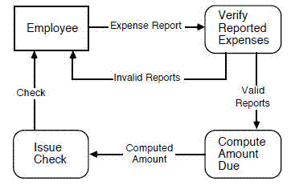

**control flow.** **(1)** sequence in which operations are performed during the execution of a computer program *(*[*ISO/IEC/IEEE 24765:2017 Systems and software engineering-Vocabulary*](http://www.iso.org/iso/en/CatalogueListPage.CatalogueList)*)* **(2)** sequence in which operations are performed during the execution of a test item *(*[*ISO/IEC/IEEE 29119-4:2021 Software and systems engineering -- Software testing -- Part 4: Test techniques*](http://www.iso.org/iso/en/CatalogueListPage.CatalogueList)*, 3.14)* *Syn:* flow of control *See Also:* data flow

**control flow diagram.** **(1)** diagram that depicts the set of all possible sequences in which operations can be performed during the execution of a system or program *(*[*ISO/IEC/IEEE 24765:2017 Systems and software engineering-Vocabulary*](http://www.iso.org/iso/en/CatalogueListPage.CatalogueList)*)* *Note:* Types include box diagram, flowchart, input-process-output chart, state diagram. *See Also:* data flow diagram, call graph, structure chart

**scope.** **(1)** sum of the products, services, and results to be provided as a project *(*[*A Guide to the Project Management Body of Knowledge (PMBOK(R) Guide) -- Seventh Edition*](http://www.pmibookstore.org/PMIBookStore/index.aspx)*)* **(2)** behavior that a system is expected to exhibit *(*[*ISO/IEC 15414:2015 Information technology -- Open distributed processing -- Reference model -- Enterprise language*](http://www.iso.org/iso/en/CatalogueListPage.CatalogueList)*, 6.1.1)* *Note:* A scope change almost always requires an adjustment to the project cost or schedule. *See Also:* project scope, product scope, scope of the FSM

**efficiency.** **(1)** relationship between the result achieved and the resources used *(*[*ISO/IEC 16350-2015 Information technology--Systems and software engineering--Application management*](http://www.iso.org/iso/en/CatalogueListPage.CatalogueList)*, 4.17)* **(2)** resources used in relation to the results achieved *(*[*ISO TR 25060:2023 Systems and software engineering--Systems and software Quality Requirements and Evaluation (SQuaRE)--General Framework for Common Industry Format (CIF) for usability-related information*](http://www.iso.org/iso/en/CatalogueListPage.CatalogueList)*, 3.1.8)* *Note:* Time-on-task and Completion Rate/Mean Time-On-Task (defect rates vs. time to achieve task) are measures of efficiency. Efficiency in the context of usability is related to productivity, rather than to its meaning in the context of software efficiency. Efficiency is the degree to which an information system efficiently uses the technical infrastructure and thus becomes usable for the customer. The most important underlying topic here is the capacity of the platform in relation to the demand. *See Also:* execution efficiency, storage efficiency

**collaboration.** **(1)** cooperative exchange of requests among classes and instances in order to achieve some goal *(*[*ISO/IEC/IEEE 24765n:2025*](http://www.iso.org/iso/en/CatalogueListPage.CatalogueList)*, 3.1.29)*

**agile development.** **(1)** development approach based on iterative development, frequent inspection and adaptation, and incremental deliveries, in which requirements and solutions evolve through collaboration in cross-functional teams and through continual stakeholder feedback *(*[*ISO/IEC/IEEE 12207:2026 Systems and software engineering--Software life cycle processes*](http://www.iso.org/iso/en/CatalogueListPage.CatalogueList)*, 3.1.4)* *(*[*ISO/IEC/IEEE 26515: 2018 Systems and software engineering: Developing information for users in an agile environment*](http://www.iso.org/iso/en/CatalogueListPage.CatalogueList)*, 3.1)* **(2)** software development approach based on iterative development, frequent inspection and adaptation, and incremental deliveries, in which requirements and solutions evolve through collaboration in cross-functional teams and through continuous stakeholder feedback *(*[*ISO/IEC/IEEE 24748-1:2024, Systems and software engineering--Life cycle management--Part 1: Guidelines for life cycle management*](http://www.iso.org/iso/en/CatalogueListPage.CatalogueList)*, 3.4)*

**data.** **(1)** representation of facts, concepts, or instructions in a manner suitable for communication, interpretation, or processing by humans or by automatic means *(*[*ISO/IEC/IEEE 24765:2017 Systems and software engineering-Vocabulary*](http://www.iso.org/iso/en/CatalogueListPage.CatalogueList)*)* **(2)** collection of values assigned to base measures, derived measures or indicators *(*[*ISO/IEC/IEEE 15939:2017 Systems and software engineering--Measurement process*](http://www.iso.org/iso/en/CatalogueListPage.CatalogueList)*, 3.4)* **(3)** representations of information dealt with by information systems and users thereof *(*[*ISO/IEC 10746-2:2009 Information technology -- Open Distributed Processing -- Reference Model: Foundations*](http://www.iso.org/iso/en/CatalogueListPage.CatalogueList)*, 3.2.1)* **(4)** reinterpretable representation of information in a formalized manner suitable for communication, interpretation, or processing *(*[*ISO/IEC 25000:2014 Systems and software Engineering--Systems and software product Quality Requirements and Evaluation (SQuaRE) -- Guide to SQuaRE*](http://www.iso.org/iso/en/CatalogueListPage.CatalogueList)*, 4.4)* **(5)** facts about an object *(*[*ISO/IEC 19770-1:2017 Information technology -- IT asset management -- Part 1: IT asset management systems--Requirements*](http://www.iso.org/iso/en/CatalogueListPage.CatalogueList)*, 3.16)* *Note:* Data can be a captured, measured, or recorded representation of information, before it is analyzed, interpreted, or processed. Data can relate to objects such as facts, events, things, processes, or ideas, including concepts that within a certain context have a particular meaning. *See Also:* data type, information

**test case.** **(1)** set of test inputs, execution conditions, and expected results developed for a particular objective, such as to exercise a particular program path or to verify compliance with a specific requirement *(*[*IEEE 1012-2024 IEEE Standard for System, Software, and Hardware Verification and Validation*](http://www.techstreet.com/ieeegate.html)*, 3.3.31)* **(2)** documentation specifying inputs, predicted results, and a set of execution conditions for a test item *(*[*IEEE 1012-2024 IEEE Standard for System, Software, and Hardware Verification and Validation*](http://www.techstreet.com/ieeegate.html)*, 3.1.31)* **(3)** set of preconditions, inputs and expected results, developed to drive the execution of a test item to meet test objectives *(*[*ISO/IEC/IEEE 29119-2:2021, Software and systems engineering--Software testing--Part 2: Test processes*](http://www.iso.org/iso/en/CatalogueListPage.CatalogueList)*, 3.23)* *Note:* A test case is the lowest level of test implementation documentation (i.e. test cases are not made up of test cases) for the test level or test type for which it is intended. Test case preconditions include the required state of the test environment, data (e.g. databases) used by the test item, and the test item itself. Inputs are the data information and actions, where applicable, used to drive test execution.

**release.** **(1)** particular version of a configuration item that is made available for a specific purpose *(*[*IEEE 828-2012 IEEE Standard for Configuration Management in Systems and Software Engineering*](http://www.techstreet.com/ieeegate.html)*, 2.12)* *(*[*ISO/IEC/IEEE 12207:2026 Systems and software engineering--Software life cycle processes*](http://www.iso.org/iso/en/CatalogueListPage.CatalogueList)*, 3.1.43)* **(2)** collection of new or changed configuration items that are tested and introduced into a live environment together *(*[*IEEE 828-2012 IEEE Standard for Configuration Management in Systems and Software Engineering*](http://www.techstreet.com/ieeegate.html)*, 2.1)* **(3)** collection of one or more new or changed configuration items deployed into the live environment as a result of one or more changes *(*[*ISO/IEC 19770-5:2015 Information technology--IT asset management--Overview and vocabulary*](http://www.iso.org/iso/en/CatalogueListPage.CatalogueList)*, 3.28)* **(4)** software version that is made formally available to a wider community *(*[*IEEE 828-2012 IEEE Standard for Configuration Management in Systems and Software Engineering*](http://www.techstreet.com/ieeegate.html)*, 2.1)* **(5)** delivered version of an application which includes all or part of an application *(*[*IEEE 828-2012 IEEE Standard for Configuration Management in Systems and Software Engineering*](http://www.techstreet.com/ieeegate.html)*, 2.1)* **(6)** set of grouped change requests, established in the Application Change Management Process, which are designed, developed, tested, and deployed as a cohesive whole *(*[*ISO/IEC 16350-2015 Information technology--Systems and software engineering--Application management*](http://www.iso.org/iso/en/CatalogueListPage.CatalogueList)*, 4.28)* **(7)** distribution of a product increment to a customer or users *(*[*ISO/IEC TR 24587:2021, Software and systems engineering--Agile development--Agile adoption considerations*](http://www.iso.org/iso/en/CatalogueListPage.CatalogueList)*, 3.13)* **(8)** one or more components of one or more products, which are intended to be put into production at the same time *(*[*A Guide to the Project Management Body of Knowledge (PMBOK(R) Guide) -- Seventh Edition*](http://www.pmibookstore.org/PMIBookStore/index.aspx)*)* *Example:* source code, code for execution, or multiple software assets packaged into an internal production release and tested for a target platform, test release *Note:* Release management includes defining acceptable quality levels for release, authority to authorize the release, and release procedures. *See Also:* version

**object-oriented design.** **(1)** software development technique in which a system or component is expressed in terms of objects and connections between those objects *(*[*ISO/IEC/IEEE 24765:2017 Systems and software engineering-Vocabulary*](http://www.iso.org/iso/en/CatalogueListPage.CatalogueList)*)* *See Also:* data structure-centered design, input-process-output, modular decomposition, rapid prototyping, stepwise refinement, structured design, transaction analysis, transform analysis

**concept phase.** **(1)** period of time in the system life cycle during which the user needs are identified and system concepts are described and evaluated *(*[*ISO/IEC/IEEE 24765:2017 Systems and software engineering-Vocabulary*](http://www.iso.org/iso/en/CatalogueListPage.CatalogueList)*)* *Note:* precedes the requirements phase

**design phase.** **(1)** period in the software life cycle during which definitions for architecture, software components, interfaces, and data are created, documented, and verified to satisfy requirements *(*[*ISO/IEC/IEEE 24765:2017 Systems and software engineering-Vocabulary*](http://www.iso.org/iso/en/CatalogueListPage.CatalogueList)*)* *See Also:* detailed design, preliminary design

**implementation phase.** **(1)** period of time in the software life cycle during which a software product is created from design documentation and debugged *(*[*ISO/IEC/IEEE 24765:2017 Systems and software engineering-Vocabulary*](http://www.iso.org/iso/en/CatalogueListPage.CatalogueList)*)* *Example:* null

**architectural design phase.** **(1)** life-cycle phase in which a system's general architecture is developed, thereby fulfilling the requirements laid down by the software requirements document and detailing the implementation plan in response to it *(*[*ISO/IEC/IEEE 24765:2017 Systems and software engineering-Vocabulary*](http://www.iso.org/iso/en/CatalogueListPage.CatalogueList)*)*

**integration testing.** **(1)** testing in which software components, hardware components, or both are combined and tested to evaluate the interaction among them *(*[*ISO/IEC 29110-5-1-2:2025 Systems and software engineering  Life cycle profiles for very small entities (VSEs)  Part 5-1-2: Software engineering guidelines for the generic Basic profile*](http://www.iso.org/iso/en/CatalogueListPage.CatalogueList)*, 3.16)* **(2)** testing in which software components, hardware components, or both are combined and tested to evaluate the interaction between them *(*[*ISO/IEC TR 7052:2023, Software engineering--Controlling frequently occurring risks during development and maintenance of custom software*](http://www.iso.org/iso/en/CatalogueListPage.CatalogueList)*, 3.28)*

**functional testing.** **(1)** testing that ignores the internal mechanism of a system or component and focuses solely on the outputs generated in response to selected inputs and execution conditions *(*[*ISO/IEC/IEEE 24765:2017 Systems and software engineering-Vocabulary*](http://www.iso.org/iso/en/CatalogueListPage.CatalogueList)*)* **(2)** testing conducted to evaluate the compliance of a system or component with specified functional requirements *(*[*ISO/IEC/IEEE 24765:2017 Systems and software engineering-Vocabulary*](http://www.iso.org/iso/en/CatalogueListPage.CatalogueList)*)* *Syn:* black-box testing *See Also:* structural testing, specification-based testing

**big-bang testing.** **(1)** type of integration testing in which software elements, hardware elements, or both are combined all at once into an overall system, rather than in stages *(*[*ISO/IEC/IEEE 24765:2017 Systems and software engineering-Vocabulary*](http://www.iso.org/iso/en/CatalogueListPage.CatalogueList)*)*

**interface testing.** **(1)** testing conducted to evaluate whether systems or components pass data and control correctly to one another *(*[*ISO/IEC/IEEE 24765:2017 Systems and software engineering-Vocabulary*](http://www.iso.org/iso/en/CatalogueListPage.CatalogueList)*)* *See Also:* component testing, integration testing, system testing, unit test

**regression testing.** **(1)** testing performed following modifications to a test item or to its operational environment, to identify whether failures in unmodified parts of the test item occur *(*[*ISO/IEC/IEEE 29119-1:2022, Software and systems engineering--Software testing--Part 1: General concepts*](http://www.iso.org/iso/en/CatalogueListPage.CatalogueList)*, 3.64)* *Note:* Regression testing differs from retesting in that it does not test that the modification works correctly, but that other parts of the system have not been accidentally affected by the change.

**scenario testing.** **(1)** specification-based test case design technique based on exercising sequences of interactions between the test item and other systems *(*[*ISO/IEC/IEEE 29119-4:2021 Software and systems engineering -- Software testing -- Part 4: Test techniques*](http://www.iso.org/iso/en/CatalogueListPage.CatalogueList)*, 3.43)* *Note:* Users are considered to be other systems in this context.

**stub.** **(1)** skeletal or special-purpose implementation of a software module, used to develop or test a module that calls or is otherwise dependent on it *(*[*ISO/IEC/IEEE 24765:2017 Systems and software engineering-Vocabulary*](http://www.iso.org/iso/en/CatalogueListPage.CatalogueList)*)* **(2)** computer programs and data files built to support software development and testing, but not intended to be included in the final product *(*[*ISO/IEC/IEEE 24748-6:2023 Systems and software engineering  Life cycle management  Part 6: System and software integration*](http://www.iso.org/iso/en/CatalogueListPage.CatalogueList)*, 3.1.7)* **(3)** engineering object in a channel, which interprets the interactions conveyed by the channel, and performs any necessary transformation or monitoring based on this interpretation *(*[*ISO/IEC 10746-3:2009 Information technology -- Open Distributed Processing -- Reference Model: Architecture*](http://www.iso.org/iso/en/CatalogueListPage.CatalogueList)*, 8.1.9)* *Syn:* scaffolding

**risk.** **(1)** effect of uncertainty on objectives *(*[*ISO/IEC 19770-1:2017 Information technology -- IT asset management -- Part 1: IT asset management systems--Requirements*](http://www.iso.org/iso/en/CatalogueListPage.CatalogueList)*, 3.48)* *(*[*A Guide to the Project Management Body of Knowledge (PMBOK(R) Guide) -- Seventh Edition*](http://www.pmibookstore.org/PMIBookStore/index.aspx)*, 3.44)* *(*[*ISO/IEC/IEEE 12207:2026 Systems and software engineering--Software life cycle processes*](http://www.iso.org/iso/en/CatalogueListPage.CatalogueList)*, 3.1.47)* *(*[*ISO/IEC/IEEE 16085:2021 Systems and software engineering--Life cycle processes--Risk management*](http://www.iso.org/iso/en/CatalogueListPage.CatalogueList)*, 3.5)* *(*[*ISO/IEC/IEEE 15288:2023 Systems and software engineering--System life cycle processes*](http://www.iso.org/iso/en/CatalogueListPage.CatalogueList)*, 3.39)* **(2)** combination of the likelihood of occurrence and the consequences of a given future undesirable event *(*[*IEEE 1012-2024 IEEE Standard for System, Software, and Hardware Verification and Validation*](http://www.techstreet.com/ieeegate.html)*, 3.1)* **(3)** combination of the likelihood of an abnormal event or failure and the consequences of that event or failure to a system's components, operators, users, or environment *(*[*IEEE 1012-2024 IEEE Standard for System, Software, and Hardware Verification and Validation*](http://www.techstreet.com/ieeegate.html)*, 3.1)* **(4)** combination of the probability of occurrence of harm and the severity of that harm *(*[*IEC/IEEE 82079-1:2019 Preparation of information for use (instructions for use) of products: Part 1: Principles and general requirements*](http://www.iso.org/iso/en/CatalogueListPage.CatalogueList)*, 3.32)* *Note:* Risk is often expressed in terms of a combination of the consequences of an event and the associated likelihood of occurrence. The probability of occurrence includes the exposure to a hazardous situation, the occurrence of a hazardous event, and the possibility to avoid or limit the harm. *See Also:* opportunity

**risk mitigation.** **(1)** risk response strategy whereby the project team acts to reduce the probability of occurrence or impact of a risk *(*[*A Guide to the Project Management Body of Knowledge (PMBOK(R) Guide) -- Seventh Edition*](http://www.pmibookstore.org/PMIBookStore/index.aspx)*)* *Note:* includes executing contingency plans when a risk metric crosses a predetermined threshold (when a risk becomes an issue or results in a problem)

**construction.** **(1)** process of writing, assembling, or generating assets *(*[*ISO/IEC/IEEE 24765j:2021*](http://www.iso.org/iso/en/CatalogueListPage.CatalogueList)*)* **(2)** activity in software development consisting of detailed design, coding, unit testing, and debugging *(*[*ISO/IEC/IEEE 24765:2017 Systems and software engineering-Vocabulary*](http://www.iso.org/iso/en/CatalogueListPage.CatalogueList)*)* *Note:* the collection of activities focused on creating source code

**engineering.** **(1)** application of a systematic, disciplined, quantifiable approach to structures, machines, products, systems, or processes *(*[*ISO/IEC/IEEE 12207:2026 Systems and software engineering--Software life cycle processes*](http://www.iso.org/iso/en/CatalogueListPage.CatalogueList)*, 3.1.24)*

**requirements engineering.** **(1)** interdisciplinary function that mediates between the domains of the acquirer and supplier to establish and maintain the requirements to be met by the system, software or service of interest *(*[*ISO/IEC/IEEE 29148:2018 Systems and software engineering-Life cycle processes-Requirements engineering*](http://www.iso.org/iso/en/CatalogueListPage.CatalogueList)*, 4.1.19)* *Note:* Requirements engineering is concerned with discovering, eliciting, developing, analyzing, determining verification methods, validating, communicating, documenting, and managing requirements *See Also:* software requirements engineering

**requirements engineering.** **(1)** interdisciplinary function that mediates between the domains of the acquirer and supplier to establish and maintain the requirements to be met by the system, software or service of interest *(*[*ISO/IEC/IEEE 29148:2018 Systems and software engineering-Life cycle processes-Requirements engineering*](http://www.iso.org/iso/en/CatalogueListPage.CatalogueList)*, 4.1.19)* *Note:* Requirements engineering is concerned with discovering, eliciting, developing, analyzing, determining verification methods, validating, communicating, documenting, and managing requirements *See Also:* software requirements engineering

**code.** **(1)** in software engineering, computer instructions and data definitions expressed in a programming language or in a form output by an assembler, compiler, or other translator *(*[*ISO/IEC/IEEE 24765:2017 Systems and software engineering-Vocabulary*](http://www.iso.org/iso/en/CatalogueListPage.CatalogueList)*)* **(2)** to express a computer program in a programming language *(*[*ISO/IEC/IEEE 24765:2017 Systems and software engineering-Vocabulary*](http://www.iso.org/iso/en/CatalogueListPage.CatalogueList)*)* **(3)** character or bit pattern that is assigned a particular meaning *(*[*ISO/IEC/IEEE 24765:2017 Systems and software engineering-Vocabulary*](http://www.iso.org/iso/en/CatalogueListPage.CatalogueList)*)* *Example:* a status code *See Also:* source code, object code, machine code, micro code

**path.** **(1)** in software engineering, a sequence of instructions that are performed in the execution of a computer program *(*[*ISO/IEC/IEEE 24765:2017 Systems and software engineering-Vocabulary*](http://www.iso.org/iso/en/CatalogueListPage.CatalogueList)*)* **(2)** in file access, a hierarchical sequence of directory and subdirectory names specifying the storage location of a file *(*[*ISO/IEC/IEEE 24765:2017 Systems and software engineering-Vocabulary*](http://www.iso.org/iso/en/CatalogueListPage.CatalogueList)*)* **(3)** sequence of executable statements of a test item *(*[*ISO/IEC/IEEE 29119-4:2021 Software and systems engineering -- Software testing -- Part 4: Test techniques*](http://www.iso.org/iso/en/CatalogueListPage.CatalogueList)*, 3.39)*

**abstraction.** **(1)** view of an object that focuses on the information relevant to a particular purpose and ignores the remainder of the information *(*[*ISO/IEC/IEEE 24765l:2024*](http://www.iso.org/iso/en/CatalogueListPage.CatalogueList)*)* **(2)** process of suppressing irrelevant detail to establish a simplified model, or the result of that process *(*[*ISO/IEC 10746-2:2009 Information technology -- Open Distributed Processing -- Reference Model: Foundations*](http://www.iso.org/iso/en/CatalogueListPage.CatalogueList)*, 6.3)* *See Also:* data abstraction

**interface.** **(1)** point at which two or more logical, physical, or both, system elements or software system elements meet and act on or communicate with each other *(*[*ISO/IEC/IEEE 12207:2026 Systems and software engineering--Software life cycle processes*](http://www.iso.org/iso/en/CatalogueListPage.CatalogueList)*, 3.1.33)* *(*[*ISO/IEC/IEEE 15288:2023 Systems and software engineering--System life cycle processes*](http://www.iso.org/iso/en/CatalogueListPage.CatalogueList)*, 3.20)* **(2)** shared boundary between two functional units, defined by various characteristics pertaining to the functions, physical signal exchanges, and other characteristics *(*[*ISO/IEC 2382:2015 Information technology -- Vocabulary*](http://www.iso.org/iso/en/CatalogueListPage.CatalogueList)*)* **(3)** abstraction of the behavior of an object that consists of a subset of the interactions of that object together with a set of constraints on when they can occur *(*[*ISO/IEC 10746-2:2009 Information technology -- Open Distributed Processing -- Reference Model: Foundations*](http://www.iso.org/iso/en/CatalogueListPage.CatalogueList)*, 8.5)* **(4)** shared boundary between two systems or system elements, defined by functional characteristics, common physical interconnection characteristics, signal characteristics, or other characteristics *(*[*INCOSE Systems Engineering Handbook, 5th ed.*](http://www.iso.org/iso/en/CatalogueListPage.CatalogueList)*)*

**level of abstraction.** **(1)** view of an object at a specific level of detail *(*[*ISO/IEC/IEEE 29148:2018 Systems and software engineering-Life cycle processes-Requirements engineering*](http://www.iso.org/iso/en/CatalogueListPage.CatalogueList)*, 4.1.12)*

**data abstraction.** **(1)** extracting the essential characteristics of data by defining data types and their associated functional characteristics and disregarding representation details *(*[*ISO/IEC/IEEE 24765:2017 Systems and software engineering-Vocabulary*](http://www.iso.org/iso/en/CatalogueListPage.CatalogueList)*)* **(2)** the result of the process in (1) *(*[*ISO/IEC/IEEE 24765:2017 Systems and software engineering-Vocabulary*](http://www.iso.org/iso/en/CatalogueListPage.CatalogueList)*)* *See Also:* encapsulation, information hiding

**complete.** **(1)** <documentation> including all critical information and any necessary, relevant information for the intended audience *(*[*ISO/IEC/IEEE 15289:2019 Systems and software engineering--Content of life-cycle information items (documentation)*](http://www.iso.org/iso/en/CatalogueListPage.CatalogueList)*, 5.2)*

**architectural design.** **(1)** definition of a collection of hardware and software components and their interfaces to establish the framework for the development of a computer system *(*[*ISO/IEC/IEEE 24765:2017 Systems and software engineering-Vocabulary*](http://www.iso.org/iso/en/CatalogueListPage.CatalogueList)*)* *See Also:* functional design

**architectural design phase.** **(1)** life-cycle phase in which a system's general architecture is developed, thereby fulfilling the requirements laid down by the software requirements document and detailing the implementation plan in response to it *(*[*ISO/IEC/IEEE 24765:2017 Systems and software engineering-Vocabulary*](http://www.iso.org/iso/en/CatalogueListPage.CatalogueList)*)*

**architectural design review.** **(1)** joint acquirer-supplier review to evaluate the technical adequacies of the software architectural design as depicted in the software design descriptions *(*[*ISO/IEC/IEEE 24765:2017 Systems and software engineering-Vocabulary*](http://www.iso.org/iso/en/CatalogueListPage.CatalogueList)*)*

**extreme programming.** **(1)** form of agile software development in which procedures for iterative planning and working are combined with technical procedures, such as test-driven design and pair programming *(*[*ISO/IEC TR 7052:2023, Software engineering--Controlling frequently occurring risks during development and maintenance of custom software*](http://www.iso.org/iso/en/CatalogueListPage.CatalogueList)*, 3.24)* *Syn:* XP

**DevOps.** **(1)** set of principles and practices which enable better communication and collaboration between relevant stakeholders for the purpose of specifying, developing, and operating software and systems products and services, and continuous improvements in all aspects of the life cycle *(*[*IEEE 2675-2021, IEEE Standard for DevOps: Building Reliable and Secure Systems Including Application Build, Package, and Deployment*](http://www.techstreet.com/ieeegate.html)*, 3.1)* **(2)** collection of practices for creating a smooth flow of deliveries by improving collaboration between development and operations staff *(*[*A Guide to the Project Management Body of Knowledge (PMBOK(R) Guide) -- Seventh Edition*](http://www.pmibookstore.org/PMIBookStore/index.aspx)*)*

**review.** **(1)** process, which can include a meeting, in which work products are presented to some stakeholders for comment or approval *(*[*IEEE 730-2014 IEEE Standard for Software Quality Assurance Processes*](http://www.techstreet.com/ieeegate.html)*, 3.2)* **(2)** process or meeting during which a work product or a set of work products, is presented to project personnel, managers, users, customers, or other stakeholders for comment or approval *(*[*ISO/IEC 29110-1-2:2024, Systems and software engineering  Lifecycle profiles for Very Small Entities (VSEs)  Part 1-2: Vocabulary*](http://www.iso.org/iso/en/CatalogueListPage.CatalogueList)*, 3.79)*

**technical review.** **(1)** series of systems engineering activities conducted at logical transition points in a system life cycle, by which the progress of a program is assessed relative to its technical requirements using a mutually agreed-upon set of criteria *(*[*ISO/IEC/IEEE 24748-8:2019, Systems and software engineering  Life cycle management  Part 7: Application of systems engineering on defense programs*](http://www.iso.org/iso/en/CatalogueListPage.CatalogueList)*, 3.1)* **(2)** formal peer review of a work product by a team of technically qualified personnel that examines the suitability of the work product for its intended use and identifies discrepancies from specifications and standards *(*[*ISO/IEC 20246:2017 Software and systems engineering -- Work product reviews*](http://www.iso.org/iso/en/CatalogueListPage.CatalogueList)*, 3.18)* *Note:* Technical reviews can also provide recommendations of alternatives and examination of various alternatives.

**code review.** **(1)** meeting at which software code is presented to project personnel, managers, users, customers, or other interested parties for comment or approval *(*[*ISO/IEC/IEEE 24765:2017 Systems and software engineering-Vocabulary*](http://www.iso.org/iso/en/CatalogueListPage.CatalogueList)*)* **(2)** activity where one or more developers establish the quality of the source code by going through it *(*[*ISO/IEC TR 7052:2023, Software engineering--Controlling frequently occurring risks during development and maintenance of custom software*](http://www.iso.org/iso/en/CatalogueListPage.CatalogueList)*, 3.9)* *See Also:* design review, formal qualification review, requirements review, test readiness review

**design review.** **(1)** formal, documented, comprehensive, and systematic examination of a design to determine if the design meets the applicable requirements, to identify problems, and to propose solutions *(*[*ISO/IEC/IEEE 24765:2017 Systems and software engineering-Vocabulary*](http://www.iso.org/iso/en/CatalogueListPage.CatalogueList)*)* **(2)** process or meeting during which a system, hardware, or software design is presented to project personnel, managers, users, customers, or other interested parties for comment or approval *(*[*ISO/IEC/IEEE 24765:2017 Systems and software engineering-Vocabulary*](http://www.iso.org/iso/en/CatalogueListPage.CatalogueList)*)* *Note:* Types include critical design review, preliminary design review, system design review. *See Also:* code review, formal qualification review, requirements review, test readiness review

**requirements review.** **(1)** process or meeting during which the requirements for a system, hardware item, or software item are presented to project personnel, managers, users, customers, or other interested parties for comment or approval *(*[*ISO/IEC/IEEE 24765:2017 Systems and software engineering-Vocabulary*](http://www.iso.org/iso/en/CatalogueListPage.CatalogueList)*)* *Note:* Types include system requirements review, software requirements review. *See Also:* code review, design review, formal qualification review, test readiness review

**system design review (SDR).** **(1)** review conducted to evaluate the manner in which the requirements for a system have been allocated to configuration items, the system engineering process that produced the allocation, the engineering planning for the next phase of the effort, manufacturing considerations, and the planning for production engineering *(*[*ISO/IEC/IEEE 24765:2017 Systems and software engineering-Vocabulary*](http://www.iso.org/iso/en/CatalogueListPage.CatalogueList)*)* *See Also:* critical design review, preliminary design review

**system requirements review (SRR).** **(1)** review conducted to evaluate the completeness and adequacy of the requirements defined for a system; to evaluate the system engineering process that produced those requirements; to assess the results of system engineering studies; and to evaluate system engineering plans *(*[*ISO/IEC/IEEE 24765:2017 Systems and software engineering-Vocabulary*](http://www.iso.org/iso/en/CatalogueListPage.CatalogueList)*)* *See Also:* software requirements review

**architectural design review. (1)** joint acquirer-supplier review to evaluate the technical adequacies of the software architectural design as depicted in the software design descriptions (ISO/IEC/IEEE 24765:2017 Systems and software engineering-Vocabulary)

**formal review.** **(1)** form of review that follows a defined process with formal documented output *(*[*ISO/IEC 20246:2017 Software and systems engineering -- Work product reviews*](http://www.iso.org/iso/en/CatalogueListPage.CatalogueList)*, 3.5)*

**informal review.** **(1)** form of review that does not follow a defined process and has no formal documented output *(*[*ISO/IEC 20246:2017 Software and systems engineering -- Work product reviews*](http://www.iso.org/iso/en/CatalogueListPage.CatalogueList)*, 3.6)*

**metric. (1**) measure or unit of measure that is designed to facilitate decision-making and improve performance and accountability through collection, analysis, and reporting of relevant data (IEEE 7005 2021, IEEE Standard for Transparent Employer Data Governance, 3.1) (2) defined measurement method and the measurement scale (ISO/IEC 14102:2008 Information Technology - Guideline for the evaluation and selection of CASE tools) (3) description of a project or product attribute and how to measure it (A Guide to the Project Management Body of Knowledge (PMBOK(R) Guide) -- Seventh Edition) See Also: software quality metric

**measure.** **(1)** variable to which a value is assigned as the result of measurement *(*[*ISO/IEC 25000:2014 Systems and software Engineering--Systems and software product Quality Requirements and Evaluation (SQuaRE) -- Guide to SQuaRE*](http://www.iso.org/iso/en/CatalogueListPage.CatalogueList)*, 4.18)* *(*[*ISO/IEC/IEEE 15939:2017 Systems and software engineering--Measurement process*](http://www.iso.org/iso/en/CatalogueListPage.CatalogueList)*, 3.15)* **(2)** make a measurement *(*[*ISO/IEC 25000:2014 Systems and software Engineering--Systems and software product Quality Requirements and Evaluation (SQuaRE) -- Guide to SQuaRE*](http://www.iso.org/iso/en/CatalogueListPage.CatalogueList)*, 4.19)* *(*[*ISO/IEC/IEEE 15939:2017 Systems and software engineering--Measurement process*](http://www.iso.org/iso/en/CatalogueListPage.CatalogueList)*, 3.16)*

**indicator.** **(1)** measure that provides an estimate or evaluation of specified attributes derived from a model with respect to defined information needs *(*[*ISO/IEC 25000:2014 Systems and software Engineering--Systems and software product Quality Requirements and Evaluation (SQuaRE) -- Guide to SQuaRE*](http://www.iso.org/iso/en/CatalogueListPage.CatalogueList)*, 4.13)* *(*[*ISO/IEC/IEEE 15939:2017 Systems and software engineering--Measurement process*](http://www.iso.org/iso/en/CatalogueListPage.CatalogueList)*, 3.10)* **(2)** device or variable that can be set to a prescribed state based on the results of a process or the occurrence of a specified condition *(*[*ISO/IEC/IEEE 24765:2017 Systems and software engineering-Vocabulary*](http://www.iso.org/iso/en/CatalogueListPage.CatalogueList)*)* **(3)** measure of a discrete element of a domain *(*[*IEEE 7010-2020, IEEE Recommended Practice for Assessing the Impact of Autonomous and Intelligent Systems on Human Well-Being*](http://www.techstreet.com/ieeegate.html)*, 2.1)* *Example:* a flag or semaphore

**SCI.** **(1)** software configuration item *(*[*ISO/IEC/IEEE 24765i:2020*](http://www.iso.org/iso/en/CatalogueListPage.CatalogueList)*)* **(2)** serial communication interface *(*[*ISO/IEC/IEEE 24765d:2015*](http://www.iso.org/iso/en/CatalogueListPage.CatalogueList)*)*